State of Florida   |  | Public Service Commission  Capital Circle Office Center ● 2540 Shumard Oak Boulevard  Tallahassee, Florida 32399-0850  -M-E-M-O-R-A-N-D-U-M-
DATE: | April 24, 2014
TO: | Office of Commission Clerk (Stauffer)
FROM: | Office of the General Counsel (Klancke)  Division of Economics (King)
RE: | Docket No. 140054-EU – Joint petition for approval of second amendment to territorial agreement in Polk County between Tampa Electric Company and the City of Lakeland.
AGENDA: | 05/09/14 – Regular Agenda – Proposed Agency Action – Interested Persons May Participate
COMMISSIONERS ASSIGNED: |  |  | All Commissioners
PREHEARING OFFICER: |  |  | Balbis
CRITICAL DATES: |  |  | None
SPECIAL INSTRUCTIONS: |  |  | None

Case Background
On March 18, 2014, Tampa Electric Company (Tampa Electric) and the City of Lakeland (Lakeland) filed a joint petition for approval of a second amendment to their territorial agreement. Tampa Electric provides service to approximately 684,000 retail customers in Hillsborough and portions of Polk, Pasco, and Pinellas Counties in Florida. Lakeland is a Florida municipal corporation that provides retail electric service to approximately 120,000 customers in and around Lakeland, Florida in Polk County. The petitioners are parties to a territorial agreement dated May 20, 1991, that was approved by the Commission in Order No. PSC-92-0570-FOF-EU (Agreement). The Agreement was first amended in August 1998 and the amendment was approved by the Commission in Order No. PSC-99-0024-FOF-EU.
A copy of the Second Amendment to Territorial Agreement (Second Amendment) entered into on February 3, 2014, is attached (Attachment A). The Second Amendment makes certain adjustments to the territorial boundary separating the service areas of the petitioners as legally described in Attachment A and shown on the maps provided in Attachment B.
This recommendation addresses the parties’ joint petition for approval of the Second Amendment. The Commission has jurisdiction over the matter pursuant to Section 366.04, Florida Statutes (F.S.).

Discussion of Issues
Issue 1:1
Should the Commission approve the joint petition of Tampa Electric Company and the City of Lakeland for Approval of Second Amendment to the Territorial Agreement?
Recommendation:
Yes. The Second Amendment to the Territorial Agreement between Tampa Electric and Lakeland will not cause a detriment to the public interest; therefore, it should be approved. (King)
Staff Analysis:
Pursuant to Section 366.04(2)(d), F.S., the Commission has the jurisdiction to approve territorial agreements between and among rural electric cooperatives, municipal electric utilities, and other electric utilities. Rule 25-6.0440(2), Florida Administrative Code, (F.A.C.), states that in approving territorial agreements, the Commission may consider the reasonableness of the purchase price of any facilities being transferred, the likelihood that the agreement will not cause a decrease in the reliability of electric service to existing or future ratepayers, and the likelihood that the agreement will eliminate existing or potential uneconomic duplication of facilities. Unless the Commission determines that the agreement will cause a detriment to the public interest, the agreement should be approved. Utilities Commission of the City of New Smyrna v. Florida Public Service Commission, 469 So. 2d 731 (Fla. 1985).
As noted in the case background, Tampa Electric and Lakeland are parties to a Territorial Agreement dated May 20, 1991, and first amended in August 1998. Both the Agreement and the first amendment were approved by the Commission. Recently, the petitioners evaluated their entire boundary line to identify areas that needed adjustment based on existing facilities and load growth. This evaluation process identified four areas (Detail 1-4), as shown in Attachment B, where such boundary changes were needed. The adjustments will better accommodate service to future load in a more efficient and cost-effective manner avoiding unnecessary duplication of transmission and distribution facilities and better serving the needs of their respective customers. The adjustment to the boundary line is described in the Second Amendment contained in Attachment A.
No customers will be transferred when the Second Amendment is implemented; therefore, no customers were notified pursuant to Rule 25-6.0440(1), F.A.C. Nor are there any facilities to be transferred and no purchase price will be involved. The petitioners state that the Second Amendment will not cause a decrease in the reliability of electrical service to the existing or future ratepayers of Tampa Electric or Lakeland. They believe approval and implementation of the Second Amendment will increase the reliability of electric service for customers of both utilities on a going-forward basis. Also, approval and implementation of the Second Amendment will help avoid uneconomic duplication of facilities in the future.
Staff believes the Second Amendment is in the public interest and will enable Tampa Electric and Lakeland to better serve their customers. It appears that the proposed amendment eliminates the potential uneconomic duplication of facilities and will not cause a decrease in the reliability of electric service. As such, staff believes that the Second Amendment between Tampa Electric and Lakeland will not cause a detriment to the public interest and should be approved.

Issue 2:2
Should this docket be closed?
Recommendation:
If no person whose substantial interests are affected by the proposed agency action files a protest within 21 days of the issuance of the order, this docket should be closed upon the issuance of a consummating order. (Klancke)
Staff Analysis:
At the conclusion of the protest period, if no protest is filed this docket should be closed upon the issuance of a consummating order.
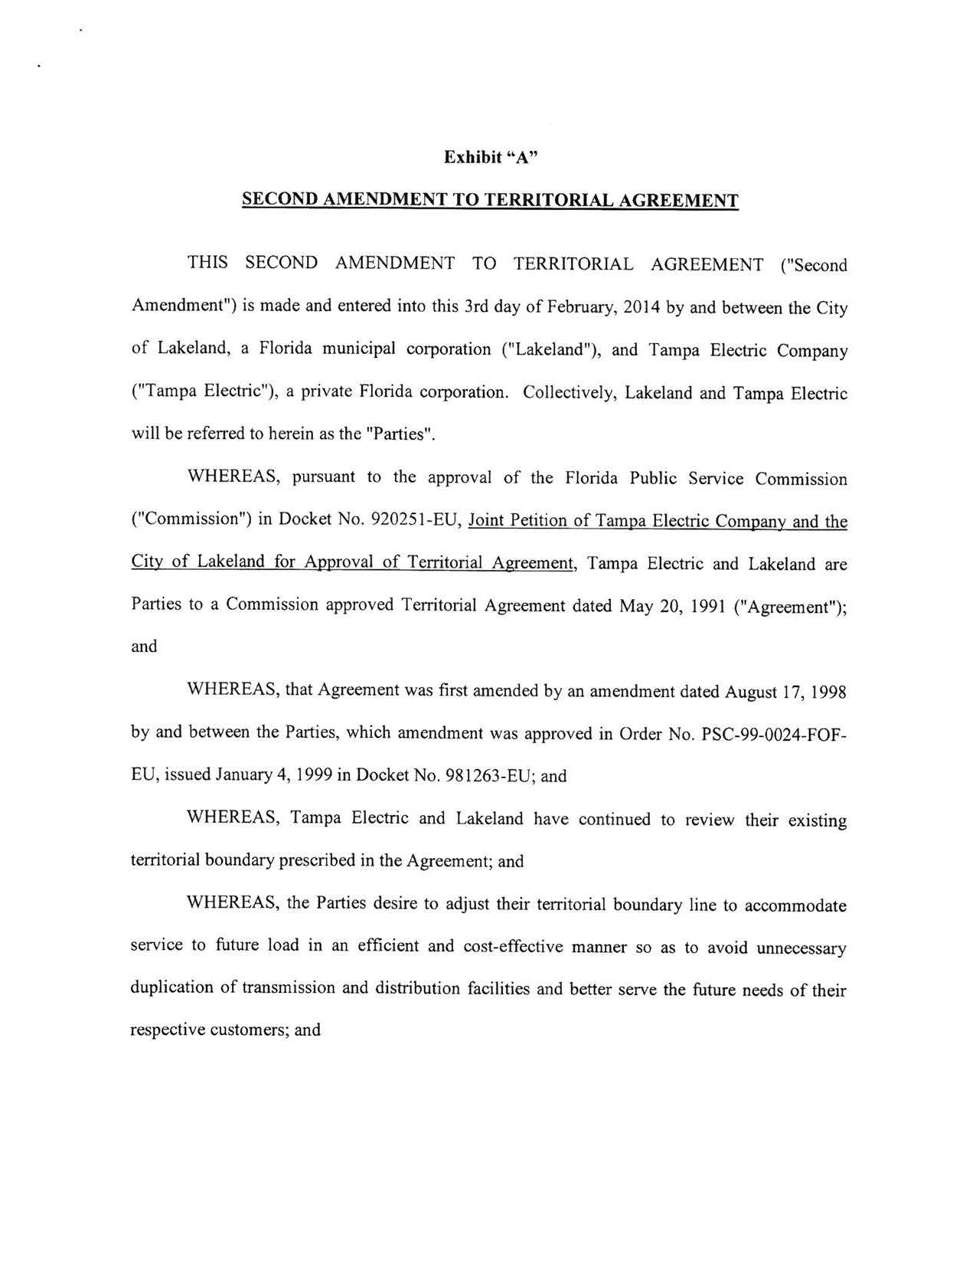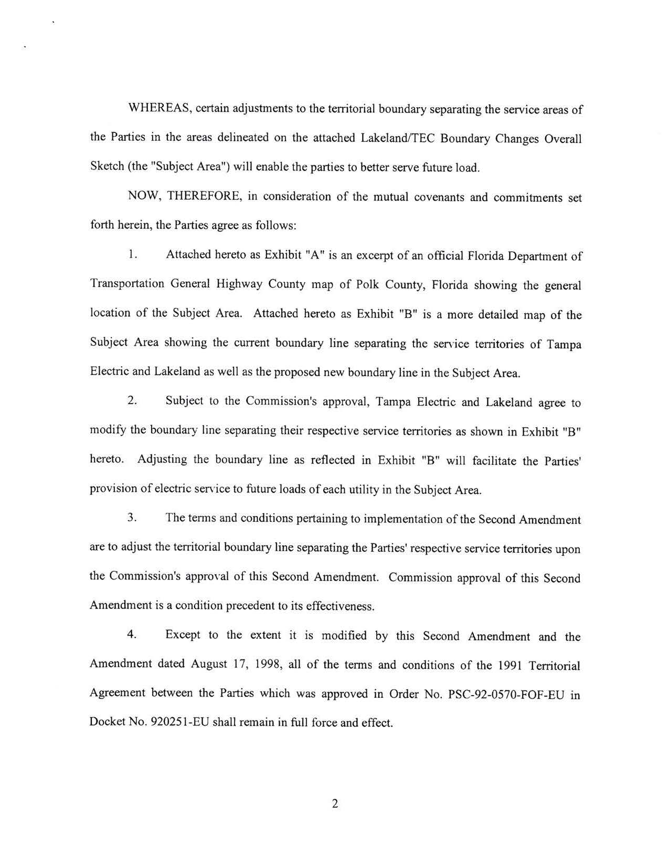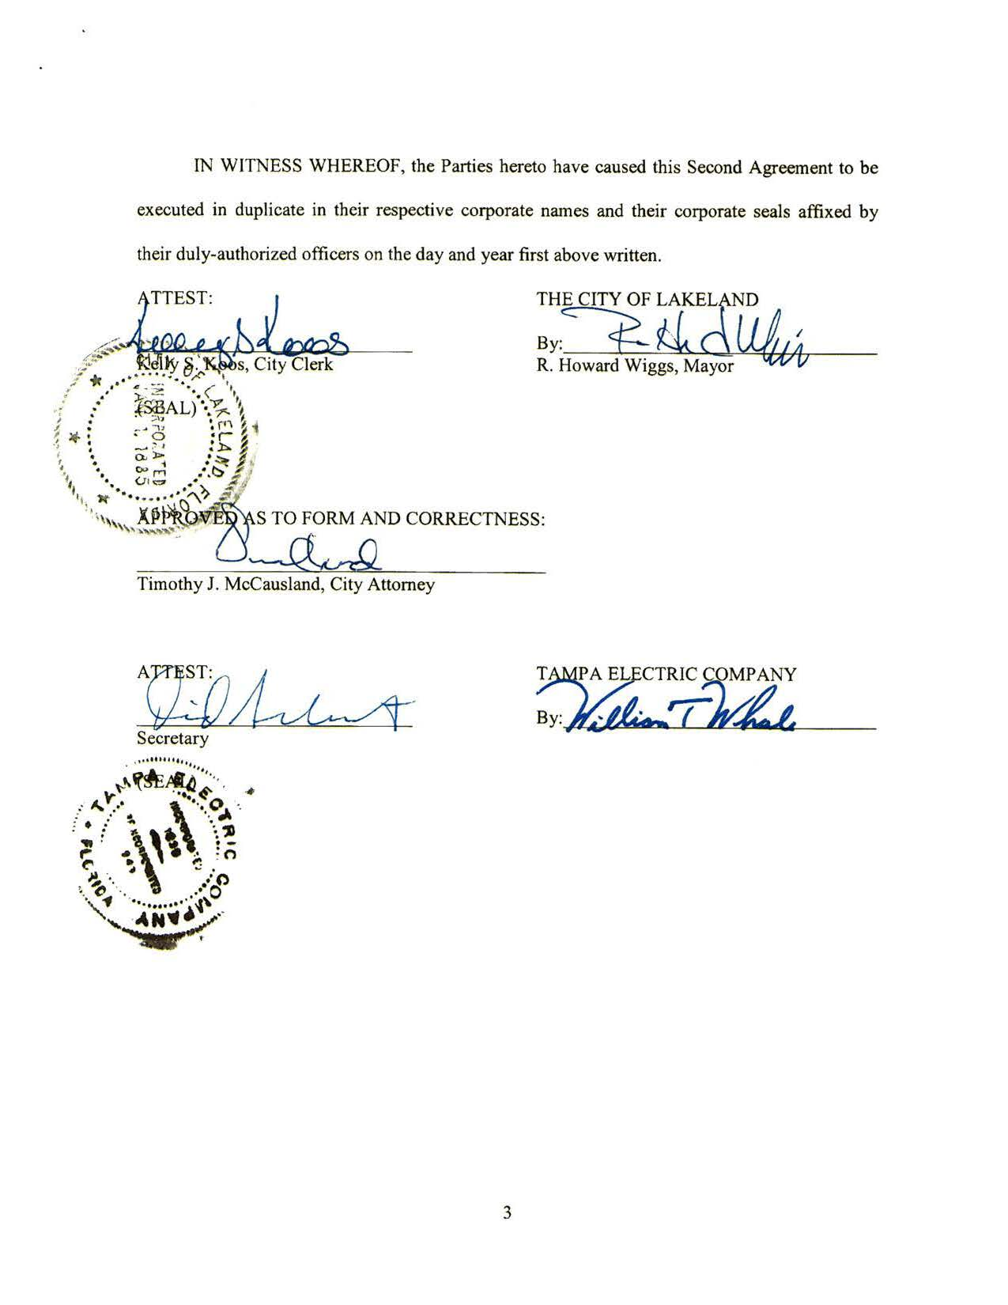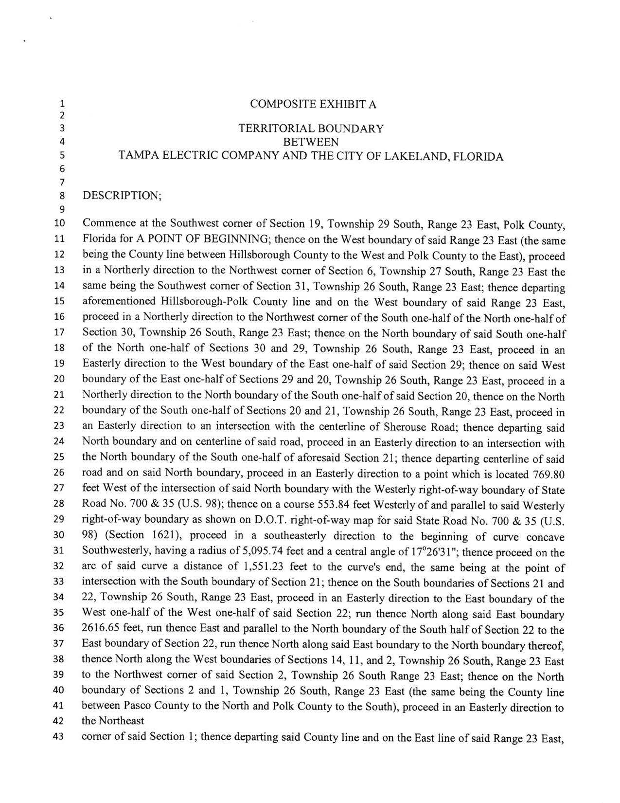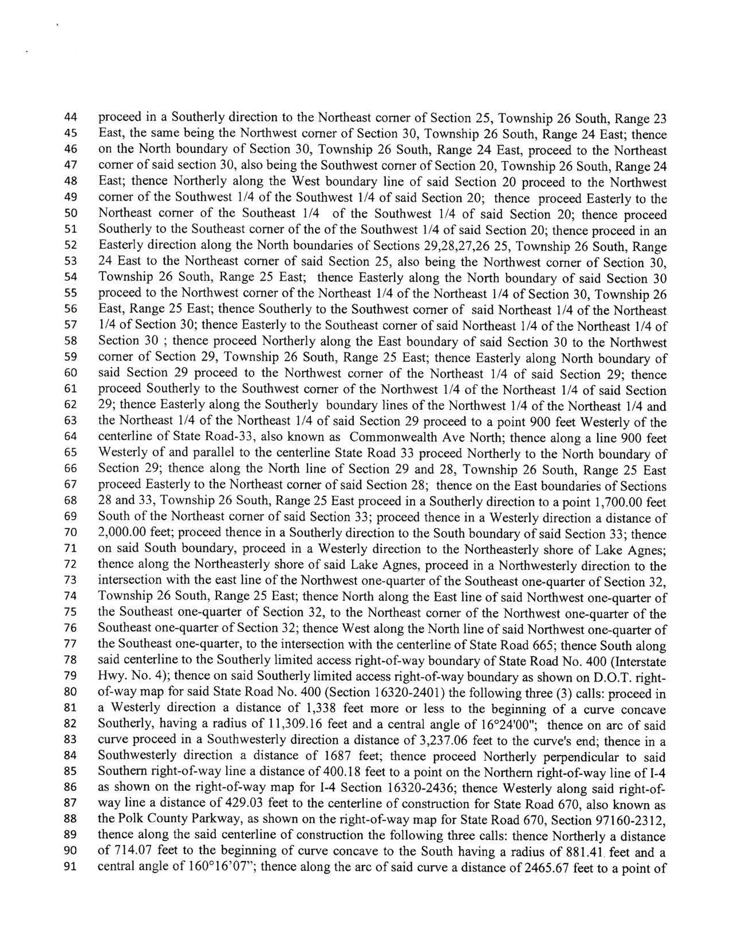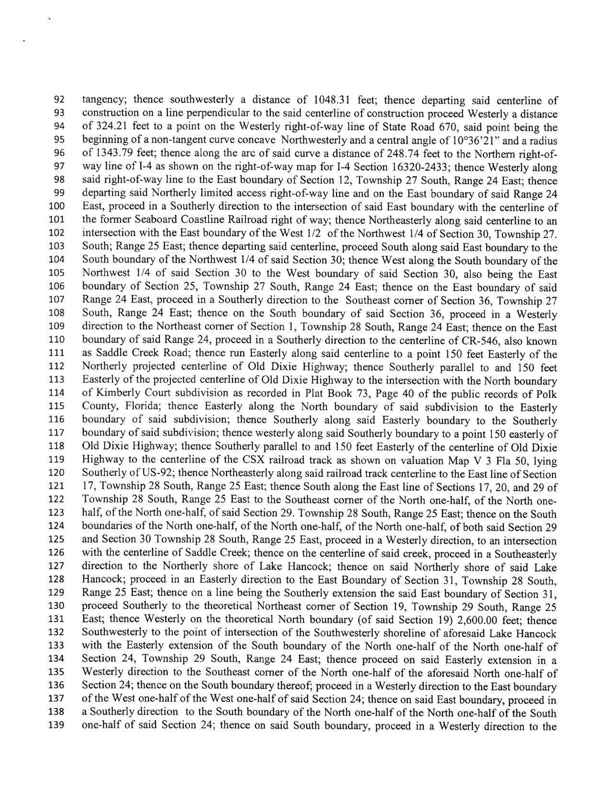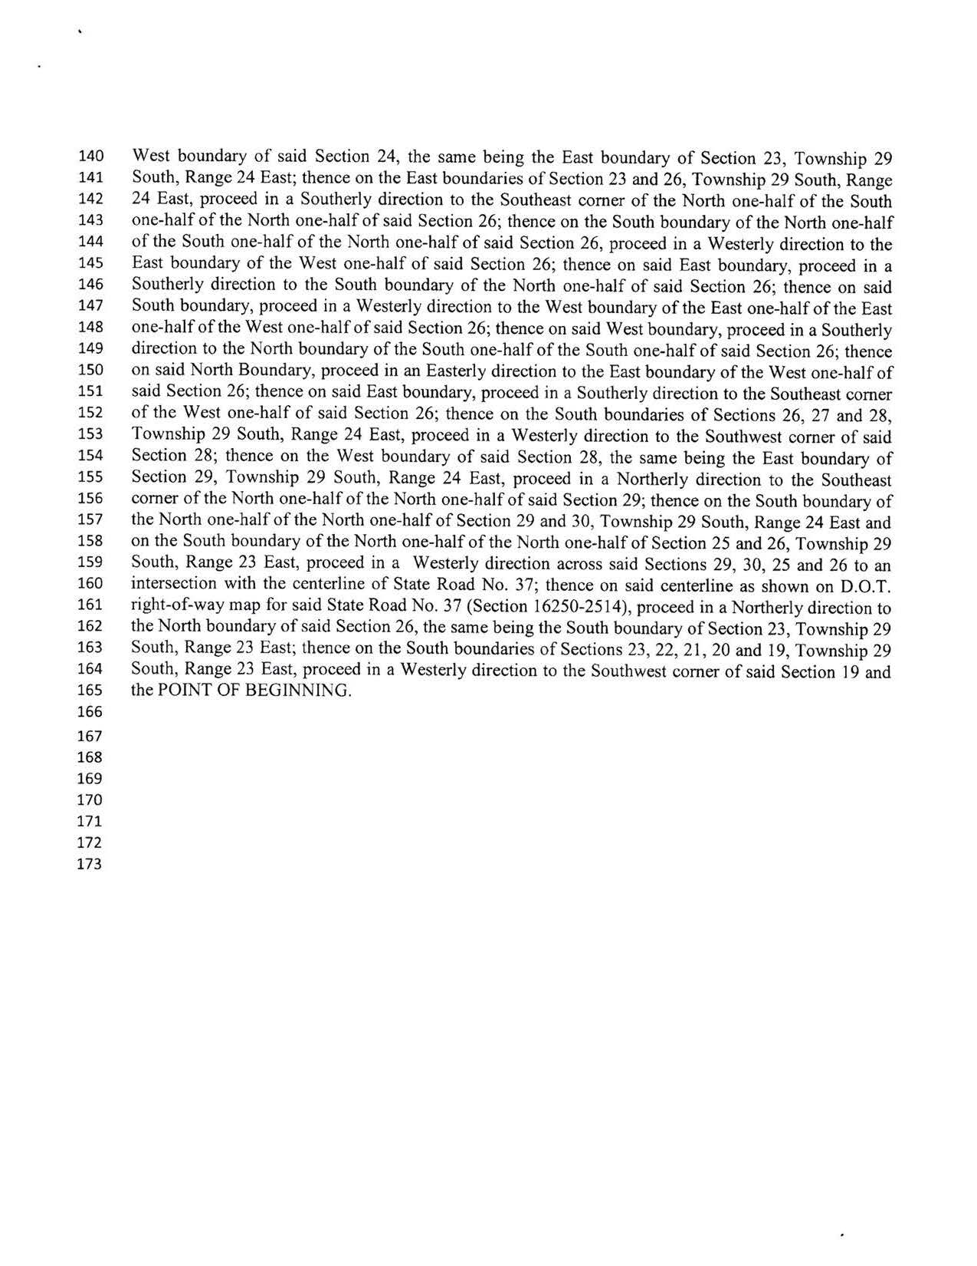
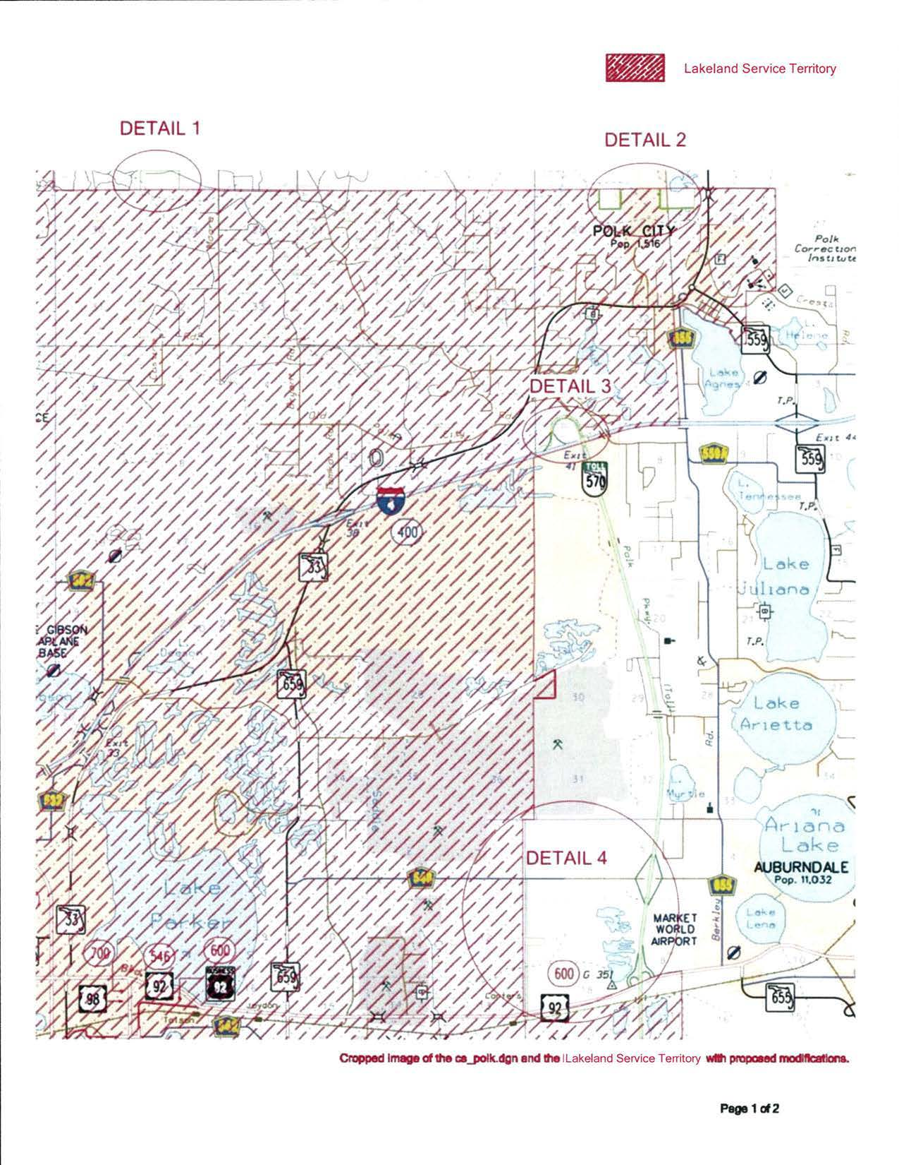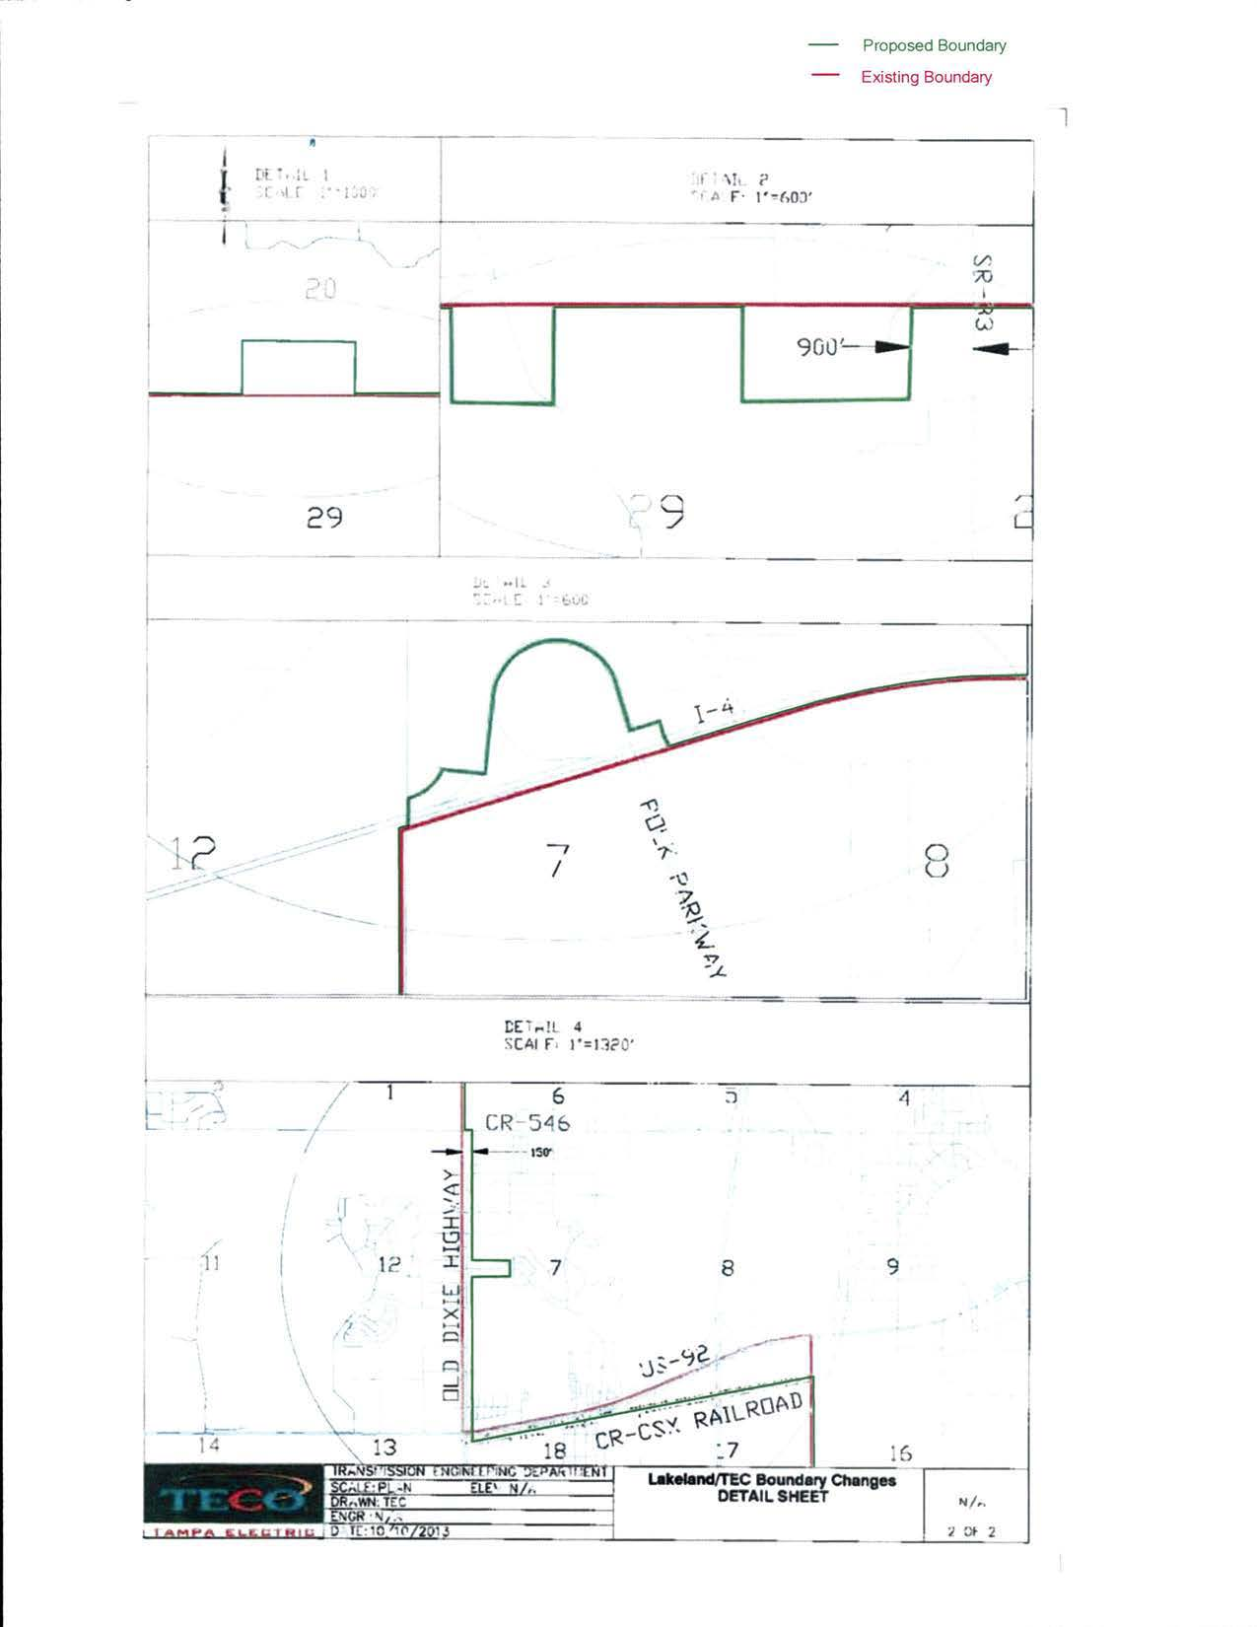

Order No. PSC-92-0570-FOF-EU, issued June 25, 1992, in Docket No. 920251-EU, In re: Joint petition for approval of territorial agreement between Tampa Electric Company and the City of Lakeland.
Order No. PSC-99-0024-FOF-EU, issued January 4, 1999, in Docket No. 981263- EU, In re: Joint petition of Tampa Electric Company and City of Lakeland for approval of amendment to territorial agreement.
For example, the area captured in Detail 1 is rural farm land and Tampa Electric does not have facilities in this area; Lakeland does, and therefore can serve future load more economically.

