BEFORE THE FLORIDA PUBLIC SERVICE COMMISSION

In re: Joint petition for approval of second amendment to territorial agreement in Polk County between Tampa Electric Company and the City of Lakeland. | DOCKET NO. 140054-EU  ORDER NO. PSC-14-0268-PAA-EU  ISSUED: May 28, 2014

The following Commissioners participated in the disposition of this matter:

ART GRAHAM, Chairman
LISA POLAK EDGAR
RONALD A. BRISÉ
EDUARDO E. BALBIS
JULIE I. BROWN

NOTICE OF PROPOSED AGENCY ACTION
ORDER APPROVING SECOND AMENDMENT TO TERRITORIAL AGREEMENT

BY THE COMMISSION:

NOTICE is hereby given by the Florida Public Service Commission that the action discussed herein is preliminary in nature and will become final unless a person whose interests are substantially affected files a petition for a formal proceeding, pursuant to Rule 25-22.029, Florida Administrative Code (F.A.C.).

BACKGROUND

On March 18, 2014, Tampa Electric Company (Tampa Electric) and the City of Lakeland (Lakeland) filed a joint petition for approval of a second amendment to their territorial agreement. Tampa Electric provides service to approximately 684,000 retail customers in Hillsborough and portions of Polk, Pasco, and Pinellas Counties in Florida. Lakeland is a Florida municipal corporation that provides retail electric service to approximately 120,000 customers in and around Lakeland, Florida in Polk County. The petitioners are parties to a territorial agreement dated May 20, 1991, that was approved in Order No. PSC-92-0570-FOF-EU (Agreement). The Agreement was first amended in August 1998 and the amendment was approved in Order No. PSC-99-0024-FOF-EU.
A copy of the Second Amendment to Territorial Agreement (Second Amendment) entered into on February 3, 2014, is attached (Attachment A). The Second Amendment makes certain adjustments to the territorial boundary separating the service areas of the petitioners as legally described in Attachment A and shown on the maps provided in Attachment B.
This Order addresses the parties’ joint petition for approval of the Second Amendment. We have jurisdiction over the matter pursuant to Section 366.04, Florida Statutes (F.S.).

DECISION
Pursuant to Section 366.04(2)(d), F.S., we have the jurisdiction to approve territorial agreements between and among rural electric cooperatives, municipal electric utilities, and other electric utilities. Rule 25-6.0440(2), F.A.C., states that in approving territorial agreements, we may consider the reasonableness of the purchase price of any facilities being transferred, the likelihood that the agreement will not cause a decrease in the reliability of electric service to existing or future ratepayers, and the likelihood that the agreement will eliminate existing or potential uneconomic duplication of facilities. Unless we determine that the agreement will cause a detriment to the public interest, the agreement should be approved. Utilities Commission of the City of New Smyrna v. Florida Public Service Commission, 469 So. 2d 731 (Fla. 1985).
As noted above, Tampa Electric and Lakeland are parties to a Territorial Agreement dated May 20, 1991, and first amended in August 1998. Both the Agreement and the first amendment were approved by us. Recently, the petitioners evaluated their entire boundary line to identify areas that needed adjustment based on existing facilities and load growth. This evaluation process identified four areas (Detail 1-4), as shown in Attachment B, where such boundary changes were needed. The adjustments will better accommodate service to future load in a more efficient and cost-effective manner avoiding unnecessary duplication of transmission and distribution facilities and better serving the needs of their respective customers. The adjustment to the boundary line is described in the Second Amendment contained in Attachment A.
No customers will be transferred when the Second Amendment is implemented; therefore, no customers were notified pursuant to Rule 25-6.0440(1), F.A.C. Nor are there any facilities to be transferred and no purchase price will be involved. The petitioners state that the Second Amendment will not cause a decrease in the reliability of electrical service to the existing or future ratepayers of Tampa Electric or Lakeland. They believe approval and implementation of the Second Amendment will increase the reliability of electric service for customers of both utilities on a going-forward basis. Also, approval and implementation of the Second Amendment will help avoid uneconomic duplication of facilities in the future.
Based on the forgoing, we find that the Second Amendment is in the public interest and will enable Tampa Electric and Lakeland to better serve their customers. It appears that the proposed amendment eliminates the potential uneconomic duplication of facilities and will not cause a decrease in the reliability of electric service. As such, we find that the Second Amendment between Tampa Electric and Lakeland will not cause a detriment to the public interest and is hereby approved.

Based on the foregoing, it is

ORDERED by the Florida Public Service Commission that the Joint Petition for Approval of Second Amendment to Territorial Agreement filed by Tampa Electric Company and the City of Lakeland is approved. It is further

ORDERED that the provisions of this Order, issued as proposed agency action, shall become final and effective upon the issuance of a Consummating Order unless an appropriate petition, in the form provided by Rule 28-106.201, Florida Administrative Code, is received by the Commission Clerk, 2540 Shumard Oak Boulevard, Tallahassee, Florida 32399-0850, by the close of business on the date set forth in the “Notice of Further Proceedings” attached hereto. It is further

ORDERED that in the event this Order becomes final, this docket shall be closed.

By ORDER of the Florida Public Service Commission this 28th day of May, 2014.

/s/ Carlotta S. Stauffer
CARLOTTA S. STAUFFER
Commission Clerk
Florida Public Service Commission
2540 Shumard Oak Boulevard
Tallahassee, Florida 32399
(850) 413-6770
www.floridapsc.com

Copies furnished: A copy of this document is provided to the parties of record at the time of issuance and, if applicable, interested persons.

CMK

NOTICE OF FURTHER PROCEEDINGS OR JUDICIAL REVIEW

The Florida Public Service Commission is required by Section 120.569(1), Florida Statutes, to notify parties of any administrative hearing that is available under Section 120.57, Florida Statutes, as well as the procedures and time limits that apply. This notice should not be construed to mean all requests for an administrative hearing will be granted or result in the relief sought.

Mediation may be available on a case-by-case basis. If mediation is conducted, it does not affect a substantially interested person's right to a hearing.

The action proposed herein is preliminary in nature. Any person whose substantial interests are affected by the action proposed by this order may file a petition for a formal proceeding, in the form provided by Rule 28-106.201, Florida Administrative Code. This petition must be received by the Office of Commission Clerk, 2540 Shumard Oak Boulevard, Tallahassee, Florida 32399-0850, by the close of business on June 18, 2014.

In the absence of such a petition, this order shall become final and effective upon the issuance of a Consummating Order.

Any objection or protest filed in this/these docket(s) before the issuance date of this order is considered abandoned unless it satisfies the foregoing conditions and is renewed within the specified protest period.
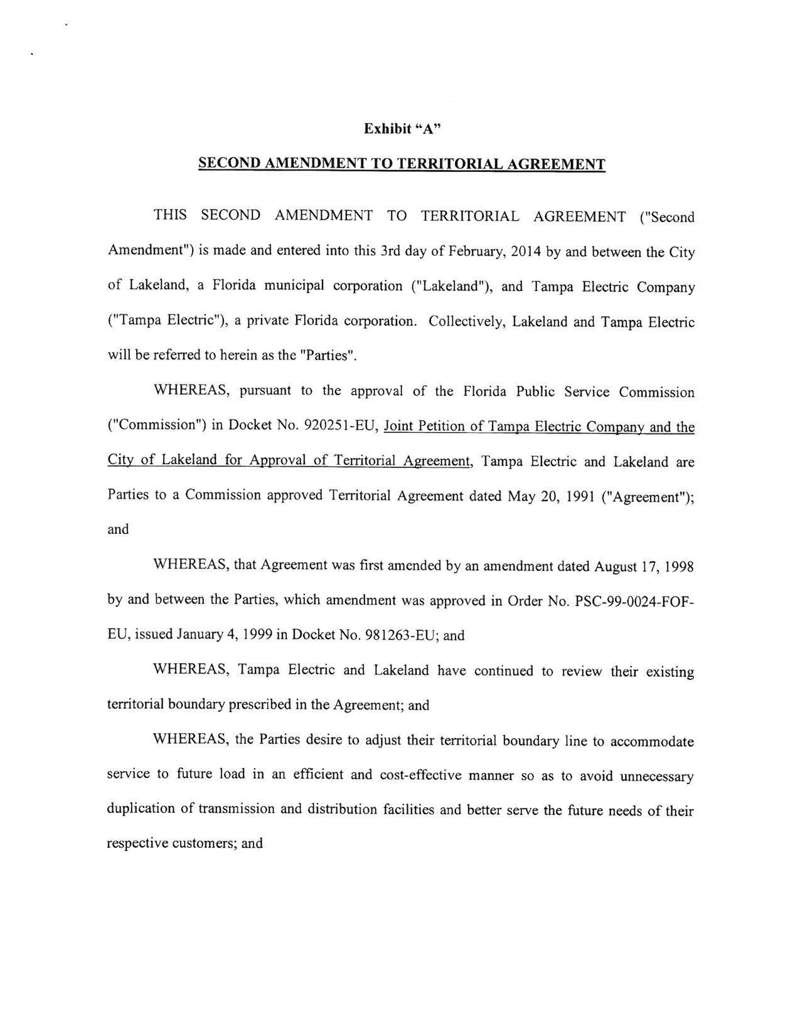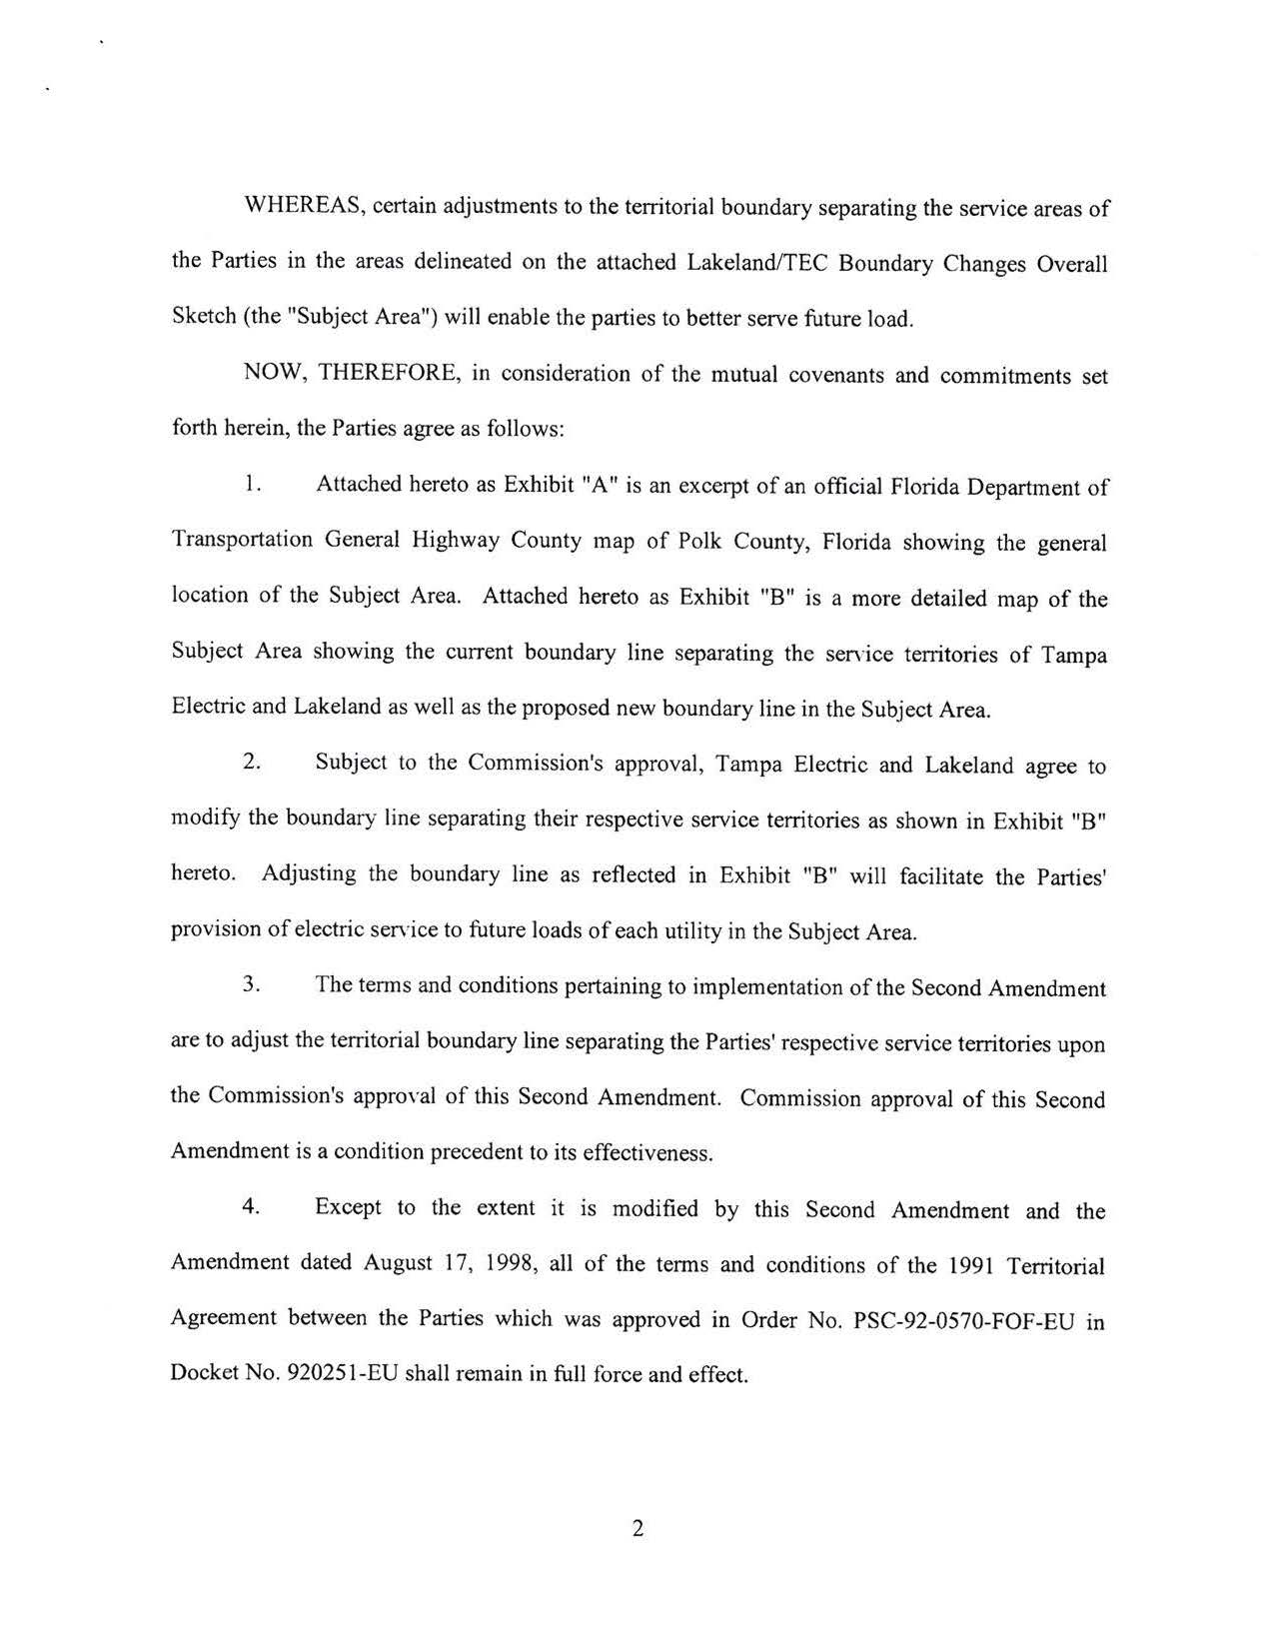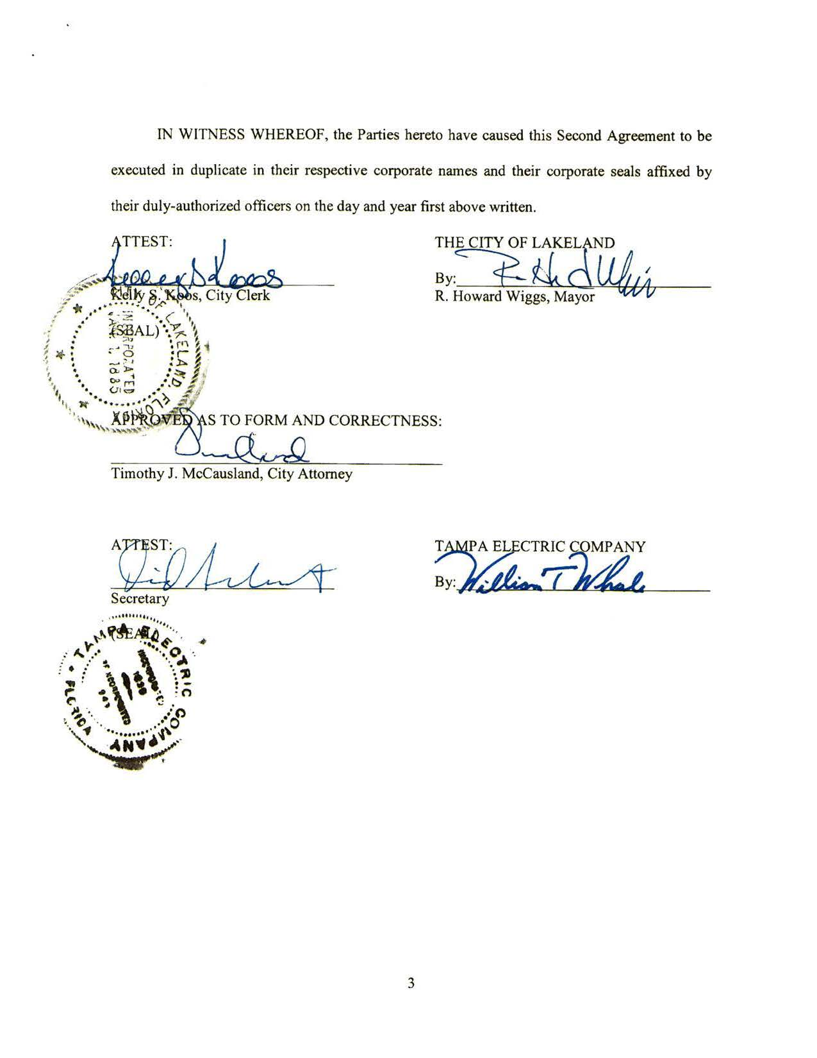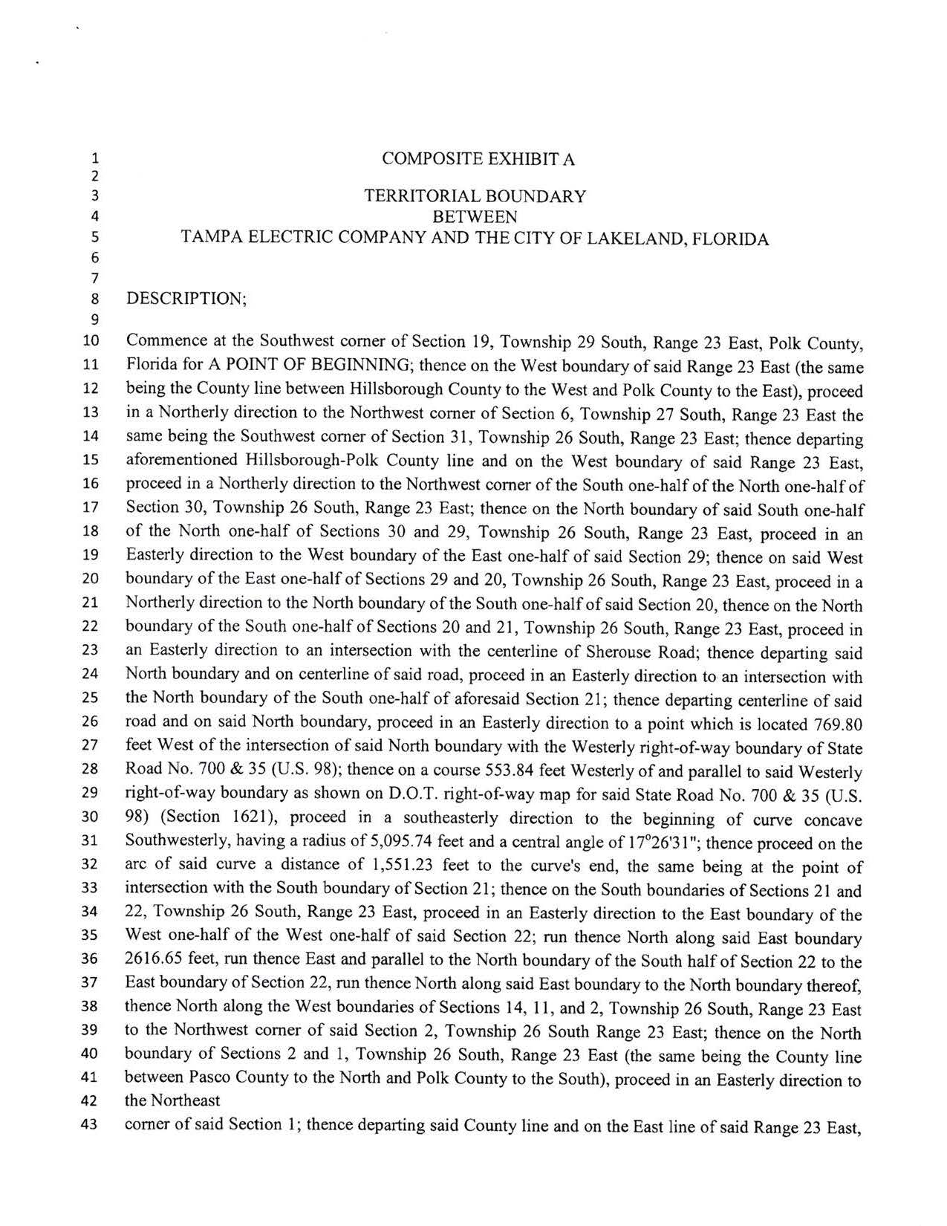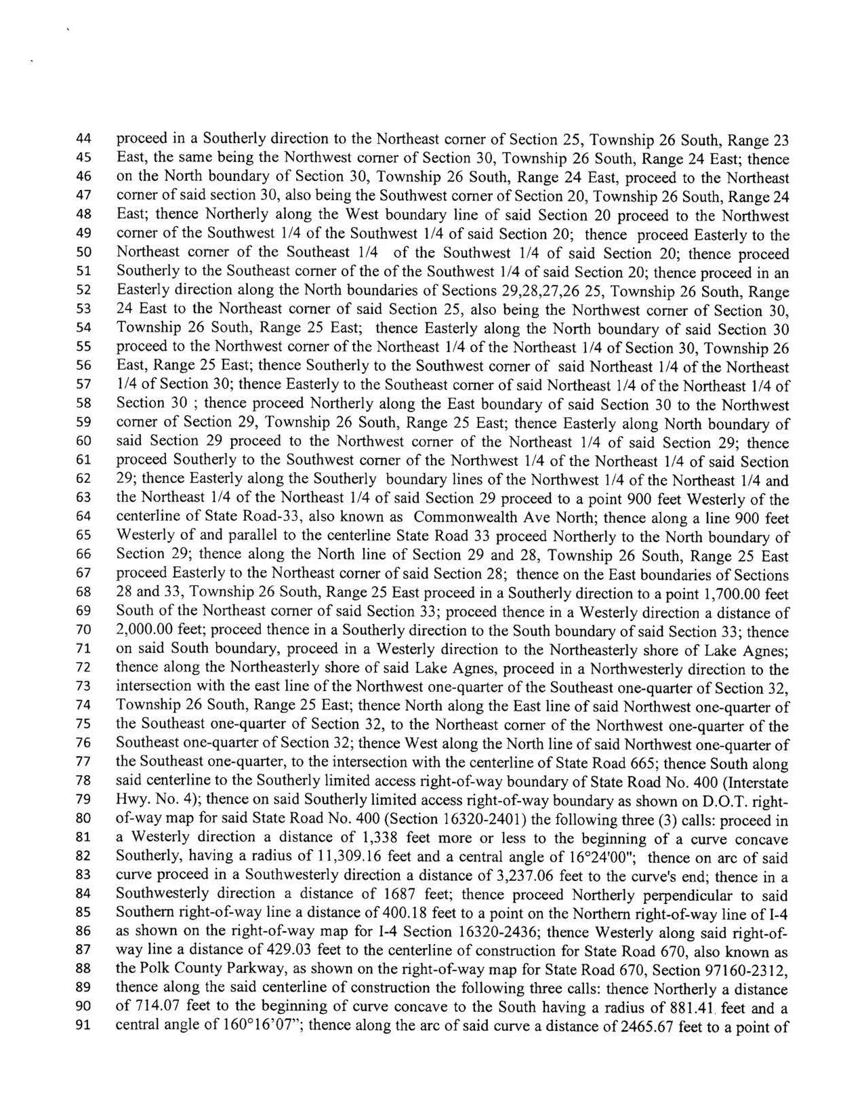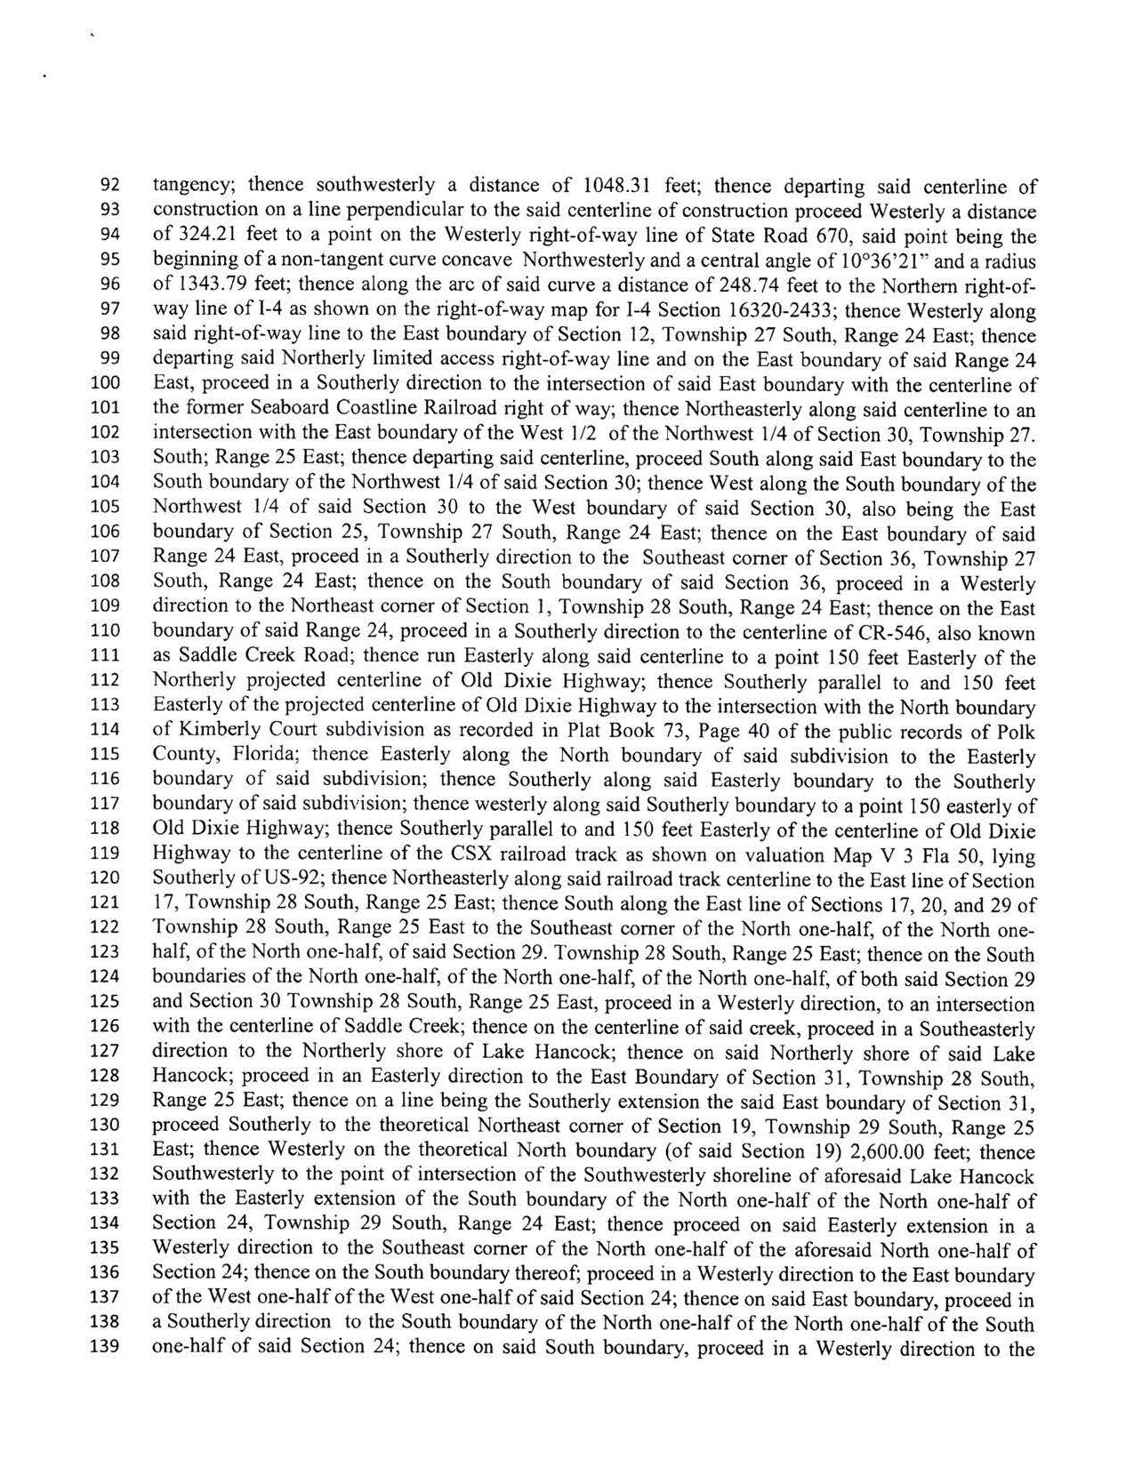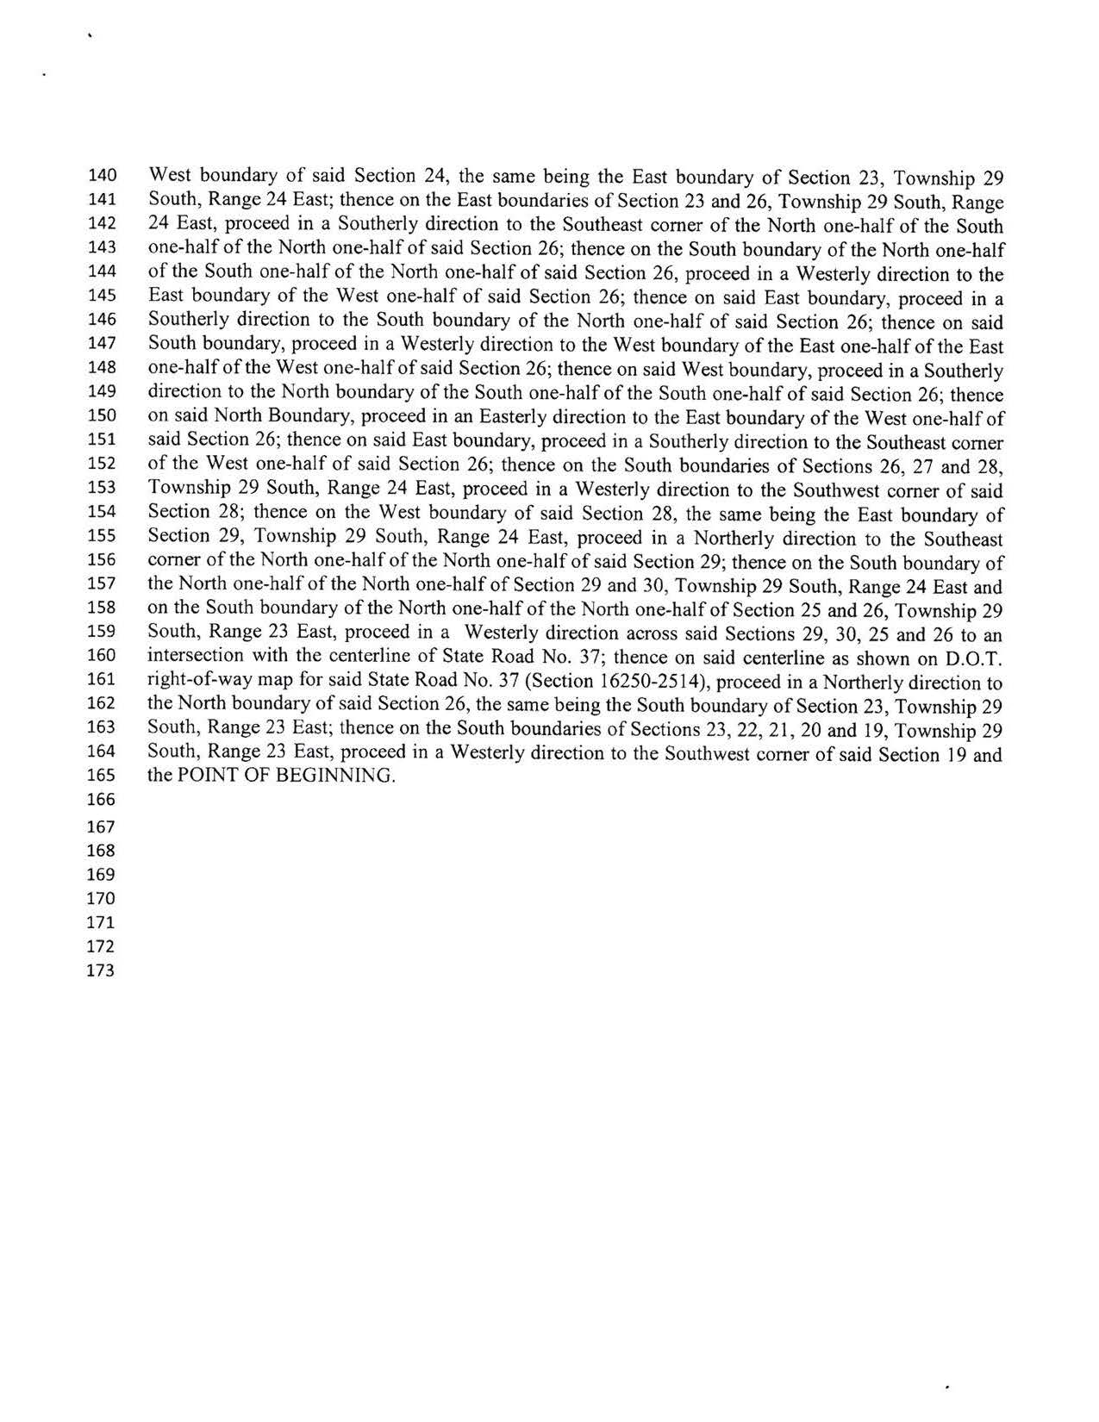
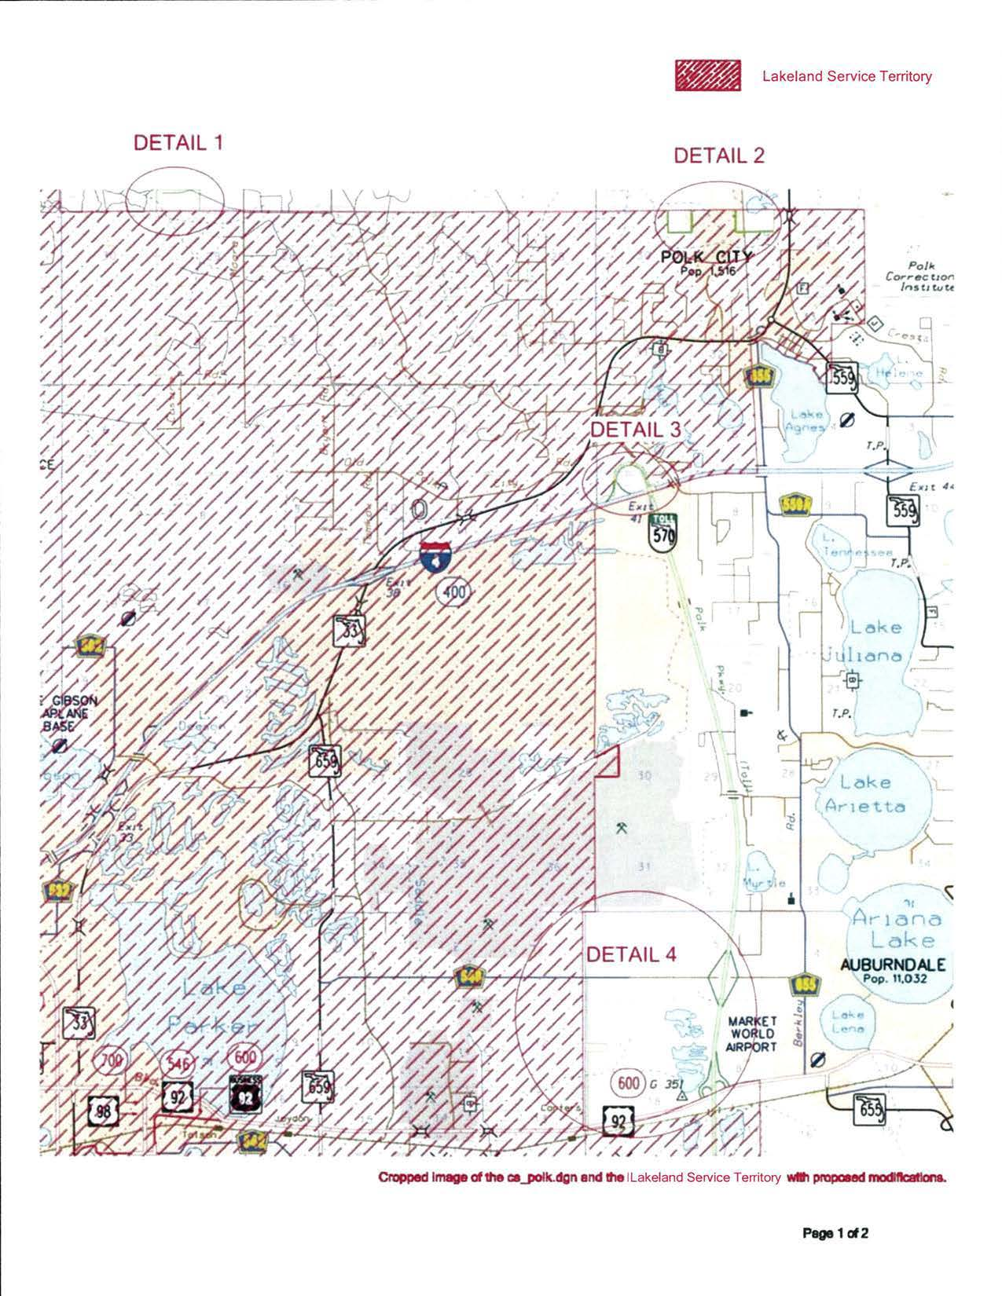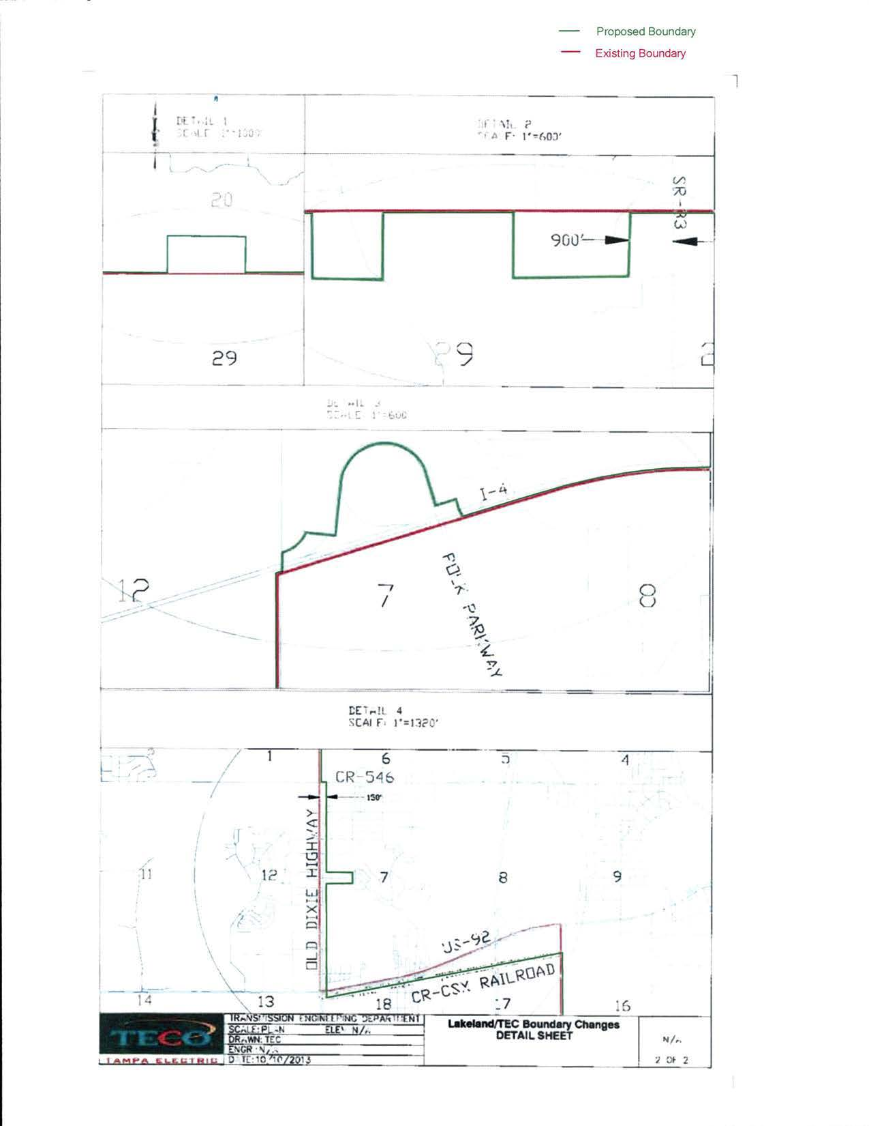

Order No. PSC-92-0570-FOF-EU, issued June 25, 1992, in Docket No. 920251-EU, In re: Joint petition for approval of territorial agreement between Tampa Electric Company and the City of Lakeland.
Order No. PSC-99-0024-FOF-EU, issued January 4, 1999, in Docket No. 981263- EU, In re: Joint petition of Tampa Electric Company and City of Lakeland for approval of amendment to territorial agreement.
For example, the area captured in Detail 1 is rural farm land and Tampa Electric does not have facilities in this area; Lakeland does, and therefore can serve future load more economically.

