BEFORE THE FLORIDA PUBLIC SERVICE COMMISSION

In re: Water and wastewater industry annual reestablishment of authorized range of return on common equity for water and wastewater utilities pursuant to Section 367.081(4)(f), F.S. | DOCKET NO. 140006-WS  ORDER NO. PSC-14-0272-PAA-WS  ISSUED: May 29, 2014

The following Commissioners participated in the disposition of this matter:

ART GRAHAM, Chairman
LISA POLAK EDGAR
RONALD A. BRISÉ
EDUARDO E. BALBIS
JULIE I. BROWN

NOTICE OF PROPOSED AGENCY ACTION
ORDER ESTABLISHING AUTHORIZED RANGE OF RETURNS ON COMMON EQUITY FOR WATER AND WASTEWATER UTILITIES

BY THE COMMISSION:

NOTICE is hereby given by the Florida Public Service Commission that the action discussed herein is preliminary in nature and will become final unless a person whose interests are substantially affected files a petition for a formal proceeding, pursuant to Rule 25-22.029, Florida Administrative Code (F.A.C.).

BACKGROUND

Section 367.081(4)(f), Florida Statutes (F.S.), authorizes the Commission to establish, not less than once each year, a leverage formula to calculate a reasonable range of returns on equity (ROE) for water and wastewater (WAW) utilities. The leverage formula methodology currently in use was established in Order No. PSC-01-2514-FOF-WS. On October 23, 2008, we held a formal hearing in Docket No. 080006-WS to allow interested parties to provide testimony regarding the validity of the leverage formula. Based on the record in that proceeding, we approved the 2008 leverage formula in Order No. PSC-08-0846-FOF-WS. In that order, we reaffirmed the methodology that was previously approved in Order No. PSC-01-2514-FOF-WS.
This order continues to use the leverage formula methodology established in Order No. PSC-01-2514-FOF-WS and reaffirmed in Order No. PSC-08-0846-FOF-WS. This methodology uses ROEs derived from financial models applied to an index of natural gas utilities. Based on the results of our annual review, there is an insufficient number of WAW utilities that meet the requisite criteria to assemble an appropriate proxy group using only WAW utilities. Therefore, since 2001, we have used natural gas utilities as the proxy companies for the leverage formula. There are many natural gas utilities that have actively traded stocks and forecasted financial data. We use natural gas utilities that derive at least 50 percent of their revenue from regulated rates. These utilities have market power and are influenced significantly by economic regulation. As explained in Issue 1, the model results based on natural gas utilities are adjusted to reflect the risks faced by Florida WAW utilities.
In 2011, we approved the leverage formula currently in effect (2011 leverage formula) by Order No. PSC-11-0287-PAA-WS. In 2012 and 2013, we approved the continued use of the 2011 leverage formula for establishing the authorized ROE for WAW utilities by Order Nos. PSC-12-0339-PAA-WS and PSC-13-0241-PAA-WS. In 2012 and 2103, we found that the ranges of returns on equity derived from the leverage formulas were not optimal for determining the appropriate authorized ROE for WAW utilities due to Federal Reserve monetary policies that resulted in historically low interest rates. Consequently, we decided that the range of returns on equity of 8.74 percent to 11.16 percent from the 2011 leverage formula was more reasonable.
Additional precedent for continuing the use of the current leverage formula occurred in 1996 when we approved the continued use of the authorized ROE for WAW utilities on the leverage formula instituted in 1995. In Order No. PSC-96-0729-FOF-WS, we found that the leverage formula range of returns from the prior year were still reasonable and found it appropriate to continue to base the authorized range of returns on common equity for WAW utilities on the leverage formula from the prior year.
Although Section 367.081(4)(f), F.S., authorizes us to establish a range of returns for setting the authorized ROE for WAW utilities, we may set an ROE for WAW utilities based on record evidence in any proceeding. If one or more parties file testimony in opposition to the use of the leverage formula, we will determine the appropriate ROE based on the evidentiary record in that proceeding. We have jurisdiction pursuant to Section 367.081, F.S.
DECISION
As stated above, Section 367.081(4)(f), F.S., authorizes us to establish a leverage formula to calculate a reasonable range of returns on common equity for WAW utilities. Section 367.081(4)(f), F.S., further requires that we establish this leverage formula not less than once a year.
In 2013, by Order No. PSC-13-0241-PAA-WS, we approved the continued use of the leverage formula initially approved in 2011. We kept the 2011 leverage formula in place because Federal Reserve monetary policies lowered interest rates to historically low levels, thereby increasing the slope of the leverage formula graph relative to previous years. The Federal Reserve’s monetary policies and resulting capital market conditions that existed in 2012 and 2013 are expected to continue through 2014.
In the instant docket, our staff updated the leverage formula using the most recent 2014 financial information and the Commission approved methodology. The updated 2014 leverage formula decreases the lower end of the current allowed ROE range by 50 basis points while increasing the upper end of the range by 58 basis points relative to the current leverage formula. The spread between the range of returns on equity for the 2014 leverage formula is 350 basis points (8.24 percent to 11.74 percent). This is the second largest spread for the allowed ROE for WAW utilities in the approximately 30 years the leverage formula has been in use in Florida. In comparison, the spread in the range of returns on equity for the 2011 leverage formula is 242 basis points (8.74 percent to 11.16 percent).
The increase in the spread in the range of the ROE from the 2014 leverage formula relative to the 2011 leverage formula is caused by the very low bond rates resulting from the Federal Reserve’s various monetary policies and quantitative easing programs, which are still in effect. In its press release dated March 19, 2014, the Federal Reserve stated:
To support continued progress toward maximum employment and price stability, the Committee today reaffirmed its view that a highly accommodative stance of monetary policy remains appropriate. In determining how long to maintain the current 0 to 1/4 percent target range for the federal funds rate, the Committee will assess progress--both realized and expected--toward its objectives of maximum employment and 2 percent inflation. This assessment will take into account a wide range of information, including measures of labor market conditions, indicators of inflation pressures and inflation expectations, and readings on financial developments. The Committee continues to anticipate, based on its assessment of these factors, that it likely will be appropriate to maintain the current target range for the federal funds rate for a considerable time after the asset purchase program ends, especially if projected inflation continues to run below the Committee's 2 percent longer-run goal, and provided that longer-term inflation expectations remain well anchored.
The most recent assumed Baa3 bond rate of 5.91 percent used in the 2014 leverage formula calculation, which includes a 50 basis point adjustment for small company risk and a 50 basis point adjustment for a private placement premium, remains low relative to historic levels. In comparison, the assumed Baa3 bond rate used in the 2011 leverage formula is 7.13 percent.
Because interest rates are at historically low levels, thereby increasing the slope of the leverage formula relative to prior years, the range of returns on equity produced from the updated 2014 leverage formula is not optimal for determining the appropriate authorized ROE for Florida WAW utilities at this time. An increase in the slope of the leverage formula means a given change in the equity ratio will result in a greater change to the cost of equity. The results of this years leverage formula produced a slope almost identical to the slope of the 2013 leverage formula, but with returns that are on average 40 basis points higher. As shown below, Chart 1 illustrates the change in the slope of the leverage formula for the four years 2011 through 2014.
Chart 1
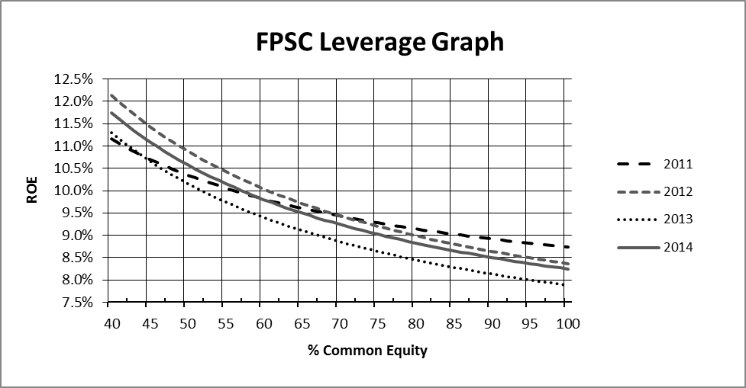
The 2011 leverage formula range of 8.74 percent to 11.16 percent is still reasonable for WAW utilities. Therefore, we find that the current leverage formula approved in Docket No. 110006-WS shall continue to be used for determining the return on equity for WAW utilities in 2014. Retaining the use of the current in-place leverage formula until the leverage formula is addressed again in 2015 is a reasonable alternative to updating the formula using current 2014 financial information. However, we continue to believe the leverage formula is a sound, workable methodology that reduces the costs and administrative burdens in WAW rate cases by eliminating the need for cost of equity testimony. Many of the WAW utilities under our jurisdiction are small operations that find it beneficial to avoid the costs associated with presenting cost of equity testimony.
Based on the information above, we find that the current range of returns on common equity of 8.74 percent to 11.16 percent is still reasonable for WAW utilities. As such, we find that the current leverage formula authorized by us in Order No. PSC-13-0241-PAA-WS shall remain unchanged until the leverage formula is readdressed in 2015.
Based on the foregoing, it is

ORDERED by the Florida Public Service Commission that the current 2011 leverage formula authorized by us in Order No. PSC-13-0241-PAA-WS, Return on Common Equity = 7.13% + (1.610 ÷ Equity Ratio), shall continue to be used until the leverage formula is readdressed in 2015. It is further

ORDERED that the current range of returns on common equity of 8.74 percent to 11.16 percent is hereby approved for water and wastewater utilities as set forth in this Order. It is further

ORDERED that the returns on common equity shall be capped at 11.16 percent for all water and wastewater utilities with equity ratios less than 40 percent in order to discourage financial risk. It is further

ORDERED that Attachment 1 is incorporated herein by reference. It is further

ORDERED that the provisions of this Order, issued as proposed agency action, shall become final and effective upon the issuance of a Consummating Order unless an appropriate petition, in the form provided by Rule 28-106.201, Florida Administrative Code, is received by the Commission Clerk, 2540 Shumard Oak Boulevard, Tallahassee, Florida 32399-0850, by the close of business on the date set forth in the “Notice of Further Proceedings” attached hereto. It is further

ORDERED that in the event this Order becomes final, this docket shall remain open to allow staff to monitor changes in capital market conditions and to readdress the reasonableness of the leverage formula as conditions warrant.

By ORDER of the Florida Public Service Commission this 29th day of May, 2014.

/s/ Carlotta S. Stauffer
CARLOTTA S. STAUFFER
Commission Clerk
Florida Public Service Commission
2540 Shumard Oak Boulevard
Tallahassee, Florida 32399
(850) 413-6770
www.floridapsc.com

Copies furnished: A copy of this document is provided to the parties of record at the time of issuance and, if applicable, interested persons.

CMK

NOTICE OF FURTHER PROCEEDINGS OR JUDICIAL REVIEW

The Florida Public Service Commission is required by Section 120.569(1), Florida Statutes, to notify parties of any administrative hearing that is available under Section 120.57, Florida Statutes, as well as the procedures and time limits that apply. This notice should not be construed to mean all requests for an administrative hearing will be granted or result in the relief sought.

Mediation may be available on a case-by-case basis. If mediation is conducted, it does not affect a substantially interested person's right to a hearing.

The action proposed herein is preliminary in nature. Any person whose substantial interests are affected by the action proposed by this order may file a petition for a formal proceeding, in the form provided by Rule 28-106.201, Florida Administrative Code. This petition must be received by the Office of Commission Clerk, 2540 Shumard Oak Boulevard, Tallahassee, Florida 32399-0850, by the close of business on June 19, 2014.

In the absence of such a petition, this order shall become final and effective upon the issuance of a Consummating Order.

Any objection or protest filed in this/these docket(s) before the issuance date of this order is considered abandoned unless it satisfies the foregoing conditions and is renewed within the specified protest period.
Attachment 1
Page 1 of 1

SUMMARY OF LEVERAGE FORMULA FACTORS
DCF ROE for Natural Gas Utility Index |  | 8.25%
CAPM ROE for Natural Gas Utility Index |  | 9.40%
AVERAGE |  | 8.83%
Bond Yield Differential |  | 0.57%
Private Placement Premium |  | 0.50%
Small-Utility Risk Premium |  | 0.50%
Adjustment to Reflect ROE at 40% Equity Ratio |  | 0.76%
Cost of Equity for Average Florida WAW Utility
with a capital structure containing a 40% Equity Ratio |  | 11.16%
Authorized Leverage Formula
Return on Common Equity = | 7.13% + (1.610 ÷ Equity Ratio)
Range of Returns on Equity (100% to 40%) = | 8.74% to 11.16%

Order No. PSC-01-2514-FOF-WS, issued December 24, 2001, in Docket No. 010006-WS, In re: Water and wastewater industry annual reestablishment of authorized range of return on common equity for water and wastewater utilities pursuant to Section 367.081(4)(f), F.S.
At the May 20, 2008, Commission Conference, upon request of the Office of Public Counsel, we voted to set the establishment of the appropriate leverage formula directly for hearing.
Order No. PSC-08-0846-FOF-WS, issued December 31, 2008, in Docket No. 080006-WS, In re: Water and wastewater industry annual reestablishment of authorized range of return on common equity for water and wastewater utilities pursuant to Section 367.081(4)(f), F.S.
Order No. PSC-11-0287-PAA-WS, issued July 5, 2011, in Docket No. 110006-WS, In re: Water and wastewater industry annual reestablishment of authorized range of return on common equity for water and wastewater utilities pursuant to Section 367.081(4)(f), F.S.
Order No. PSC-12-0339-PAA-WS, issued June 28, 2012, in Docket No. 120006-WS, In re: Water and wastewater industry annual reestablishment of authorized range of return on common equity for water and wastewater utilities pursuant to Section 367.081(4)(f), F.S.
Order No. PSC-13-0241-PAA-WS, issued June 3, 2013, in Docket No. 130006-WS, In re: Water and wastewater industry annual reestablishment of authorized range of return on common equity for water and wastewater utilities pursuant to Section 367.081(4)(f), F.S.
Order No. PSC-96-0729-FOF-WS, issued May 31, 1996, in Docket No. 960006-WS, In re: Annual reestablishment of authorized range of returns on common equity of water and wastewater utilities, pursuant to Section 367.081(4)(f), F.S.
See Federal Reserve System, minutes of the Federal Open Market Committee on March 18-19, 2014, p. 5, available at http://www.federalreserve.gov/monetarypolicy/files/fomcminutes20140319.pdf.
See Federal Reserve System, Press Release, issued March 19, 2014, available at http://www.federalreserve.gov/newsevents/press/monetary/20140319a.htm.
For the leverage formula calculations see Order No. PSC-11-0287-PAA-WS, issued July 5, 2011, in Docket No. 110006-WS, In re: Water and wastewater industry annual reestablishment of authorized range of return on common equity for water and wastewater utilities pursuant to Section 367.081(4)(f), F.S.

