BEFORE THE FLORIDA PUBLIC SERVICE COMMISSION

In re: Petition for approval of revisions to renewable energy tariffs REN-1 and REN 2, by Florida Public Utilities Company. | DOCKET NO. 140073-EQ  ORDER NO. PSC-14-0394-PAA-EQ  ISSUED: July 30, 2014

The following Commissioners participated in the disposition of this matter:

ART GRAHAM, Chairman
LISA POLAK EDGAR
RONALD A. BRISÉ
EDUARDO E. BALBIS
JULIE I. BROWN

NOTICE OF PROPOSED AGENCY ACTION
ORDER APPROVING STANDARD OFFER CONTRACT AND RATE SCHEDULES

BY THE COMMISSION:

NOTICE is hereby given by the Florida Public Service Commission that the action discussed herein is preliminary in nature and will become final unless a person whose interests are substantially affected files a petition for a formal proceeding, pursuant to Rule 25-22.029, Florida Administrative Code.

Case Background
Section 366.91(3), Florida Statutes (F.S.) requires that each investor-owned utility (IOU) continuously offers to purchase capacity and energy from renewable energy generators. Commission Rules 25-17.200 through 25-17.310, Florida Administrative Code (F.A.C.), implement the statute and require each IOU to file with us, by April 1 of each year, a standard offer contract based on the next avoidable fossil fueled generating unit or planned purchase. On April 4, 2014, Florida Public Utilities Company (FPUC or Utility) filed a petition for approval of revisions to its standard offer contract and associated rate schedule.
Because FPUC does not own or operate any electric generating units, the utility does not have any avoidable unit on which to base its standard offer contract. Rule 25-17.250(1), F.A.C., requires that, under these circumstances, the standard offer contract be based on avoiding or deferring a planned purchase. FPUC purchases all of its electric power through purchased power agreements (PPAs) in its Northeast Division from JEA, and in its Northwest Division from Gulf Power Company. The rate schedules REN-1 and REN-2 submitted with the standard offer contract reflect avoided purchases in the Northeast and Northwest Divisions in accordance with the PPAs for each division.
We have jurisdiction over this standard offer contract pursuant to Sections 366.04 through 366.06 and 366.91, F.S.
Analysis

Pursuant to Rule 25-17.250, F.A.C., an IOU must continuously make available a standard offer contract for the purchase of firm capacity and energy from renewable generating facilities and small qualifying facilities with a design capacity of 100 kilowatt (kW) or less.
Since FPUC does not generate any electric energy for sale to retail customers, FPUC does not file a Ten-Year Site Plan and has no planned generating unit that can serve as an avoided unit. In such a circumstance, Rule 25-17.250(1), F.A.C., requires that a standard offer be based on avoiding or deferring a planned purchase. FPUC has met this requirement by submitting standard offer contracts based on the Utility’s purchased power agreements with Gulf Power Company for the Northwest Division and JEA for the Northeast Division.
FPUC proposes revisions to two rate schedules for each division: REN-1, for as-available energy only; and REN-2, for firm energy and capacity. Energy and capacity payments for these schedules are based on actual costs under FPUC’s wholesale contracts with estimates provided in the rate schedule filing. The revisions reflect updated energy price estimates for 2014, and are detailed below. The rate schedules are otherwise unchanged. FPUC’s standard offer contract, incorporating the revised rate schedules, is provided as Attachment A.
We approved similar revisions in 2013 by Order No. PSC-13-0328-PAA-EQ, issued July 17, 2013.

Northwest Division

Payments for energy in 2014 are projected to be 4.146 cents per kilowatt-hour (kWh), which represents an increase of 8.4 percent from the previous year. Payments for capacity are projected to remain at zero due to the so-called “ratchet provision” included in FPUC’s contract with Gulf Power Company. This provision precludes any decrease in demand payments to Gulf Power Company based on a decrease in the overall demand or the addition of generation resources including a renewable provider. Actual payments to a renewable provider are based on the actual deferred cost of energy and capacity subject to FPUC’s PPA with Gulf Power Company.

Northeast Division
Payments for energy in 2014 are projected to be 4.360 cents per kilowatt-hour (kWh), which is identical to that of the previous year. Payments for capacity are projected at $14.31 per kilowatt (kW) of the renewable provider’s capacity at time of system peak, which is an increase of $2.93, or 25.7 percent, from the previous year. Actual payments to a renewable provider are based on the actual deferred cost of energy and capacity subject to FPUC’s PPA with JEA.

Decision

The revised standard offer contract and related rate schedules conform to all the requirements of Rules 25-17.200 through 25-17.310, F.A.C., and reflect the avoidable costs associated with FPUC’s purchased power agreements. We find it appropriate to approve the revised standard offer contract and related rate schedules filed by FPUC. Potential signatories shall be aware that, if a timely protest is filed, FPUC’s standard offer contract may subsequently be revised.

Based on the foregoing, it is

ORDERED by the Florida Public Service Commission that Florida Public Utilities Company’s revised standard offer contract and related rate schedules REN-1 and REN 2 are hereby approved, effective July 10, 2014. It is further

ORDERED that the provisions of this Order, issued as proposed agency action, shall become final and effective upon the issuance of a Consummating Order unless an appropriate petition, in the form provided by Rule 28-106.201, F.A.C., is received by the Office of Commission Clerk, 2540 Shumard Oak Boulevard, Tallahassee, Florida 32399-0850, by the close of business on the date set forth in the “Notice of Further Proceedings” attached hereto. It is further

ORDERED that potential signatories shall be aware that, if a timely protest is filed, FPUC’s standard offer contract may subsequently be revised. It is further

ORDERED that, if no timely protest is filed and this Order becomes final, then this docket shall be closed upon the issuance of a Consummating Order.
By ORDER of the Florida Public Service Commission this 30th day of July, 2014.

/s/ Carlotta S. Stauffer
CARLOTTA S. STAUFFER
Commission Clerk
Florida Public Service Commission
2540 Shumard Oak Boulevard
Tallahassee, Florida 32399
(850) 413-6770
www.floridapsc.com

Copies furnished: A copy of this document is provided to the parties of record at the time of issuance and, if applicable, interested persons.

TLT

NOTICE OF FURTHER PROCEEDINGS OR JUDICIAL REVIEW

The Florida Public Service Commission is required by Section 120.569(1), Florida Statutes, to notify parties of any administrative hearing that is available under Section 120.57, Florida Statutes, as well as the procedures and time limits that apply. This notice should not be construed to mean all requests for an administrative hearing will be granted or result in the relief sought.

Mediation may be available on a case-by-case basis. If mediation is conducted, it does not affect a substantially interested person's right to a hearing.

The action proposed herein is preliminary in nature. Any person whose substantial interests are affected by the action proposed by this order may file a petition for a formal proceeding, in the form provided by Rule 28-106.201, Florida Administrative Code. This petition must be received by the Office of Commission Clerk, 2540 Shumard Oak Boulevard, Tallahassee, Florida 32399-0850, by the close of business on August 20, 2014.

In the absence of such a petition, this order shall become final and effective upon the issuance of a Consummating Order.

Any objection or protest filed in this/these docket(s) before the issuance date of this order is considered abandoned unless it satisfies the foregoing conditions and is renewed within the specified protest period.
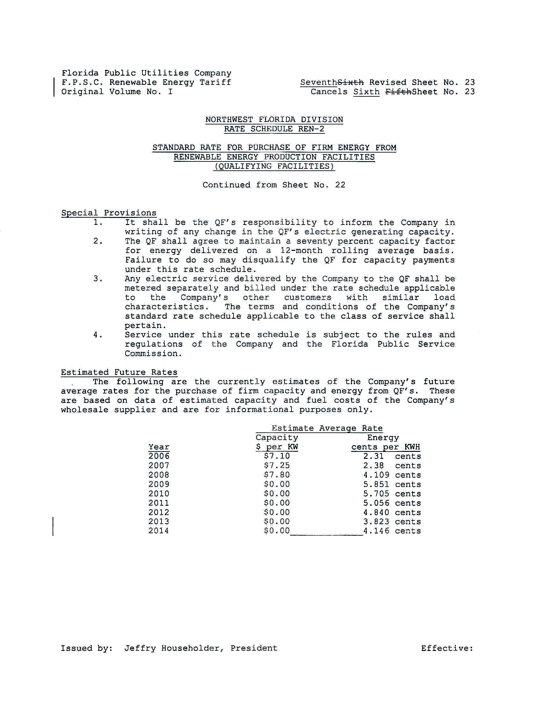
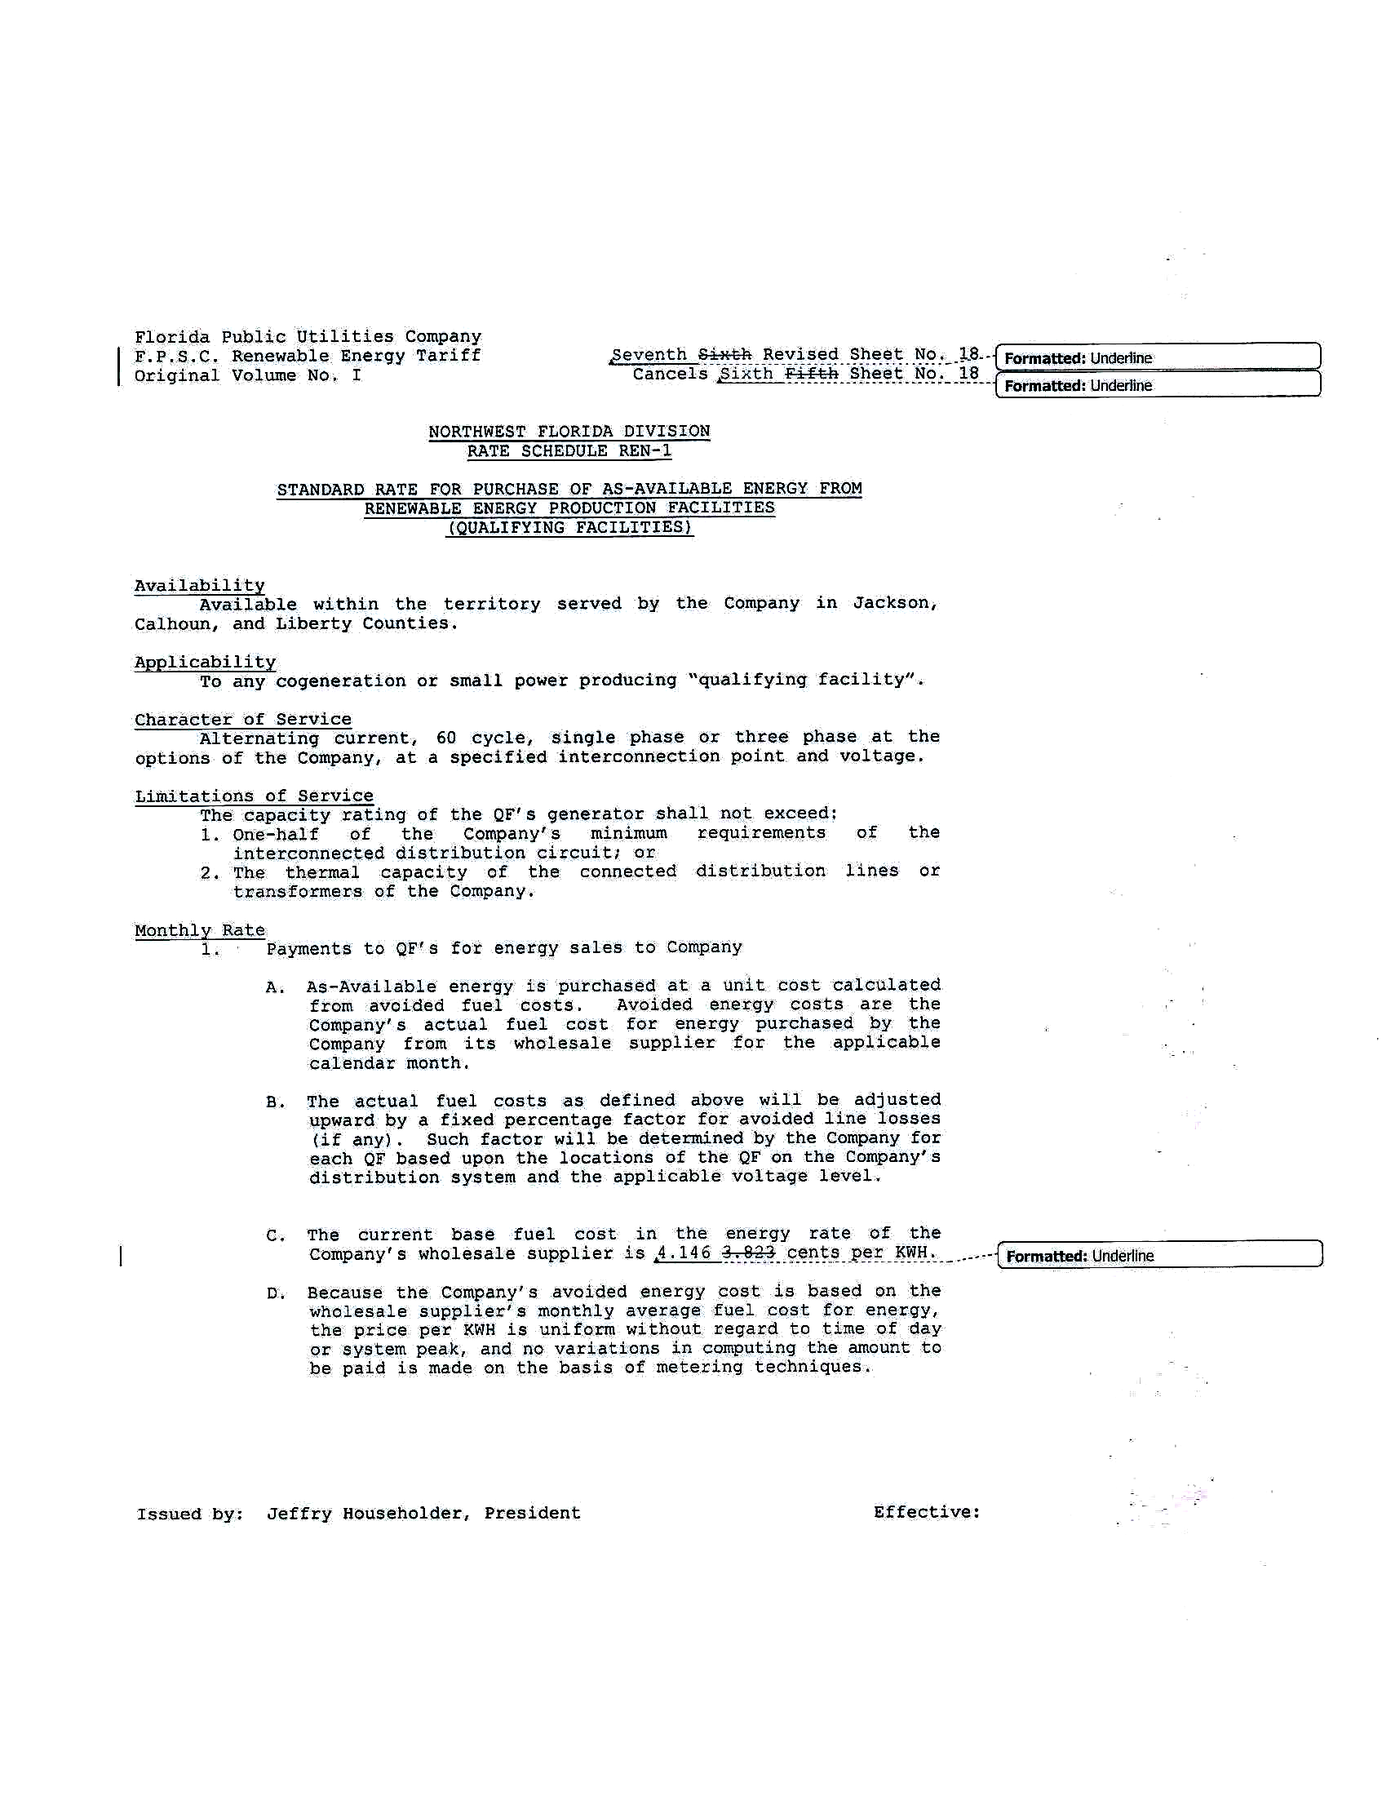
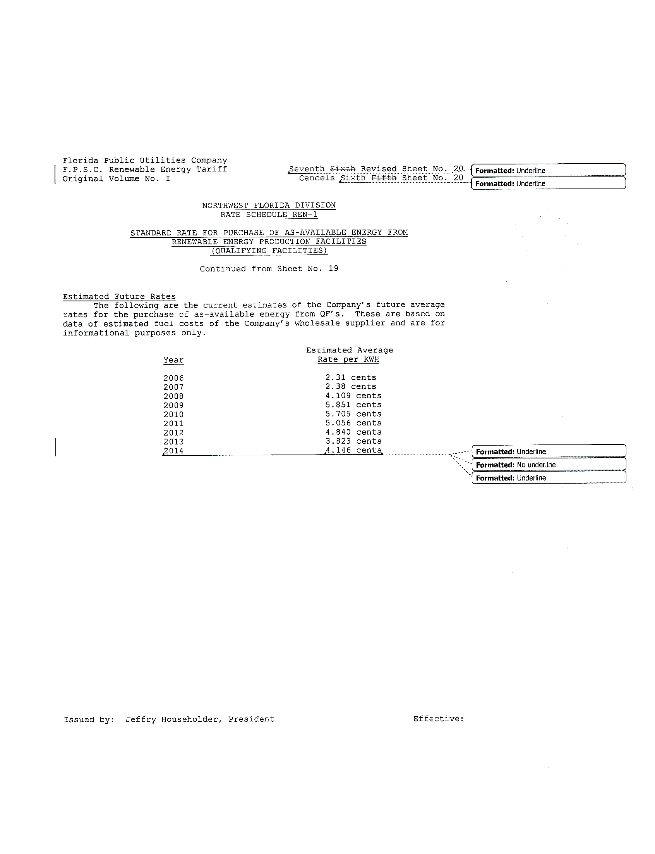
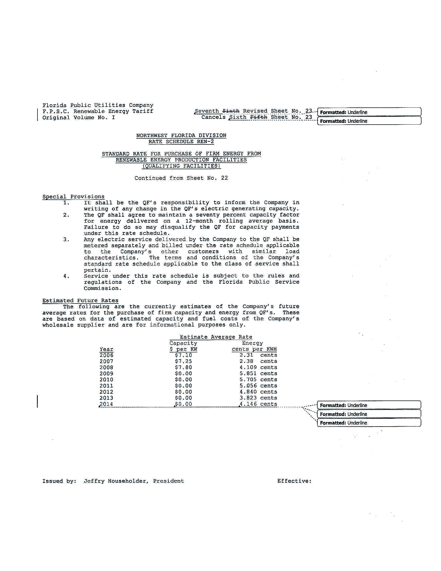
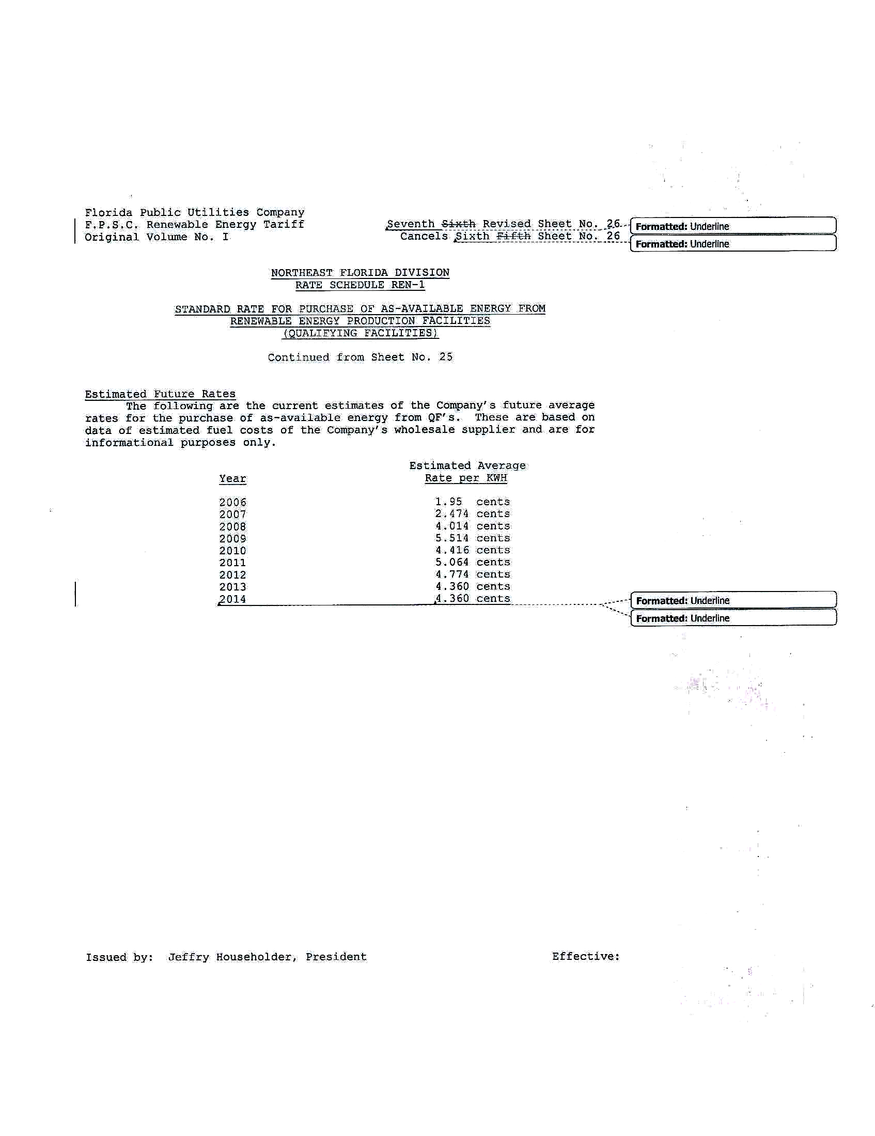
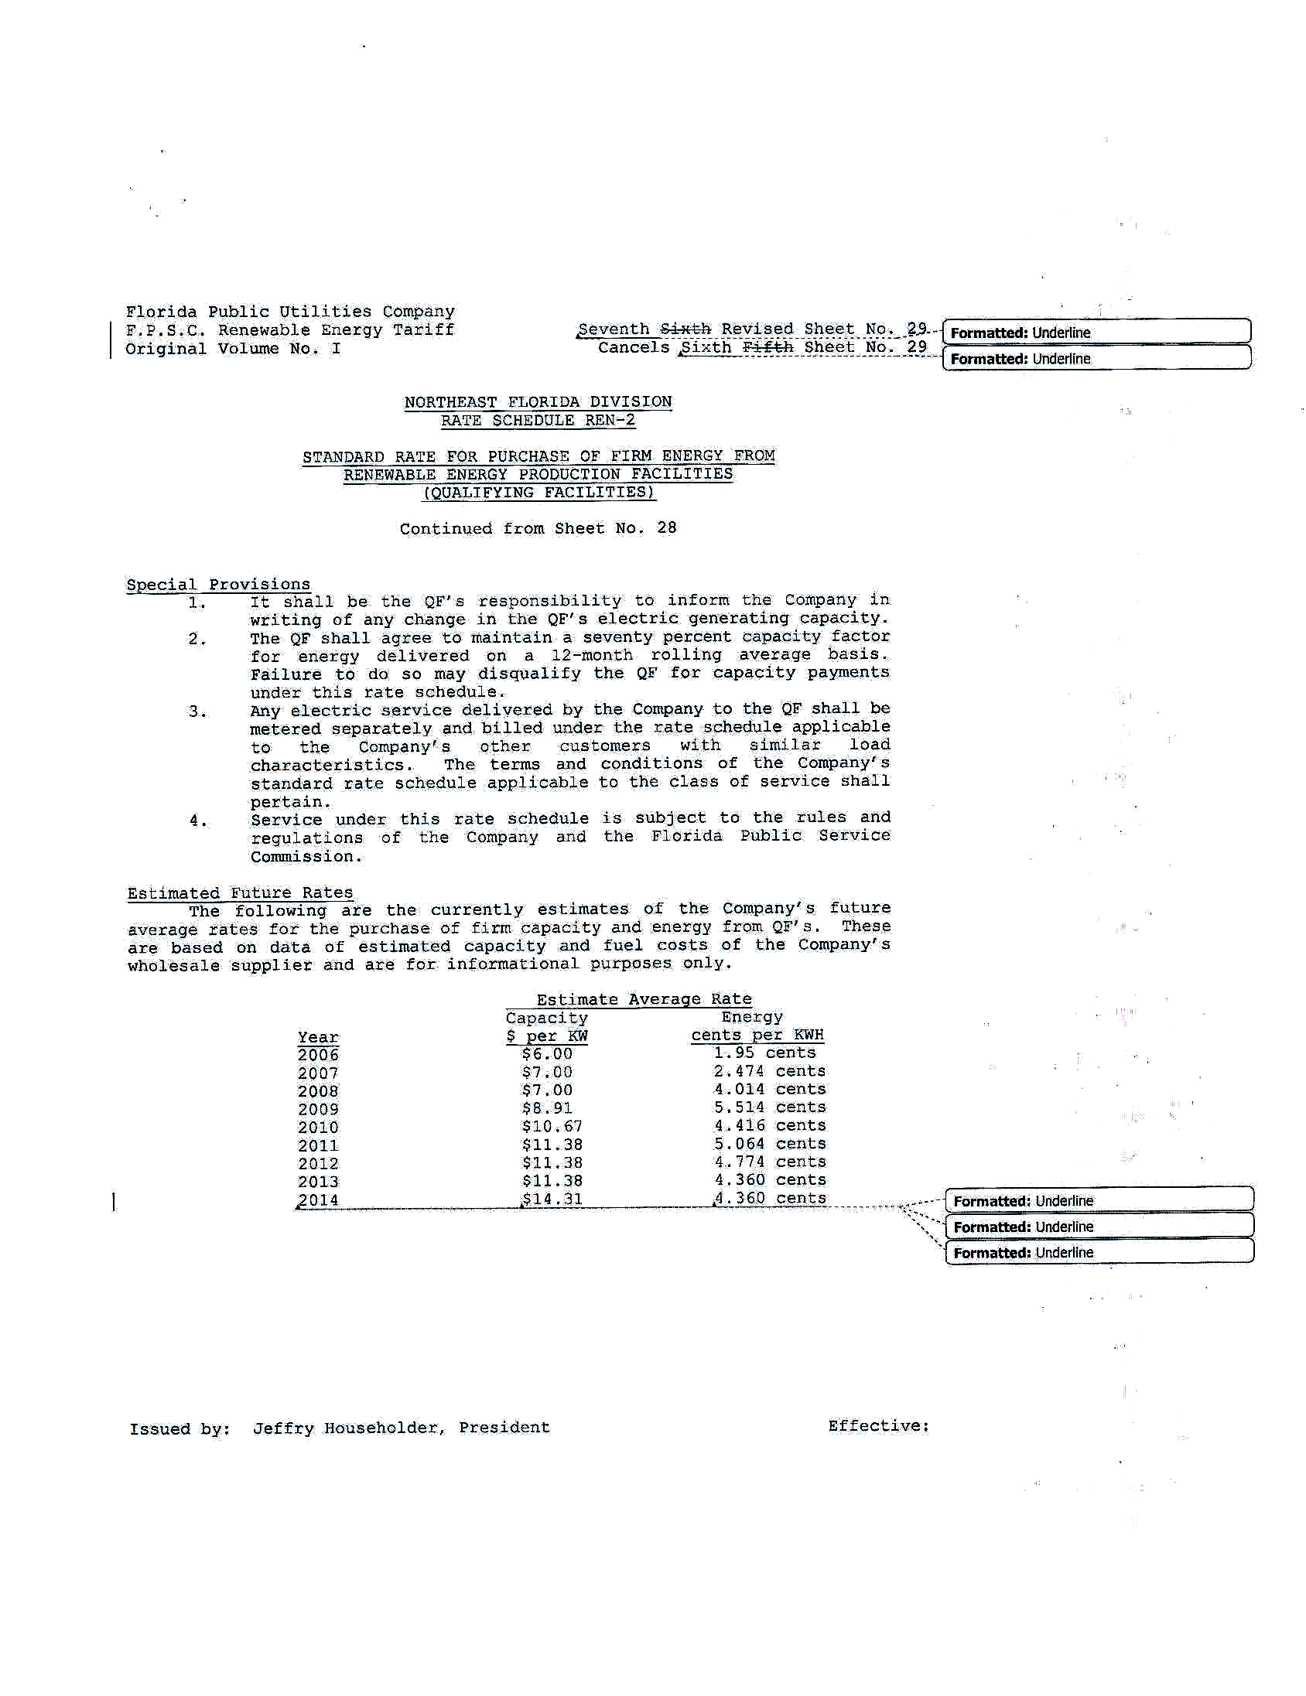

In its letter accompanying its petition, FPUC indicated that the failure to timely file the petition was inadvertent and unintentional, and that the filing was made immediately upon discovering the oversight.
See Order No. PSC-13-0328-PAA-EQ, issued July 17, 2013 in Docket No. 130074-EI – In re: Petition for approval of revisions to standard offer renewable energy tariff REN-1 and REN-2, by Florida Public Utilities Company.

