State of Florida   |  | Public Service Commission  Capital Circle Office Center ● 2540 Shumard Oak Boulevard  Tallahassee, Florida 32399-0850  -M-E-M-O-R-A-N-D-U-M-
DATE: | July 31, 2014
TO: | Office of Commission Clerk (Stauffer)
FROM: | Office of the General Counsel (Cowdery)  Division of Economics (Rome)  Office of Telecommunications (Bates, Casey, Salak)
RE: | Docket No. 140141-TP – Proposed Repeal of Rules 25-4.002, 25-24.505, 25-24.514, 25-24.555, and 25-24.560, F.A.C., and Amendment of Rules 25-4.003, and 25-22.061, F.A.C.
AGENDA: | 08/12/14 – Regular Agenda – Interested Persons May Participate
COMMISSIONERS ASSIGNED: |  |  | All Commissioners
PREHEARING OFFICER: |  |  | Balbis
RULE STATUS: |  |  | Proposal may be deferred
SPECIAL INSTRUCTIONS: |  |  | None

Case Background
The Commission repealed and amended a significant number of telecommunications industry rules in Chapters 25-4 and 25-24, Florida Administrative Code (F.A.C.), following enactment of changes to Chapter 364, Florida Statutes (F.S.), made by the 2011 Legislature. As a result of these statutory and rule changes, staff believes that Rules 25-4.002, Application and Scope, 25-24.505, Scope, 25-24.514, Cancellation of a Certificate, 25-24.555, Scope and Waiver, and 25-24.560, Terms and Definitions, F.A.C., are obsolete and should be repealed. In addition, staff believes that Rule 25-4.003, Definitions, F.A.C., should be amended to delete obsolete language and to update the rule, and Rule 25-22.061, Stay Pending Judicial Review, F.A.C., should be amended to delete obsolete language.
Notices of rule development appeared in the May 13, 2014, edition of the Florida Administrative Register. There was no request for a workshop and no workshop was held.
This recommendation addresses whether the Commission should repeal Rules 25-4.002, 25-24.505, 25-24.514, 25-24.555, and 25-24.560, F.A.C., and amend Rules 25-4.003 and 25-22.061, F.A.C. The Commission has jurisdiction pursuant to Section 120.54, F.S.

Discussion of Issues
Issue 1:1
Should the Commission propose the repeal of Rules 25-4.002, Application and Scope; 25-24.505, Scope; 25-24.514, Cancellation of a Certificate; 25-24.555, Scope and Waiver; and 25-24.560, Terms and Definitions, and the amendment of Rules 25-4.003, Definitions, and 25-22.061, Stay Pending Judicial Review?

Recommendation:
Yes, the Commission should propose the repeal of Rules 25-4.002, 25-24.505, 25-24.514, 25-24.555, and 25-24.560, F.A.C., and the amendment of Rules 25-4.003 and 25-22.061, F.A.C., as set forth in Attachment A. (Cowdery, Salak, Bates, Casey, Rome)

Staff Analysis:
In 2011, the Legislature enacted changes to Chapter 364, F.S., which resulted in the Commission repealing and amending a significant number of rules in Chapters 25-4, Telephone Companies, and 25-24, Telecommunications, F.A.C. As a result of these statutory and rule changes, staff is recommending the repeal of Rules 25-4.002, 25-24.505, 25-24.514, 25-24.555, and 25-24.560, F.A.C., and the amendment of Rules 25-4.003 and 25-22.061, F.A.C.
Rule 25-4.002, F.A.C., addresses the application and scope of the rules in Parts I-XI of Chapter 25-4 and Parts X-XV of Chapter 25-24, F.A.C. The language concerning the scope of individual parts of Chapter 25-4 is now obsolete because the Commission does not regulate shared tenant service companies, operator service provider companies and call aggregators, and Alternative Access Vendor Service Providers. Further, Chapters 25-4 and 25-24, F.A.C., are no longer divided into Parts. The individual rules contained in Chapters 25-4 and 25-24, F.A.C., by their terms, identify the providers being addressed, and, as a result, there is no need to have a separate rule defining the scope of Chapter 25-4, F.A.C. Because Rule 25-4.002, F.A.C., contains obsolete language and is not necessary to implement any sections of Chapter 364, F.S., staff recommends that it be repealed.
Rule 25-4.003, F.A.C., defines terms addressed by Chapter 25-4, F.A.C. Staff recommends deleting all terms which are unnecessary or no longer addressed in Chapter 25-4, F.A.C., because rules addressing those terms having been repealed or amended in prior dockets. Staff recommends that a definition of “Certificate of Authority,” “Certificate of Necessity,” and “Number Portability” be added for clarity and consistency with statutory changes. Staff also recommends that the definition of “Exchange” be rewritten for accuracy and clarity.
Rule 25-22.061, F.A.C., addresses Commission procedures to be followed concerning stays of Commission orders pending judicial review in state court. Subsection 25-22.061(3) provides that when the Commission grants a stay conditioned upon posting of an appropriate form of surety, interest to be paid by the company shall be set for telecommunication companies pursuant to subsection 25-4.114(4), F.A.C. Reference to Rule 25-4.114 is obsolete because that rule has been repealed. For this reason, staff recommends that the rule language “subsection 25-4.114(4), F.A.C., for telecommunication companies” be deleted from Rule 25-22.061, F.A.C., as obsolete.
Rule 25-24.505, F.A.C., addresses the scope of the rules concerning pay telephone service companies. Rule 25-24.505, F.A.C., references Rules 25-4.019 and 25-4.043, F.A.C. This language is obsolete because the Commission has repealed Rules 25-4.019 and 25-4.043, F.A.C. In addition, the language of the rules in Chapters 25-4 and 25-24, F.A.C., makes clear what type provider is addressed by each rule, and, for this reason, there is no need to have a separate rule defining the scope of Chapter 25-24, F.A.C. For these reasons, staff recommends that this rule be repealed as obsolete and unnecessary to implementation of Chapter 364, F.S.
Subsection (1) of Rule 25-24.514, Cancellation of a Certificate, lists the bases for cancellation of a certificate. Paragraphs (a) – (c) of subsection (1) restate reasons for certificate revocation stated in Section 364.285, F.S. Paragraph (d) states that the Commission may cancel a certificate for the company’s failure to provide service for six months. This reason for certificate cancellation is not required by statute, has not been applied for many years, and is not necessarily an appropriate reason for revocating a certificate. For these reasons, staff recommends that subsection (1) of Rule 25-24.514 be deleted.
Subsection (2) of Rule 25-24.514 requires a company to request certificate cancellation in writing and provide a statement of intent and date to pay regulatory assessment fees, and subsection (3) states that certificate cancellation shall be ordered subject to the company providing the information required by subsection (2). Staff believes that these subsections are not necessary to implement Chapter 364, F.S. Section 364.335(3), F.S., states that a company may terminate a certificate by submitting notice to the Commission. Section 364.336, F.S., and Rule 25-4.061, F.A.C., require all telecommunications companies to pay regulatory assessment fees. Staff does not believe that a “statement of intent” concerning intent and date to pay regulatory assessment fees is necessary to implement Section 364.335, F.S. For the reasons explained above, staff recommends that Rule 25-24.514, F.A.C., be repealed as obsolete, redundant of statutory language, and unnecessary to implement Chapter 364, F.S.
Rule 25-24.555, Scope and Waiver, applies to shared tenant service, and Rule 25-24.560, Terms and Definitions, applies to alternative access vendors. Because the Commission no longer regulates shared tenant services or alternative access vendors, staff recommends that these rules be repealed as obsolete and unnecessary to implement Chapter 364, F.S.

Statement of Estimated Regulatory Costs
Pursuant to Section 120.54, F.S., agencies are encouraged to prepare a statement of estimated regulatory costs (SERC) before the adoption, amendment, or repeal of any rule. The SERC is appended as Attachment B. The SERC analysis includes whether the rule repeals and amendment are likely to have an adverse impact on growth, private sector job creation or employment, or private sector investment in excess of $1 million in the aggregate within 5 years after implementation.
The SERC concludes that the rule repeals and amendment are not likely to directly or indirectly increase regulatory costs in excess of $200,000 in the aggregate in Florida within 1 year after implementation. Further, the SERC concludes that the rule repeals and amendments will not likely have an adverse impact on business competitiveness, productivity, or innovation in excess of $1 million in the aggregate within 5 years of implementation. Thus, the rule repeals and amendment do not require legislative ratification, pursuant to Section 120.541(3), Florida Statutes. In addition, the SERC states that the rule repeals and amendments would not have an adverse impact on small businesses, and would have no impact on small cities or small counties. The SERC addresses additional statutory requirements.
Staff recommends that the Commission should propose the repeal of Rules 25-4.002, 25-24.505, 25-24.514, 25-24.555, and 25-24.560, F.A.C., and the amendment of Rules 25-4.003 and 25-22.061, F.A.C., as set forth in Attachment A.
Issue 2:2
Should this docket be closed?

Recommendation:
Yes. If no requests for hearing or comments are filed, the rules should be filed with the Department of State, and the docket should be closed. (Cowdery)

Staff Analysis:
If no requests for hearing or comments are filed, the rules should be filed with the Department of State, and the docket should be closed.

25-4.002 Application and Scope.
(1) These rules are intended to define reasonable service standards that will promote the furnishing of adequate and satisfactory local and long distance service to the public, and to establish the rights and responsibilities of both the company and the customer. The rules contained in Parts I-XI of this chapter apply to local exchange companies. The rules contained in Part X of Chapter 25-24, F.A.C., apply to any Interexchange Company. The rules in Part XI of Chapter 25-24, F.A.C., apply to any pay telephone service. The rules in Part XII of Chapter 25-24, F.A.C., apply to all Shared Tenant Service Companies. The rules in Part XIII of Chapter 25-24, F.A.C., apply to all Operator Service Provider Companies and call aggregators. The rules contained in Part XIV of Chapter 25-24, F.A.C., apply to all Alternative Access Vendor Service Providers. The rules contained in Part XV of Chapter 25-24, F.A.C., apply to all competitive local exchange telecommunications companies.
(2) In addition to the rules contained in this part, any local exchange company that provides operator services in a call aggregator context shall also comply with the rules contained in Part XIII of Chapter 25-24, F.A.C.
Rulemaking Authority 350.127(2) FS. Law Implemented 364.01, 364.335, 364.337, 364.3375, 364.3376 FS. History–Revised 12-1-68, Formerly 25-4.02, Amended 2-23-87, 1-8-95, 2-1-99, 4-3-05, 3-26-09, Repealed _________.

25-4.003 Definitions.
For the purpose of Chapter 25-4, F.A.C., the definitions of the following terms apply:
(1) “Access Line” or “Subscriber Line” or “Subscriber Loop”. The circuit or channel between the demarcation point at the customer’s premises and the serving end or class 5 central office.
(2) “Average Busy Season-Busy Hour Traffic.” The average traffic volume for the busy season busy hours.
(3) “Billing Party.” Any entity that bills an end user on its own behalf or on behalf of an originating party.
(4) “Busy Hour.” The continuous one-hour period of the day during which the greatest volume of traffic is handled in the office.
(5) “Busy Season.” The calendar month or period of the year (preferably 30 days but not to exceed 60 days) during which the greatest volume of traffic is handled in the office.
(2) (6) “Call.” An attempted telephone message.
(3) (7) “Central Office.” A location where there is an assembly of equipment that establishes the connections between subscriber access lines, trunks, switched access circuits, private line facilities, and special access facilities with the rest of the telephone network.
(4) “Certificate of Authority.” Certificates received by all companies providing telecommunications services after July 1, 2011.
(5) “Certificate of Necessity.” Certificate received by all incumbent local exchange companies, shared tenant service providers, alternative access vendors, competitive local exchange companies, and pay telephone service providers to provide telecommunication services prior to July 1, 2011.
(8) “Commission.” The Florida Public Service Commission.
(6) (9) “Company,” “Telecommunications Company,” or “Telephone Company. ,” or “Utility.” These terms may be used interchangeably herein and shall mean “telecommunications company” as defined in Section 364.02(14), F.S.
(10) Competitive Local Exchange Telecommunications Company (CLEC).” Any company certificated by the commission to provide local exchange telecommunications services in Florida on or after July 1, 1995.
(11) “Completed call.” A call which has been switched through an established path so that two-way conversation or data transmission is possible.
(12) “Disconnect” or “Disconnection.” The dissociation or release of a circuit. In the case of a billable call, the end of the billable time for the call whether intentionally terminated or terminated due to a service interruption.
(13) “Drop or Service Wire.” The connecting link that extends from the local distribution service terminal to the protector or telephone network interface device on the customer’s premises.
(7) (14) “Exchange.” The entire telephone plant and facilities used in providing telephone service to subscribers located in an exchange area. An exchange may include more than one central office unit. A central office or group of central offices with the subscriber’s stations and lines connected, forming a local system which furnishes means of telephonic intercommunication without toll charges between subscribers within a specified area.
(15) “Exchange (Service) Area.” The territory of a local exchange company (LEC) within which local telephone service is furnished at the exchange rates applicable within that area.
(16) “Extended Area Service.” A type of telephone service whereby subscribers of a given exchange or area may complete calls to, and receive messages from, one or more other exchanges or areas without toll charges, or complete calls to one or more other exchanges or areas without toll message charges.
(17) “Foreign Exchange Service.” A classification of LEC exchange service furnished under tariff provisions whereby a subscriber may be provided telephone service from an exchange other than the one from which he would normally be served.
(18) “Information Service.” Telephone calls made to 900 or 976 type services, but does not include Internet services.
(19) “Intercept Service.” A service arrangement provided by the telecommunications company whereby calls placed to an unequipped non-working, disconnected, or discontinued telephone number are intercepted by operator, recorder, or audio response computer and the calling party informed that the called telephone number is not in service, has been disconnected, discontinued, or changed to another number, or that calls are received by another telephone. This service is also provided in certain central offices and switching centers to inform the calling party of conditions such as system blockages, inability of the system to complete a call as dialed, no such office code, and all circuits busy.
(20) “Inter-office Call.” A telephone call originating in one central office but terminating in another central office, both of which are in the same designated exchange area.
(21) “Interstate Toll Message.” Those toll messages that do not originate and terminate within the same state.
(22) “Intertoll Trunk.” A line or circuit between two toll offices, two end offices, or between an end office and toll office, over which toll calls are passed.
(23) “Intra-office Call.” A telephone call originating and terminating within the same central office.
(24) Intrastate Interexchange Company (IXC).” Any entity that provides intrastate interexchange telecommunications services.
(25) “Intrastate Toll Message.” Those toll messages which originate and terminate within the same state.
(26) “Invalid Number.” A number comprised of an unassigned area code number or a non-working central office code (NXX).
(27) “Large LEC.” A LEC certificated by the Commission prior to July 1, 1995, that had in excess of 100,000 access lines in service on July 1, 1995.
(28) “Local Access and Transport Area (LATA)” or “Market Area.” A geographical area, which is loosely based on standard metropolitan statistical areas (SMSAs), within which a LEC may transport telecommunication signals.
(29) “Local Exchange Telecommunications Company (LEC).” Any telecommunications company, certificated by the Commission prior to July 1, 1995, to provide local exchange telecommunications service.
(8)(30) “Local Provider (LP).” Any telecommunications company providing local telecommunications service, excluding pay telephone providers and call aggregators.
(9)(31) “Local Service Area”. or “Local Calling Area.” The area within which telecommunications telephone service is furnished subscribers under a specific schedule of rates and without toll charges. A LEC’s local service area may include one or more exchange areas or portions of exchange areas.
(32) “Local Toll Provider (LTP).” Any entity providing intraLATA or intramarket area long distance telecommunications service.
(33) “Main Station.” The principal telephone associated with each service to which a telephone number is assigned and which is connected to the central office equipment by a circuit or channel.
(10)(34) “Message.” A completed telephone call.
(11) “Number Portability.” Consumer’s ability to change providers and still keep the same phone number.
(35) “Mileage Charge.” A tariff charge for circuits and channels connecting other services that are auxiliary to local exchange service such as off premises extensions, foreign exchange and foreign central office services, private line services, and tie lines.
(36) New Construction.” New construction is the installation of facilities to serve unserved areas; new construction is not the rearrangement or repair of defective facilities to serve an existing area. Adding to or the rearrangement of existing facilities is not considered “new construction” unless an engineer work order is issued.
(37) “Normal Working Days.” The normal working days for installation and construction shall be all days except Saturdays, Sundays, and holidays. The normal working days for repair service shall be all days except Sundays and holidays. Holidays shall be the days which are observed by each individual telephone company.
(38) “Optional Calling Plan.” An optional service furnished under tariff provisions which recognizes the need of some subscribers for extended area calling without imposing the cost on the entire body of subscribers.
(39) “Originating Party.” Any person, firm, corporation, or other entity, including a telecommunications company or a billing clearinghouse, that provides any telecommunications service or information service to a customer or bills a customer through a billing party, except the term “originating party” does not include any entity specifically exempted from the definition of “telecommunications company” as provided in Section 364.02(14)(a) through (f), F.S.
(40) “Out of Service.” The inability, as reported by the customer, to complete either incoming or outgoing calls over the subscriber’s line. “Out of Service” shall not include:
(a) Service difficulties such as slow dial tone, circuits busy, or other network or switching capacity shortages;
(b) Interruptions caused by a negligent or willful act of the subscriber; and
(c) Situations in which a company suspends or terminates service because of nonpayment of bills, unlawful or improper use of facilities or service, or any other reason set forth in approved tariffs or Commission rules.
(41) “Outside Plant.” The telephone equipment and facilities installed on, along, or under streets, alleys, highways, or on private rights-of-way between the central office and subscribers’ locations or between central offices of the same or different exchanges.
(12)(42) “Pay Telephone Service Provider Company.” Any telecommunications company that provides pay telephone service as defined in Section 364.3375, F.S.
(13)(43) “PC-Freeze.” (Preferred Carrier Freeze) A service offered that restricts the customer’s carrier selection until further notice from the customer.
(44) “Price regulated local exchange telecommunications company.” Any local exchange telecommunications company certificated by the Commission prior to July 1, 1995 that has elected to become subject to price regulation pursuant to Section 364.051, F.S.
(14)(45) “Provider.” Any entity providing telecommunication service, excluding pay telephone providers and call aggregators (i.e., local, local toll, and toll providers).
(46) “Rate-of-return regulated local exchange telecommunications company.” Any local exchange telecommunications company certificated by the Commission prior to July 1, 1995 that has not elected to become subject to price regulation pursuant to Section 364.051, F.S.
(47) “Service Objective.” A quality of service which is desirable to be achieved under normal conditions.
(48) “Service Standard.” A level of service that a telecommunications company, under normal conditions, is expected to meet in its certificated territory as representative of adequate services.
(49) “Small LEC.” A LEC certificated by the Commission prior to July 1, 1995, which had fewer than 100,000 access lines in service on July 1, 1995.
(15)(50) “Station.” A telephone instrument consisting of a transmitter, receiver, and associated apparatus so connected as to permit sending or receiving telephone messages.
(16)(51) “Subscriber” or “Customer.” These terms may be used interchangeably herein and shall mean any person, firm, partnership, corporation, municipality, cooperative organization, or governmental agency supplied with telecommunications communication service by a telecommunications company.
(52) “Subscriber Line.” or “Subscriber Loop.” See “Access Line.”
(53) “Switching Center.” Location at which telephone traffic, either local or toll, is switched or connected from one circuit or line to another. A local switching center may be comprised of several central office units.
(54) “Toll Connecting Trunk.” A trunk that connects a local central office with its toll operating office.
(55) “Toll Message.” A completed telephone call between stations in different exchanges for which message toll charges are applicable.
(56) “Toll Provider (TP).” Any entity providing interLATA long distance telecommunications service.
(57) “Traffic Study.” The process of recording usage measurements which can be translated into required quantities of equipment.
(58) “Trouble Report.” Any oral or written report from a subscriber or user of telephone service to the telephone company indicating improper function or defective conditions with respect to the operation of telephone facilities over which the telephone company has control.
(59) “Trunk.” A communication channel between central office units or entities, or private branch exchanges.
(60) “Valid Number.” A number for a specific telephone terminal in an assigned area code and working central office which is equipped to ring and connect a calling party to such terminal number.
Rulemaking Authority 350.127(2) FS. Law Implemented 364.01, 364.02, 364.16, 364.32, 364.335, 364.337, 364.3375, 364.3376, 364.602, 364.603, 364.604 FS. History–Revised 12-1-68, Amended 3-31-76, Formerly 25-4.03, Amended 2-23-87, 3-4-92, 12-21-93, 3-10-96, 12-28-98, 7-5-00, 4-3-05, Repromulgated 5-8-05, Amended 11-20-08,_____________.

25-22.061 Stay Pending Judicial Review.
(1) When the order being appealed involves the refund of moneys to customers or a decrease in rates charged to customers, the Commission shall, upon motion filed by the utility or company affected, grant a stay pending judicial proceedings. The stay shall be conditioned upon the posting of good and sufficient bond the posting of a corporate undertaking, or such other conditions as the Commission finds appropriate to secure the revenues collected by the utility subject to refund.
(2) Except as provided in subsection (1), a party seeking to stay a final or nonfinal order of the Commission pending judicial review may file a motion with the Commission, which has authority to grant, modify, or deny such relief. A stay pending review granted pursuant to this subsection may be conditioned upon the posting of a good and sufficient bond or corporate undertaking, other conditions relevant to the order being stayed, or both. In determining whether to grant a stay, the Commission may, among other things, consider:
(a) Whether the petitioner has demonstrated a likelihood of success on the merits on appeal;
(b) Whether the petitioner has demonstrated a likelihood of sustaining irreparable harm if the stay is not granted; and
(c) Whether the delay in implementing the order will likely cause substantial harm or be contrary to the public interest if the stay is granted.
(3) When a stay is conditioned upon the posting of a bond, corporate undertaking, or other appropriate form of surety, the Commission shall at the time it grants the stay set the rate of interest to be paid by the utility or company pursuant to subsection 25-4.114(4), F.A.C., for telecommunication companies, subsection 25-6.109(4), F.A.C., for electric public utilities, subsection 25-7.091(4), F.A.C., for gas public utilities, and subsection 25-30.360(4), F.A.C., for water and wastewater utilities in the event that the Court’s decision requires a refund to customers.
(4) Motions filed pursuant to this rule shall be heard by those Commissioners who were on the deciding panel for the order being appealed.
Rulemaking Authority 350.127(2), 366.05(1), 368.05(2) FS. Law Implemented 120.68(3), 350.01(5), 364.01(4), 366.04(1), 366.05(1), 366.06(1), 367.011(2), 367.081(2), 367.0814, 367.121(1)(g), 368.05(2) FS. History–New 2-1-82, Formerly 25-22.61, Amended 6-27-10, ________.

25-24.505 Scope.
This part applies to any person providing pay telephone service. As provided by Rules 25-4.002, 25-9.001 and 25-14.001, F.A.C., no provision of Chapter 25-4, 25-9, or 25-14, F.A.C., shall apply to pay telephone service companies, except the following: Rules 25-4.003 (Definitions), 25-4.0161 (Regulatory Assessment Fees; Telecommunications Companies), 25-4.019 (Records and Reports in General), subsection 25-4.020(2) (Location and Preservation of Records), and 25-4.043, F.A.C. (Response to Commission Staff Inquiries).
Rulemaking Authority 350.127(2) FS. Law Implemented 350.113, 350.115, 350.117, 364.01, 364.016, 364.02, 364.17, 364.18, 364.183, 364.185, 364.32, 364.337, 364.3375 FS. History–New 1-5-87, Amended 11-13-95, 2-1-99, Repealed_________.

25-24.514 Cancellation of a Certificate.
(1) The Commission’s cancellation of a certificate shall be based on one or more of the following reasons:
(a) Violation of the terms and conditions under which the authority was originally granted;
(b) Violation of Commission rules or orders;
(c) Violation of Florida Statutes; or
(d) Failure to provide service for a period of six (6) months.
(2) If a certificated company desires to cancel its certificate, it shall request cancellation from the Commission in writing and shall provide a statement of intent and date to pay Regulatory Assessment Fees with its request.
(3) Cancellation of a certificate shall be ordered subject to the holder providing the information required by subsection (2).
Rulemaking Authority 350.127(2) FS. Law Implemented 350.113, 350.127(1), 364.285 FS. History–New 1-5-87, Amended 2-7-13, Repealed___________.

25-24.555 Scope and Waiver.
(1) This part applies to persons or companies who provide for sharing or resale of local telecommunications service as defined in subsection 25-24.560(10), F.A.C.
(2) To the extent these rules are inconsistent with provisions of Chapter 364, Florida Statutes, regarding shared tenant service, companies subject to this Part are exempted from such provisions or are subject to different requirements than otherwise prescribed for telecommunications companies under the authority of Section 364.339, Florida Statutes.
(3) A shared tenant service company may petition for exemption from applicable portions of Chapter 364, Florida Statutes, or for application of different requirements than otherwise prescribed for telecommunications companies by Chapter 364, Florida Statutes, under the authority of Section 364.339, Florida Statutes.
Rulemaking Authority 350.127(2) FS. Law Implemented 364.01, 364.339 FS. History–New 1-28-91, Amended 7-29-97, 1-31-00, Repealed____________.

25-24.560 Terms and Definitions.
For purposes of this Part, the definitions for the following terms apply:
(1) “Alternative Access Vendor” (AAV) means any telecommunications company, as defined in Section 364.337(6)(a), Florida Statutes.
(2) “Agent” means one authorized to act on behalf of another.
(3) “Competitive local exchange telecommunications company” (CLEC) means any company as defined in Section 364.02(1), Florida Statutes.
(4) “Company” means a shared tenant service company.
(5) “Interexchange Company” (IXC) means any telecommunications company, as defined in Section 364.02(6), Florida Statutes, which provides telecommunication service between exchange areas as those areas are described in the approved tariffs of individual local exchange companies.
(6) “Local Exchange Telecommunications Company” (LEC) means any telecommunications company, as defined in Section 364.02(6), Florida Statutes.
(7) “Local Service Area” or “Local Calling Area” means the area within which telecommunications service is furnished to subscribers under a specific schedule of exchange rates and within which calls may be completed without toll charges. A local service area may include one or more exchange areas or portions of exchange areas.
(8) “Pay telephone service company” means any telecommunications company, as defined in Section 364.02(6), Florida Statutes, other than a Local Exchange Company, which provides pay telephone service as defined in Section 364.335(3), Florida Statutes.
(9) “Private Branch Exchange” (PBX) means a system in which trunk lines connect a telephone company central office to a switching system which directs incoming calls to the appropriate user.
(10) “Shared tenant service” (STS) as defined in Section 364.339(1), Florida Statutes, means the provision of service which duplicates or competes with local service provided by an existing local exchange telecommunications company and is furnished through a common switching or billing arrangement to tenants by an entity other than an existing local exchange telecommunications company.
(11) “Tenant” means any person entitled to occupy a premises under a rental or lease agreement.
(12) “Unaffiliated Entities” means those corporations, partnerships, proprietorships, or other groups that control less than 50 percent of the stock of the entity which claims to be affiliated.
Rulemaking Authority 350.127(2) FS. Law Implemented 364.33, 364.335, 364.339 FS. History–New 1-28-91, Amended 7-29-97, Repealed___________.

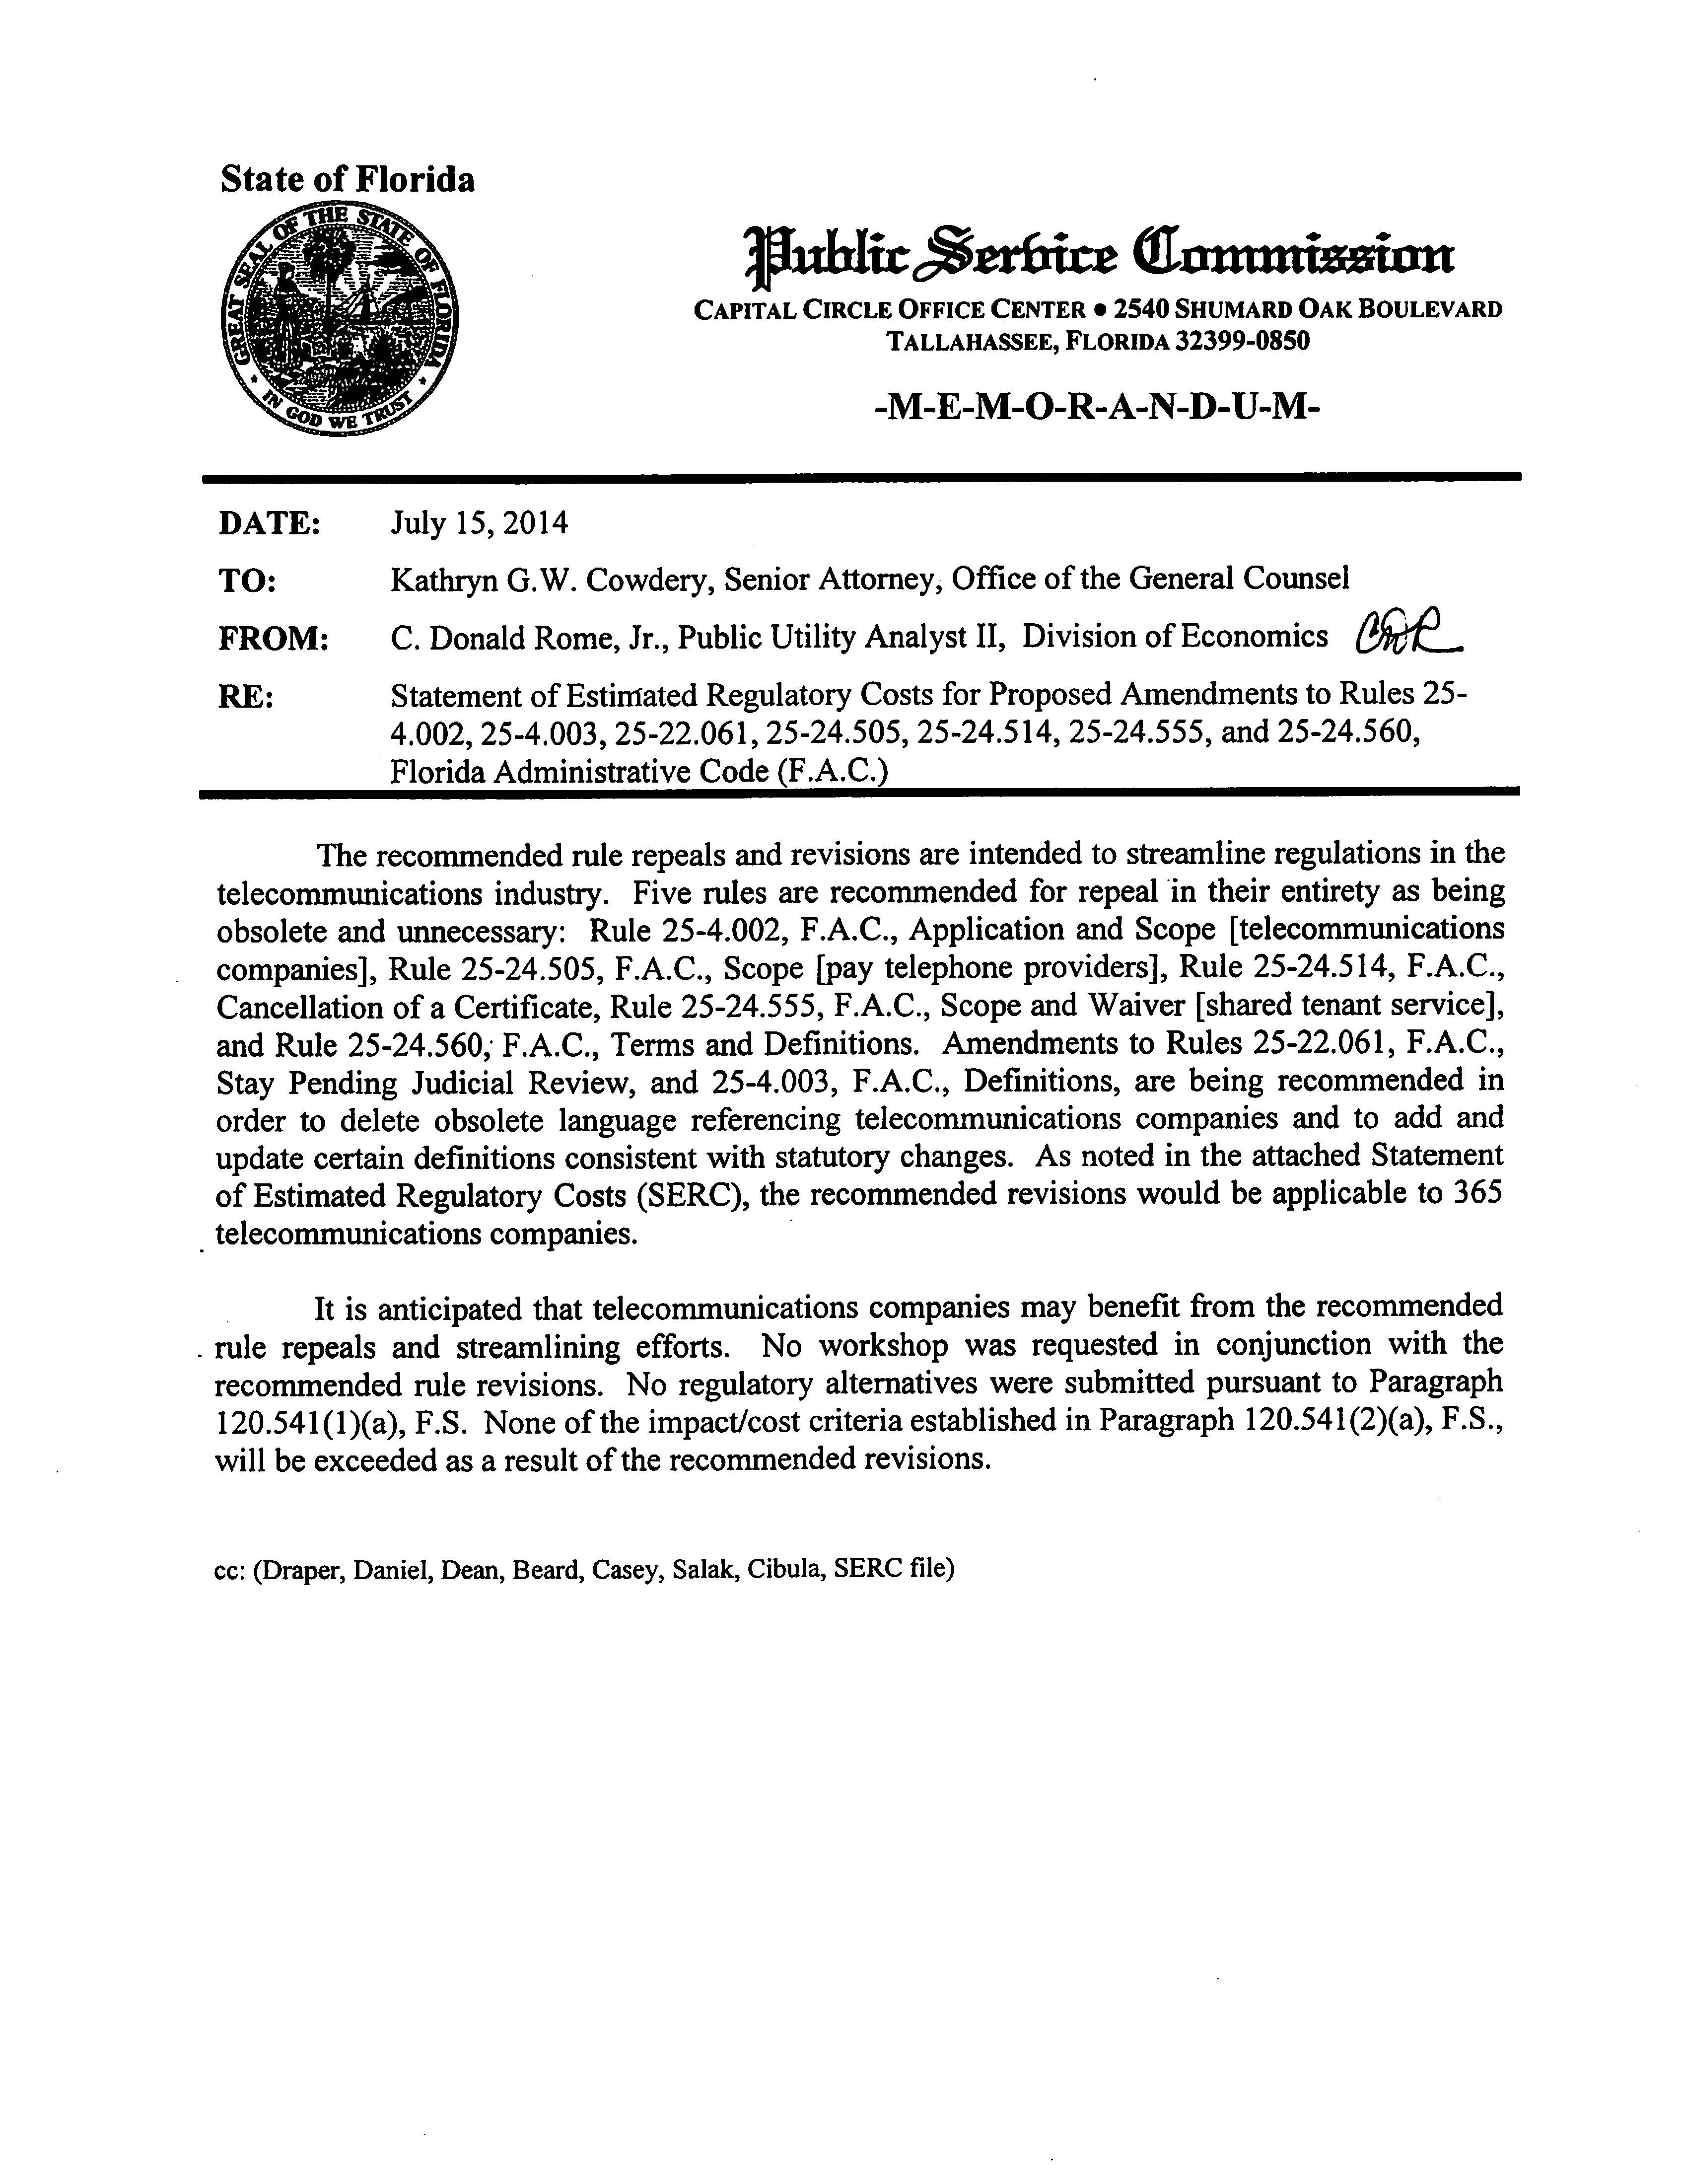
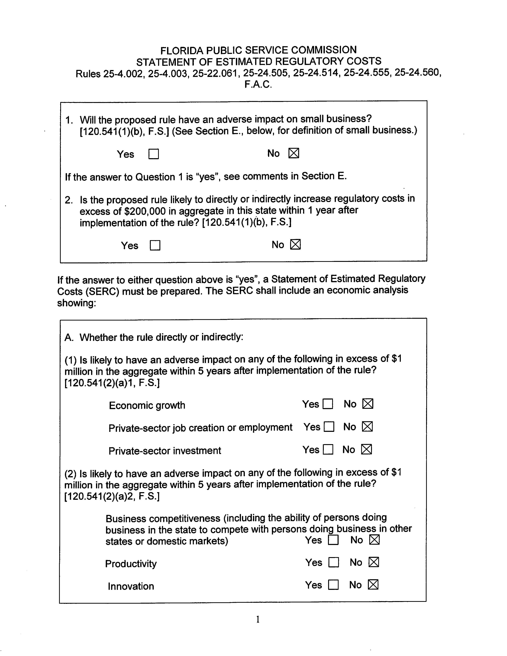
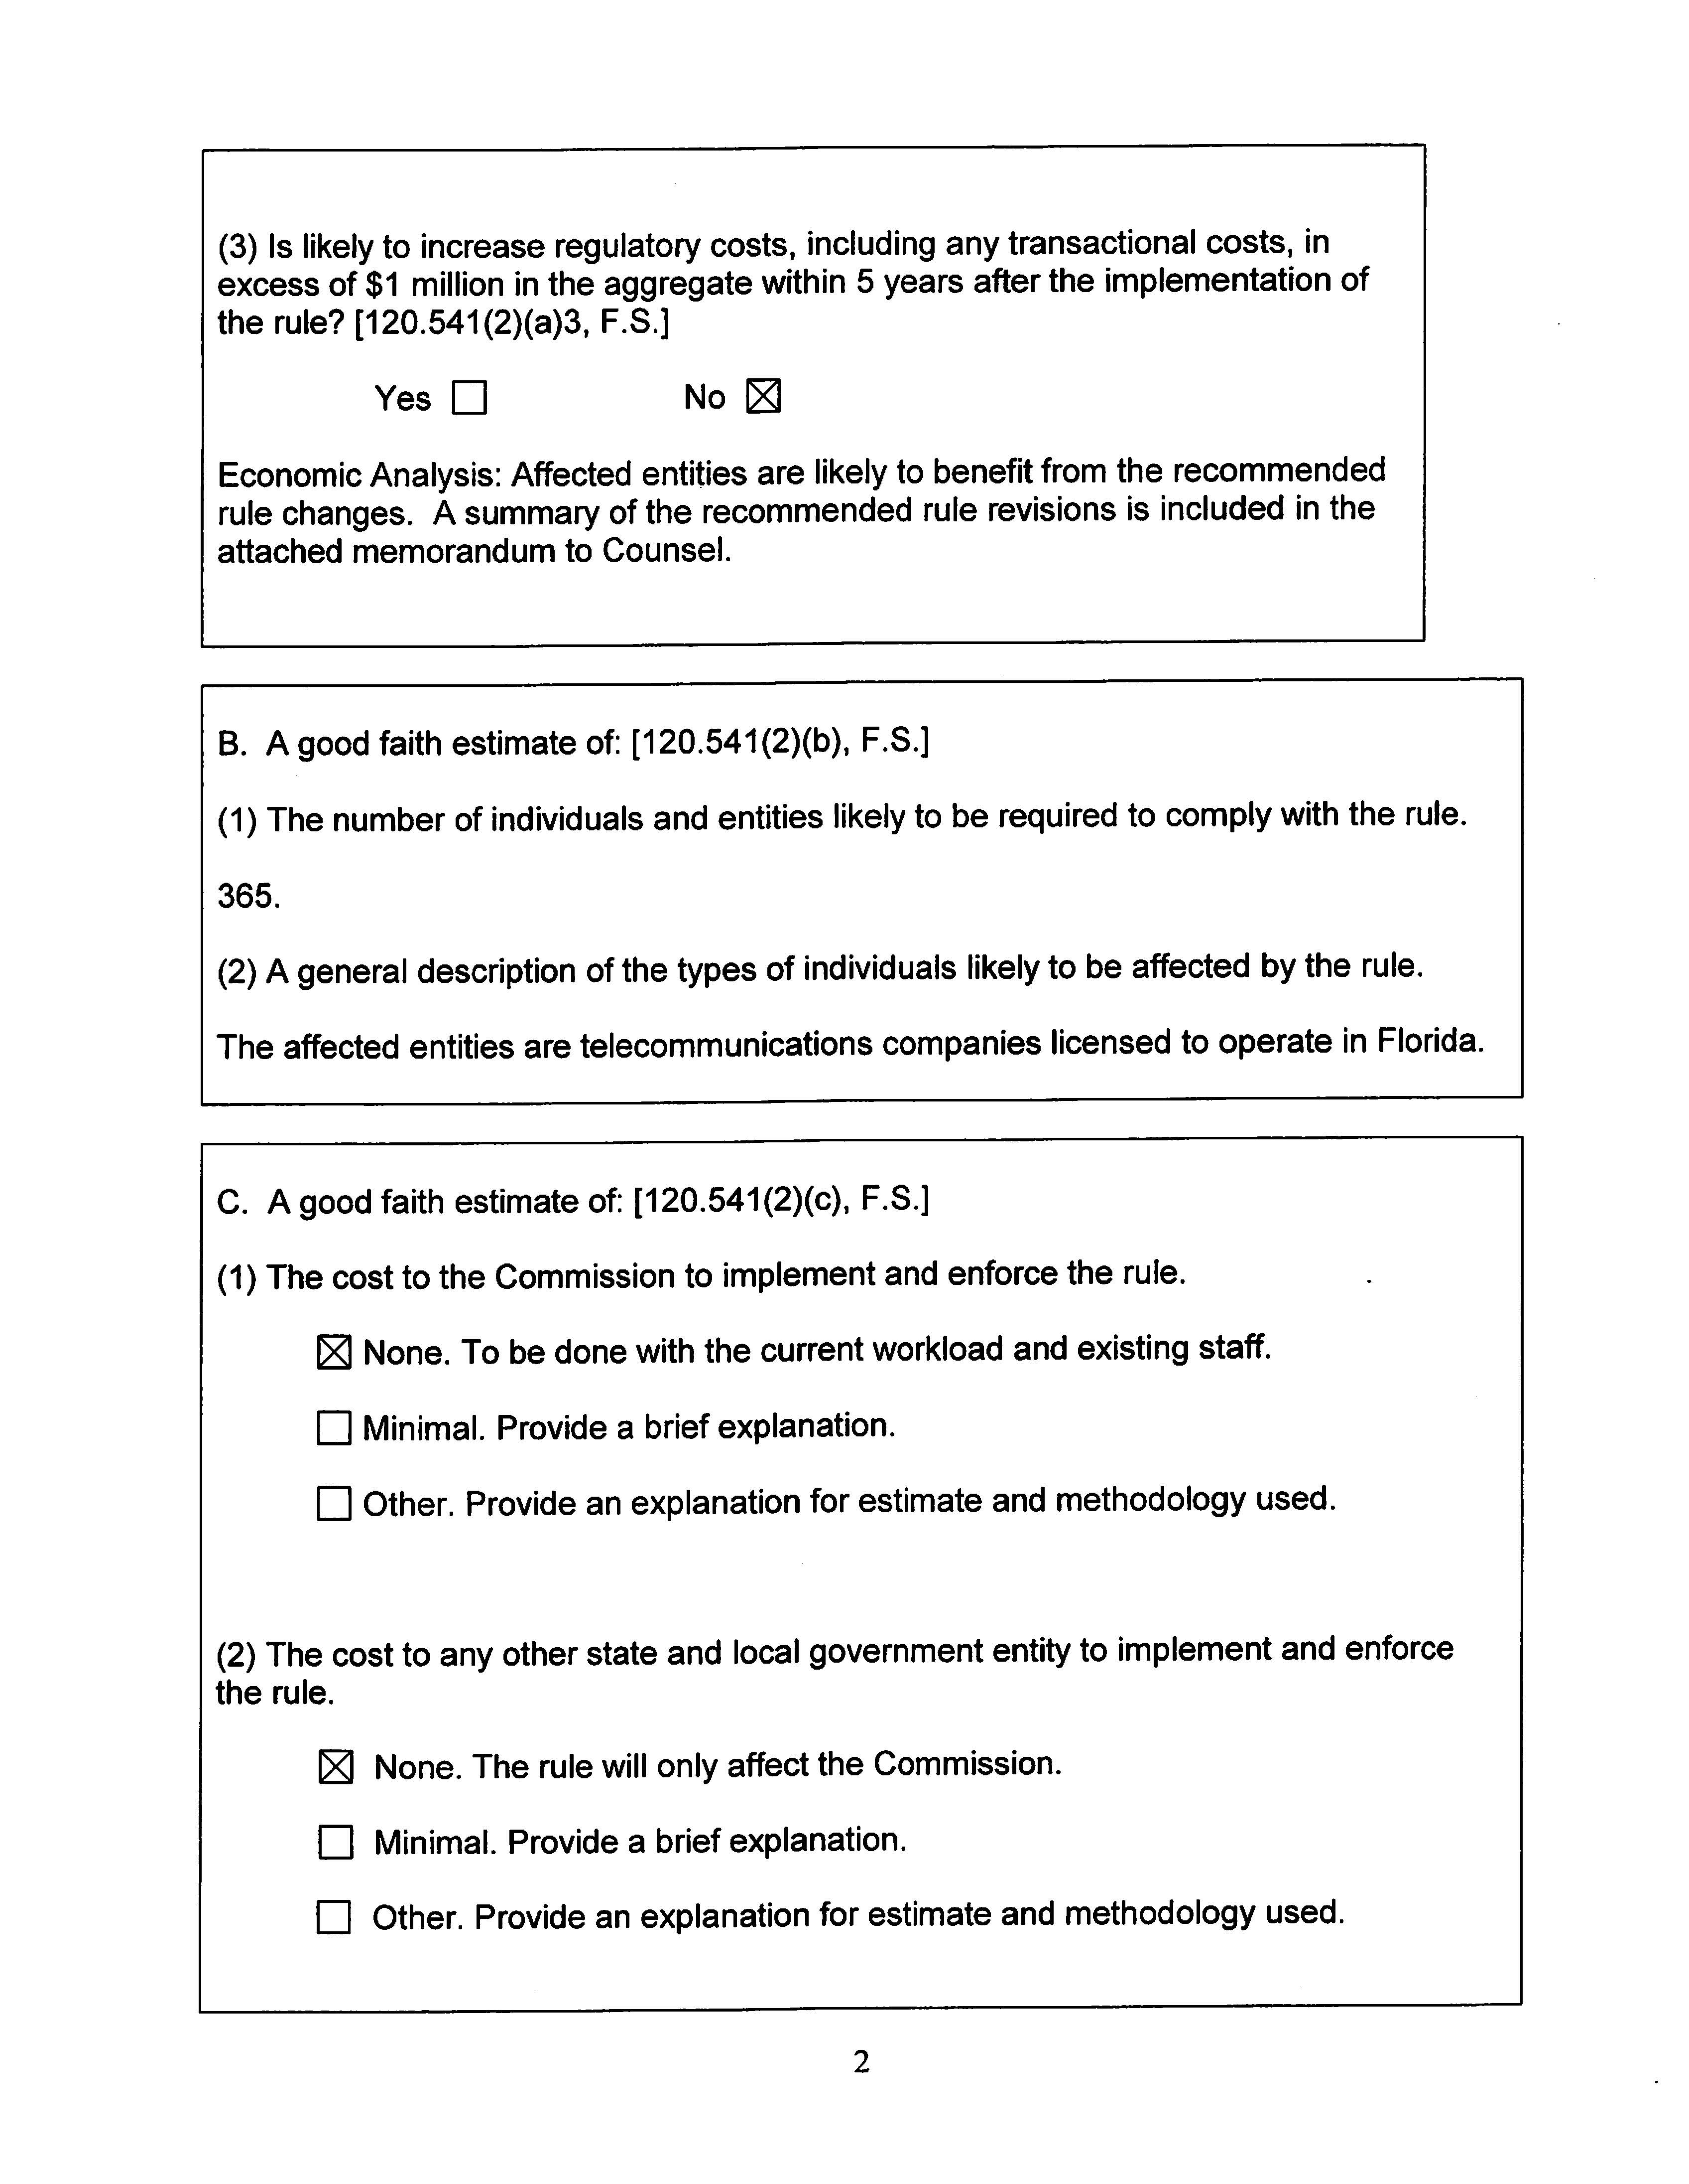
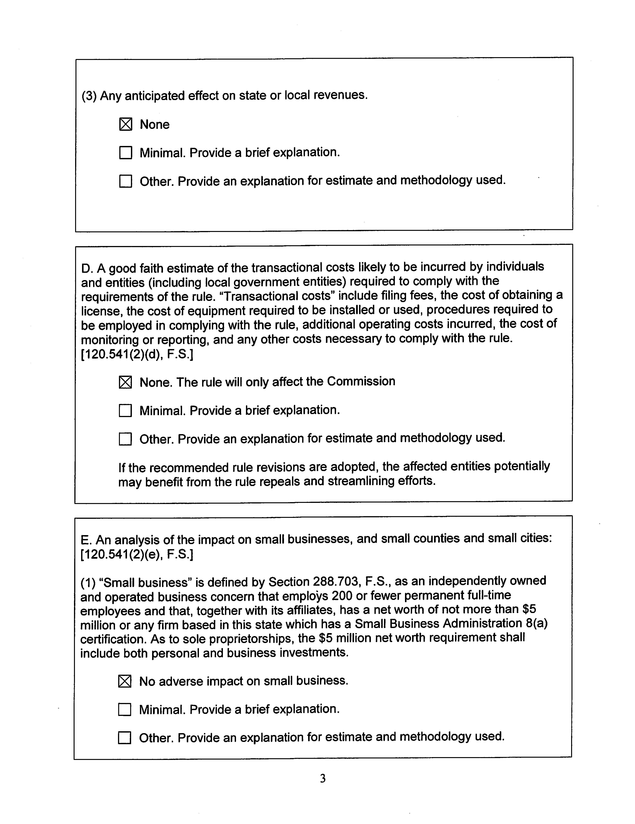
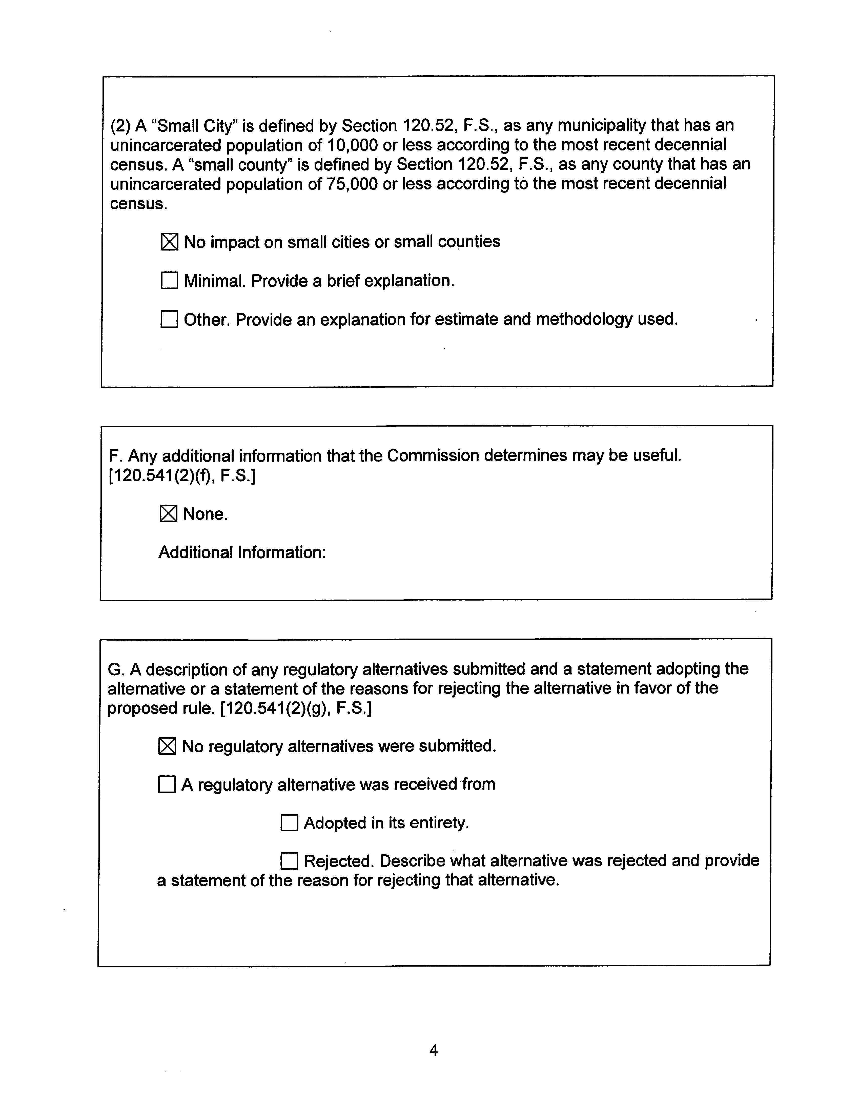

In re: Repeal of rules resulting from changes to Chapter 364, Florida Statutes, Docket No. 110209-TP, Order No. PSC-11-0438-FOF-TP, issued September 29, 2011 (repealing sixty-six rules); In re: Proposed repeal of Rule 25-24.585 and 25-24.835, and proposed adoption of Rule 25-4.0051, Docket No. 120238-TP, Order No. PSC-13-0037-FOF-TP, issued January 22, 2013; In re Initiation of rulemaking to amend Rules 25-4.004 and 25-4.005 and to repeal Rules 25-24.565, 25-24.567, 25-24.568, 25-24.569, 25-24.572, 25-24.705, etc., Docket No. 120241-TP, Order No. PSC-12-0637-FOF-TP, issued November 30, 2012 (repealing eighteen rules and amending two rules); In re: Proposed revisions to pay telephone Rules 25-24.510, 25-24.511, 25-24.512, 25-24.514, and 25-24.515, F.A.C., Docket No. 120262-TC, Order No. PSC-13-0040-FOF-TC, issued January 22, 2013; In re: Proposed amendment of Rule 25-4.034, 25-4.0341, and proposed repeal of Rule 25-24.825, F.A.C., Docket No. 120265-TP, Order No. PSC-13-0034-FOF-TP, issued January 18, 2013; and In re: Proposed amendment of Rule 25-4.118 and proposed repeal of Rules 25-4.083 and 25-24.845, F.A.C., Docket No. 120226-TP, Order No. PSC-13-0035-FOF-TP, issued January 18, 2013.
Regulatory Reform Act of 2011, Chapter 2011-36, Laws of Florida.
Section 364.33, F.S., Certificate of necessity or authority.
In re: Initiation of rulemaking to amend and repeal rules in Chapters 25-4 and 25-9, F.A.C., pertaining to telecommunications, Docket No. 080641- TP, Order No. PSC-08-0773-NOR-TP, issued November 24, 2008.
In re: Proposed repeal of Rule 25-4.043, etc., Docket No. 120230-PU, Order No. PSC-12-0606-FOF-PU, issued November 3, 2012.
Section 120.54(2), F.S.

