State of Florida   |  | Public Service Commission  Capital Circle Office Center ● 2540 Shumard Oak Boulevard  Tallahassee, Florida 32399-0850  -M-E-M-O-R-A-N-D-U-M-
DATE: | July 31, 2014
TO: | Office of Commission Clerk (Stauffer)
FROM: | Office of the General Counsel (M. Brown)  Division of Economics (Ollila)
RE: | Docket No. 140130-EU – Joint petition for approval of amendment to territorial agreement between Florida Power & Light Company and JEA.
AGENDA: | 08/12/14 – Regular Agenda – Proposed Agency Action – Interested Persons May Participate
COMMISSIONERS ASSIGNED: |  |  | All Commissioners
PREHEARING OFFICER: |  |  | Brown
CRITICAL DATES: |  |  | None
SPECIAL INSTRUCTIONS: |  |  | None

Case Background
On June 17, 2014, Florida Power & Light Company (FPL) and JEA filed a joint petition for approval of an amendment (2014 Amendment) to the existing Territorial Agreement between FPL and JEA. The territorial boundary between the two utilities was first approved by the Commission in 1965. The territorial boundary was re-affirmed by the Commission in 1980. In 1996, as the result of a territorial dispute, FPL and JEA entered into a new territorial agreement (1996 Agreement) which replaced the prior agreement. After the discovery of an inconsistency between the 1996 Agreement and a territorial agreement between JEA and Clay Electric Cooperative, a new territorial agreement between FPL and JEA was approved by the Commission in 1998. In 2012 FPL and JEA agreed to an amendment that altered a segment of the territorial boundaries between the parties so that a single utility could serve the electric needs of a new private development planned for an undeveloped area.
The 2014 Amendment provides for the swap of two land parcels. Attachment A is a copy of the 2014 Amendment. Attachments B and C provide a legal description and map of the two parcels. Pursuant to Rule 25-6.0440(1)(f), Florida Administrative Code (F.A.C.), Attachment D is an official Florida Department of Transportation General Highway County map for St. Johns County depicting boundary lines established by the territorial agreement.
This recommendation addresses the parties’ joint petition for approval of the 2014 Amendment. The Commission has jurisdiction over the matter pursuant to Section 366.04, Florida Statutes (F.S.).

Discussion of Issues
Issue 1:1
Should the Commission approve the 2014 Amendment?
Recommendation:
Yes, the Commission should approve the 2014 Amendment. (Ollila, M. Brown)
Staff Analysis:
Pursuant to Section 366.04(2)(d), F.S., the Commission has the jurisdiction to approve territorial agreements between and among rural electric cooperatives, municipal electric utilities, and other electric utilities. Rule 25-6.0440(2), F.A.C., states that in approving territorial agreements, the Commission may consider the reasonableness of the purchase price of any facilities being transferred, the likelihood that the agreement will not cause a decrease in the reliability of electric service to existing or future ratepayers, and the likelihood that the agreement will eliminate existing or potential uneconomic duplication of facilities. Unless the Commission determines that the agreement will cause a detriment to the public interest, the agreement should be approved. Utilities Commission of the City of New Smyrna v. Florida Public Service Commission, 469 So. 2d 731 (Fla. 1985).
As noted in the case background, FPL and JEA are parties to a Territorial Agreement, mostly recently amended in 2012. The 2014 Amendment, if approved, would:
- Move Swap Parcel 1, currently in FPL’s territory, and place it in JEA’s territory; and
- Move Swap Parcel 2, currently in JEA’s territory, and place it in FPL’s territory.
The current territorial boundary between FPL and JEA traverses an undeveloped area for which a new private development is planned. At present there is no electric infrastructure in place to serve electric needs; however, JEA has existing infrastructure nearby. The 2014 Amendment alters the territory between FPL and JEA so that the new territorial boundary will be more closely aligned with planned road ways and will facilitate the provision of electric service for the new development by one utility. Although there are no current development plans for the area within Swap Parcel 2, FPL and JEA agree that FPL will be in a better position to provide electric service to any future development in this area.
No customers will be transferred when the 2014 Amendment is implemented; therefore, no customers were notified pursuant to Rule 25-6.0440(1), F.A.C. Nor are there any facilities to be transferred and no purchase price will be involved. FPL and JEA state that they entered the 2014 Amendment after consideration of the best interest of electric consumers and the residents of the areas served by both parties. The 2014 Amendment is intended to avoid unnecessary duplication of services in the area. FPL and JEA state that it is their position that the 2014 Amendment is in the best interest of the public.
Staff believes that the 2014 Amendment is in the public interest and will enable FPL and JEA to better serve potential customers. It appears that the proposed amendment eliminates any potential uneconomic duplication of facilities and will not cause a decrease in the reliability of electric service. As such, staff believes that the 2014 Amendment between FPL and JEA will not cause a detriment to the public interest and should be approved.
Issue 2:2
Should this docket be closed?
Recommendation:
If no person whose substantial interests are affected by the proposed agency action files a protest within 21 days of the issuance of the order, this docket should be closed upon the issuance of a consummating order. (M. Brown)
Staff Analysis:
At the conclusion of the protest period, if no protest is filed this docket should be closed upon the issuance of a consummating order.
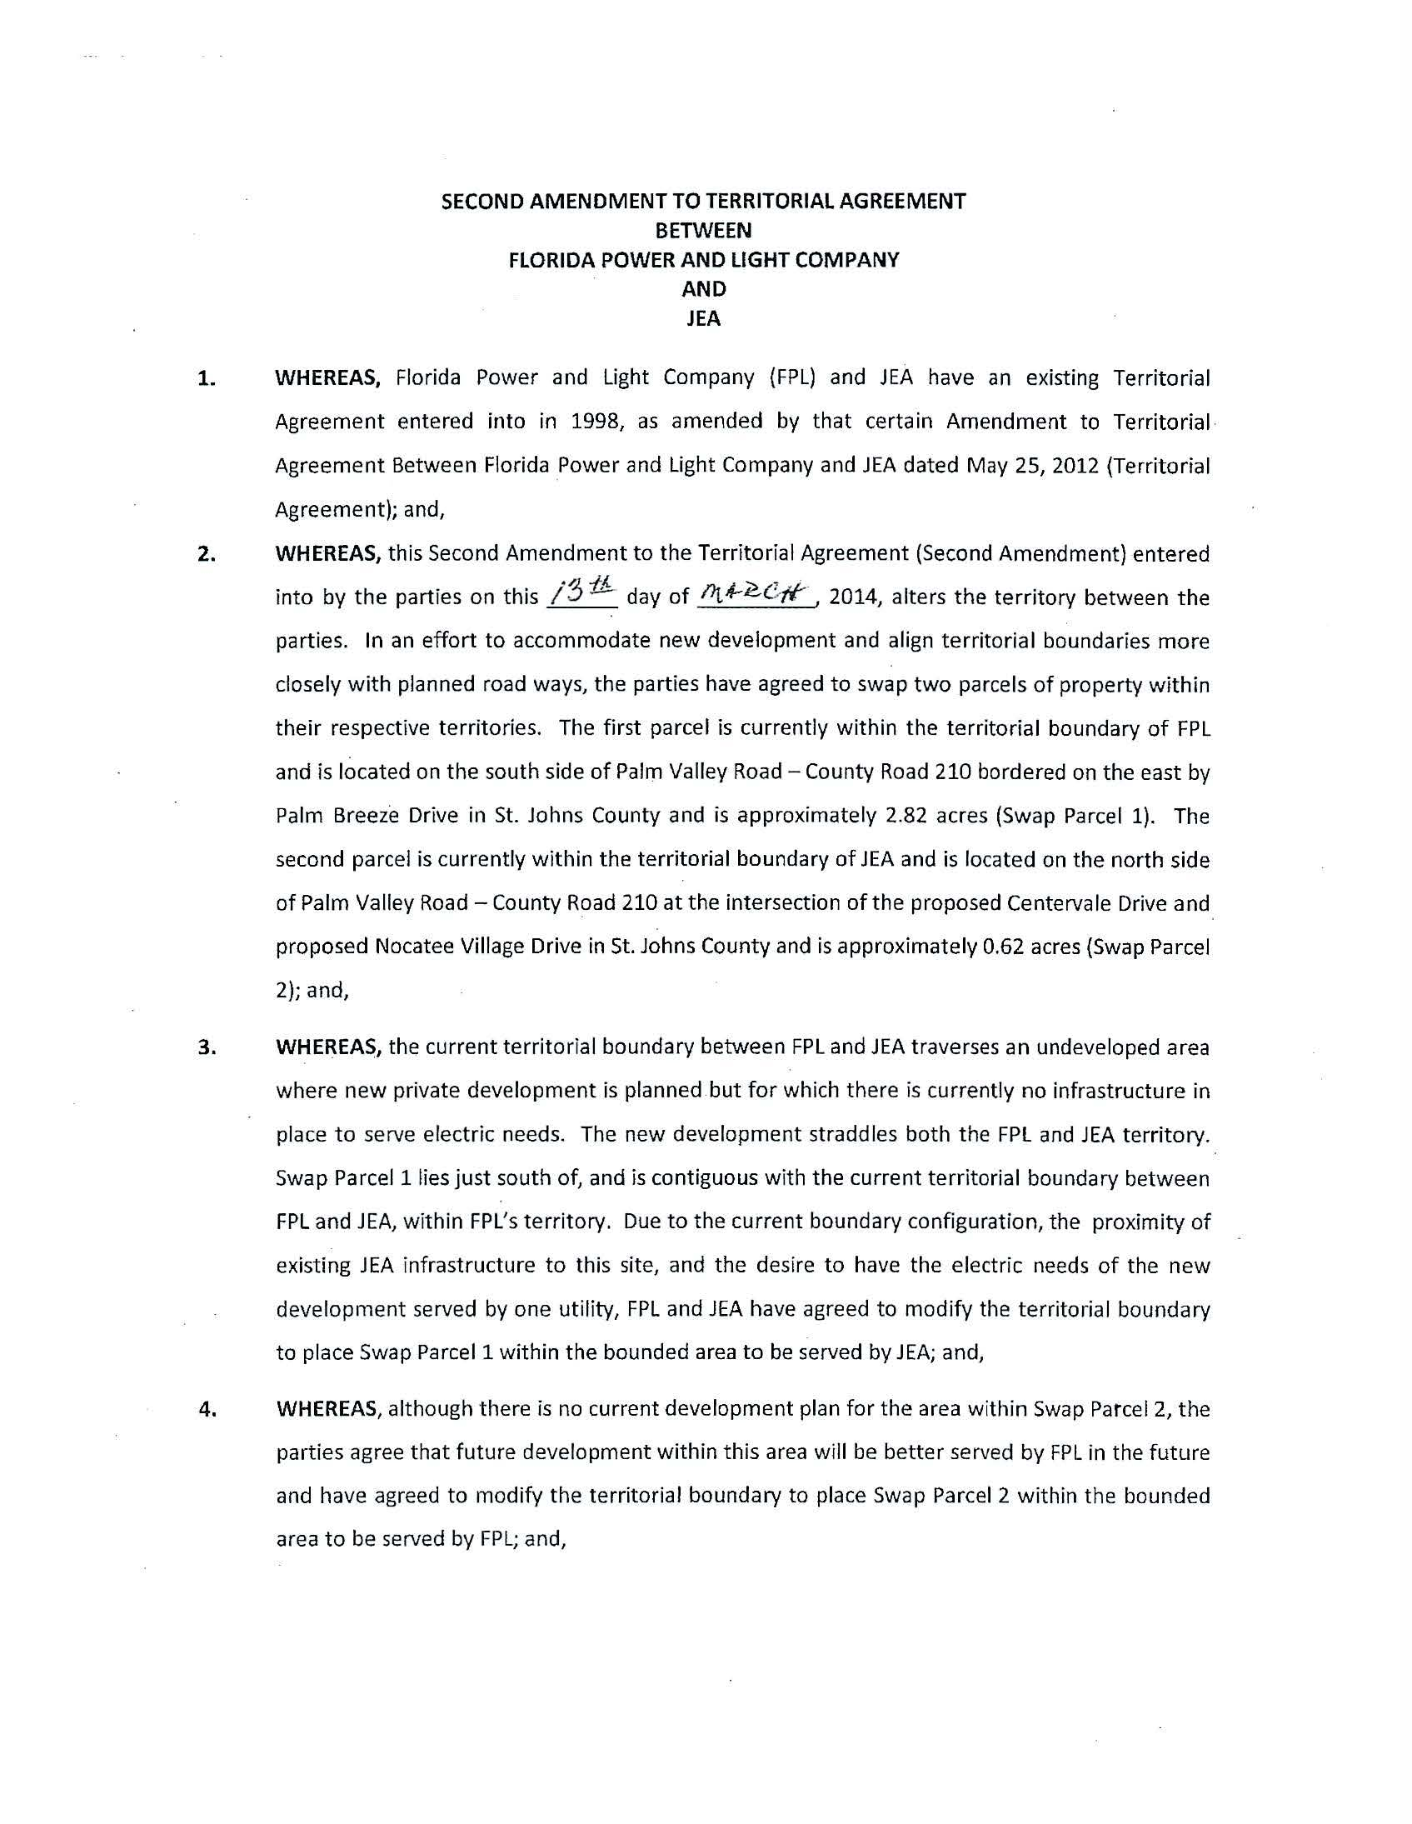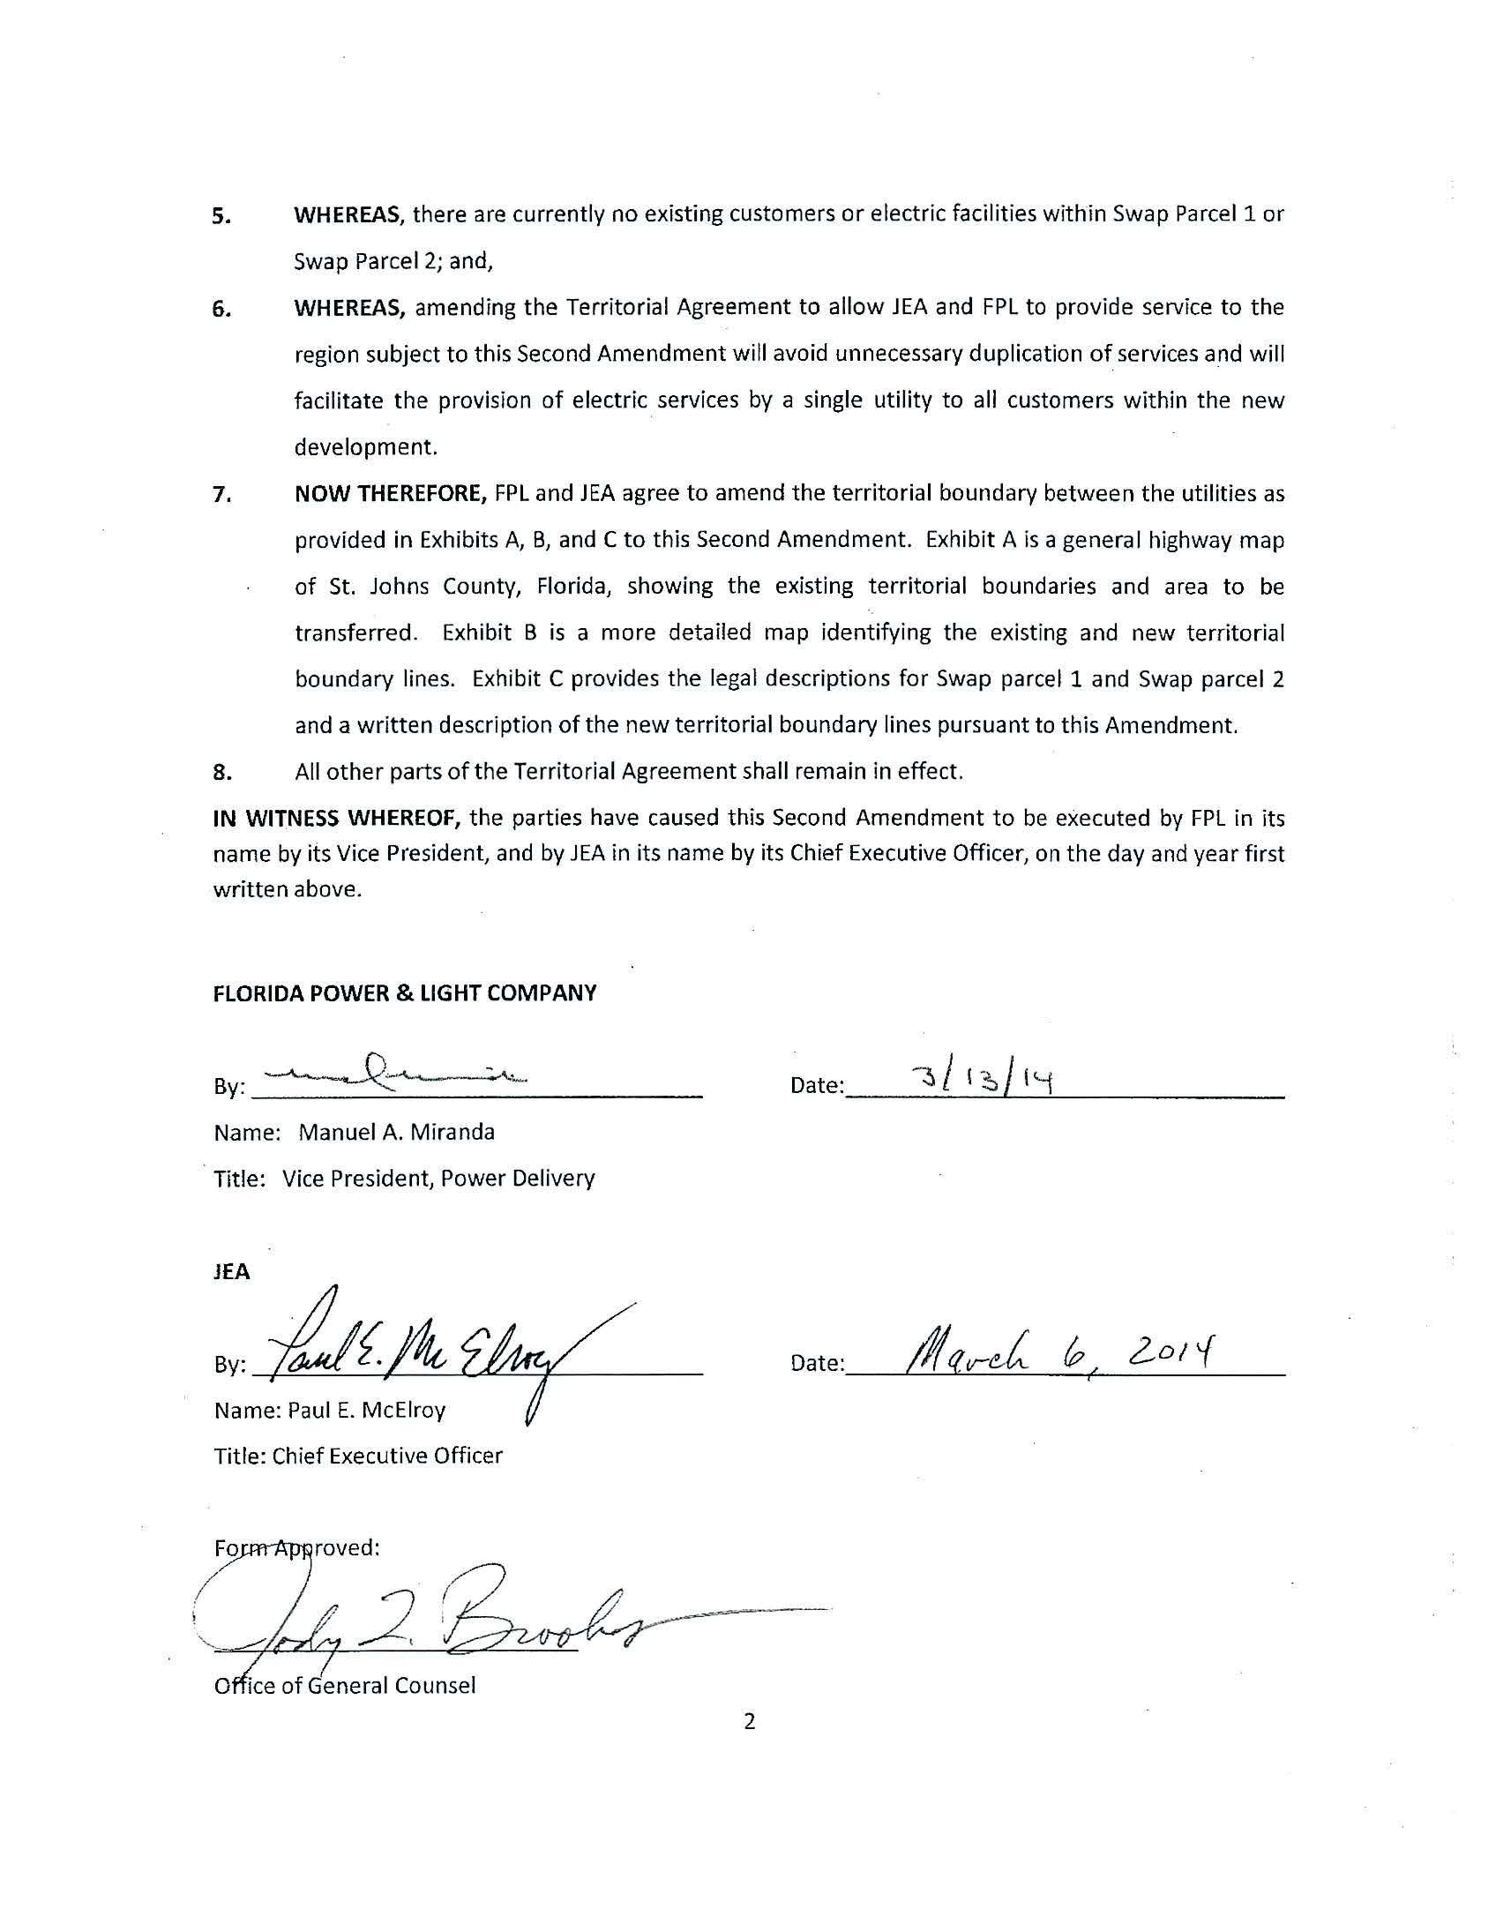
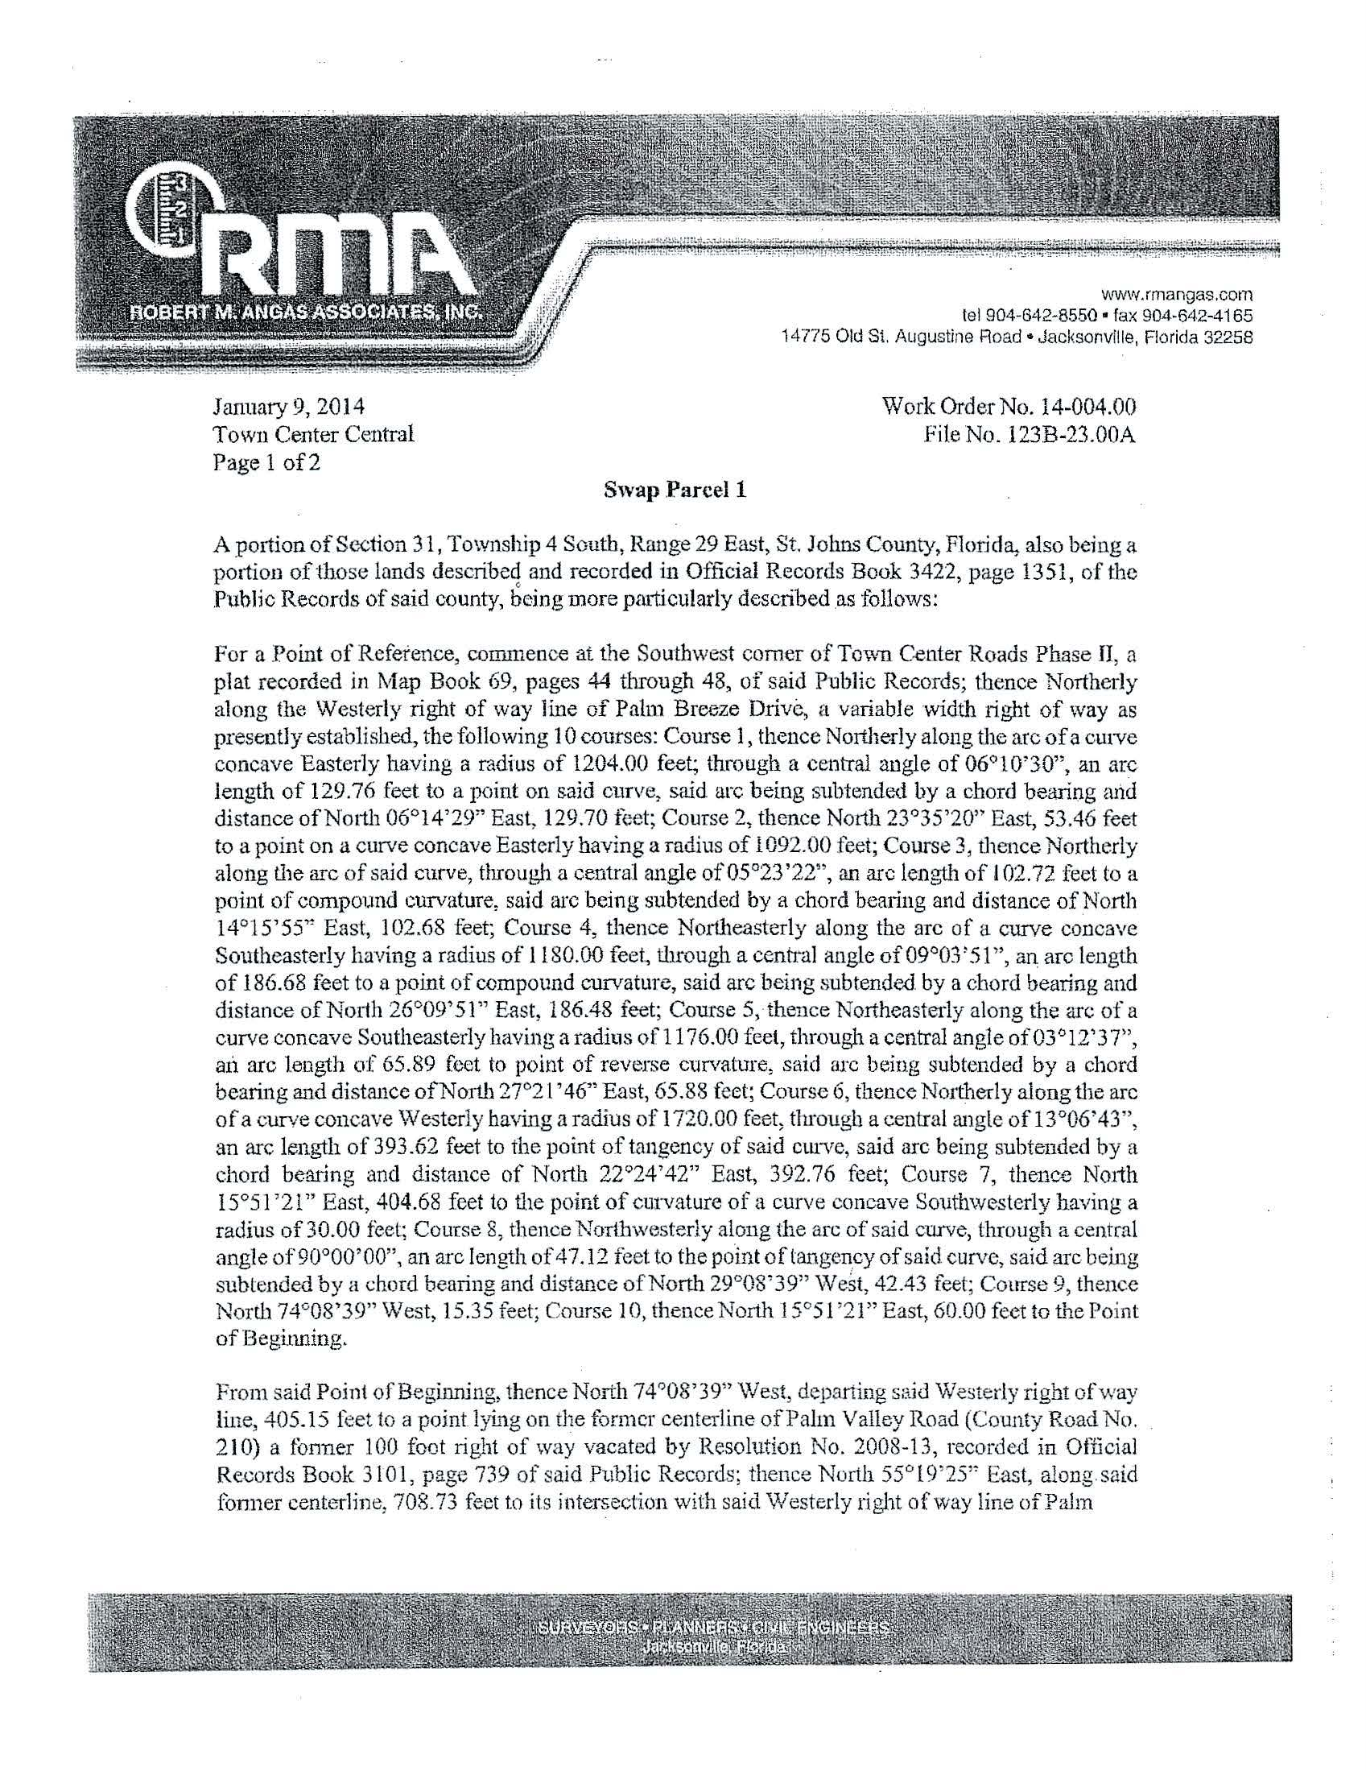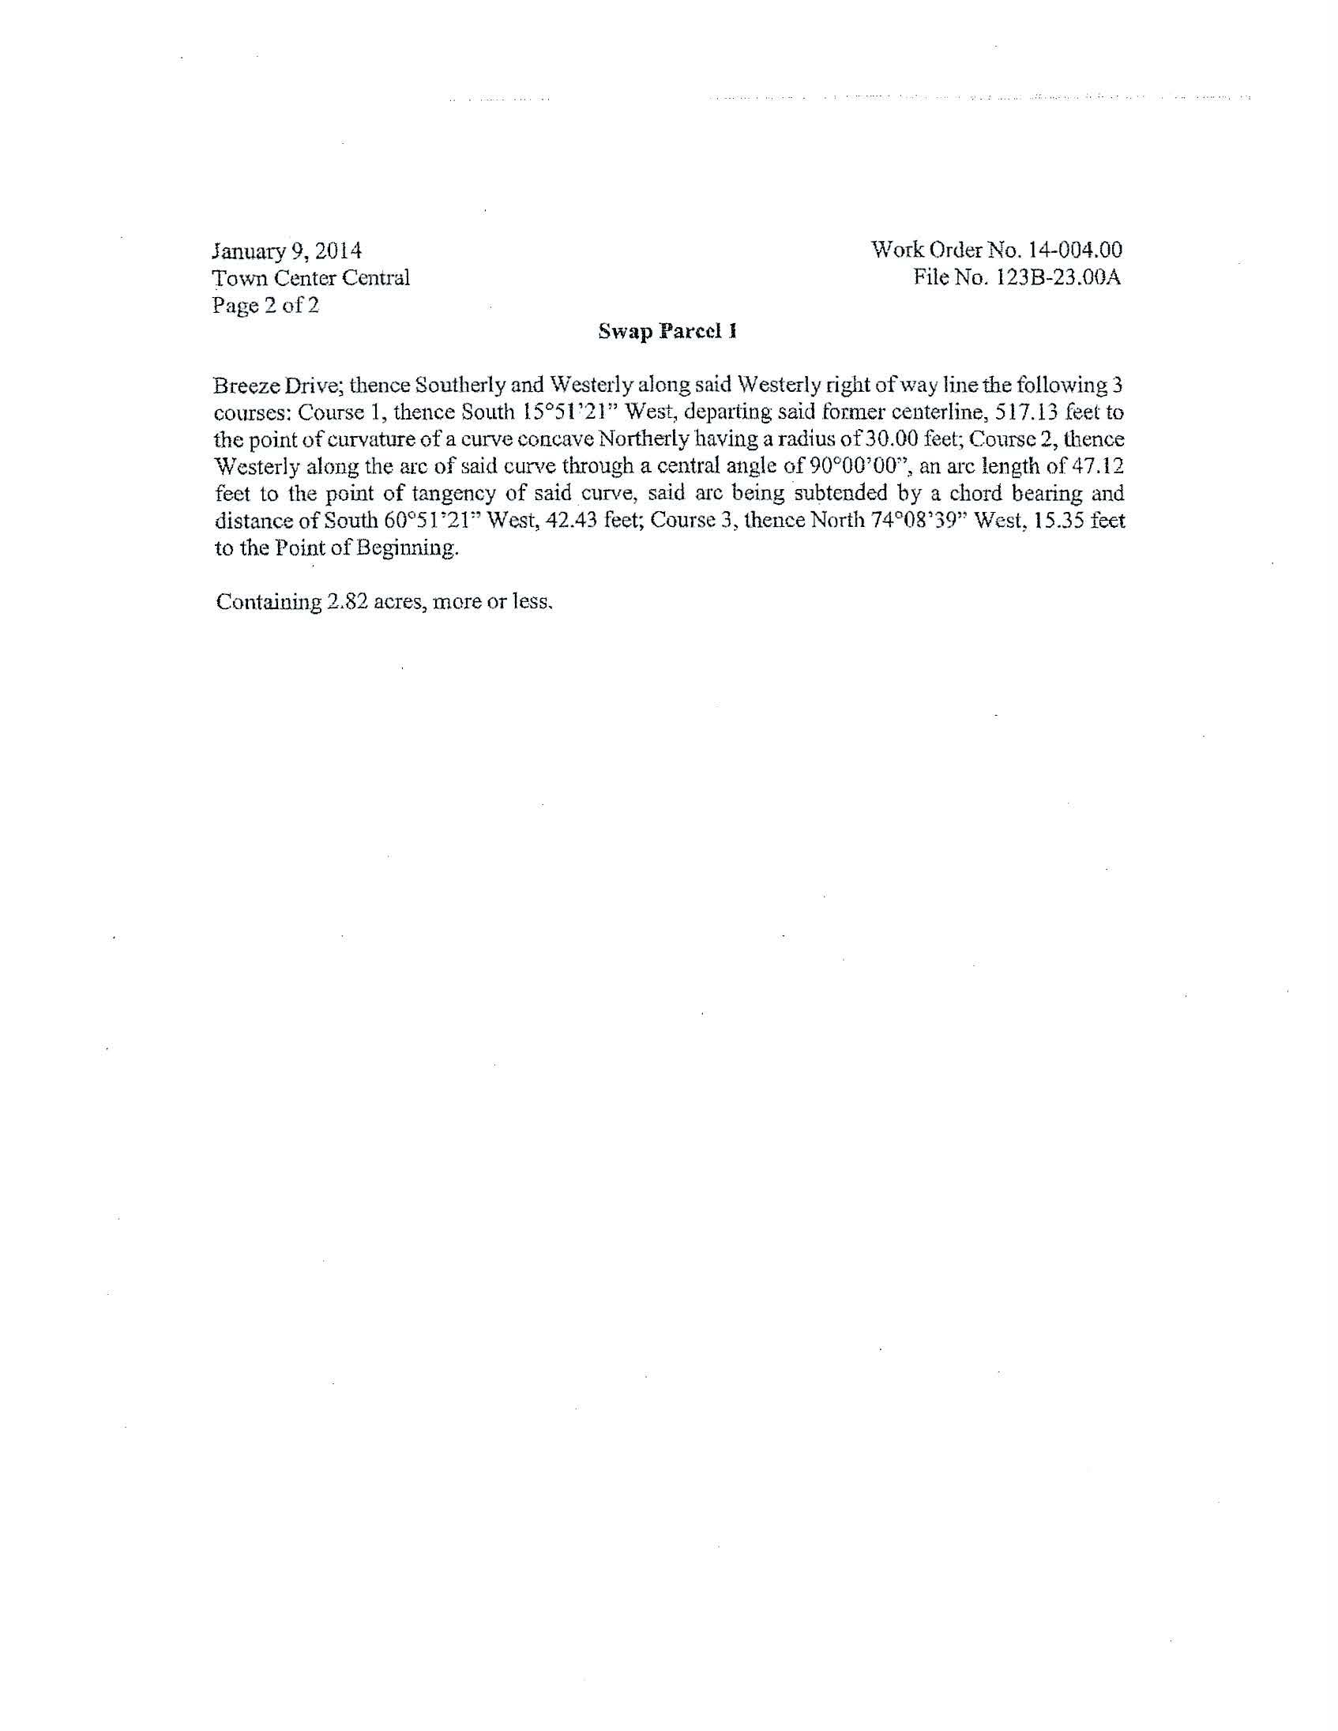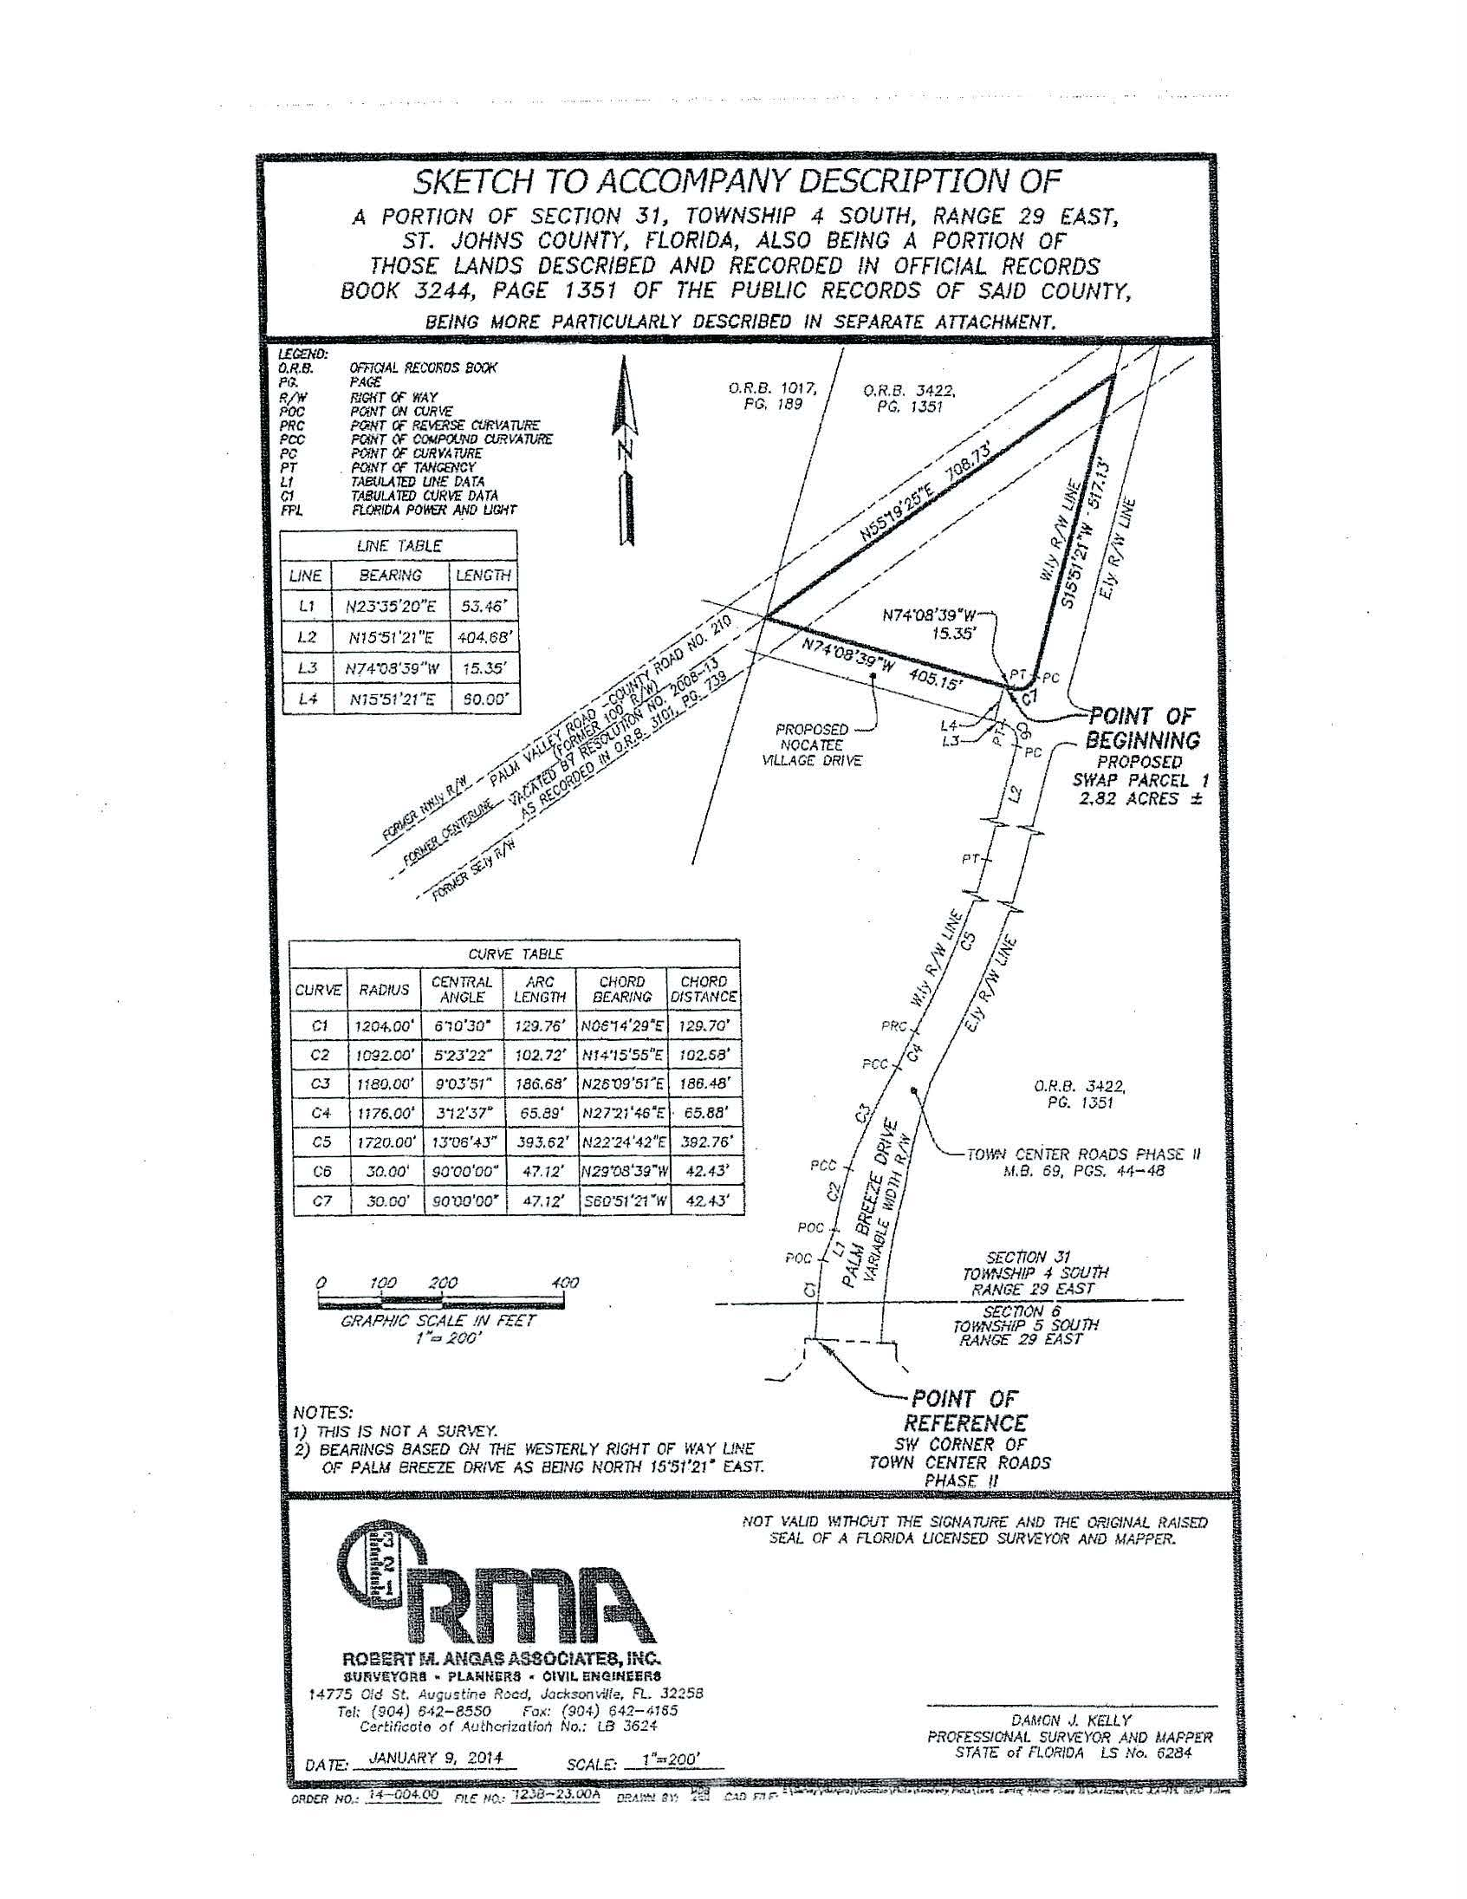
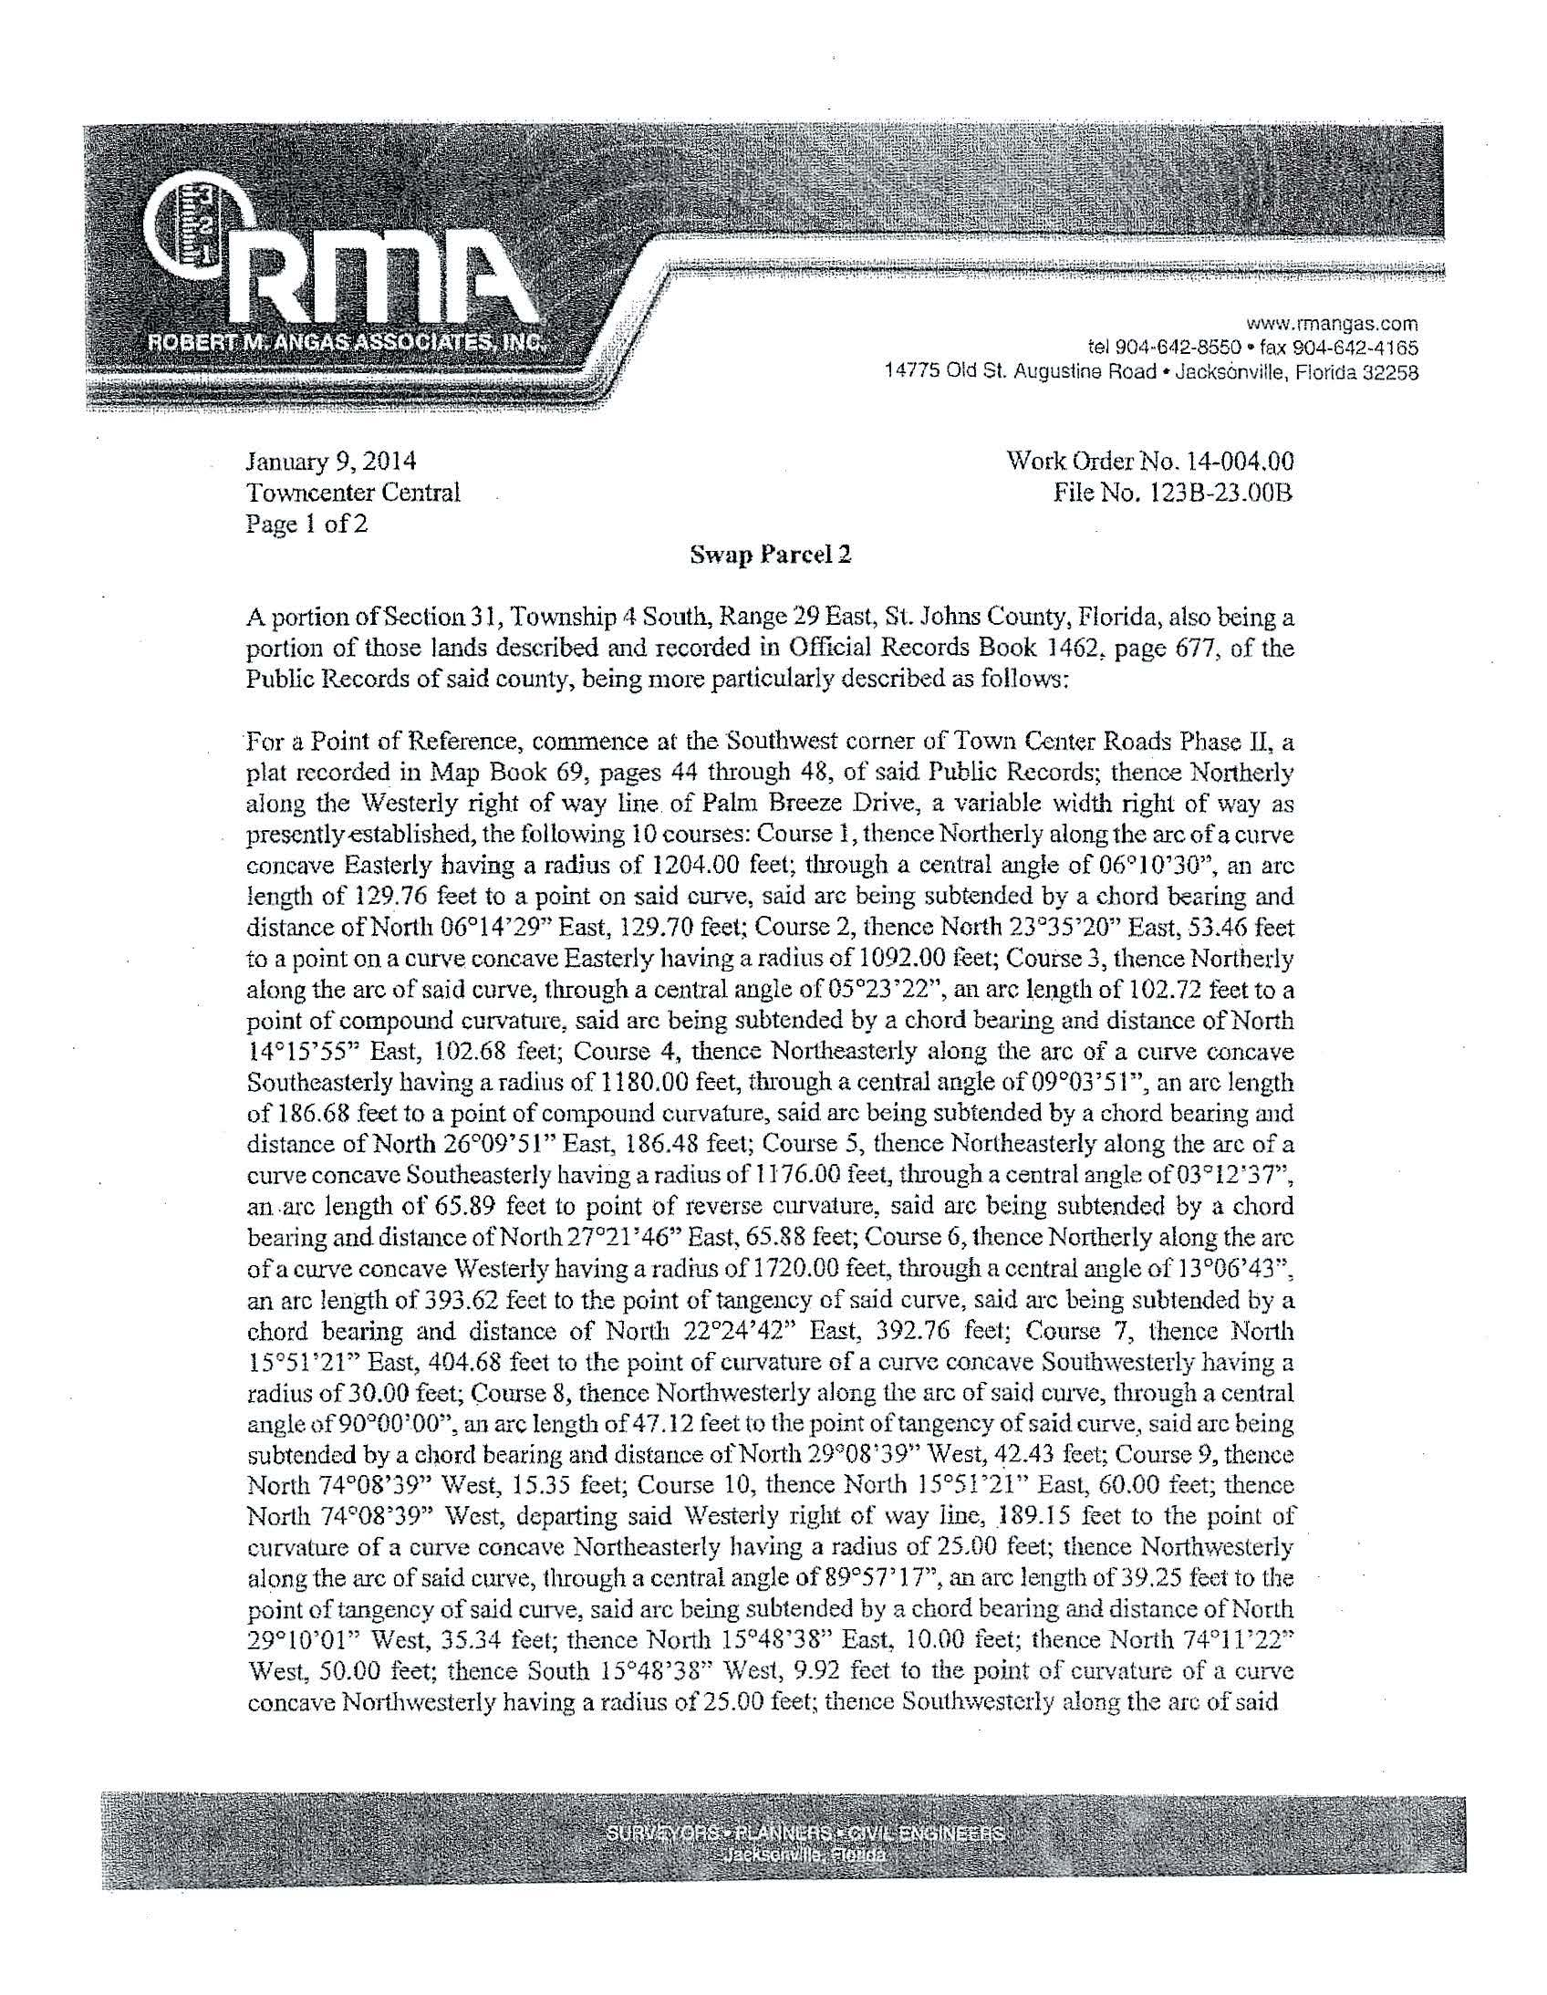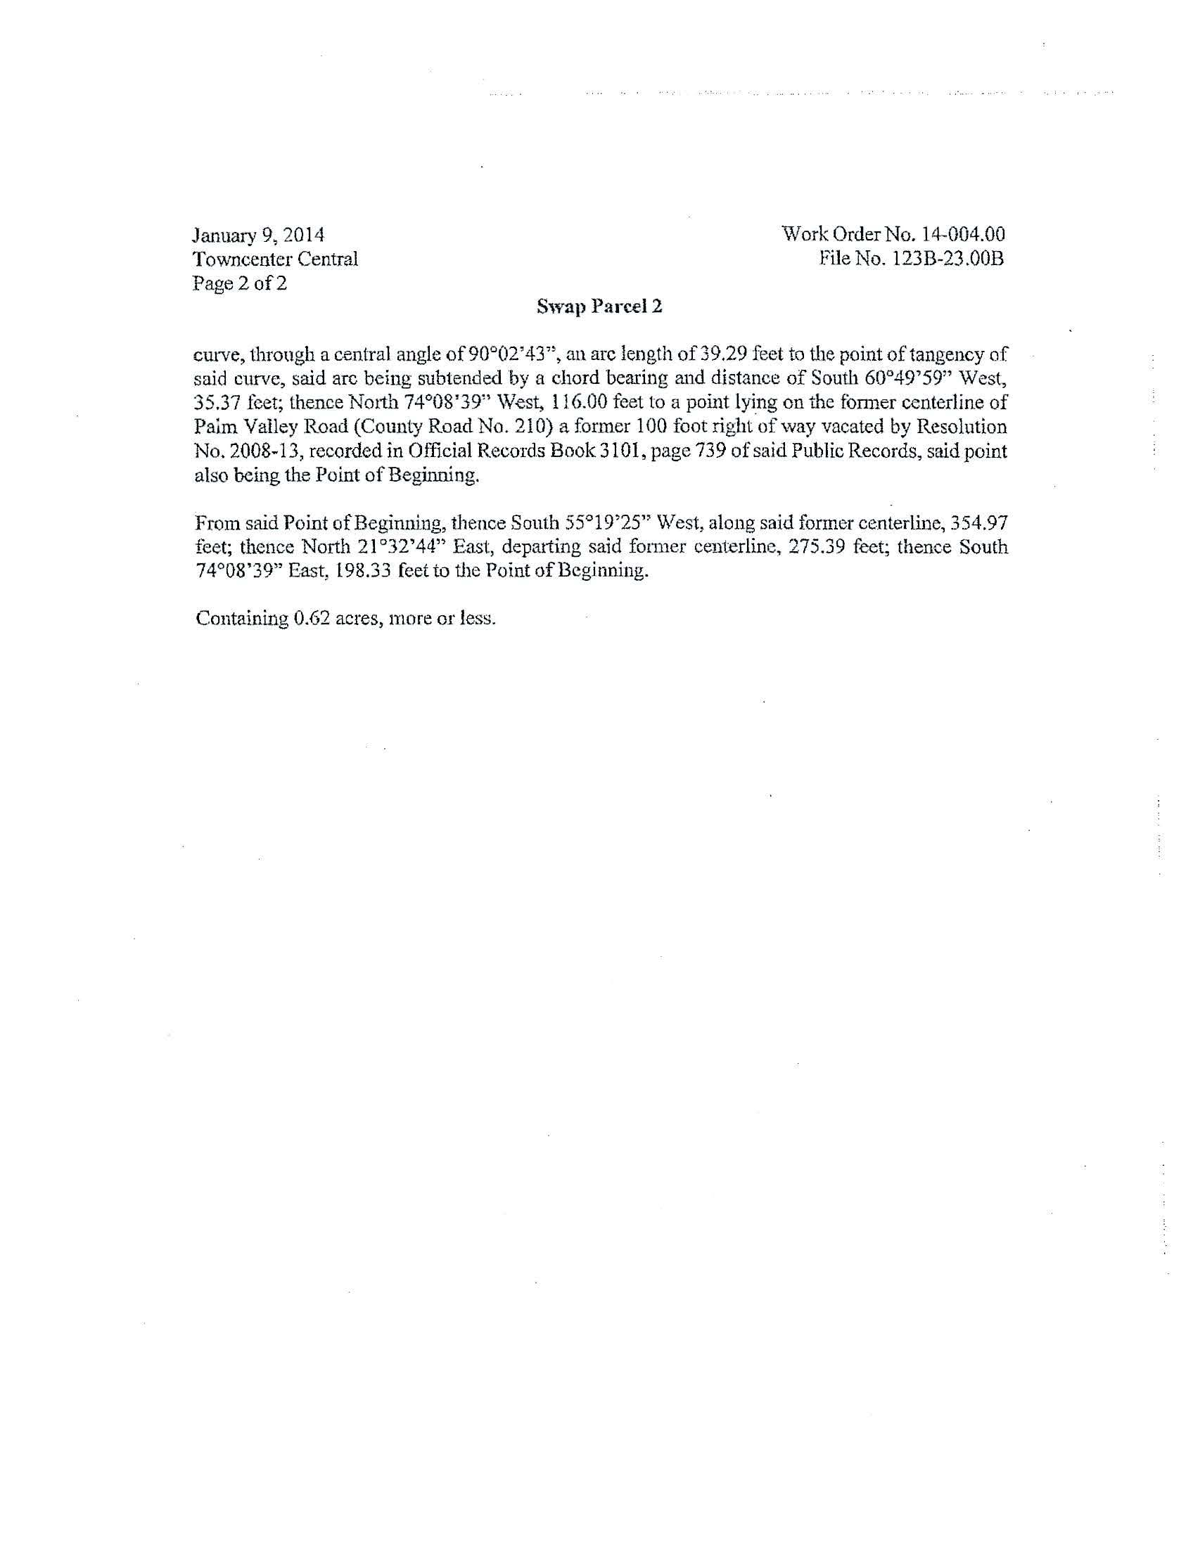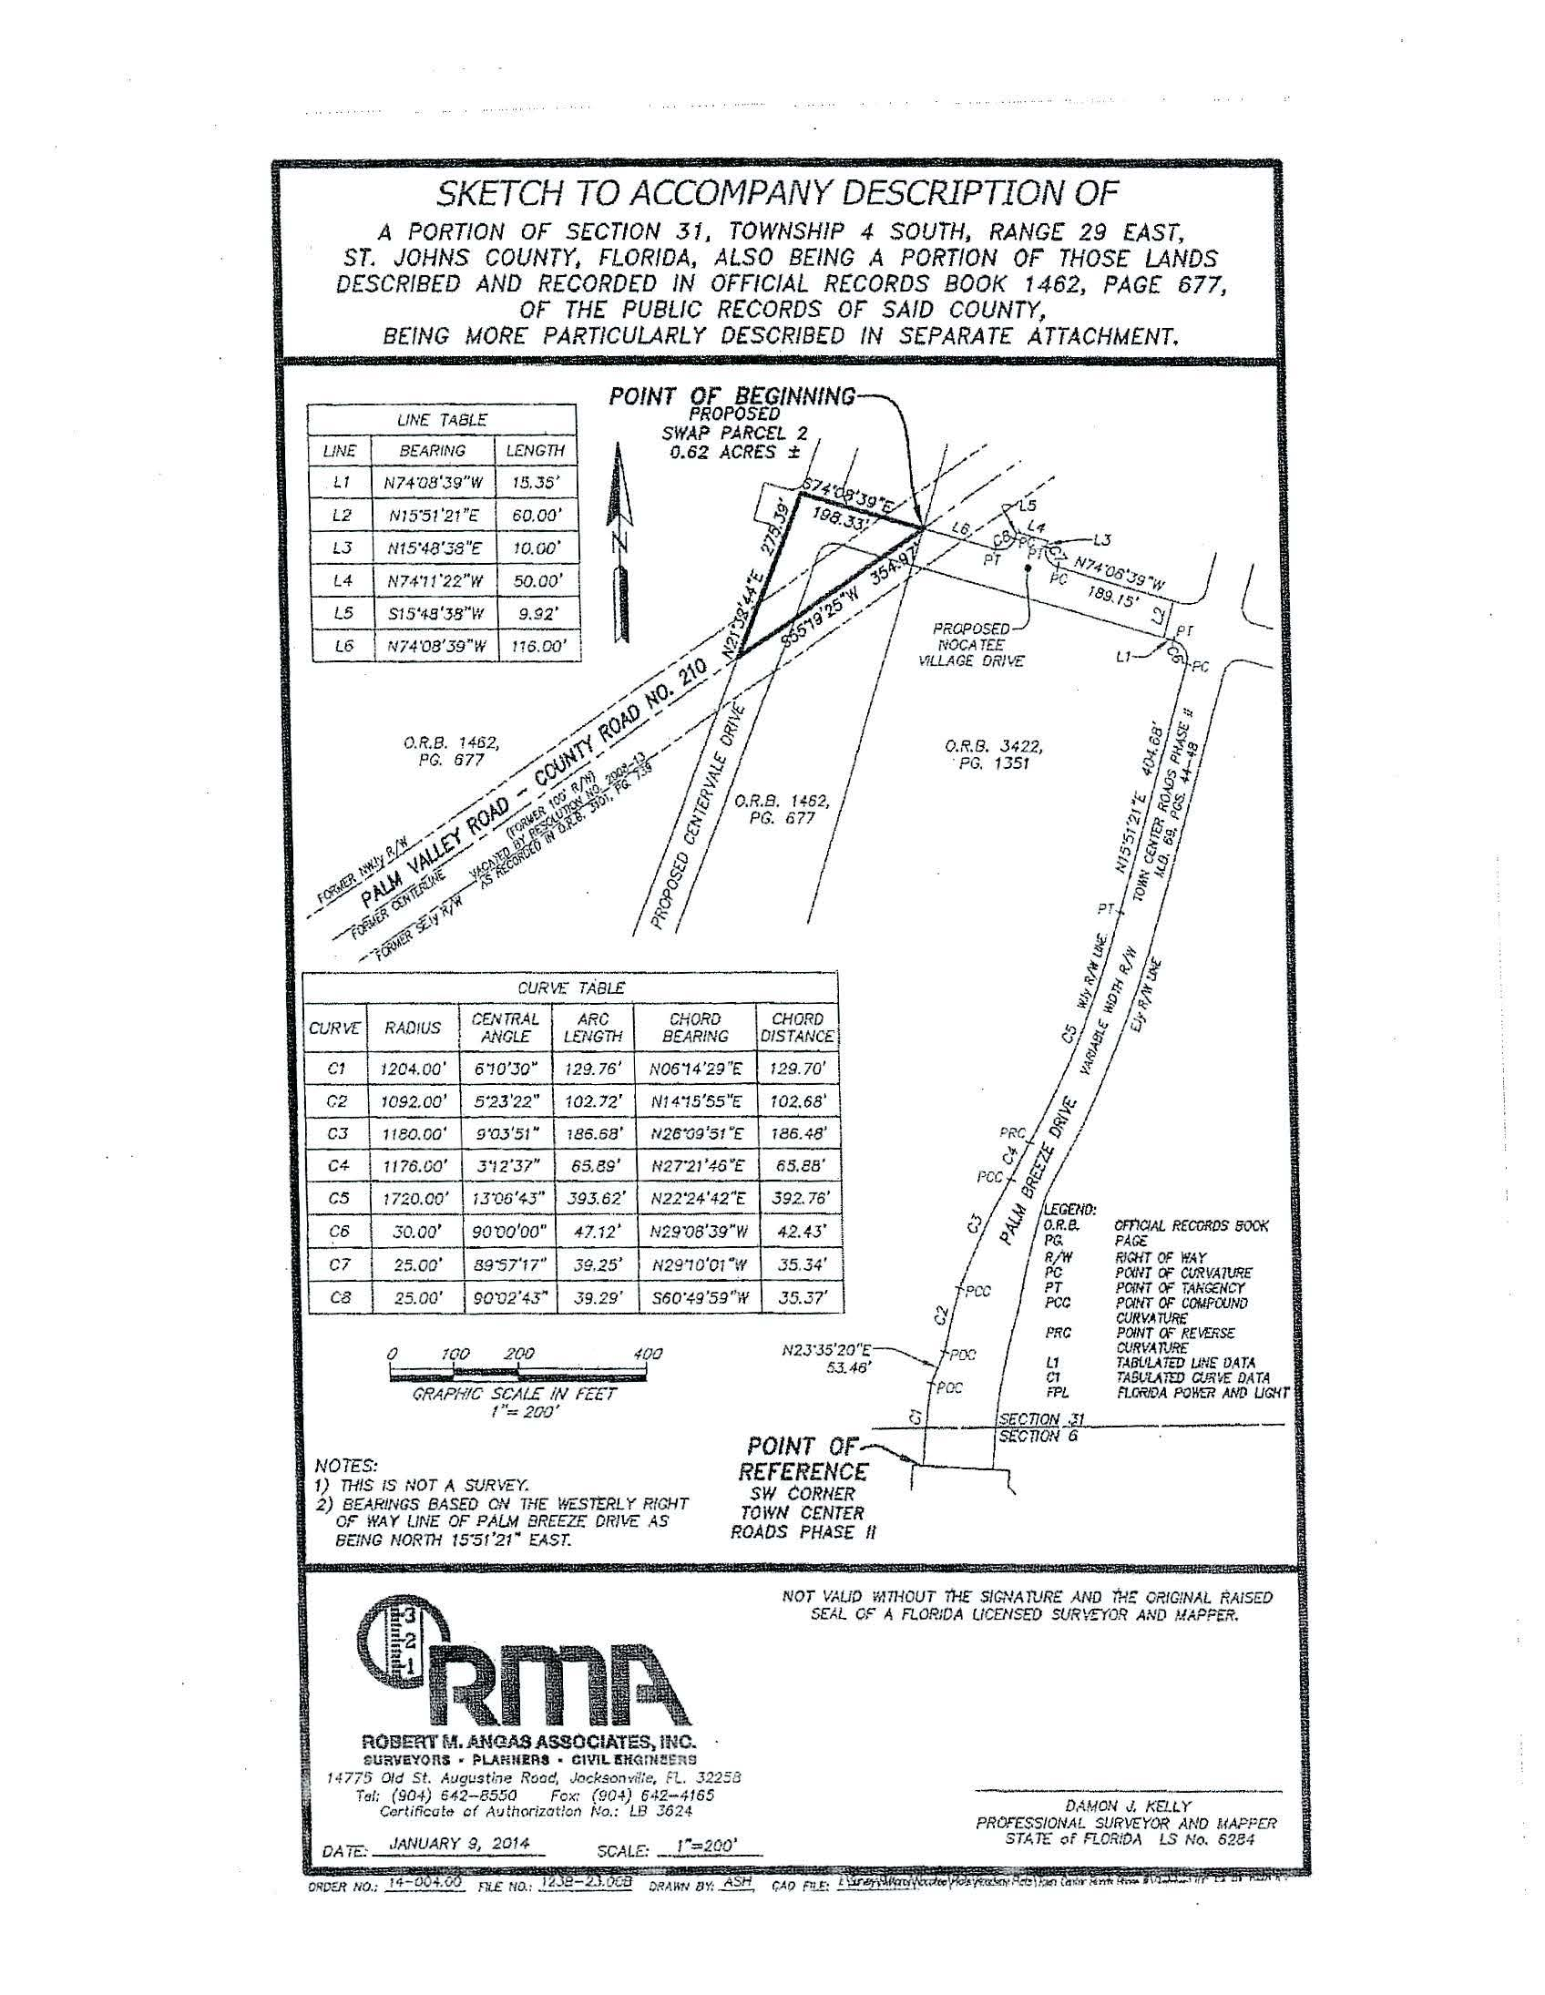
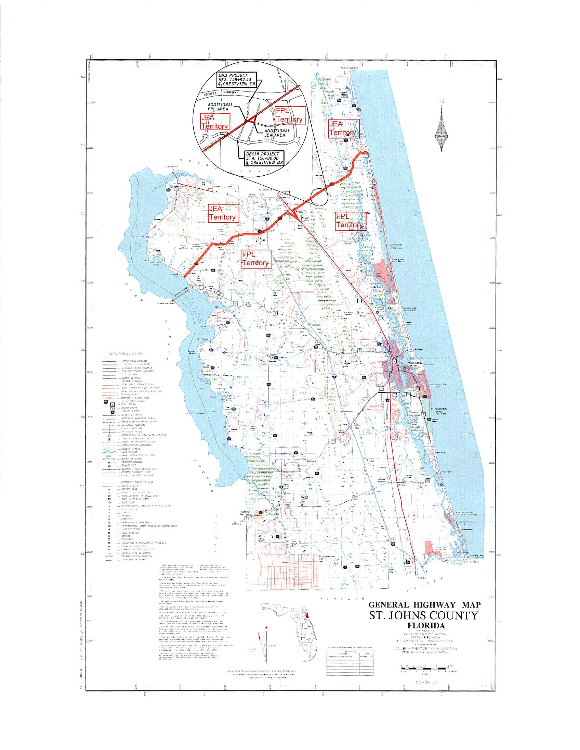

Order No. 9363, issued May 9, 1980, in Docket No. 790886-EU, In re: Petition of Jacksonville Electric Authority for approval of a territorial agreement between JEA and Florida Power and Light Company.
Order No. PSC-96-0212-FOF-EU, issued February 14, 1996 and finalized by Order No. PSC-96-0755-FOF-EU, issued June 10, 1996, in Docket No. 950307-EU, In re: Petition of Jacksonville Electric Authority to Resolve a Territorial Dispute With Florida Power & Light Company in St. Johns County.
Order No. PSC-98-1687-FOF-EU, issued December 14, 1998, in Docket No. 980755-EU, In re: Joint petition for approval of new territorial agreement between Florida Power & Light Company and Jacksonville Electric Authority.
Order No. PSC-12-0561-PAA-EU, issued October 22, 2012, in Docket No. 120171-EU, In re: Joint petition for approval of amendment to territorial agreement in St. Johns County between Florida Power & Light Company, a Florida corporation, and JEA, a Florida municipal corporation.

