BEFORE THE FLORIDA PUBLIC SERVICE COMMISSION

In re: Joint petition for approval of amendment to territorial agreement between Florida Power & Light Company and JEA. | DOCKET NO. 140130-EU  ORDER NO. PSC-14-0469-PAA-EU  ISSUED: August 29, 2014

The following Commissioners participated in the disposition of this matter:

ART GRAHAM, Chairman
LISA POLAK EDGAR
RONALD A. BRISÉ
EDUARDO E. BALBIS
JULIE I. BROWN

NOTICE OF PROPOSED AGENCY ACTION
ORDER APPROVING AMENDMENT TO TERRITORIAL AGREEMENT

BY THE COMMISSION:

NOTICE is hereby given by the Florida Public Service Commission that the action discussed herein is preliminary in nature and will become final unless a person whose interests are substantially affected files a petition for a formal proceeding, pursuant to Rule 25-22.029, Florida Administrative Code (F.A.C.).

BACKGROUND
On June 17, 2014, Florida Power & Light Company (FPL) and JEA filed a joint petition for approval of an amendment (2014 Amendment) to the existing territorial agreement between FPL and JEA. We first approved the territorial boundary between the two utilities in 1965, and we reaffirmed our approval in 1980. In 1996, as the resolution of a territorial dispute, FPL and JEA entered into a new territorial agreement which was subsequently revised and approved by us in 1998. In 2012 FPL and JEA agreed to an amendment that altered a segment of the territorial boundaries between the parties so that a single utility could serve the electric needs of a new private development planned for an undeveloped area.
FPL and JEA’s 2014 Amendment provides for the swap of two land parcels. Attachment A is a copy of the 2014 Amendment. Attachments B and C provide a legal description and map of the two parcels. Pursuant to Rule 25-6.0440(1)(f), F.A.C., Attachment D is an official Florida Department of Transportation General Highway County map for St. Johns County depicting boundary lines established by the territorial agreement.
As explained below, we approve the proposed amendment to the parties’ territorial agreement. We have jurisdiction over the matter pursuant to Section 366.04, Florida Statutes (F.S.).
DECISION
Pursuant to Section 366.04(2)(d), F.S., we have the jurisdiction to approve territorial agreements between and among rural electric cooperatives, municipal electric utilities, and other electric utilities. Rule 25-6.0440(2), F.A.C., states that in approving territorial agreements, we may consider the reasonableness of the purchase price of any facilities being transferred, the likelihood that the agreement will not cause a decrease in the reliability of electric service to existing or future ratepayers, and the likelihood that the agreement will eliminate existing or potential uneconomic duplication of facilities. Unless we determine that the agreement will cause a detriment to the public interest, the agreement should be approved. Utilities Commission of the City of New Smyrna v. Florida Public Service Commission, 469 So. 2d 731 (Fla. 1985).
As noted in the case background, FPL and JEA are parties to a Territorial Agreement, mostly recently amended in 2012. The 2014 Amendment would move Swap Parcel 1, currently in FPL’s territory, and place it in JEA’s territory; and move Swap Parcel 2, currently in JEA’s territory, and place it in FPL’s territory.
The current territorial boundary between FPL and JEA traverses an undeveloped area for which a new private development is planned. At present there is no electric infrastructure in place to serve electric needs; however, JEA has existing infrastructure nearby. The 2014 Amendment alters the territory between FPL and JEA so that the new territorial boundary will be more closely aligned with planned road ways and will facilitate the provision of electric service for the new development by one utility. Although there are no current development plans for the area within Swap Parcel 2, FPL and JEA agree that FPL will be in a better position to provide electric service to any future development in this area.
No customers will be transferred when the 2014 Amendment is implemented; therefore, no customers were notified pursuant to Rule 25-6.0440(1), F.A.C. Nor are there any facilities to be transferred and no purchase price will be involved. FPL and JEA state that they entered the 2014 Amendment after consideration of the best interest of electric consumers and the residents of the areas served by both parties. According to FPL and JEA, the 2014 Amendment is intended to avoid unnecessary duplication of services in the area and is in the best interest of the public.
We agree that the 2014 Amendment is in the public interest and will enable FPL and JEA to better serve potential customers. The proposed amendment eliminates any potential uneconomic duplication of facilities and will not cause a decrease in the reliability of electric service. For these reasons, we find that the 2014 Amendment will not cause a detriment to the public interest and we approve it.
Based on the foregoing, it is

ORDERED by the Florida Public Service Commission that the Joint petition for approval of amendment to territorial agreement between Florida Power & Light Company and JEA is approved. It is further

ORDERED that the provisions of this Order, issued as proposed agency action, shall become final and effective upon the issuance of a Consummating Order unless an appropriate petition, in the form provided by Rule 28-106.201, Florida Administrative Code, is received by the Commission Clerk, 2540 Shumard Oak Boulevard, Tallahassee, Florida 32399-0850, by the close of business on the date set forth in the “Notice of Further Proceedings” attached hereto. It is further

ORDERED that in the event this Order becomes final, this docket shall be closed.

By ORDER of the Florida Public Service Commission this 29th day of August, 2014.

/s/ Carlotta S. Stauffer
CARLOTTA S. STAUFFER
Commission Clerk
Florida Public Service Commission
2540 Shumard Oak Boulevard
Tallahassee, Florida 32399
(850) 413-6770
www.floridapsc.com

Copies furnished: A copy of this document is provided to the parties of record at the time of issuance and, if applicable, interested persons.

MCB

NOTICE OF FURTHER PROCEEDINGS OR JUDICIAL REVIEW

The Florida Public Service Commission is required by Section 120.569(1), Florida Statutes, to notify parties of any administrative hearing that is available under Section 120.57, Florida Statutes, as well as the procedures and time limits that apply. This notice should not be construed to mean all requests for an administrative hearing will be granted or result in the relief sought.

Mediation may be available on a case-by-case basis. If mediation is conducted, it does not affect a substantially interested person's right to a hearing.

The action proposed herein is preliminary in nature. Any person whose substantial interests are affected by the action proposed by this order may file a petition for a formal proceeding, in the form provided by Rule 28-106.201, Florida Administrative Code. This petition must be received by the Office of Commission Clerk, 2540 Shumard Oak Boulevard, Tallahassee, Florida 32399-0850, by the close of business on September 19, 2014.

In the absence of such a petition, this order shall become final and effective upon the issuance of a Consummating Order.

Any objection or protest filed in this/these docket(s) before the issuance date of this order is considered abandoned unless it satisfies the foregoing conditions and is renewed within the specified protest period.

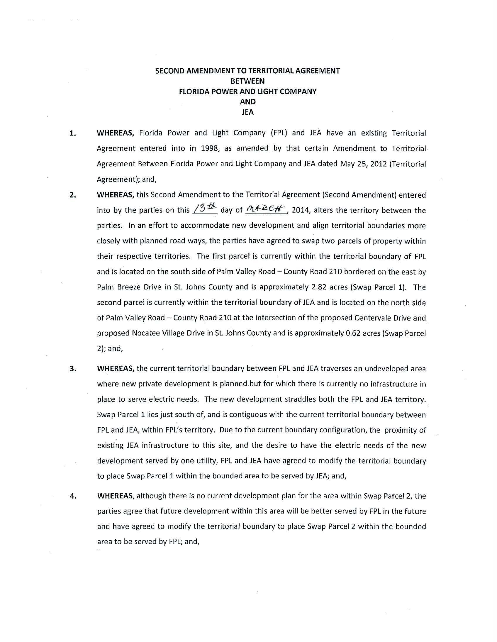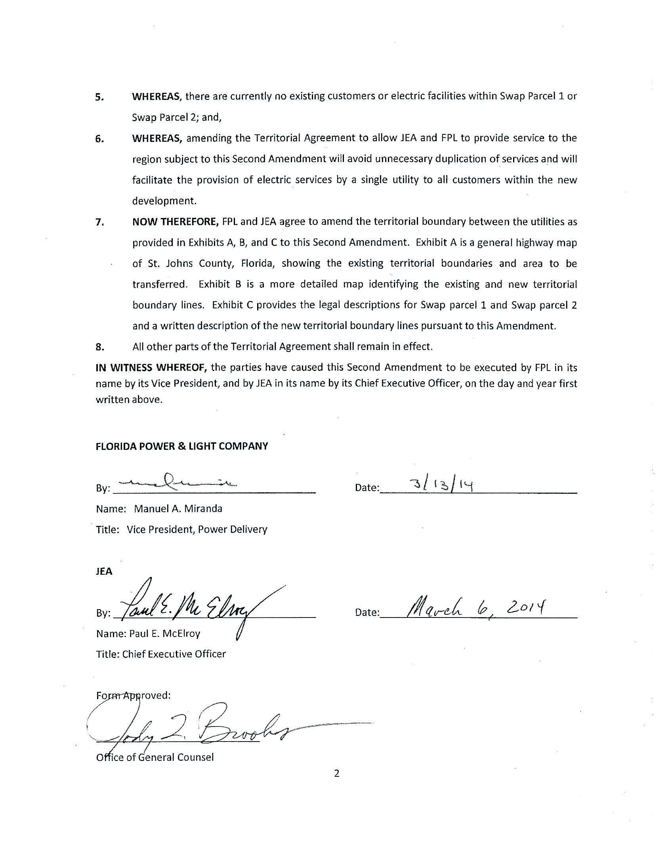
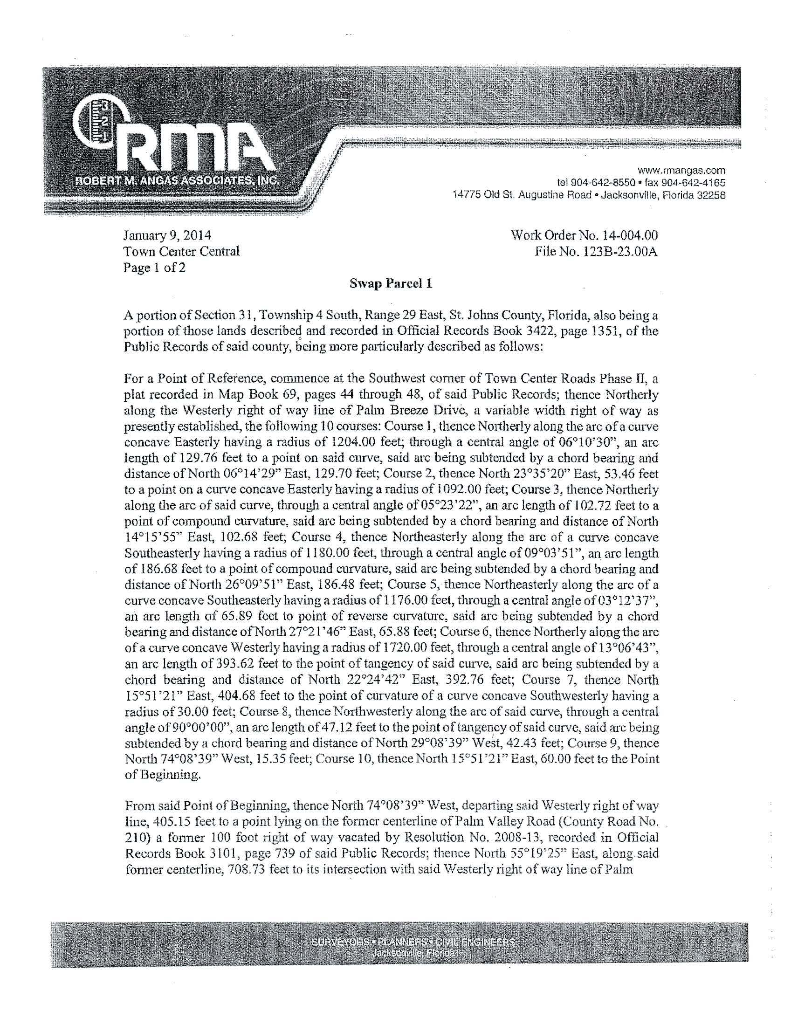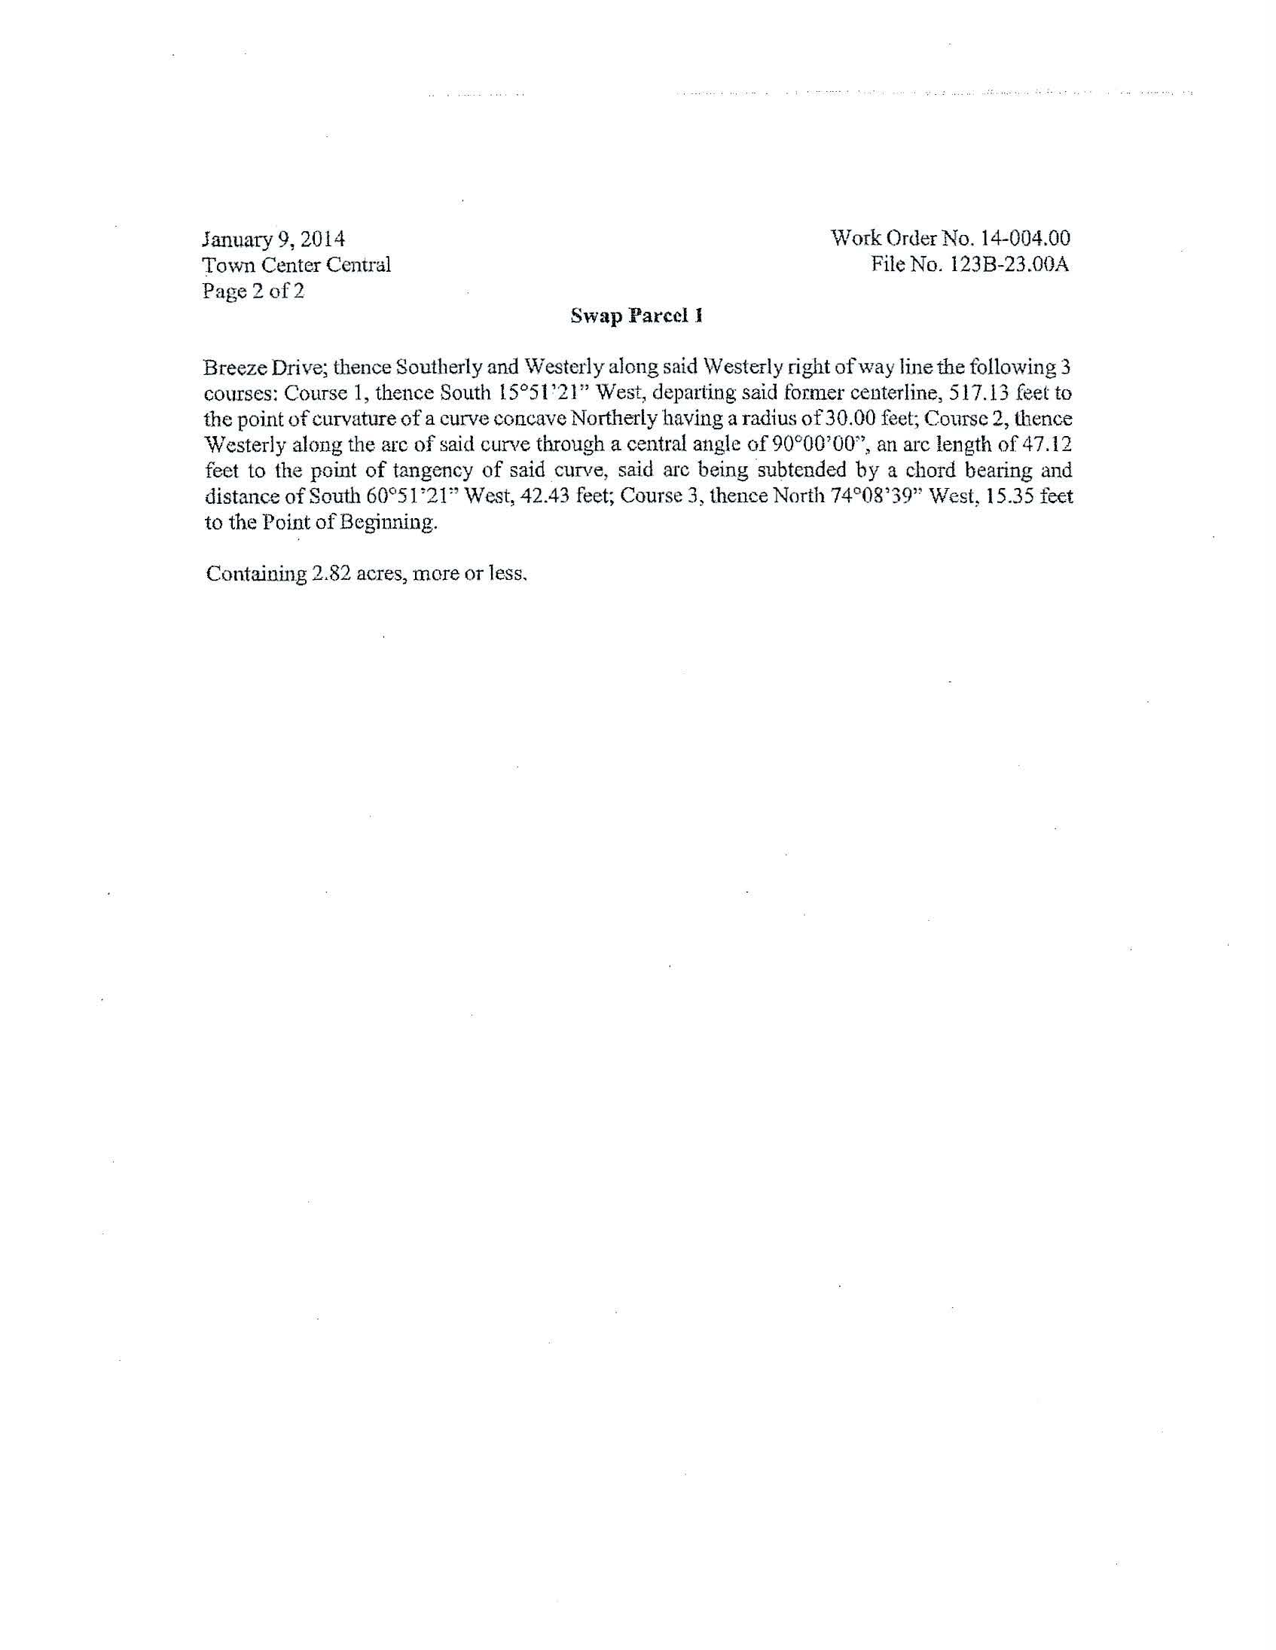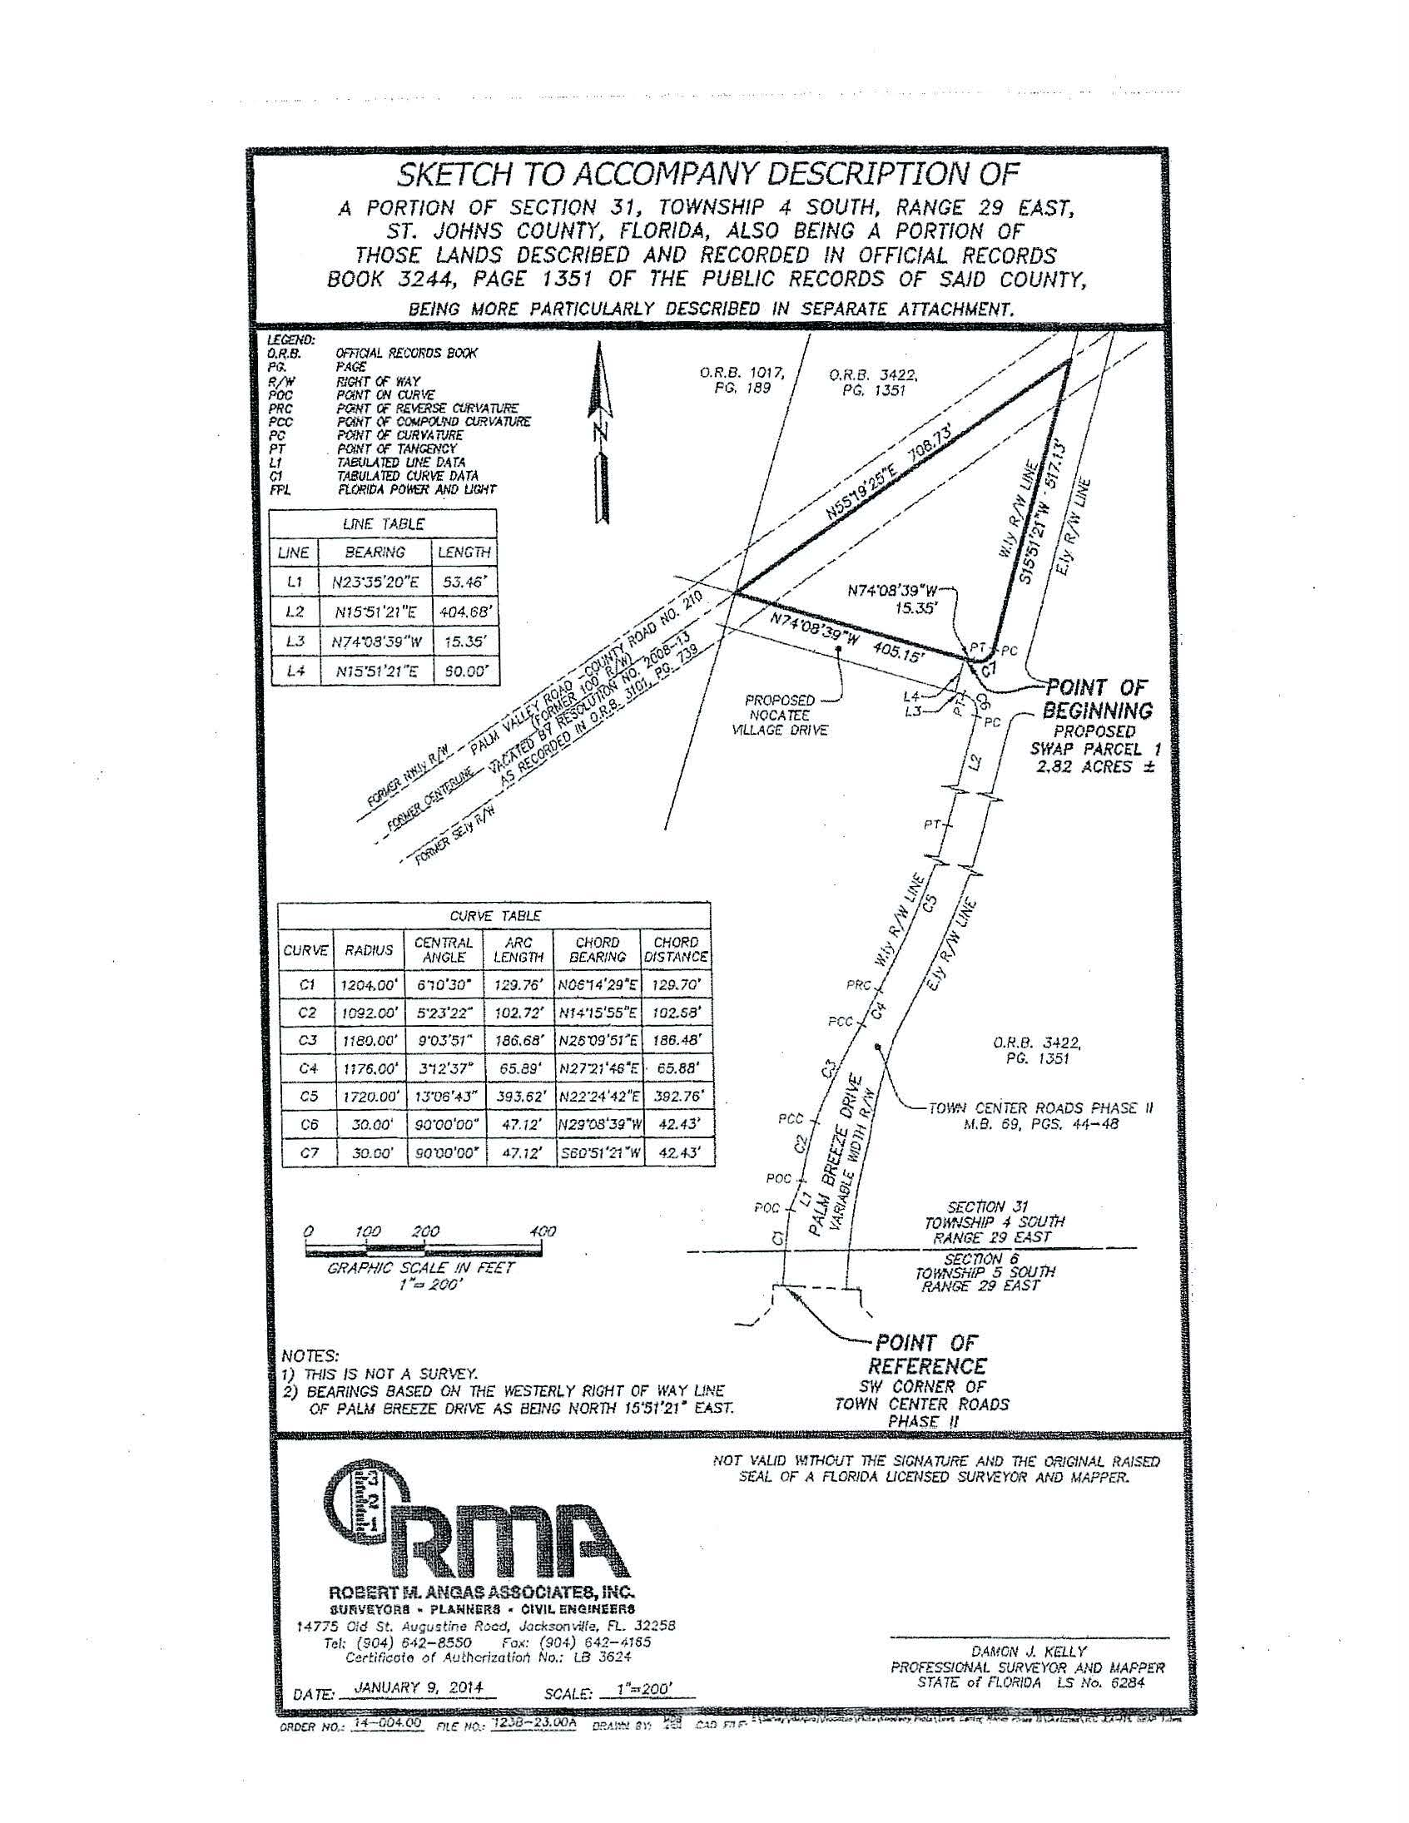
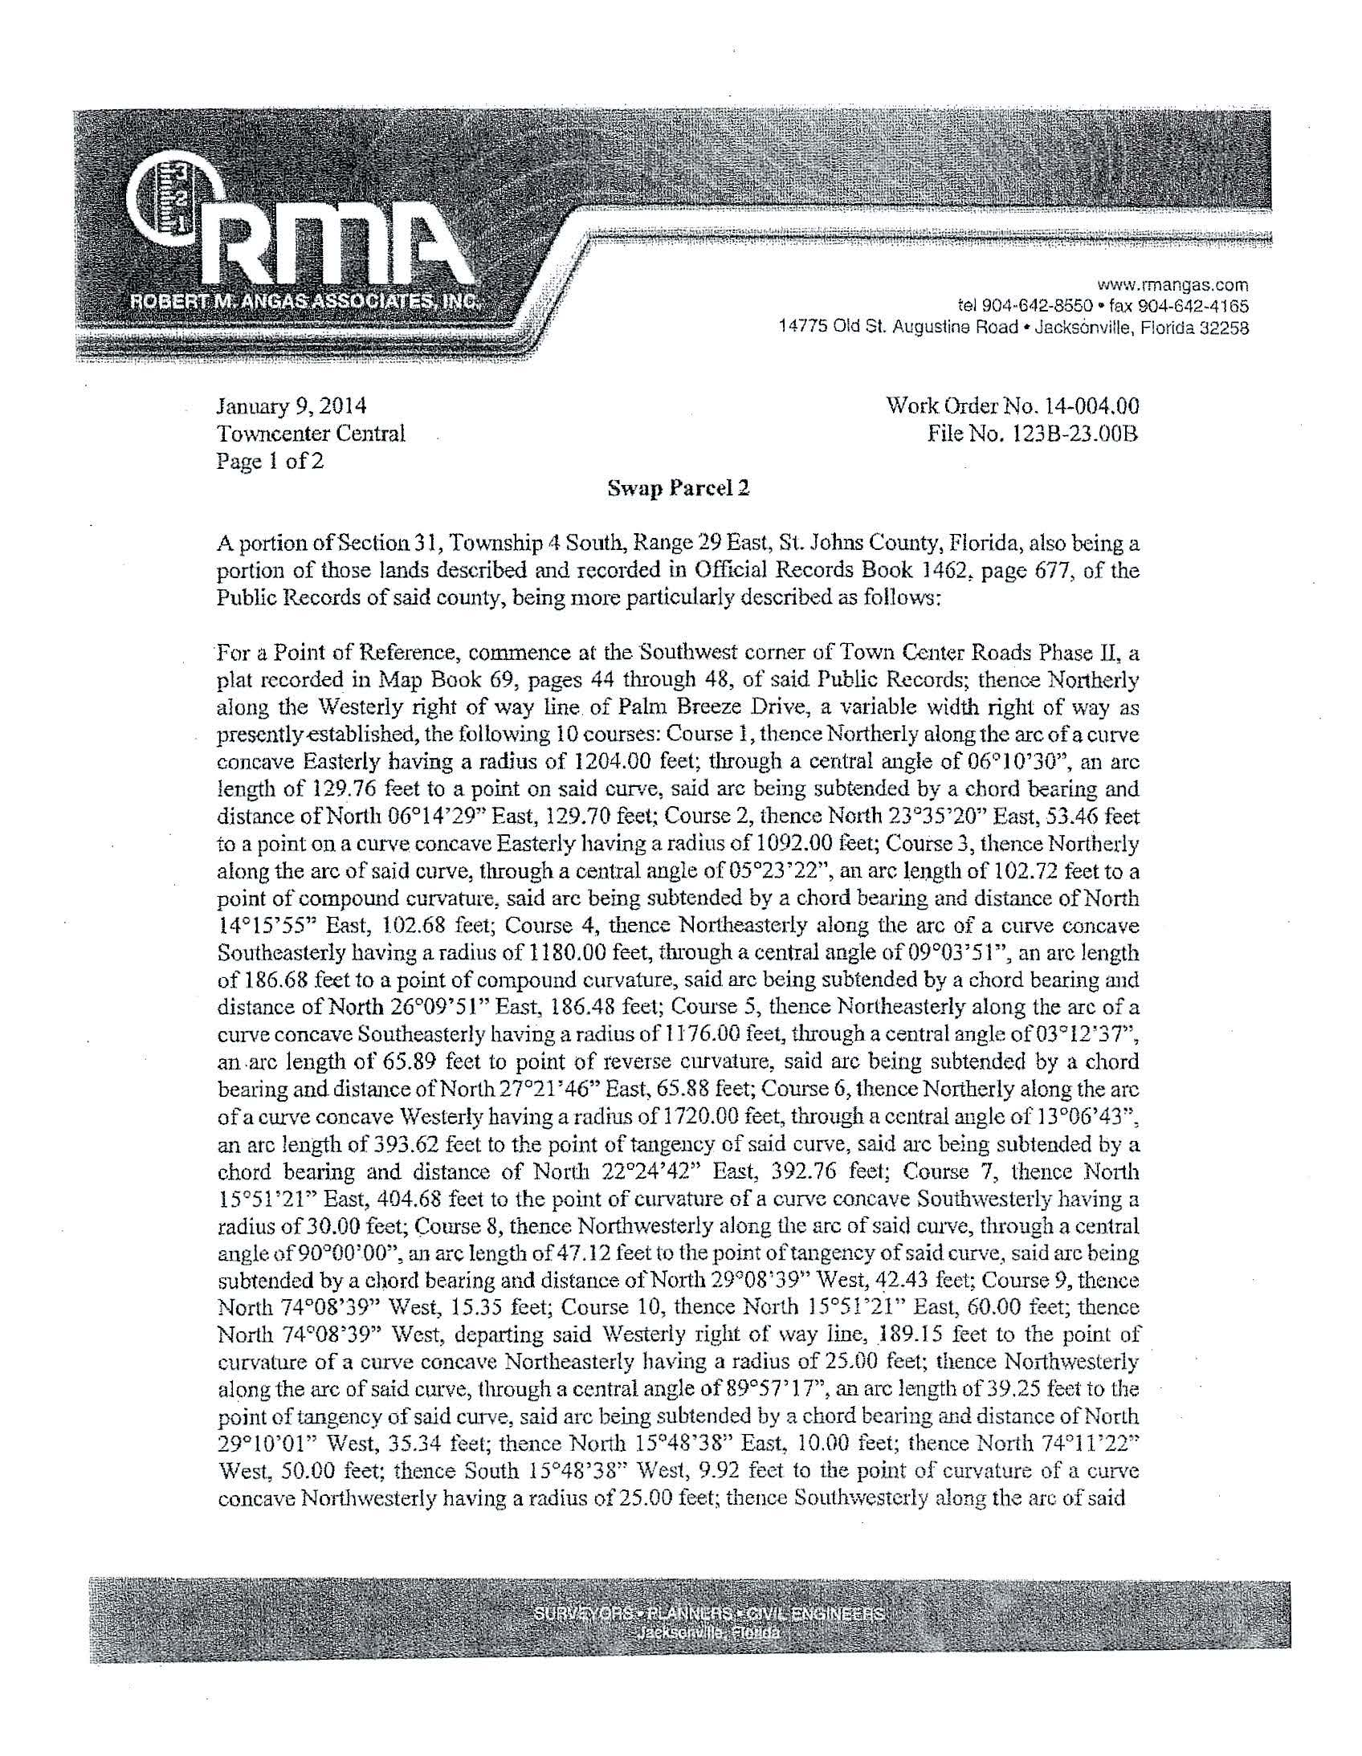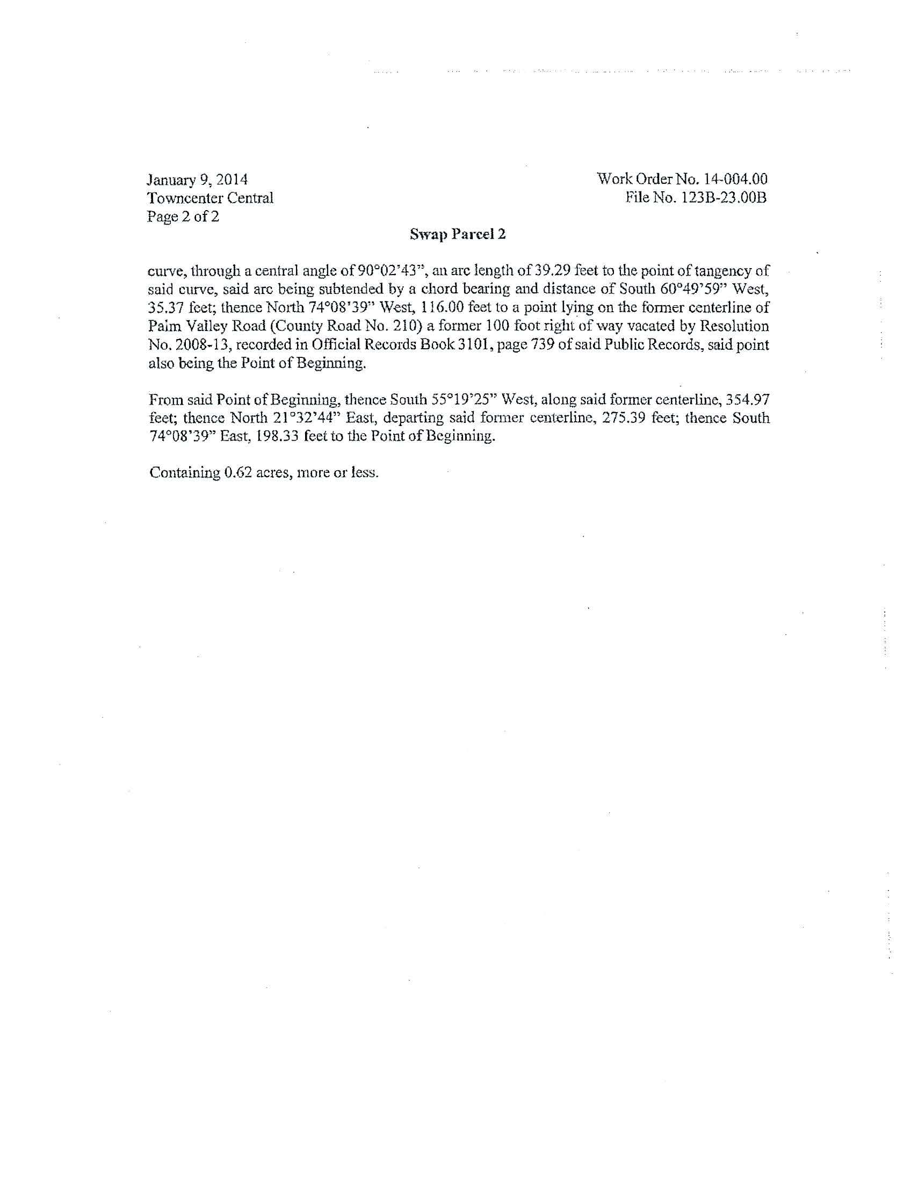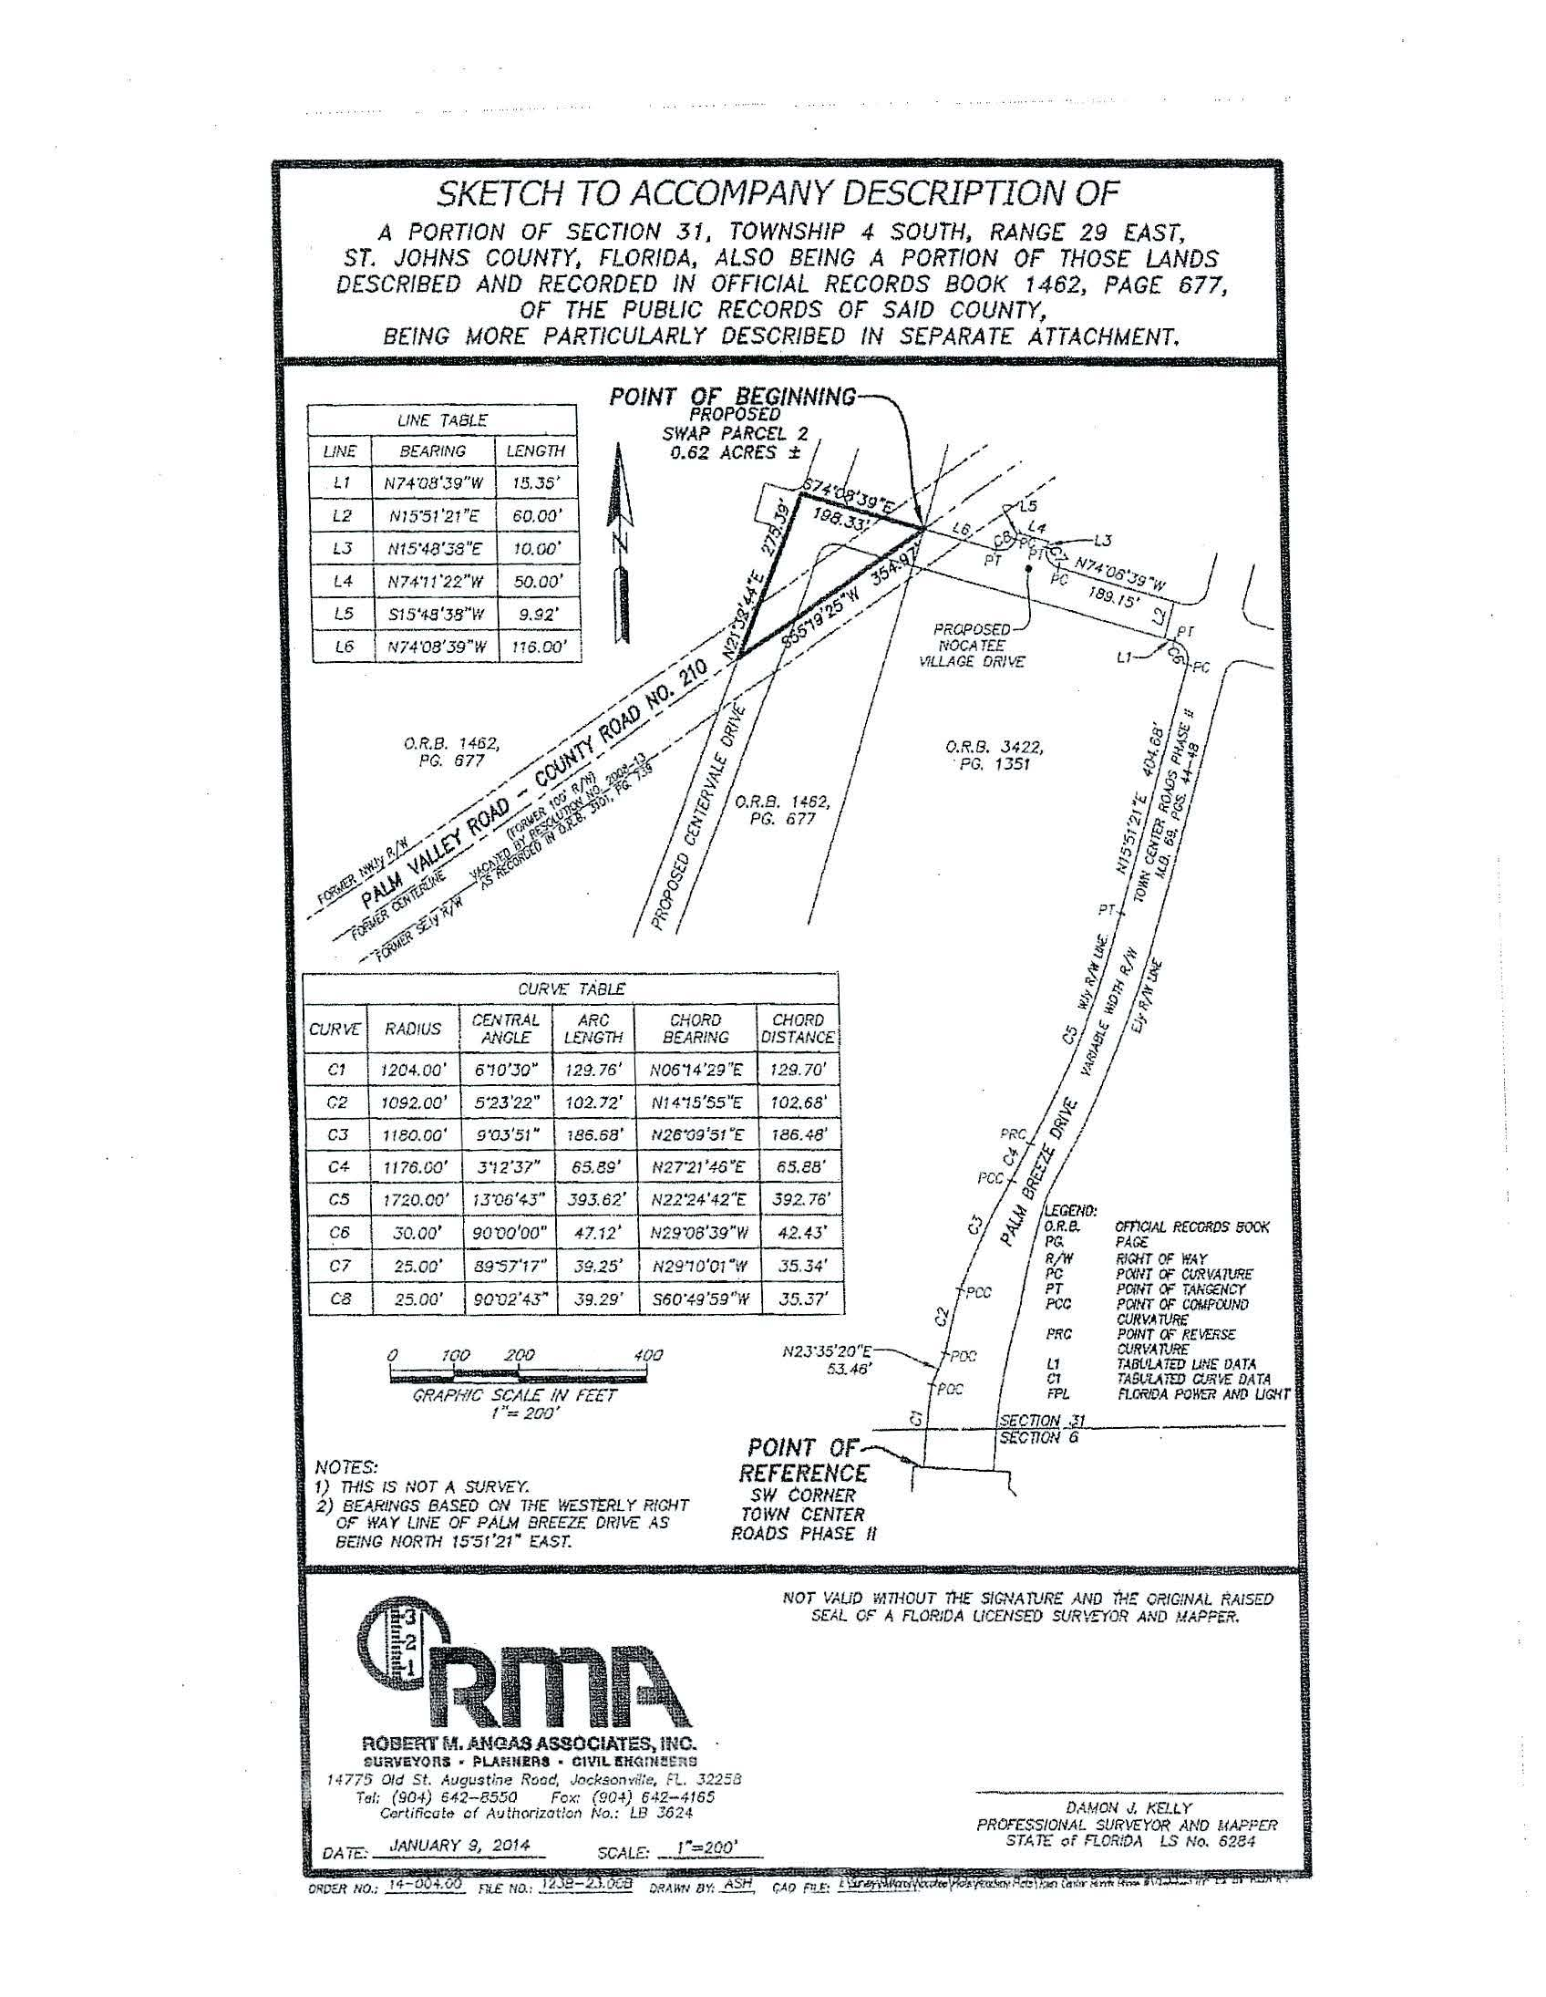
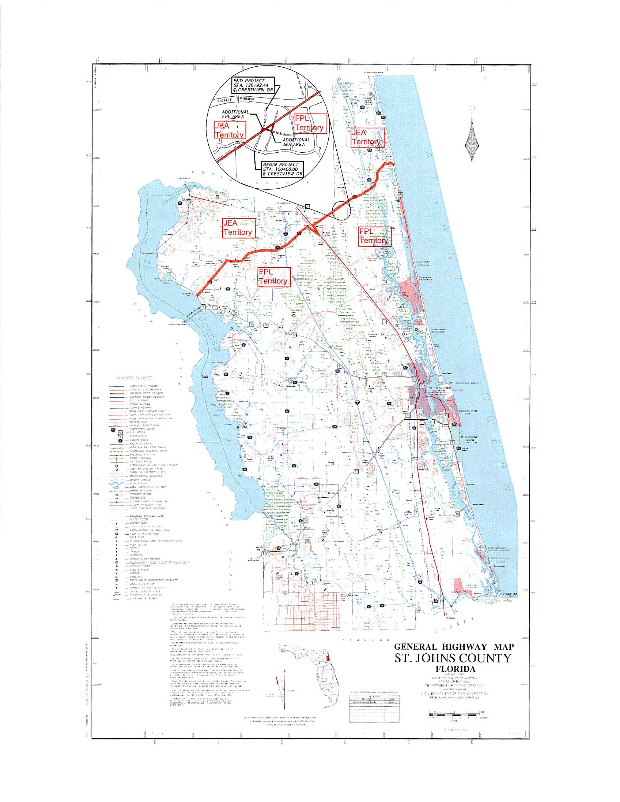

Order No. 9363, issued May 9, 1980, in Docket No. 790886-EU, In re: Petition of Jacksonville Electric Authority for approval of a territorial agreement between JEA and Florida Power and Light Company.
Order No. PSC-96-0212-FOF-EU, issued February 14, 1996 and finalized by Order No. PSC-96-0755-FOF-EU, issued June 10, 1996, in Docket No. 950307-EU, In re: Petition of Jacksonville Electric Authority to Resolve a Territorial Dispute With Florida Power & Light Company in St. Johns County.
Order No. PSC-98-1687-FOF-EU, issued December 14, 1998, in Docket No. 980755-EU, In re: Joint petition for approval of new territorial agreement between Florida Power & Light Company and Jacksonville Electric Authority.
Order No. PSC-12-0561-PAA-EU, issued October 22, 2012, in Docket No. 120171-EU, In re: Joint petition for approval of amendment to territorial agreement in St. Johns County between Florida Power & Light Company, a Florida corporation, and JEA, a Florida municipal corporation.

