State of Florida   |  | Public Service Commission  Capital Circle Office Center ● 2540 Shumard Oak Boulevard  Tallahassee, Florida 32399-0850  -M-E-M-O-R-A-N-D-U-M-
DATE: | September 22, 2014
TO: | Office of Commission Clerk (Stauffer)
FROM: | Division of Economics (Garl)  Office of the General Counsel (Mapp)
RE: | Docket No. 140151-GU – Petition for approval to close firm transportation service - 13 rate schedule, by Florida Division of Chesapeake Utilities Corporation.
AGENDA: | 10/02/14 – Regular Agenda – Tariff Filing – Interested Persons May Participate
COMMISSIONERS ASSIGNED: |  |  | All Commissioners
PREHEARING OFFICER: |  |  | Edgar
CRITICAL DATES: |  |  | 10/12/14 (60-Day Suspension Date)
SPECIAL INSTRUCTIONS: |  |  | None

Case Background
On August 13, 2014, the Florida Division of Chesapeake Utilities Corporation (Chesapeake) filed a petition requesting Commission approval to close its Firm Transportation Service-13 (FTS-13) rate schedule to new customers. The Commission last reviewed the FTS-13 rate schedule in Chesapeake’s 2009 rate case, acknowledging that the rate was based on unique circumstances of the one customer taking service under this rate, the Mosaic phosphate company. Mosaic has the ability to bypass Chesapeake’s distribution system since the Florida Gas Transmission (FGT) pipeline traverses Mosaic’s property and Mosaic could directly interconnect with FGT. The FTS-13 Firm Transportation Charge was developed as a retention rate based on Mosaic’s cost to bypass Chesapeake. Mosaic is the only customer on the rate, but the rate is open to any other qualified customer. The Commission has jurisdiction in this matter pursuant to Section 366.06, Florida Statutes.
Discussion of Issues
Issue 1:1
Should the Commission approve Chesapeake’s proposal to close rate schedule FTS-13 to new customers?
Recommendation:
Yes. Staff recommends approval of Chesapeake’s proposal to close rate schedule FTS-13 to new customers. The proposed tariff should become effective on October 2, 2014. (Garl)
Staff Analysis: As mentioned in the case background, the Commission reviewed the FTS-13 rate, along with all other rate schedules, during Chesapeake’s last rate case in 2009. At that time, the FTS-13 rate covered the cost to serve Mosaic, the one customer taking service under that rate. Chesapeake’s 2nd Quarter Earnings Surveillance Reports for 2014, dated August 8, 2014, shows a rate of return within the Commission-approved range.
Chesapeake acknowledged in its petition that rate schedule FTS-13 was created for Mosaic and is more akin to a special contract. The rate was specifically designed to retain this customer and to cover the cost to serve Mosaic so the general body of ratepayers did not subsidize service to this one customer.
Chesapeake further explained that a new customer seeking service under the same tariff may not have the same cost to serve profile as Mosaic. A different cost profile could result in Chesapeake’s FTS-13 rate schedule not covering the cost to serve the new customer, thereby causing Chesapeake to loose revenues and the new customer being subsidized by the general body of ratepayers. Chesapeake stated that it knows of no such potential customers.
Chesapeake proposed to retain Mosaic on the FTS-13 rate schedule, i.e. grandfather the only customer, until Chesapeake files for a rate case or Mosaic terminates service with Chesapeake, whichever occurs first. Upon filing of a rate case, Chesapeake would reassess whether the rate for Mosaic continues to recover the cost to serve Mosaic, and whether it would be more appropriate to either move Mosaic to another rate class or attempt to establish a special contract with Mosaic.
Conclusion
Special contracts can be individually tailored for customers that have the option to bypass a utility. In this case, the “open-tariff” should be closed to ensure that special contracts are used to retain at-risk customers.
Staff believes Chesapeake’s proposal to close rate schedule FTS-13 to new customers, and to grandfather Mosaic under the FTS-13 rate is in the best interest of Chesapeake and its ratepayers. The proposed tariff should become effective October 2, 2014. The proposed tariff revision is included as Attachment A. Staff recommends approval of Chesapeake’s request.
Issue 2:2
Should this docket be closed?
Recommendation:
Yes. If Issue 1 is approved, and a protest is filed within 21 days of the issuance of the order, the tariff should remain in effect, with any increase in revenue collected held subject to refund, pending resolution of the protest. If no timely protest is filed, this docket should be closed upon the issuance of a consummating order. (Mapp)
Staff Analysis:
If Issue 1 is approved, and a protest is filed within 21 days of the issuance of the order, the tariff should remain in effect, with any increase in revenue collected held subject to refund, pending resolution of the protest. If no timely protest is filed, this docket should be closed upon the issuance of a consummating order.

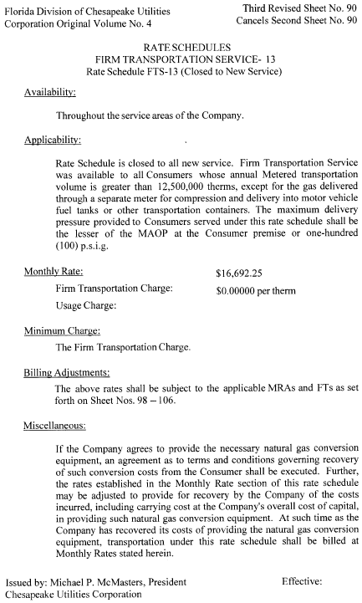

See Order No. PSC-10-0029-PAA-GU, issued January 14, 2010, in Docket No. 090125-GU, In re: Petition for increase in rates by Florida Division of Chesapeake Utilities Corporation.
Id.
Florida Public Utilities Company (Electric and all Gas Divisions), and Central Florida Gas (Florida Division of Chesapeake Utilities Corporation) 2nd Quarter Surveillance Reports, available at http://www.floridapsc.com/library/ Financials/GU616-DOCS/EARNINGS-SURVEILLANCE/GU616-2014-06-ESR.pdf.

