State of Florida   |  | Public Service Commission  Capital Circle Office Center ● 2540 Shumard Oak Boulevard  Tallahassee, Florida 32399-0850  -M-E-M-O-R-A-N-D-U-M-
DATE: | November 13, 2014
TO: | Office of Commission Clerk (Stauffer)
FROM: | Office of the General Counsel (Page)  Division of Accounting and Finance (Bulecza-Banks)  Office of Auditing and Performance Analysis (Mailhot)  Division of Economics (Rome)
RE: | Docket No. 140124-PU – Amendment of Rule 25-6.014, F.A.C., Records and Reports in General, Rule 25-6.015, F.A.C., Location and Preservation of Records, Rule 25-7.014, F.A.C., Records and Reports in General, Rule 25-7.015, F.A.C., Location and Preservation of Records, and Rule 25-7.0461, F.A.C., Capitalization Versus Expensing.
AGENDA: | 11/25/14 – Regular Agenda – Interested Persons May Participate
COMMISSIONERS ASSIGNED: |  |  | All Commissioners
PREHEARING OFFICER: |  |  | Brown
RULE STATUS: |  |  | Proposal May Be Deferred
SPECIAL INSTRUCTIONS: |  |  | None

Case Background
Rule 25-6.014, Florida Administrative Code (F.A.C.), Records and Reports in General, Rule 25-6.015, F.A.C., Location and Preservation of Records, Rule 25-7.014, F.A.C., Records and Reports in General, Rule 25-7.015, F.A.C., Location and Preservation of Records, and Rule 25-7.0461, F.A.C., Capitalization Versus Expensing, address the Commission’s authority to inspect records and establish accounting principles and record keeping requirements for electric and gas utilities. The rules implement Section 350.115, Florida Statutes (F.S.), Section 366.02(2), F.S., Section 366.04(2)(a) and (f), F.S., Section 366.05(1),(9), and (11), F.S., Section 366.08, F.S., and Section 366.093(1), F.S. Staff initiated rulemaking to conform the rules to the federal Uniform System of Accounts (USOA) (2013), applicable to electric and gas utilities, and to clarify and update the rules.

The Commission’s Notice of Development of Rulemaking was published on February 5, 2014, in Volume 40, Number 24, of the Florida Administrative Register. No rule development workshop was requested, and thus a workshop was not held. However, comments were received from Duke Energy Florida, Inc., (DEF) and Gulf Power Company (Gulf).

On September 29, 2014, this rulemaking was deferred from the October 2, 2014 Agenda to the November 25, 2014 Agenda. On October 7, 2014, the Office of Public Counsel (OPC) filed comments. DEF submitted further comments in which it indicated that DEF, Florida Power & Light Company, Gulf Power, and Tampa Electric Company agreed with OPC’s comments.

This revised recommendation addresses whether the Commission should propose the amendment of the rules. The Commission has jurisdiction pursuant to Section 120.54, F.S., and Section 366.04, F.S.

Discussion of Issues
Issue 1:1
Should the Commission propose the amendment of Rule 25-6.014, F.A.C., Records and Reports in General, Rule 25-6.015, F.A.C., Location and Preservation of Records, Rule 25-7.014, F.A.C., Records and Reports in General, Rule 25-7.015, F.A.C., Location and Preservation of Records, and Rule 25-7.0461, F.A.C., Capitalization Versus Expensing?
Recommendation:
Yes, the Commission should propose the amendment of Rules 25-6.014, 25-6.015, 25-7.014, 25-7.015, and 25-7.0461, F.A.C., as set forth in Attachment A. (Page, Bulecza-Banks, Mailhot, Rome)
Staff Analysis: Rules 25-6.014, 25-6.015, 25-7.014, 25-7.015, and 25-7.0461, F.A.C., implement the Commission’s statutory authority to prescribe uniform systems and classifications of accounts and to inspect electric and gas utility records. Pursuant to Section 350.115, F.S., the Commission has authority to prescribe by rule uniform systems and classifications of accounts for utilities. Section 366.04(2)(a), and (f), F.S., authorizes the Commission to require the filing of periodic reports by electric and gas utilities. Section 366.093(1), F.S., grants the Commission continuous reasonable access to all utility records. Section 366.08, F.S., authorizes the Commission to visit a utility at any reasonable time to conduct inspections and investigations. Section 366.05(11), F.S., establishes the Commission’s authority to assess the utility reasonable travel costs incurred in reviewing records kept outside of Florida.
Staff recommends that Rules 25-6.014, 25-6.015, 25-7.014, 25-7.015, and 25-7.0461, F.A.C., be amended as set forth in Attachment A. All references to the USOA have been updated to indicate the 2013 version of the federal regulations. Staff also recommends that the references in Rule 25-6.015(2)(b)2., F.A.C., and Rule 25-7.015(2)(b)2., FA.C., to a utility located within 50 miles of the Florida state line be stricken because this utility no longer exists. Other substantive recommended rule amendments are discussed in more detail below.

- Electric Utilities

A. Reports and Inspection of Records

Rule 25-6.014(4), F.A.C., implements Section 366.04(2)(f), F.S. Currently, several provisions of Rule 25-6.014(4), F.A.C., reiterate the Commission’s authority under Section 366.04(2)(f), F.S., to require the filing of reports and other data by electric utilities. Rule 25-6.014(5), F.A.C., implements Section 366.08, F.S. Rule 25-6.014(5), F.A.C., reiterates the Commission’s authority under Section 366.08, F.S., to inspect all records of electric utilities.

Pursuant to Section 120.545, F.S., the Joint Administrative Procedures Committee may object to rule language that reiterates or paraphrases statutory language. Therefore, staff recommends Rule 25-6.014(4) and (5), F.A.C., be amended to eliminate the reiteration of the statutes.

B. Original Source Documents

Commission Rule 25-6.015(3)(b), F.A.C., requires that all original source documents, including sales invoices, cash receipts, and cash register slips, be retained for a minimum of three years after the document was created or received by the utility. Rule 25-6.015(3)(b), F.A.C., also provides that the Commission may grant a waiver of this requirement if the utility shows that it employs a storage and retrieval system that produces clear, readable copies which are substantially equivalent to the original documents. Staff recommends an amendment substituting the term “identical” for the subjective term “substantially equivalent.”

Staff recommends that Rule 25-6.015(3)(b), F.A.C., be amended so that utilities will not be required to retain original source documents for a minimum of three years if the documents have been added to a storage and retrieval system. In comments provided to staff, Gulf suggested this amendment, stating that the amendment is supported by DEF, Florida Power & Light Company, and Tampa Electric Company. OPC also supports this amendment. It has been staff’s experience that this amendment reflects the current practice of electric utilities to store original source documents in modern storage and retrieval systems.

C. Out-of-State Records

Rule 25-6.015(2)(b)1., F.A.C., provides for a waiver of the electric utility’s obligation to reimburse the Commission for reasonable travel expenses. The waiver is contingent upon the electric utility’s making its out-of-state records available at the utility’s office located in Florida or at another mutually agreed upon location in Florida within 10 working days from the Commission’s initial request.

Staff recommends an amendment to the rule providing that if the electric utility demonstrates that 10 working days is not reasonable because of the complexity and nature of the issues involved or the volume and type of material requested, the Commission will establish a different time frame to bring records into the state. The amendment clarifies that the utility must request approval to obtain a different time frame for production of records.

- Gas Utilities

- Reports and Inspection of Records

Rule 25-7.014(5), F.A.C., implements Section 366.04(1)(f), F.S. Currently, several provisions of Rule 25-7.014(5), F.A.C., reiterate the Commission’s authority under Section 366.04(1)(f), F.S., to require the filing of reports and other data by gas utilities. Rule 25-7.014(7), F.A.C., implements Section 366.08, F.S., and reiterates the Commission’s authority under Section 366.08, F.S., to inspect all records of gas utilities.

Pursuant to Section 120.545, F.S., the Joint Administrative Procedures Committee may object to rule language that reiterates or paraphrases statutory language. Therefore, staff recommends Rule 25-7.014(5) and (7), F.A.C., be amended to eliminate the reiteration of the statutes.

- List of Retirement Units

Subsection (12) of Rule 25-7.0461, F.A.C., currently refers to the List of Retirement Units. Staff recommends that subsection (12) be deleted and moved to subsection (2)(i), the definition section of the rule. Staff believes that this will make the rule clearer.

- Original Source Documents

Rule 25-7.015(3)(b), F.A.C., requires gas utilities to retain original source documents for three years. Staff is recommending above that this requirement be removed for electric utilities in Rule 25-6.015, F.A.C. Unlike electric utilities, gas utilities generally do not retain original source documents in up-to-date storage and retrieval systems. Therefore, staff recommends that the language in Rule 25-7.015(3)(b), F.A.C., not be amended. The rule will continue to require gas utilities to retain original source documents for the Commission’s required minimum three year records retention period.

Rule 25-7.015(3)(b), F.A.C., also provides that gas utilities have the option to request approval from the Commission to waive the requirement that original source documents be retained for a minimum of three years. Staff recommends that the existing waiver provision remain available to gas utilities. Staff recommends, however, that the language in the waiver provision be amended to state that in order to obtain the waiver, the gas utility must show that it employs a storage and retrieval system that consistently produces clear, readable copies that are identical to the originals, including any handwritten notations on the documents. Staff also recommends amending the rule to substitute the term “identical” for the subjective term “substantially equivalent.”

- Out-of-State Records

Rule 25-7.015(2)(b)1., F.A.C., requires that gas utilities show good cause for an extension of time to produce out-of-state records. Under the rule, a finding of good cause is based upon several factors, including the volume of the records and whether the utility has worked diligently to assemble the records. Staff recommends that this language be stricken and the rule amended to reflect the amended language in Rule 25-6.015(2)(b)1., F.A.C. Under the rule amendment, if the gas utility demonstrates that 10 working days is not reasonable because of the complexity and nature of the issues involved or the volume and type of material requested, the Commission will establish a different time frame to bring records into the state.

- Statement of Estimated Regulatory Costs

Pursuant to Section 120.54, F.S., agencies are encouraged to prepare a statement of estimated regulatory costs (SERC) before the adoption, amendment, or repeal of any rule. The SERC is appended as Attachment B to this recommendation. The SERC analysis includes whether the rule amendment is likely to have an adverse impact on growth, private sector job creation or employment, or private sector investment in excess of $1 million in the aggregate within five years after implementation.
The SERC concludes that the rule amendments will likely not directly or indirectly increase regulatory costs in excess of $200,000 in the aggregate in Florida within one year after implementation. The SERC also states that it is anticipated that investor-owned electric and gas utilities may benefit from the rule updates and clarifications. Further, the SERC concludes that the rule amendments will not likely have an adverse impact on economic growth, private-sector job creation or employment, private-sector investment, business competitiveness, productivity, or innovation in excess of $1 million in the aggregate within five years of implementation. Thus, the rule amendments do not require legislative ratification pursuant to Section 120.541(3), F.S. In addition, the SERC states that the rule amendments will not have an adverse impact on small business and will have no impact on small cities or small counties.
- Conclusion
Based on the foregoing, staff recommends that Rules 25-6.014, 25-6.015, 25-7.014, 25-7.015, and 25-7.0461, F.A.C., be amended as set forth in Attachment A.
Issue 2:2
Should this docket be closed?
Recommendation:
Yes. If no requests for hearing or comments are filed, the rules may be filed with the Department of State, and this docket should be closed. (Page)
Staff Analysis:
If no requests for hearing or comments are filed, the rules may be filed with the Department of State, and this docket should be closed.

25-6.014 Records and Reports in General.
(1) Except as modified in subsection (2), eEach investor-owned electric utility shall maintain its accounts and records in conformity with the Uniform System of Accounts (USOA) for Public Utilities and Licensees as found in the Code of Federal Regulations, Title 18, Subchapter C, Part 101, for Major Utilities (2013) as revised April 1, 2002, which is hereby incorporated by reference into this rule and as modified below. may be accessed at http://www.flrules.org[hyperlink address]. All inquiries relating to interpretation of the USOA shall be submitted to the Commission’s Division of Accounting and Finance in writing.
(2) For ratemaking purposes only, each investor-owned electric utility shall accrue unbilled base rate revenues, excluding those base rate revenues recoverable through other cost recovery or adjustment mechanisms.
(3) Each utility shall establish and maintain continuing property records in conformity with the plant accounts prescribed in the USOA. The records shall be compiled on the basis of original cost or other book cost consistent with the provisions of the USOA. The continuing property records or records supplemental thereto shall contain such detailed description and classification of property record units that will permit their ready identification and verification. They shall be maintained in such manner as will meet the following basic objectives:
(a) An inventory of property record units which may be readily checked for proof of physical existence;
(b) The association of costs with such property record units to assure accurate accounting for retirements; and
(c) The determination of dates of installation and removal of plant to provide data for use in connection with depreciation studies.
(4) Each utility shall furnish to the Commission at such time and in such form as the Commission may require, the results of any required tests and summaries of any required records. The utility shall also furnish the Commission with any information concerning the utility’s facilities or operation which the Commission may request and require for determining rates and judging the practices of the utility. For each utility providing data to the Commission, aAll such data, unless otherwise specified, shall be consistent with and reconcilable with the utility’s Annual Report to the Commission.
(5) Upon direction of the Commission, or in the performance of delegated staff duties, any member of the Commission staff may make at any reasonable time a personal visit to the utility’s offices or other places of business, and may inspect any facility, records, accounts, books, reports, and papers of the utility which may appear necessary in the discharge of Commission duties. During such visits authorized by Section 366.08, F.S., the utility shall provide staff members with adequate and comfortable working and filing space, consistent with prevailing conditions and climate and comparable with the accommodations provided to the utility’s outside auditors.
(6) The Commission prescribes the Uniform System of Accounts for Public Utilities and Licensees, as found in the Code of Federal Regulations, Title 18, Subchapter C, Part 101, for Major Utilities (2013) as revised April 1, 2002, to be used by Rural Electric Cooperative and Municipal Electric Utilities operating within the State. All inquiries relating to interpretations of the USOA Uniform System of Accounts shall be submitted to the Commission’s Division of Accounting and Finance in writing.
Rulemaking Specific Authority 350.127(2), 366.05(1) FS. Law Implemented 350.115, 366.02(2), 366.04(2)(a), (f), 366.05(1), 366.08 FS. History–Amended 7-29-69, 2-4-76, 8-21-79, 1-2-80, 11-18-82, Formerly 25-6.14, Amended 10-1-86, 11-2-87, 7-20-89, 12-27-94, 4-22-96, 3-30-04, ______________
25-6.015 Location and Preservation of Records.
(1) All records that a utility is required to keep by reason of these or other rules prescribed by the Commission shall be kept at the office or offices of the utility within this state, unless otherwise authorized by the Commission.
(2) Any utility that keeps its records outside of the state shall reimburse the Commission for the reasonable travel expenses incurred by each Commission representative during any review of the out-of-state records of the utility or its affiliates. Reasonable travel expenses are those travel expenses that are equivalent to travel expenses paid by the Commission in the ordinary course of its business.
(a) The utility shall remit reimbursement for out-of-state travel expenses within 30 days from the date the Commission mails the invoice.
(b) The reimbursement requirement in subsection (2) shall be waived:
1. fFor any utility that makes its out-of-state records available at the utility’s office located in Florida or at another mutually agreed upon location in Florida within 10 working days from the Commission’s initial request. If the utility demonstrates that 10 working days is not reasonable because of the complexity and nature of the issues involved or the volume and type of material requested, the Commission will may establish a different time frame for the utility to bring records into the state. For individual data requests made during an audit, the response time frame in Rule 25-6.0151, F.A.C., shall control.; or
2. For a utility whose records are located within 50 miles of the Florida state line.
(3) All records shall be preserved in accordance with the Federal Energy Regulatory Commission’s regulations, Title 18, Subchapter C, Part 125, Code of Federal Regulations, entitled “Preservation of Records of Public Utilities and Licensees” (2013) as revised, April 1, 2002, which is hereby incorporated by reference into this rule, with the exception of the records listed in paragraph (3)(a) of this rule. and may be accessed at http://www.flrules.org[hyperlink address]. Instead, utilities shall retain records listed in paragraph (3)(a) of this rule for the periods indicated.
(a) The Code of Federal Regulations items listed below are exceptions to the Schedule of Records and Periods of Retention contained in Title 18, Subchapter C, Section 125.3, Code of Federal Regulations:
1. Item 2(a), minute books of stockholders’, directors’, and directors’ committee meetings, earlier of 20 years or termination of the corporation’s existence;
2. Item 6(a)(1), general ledgers, 20 years;
3. Item 6(a)(2), ledgers: subsidiary or auxiliary, 20 years;
4. Item 7, journals: general and subsidiary, 20 years;
5. Item 8(a), journal vouchers and journal entries, 20 years; and
6. Item 20(a), appraisals and valuations made by the company of its properties or investments or of the properties or investments of any associated companies (includes all records essential thereto), 10 years after appraisal.
(b) The utility shall not be required to retain original source documents once the documents have been added to a storage and retrieval system that consistently produces clear, readable copies of source documents and the content of the documents is identical to the originals including any handwritten notations on the documents.
(b) However, all source documents retained as required by Title 18, Subchapter C, Part 125, Code of Federal Regulations shall be maintained in their original form for a minimum of three years, or for any lesser period of time specified for that type of record in Title 18, Subchapter C, Part 125, Code of Federal Regulations, after the date the document was created or received by the utility. This paragraph does not require the utility to create paper copies of documents where the utility would not otherwise do so in the ordinary course of its business. The Commission will waive the requirement that documents be retained in their original form upon a showing by a utility that it employs a storage and retrieval system that consistently produces clear, readable copies that are substantially equivalent to the originals, and clearly reproduces handwritten notations on documents.
(c) The utility shall maintain written procedures governing the conversion of source documents to a storage and retrieval system, which procedures ensure the authenticity of documents and the completeness of records. Records maintained in the storage and retrieval system must be searchable easy to search and readable easy to read.
Rulemaking Specific Authority 350.127(2), 366.05(1) FS. Law Implemented 366.05(1), (9), (11), 366.08, 366.093(1) FS. History–Amended 7-29-69, 7-19-72, 1-11-76, 9-28-81, 11-18-82, Formerly 25-6.15, Amended 10-1-86, 11-2-87, 6-23-93, 11-13-95, 6-6-04, ___________.

25-7.014 Records and Reports in General.
(1) Except as modified in subsection (4), eEach natural gas utility shall maintain its accounts and records in conformity with the Uniform System of Accounts for Natural Gas Companies (USOA) as found in the Code of Federal Regulations, Title 18, Subchapter F, Part 201, for Major Utilities (2013) as revised, April 1, 2002, which is hereby incorporated by reference, and as modified below. may be accessed at http://www.flrules.org[hyperlink address]. All inquiries relating to interpretation of the USOA shall be submitted to the Commission’s Division of Accounting and Finance in writing.
(2) Each utility shall establish and maintain continuing property records in conformity with the plant accounts prescribed in the USOA. The records shall be compiled on the basis of original cost or other book cost consistent with the provisions of the USOA. The continuing property records or records supplemental thereto shall contain such detailed description and classification of property record units that will permit their ready identification and verification. They shall be maintained in such manner as will meet the following basic objectives:
(a) An inventory of property record units which may be readily checked for proof of physical existence;
(b) The association of costs with such property record units to assure accurate accounting for retirements; and
(c) The determination of dates of installation and removal of plant to provide data for use in connection with depreciation studies.
(3) Each gas utility shall maintain its depreciation rates and depreciation reserve by primary account as prescribed in the Uniform System and Classification of Accounts.
(4) For ratemaking purposes only, each investor-owned natural gas utility shall accrue unbilled base rate revenues, excluding those base rate revenues recoverable through other cost recovery or adjustment mechanisms.
(5) Each utility shall furnish to the Commission at such time and in such form as the Commission may require, the results of any required tests and summaries of any required records. The utility shall also furnish the Commission with any information concerning the utility’s facilities or operation which the Commission may request and require for determining rates and judging the practices of the utility. For each utility providing data to the Commission, aAll such data, unless otherwise specified, shall be consistent with and reconcilable with the utility’s Annual Report to the Commission.
(6) The results of all tests, summaries, records and reports required by the Commission (including the Annual Report) shall, where appropriate, be reported on a therm basis rather than a volumetric or MCF basis.
(7) Upon direction of the Commission, or in the performance of delegated staff duties, any member of the Commission staff may make at any reasonable time a personal visit to the utility’s offices or other places of business, and may inspect any facility, records, accounts, books, reports, and papers of the utility which may appear necessary in the discharge of Commission duties. During such visits authorized by section 366.08, F.S., the utility shall provide staff members with adequate and comfortable working and filing space, consistent with prevailing conditions and climate and comparable with the accommodations provided to the utility’s outside auditors.
Rulemaking Specific Authority 366.05(1), 350.127(2) FS. Law Implemented 366.05(1), 366.08, FS. History–Amended 7-19-72, Repromulgated 1-8-75, 5-4-75, Amended 12-30-75, 9-28-81, 11-18-82, Formerly 25-7.14, Amended 10-1-86, 4-3-88, 7-20-89, 12-27-94, 4-22-96, 12-8-03, ______.

25-7.015 Location and Preservation of Records.
(1) All records that a utility is required to keep, by reason of these or other rules prescribed by the Commission, shall be kept at the office or offices of the utility within the state, unless otherwise authorized by the Commission. Such records shall be open for inspection by the Commission or its authorized representatives at any and all reasonable times.
(2) Any utility that keeps its records outside of the state shall reimburse the Commission for the reasonable travel expenses incurred by each Commission representative during any review of the out-of-state records of the utility or its affiliates. Reasonable travel expenses are those travel expenses that are equivalent to travel expenses paid by the Commission in the ordinary course of its business.
(a) The utility shall remit reimbursement for out-of-state travel expenses within 30 days from the date the Commission mails the invoice.
(b) The reimbursement requirement in subsection (2) shall be waived:
1. fFor any utility that makes its out-of-state records available at the utility’s office located in Florida or at another mutually agreed upon location in Florida within 10 working days from the Commission’s initial request. If the a utility demonstrates that would like more than 10 working days, is not reasonable because of the complexity and nature of the issues involved or the volume and type of material requested, the Commission will establish a different time frame for the utility to bring records into the state it must submit a request for approval of a time extension stating the date by which it would like to make the records available. A request for approval of a time extension shall only be granted for good cause. To establish good cause for a time extension, the utility must show that:
a. The nature of the issues, the volume of the records, or the type of record is such that assembling and providing the records requires more than 10 days;
b. The utility has worked diligently to assemble the records; and
c. The additional time requested is both reasonable and necessary given the utility’s particular circumstances. For individual data requests made during an audit, the response time frame established in Rule 25-7.0151, F.A.C., shall control.; or
2. For a utility whose records are located within 50 miles of the Florida state line.
(3) All records shall be preserved in accordance with the Federal Energy Regulatory Commission’s regulations, Title 18, Subchapter F, Part 225, Code of Federal Regulations, entitled “Preservation of Records of Natural Gas Companies” (2013) as revised, April 1, 2002, which is incorporated by reference into this rule, with the exception of the records listed in paragraph (3)(a) of this rule and may be accessed at http://www.flrules.org[hyperlink address]. Instead, utilities shall retain records listed in paragraph (3)(a) of this rule for the periods indicated.
(a) The Code of Federal Regulations Items listed below are exceptions to the Schedule of Records and Periods of Retention contained in Title 18, Subchapter F, Section 225.3, Code of Federal Regulations:
1. Item 2(a), minute books of stockholders’, directors’, and directors’ committee meetings, earlier of 20 years or termination of corporation’s existence;
2. Item 6(a)(1), general ledgers, 20 years;
3. Item 6(a)(2), ledgers subsidiary or auxiliary, 20 years;
4. Item 7, journals: general and subsidiary, 20 years;
5. Item 8(a), journal vouchers and journal entries, 20 years;
6. Item 20(a), appraisals and valuations made by the company of its properties or investments or of the properties or investments of any associated companies (includes all records essential thereto), 10 years after appraisal.
(b) However, Aall source documents retained as required by Title 18, Subchapter F, Part 225, Code of Federal Regulations, shall be maintained in their original form for a minimum of three years, or for any lesser period of time specified for that type of record in Title 18, Subchapter F, Part 225, Code of Federal Regulations, after the date the document was created or received by the utility. This paragraph does not require the utility to create paper copies of documents where the utility would not otherwise do so in the ordinary course of its business. The A utility may request approval to waive the requirement that documents be retained in their original form. The utility Such request must show that the utility employs a storage and retrieval system that consistently produces clear, readable copies that are identical substantially equivalent to the originals, including any and clearly reproduces handwritten notations on documents.
(c) The utility shall maintain written procedures governing the conversion of source documents to a storage and retrieval system, which procedures ensure the authenticity of documents and the completeness of records. Records maintained in the storage and retrieval system must be searchable easy to search and readable easy to read.
Rulemaking Specific Authority 366.05(1), (9), (11), 366.08, 366.093(1), 350.127(2) FS. Law Implemented 366.05(1), (9), (11), 366.08, 366.093(1) FS. History–Amended 7-19-72, Repromulgated 1-8-75, Amended 5-4-75, 12-30-75, 9-28-81, 11-18-82, Formerly 25-7.15, Amended 10-1-86, 4-3-88, 11-13-95, 12-8-03, _________.

25-7.0461 Capitalization Versus Expensing.
(1) Except as provided in subsections (2)-(11) of this rule, tThe rules and definitions set forth below are intended to establish capitalization versus expensing guidelines and uniform retirement units for natural gas utilities and do not relieve any utility from maintaining its accounts and records in conformity with the Uniform System of Accounts prescribed by the Code of Federal Regulations, Title 18, Subchapter F, Part 201 (2013), as revised April 1, 1985 which is incorporated by reference in Rule 25-7.014. F.A.C. except as provided in subsections (2)-(12) of this rule.
(2) For the purposes of this part, the following definitions shall apply:
(a) “Book Cost” means the amount at which a retirement unit is included in a plant account, including all components of labor and installation costs without deduction of related provisions for accrued depreciation. This cost should be determined from the utility’s records and if this cannot be done, it should be estimated.
(b) “Cost” means the original purchased cost plus associated labor and installation costs.
(c) “Cost of Removal” means the cost of demolishing, removing, tearing down or otherwise disposing of a retirement unit, including the cost of transportation and handling.
(d) “Cradle-To-Grave Accounting” means an accounting method which treats a unit of plant as being in service from the time it is first purchased until it is finally junked or is otherwise finally disposed of. The period in shop for refurbishing, and in stock/inventory awaiting reinstallation are treated as being in service.
(e) “Gross Salvage” means the amount received from selling or trading-in a retirement unit; or, if retained, the original (estimated if not known) material cost of the unit. (Original Material Cost = Book Cost Less Labor and Installation Cost)
(f) “Item” means a single identifiable unit of plant. Where a dollar amount (viz., $500 minimum for capitalization) is imposed, this amount limit shall apply to the single item and not to a block or group of such items purchased on one order.
(g) “Minor Item” means any part or element of plant which is not designated as a retirement unit, but is a component part of the retirement unit.
(h) “Retirement” means a retirement unit or unreplaced minor item which has been removed, sold, abandoned, destroyed, or otherwise removed from service. (Exception see “Cradle-to-Grave”)
(i) “Retirement Unit” means an item of utility plant which, when placed into service, is capitalized and when removed from service, with or without replacement, is always retired. The “List of Retirement Units Gas Utilities Effective August 21, 1986” (“List of Retirement Units”) (10/14), is hereby incorporated by reference into this rule and may be accessed at http://www.flrules.org[hyperlink address].
(3) All depreciable property is considered as consisting of (a) retirement units and (b) minor items of property. Each utility shall implement the list of retirement units referred to in subsection (12) of this rule as of the beginning of the next fiscal year following the adoption of this rule. This list can be expanded by any utility without other authorization from this Commission as long as the cost of the additional item is more than $500. In the case of such expansion, the utility should notify the Division of Economics Commission Clerk within thirty days as to the nature and justification of the expansion.
(4) The addition and retirement of retirement units should be accounted for as follows:
(a) When a retirement unit is added for the first time at a location, the cost should be added to the appropriate plant account along with associated labor and installation costs.
(b) When a retirement unit is replaced, the cost of the replacing item should be accounted for in the same manner as in paragraph (a) if the item is cost meets the criteria set forth in the “List of Retirement Units” referred to in subsection (12). Otherwise, the charge should be made to the appropriate expense account.
(c) When a retirement unit is retired, with a replacement that meets the criteria set forth in the “List of Retirement Units,” referred to in subsection (12), or without a replacement, the book cost of the retiring unit should be credited to the plant account in which it is included and likewise debited to the associated account reserve. Any cost of removal and gross salvage associated with the retirement should likewise be debited and credited, respectively, to the account reserve. Costs of the retiring unit, removal and salvage should be recorded within one month of the retirement date and may be estimated with corrective adjustment entries made when the transactions are finalized.
(5) The addition and retirement of minor items of depreciable property should be accounted for as follows:
(a) When a minor item which did not previously exist as a part of a retirement unit at a given location is added, the cost should be accounted for in the same manner as for the addition of a retirement unit if the cost is more than $500. Otherwise, the charge should be made to the appropriate maintenance expense account.
(b) When a minor item having a book cost more than $500 is retired and not replaced, the book cost along with any associated cost of removal and gross salvage should be accounted for in the same manner as for the retirement of a retirement unit. If, however, the book cost of the minor item retired and not replaced has been accounted for by its inclusion in the retirement unit of which it is a part, no separate credit to the property account or debit to the associated account is required.
(c) When a minor item is replaced independently of the retirement unit of which it is a part, the cost of replacement should be charged to the maintenance account appropriate for the item, except that if the replacement effects a substantial betterment (the primary aim of which is to make the property affected more useful, more efficient, of greater durability, or of greater capacity), the excess cost of the replacement over the estimated cost at current prices of replacing without betterment should be charged to the appropriate plant account.
(6) The addition and retirement of meters and regulators should be accounted for as cradle-to-grave. Costs for refurbishing these items should be charged to the appropriate expense accounts.
(7) Overhead construction costs such as engineering, supervision, general office salaries and expenses, construction engineering, insurance, taxes, relief and pensions, injuries and damages should be capitalized only if they are directly associated with the construction project.
(8) All maintenance costs, whether the work is done by the utility or under contract, should be expensed. Unusual or extraordinary expenses can be amortized over a reasonable period of time as determined by the Commission.
(9) Engineering unclassified time should be expensed.
(10) The testing on initial installations of mains and services, meters and regulators should be capitalized. Subsequent testing should be expensed. The testing on uprating to higher pressure should be capitalized.
(11) The initial purchase and installation of valves and testing thereof should be capitalized. Labor costs associated with locating existing valves, moving existing valves, maintenance and monitoring should be expensed.
(12) List of Retirement Units: See “List of Retirement Units (Gas Utilities)”, Effective August 21, 1986 published by the Florida Public Service Commission.
Rulemaking Specific Authority 350.127(2), 366.05(1) FS. Law Implemented 350.115 FS. History–New 8-21-86, _________.

LIST OF RETIREMENT UNITS

GAS UTILITIES

Effective August 21, 1986

Published by:
Florida Public Service Commission
2540 Shumard Oak Boulevard
Tallahassee, Florida 32399-0850
Rule 25-7.0461 (10/14)
LIST OF RETIREMENT UNITS - GAS UTILITIES

This listing sets forth the units of depreciable gas plant authorized by the Florida Public Service Commission to be designated ARetirement Units@. The addition and retirement of retirement units should be in accordance with 25-7.0461.

A. LOCAL STORAGE PLANT

1. Structures and Improvements

The replacement or removal of a portion of a given retirement unit which has a book cost of $10,000 or more should be accounted for in the same manner as for the replacement of a retirement unit. Otherwise, the replacement is charged to the appropriate expense account with no retirement recorded.

a. Structure complete, with or without stack or chimney
b. Air conditioning system, ventilating system, heating system, or any combination thereof
c. Bridge, trestle
d. Bulkhead, retaining wall
e. Drainage and sewerage system
f. Elevator, crane, hoist, complete with operating mechanism
g. Fence complete with gates
h. Fire escape system
i. Fire protection system
j. Light and power system complete
k. Railroad or track system, including culvert
l. Roof, with or without supporting members
m. Water supply system, including well
n. Yard drainage system
o. Yard lighting system
p. Landscaping
q. Paving
r. Floor covering (permanently attached)
s. Painting (first coat)
t. Equipment item, such as, a generator, engine, turbine, compressor, or similar item of equipment includible in structures, with or without associated wiring, control equipment
u. Foundation (equipment) when includible in structure
v. Plumbing system
w. Refrigeration system
x. Tunnel, pipe line
y. Vacuum cleaning system
z. Water basin or reservoir
2. Gas Holders

Initial placement of each principal item (and replacement if in-plant cost is more than $500) such as:

a. Buried pipe holder
b. Holder
c. Hortonsphere and/or high pressure tank
d. Holder heating system

3. Other

Initial placement of each principal item (and replacement if in-plant cost is more than $500), such as:

a. Compressors
b. Instrumentation
c. Pumps
d. Valves

B. DISTRIBUTION PLANT

1. Structures and Improvements

The replacement or removal of a portion of a given retirement unit which has a book cost of $10,000 or more should be accounted for in the same manner as for the replacement of a retirement unit. Otherwise, the replacement is charged to the appropriate expense account with no retirement recorded.

a. Structure complete, with or without stack or chimney
b. Air conditioning system, ventilating system, heating system, or any combination thereof
c. Bridge, trestle
d. Bulkhead, retaining wall
e. Drainage and sewerage system
f. Elevator, crane, hoist, complete with operating mechanism
g. Fence complete with gates
h. Fire escape system
i. Fire protection system
j. Light and power system complete
k. Railroad or track system, including culvert
l. Roof, with or without supporting members
m. Water supply system, including well
n. Yard drainage system
o. Yard lighting system
p. Landscaping
q. Paving

r. Floor covering (permanently attached)
s. Painting (first coat)
t. Equipment items, such as, a generator, engine, turbine, compressor, or similar item of equipment includible in structures, with or without associated wiring, control equipment
u. Foundation (equipment) when includible in structure
v. Plumbing system
w. Refrigeration system
x. Tunnel, pipe line
y. Vacuum cleaning system
z. Water basin or reservoir

2. Mains

a. The following retirement units should apply to both plastic mains as well as other type mains:
(1) Pipe, initial installation - includes pipe, fittings, specials, drips, joints, blocking, clamps and other accessory items
(2) Cathodic protection equipment
(a) Rectifier complete with transformer, or other power facility, including ground bed
(b) Anodes, insulators and test points - to bring existing system in compliance with Federal regulation
(3) Bridge, trestle, catenary suspension, or other special overhead crossing structure
(4) Canal crossing, aerial or submerged including header
(5) Tunnel
b. Replacement of pipe 100 feet or more in length or costing more than $1,000 should be capitalized with a resulting retirement of the book cost, estimated if not known, of the existing pipe and associated appurtenances from the plant account.
c. When insertion is performed, the book cost, estimated if not known, of the old main should be retired from the plant account and the cost of the inserted main should be capitalized.

3. Measuring and Regulating Station Equipment - General

Initial placement of each principal item (and replacement if in-plant cost is more than $500), such as:

a. Automatic control equipment (including associated small regulators, pipe fitting and valves)
b. Fogger equipment or system
c. Foundation
d. Instrument or device for indicating, measuring, recording or weighing
e. Line heater
f. Meter, displacement, or orifice including support, flanges, vanes and plates

g. Odorizer equipment or system
h. Panel or panels, devoted to a single purpose, with equipment associated thereto, such as, instruments, wiring, piping
i. Pit or vault
j. Regulator complete, with or without control equipment, including pilot regulators, fittings
k. Valve, power operated, pressure reducing, atmospheric relief
l. Piping with or without valves, between two or more units of property and/or a header
m. Portable or package nit
n. Tanks and vessels, such as, scrub-regulators, fittings

4. Measuring and Regulating Station Equipment - City Gate

Initial placement of each principal item (and replacement if in-plant cost is more than $500), such as:

a. Automatic control equipment (including associated small regulators, pipe fitting and valves)
b. Fogger equipment or system
c. Foundation
d. Instrument or device for indicating, measuring, recording or weighing
e. Line heater
f. Meter - displacement, or orifice including support, flanges, vanes and plates
g. Odorizer equipment or system
h. Panel or panels, devoted to a single purpose, with equipment associated thereto, such as, instruments, wiring, piping
i. Pit or vault
j. Regulator complete, with or without control equipment, including pilot regulators, fittings
k. Valve, power operating, pressure reducing, atmospheric relief
l. Piping with or without valves, between two or more units of property and/or a header
m. Portable or package nit
n. Tanks and vessels, such as, scrub-regulators, fittings

5. Services

a. The following retirement units should apply to both plastic services as well as other type services:
(1) A complete service
b. When insertion is performed, the book cost, estimated if not know, of the old service line should be retired from the plant account and the cost of the inserted service line should be capitalized.

6. Meters

a. Each meter

7. Meter Installations

a. Each installation (first meter set)

8. Regulators

a. Each regulator

9. Regulator Installation

a. Each installation (first regulator set)

10. Industrial Measuring and Regulating Station Equipment

Initial placement of each principal item (and replacement if in-plant cost is more than $500), such as:

a. Automatic control equipment (including associated small regulators, pipe fitting and valves)
b. Fogger equipment or system
c. Foundation
d. Instrument or device for indicating, measuring, recording or weighing
e. Line heater
f. Meter - displacement or orifice, including support, flanges, vanes and plates
g. Odorizer equipment or system
h. Panel or panels, devoted to a single purpose, with equipment associated thereto, such as, instruments, wiring, piping
i. Pit or vault
j. Regulator complete, with or without control equipment, including pilot regulators, fittings
k. Valve, power operated, pressure reducing, atmospheric relief
l. Piping, with or without valves, between two or more units of property and/or a header
m. Portable or package unit
n. Tanks and vessels, such as, scrub-regulators, fittings

11. Other Property on Customer=s Premises

a. Each principal item if cost is more than $500

12. Other Equipment

Initial placement or replacement of each principal item if in-plant cost is more than $500, such as:

a. Fire protection equipment
b. Leak Detector
c. Pipe located
d. Recording gauge
e. Odormeter
f. Recording flow meter
g. Pressure gauge
h. Monometer
i. Corrosion Test Equipment
j. Voltmeter

C. GENERAL PLANT

1. Structure and Improvements

The replacement or removal of a portion of a given retirement unit which has a book cost of $10,000 or more should be accounted for the in the same manner as for the replacement of a retirement unit. Otherwise, the replacement is charged to the appropriate expense account with no retirement recorded.

a. Structure complete, with or without stack or chimney
b. Air conditioning system, ventilating system, heating system, or any combination thereof
c. Bridge, trestle
d. Bulkhead, retaining wall
e. Drainage and sewerage system
f. Elevator, crane, hoist, complete with operating mechanism
g. Fence complete with gates
h. Fire escape system
i. Fire protection system
j. Light and power system complete
k. Railroad or track system, including culvert
l. Roof, with or without supporting members
m. Water supply system, including well
n. Yard drainage system
o. Yard lighting system
p. Landscaping
q. Paving
r. Floor covering (permanently attached)
s. Painting (first coat)

t. Equipment items, such as, a generator, engine, turbine, compressor, or similar item of equipment includible in structures, with or without associated wiring, control equipment
u. Foundation (equipment) when includible in structure
v. Plumbing system
w. Refrigeration system
x. Tunnel, pipe line
y. Vacuum cleaning system
z. Water basing or reservoir

2. Office Furniture

Initial placement or replacement of each principal item if in-plant cost is more than $500, such as:

a. Desk
b. Cabinet
c. Safe
d. File
e. Chair
f. Table
g. Drapes
h. Carpet
i. Picture
j. Lounge equipment

3. Office Machines

Initial placement or replacement of each principal item if in-plant cost is more than $500, such as:

a. Blueprint machine
b. Photostat machine
c. Offset press
d. Photocopy machine
e. Transcopy machine
f. Key punch machine
g. Sorter
h. Tabulator
i. Electronic calculator
j. Accounting machine
k. Adding machine
l. Calculating machine
m. Coin counter
n. Signature writer
o. Typewriter

4. Computer Equipment

Initial placement of each principal item (and replacement if in-plant cost is more than $500), such as:

a. CRT
b. CPU
c. Keyboard
d. Modem
e. Associated cabling/wiring
f. Printer
g. Disk drive
h. Initial software system, or software additions or replacements which materially change the function

5. Transportation Equipment

Initial placement of each principal item (and replacement if in-plant cost is more than $500), such as:

a. Airplane
b. Automobile
c. Boat
d. Electrical vehicle
e. Motor truck
f. Motorcycle
g. Tractor
h. Trailer, wagon

6. Stores Equipment

Initial placement or replacement of each principal item if in-plant cost is more than $500, such as:

a. Counter
b. Shelving
c. Storage bin

7. Tools, Shop and Garage Equipment

Initial placement or replacement of each principal item if in-plant cost is more than $500, such as:

a. Gasoline or oil pump
b. Battery charging set
c. Car lift
d. Power-driven greasing machine
e. Drill press
f. Welding machine
g. Forge
h. Furnace
i. Lathe
j. Planer shaper
k. Pneumatic tool
l. Welding set
m. Power saw
n. Transit
o. Level
p. Concrete mixer
q. Vapor tester
r. Crane (portable)
s. Elevating and stacking equipment (portable)
t. Hoist
u. Scale
v. Pallet track
w. Air compressor
x. Gasoline dispensing equipment (LPG)
y. Ditch pump
z. Wheel barrow
aa. Ladder

8. Laboratory Equipment

Initial placement or replacement of each principal item if in-plant cost is more than $500, such as:

a. Automatic electronic prover
b. Binocular electronic reader
c. Hydro-pneumatic meter tester
d. Metameter test set
e. Meter prover
f. Test meter

9. Power Operated Equipment

Initial placement of each principal item (and replacement if in-plant cost is more than $500), such as:

a. Air compressor, mounted on a truck or trailer including driving unit and any conveyance
b. Back filling machine
c. Boring machine
d. Bulldozer
e. Digger
f. Pile driver
g. Pipe cleaning machine
h. Pipe coating or wrapping machine
i. Trencher
j. Crane or hoist (self-propelled)
k. Tractor
l. Forklift

10. Communication Equipment

Initial placement or replacement of each principal item if in-plant cost is more than $500, such as:

a. Antenna and supporting structure
b. Carrier terminal equipment
c. Microwave equipment
d. Receiver, stationary or mobile
e. Storage battery set or motor generator set
f. Telephone equipment
g. Teletype equipment
h. Transmitter, stationary or mobile
i. Pager
j. Intercommunicating telephone apparatus
k. Wire, cable, supports and duct lines
l. Telemetering equipment
m. Telephone system

11. Miscellaneous Equipment

Initial placement or replacement of each principal item if in-plant cost is more than $500, such as:

a. Infirmary equipment
b. Kitchen demonstration equipment
c. Recreation equipment
d. Restaurant equipment
e. Other miscellaneous equipment
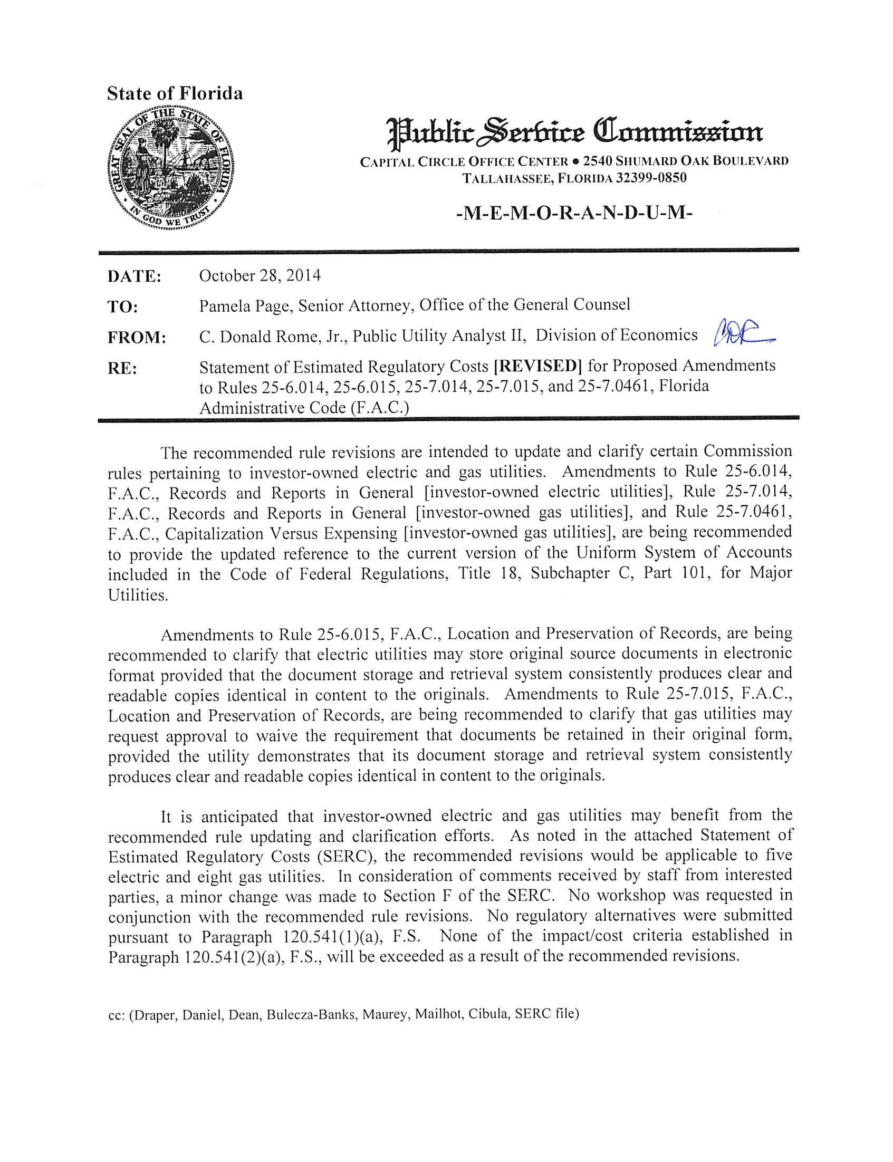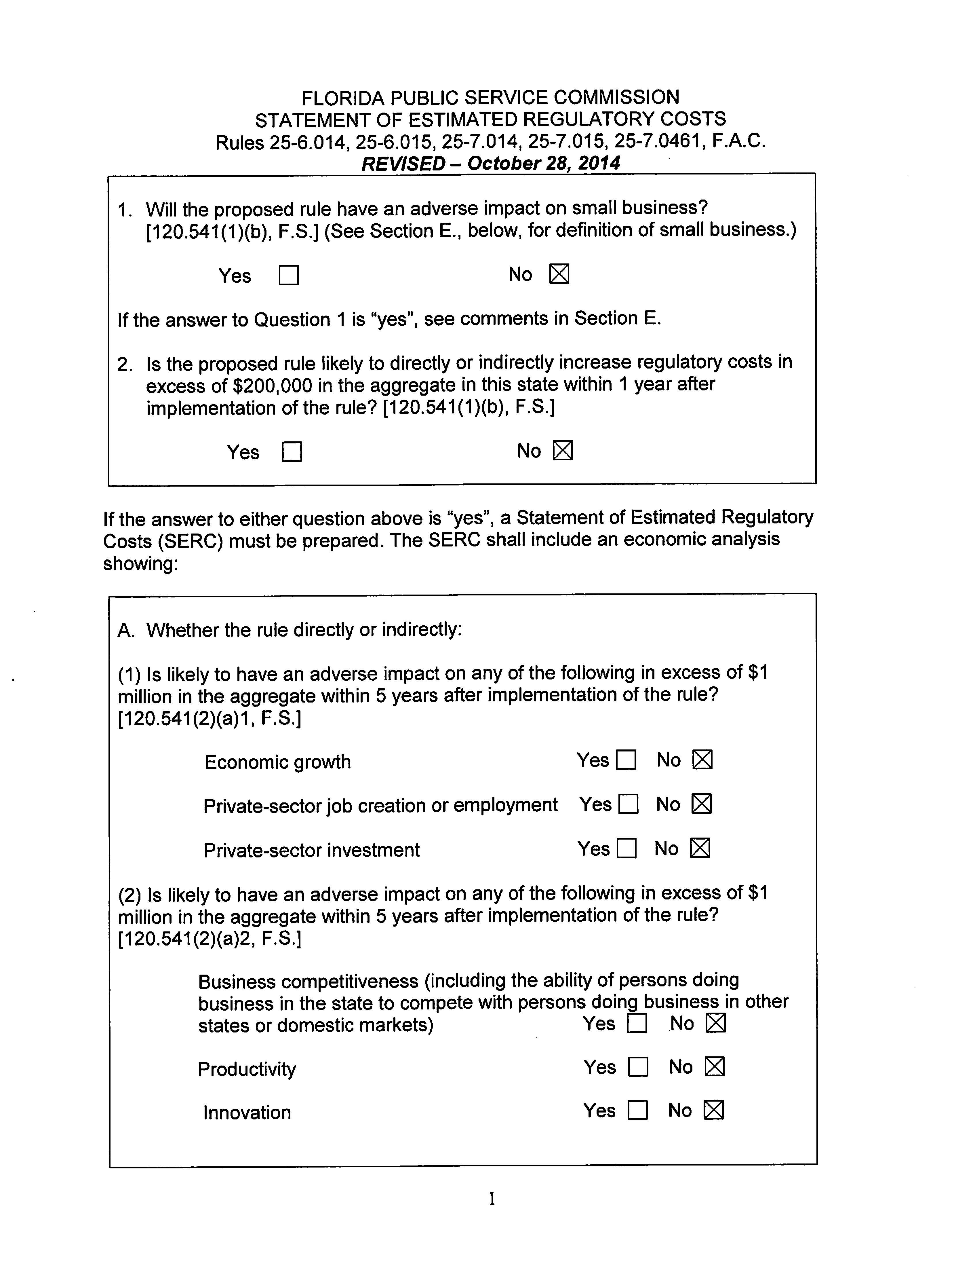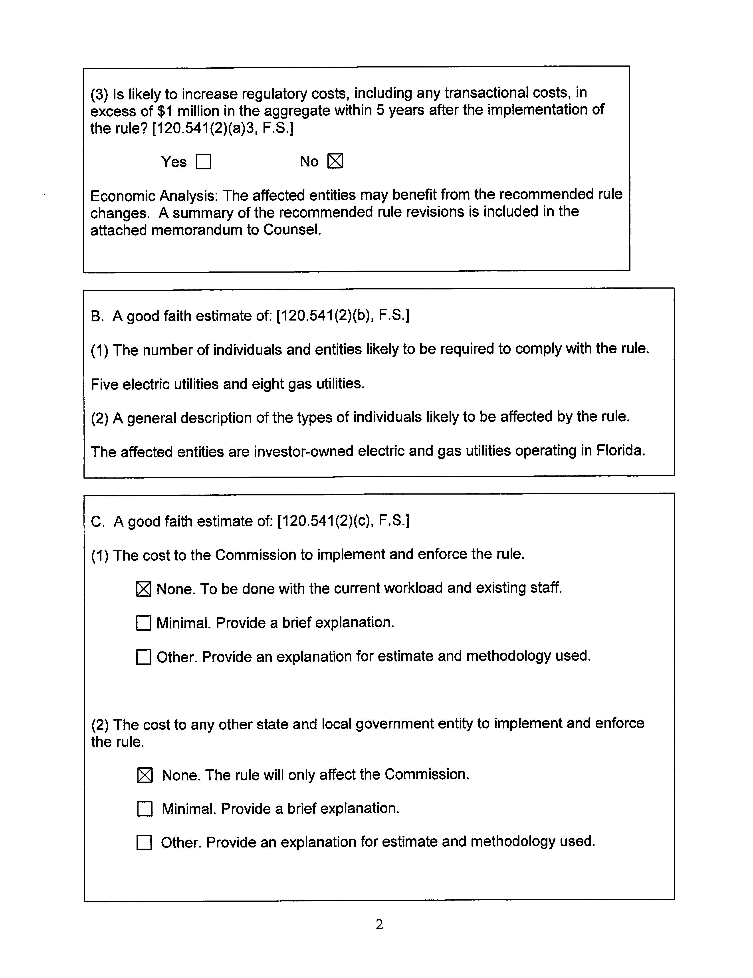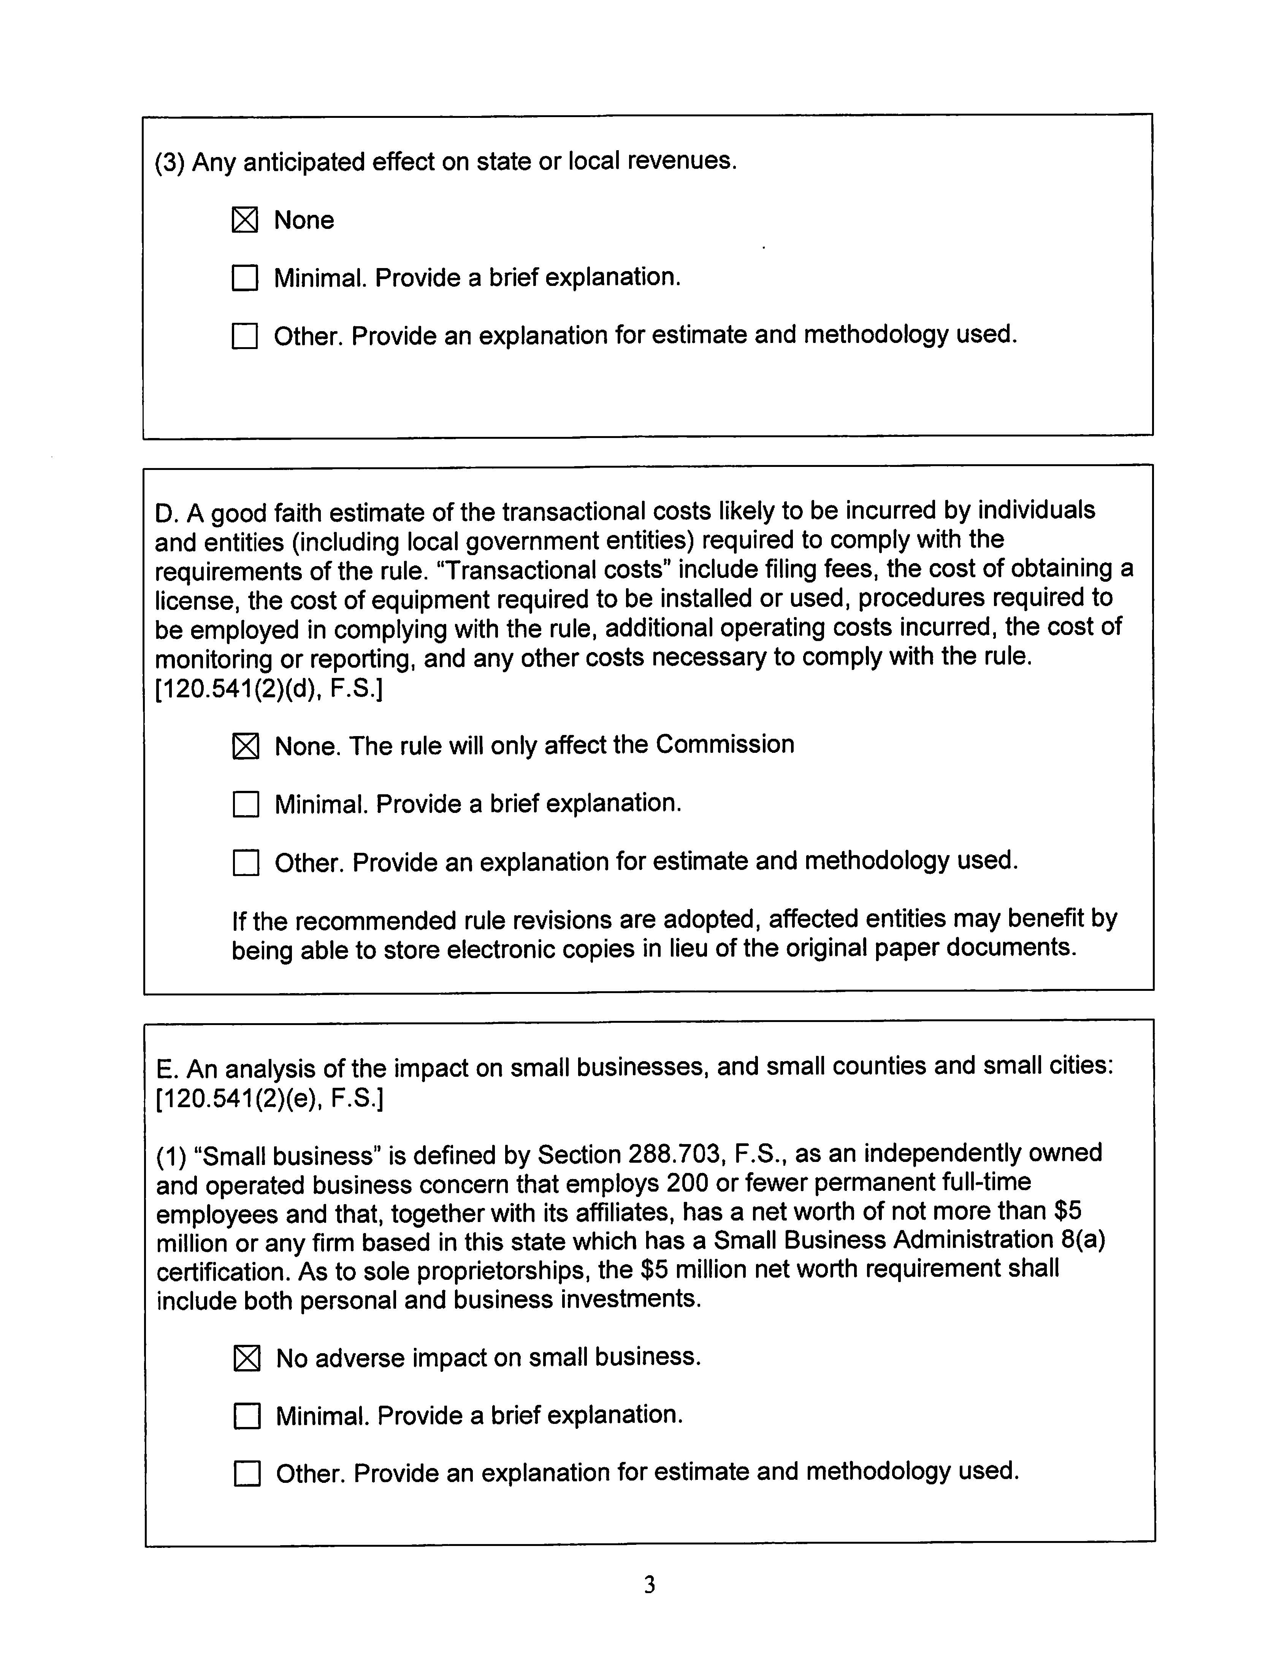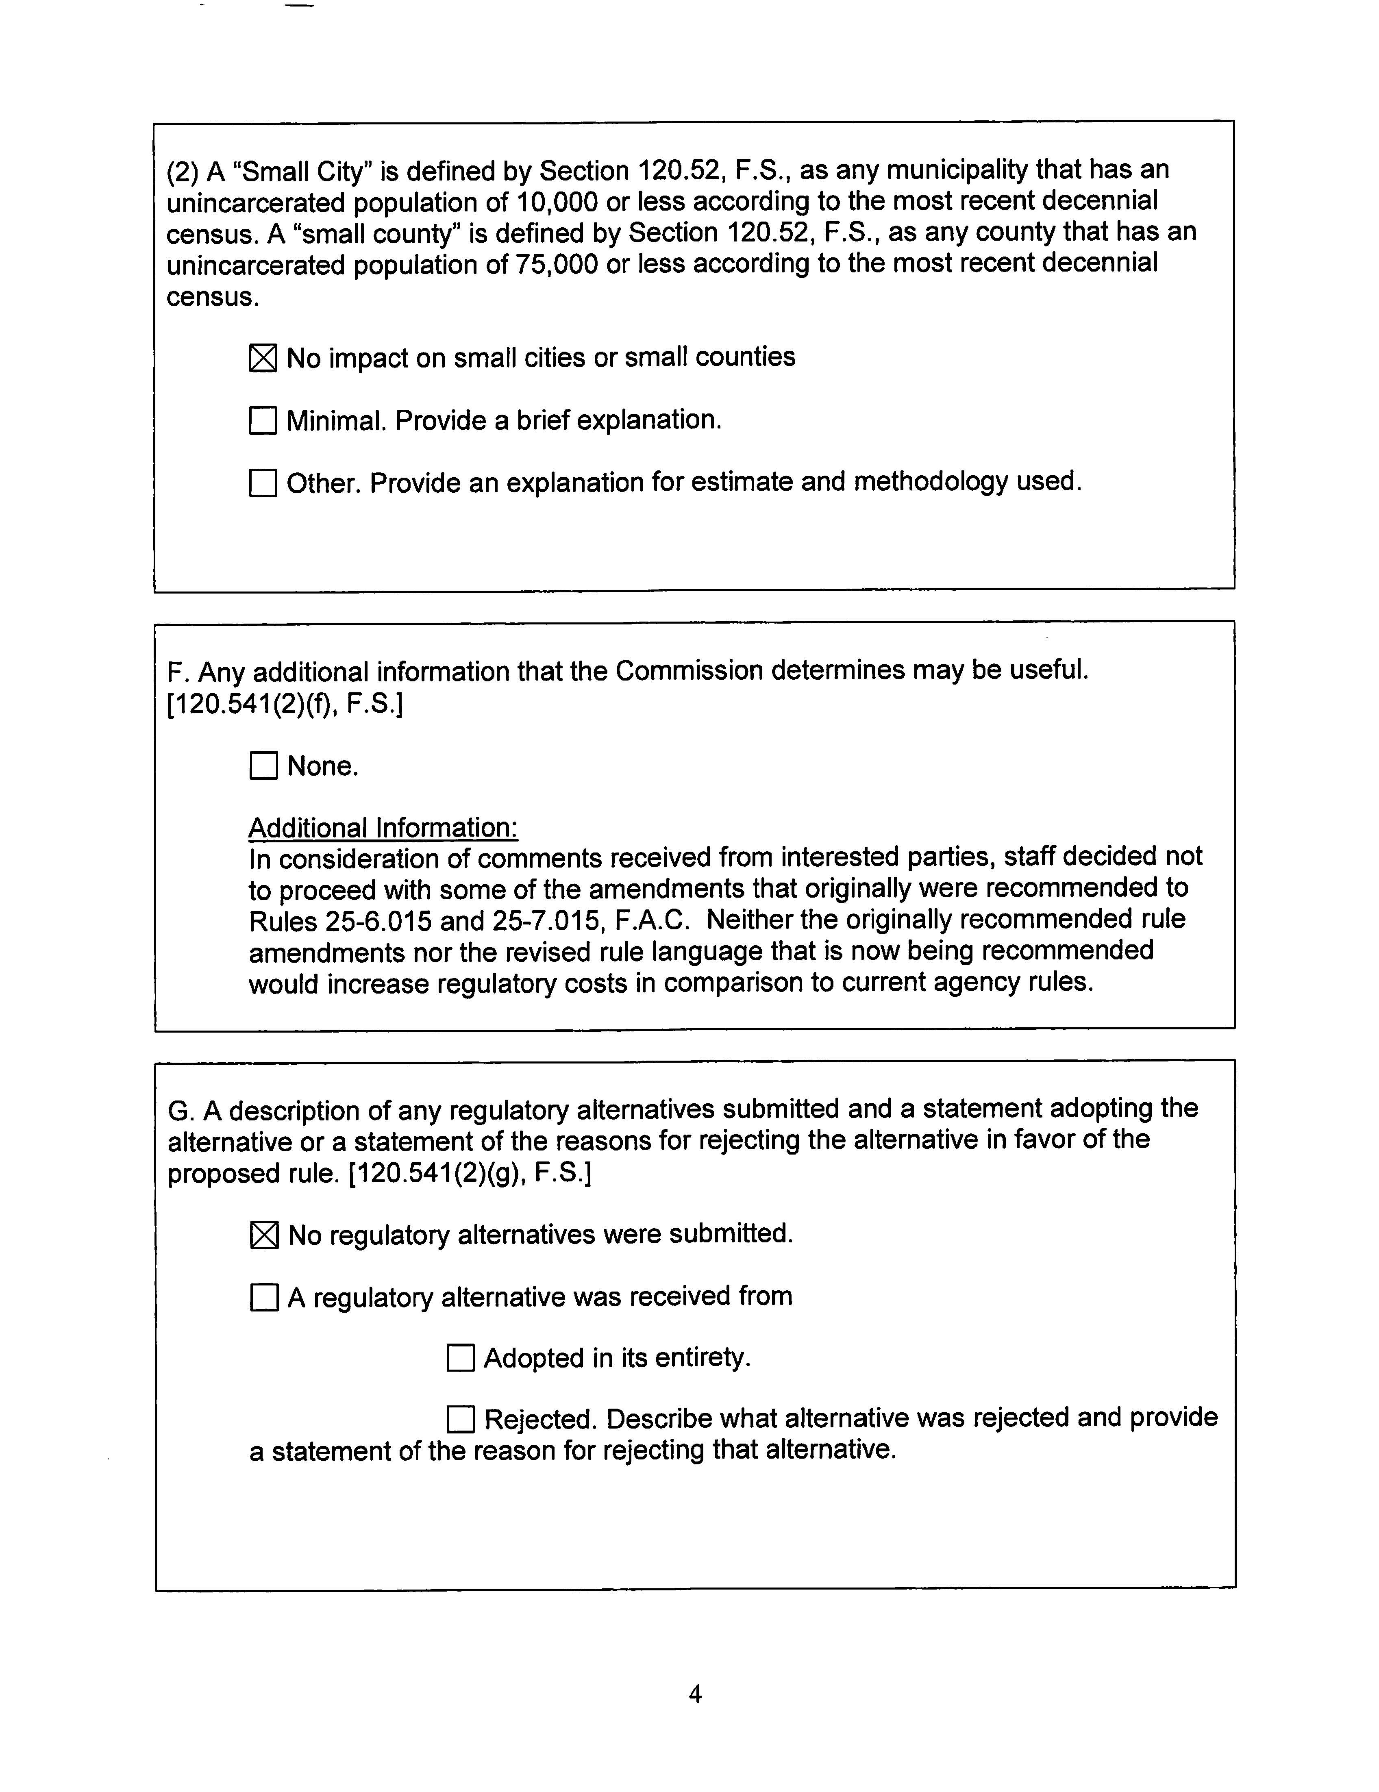

“Uniform System of Accounts Prescribed for Public Utilities and Licensees Subject to the Provisions of the Federal Power Act,” Title 18, U.S. Code of Federal Regulations, Subchapter C, Part 101 and “Preservation of Records of Public Utilities and Licensees,” Title 18, U.S. Code of Federal Regulations, Subchapter C, Part 125.
“Uniform System of Accounts Prescribed for Natural Gas Companies Subject to the Provisions of the Natural Gas Act,” Title 18, U.S. Code of Federal Regulations, Subchapter F, Part 201, and “Preservation of Records of Natural Gas Companies,” Title 18, U.S. Code of Federal Regulations, Subchapter F, Part 225.
Section 120.541(2), F.S.

