State of Florida   |  | Public Service Commission  Capital Circle Office Center ● 2540 Shumard Oak Boulevard  Tallahassee, Florida 32399-0850  -M-E-M-O-R-A-N-D-U-M-
DATE: | November 13, 2014
TO: | Office of Commission Clerk (Stauffer)
FROM: | Division of Economics (Garl)  Office of the General Counsel (Villafrate)
RE: | Docket No. 140183-GU – Petition for approval of Cast Iron/Bare Steel Pipe Replacement Rider (Rider CI/BSR), by Peoples Gas System.
AGENDA: | 11/25/14 – Regular Agenda – Tariff Filing – Interested Persons May Participate
COMMISSIONERS ASSIGNED: |  |  | All Commissioners
PREHEARING OFFICER: |  |  | Administrative
CRITICAL DATES: |  |  | 8-Month Effective Date: 5/5/15
SPECIAL INSTRUCTIONS: |  |  | None

Case Background
On September 5, 2014, Peoples Gas System (Peoples) filed a petition for approval of its Cast Iron/Bare Steel Pipe Replacement Rider (CI/BSR Rider) revenue requirements and surcharges for the period January through December 2015. The Rider was originally approved in Order No. PSC-12-0476-TRF-GU to recover the cost of accelerating the replacement of cast iron and bare steel distribution pipes through a surcharge on customers’ bills. Peoples’ currently effective surcharges were approved in Order No. PSC-13-0602-TRF-GU.
The order approving the Rider addressed the reliability and safety rationale for pipeline replacement, the scope of the program, similar actions in other states, and the procedure for annually setting the surcharge to recover the costs of the program. The procedure requires an annual filing with three components:
- A final true-up showing the actual replacement costs and actual surcharge revenues for the most recent 12-month historical period from January 1 through December 31 that ends prior to the annual petition filing, including the final over- or under-recovery for the final true-up period;
- An actual/estimated true-up showing seven months of actual and five months of projected costs and revenues;
- A projection showing 12 months of projected Rider revenue requirement for the period beginning January 1 following the annual filing.
The Commission concluded the order by stating:
We find that replacement of these types of pipelines is in the public interest to improve the safety of Florida’s natural gas infrastructure, and reduce the possibility of loss of life and destruction of property should an incident occur. Given the length of time these pipelines have been installed and the leak history due to corrosion, it is appropriate to approve the proposed accelerated replacement program. Without the Rider, it is reasonable to expect that Peoples will have to file for more frequent base rate proceedings to recover the expenses of the program. The annual filings will provide us with the oversight to ensure that projected expenses are trued-up and only actual costs are recovered. The Rider and its associated surcharges will terminate when all replacements have been made and the revenue requirement has been rolled into rate base.
Order No. PSC-12-0476-TRF-GU at p. 9.
In its petition, Peoples waived the 60-day file and suspend provisions of Section 366.06(3), Florida Statutes (F.S.). On October 27, 2014, Peoples responded to staff and the Office of Public Council’s (OPC) data requests. The Commission has jurisdiction over this matter pursuant to Sections 366.03, 366.04, 366.05, and 366.06, F.S.

Discussion of Issues
Issue 1:1
Should the Commission approve Peoples' proposed CI/BSR Rider surcharges for 2015?
Recommendation:
Yes. Peoples’ calculation of the CI/BSR Rider surcharge for each rate class is reasonable and accurate. (Garl)
Staff Analysis:
The CI/BSR Rider surcharges have been in effect since January 2013. Peoples’ calculations for the 2015 revenue requirement and surcharges include a final true-up for 2013, an actual/estimated true-up for 2014 and projected costs for 2015. Each component is addressed separately below.
Final True-up for 2013. In developing its 2015 revenue requirement for its CI/BSR program, Peoples stated the actual revenues for 2013 were $510,274 as compared to pipe replacement costs of $476,698 for an over-recovery of $33,578. As shown in the table below, the final true-up including interest for 2013 is $33,685.
Table 1-1
Final True-up for 2013
2013 CI/BSR Revenues | $510,274
2013 CI/BSR Revenue Requirement | ($476,698)
2013 Over-Recovery | $33,578
Interest | $107
2013 Final True-up (Over-recovery) | $33,685
Note: Some numbers do not add correctly due to rounding.
Actual/Estimated 2014 true-up. Peoples provided actual revenues received (January through July) and estimated revenues (August through December) for 2014. Exhibit B of Peoples’ petition shows this total is $2,173,268. The actual/estimated revenue requirement for 2014 is $2,154,987 and includes a return on investment, depreciation, and ad valorem taxes. The resulting over-recovery is $45,714. After adding interest and subtracting the 2013 over-recovery amount ($18,281) that was already collected in the 2014 surcharges, the 2014 total over-recovery is $61,277 as shown below:
Table 1-2
Actual/Estimated 2014 True-up
2014 CI/BSR Revenues | $2,154,987
2014 CI/BSR Revenue Requirement | ($2,127,555)
2014 Over-Recovery | $27,432
Interest | $159
2013 Final True-up | $33,685
2014 Total True-up (Over-recovery) | $61,277
Note: Some numbers do not add correctly due to rounding.
Projected 2015 costs. Peoples projects capital expenditures of $10,182,871 for the replacement of cast iron/bare steel infrastructure in 2015. The return on investment, depreciation expense, and ad valorem tax expense associated with the projected capital expenditures is $3,565,348. Subtracting the 2014 total over-recovery provides the 2015 revenue requirement of $3,504,071 as shown below:
Table 1-3
Projected 2015 Costs
2015 Projected Replacements | $10,182,871
Return on Investment | $2,409,250
Depreciation Expense | $803,525
Tax Expense | $352,573
2015 Revenue Requirement | $3,565,348
Less 2014 Total True-up | ($61,277)
Total 2015 Revenue Requirement | $3,504,071
Note: Some numbers do not add correctly due to rounding.
The calculation of the CI/BSR Rider surcharges by rate class is shown in Attachment 1 to the recommendation. The proposed tariff is shown is Attachment 2. As established in the order approving the Rider, the total 2015 revenue requirement is allocated to the rate classes using the same methodology that was used for the allocation of mains and services in the cost of service study used in Peoples’ most recent rate case. After calculating the percentage of total plant costs attributed to each rate class, the respective percentages were multiplied by the 2015 revenue requirement resulting in the revenue requirement by rate class. Dividing each rate class’ revenue requirement by projected therm sales provides the CI/BSR Rider surcharge for each rate class. The CI/BSR Rider surcharge for residential customers is $0.01876 per therm. The monthly bill impact for a residential customer who uses 20 therms is $0.38 beginning January 1, 2015.
In response to OPC’s data request, Peoples explained that it has focused on pipeline replacement in urban and high consequence areas. Costs are determined by the location of the project, population density, contractor cost, and material rates. Peoples further stated that contractor availability is competitive due to pipeline replacement projects. Table 1-4 shows the progress of the 10-year pipe replacement program. At the end of 2014, Peoples projects having 326 miles of mains and 13,121 steel services remaining to be replaced. The company appears to be on track to complete the replacements on time.

Table 1-4
Pipe Replacement Program Progress
 | Main Replacements |  |  |  |  | Service Replacements
 | Replaced  Cast Iron  (miles) | Replaced  Bare Steel  (miles) | Remaining  Cast Iron at Year  End  (miles) | Remaining  Bare Steel  at Year End  (miles) | Total Miles  Remaining | Replaced  Number of  Steel  Services | Total Number of  Remaining  Steel  Services
Year
2012 |  |  | 100 | 354 | 454 |  | 14,978
2013 | 14 | 46 | 86 | 308 | 394 | 907 | 14,071
*2014 | 9 | 59 | 77 | 249 | 326 | 950 | 13,121
2015 | 13 | 35 | 64 | 214 | 278 | 1,350 | 11,771
2016 | 13 | 35 | 51 | 179 | 230 | 1,800 | 9,971
2017 | 13 | 35 | 38 | 144 | 182 | 1,950 | 8,021
2018 | 13 | 35 | 25 | 109 | 134 | 2,200 | 5,821
2019 | 13 | 35 | 12 | 74 | 86 | 2,200 | 3,621
2020 | 12 | 35 | 0 | 39 | 39 | 2,100 | 1,521
2021 | 0 | 35 | 0 | 4 | 4 | 1,400 | 121
2022 | 0 | 4 | 0 | 0 | 0 | 121 | 0
*9 months actual, 3 months projected
Staff notes that the Order approving the Rider indicated that Peoples will identify and report any operations and maintenance (O&M) and depreciation savings in its annual petitions, beginning the second year of the program. Peoples explained that it has not identified any savings as the second year of the program has not been completed yet. However, Peoples stated in the petition that it has been in preliminary discussions with OPC and will continue such discussions to identify and quantify any O&M and deprecation expense reductions.
Conclusion
Staff believes the calculation of the 2015 CI/BSR revenue requirement and surcharges for each rate class is reasonable and accurate. Staff therefore recommends approval of Peoples' proposed CI/BSR Rider surcharges for 2015.
Issue 2:2
Should this docket be closed?
Recommendation:
Yes. If Issue 1 is approved, the tariffs should become effective on January 1, 2015. If a protest is filed within 21 days of the issuance of the order, the tariffs should remain in effect, with any revenues held subject to refund, pending resolution of the protest. If no timely protest is filed, this docket should be closed upon the issuance of a consummating order. (Villafrate)
Staff Analysis:
If Issue 1 is approved, the tariffs should become effective on January 1, 2015. If a protest is filed within 21 days of the issuance of the order, the tariffs should remain in effect, with any revenues held subject to refund, pending resolution of the protest. If no timely protest is filed, this docket should be closed upon the issuance of a consummating order.

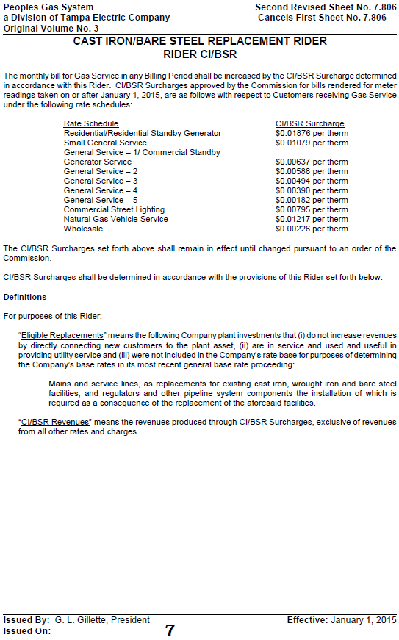

Order No. PSC-12-0476-TRF-GU, issued September 18, 2012, in Docket No. 110320-GU, In re: Petition for approval of Case Iron/Bare Steel Pipe Replacement Rider (Rider CI/BSR), by Peoples Gas System.
Order No. PSC-13-0602-TRF-GU, issued November 13, 2013, in Docket No. 110320-GU, In re: Petition for approval of Cast Iron/Bare Steel Pipe Replacement Rider (Rider CI/BSR), by Peoples Gas System.

