State of Florida   |  | Public Service Commission  Capital Circle Office Center ● 2540 Shumard Oak Boulevard  Tallahassee, Florida 32399-0850  -M-E-M-O-R-A-N-D-U-M-
DATE: | November 13, 2014
TO: | Office of Commission Clerk (Stauffer)
FROM: | Division of Economics (Garl)  Office of the General Counsel (Janjic)
RE: | Docket No. 140184-EI – Petition for approval of revised facilities rental agreement by Tampa Electric Company.
AGENDA: | 11/25/14 – Regular Agenda – Tariff Filing – Interested Persons May Participate
COMMISSIONERS ASSIGNED: |  |  | All Commissioners
PREHEARING OFFICER: |  |  | Brown
CRITICAL DATES: |  |  | 60-Day Suspension Date Waived until 11/25/14
SPECIAL INSTRUCTIONS: |  |  | None

Case Background
On September 23, 2014, Tampa Electric Company (TECO or the company) filed a petition requesting approval of revisions to the facilities rental agreement contained in its tariff. The proposed revisions address replacements due to equipment failure, changes to the in-place value of equipment, billing of maintenance cost, and other non-substantive changes.
The Commission last reviewed TECO’s facilities rental agreement on January 21, 2003. The company waived the 60-day file-and-suspend provisions of Section 366.06(3), Florida Statutes (F.S.), for an additional 3 days until November 25, 2014. On October 30, 2014, TECO responded to staff’s data request. The Commission has jurisdiction over this matter pursuant to Section 366.06, F.S.
Discussion of Issues
Issue 1:1
Should the Commission approve TECO's revisions to its facilities rental agreement?
Recommendation:
Yes. TECO=s proposed revision to its facilities rental agreement should be approved. (Garl)
Staff Analysis:
The facilities rental agreement (agreement) is a contract that allows customers to lease distribution equipment such as transformers from TECO. The monthly rental charge under the contract is calculated by multiplying the in-place value of the facilities by a Commission-approved monthly rental factor of 1.19 percent, and covers equipment and installation costs. The term of the agreement is 20 years. Customers wishing to terminate the agreement early are required to pay a termination fee computed by applying a termination factor to the in-place value of the facilities based on the year in which the agreement is terminated.
The development of the monthly rental factor and the termination factors are based on assumptions of the book and tax life of distribution equipment, property tax, insurance, and the capital structure and cost of equity. The factors reflect the cumulative present value of revenue requirements levelized over the remaining life of the distribution plant.
The proposed revisions to the agreement address three elements: (1) in-place value of replaced equipment, (2) synchronizing the agreement term and early termination factor, and (3) billing of maintenance costs. Each element is discussed below. The proposed tariff sheet revision (type-and-strike version) is shown in Attachment 1. The revised agreement will be a prospective change and will not affect agreements currently in effect.
In-place value of replaced equipment
TECO’s current agreement does not address the value of equipment replacement resulting from equipment failure within the 20-year term. The company proposed a new provision under which the in-place value of the equipment will be increased by the installed cost of the replacement equipment and reduced by the in-place value of equipment being removed. The proposed language is very similar to the language contained in Florida Power & Light Company's Commission approved tariff (Facilities Rental Service Agreement and Facilities Rental Agreement for Distribution Substation Equipment). The current agreement provides that when TECO replaces or modifies the rented equipment at the company's option, no changes will be made to the in-place value of the equipment.
Synchronizing the term and termination factor
The current agreement includes an early termination factor for each year of the 20-year term ensuring full cost recovery of the equipment. TECO proposed restarting the 20-year term of the agreement with each change to the in-place value of the equipment being rented whether that change is due to additional equipment being installed or existing equipment being modified or replaced. By restarting the term of the agreement, the term and the termination factors will remain synchronous and will ensure full cost recovery of the new equipment in the event of early termination by a customer.
Billing of maintenance costs
Under the current agreement any facilities maintenance or repairs provided by TECO is priced at cost and billed to the customer separate from the monthly rental charge. TECO proposed to eliminate this maintenance billing provision and may propose to increase the rental charge to include the cost of average monthly maintenance in a future rate proceeding. The current Commission-approved monthly rental factor does not include maintenance/repair cost. However, the company is not proposing to increase the monthly rental factor at this time pursuant to the 2013 Stipulation and Settlement Agreement approved by the Commission in TECO’s 2013 rate case. The Settlement provides that Tampa Electric cannot file for new rates that would be effective prior to January first 2018, except under very limited circumstances. TECO explained that when outages of this type of equipment occur it is most frequently the result of failed equipment that must be replaced and regular maintenance is infrequent.
Conclusion
Staff has reviewed TECO’s proposed revisions and believes they are appropriate. Staff therefore recommends approval of TECO’s revisions to its facilities rental agreement.
Issue 2:2
Should this docket be closed?
Recommendation:
Yes. If Issue 1 is approved, and a protest is filed within 21 days of the issuance of the order, the tariff should remain in effect, with any increase in revenue collected held subject to refund, pending resolution of the protest. If no timely protest is filed, this docket should be closed upon the issuance of a consummating order. (Janjic)
Staff Analysis:
If Issue 1 is approved, and a protest is filed within 21 days of the issuance of the order, the tariff should remain in effect, with any increase in revenue collected held subject to refund, pending resolution of the protest. If no timely protest is filed, this docket should be closed upon the issuance of a consummating order.

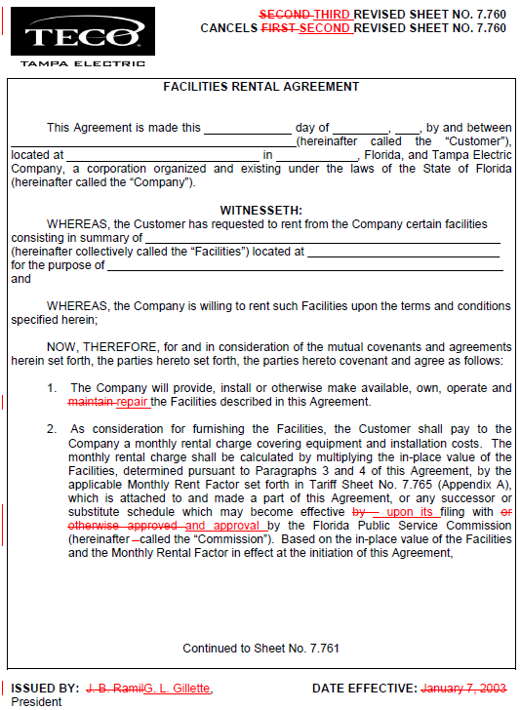

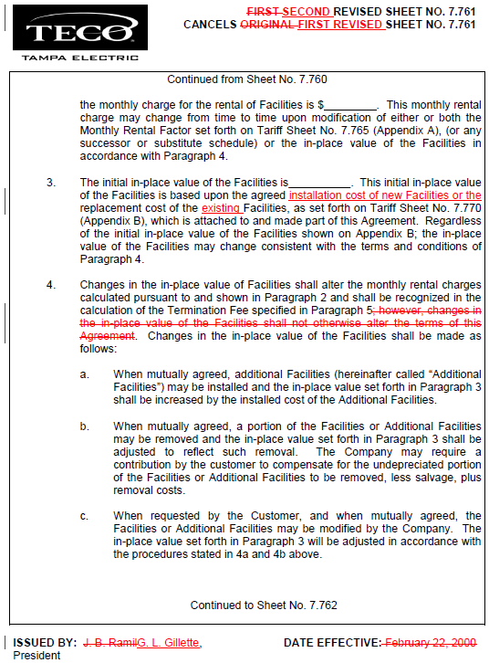

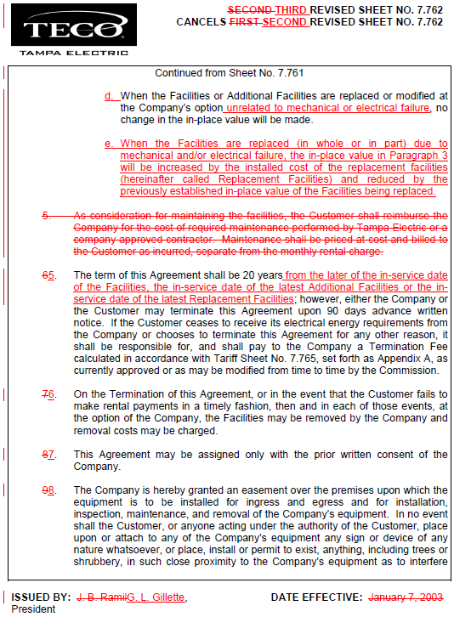

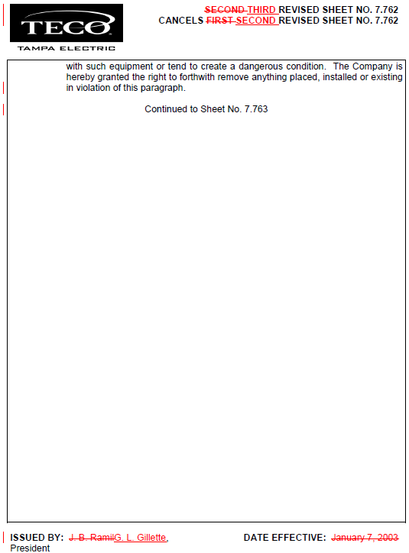

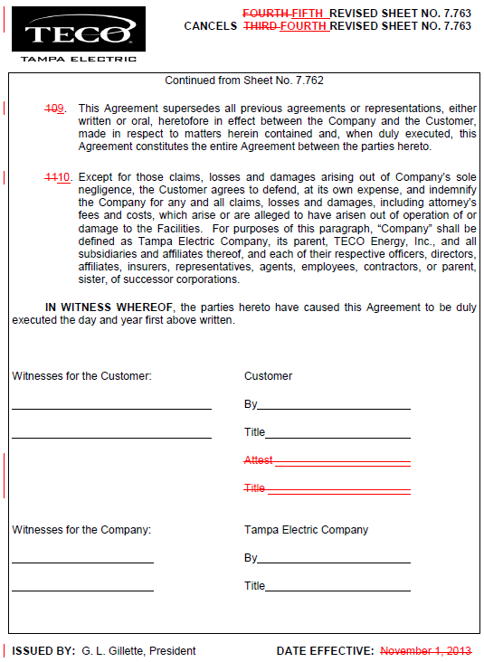

See Order No. PSC-03-0116-TRF-EI, issued January 21, 2003, in Docket No. 021139, In re: Petition for approval of revised facilities rental agreement and revised tariff by Tampa Electric Company.
See Order No. PSC-13-0443-FOF-EI, issued September 30, 2013, in Docket 130040-EI, In re: Petition for rate increase by Tampa Electric Company.
See Order No. PSC-09-0283-FOF-EI, issued April 30, 2009, in Docket 080317-EI, In re: Petition for rate increase by Tampa Electric Company.
See Order No. PSC-13-0443-FOF-EI, issued September 30, 2013, in Docket 130040-EI, In re: Petition for rate increase by Tampa Electric Company.

