State of Florida   |  | Public Service Commission  Capital Circle Office Center ● 2540 Shumard Oak Boulevard  Tallahassee, Florida 32399-0850  -M-E-M-O-R-A-N-D-U-M-
DATE: | December 4, 2014
TO: | Office of Commission Clerk (Stauffer)
FROM: | Division of Economics (Draper, Rome)  Office of the General Counsel (Janjic)
RE: | Docket No. 140189-GU – Petition for approval of transportation service agreement for an extension in Nassau County with Florida Public Utilities Company, by Peninsula Pipeline Company, Inc.
AGENDA: | 12/18/14 – Regular Agenda – Proposed Agency Action – Interested Persons May Participate
COMMISSIONERS ASSIGNED: |  |  | All Commissioners
PREHEARING OFFICER: |  |  | Brown
CRITICAL DATES: |  |  | None
SPECIAL INSTRUCTIONS: |  |  | Place this item next to the item for Docket No. 140190-GU on the Agenda

Case Background
On September 30, 2014, Peninsula Pipeline Company, Inc. (Peninsula) filed a petition seeking approval of a firm transportation service agreement (Agreement) between Peninsula and Florida Public Utilities Company (FPUC) for an extension in Nassau County. Peninsula operates as a natural gas transmission company as defined in Section 368.103(4), Florida Statutes (F.S.).

In Order No. PSC-07-1012-TRF-GP Peninsula received approval of an intrastate gas pipeline tariff that allows it to construct and operate intrastate pipeline facilities and to actively pursue agreements with gas customers. Peninsula provides transportation service only, and does not engage in the sale of natural gas. Pursuant to Order No. PSC-07-1012-TRF-GP Peninsula is allowed to enter into certain gas transmission agreements without prior Commission approval. However, Peninsula is requesting Commission approval of this Agreement as it does not fit any of the criteria enumerated in the tariff for which Commission approval would not be required. Both Peninsula and FPUC are subsidiaries of Chesapeake, and agreements between affiliated companies must be approved by the Commission pursuant to Section 368.105, F.S., and Order No. PSC-07-1012-TRF-GP.
Peninsula is seeking to extend its existing infrastructure in Nassau County by 4.6 miles to interconnect with FPUC’s distribution system near the City of Yulee north of Jacksonville. During its evaluation of the petition, staff issued a data request to both Peninsula and FPUC for which responses were received on October 29, 2014. The Commission has jurisdiction over this matter pursuant to Sections 366.05(1), 366.06, and 368.105, F.S.

Discussion of Issues
Issue 1:1
Should the Commission approve the Transportation Service Agreement between Peninsula and FPUC dated September 26, 2014, for an extension in Nassau County?
Recommendation:
Yes. The Commission should approve the Transportation Service Agreement between Peninsula and FPUC dated September 26, 2014, for an extension in Nassau County. (Draper, Rome)
Staff Analysis:
The proposed Agreement provides for an extension of Peninsula’s existing Fernandina Beach Line to allow FPUC to serve new load in Nassau County and will be in effect for an initial period of 20 years. The Commission addressed Peninsula’s construction of the Fernandina Beach Line and associated transportation service agreement between Peninsula and FPUC in Order No. PSC-12-0230-PAA-GU. The Fernandina Beach Line is labeled “PPC/PGS Joint Pipeline” in the map provided in Attachment A. The Fernandina Beach Line is jointly owned by Peninsula and Peoples Gas System (PGS).
Pursuant to the proposed Agreement, Peninsula will construct a 4.6 mile steel pipeline extending from the existing Fernandina Beach Line along William Burgess Road as shown in Attachment A. Peninsula stated that it has received all required permits and anticipates the construction to be completed in the second quarter of 2015. The negotiated monthly reservation charge included in the proposed Agreement is designed to allow Peninsula to recover its investment and operational costs associated with the extension. These costs include design engineering, permitting, material and installation costs, on-going maintenance costs, property taxes, and Peninsula’s return on investment.
The parties assert that the rates contained in the Agreement are consistent with a market rate in that they are within the ranges of rates set forth in similar agreements as required by Section 368.105(3)(b), F.S. In response to staff’s data request Peninsula provided a comparison of construction costs (confidential) for other similar agreements entered into by Peninsula. While construction costs vary for each project due to pipe size, construction conditions, permitting, etc., staff believes that Peninsula’s construction costs for the proposed extension appear reasonable and comparable to other projects.
Peninsula explained in its petition and in response to staff’s data request that the area to be served by this pipeline extension is expected to experience considerable growth in gas usage. Specifically, there are two major projects planned for development: the Terrapointe East Nassau Employment Center and the Nassau County Government complex. Both projects are expected to include new residential subdivisions and commercial and industrial space.
To support the proposed Agreement, Peninsula lists three benefits of Peninsula, as opposed to FPUC, constructing this extension: (1) Peninsula has expertise to construct and manage this type of pipeline, (2) the extension will be made from an existing Peninsula facility, thus avoiding negotiating interconnection rights with a third party, and (3) Peninsula’s construction and ownership will avoid FPUC undertaking the costs and risk for this project, protecting FPUC’s ratepayers.
Prior to the construction of the Fernandina Beach Line in 2012, FPUC issued a request for proposal (RFP) to all potential entities that could provide a valid proposal to bring gas from the Florida Gas Transmission Company (FGT) interstate pipeline into Nassau County. The Commission evaluated the RFP responses including FPUC’s self-build option, and approved the resulting agreements in Order No. PSC-12-0230-PAA-GU. Since this project is an extension from an existing Peninsula pipeline for which FPUC already has a transportation service agreement, FPUC did not issue an RFP to obtain construction cost estimates from other entities for this line extension. FPUC also stated that, operationally, it is not practical to contract with another pipeline operator for a relatively small extension and the capacity held by FPUC on the existing Peninsula pipeline is the same capacity that will be used to deliver gas to the proposed extension.
FPUC is proposing to recover the payments to Peninsula under the proposed Agreement through its Purchased Gas Adjustment (PGA) mechanism consistent with other gas transmission pipeline costs incurred by FPUC. Staff notes that in the annual PGA docket the Commission does not set an actual factor, but a PGA cap. FPUC provided information showing that the impact on the PGA cap will be minor. While FPUC will incur costs associated with this service expansion to new areas, the anticipated new load will help spread the costs over a larger customer base.
Based on the petition and responses from FPUC and Peninsula to staff’s data request, staff believes the proposed Agreement is cost effective, reasonable, meets the requirements of Section 368.105, F.S., and benefits FPUC’s customers. Staff therefore recommends approval of the proposed Agreement.

Issue 2:2
Should this docket be closed?
Recommendation:
Yes. If no protest is filed by a person whose substantial interests are affected within 21 days of the issuance of the Order, this docket should be closed upon the issuance of a Consummating Order. (Janjic)
Staff Analysis:
If no protest is filed by a person whose substantial interests are affected within 21 days of the issuance of the Order, this docket should be closed upon the issuance of a Consummating Order.

Map showing location of proposed Peninsula extension

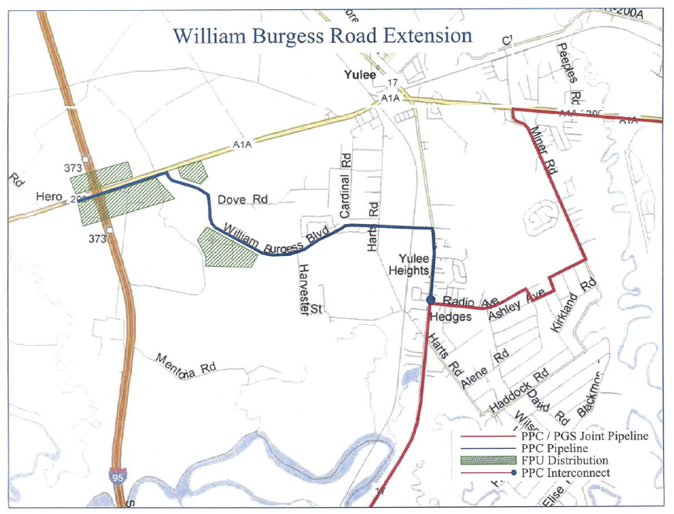

See Order No. PSC-06-0023-DS-GP, issued January 9, 2006, in Docket No. 050584-GP, In re: Petition for declaratory statement by Peninsula Pipeline Company, Inc. concerning recognition as a natural gas transmission company under Section 368.101, F.S., et seq.
Order No. PSC-07-1012-TRF-GP, issued December 21, 2007, Docket No. 070570-GP, In re: Petition for approval of natural gas transmission pipeline tariff by Peninsula Pipeline Company, Inc.
Peninsula Pipeline Company, Inc., Intrastate Pipeline Tariff, Original Vol. 1, Sheet No. 12, Section 4.
Order No. PSC-12-0230-PAA-GU, issued May 9, 2012, Docket No. 110271-GU, In re: Petition for approval of transportation service agreement with Florida Public Utilities Company, by Peninsula Pipeline Company.
The projected $/therm impact to the PGA factor was provided under a claim of confidentiality.

