State of Florida   |  | Public Service Commission  Capital Circle Office Center ● 2540 Shumard Oak Boulevard  Tallahassee, Florida 32399-0850  -M-E-M-O-R-A-N-D-U-M-
DATE: | December 4, 2014
TO: | Office of Commission Clerk (Stauffer)
FROM: | Division of Economics (Garl)  Office of the General Counsel (Corbari)
RE: | Docket No. 140210-EU – Joint petition for approval of amendment to territorial agreement in Charlotte, Lee, and Collier Counties, by Florida Power & Light Company and Lee County Electric Cooperative.
AGENDA: | 12/18/14 – Regular Agenda – Proposed Agency Action – Interested Persons May Participate
COMMISSIONERS ASSIGNED: |  |  | All Commissioners
PREHEARING OFFICER: |  |  | Balbis
CRITICAL DATES: |  |  | None
SPECIAL INSTRUCTIONS: |  |  | None

Case Background
On November 3, 2014, Florida Power & Light Company (FPL) and Lee County Electric Cooperative (LCEC) jointly filed a petition for approval of amendment to the existing territorial agreement. The amendment is included as Attachment 3 to this recommendation. The Commission approved the existing territorial agreement in 1993, establishing service areas in Charlotte, Collier, Hendry, and Lee Counties. A territorial variance agreement relating to Lee County was approved by the Commission in 1997.

The instant petition follows a petition from Babcock Ranch Community Independent Special District (Babcock Ranch) requesting the Commission to acknowledge Babcock Ranch as a new municipal electric utility. LCEC, the Florida Electric Cooperatives Association, and Tampa Electric Company filed comments in opposition to Babcock Ranch’s Petition. Before the Commission could take the matter under consideration, however, Babcock Ranch, LCEC, and FPL requested the matter be deferred while the parties attempted to resolve their disputes in the matter. On November 4, 2014, the parties advised the Commission that they had reached a settlement agreement in the form of a territorial amendment which is addressed in Issue 1 below. In addition, the parties’ notification to the Commission regarding the settlement stated, “[a]fter the Commission has rendered a Final Order approving the territorial amendment and the time for appeal has lapsed, the District will voluntarily dismiss its notice and petition in this docket.” The Commission has jurisdiction over this matter pursuant to Section 366.04, Florida Statutes, (F.S.).
Discussion of Issues
Issue 1:1
Should the Commission approve the proposed amendment to the territorial agreement between FPL and LCEC?

Recommendation:
Yes. The amendment to the territorial agreement between FPL and LCEC eliminates existing or potential uneconomic duplication of facilities, does not cause a decrease in the reliability of electric service to existing or future ratepayers, and does not cause a detriment to the public interest; therefore, it should be approved. (Garl, Corbari)

Staff Analysis:
Pursuant to Section 366.04(2)(d), F.S., the Commission has the jurisdiction to approve territorial agreements between and among rural electric cooperatives, municipal electric utilities, and other electric utilities. Rule 25-6.0440(2), Florida Administrative Code, (F.A.C.), provides that in approving territorial agreements, the Commission may consider the reasonableness of the purchase price of any facilities being transferred, the likelihood that the agreement will not cause a decrease in the reliability of electric service to existing or future ratepayers, and the likelihood that the agreement will eliminate existing or potential uneconomic duplication of facilities. Unless the Commission determines that the agreement will cause a detriment to the public interest, the agreement should be approved. Utilities Commission of the City of New Smyrna Beach v. Florida Public Service Commission, 469 So. 2d 731 (Fla. 1985).

The proposed amendment alters the territorial boundary between FPL and LCEC in Charlotte, Lee, and Collier Counties to allow both utilities to more efficiently serve anticipated development and to avoid unnecessary duplication of facilities in two mostly undeveloped areas where both utilities currently have minimal infrastructure in place. The amendment refers to the two areas to be transferred as exchange parcels 1 and 2.

The current territorial boundary line between FPL and LCEC runs through Babcock Ranch, which would result in two different utilities serving Babcock Ranch. Exchange parcel 1 includes the western half of Babcock Ranch, as well as adjacent areas in Charlotte and Lee Counties, and is currently within the service area of LCEC adjacent to FPL’s service area. The amendment places exchange parcel 1 wholly within an area to be served by FPL and is shown in Attachment 1.

Exchange parcel 2, which is about 28 miles southeast of exchange parcel 1 in central Collier County, is currently within the service area of FPL adjacent to LCEC’s service area. The utilities agreed to place the exchange parcel 2 wholly within an area to be served by LCEC. As required by Rule 25-6.0440(1)(a), the utilities provided maps and legal descriptions of the affected areas.

The amendment specifies that no existing customers will be transferred to the other utility until there is a “Change in Use,” which is defined as (1) a change in use of the property, (2) a change requiring reclassification of service, or (3) a change in ownership of the property.

As required by Rule 25-6.0440(1)(d), F.A.C., both FPL and LCEC have contacted their respective customers in the applicable exchange parcels. Each of the exchange parcels have 4 named customers, comprising 15 accounts. Of the existing customers, none expressed opposition to the territorial amendment. One customer was in favor of the amendment, and the remainder had no concerns. The script and letters the utilities used when contacting the customers and a spreadsheet recording the results of the utilities’ customer contacts is included in Attachment 2.

Reasonableness of the Purchase Price

The amendment states that any removal of facilities due to a transfer of service from one utility to the other will be at the sole cost of the owner of the facilities being removed. Furthermore, any transfer or exchange of facilities will be at net book value.

Reliability of Electric Service

In addition to LCEC continuing to provide uninterrupted electric service to its existing customers within Babcock Ranch, the utilities agreed to coordinate planning, construction, and service activities to provide timely service to new customers in Babcock Ranch. Should circumstances at the time require, LCEC will initially, but temporarily, provide service for no more than two years. During that period the utilities agreed to work expeditiously toward FPL assuming electric service responsibilities for new customers within the Babcock Ranch area.

Conclusion

Staff believes that the proposed amendment to the existing agreement is in the best interests of FPL, LCEC, and their respective customers. The amendment to the territorial agreement between FPL and LCEC eliminates existing or potential uneconomic duplication of facilities, does not cause a decrease in the reliability of electric service to existing or future ratepayers, and does not cause a detriment to the public interest; therefore, it should be approved.

Issue 2:2
Should this docket be closed?
Recommendation:
Yes. This docket should be closed upon issuance of a Consummating Order unless a person whose substantial interests are affected by the Commission’s decision files a protest within 21 days of the issuance of the proposed agency action. (Corbari)
Staff Analysis:
This docket should be closed upon issuance of a Consummating Order unless a person whose substantial interests are affected by the Commission’s decision files a protest within 21 days of the issuance of the proposed agency action.

Proposed Territorial Boundary (Exchange Parcel 1)
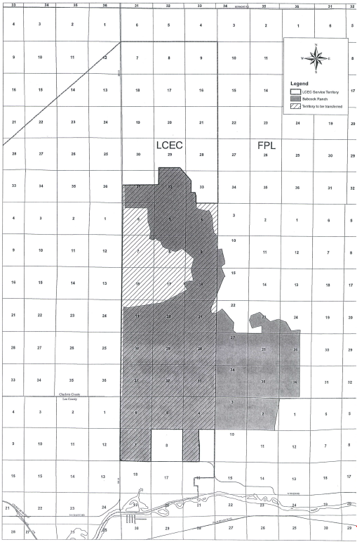
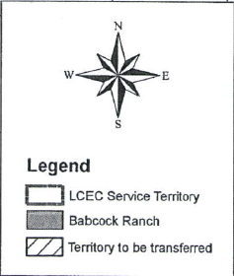

Source: Document No. 06148-14, Joint Petition for Approval of Amendment to Territorial Agreement – Exhibit A “Legal description and sketch of Exchange Parcel 1,” Docket 140210-EU In re: Joint petition for approval of amendment to territorial agreement in Charlotte, Lee, and Collier Counties, by Florida Power & Light Company and Lee County Electric Cooperative.
SCRIPT FOR CALLS TO CUSTOMER AFFECTED BY TERRITORY SWAP

Following is proposed language for calls that will be placed to existing customers that are within Babcock Ranch Special District and the proposed boundaries of the Big Cypress.
A representative from each company will be on each call when possible.
The employer representative of the company that is currently providing service will lead the call.

Hello:

My name is (current company) with (company name).

On the phone with me is (replacement company) with (company name).

We want to inform you that there is a planned change in the Florida Public Service Commission approved service territory boundaries that will result in a change of the company that provides electric service in your area.

In the future your area will fall within (name of new provider) service territory and not (name of existing provider) as it is now.

However, even though your facility will be in (name of new company) service territory in the future, you will continue to receive electric service from (name of existing company) until there is a change of use of your existing service.

A change of use would include:
- A request for new service.
- A change in ownership or change of name on the account, or,
- A change in the type of service that would fall under a different tariff.

After a change in use occurs and the utilities agree that their facilities can economically support service to the new customer, that new customer then would be served by the (new company) and would receive service under (new company ) applicable rate tariff in effect at the time. Because LCEC and FPL have different tariffs and their rates change periodically it’s not possible to say what those tariffed rates would be. At present LCEC’s rates are generally 8 to 10% higher than FPL depending on rate class, but are subject to change at any time. Again, however, your current service provider will not change unless and until there is a change in use.

We want to assure you that both of our companies support this change in electric providers and believe it is in the best interest of our long-term strategic goals of providing low cost and reliable electricity to our customers.

We appreciate your time and would be happy to address any questions you may have.

If nothing further, again thank you for your time.

Source: Document No. 06377-14 FPL-LCEC Territory Amendment – Received via email from Scott Goodland 11/17/14, Docket 140210-EU In re: Joint petition for approval of amendment to territorial agreement in Charlotte, Lee, and Collier Counties, by Florida Power & Light Company and Lee County Electric Cooperative.
Source: Document No. 06573-14 FPL-LCEC Territory Amendment – Received via email from Scott Goodland 12/3/14, Docket 140210-EU In re: Joint petition for approval of amendment to territorial agreement in Charlotte, Lee, and Collier Counties, by Florida Power & Light Company and Lee County Electric Cooperative.

Source: Document No. 06573-14 FPL-LCEC Territory Amendment – Received via email from Scott Goodland 12/3/14, Docket 140210-EU In re: Joint petition for approval of amendment to territorial agreement in Charlotte, Lee, and Collier Counties, by Florida Power & Light Company and Lee County Electric Cooperative.

Contacts with Exchange Parcel 1 Customers Currently Served by LCEC

Row No. from Exhibit "C" to Appendix "A" of Exchange Parcel 1 Customers* | Dates of Contact | Comments
1 to 12 | 10/23/2014, 11/17/2014 | Spoke to Customer. Provided full messaging. The customer expressed no concerns. During follow-up call customer expressed thanks for the follow-up call and had no questions.
13 | 10/23/2014, 11/4/2014, 11/17/2014, 12/2/14 | Left three voice messages with full messaging. Calls were not returned. When able to speak with the customer, the customer expressed no concerns about the amended service area.
14 | 10/23/2014, 11/17/2014, 12/2/14 | Left two voice messages with full messaging. Calls were not returned. When able to speak with the customer, the customer expressed no concerns about the amended service area.
15 | 10/23/2014, 11/10/2014, 11/17/2014 | Spoke to customer. Provided full messaging. The Customer expressed thanks and indicated there were no questions.

Source: Document No. 06573-14 FPL-LCEC Territory Amendment – Received via email from Scott Goodland 12/3/14, Docket 140210-EU In re: Joint petition for approval of amendment to territorial agreement in Charlotte, Lee, and Collier Counties, by Florida Power & Light Company and Lee County Electric Cooperative.

Contacts with Exchange Parcel 2 Customers Currently Served by FPL

Row No. from Exhibit "C" to Appendix "A" of Exchange Parcel 2 Customers* | Dates of Contact | Comments
1 to 3 | 10/23/2014, 11/17/2014 | Left voice messages with full details. When able to speak with the customer, the customer expressed appreciation for the call.
4 to 14 | 10/23/2014, 11/12/2014, 11/17/2014, 12/3/14 | Left voice messages with full details. When able to speak with the customer, the customer expressed no concerns about the amended service area.
15 | 10/23/2014, 11/12/2014, 11/17/2014 | Left voice messages with the customer and gave full details. When able to speak with the customer, the customer expressed appreciation for the call and asked to be notified if a meter is ever changed out in case an outage needs to be coordinated.

Source: Document No. 06573-14 FPL-LCEC Territory Amendment – Received via email from Scott Goodland 12/3/14, Docket 140210-EU In re: Joint petition for approval of amendment to territorial agreement in Charlotte, Lee, and Collier Counties, by Florida Power & Light Company and Lee County Electric Cooperative.

Source: Document No. 06148-14, Joint Petition for Approval of Amendment to Territorial Agreement – Appendix A “Agreement Amending the Existing Territorial Agreement Between FPL and LCEC,” Docket 140210-EU In re: Joint petition for approval of amendment to territorial agreement in Charlotte, Lee, and Collier Counties, by Florida Power & Light Company and Lee County Electric Cooperative.

See Order No. PSC-93-0705-FOF-EU, issued May 10, 1993, in Docket No. 930092-EU, In re: Joint application for approval of territorial agreement between Florida Power & Light Company and Lee County Electric Cooperative, Inc.
See Order No. PSC-97-0527-FOF-EU, issued May 7, 1997, in Docket No. 970105-EU, In re: Petition for approval of change in territorial boundary under territorial agreement with Lee County Electric Cooperative, Inc., by Florida Power & Light Company.
See Docket No. 140059-EM, established March 24, 2014, In re: Notice of new municipal electric service provider and petition for waiver of Rule 25-9.044(2), F.A.C., by Babcock Ranch Community Independent Special District. Documents providing the notices of opposition, requests for deferral, and announcement of a settlement are all contained in the docket file.
Id., Document No. 06196-14, November 4, 2014, Letter from counsel for Babcock Ranch to Commission Executive Director Baez regarding settlement agreement and requesting deferral of matter pending resolution of Docket No. 140210-EU, In re: Joint petition for approval of amendment to territorial agreement in Charlotte, Lee, and Collier Counties, by Florida Power & Light Company and Lee County Electric Cooperative.

