BEFORE THE FLORIDA PUBLIC SERVICE COMMISSION

In re: Petition for approval of revised facilities rental agreement by Tampa Electric Company. | DOCKET NO. 140184-EI  ORDER NO. PSC-14-0678-TRF-EI  ISSUED: December 9, 2014

The following Commissioners participated in the disposition of this matter:

ART GRAHAM, Chairman
LISA POLAK EDGAR
RONALD A. BRISÉ
EDUARDO E. BALBIS
JULIE I. BROWN

ORDER APPROVING REVISED TARIFF FACILITIES RENTAL AGREEMENT BY TAMPA ELECTRIC COMPANY

BY THE COMMISSION:

Background

On September 23, 2014, Tampa Electric Company (TECO) filed a petition requesting approval of revisions to the facilities rental agreement contained in its tariff. The proposed revisions address replacements due to equipment failure, changes to the in-place value of equipment, billing of maintenance cost, and other non-substantive changes.
This Commission last reviewed TECO’s facilities rental agreement on January 21, 2003. The company waived the 60-day file-and-suspend provisions of Section 366.06(3), Florida Statutes (F.S.), for an additional 3 days until November 25, 2014. We have jurisdiction over this matter pursuant to Section 366.06, F.S.
Discussion

The facilities rental agreement (agreement) is a contract that allows customers to lease distribution equipment such as transformers from TECO. The monthly rental charge under the contract is calculated by multiplying the in-place value of the facilities by a Commission-approved monthly rental factor of 1.19 percent, and covers equipment and installation costs. The term of the agreement is 20 years. Customers wishing to terminate the agreement early are required to pay a termination fee computed by applying a termination factor to the in-place value of the facilities based on the year in which the agreement is terminated.
The development of the monthly rental factor and the termination factors are based on assumptions of the book and tax life of distribution equipment, property tax, insurance, and the capital structure and cost of equity. The factors reflect the cumulative present value of revenue requirements levelized over the remaining life of the distribution plant.
The proposed revisions to the agreement address three elements: (1) in-place value of replaced equipment, (2) synchronizing the agreement term and early termination factor, and (3) billing of maintenance costs. Each element is discussed below. The proposed tariff sheet revision (type-and-strike version) is shown in Attachment 1. The revised agreement will be a prospective change and will not affect agreements currently in effect.
In-place value of replaced equipment
TECO’s current agreement does not address the value of equipment replacement resulting from equipment failure within the 20-year term. The company proposed a new provision under which the in-place value of the equipment will be increased by the installed cost of the replacement equipment and reduced by the in-place value of equipment being removed. The proposed language is very similar to the language contained in Florida Power & Light Company's Commission approved tariff (Facilities Rental Service Agreement and Facilities Rental Agreement for Distribution Substation Equipment). The current agreement provides that when TECO replaces or modifies the rented equipment at the company's option, no changes will be made to the in-place value of the equipment.
Synchronizing the term and termination factor
The current agreement includes an early termination factor for each year of the 20-year term ensuring full cost recovery of the equipment. TECO proposed restarting the 20-year term of the agreement with each change to the in-place value of the equipment being rented whether that change is due to additional equipment being installed or existing equipment being modified or replaced. By restarting the term of the agreement, the term and the termination factors will remain synchronous and will ensure full cost recovery of the new equipment in the event of early termination by a customer.
Billing of maintenance costs
Under the current agreement any facilities maintenance or repairs provided by TECO is priced at cost and billed to the customer separate from the monthly rental charge. TECO proposed to eliminate this maintenance billing provision and may propose to increase the rental charge to include the cost of average monthly maintenance in a future rate proceeding. The current Commission-approved monthly rental factor does not include maintenance/repair cost. However, the company is not proposing to increase the monthly rental factor at this time pursuant to the 2013 Stipulation and Settlement Agreement approved by this Commission in TECO’s 2013 rate case. The Settlement provides that TECO cannot file for new rates that would be effective prior to January first 2018, except under very limited circumstances. TECO explained that when outages of this type of equipment occur it is most frequently the result of failed equipment that must be replaced and regular maintenance is infrequent.
Decision
Based upon our review of TECO’s proposed revisions, we believe they are appropriate. We hereby approve of TECO’s revisions to its facilities rental agreement.

Based on the foregoing, it is

ORDERED by the Florida Public Service Commission that the petition of Tampa Electric Company to revise its facilities rental agreement is approved as set forth in the body of this Order. It is further

ORDERED that if a protest is filed within 21 days of issuance of the Order, the tariff shall remain in effect with any increase in revenue collected held subject to refund, pending resolution of the protest. It is further

ORDERED that if no timely protest is filed, this docket shall be closed upon the issuance of a Consummating Order.

By ORDER of the Florida Public Service Commission this 9th day of December, 2014.

/s/ Hong Wang
HONG WANG
Chief Deputy Commission Clerk
Florida Public Service Commission
2540 Shumard Oak Boulevard
Tallahassee, Florida 32399
(850) 413-6770
www.floridapsc.com

Copies furnished: A copy of this document is provided to the parties of record at the time of issuance and, if applicable, interested persons.

DJ

NOTICE OF FURTHER PROCEEDINGS

The Florida Public Service Commission is required by Section 120.569(1), Florida Statutes, to notify parties of any administrative hearing or judicial review of Commission orders that is available under Sections 120.57 or 120.68, Florida Statutes, as well as the procedures and time limits that apply. This notice should not be construed to mean all requests for an administrative hearing or judicial review will be granted or result in the relief sought.

Mediation may be available on a case-by-case basis. If mediation is conducted, it does not affect a substantially interested person's right to a hearing.

The Commission's decision on this tariff is interim in nature and will become final, unless a person whose substantial interests are affected by the proposed action files a petition for a formal proceeding, in the form provided by Rule 28-106.201, Florida Administrative Code. This petition must be received by the Office of Commission Clerk, 2540 Shumard Oak Boulevard, Tallahassee, Florida 32399-0850, by the close of business on December 30, 2014.

In the absence of such a petition, this Order shall become final and effective upon the issuance of a Consummating Order.

Any objection or protest filed in this docket before the issuance date of this order is considered abandoned unless it satisfies the foregoing conditions and is renewed within the specified protest period.

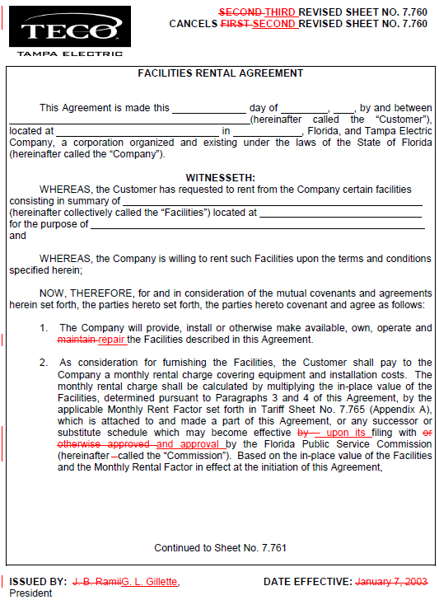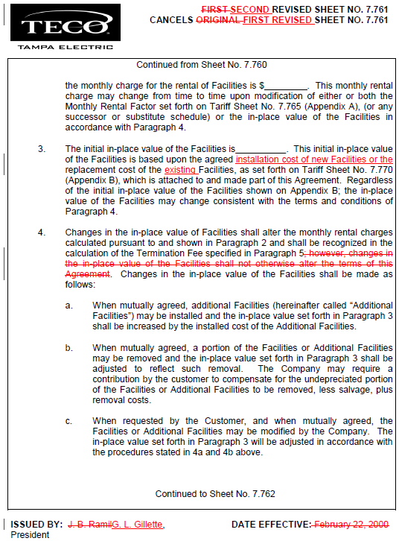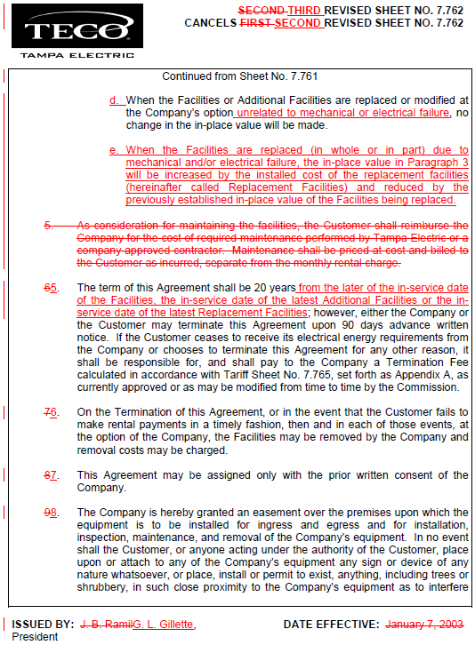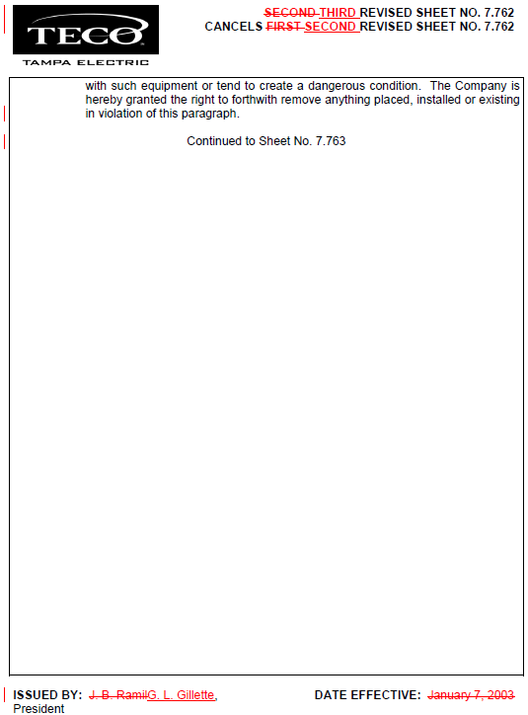

See Order No. PSC-03-0116-TRF-EI, issued January 21, 2003, in Docket No. 021139, In re: Petition for approval of revised facilities rental agreement and revised tariff by Tampa Electric Company.
See Order No. PSC-13-0443-FOF-EI, issued September 30, 2013, in Docket 130040-EI, In re: Petition for rate increase by Tampa Electric Company.
See Order No. PSC-09-0283-FOF-EI, issued April 30, 2009, in Docket 080317-EI, In re: Petition for rate increase by Tampa Electric Company.
See Order No. PSC-13-0443-FOF-EI, issued September 30, 2013, in Docket 130040-EI, In re: Petition for rate increase by Tampa Electric Company.

