State of Florida   |  | Public Service Commission  Capital Circle Office Center ● 2540 Shumard Oak Boulevard  Tallahassee, Florida 32399-0850  -M-E-M-O-R-A-N-D-U-M-
DATE: | December 23, 2014
TO: | Office of Commission Clerk (Stauffer)
FROM: | Office of the General Counsel (Corbari)  Office of Telecommunications (Casey)  Office of Consumer Assistance & Outreach (Hicks)
RE: | Docket No. 140223-TC – Initiation of show cause proceedings against Florida Public Telephone Company for apparent violation of Section 364.335(2), F.S., Application for Certificate of Authority, Section 364.3375(2), F.S., Pay Telephone Service Providers, Rule 25-4.0051, F.A.C., Current Certificate Holder Information, and Rule 25-22.032(6)(b), F.A.C., Customer Complaints.
AGENDA: | 01/08/15 – Regular Agenda – Interested Persons May Participate
COMMISSIONERS ASSIGNED: |  |  | All Commissioners
PREHEARING OFFICER: |  |  | Administrative
CRITICAL DATES: |  |  | None
SPECIAL INSTRUCTIONS: |  |  | None

Case Background
By Order PSC-97-0271-FOF-TC, issued March 11, 1997, Florida Public Telephone Company (Company) was granted Payphone Certificate Number 5108 to provide pay telephone service in the State of Florida. The Order specified that pay telephone providers are required to comply with all applicable provisions of Chapter 364, Florida Statutes (F.S.), and Chapter 25-24, Florida Administrative Code (F.A.C.). In 2014, the Company paid its 2013 Regulatory Assessment Fees (RAFs) and indicated on its Regulatory Assessment Fee Return that it had 42 payphones in operation at the end of 2013.
On February 18, 2014, the Florida Public Service Commission’s (Commission) Office of Consumer Assistance & Outreach received a complaint from a consumer who stated that the payphone located at 10696 Biscayne Boulevard in Jacksonville, Florida operated by Florida Public Telephone Company was not working (Complaint No. 1139237T). The consumer stated that both the payphone number and repair number were out of order.
On March 27, 2014, the Commission’s Office of Consumer Assistance & Outreach received a complaint from the City of Jacksonville stating the payphone operated by Florida Public Telephone Company, located at 1245 West 8th Street in Jacksonville, Florida, was not working and should be removed (Complaint No. 1142992T). The complaint states that this payphone is located in a known drug area, has not been working for a very long time, and the Jacksonville Sheriff’s Office would like the payphone removed due to illegal activity in the area.
This recommendation addresses two payphone complaints forwarded to Florida Public Telephone Company and Florida Public Telephone Company’s apparent violation of Section 364.335(2), F.S., Section 364.3375(2), F.S., Rule 25-4.0051, F.A.C., and Rule 25-22.032(6)(b), F.A.C. The Commission has jurisdiction pursuant to Chapter 364, F.S., Rule 25-4.0051, F.A.C., and Rule 25-22.032, F.A.C.

Discussion of Issues
Issue 1:1
Should the Commission order Florida Public Telephone Company to show cause in writing, within 21 days of the date of the order why it should not be penalized $2,000, or its Certificate No. 5108 should not be cancelled for apparent violations of Section 364.335(2), F.S., Section 364.3375(2), F.S., Rule 25-4.0051, F.A.C., and Rule 25-22.032(6)(b), F.A.C.?
Recommendation:
Yes. The Commission should order Florida Public Telephone Company to show cause in writing, within 21 days of the issuance of an Order, why it should not be penalized $2,000, or its Certificate No. 5108 cancelled for apparent violations of Section 364.335(2), F.S., Section 364.3375(2), F.S., Rule 25-4.0051, F.A.C., and Rule 25-22.032(6)(b), F.A.C. Specifically, staff recommends that Florida Public Telephone Company be directed to repair or remove the inoperable payphones, pay a penalty of $2,000, update company contact information with the Commission Clerk, and update the Company’s Corporate Registration with the Florida Secretary of State. Florida Public Telephone Company=s response must contain specific allegations of fact or law. If Florida Public Telephone Company fails to respond to the show cause order or request a hearing pursuant to Section 120.57, F.S., within 21 days and/or remit the penalty and resolve the complaints, the facts should be deemed admitted and the Company’s certificate No. 5108 should be cancelled. If a penalty is assessed and paid by the Company, the Commission will remit the penalty to the State of Florida General Revenue Fund pursuant to Section 364.285, F.S. (Corbari, Casey, Hicks)
Staff Analysis:

Factual Allegations

Pursuant to Section 364.335(2), F.S., certificated companies are required to ensure continued compliance with applicable business formation, registration, and taxation provisions of law.

Pursuant to Section 364.3375(2), F.S., each pay telephone station shall:

- Receive and permit coin-free access to the universal emergency telephone number “911” where operable or to a local exchange company toll operator;
- Receive and provide coin-free or coin-return access to local directory assistance and the telephone number of the person responsible for repair service; and
- Be eligible to subscribe to flat-rate, single-line business local exchange services.

Rule 25-4.0051, F.A.C., (Current Certificate Holder Information) requires each certificated company to file updated information for the following items with the Office of Commission Clerk within 10 days after any changes to the following:

- The address of the certificate holder’s main corporate and Florida offices (if any) including street name and address and post office box, city, state and zip code; or

- Telephone number, name, and address of the individual who is to serve as primary liaison with the Commission in regard to the ongoing Florida operations of the certificated company.

Rule 25-22.032(6)(b), F.A.C., (Customer Complaints), requires a company to provide the Commission with a written response to a customer complaint, within 15 working days after the complaint is sent to the company by Commission staff.

In the instant docket, Commission staff received two complaints that payphones located at 10696 Biscayne Boulevard, and 1245 West 8th Street in Jacksonville, Florida, were out of order. Staff from the Office of Consumer Assistance & Outreach attempted to contact Florida Public Telephone Company via telephone and facsimile, however, both lines were out of service. To date, Florida Public Telephone Company has not responded to either complaint that its payphones are out of order. In addition, technical staff from the Office of Telecommunications attempted to call the two payphone numbers and received a recording that the payphones were disconnected.

Complaint No. 1139237T

On February 18, 2014, the Commission’s Office of Consumer Assistance & Outreach received a complaint that the payphone at 10696 Biscayne Boulevard, Jacksonville, Florida was out of order. The complainant stated that neither the payphone number nor the repair number was working. On February 19, 2014, the Office of Consumer Assistance & Outreach mailed a copy of the complaint to the Company. No response has been received.

On March 21, 2014, the Office of Consumer Assistance & Outreach forwarded the complaint to the Commission’s Office of Telecommunications for further action. On June 25, 2014, the Office of Telecommunications sent a certified letter to Florida Public Telephone Company notifying it of the payphone complaint and that Commission staff had attempted to contact the Company numerous times regarding the payphone located at 10696 Biscayne Boulevard, with no success. Commission staff requested Florida Public Telephone Company submit a plan, within fifteen (15) days of the date of the letter, outlining when the payphone would be operational. In addition, staff advised the Company that failure to comply with staff’s request may result in cancellation of its payphone certificate or penalties of up to $25,000 per day, pursuant to Section 364.285, F.S. On July 25, 2014, the certified letter was returned by the United States Postal Service as “unclaimed, unable to forward.” (See, Attachment A – Copy of staff’s June 25, 2014, letter which was returned on July 25, 2014.)

Complaint No. 1142992T

On March 27, 2014, the Commission’s Office of Consumer Assistance & Outreach received a complaint regarding the payphone at 1245 West 8th Street in Jacksonville, Florida was out of order. On March 28, 2014, staff with the Office of Consumer Assistance & Outreach sent a copy of the complaint to the Company, via certified mail. On April 4, 2014, a Certified, Return Receipt postcard signed by David Swearingen (owner of Florida Public Telephone Company) was received by the Commission, evidencing receipt of the complaint by Florida Public Telephone Company. (See, Attachment B – Copy of Certified Return Receipt signed by David Swearingen on March 31, 2014.)

After receiving no response from the Company to the complaint, the Office of Consumer Assistance & Outreach attempted to call and fax the Company regarding the complaint, however, the Company’s fax number was “out of order” and the telephone number was “disconnected.” On May 1, 2014, the Office of Consumer Assistance & Outreach sent another copy of the complaint to the Company via certified mail. On May 9, 2014, a Certified, Return Receipt postcard was received by the Commission, evidencing receipt of the complaint by Florida Public Telephone Company. (See, Attachment C – Copy of Certified Return Receipt signed on May 3, 2014)

Upon receiving no response from the Company, the complaint was forwarded to the Commission’s Office of Telecommunications for further action. On July 3, 2014, the Office of Telecommunications sent a certified letter to Florida Public Telephone Company notifying it of the payphone complaint and that Commission staff had attempted to contact the Company numerous times regarding the payphone located at 1245 West 8th, with no success. Commission staff requested Florida Public Telephone Company submit a plan, within fifteen (15) days of the date of the letter, outlining when the payphone would be operational. In addition, staff advised the Company that failure to comply with staff’s request may result in cancellation of its payphone certificate or penalties of up to $25,000 per day pursuant to Section 364.285, F.S. On August 9, 2014, the certified letter was returned by the United States Postal Service as “unclaimed, unable to forward.” (See, Attachment D – Copy of staff’s July 3, 2014, letter which was returned on August 9, 2014.)

Staff Recommendation

Certificated companies are charged with the knowledge of the Commission's rules and statutes. Additionally, "[i]t is a common maxim, familiar to all minds that ‘ignorance of the law’ will not excuse any person, either civilly or criminally." Barlow v. United States, 32 U.S. 404, 411 (1833). In making similar decisions, the Commission has repeatedly held that certificated companies are charged with the knowledge of the Commission’s Rules and Statutes, and the intent of Section 364.285(1) is to penalize those who affirmatively act in opposition to those orders, rules, or statutes.
The procedure followed by the Commission in dockets such as this is to consider the Commission staff’s recommendation and determine whether or not the facts warrant requiring the company to respond. If the Commission approves staff’s recommendation, the Commission issues an Order to Show Cause. A show cause order is considered an administrative complaint by the Commission against the company. If the Commission issues a show cause order, the company is required to file a written response. The response must contain specific allegations of disputed fact. If there are no disputed factual issues, the company’s response should so indicate. The response must be filed within 21 days of service of the show cause order on the respondent.

The company has two options if a show cause order is issued. The company may respond and request a hearing pursuant to Sections 120.569 and 120.57, F.S. If the company requests a hearing, a hearing will be scheduled to take place before the Commission, after which a final determination will be made. Alternatively, the company may respond to the show cause order by remitting the penalty and resolving the complaints. If the company pays the penalty and resolves the complaints, the show cause matter will be considered resolved, and the docket closed.

In the event the company fails to timely respond to the show cause order, the company is deemed to have admitted the factual allegations contained in the show cause order. The company’s failure to timely respond is also a waiver of its right to a hearing. Additionally, a final order will be issued imposing the sanctions set out in the show cause order.

Pursuant to Section 364.285, F.S., the Commission is authorized to impose upon any entity subject to its jurisdiction a penalty of not more than $25,000 for each offense, if such entity is found to have refused to comply with or to have willfully violated any lawful rule or order of the Commission, or any provision of Chapter 364. Each day a violation continues is treated as a separate offense. Each penalty is a lien upon the real and personal property of the company and is enforceable by the Commission as a statutory lien.

Willfulness is a question of fact. Therefore, part of the determination the Commission must make in evaluating whether to penalize a company is whether the company willfully violated the rule, statute, or order. Section 364.285, F.S., does not define what it is to “willfully violate” a rule or order. In Commission Order No. 24306, issued April 1, 1991, in Docket No. 890216-TL titled In Re: Investigation Into The Proper Application of Rule 25-14.003, F.A.C., Relating To Tax Savings Refund for 1988 and 1989 For GTE Florida, Inc., the Commission stated that “willful implies an intent to do an act, and this is distinct from an intent to violate a statute or rule." The plain meaning of "willful" typically applied by the Courts in the absence of a statutory definition, is an act or omission that is done “voluntarily and intentionally” with specific intent and “purpose to violate or disregard the requirements of the law.” Fugate v. Fla. Elections Comm’n, 924 So. at 76.
As outlined above, staff has attempted to contact Florida Public Telephone Company numerous times, by numerous methods, in order to resolve the two complaints and have been unsuccessful. The Company’s telephone and facsimile lines have been disconnected. Staff even attempted to contact the Company at the telephone numbers listed on the Company’s 2013 Regulatory Assessment Fee Return, with no success. Furthermore, staff’s attempts to contact the Company via certified mail were either received and ignored by the Company, or returned as “unclaimed.” By failing to file updated contact information with the Office of Commission Clerk within 10 days after any changes, the Company is in apparent violation of Rule 25-4.0051, F.A.C. In addition, staff reviewed the Florida Secretary of State Corporation database (See, Attachment E – Copy of Florida Public Telephone Company Expired Corporate Registration) and found that the Company does not have a current Florida Corporate Registration, in violation of Section 364.335, F.S.

Staff believes that Florida Public Telephone Company has knowingly failed to comply with the provisions of Section 364.335(2), F.S., Section 364.3375(2), F.S., Rule 25-4.0051, F.A.C., and Rule 25-22.032(6)(b), F.A.C., and, as a result, Florida Public Telephone Company’s acts were “willful” in the sense intended by Section 364.285, F.S., and Fugate. Staff therefore recommends that Florida Public Telephone Company should be ordered to show cause in writing, within 21 days of the issuance of the Commission Order, why it should not be penalized $2,000 or its certificate No. 5108 cancelled for apparent violations of Section 364.335(2), F.S., Section 364.3375(2), F.S., Rule 25-4.0051, F.A.C., and Rule 25-22.032(6)(b), F.A.C. Staff asserts that the penalty amount recommended of $500 per violation is consistent with amounts imposed for similar violations.

Florida Public Telephone Company=s response must contain specific allegations of fact or law. If Florida Public Telephone Company fails to respond to the show cause order or request a hearing pursuant to Section 120.57, F.S., and/or the penalty is not paid within the 21-day response period and the complaints resolved, the facts should be deemed admitted and the Company’s certificate No. 5108 should be cancelled. If the Company pays the assessed penalty, the Commission will remit the penalty to the State of Florida General Revenue Fund pursuant to Section 364.285, F.S.

In addition, staff recommends that the show cause order incorporate the following conditions:

- This show cause order is an administrative complaint by the Florida Public Service Commission, as petitioner, against Florida Public Telephone Company, as respondent.

- The Company shall respond to the show cause order within 21 days of service on the Company, and the response shall reference Docket No. 140223-TC In re: Initiation of show cause proceedings against Florida Public Telephone Company for apparent violations of Section 364.335(2), F.S., Application for Certificate of Authority, Section 364.3375(2), F.S., Pay Telephone Service Providers, Rule 25-4.0051, F.A.C., Current Certificate Holder Information, and Rule 25-22.032(6)(b), F.A.C., Customer Complaints.

- The Company has the right to request a hearing to be conducted in accordance with Sections 120.569 and 120.57, F.S., and to be represented by counsel or other qualified representative.

- Requests for hearing shall comply with Rule 28-106.2015, F.A.C.

- The Company’s response to the show cause order shall identify those material facts that are in dispute. If there are none, the petition must so indicate.

- If Florida Public Telephone Company files a timely written response and makes a request for a hearing pursuant to Sections 120.569 and 120.57, F.S., a further proceeding will be scheduled before a final determination of this matter is made.

- A failure to file a timely written response to the show cause order will constitute an admission of the facts herein alleged and a waiver of the right to a hearing on this issue.

- In the event that Florida Public Telephone Company fails to file a timely response to the show cause order, and the respective penalty is not received, Florida Public Telephone Company’s Certificate No. 5108 should be cancelled and this docket closed administratively.

- If the Company responds to the show cause order by remitting the penalty, resolving the complaints, updating company contact information with the Commission Clerk, and updating the Company’s Corporate Registration with the Florida Secretary of State, this show cause matter will be considered resolved, and the docket closed administratively.
Issue 2:2
Should this docket be closed?
Recommendation:
No. If Issue 1 is approved, then Florida Public Telephone Company, will have 21 days, from the issuance of the Order to Show Cause, to respond in writing why it should not be assessed a penalty or have its certificate canceled. If Florida Public Telephone Company timely responds, in writing, to the Order to Show Cause, and repairs or removes the inoperable payphones, updates the company contact information with the Commission Clerk, updates the Company’s Corporate Registration with the Florida Secretary of State, and timely pays the assessed penalty of $2,000, the penalty should be deposited in the Florida General Revenue Fund pursuant to Section 364.285(1), Florida Statutes, and the docket closed administratively. If Issue 1 is approved and Florida Public Telephone Company fails to timely respond to the Order to Show Cause or request a hearing, fails to repair or remove the inoperable payphones, fails to update the company contact information with the Commission Clerk, fails to update the Company’s Corporate Registration with the Florida Secretary of State, or fails to timely pay the assessed penalty of $2,000, then Florida Public Telephone Company’s Certificate No. 5108 should be canceled and the docket closed administratively. (Corbari, Casey, Hicks)
Staff Analysis:
If Issue 1 is approved, then Florida Public Telephone Company, will have 21 days, from the issuance of the Order to Show Cause, to respond in writing why it should not be assessed a penalty or have its certificate canceled. If Florida Public Telephone Company timely responds, in writing, to the Order to Show Cause, and repairs or removes the inoperable payphones, updates the company contact information with the Commission Clerk, updates the Company’s Corporate Registration with the Florida Secretary of State, and timely pays the assessed penalty of $2,000, the penalty should be deposited in the Florida General Revenue Fund pursuant to Section 364.285(1), Florida Statutes, and the docket closed administratively. If Issue 1 is approved and Florida Public Telephone Company fails to timely respond to the Order to Show Cause or request a hearing, fails to repair or remove the inoperable payphones, fails to update the company contact information with the Commission Clerk, fails to update the Company’s Corporate Registration with the Florida Secretary of State, or fails to timely pay the assessed penalty of $2,000, then Florida Public Telephone Company’s Certificate No. 5108 should be canceled and the docket closed administratively.

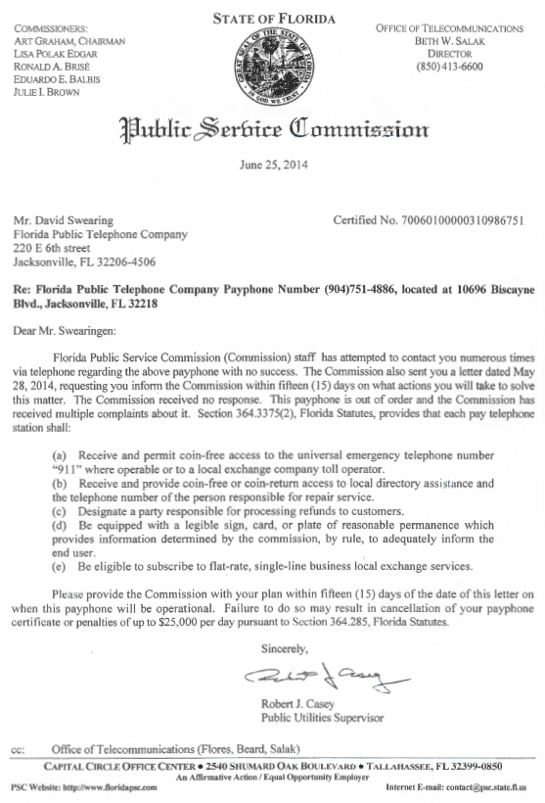
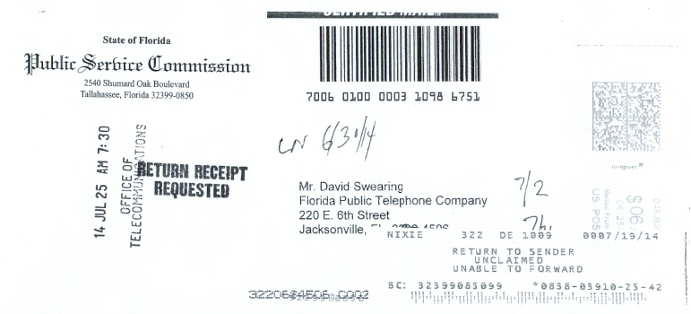

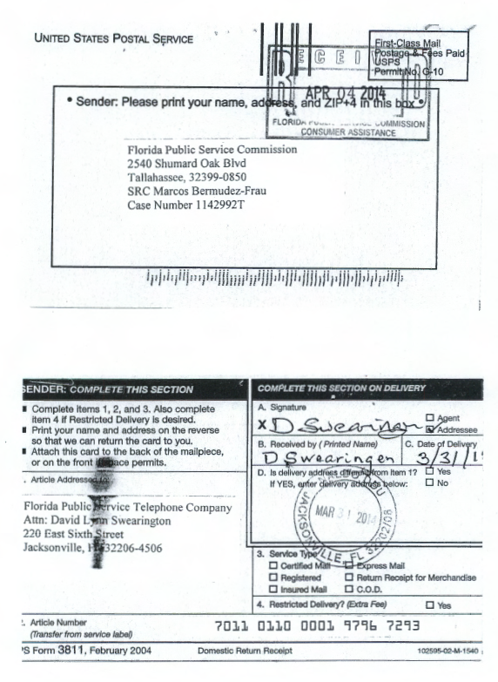

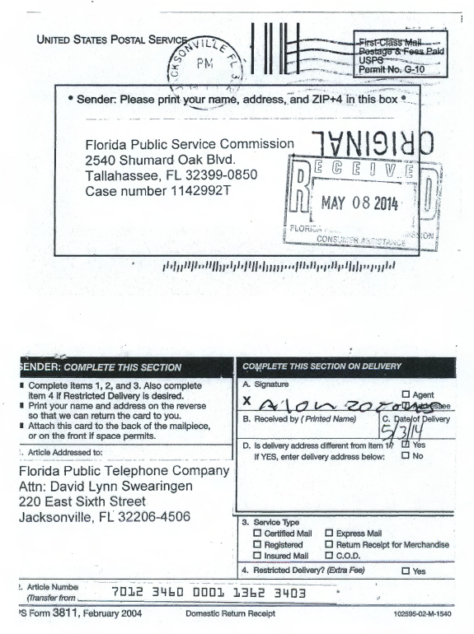
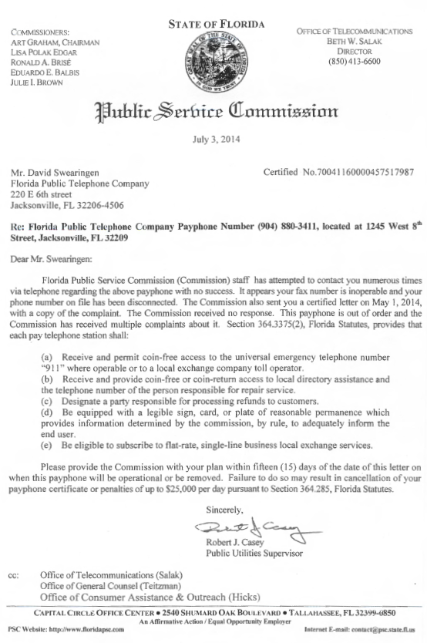

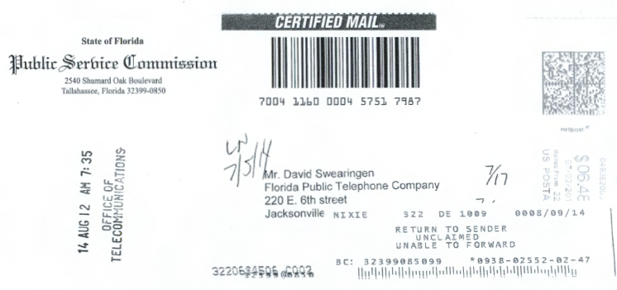

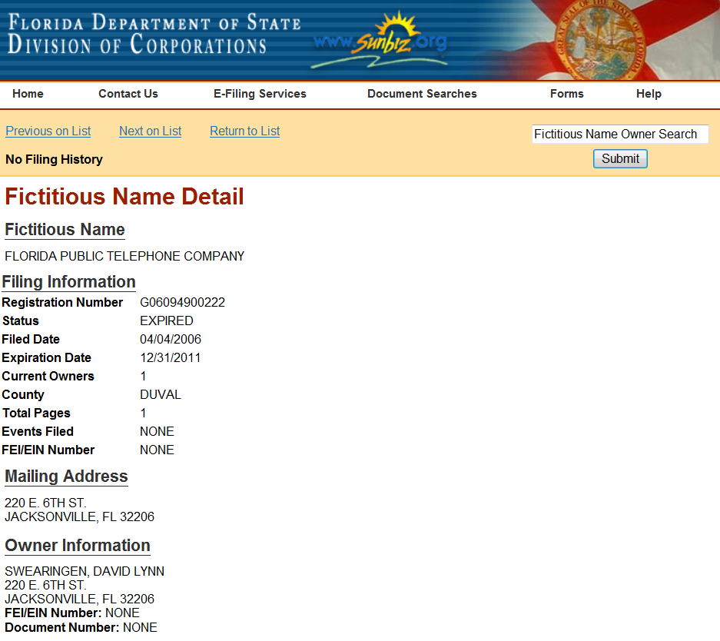

See, Order No. PSC-11-0250-FOF-WU, issued June 13, 2011, in Docket No. 100104-WU, In re: Application for increase in water rates in Franklin County by Water Management Services, Inc.; Order No. PSC-07-0275-SC-SU, issued April 2, 2007, in Docket No. 060406-SU, In re: Application for staff-assisted rate case in Polk County by Crooked Lake Park Sewerage Company; and Order No. PSC-05-0104-SC-SU, issued January 26, 2005 in Docket Nos. 020439-SU and 020331-SU; In re: Application for staff-assisted rate case in Lee County by Sanibel Bayous Utility Corporation; In re: Investigation into alleged improper billing by Sanibel Bayous Utility Corporation in Lee County in violation of Section 367.091(4), Florida Statutes. See also, Florida State Racing Commission v. Ponce de Leon Trotting Association, 151 So.2d 633, 634 (Fla. 1963), and Commercial Ventures, Inc. v. Beard, 595 So.2d 47, 48 (Fla. 1992) (utilities are subject to the rules published in the Florida Administrative Code).
See, Section 364.285(1), F.S.
Fugate v. Fla. Elections Comm’n, 924 So. 2d 74, 75 (Fla. 1st DCA 3006), citing, Metro. Dade County v. State Dep't of Envtl. Prot., 714 So. 2d 512, 517 (Fla. 3d DCA 1998).

