BEFORE THE FLORIDA PUBLIC SERVICE COMMISSION

In re: Petition for approval of transportation service agreement for an extension in Palm Beach County with Florida Public Utilities Company, by Peninsula Pipeline Company, Inc. | DOCKET NO. 140190-GU  ORDER NO. PSC-14-0712-PAA-GU  ISSUED: December 31, 2014

The following Commissioners participated in the disposition of this matter:

ART GRAHAM, Chairman
LISA POLAK EDGAR
RONALD A. BRISÉ
EDUARDO E. BALBIS
JULIE I. BROWN

NOTICE OF PROPOSED AGENCY ACTION
ORDER APPROVING THE TRANSPORTATION SERVICE AGREEMENT

BY THE COMMISSION:

NOTICE is hereby given by the Florida Public Service Commission that the action discussed herein is preliminary in nature and will become final unless a person whose interests are substantially affected files a petition for a formal proceeding, pursuant to Rule 25-22.029, Florida Administrative Code (F.A.C.).

Background

On September 30, 2014, Peninsula Pipeline Company, Inc. (Peninsula) filed a petition seeking approval of a firm transportation service agreement (Agreement) between Peninsula and Florida Public Utilities Company (FPUC) for an extension in Palm Beach County. Peninsula operates as a natural gas transmission company as defined in Section 368.103(4), Florida Statutes (F.S.).

By Order No. PSC-07-1012-TRF-GP, we approved an intrastate gas pipeline tariff that allows Peninsula to construct and operate intrastate pipeline facilities and to actively pursue agreements with gas customers. Peninsula provides transportation service only, and does not engage in the sale of natural gas. Pursuant to Order No. PSC-07-1012-TRF-GP, Peninsula is allowed to enter into certain gas transmission agreements without our prior approval. However, Peninsula is requesting our approval of this Agreement as it does not fit any of the criteria enumerated in the tariff for which our approval would not be required. Both Peninsula and FPUC are subsidiaries of Chesapeake, and agreements between affiliated companies must be approved by this Commission pursuant to Section 368.105, F.S., and Order No. PSC-07-1012-TRF-GP.
Peninsula is seeking to extend its existing infrastructure at the Port of Palm Beach in the city of Riviera Beach, Palm Beach County, Florida. During its evaluation of the petition, Commission staff issued a data request to both Peninsula and FPUC for which responses were received on October 29, 2014. This Commission has jurisdiction over this matter pursuant to Sections 366.05(1), 366.06, and 368.105, F.S.

Discussion
The proposed Agreement provides for three projects Peninsula will undertake at the Port of Palm Beach (Port) and will be in effect for an initial period of 20 years. Peninsula explained in the petition that the Port has started construction to support anticipated growth and redevelopment. Delivery pressure in and around the Port on FPUC’s distribution system is currently limited and FPUC therefore is not able to serve any potential new customers on this part of the existing distribution system.
Peninsula’s proposed projects interconnect to the Riviera Lateral Peninsula acquired in September 2013 from the Florida Gas Transmission Company (FGT). The 5.4 mile Riviera Lateral interconnects FPUC’s distribution system to FGT’s interstate pipeline system. Subsequent to Peninsula’s purchase of the Riviera Lateral, Peninsula and FPUC executed a transportation service agreement providing for deliveries of natural gas received from FGT to FPUC’s distribution system through the Riviera Lateral. Peninsula’s three new projects are discussed in more detail below and are shown in the map provided in Attachment A.
First, Peninsula will inspect, test, and reactivate 800 feet of an existing 12 inch steel pipe that extends across the southern boundary of the Port. This pipe is part of the Riviera Lateral that was cut and capped during Peninsula’s acquisition of the lateral from FGT. Reactivating the line will alleviate the pressure issues FPUC has been experiencing around the Port. In response to Commission staff’s data request, FPUC explained that Peninsula’s activation of that pipe is more cost effective than FPUC installing a new pipe.
Second, Peninsula will install a new interconnection at the midpoint of the reactivated pipe and install 820 feet of 12 inch steel pipe north across the Port property to FPUC’s facilities serving the existing and potential new customers at the Port. The existing customer is currently served by a 4 inch lower pressure plastic main owned by FPUC, which is undersized as the customer has increased consumption. In addition, the Port has given FPUC notice that it must relocate its 4 inch main as the Port needs the space. FPUC explained in response to Commission staff’s data request that FPUC evaluated a self build project, and concluded that there is no cost difference between FPUC’s cost to abandon the 4 inch plastic main and construct the 12 inch steel pipe north through the Port and Peninsula’s cost of the project. FPUC stated that it will remove the 4 inch main from rate base.
Third, delivery pressure on the FPUC distribution system in and around the Port is limited to a maximum of 25 pounds per square inch. Peninsula will install an additional custody transfer point, with pressure regulation, to connect the activated 800 feet of 12 inch steel pipe into FPUC’s existing distribution system at the southeast corner of the Port property to alleviate existing pressure problems and support growth in that area. Finally, Peninsula will increase its contract capacity with FPUC to make more gas available to FPUC.
Peninsula stated that it has applied to obtain permits from the Department of Transportation and the Port Authority to install the proposed projects and expects to receive all permits before the end of 2014 and complete the construction in the second quarter of 2015. The negotiated monthly reservation charge included in the proposed Agreement is designed to allow Peninsula to recover its investment and operational costs associated with the projects. These costs include design engineering, permitting, material and installation costs, ongoing maintenance costs, property taxes, and Peninsula’s return on investment.
The parties assert that the rates contained in the Agreement are consistent with a market rate in that they are within the ranges of rates set forth in similar agreements as required by Section 368.105(3)(b), F.S. In response to Commission staff’s data request, Peninsula provided a comparison of construction costs (confidential) for other similar agreements entered into by Peninsula. While construction costs vary for each project due to pipe size, construction conditions, permitting, etc., we find that Peninsula’s construction costs for the proposed extension appear reasonable and comparable to other projects. Peninsula explained that the Port is a highly congested, asphalt-surrounded property, which impacts construction costs.
To support the proposed Agreement, Peninsula lists four benefits of Peninsula, as opposed to FPUC, constructing the projects: (1) Peninsula has expertise to construct and manage this type of pipeline, (2) the project would satisfy FPUC’s requirement to relocate the 820 feet of existing 4 inch main, (3) the existing FPUC customer at the Port would no longer experience pressure problems or delivery quantity limits, and (4) Peninsula’s construction and ownership will avoid FPUC undertaking the costs and risk for this project, protecting FPUC’s ratepayers.
FPUC is proposing to recover the payments to Peninsula under the proposed Agreement through its Purchased Gas Adjustment (PGA) mechanism consistent with other gas transmission pipeline costs incurred by FPUC. In the annual PGA docket we do not set an actual factor, but a PGA cap. FPUC provided information showing that the impact on the PGA cap will be minor. While FPUC will incur costs associated with this service expansion to new areas, the anticipated new load will help spread the costs over a larger customer base.
Decision
Based on the petition and responses from FPUC and Peninsula to Commission staff’s data request, we find the proposed Agreement is cost effective, reasonable, meets the requirements of Section 368.105, F.S., and benefits FPUC’s customers. We hereby approve the Transportation Service Agreement between Peninsula and FPUC dated September 26, 2014, for an extension in Palm Beach County.
Based on the foregoing, it is
ORDERED by the Florida Public Service Commission that the Transportation Service Agreement between Peninsula Pipeline Company, Inc. and Florida Public Utility Company for an extension in Palm Beach County is approved. It is further

ORDERED that the provisions of this Order, issued as proposed agency action, shall become final and effective upon the issuance of a Consummating Order unless an appropriate petition, in the form provided by Rule 28-106.201, Florida Administrative Code, is received by the Commission Clerk, 2540 Shumard Oak Boulevard, Tallahassee, Florida 32399-0850, by the close of business on the date set forth in the “Notice of Further Proceedings” attached hereto. It is further

ORDERED that in the event this Order becomes final, this docket shall be closed.

By ORDER of the Florida Public Service Commission this 31st day of December, 2014.

/s/ Hong Wang
HONG WANG
Chief Deputy Commission Clerk
Florida Public Service Commission
2540 Shumard Oak Boulevard
Tallahassee, Florida 32399
(850) 413-6770
www.floridapsc.com

Copies furnished: A copy of this document is provided to the parties of record at the time of issuance and, if applicable, interested persons.

DJ

NOTICE OF FURTHER PROCEEDINGS OR JUDICIAL REVIEW

The Florida Public Service Commission is required by Section 120.569(1), Florida Statutes, to notify parties of any administrative hearing that is available under Section 120.57, Florida Statutes, as well as the procedures and time limits that apply. This notice should not be construed to mean all requests for an administrative hearing will be granted or result in the relief sought.

Mediation may be available on a case-by-case basis. If mediation is conducted, it does not affect a substantially interested person's right to a hearing.

The action proposed herein is preliminary in nature. Any person whose substantial interests are affected by the action proposed by this order may file a petition for a formal proceeding, in the form provided by Rule 28-106.201, Florida Administrative Code. This petition must be received by the Office of Commission Clerk, 2540 Shumard Oak Boulevard, Tallahassee, Florida 32399-0850, by the close of business on January 21, 2015.

In the absence of such a petition, this order shall become final and effective upon the issuance of a Consummating Order.

Any objection or protest filed in this/these docket(s) before the issuance date of this order is considered abandoned unless it satisfies the foregoing conditions and is renewed within the specified protest period.
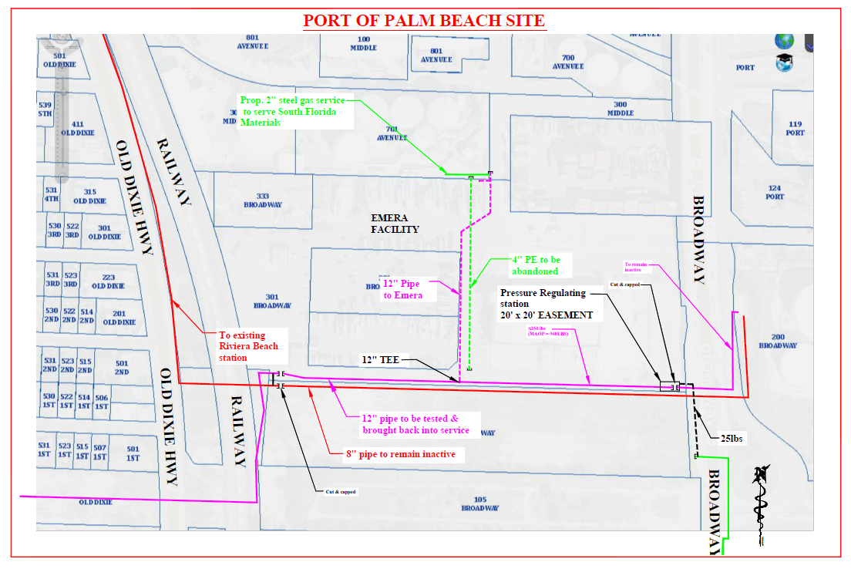

See Order No. PSC-06-0023-DS-GP, issued January 9, 2006, in Docket No. 050584-GP, In re: Petition for declaratory statement by Peninsula Pipeline Company, Inc. concerning recognition as a natural gas transmission company under Section 368.101, F.S., et seq.
Order No. PSC-07-1012-TRF-GP, issued December 21, 2007, in Docket No. 070570-GP, In re: Petition for approval of natural gas transmission pipeline tariff by Peninsula Pipeline Company, Inc.
Peninsula Pipeline Company, Inc., Intrastate Pipeline Tariff, Original Vol. 1, Sheet No. 12, Section 4.
Order No. PSC-13-0378-PAA-GU, issued August 13, 2013, in Docket No. 120313-GU, In re: Petition for approval of transportation service agreement with Florida Public Utilities Company, by Peninsula Pipeline Company, Inc.
The projected $/therm impact to the PGA factor was provided under a claim of confidentiality.

