BEFORE THE FLORIDA PUBLIC SERVICE COMMISSION

In re: Joint petition for approval of amendment to territorial agreement in Charlotte, Lee, and Collier Counties, by Florida Power & Light Company and Lee County Electric Cooperative. | DOCKET NO. 140210-EU  ORDER NO. PSC-15-0021-PAA-EU  ISSUED: January 5, 2015

The following Commissioners participated in the disposition of this matter:

ART GRAHAM, Chairman
LISA POLAK EDGAR
RONALD A. BRISÉ
EDUARDO E. BALBIS
JULIE I. BROWN

NOTICE OF PROPOSED AGENCY ACTION
ORDER APPROVING AMENDMENT TO TERRITORIAL AGREEMENT
BETWEEN FLORIDA POWER & LIGHT COMPANY AND
LEE COUNTY ELECTRIC COOPERATIVE

BY THE COMMISSION:

NOTICE is hereby given by the Florida Public Service Commission that the action discussed herein is preliminary in nature and will become final unless a person whose interests are substantially affected files a petition for a formal proceeding, pursuant to Rule 25-22.029, Florida Administrative Code (F.A.C.).

Background

On November 3, 2014, Florida Power & Light Company (FPL) and Lee County Electric Cooperative (LCEC) jointly filed a petition for approval of an amendment to the existing territorial agreement (Amendment) between the two Utilities. We approved the existing territorial agreement in 1993, establishing service areas in Charlotte, Collier, Hendry, and Lee Counties. A territorial variance agreement relating to Lee County was approved by this Commission in 1997.

The instant petition follows a petition from Babcock Ranch Community Independent Special District (Babcock Ranch) requesting we acknowledge Babcock Ranch as a new municipal electric utility. LCEC, the Florida Electric Cooperatives Association, and Tampa Electric Company filed comments in opposition to Babcock Ranch’s Petition. Before we could take the matter under consideration, however, Babcock Ranch, LCEC, and FPL requested the matter be deferred while the parties attempted to resolve their disputes on the matter. On November 4, 2014, the parties advised us that they had reached a settlement agreement in the form of a territorial amendment, which is the subject of the instant matter. In addition, the parties agreed that, “[a]fter the Commission has rendered a Final Order approving the territorial amendment and the time for appeal has lapsed, the District will voluntarily dismiss its notice and petition in this docket.”

We have jurisdiction over this matter pursuant to Section 366.04, Florida Statutes (F.S.).

DECISION

Pursuant to Section 366.04(2)(d), F.S., we have jurisdiction to approve territorial agreements between and among rural electric cooperatives, municipal electric utilities, and other electric utilities. Rule 25-6.0440(2), F.A.C., provides that in approving territorial agreements, we may consider the reasonableness of the purchase price of any facilities being transferred, the likelihood that the agreement will not cause a decrease in the reliability of electric service to existing or future ratepayers, and the likelihood that the agreement will eliminate existing or potential uneconomic duplication of facilities. Unless we determine that the agreement will cause a detriment to the public interest, the agreement should be approved. Utilities Commission of the City of New Smyrna Beach v. Florida Public Service Commission, 469 So. 2d 731 (Fla. 1985).

As stated above, the proposed Amendment alters the territorial boundary between FPL and LCEC in Charlotte, Lee, and Collier Counties to allow both FPL and LCEC to serve the anticipated development more efficiently and avoid unnecessary duplication of facilities in two mostly undeveloped areas where both utilities currently have minimal infrastructure in place. The two areas to be transferred are identified in the proposed Amendment as Exchange Parcels 1 and 2.

The current territorial boundary line between FPL and LCEC runs through the Babcock Ranch Community Independent Special District, thus resulting in two different utilities serving the Babcock Ranch area. Exchange Parcel 1 includes the western half of Babcock Ranch, as well as adjacent areas in Charlotte and Lee Counties, and is currently within LCEC’s service area adjacent to the service area of FPL. The proposed Amendment places Exchange Parcel 1 wholly within an area to be served by FPL.

Exchange Parcel 2, which is about 28 miles southeast of Exchange Parcel 1 in central Collier County, is currently within FPL’s service area adjacent to the service area of LCEC. FPL and LCEC agreed to place Exchange Parcel 2 wholly within an area to be served by LCEC. As required by Rule 25-6.0440(1)(a), F.A.C., FPL and LCEC provided us with maps and legal descriptions of the affected areas.

The proposed Amendment specifies that no existing customers will be transferred to the other utility until there is a “Change in Use,” which is defined in the proposed Amendment as (1) a change in use of the property, (2) a change requiring reclassification of service, or (3) a change in ownership of the property.

As required by Rule 25-6.0440(1)(d), F.A.C., both FPL and LCEC have contacted their respective customers in the applicable exchange parcels. Each of the exchange parcels has four named customers, comprising fifteen accounts. Of the existing customers, none expressed opposition to the territorial amendment. One customer was in favor of the amendment, and the remainder had no concerns.

Reasonableness of the Purchase Price

The proposed Amendment states that any removal of facilities due to a transfer of service from one utility to the other will be at the sole cost of the owner of the facilities being removed. Furthermore, any transfer or exchange of facilities will be at net book value.

Reliability of Electric Service

In addition to LCEC continuing to provide uninterrupted electric service to its existing customers within Babcock Ranch, FPL and LCEC agreed to coordinate planning, construction, and service activities to provide timely service to new customers in the Babcock Ranch area. Should circumstances at the time require, LCEC will initially, but temporarily, provide service for no more than two years. During that period, FPL and LCEC have agreed to work expeditiously toward FPL assuming electric service responsibilities for new customers within the Babcock Ranch area.

RULING

We find that the proposed Amendment to the existing territorial agreement between FPL and LCEC is in the best interests of FPL, LCEC, and their respective customers. The proposed Amendment will eliminate any existing or potential uneconomic duplication of facilities, will not cause a decrease in the reliability of electric service to existing or future ratepayers, and will not cause a detriment to the public interest. Therefore, for the reasons outlined herein, we approve the Amendment.

Based on the foregoing, it is

ORDERED by the Florida Public Service Commission that the Joint petition for approval of amendment to the existing territorial agreement between Florida Power & Light Company and Lee County Electric Cooperative is approved. It is further

ORDERED that the provisions of this Order, issued as proposed agency action, shall become final and effective upon the issuance of a Consummating Order unless an appropriate petition, in the form provided by Rule 28-106.201, Florida Administrative Code, is received by the Commission Clerk, 2540 Shumard Oak Boulevard, Tallahassee, Florida 32399-0850, by the close of business on the date set forth in the “Notice of Further Proceedings” attached hereto. It is further

ORDERED that in the event this Order becomes final, this docket shall be closed.

By ORDER of the Florida Public Service Commission this 5th day of January, 2015.

/s/ Hong Wang
HONG WANG
Chief Deputy Commission Clerk
Florida Public Service Commission
2540 Shumard Oak Boulevard
Tallahassee, Florida 32399
(850) 413-6770
www.floridapsc.com

Copies furnished: A copy of this document is provided to the parties of record at the time of issuance and, if applicable, interested persons.

KFC

NOTICE OF FURTHER PROCEEDINGS OR JUDICIAL REVIEW

The Florida Public Service Commission is required by Section 120.569(1), Florida Statutes, to notify parties of any administrative hearing that is available under Section 120.57, Florida Statutes, as well as the procedures and time limits that apply. This notice should not be construed to mean all requests for an administrative hearing will be granted or result in the relief sought.

Mediation may be available on a case-by-case basis. If mediation is conducted, it does not affect a substantially interested person's right to a hearing.

The action proposed herein is preliminary in nature. Any person whose substantial interests are affected by the action proposed by this order may file a petition for a formal proceeding, in the form provided by Rule 28-106.201, Florida Administrative Code. This petition must be received by the Office of Commission Clerk, 2540 Shumard Oak Boulevard, Tallahassee, Florida 32399-0850, by the close of business on January 26, 2015.

In the absence of such a petition, this order shall become final and effective upon the issuance of a Consummating Order.

Any objection or protest filed in this/these docket(s) before the issuance date of this order is considered abandoned unless it satisfies the foregoing conditions and is renewed within the specified protest period.

EXCHANGE PARCEL 1
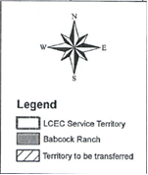

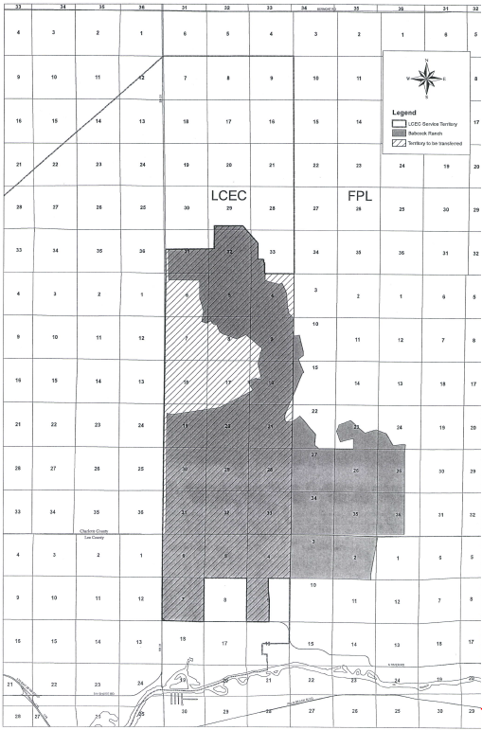

EXCHANGE PARCEL 2

See, Attachment 1, Amendment to Territorial Agreement Between Florida Power & Light Company and Lee County Electric Cooperative.
See, Order No. PSC-93-0705-FOF-EU, issued May 10, 1993, in Docket No. 930092-EU, In re: Joint application for approval of territorial agreement between Florida Power & Light Company and Lee County Electric Cooperative, Inc.
See, Order No. PSC-97-0527-FOF-EU, issued May 7, 1997, in Docket No. 970105-EU, In re: Petition for approval of change in territorial boundary under territorial agreement with Lee County Electric Cooperative, Inc., by Florida Power & Light Company.
See, Docket No. 140059-EM, established March 24, 2014, In re: Notice of new municipal electric service provider and petition for waiver of Rule 25-9.044(2), F.A.C., by Babcock Ranch Community Independent Special District. Documents providing the notices of opposition, requests for deferral, and announcement of a settlement are all contained in the docket file.
Id., Document No. 06196-14, November 4, 2014, Letter from counsel for Babcock Ranch to Commission Executive Director Baez regarding settlement agreement and requesting deferral of matter pending resolution of Docket No. 140210-EU, In re: Joint petition for approval of amendment to territorial agreement in Charlotte, Lee, and Collier Counties, by Florida Power & Light Company and Lee County Electric Cooperative.
See, Attachment 2, Sketch and Legal Description of Proposed Territorial Boundary (Exchange Parcel 1).
See, Attachment 3, Sketch and Legal Description of Proposed Territorial Boundary (Exchange Parcel 2).

