BEFORE THE FLORIDA PUBLIC SERVICE COMMISSION

In re: Petition for approval of amendment to extend term of negotiated renewable energy power purchase contract with Rayonier Performance Fibers, LLC, by Florida Public Utilities Company. | DOCKET NO. 140180-EQ  ORDER NO. PSC-15-0025-PAA-EQ  ISSUED: January 7, 2015

The following Commissioners participated in the disposition of this matter:

ART GRAHAM, Chairman
LISA POLAK EDGAR
RONALD A. BRISÉ
EDUARDO E. BALBIS
JULIE I. BROWN

NOTICE OF PROPOSED AGENCY ACTION ORDER
APPROVING REQUEST TO EXTEND TERM
OF NEGOTIATED PURCHASE POWER AGREEMENT

BY THE COMMISSION:

NOTICE is hereby given by the Florida Public Service Commission (Commission) that the action discussed herein is preliminary in nature and will become final unless a person whose interests are substantially affected files a petition for a formal proceeding, pursuant to Rule 25-22.029, Florida Administrative Code.

Case Background
On September 12, 2014, Florida Public Utilities Company (FPUC or Company) filed a petition (Petition) requesting approval of an amendment of its approved purchased power agreement (Agreement) with Rayonier Performance Fibers, LLC (Rayonier) to extend the expiration date of the Agreement from October 2022 to September 2036. The Agreement, which we approved by Order No. PSC 12-0380-PAA-EQ, has been in place and producing savings for FPUC’s customers for two years.
The facility is a certified Qualifying Facility (QF) as that term is defined by the Federal Energy Regulatory Commission rules and Rule 25-17.080, Florida Administrative Code (F.A.C). Rayonier currently owns and operates mills in Jessup, Georgia, and Fernandina Beach, Florida, that produce high-purity cellulose products from wood chips. The steam created by this process is utilized by Rayonier’s existing steam turbines to partially mitigate its electric demand. As such, the Rayonier facility is a renewable energy resource as defined by Section 366.91 (2)(d), Florida Statutes (F.S.). We have jurisdiction over this matter pursuant to Sections 366.051, 366.91 and 366.92, F.S.

Review and Decision

The Agreement provides FPUC with a viable source of renewable capacity and energy. FPUC and Rayonier (collectively Parties) have been operating under the Agreement for almost two years, and have encountered no notable operational issues.
Because the anticipated benefits have been realized since the Agreement became effective in October 2012, the Parties expect that these benefits will continue to accrue over an extended period. Therefore, the Parties have negotiated an Amendment No. 1 to extend the expiration of the Agreement 14 years from 2022 to 2036. (Amended Agreement). Rayonier will purchase low pressure steam from Eight Flags, an affiliate of Chesapeake Utilities, which is also the parent company of FPUC. The low pressure steam from Eight Flags will allow Rayonier to channel additional high pressure steam into its electric generating unit. The high pressure steam will enable Rayonier to increase the output of its generator and potentially sell additional renewable energy to FPUC, thereby increasing the savings to FPUC’s customers. The Agreement already provides for the purchase of this additional energy; by its Petition, FPUC is only requesting approval to extend the Agreement.
FPUC has represented that the increase in capacity gained from the additional output will have no impact on the transmission facilities connecting the Rayonier generating unit to FPUC’s system and that the Company plans to relocate the transmission facilities from an inaccessible, marshy area to a more easily accessible road right-of-way, which will greatly improve the overall system reliability by conforming to FPUC’s storm hardening standards.
The confidential projected annual savings for the Amended Agreement was provided with the Petition. Payments are estimated to provide a net present value (NPV) savings of $8.2 million over the entire term of the Amended Agreement.
Because the terms and conditions of the Agreement will continue throughout the extension period and extending the term of the Agreement is estimated to provide a net present value (NPV) savings of $8.2 million over the entire term of the Amended Agreement, we shall approve the Company’s Petition to extend the expiration date of its Agreement.
Based on the foregoing, it is
ORDERED by the Florida Public Service Commission that Florida Public Utilities Company’s September 12, 2014 petition for approval of an amendment to its negotiated purchased power agreement with Rayonier Performance Fibers, LLC is hereby approved. It is further,
ORDERED that this docket shall be closed upon issuance of a Consummating Order unless a person whose substantial interests are affected by the Commission’s decision files a protest within 21 days of the issuance of the proposed agency action.

By ORDER of the Florida Public Service Commission this 7th day of January, 2015.

/s/ Carlotta S. Stauffer
CARLOTTA S. STAUFFER
Commission Clerk
Florida Public Service Commission
2540 Shumard Oak Boulevard
Tallahassee, Florida 32399
(850) 413-6770
www.floridapsc.com

Copies furnished: A copy of this document is provided to the parties of record at the time of issuance and, if applicable, interested persons.

CWM

NOTICE OF FURTHER PROCEEDINGS OR JUDICIAL REVIEW

The Florida Public Service Commission is required by Section 120.569(1), Florida Statutes, to notify parties of any administrative hearing that is available under Section 120.57, Florida Statutes, as well as the procedures and time limits that apply. This notice should not be construed to mean all requests for an administrative hearing will be granted or result in the relief sought.

Mediation may be available on a case-by-case basis. If mediation is conducted, it does not affect a substantially interested person's right to a hearing.

The action proposed herein is preliminary in nature. Any person whose substantial interests are affected by the action proposed by this order may file a petition for a formal proceeding, in the form provided by Rule 28-106.201, Florida Administrative Code. This petition must be received by the Office of Commission Clerk, 2540 Shumard Oak Boulevard, Tallahassee, Florida 32399-0850, by the close of business on January 28, 2015.

In the absence of such a petition, this order shall become final and effective upon the issuance of a Consummating Order.

Any objection or protest filed in this/these docket(s) before the issuance date of this order is considered abandoned unless it satisfies the foregoing conditions and is renewed within the specified protest period.
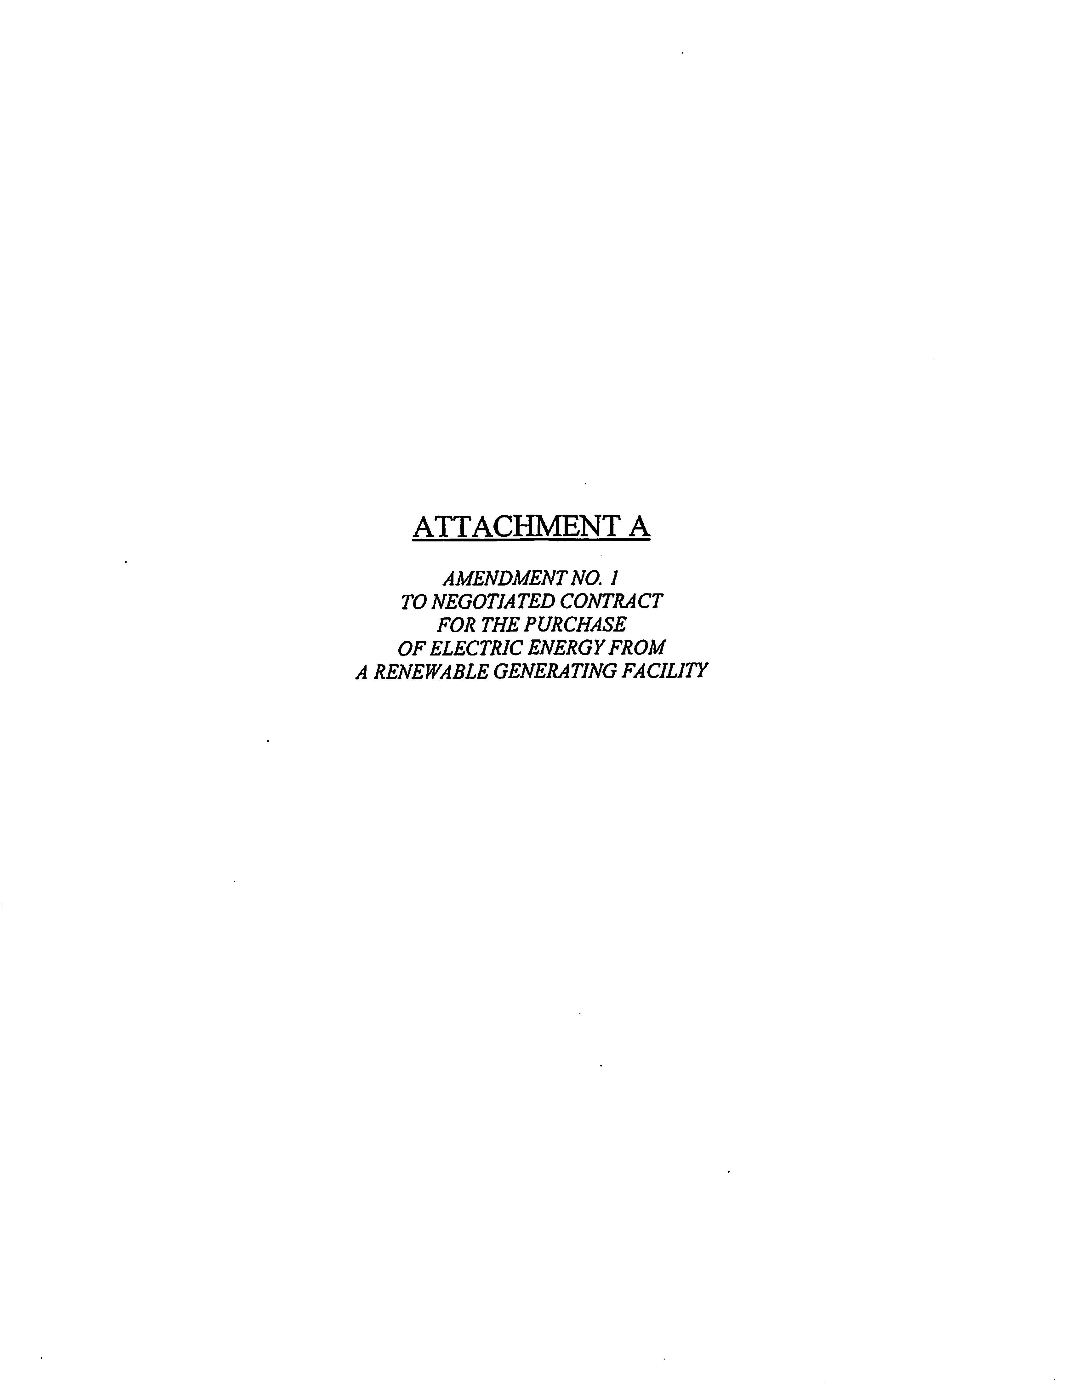
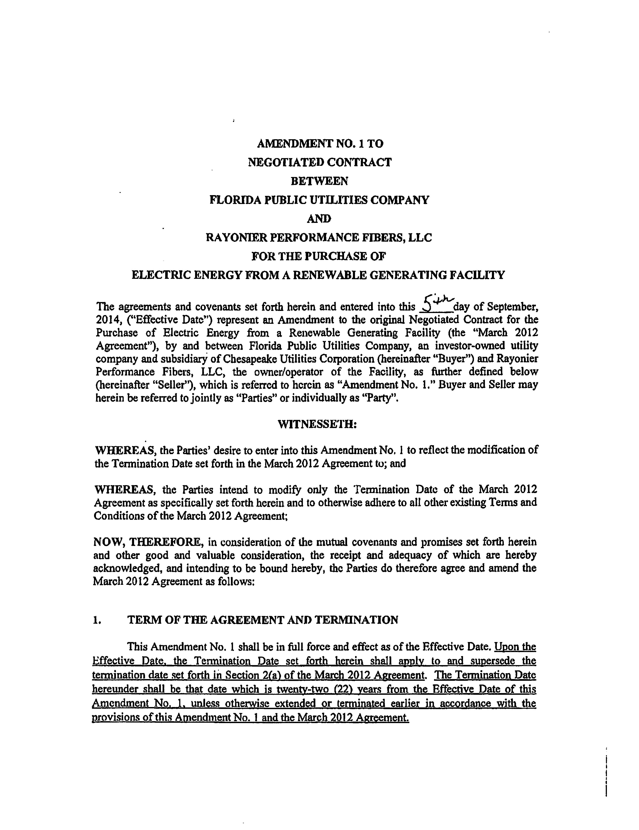
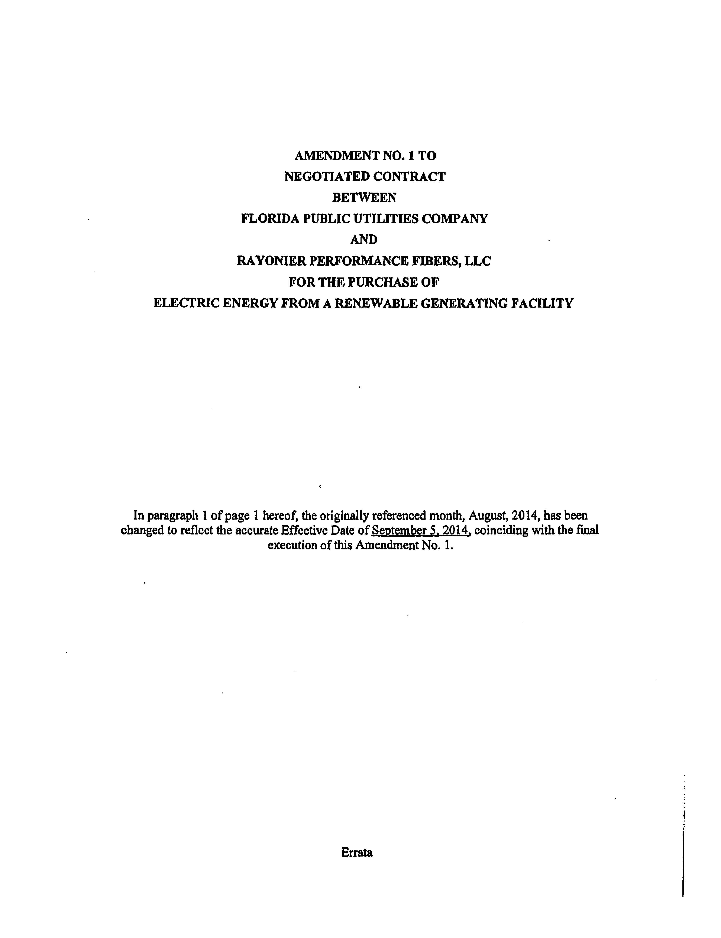
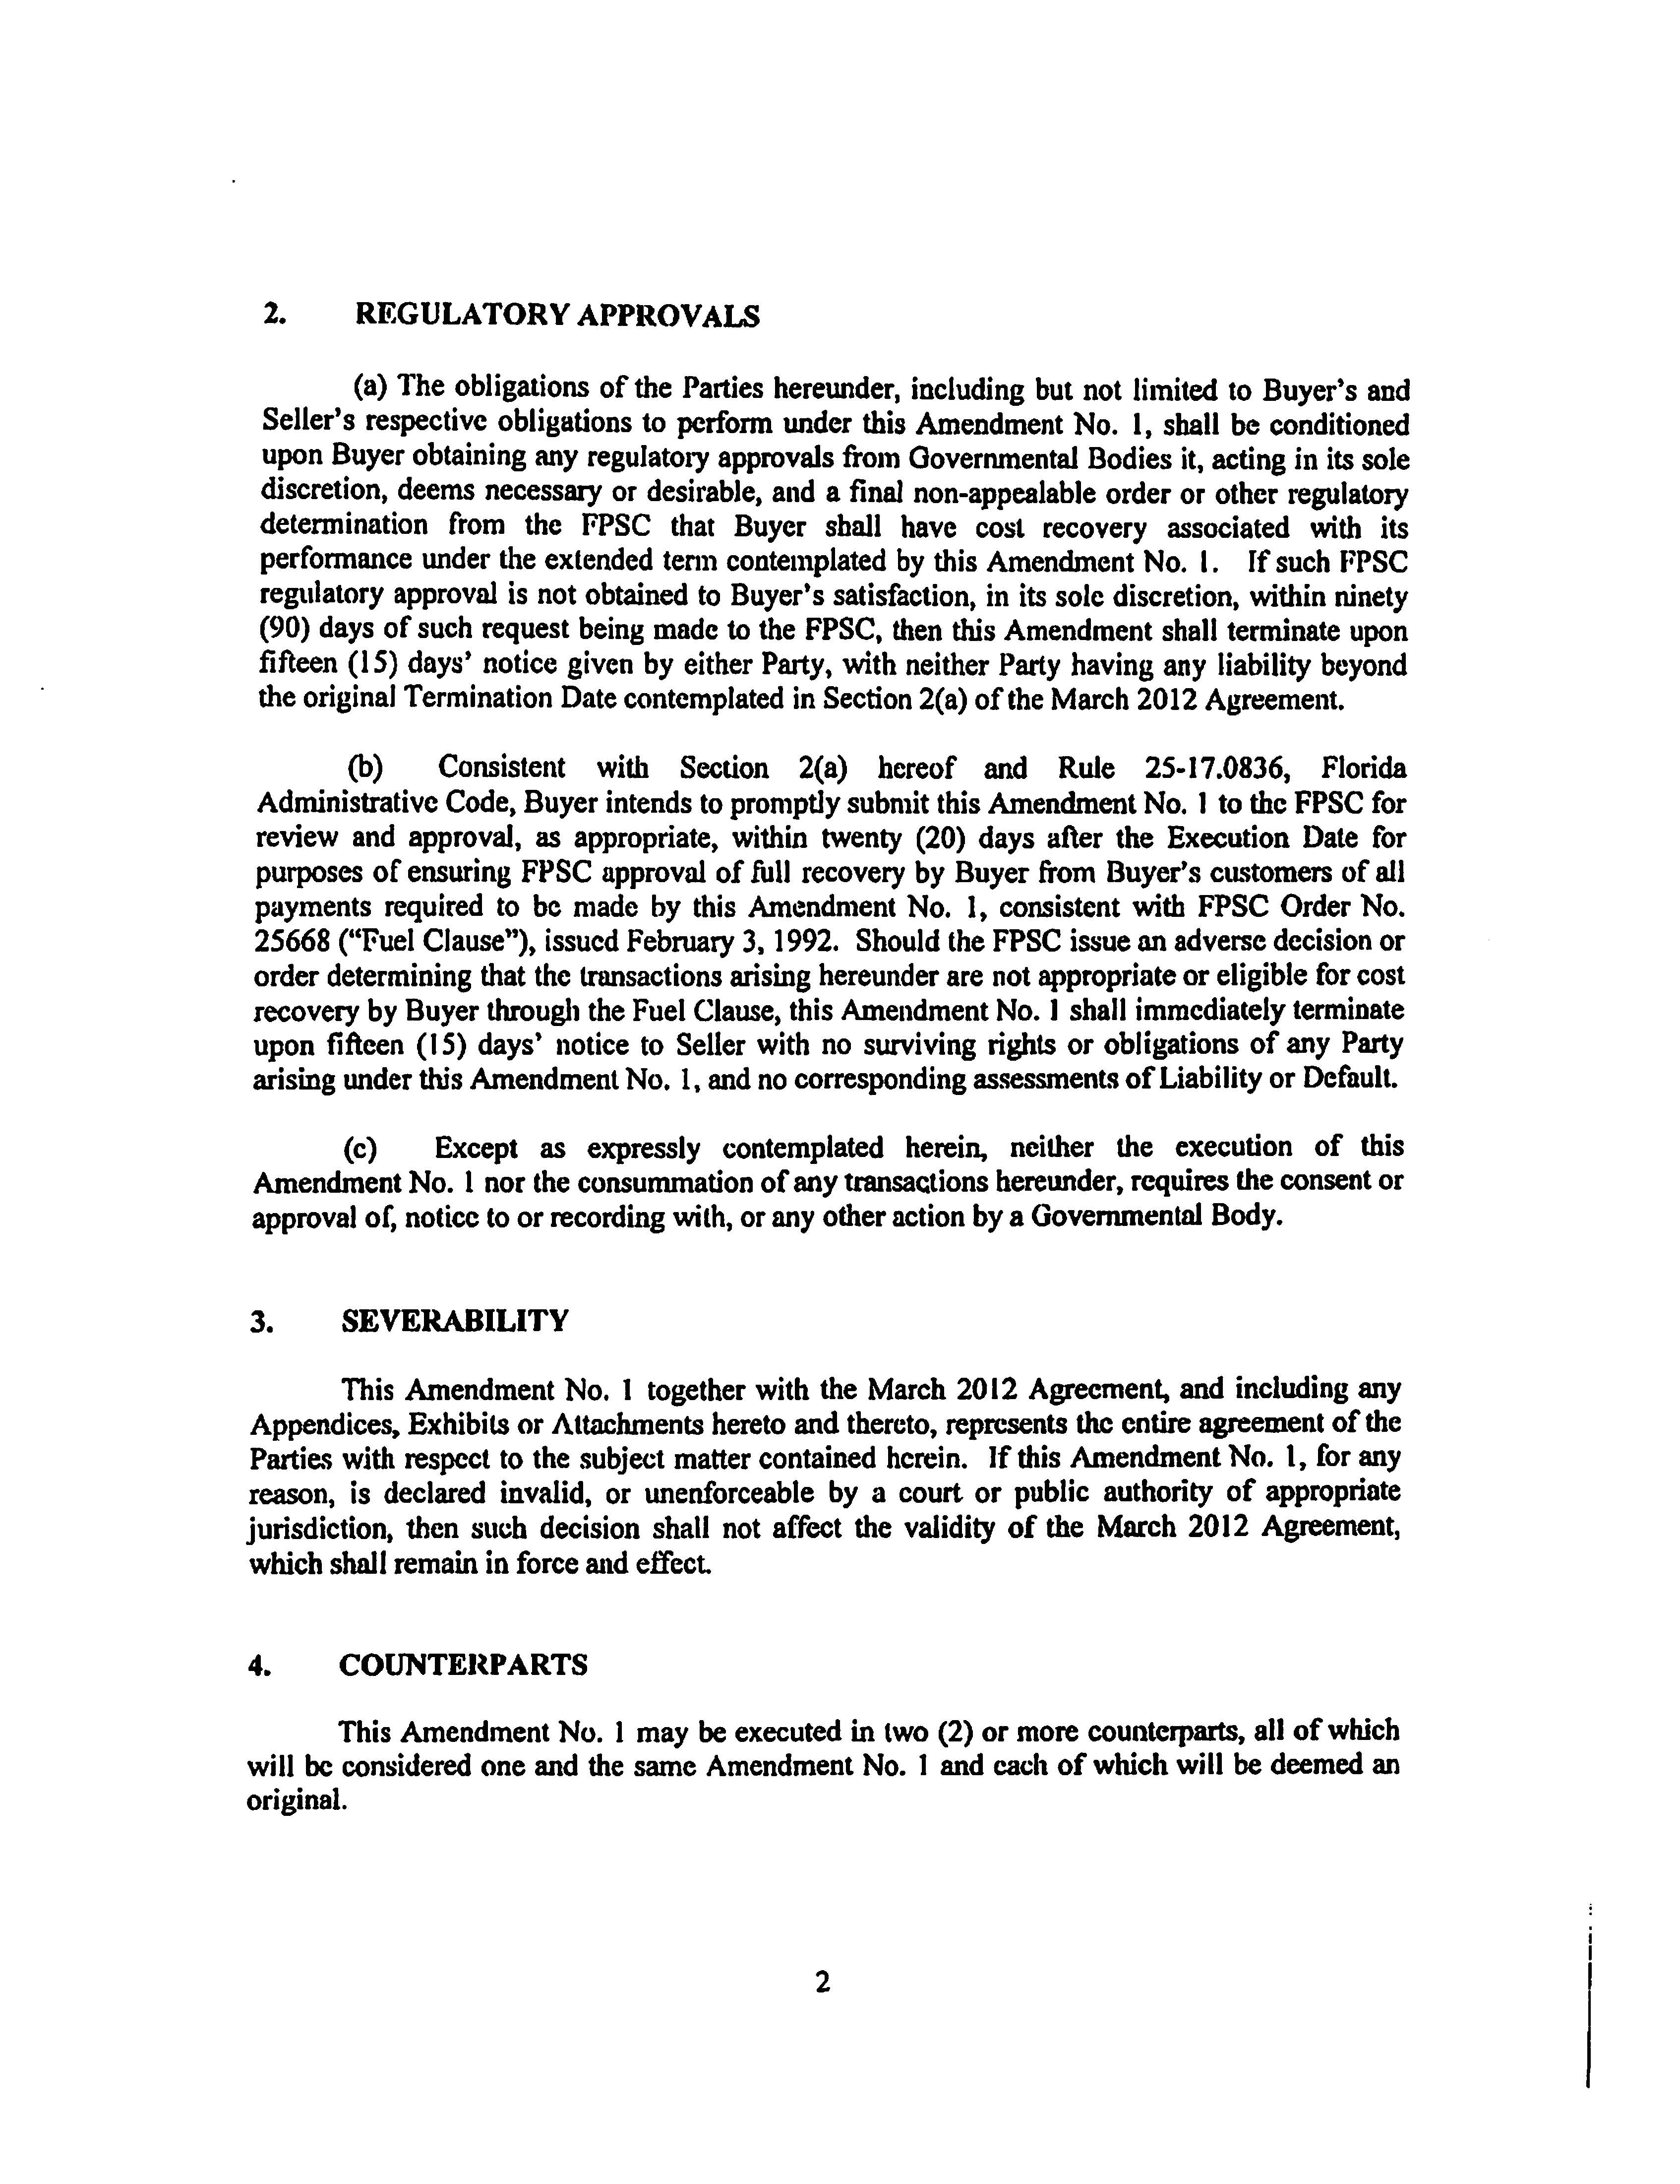
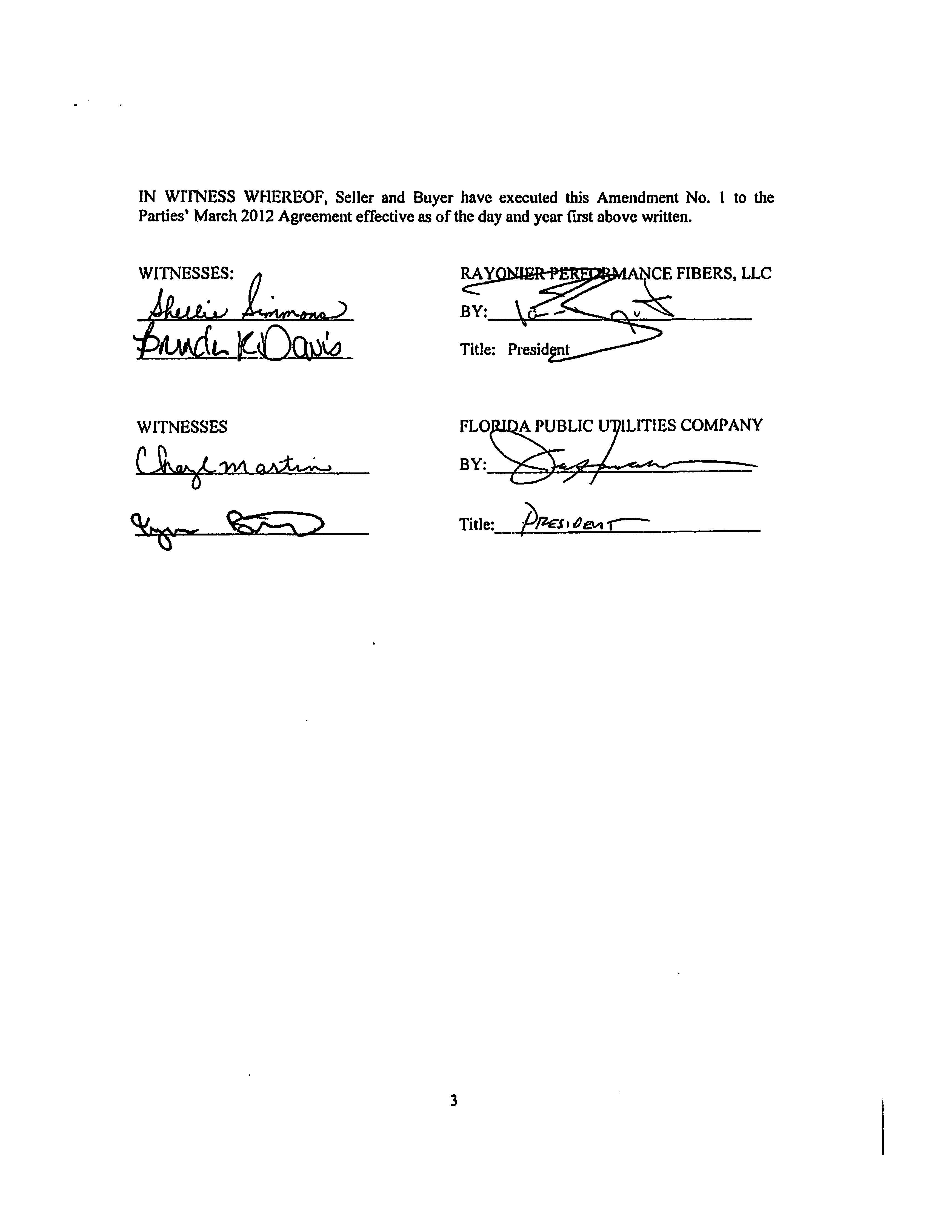

Issued on July 23, 2012, in Docket 120058-EQ, In re: Petition for approval of negotiated renewable energy power purchase contract for power purchased with Rayonier Performance Fibers, LLC, by Florida Public Utilities Company.
Included in this Order as Attachment A.
Which coincides with the expiration date of the new Eight Flags Energy, LLC (Eight Flags) purchased power agreement which we approved by Order No. PSC-14-0711-PAA-EQ, issued on December 30, 2014, in Docket 140185-EQ, Petition for approval of negotiated power purchase contract with Eight Flags Energy, LLC, by Florida Public Utilities Company.

