BEFORE THE FLORIDA PUBLIC SERVICE COMMISSION

In re: Fuel and purchased power cost recovery clause with generating performance incentive factor. | DOCKET NO. 150001-EI  ORDER NO. PSC-15-0038-FOF-EI  ISSUED: January 12, 2015

The following Commissioners participated in the disposition of this matter:

ART GRAHAM, Chairman
LISA POLAK EDGAR
RONALD A. BRISÉ
EDUARDO E. BALBIS
JULIE I. BROWN

APPEARANCES:

R. WADE LITCHFIELD, JOHN T. BUTLER, and MARIA J. MONCADA, ESQUIRES, Florida Power & Light Company, 700 Universe Boulevard, Juno Beach, Florida 33408-0420; CHARLES A. GUYTON, ESQUIRE, Gunster Law Firm, 215 South Monroe Street, Suite 601, Tallahassee, Florida 32101-1804
On behalf of Florida Power & Light Company (FPL)

J.R. KELLY, PATRICIA A. CHRISTENSEN, CHARLES REHWINKEL, and ERIK SAYLER, ESQUIRES, Office of Public Counsel, c/o The Florida Legislature, 111 West Madison Street, Room 812, Tallahassee, Florida 32399-1400
On behalf of the Citizens of the State of Florida (OPC)

JON C. MOYLE, JR., KAREN PUTNAL, and VICKI GORDON KAUFMAN, ESQUIRES, Moyle Law Firm, PA, The Perkins House, 118 North Gadsden Street, Tallahassee, Florida 32301
On behalf of the Florida Industrial Power Users Group (FIPUG)

Robert Scheffel Wright and John T. LaVia, III, ESQUIRES, Gardner, Bist, Wiener, Bowden, Bush, Dee, LaVia & Wright, P.A., 1300 Thomaswood Drive, Tallahassee, Florida 32308
On behalf of the Florida Retail Federation (FRF)

MARTHA BARRERA, KEINO YOUNG, and KYESHA MAPP, ESQUIRES, Florida Public Service Commission, 2540 Shumard Oak Boulevard, Tallahassee, Florida 32399-0850
On behalf of the Florida Public Service Commission (Staff)

Mary Anne Helton, ESQUIRE, Deputy General Counsel, Florida Public Service Commission, 2540 Shumard Oak Boulevard, Tallahassee, Florida 32399-0850
Advisor to the Florida Public Service Commission

FINAL ORDER GRANTING FLORIDA POWER & LIGHT COMPANY’S PETITION FOR APPROVAL OF PROPOSED GAS RESERVE PROJECT

BY THE COMMISSION:

On June 25, 2014, Florida Power & Light Company (FPL) filed a petition requesting a prudence determination on FPL’s proposal to acquire an interest in a natural gas reserve project (Project) and to allow the revenue requirements associated with investing in and operating the gas reserves be recovered through the Fuel Clause (Petition). USG Properties Woodford I, LLC (USG), an FPL affiliate, entered into a series of agreements with PetroQuest Energy, Inc. (PetroQuest), under which USG will pay a share of the costs for developing and operating natural gas production wells and will receive a portion of PetroQuest’s working interest in those wells in the Woodford Shale Gas Region in Oklahoma. Subject to the terms of the agreements, FPL will be entitled to acquire USG’s interest, contingent upon a Commission finding that the Project is prudent and may be recovered through the Fuel Clause.

The Office of Public Counsel (OPC), Florida Industrial Power Users Group (FIPUG), and Florida Retail Federation (FRF) participated as intervenors in the proceeding. By motion filed August 1, 2014, FPL and OPC sought approval of a stipulation to modify the Order Establishing Procedure’s schedule for discovery, prefiled testimony, and briefs so that the gas reserve issues could be heard at the October 22-24, 2014, hearing and a vote be taken before the end of the calendar year. On August 22, 2014, by Order No. PSC-14-0439-PCO-EI, the gas reserve issues were deferred to a December 1 and 2, 2014 hearing. The parties’ post hearing briefs were filed December 12, 2014.

FPL’s petition also requested that we establish guidelines under which FPL could participate in future gas reserve projects without our prior approval, and recover the costs through the Fuel Clause subject to our established process for reviewing fuel related transactions in the fuel cost proceedings. At the end of the hearing, we deferred consideration of the issues raised by the request for guidelines to the next year. Briefs on these issues are due by January 12, 2015.

On August 22, 2014, OPC moved for an order dismissing FPL’s petition on the grounds that we do not have subject matter jurisdiction (motion). On August 29, 2014, FPL filed its response in opposition to the motion (response). We heard oral argument on the motion at the Commission Conference on November 25, 2014. On December 17, 2014, we issued Order No. PSC-14-0697-PCO-EI denying OPC’s motion.

At the hearing, we heard the testimony of FPL witnesses and considered exhibits in support of its Petition. FPL presented evidence in support of its assertions that its investment in the Woodford Project is projected to provide fuel savings over the life of the Project; that the investment will provide fuel price stability, effectively acting as a long-term hedge; that it is designed to reduce the delivered price of fossil fuel (natural gas); and that since the costs for the PetroQuest joint venture were not recognized or anticipated in the cost levels used to determine FPL’s current base rates, the costs associated with the PetroQuest joint venture are appropriate for recovery through the Fuel Clause.

We also heard the testimony of FIPUG and OPC’s witnesses, and considered the exhibits presented in support of their position that the proposed recovery of costs associated with the PetroQuest joint venture did not satisfy the criteria for Fuel Clause recovery; that its costs were not capital costs normally recovered through base rates; that these projected costs went beyond our policy for dealing with fossil fuel-related costs normally recovered through base rates that will result in fuel savings to customers; and that recovery of these costs is contractually precluded by paragraph 6 of the Stipulation and Settlement Agreement dated December 12, 2012 that we approved by Order No. PSC-13-0023-S-EI, in Docket No. 120015-EI, issued January 14, 2013, In re: Petition for increase in rates by Florida Power & Light (Settlement).

We have jurisdiction over this subject matter pursuant to the provisions of Chapter 366, Florida Statutes (F.S.), including Sections 366.04, 366.05, and 366.06, F.S.

2012 Stipulation and Settlement

We first consider whether FPL is contractually precluded by paragraph 6 of the Settlement from obtaining the ultimate relief sought in its petition, approval of the Woodford Project costs through the Fuel Clause. The 2012 Settlement precludes FPL from requesting an increase in base rates to take effect before January 1, 2017. However, the relevant portion of paragraph 6 states:

Nothing shall preclude the Company from requesting the Commission to approve the recovery of costs (a) that are of a type which traditionally and historically would be, have been, or are presently recovered through cost recovery clauses or surcharges. . .
* * *
It is the intent of the Parties in this Paragraph 6 that FPL not be allowed to recover through cost recovery clauses increases in the magnitude of costs of types or categories (including but not limited to, for example: investment in and maintenance of transmission assets) that have been and traditionally, historically, and ordinarily would be recovered through base rates.

FPL alleged that the Woodford Project is projected to provide net savings for customers and will serve as a valuable longer term physical hedge. FIPUG argued that oil and gas exploration and production costs are more analogous to base rate type expenditures that would be recovered in base rates. OPC added that the Woodford Project costs are not a hedge and not costs that are traditionally, historically, and ordinarily recovered through the Fuel Clause.

We have consistently found that the primary purpose of hedging programs is to reduce the variability or volatility in fuel costs paid by customers over time. We have traditionally and historically allowed hedging costs to pass through the Fuel Clause. For the reasons stated below, we find that the Woodford Project acts as a hedging program of the type traditionally, historically, and ordinarily recovered through the Fuel Clause. Thus, the Settlement does not preclude FPL from recovering the Woodford Project costs.

Prudence Determination
We next address whether FPL’s petition should be granted. The proposed Woodford Project is a joint venture agreement between FPL and PetroQuest, a publicly traded independent oil and natural gas company engaged in the acquisition, exploration, development, and production of oil and natural gas properties in the United States (agreement). The Woodford Project is a capital investment that FPL projects will result in fuel cost savings by paying production costs rather than the market price of the natural gas. Pursuant to the agreement, FPL would invest directly in PetroQuest’s shale gas reserves in the Woodford Shale region and, in return, receive the rights to FPL’s share of the physical gas produced.

FPL asserted that the Woodford Project is similar to a long term physical hedge. The objective of any hedging program is to minimize price volatility. We have found that minimizing price volatility produces customer benefits. Financial hedging programs have different terms, from several weeks to up to two years. At the end of the year, the actual costs associated with the programs are passed on to customers. Because natural gas prices are uncertain and volatile, there will be periods when the companies have hedging gains and other periods where the companies will have hedging losses. We note that utilities are not expected to predict or speculate on whether markets will ultimately rise or fall and actually settle higher or lower than the price levels that existed at the time hedges were put into place. We have found that hedging maintains flexibility for a utility to create the type of risk management program for fuel procurement that it finds most appropriate while allowing us to retain the discretion to evaluate, and the parties the opportunity to address, the prudence of such programs at the appropriate time.

Any type of hedging is still going to be subject to market conditions. Historically, production costs have been less volatile than market prices. We find the Woodford Project will act as a hedge that is designed to decouple costs from market prices. The Woodford Project costs are based solely on the operations and maintenance costs, and on the investment that is required, and is essentially fixed. FPL purchases more natural gas than any other electric utility in the country. The reality is that in this state, and nationally, we continue to grow the need for natural gas to provide electricity as we move away from coal. Although the Woodford Project is relatively small and will have a small effect on FPL’s overall cost of natural gas and on price hedging, it will act as a long-term physical hedge (30 years or longer in duration) compared to financial hedges, which typically lock in prices for 12 – 24 months.

Fuel and related costs that are subject to volatile changes are recoverable through the Fuel Clause. We have allowed non-fuel items to be recovered through the Fuel Clause as long as they are projected to result in fuel savings. FPL’s natural gas price forecasts of October 2013 and July 2014 indicate that the Woodford Project will likely produce positive customer fuel savings over the life of the Project based on combinations of two factors: well productivity and natural gas market price. Under FPL’s July 2014 natural gas price forecast, 6 of 9 sensitivities produce positive customer savings (see Table 1), and the base case indicates savings of $51.9 million over the life of the project. Also, the sensitivities show that the magnitude of potential positive savings ($170.2 million assuming high fuel price and high productivity) exceeds the magnitude of potential losses (-$50.7 million assuming low fuel price and low productivity).

Table 1 Pricing and Production Sensitivities
(Savings (losses) in Millions $)
 | Low Fuel Pricing | Base Fuel Pricing | High Fuel Pricing
Low Production | ($50.7) | $23.1 | $97.0
Base Production | ($30.0) | $51.9 | $134.0
High Production | ($10.2) | $79.9 | $170.2
Based on 1. July 2014 Fuel Curve; 2. Pricing: +/- 20.9% per MMBtu around NYMEX Henry Hub based on 8 year historical volatility from 2005-2012; and 3. Production: +/-10% monthly production)
Source: Exhibit 64, Attachment 2

As we have determined that investment in the Woodford Project is prudent, we do not need to address the standard to apply to a request by FPL to recover the price that FPL pays to its subsidiary/affiliate for gas obtained through the joint venture with PetroQuest.
Cost Recovery Factor
We set FPL’s 2015 fuel cost recovery factors at the October 22, 2014 Fuel Hearing without including any amount of estimated costs associated with the Woodford Project. Our approval of the FPL petition does not change the 2015 factors. FPL shall file for cost recovery of actual expenses in its actual/estimated and final true-up filings for 2015 to be implemented in the first billing cycle of 2016.

GPIF Targets/Ranges for 2015
We set the GPIF Target/Ranges for 2015 and the GPIF factor in these proceedings without calculating the impact of the Woodford Project in this Docket by Order No. PSC-14-0701-FOF-EI, issued on December 19, 2014. However, the record in this proceeding includes the GPIF Targets/Ranges for 2015 prepared with and without the impact of the Woodford Project, and the appropriate GPIF Targets/Ranges for 2015 are those which reflect the impact of the Woodford Project attached to this Order as Appendix A. Thus, the GPIF results for 2015 shall be calculated by comparing actual performance measures against these targets/ranges, which reflect the impact of the Woodford Project.
Conclusion

We find the Woodford Project, in the manner described in the FPL petition and evidence on the record, is expected to produce customer benefits and is in the public interest. We find its costs are recoverable through the Fuel Clause. In order to provide additional protections for FPL customers, we find it necessary to add two conditions for compliance with this Order. First, FPL shall add the appropriate subaccounts, under the FERC system of accounting, which will correspond on a one-on-one basis with the accounts used by the Gas Reserve Company (GRCO). Second, FPL shall utilize an independent auditor in performing the audits provided in the agreement and shall work with Commission staff to develop the scope of the audits.

Based on the foregoing, it is

ORDERED by the Florida Public Service Commission that Florida Power & Light Company’s Petition with respect to the Woodford Project is approved as provided in the body of this Order. It is further

ORDERED that the appropriate GPIF Targets/Ranges for 2015 are those that reflect that impact of the Woodford Project, as shown in Appendix A. It is further

ORDERED that FPL shall hire an independent party to conduct the audits authorized in the joint venture agreement with PetroQuest and shall work with Commission staff to develop the scope of the audit. It is further
ORDERED that FPL shall add subaccounts under the FERC system of accounting which will correspond on a one-on-one basis with the accounts used by the Gas Reserve Company (GRCO). It is further
ORDERED that the parties shall file post-hearing briefs on the proposed guidelines by January 12, 2015.
By ORDER of the Florida Public Service Commission this 12th day of January, 2015.

/s/ Carlotta S. Stauffer
CARLOTTA S. STAUFFER
Commission Clerk
Florida Public Service Commission
2540 Shumard Oak Boulevard
Tallahassee, Florida 32399
(850) 413-6770
www.floridapsc.com

Copies furnished: A copy of this document is provided to the parties of record at the time of issuance and, if applicable, interested persons.

MFB

Chairman Art Graham dissents without further opinion.

Commissioner Ronald A. Brisé dissents on whether FPL’s proposal is precluded by Order No. PSC-13-0023-S-EI.

NOTICE OF FURTHER PROCEEDINGS OR JUDICIAL REVIEW
The Florida Public Service Commission is required by Section 120.569(1), Florida Statutes, to notify parties of any administrative hearing or judicial review of Commission orders that is available under Sections 120.57 or 120.68, Florida Statutes, as well as the procedures and time limits that apply. This notice should not be construed to mean all requests for an administrative hearing or judicial review will be granted or result in the relief sought.

Any party adversely affected by the Commission's final action in this matter may request: 1) reconsideration of the decision by filing a motion for reconsideration with the Office of Commission Clerk, 2540 Shumard Oak Boulevard, Tallahassee, Florida 32399-0850, within fifteen (15) days of the issuance of this order in the form prescribed by Rule 25-22.060, Florida Administrative Code; or 2) judicial review by the Florida Supreme Court in the case of an electric, gas or telephone utility or the First District Court of Appeal in the case of a water and/or wastewater utility by filing a notice of appeal with the Office of Commission Clerk, and filing a copy of the notice of appeal and the filing fee with the appropriate court. This filing must be completed within thirty (30) days after the issuance of this order, pursuant to Rule 9.110, Florida Rules of Appellate Procedure. The notice of appeal must be in the form specified in Rule 9.900(a), Florida Rules of Appellate Procedure.
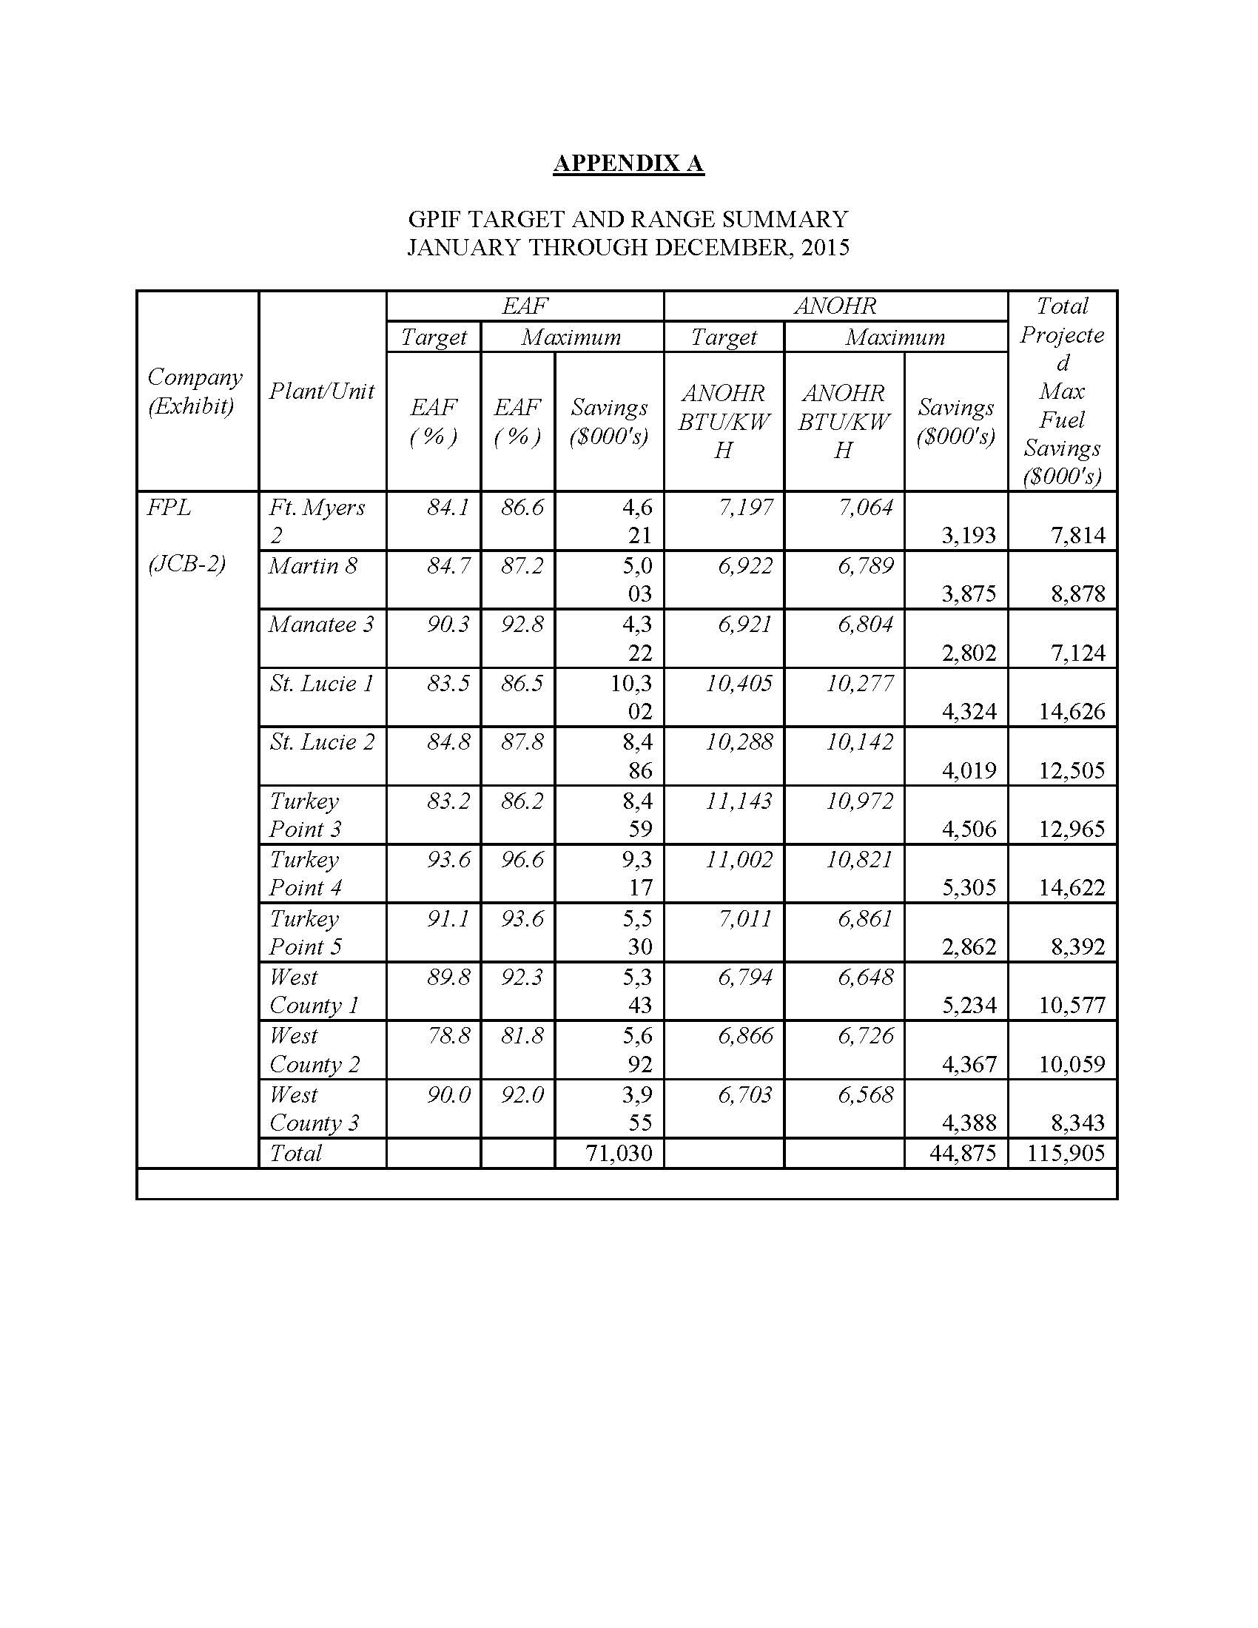

The issues deferred were identified as Issues 4, 5, 7, and 9 in Order No. PSC-14-0667-PHO-EI.
The Woodford project is also referred to as the “PetroQuest joint venture.”
See Order No. PSC-02-1484-FOF-EI, issued October 30, 2002, in Docket No. 011605-EI, In re: Review of investor-owned electric utilities' risk management policies and procedures; Order No. PSC-06-1057-FOF-EI, issued December 22, 2006, in Docket No. 060001-EI, In re: Fuel and purchased power cost recovery clause with generating performance incentive factor; Order No. PSC-08-0667-PAA-EI, issued October 8, 2008, in Docket No. 080001-EI, In re: Fuel and purchased power cost recovery clause with generating performance incentive factor.
Order No. PSC-06-1057-FOF-EI, issued December 22, 2006, in Docket No. 060001-EI, In re: Fuel and purchased power cost recovery clause with generating performance incentive factor.
Order No. PSC-08-0667-PAA-EI, issued October 8, 2008, in Docket No. 080001-EI, In re: Fuel and purchased power cost recovery clause with generating performance incentive factor.
Order No. PSC-02-1484-FOF-EI.
We note that customers currently bear certain drilling, production, and shale gas risks (earthquakes, environmental issues, etc.) as these factors are embedded in the market price of gas.
Order No. 14546, issued July 8, 1985, in Docket No. 850001-EI-B, In re: Cost recovery Methods for Fuel-Related Expenses.
See Order No. PSC-97-0359-FOF-EI, issued March 31, 1997, in Docket 970001-EI, In re: Fuel and purchased power cost recovery clause and generating performance incentive factor (FPL investment in rail cars); Order No. PSC-01-2516-FOF-EI, issued December 26, 2001, in Docket 010001-EI, In re: Fuel and purchased power cost recovery clause and generating performance incentive factor (Incremental Power Plant Security Costs).

