State of Florida   |  | Public Service Commission  Capital Circle Office Center ● 2540 Shumard Oak Boulevard  Tallahassee, Florida 32399-0850  -M-E-M-O-R-A-N-D-U-M-
DATE: | January 22, 2015
TO: | Office of Commission Clerk (Stauffer)
FROM: | Division of Economics (Garl)  Office of the General Counsel (Brownless)
RE: | Docket No. 140232-EI – Petition for approval of revised lighting tariff by Tampa Electric Company.
AGENDA: | 02/03/15 – Regular Agenda – Tariff Filing – Interested Persons May Participate
COMMISSIONERS ASSIGNED: |  |  | All Commissioners
PREHEARING OFFICER: |  |  | Administrative
CRITICAL DATES: |  |  | 02/03/15 (60-Day Suspension Date)
SPECIAL INSTRUCTIONS: |  |  | None

Case Background
On December 3, 2014, Tampa Electric Company (TECO or company) filed a petition requesting Commission approval to close to new customers all of the existing High Pressure Sodium (HPS) and Metal Halide (MH) outdoor lighting offerings. The proposed closing would result in TECO offering only light emitting diode (LED) technology to new outdoor lighting customers. In addition, TECO proposed adding nine new LED fixtures to the current LED tariff. The proposed tariff revisions are included as Attachment 1 to this recommendation.
The Commission first approved TECO’s LED lighting tariff in Order No. PSC-13-0138-FOF-EI. The Commission has jurisdiction over this matter pursuant to Section 366.06(1), Florida Statutes (F.S.).
Discussion of Issues
Issue 1:1
Should the Commission approve TECO’s revised lighting tariff?
Recommendation:
Yes. The Commission should approve TECO’s revised lighting tariff. (Garl)
Staff Analysis:
TECO requested approval in its petition to close the existing HPS and MH fixtures tariff to new customers and to add nine new LED fixtures to its current tariff.

Closure of HPS and MH fixtures. TECO explained in its petition that in the few short years since the company began studying LED outdoor lighting, the technology and its pricing have evolved to the point that LED lighting is now the preferred solution for roadway and outdoor area applications. The company also stated that LED technology is superior to the HPS and MH technologies in several ways. LED lighting is significantly more energy-efficient and more reliable than HPS and MH technology and provides for more uniform illumination. In addition, unlike the bulbs used for HPS and MH lighting, LED fixtures and components are environmentally friendly involving no special disposal practices or costs.
TECO reported that market demand for LED outdoor lighting has seen a rapid rise in recent years, even with the higher cost of the early generation products. Several municipal customers within TECO's service area are currently subscribing to the company's LED tariff for street lighting. Those customers are also demanding additional LED street lighting options and are beginning to request conversion to LED fixtures of some of their existing HPS fixtures that are in service but have reached the end of their contract commitment.
In addition to the efficiency benefits, TECO listed four additional reasons customers are requesting to change to LED lighting:
- Obtaining certifications relating to security, environment, or energy efficiency;
- Better reliability resulting in fewer business disruptions for lighting repairs or replacements;
- Favorable color rendition and aiming characteristics; and
- LED lighting is viewed as a "green" choice.
TECO also reported that lighting manufacturing industry representatives have informed the company that over the next few years, many plants currently manufacturing HPS and MH lighting fixtures for utility use will close or be retooled to produce comparable LED products. As the HPS and MH products are phased out, the costs of such fixtures and components are expected to increase substantially and future availability is uncertain due to this reduction in production capacity. The proposed closure of the HPS and MH fixtures is shown on tariff sheets 6.805 and 6.806 (Attachment 1, pages 1 and 2).
New LED fixtures. While proposing to close the HPS and MH tariffs to new customers, TECO also proposed to add nine new LED fixtures: two floodlight, two decorative post-top, one area-lighter, two mongoose, and two roadway fixtures. The charges for the new LED lighting fixtures are comprised of three components: a fixture charge, a maintenance charge, and a non-fuel energy charge, consistent with TECO’s current other lighting options. The new LED fixtures and associated charges are shown on tariff Sheet 6.808 (Attachment 1, page 3). In conjunction with its petition TECO submitted supporting cost information that included a presentation of the following: individual tariff calculations; installation, maintenance, labor and vehicle costs; overhead cost factors; and monthly energy consumption charges. Staff reviewed the cost information submitted with TECO’s petition and believes the charges are reasonable and appropriate.
Conclusion. Staff confirmed TECO’s observations about the desirability of LED lighting based on information provided by the U.S. Energy Information Agency (EIA). In a November 4, 2014 report, EIA stated,
Improvements in lighting technology for light-emitting diode (LED) bulbs have increased lighting efficiency, or efficacy, as well as color quality. In September of this year, several manufacturers released ENERGY STAR®-qualified bulbs surpassing 100 lumens per watt. For comparison, traditional incandescent bulbs, which do not meet current light bulb efficiency standards and are no longer sold, provide 13 to 18 lumens per watt.
When first introduced, LED bulbs were far more expensive than other bulbs, but their costs have since come down dramatically. Even now, however, they are often the most expensive bulbs on the shelf, but their much longer lifetimes and lower power draw can economically justify the higher initial cost.
For the reasons discussed above, staff recommends approval of TECO’s revised lighting tariff.
Issue 2:2
Should this docket be closed?
Recommendation:
Yes. If Issue 1 is approved, the tariffs should become effective on February 3, 2015. If a protest is filed within 21 days of the issuance of the order, the tariffs should remain in effect, with any revenues held subject to refund, pending resolution of the protest. If no timely protest is filed, this docket should be closed upon the issuance of a consummating order. (Brownless)
Staff Analysis:
If Issue 1 is approved, the tariffs should become effective on February 3, 2015. If a protest is filed within 21 days of the issuance of the order, the tariffs should remain in effect, with any revenues held subject to refund, pending resolution of the protest. If no timely protest is filed, this docket should be closed upon the issuance of a consummating order.

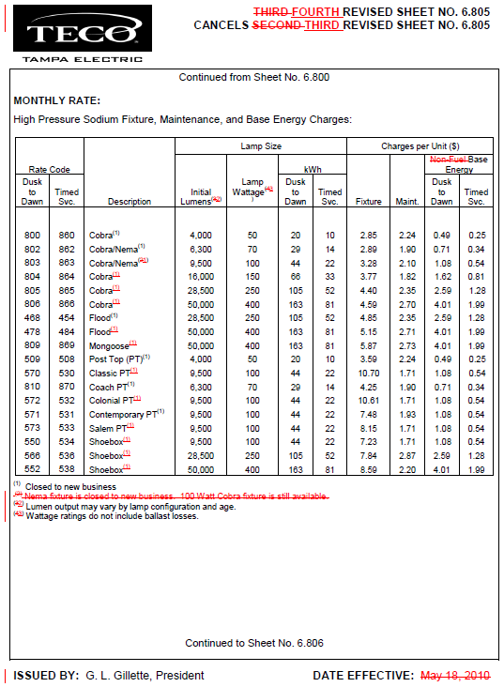

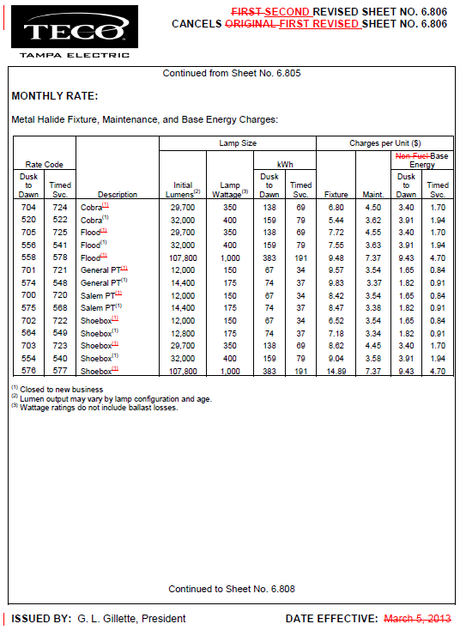

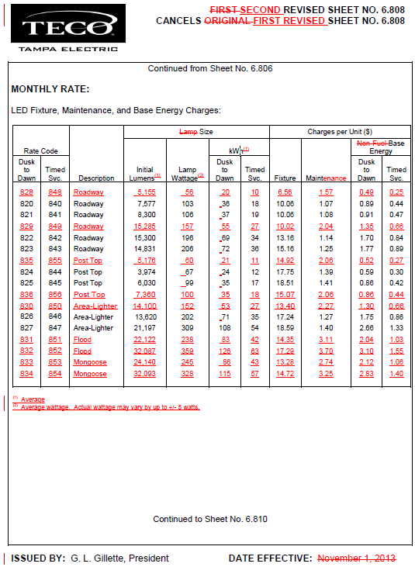

Order No. PSC-13-0138-FOF-EI, issued March 25, 2013, in Docket No. 130019-EI, In re: Petition for approval of revised lighting tariffs by Tampa Electric Company.
U.S. Energy Information Administration website report, “LED light bulbs keep improving in efficiency and quality”, November 4, 2014, http://www.eia.gov/todayinenergy/detail.cfm?id=18671&src=email.

