State of Florida   |  | Public Service Commission  Capital Circle Office Center ● 2540 Shumard Oak Boulevard  Tallahassee, Florida 32399-0850  -M-E-M-O-R-A-N-D-U-M-
DATE: | April 2, 2015
TO: | Office of Commission Clerk (Stauffer)
FROM: | Division of Engineering (Lewis, King, Rieger)  Division of Economics (Bruce)  Office of the General Counsel (Janjic, Crawford)
RE: | Docket No. 130209-SU – Application for expansion of certificate (CIAC) (new wastewater line extension charge) by North Peninsula Utilities Corp.
AGENDA: | 04/16/15 – Regular Agenda – Proposed Agency Action – Interested Persons May Participate
COMMISSIONERS ASSIGNED: |  |  | All Commissioners
PREHEARING OFFICER: |  |  | Edgar
CRITICAL DATES: |  |  | None
SPECIAL INSTRUCTIONS: |  |  | None

Case Background
North Peninsula Utilities Corporation (NPUC or Utility) is a Class B Utility, which provides wastewater service to 570 customers in Volusia County. The City of Ormond Beach provides water to the area. NPUC’s 2013 Annual Report (revised on June 17, 2014) lists operating revenues of $219,546 and a net operating loss of $511. NPUC bought the assets of Shore Utility Corp. in 1989 and filed five subsequent territory amendments, which were all approved by the Commission. On August 2, 2013, the Utility filed an application to amend its wastewater certificate, pursuant to Section 367.045, Florida Statutes, (F.S.) and Rule 25-30.036, Florida Administrative Code (F.A.C.). In addition, the Utility requested to implement a main extension charge and a flat rate adjustment of three percent per year to monthly rates for five years. On November 4, 2013, NPUC withdrew its request for the flat rate adjustment. Staff identified several deficiencies in the filing and met with the Utility’s representatives. At that meeting it was disclosed that there were potential objections to the territory amendment by Volusia County and the City of Ormond Beach. As such, the processing of the application was put on hold.
On March 10, 2014, the Utility filed a revised application to amend its service territory based upon negotiations with the City of Ormond Beach and Volusia County. The revised application included less territory than its original filing and a proposed tariff for a $795 main extension charge. Pursuant to Order No. PSC-14-0273-PCO-SU, issued May 29, 2014, the Commission suspended the proposed tariff to allow staff sufficient time to review all pertinent information. On July 21, 2014, NPUC filed additional information to address the deficiencies previously identified by staff. On October 20, 2014, NPUC representatives met with staff to discuss the amended application and on January 13, 2015, NPUC filed supplemental information to address staff’s concerns. The Commission has jurisdiction pursuant to Section 367.045, F.S.

Discussion of Issues
Issue 1:1
Should North Peninsula Utilities Corporation’s proposed territory amendment and main extension charge be approved?
Recommendation:
No. The application fails to demonstrate a need for service in the territory requested. Therefore, the application does not appear to be in the public interest and should be denied. Denial of the application obviates the need for a main extension charge. The service availability policy should be revised to reflect that there are no service availability charges because the plant is fully depreciated. (Bruce, Crawford, Janjic, Lewis, Rieger, King)
Staff Analysis:
NPUC currently provides wastewater service in the north peninsula area of Volusia County pursuant to wastewater certificate number 249-S. If granted, the territory expansion (see Attachment A) would effectively make the service territory contiguous by adding residential areas within and adjacent to its existing service territory. The Utility would extend its services in three phases. Phase 1 would be completed by 2017 and would provide the Utility the ability to serve an additional 282 customers; Phase 2 would be completed by 2020 and would provide the Utility the opportunity to serve an additional 255 customers; and Phase 3 would be completed by 2025 and would provide the Utility the ability to serve an additional 119 customers.
Rule 25-30.036(3)(b), F.A.C., Application for Amendment to Certificate of Authorization to Extend or Delete Service requires the Utility provide a statement showing its financial and technical ability to provide service and the need for service in the area requested. With its original application the Utility provided letters from potential customers stating they are interested in information on the availability of wastewater service, but not actually requesting service. Currently, it appears that there are four customers (21 equivalent residential connections) that may want service; however, it is unclear which phase of the Utility’s planned expansion impacts these customers.
NPUC’s request is unique and can be differentiated from other certificate amendment filings. First, the territory NPUC seeks to serve is developed, with many single family homes and condominiums, so unlike many requests for territory expansion, this is not a greenfield situation or a situation where one owner/developer owns the area to be served. Second, and more importantly, all residences in the territory NPUC seeks to serve currently have wastewater treatment in place, either by privately owned and maintained septic tanks or existing wastewater treatment (package) plants.
The Utility acknowledges that wastewater treatment is in place for county residents and the need for service has not been adequately demonstrated. However, NPUC argues that state law supports what it wants to accomplish, which is the treatment and disposal of wastewater by central facilities. In its January 13, 2015, supplemental filing, NPUC states:
Florida law purports to require property owners who currently have onsite sewage treatment and disposal systems to connect to available central wastewater systems within a year of availability of the central system and also requires to [sic] connection of onsite systems in need of repair (in order to be compliant with applicable rules) to connect upon notice from the Health Department that central service is available. Despite the sound basis for mandatory connection in Florida, and the compelling need for the reduction of on-site septic systems (particularly within fragile environmental areas) the actual implementation of this concept has been problematic and sporadic. If the legal mechanism and political will exists for mandatory connection to be put into place in those territories which NPUC seeks to certificate, NPUC commits to extend its facilities as necessary to effectuate the policy.
The Utility was referring to Section 381.00655, F.S., which was enacted by the Florida Legislature in 1993. The Department of Health and Rehabilitative Services (HRS) is the agency responsible for enforcing Chapter 381. Pursuant to Section 381.00655(1) (a), F.S. provides:

[t]he owner of a properly functioning onsite sewage treatment and disposal system, excluding an approved onsite graywater system, must connect the system or the building’s plumbing to an available publicly owned or investor-owned sewerage system within 365 days after written notification by the owner of the publicly owned or investor-owned sewerage system that the system is available for connection.

In addition, Section 381.00655(1)(b), F.S., states that:

[t]he owner of an onsite sewage treatment and disposal system that needs repair or modification to function in a sanitary manner or to comply with the requirements of ss. 381.0065 – 381.0067 or rules adopted under those sections must connect to an available publicly owned or investor-owned sewerage system within 90 days after written notification from the department.

Section 381.00655, F.S., does not authorize a county to enforce the requirements of the statute. However, a county may, pursuant to its home rule powers, adopt an ordinance providing for enforcement of the statute. In this case, the Volusia County ordinance only requires connection to a county-owned or operated sewer system (emphasis added). The Volusia County ordinance states, in pertinent part:

Section 122-55. – Use of septic tanks or other private sewage disposal systems.

* * *

(b) The owner of a properly functioning on-site sewage treatment and disposal system will be required to connect the system or the building's plumbing to a county-owned or operated sewer system when service is available . . . . This mandatory connection requirement applies to properties available to be served by a county-owned or operated system both in the incorporated areas of the county, and in unincorporated areas of the county.

(c) The requirement for mandatory connection of existing onsite sewage treatment and disposal systems to a county owned or operated central sewer system will be subject to the provisions of Florida Statute Section 381.00655-67, except where modified herein . . . .

In further support of its position, the Utility provided an opinion from the Florida Attorney General’s Office dated December 12, 2000, in which the Attorney General indicates that “ . . . the Legislature, through the enactment of section 381.00655, Florida Statutes, requires residential owners whose property is served by an onsite septic system to connect with an investor-owned sewerage system after written notification by the owner of the investor-owned sewerage system that the system is available for connection . . . .” The opinion acknowledges that the Florida Statutes do not provide a mechanism for enforcement and therefore, “a county or a municipality may take local legislative action providing for the enforcement of section 381.00655, Florida Statutes, under home rule powers.”

As indicated above, Section 12-55(b) and (c) of the Volusia County ordinances requires a connection to a county-owned or operated sewer system. In this case, NPUC is neither county-owned nor operated. In addition, there is no indication that Volusia County is considering any changes to its ordinance to require connection to include privately owned wastewater systems in the county. The county continues to issue permits for septic tank system installations, replacements and repairs. In fact, 176 repairs and/or new installations have been permitted from 2010 through September 2014 in the north peninsula area.

Staff agrees with NPUC that Florida Statutes do address the interconnection of an onsite septic system to an investor-owned sewerage system. However, the Volusia County ordinance appears clear on its face that mandatory connections are only required with a county-owned or operated sewer system when service is available. Staff believes, as long as the county continues to issue permits for replacement and repair of existing wastewater treatment systems and mandatory interconnection is not required, customers are highly unlikely to voluntarily connect to NPUC’s system. While staff understands and applauds NPUC’s attempts to bring central wastewater treatment to this barrier island, environmental impacts do not appear to be a criteria for approving or denying a territory expansion. Without an enforced mandatory interconnection, a customer is unlikely to abandon a functioning septic system to connect to NPUC. Staff is not persuaded by the documents and arguments presented by the Utility that there is a need for service in the area NPUC seeks to serve.
Also, staff questions the prudency of the capital expenditures described in the application. According to the Utility, Phase 1 activities are anticipated to cost $658,000; Phase 2 anticipated costs are $683,000; Phase 3 is approximately $332,000. These are significant dollars to invest when it is questionable how many customers, if any, will take service. These facilities would be zero percent Used and Useful until customers actually take service; therefore, these dollars may not be recovered through the Utility’s rates for some period of time, if ever. This may lead to stranded investment for the Utility and could harm existing customers if NPUC lacks capital to maintain its current service level.
In addition, the necessary collection lines to connect to the force mains have not been included in the above cost estimates. NPUC states it “will interact with the various developments and HOAs [homeowners associations] and HOA managers to customize the most appropriate mini-collection systems and to assist in its construction.” The programs would be voted on by the HOA, and whatever level of assessment is determined the HOA would be billed before construction. At the moment, there are no signed agreements with any homeowners association for the construction and maintenance of these “mini-collection” systems. An individual customer within the service territory would have to rely on their HOA to approve and levy fees to provide the mini-collection systems mentioned above. Given the need for the Utility to negotiate with the various HOAs and its three phase plan to offer service, if the territory expansion were granted, it is unknown when service may actually be made available.
Last, the Utility proposed a main extension charge for the additional territory, which incorporated the projected plant investment and additional equivalent residential connections. As a result of staff’s recommending denial of NPUC’s application for a territory amendment, it obviates the Utility’s request for the proposed main extension charge. Staff notes that NPUC currently does not have a main extension charge and the Utility’s plant capacity charge was eliminated in a prior docket, because continued collection would have resulted in a contribution level at build out in excess of the 75 percent maximum pursuant to Rule 25-30.580, F.A.C. All collection lines for the existing territory are installed and the Utility’s existing service availability policy indicates the cost and expense of the installation of the collection lines are borne by the developer. However, the Utility’s practice has been to connect new customers without charge for the installation of the service line when a vacant lot is developed. Staff evaluated whether service availability charges would be appropriate for its existing territory, and determined that the Utility’s existing plant will be fully depreciated in 2015 and as a result service availability charges are not warranted for its existing territory. In addition, the service availability policy should be revised to reflect that there are no service availability charges because the plant is fully depreciated.
Conclusion
Rule 25-30.036(3) (b), F.A.C., requires a statement showing the Utility has the financial and technical ability to provide service and that there is a need for service in the area requested. Staff does not believe that NPUC has demonstrated there is a need for service. The existing residents, in the territory NPUC seeks to add, likely will not connect to NPUC’s system unless required by the county, which at the moment does not have that requirement in its ordinances. In addition, it is reasonable to assume residents, whose septic systems are working properly or have recently replaced septic systems, would be highly unlikely to contribute the funds necessary to allow their HOA to build collection lines for the Utility. Without these collection lines the Utility would not have the associated customer connections and would be deprived of revenues to pay for the investment in the new and expanded force mains. NPUC could have an issue with stranded investment that may diminish the quality of service to existing customers due to the lack of capital to maintain the entire system. Therefore, staff recommends that the proposed territory amendment fails to demonstrate a need for service in the territory requested. The application does not appear to be in the public interest and should be denied. Denial of the application obviates the need for a main extension charge in NPUC’s proposed territory and service availability charges are not warranted for its existing territory. The service availability policy should be revised to reflect that there are no service availability charges because the plant is fully depreciated.

Issue 2:2
Should this docket be closed?
Recommendation:
Yes. If no person whose substantial interests are affected by the proposed agency action files a protest within 21 days of the issuance of the order, this docket should be closed upon the issuance of a consummating order. (Janjic)
Staff Analysis:
If no protest is filed by a person whose substantial interests are affected within 21 days of the issuance of the order, this docket should be closed upon the issuance of a consummating order.
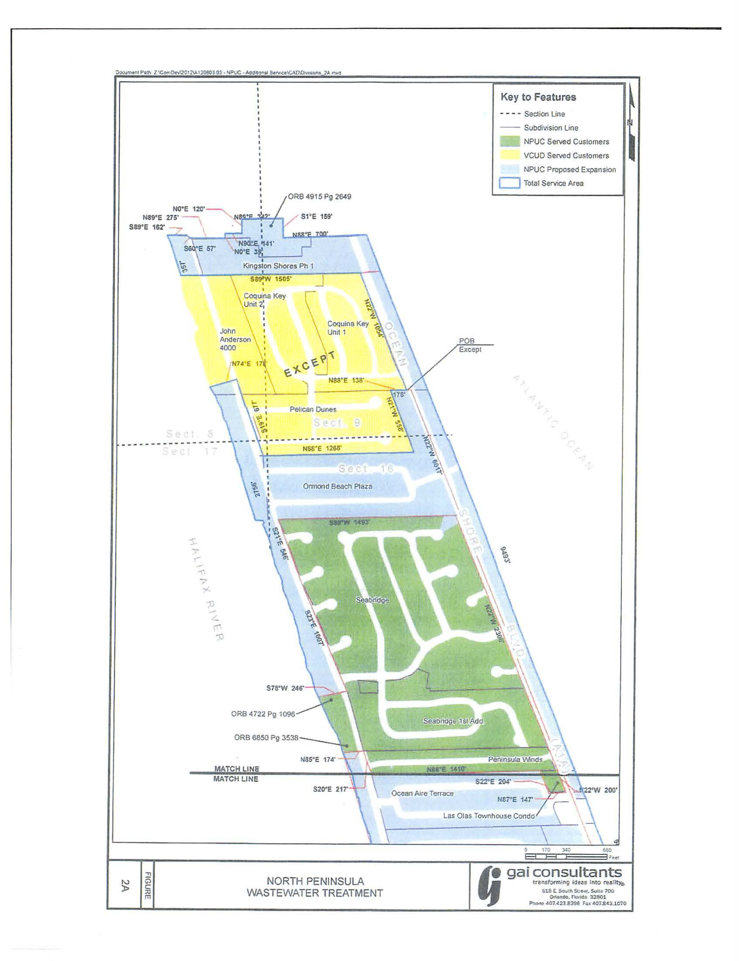
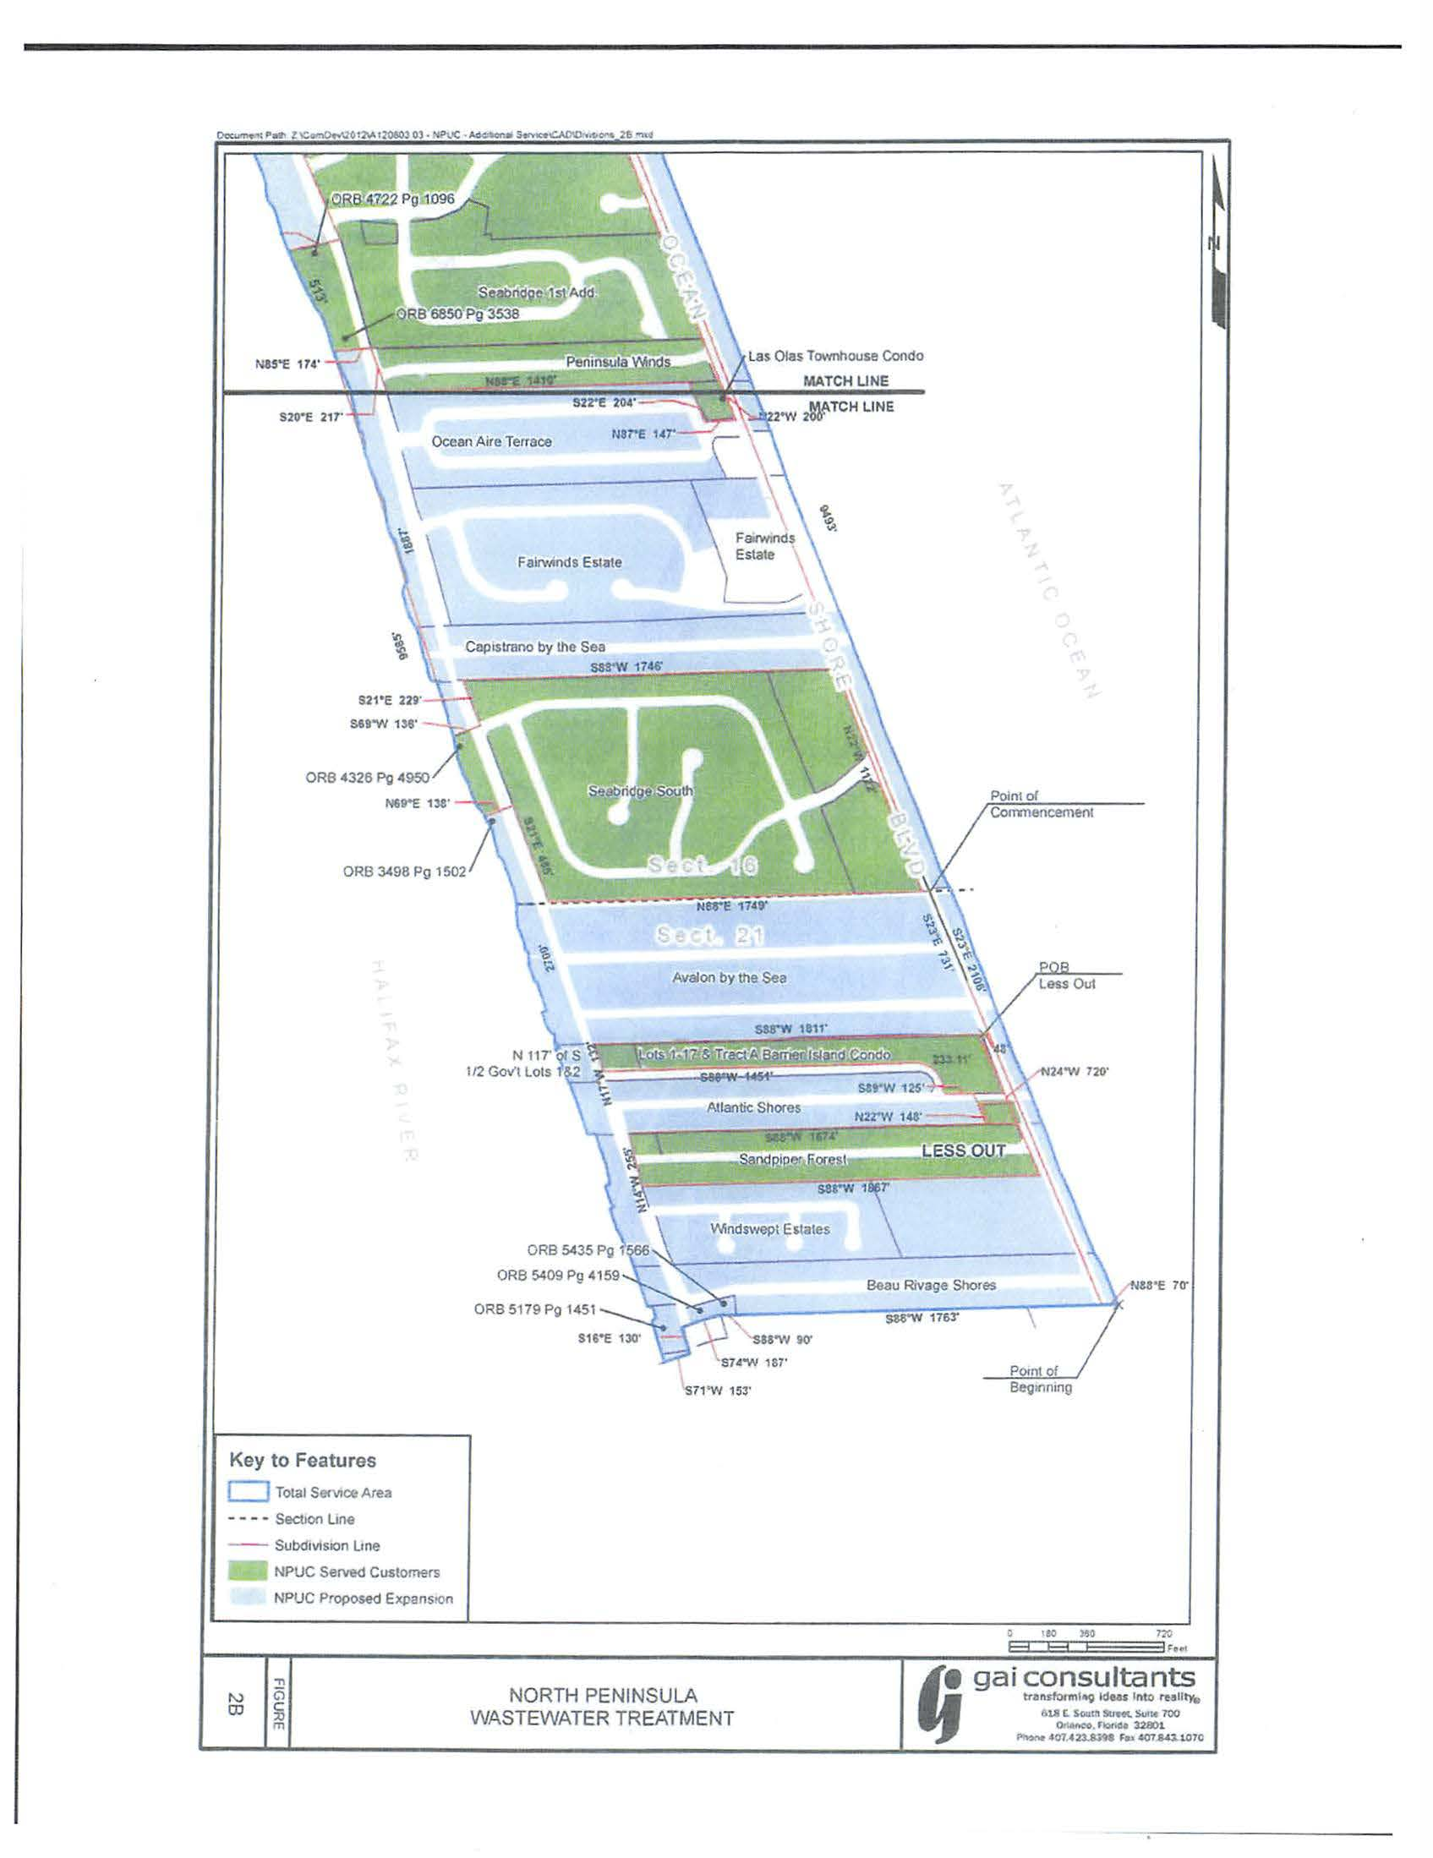

Order No. 22445, issued October 6, 2008, in Docket No. 891016-SU, In re: Application of North Peninsula Utilities Corporation for transfer of Certificate No. 249-S from Shore Utility Corporation in Volusia County.
Order No. PSC-14-0273-PCO-SU, issued May 29, 2014, in Docket No. 130209-SU, In re: Application for expansion of certificate (CIAC) (new wastewater line extension charge) by North Peninsula Utilities Corp.
Document 03862-14, p. 149, filed July 21, 2014.
Document 00260-15, p. 2, filed January 13, 2015.
Document 00260-15, p. 9, filed January 13, 2015.
Id.
The term “Mini-collection system,” as utilized by NPUC, means the residents of specific streets or grouped by HOAs would be responsible for providing the collection lines for their specific areas.
Document No. 00260-15, p. 2, filed January 13, 2015.
Order No. 16184, issued June 4, 1986, in Docket No. 850121-SU, In re: Application of Shore Utility Corporation for a staff-assisted rate case in Volusia County, Florida.
Because staff believes the Utility has not demonstrated there is a need to serve, staff did not pursue a comprehensive evaluation of NPUC’s technical and financial abilities.

