State of Florida   |  | Public Service Commission  Capital Circle Office Center ● 2540 Shumard Oak Boulevard  Tallahassee, Florida 32399-0850  -M-E-M-O-R-A-N-D-U-M-
DATE: | July 9, 2015
TO: | Office of Commission Clerk (Stauffer)
FROM: | Division of Engineering (Mtenga)  Office of the General Counsel (Murphy)
RE: | Docket No. 150104-EQ – Petition for approval of revisions to renewable energy tariffs REN-1 and REN-2, by Florida Public Utilities Company.
AGENDA: | 07/21/15 – Regular Agenda – Interested Persons May Participate
COMMISSIONERS ASSIGNED: |  |  | All Commissioners
PREHEARING OFFICER: |  |  | Administrative
CRITICAL DATES: |  |  | None
SPECIAL INSTRUCTIONS: |  |  | Staff recommends the Commission simultaneously consider Docket Nos. 150101-EQ, 150104-EQ, 150105-EQ, and 150106-EQ.

Case Background
Section 366.91(3), Florida Statutes (F.S.), requires that each investor-owned utility (IOU) continuously offer to purchase capacity and energy from renewable energy generators. Commission Rules 25-17.200 through 25-17.310, Florida Administrative Code (F.A.C.), implement the statute and require each IOU to file with the Commission, by April 1 of each year, a standard offer contract based on the next avoidable fossil fueled generating unit or planned purchase. On April 1, 2015, Florida Public Utilities Company (FPUC or Utility) filed a petition for approval of revisions to its standard offer contract and associated rate schedule.
Because FPUC does not own or operate any electric generating units, the Utility does not have any avoidable unit on which to base its standard offer contract. Rule 25-17.250(1), F.A.C., requires that, under these circumstances, the standard offer contract be based on avoiding or deferring a planned purchase. FPUC purchases all of its electric power through purchased power agreements (PPAs) in its Northeast Division from JEA, and in its Northwest Division from Gulf Power Company. The rate schedules REN-1 and REN-2 submitted with the standard offer contract reflect avoided purchases in the Northeast and Northwest Divisions in accordance with the PPAs for each division.
The Commission has jurisdiction over this standard offer contract pursuant to Sections 366.04 through 366.06 and 366.91, F.S.

Discussion of Issues

Issue 1:
Should the Commission approve the revised standard offer contract filed by Florida Public Utilities Company?

Recommendation:
Yes. The revised standard offer contracts and related rate schedules conform to all the requirements of Rules 25-17.200 through 25-17.310, F.A.C., and reflect the avoidable costs associated with FPUC’s power purchase agreements. Staff recommends that the revised standard offer contracts and related rate schedules filed by FPUC be approved as filed. (Mtenga)

Staff Analysis:

Pursuant to Rule 25-17.250, F.A.C., an IOU must continuously make available a standard offer contract for the purchase of firm capacity and energy from renewable generating facilities and small qualifying facilities with a design capacity of 100 kilowatt (kW) or less.
Since FPUC does not generate any electric energy for sale to retail customers, FPUC does not file a Ten-Year Site Plan and has no planned generating unit that can serve as an avoided unit. In such a circumstance, Rule 25-17.250(1), F.A.C., requires that a standard offer be based on avoiding or deferring a planned purchase. FPUC has met this requirement by submitting standard offer contracts based on the Utility’s purchased power agreements with Gulf Power Company for the Northwest Division and JEA for the Northeast Division.
FPUC proposes revisions to the Northwest division for REN-1, for as-available energy. Energy and capacity payments for these schedules are based on actual costs under FPUC’s wholesale contracts with estimates provided in the rate schedule filing. The revisions reflect updated energy price estimates for 2015, and are detailed below. The rate schedules are otherwise unchanged. FPUC’s standard offer contract, incorporating the revised rate schedules, is provided as Attachment A. Similar revisions were approved by the Commission in 2014 by FPSC Order No. PSC-14-0394-PAA-EQ, issued July 30, 2014.

Northwest Division

Payments for energy in 2015 are projected to be 4.222 cents per kilowatt-hour (kWh), which represents an increase of 7.6 percent from the previous year. Payments for capacity are projected to remain at zero due to the so-called “ratchet provision” included in FPUC’s contract with Gulf Power Company. This provision precludes any decrease in demand payments to Gulf Power Company based on a decrease in the overall demand or the addition of generation resources including a renewable provider. Actual payments to a renewable provider are based on the actual deferred cost of FPUC’s PPA with Gulf Power Company.

Northeast Division
Payments for energy in 2015 are projected to be 4.360 cents per kilowatt-hour (kWh), which is identical to that of the previous year. Payments for capacity are projected at $14.31 per kilowatt (kW) of the renewable provider’s capacity at time of system peak, which is also the same as the previous year. Actual payments to a renewable provider are based on the actual deferred cost of FPUC’s PPA with JEA.

Conclusion
The revised standard offer contracts and related rate schedules conform to all the requirements of Rules 25-17.200 through 25-17.310, F.A.C., and reflect the avoidable costs associated with FPUC’s purchased power agreements. Staff recommends that the revised standard offer contracts and related rate schedules filed by FPUC be approved as filed.

Issue 2:
Should this docket be closed?

Recommendation:
Yes. This docket should be closed upon issuance of a consummating order, unless a person whose substantial interests are affected by the Commission’s decision files a protest within 21 days of the issuance of the Commission’s Proposed Agency Action Order. Potential signatories should be aware that, if a timely protest is filed, FPUC’s standard offer contract may subsequently be revised. (Murphy)

Staff Analysis:

This docket should be closed upon issuance of a consummating order, unless a person whose substantial interests are affected by the Commission’s decision files a protest within 21 days of the issuance of the Commission’s Proposed Agency Action Order. Potential signatories should be aware that, if a timely protest is filed, FPUC’s standard offer contract may subsequently be revised.

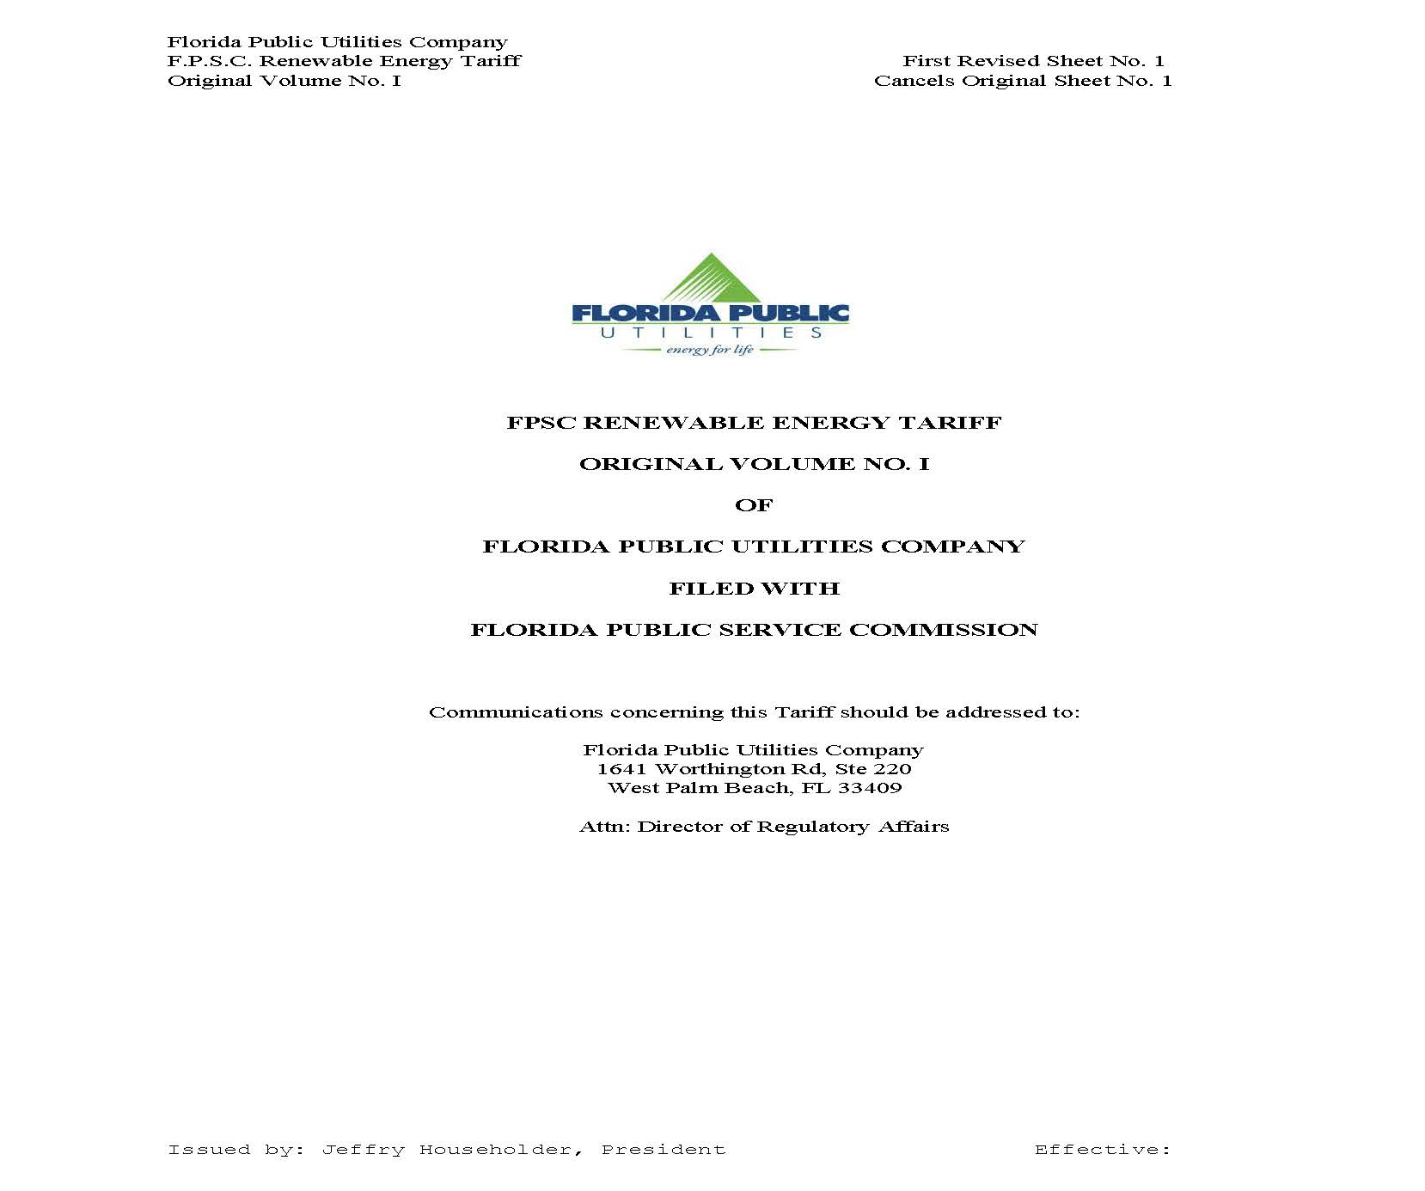

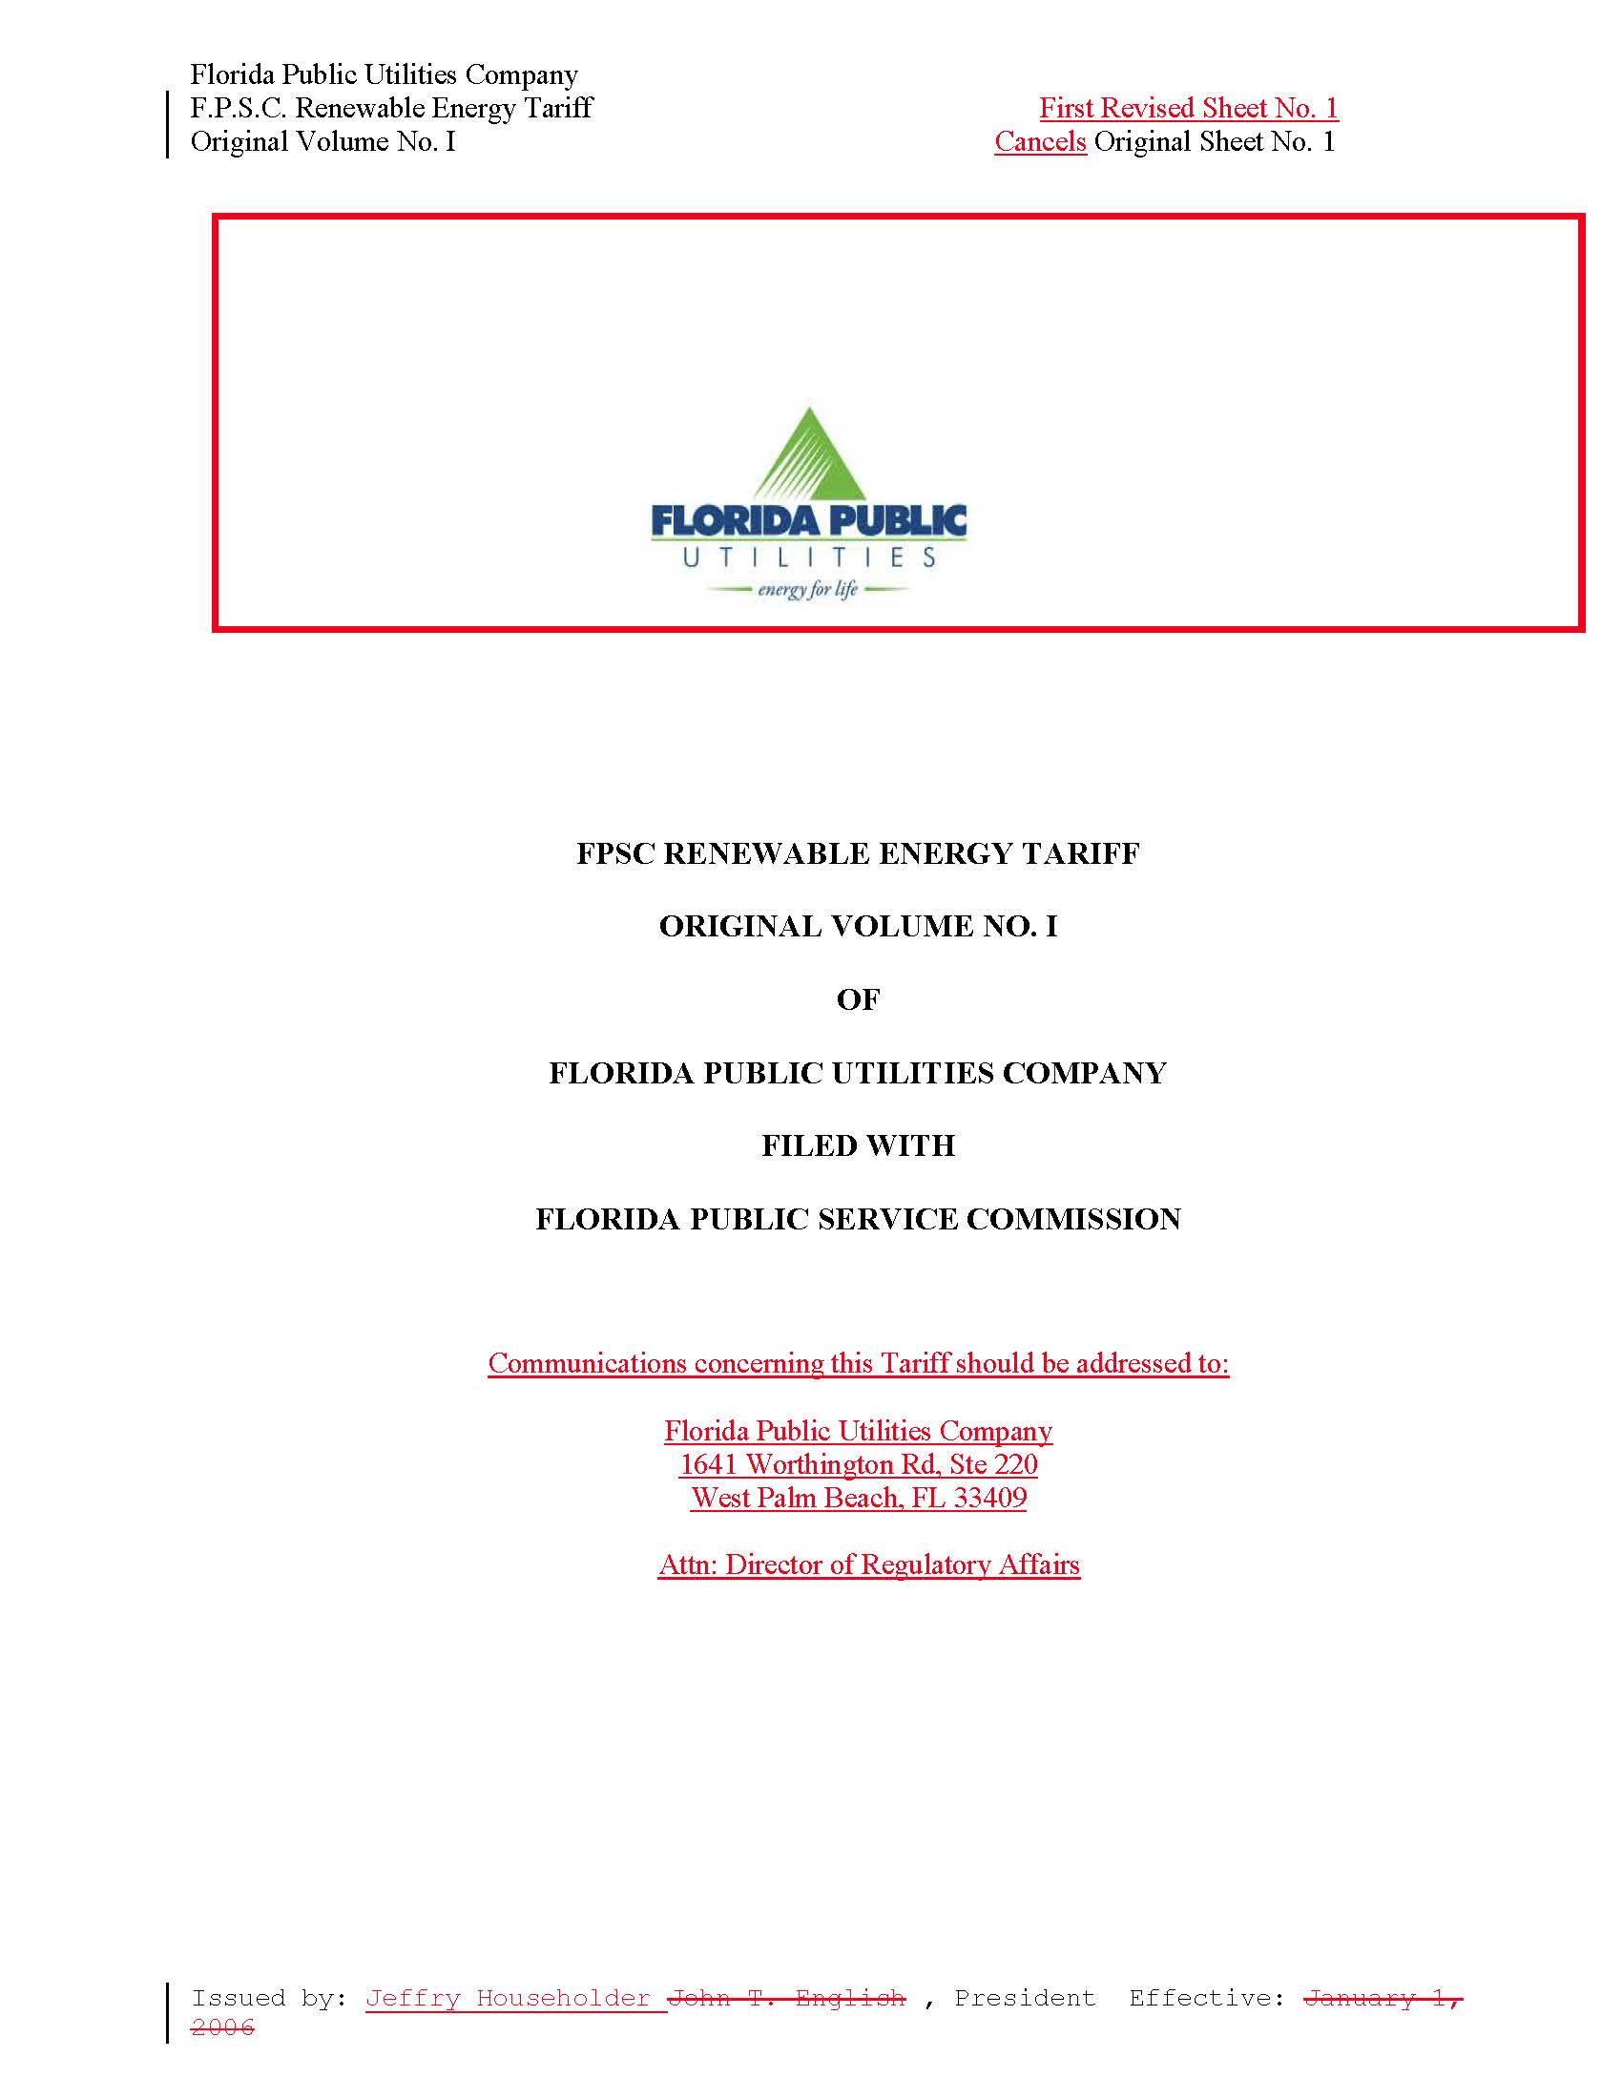

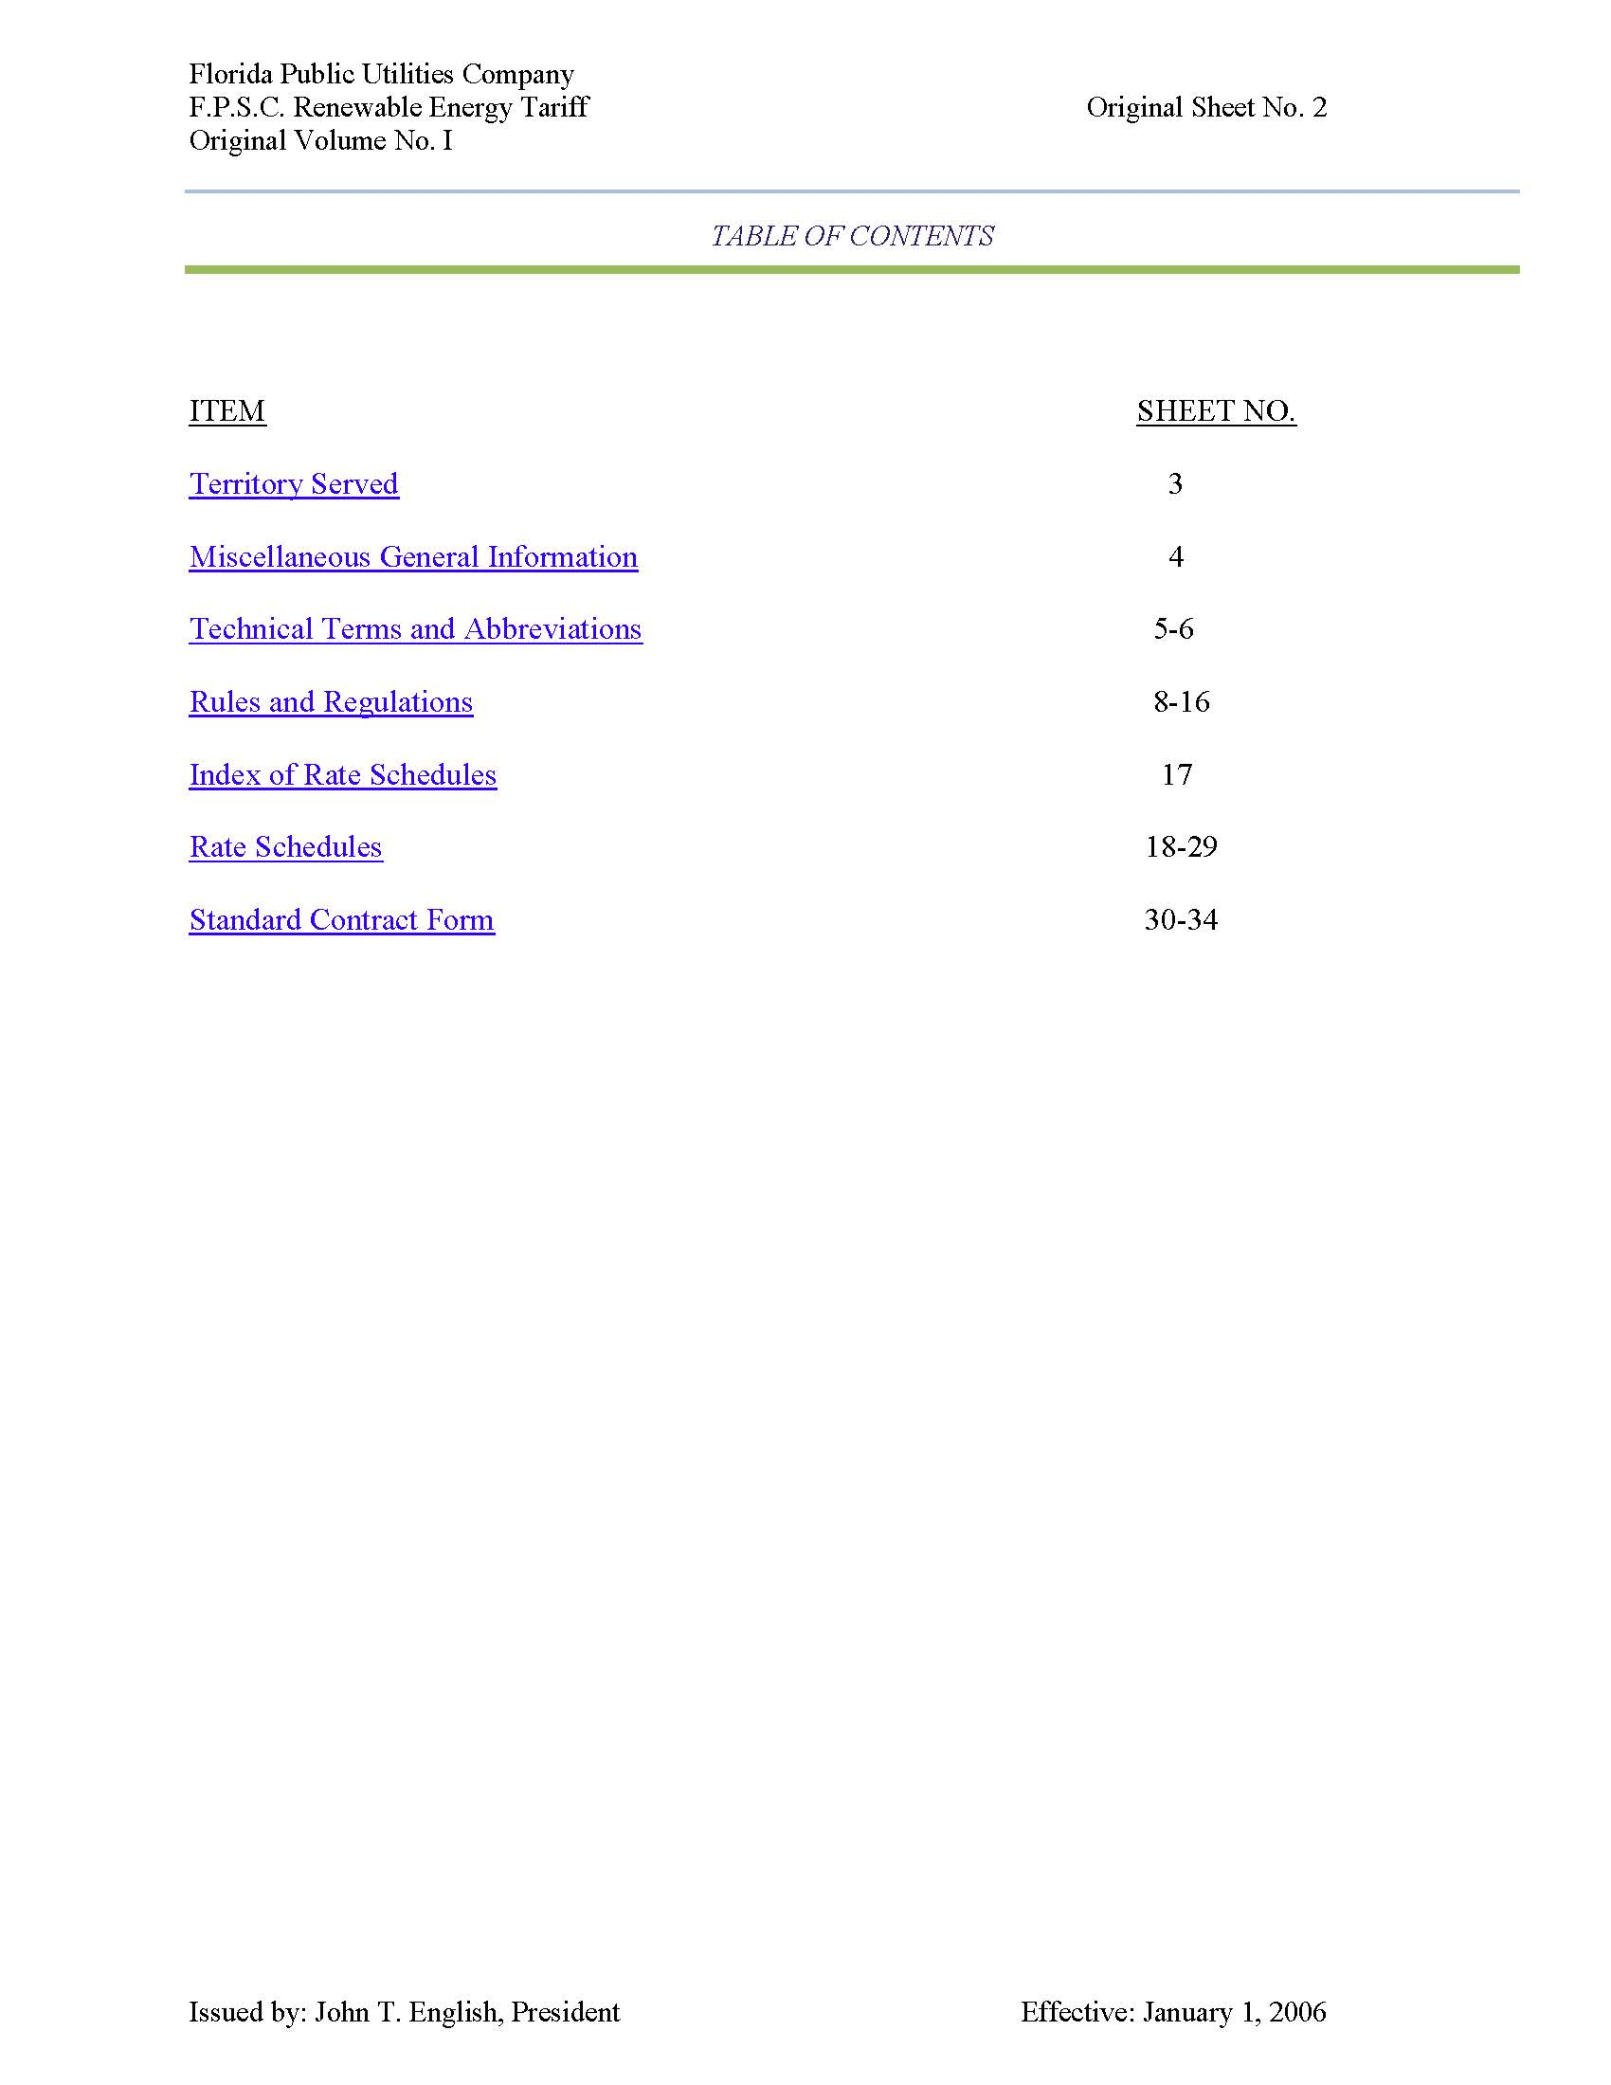

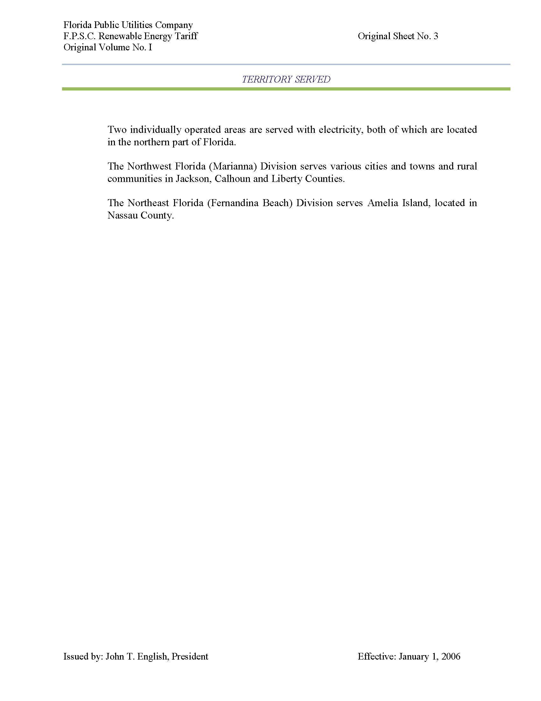

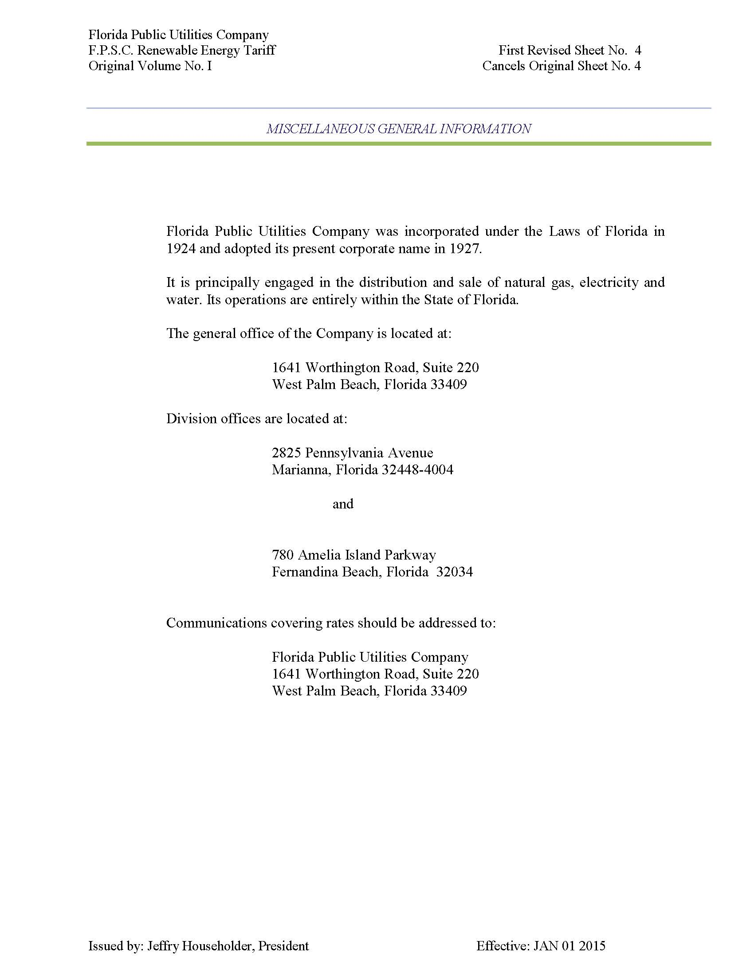

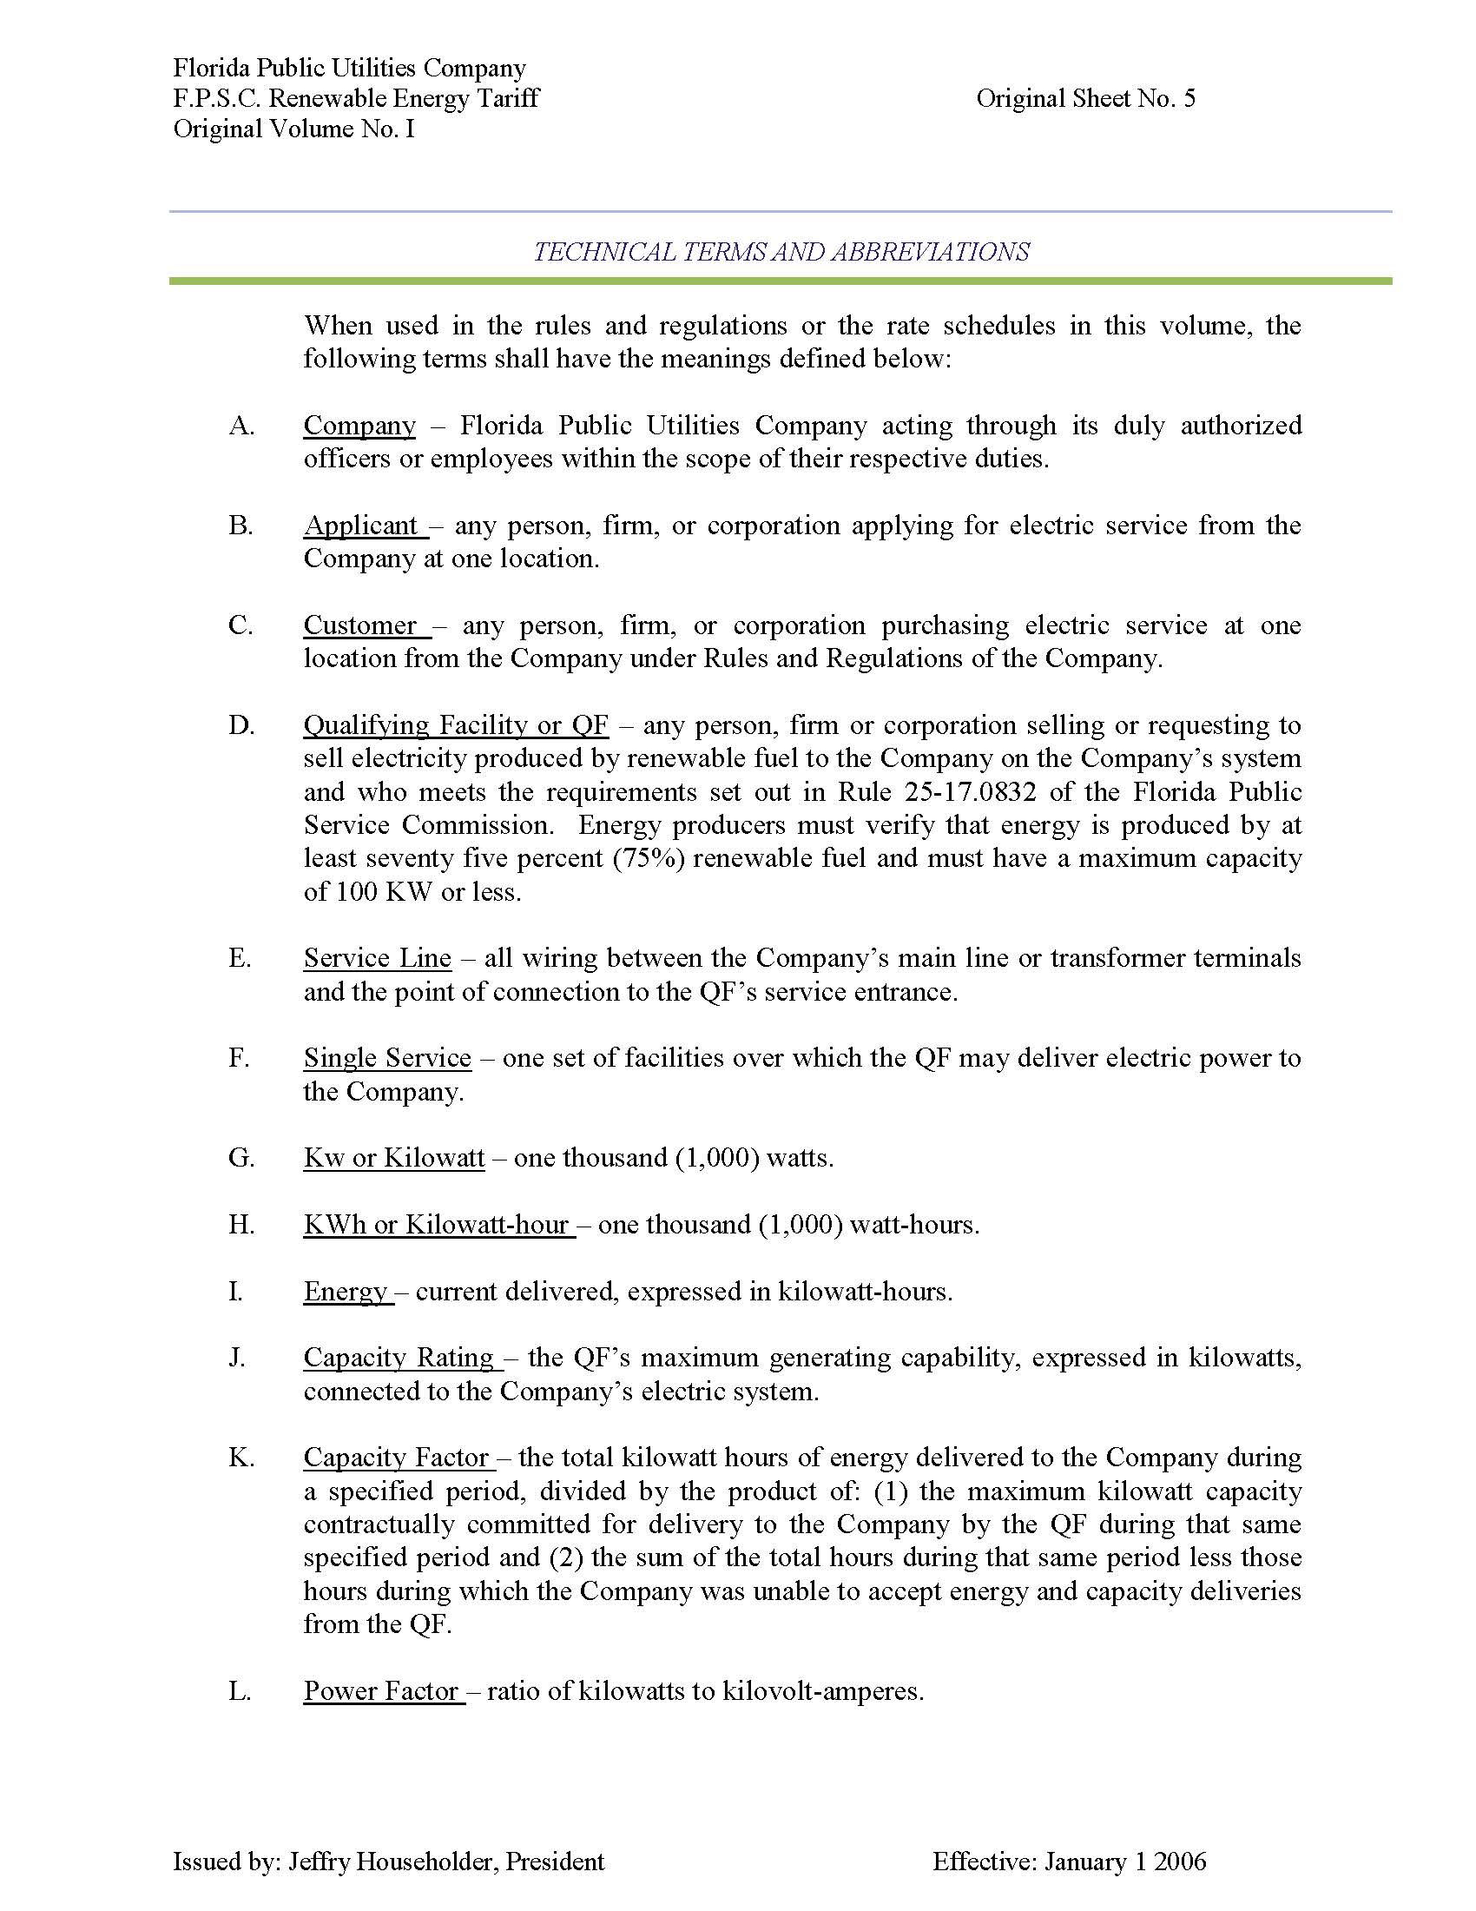

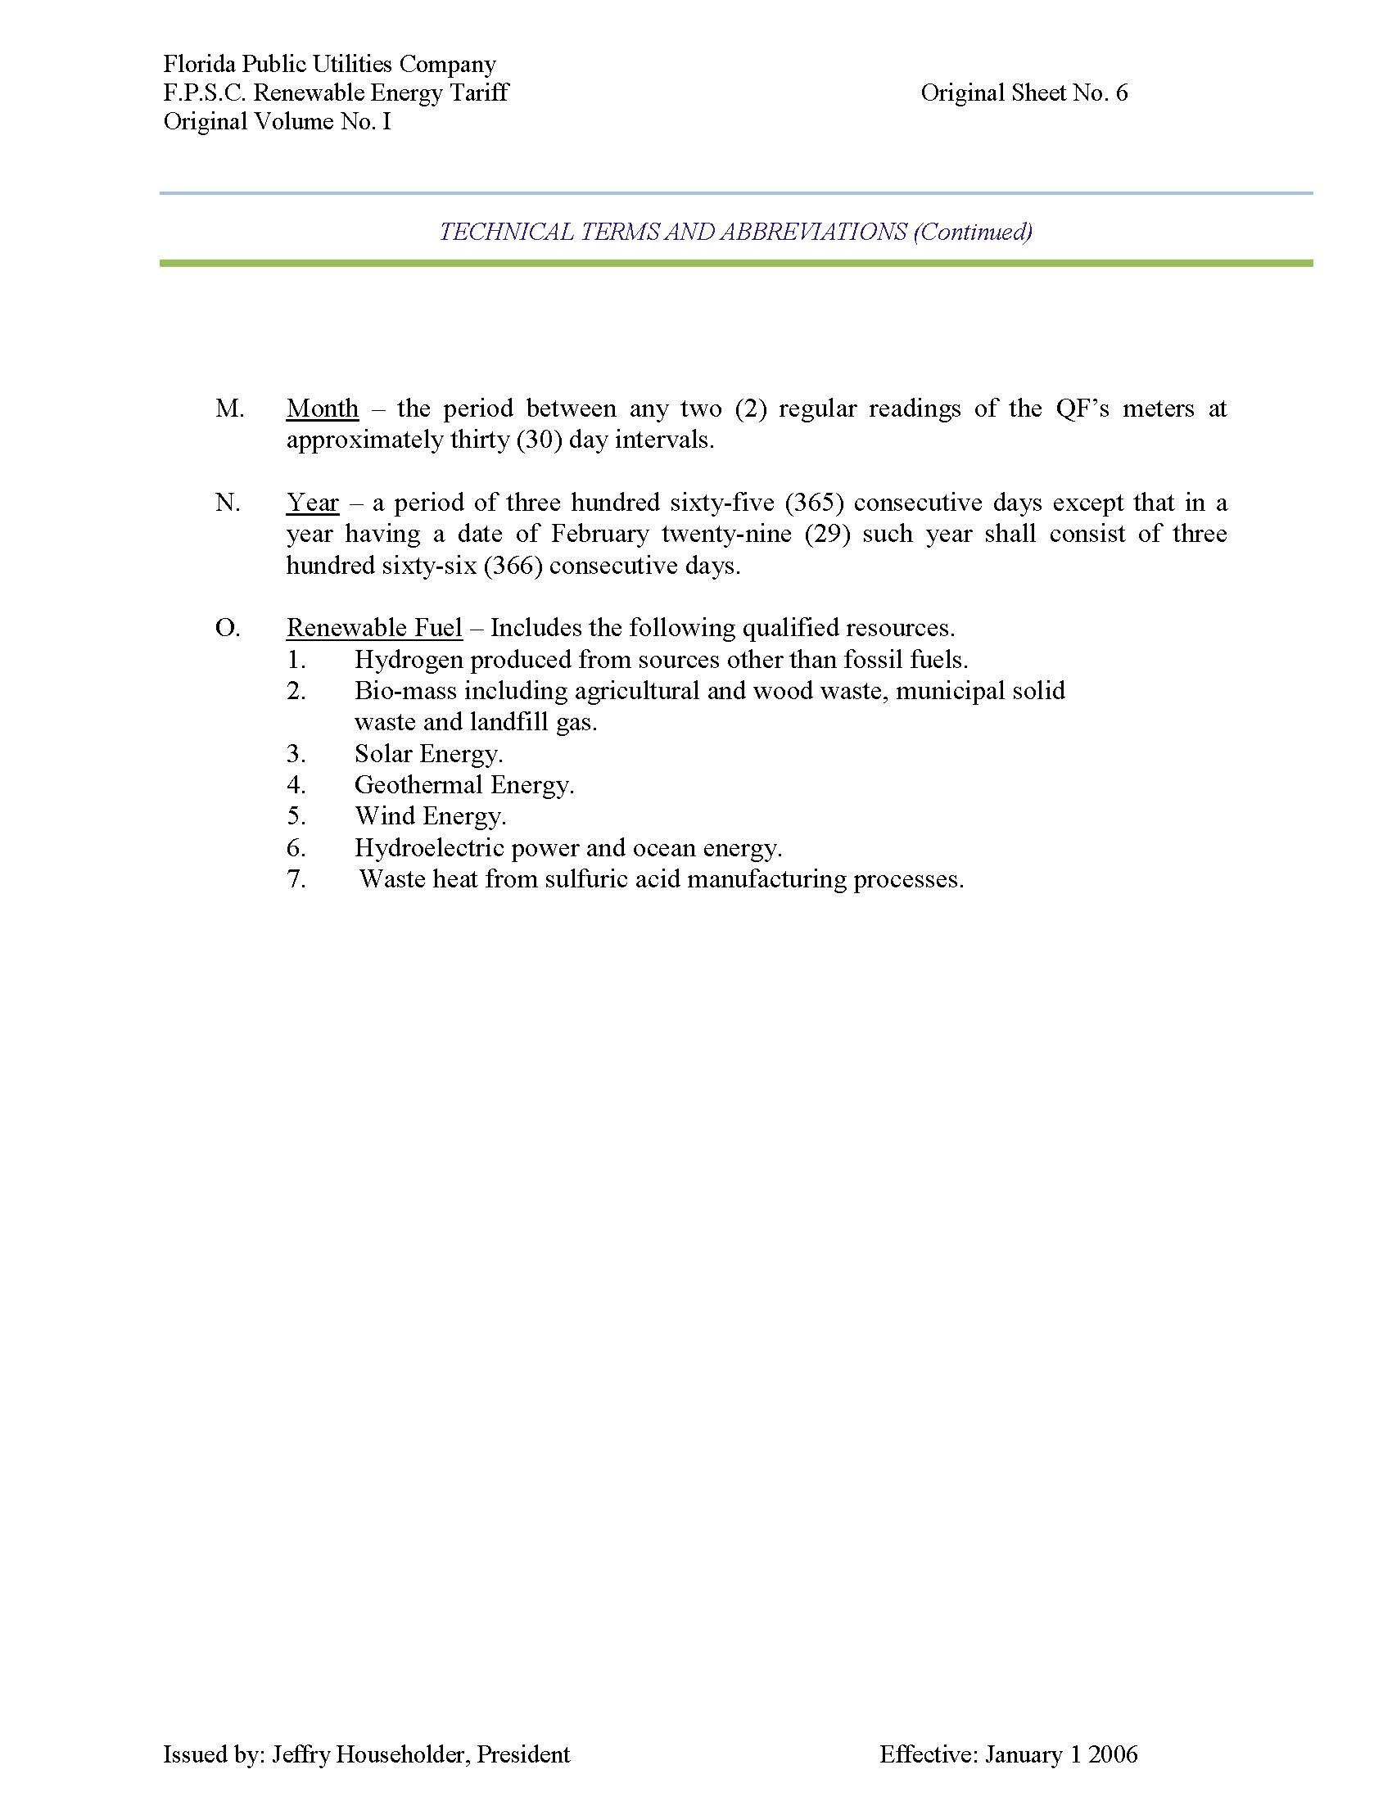

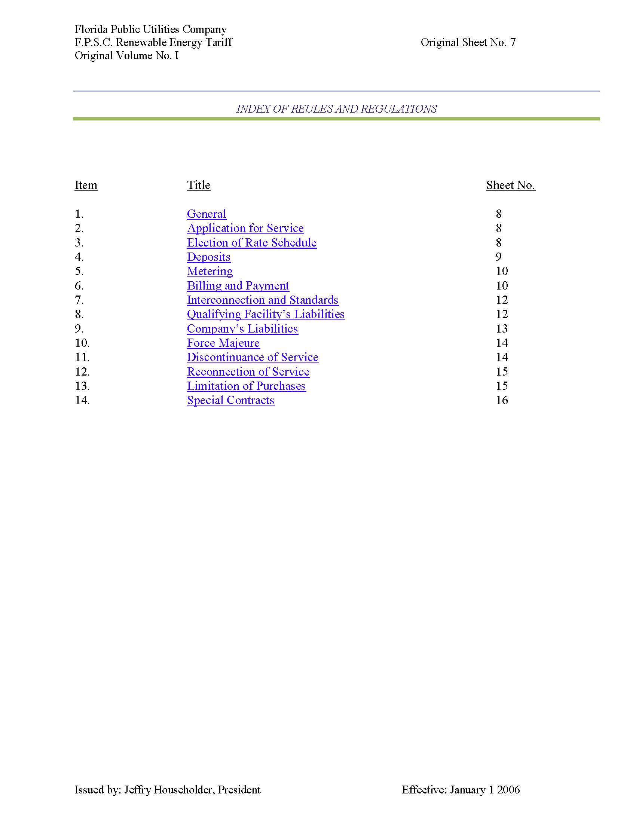

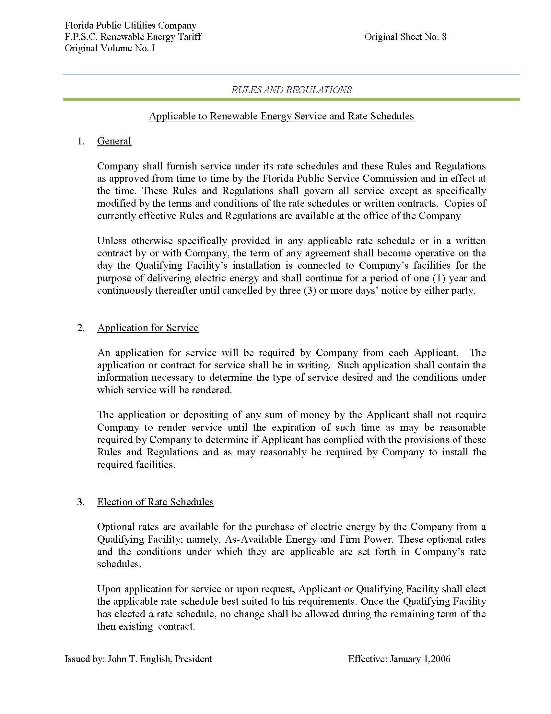

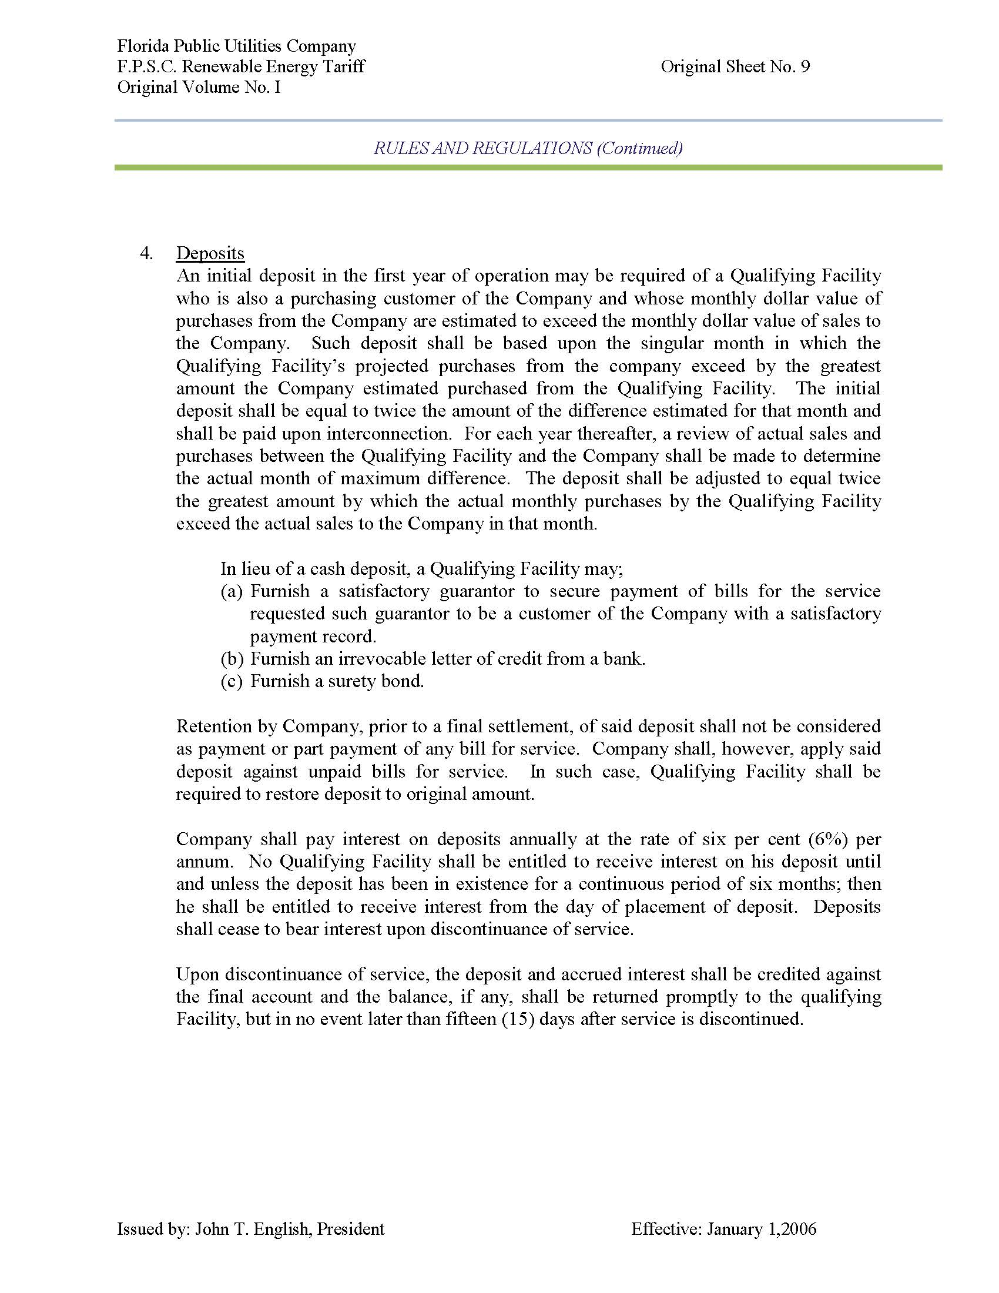

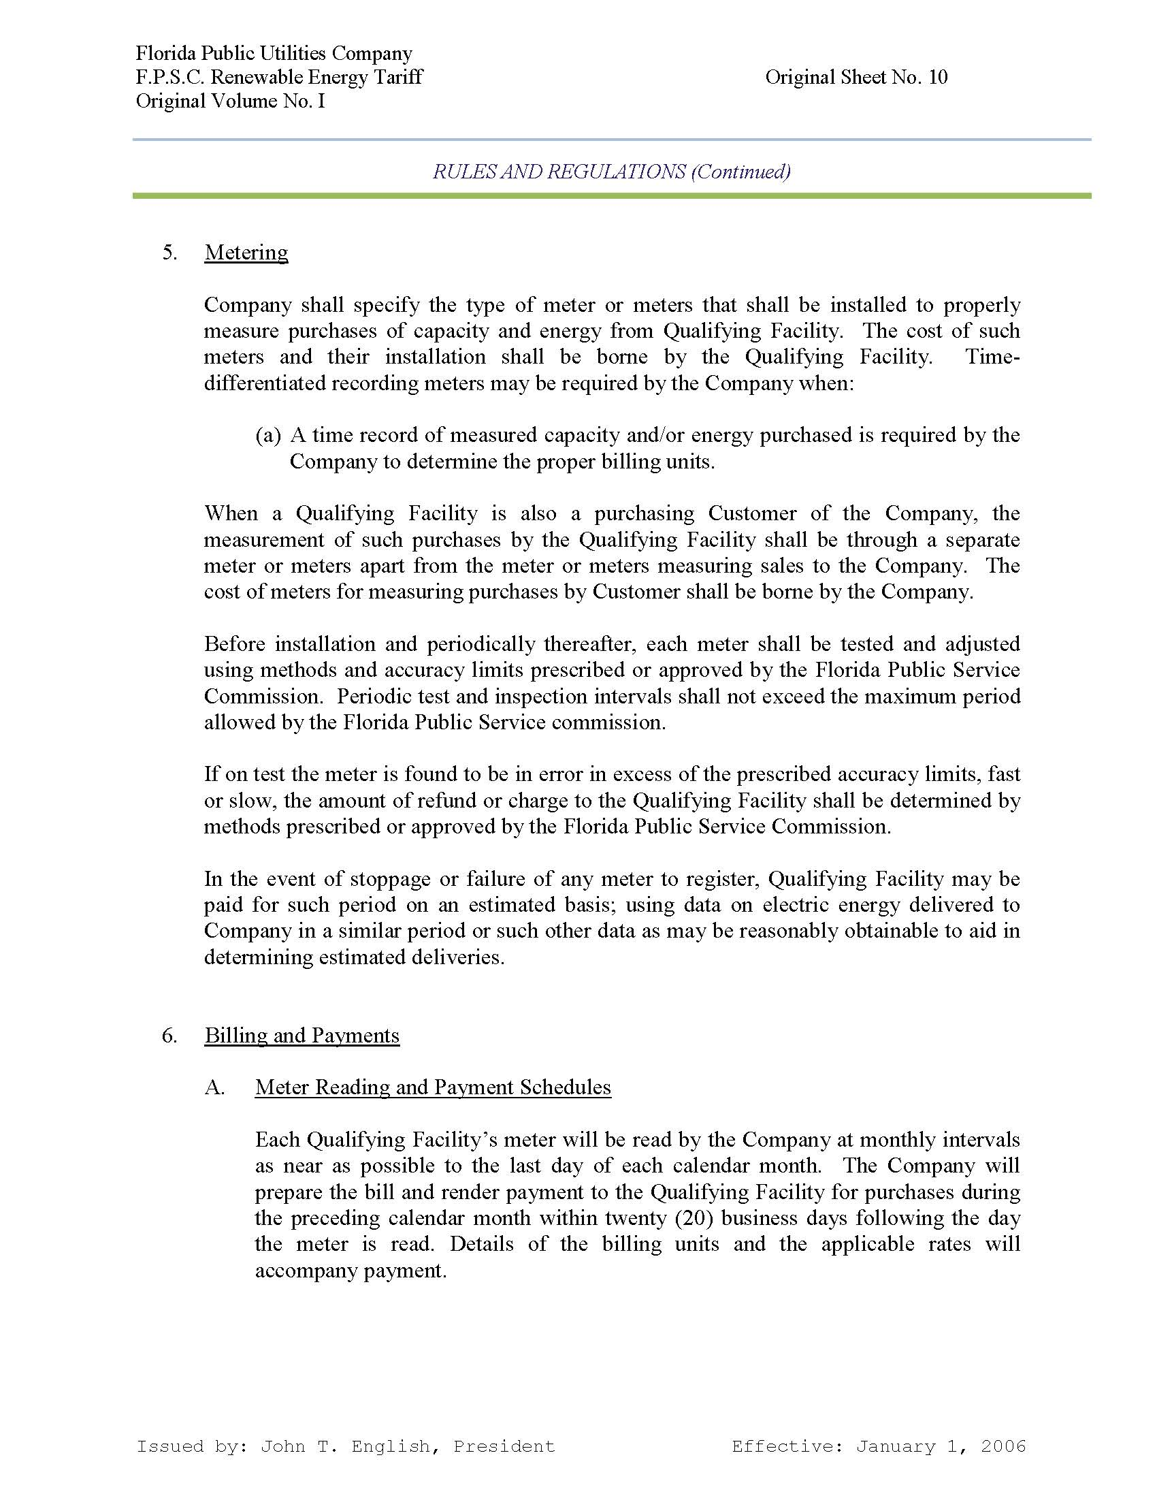

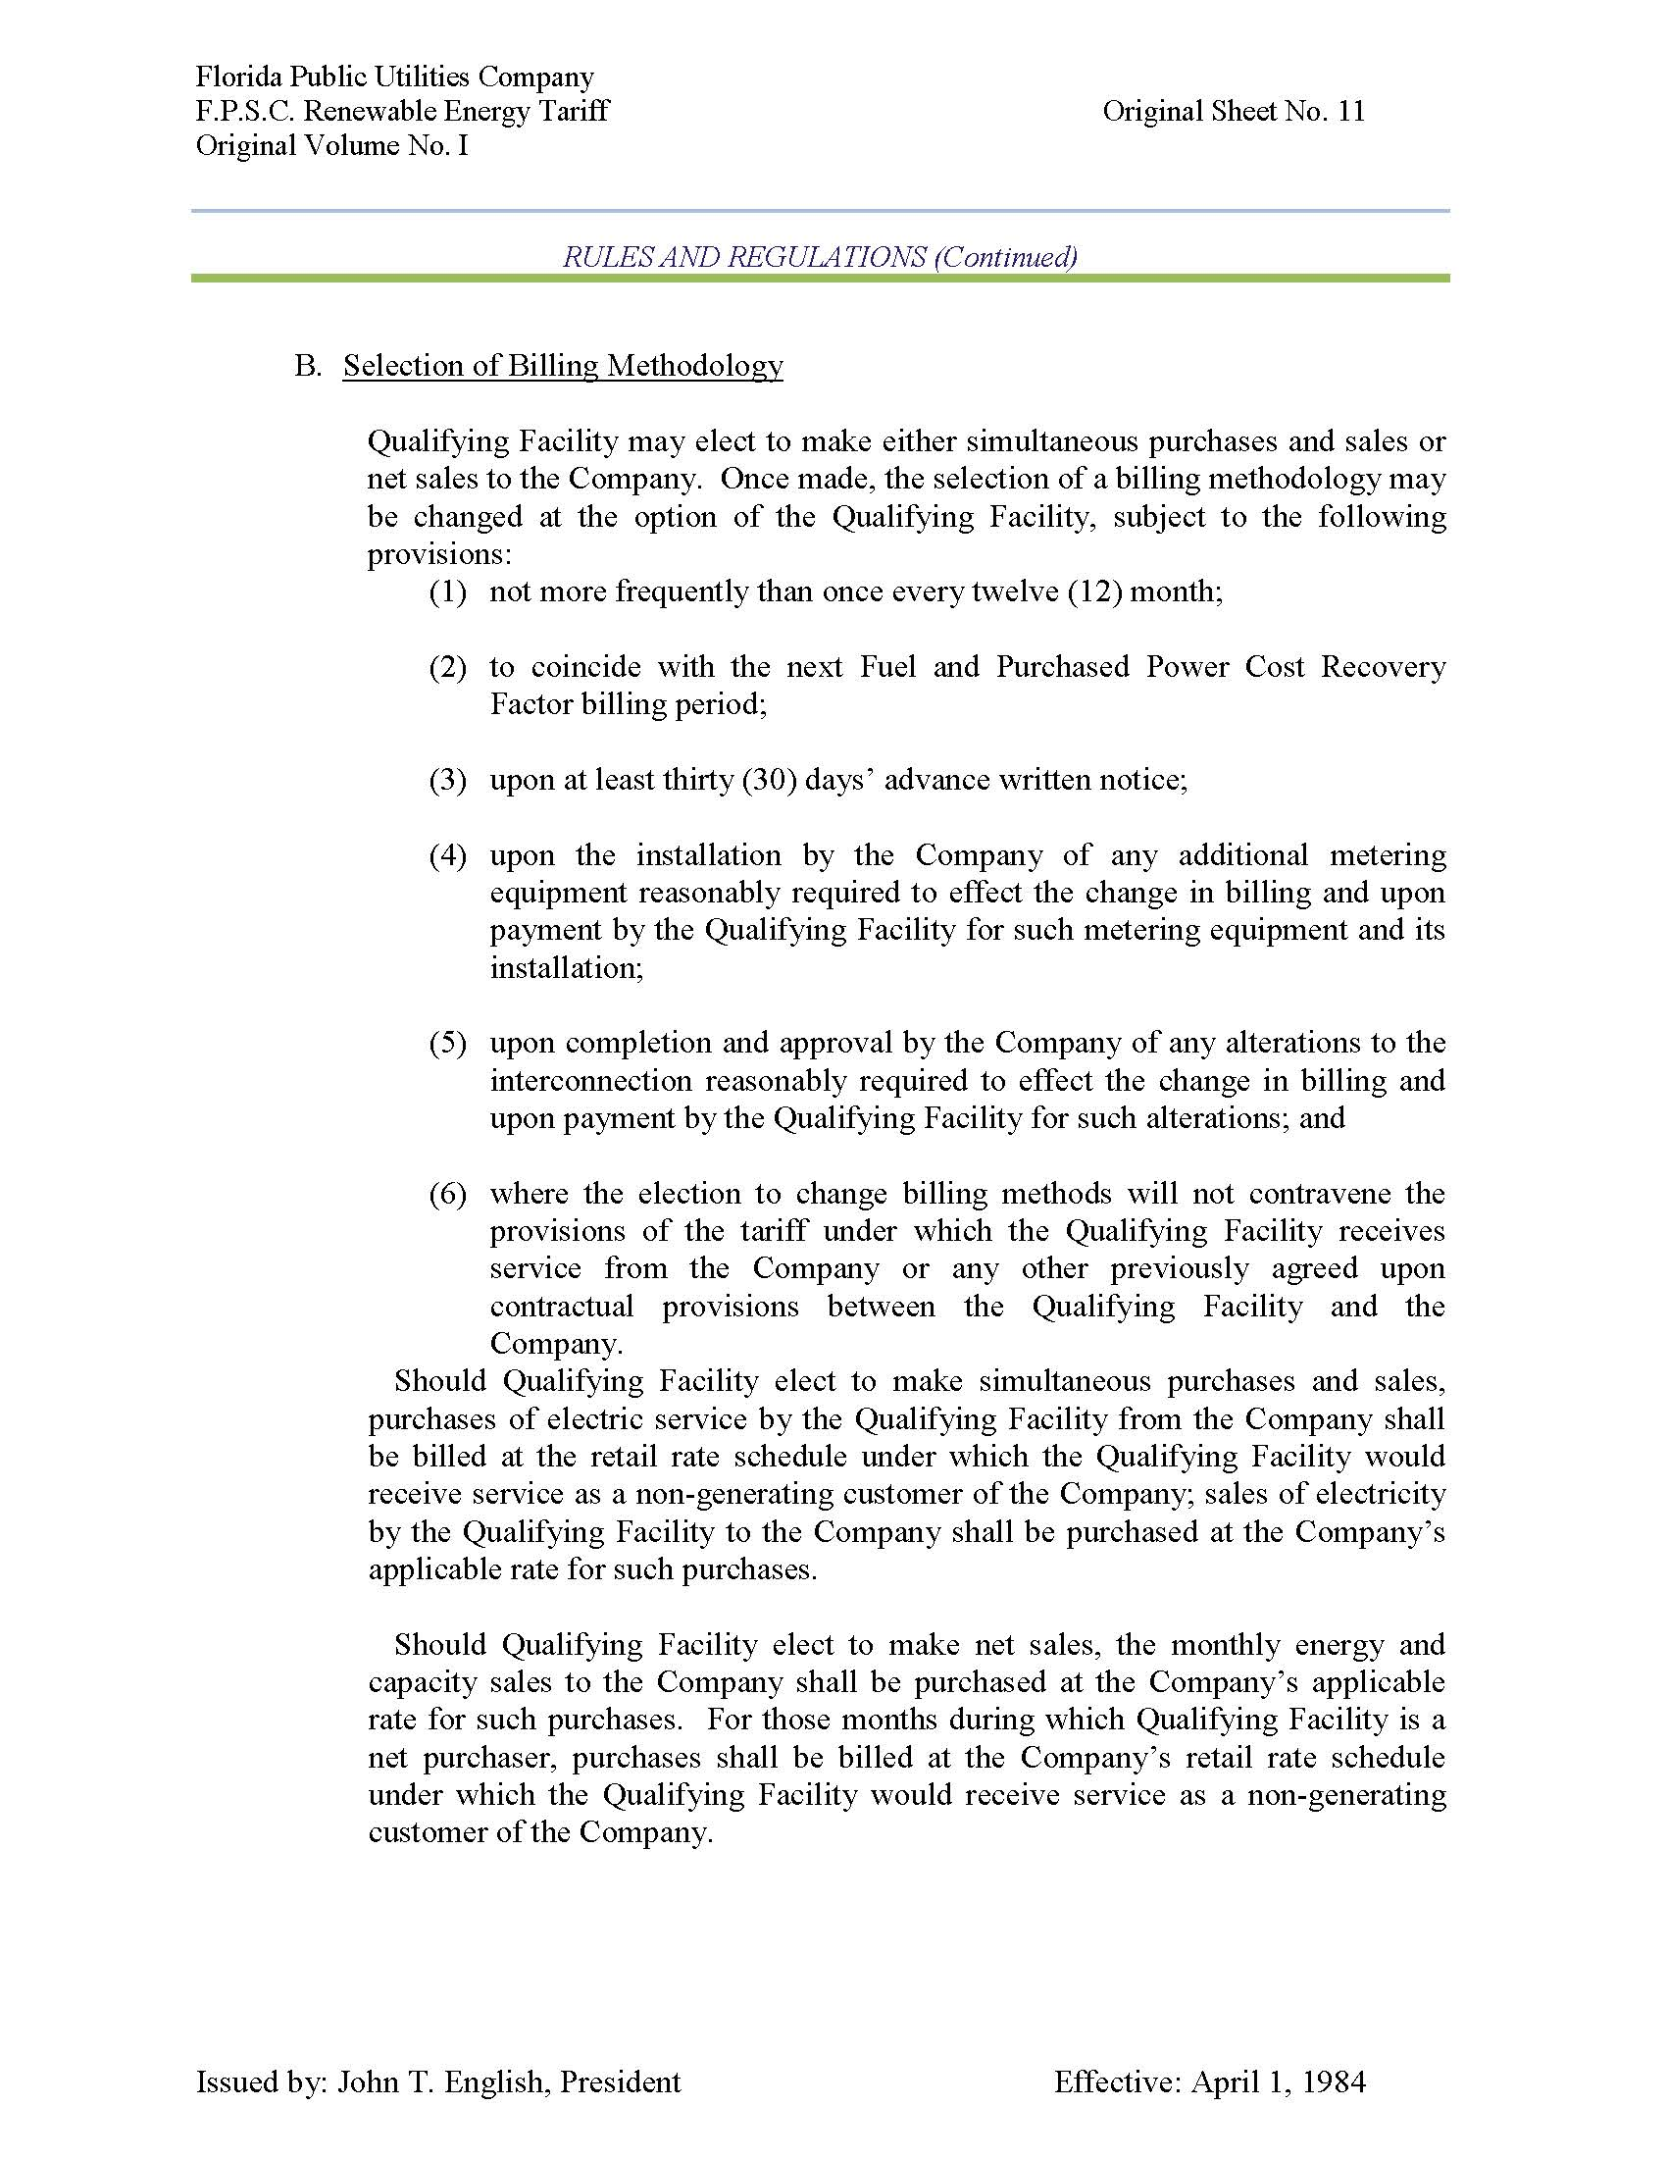

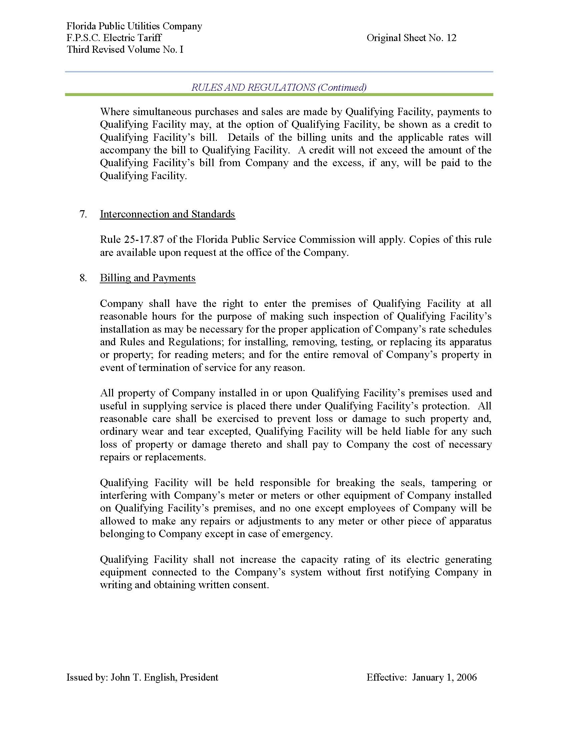

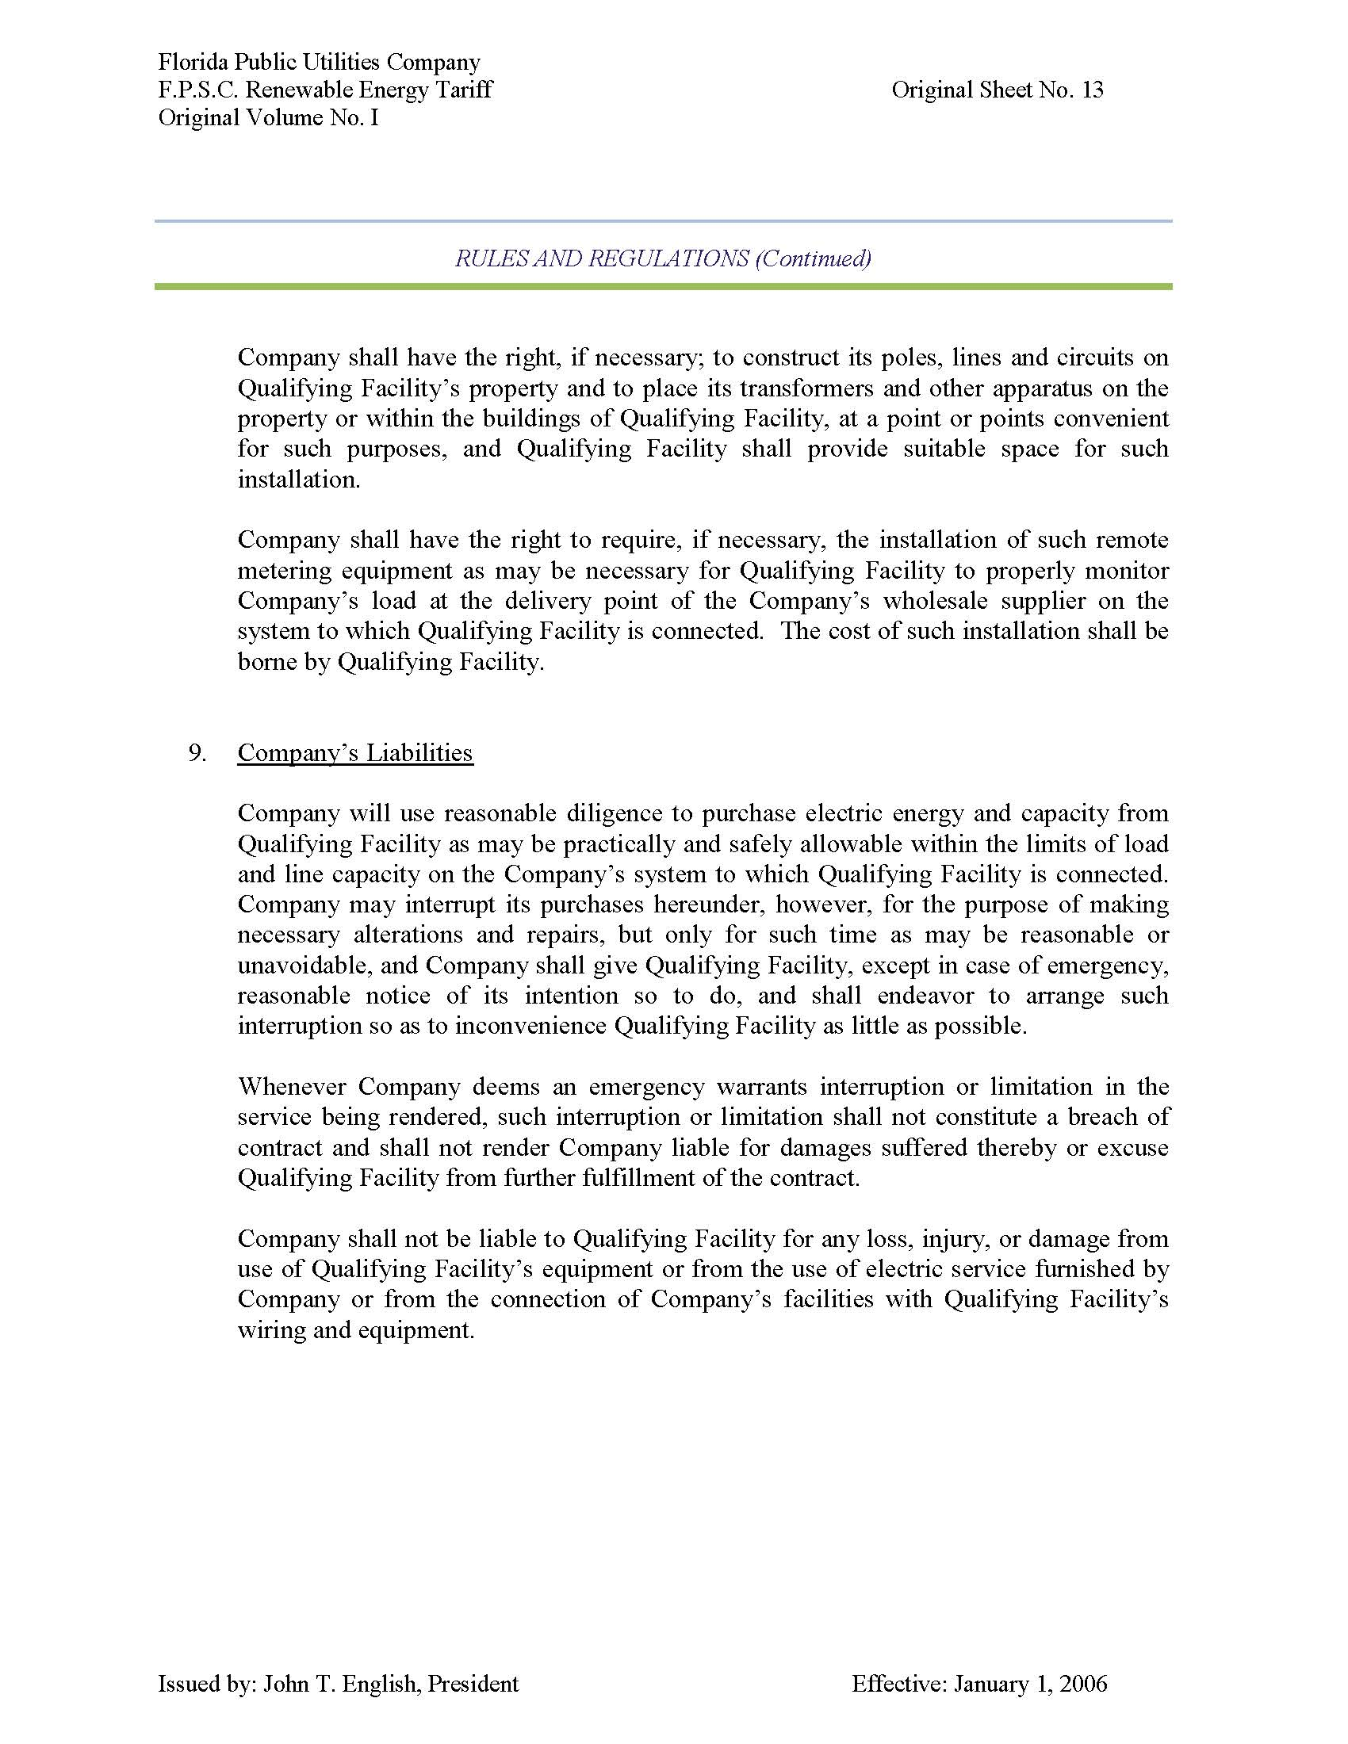

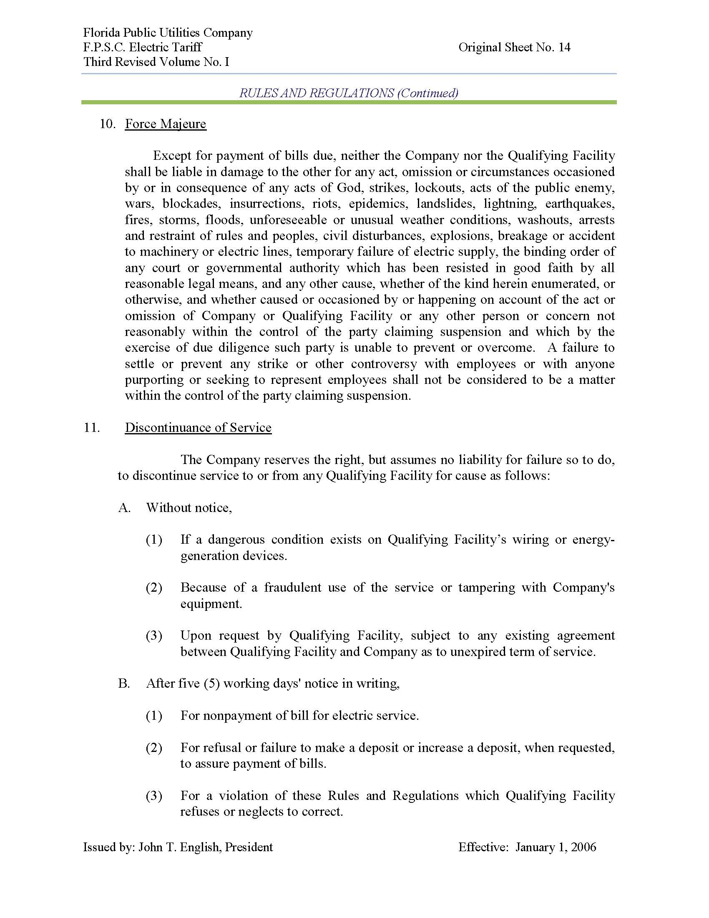

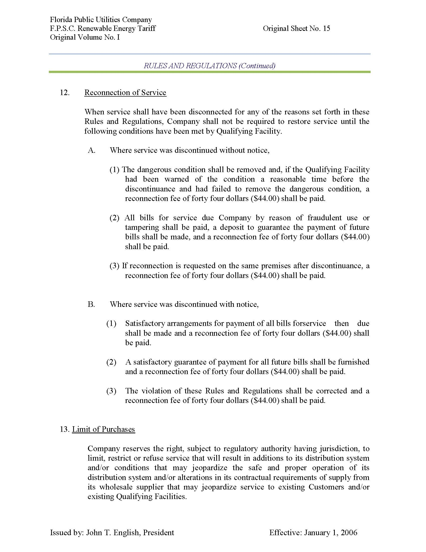

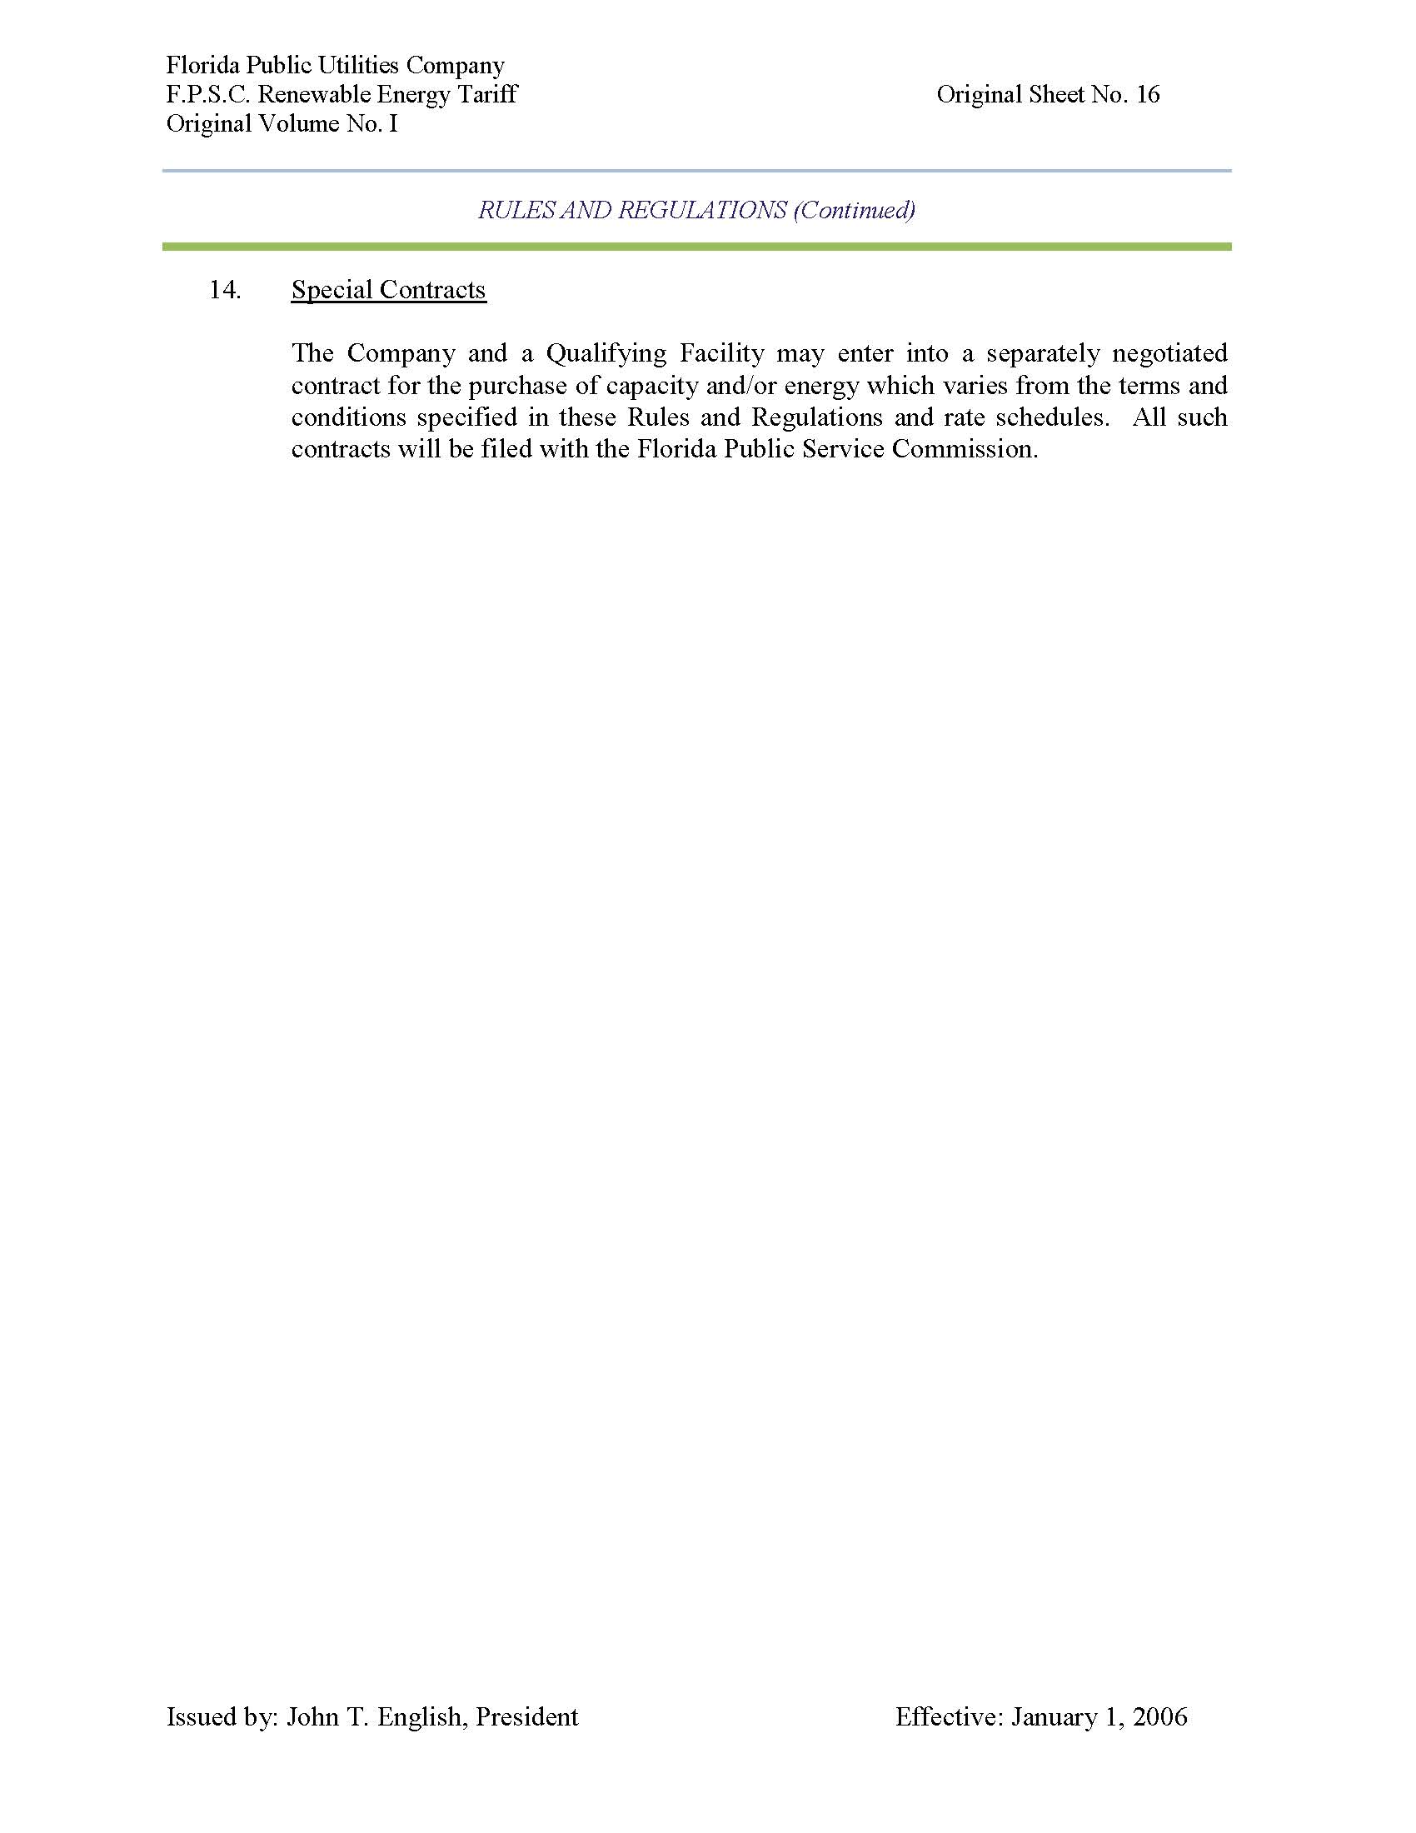

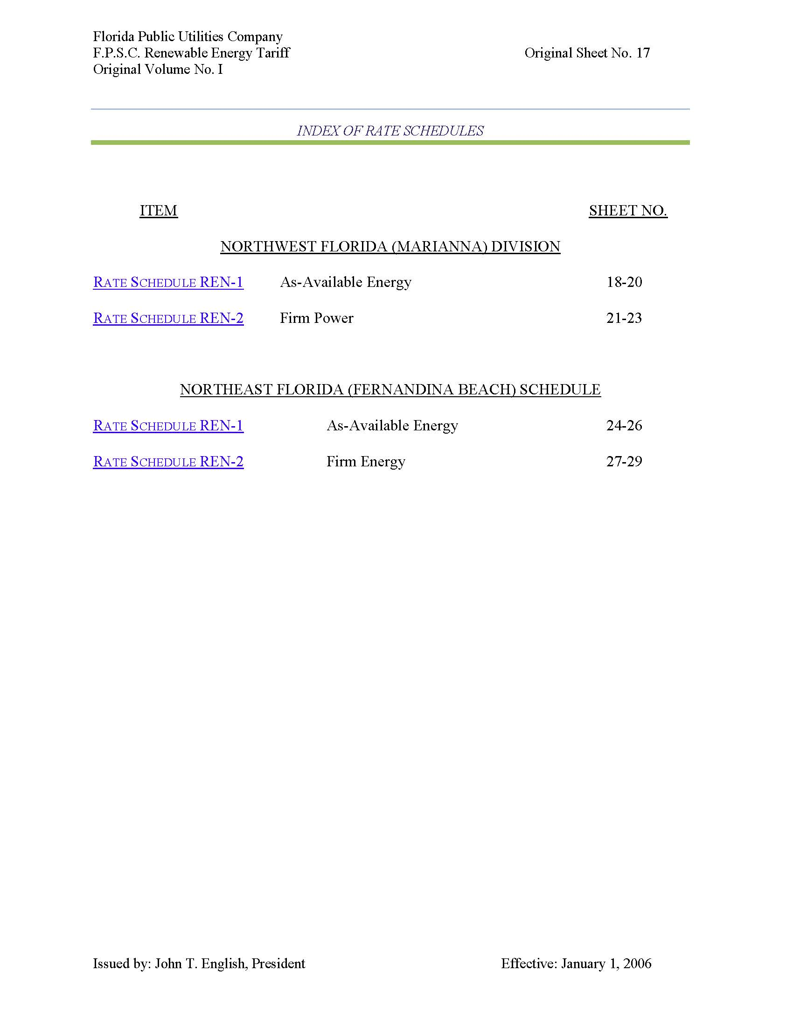

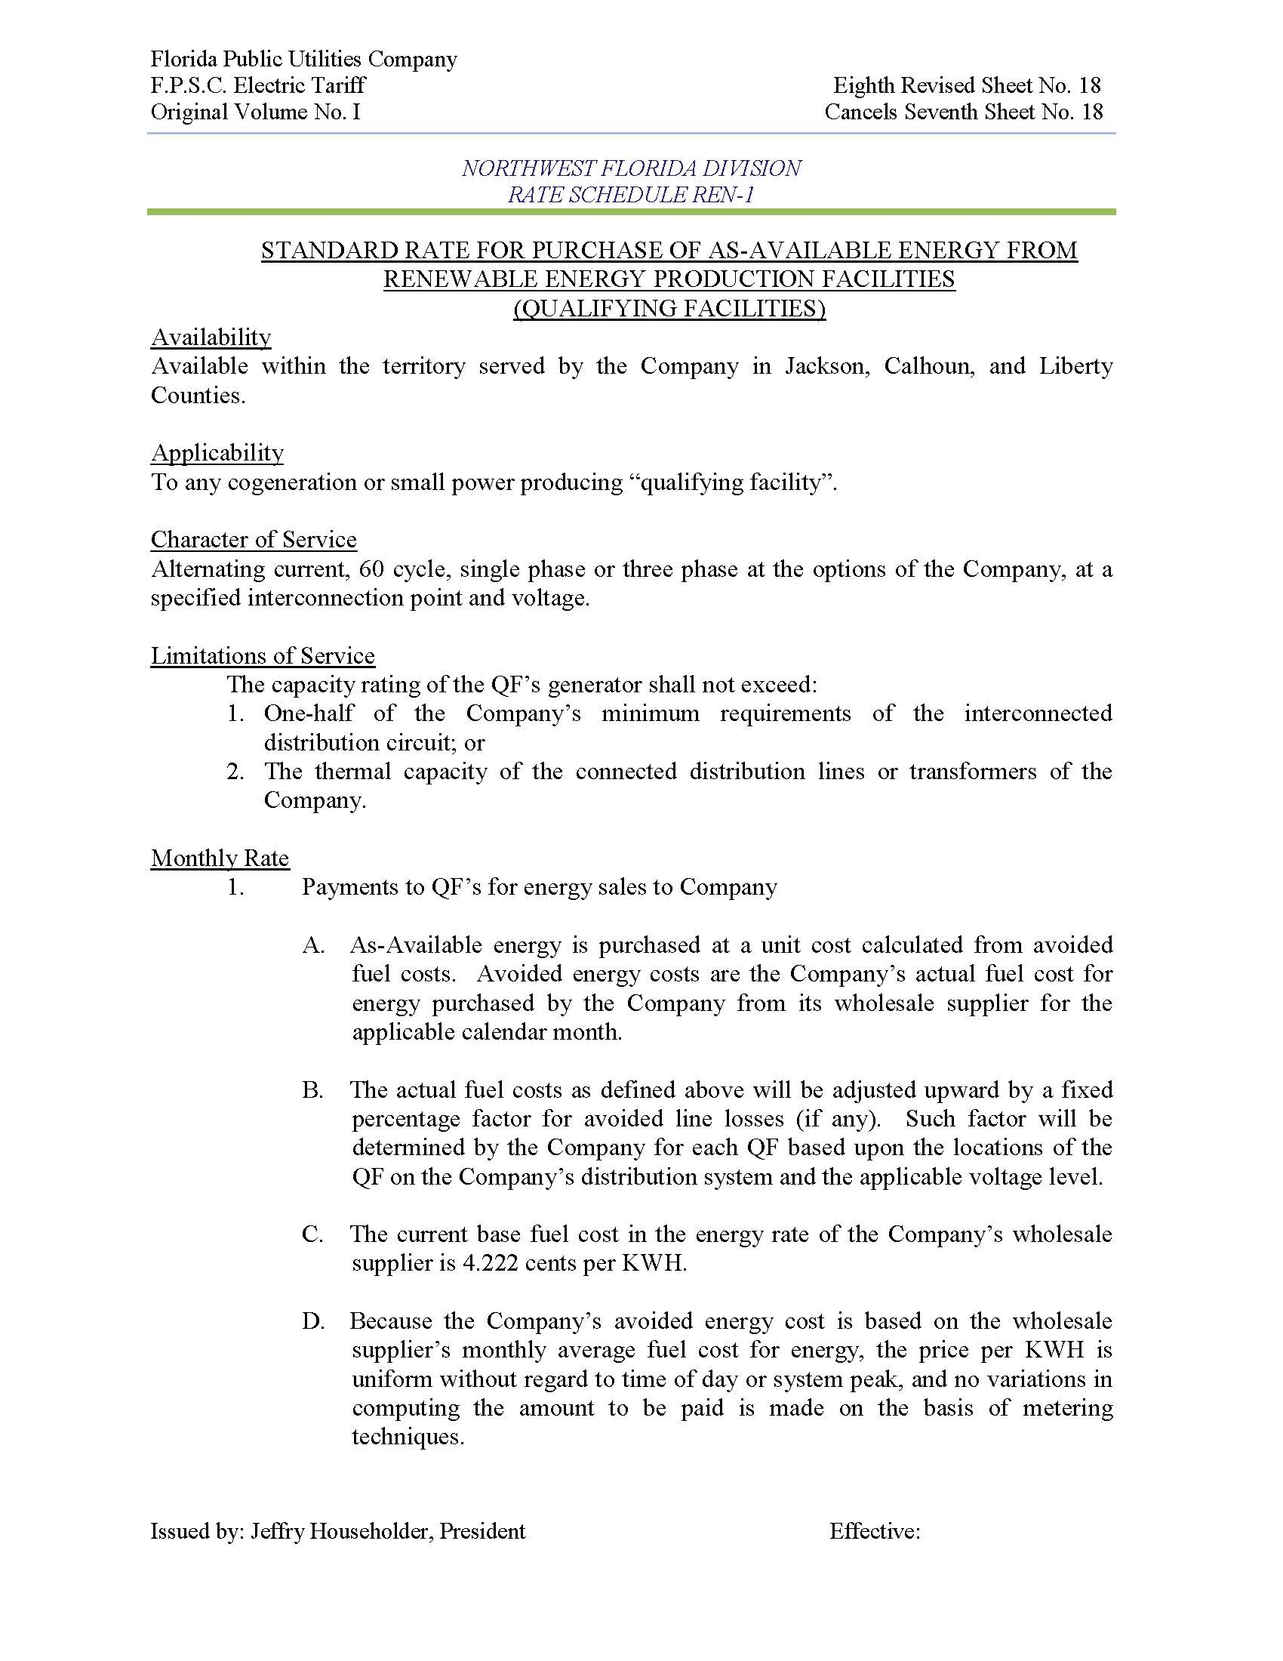

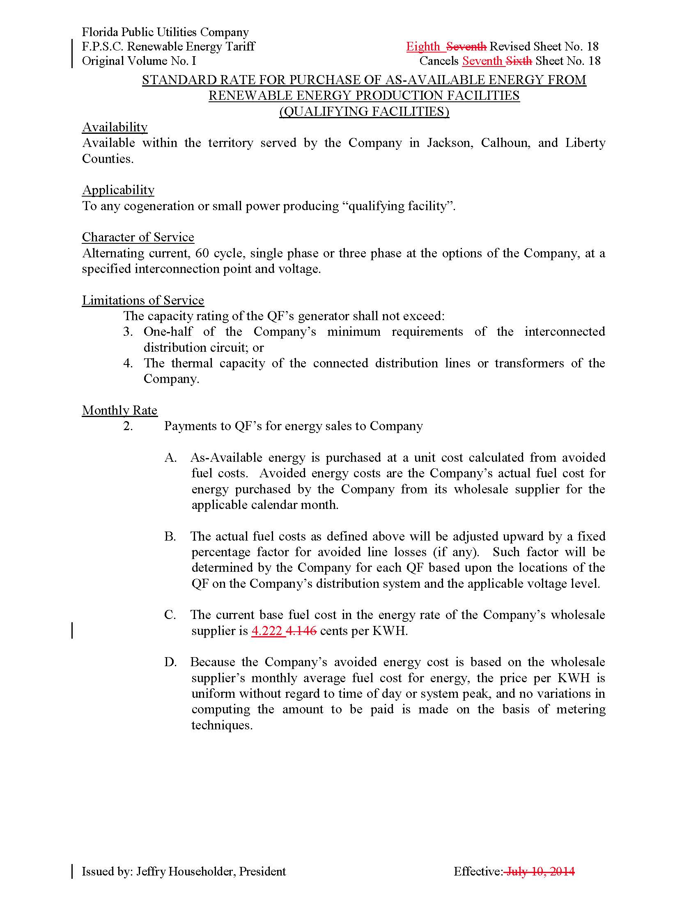

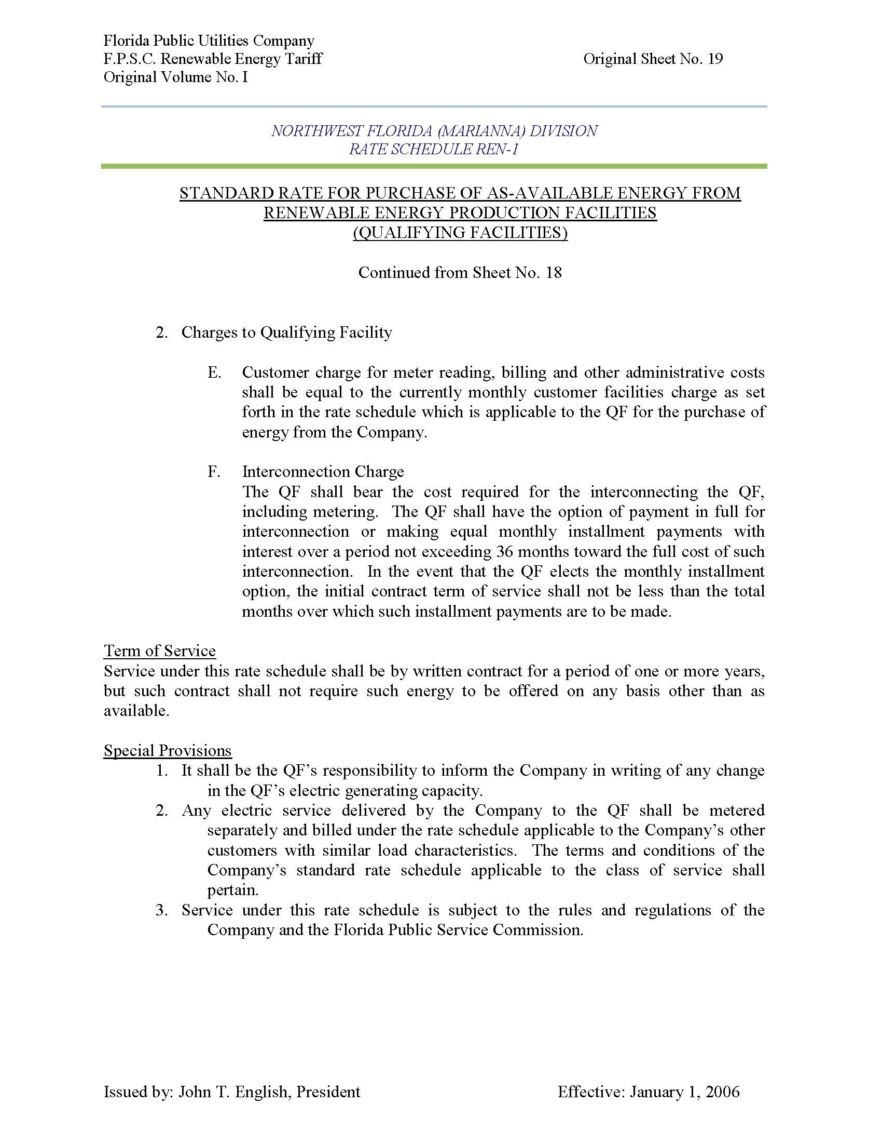

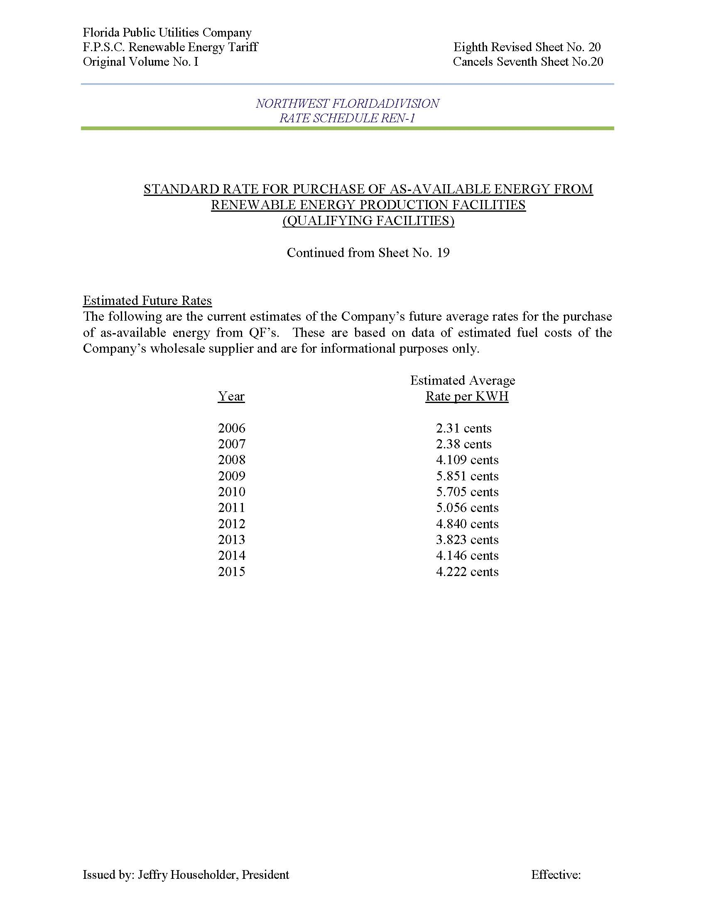

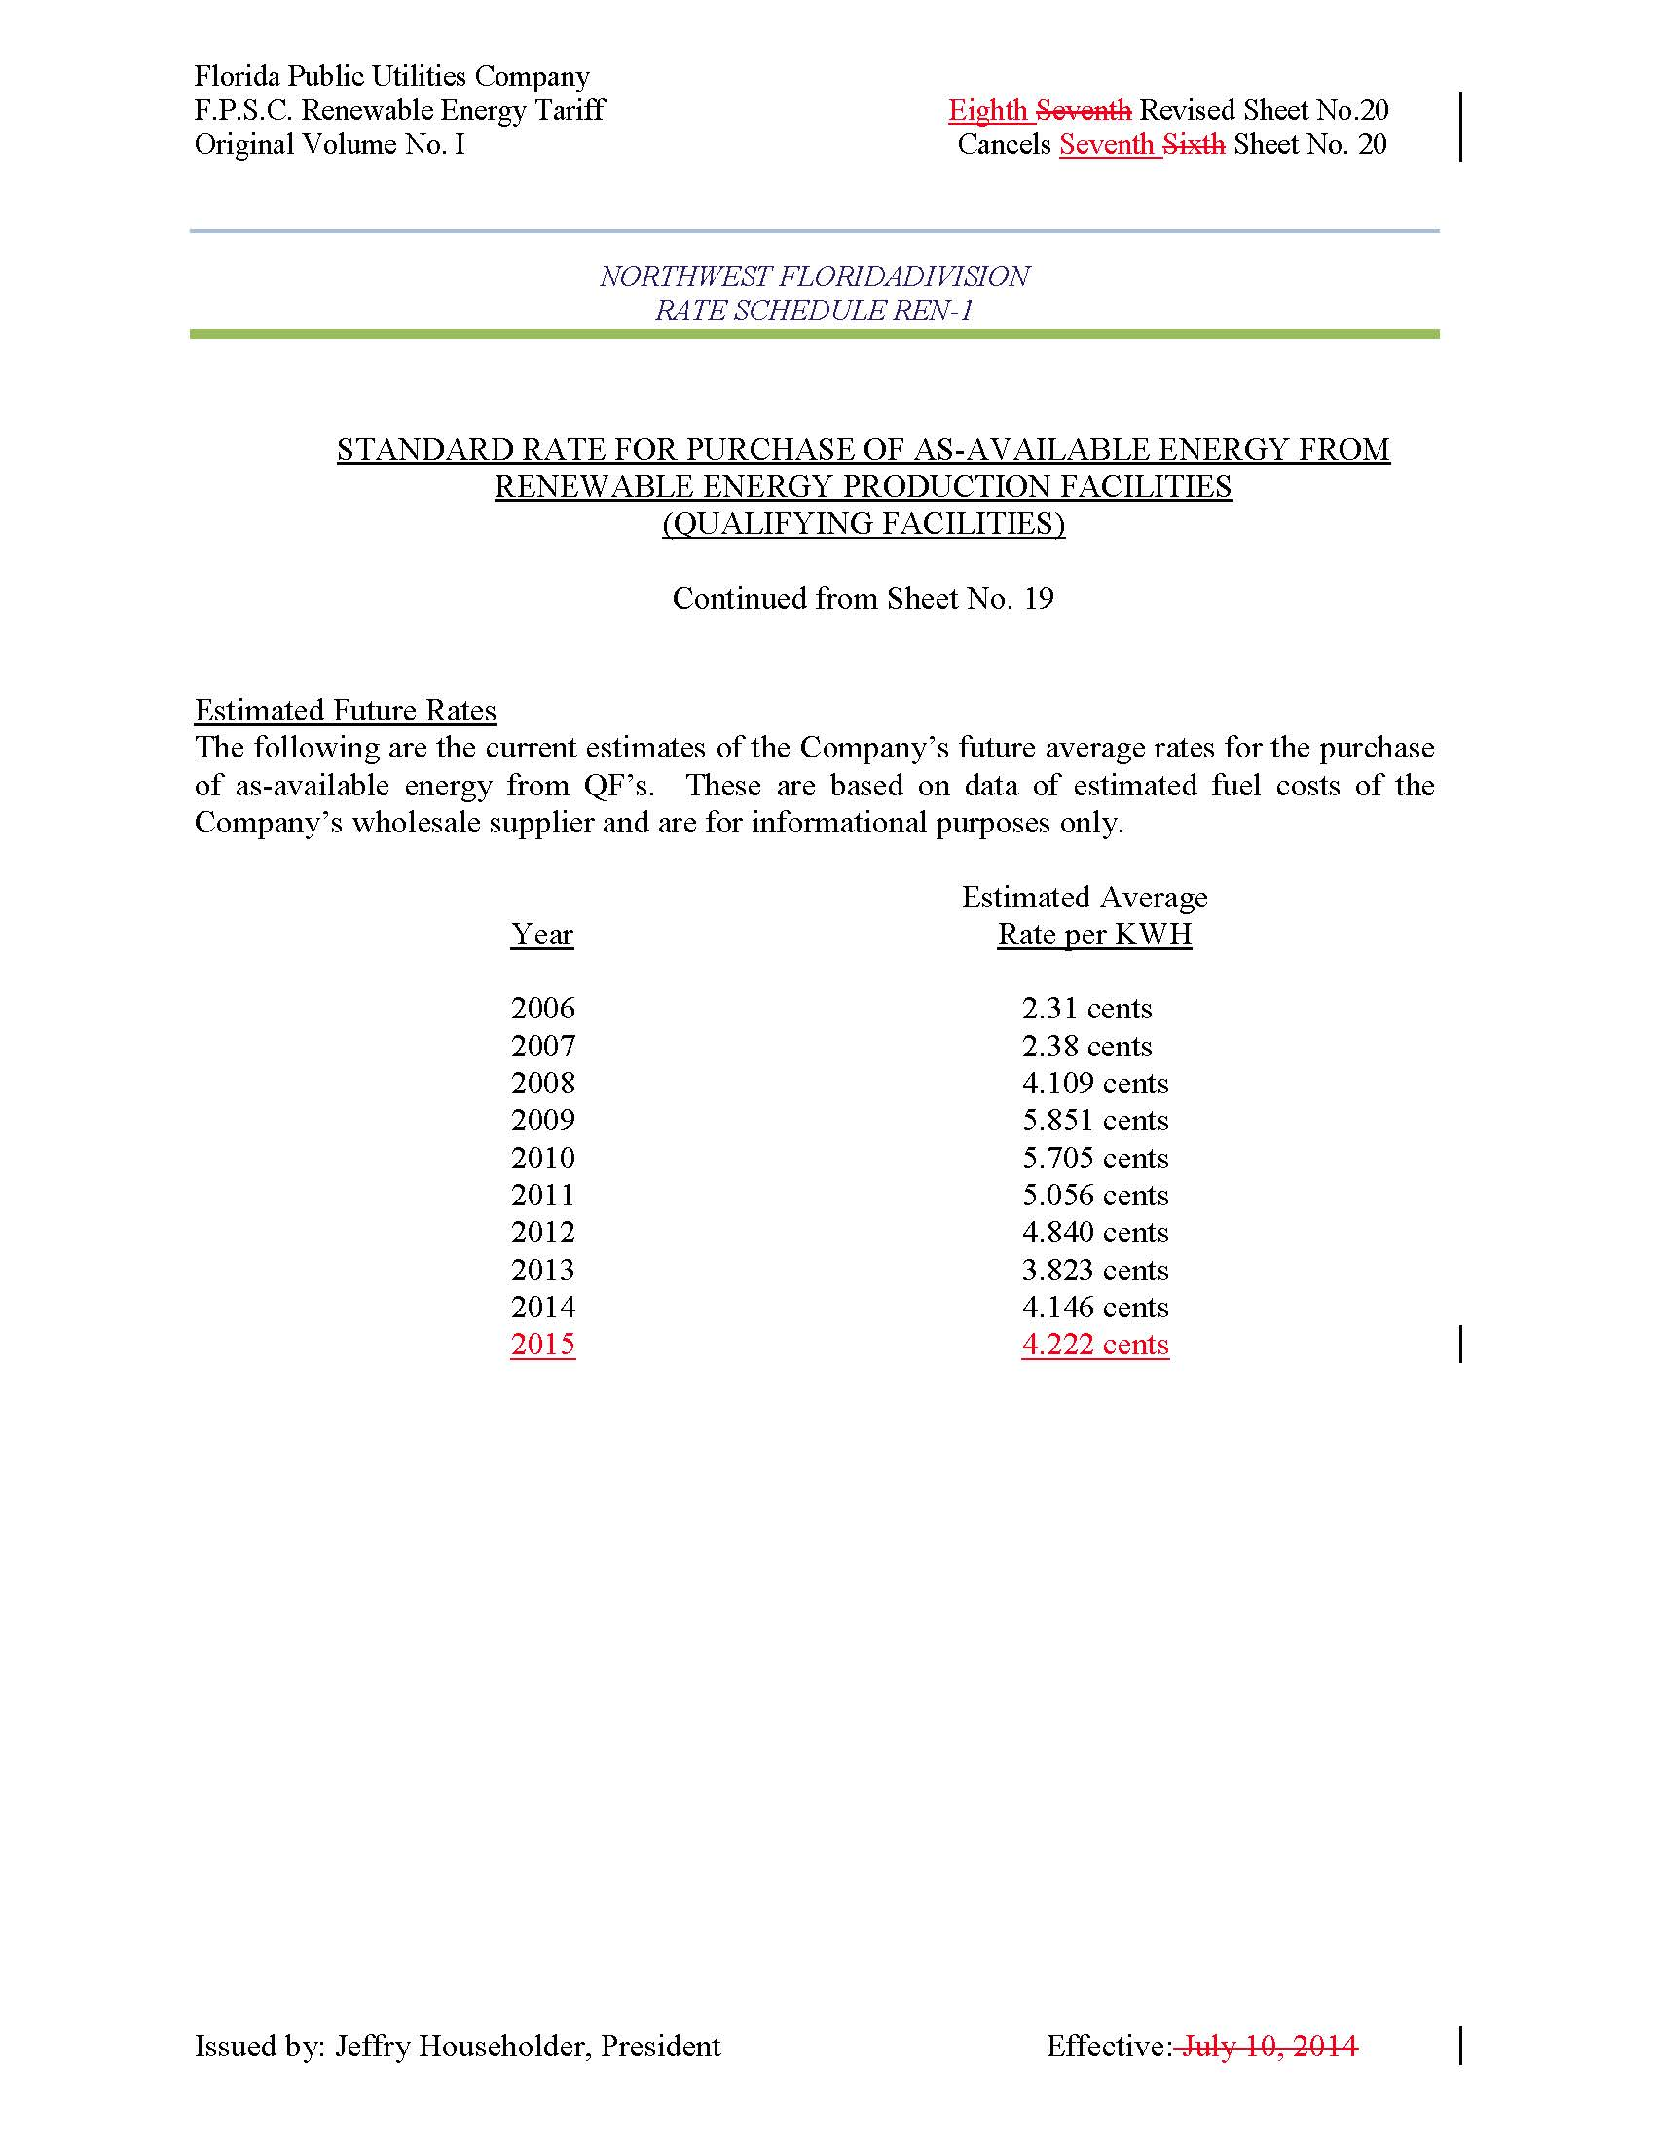

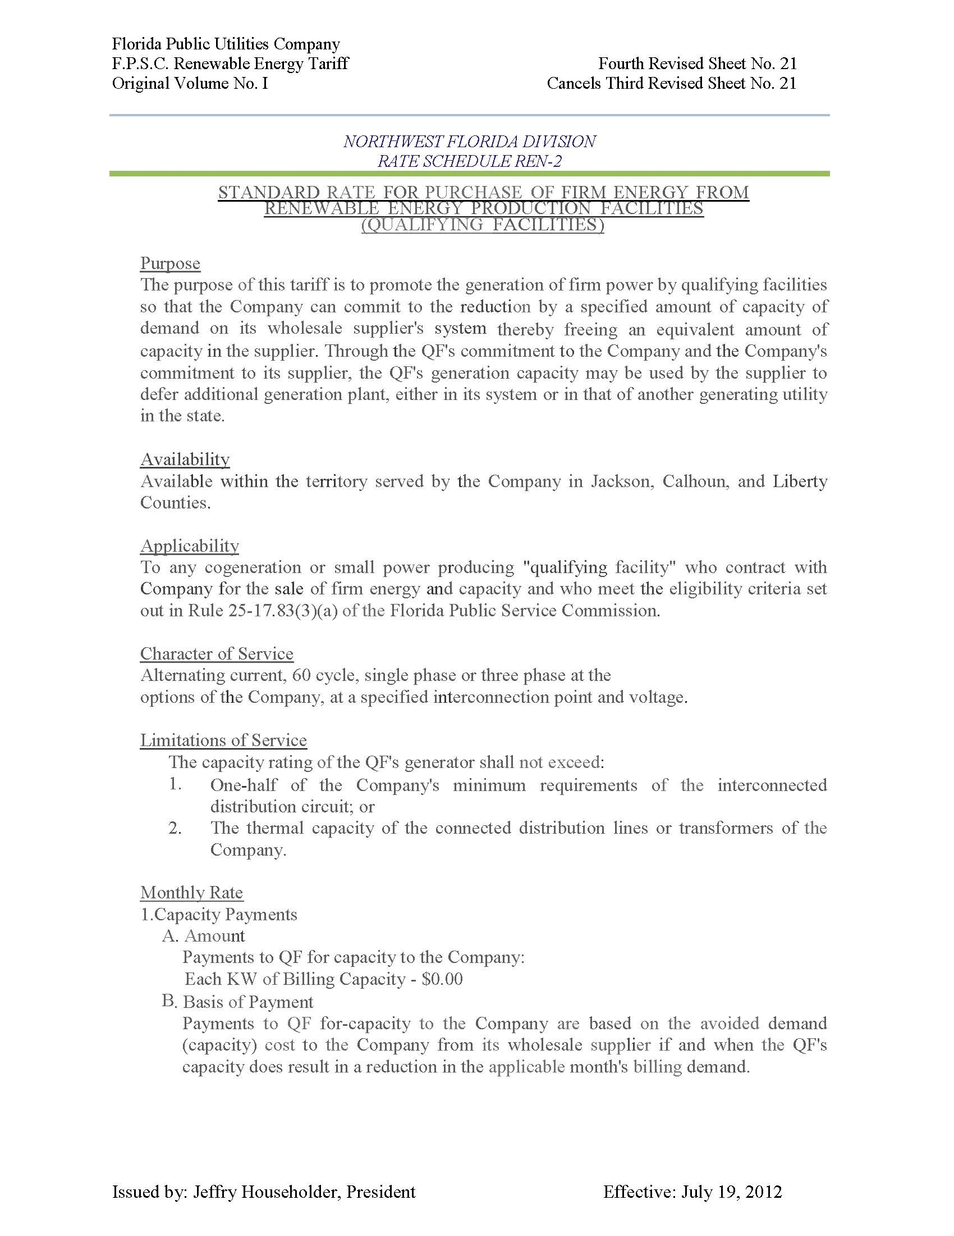

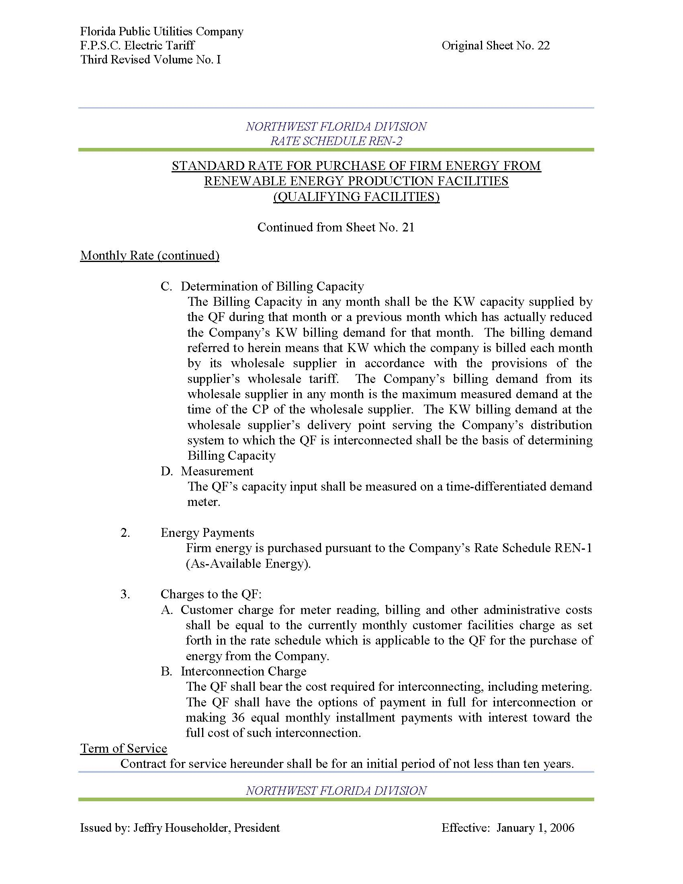

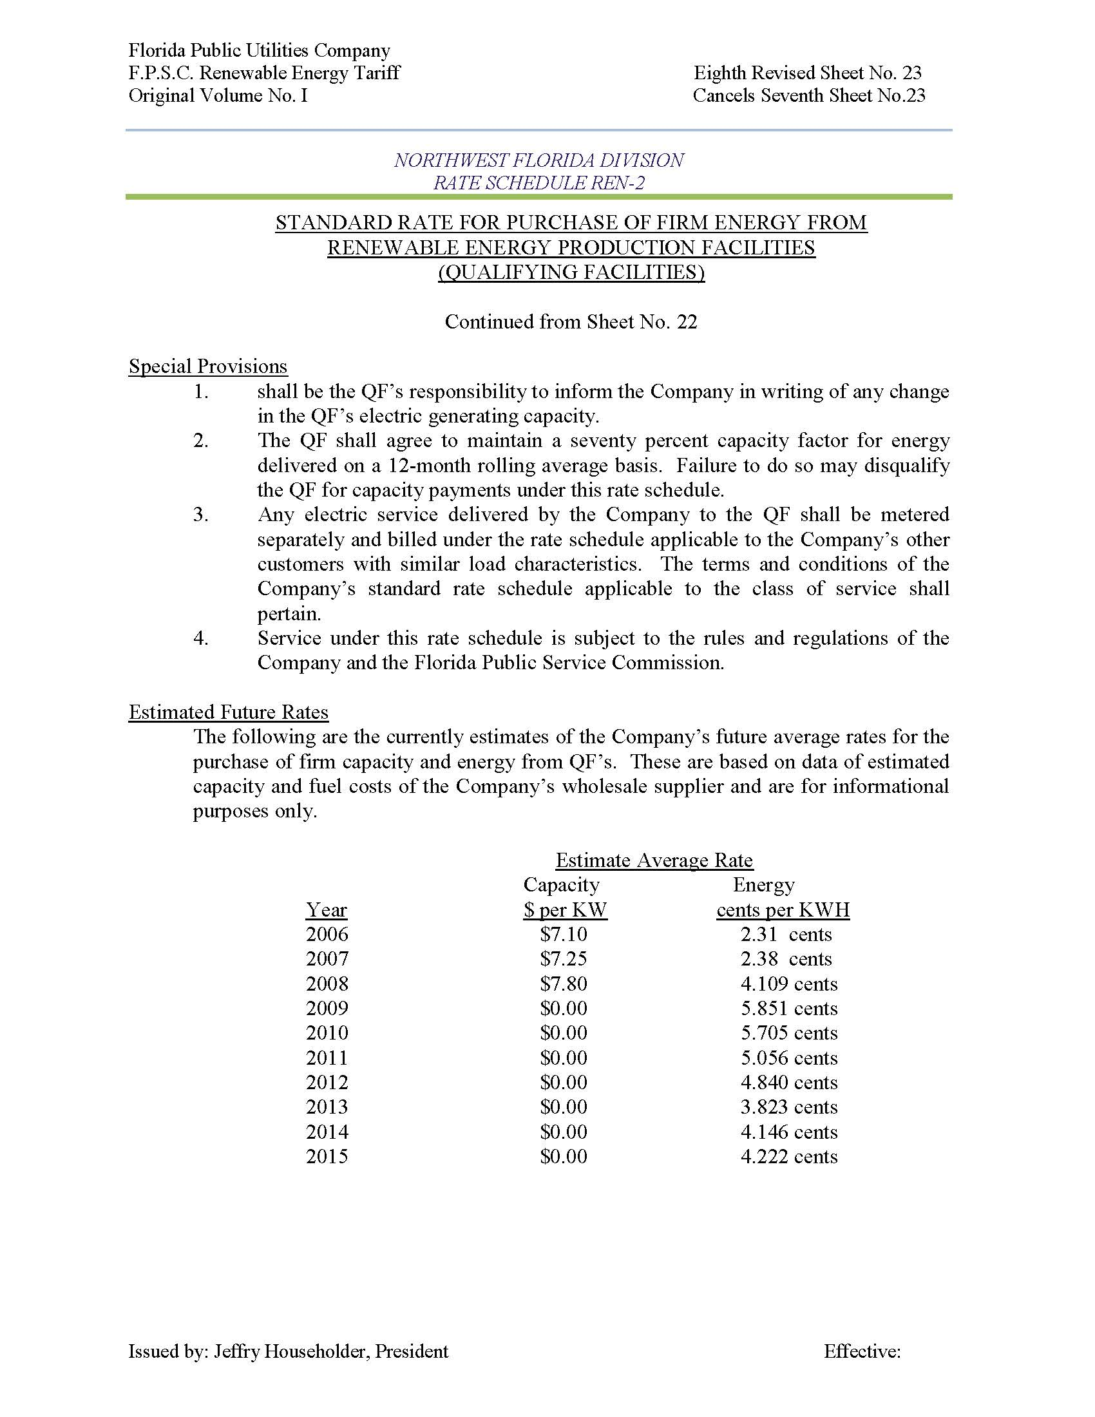

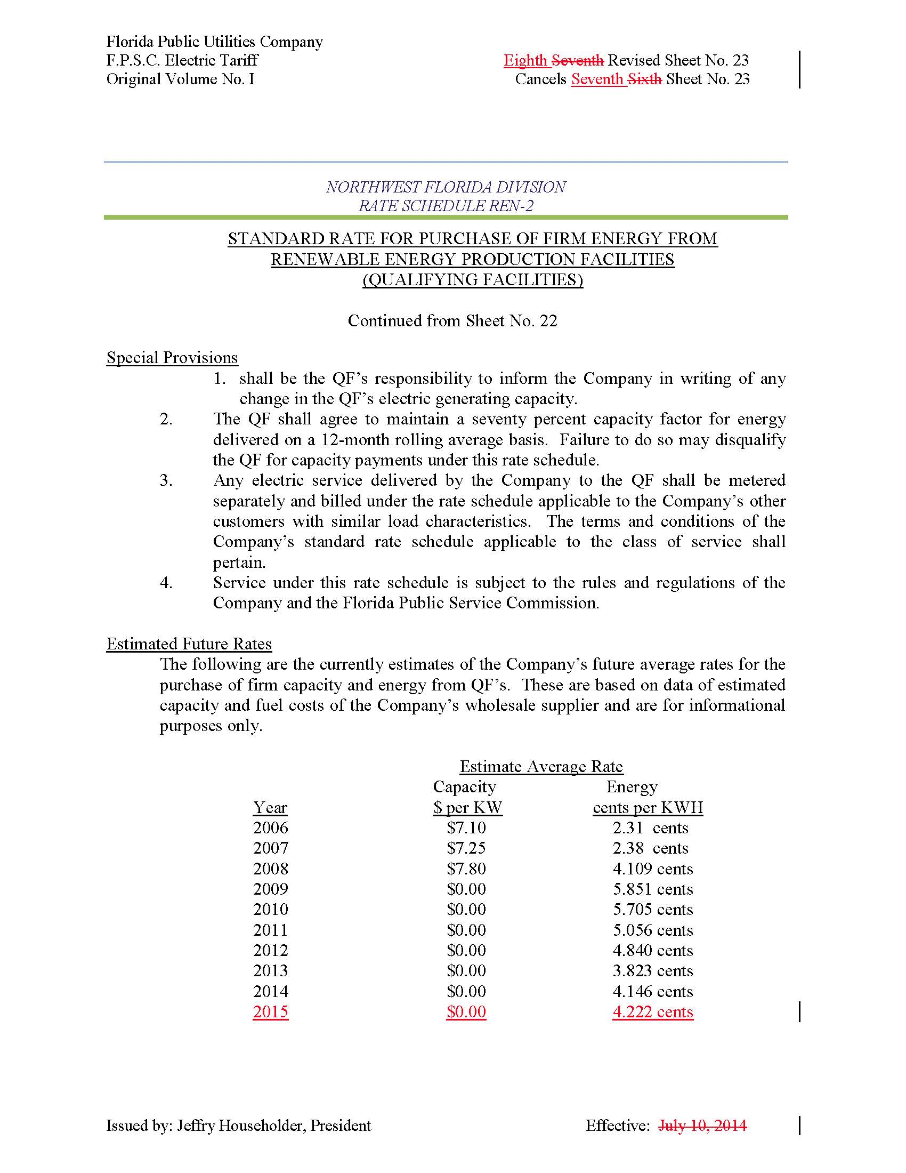

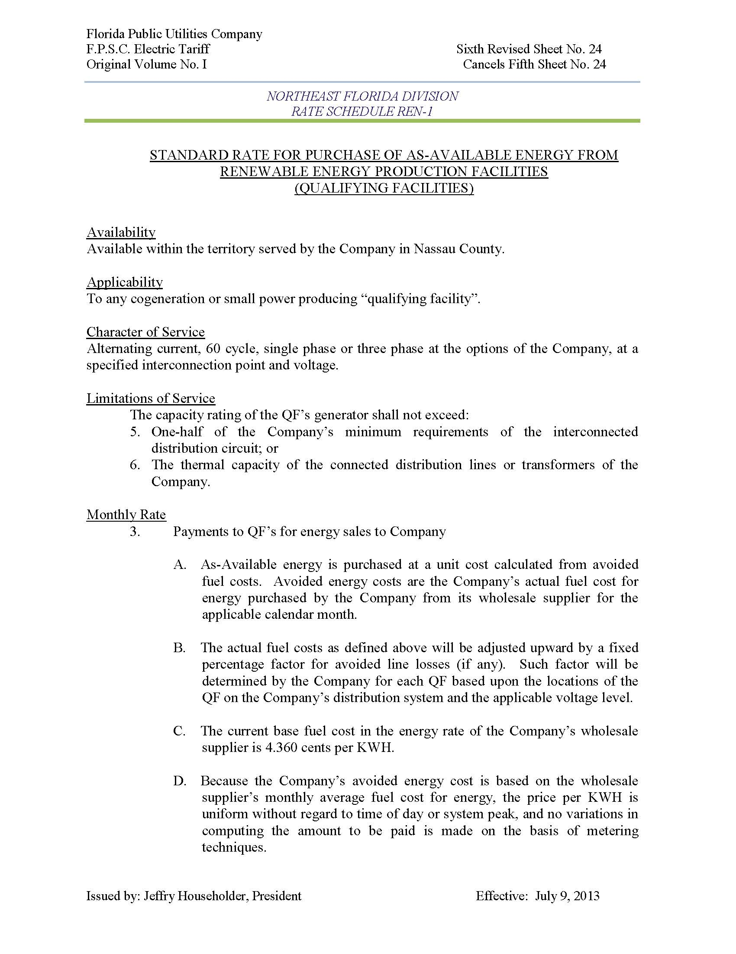

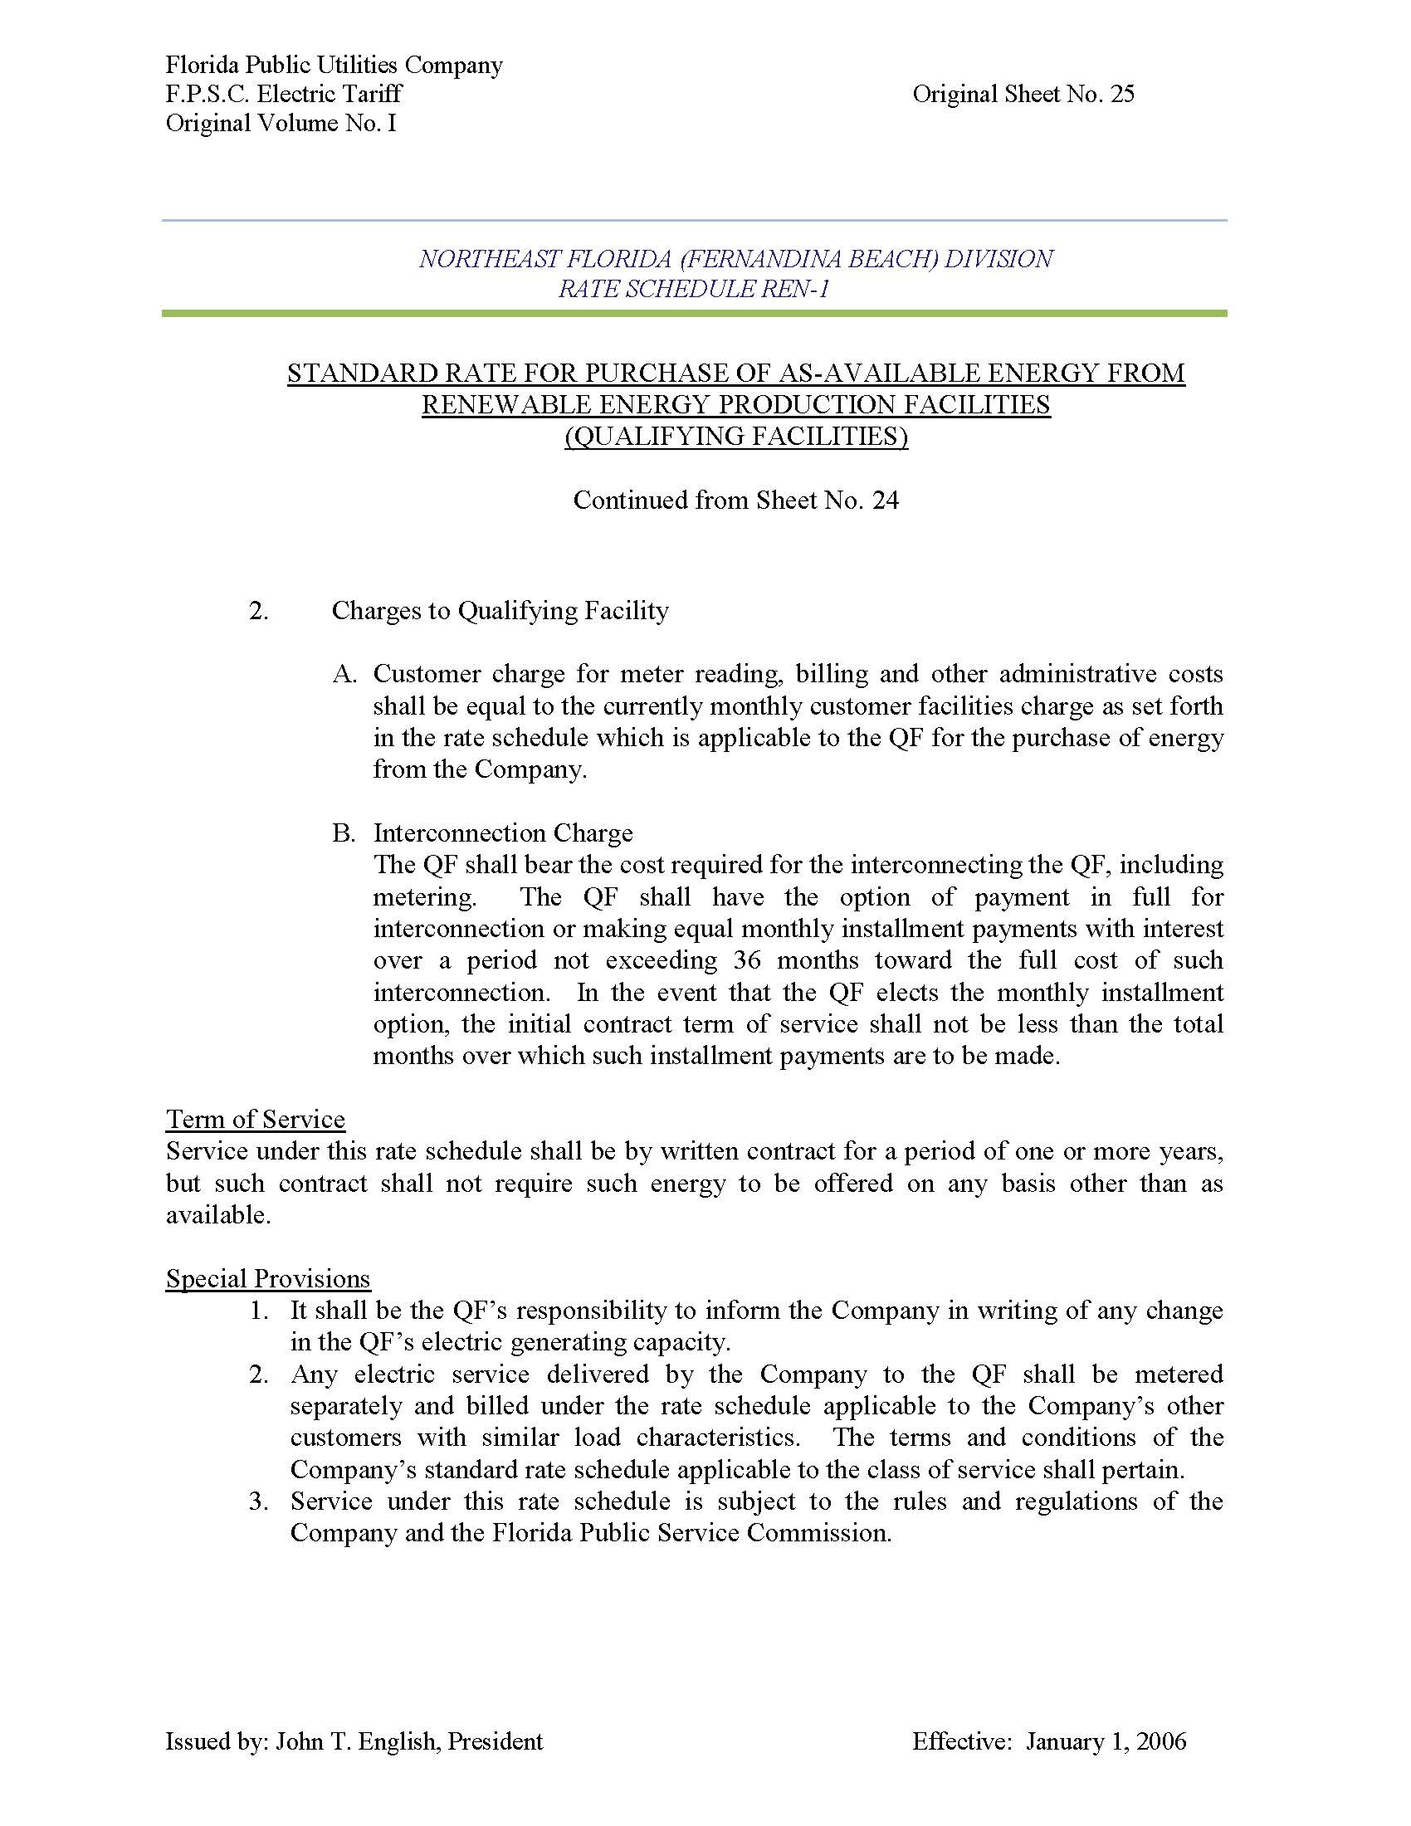

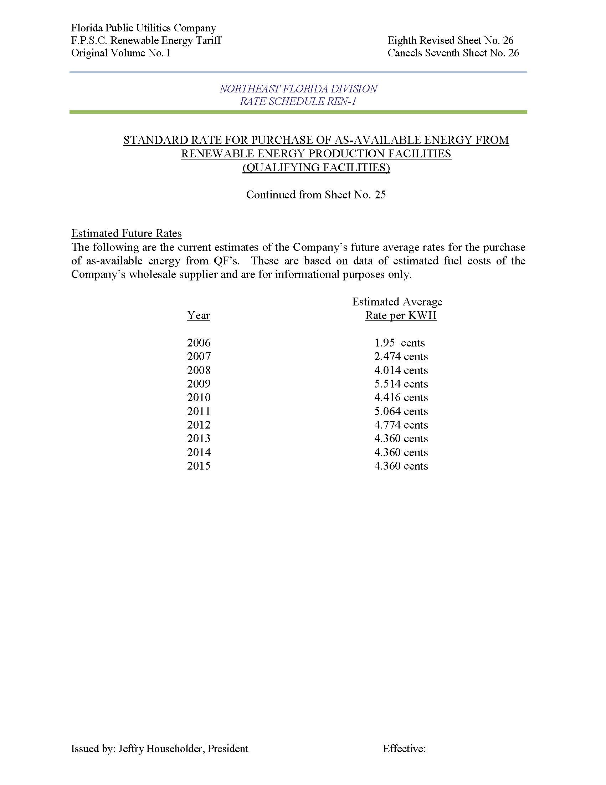

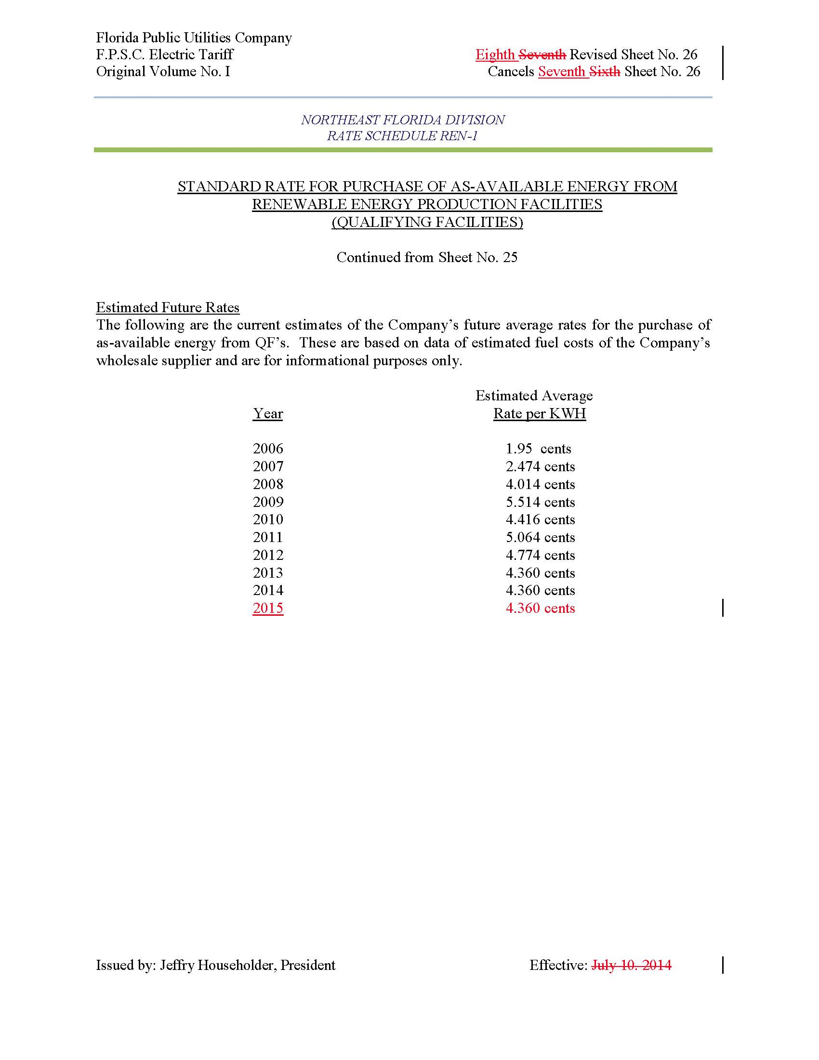

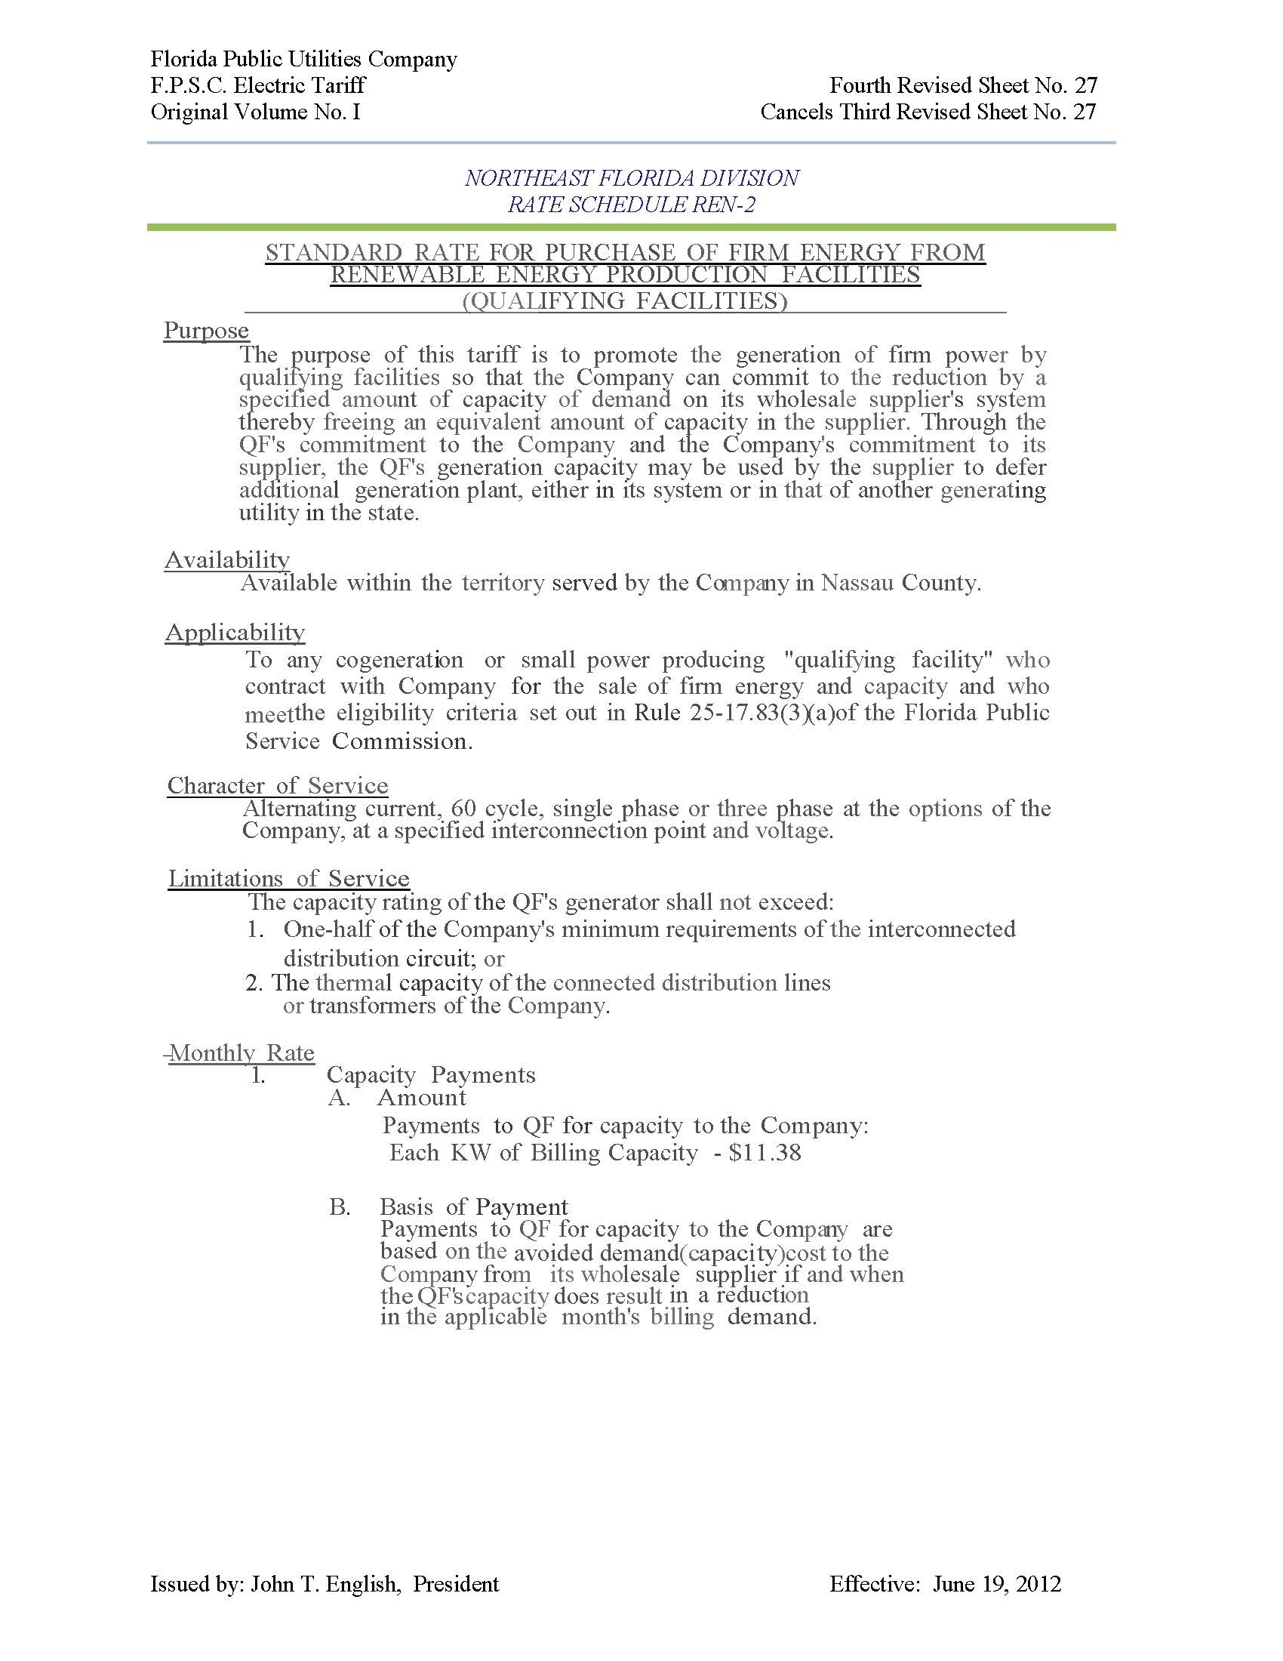

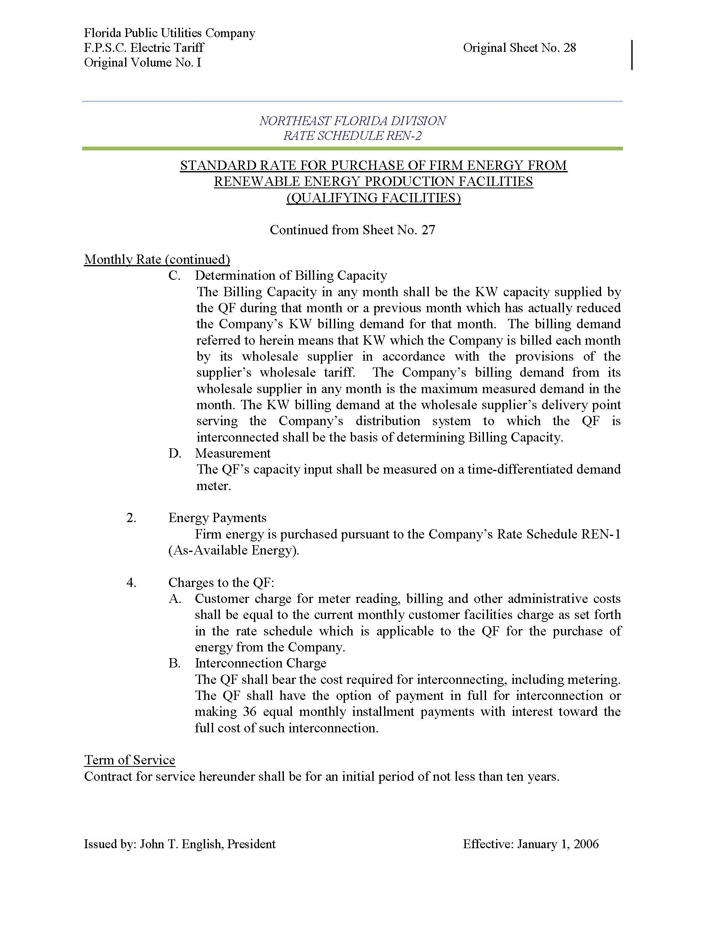

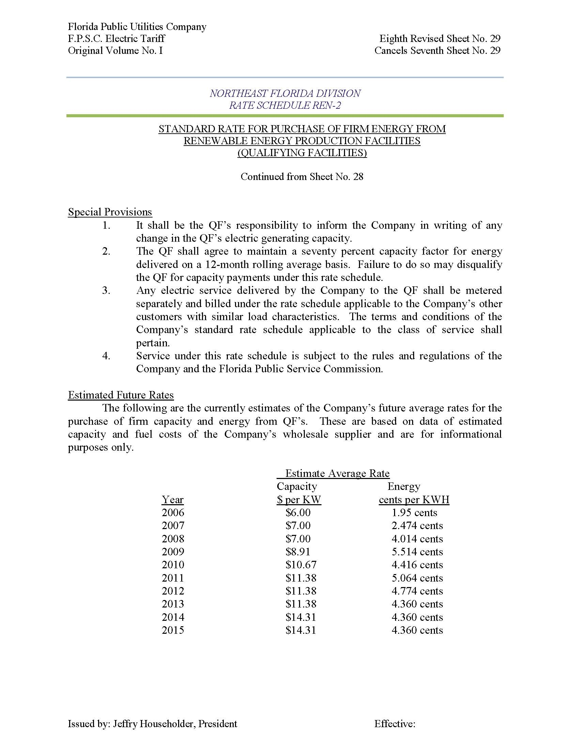

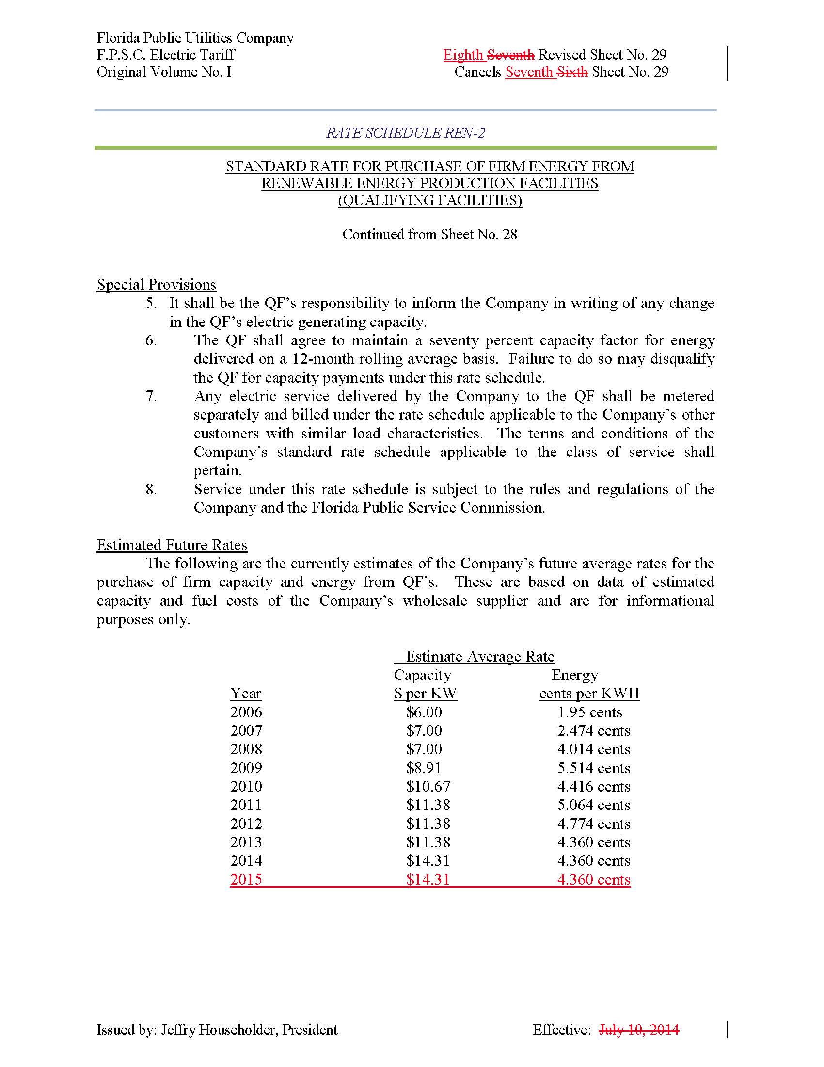

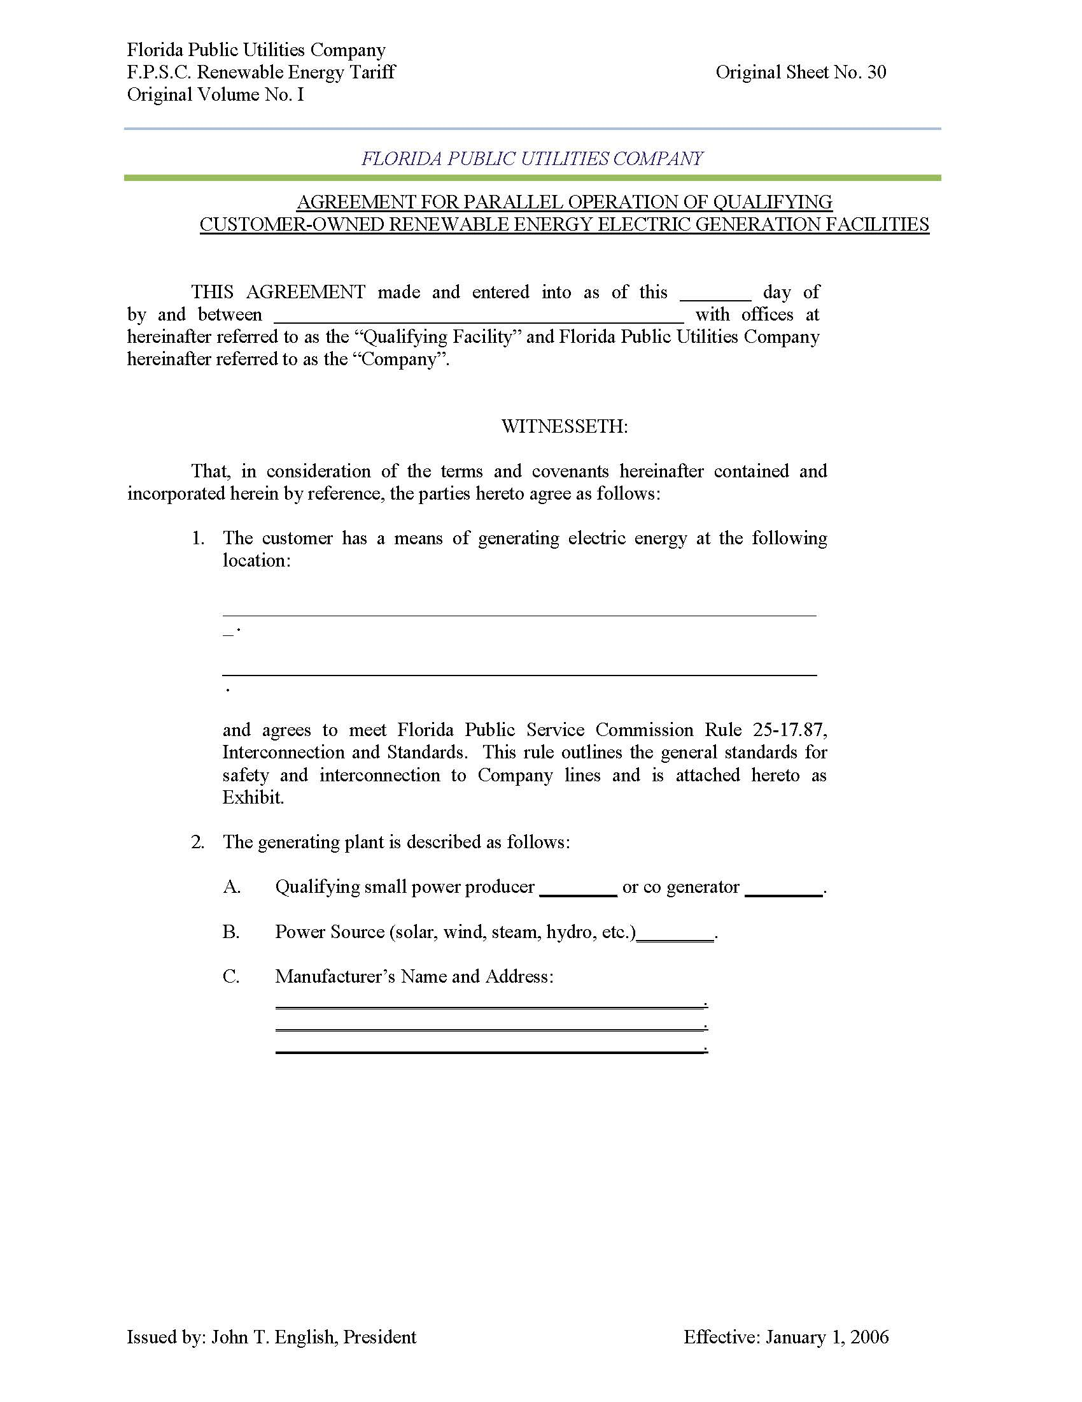

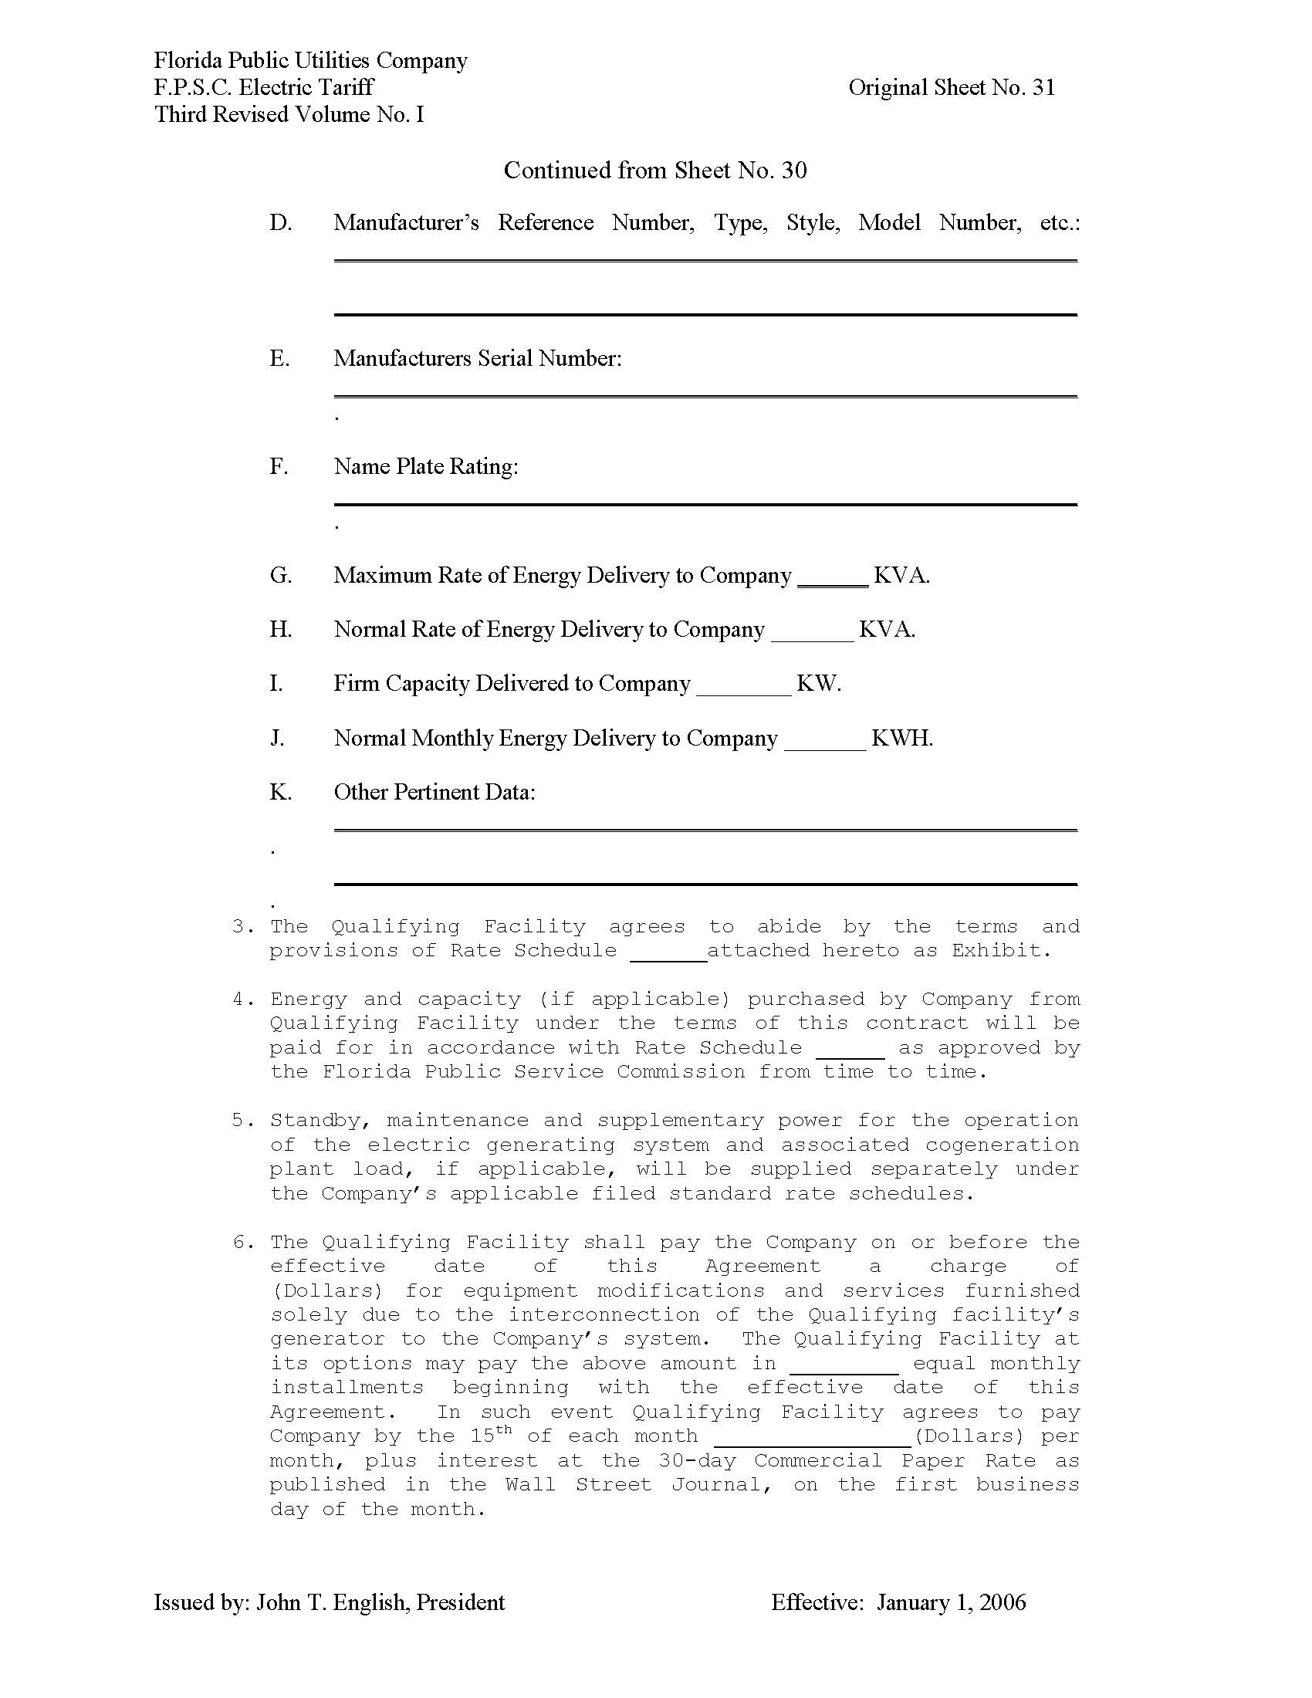

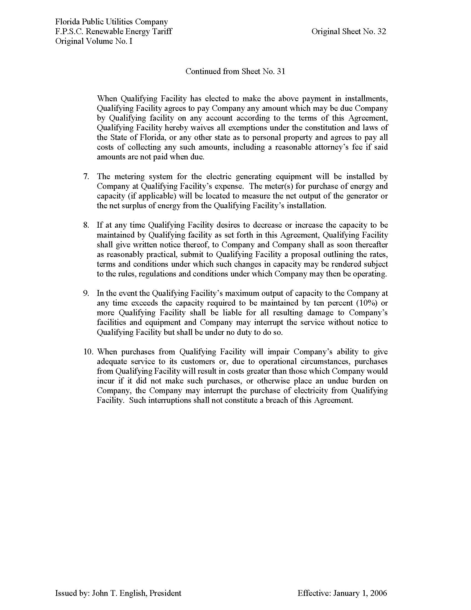

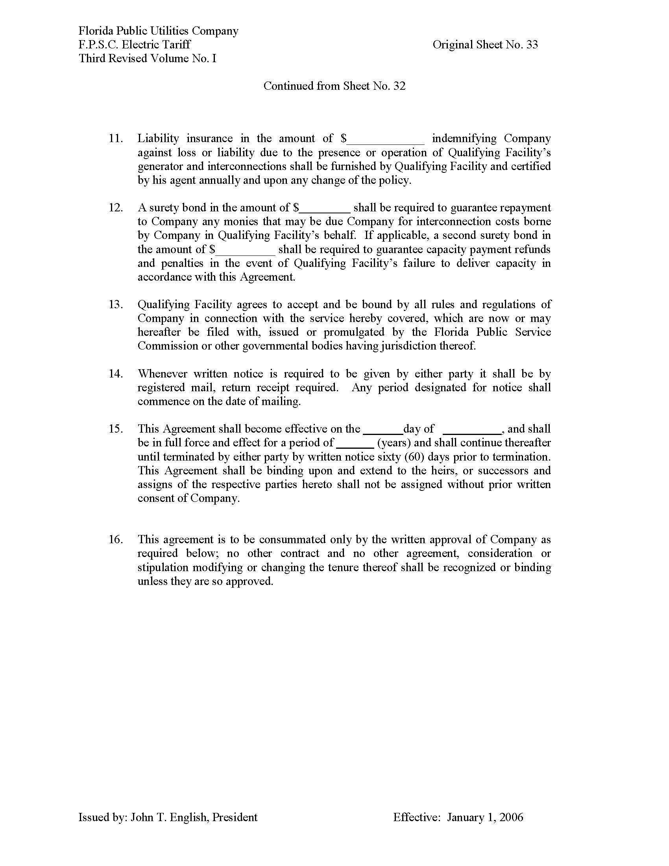

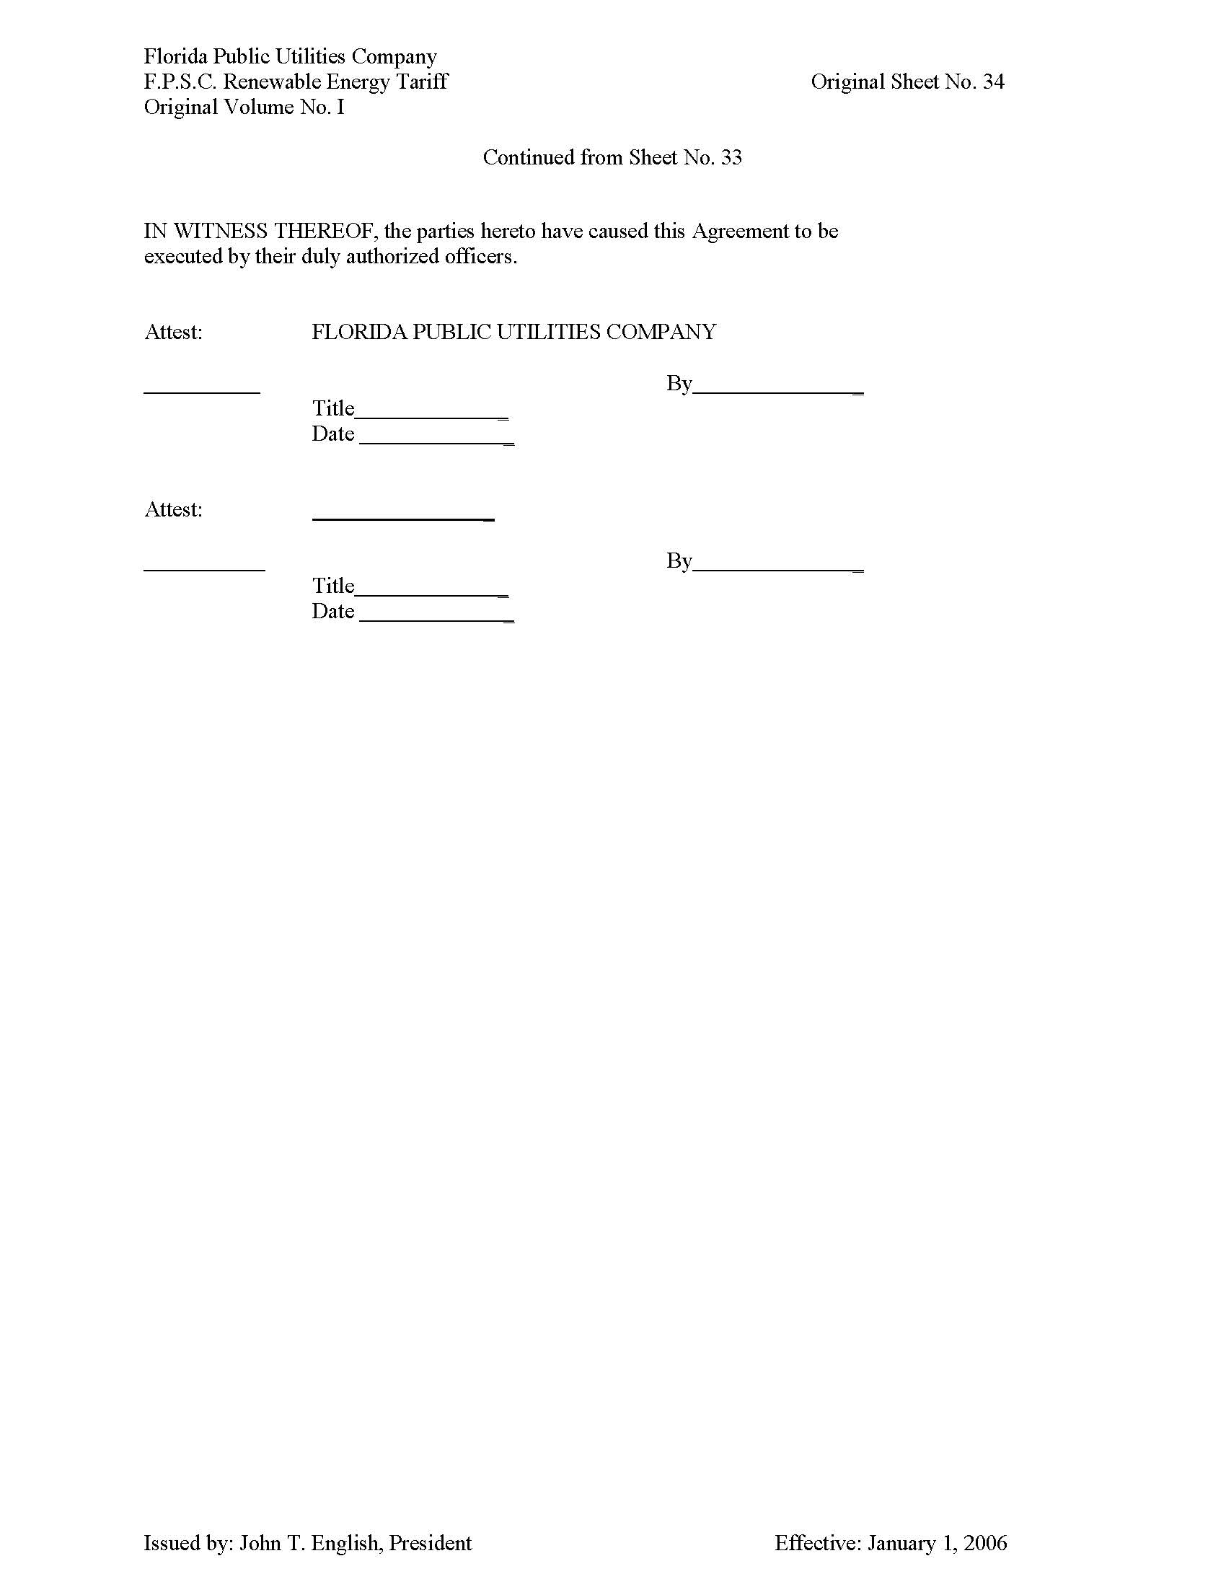

FPSC Order No. PSC-14-0394-PAA-EQ, issued July 30, 2014, in Docket No. 140073-EQ, Petition for approval of revisions to standard offer renewable energy tariff REN-1 and REN-2, by Florida Public Utilities Company.

