|  |  |  |  |  |
| --- | --- | --- | --- | --- |
| State of Florida  pscSEAL | | Public Service Commission  Capital Circle Office Center ● 2540 Shumard Oak Boulevard Tallahassee, Florida 32399-0850  -M-E-M-O-R-A-N-D-U-M- | | |
| **DATE:** | | October 22, 2015 | | |
| **TO:** | | Office of Commission Clerk (Stauffer) | | |
| **FROM:** | | Division of Engineering (Lewis, King, Rieger)  Division of Economics (Bruce)  Office of the General Counsel (Janjic) | | |
| **RE:** | | Docket No. 130209-SU – Application for expansion of certificate (CIAC) (new wastewater line extension charge) by North Peninsula Utilities Corp. | | |
| **AGENDA:** | | 11/05/15 – Regular Agenda – Proposed Agency Action – Interested Persons May Participate | | |
| **COMMISSIONERS ASSIGNED:** | | | | All Commissioners |
| **PREHEARING OFFICER:** | | | | Edgar |
| **CRITICAL DATES:** | | | | None |
| **SPECIAL INSTRUCTIONS:** | | | | None |

**Case Background**

North Peninsula Utilities Corporation (NPUC or Utility) is a Class B utility, which provides wastewater service to 570 customers in Volusia County. The City of Ormond Beach provides water to the area. NPUC’s 2014 Annual Report lists operating revenues of $221,984 and a net operating income of $ 3,024. NPUC bought the assets of Shore Utility Corp. in 1989[1] and filed five subsequent territory amendments, which were all approved by the Commission. On August 2, 2013, the Utility filed an application to amend its wastewater certificate, pursuant to Section 367.045, Florida Statutes, (F.S.) and Rule 25-30.036, Florida Administrative Code (F.A.C.). In addition, the Utility requested to implement a main extension charge and a flat rate adjustment of three percent per year to monthly rates for five years. On November 4, 2013, NPUC withdrew its request for the flat rate adjustment. Staff identified several deficiencies in the certificate amendment filing and met with the Utility’s representatives. At that meeting, it was disclosed that there were potential objections to the territory amendment by Volusia County and the City of Ormond Beach. As such, the processing of the application was put on hold.

On March 10, 2014, the Utility filed a revised application to amend its service territory based upon negotiations with the City of Ormond Beach and Volusia County. The revised application included less territory than its original filing and a proposed tariff for a $795 main extension charge. Pursuant to Order No. PSC-14-0273-PCO-SU, issued May 29, 2014, the Commission suspended the proposed tariff to allow staff sufficient time to review all pertinent information.[2] On July 21, 2014, NPUC filed additional information to address the deficiencies previously identified by staff. On October 20, 2014, NPUC representatives met with staff to discuss the amended application and on January 13, 2015, NPUC filed supplemental information to address staff’s concerns.

On April 2, 2015, staff filed a written recommendation that:

* NPUC’s revised application be denied because the application failed to demonstrate a need for service in the territory requested.
* Denial of the application obviated the need for a main extension charge.
* The service availability policy should be revised to reflect that there are no service availability charges because the plant is fully depreciated.

On April 3, 2015, NPUC requested that the item be deferred from the April 16, 2015, Commission Conference so that representatives of the Utility could again meet with staff. The deferral was granted and a noticed informal meeting was convened on April 20, 2015. At that meeting, NPUC informed staff that it was removing certain areas from the previously filed request for territory expansion, abandoning its three-phased approach to expanding the territory, and withdrawing its request for a main extension charge. A map outlining the changes in territory was provided at the meeting, and on May 26, July 24, and August 27, 2015, additional data was filed by the Utility.

The Commission has jurisdiction pursuant to Section 367.045, F.S.

**Discussion of Issues**

***Issue 1:***

Should North Peninsula Utilities Corporation’s proposed territory amendment be approved?

***Recommendation***:

 No. The application fails to demonstrate a need for service in the territory requested. Also, the Utility’s plan to connect customers would require customers to install equipment that is normally the responsibility of the Utility or developer. As such, the requested territory amendment does not appear to be in the public interest and should be denied. The Utility’s existing service availability policy indicates the manner in which service will be provided to vacant lots and the undeveloped eight- acre parcel in its existing territory and should remain unchanged. (Bruce, Janjic, Lewis, Rieger, King)

***Staff Analysis***:

 NPUC currently provides wastewater service in the north peninsula area of Volusia County pursuant to wastewater certificate number 249-S. On August 2, 2013, NPUC filed an application to expand its current service territory. The request has been modified several times since filed. NPUC’s current territory expansion request is shown on the attached map (Attachment A).

Rule 25-30.036(3)(b), F.A.C., requires the Utility provide a statement showing its financial and technical ability to provide service and the need for service in the area requested. With its original application the Utility provided letters from nine condominium associations stating they are interested in information on the availability of wastewater service, but not actually requesting service.[3] On May 26, 2015, the Utility provided additional letters in which some individuals specifically stated they would like to connect to NPUC’s service and others stated a more general interest in having options for their wastewater needs.[4] There appears to be a total of 11 current inquiries or requests for service that represent approximately 170 equivalent residential connections.

NPUC’s request is unique and can be differentiated from other certificate amendment filings. First, the territory NPUC seeks to serve is developed, with many single family homes and condominiums, so unlike many requests for territory expansion, this is not a greenfield development or a situation where one owner/developer owns the area to be served. Second, NPUC is claiming that the facilities needed to connect to NPUC’s existing force main would be constructed and paid for by the individual customers (or perhaps a group such as a home owners association). Third, and more importantly, in the territory NPUC seeks to serve, wastewater treatment is already in place or available, either by privately owned and maintained septic tanks or existing wastewater treatment (package) plants.

The Utility acknowledges that the transition of a developed area, particularly one adjacent to a fragile marine environment, from onsite wastewater disposal to central treatment and central disposal cannot occur at a singular point in time. Stating that, “[e]veryone will not connect at once, given the vagaries of local law, individual demand, onsite wastewater system useful life, economics, etc.” However, NPUC argues that state law supports what it wants to accomplish, which is the treatment and disposal of wastewater by central facilities. In its January 13, 2015, supplemental filing, NPUC states:

Florida law purports to require property owners who currently have onsite sewage treatment and disposal systems to connect to available central wastewater systems within a year of availability of the central system and also requires to [sic] connection of onsite systems in need of repair (in order to be compliant with applicable rules) to connect upon notice from the Health Department that central service is available. Despite the sound basis for mandatory connection in Florida, and the compelling need for the reduction of on-site septic systems (particularly within fragile environmental areas) the actual implementation of this concept has been problematic and sporadic. If the legal mechanism and political will exists for mandatory connection to be put into place in those territories which NPUC seeks to certificate, NPUC commits to extend its facilities as necessary to effectuate the policy.[5]

The Utility was referring to Section 381.00655, F.S., which was enacted by the Florida Legislature in 1993. The Department of Health is the agency responsible for enforcing Chapter 381. Pursuant to Section 381.00655(1) (a), F.S. provides:

[t]he owner of a properly functioning onsite sewage treatment and disposal system, excluding an approved onsite graywater system, must connect the system or the building’s plumbing to an available publicly owned or investor-owned sewerage system within 365 days after written notification by the owner of the publicly owned or investor-owned sewerage system that the system is available for connection.

In addition, Section 381.00655(1)(b), F.S., states that:

[t]he owner of an onsite sewage treatment and disposal system that needs repair or modification to function in a sanitary manner or to comply with the requirements of ss. 381.0065 – 381.0067 or rules adopted under those sections must connect to an available publicly owned or investor-owned sewerage system within 90 days after written notification from the department.

Section 381.00655, F.S., does not authorize a county to enforce the requirements of the statute. However, a county may, pursuant to its home rule powers, adopt an ordinance providing for enforcement of the statute. In this case, the Volusia County ordinance only requires connection to a *county-owned or operated sewer system* (emphasis added). The Volusia County ordinance states, in pertinent part:

Section 122-55. – Use of septic tanks or other private sewage disposal systems.

* * *

(b) The owner of a properly functioning on-site sewage treatment and disposal system will be required to connect the system or the building's plumbing to a county-owned or operated sewer system when service is available . . . . This mandatory connection requirement applies to properties available to be served by a county-owned or operated system both in the incorporated areas of the county, and in unincorporated areas of the county.

(c) The requirement for mandatory connection of existing onsite sewage treatment and disposal systems to a county owned or operated central sewer system will be subject to the provisions of Florida Statute Section 381.00655-67, except where modified herein . . . .

In further support of its position, the Utility provided an opinion from the Florida Attorney General’s Office dated December 14, 2000,[6] in which the Attorney General indicates that “ . . . the Legislature, through the enactment of section 381.00655, Florida Statutes, requires residential owners whose property is served by an onsite septic system to connect with an investor-owned sewerage system after written notification by the owner of the investor-owned sewerage system that the system is available for connection . . . .” The opinion acknowledges that the Florida Statutes do not provide a mechanism for enforcement and therefore, “a county or a municipality may take local legislative action providing for the enforcement of section 381.00655, Florida Statutes, under home rule powers.”[7]

As indicated above, Section 12-55(b) and (c) of the Volusia County ordinances requires a connection to a county-owned or operated sewer system. In this case, NPUC is neither county-owned nor operated. In addition, there is no indication that Volusia County is considering any changes to its ordinance to require connection to include privately owned wastewater systems in the county. The county continues to issue permits for septic tank system installations, replacements and repairs. In fact, 176 repairs and/or new installations have been permitted from 2010 through September 2014 in the north peninsula area.

Staff agrees with NPUC that Florida Statutes do address the interconnection of an onsite septic system to an investor-owned sewerage system. However, the Volusia County ordinance appears clear on its face that mandatory connections are only required with a county-owned or operated sewer system when service is available. Staff believes that as long as the county continues to issue permits for replacement and repair of existing wastewater treatment systems and mandatory interconnection is not required, customers are highly unlikely to voluntarily connect to NPUC’s system. While staff understands and applauds NPUC’s attempts to bring central wastewater treatment to this coastal area, environmental impacts do not appear to be a criteria for approving or denying a territory expansion. Without an enforced mandatory interconnection, a customer is unlikely to abandon a functioning septic system to connect to NPUC.[8] Staff is not persuaded by the documents and arguments presented by the Utility that there is a need for service in the area NPUC seeks to serve.

Also, in its prior recommendation, filed April 2, 2015, staff expressed concern regarding the prudency of the proposed capital expenditures. The Utility had planned on expanding its service in three phases at a cost of approximately $1.6 million with an anticipated completion date of 2025. NPUC has abandoned this plan and now appears to expect those wishing to connect to pay to construct facilities and contribute the collection lines to the Utility. NPUC stated that “[s]ervice would be provided upon execution of the standard customer service agreement and *construction by the owner of the facilities needed to connect for service*.”[9] (emphasis added) It appears that some customers wishing service from NPUC would use a low pressure grinder pump from their existing septic tank and provide a customer connection to NPUC’s force main. NPUC would have other customers installing the collection lines and/or making engineering decisions which are normally functions undertaken by the Utility.

In addition, the provision of service in part of the area NPUC seeks to serve (see areas in pink on Attachment A) is contingent upon “sufficient customer request.” When asked what criteria would be applied for determining “sufficient customer request,” the Utility replied “. . . when enough customers want service and can pay for it. It could be just one, but probably more.” [10] These vague conditions for service trouble staff. It appears that each individual customer service request would be evaluated and the customer may or may not have to pay for the collection lines depending on the situation or facilities required. Individual customer costs, terms, and conditions of service could vary greatly. Staff is not aware of another wastewater utility that currently offers service in this manner and staff believes that such a plan could lend itself to considerable complaints from those requesting service.

Last, as noted above, the Utility has withdrawn its request for a main extension charge. The Utility’s plant capacity charge was eliminated in a prior docket, because continued collection would have resulted in a contribution level at build out in excess of the 75 percent maximum pursuant to Rule 25-30.580, F.A.C.[11] All collection lines for the existing territory are installed with the exception of an eight-acre parcel. The Utility’s existing service availability policy indicates the manner in which service will be provided to vacant lots and the undeveloped eight- acre parcel in its existing territory and should remain unchanged.

**Conclusion**

Rule 25-30.036(3) (b), F.A.C., requires a statement showing the Utility has the financial and technical ability to provide service and that there is a need for service in the area requested. Staff does not believe that NPUC has demonstrated there is a need for service.[12] The existing residents, in the territory NPUC seeks to add, likely will not connect to NPUC’s system unless required by the county, which at the moment does not have that requirement in its ordinances. Therefore, staff recommends that the proposed territory amendment fails to demonstrate a need for service in the territory requested and the plan to connect customers in the requested territory would require customers to install collection lines and/or make engineering decisions which are normally undertaken by the Utility. The application does not appear to be in the public interest and should be denied. The Utility’s existing service availability policy indicates the manner in which service will be provided to vacant lots and the undeveloped eight-acre parcel in its existing territory and should remain unchanged.

***Issue 2*:**

Should this docket be closed?

***Recommendation***:

 Yes. If no person whose substantial interests are affected by the proposed agency action files a protest within 21 days of the issuance of the order, this docket should be closed upon the issuance of a consummating order. (Janjic)

***Staff Analysis***:

 If no protest is filed by a person whose substantial interests are affected within 21 days of the issuance of the order, this docket should be closed upon the issuance of a consummating order.

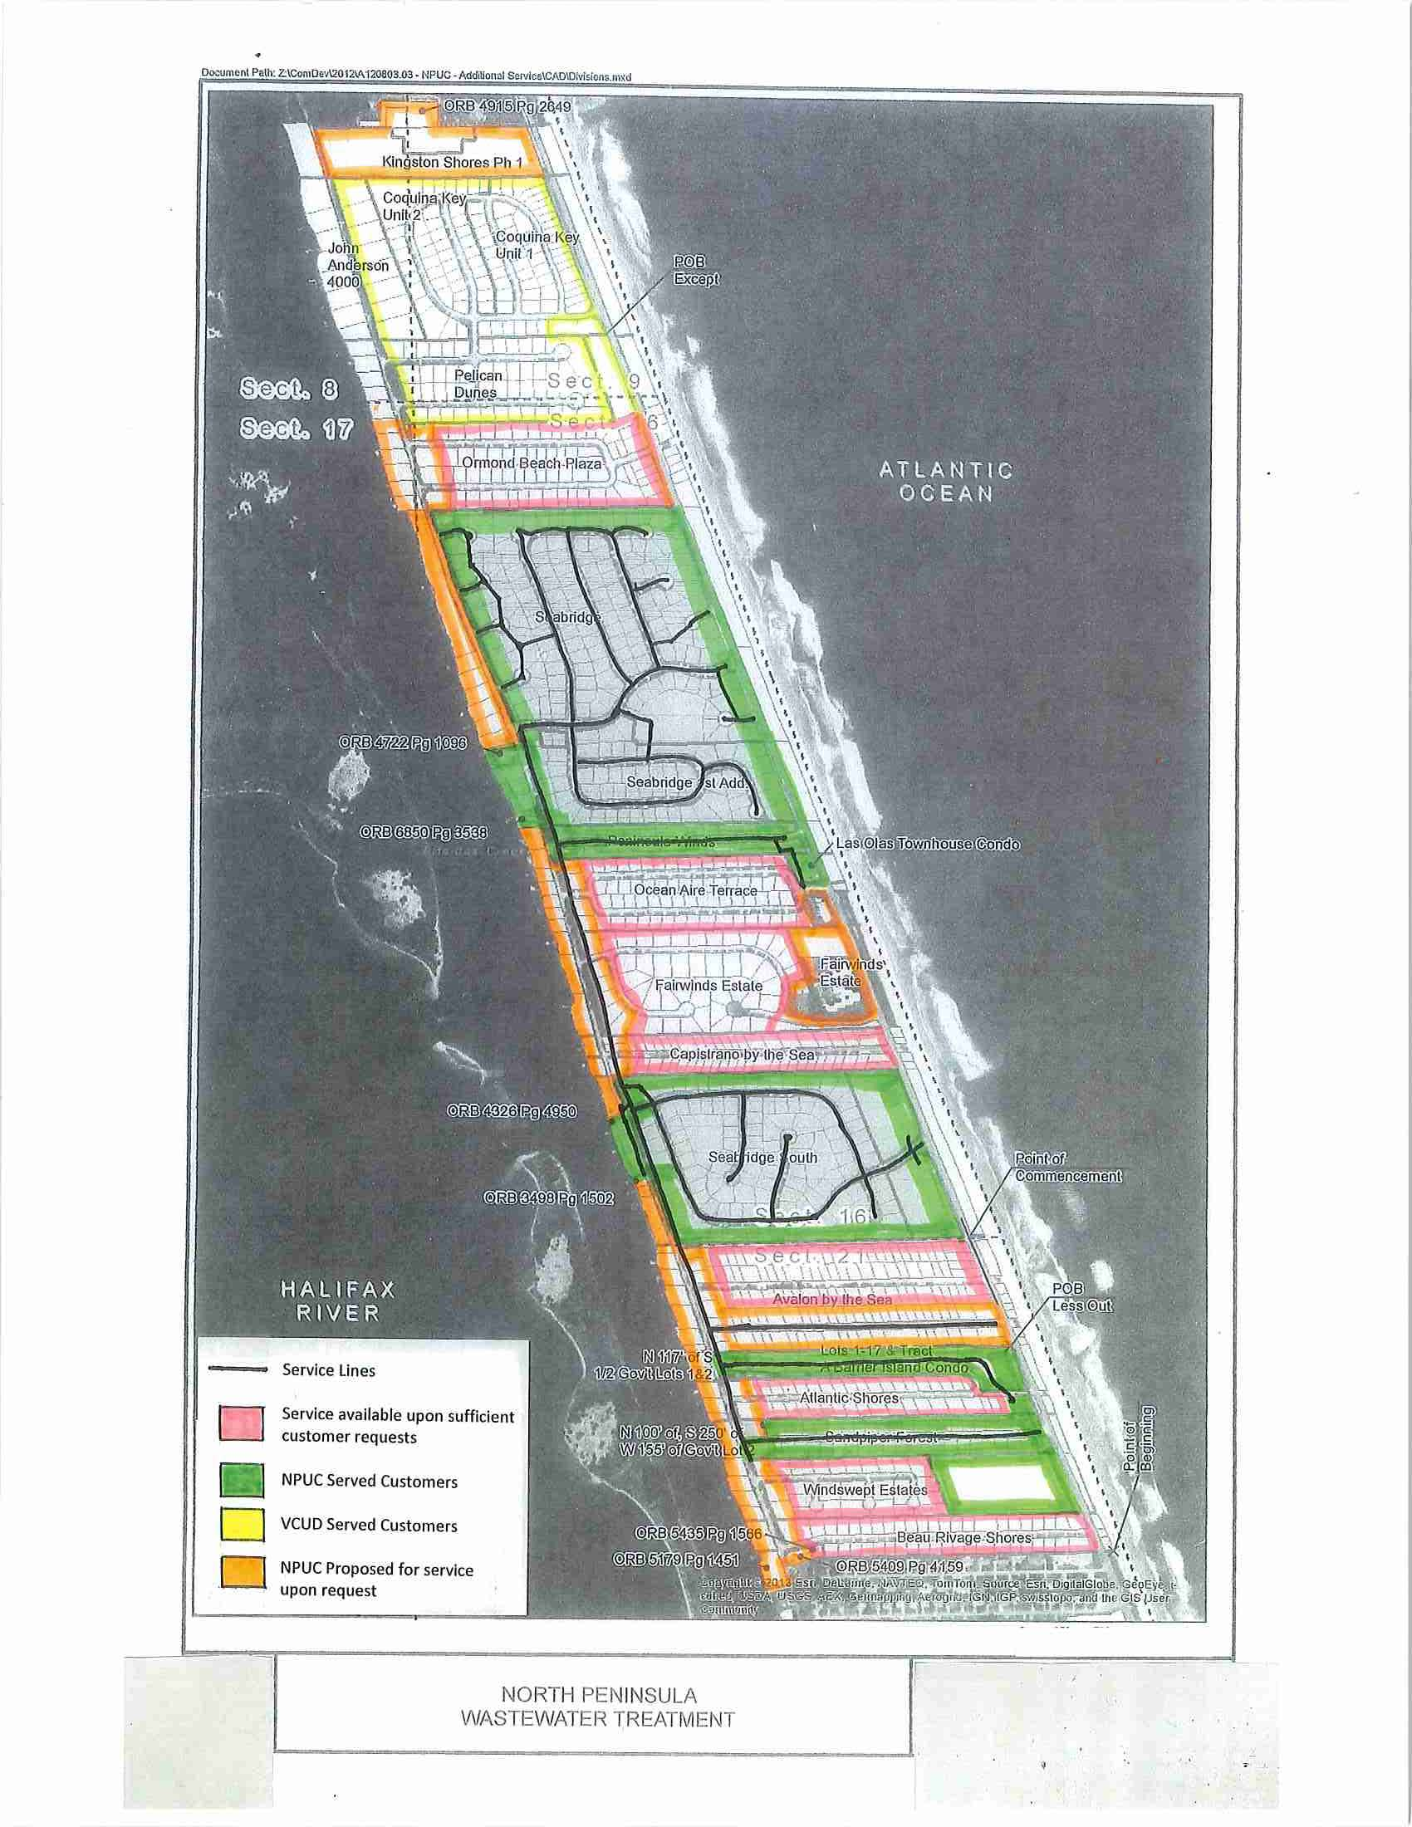

1. Order No. 22445, issued October 6, 2008, in Docket No. 891016-SU, *In re: Application of North Peninsula Utilities Corporation for transfer of Certificate No. 249-S from Shore Utility Corporation in Volusia County.*
2. Order No. PSC-14-0273-PCO-SU, issued May 29, 2014, in Docket No. 130209-SU, *In re: Application for expansion of certificate (CIAC) (new wastewater line extension charge) by North Peninsula Utilities Corp.*
3. The requests were from Ms. Kreinest, who represented all nine condominium associations that have approximately 261 units total. Since changing its requested territory amendment these nine condominiums are no longer included in the territory NPUC is requesting to serve.
4. Information regarding Kingston Shores Condominium’s request was not provided via letter but rather in a telephone call summary log provided by the Utility.
5. Document 00260-15, p. 2, filed January 13, 2015.
6. Document 00260-15, p. 9, filed January 13, 2015; *see* Op. Atty’s Gen. Fla. 2000-71 (2000).
7. *Id.*
8. Staff also questions whether an individual with a nonfunctioning septic system would contact NPUC for service because when asked how long, in terms of days, weeks, months, would it take to provide service the Utility responded that it would be a customer decision as service (capacity) is available immediately **after** the property owner constructs the facilities needed to connect for service. A consumer with a failing or nonfunctioning septic system likely does not have the time needed to construct facilities and obtain permits to reach NPUC’s force main.
9. Document No. 04649-15, p. 1, filed July 24, 2015.
10. Document No. 05415-15, p. 6, filed August 31, 2015
11. Order No. 16184, issued June 4, 1986, in Docket No. 850121-SU, *In re: Application of Shore Utility Corporation for a staff-assisted rate case in Volusia County, Florida.*
12. Staff believes the Utility has not demonstrated that there is a need to serve therefore, staff did not pursue a comprehensive evaluation of NPUC’s technical and financial abilities.