|  |  |  |  |
| --- | --- | --- | --- |
| State of Florida  pscSEAL | | Public Service Commission  Capital Circle Office Center ● 2540 Shumard Oak Boulevard Tallahassee, Florida 32399-0850  -M-E-M-O-R-A-N-D-U-M- | |
| DATE: | February 18, 2016 | | |
| TO: | Office of Commission Clerk (Stauffer) | | |
| FROM: | Division of Engineering (Ellis, Wooten)  Office of the General Counsel (Murphy) | | |
| RE: | Docket No. 150256-EQ – Petition for approval to terminate the North Broward Resource Recovery Facility electric power purchase agreement with Wheelabrator North Broward, Inc., by Florida Power & Light Company. | | |
| AGENDA: | 03/01/16 – Regular Agenda – Proposed Agency Action – Interested Persons May Participate | | |
| COMMISSIONERS ASSIGNED: | | | All Commissioners |
| PREHEARING OFFICER: | | | Administrative |
| CRITICAL DATES: | | | None |
| SPECIAL INSTRUCTIONS: | | | None |

Case Background

On December 3, 2015, Florida Power & Light Company (FPL) filed a petition to terminate its purchased power agreement, known as the North Broward Resource Recovery Facility Electric Power Purchase Agreement (PPA), with Wheelabrator North Broward, Inc. (WNB). The North Broward Resource Recovery Facility (Facility) is a 68 MW municipal solid waste generating facility. The PPA is for 11 MW of firm capacity and energy and currently expires on December 31, 2026.

The Commission previously approved the PPA in Order No. PSC-92-0050-FOF-EQ, issued March 11, 1992.[1] On September 9, 2015, FPL was advised by WNB that the Facility would be shut down due to the economics and the lack of a dedicated waste stream. On November 3, 2015, FPL and WNB entered into an agreement terminating the PPA as of that date.

The Commission has jurisdiction over this matter pursuant to Sections 366.051, 366.91 and 366.92 Florida Statutes (F.S.).

Discussion of Issues

Issue 1:

 Should the Commission approve Florida Power & Light Company’s request to terminate the North Broward Resource Recovery Facility Electric Power Purchase Agreement?

Recommendation:

 Yes. The mutually agreed upon termination does not require FPL to construct or purchase replacement capacity to meet seasonal peak demand. Early capacity payments made under the PPA have been repaid over the term of the contract, reaching a zero value in 2003. Therefore, termination of the contract will have no impact to the rates of the general body of ratepayers. (Wooten)

Staff Analysis:

 The PPA is for 11 MW of firm capacity and energy and currently expires on December 31, 2026. However, the Facility has not delivered energy or capacity to FPL’s system since August 2015. Pursuant to the PPA capacity payments continue until the Annual Billing Capacity Factor, a term defined within the PPA, drops below 60 percent. At the time of FPL’s petition this was projected to occur in December 2015.

On September 9, 2015, FPL was advised by WNB that the Facility would be shut down due to the economics and the lack of a dedicated waste stream. On November 3, 2015, FPL and WNB entered into an agreement to terminate the PPA as of that date (See Attachment A). Pursuant to the terms of the agreement, FPL and WNB have mutually agreed to terminate the PPA and state that there are no further obligations or liabilities to either company.

Pursuant to Rule 25-17.0836, Florida Administrative Code (F.A.C.), Staff reviewed the agreement to terminate for the impact on the general body of ratepayers, including benefits to ratepayers and avoided cost. A termination of the PPA would result in a net loss of 11 MW of firm capacity on FPL’s system. FPL would retain sufficient generating capacity without the PPA to meet its reserve margin requirements through the current ten-year planning horizon (2015 through 2024). As a result, FPL is not required to construct or purchase replacement capacity to meet seasonal peak demand.

As noted previously, the Facility has not produced energy or capacity since August 2015, and no energy or capacity payments from the PPA would be due for recovery through the Fuel and Purchased Power Cost Recovery Clause. Early capacity payments made under the PPA have been repaid over the term of the contract, reaching a zero value in 2003. Therefore, termination of the contract will have a minimal impact to the general body of ratepayers and there are no projected costs to avoid for replacement capacity.

Conclusion

Staff recommends that the Commission approve FPL’s request to terminate the PPA. The mutually agreed upon termination does not require FPL to construct or purchase replacement capacity to meet seasonal peak demand. Early capacity payments made under the PPA have been repaid over the term of the contract, reaching a zero value in 2003. Therefore, termination of the contract will have no impact to the rates of the general body of ratepayers.

Issue 2:

 Should this docket be closed?

Recommendation: Yes.

 If no protest is filed by a person whose substantial interests are affected within 21 days of the issuance of the Order, this docket should be closed upon the issuance of a Consummating Order. (Murphy)

Staff Analysis:

 If no protest is filed by a person whose substantial interests are affected within 21 days of the issuance of the Order, this docket should be closed upon the issuance of a Consummating Order.

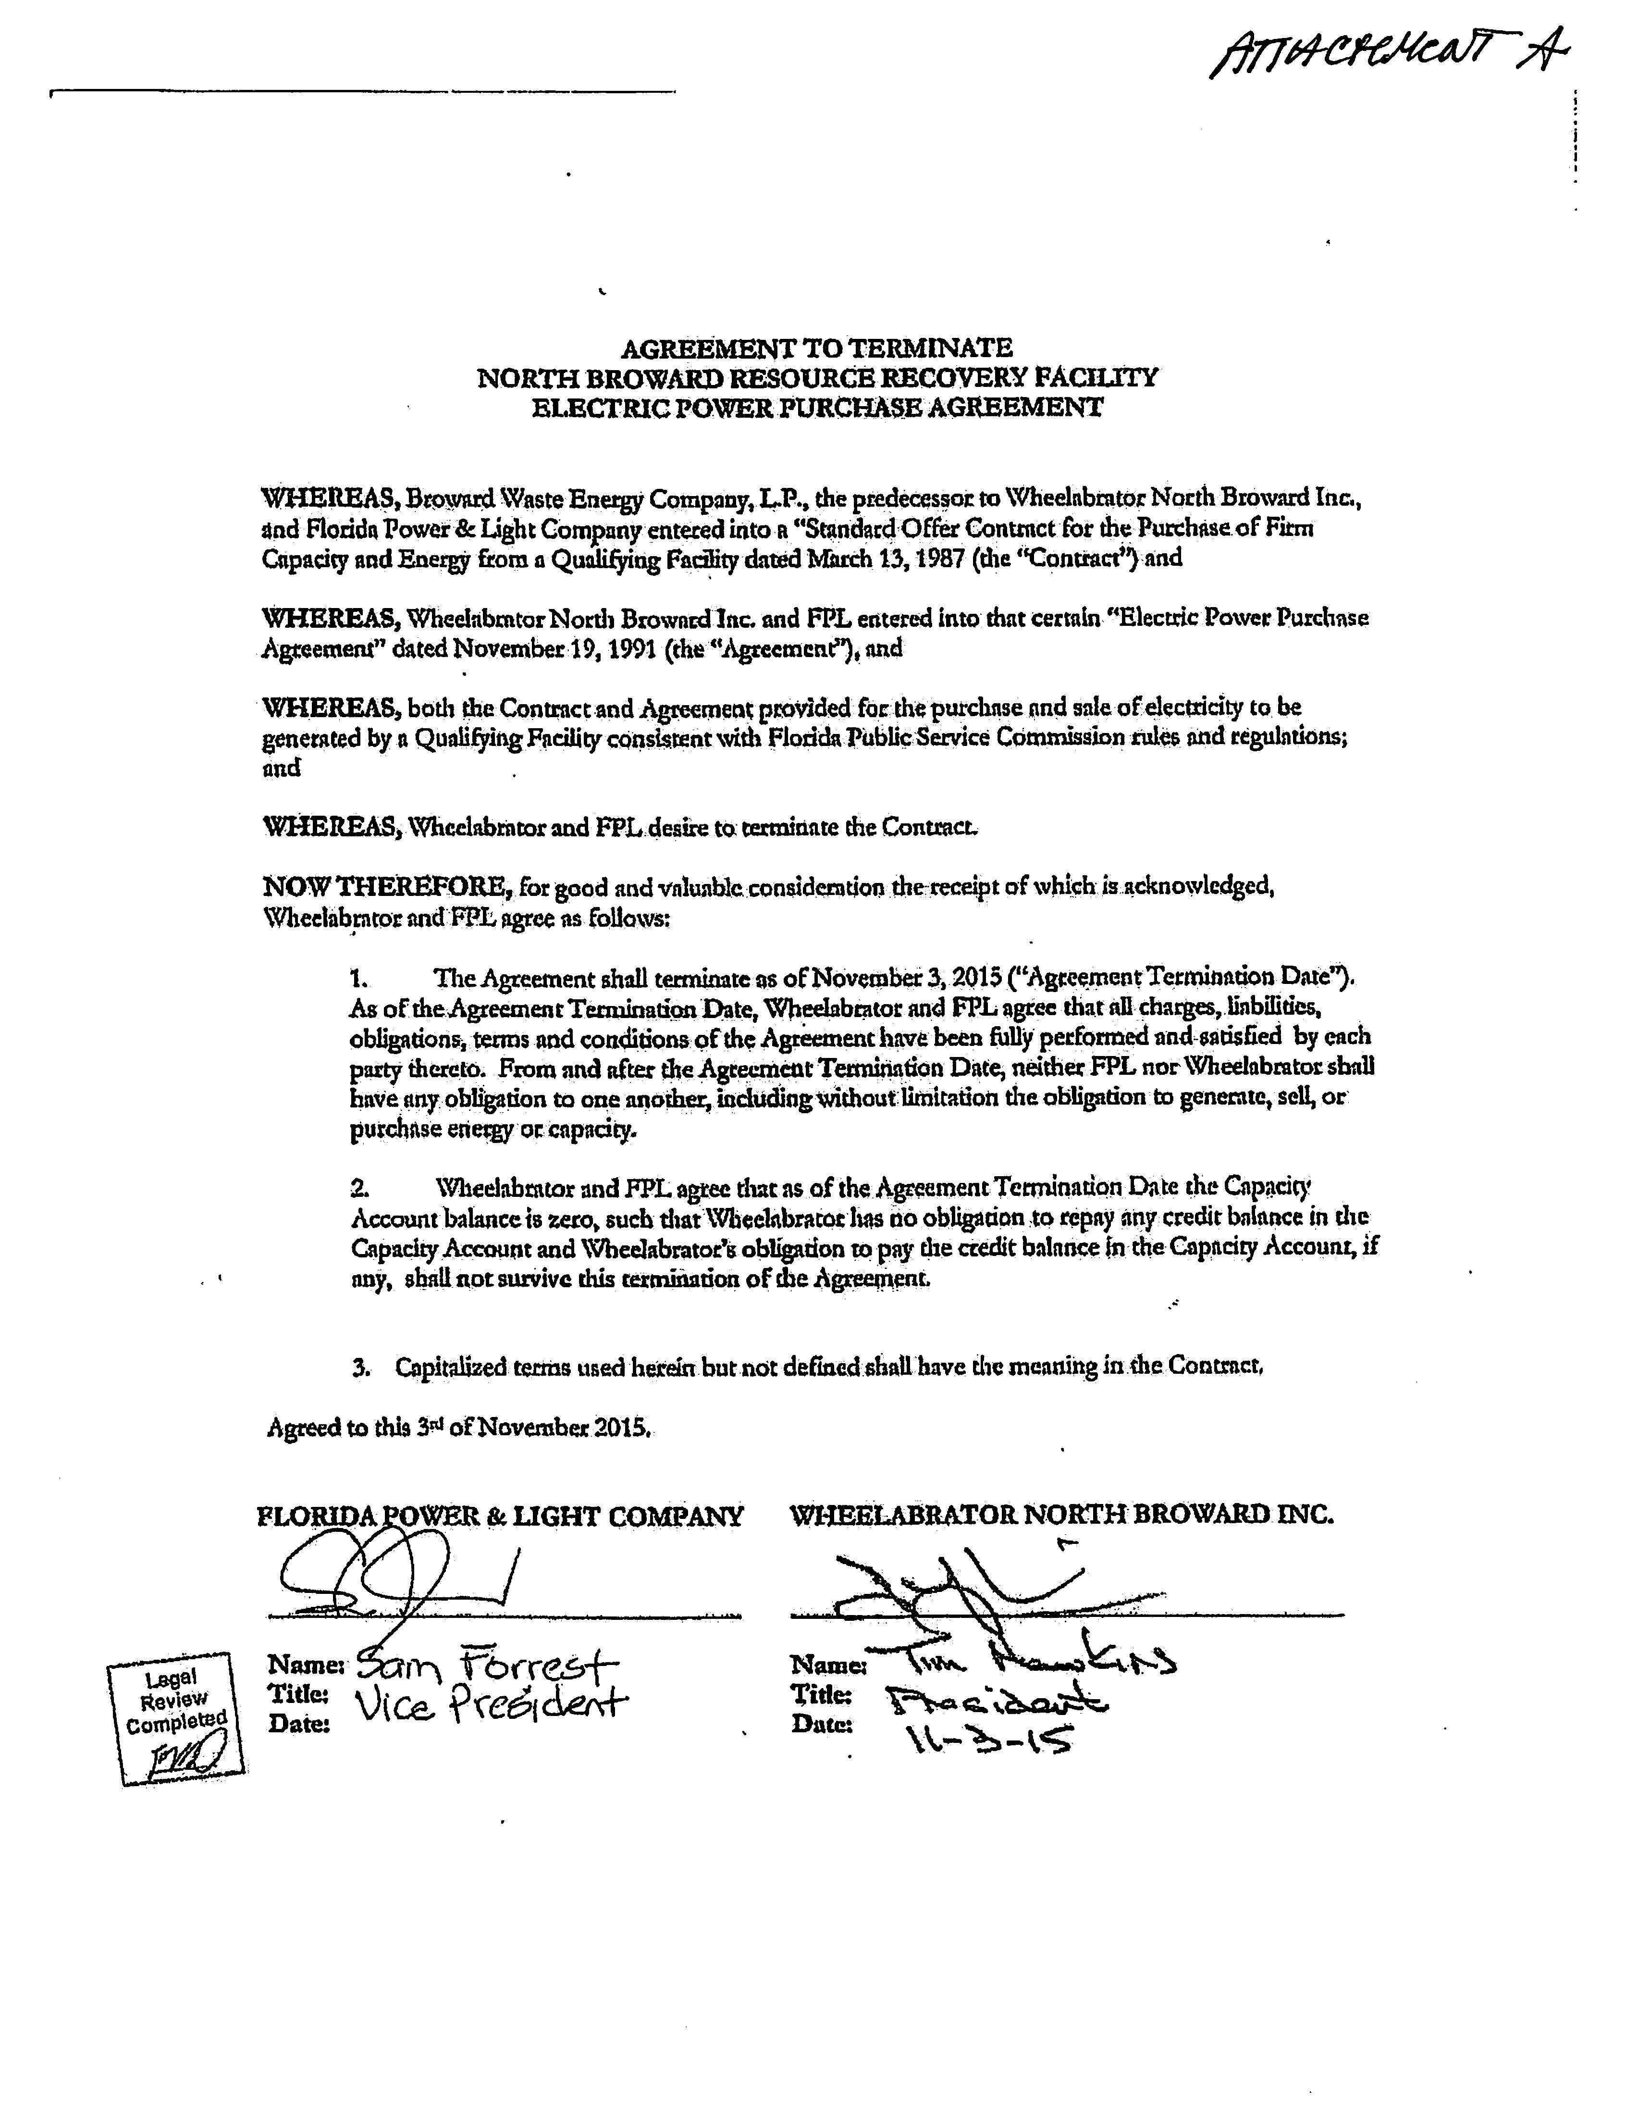

1. Order No. PSC-92-0050-FOF-EQ, issued March 11, 1992, in Docket No. 911140-EQ, *In re: Petition for closure of standard offer contract subscription limit, and for approval of cost recovery of payments to be made through two negotiated power purchase agreements with Wheelabrator North Broward, Inc. and Wheelabrator South Broward, Inc. by Florida Power & Light Company.*