|  |  |  |  |
| --- | --- | --- | --- |
| State of Florida  pscSEAL | | Public Service Commission  Capital Circle Office Center ● 2540 Shumard Oak Boulevard Tallahassee, Florida 32399-0850  -M-E-M-O-R-A-N-D-U-M- | |
| DATE: | February 18, 2016 | | |
| TO: | Office of Commission Clerk (Stauffer) | | |
| FROM: | Division of Economics (Ollila, Higgins, Margolis)  Division of Engineering (Ellis)  Office of the General Counsel (Tan)  Office of Industry Development and Market Analysis (Marr) | | |
| RE: | Docket No. 150248-EG – Petition for approval of community solar pilot program, by Gulf Power Company. | | |
| AGENDA: | 03/01/16 – Regular Agenda – Tariff Filing – Interested Persons May Participate | | |
| COMMISSIONERS ASSIGNED: | | | All Commissioners |
| PREHEARING OFFICER: | | | Administrative |
| CRITICAL DATES: | | | 07/19/16 (8-Month Effective Date) |
| SPECIAL INSTRUCTIONS: | | | None |

Case Background

On November 19, 2015, Gulf Power Company (Gulf or company) filed a petition for approval of its voluntary five-year Community Solar Pilot Program (solar program or program) and associated tariffs, the termination of its Rate Rider PV (photovoltaics) tariff, and a request for a depreciation rate for the proposed solar PV facilities.

The proposed program, addressed in Issue 1, would offer all Gulf customers an opportunity to voluntarily contribute to the construction and operation of a 1 megawatt (MW) solar PV facility (solar facility) through annual subscriptions. The energy generated from the solar facility would provide power to all of Gulf’s customers.

Issue 2 addresses Gulf’s request for termination of its current voluntary Rate Rider PV (PV Rider) tariff.[1] The PV Rider allows any customer to purchase 100-watt blocks of PV energy for $6; however, customers are not charged until sufficient commitments are made to construct a PV facility or purchase PV energy from a third party. As of late 2015 there were 42 customers; to date, no customers have been charged under this tariff as no solar facility has been constructed and no solar energy has been delivered. Gulf also requests a depreciation rate for the proposed solar facilities, which is addressed in Issue 3.

Staff notes that on August 29, 2014, the Commission issued an order approving Florida Power & Light Company’s (FPL) three-year Voluntary Solar Partnership Pilot Program (VSP program).[2] This program offers all FPL customers an opportunity to participate voluntarily in a program designed to contribute to the construction and operation of PV generation facilities in communities throughout FPL’s service territory.

On January 7, 2016, the Commission issued an order suspending the tariff pursuant to Section 366.06(3), Florida Statutes (F.S.).[3] Staff issued two data requests to Gulf. The company responded to the first data request on January 4, 2016, and to the second data request on January 21, 2016. The proposed tariff pages are contained in Attachment 1. There are three interested persons in this proceeding: the Florida Industrial Power Users Group, the Office of Public Counsel, and the Southern Alliance for Clean Energy (SACE). On February 15, 2016, SACE filed comments on the solar program. The Commission has jurisdiction pursuant to Sections 366.06 and 366.075, F.S.

Discussion of Issues

Issue :

 Should the Commission approve the proposed community solar five-year pilot program and associated tariffs?

Recommendation:

 Yes. Staff believes that the proposed solar program provides an opportunity for customers to participate in a community solar project and also provides solar energy for Gulf’s general body of ratepayers. Staff recommends that the Commission approve the proposed community solar five-year pilot program and associated tariffs, effective March 1, 2016.

Staff also recommends that Gulf file an initial annual report on the commercial operation date of the initial solar facility and subsequently on each anniversary date, to include participation levels, the level of participation by type of participant (e.g., one-year and five-year), how many subscriptions each participant purchases, subscription fee revenue, facility performance, program costs, the annual dollar amount of bill credits paid to participants, and the amount of annual avoided energy costs retained by Gulf. (Ollila, Ellis, Marr)

Staff Analysis:

Description of Proposed Solar Program

According to Gulf, the solar program is designed to allow customers to participate in and receive benefits from a solar facility without having to install, own, or maintain their own system. The program has an annual subscription fee used to cover the full projected annual revenue requirement of the program and a monthly bill credit for participants so that they receive credit for the energy produced by the solar facility. The program will also provide Gulf with the opportunity to collect and analyze data including customer interest, continuity of customer participation, mix of customer participation, customer satisfaction, actual program costs and sustainability. Gulf proposes that this program be piloted over a five-year period, beginning with the commercial operation of the solar facility.

During this pilot period Gulf plans to report to the Commission annually on the results of the program including participation levels, subscription fee revenue, facility performance, and program costs, beginning with the commercial operation of its solar facility. At the end of the five-year pilot period (estimated to be 2016-2021), Gulf will file a petition to continue, modify, or close the program and associated tariffs.

Initially, program subscription will be limited to a 1 MW facility, which Gulf states balances economies of scale with subscription achievability. Through this petition, Gulf is also seeking the Commission’s approval to construct additional facilities if Gulf anticipates that new subscriptions will offset the revenue requirements of additional facilities. Gulf plans to provide both pre- and post-construction notification to the Commission of any facilities beyond the initial 1 MW facility, in addition to addressing the potential for additional facilities in its annual report.

Gulf’s proposed facility does not fall under the Florida Electrical Power Plant Siting Act, Section 403.503(14), F.S., as it will be a solar facility of less than 75 MW in capacity. As the proposed facility is less than 75 MW, a Request for Proposal (RFP) to construct the initial facility was not required according to Rule 25-22.082, Florida Administrative Code (F.A.C.). However, Gulf did issue an RFP for the construction of the initial facility. Gulf evaluated the bidders and proposals based on technical merit, energy production, and price. Gulf states that while each proposal met the technical requirements, the winning proposal had higher energy production and a lower equipment, procurement, and construction (also known as EPC) cost. According to Gulf, the installed cost of the 1 MW facility is expected to be approximately $2.6 million based on the results of the RFP issued by Gulf on September 22, 2015.

Market Research

In order to determine interest, Gulf retained a market research firm to conduct nine customer focus groups and telephonic surveys on solar in general and community solar programs specifically. Gulf states that the results indicated that a majority of residential and small business customers are supportive of solar initiatives, and that some are willing to pay a premium for solar. The average annual premium customers surveyed were willing to pay was $346 for residential customers and $414 for business customers. Of those customers interested in community solar, the research shows that two percent of residential customers and one percent of small business customers would “definitely” be willing to pay more for solar.

Subscriptions

In order to strike a balance between a cost low enough to be attractive to customers yet high enough to minimize the number of participants needed to fully subscribe to the program to build the initial facility, Gulf established annual subscription fee levels at $99 and, for a five-year commitment, $89. Staff notes that a five-year commitment may be made at any time during the pilot period. Gulf believes it is reasonable to distribute evenly the number of customer subscriptions between those who sign up for one year at a time and those who sign a five-year commitment, resulting in approximately 2,880 subscriptions required to cover the levelized (over 35 years) annual revenue requirement for the initial facility. The levelized annual revenue requirement for the initial facility is approximately $270,000. A customer may purchase more than one subscription, depending on the customer’s usage. Gulf’s customers total approximately 450,000, therefore the 2,880 subscriptions required represent less than one percent of Gulf’s total customers. Gulf states that based on its market research sufficient customer interest exists to fully subscribe the initial facility.

The number of subscriptions a participant may purchase is limited by the participant’s average annual kilowatt hour (kWh) consumption. The initial facility’s projected output in the first year of operation is 2,150,000 kWh; that number divided by 2,880 (the total number of subscriptions) equals an output of 746 kWh per subscription projected to be delivered to the grid the first year. A customer with an average annual consumption of 12,000 kWh would be limited to 16 subscriptions in the first year of the program (12,000/746=16 subscriptions).

Revenue Requirements

The subscription fees are intended to cover the full projected annual revenue requirements of the solar facilities that would be constructed to support the solar program. Initially, subscriptions will be limited to a 1 MW facility, which will be owned and operated by Gulf and located in Milton, Florida. Assuming Commission approval of the program, the company anticipates that construction will be complete by the third quarter of 2016, with pre-enrollment beginning after final Commission action approving the program. Participants will not be billed until the initial facility begins full commercial operation.

The projected levelized annual revenue requirements include all costs associated with the engineering, procurement, construction, and operations and maintenance (O&M) of the solar facility. Impacts of the federal Solar Investment Tax Credits are embedded in the calculation. The projected levelized annual revenue requirement is $270,000. Recurring capital costs are four percent of the $270,000 while O&M costs are 11 percent. The remaining 85 percent is attributable to the initial facility costs. The O&M costs include fixed O&M, insurance, and marketing. Marketing represents the only administrative cost included in the revenue requirement. Gulf anticipates the highest level of marketing costs will occur in 2016, $50,000 or approximately 19 percent of the $270,000 levelized annual revenue requirement. Marketing costs are expected to decline through the end of the five-year pilot period to $6,250 or 2.3 percent of the levelized annual revenue requirement. According to Gulf, one objective of the pilot program is to evaluate what actual marketing and other administrative costs are required to fully subscribe to this type of program.

Bill Credits and Avoided Energy Costs

Each program subscription in the solar program would receive a monthly bill credit of $2.11 for the first year. The monthly $2.11 credit is calculated by multiplying the solar weighted average annual avoided energy cost (3.4 cents/kWh) by 746 kWh (output per subscription projected to be delivered to the grid the first year), divided by 12 to get a monthly credit.

As stated in the utility’s petition, Gulf would seek to recover the avoided energy costs associated with the output of the solar facilities through the Fuel and Purchased Power Cost Recovery Clause (Fuel Clause). To illustrate, the facility’s projected output in the first year is 2,150,000 kWh. Based on the projected 3.4 cents/kWh avoided energy costs, the avoided energy costs associated with the solar facility is $73,100 (2,150,000 kWh x 3.4 cents/kWh).

Gulf states that this is appropriate because all customers will benefit from the output of the solar facility as the output will offset an equal amount of purchased energy (i.e., the amount of purchased energy will decrease by the 2,150,000 kWh). Gulf would recalculate the bill credit on an annual basis as part of the Fuel Clause proceeding to reflect changes in avoided energy cost and capacity output projections. Gulf will provide updated facility output and avoided energy costs for Commission review in the annual Fuel Clause projection filings.

Marketing

If the solar program is approved, Gulf plans to begin pre-enrollment following the receipt of a Commission final order approving the program. Marketing will focus on Gulf’s three categories of eligible customers: residential, business, and industrial. For the three categories the marketing plan is expected to include targeted emails, bill inserts, webpage, social media promotion, print information, and a video that will be made available on the website and in social media.

Renewable Energy Credits

Gulf states that renewable energy credits (REC) resulting from the community solar program will be retired on behalf of the program participants. Once retired, the RECs cannot be sold or transferred to another party. Gulf’s proposed treatment of RECs will have a zero impact on program revenue requirements.

Analysis

Staff believes that, overall, the solar program and its components are reasonable. However, there are topics that staff believes merit further discussion.

Risk of Insufficient Subscriptions

Staff asked Gulf in a data request to explain who would assume the risk for unrecovered costs if subscriptions are insufficient to cover the projected annual revenue requirements during the pilot program or should Gulf decide to close the solar program after the five-year pilot period. Gulf stated that its market research indicates that sufficient customer interest exists to fully cover the project’s program costs with revenues from participants. Furthermore, Gulf asserted that it believes it is important to remove uncertainty about whether the initial facility will be built; therefore, it plans to begin construction once it receives a final order while it is signing up participants. Gulf explained that the proposed solar program is experimental and limited in size and scope; undersubscription is not anticipated. Should undersubscription occur, Gulf noted that the initial facility will continue to provide service to all of Gulf’s customers. The company stated that if subscriptions consistently fall significantly short of the number needed to recover the costs during the pilot, Gulf would anticipate further discussion with the Commission concerning the program.

Staff also asked Gulf if it would be willing to absorb costs if undersubscription occurs, as FPL has committed to in its VSP program.[4] Gulf responded that it acknowledges that its shareholders, as opposed to its non-participating customers, are assuming the risk that program costs will not be fully supported by the program structure. Gulf stated that it is not seeking by its petition to insulate itself or its shareholders from that risk. Furthermore, Gulf stated that it is not assuming that Commission approval of the solar program would have the effect of insulating shareholders from that risk. Gulf stated that it does reserve its right to petition the Commission for alternative treatment of the solar program and/or solar assets if circumstances develop in the future to warrant proposing alternative treatment. According to Gulf, for example, should the program’s assets become cost-effective for Gulf’s general body of customers in the future, Gulf asserts that it must retain the ability to petition the Commission for appropriate regulatory treatment of the assets based on the facts and circumstances as they exist at the time. Staff notes that this recommendation does not address prudency. Gulf will have to demonstrate prudency in a future proceeding, if it seeks to recover costs.

Avoided Energy Costs

By using annually projected avoided energy costs and recovering these from the general body of ratepayers through the Fuel Clause, Gulf is shifting some risk for avoided energy costs from the program participants to the general body of ratepayers. For example, if actual avoided energy costs are below the projected values Gulf calculated, non-participants would see a net loss. Conversely, if actual avoided energy costs are higher than projected, non-participants would see a net benefit. Regardless, Gulf would recover the projected avoided energy costs through the Fuel Clause, subject to Commission review. This is similar to fixed energy rates in purchased power agreements, although these tend to include multiple year terms and additional security provisions associated with system performance. For example, in Docket No. 150035-EI, the Commission approved three renewable purchased power agreements for solar facilities with 25-year terms featuring fixed energy rates.[5]

One method to mitigate the risk would be to include a true-up provision in the calculation of the annual avoided energy costs as part of the Fuel Clause. Gulf stated in response to staff’s first data request that a true-up mechanism was possible but based on the utility’s analysis the cost and complexity of implementation far exceeded any costs to be trued up. Staff would note that since this is a pilot program and the avoided energy cost will be recalculated each year, the difference between forecasted and actual as-available energy values should be minimal.

Reporting requirements

Gulf’s planned annual reports to the Commission include participation levels, subscription fee revenue, facility performance, and program costs. Staff believes additional information should be included in the annual reports: the level of participation by type of participant (e.g., one-year and five-year), how many subscriptions each participant purchases, the annual dollar amount of bill credits paid to participants, and the amount of annual avoided energy costs retained by Gulf.[6] Gulf should file an initial annual report on the commercial operation date of the solar facility and subsequently on each anniversary date for the duration of the five-year pilot period. Gulf plans to provide both pre- and post-construction notification to the Commission of any facilities beyond the initial facility, in addition to addressing the potential for additional facilities in its annual reports. These reports should be filed in this docket.

Conclusion

Staff believes that the proposed solar program provides an opportunity for customers to participate in a community solar project and also provides solar energy for Gulf’s general body of ratepayers. Staff recommends that the Commission approve the proposed community solar five-year pilot program and associated tariffs, effective March 1, 2016.

Staff also recommends that Gulf file an initial annual report on the commercial operation date of the initial solar facility and subsequently on each anniversary date, to include participation levels, the level of participation by type of participant (e.g., one-year and five-year), how many subscriptions each participant purchases, subscription fee revenue, facility performance, program costs, the annual dollar amount of bill credits paid to participants, and the amount of annual avoided energy costs retained by Gulf.

***Issue 2:*** Should the Commission approve the termination of the optional PV Rider tariff?

Recommendation:

 Yes. Staff believes that the termination of the optional PV Rider is reasonable and recommends that the Commission approve its termination effective March 1, 2016. If the Commission approves staff’s recommendation, current participants should be notified of the termination of the PV Rider within 30 days of the effective date. (Ollila)

Staff Analysis:

 Gulf requests termination of its PV Rider tariff, a voluntary subscription program dating from 1999. The PV Rider is an optional rate rider that permits any customer to purchase one or more 100-watt blocks of PV energy for a monthly charge of $6.00 per block. Participating customers must commit to an initial term of five years; however, they are not charged until Gulf receives sufficient customer commitments to cover the cost of constructing a solar facility or purchasing solar energy from a third party. The minimum threshold for this program, 10,000 100-watt blocks, has not been attained, thus no solar facility has been built, no solar energy has been delivered, and no participant has been billed. Since 2005 the greatest number of participants, 70, occurred in 2005. The smallest number of participants is 42, as of the end of 2015.

Gulf requests to terminate the PV Rider irrespective of whether the Commission approves the company’s proposed solar program discussed in Issue 1. Gulf asserts that continuing this rate rider in conjunction with its proposed solar program has the potential to lead to customer confusion and that the solar program is likely to be a preferable alternative to customers interested in promoting solar energy. Gulf notes that this program showed the difficulty of achieving adequate customer participation without a PV facility already in operation. If the proposed solar program is not approved, Gulf states it would want the flexibility to propose alternative solar program designs, which would likely differ from the existing PV Rider.

Conclusion

Staff believes that the termination of the optional PV Rider is reasonable and recommends that the Commission approve its termination effective March 1, 2016. If the Commission approves staff’s recommendation, current participants should be notified of the termination of the PV Rider within 30 days of the effective date.

Issue :

 What is the appropriate depreciation rate for Gulf’s proposed solar facilities?

Recommendation:

 Staff recommends the Commission approve a whole life depreciation rate of 2.9 percent, which is based on a 35-year average service life and zero percent net salvage for Gulf’s proposed solar facilities. (Higgins)

Staff Analysis:

 Gulf is seeking Commission establishment of a depreciation rate for planned investments in utility-scale solar facilities. Specifically, Gulf requests approval to depreciate solar-to-electric generating facility investments over an average service life of 35 years, with a zero net salvage provision. Using these life and salvage parameters, the resulting whole life depreciation rate equals 2.9 percent. The major components of Gulf’s planned initial solar PV facility include Solar World Sunmodule SW 320 XL MONO PV modules, SMA Sunny World Tripower 24000TL-US inverters, and RBI Solar Ground Mount racking units.[7] The company intends to record its utility-scale solar investments in Federal Energy Regulatory Commission accounts 340 thru 346, which are classified as “Other Power Production.”

The Commission has experience addressing depreciation matters in utility-scale solar generation.[8] Most recently, the Commission approved depreciation life parameters for Tampa Electric Company’s (TECO) solar PV generating unit at the Tampa International Airport (TIA). The Commission found TECO’s proposed depreciation parameters of a 30-year average service life and a zero net salvage provision to beappropriate for initial investment recovery of the TIA Plant.[9] However, in the instant proceeding, Gulf is proposing to depreciate its solar plant investments over a 35-year life, while also estimating a zero net salvage provision. This results in a lower rate of depreciation, i.e. 2.9 percent versus the 3.3 percent approved for TECO. Staff notes that the Commission also ordered a 30-year life (and resulting 3.3 percent depreciation rate) for FPL’s DeSoto and Space Coast Solar Energy Centers.[10]

Staff, through two data requests, asked how Gulf determined a 35-year life would be appropriate for use in recovering its solar plant investments. The company responded its life proposal was informed through a study conducted by Southern Company Services (SCS) and KPMG LLP (KPMG).[11] Generally speaking, the study divided components of a generic PV plant into three categories: PV panels, inverters, and other PV components. The three individual component categories’ average service lives’ were then multiplied by the percentage of overall initial investment they represent of the facility. At this point, the weighted average service lives were summed. Overall, the weighted average service life of the solar PV facility infrastructure totaled approximately 35 years. Staff has reviewed the SCS and KPMG Study and the findings are consistent with Gulf’s request.

Concerning Gulf’s proposed zero net salvage provision, the company claims it currently has minimal experience operating and maintaining utility-scale solar facilities, and thus does not have sufficient data with respect to cost of removal or gross salvage values. However, the company claims it will address and update, as warranted, depreciation components through future depreciation studies. Staff notes according to Rule 25-6.0436(8)(a), F.A.C., the company is required to file an updated depreciation study at least once every four years from submission of its most recent study. Staff further notes that the Commission has previously ordered a zero net salvage provision for utility-scale solar facilities for both FPL and TECO.[12]

For the purposes of determining a depreciation rate for Gulf’s planned solar PV investments, staff believes the methodology the company used as a basis for its request is reasonable. Staff also recognizes that if by estimating a 35-year life and a zero net salvage results in a rate of investment recovery that is inadequate, this would likely be identified in a future depreciation review proceeding and adjustment sought at that time. The Commission has methods and procedures for maintaining appropriate rates of asset recovery in Rule 25-6.0436, F.A.C. Gulf’s request of a 35-year average service life for its solar PV investments, which is based on the SCS and KPMG Study, and a zero percent net salvage, appears reasonable at this time. If approved, the resulting whole life depreciation rate for Gulf’s planned solar PV investments would be 2.9 percent.

Conclusion

For the reasons discussed above, staff recommends the Commission approve a whole life depreciation rate of 2.9 percent, which is based on a 35-year average service life and zero percent net salvage for Gulf’s proposed solar facilities.

Issue :

 Should this docket be closed?

Recommendation:

 If Issues 1, 2, and 3 are approved and if a protest is filed within 21 days of the issuance of the order, the tariff should remain in effect pending resolution of the protest. There will not be any dollar amount subject to refund because Gulf will not begin pre-enrollment until a final order is issued. If no timely protest is filed, this docket should be closed upon the issuance of a consummating order. (Tan)

Staff Analysis:

 If Issues 1, 2, and 3 are approved and if a protest is filed within 21 days of the issuance of the order, the tariff should remain in effect pending resolution of the protest. There will not be any dollar amount subject to refund because Gulf will not begin pre-enrollment until a final order is issued. If no timely protest is filed, this docket should be closed upon the issuance of a consummating order.

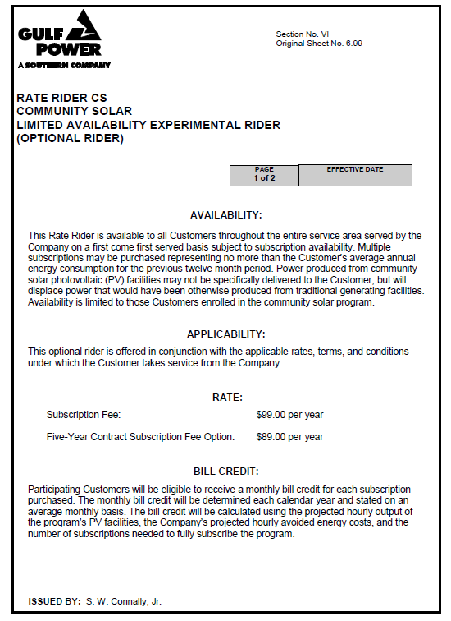

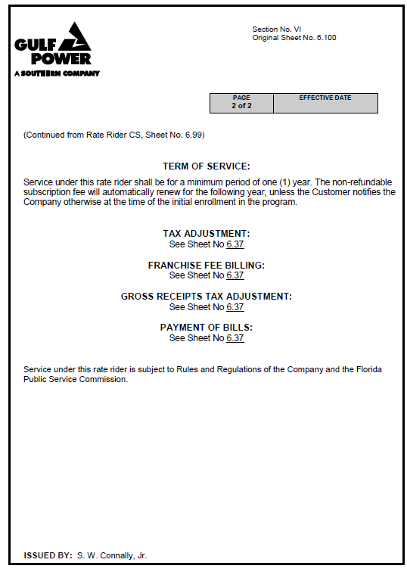

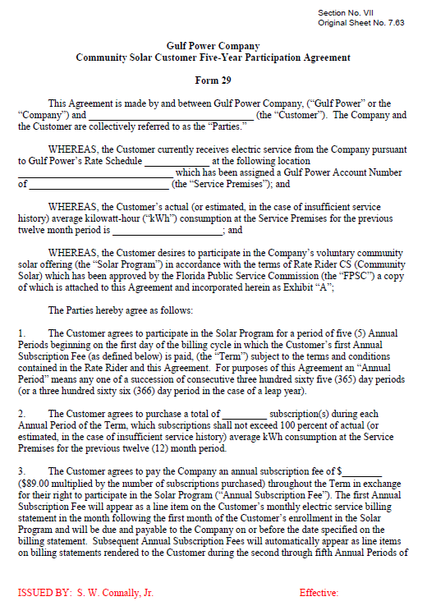

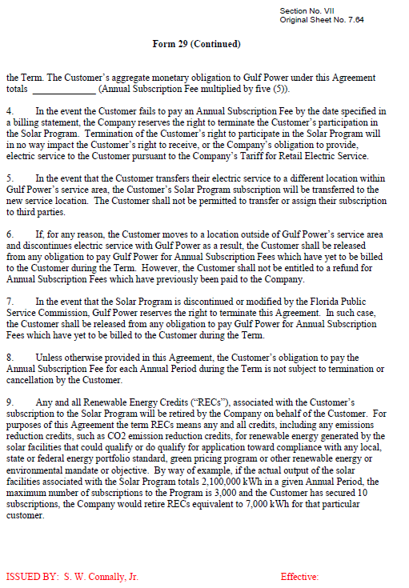

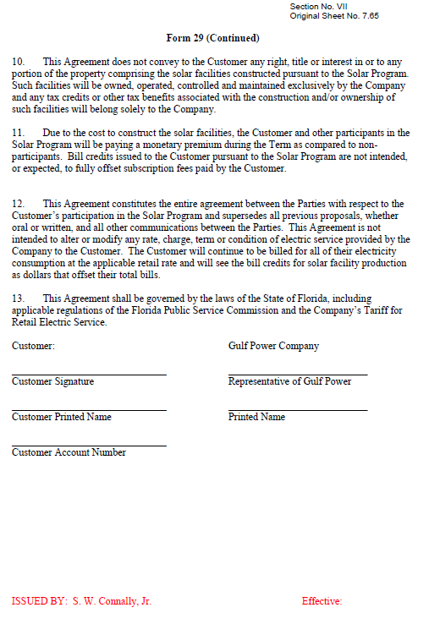

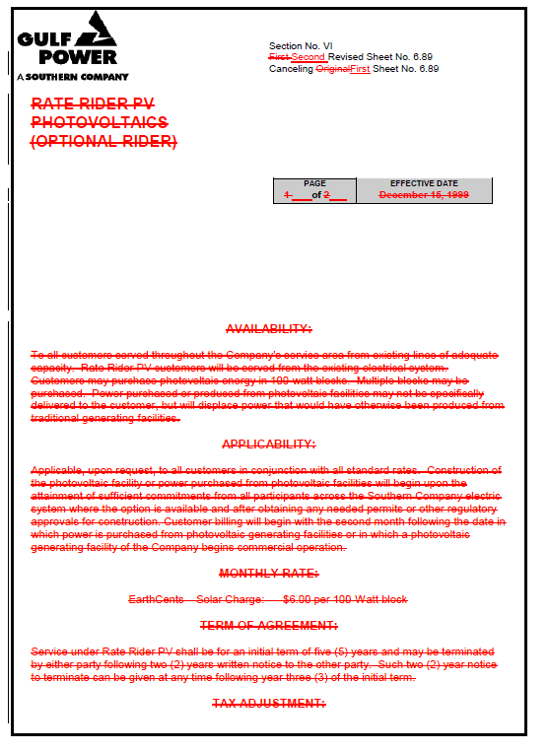

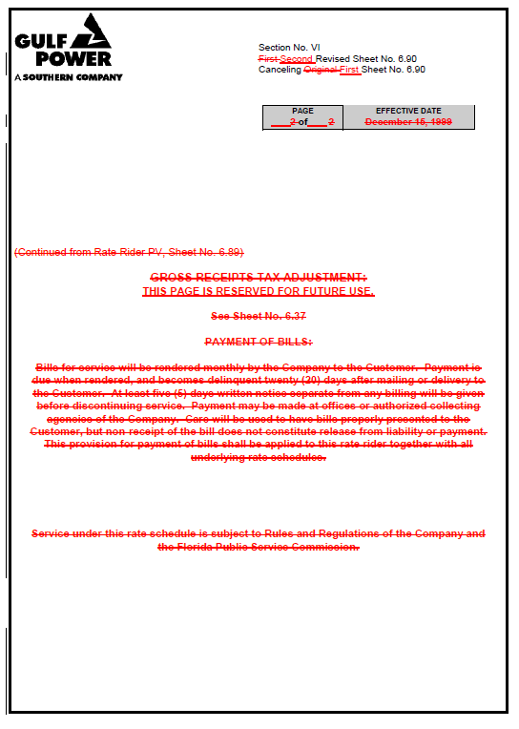

1. Order No. PSC-99-2485-TRF-EI, issued December 20, 1999, in Docket No. 991317-EI, *In re: Petition by Gulf Power Company for approval of optional rate rider PV (photovoltaics)*.
2. Order No. PSC-14-0468-TRF-EI, issued August 29, 2014, in Docket No. 140070-EI, *In re: Petition for approval of voluntary solar partnership pilot program and tariff, by Florida Power & Light Company*.
3. Order No. PSC-16-0015-PCO-EG, issued January 7, 2016, in Docket No. 150248-EG, *In re: Petition for approval of community solar pilot program, by Gulf Power Company*.
4. Order No. PSC-14-0468-TRF-EI, issued August 29, 2014, in Docket No. 140070-EI, *In re: Petition for approval of voluntary solar partnership pilot program and tariff, by Florida Power & Light Company*.
5. Order No. PSC-15-0155-PAA-EI issued April 22, 2015, in Docket No. 150035-EI, *In re: Petition for approval of energy purchase agreements between Gulf Power Company and Gulf Coast Solar Center I, LLC, Gulf Coast Solar Center II, LLC, and Gulf Coast Solar Center III, LLC*.
6. Gulf states that the program is designed such that the avoided energy costs associated with facility output that is to be recovered through the Fuel Clause will be equal to the annual energy credits to be paid to subscribers if the program is fully subscribed (2,880 subscriptions). However, if the program is not fully subscribed, energy credits paid to subscribers would be less than the avoided energy costs recovered through the Fuel Clause.
7. Gulf’s responses to Staff’s First Data Request No. 42.
8. Order No. PSC-08-0731-PAA-EI, issued November 3, 2008, in Docket 080543-EI. *In re: Request for approval to begin depreciating new technology solar photovoltaic plant sites for DeSoto and Space Coast Solar Energy Centers over 30-year period, effective with in-service dates of units, by Florida Power & Light Company;* Order No. PSC-15-0573-PAA-EI, issued December 18, 2015, in Docket No. 150211-EI, *In re: Petition for approval of depreciation rates for solar photovoltaic generating units, by Tampa Electric Company*.
9. Ibid.
10. Order No. PSC-08-0731-PAA-EI.
11. Gulf’s responses to Staff’s First Data Request No. 43 and Staff’s Second Data Request No. 4 (Confidential).
12. Order No. PSC-08-0731-PAA-EI; Order No. PSC-15-0573-PAA-EI.