|  |  |  |  |
| --- | --- | --- | --- |
| State of Florida  pscSEAL | | Public Service Commission  Capital Circle Office Center ● 2540 Shumard Oak Boulevard Tallahassee, Florida 32399-0850  -M-E-M-O-R-A-N-D-U-M- | |
| DATE: | March 24, 2016 | | |
| TO: | Office of Commission Clerk (Stauffer) | | |
| FROM: | Division of Economics (Guffey)  Office of the General Counsel (Mapp) | | |
| RE: | Docket No. 160029-GU – Petition by Peoples Gas System for approval of special contract with United Parcel Service, Inc. | | |
| AGENDA: | 04/05/16 – Regular Agenda – Proposed Agency Action – Interested Persons May Participate | | |
| COMMISSIONERS ASSIGNED: | | | All Commissioners |
| PREHEARING OFFICER: | | | Graham |
| CRITICAL DATES: | | | None |
| SPECIAL INSTRUCTIONS: | | | None |

Case Background

On February 4, 2016, Peoples Gas System (Peoples) filed a petition for approval of a special contract with United Parcel Service, Inc. (UPS). Peoples proposes to extend its distribution facilities to provide natural gas transportation service to a compressed natural gas (CNG) vehicle fueling station to be constructed by UPS to serve its fleet in the Orlando operating center.

UPS currently has a fleet of 5,400 vehicles which operate on alternative fuels and advanced technology. UPS expanded its use of CNG in 2015 and continues to build CNG stations across the country to support its daily operations. The proposed Orlando facility will initially serve 30 vehicles with opportunities for future expansion. The 30 CNG fueled vehicles will displace the use of 700,000 gallons of traditional fuels annually. Section 334.044(33)(a)4., Florida Statutes, (F.S.), encourages the increased use of natural gas to reduce transportation costs for businesses and residents within the state.

During the evaluation of this petition, staff issued its first data request to Peoples for which responses were received on March 3, 2016. After reviewing the responses, staff issued a second data request on March 9, 2016, for which responses were received on March 11, 2016. The Office of the Public Counsel (OPC) filed a Notice of Intervention on February 17, 2016, which was granted by Order No. PSC-16-0097-PCO-GU, issued March 9, 2016.

Rule 25-9.034(1), Florida Administrative Code, (F.A.C.), requires that whenever a special contract is entered into by a utility for the sale of its product or service in a manner not specifically covered by its filed regulations and standard approved rate schedules, such a contract must be approved by the Florida Public Service Commission (Commission) prior to its execution. The Commission has jurisdiction over this matter pursuant to Section 366.04, F.S.

Discussion of Issues

Issue :

 Should the Commission approve the special contract between Peoples and UPS?

Recommendation:

 Yes. The Commission should approve the special contract between Peoples and UPS. (Guffey)

Staff Analysis:

 As required by Rule 25-9.034(1), F.A.C., Peoples filed for Commission approval of its proposed special contract with UPS. In order to provide natural gas to UPS’s proposed CNG filling station, Peoples will extend its distribution facilities by 3.8 miles of 6-inch coated steel pipes. The confidential dollar per therm distribution charge contained in the contract is higher than the otherwise applicable tariff rate to allow Peoples to recover the cost of the pipeline extension made to UPS’ planned fueling station. In addition to the distribution charge contained in the contract, UPS will be responsible for all other applicable charges and clauses of Rate Schedule GS-5, such as the customer charge, swing service charge, energy conservation cost recovery clause, and cast iron bare steel replacement surcharge.

Peoples will provide natural gas transportation service only to UPS; the natural gas UPS will compress and sell as CNG will be provided by a gas marketer. Specifically, UPS will receive transportation service under Peoples Natural Choice Transportation Service Rider (Rider NCTS). Rider NCTS customers acquire gas from a gas marketer as a part of a customer pool. The gas marketer delivers gas to Peoples’ distribution system for all Rider NCTS customers, and Peoples subsequently transports the gas to the customers. All Rider NCTS customers are required to execute a Letter of Authorization, which is a contract setting forth the terms and conditions under which Peoples will provide transportation service to the customer.[1] UPS has executed the Letter of Authorization. The proposed special contract, for which Peoples seeks Commission approval because it contains a charge that is higher than standard tariff rates, is an addendum to the Letter of Authorization. The redacted special contract is shown as Attachment A to the recommendation.

The term of the contract is 10 years and can be extended for an additional five years upon mutual agreement by Peoples and UPS under the otherwise applicable rate schedule and tariff rate as approved by the Commission and in effect at the time of the extension of the term.

Peoples provided a confidential cost of service study to show that the revenues generated by charges contained in the contract will cover the annual operating cost of providing natural gas to UPS. The estimated annual costs associated with the facility extension include operation and maintenance, depreciation, taxes, and return on investment.

Peoples stated that only a certain portion of the extension costs (according to the amount of gas usage) are allocated to UPS who will be the first customer on the new distribution line. Peoples explained that it anticipates other gas customers, including a large industrial customer, to come on line later in 2016 who would then be allocated most of the remaining pipeline extension cost. The remaining capacity of the gas line will be used for system reinforcement and peaking requirements. The contract also provides for annual minimum volumes to be taken or paid for during the term of the contract.

Staff recommends that the Commission approve the proposed special contract between Peoples and UPS as it will generate revenues in excess of the cost of service, and thereby provide benefits to Peoples’ general body of ratepayers.

Issue 2:

 Should this docket be closed?

Recommendation:

 If no protest is filed by a person whose substantial interests are affected within 21 days of the issuance of the Order, this docket should be closed upon the issuance of a Consummating Order. (Mapp)

Staff Analysis:

 If no protest is filed by a person whose substantial interests are affected within 21 days of the issuance of the Order, this docket should be closed upon the issuance of a Consummating Order.

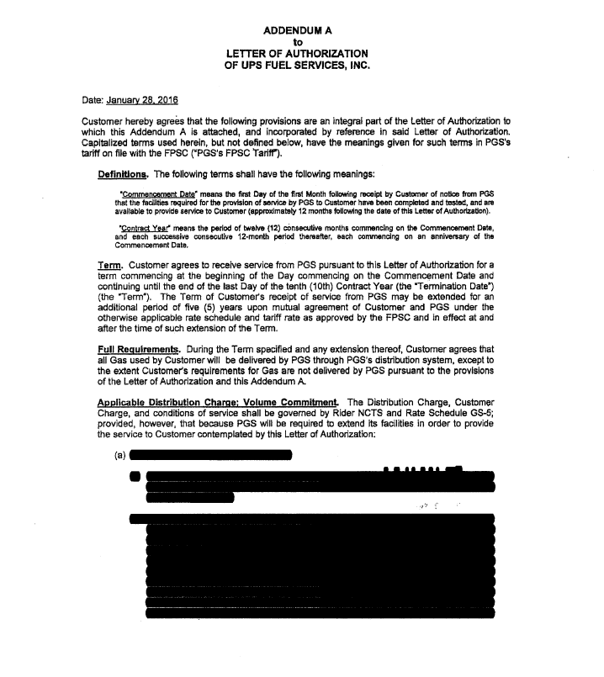

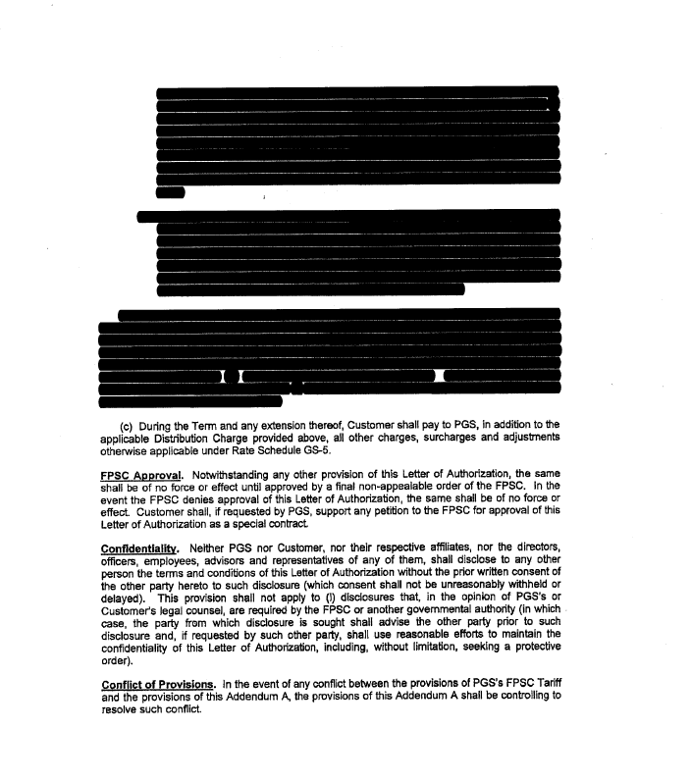

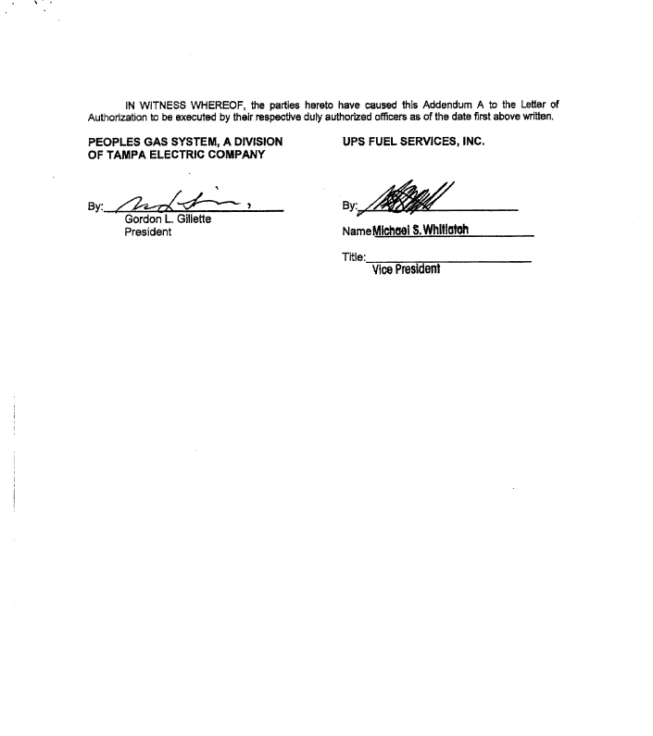

1. The Letter of Authorization is a standard form and does not require Commission approval.