|  |  |  |  |
| --- | --- | --- | --- |
| State of Florida  pscSEAL | | Public Service Commission  Capital Circle Office Center ● 2540 Shumard Oak Boulevard Tallahassee, Florida 32399-0850  -M-E-M-O-R-A-N-D-U-M- | |
| DATE: | April 22, 2016 | | |
| TO: | Office of Commission Clerk (Stauffer) | | |
| FROM: | Division of Economics (Ollila)  Office of the General Counsel (Leathers) | | |
| RE: | Docket No. 160059-EI – Petition to extend economic development rider on a permanent basis, by Tampa Electric Company. | | |
| AGENDA: | 05/05/16 – Regular Agenda – Tariff Filing – Interested Persons May Participate | | |
| COMMISSIONERS ASSIGNED: | | | All Commissioners |
| PREHEARING OFFICER: | | | Administrative |
| CRITICAL DATES: | | | 05/13/16 (60-Day Suspension Date) |
| SPECIAL INSTRUCTIONS: | | | None |

Case Background

On March 14, 2016, Tampa Electric Company (Tampa Electric or company) filed a petition to extend its Economic Development Rider program (rider or program) on a permanent basis. The rider was introduced as a three-year pilot in the stipulation and settlement agreement (settlement) the Commission approved in Tampa Electric’s 2013 base rate proceeding.[1] The program became effective on the implementation date of the settlement (November 1, 2013) and ends on December 31, 2016. The rider, which requires a five-year contract, provides base rate discounts for new businesses that meet certain requirements such as minimum size, job creation, and verification that the availability of the rider is a significant factor in the customer’s location or expansion decision.

Staff issued one data request to Tampa Electric, to which the company responded on April 1, 2016. On April 19, 2016, Tampa Electric filed a letter in the docket file clarifying paragraph 7 of the petition. The proposed tariff pages are contained in Attachment 1. The Commission has jurisdiction over this matter pursuant to Sections 288.035 and 366.06, Florida Statutes.

Discussion of Issues

Issue 1:

 Should the Commission approve Tampa Electric’s petition to extend its economic development rider and associated tariffs on a permanent basis?

Recommendation:

 Yes, the Commission should approve Tampa Electric’s petition to extend its economic development rider and associated tariffs on a permanent basis effective May 5, 2016. (Ollila)

Staff Analysis:

 The economic development rider is designed to attract new business to Tampa Electric’s service territory. The rider is available for load associated with initial permanent service to new establishments or the expansion of existing establishments and requires a five-year customer contract. Under the rider, the new load must be a minimum of 350 kilowatt (kW) at a single delivery point and the customer must employ an additional work force of at least 25 full time equivalent employees (FTEs). Each customer taking service under the rider must sign an attestation letter stating that the customer will employ at least 25 FTEs. The percentage discount applicable to the base demand and energy charges of the customer’s otherwise applicable rate schedule begin at 20 percent in the first year, and declines by five percentage points every year (e.g., 15 percent discount in year 2) until the fifth year when the discount is zero.

The first customer took service under the rider in June 2014. Since that time, Tampa Electric stated that the program has attracted new load resulting in approximately $760,000 in incremental base revenue and the addition of 405 FTEs in Tampa Electric’s service territory. The discount amount associated with the new load is approximately $130,000, which represents the difference between the rider rates and the otherwise applicable tariffed rates for the period June 2014 through February 2016. Currently, there are two commercial customers taking service under the rider.

The proposed permanent rider tariff deletes the pilot program’s beginning and end dates and adds additional language to specify that the discount will begin once the customer has achieved minimum load and job requirements and that the agreement will terminate automatically if the minimum load and job requirements have not been achieved within 120 days of the effective date of the service agreement. Tampa Electric is developing an annual attestation letter that customers will have to sign and return which states that the customers are maintaining the minimum 25 FTEs required to remain on the program. The rider contains provisions for early termination and requires a customer to reimburse Tampa Electric for any discounts received under the rider if the agreement is terminated prior to the end of the five-year contract.

Pursuant to Rule 25-6.0426(5), Florida Administrative Code (F.A.C.), Tampa Electric is currently reporting any economic development expenses associated with the rider (e.g., marketing) on its earnings surveillance reports filed with the Commission. In response to staff’s data request and the letter filed on April 19, Tampa Electric explained that in the next rate case the company will request recovery of any base rate reductions, i.e., difference between tariffed base rates and discounted base rates pursuant to the rider, as a cost of the rider. Only discounts provided in the test year will be eligible for cost recovery. Pursuant to Rule 25-6.0426(4), F.A.C., the Commission will determine the level of sharing of prudent economic development costs in the company’s next rate case.

Any direct impact on the general body of ratepayers will depend on the amount of discounts, if any, in the test year and the level of sharing determined by the Commission. Staff notes that economic development provides indirect positive impacts to ratepayers including economic and job growth. Furthermore, any increased load as a result of the rider benefits the general body of ratepayers by spreading fixed cost among a larger customer base.

The company avers it is working on additional customer projects that would not have been viable without the rider incentive. According to Tampa Electric, economic development contacts and negotiations are often conducted a substantial amount of time before a prospective customer would begin to take service from the company. The company asserts that being able to assure that the rider will be available when the customer is ready to make a decision is very important to continue the success of the program. Therefore, the company requests approval to make the rider permanent several months before the pilot program expires at the end of this year. Tampa Electric believes that a permanent program will encourage business growth in its territory.

The rider appears to be successful in attracting new load and incremental base revenues to Tampa Electric’s service territory, which benefits the general body of ratepayers. Therefore, staff recommends that the Commission should approve Tampa Electric’s petition to extend its economic development rider and associated tariffs on a permanent basis effective May 5, 2016.

Issue 2:

 Should this docket be closed?

Recommendation:

 If Issue 1 is approved and a protest is filed within 21 days of the issuance of the order, the tariff should remain in effect pending resolution of the protest. If no timely protest is filed, this docket should be closed upon the issuance of a consummating order. (Leathers)

Staff Analysis:

 If Issue 1 is approved and a protest is filed within 21 days of the issuance of the order, the tariff should remain in effect, pending resolution of the protest. If no timely protest is filed, this docket should be closed upon the issuance of a consummating order.

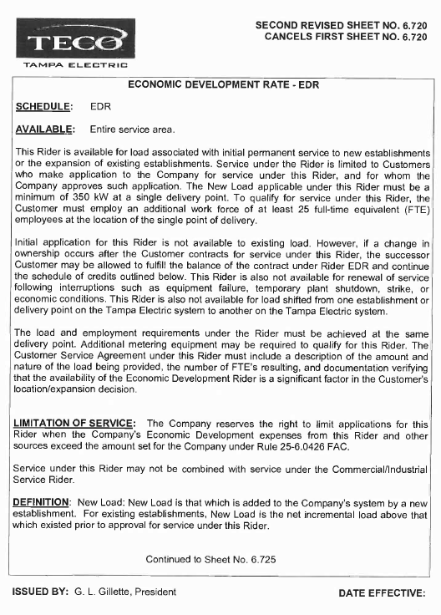

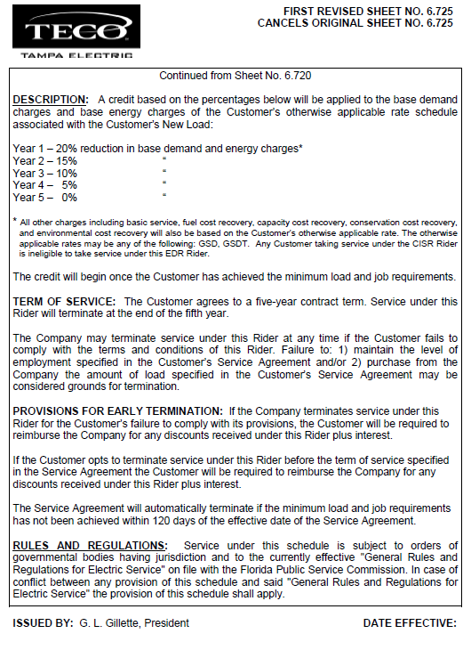



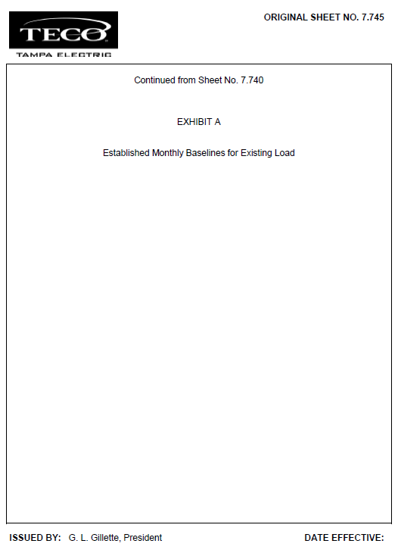

1. Order No. PSC-13-0443-FOF-EI, issued September 30, 2013, in Docket No. 130040-EI, *In re: Petition for rate increase by Tampa Electric Company*.