|  |  |  |  |
| --- | --- | --- | --- |
| State of Florida  pscSEAL | | Public Service Commission  Capital Circle Office Center ● 2540 Shumard Oak Boulevard Tallahassee, Florida 32399-0850  -M-E-M-O-R-A-N-D-U-M- | |
| DATE: | May 26, 2016 | | |
| TO: | Office of Commission Clerk (Stauffer) | | |
| FROM: | Division of Economics (Guffey)  Office of the General Counsel (Brownless) | | |
| RE: | Docket No. 160090-EI – Petition for limited extension of experimental large business incentive rate rider, medium business incentive rate rider, and small business incentive rate rider, by Gulf Power Company. | | |
| AGENDA: | 06/09/16 – Regular Agenda – Tariff Filing – Interested Persons May Participate | | |
| COMMISSIONERS ASSIGNED: | | | All Commissioners |
| PREHEARING OFFICER: | | | Administrative |
| CRITICAL DATES: | | | 60 Day Suspension Date: June 18, 2016 |
| SPECIAL INSTRUCTIONS: | | | None |

Case Background

On April 18, 2016, Gulf Power Company (Gulf or company) filed a petition requesting a limited extension of the company’s experimental Large Business Incentive Rate Rider (LBIR), Medium Business Incentive Rate Rider (MBIR), and Small Business Incentive Rate Rider (SBIR), collectively referred to as the riders. The riders were introduced in the Stipulation and Settlement Agreement that the Commission approved during Gulf’s 2013 base rate proceeding as a three-year pilot program (January 1, 2014 through December 31, 2016).[1] The riders, which require a five-year electric service contract, provide base rate credits for new businesses that meet certain requirements such as minimum size, job creation, and verification that the availability of the riders are a significant factor in the customer’s location or expansion decision.

Staff issued one data request to Gulf on April 26, 2016, for which responses were received on May 10, 2016. After reviewing the responses, staff requested the company’s employment verification form referenced in a response which was filed in the docket on May 16, 2016. The tariff pages with proposed changes are contained in Attachment A of this recommendation. The Commission has jurisdiction over this matter pursuant to Sections 288.035 and 366.06, Florida Statutes.

Discussion of Issues

Issue 1:

 Should the Commission approve Gulf's petition for an extension of its business incentive rate riders until December 31, 2017?

Recommendation:

 Yes, the Commission should approve Gulf's petition for an extension of its business incentive rate riders until December 31, 2017. (Guffey)

Staff Analysis:

 The business incentive rate riders are designed to attract new commercial and industrial customers to Gulf’s service territory, and foster economic growth. The riders offer base rate electric price incentives over a four-year period for new or expanding businesses that meet certain electric load, and job creation requirements. The LBIR also requires new capital investment of at least $1 million. As shown in Table 1-1, the three riders require that the customers hire and maintain the following number of full-time employees within one year of receiving power service at the qualified delivery point.

Table 1-1

Required Full Time Employees

|  |  |  |
| --- | --- | --- |
| **Riders** | **kW Load** | **Number of Full Time Employees** |
| SBIR | 200 to 349 | 10 |
| MBIR | 350 to 999 | 25 |
| LBIR | 1,000 kW or greater | 25 FTEs per 1,000 kW of qualifying load |

Source: Tariff Sheet Nos. 6.93, 6.95, 6.97.

To take service under the riders, the customers must agree to a minimum five-year service agreement and submit documentation verifying the current number of full-time employees. The rider customers are required to annually complete an employment verification form before receiving additional year credits. Table 1-2 illustrates the credits that will be applied to base demand and energy charges.

Table 1-2

Percentage Reduction in Base Demand & Energy Charges

|  |  |  |  |
| --- | --- | --- | --- |
| **Year** | **SBIR** | **MBIR** | **LBIR** |
| 1 | 20% | 40% | 60% |
| 2 | 15% | 30% | 45% |
| 3 | 10% | 20% | 30% |
| 4 | 5% | 10% | 15% |
| 5 | 0% | 0% | 0% |

Source: Tariff Sheet Nos. 6.93, 6.95, 6.97.

Gulf stated in its response to staff discovery that since its approval the program has attracted two retail establishments that started service under the riders in 2015. This new load resulted in approximately $75,735 in incremental base revenue and the addition of 79 employees in Gulf’s service territory. The discount amount associated with the new load to date is $9,513.

Gulf explained in its petition that it has received commitments from one new and one expanding customer with a possibility of adding 5,300 new jobs and approximately 4.5 megawatts (MW) of new load. The availability of the riders was a significant factor for the customers’ decisions to take service from Gulf. The customers have commenced initial construction work but do not anticipate completion of construction and taking service prior to the expiration of the current riders on December 31, 2016. The company is also actively negotiating with four potential customers to relocate/expand. If successful, Gulf stated they will add over 2,000 jobs and will have a new load demand of 25 MW.

If Gulf’s petition is approved, Gulf would make a request to the Commission on or before December 31, 2017 to: (1) continue the riders in their existing form; (2) continue the riders with modifications based on lessons learned; or (3) discontinue the riders in their entirety. Staff notes that the Commission recently approved Tampa Electric Company’s petition in Docket No. 160059-EI to extend its economic development rider on a permanent basis. In response to staff inquiry, Gulf explained that the company wishes to continue the pilot program for another year to collect additional information before making a decision on the future of the riders.

The riders appear to be successful in attracting new load and incremental base revenues to Gulf’s service territory, which benefits the general body of ratepayers. Therefore, staff recommends that the Commission should approve Gulf’s petition for an extension of its business incentive rate riders until December 31, 2017.

Issue 2:

 Should this docket be closed?

Recommendation:

 If Issue 1 is approved and a protest is filed within 21 days of the issuance of the order, the tariff should remain in effect pending resolution of the protest. If no timely protest is filed, this docket should be closed upon the issuance of a consummating order. (Brownless)

Staff Analysis:

 If Issue 1 is approved and a protest is filed within 21 days of the issuance of the order, the tariff should remain in effect pending resolution of the protest. If no timely protest is filed, this docket should be closed upon the issuance of a consummating order.

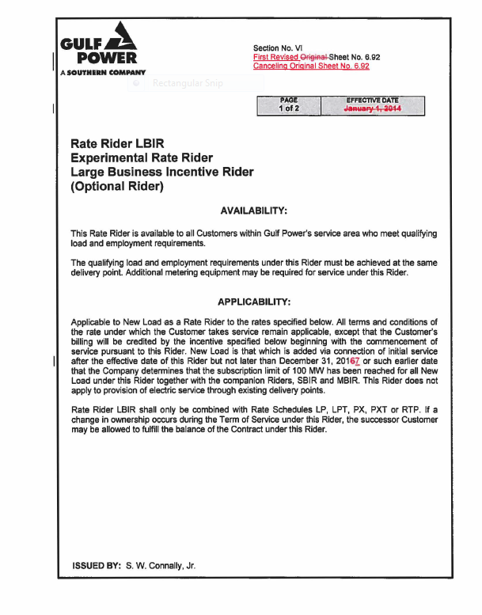

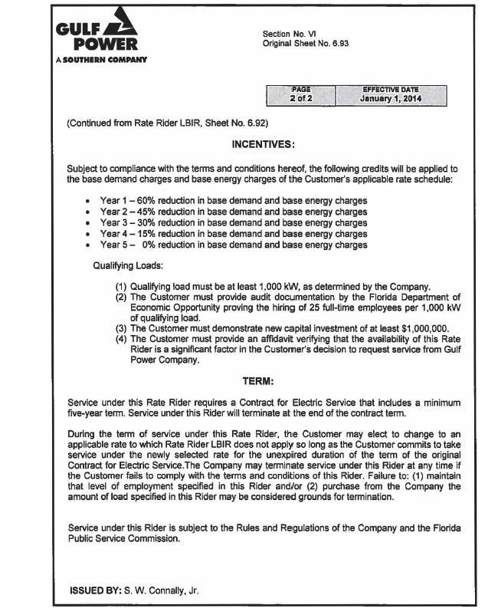

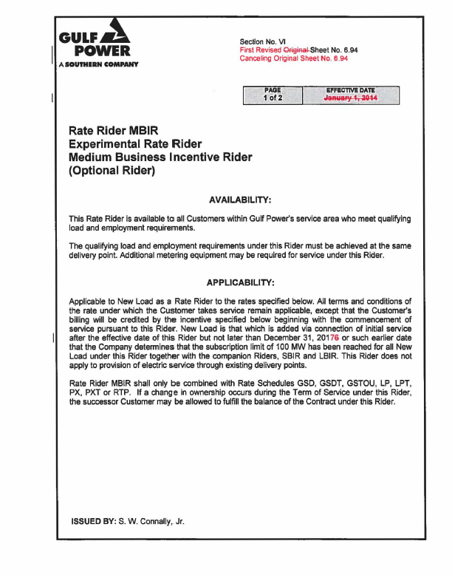

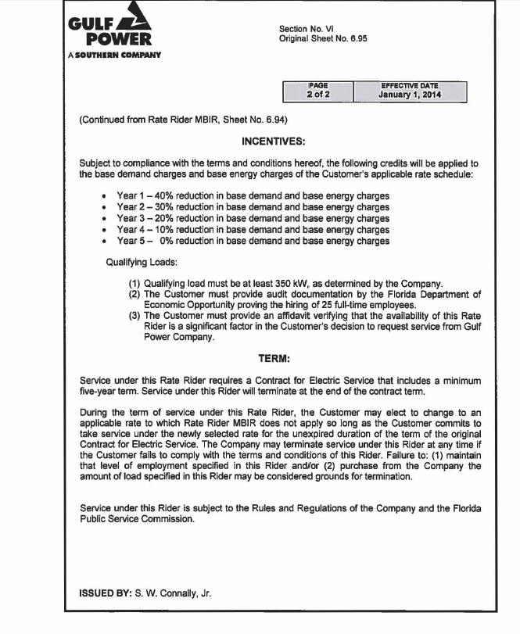

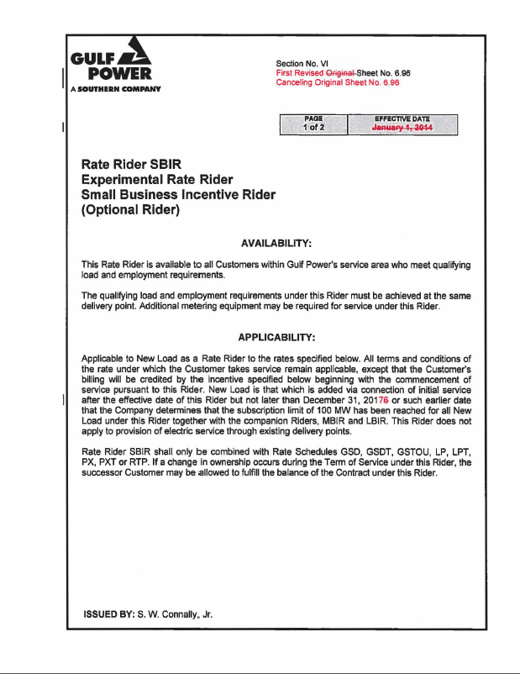

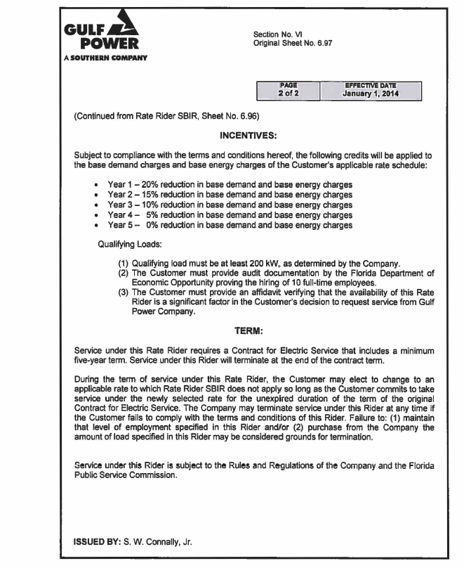

1. Order No. PSC-13-0670-S-EI, issued December 19, 2013, in Docket No. 130140-EI, *In Re: Petition for rate increase by Gulf Power Company*.