**Asset Retirement Policy**

Fixed Asset disposals occur as assets are replaced, scrapped or sold.

**Asset Replacements**

Each time a purchase order is issued, Utilities Inc’s accounting system, JD Edwards (JDE), requires that it be established whether an asset would be retired as the result of the purchase. The PO creator must mark Y or N in the ‘Replacement?’ field before the PO can be finalized. If the purchase is flagged as a replacement, the system will require the information needed to make the retirement calculation (geographic region, asset account type, year of purchase of asset being retired).

Due to the nature of utility companies we follow the group depreciation method rather than a single unit depreciation approach. Under this approach no gain or loss on retirement is recorded. The practice of not recognizing gain or loss is justified because some assets will be retired before the average service life and others after the average life.

The estimation of the proper cost amount to be retired is determined by indexing the cost of the addition based on the estimated date when the asset retired was placed in service. We use the Handy Whitman Index that is commonly used by the water utility industry for retirement purposes and accepted by our auditors and regulators.

|  |  |  |  |  |
| --- | --- | --- | --- | --- |
| Handy Whitman Retirement Calculation: | | |  |  |
|  |  |  |  |  |
| Amount to be Retired | = | Cost of New Asset | * | Cost Index Number Base Year |
| Cost Index Number Current Year |

At the end of each month, the JDE retirement module is run and retirement entries are calculated based on the information provided by the purchase orders. Entries are created to credit the cost account and debit the accum for each particular asset group and the entry is marked with the PO number for future reference. The retirement module will only process entries for POs which have been paid, verifying the purchase has been made and new purchase costs are final.

On occasion a retirement entry will be calculated for an amount that exceeds that asset’s group current net book value. When this occurs a manual JE is created and posted to the asset account that held the original cost. This scenario occurs primarily in a handful of asset accounts where original costs were recorded in a related but alternate account. For example, a new purchase made in account 1300 – “Struct/Improv Treat Plant” is flagged as a replacement purchase; however, the retirement amount of this transaction exceeds the prior balance of that asset group. A manual JE is then calculated to retire this amount from account 1315 – “Struct/Improv Gen Plt” which was used historically and is where the original asset cost resides.

PO requires “Replacement?” field to be completed before PO can be processed: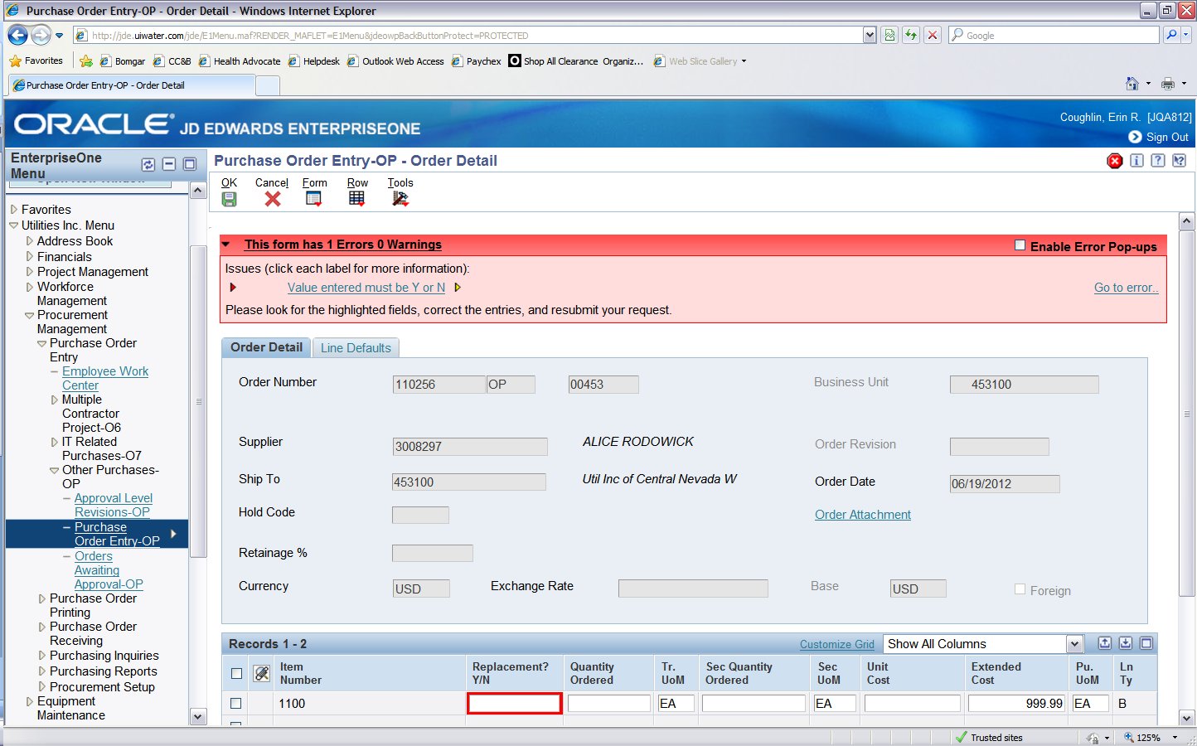

When the PO is flagged as a Replacement, the retirement form appears requiring geographic location, asset type and date of purchase of the asset being replaced/retired. These three items are required to perform the Handy Whitman Retirement Calculation: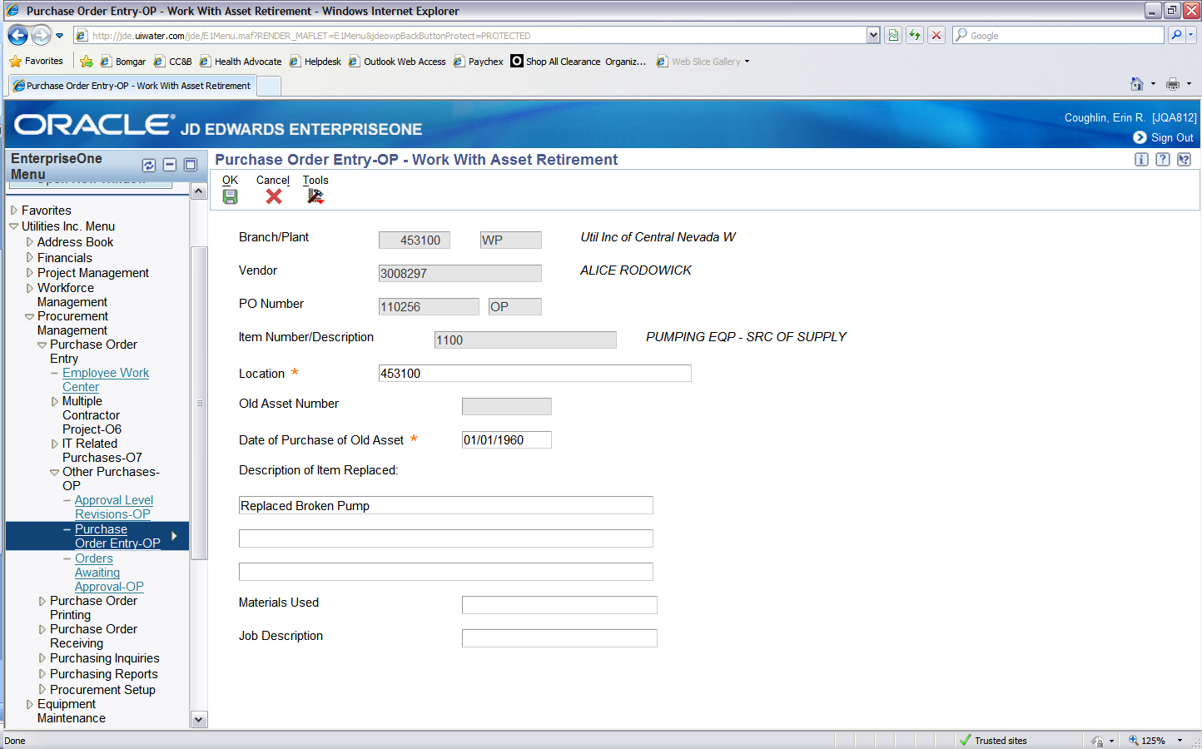

Capital Projects

When a purchase is expected to exceed $ 50,000 or last longer than 30 days, a capital project code is created to track the costs related to that effort. When the project is completed and placed in service the project manager/ owner works with accounting to determine which asset accounts have been affected and if any assets were retired as a result of the project. If the project has caused assets to be disposed, a retirement form is completed. A variation of the Handy Whitman retirement calculation is manually performed based on the information provided by the project manager. The retirement formula used for capital projects is as follows:

|  |  |  |  |  |
| --- | --- | --- | --- | --- |
| Amount to be Retired | = | Cost of Old Asset | * ( 1 - | Cost Index Number Base Year |
| Cost Index Number Current Year |

)

A journal entry is then posted to retire the asset(s), which can be based off of the entire project cost, or an isolated amount depending on the scope of the project.

System Sales

When a company or business unit is sold to an outside party, all assets are disposed at the time of sale. Any remaining net book value on the books gets posted against the sale of utility account reducing the gain on sale resulting from money received as a result of the sale.

Vehicle sales

Vehicle assets are the exception to the group depreciation method of tracking assets, in that each vehicle is assigned a unique asset number to track cost and depreciation. When vehicles are sold, the vehicle’s asset is disposed in JDE. Any remaining net book value on the books gets posted against the sale of utility account reducing the gain on sale resulting from money received as a result of the sale.

Assets scrapped or sold

In rare occasion assets are scrapped or sold and not replaced. When this occurs, the manager in charge of that region provides a manual retirement form describing the item(s) to dispose and an estimated current net book value of which to remove from the books.