State of Florida  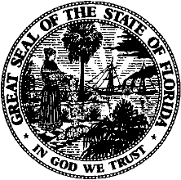 |  | Public Service Commission  Capital Circle Office Center ● 2540 Shumard Oak Boulevard  Tallahassee, Florida 32399-0850  -M-E-M-O-R-A-N-D-U-M-
DATE: | September 26, 2022
TO: | All Interested Persons
FROM: | Office of the General Counsel JHR
RE: | Docket No. 20200181-EU, Notice of Cancellation of September 27, 2022 Rule Development Workshop

NOTICE is hereby given that the staff rule development workshop scheduled for September 27, 2022, to obtain comments on potential amendments to Rule 25-17.0021, F.A.C., is CANCELLED.

The workshop will be rescheduled for a later date. A notice will be issued in the Florida Administrative Register when the workshop is rescheduled to a future date.

Cc: Office of the Commission Clerk
JHR

