BEFORE THE FLORIDA PUBLIC SERVICE COMMISSION

|  |  |
| --- | --- |
| In re: Petition for approval of modifications to rate schedule tariff sheet No. 4.122 and determination under Rule 25-6.115(12), F.A.C, by Duke Energy Florida, LLC. | DOCKET NO. 20220089-EI  ORDER NO. PSC-2022-0336-TRF-EI  ISSUED: September 28, 2022 |

The following Commissioners participated in the disposition of this matter:

ANDREW GILES FAY, Chairman

ART GRAHAM

GARY F. CLARK

MIKE LA ROSA

GABRIELLA PASSIDOMO

ORDER MODIFYING TARIFF

BY THE COMMISSION:

BACKGROUND

On April 29, 2022, Duke Energy Florida, LLC (Duke or utility) filed a petition for approval to modify Tariff Sheet No. 4.122 and for a determination under Rule 25-6.115(12), Florida Administrative Code (F.A.C.), that the limited waiver of certain costs is warranted. In its petition, Duke requested that the costs identified in Rule 25-6.115(8)(b), F.A.C., be excluded from the contribution-in-aid-of-construction (CIAC) calculation for customers requesting to underground overhead distribution facilities that have not been hardened under the utility’s Storm Protection Plan filed pursuant to Section 366.96, Florida Statutes (F.S.), and Rule 25-6.030, F.A.C. Rather, the utility requests that these costs be included in net plant in service per Rule 25-6.115(12), F.A.C.

In Order No. PSC-2022-0209-PCO-EI we suspended Duke's proposed revisions to Tariff Sheet No. 4.122 to allow our staff time to gather additional data. On June 6, 2022, staff issued its first data request, to which Duke responded on July 6, 2022. On August 17, 2022, staff held an informal conference call with the utility to get additional information regarding Duke’s proposal. We have jurisdiction over this matter pursuant to Sections 366.03, 366.04, 366.05, and 366.06, F.S.

DECISION

Current CIAC Calculation

Rule 25-6.115, F.A.C., and Duke’s tariff provide the terms under which applicants are to pay CIAC for the conversion of existing overhead distribution facilities to underground. The CIAC is designed to recover the incremental costs Duke incurs resulting from a conversion, over and above the cost of serving the conversion area with overhead facilities. Overhead service is paid by all customers through base rates. In lieu of overhead service, customers have the option of requesting to convert existing overhead to underground facilities. The CIAC paid by an applicant is to ensure that the general body of ratepayers do not bear any costs associated with the conversion.

The formula to calculate CIAC is defined in Rule 25-6.115(8), F.A.C., and in Duke's Tariff Sheet No. 4.122 (the tariff refers to the CIAC as Facility Charge). Paragraph (8)(b) of the rule requires Duke to include the estimated remaining net book value of the existing facilities to be removed less the estimated net salvage value of the facilities to be removed (existing facilities cost). Paragraph (12) of the rule allows a utility to waive all or any portion of the cost for providing underground facilities. If the utility waives any charge, the utility is required to reduce net plant in service unless we determine that there is a quantifiable benefit to the general body of ratepayers commensurate with the waived charge.

Storm Protection Plan and Cost Recovery

In February 2020, Rules 25-6.030, F.A.C., Storm Protection Plan (SPP), and 25-6.031, F.A.C., Storm Protection Plan Cost Recovery Clause (SPP Clause), were implemented to codify Section 366.96, F.S. These rules establish a utility’s process for reporting to this Commission its hardening efforts for transmission and distribution facilities from extreme weather events and to allow for the recovery of prudent hardening-related costs. Under the SPP, a utility must provide us with a storm protection plan outlining its hardening initiatives for the upcoming 10-year period. In addition, the utility must update its plan every three years. The SPP Clause allows the utility to seek recovery from the general body of ratepayers of these hardening costs through an annual cost recovery mechanism. Prior to the SPP statute being implemented, utilities made investments in storm hardening under Rule 25-6.042, F.A.C. (storm hardening rule).

Duke’s Proposal

Duke’s proposed modifications would exclude the cost of existing facilities from the calculation of the CIAC for customers requesting to underground overhead facilities that have not been hardened under the utility’s SPP. Attachment A to this order is Duke's proposed revision to Tariff Sheet No. 4.122, which contemplates that elements a, b, and c of the CIAC formula be excluded from the CIAC calculation for an applicant that intends to convert qualifying, non-hardened overhead facilities to underground. Specifically, the elements to be excluded are: a) the remaining net book value of existing overhead facilities to be removed; b) the removal cost of existing overhead facilities; and c) the salvage value of existing overhead facilities.

In general, hardening includes the strengthening of the overhead system or the conversion of overhead to underground. To support its petition, Duke stated the utility intends to eventually harden all overhead facilities as part of its SPP and seek cost recovery through the SPP Clause paid by all customers. Duke contends that customers who pay CIAC to underground non-hardened facilities are effectively hardening the facilities and, thereby, save the general body of ratepayers from the cost of having to harden those facilities through the SPP Clause. Duke explained that the utility will review each request for undergrounding to determine if the distribution lines were previously hardened under the SPP to ensure that only facilities that have not yet been hardened are eligible for the proposed revised CIAC calculation.

Duke states that the utility has just begun the hardening of its lateral lines under its SPP and that approximately 96 percent of current lateral lines still require hardening efforts. The utility states that it will take approximately 40 years to complete the hardening of these facilities.

Duke’s tariff specifies the terms and conditions for customers, or applicants, seeking the undergrounding of existing distribution facilities by Duke. The tariff also defines which distribution facilities do not qualify for underground conversions pursuant to Tariff Sheet No. 4.122. Tariff Sheet Nos. 4.120 and 4.121 (pages 1 and 2 of Attachment A), show which customers qualify and which do not qualify for conversion pursuant to this tariff. Municipalities are typically the type of customer requesting the undergrounding of distribution facilities. The utility noted that in 2021, three municipalities requested a conversion that would have qualified under this proposal. The average CIAC for the three municipalities was $1.53 million. If the proposed tariff revision is approved, Duke stated that customers with active underground conversion projects for facilities that were not previously hardened will receive a reduction in the CIAC estimate already received.

In addition, Duke requests that we determine that there are quantifiable benefits to the general body of ratepayers from the exclusion of the existing non-storm hardened facilities cost from the CIAC calculation for the underground conversions. This determination would allow Duke, pursuant to Rule 25-6.115(12), F.A.C., to treat these existing facilities costs as net plant in service costs that can be recovered from all customers.

Duke has provided an analysis quantifying the benefits of undergrounding. Specifically, based on three undergrounding projects, Duke compared the estimated storm restoration savings for a hardened overhead system to the estimated storm restoration savings for the same underground system over 40 years. Duke explained that while both a hardened overhead system and an underground system provide savings in storm restoration costs, an underground system provides greater savings. Duke’s analysis shows that an underground system, on a net present value basis, provides 45 percent greater savings in storm restoration costs on a per mile basis compared to a hardened overhead system. We have reviewed Duke’s analysis, and based on the three projects chosen by Duke, it appears reasonable.

Benefit to the General Body of Ratepayers

Duke stated in its petition four benefits to the general body of ratepayers from excluding the cost from the calculation of CIAC for underground conversions of the existing non-hardened overhead facilities. First, Duke asserts that the general body of ratepayers would not pay any additional costs related to the conversion because these costs would eventually be included as part of Duke’s SPP Clause process. Second, Duke asserts that in instances where the utility’s SPP is scheduled to keep the existing facilities overhead, but hardened, the utility states that undergrounding provides greater storm resiliency which would benefit all customers. Third, Duke states that because the converting customer is accelerating the timing of when the utility would have hardened the facilities, the general body of ratepayers would receive the benefits of such hardening more quickly. Finally, the utility asserts that the cost of conversion may incentivize more customers to convert, which would further reduce the hardening projects that the general body of ratepayers would have to pay through the SPP Clause.

We have previously recognized the benefits of undergrounding. In 2007, Rule 25- 6.115, F.A.C., was amended to include in the CIAC calculation the cost of maintenance and storm restoration activities over time to capture the longer-term costs and benefits of undergrounding. Prior to this rule amendment, the CIAC was based on estimated work order cost only.

In 2018, we approved the same revision to the CIAC calculation and the request to include the waived existing facilities cost in net plant in service for Florida Power & Light Company (FPL).[1] The SPP Clause rule was not in effect in 2017; however, utilities made storm hardening investments pursuant to the storm hardening rule with Commission-approved costs being born by the general body of ratepayers through base rates.

As required by Rule 25-6.115(12), F.A.C., Duke has provided an analysis quantifying the benefits of waiving certain costs from the CIAC calculation for customers choosing to underground non-hardened overhead distribution facilities. Duke’s analysis showing the expected storm restoration savings as a result of undergrounding is reasonable. In addition, encouraging the undergrounding of non-hardened facilities provides benefits to the general body of ratepayers through future reductions in Storm Protection Plan costs. Based on the discussion above, we find that Duke’s petition for a determination under Rule 25-6.115(12), F.A.C., to waive certain costs and approve associated revised Tariff Sheet No. 4.122 meets the requirements of Rule 25-6.115(12), F.A.C., and is hereby granted.

At the September 8, 2022 Agenda Conference, the Office of Public Counsel (OPC) and Duke presented additional terms and conditions the parties agreed upon with regard to the implementation of this tariff modification and requested our approval of these conditions. These conditions are:

1. Duke agrees to record any costs attributable to the waiver of the three elements of the calculation of CIAC – as incurred. Duke will not seek to defer such costs or to create a regulatory asset for them.

2. Duke agrees to take reasonable steps to cost-effectively maintain records to provide information on the number of, and dollar amounts related to, these CIAC element waivers so they will be available as part of the next SPP or rate case determination. Duke will make its best efforts to provide this information in that proceeding by answering any discovery from the Commission or intervenors on dollar amounts and number of waivers. Duke can, at its sole discretion, include such information in the SPP.

We find that these terms are reasonable and approve their implementation with regard to this tariff.

Based on the foregoing, it is

ORDERED by the Florida Public Service Commission that Duke Energy Florida, LLC’s Petition for Approval of Modifications to Duke Energy Florida, LLC’s Rate Schedule Tariff Sheet No. 4.122 and Determination under Rule 25-6.115(12), F.A.C., as discussed in the body of this order, is hereby approved. It is further

ORDERED that Tariff Sheet 4.122 is modified as stated in Attachment A hereto. It is further

ORDERED that if a protest is filed within 21 days of the issuance of this order approving the proposed tariff, the current tariff shall remain in effect pending resolution of the protest. If no timely protest is filed, the approved tariff shall go into effect, and the docket be closed, upon the issuance of a consummating order.

By ORDER of the Florida Public Service Commission this 28th day of September, 2022.

|  |  |
| --- | --- |
|  | /s/ Adam J. Teitzman |
|  | ADAM J. TEITZMAN  Commission Clerk |

Florida Public Service Commission

2540 Shumard Oak Boulevard

Tallahassee, Florida 32399

(850) 413‑6770

www.floridapsc.com

Copies furnished: A copy of this document is provided to the parties of record at the time of issuance and, if applicable, interested persons.

SBr

NOTICE OF FURTHER PROCEEDINGS

The Florida Public Service Commission is required by Section 120.569(1), Florida Statutes, to notify parties of any administrative hearing or judicial review of Commission orders that is available under Sections 120.57 or 120.68, Florida Statutes, as well as the procedures and time limits that apply. This notice should not be construed to mean all requests for an administrative hearing or judicial review will be granted or result in the relief sought.

Mediation may be available on a case-by-case basis. If mediation is conducted, it does not affect a substantially interested person's right to a hearing.

The Commission's decision on this tariff is interim in nature and will become final, unless a person whose substantial interests are affected by the proposed action files a petition for a formal proceeding, in the form provided by Rule 28-106.201, Florida Administrative Code. This petition must be received by the Office of Commission Clerk, 2540 Shumard Oak Boulevard, Tallahassee, Florida 32399-0850, by the close of business on October 19, 2022.

In the absence of such a petition, this Order shall become final and effective upon the issuance of a Consummating Order.

Any objection or protest filed in this docket before the issuance date of this order is considered abandoned unless it satisfies the foregoing conditions and is renewed within the specified protest period.

ATTACHMENT A

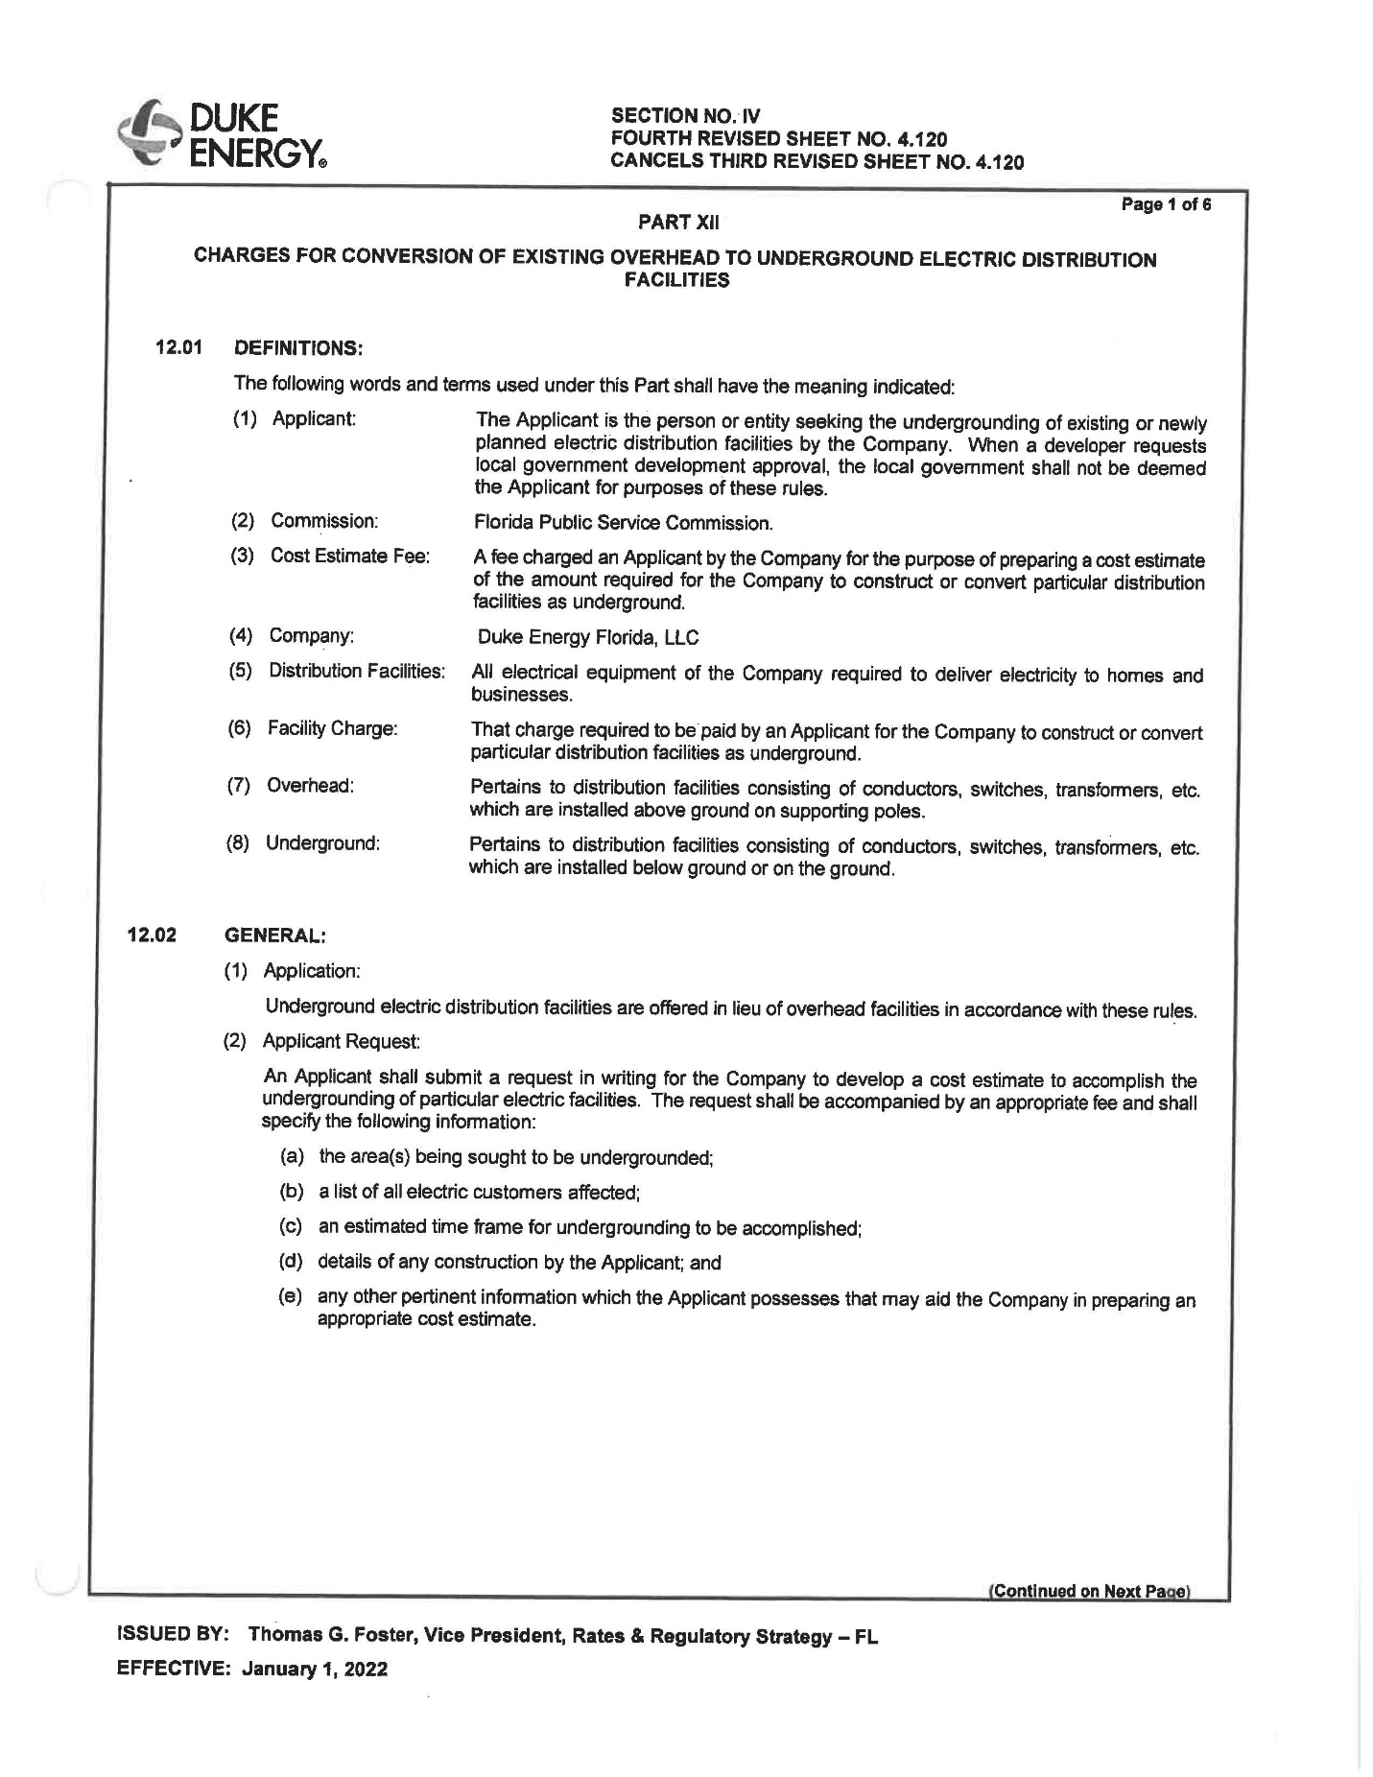

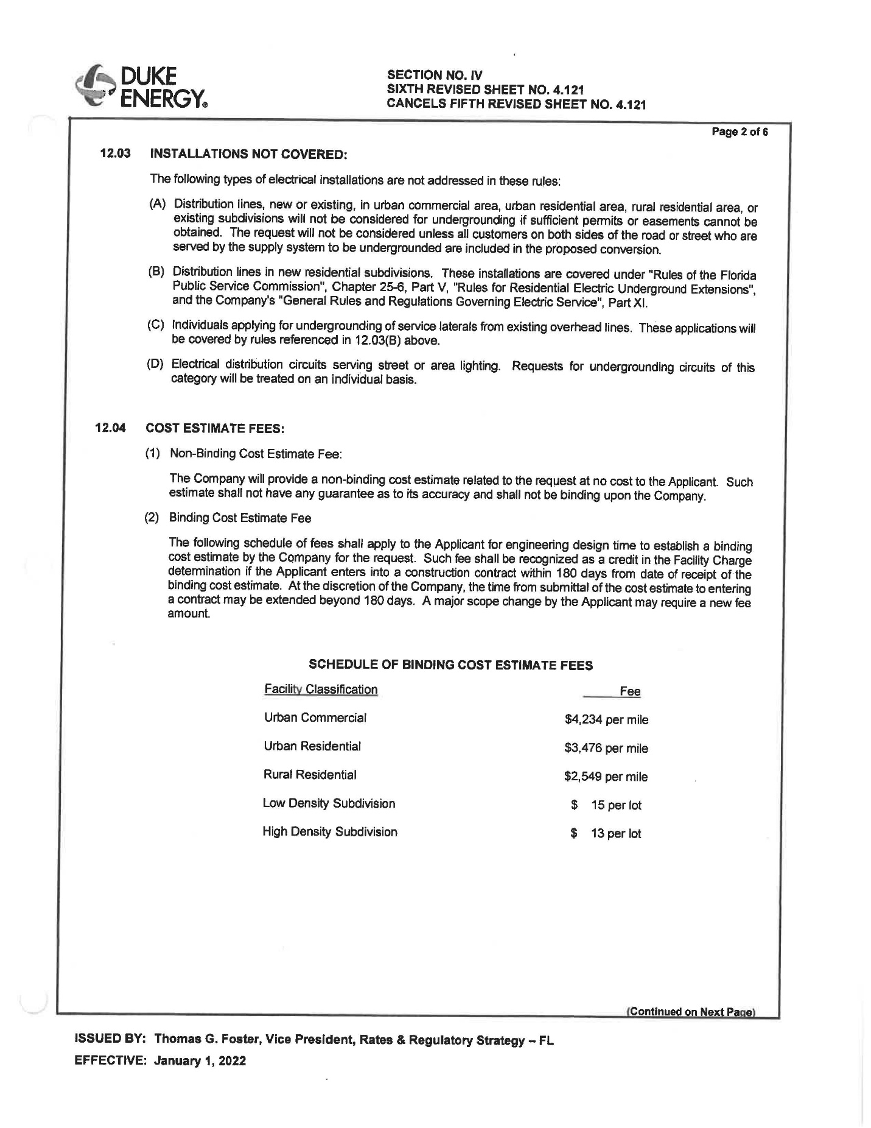

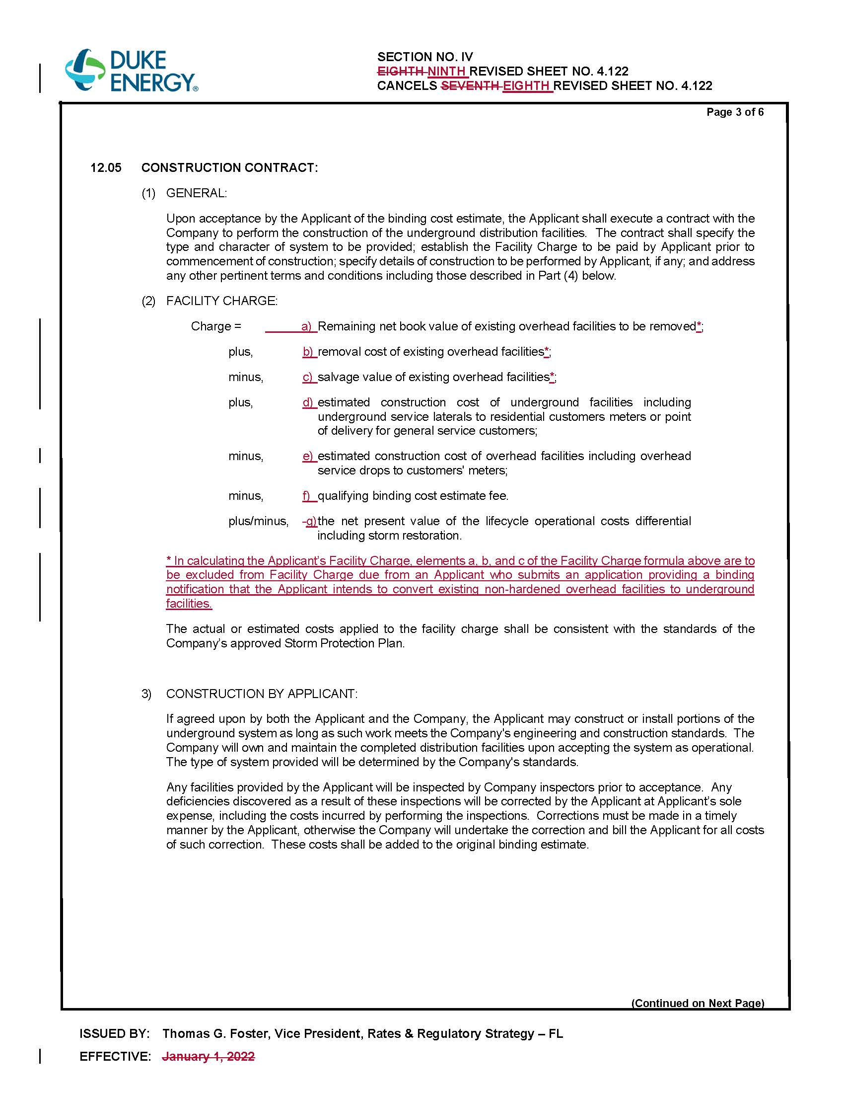

1. Order No. PSC-2018-0050-TRF-EI, issued January 22, 2018, in Docket No. 20170148-EI, *In re: Petition for determination under Rule 25-6.115, F.A.C., and approval of associated revised tariff sheet 6.300, by Florida Power & Light Company.*