BEFORE THE FLORIDA PUBLIC SERVICE COMMISSION

|  |  |
| --- | --- |
| In re: Joint petition for approval of firm transportation between Florida Public Utilities Company and Peninsula Pipeline Company, Inc. to reflect expansion of Wildlight development in Nassau County. | DOCKET NO. 20220144-GU  ORDER NO. PSC-2022-0391-PAA-GU  ISSUED: November 14, 2022 |

The following Commissioners participated in the disposition of this matter:

ANDREW GILES FAY, Chairman

ART GRAHAM

GARY F. CLARK

MIKE LA ROSA

GABRIELLA PASSIDOMO

NOTICE OF PROPOSED AGENCY ACTION

ORDER APPROVING FIRM TRANSPORTATION SERVICE AGREEMENT

BY THE COMMISSION:

NOTICE is hereby given by the Florida Public Service Commission that the action discussed herein is preliminary in nature and will become final unless a person whose interests are substantially affected files a petition for a formal proceeding, pursuant to Rule 25-22.029, Florida Administrative Code (F.A.C.).

Background

On August 16, 2022, Florida Public Utilities Company (FPUC) and Peninsula Pipeline Company, Inc. (Peninsula) (collectively, Petitioners) filed a petition seeking approval of a firm transportation service agreement (proposed Agreement) to reflect expansion of the Wildlight development in Nassau County. Peninsula operates as an intrastate natural gas transmission company as defined by Section 368.103(4), Florida Statutes (F.S.).[1] FPUC is a local distribution company subject to our regulatory jurisdiction pursuant to Chapter 366, F.S. The Petitioners are both subsidiaries of Chesapeake Utility Corporation.

By Order No. PSC-07-1012-TRF-GP,[2] Peninsula received approval of an intrastate gas pipeline tariff that allows it to construct and operate intrastate pipeline facilities and to actively pursue agreements with natural gas customers. Peninsula provides transportation service and does not engage in the sale of natural gas. Pursuant to Order No. PSC-07-1012-TRF-GP, Peninsula is allowed to enter into certain gas transmission agreements without our prior approval.[3] However, Peninsula is requesting our approval of this proposed Agreement as it does not fit any of the criteria enumerated in the tariff for which our approval would not be required.[4] Furthermore, agreements between affiliated companies must be approved by us pursuant to Section 368.105, F.S., and Order No. PSC-07-1012-TRF-GP.

In accordance with the proposed Agreement, Peninsula will construct, own, and operate natural gas pipeline extensions, two new regulator stations, and a natural gas injection interconnect in Nassau County. The Petitioners state that the proposed Agreement reflects FPUC’s ongoing efforts to extend natural gas service to meet needs associated with anticipated growth in Nassau County.

We have previously approved transportation and territorial agreements involving FPUC, Peninsula, and Peoples in Nassau County. In 2012, we approved transportation agreements between FPUC and Peninsula and between Peoples and Peninsula, as well as a territorial agreement between Peoples and FPUC.[5] In 2014, we also approved an agreement between the Petitioners to further extend facilities in Nassau County.[6] In 2015, we approved an amendment to the transportation agreement between Peninsula and Peoples.[7] Finally, in 2019, we approved further restructuring of the agreements to reflect the new Callahan intrastate pipeline, which expanded natural gas service in Nassau and Duval Counties.[8]

During the evaluation of the petition, our staff issued one data request to the Petitioners, for which responses were received on September 8, 2022. The proposed Agreement is included with this order as Attachment A. Attachment B provides a description of the proposed expansion project pipeline routes. The project maps, identifying the proposed construction projects, are included as Attachment C. We have jurisdiction over this matter pursuant to Sections 366.05(1), 366.06, and 368.105, F.S.

Decision

Proposed Transportation Agreement

The Petitioners have entered into the proposed Agreement to enhance FPUC’s ability to provide and expand natural gas service for the Wildlight community in Yulee, Florida. The facilities contemplated in the proposed Agreement will allow delivery of natural gas to areas in Nassau County that currently do not have access to natural gas service.

The proposed Agreement specifies an initial term of 20 years and thereafter shall be extended on a year-to-year basis, unless either party gives no less than 90 days of written notification of termination. If either party desires to negotiate modifications to the rates or terms of this Agreement, they may do so no less than 120 days prior to expiration of the current active term. The proposed expansion project is discussed below and the project maps are included as Attachment B to this order.

In order to build alongside the construction and development of the area, the proposed project would be constructed in two phases. Attachment B provides a description of each phase of the proposed expansion project pipeline routes. Attachment C shows the proposed expansion project in Nassau County.

Anticipated System Benefits

The Petitioners state that the proposed Agreement will further enhance FPUC’s ability to expand service for the growing Wildlight Community, located in Yulee, Florida. The petition states that there are two residential developments in the process of planning and construction. The Petitioners assert that, in total, the proposed facilities would provide natural gas service to over 5,978 homes, along with the commercial and industrial customers that may come as the area develops. Additionally, according to the proposed Agreement, Peninsula would construct a gas injection interconnect. The Petitioners state the gas injection interconnect would ensure FPUC has the ability to access gas quantities at an additional point on the line to provide additional reliability for customers.

In response to our staff’s data request, FPUC stated it did not obtain a formal Request for Proposals (RFP) responses from other entities.[9] The Petitioners explained that the facilities to be installed will be extended from facilities that are already owned and operated by Peninsula. Furthermore, the Petitioners explained in their response that the proposed project would improve service, reliability, and overall operation benefits and does not require coordination with other parties and operators.

Negotiated Monthly Reservation Payments to Peninsula

In accordance with the proposed Agreement, Peninsula would recover the project construction costs through the monthly reservation charges to FPUC, as contained in the proposed Agreement. Given that the proposed project would be completed in phases, the Petitioners have explained that the total monthly reservation charge will increase as each portion of the project goes into service. The monthly reservation charge is designed to recover costs such as, but not limited to, engineering, permitting, materials, and installation costs associated with pipeline and related facilities, ongoing maintenance including Pipeline and Hazardous Materials Safety Administration (PHMSA) compliance, safety requirements, property taxes, gas control, and Peninsula’s return on investment.

FPUC is proposing to recover its payments to Peninsula through Purchased Gas Adjustment (PGA) and swing service rider mechanisms.[10] The PGA allows FPUC to periodically adjust the price of natural gas supplied to its customers to reflect the actual cost of gas purchased and delivered on behalf of the customers. The swing service rider allows FPUC to recover intrastate capacity costs from its transportation customers and is a cents per therm charge that is included in the monthly customer gas bill of transportation customers. While FPUC will incur costs associated with this service expansion, new load added to the system will help spread the costs over a larger customer base.

Conclusion

Based on the petition and the Petitioners’ responses to our staff’s data request, the proposed Agreement is reasonable and meets the requirements of Section 368.105, F.S. Furthermore, the proposed Agreement is in the public interest, because it facilitates the delivery of natural gas to areas in Nassau County that currently do not have access to natural gas service. Therefore, we approve the proposed Firm Transportation Service Agreement between Peninsula and FPUC dated July 8, 2022.

Based on the foregoing, it is

ORDERED by the Florida Public Service Commission that the proposed Firm Transportation Service Agreement between Peninsula Pipeline Company, Inc. and Florida Public Utilities Company, dated July 8, 2022, is hereby approved. It is further

ORDERED that the provisions of this Order, issued as proposed agency action, shall become final and effective upon the issuance of a Consummating Order unless an appropriate petition, in the form provided by Rule 28-106.201, Florida Administrative Code, is received by the Commission Clerk, 2540 Shumard Oak Boulevard, Tallahassee, Florida 32399-0850, by the close of business on the date set forth in the “Notice of Further Proceedings” attached hereto. It is further

ORDERED that in the event this Order becomes final, this docket shall be closed.

By ORDER of the Florida Public Service Commission this 14th day of November, 2022.

|  |  |
| --- | --- |
|  | /s/ Adam J. Teitzman |
|  | ADAM J. TEITZMAN  Commission Clerk |

Florida Public Service Commission

2540 Shumard Oak Boulevard

Tallahassee, Florida 32399

(850) 413‑6770

www.floridapsc.com

Copies furnished: A copy of this document is provided to the parties of record at the time of issuance and, if applicable, interested persons.

NRP/JSC

NOTICE OF FURTHER PROCEEDINGS OR JUDICIAL REVIEW

The Florida Public Service Commission is required by Section 120.569(1), Florida Statutes, to notify parties of any administrative hearing that is available under Section 120.57, Florida Statutes, as well as the procedures and time limits that apply. This notice should not be construed to mean all requests for an administrative hearing will be granted or result in the relief sought.

Mediation may be available on a case-by-case basis. If mediation is conducted, it does not affect a substantially interested person's right to a hearing.

The action proposed herein is preliminary in nature. Any person whose substantial interests are affected by the action proposed by this order may file a petition for a formal proceeding, in the form provided by Rule 28-106.201, Florida Administrative Code. This petition must be received by the Office of Commission Clerk, 2540 Shumard Oak Boulevard, Tallahassee, Florida 32399-0850, by the close of business on December 5, 2022.

In the absence of such a petition, this order shall become final and effective upon the issuance of a Consummating Order.

Any objection or protest filed in this/these docket(s) before the issuance date of this order is considered abandoned unless it satisfies the foregoing conditions and is renewed within the specified protest period.

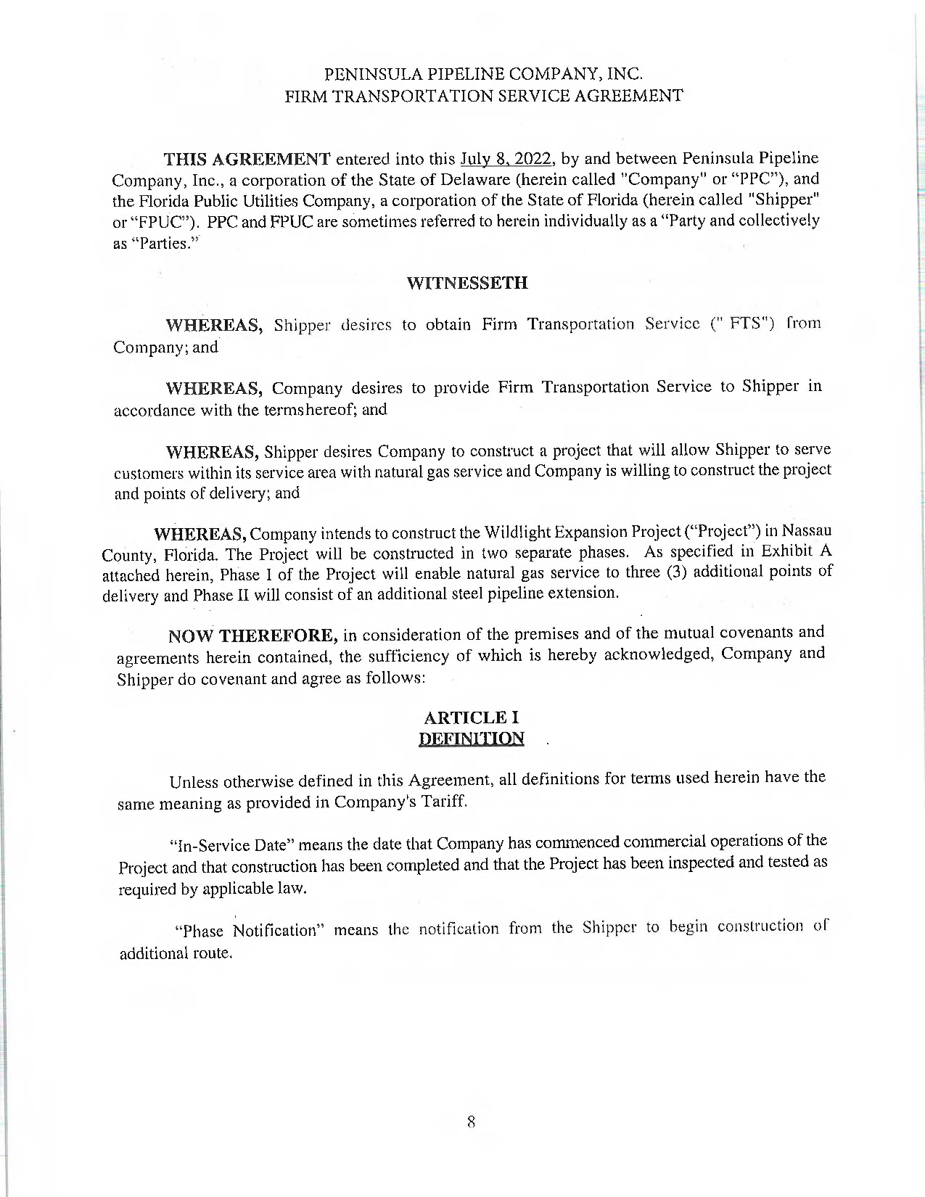

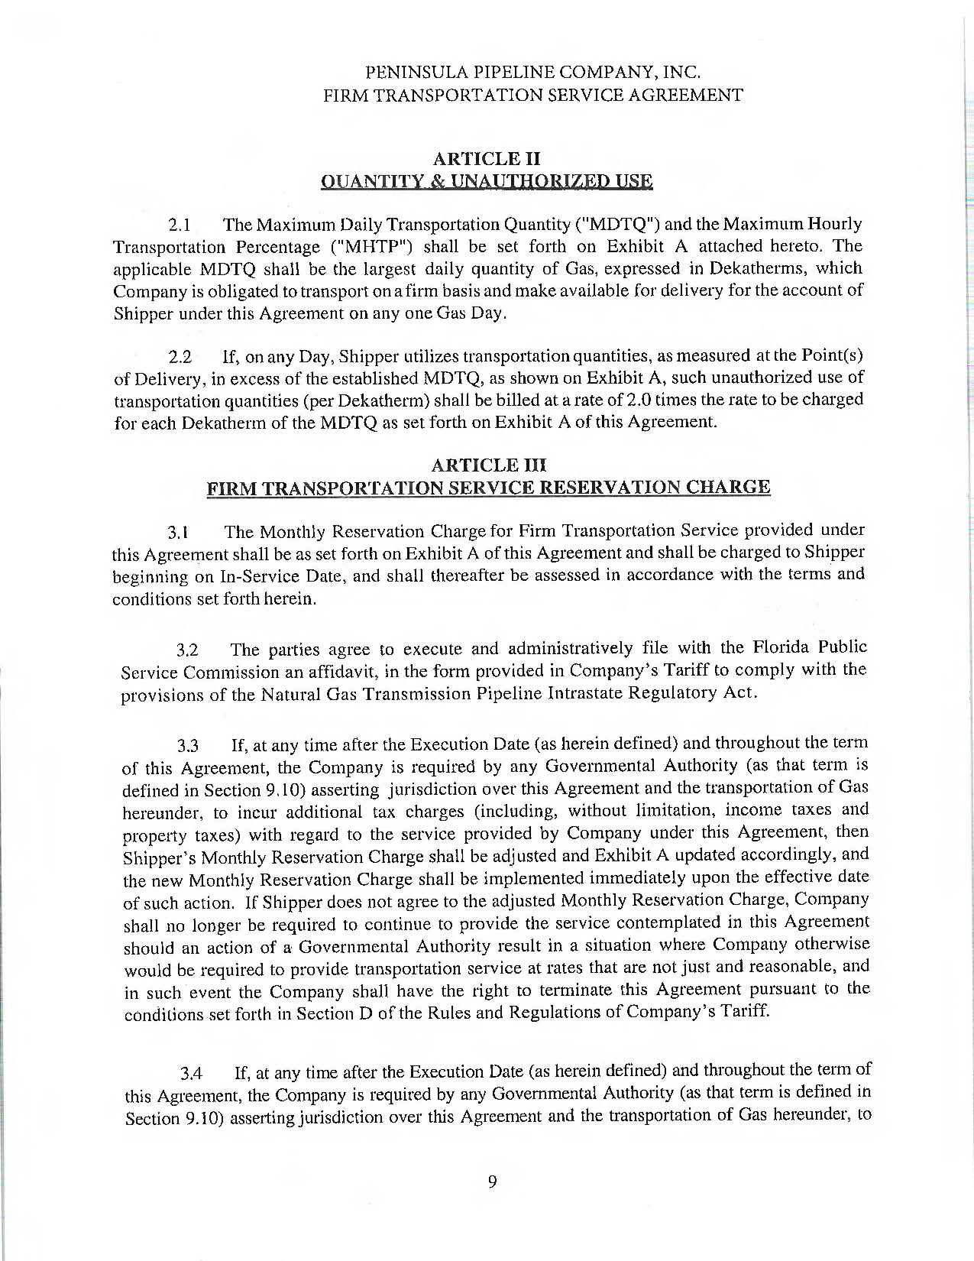

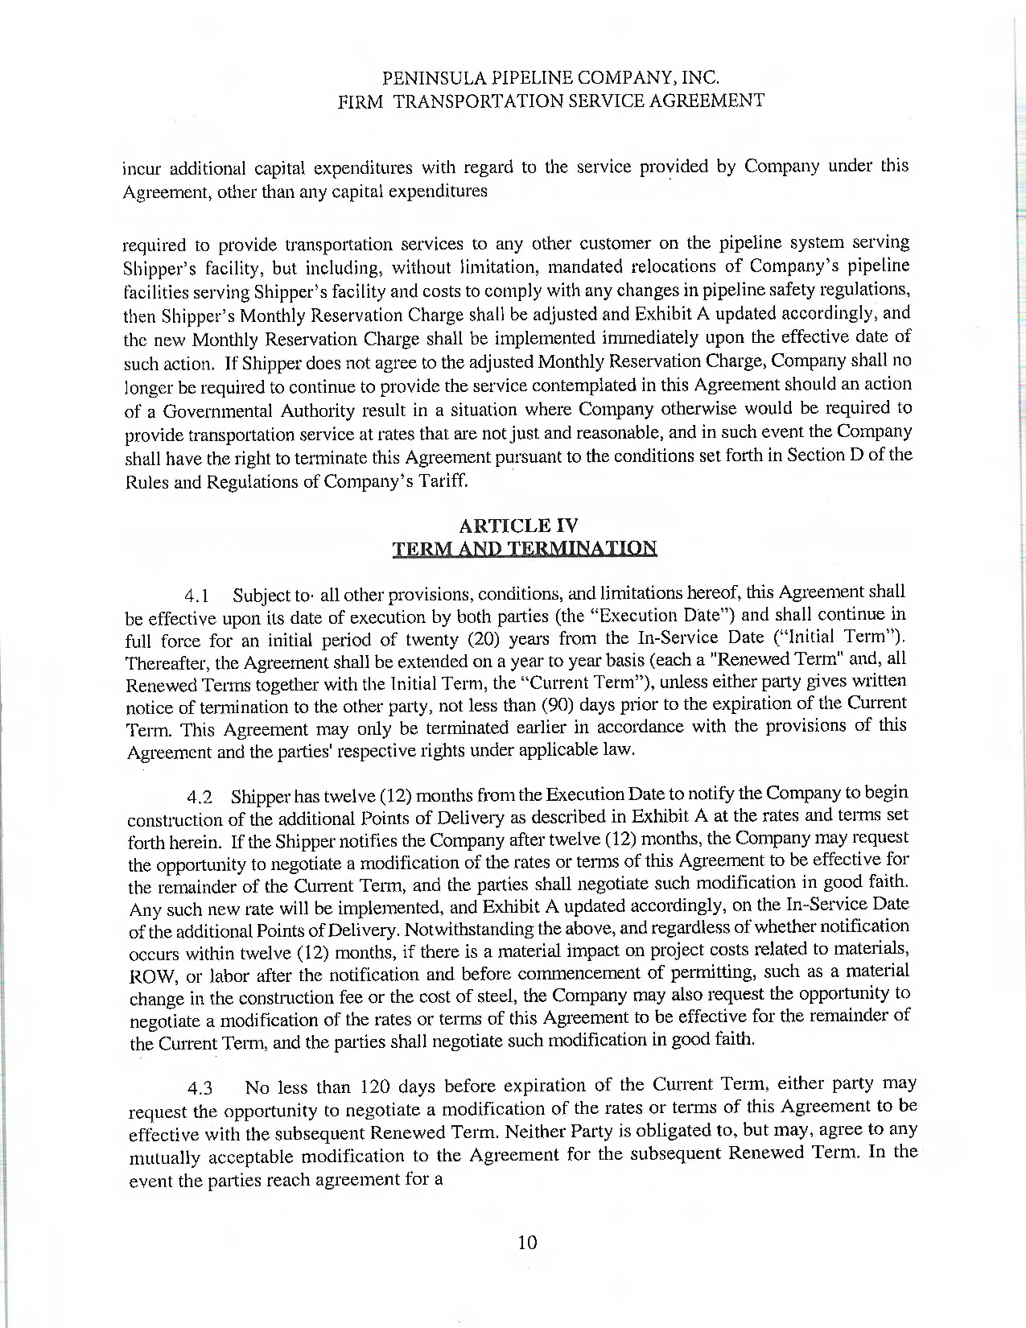

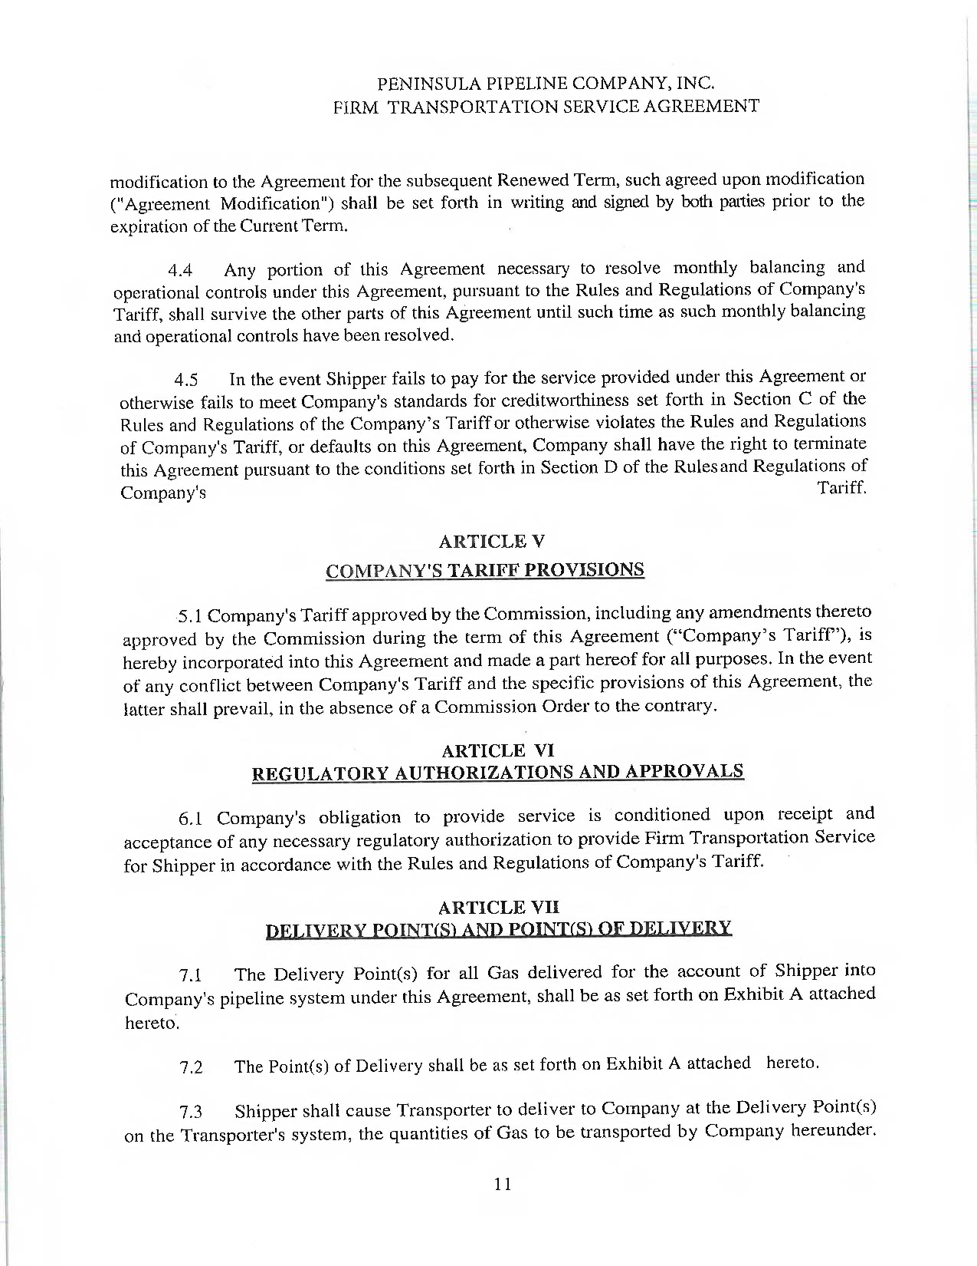

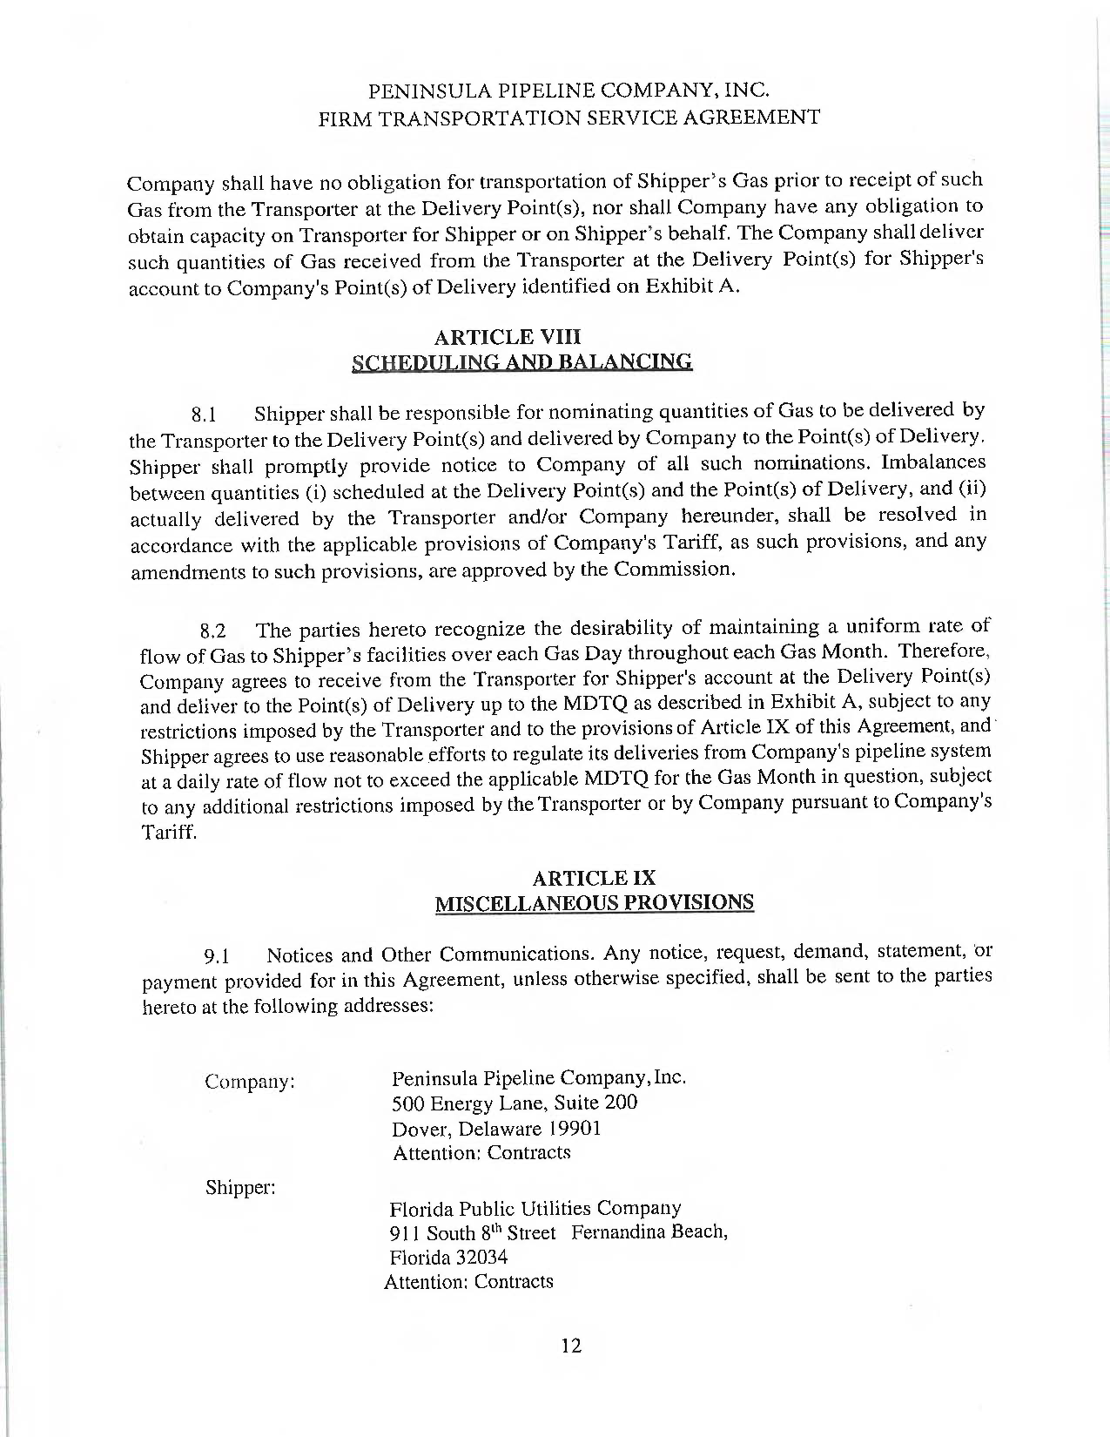

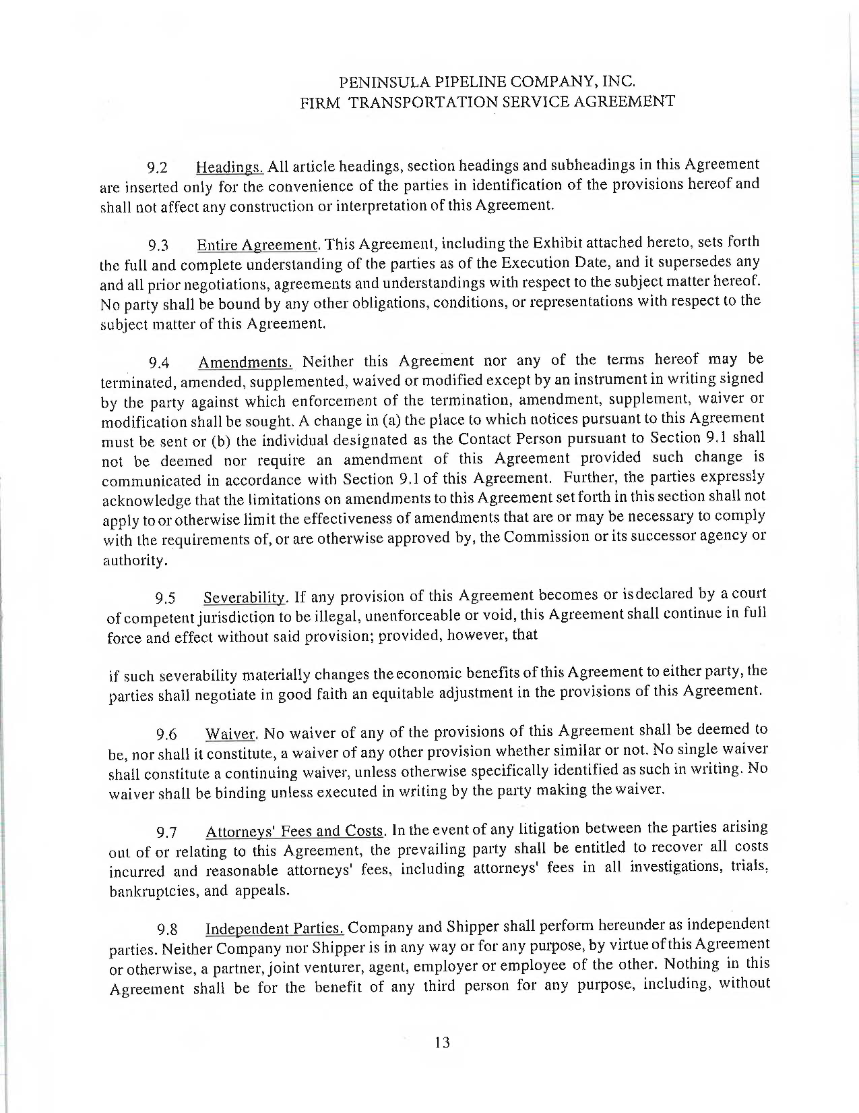

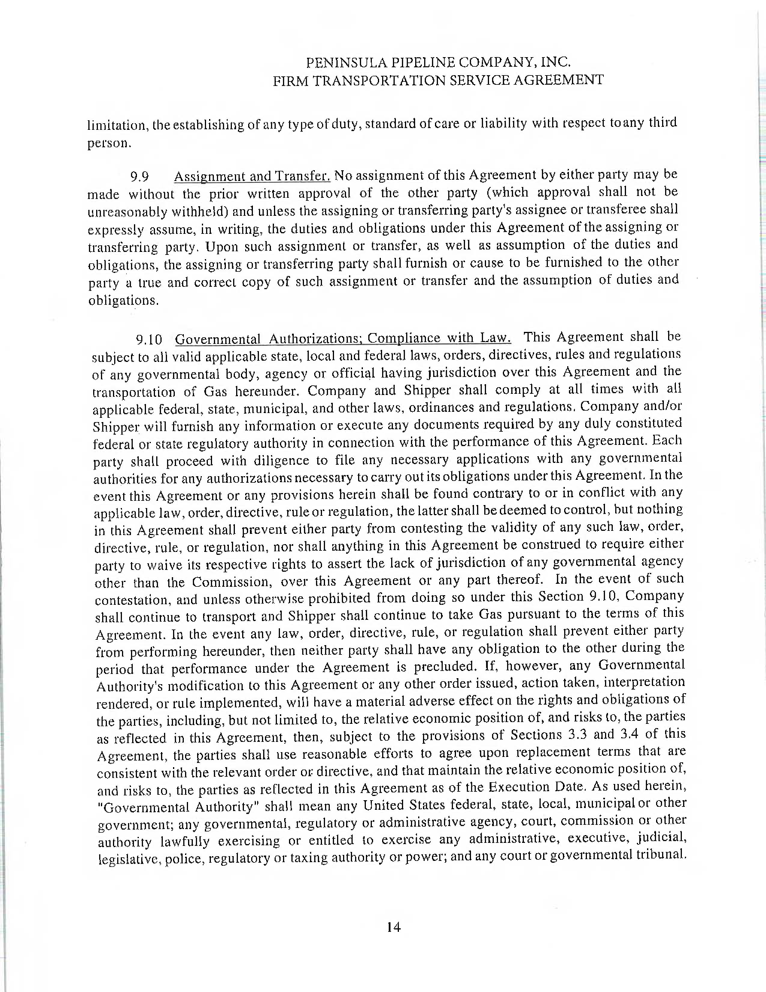

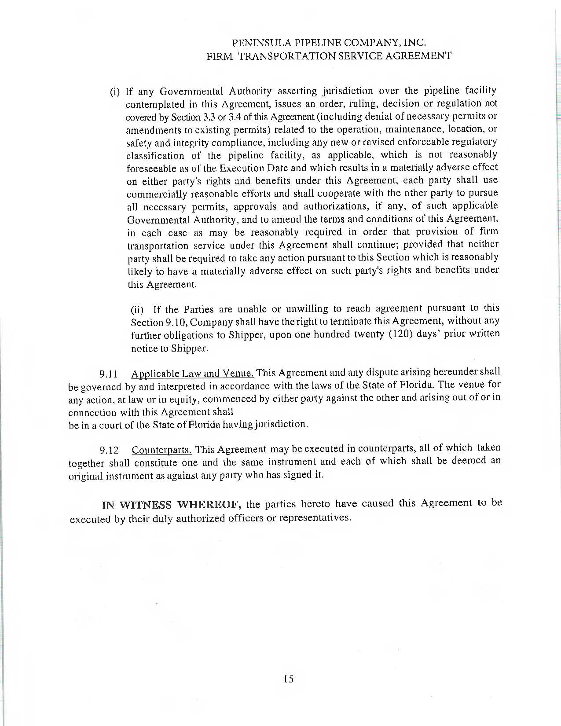

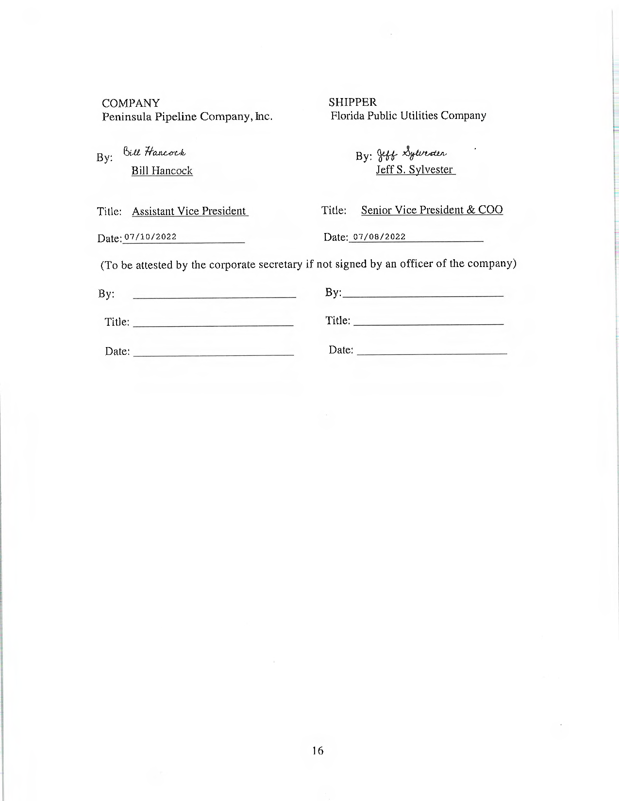

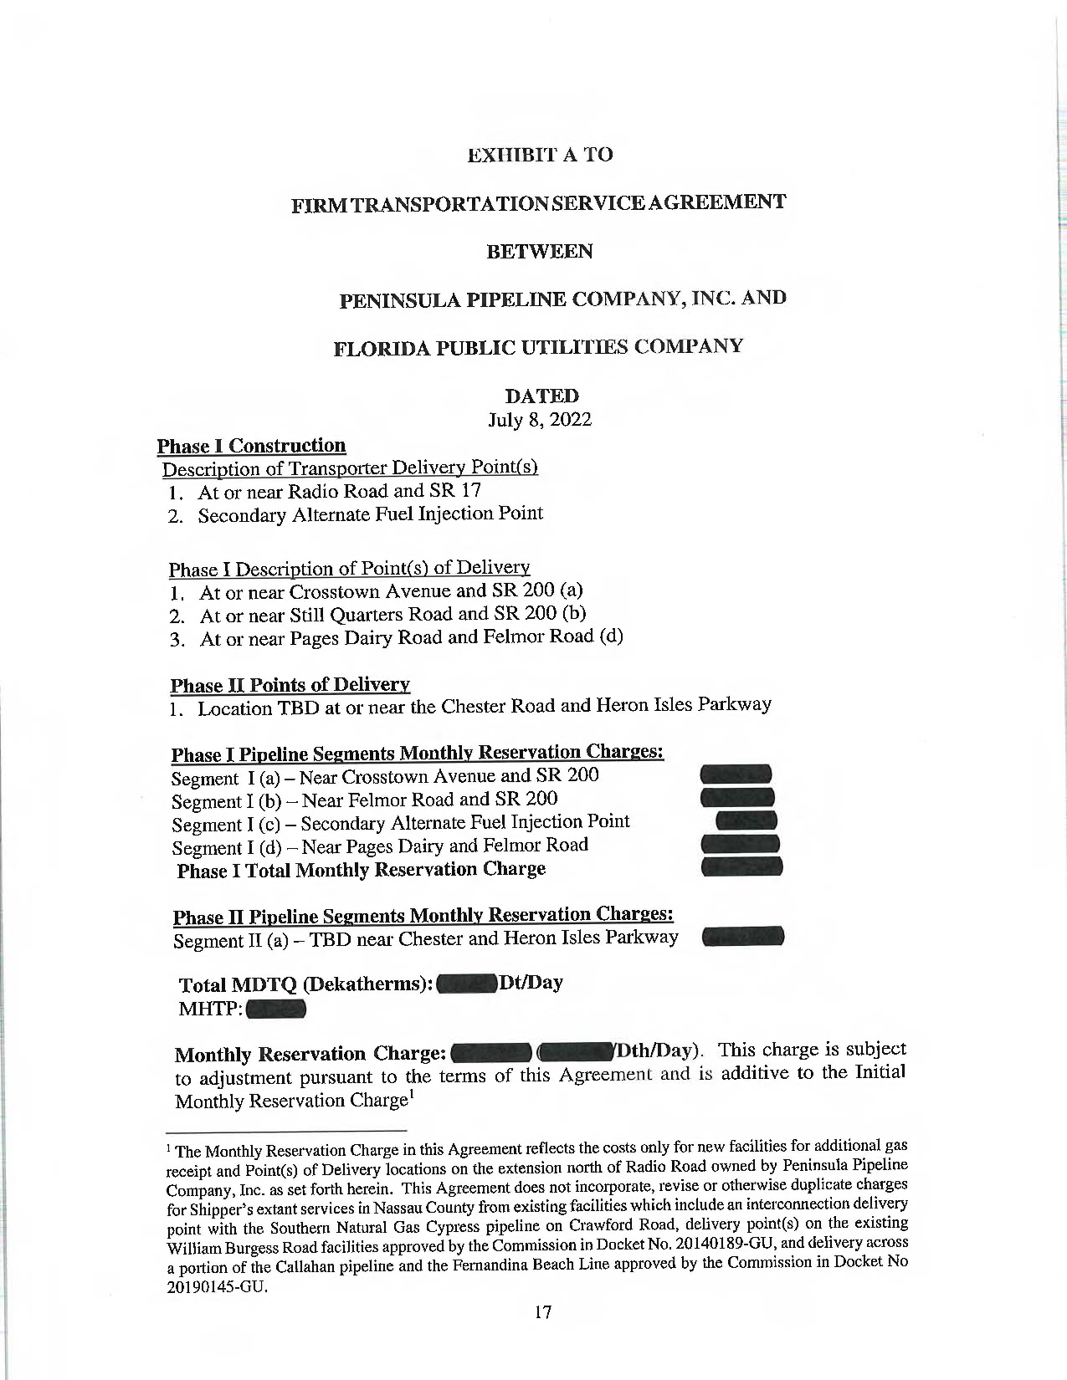

**Proposed Expansion Project Pipeline Routes**

Phase 1A would consist of approximately 7,525 feet of 6-inch steel pipeline and 3,675 feet of 6-inch high-density polyethylene pipe (HDPE) in total, as well as a regulator station. Beginning at the existing gas main, Peninsula will construct 6-inch steel pipeline east along State Road 200 to the intersection of State Road 200 and Crosstown Avenue. Peninsula would then construct 6-inch steel pipeline north, along Crosstown Avenue, and ending near Curiosity Avenue. Peninsula would also construct a regulator station on Crosstown Avenue, just north of State Road 200. From the regulator station, Peninsula would install 6-inch HDPE northwards along Crosstown Avenue continuing to a point of delivery for FPUC. The Petitioners state that this portion of the project is contemplated to be completed by the first quarter of 2023.

Phase 1B would consist of approximately 4,000 feet of 8-inch steel pipeline and 500 feet of 2-inch steel pipeline. Peninsula would construct a new tie-in with existing facilities along State Road 200 and would build 8-inch steel pipeline north along Felmor Road to the intersection of Pages Dairy Road. From there, Peninsula would install 2-inch steel pipeline to the entrance of a new housing development, which would be the new point of delivery for FPUC. The Petitioners state that Phase 1B is also contemplated to be completed by the first quarter of 2023.

As mentioned above, Peninsula would also construct a gas injection interconnect in Phase 1 of the proposed project, which would be located near the intersection of Radio Avenue and US Highway 17. By serving as an emergency backup point for injecting gas supplies, the Petitioners state that the gas injection interconnect will ensure FPUC has the ability to access gas quantities at an additional point on the line to provide additional reliability to others.

Phase 1D of the proposed project would consist of approximately 12,400 feet of 8-inch steel pipeline and 4,400 feet of 6-inch steel pipeline, as well as a regulator station. Peninsula would begin by constructing a new regulator station near the intersection of Radio Avenue and US Highway 17 which would tie into the existing facilities. From the regulator station, Peninsula would build 8-inch steel pipeline north along US Highway 17 to the intersection of Pages Dairy Road. Peninsula would then construct 6-inch steel pipeline along Pages Dairy Road, east along State Road 200, and terminating on Still Quarters Road. The Petitioners state that Phase 1D is contemplated to be completed by the first quarter of 2024.

For Phase 2 of the proposed project, the Petitioners plan to construct the pipeline extension in two portions. Page 2 of Attachment C shows Phase 2 of the proposed project. The first portion of Phase 2 would begin at the existing facilities near the intersection of State Road 200 and David Hallman Parkway. From here, Peninsula would install approximately 11,000 feet of 8-inch steel pipeline along David Hallman Parkway, continuing north onto Chester Road to Heron Isles Parkway. The Petitioners state that this portion of the project is contemplated to be completed by the third quarter of 2024.

Finally, the second portion of Phase 2 would continue from the end of the first portion, along Chester Road and Heron Isles Parkway. The Petitioners agree that Peninsula would construct approximately 22,000 feet of 8-inch steel pipeline along a road not yet completed named Spine Road. The Petitioners state that this portion of the project is contemplated to be completed by the third quarter of 2024.

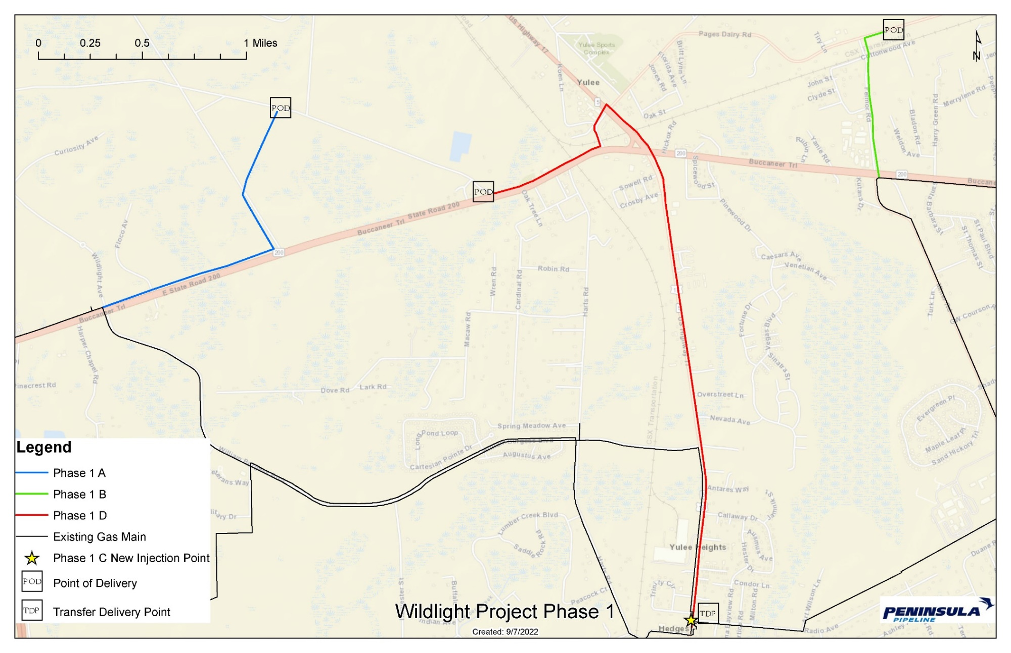

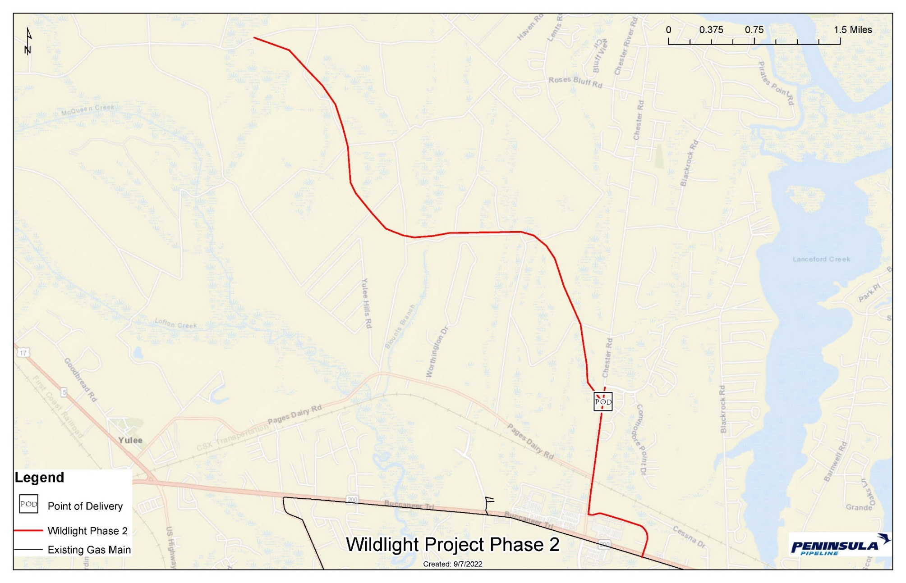

1. Order No. PSC-06-0023-DS-GP, issued January 9, 2006, in Docket No. 20050584-GP, *In re: Petition for declaratory statement by Peninsula Pipeline Company, Inc. concerning recognition as a natural gas transmission company under Section 368.101, F.S., et seq.*
2. Order No. PSC-07-1012-TRF-GP, issued December 21, 2007, in Docket No. 20070570-GP, *In re: Petition for approval of natural gas transmission pipeline tariff by Peninsula Pipeline company, Inc.*
3. Peninsula Pipeline Company, Inc., Intrastate Pipeline Tariff, Original Vol. 1, Original Sheet No. 11, Section 3.
4. Peninsula Pipeline Company, Inc., Intrastate Pipeline Tariff, Original Vol. 1, Original Sheet No. 12, Section 4.
5. Order No. PSC-12-0230-PAA-GU, issued May 9, 2012, in Docket No. 20110271-GU, *In re:* *Petition for approval of transportation service agreement with Florida Public Utilities Company, by Peninsula Pipeline Company, Inc.*
6. Order No. PSC-14-0713-PAA-GU, issued December 31, 2014, in Docket No. 20140189-GU, *In re: Petition for approval of transportation service agreement for an extension in Nassau County with Florida Public Utilities Company, by Peninsula Pipeline Company, Inc.*
7. Order No. PSC-15-0318-PAA-GP, issued August 10, 2015, in Docket No. 20150094-GP, *In re: Petition for approval of amendment to special contract with Peninsula Pipeline Company, by Peoples Gas System.*
8. Order No. PSC-2019-0545-PAA-GU, issued December 20, 2019, in Docket No. 20190145-GU, *In re: Joint petition for approval of restructures Nassau County agreements to reflect Callahan expansion, by Peoples Gas System, Florida Public Utilities Company, SeaCoast Gas Transmission, and Peninsula Pipeline Company, Inc.*
9. Joint Responses to Staff’s First Data Request, No. 2 (DN 06132-2022)
10. Joint Responses to Staff’s First Data Request, No. 8 (DN 06132-2022)