BEFORE THE FLORIDA PUBLIC SERVICE COMMISSION

In re: Petition to implement 2023 generation base rate adjustment provisions in 2021 agreement, by Tampa Electric Company. | DOCKET NO. 20220148-EI  ORDER NO. PSC-2022-0434-TRF-EI  ISSUED: December 21, 2022

The following Commissioners participated in the disposition of this matter:

ANDREW GILES FAY, Chairman
ART GRAHAM
GARY F. CLARK
MIKE LA ROSA
GABRIELLA PASSIDOMO

ORDER APPROVING TAMPA ELECTRIC COMPANY’S
2023 GENERATION BASE RATE ADJUSTMENT

BY THE COMMISSION:

Background
On August 26, 2022, Tampa Electric Company (TECO or Company) filed a petition to implement the 2023 Generation Base Rate Adjustment (GBRA) provisions in its 2021 rate case Stipulation and Settlement Agreement (settlement agreement). We previously approved the settlement agreement in Order No. PSC-2021-0423-S-EI (settlement order). The GBRA provisions of the settlement agreement provide for an increase in base rates to reflect the 2023 GBRA amount of $89,754,622, effective with the first billing cycle of January 2023. In this petition, TECO proposed to increase the GBRA amount to $91,011,994, to reflect the increased return on equity (ROE) allowed by a trigger provision of the 2021 settlement agreement and approved by us in Docket No. 20220122-EI.
This item was deferred from the October 4, 2022 Agenda Conference to give the Company time to update its request to reflect the impact of the Inflation Reduction Act of 2022 (IRA). The Company now has indicated it is in the process of updating the 2023 GBRA and is in discussions with the Office of Public Counsel about its proposed update. The Company is requesting that we consider its request now so the 2023 GBRA can go into effect with the first billing cycle of January 2023. The Company agrees to collect the rate increase reflected in the 2023 GBRA subject to refund. The Company will refund the difference between the 2023 GBRA, as reflected in the Original Petition and this Order, and the 2023 GBRA as adjusted for the IRA, once we have approved the adjusted 2023 GBRA.

On October 10, 2022, TECO filed a letter in the docket file waiving the 60-day file and suspend provision of Section 366.06(3), Florida Statutes (F.S.). We have jurisdiction over this matter pursuant to Section 366.076, F.S.

Decision
As discussed above, the GBRA provisions of the 2021 settlement agreement provide that TECO’s base rates will increase by $89,754,622 effective with the first billing cycle in January 2023. The calculation of this GBRA amount was based on the authorized return on equity (ROE) mid-point of 9.95 percent as specified in subparagraph 2(a). However, subparagraph 4(d) states that if the Company’s authorized ROE mid-point changes by operation of subparagraph 2(b) prior to the effective date of the rate adjustment specified in subparagraph 4(b), the calculation of the 2023 GBRA amount shall be updated to reflect the new authorized ROE.
As memorialized in Order No. PSC-2022-0322-FOF-EI, we approved TECO’s petition to implement the ROE trigger provisions of subparagraph 2(b) of the 2021 settlement agreement following an evidentiary hearing on August 16, 2022. As a result, the Company’s authorized ROE midpoint was increased by 25 basis points from 9.95 percent to 10.20 percent, effective as of July 1, 2022, for all regulatory purposes. In its petition to implement the 2023 GBRA, TECO provided a calculation updating the GBRA amount to $91,011,994 to reflect the Company’s 10.20 percent authorized ROE mid-point. We have reviewed the Company’s calculation and approve the updated amount of $91,011,994.

TECO’s petition includes the proposed tariff sheets, the allocation of the revenue increase to the various rate classes, and calculations showing the revenue from the sale of electricity by rate schedule under current and proposed rates. A residential customer who uses 1,000 kilowatt-hours (kWh) per month will see an increase of $6.76 on the base rate portion of their monthly bill as a result of the GBRA increase. The Company’s proposed tariff sheets are appended to this Order as Attachment A.

Subparagraph 4(e) of the settlement agreement, which addresses the GBRA increase and was approved by Order No. PSC-2021-0423-S-EI, states:
… the GBRAs shall be reflected on customer bills by allocating each GBRA revenue requirement to rate classes as shown in Exhibit K and demand and energy base rate charges shall be increased on an equal percentage basis (to the extent practicable) within each class to recover the allocated revenue requirement increase for each class, and shall be calculated based upon the billing determinants used in the company’s then-most-current-ECCR filing with the Commission for the twelve months following the effective date of any respective GBRA. For GSD, GSLDPR, and GSLDSU rate classes, the increase will be recovered exclusively based on demand charges.
TECO’s most current Energy Conservation Cost Recovery Clause (ECCR) filing in Docket No. 20220002-EI was filed on August 5, 2022. The billing determinants used in calculating the proposed GBRA base rate charges are consistent with the billing determinants in TECO’s most recent ECCR filing, and in compliance with the language of the settlement agreement.
The calculations in TECO’s proposed 2023 GBRA tariff sheets and supporting documentation are accurate and reflect the language of the approved settlement agreement. Therefore, we approve TECO’s tariff rate changes to implement the updated GBRA increase of $91,011,994, due to the ROE trigger provision in the settlement agreement. Pursuant to the settlement order, the rate changes shall become effective with the first billing cycle of January 2023. TECO shall notify its customers of the approved new rates, by way of bill notification, in the December 2022 billing cycle.

Based on the foregoing, it is

ORDERED by the Florida Public Service Commission that Tampa Electric Company’s Petition to implement the 2023 generation base rate adjustment provisions in the 2021 settlement agreement is approved as set forth in this decision. It is further

ORDERED that the Company’s rate changes are approved and shall become effective with the first billing cycle of January 2023. It is further

ORDERED that the Company’s tariff sheets appended to this Order as Attachment A are approved. It is further

ORDERED that if a protest is filed within 21 days of issuance of the Order, the tariff shall remain in effect with any charges held subject to refund pending resolution of the protest. It is further

ORDERED that if no timely protest is filed, this docket shall be closed upon the issuance of a Consummating Order.

By ORDER of the Florida Public Service Commission this 21st day of December, 2022.

/s/ Adam J. Teitzman
ADAM J. TEITZMAN
Commission Clerk
Florida Public Service Commission
2540 Shumard Oak Boulevard
Tallahassee, Florida 32399
(850) 413-6770
www.floridapsc.com

Copies furnished: A copy of this document is provided to the parties of record at the time of issuance and, if applicable, interested persons.

SPS

NOTICE OF FURTHER PROCEEDINGS

The Florida Public Service Commission is required by Section 120.569(1), Florida Statutes, to notify parties of any administrative hearing or judicial review of Commission orders that is available under Sections 120.57 or 120.68, Florida Statutes, as well as the procedures and time limits that apply. This notice should not be construed to mean all requests for an administrative hearing or judicial review will be granted or result in the relief sought.

Mediation may be available on a case-by-case basis. If mediation is conducted, it does not affect a substantially interested person's right to a hearing.

The Commission's decision on this tariff is interim in nature and will become final, unless a person whose substantial interests are affected by the proposed action files a petition for a formal proceeding, in the form provided by Rule 28-106.201, Florida Administrative Code. This petition must be received by the Office of Commission Clerk, 2540 Shumard Oak Boulevard, Tallahassee, Florida 32399-0850, by the close of business on January 11, 2023.

In the absence of such a petition, this Order shall become final and effective upon the issuance of a Consummating Order.

Any objection or protest filed in this docket before the issuance date of this order is considered abandoned unless it satisfies the foregoing conditions and is renewed within the specified protest period.

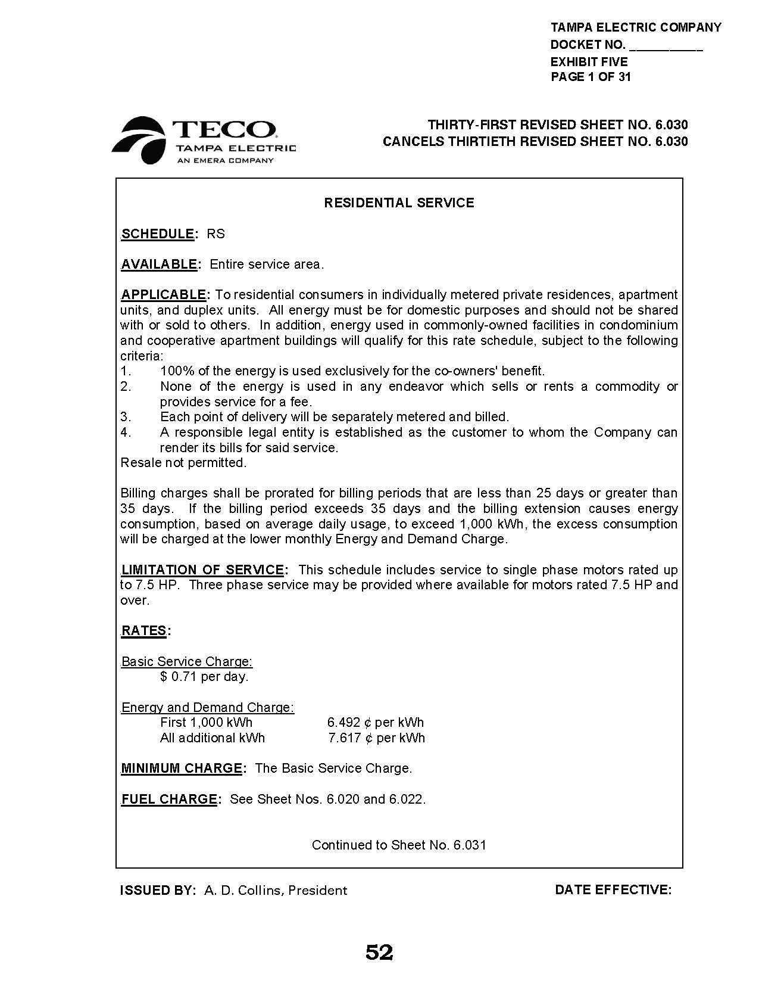

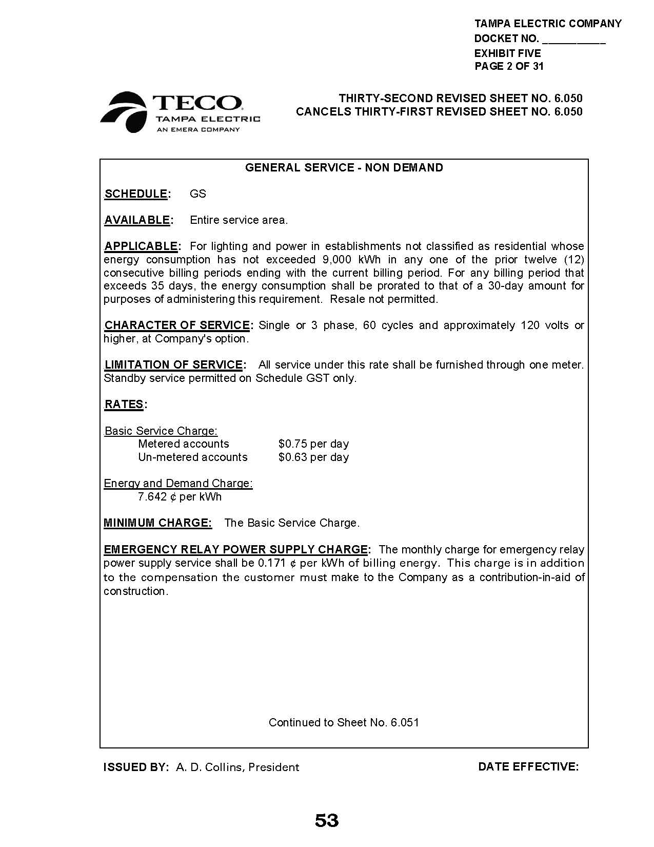
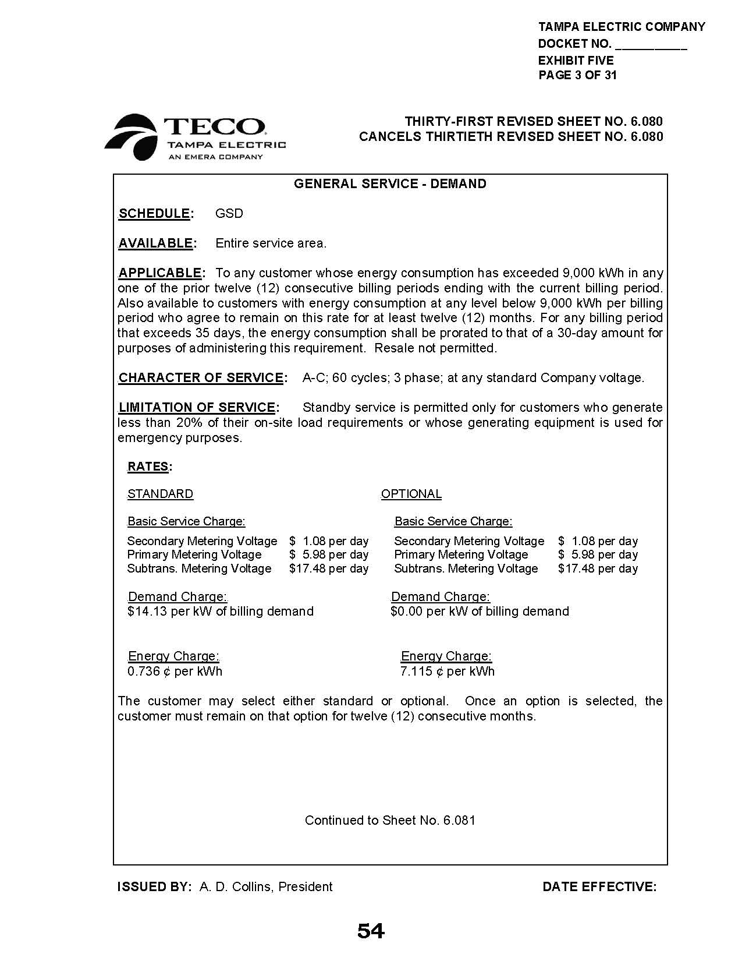
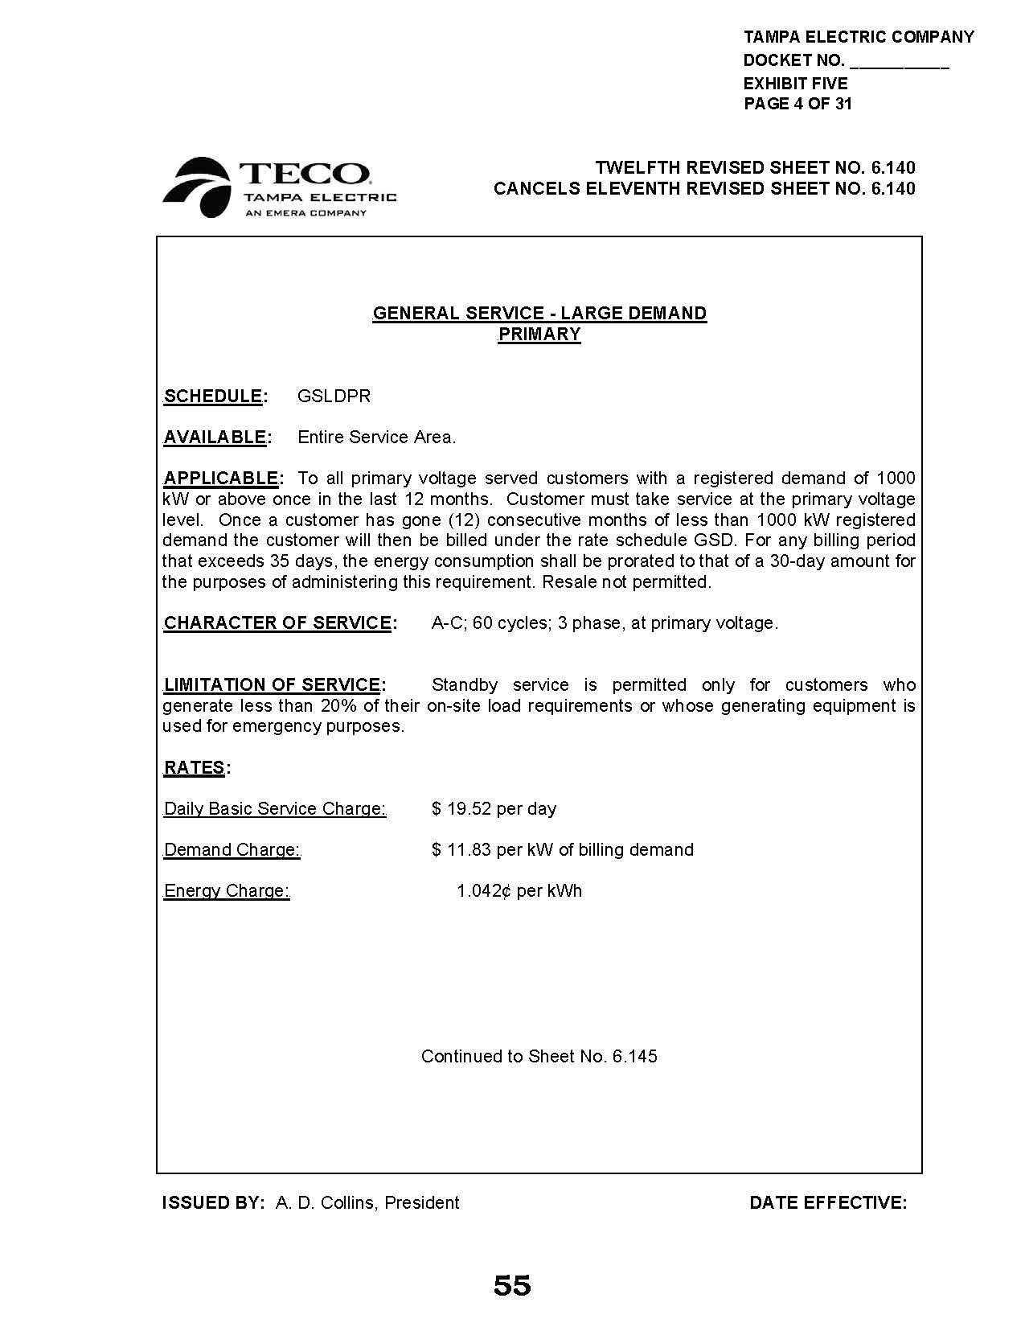
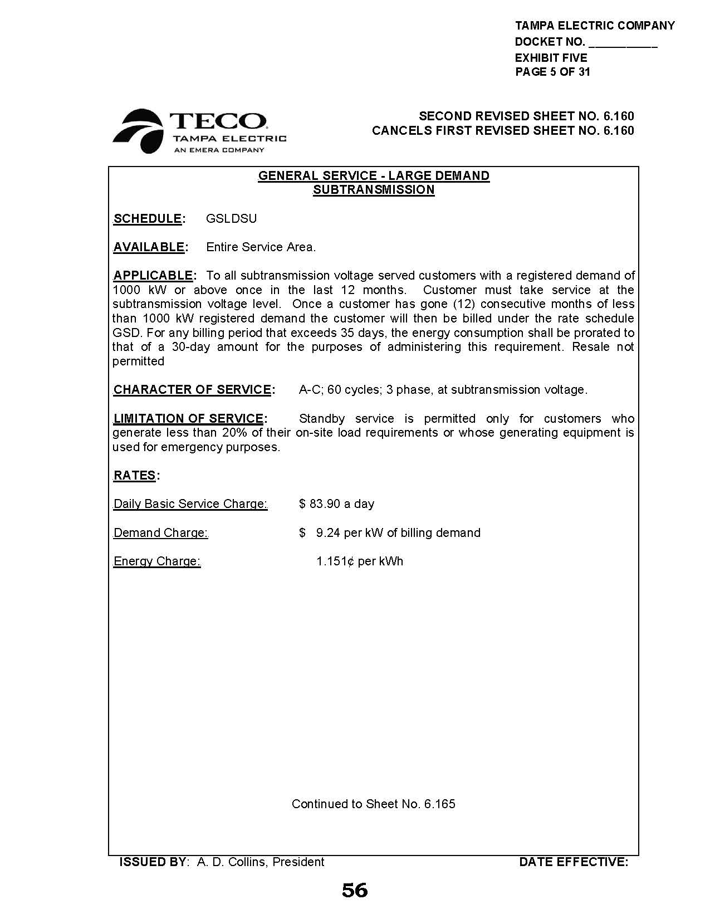
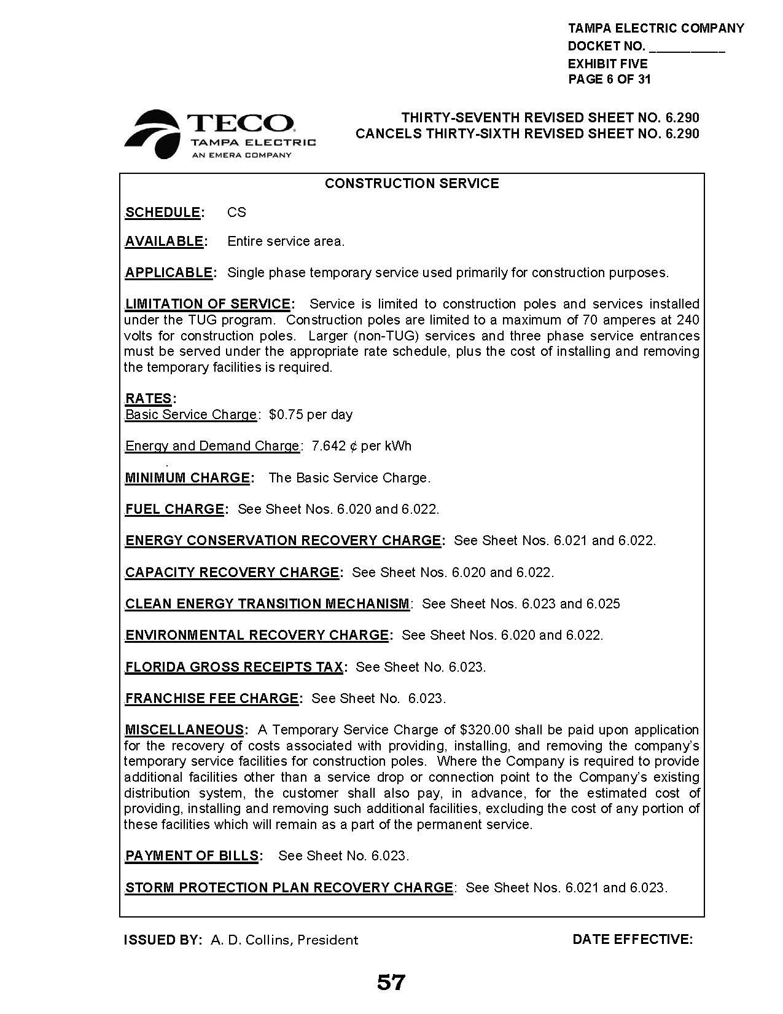
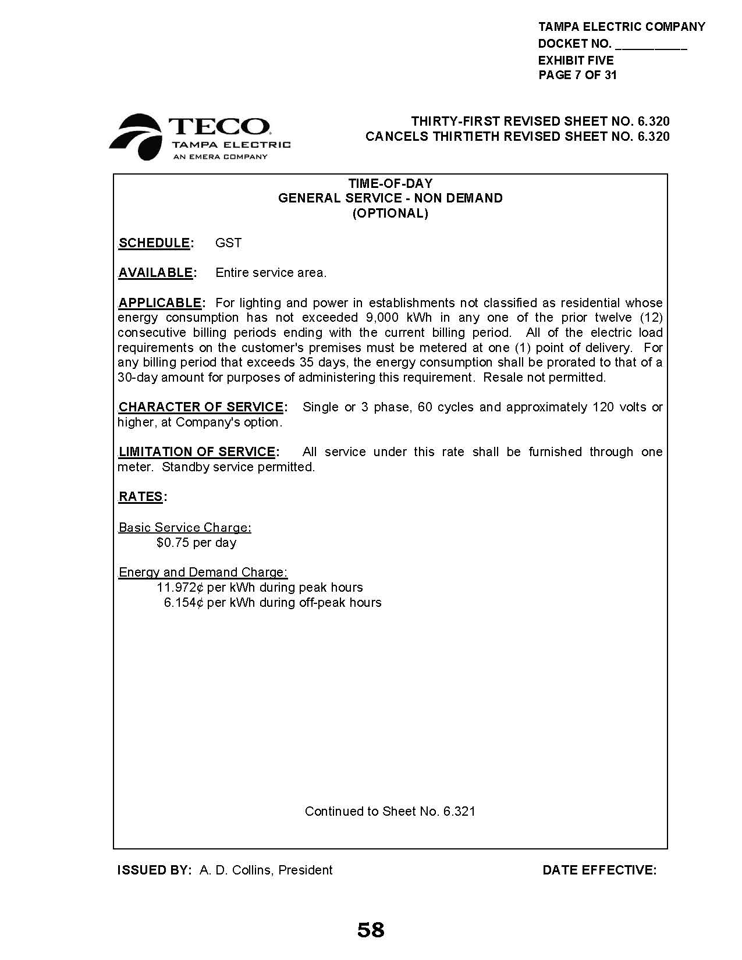
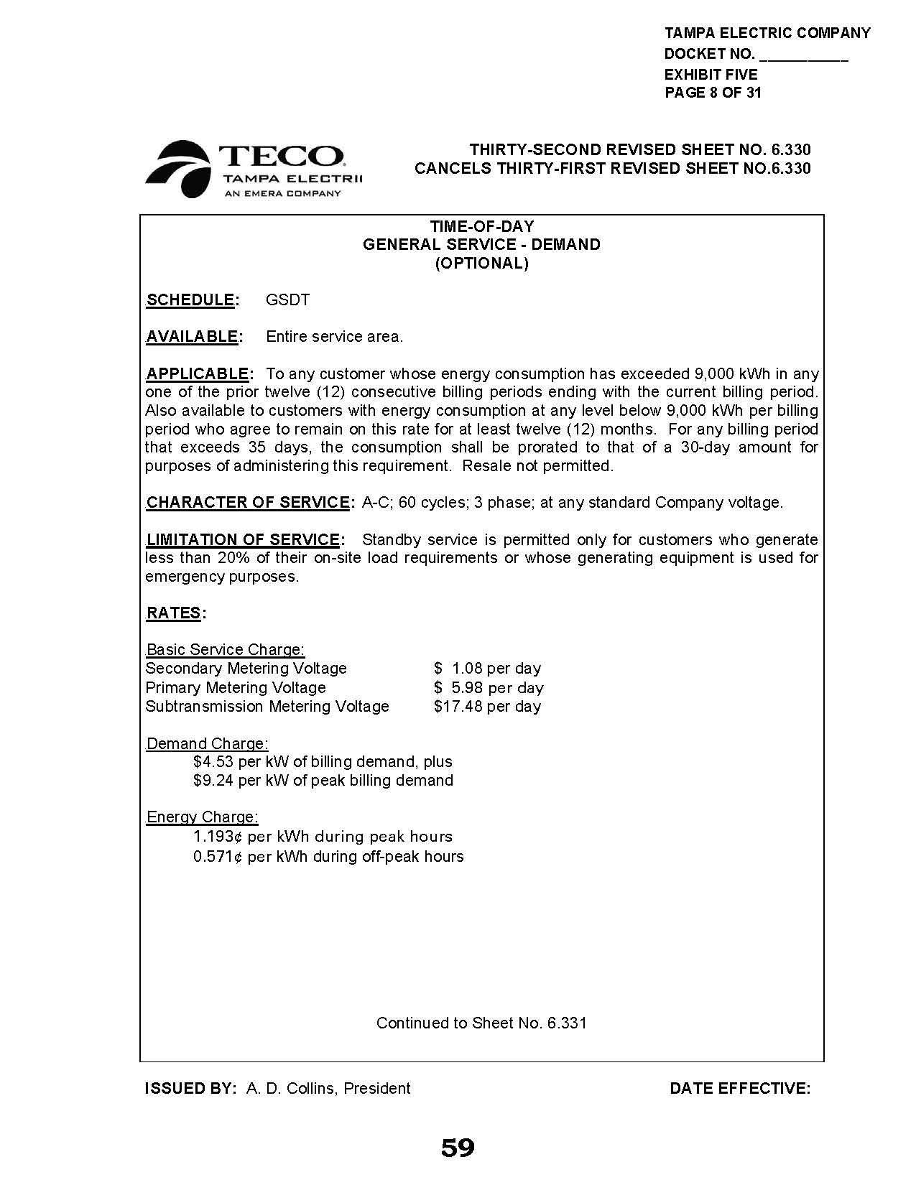
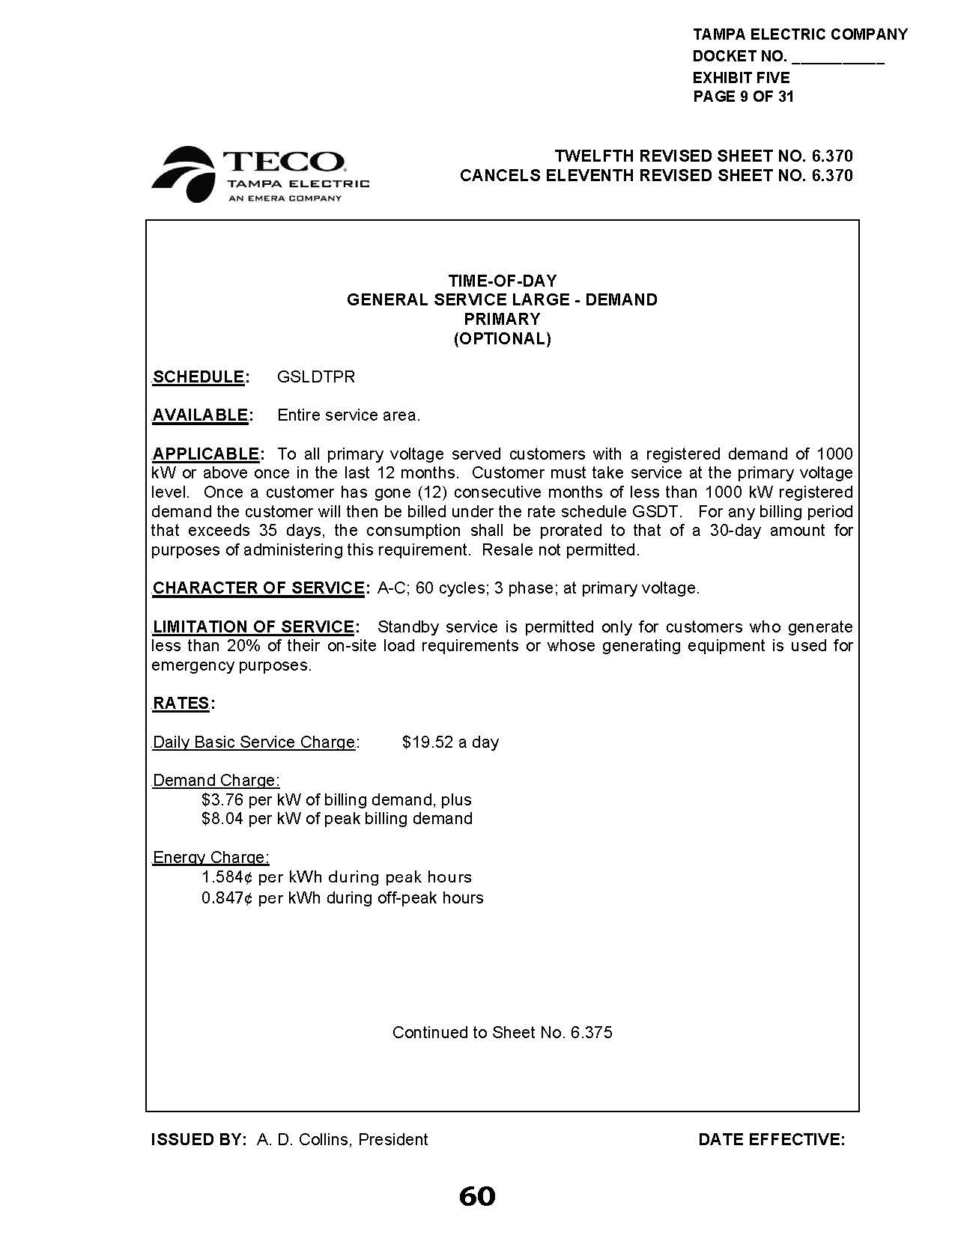
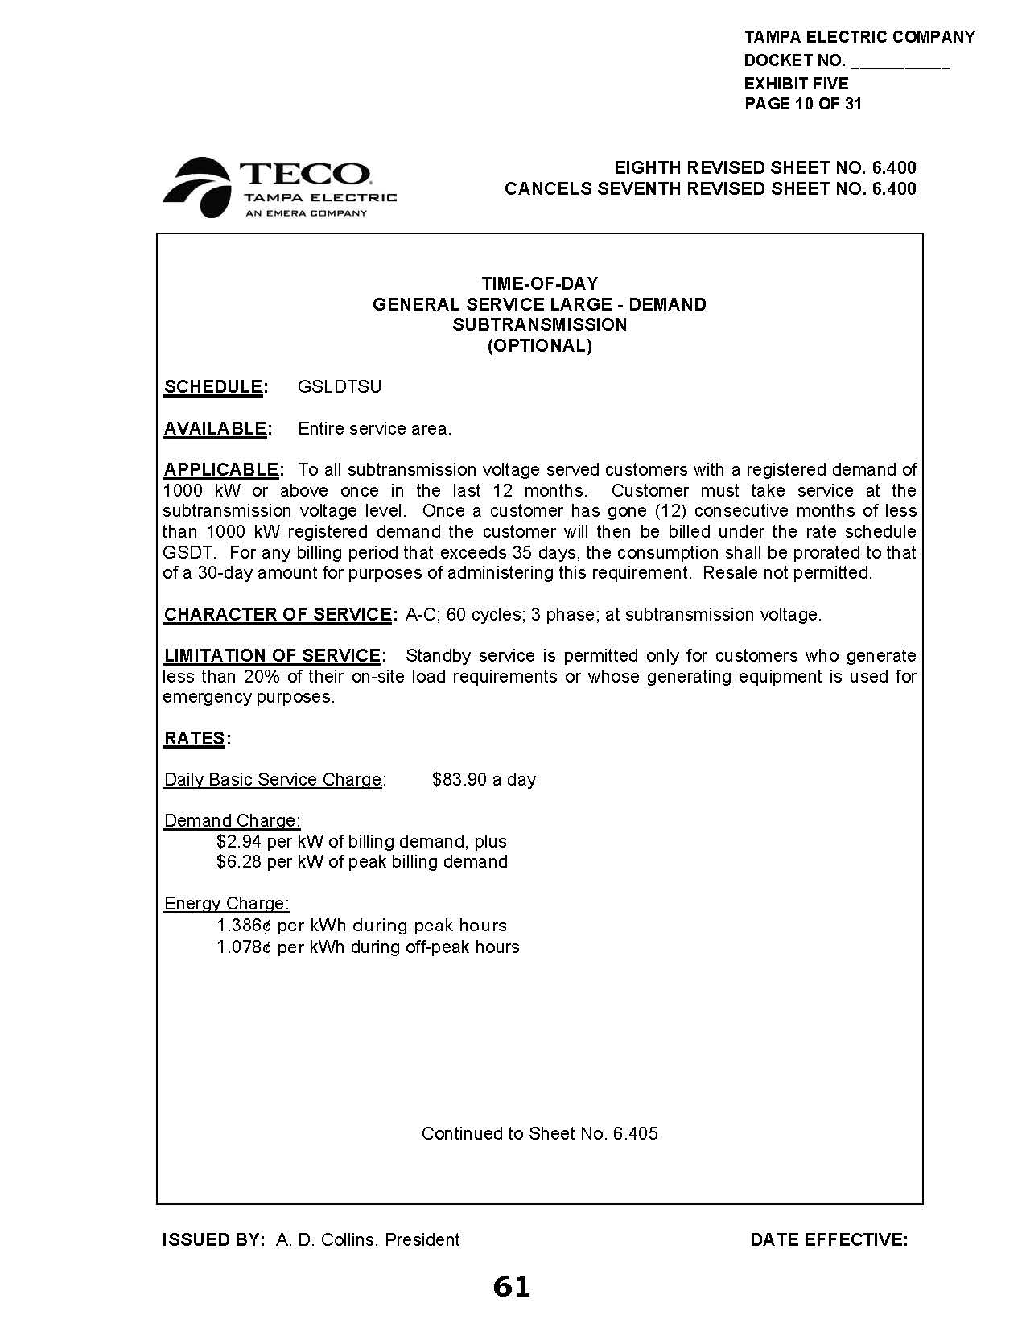
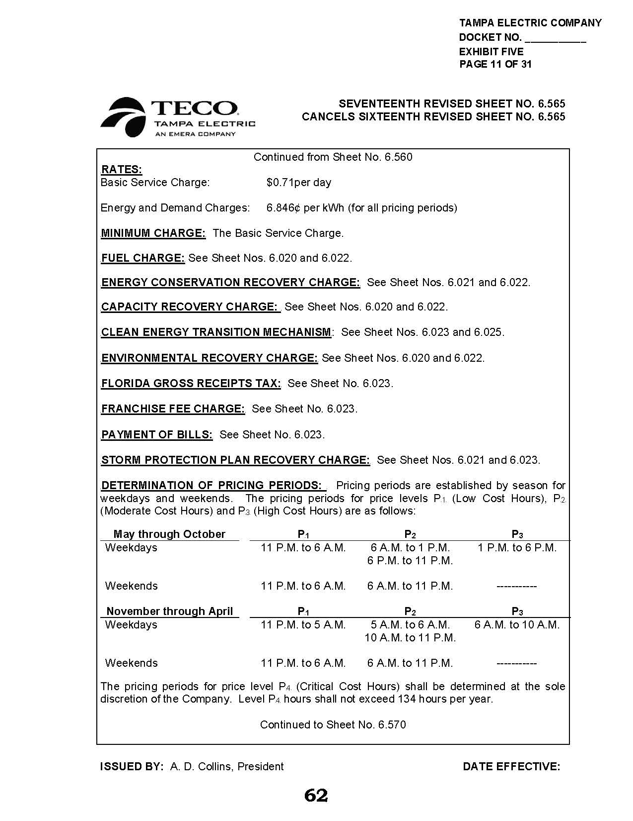
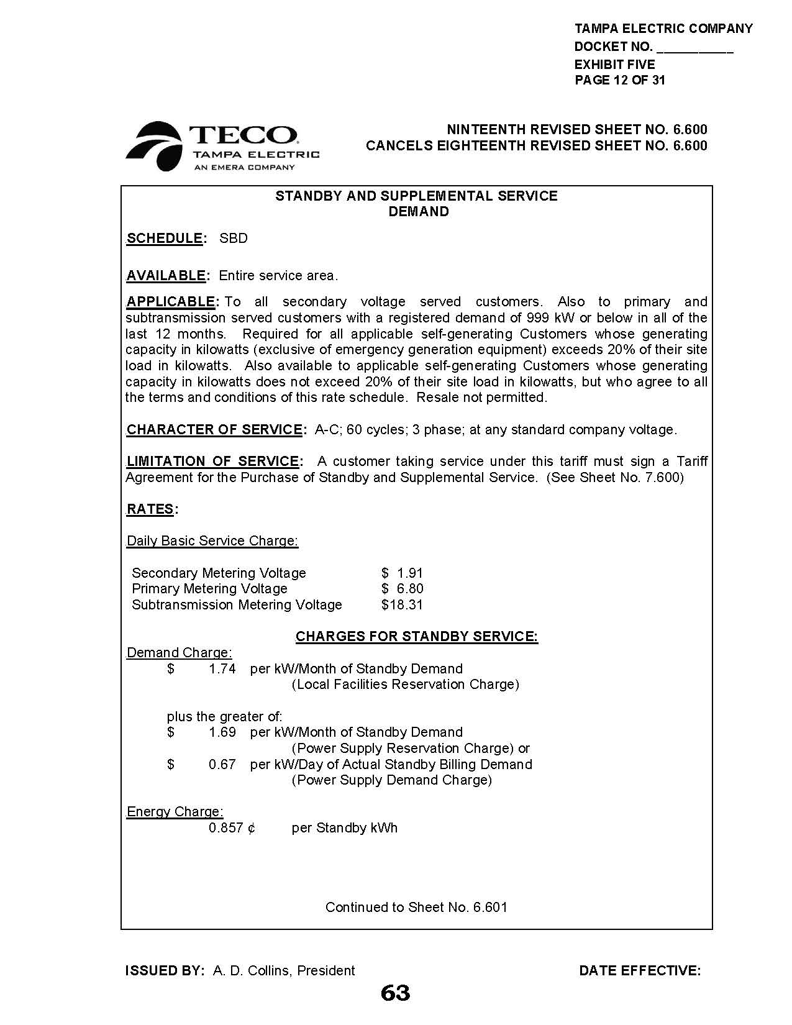
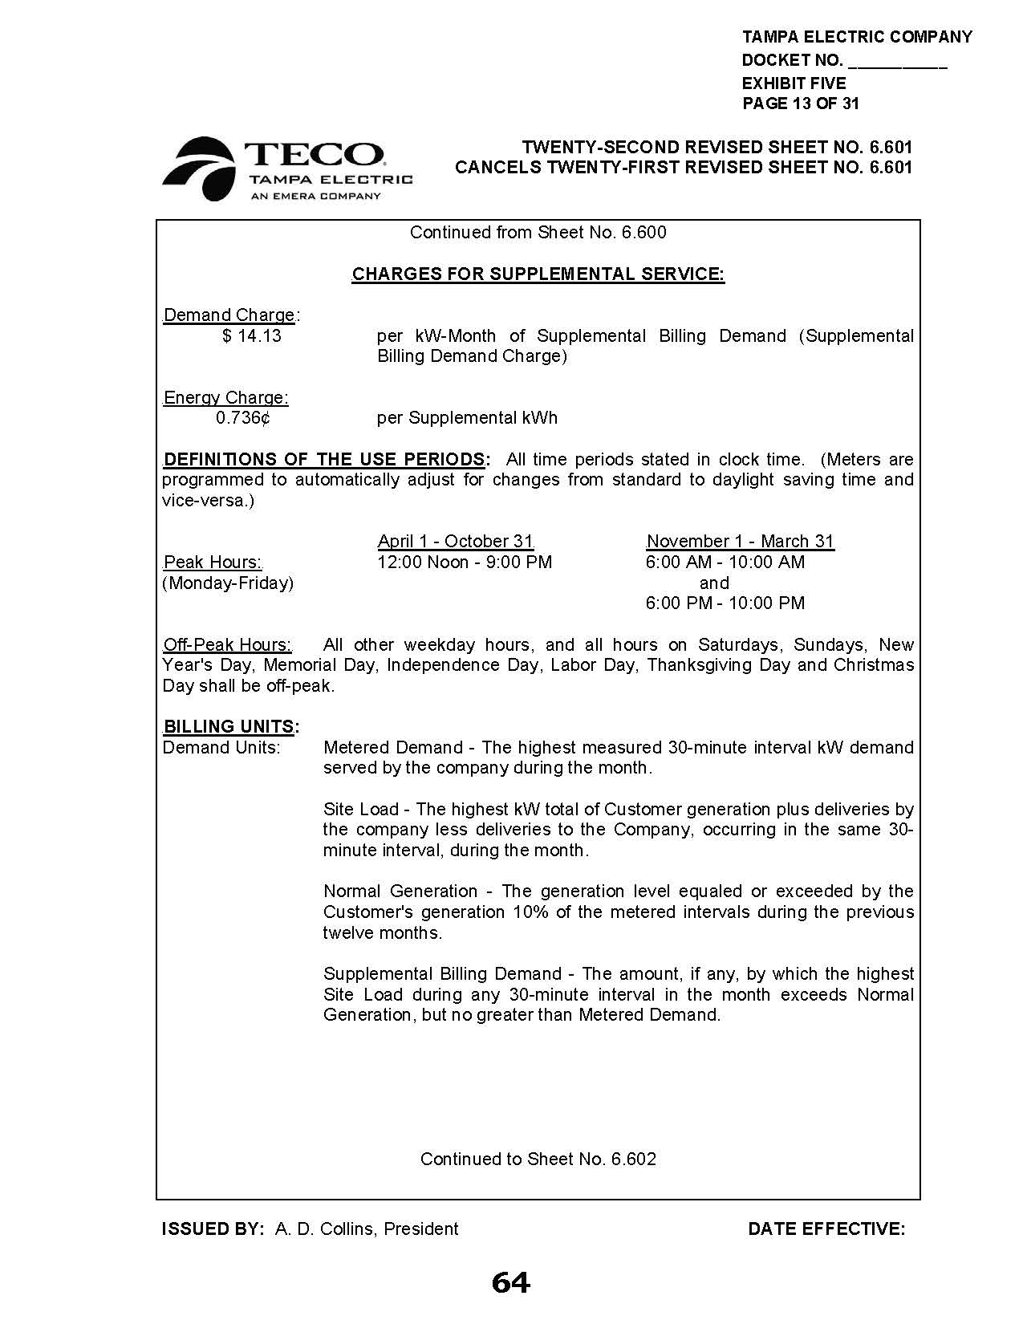
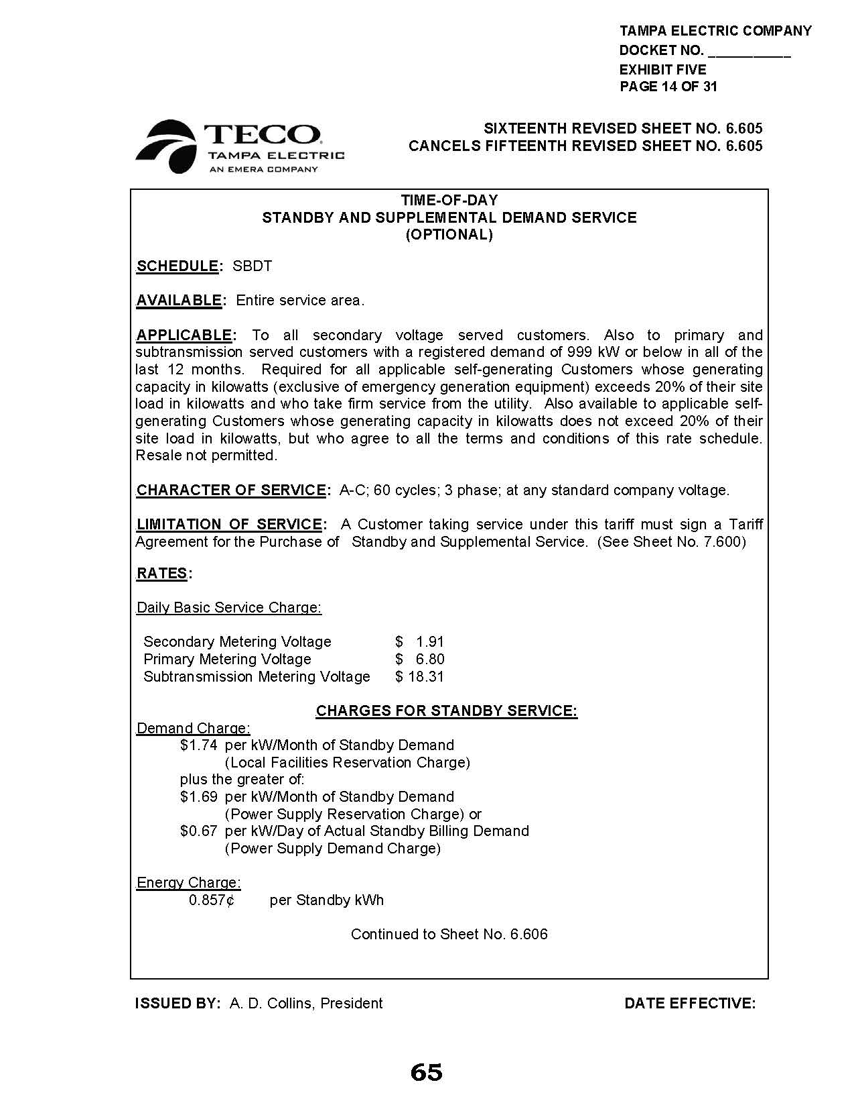
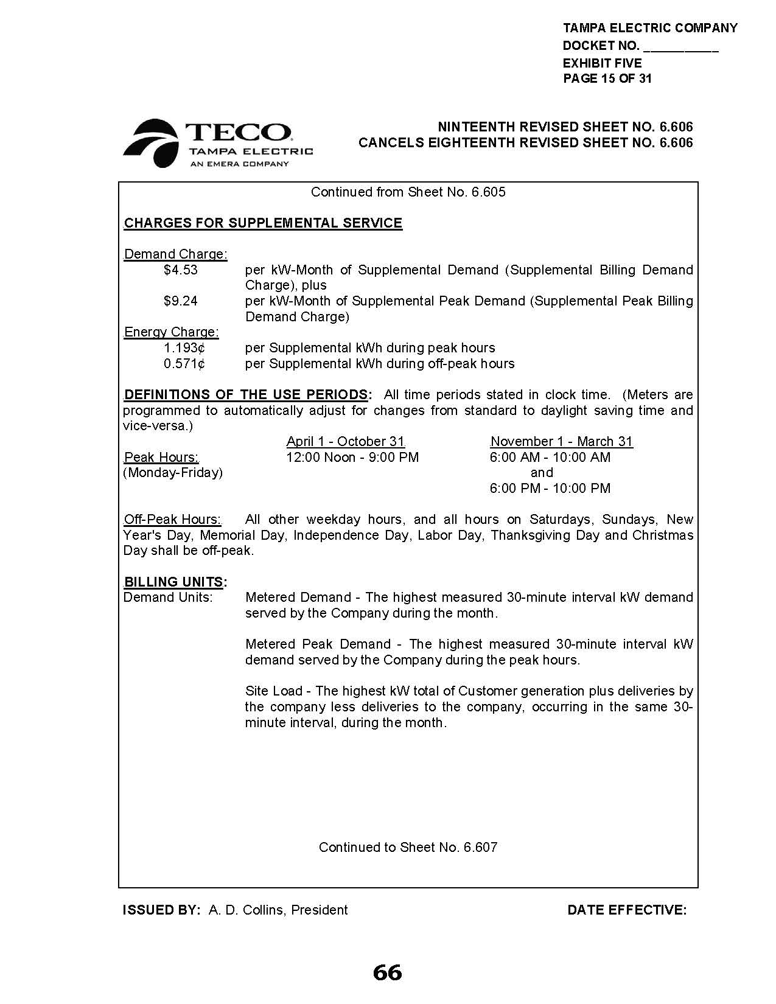
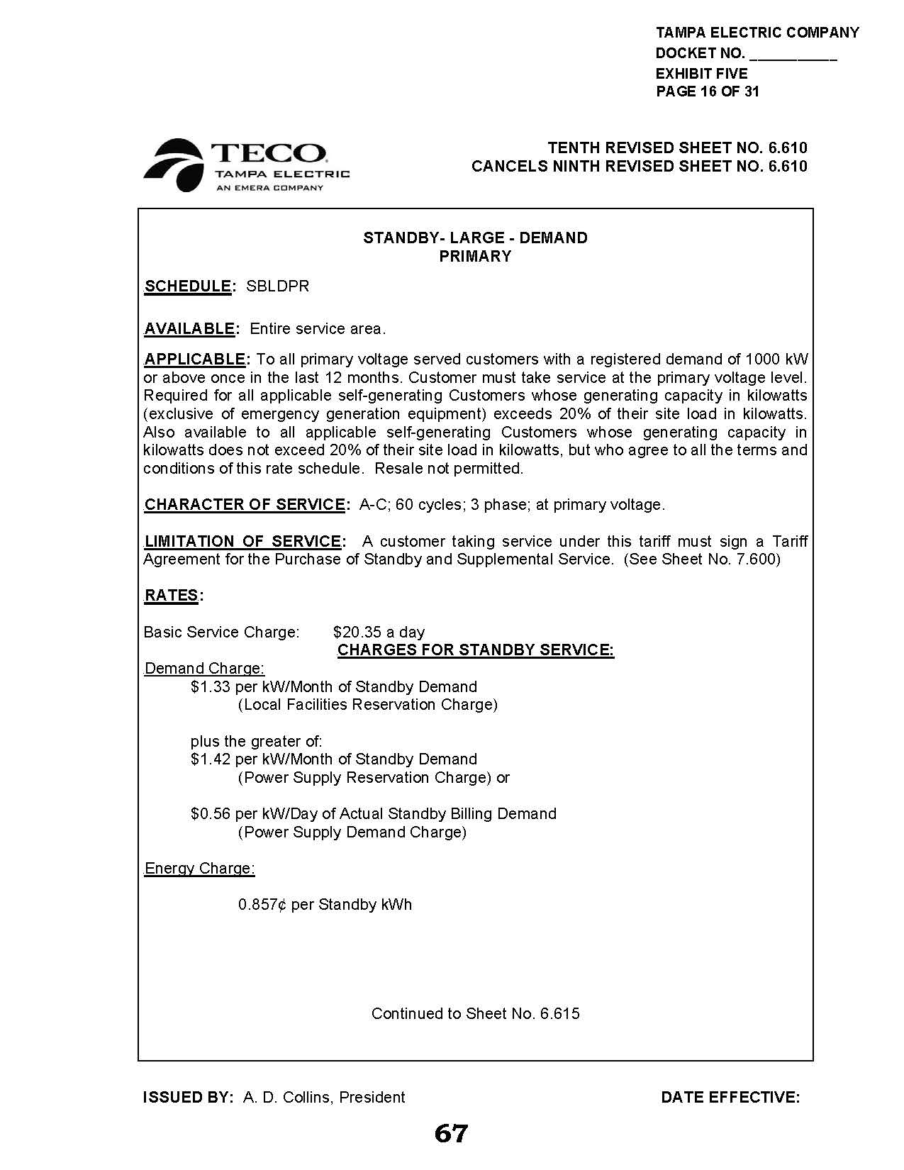
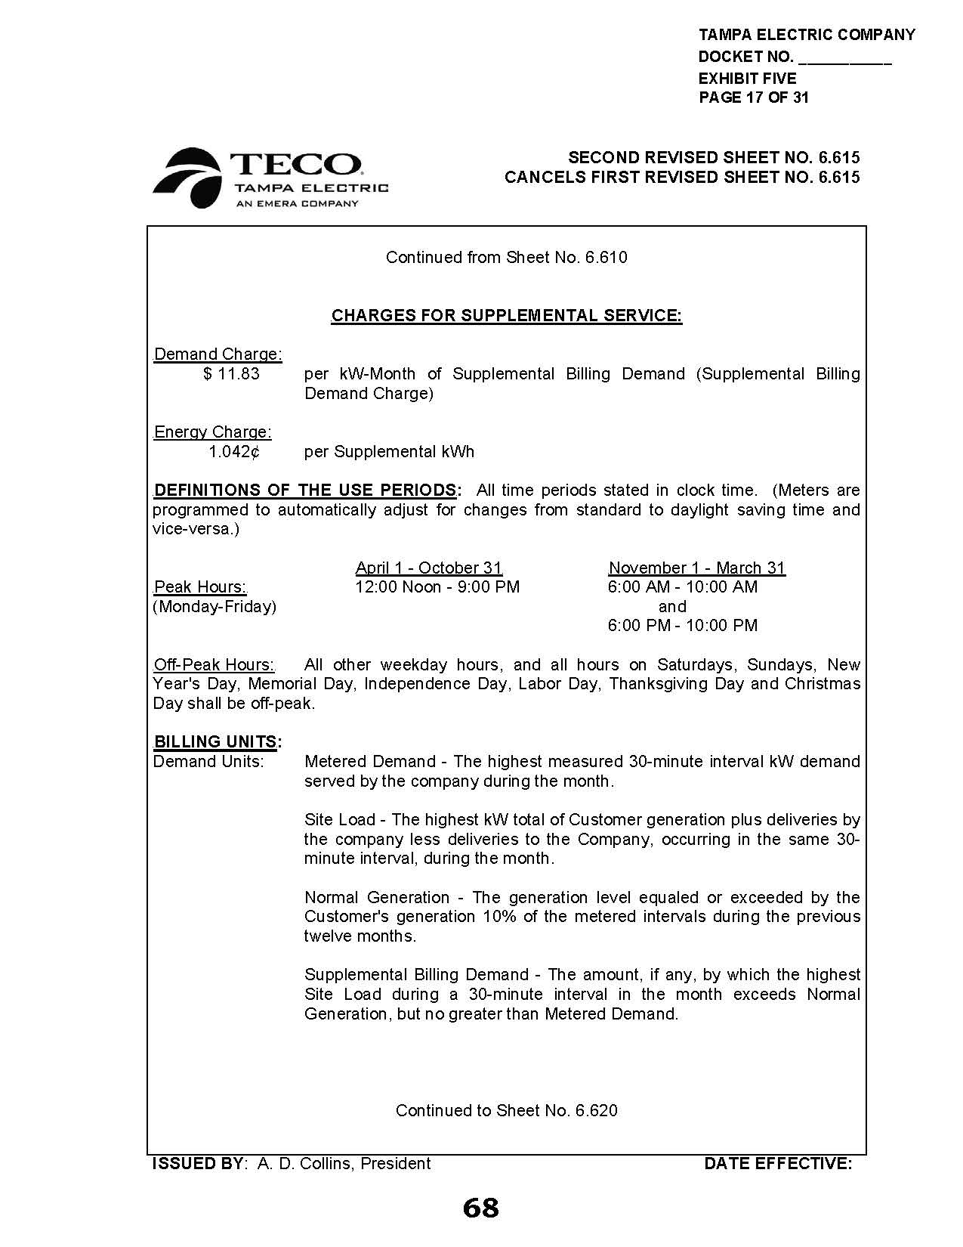
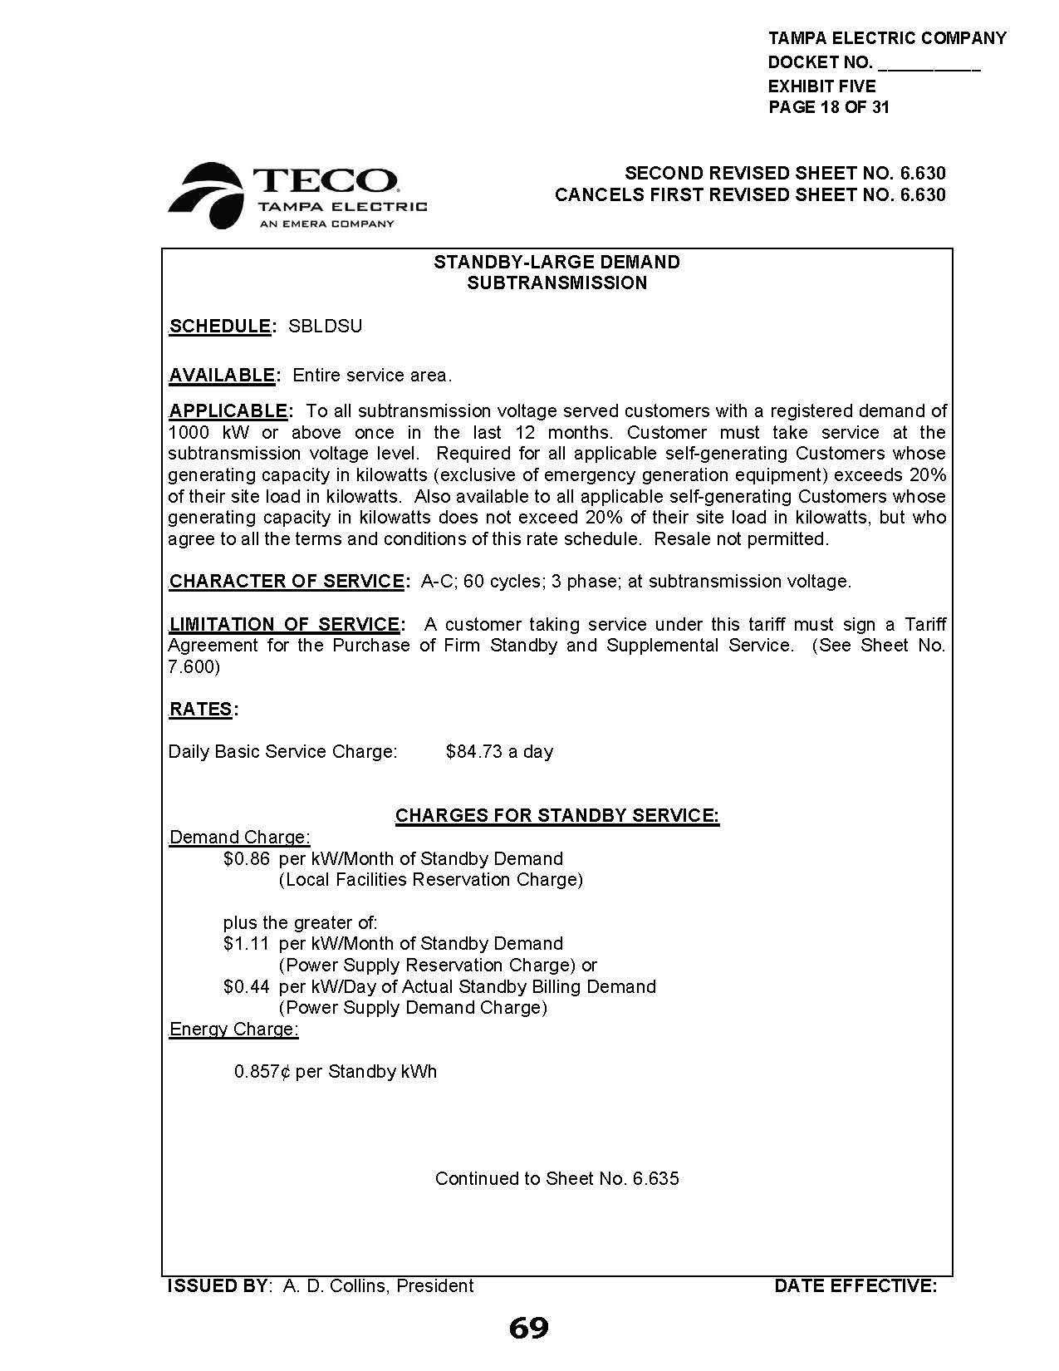
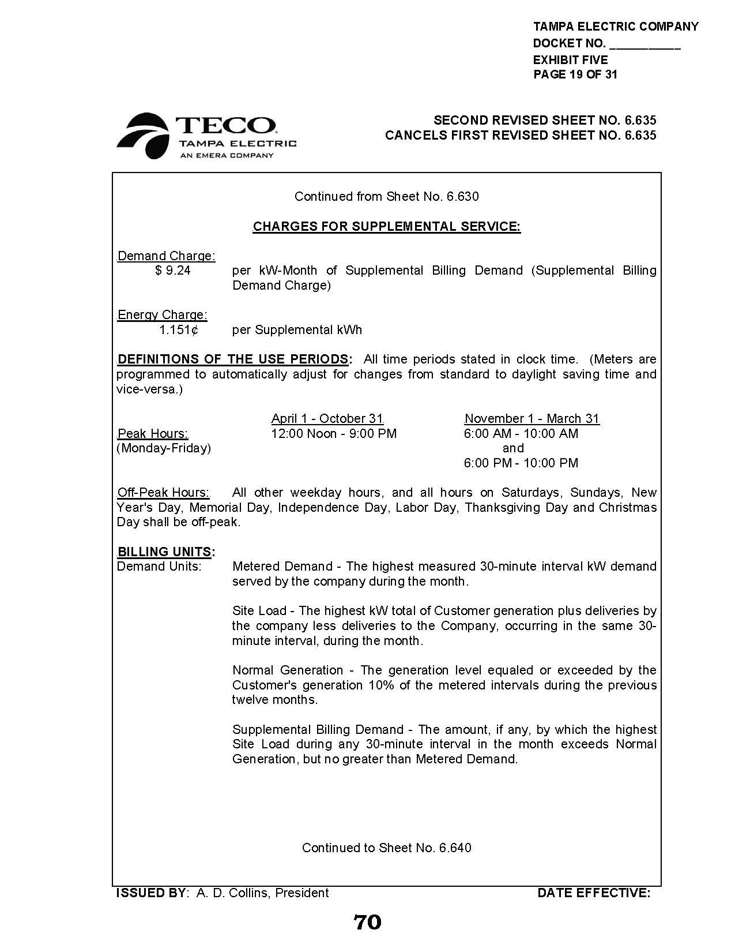
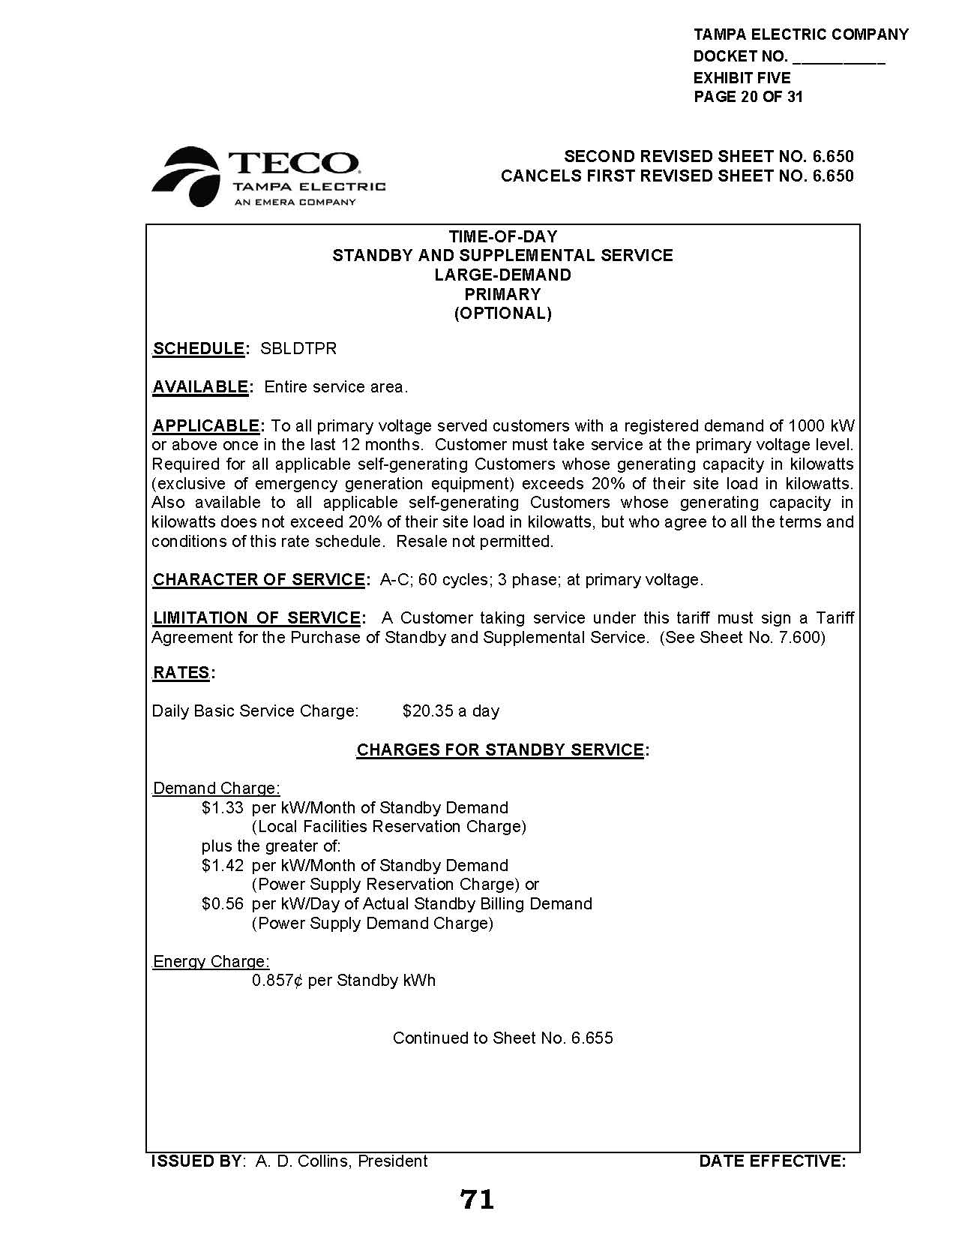
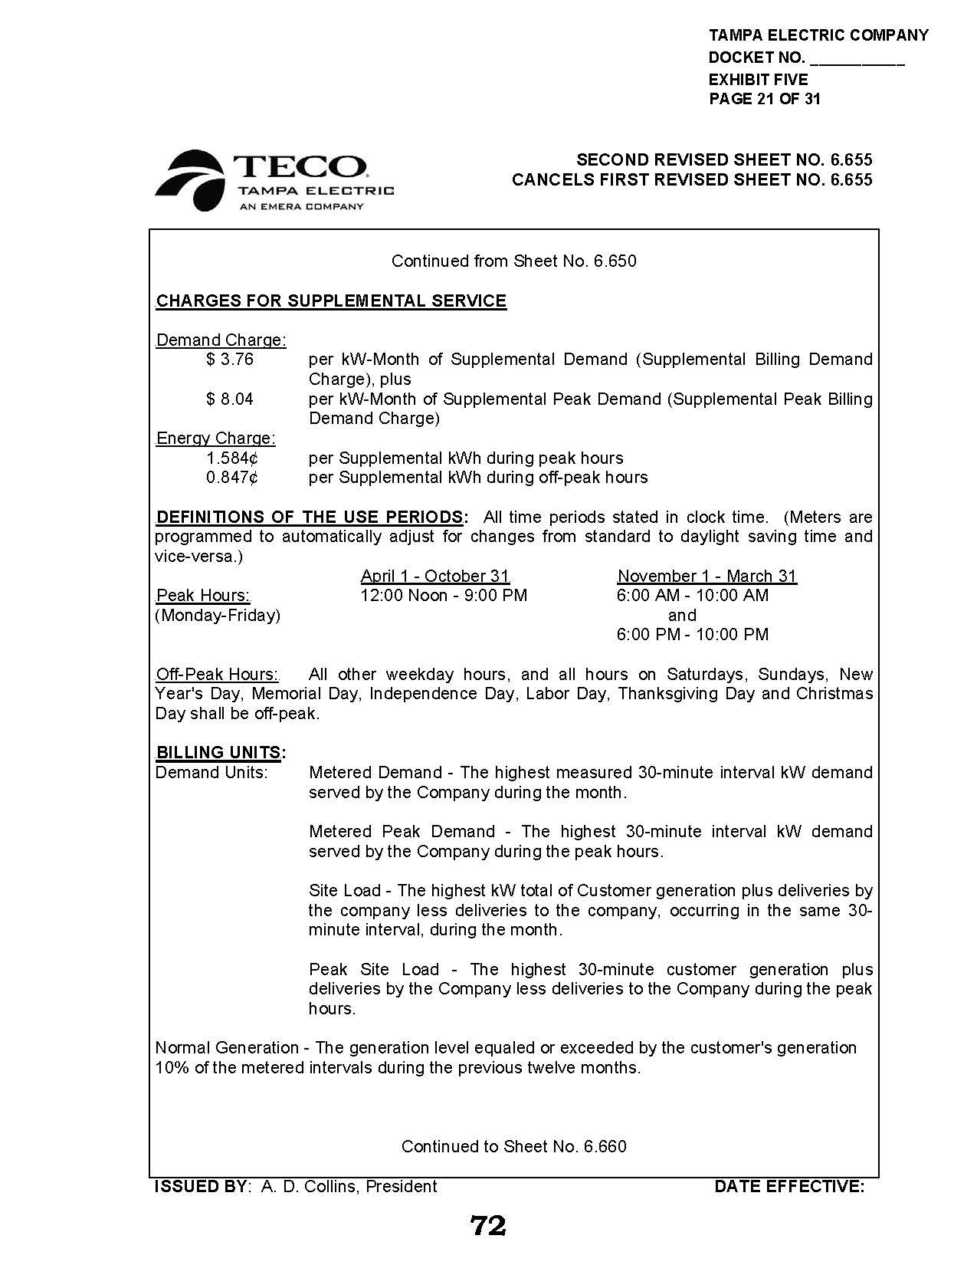
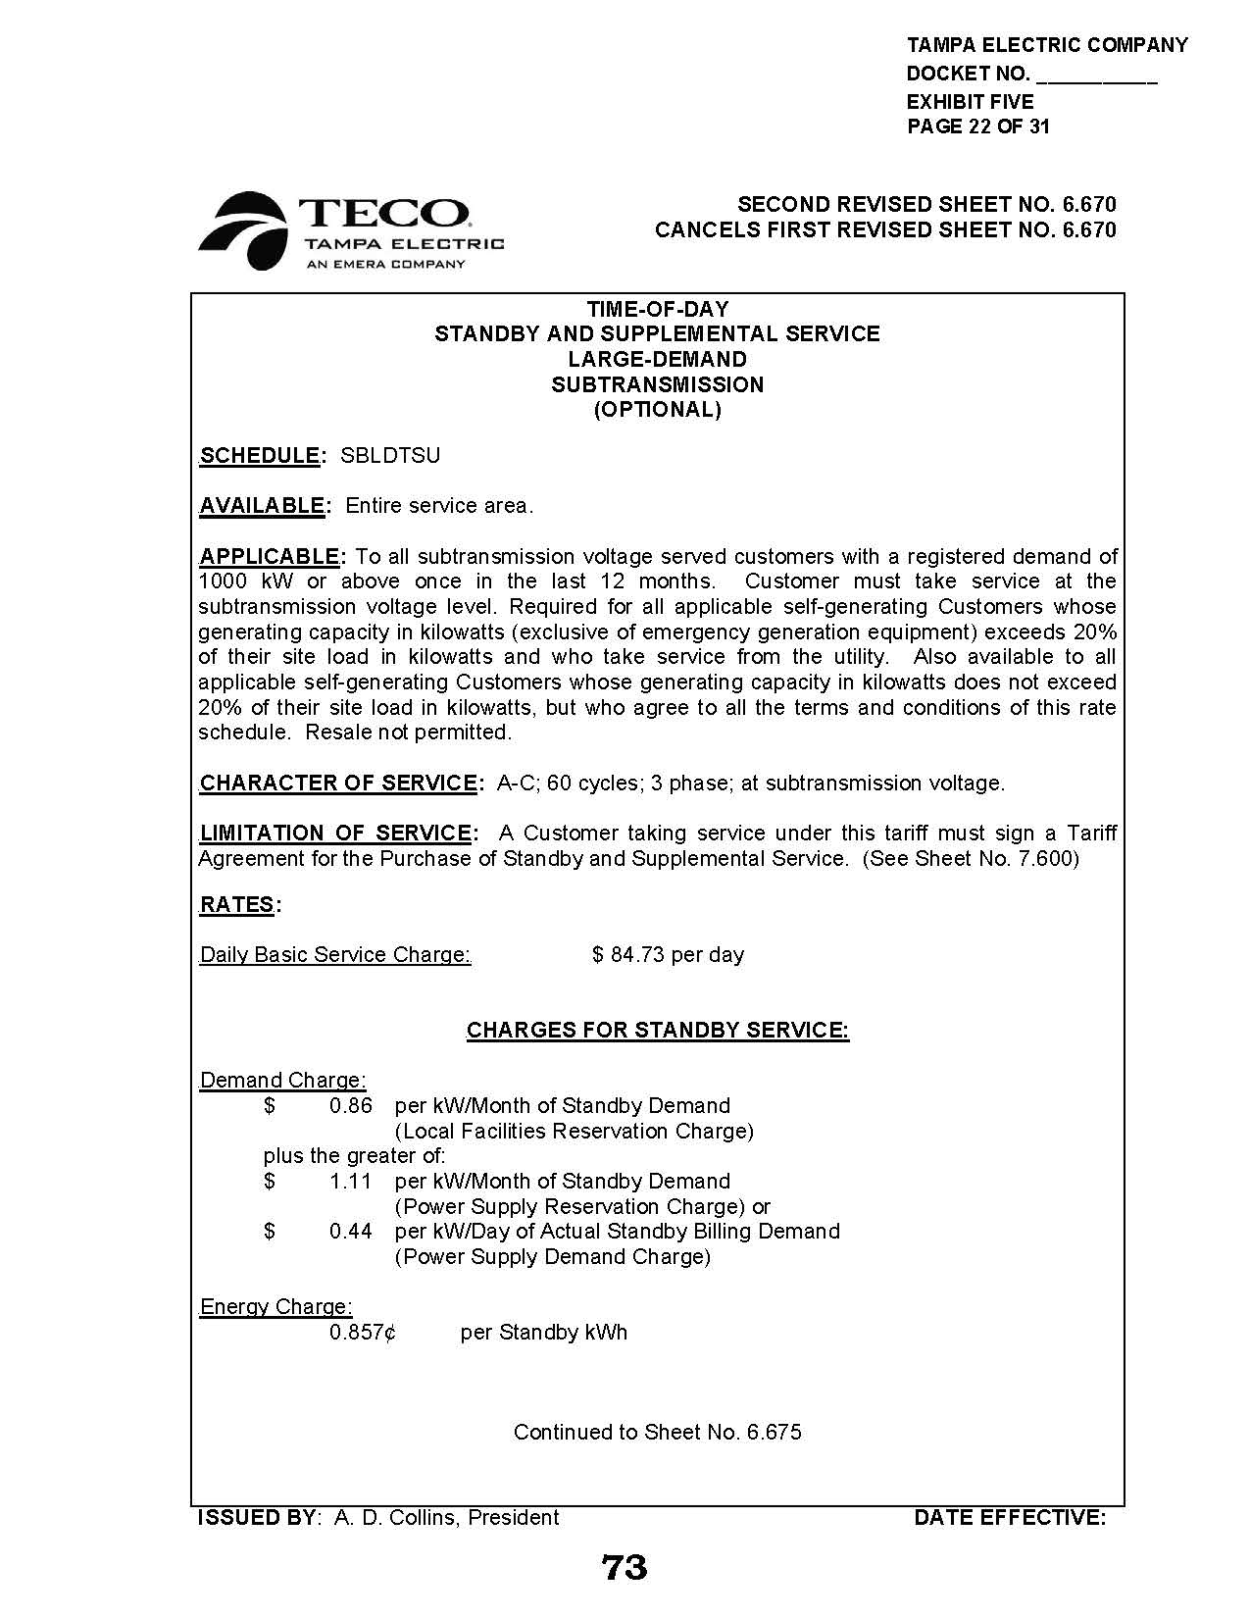
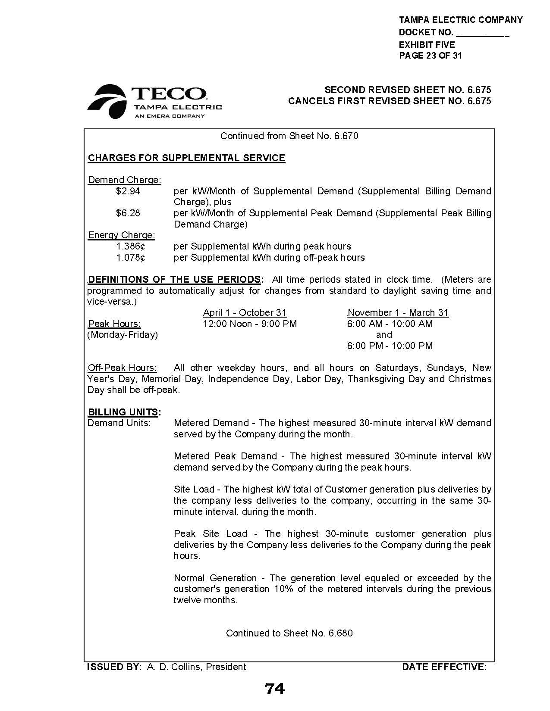
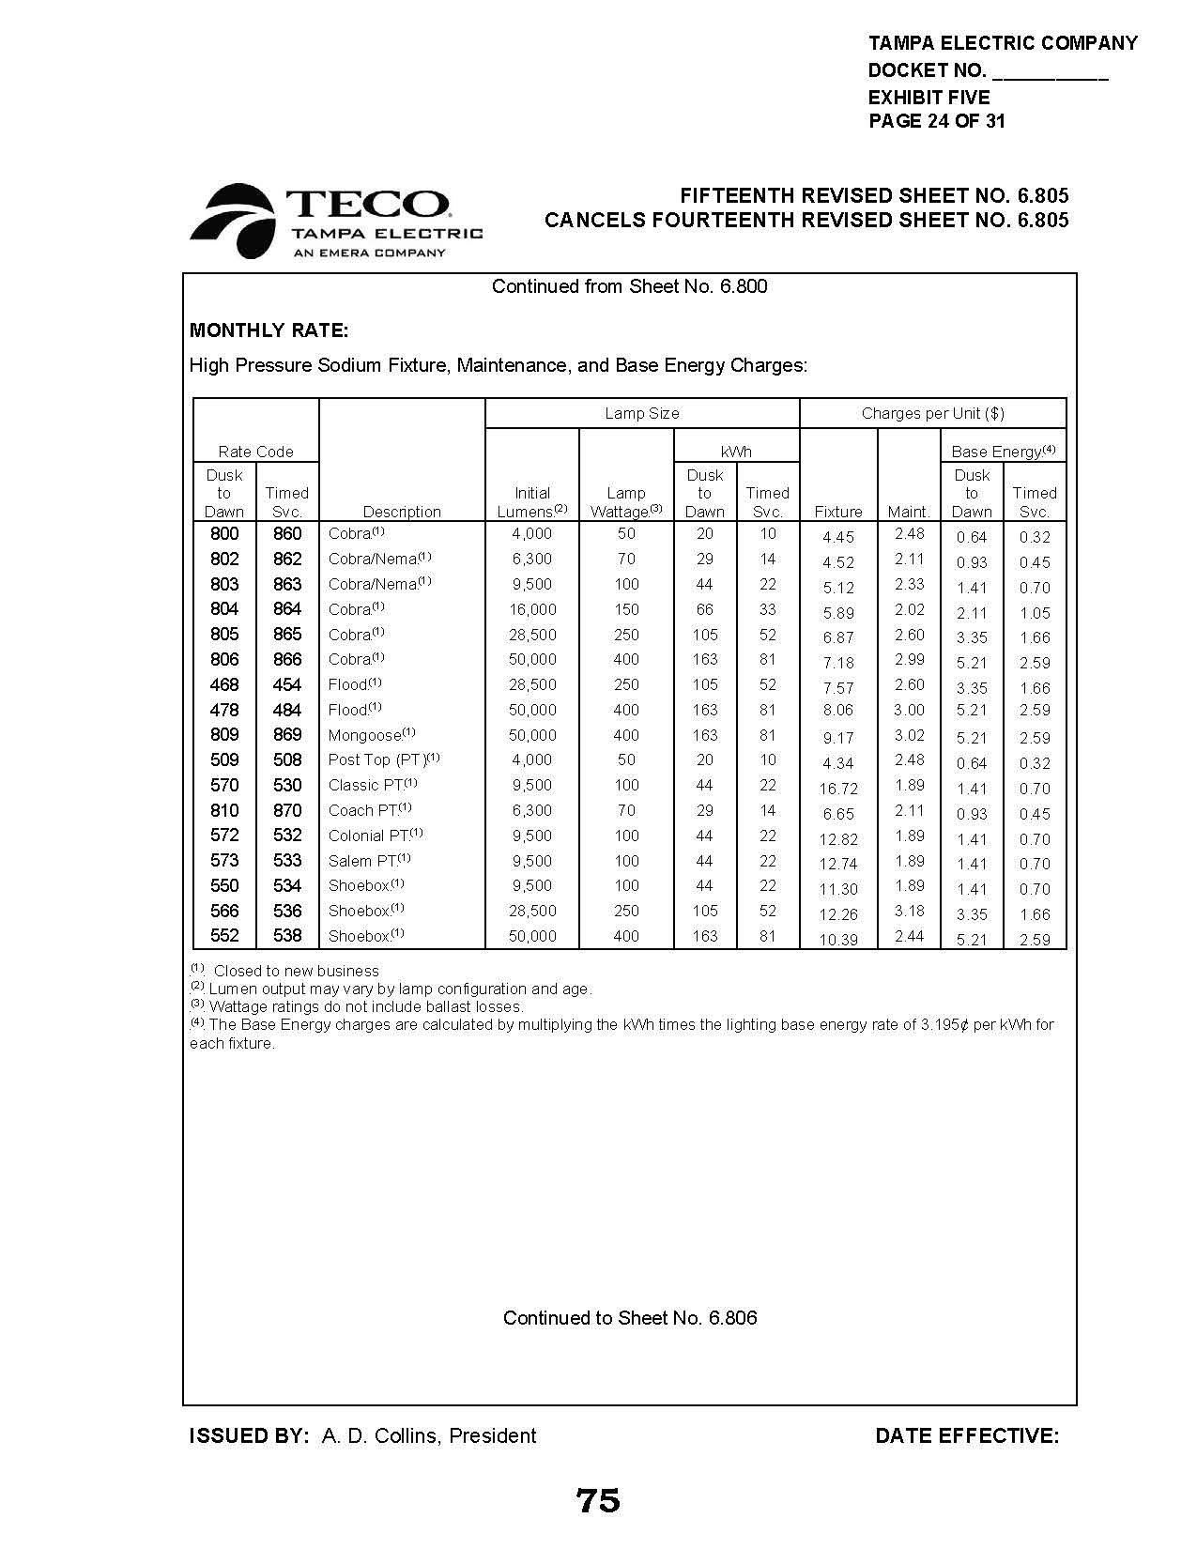
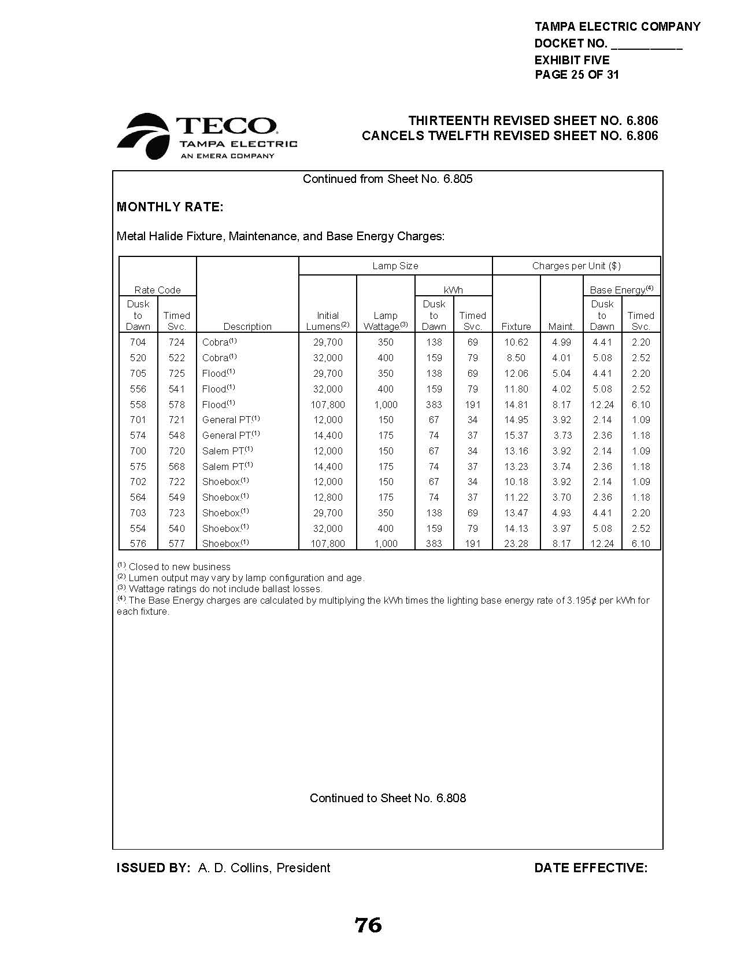
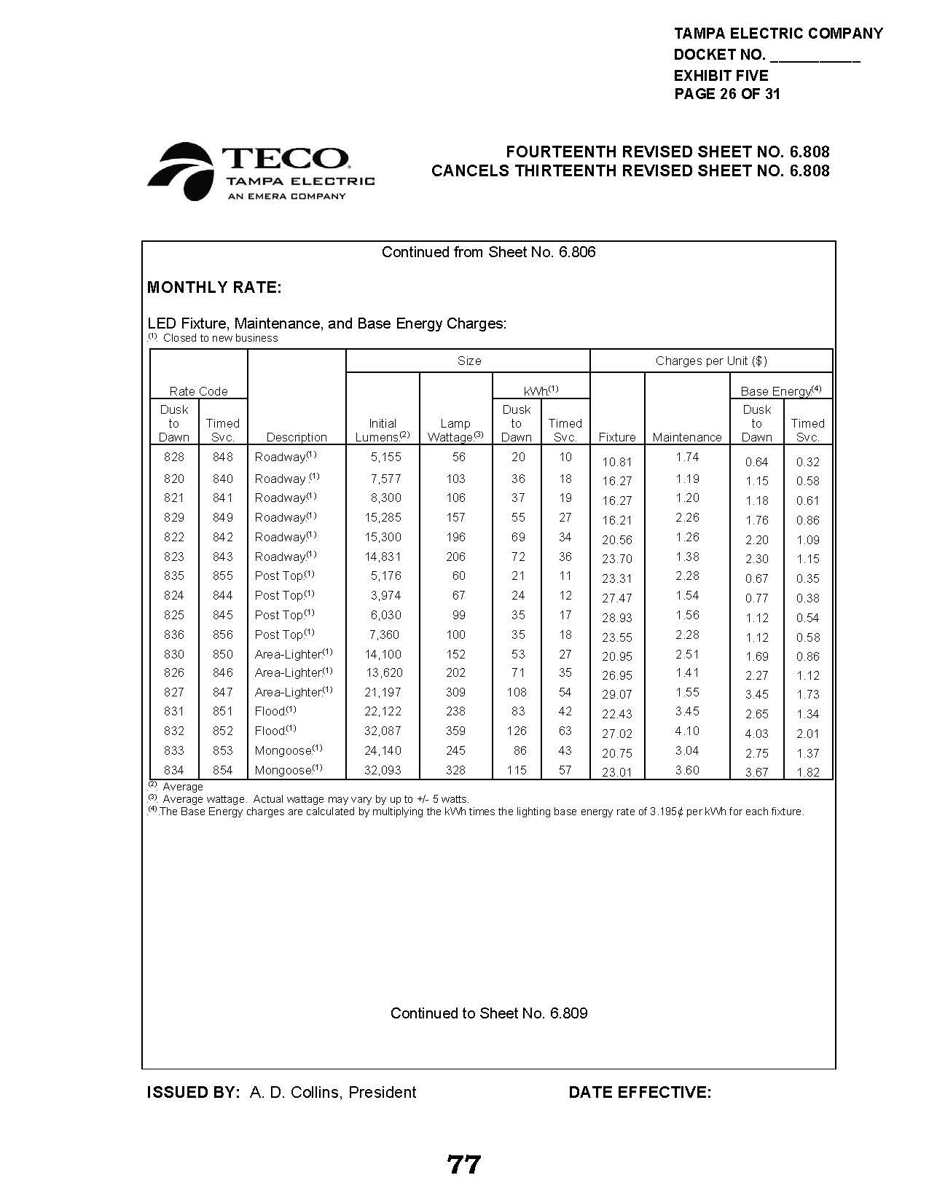
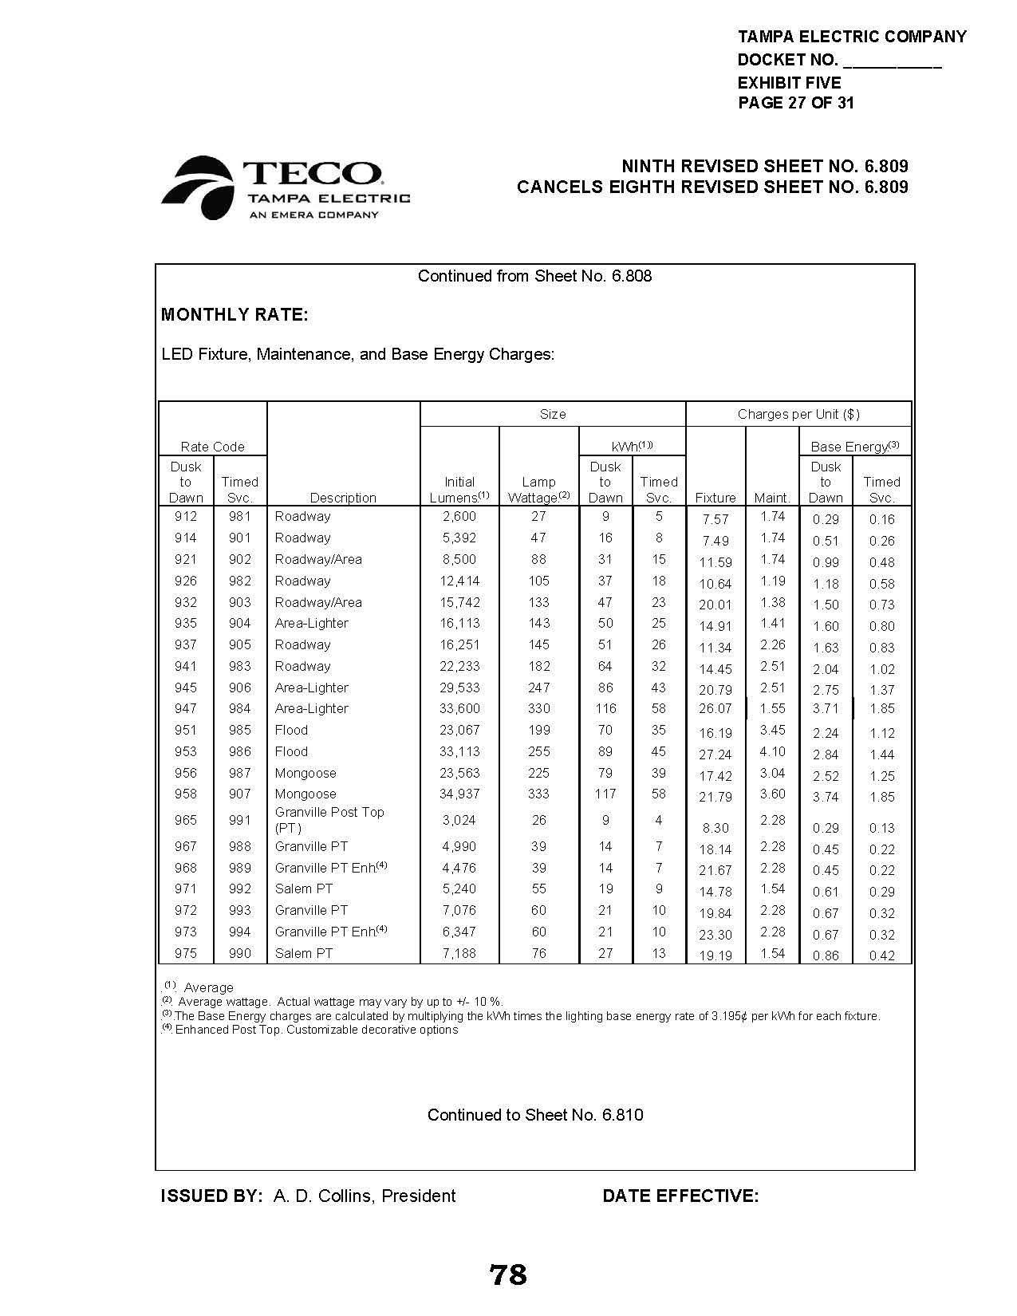
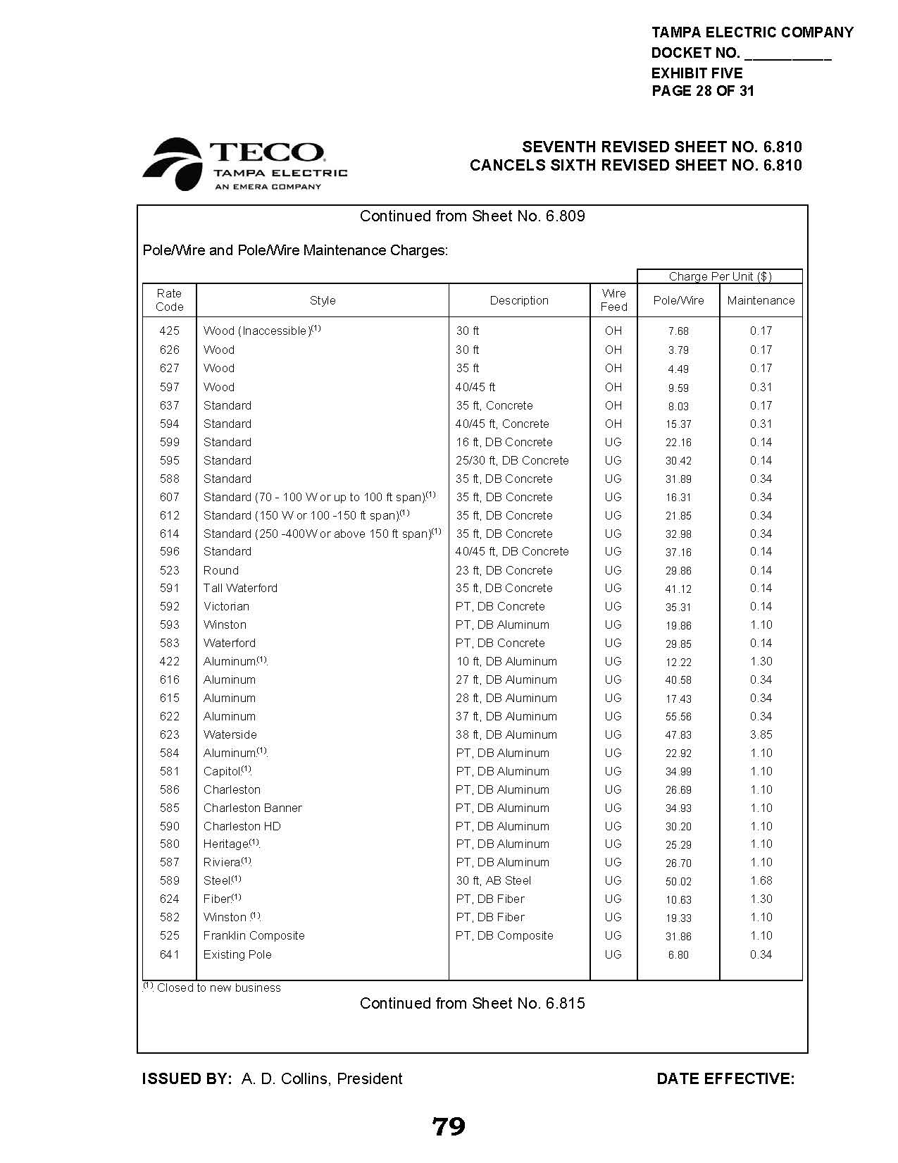
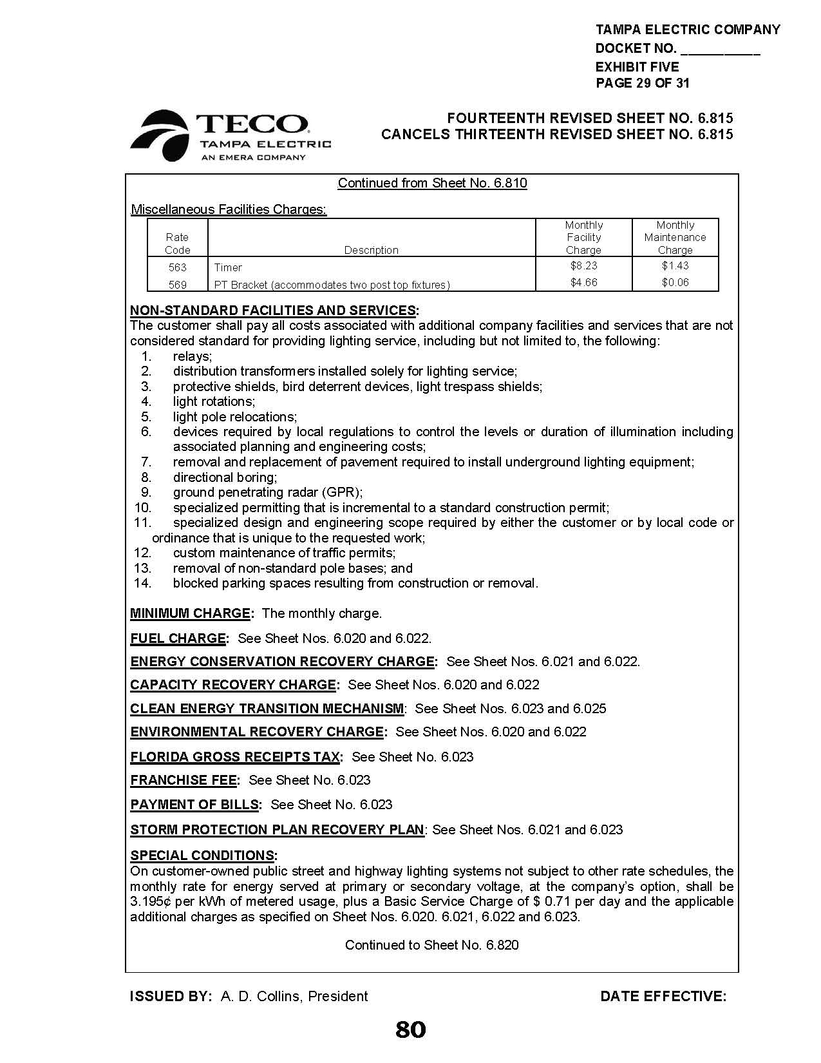
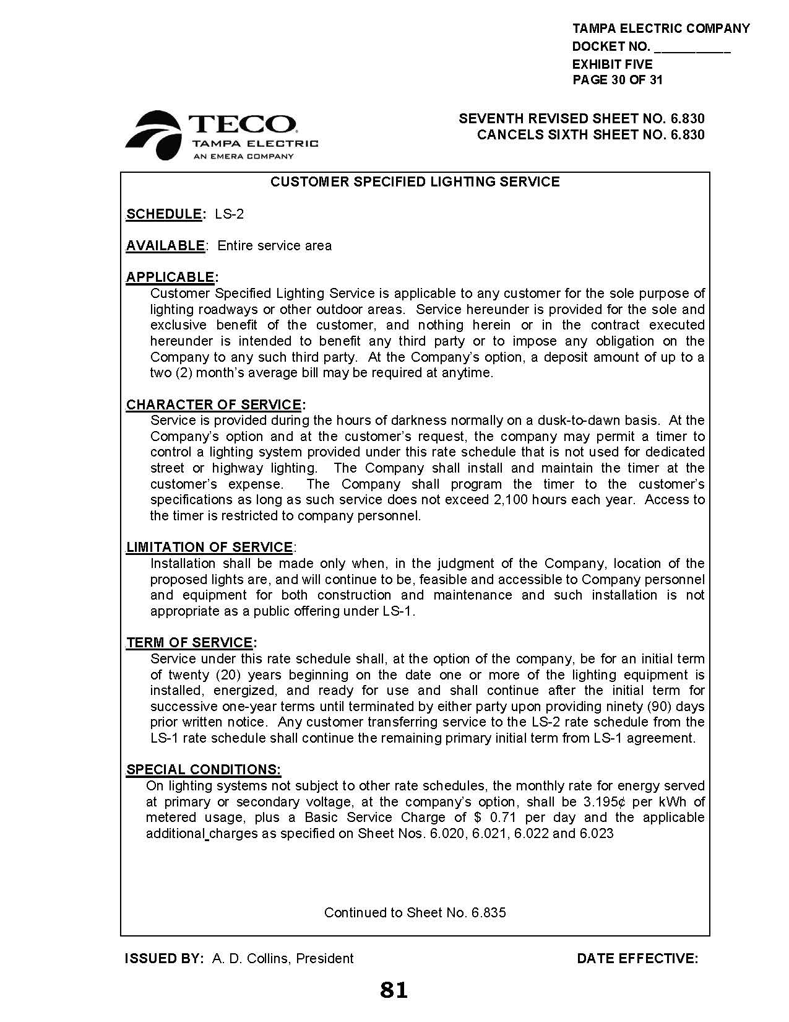
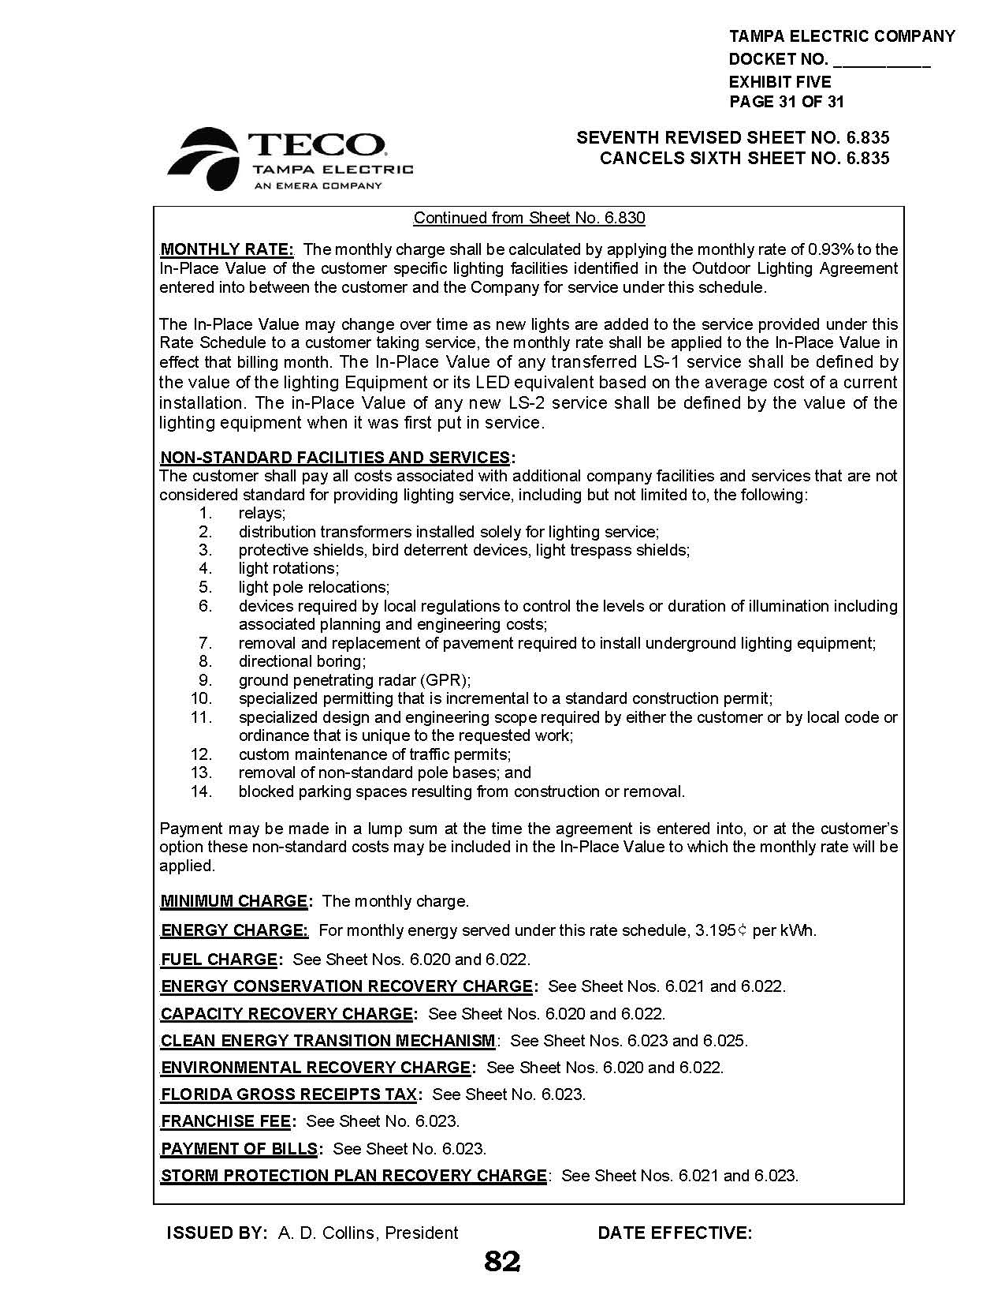
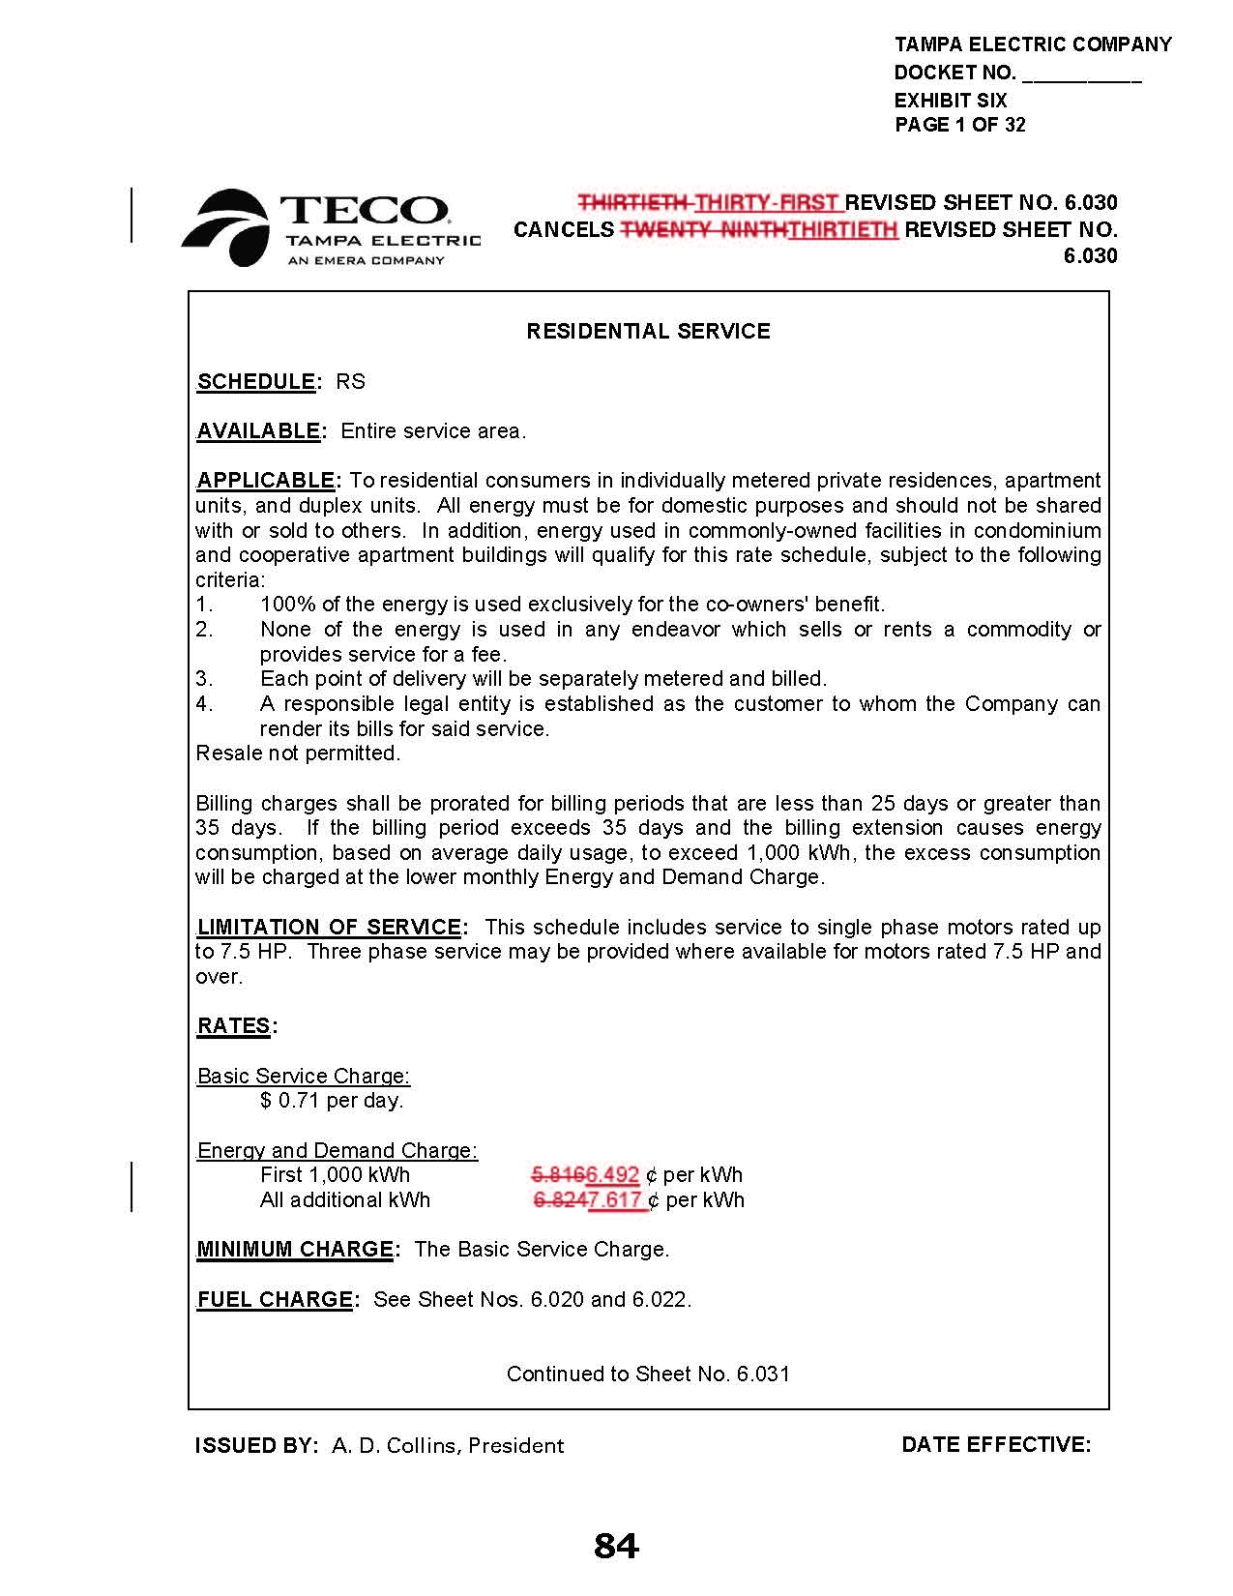
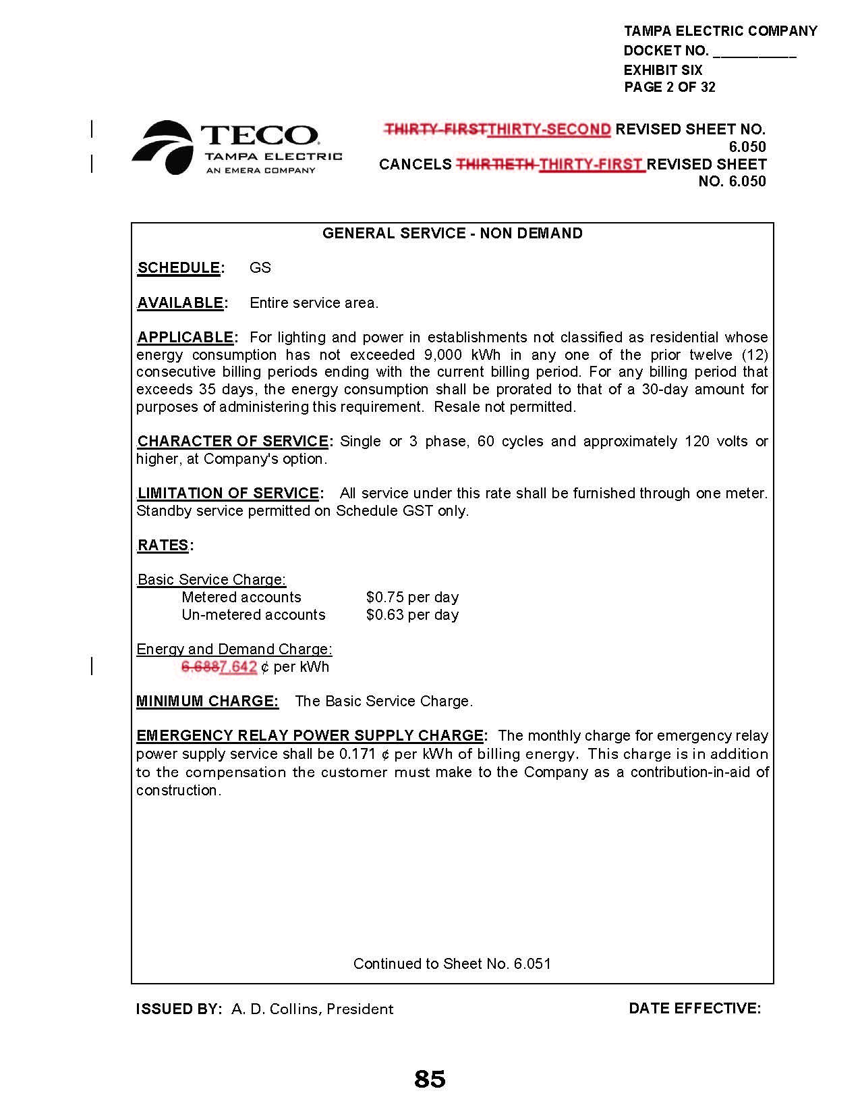
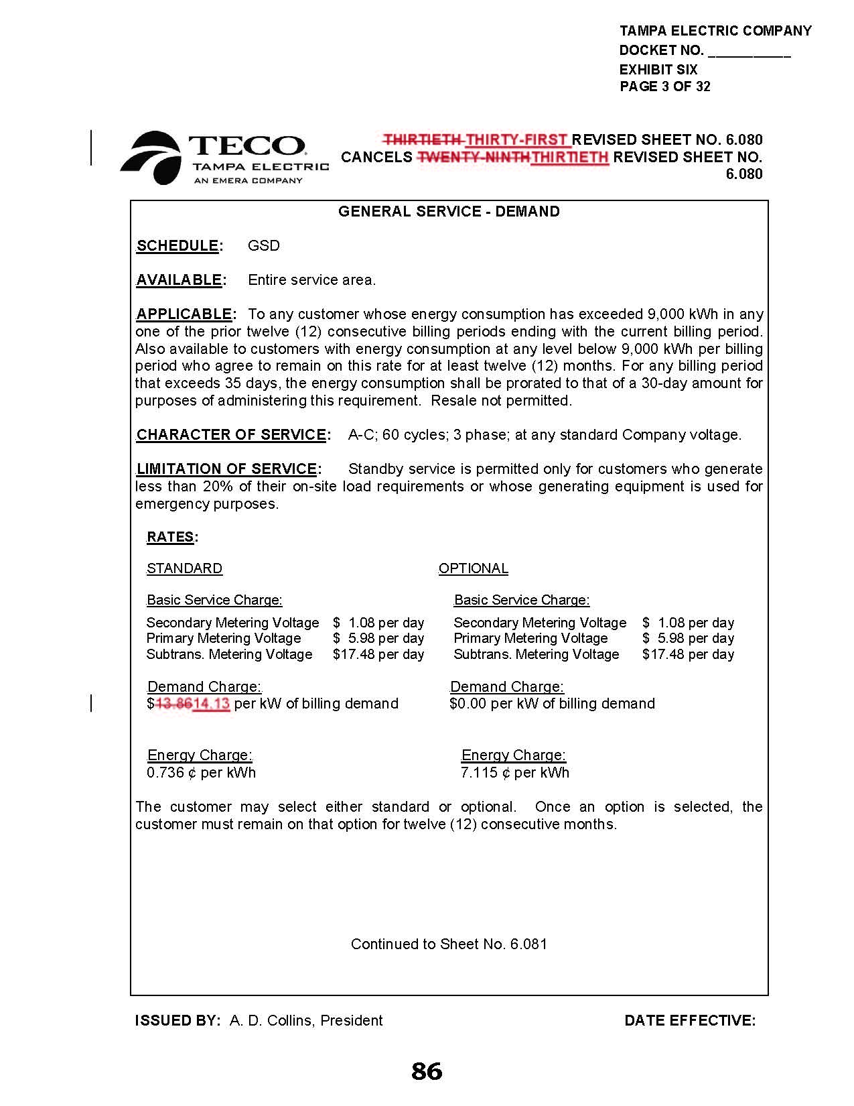
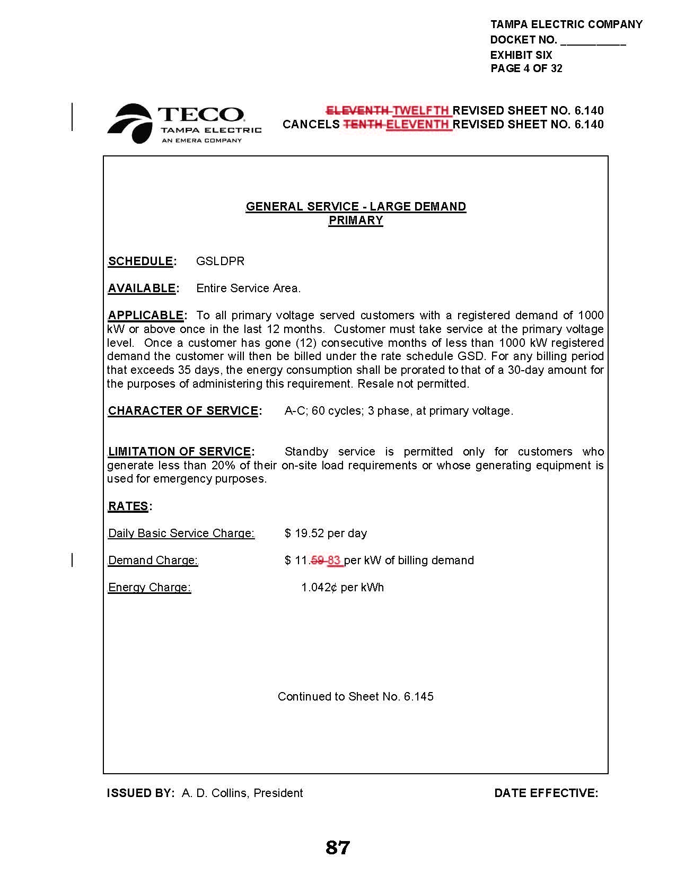
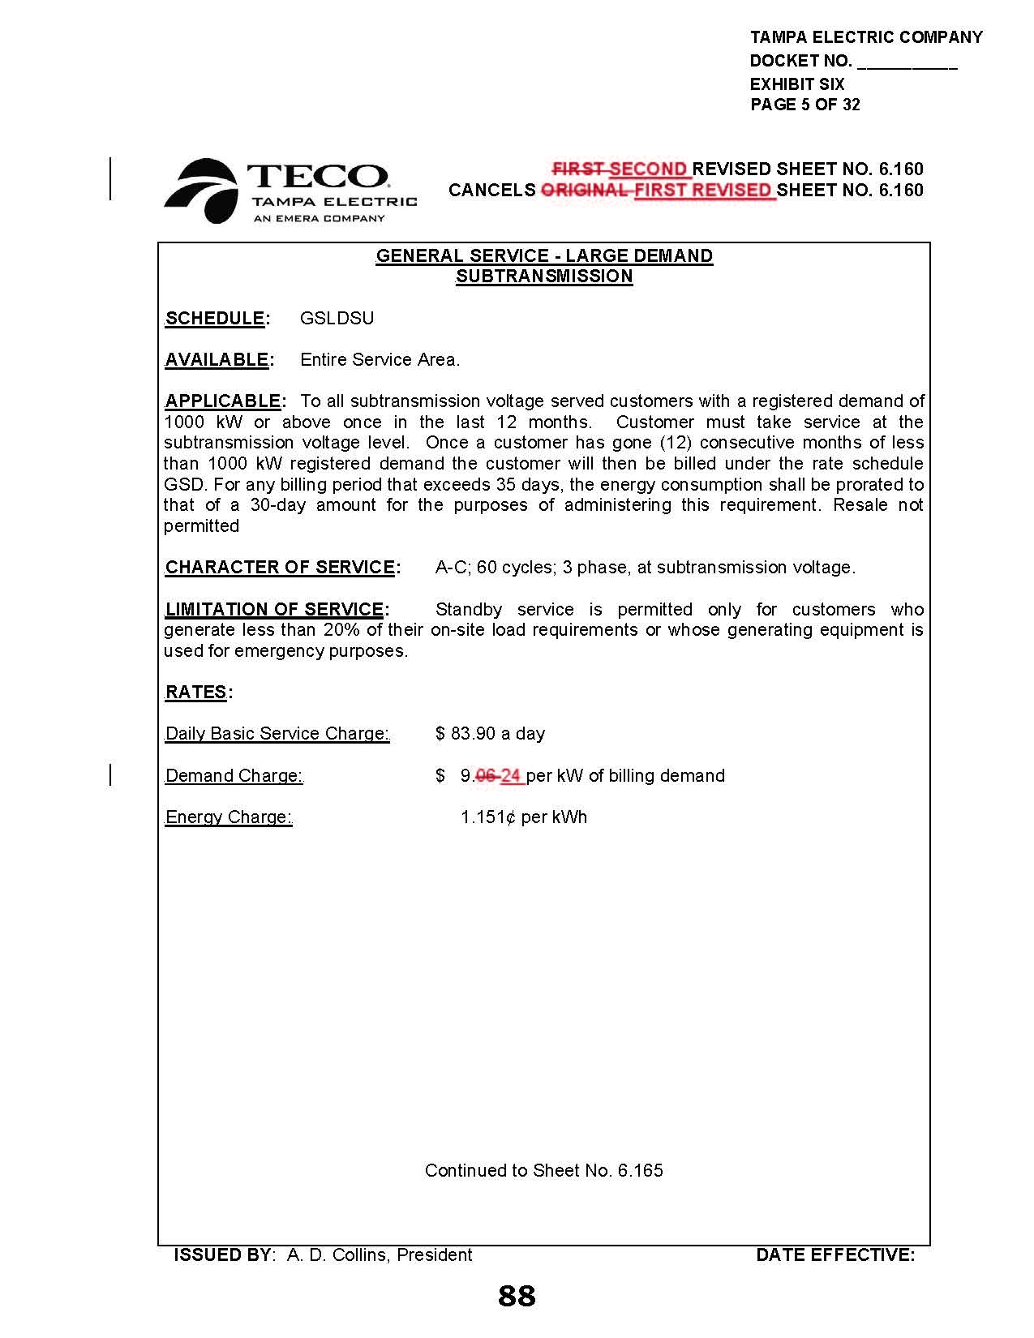
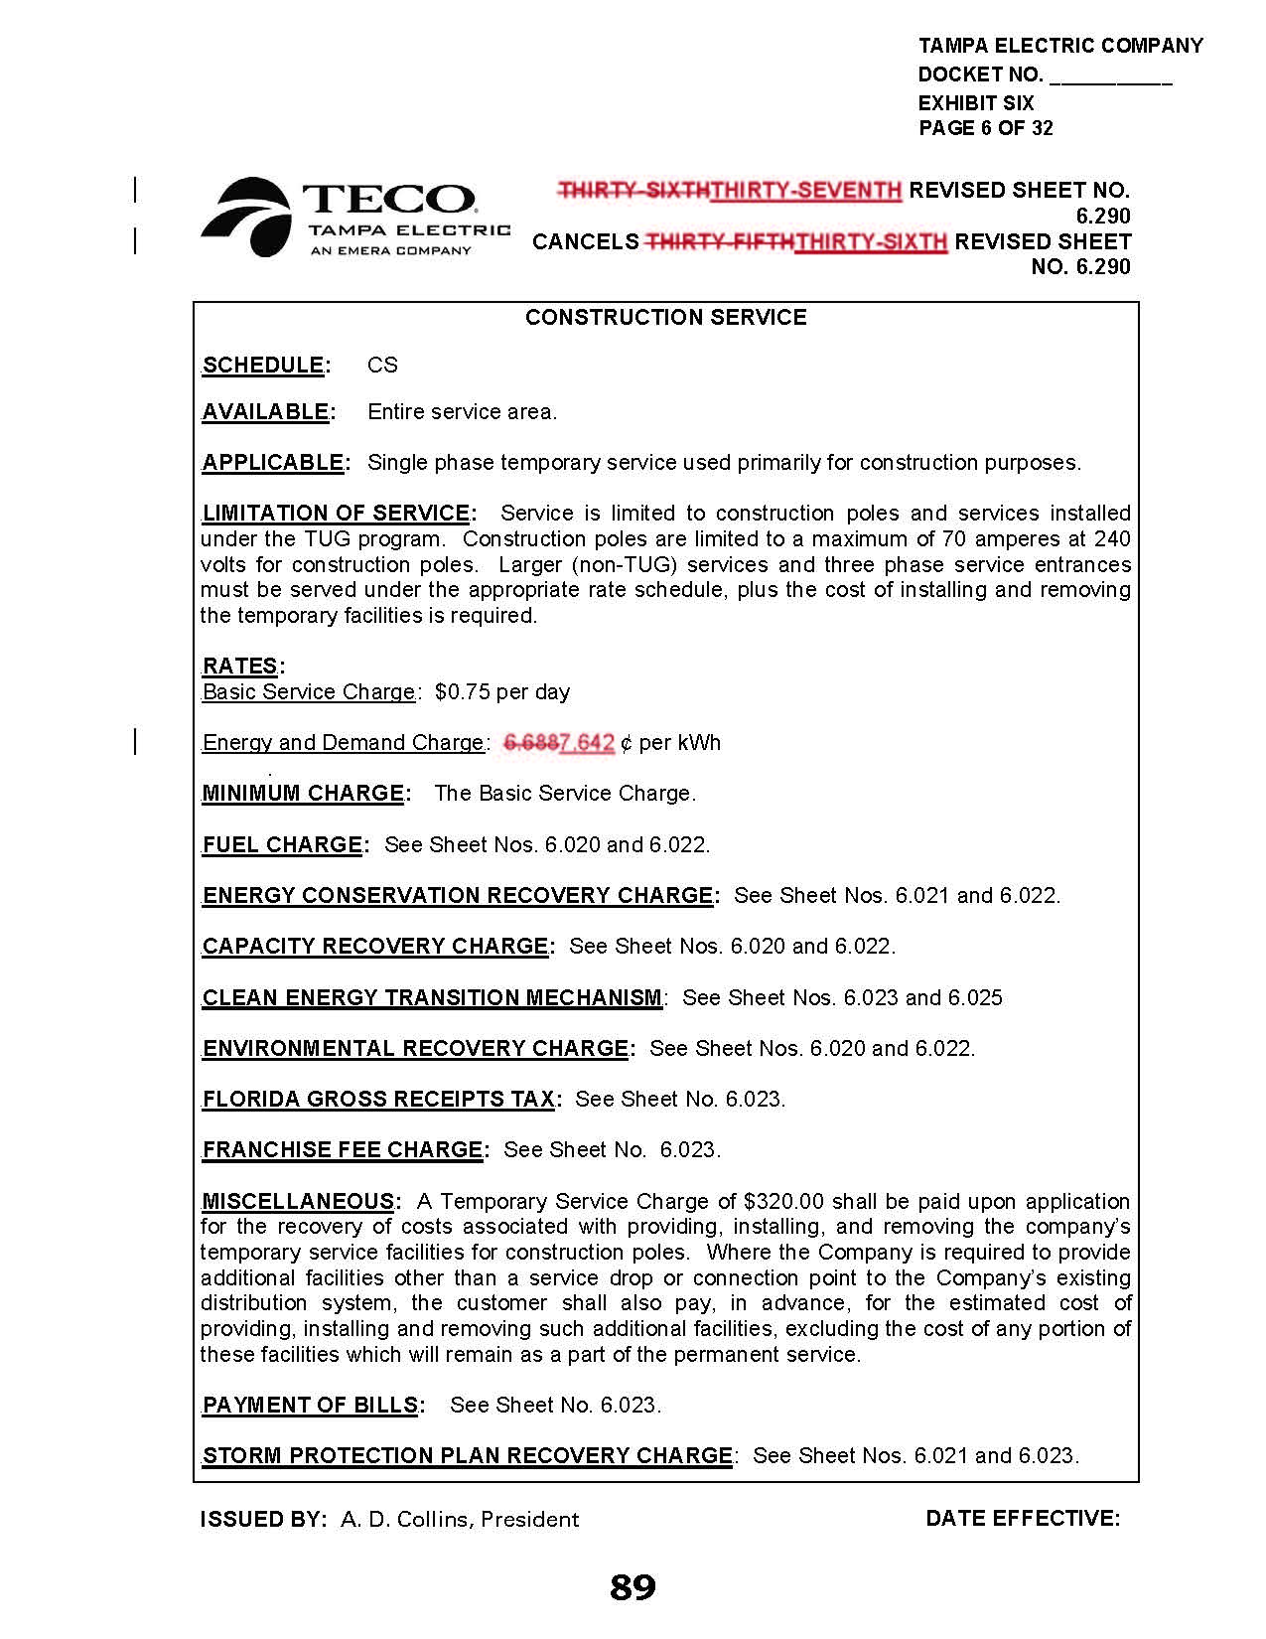
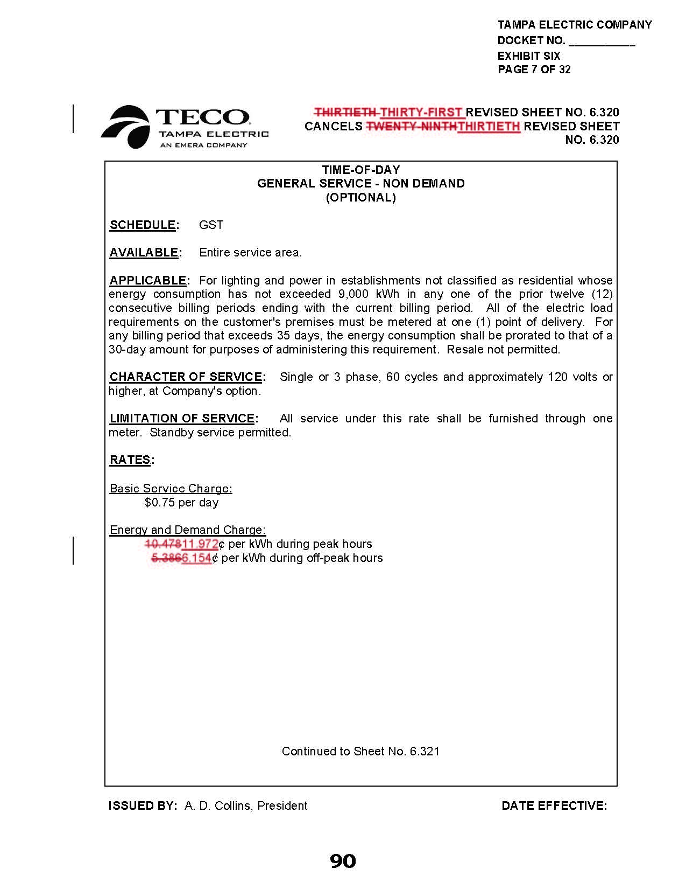
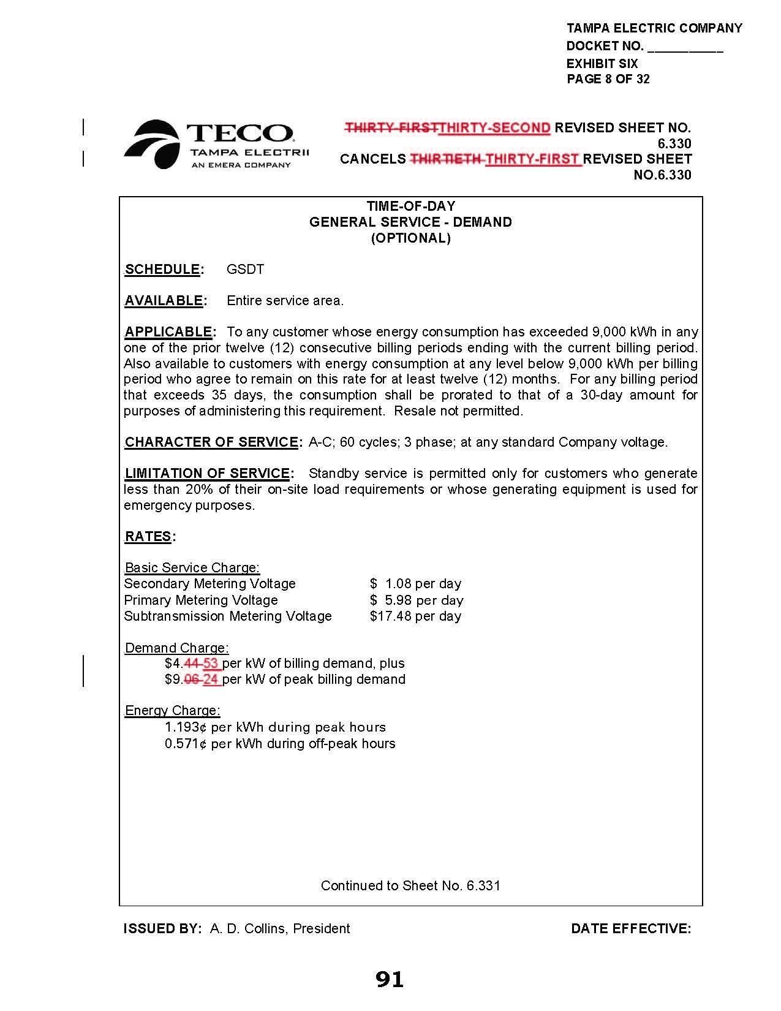
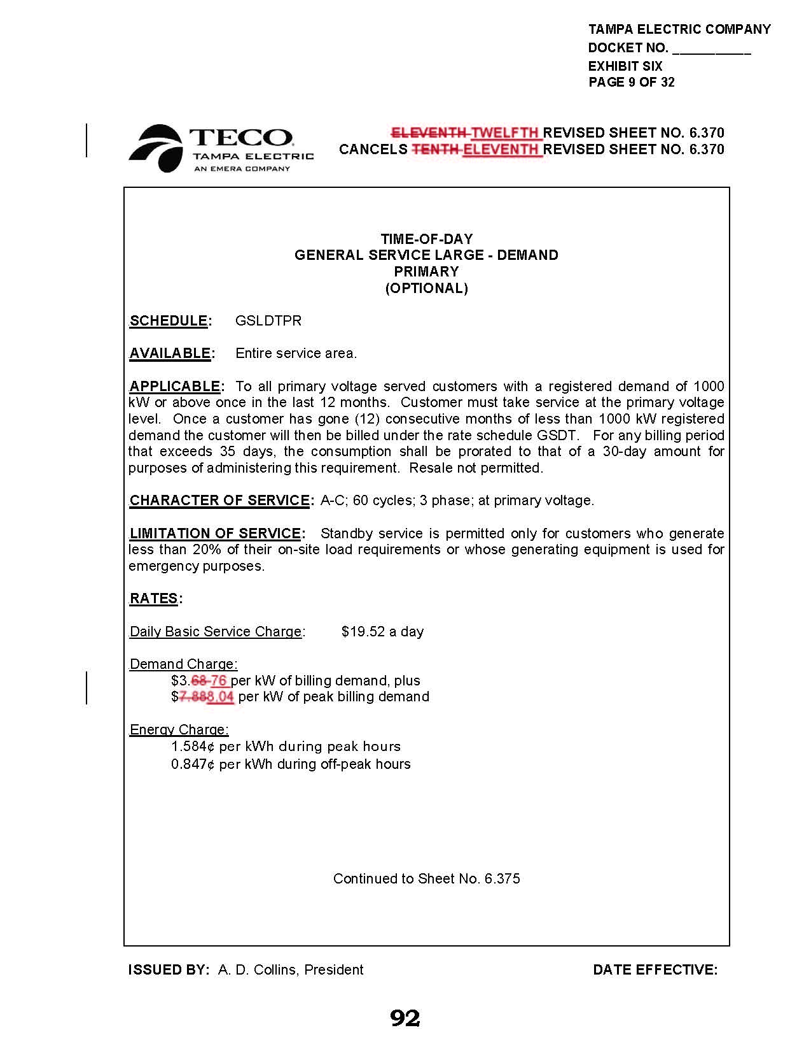
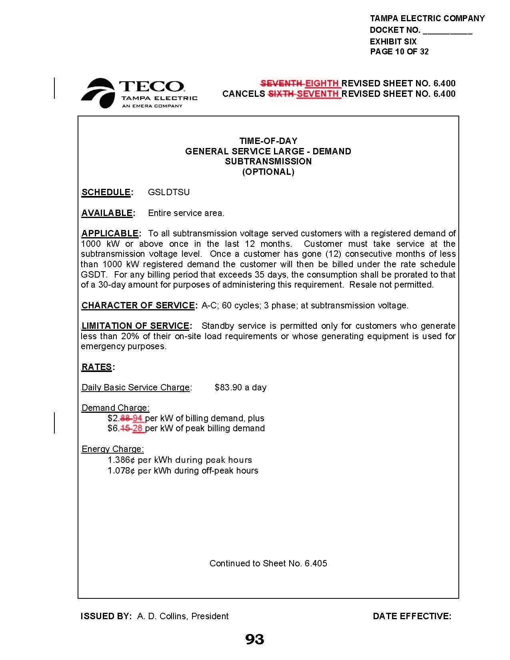
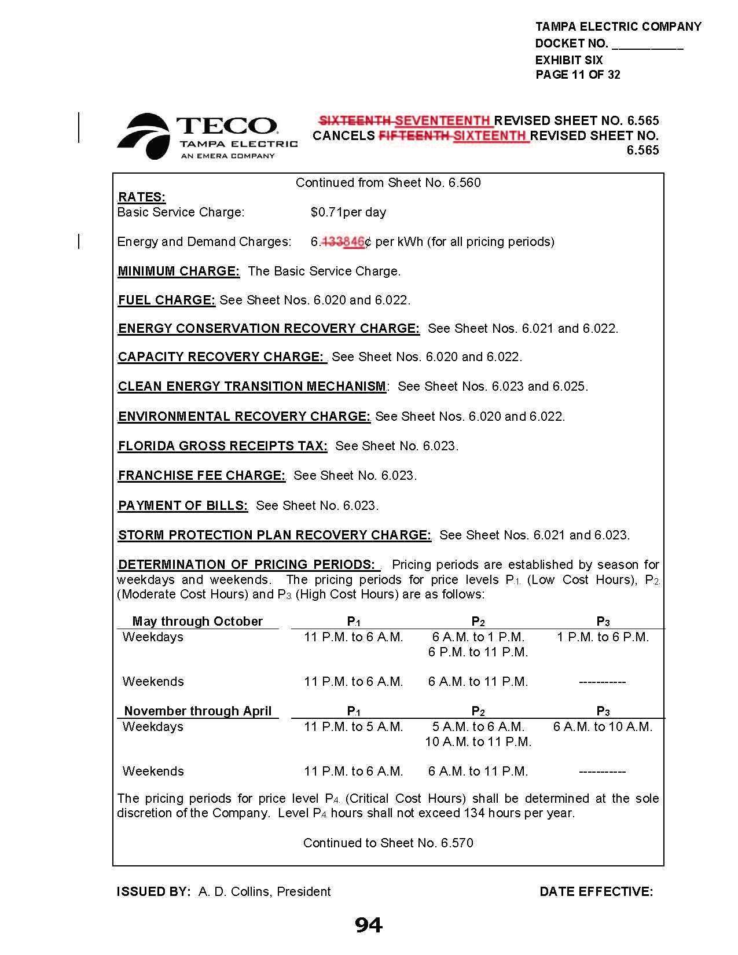
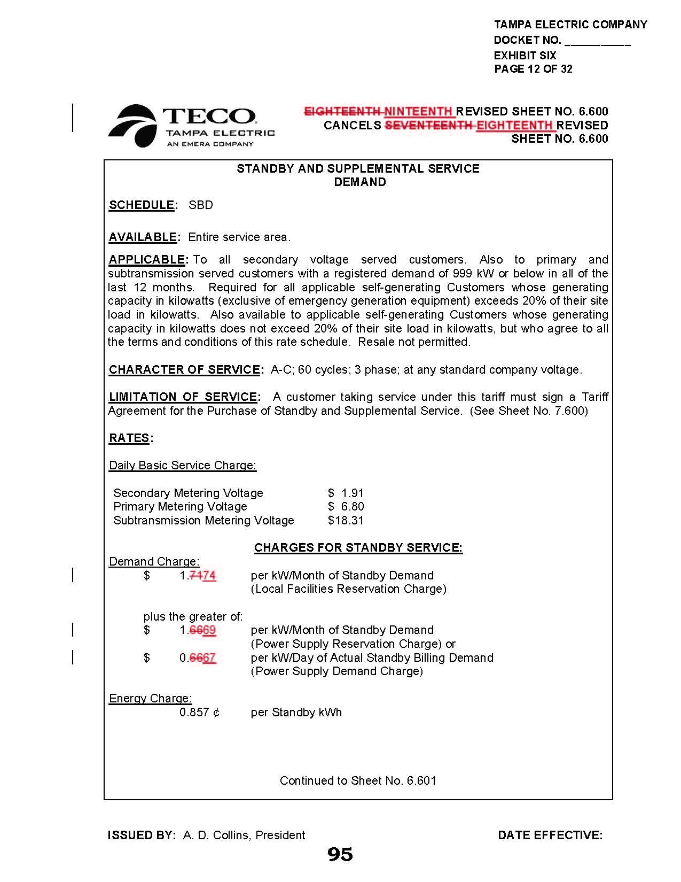
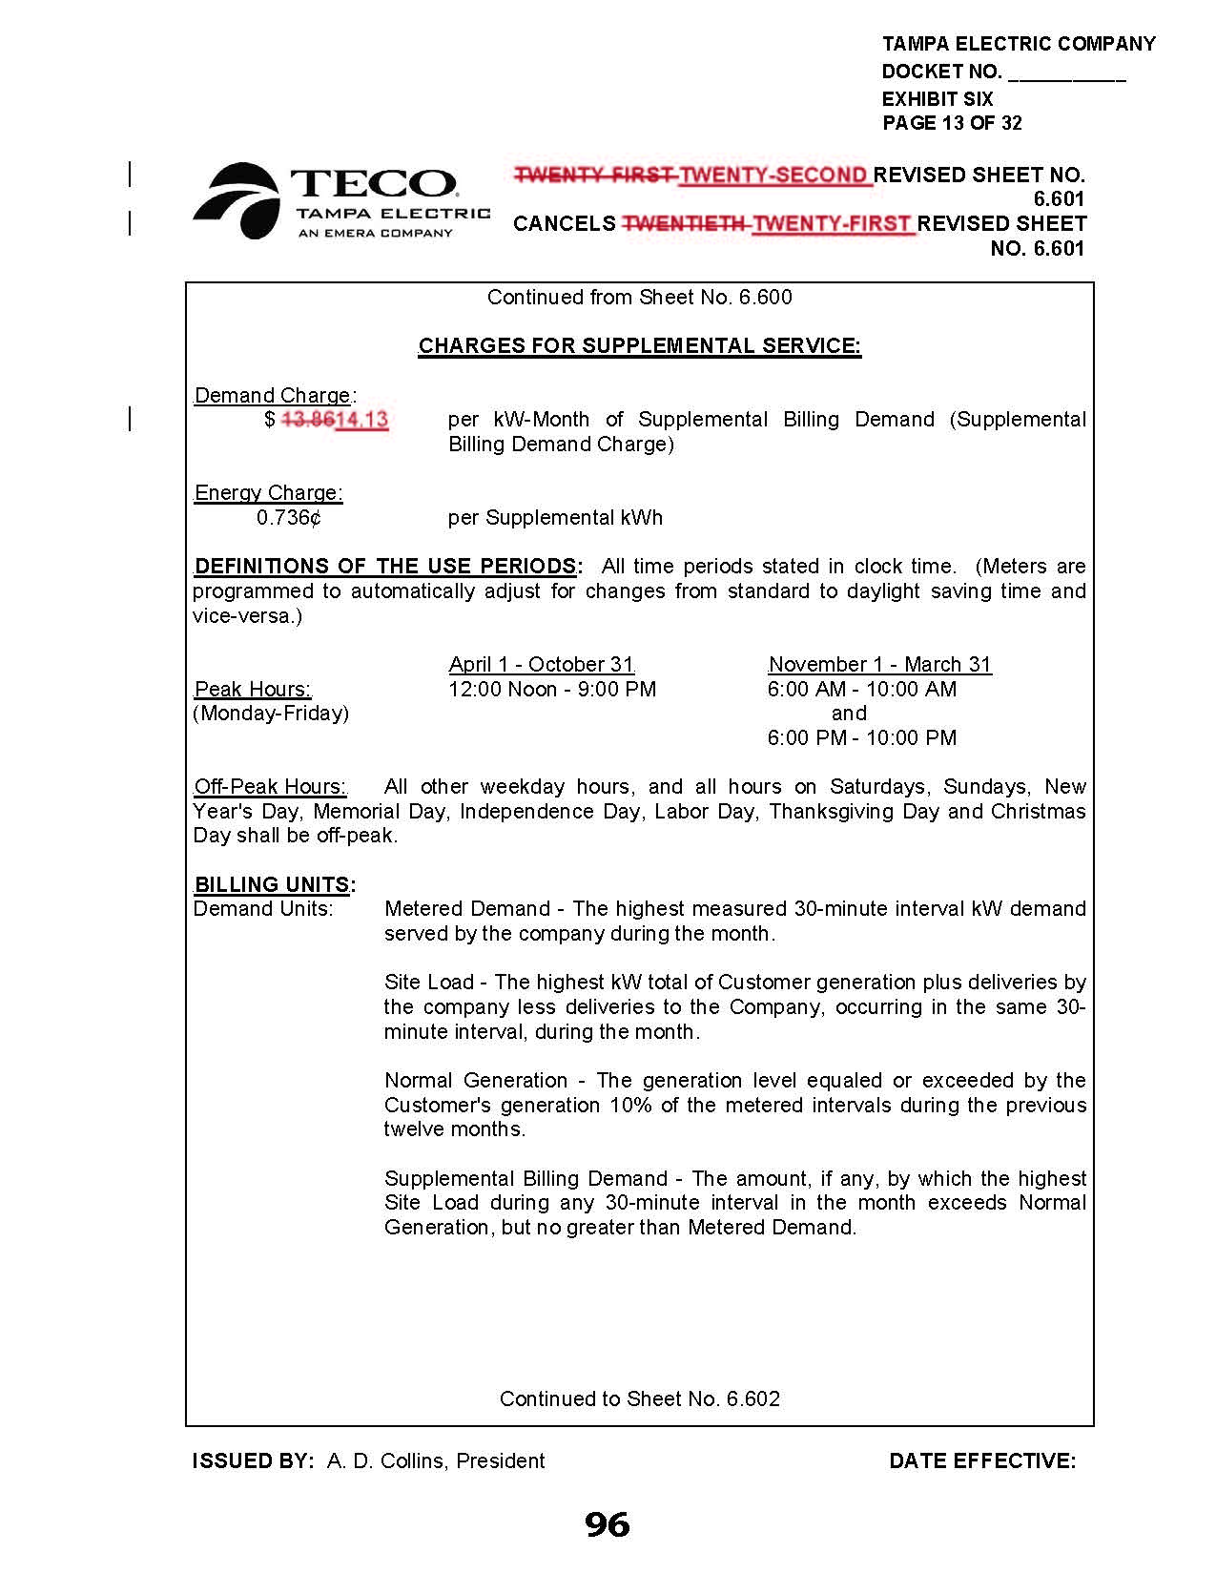
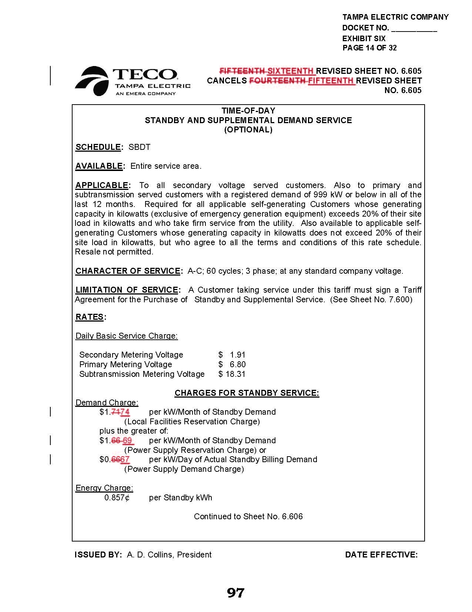
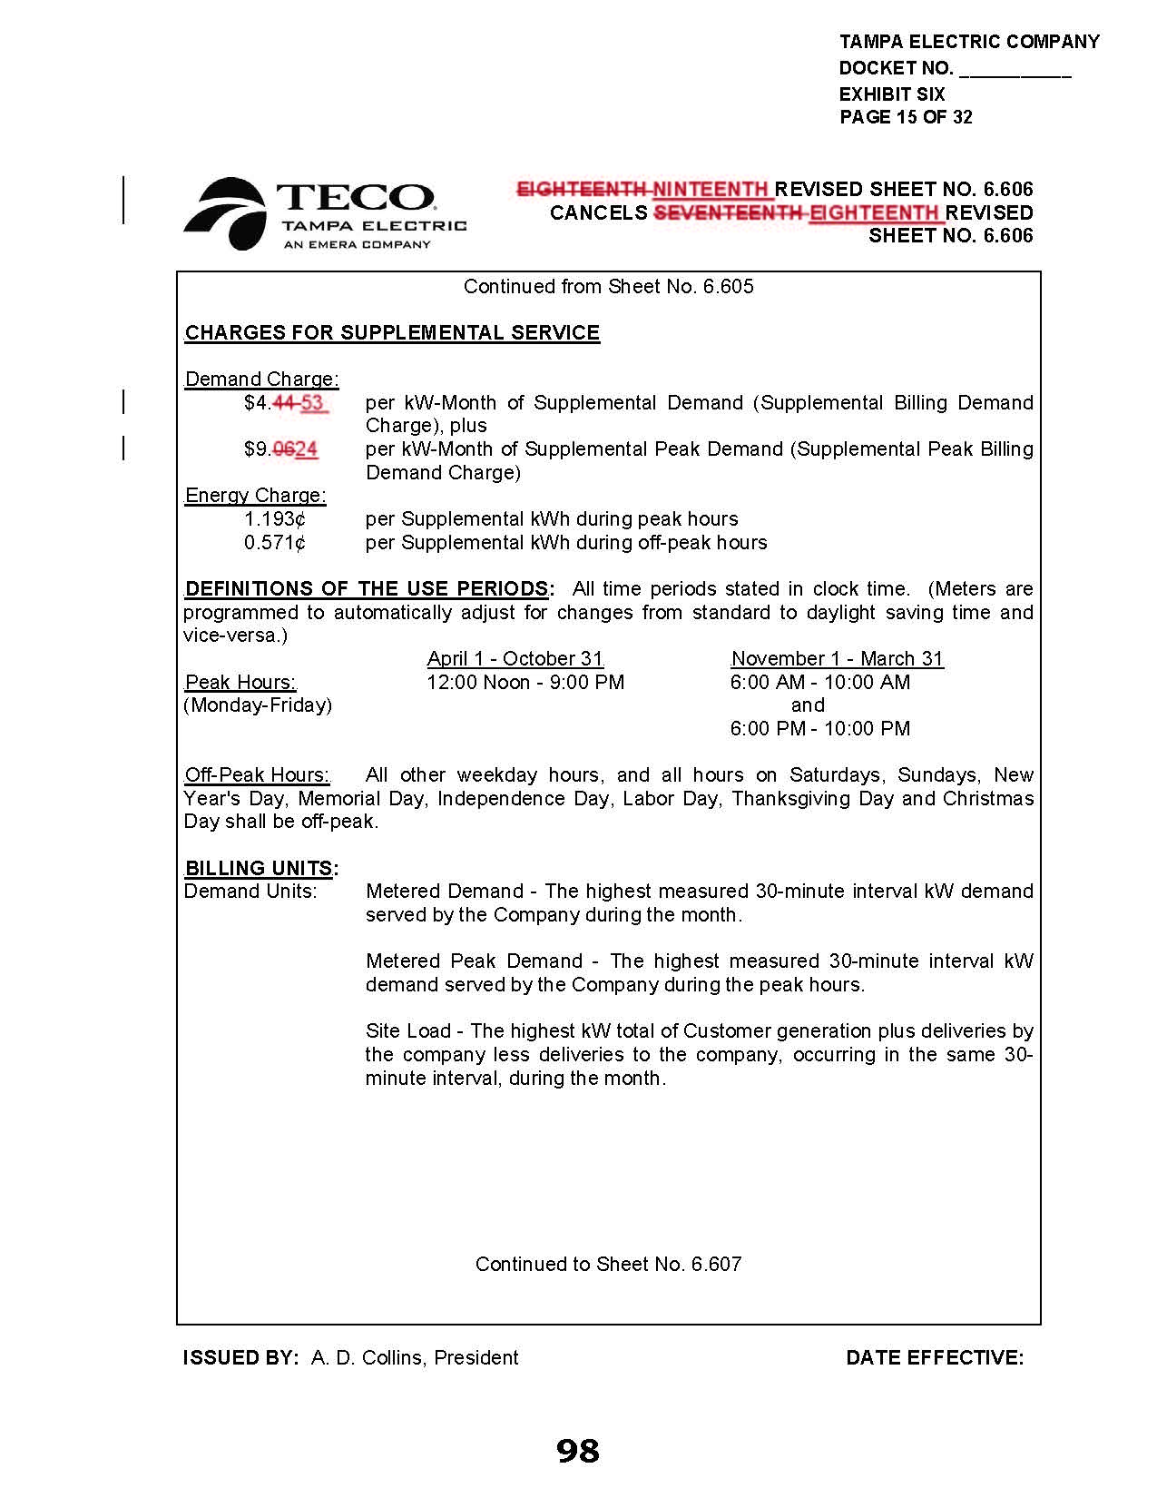
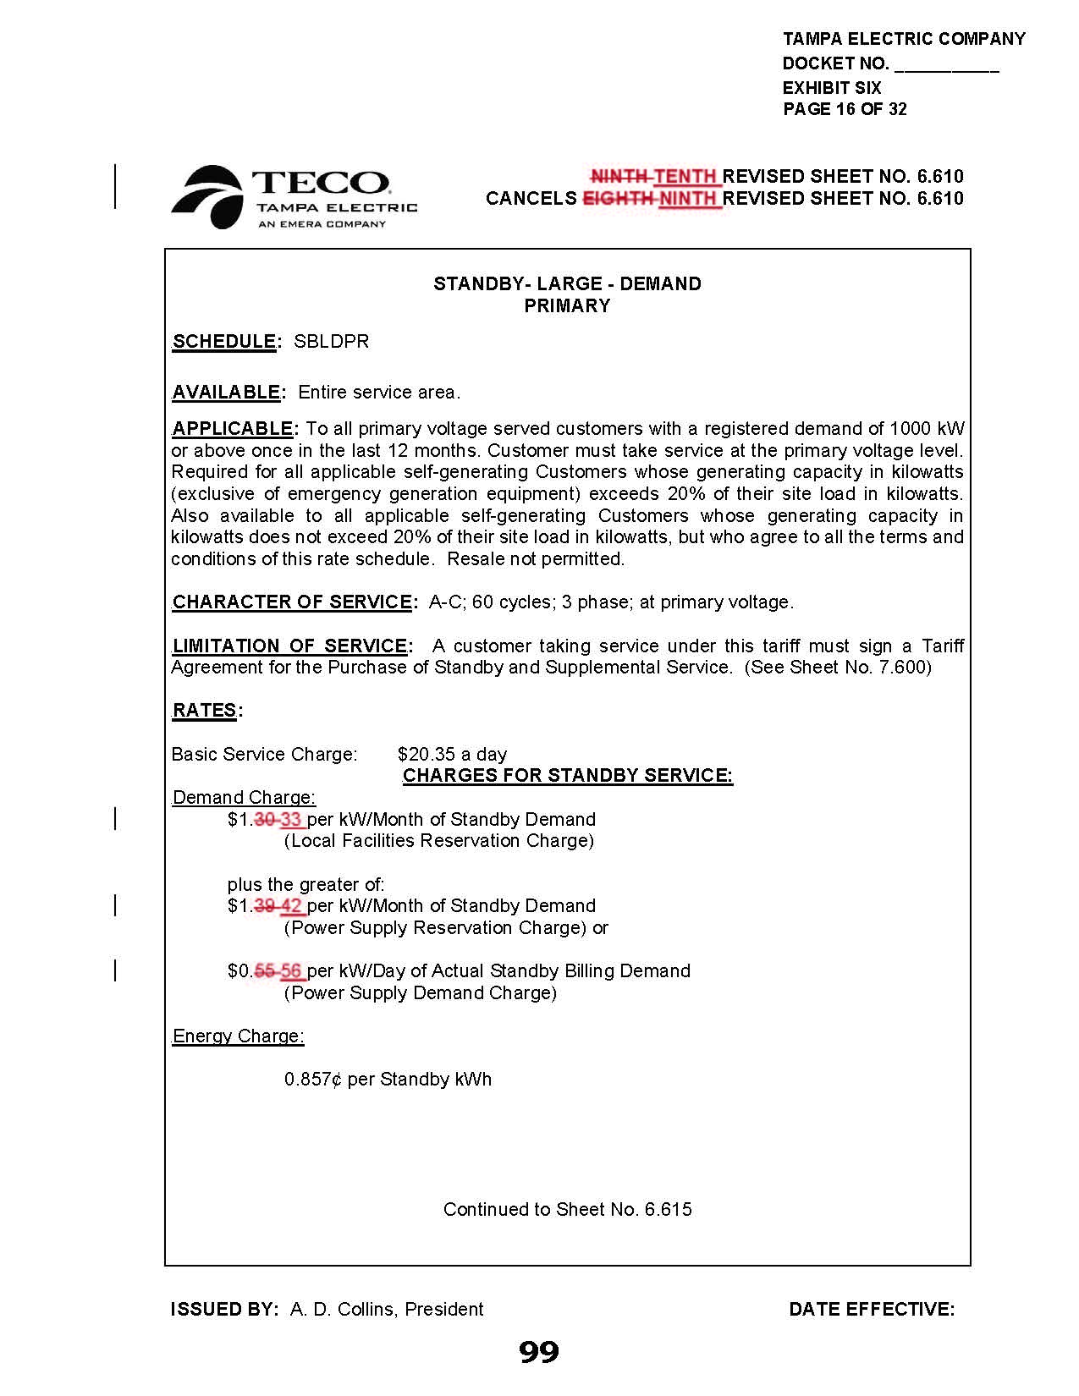
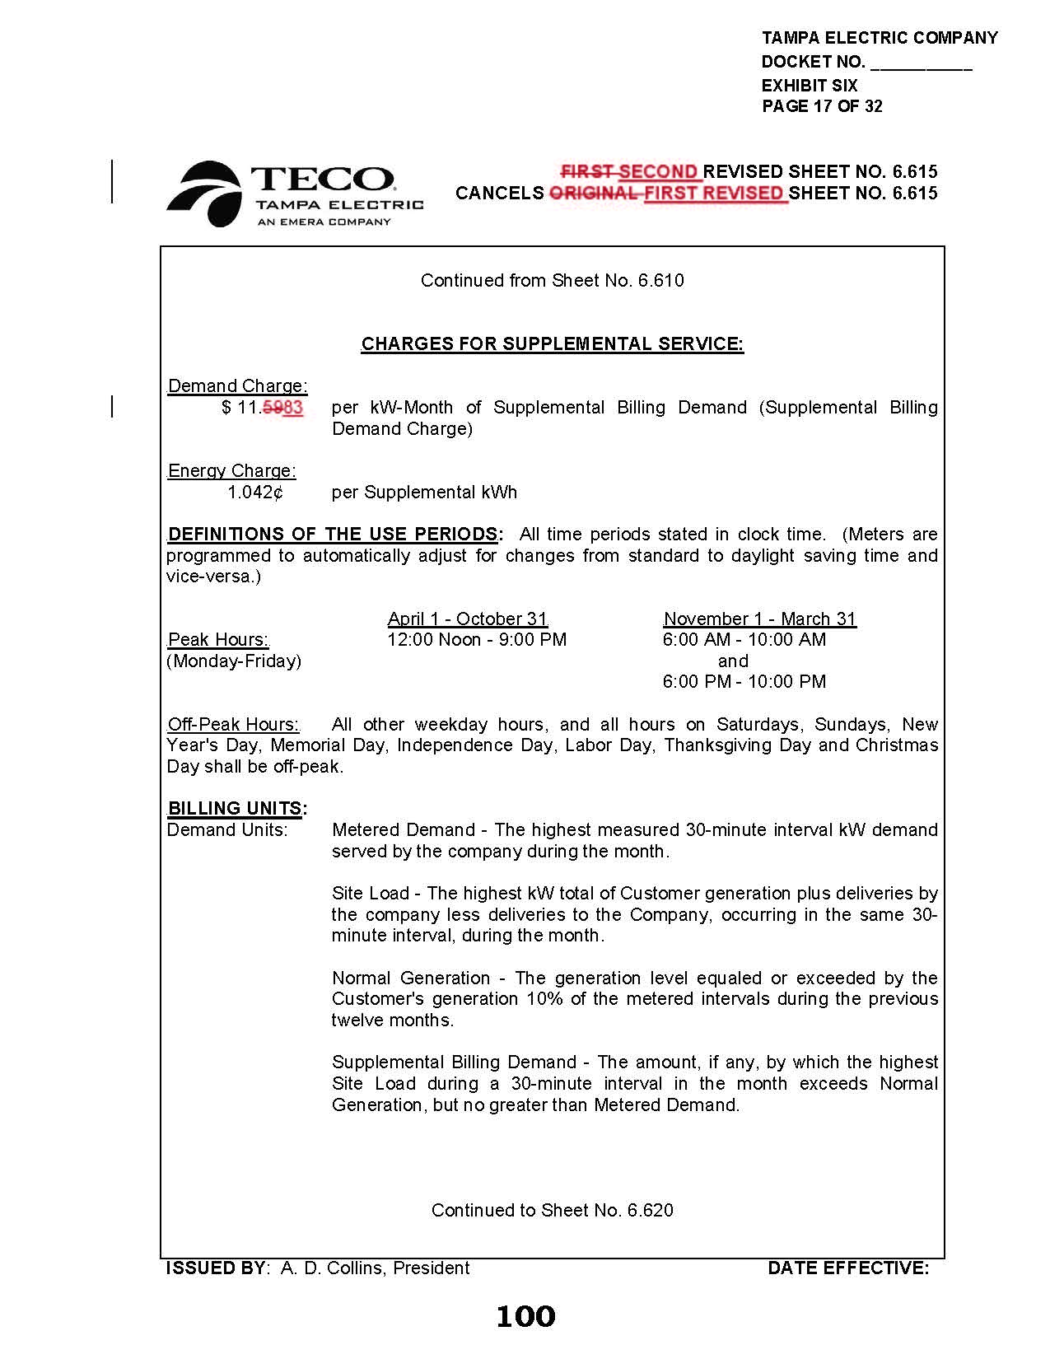
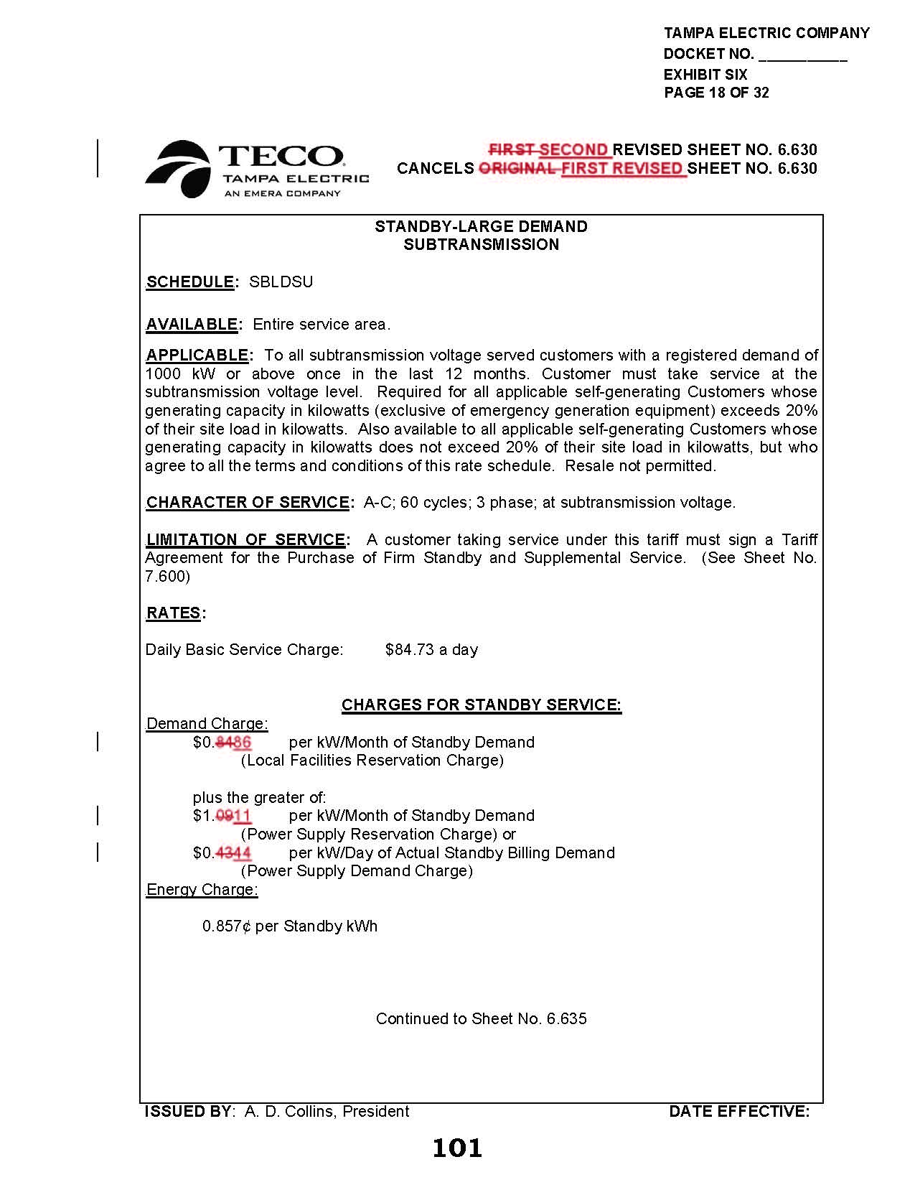
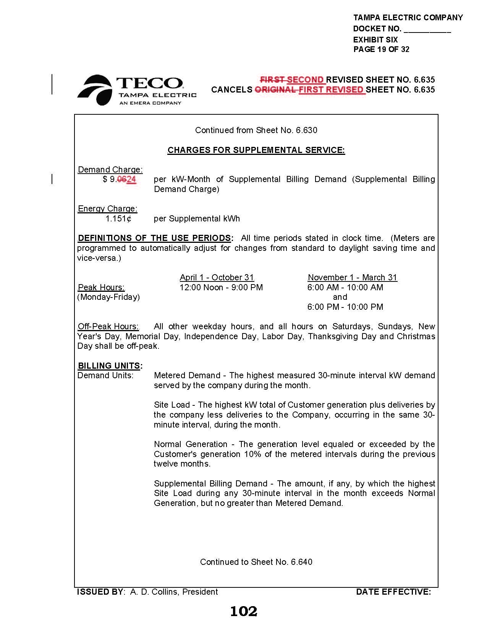
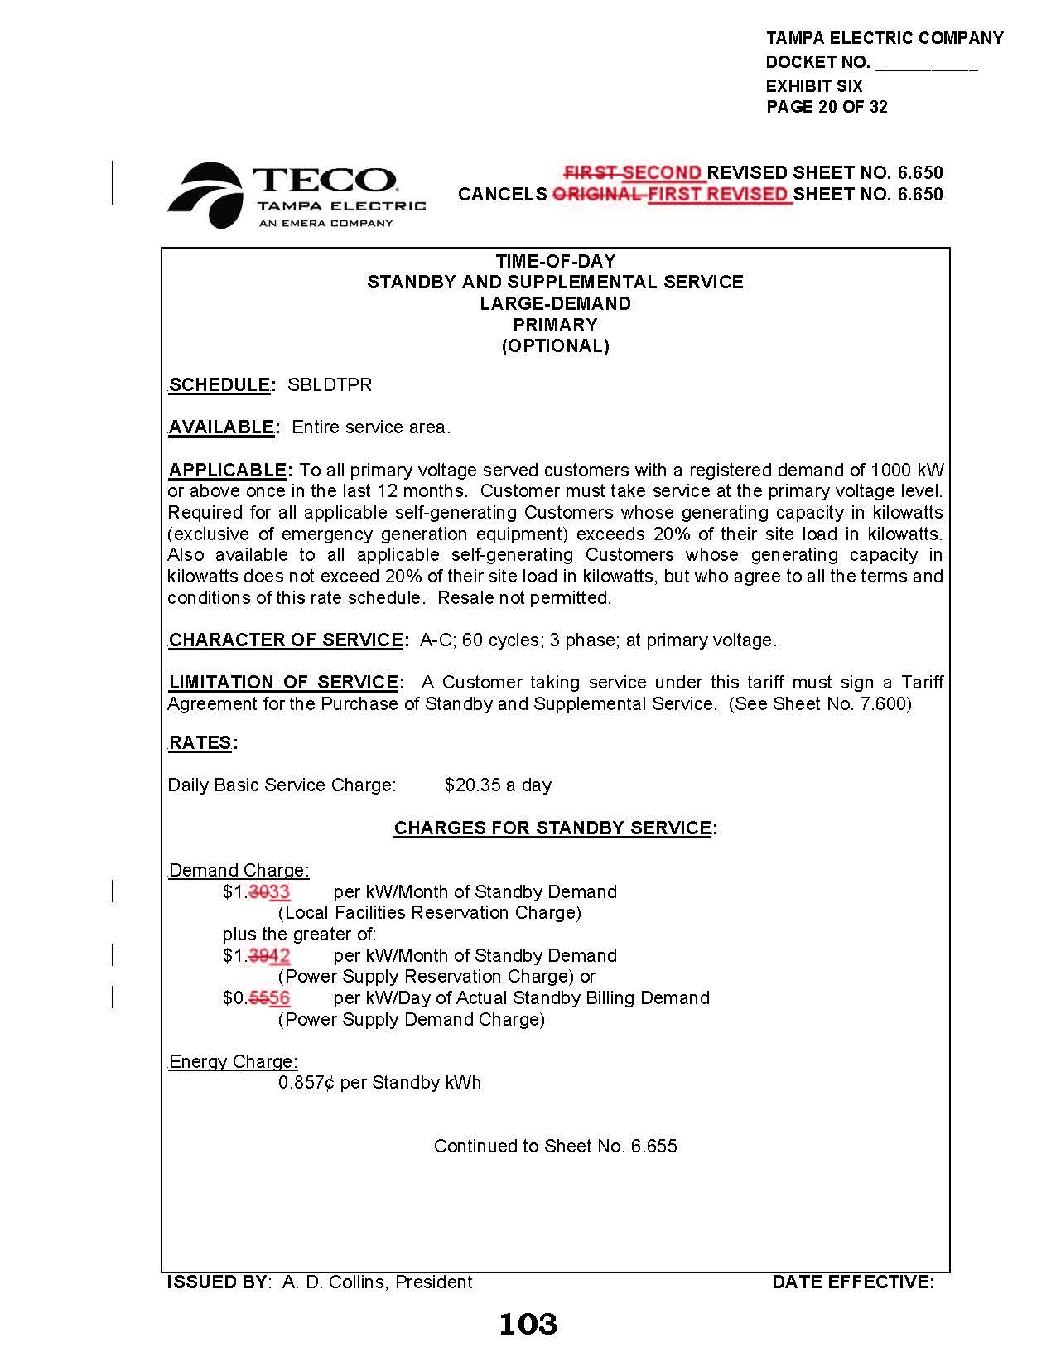
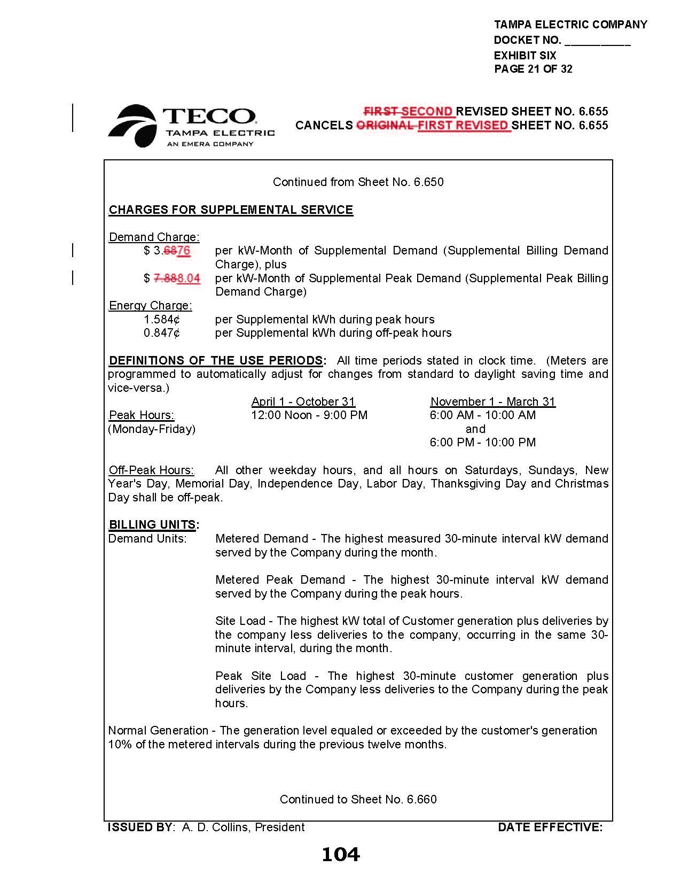
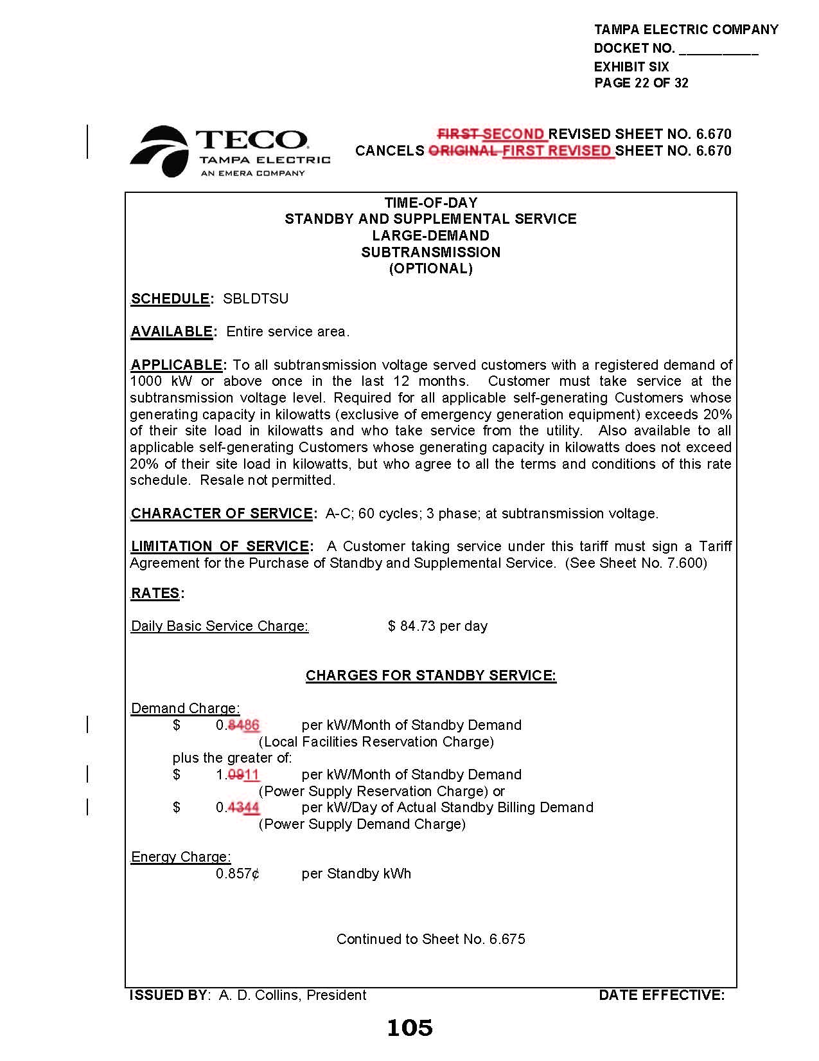
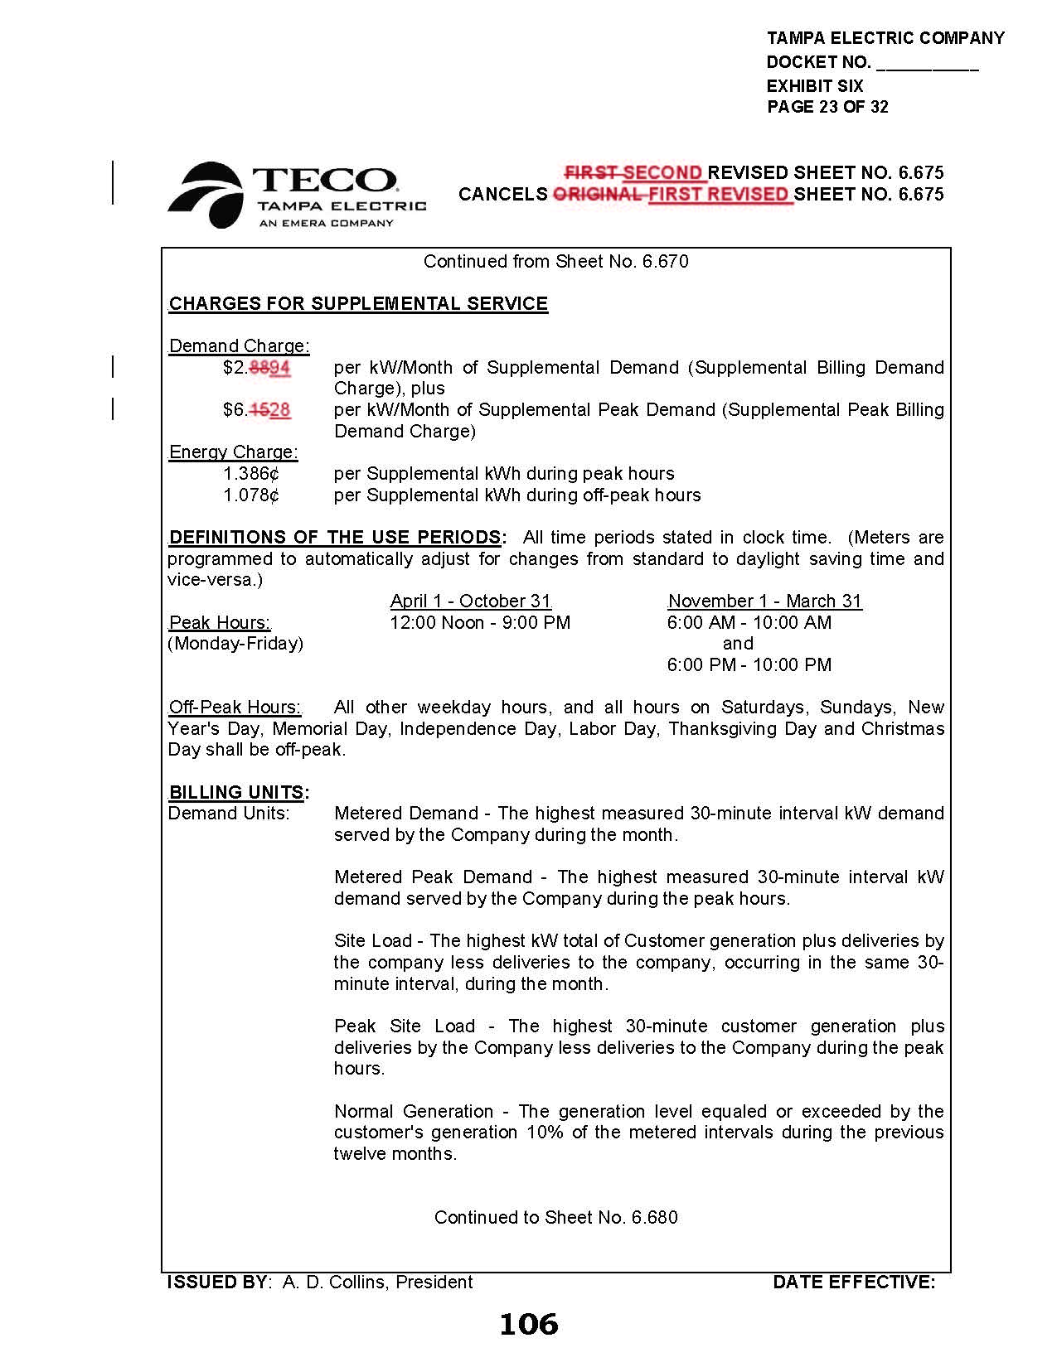
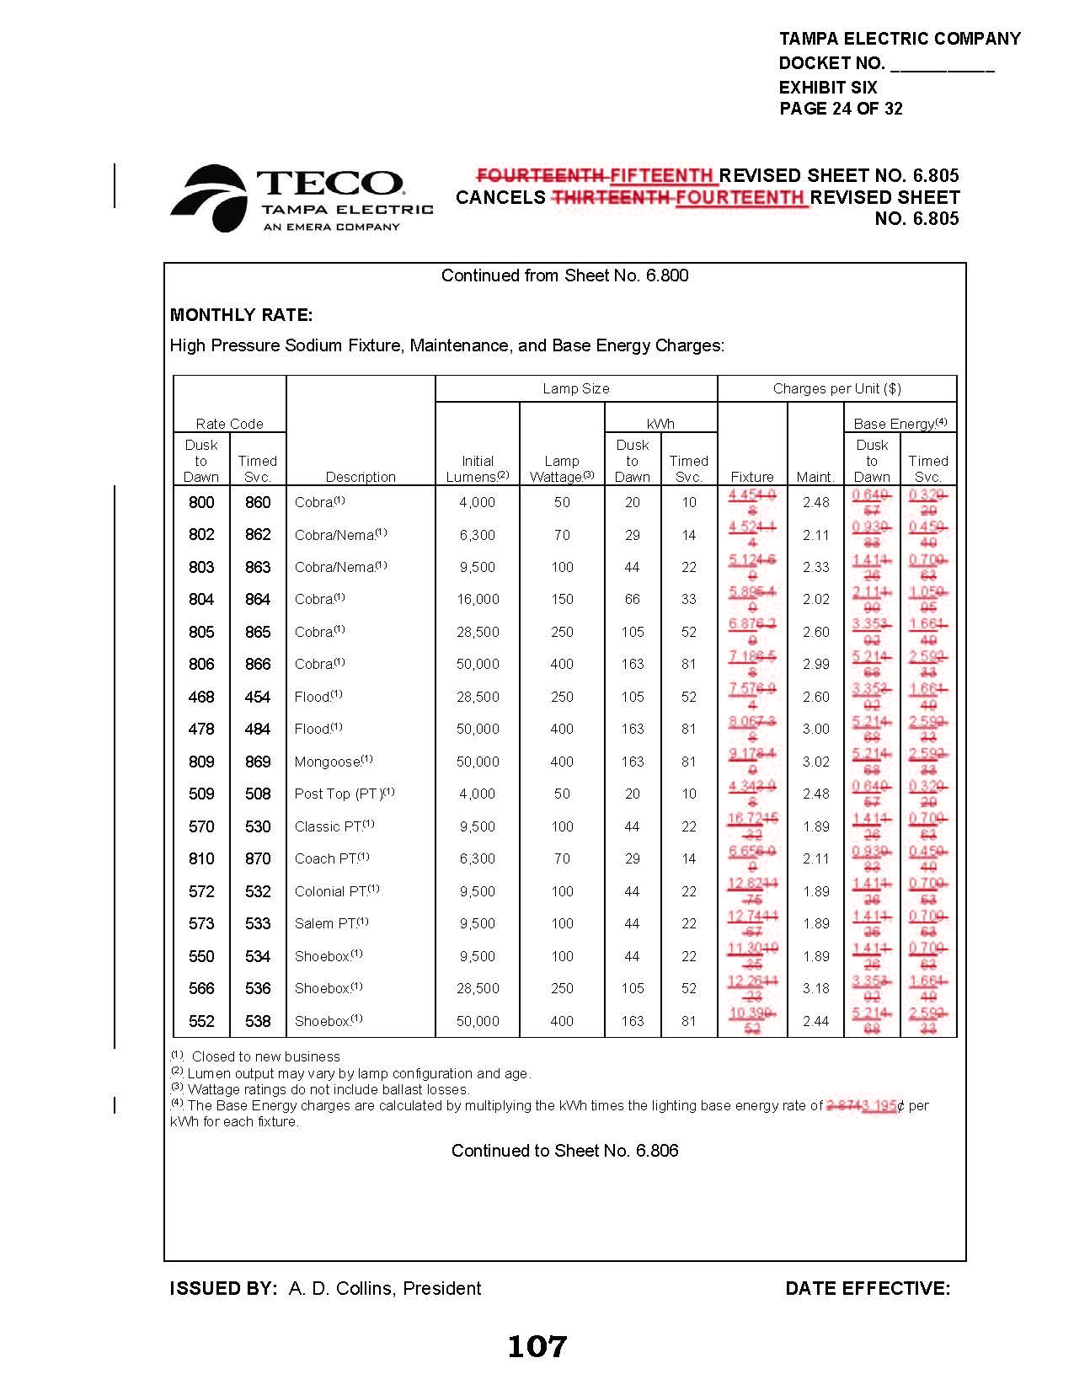
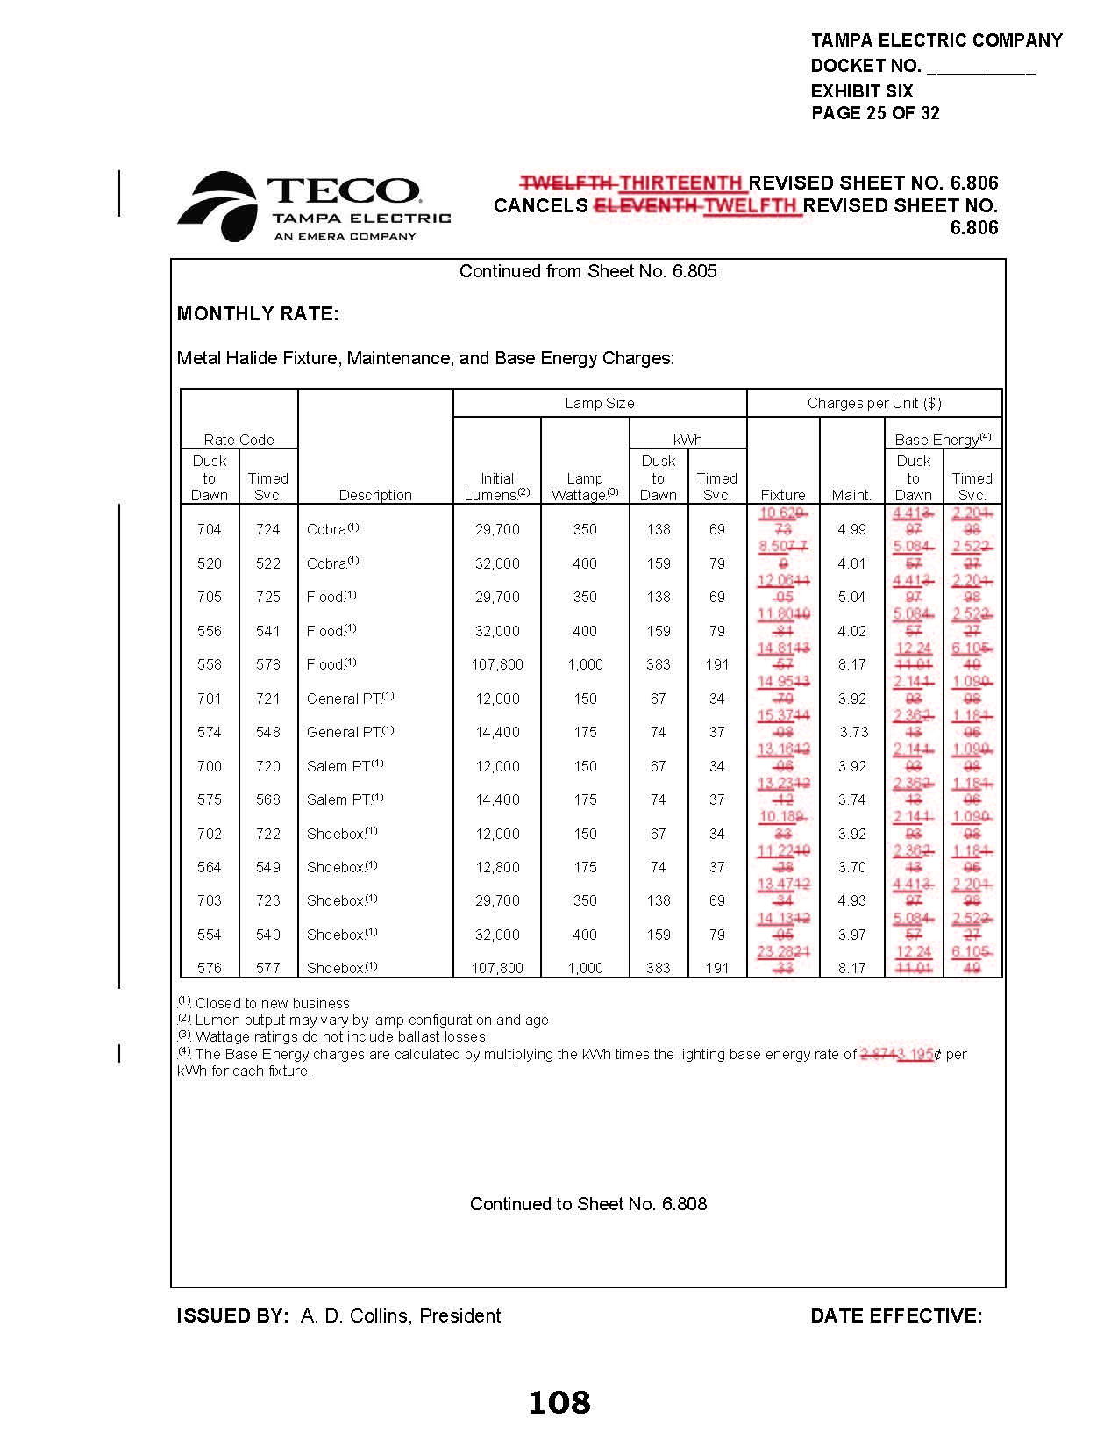
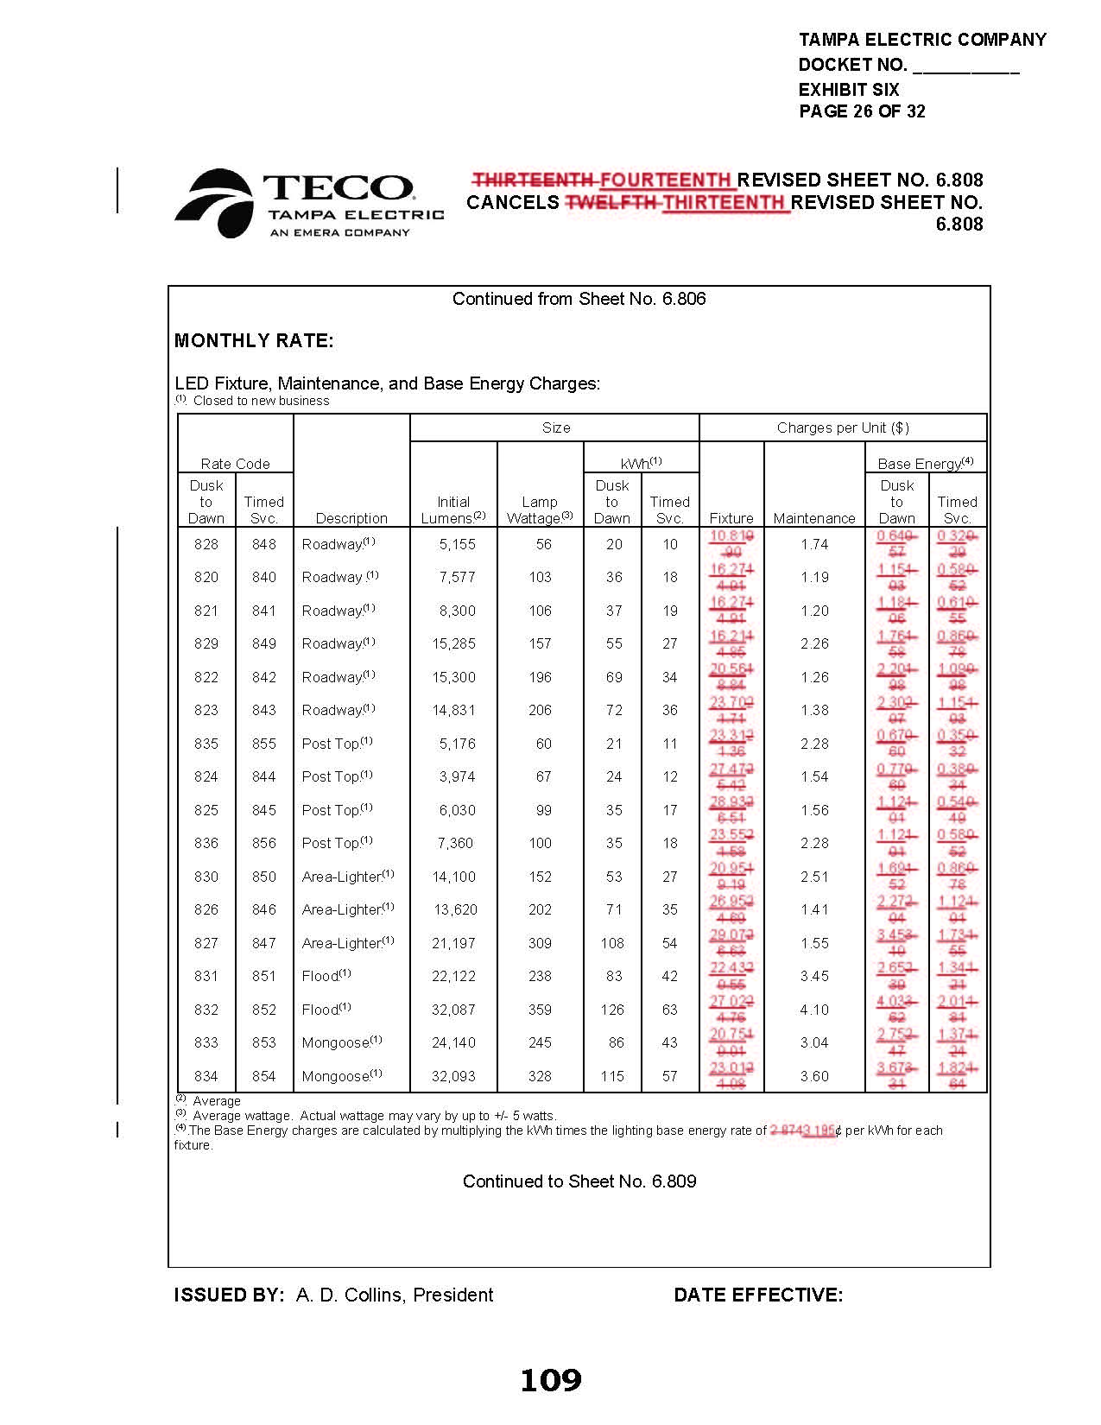
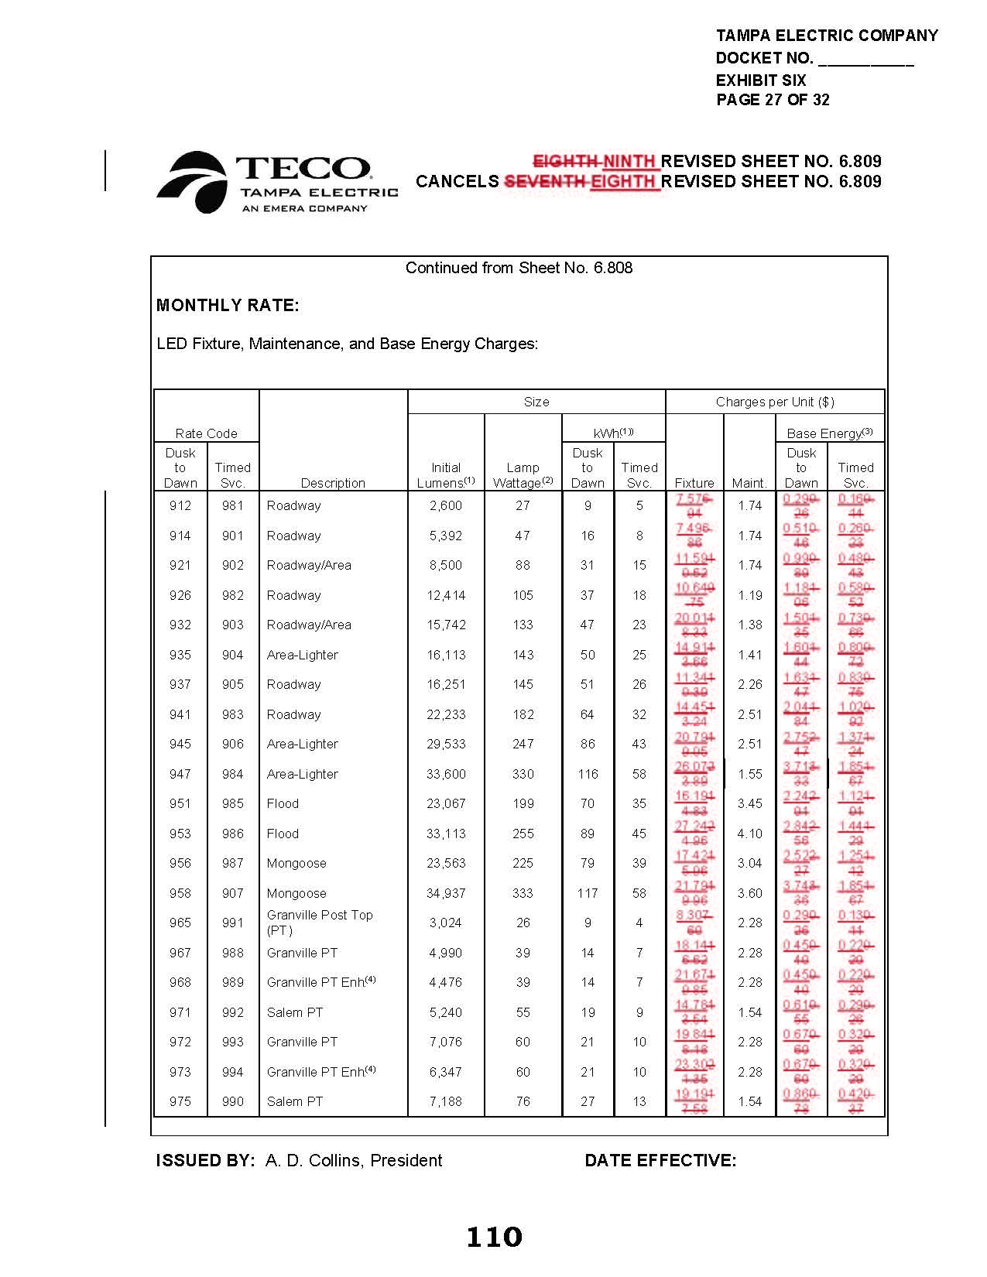
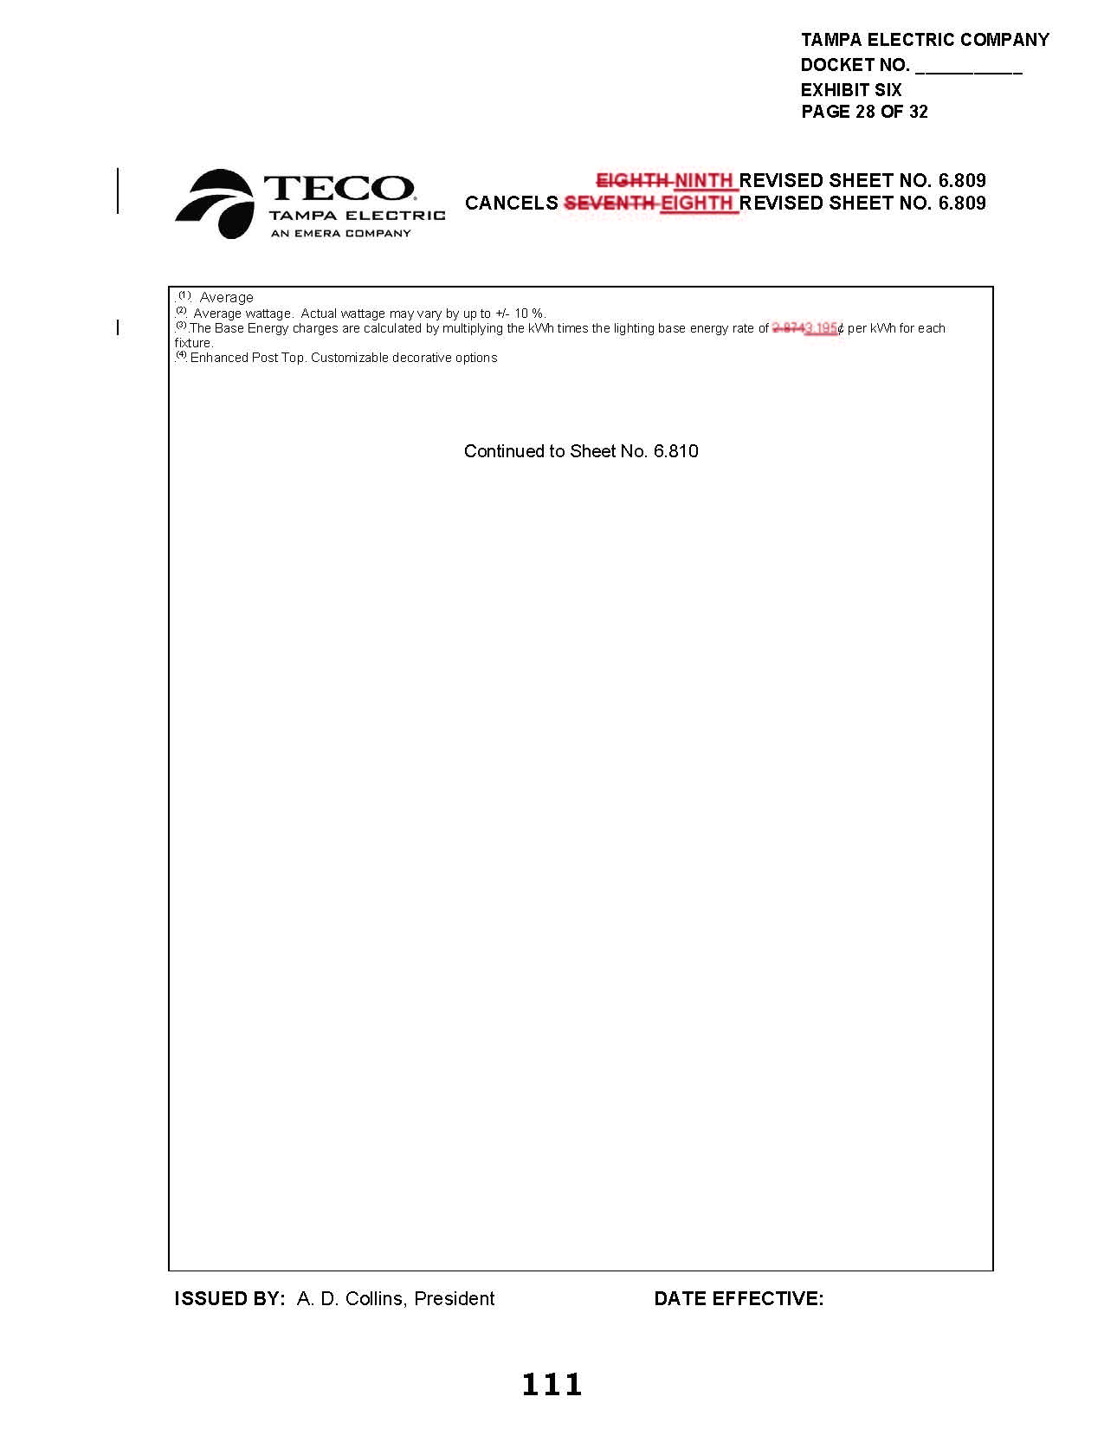
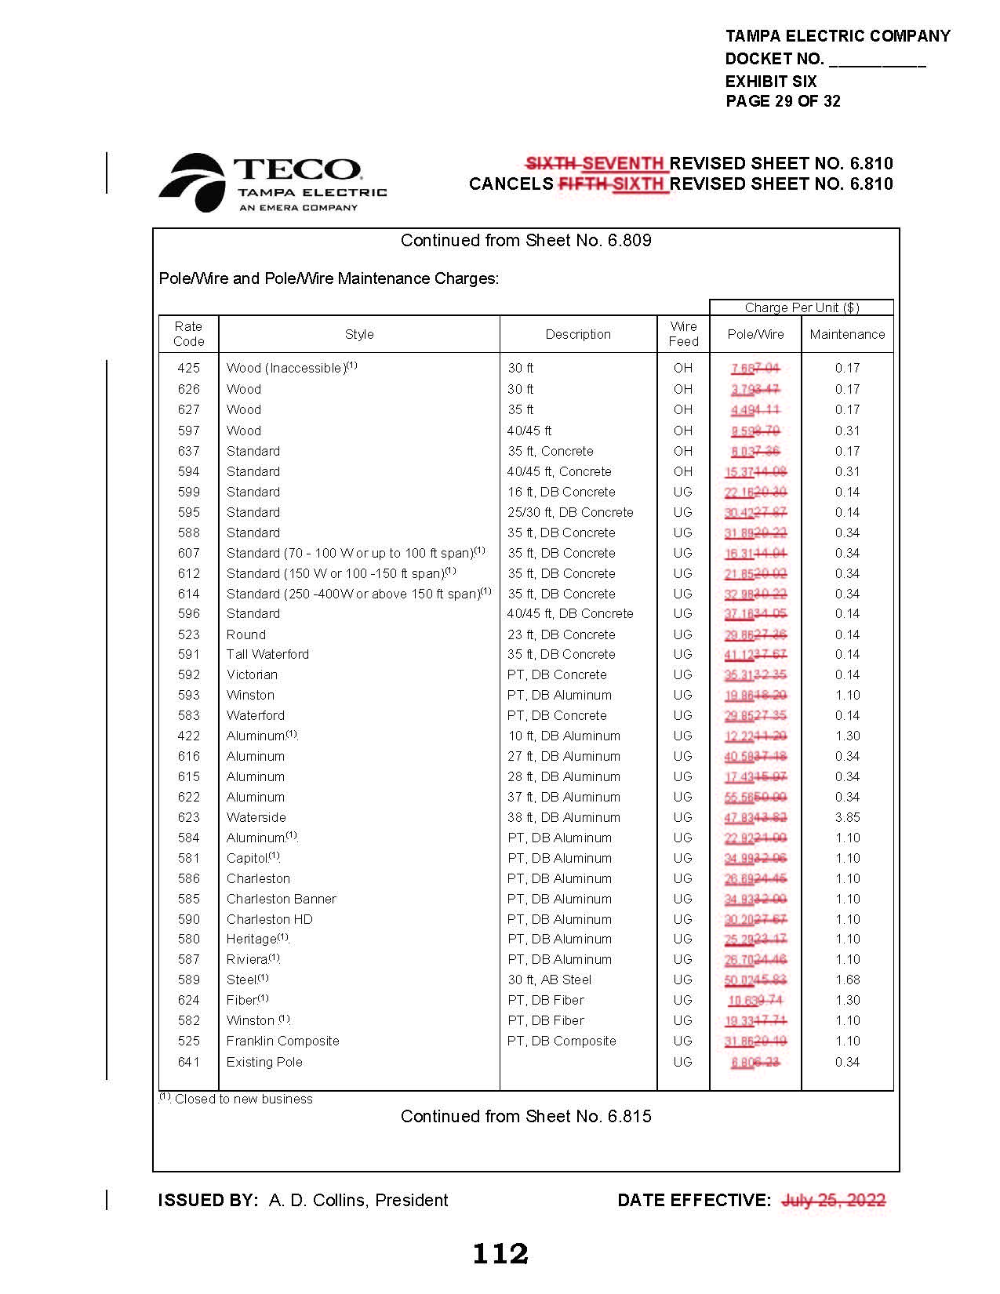
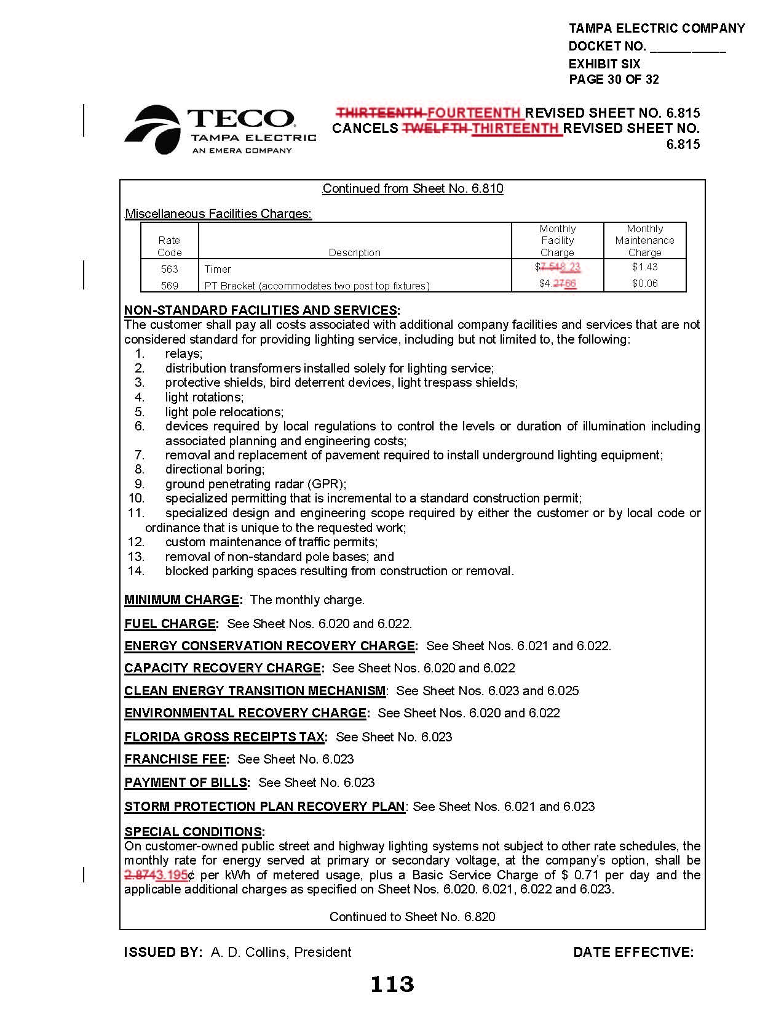
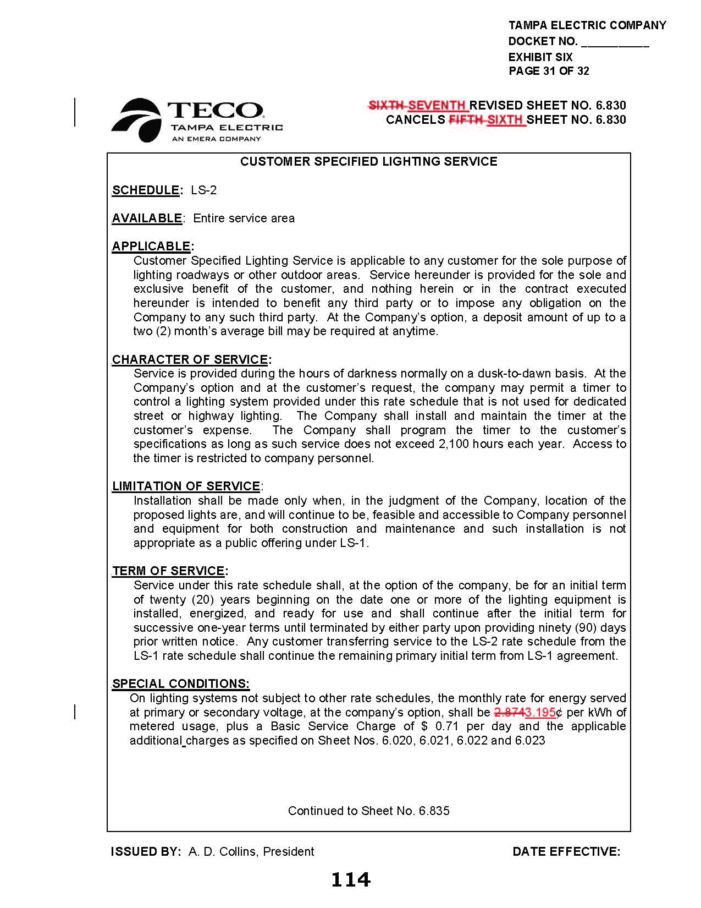
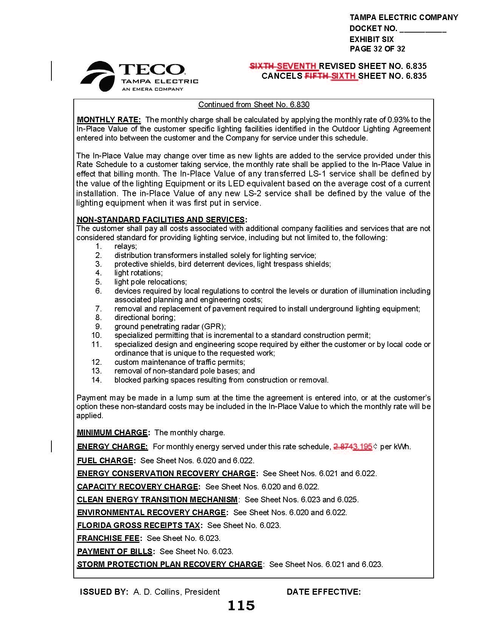

Order No. PSC-2021-0423-S-EI, issued November 10, 2021, in Docket No. 20210034-EI, In re: Petition for rate increase by Tampa Electric Company.
Order No. PSC-2022-0322-FOF-EI, issued September 12, 2022, in Docket No. 20220122-EI, In re: Petition for limited proceeding rate increase to implement return on equity provisions in 2021 agreement, by Tampa Electric Company.
Document No. 05237-2022, filed August 5, 2022, in Docket No. 20220002-EI, In re: Energy Conservation Cost Recovery Clause.

