|  |  |  |  |
| --- | --- | --- | --- |
| State of Florida  pscSEAL | | Public Service Commission  Capital Circle Office Center ● 2540 Shumard Oak Boulevard Tallahassee, Florida 32399-0850  -M-E-M-O-R-A-N-D-U-M- | |
| DATE: | December 28, 2022 | | |
| TO: | Office of Commission Clerk (Teitzman) | | |
| FROM: | Division of Economics (Guffey)  Office of the General Counsel (Watrous, Crawford) | | |
| RE: | Docket No. 20220164-GU – Joint petition for approval of territorial agreement in Santa Rosa County, by the Okaloosa Gas District and the City of Milton. | | |
| AGENDA: | 01/10/23 – Regular Agenda – Proposed Agency Action – Interested Persons May Participate | | |
| COMMISSIONERS ASSIGNED: | | | All Commissioners |
| PREHEARING OFFICER: | | | Passidomo |
| CRITICAL DATES: | | | None |
| SPECIAL INSTRUCTIONS: | | | None |

Case Background

On September 22, 2022, the City of Milton (Milton) and the Okaloosa Gas District (District), collectively the parties, filed a joint petition seeking Commission approval of a new Territorial Agreement (Agreement) delineating their respective service boundaries in Santa Rosa County. Presently, both Milton and the District provide retail natural gas service to customers in contiguous areas in Santa Rosa County pursuant to service territories established by the Florida Legislature.

The Florida Legislature enacted Chapters 61-2489 and 29334 (1953), Laws of Florida, to establish Milton’s and the District’s natural gas service areas respectively. Therefore, the parties in this docket currently do not have a Commission-approved territorial agreement.[1] The purpose of the proposed Agreement is to clearly define, by mutual agreement, specific service boundaries of the parties within Santa Rosa County and avoid duplication of services and facilities. No customers will be transferred pursuant to the Agreement. The Agreement, Laws of Florida describing Milton’s and the District’s current service areas, and map depicting the service boundaries are shown in Attachment A to this recommendation.

Staff issued a data request to the parties for which the responses were received on November 22, 2022. The Commission has jurisdiction over this matter pursuant to Section 366.04, Florida Statutes (F.S.).

Discussion of Issues

Issue 1:

 Should the Commission approve the proposed new Territorial Agreement between the City of Milton and the Okaloosa Gas District in Santa Rosa County?

Recommendation:

 Yes, the Commission should approve the proposed new Territorial Agreement between the City of Milton and the Okaloosa Gas District in Santa Rosa County. The proposed Territorial Agreement will clearly define specific service boundaries within Santa Rosa County between Milton and the Gas District and will avoid duplication of facilities and services. (Guffey)

Staff Analysis:

 Pursuant to Section 366.04(3)(a), F.S., and Rule 25-7.0471, Florida Administrative Code (F.A.C.), the Commission has the jurisdiction to approve territorial agreements between natural gas utilities. Section 366.04(3)(c), F.S., defines natural gas utility to include municipalities and gas districts. Unless the Commission determines that the Agreement will cause a detriment to the public interest, it should be approved.[2]

Milton, the county seat of Santa Rosa County, is serving approximately 4,500 natural gas customers in a defined area pursuant to Chapter 71-773, Laws of Florida.[3] Chapter 71-773, Laws of Florida, is included as Exhibit A to the petition and page 11 of 27 of Attachment A to the recommendation.

The Okaloosa Gas District is an independent special district created and established by the Florida Legislature in 1953 to own and operate natural gas transmission and distribution systems in Okaloosa County.[4] In 2000, the Legislature expanded in Chapter 2000-443, Laws of Florida, the District’s service area to include portions of Santa Rosa and Walton counties. Chapter 2000-443, Laws of Florida, is included in Exhibit A to the petition and on pages 12 through 23 of Attachment A to the recommendation. The District provides natural gas service to 50,996 residential, commercial, and industrial customers within its entire service area and to approximately 4,800 customers in Santa Rosa County.[5] In response to staff’s first data request, the parties explained that under the provisions of Chapter 71-773, Laws of Florida, and Chapter 2021-262, Laws of Florida, both parties were granted the right to serve some of the same geographic areas, which has resulted in some overlapping service areas.[6]

In 2021, the Florida Legislature enacted Chapter 2021-262,[7] Laws of Florida, to expand the service area of the District to include all of Santa Rosa and Walton counties except for certain areas explicitly excluded. Specifically, the City of Milton and its rights to serve natural gas customers within its territorial grants are excluded from the District’s service area. Chapter 2021-262, Laws of Florida, is shown in Exhibit B to the petition and on pages 24 through 26 of Attachment A to the recommendation.

Proposed Territorial Agreement

Chapter 2021-262, Section 3(1)(a), Laws of Florida, provides the following language:

The area within the corporate limits of the City ~~Town~~ of Milton and the surrounding territory presently served by the gas distribution system of said city ~~town~~; however, nothing in this act shall be construed to restrict or limit the City of Milton’s right to serve gas customers within its territorial grants and in all areas where the district territories overlap with territories of the City of Milton authorized by chapter 61-2489 and chapter 71-773, Laws of Florida;

The underlined language shows the amendment from Chapter 2000-443, Laws of Florida, and is shown on page 24 of 27 of Attachment A to the recommendation. Through this proposed Agreement, the parties stated that they desire to clearly define their specific territorial boundaries within Santa Rosa County, provide efficient service to customers, and avoid duplication of service and facilities.

There are no customer or infrastructure facility transfers contemplated in this proposed Agreement. The initial term of the Agreement is for 25 years and unless modified by mutual agreement, the Agreement will be renewed every five years thereafter.

Conclusion

After review of the joint petition and the petitioners’ joint responses to Commission staff’s data request, staff believes that the proposed new Agreement is in the public interest and will enable Milton and the District to serve their current and future customers efficiently in Santa Rosa County. The proposed Agreement will clearly define specific service boundaries within Santa Rosa County between Milton and the District and will avoid duplication of facilities and services. Therefore, staff recommends that the Commission should approve the proposed new Agreement between the City of Milton and the Okaloosa Gas District in Santa Rosa County.

Issue 2:

 Should this docket be closed?

Recommendation:

 If no protest is filed by a person whose substantial interests are affected within 21 days of the issuance of the Order, this docket should be closed upon the issuance of a Consummating Order. (Watrous)

Staff Analysis:

 If no protest is filed by a person whose substantial interests are affected within 21 days of the issuance of the Order, this docket should be closed upon the issuance of a Consummating Order.

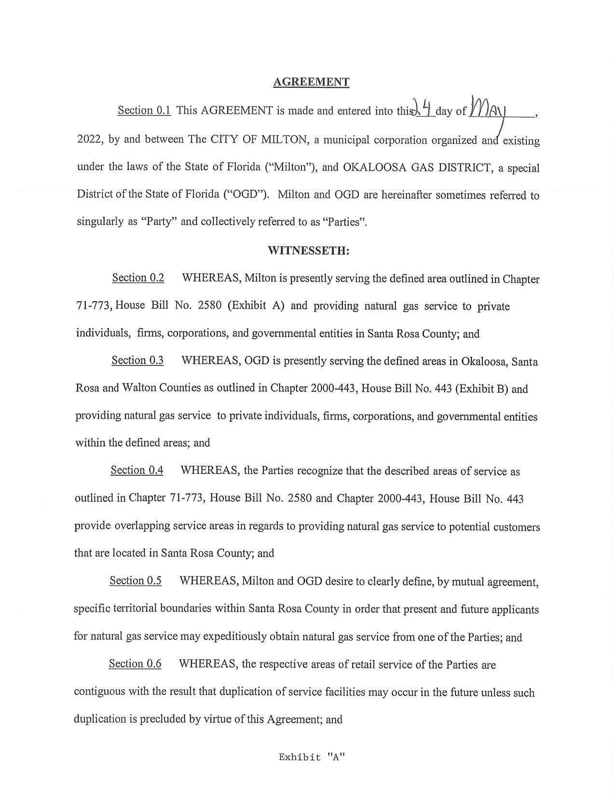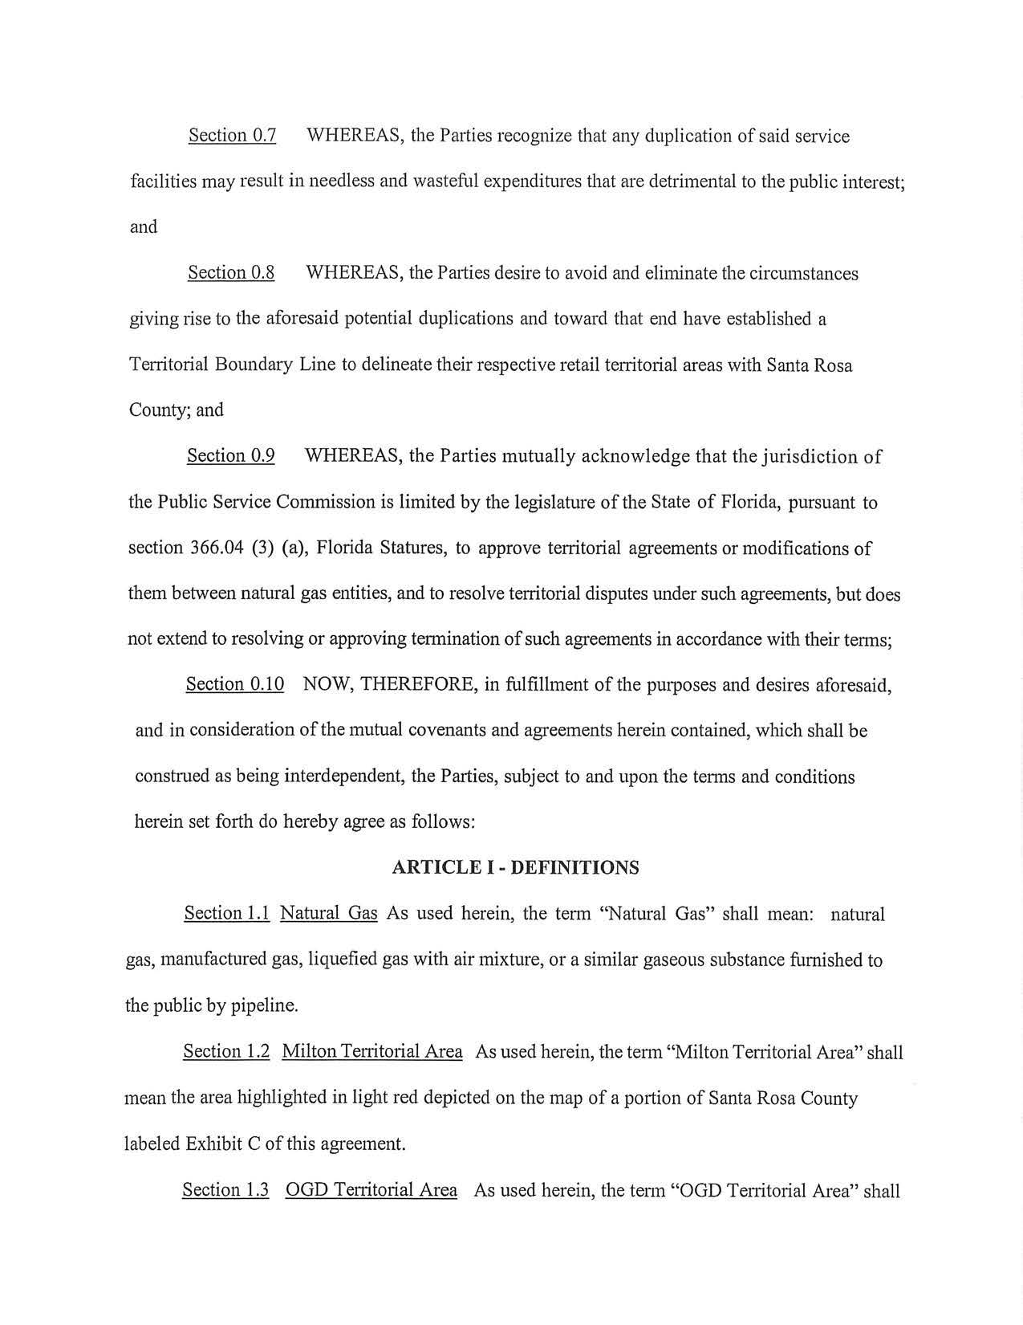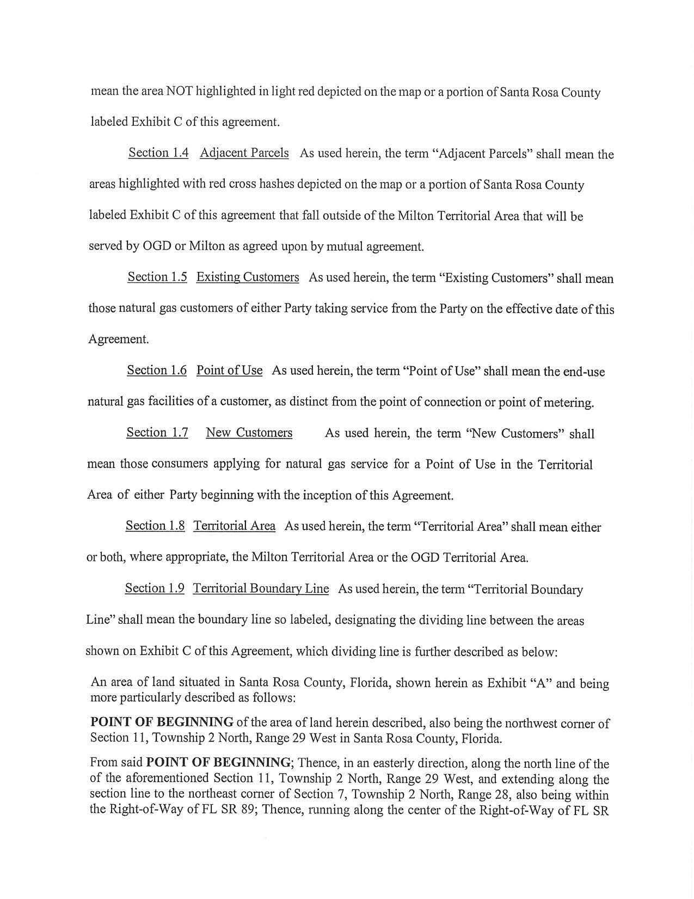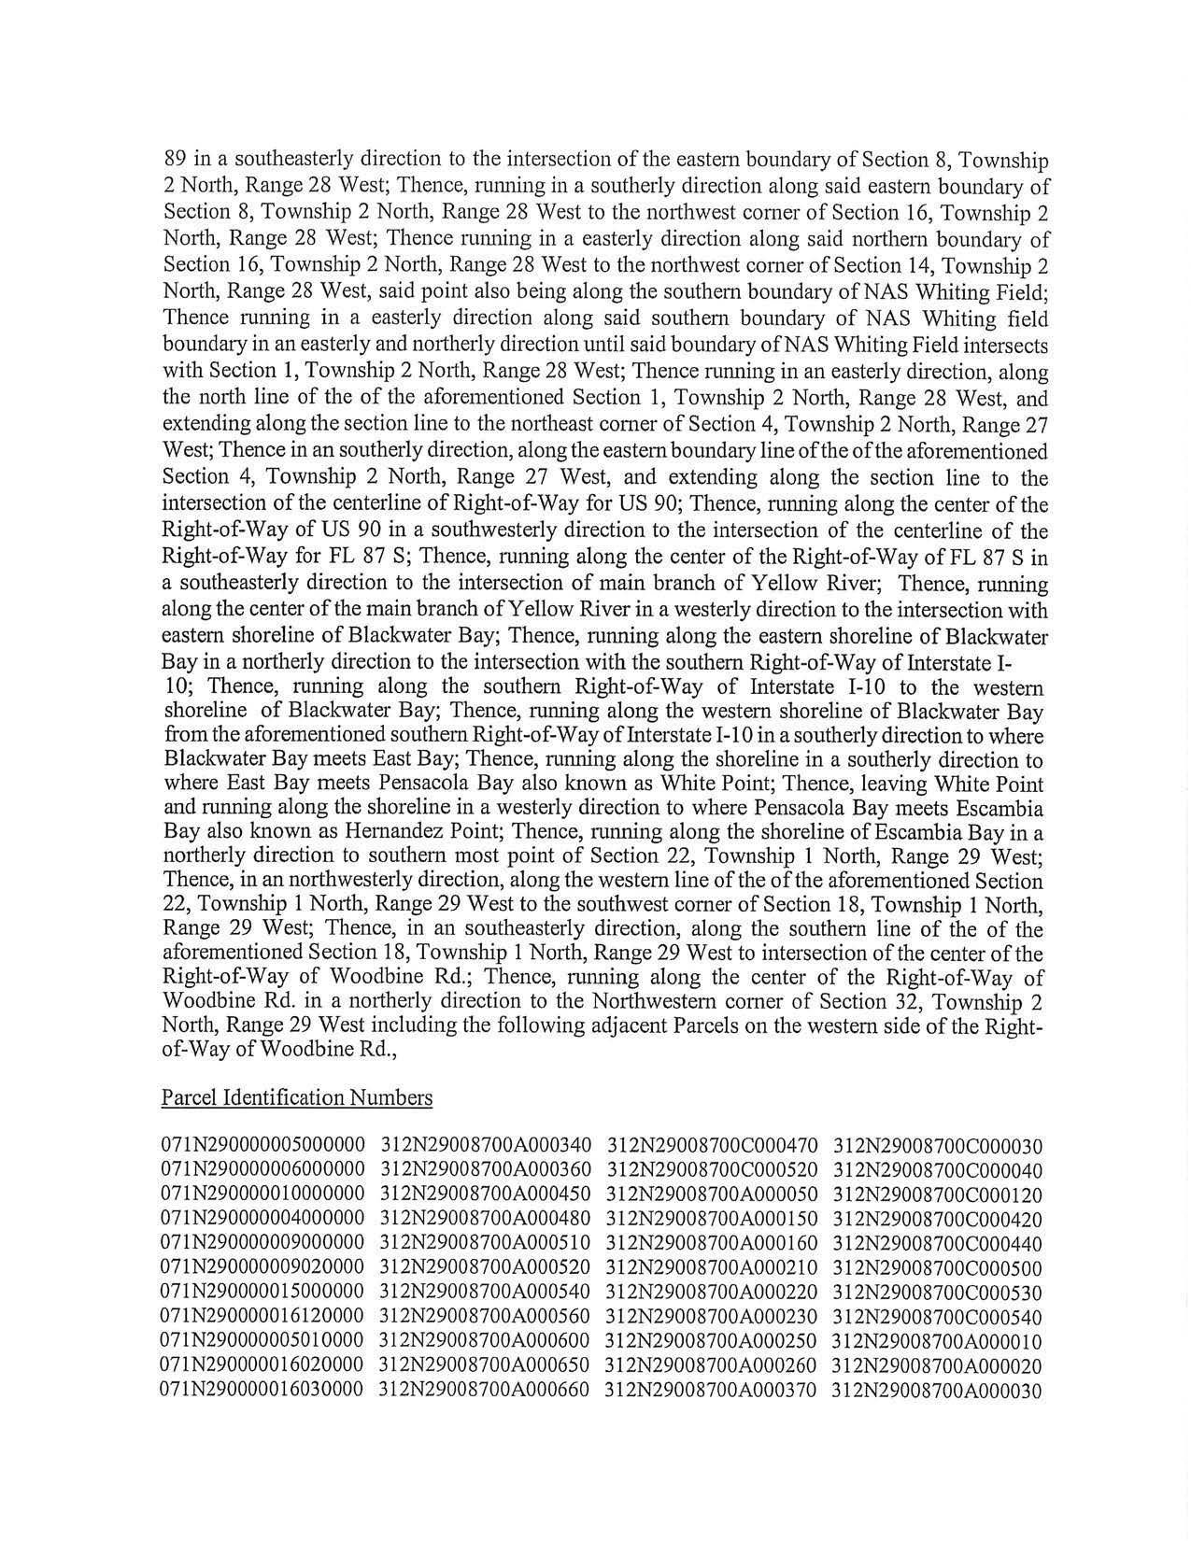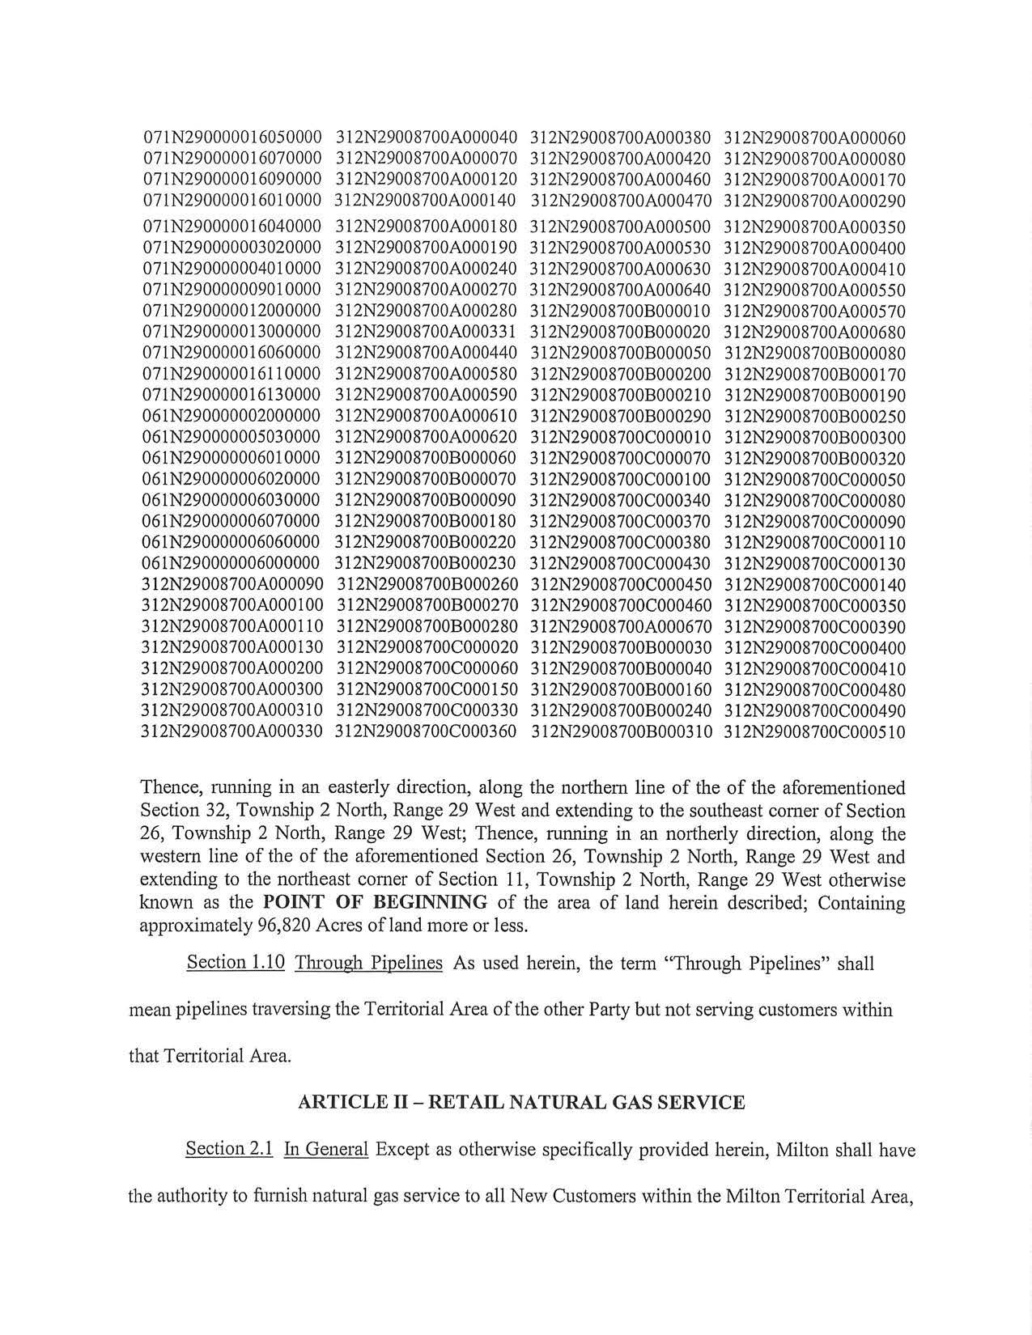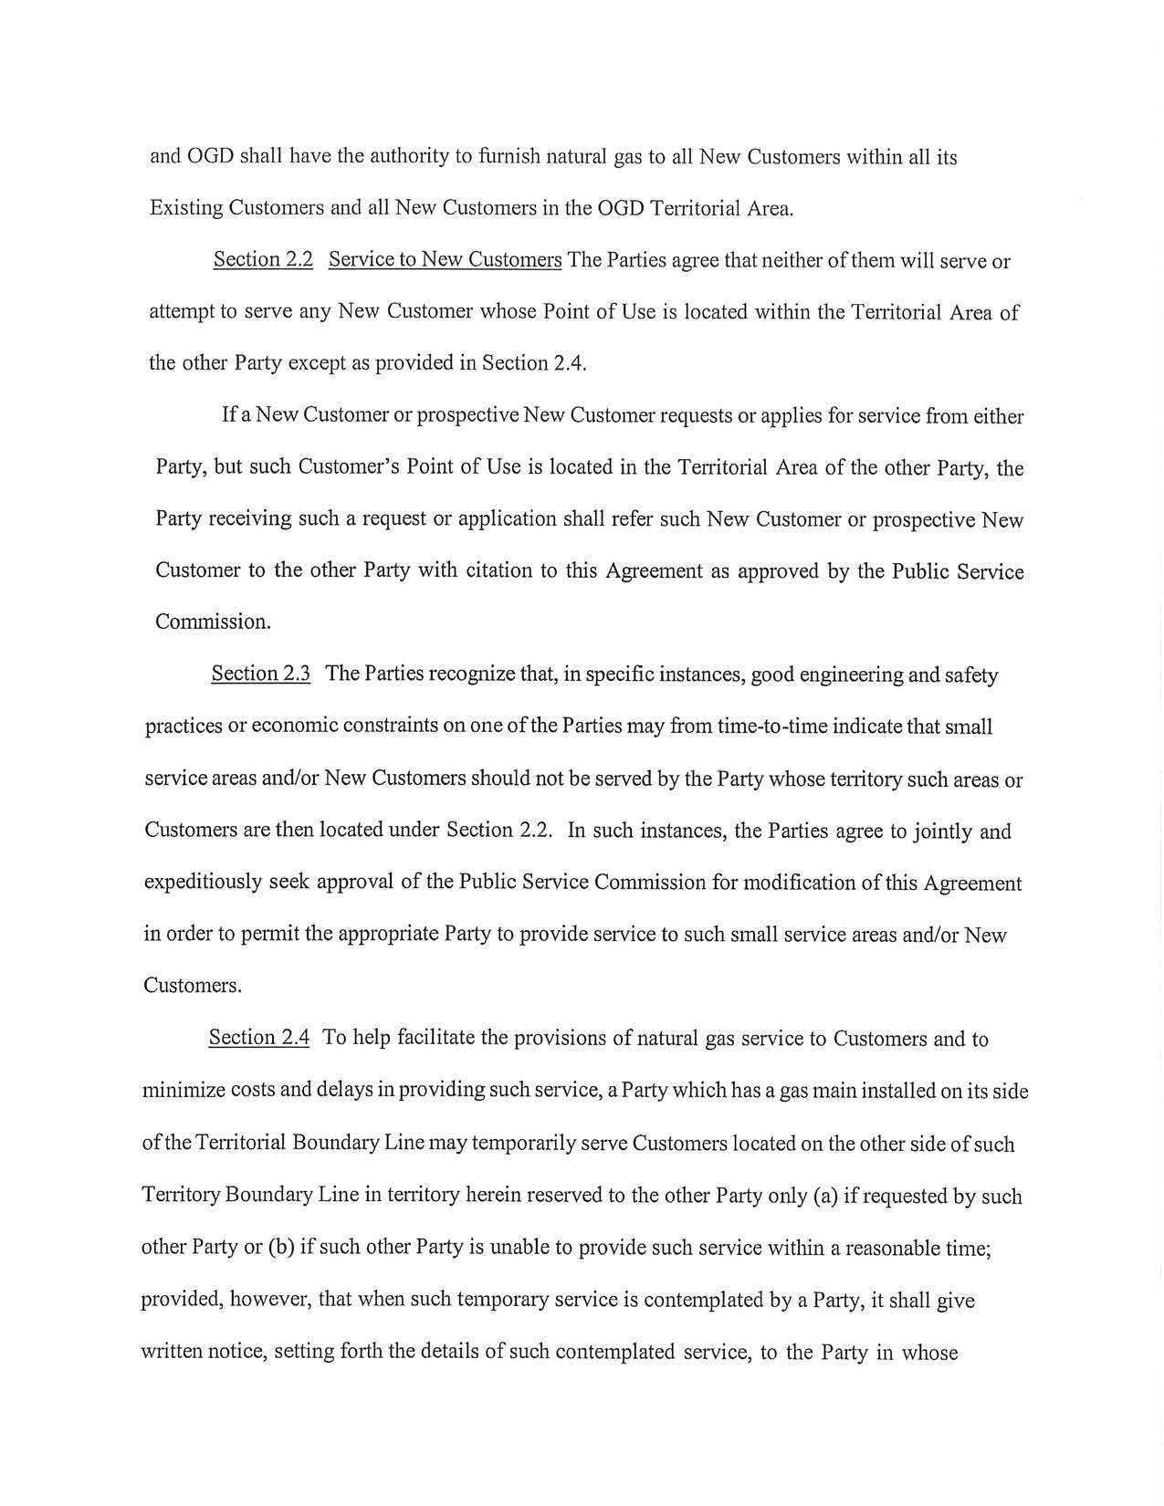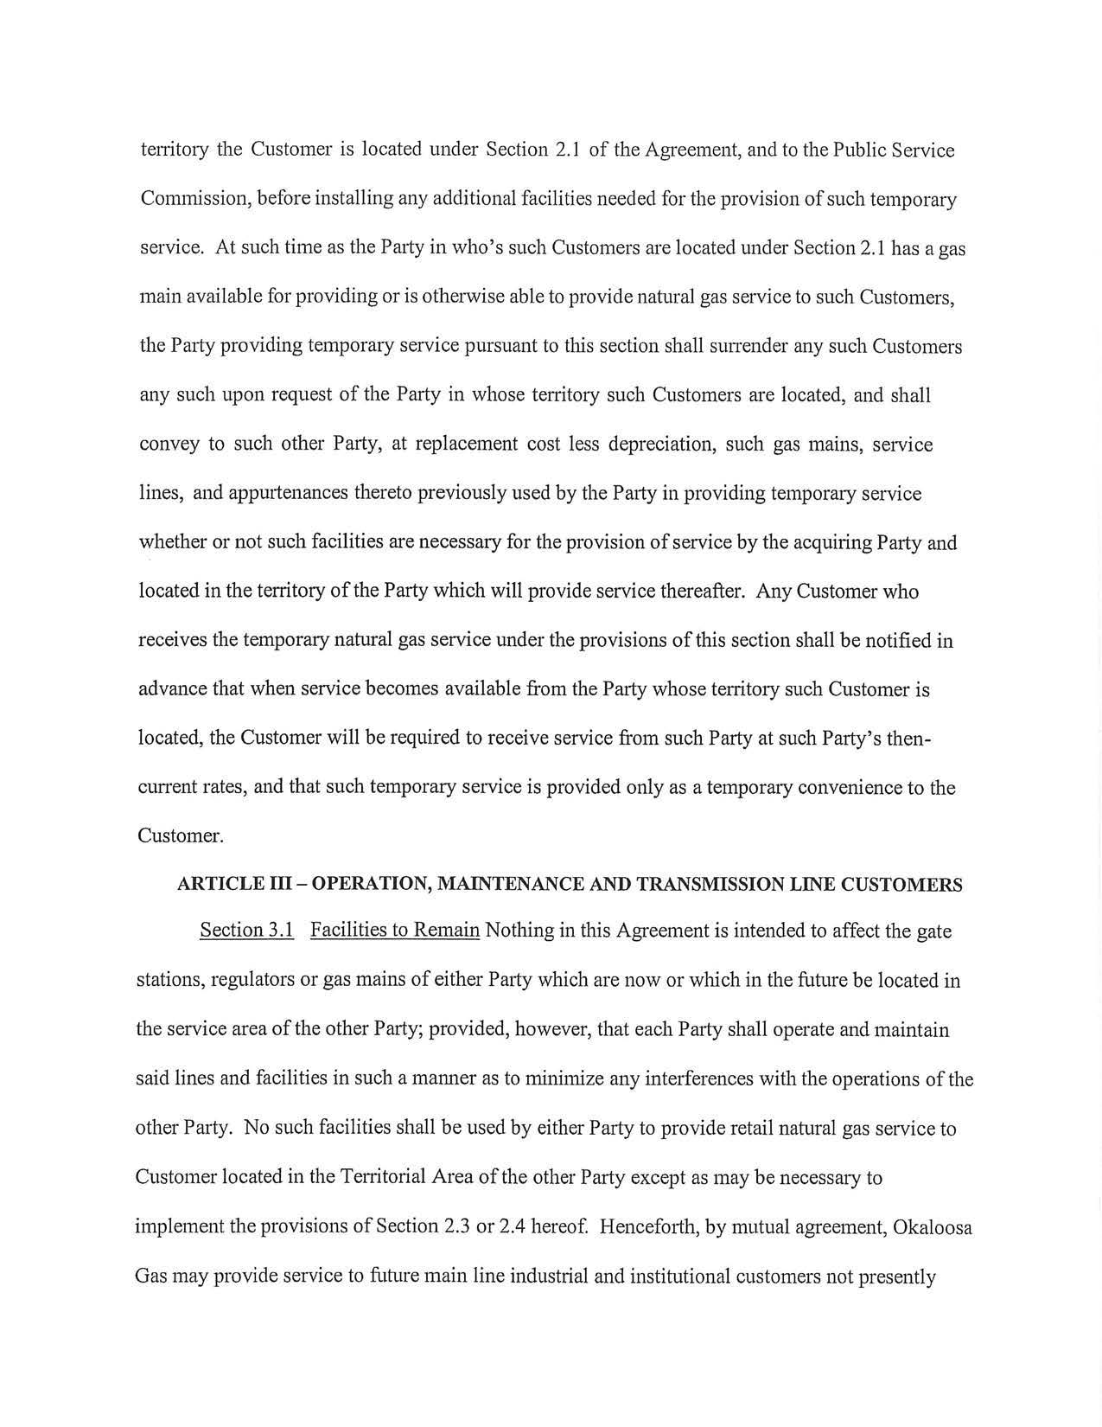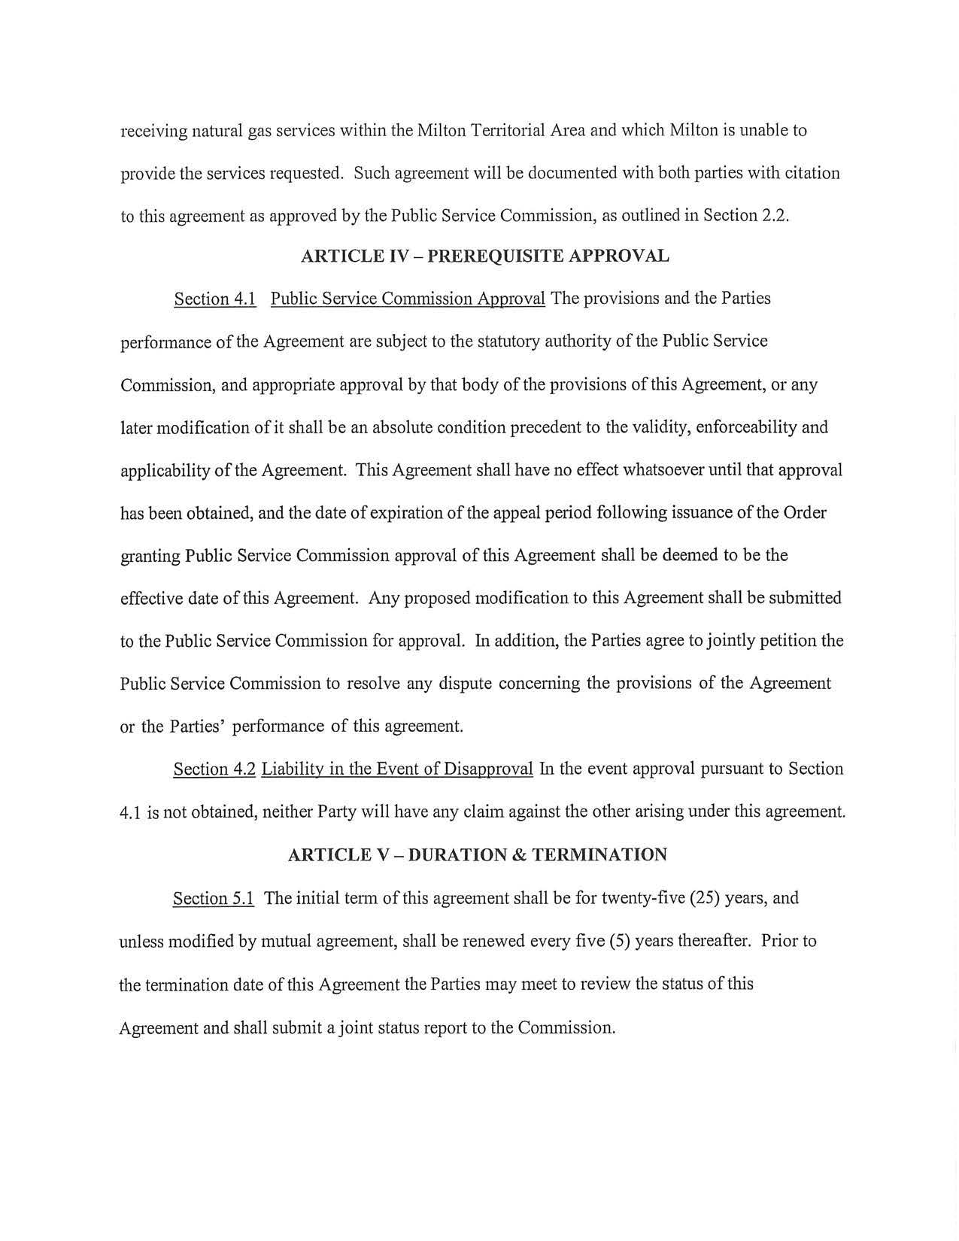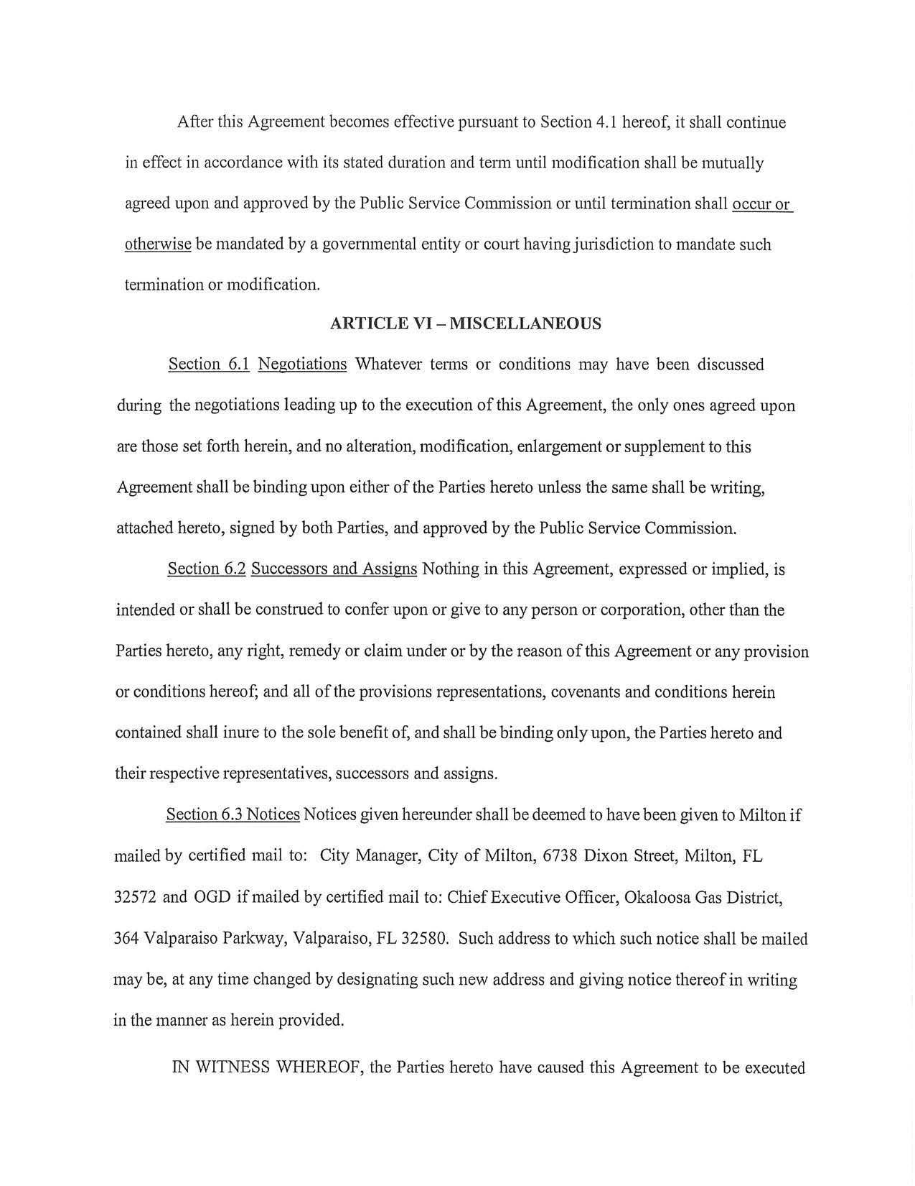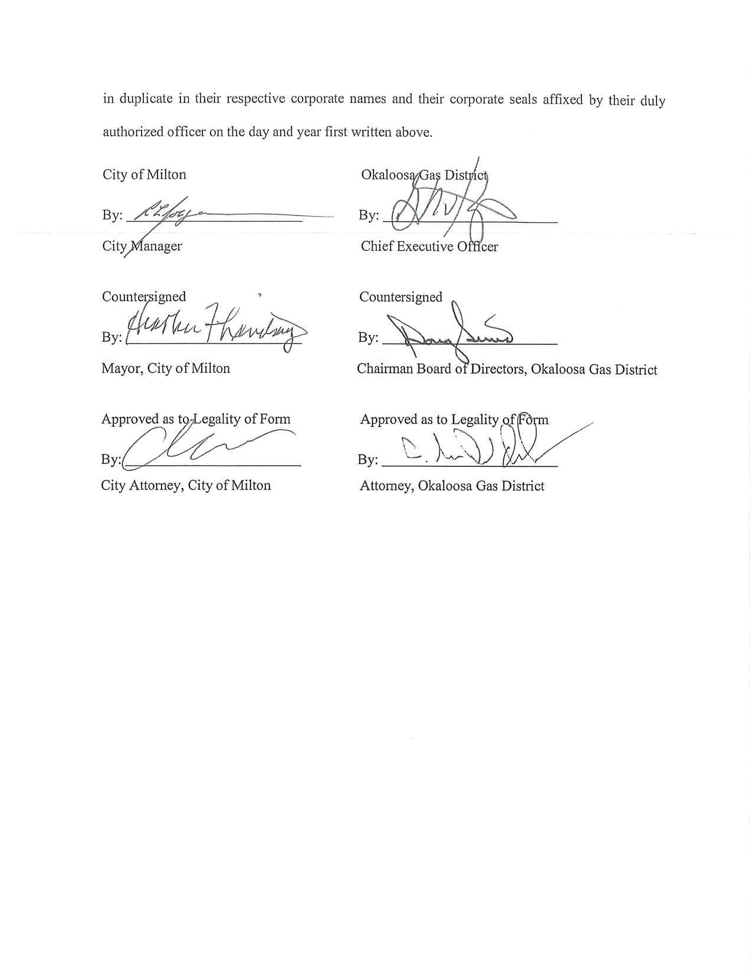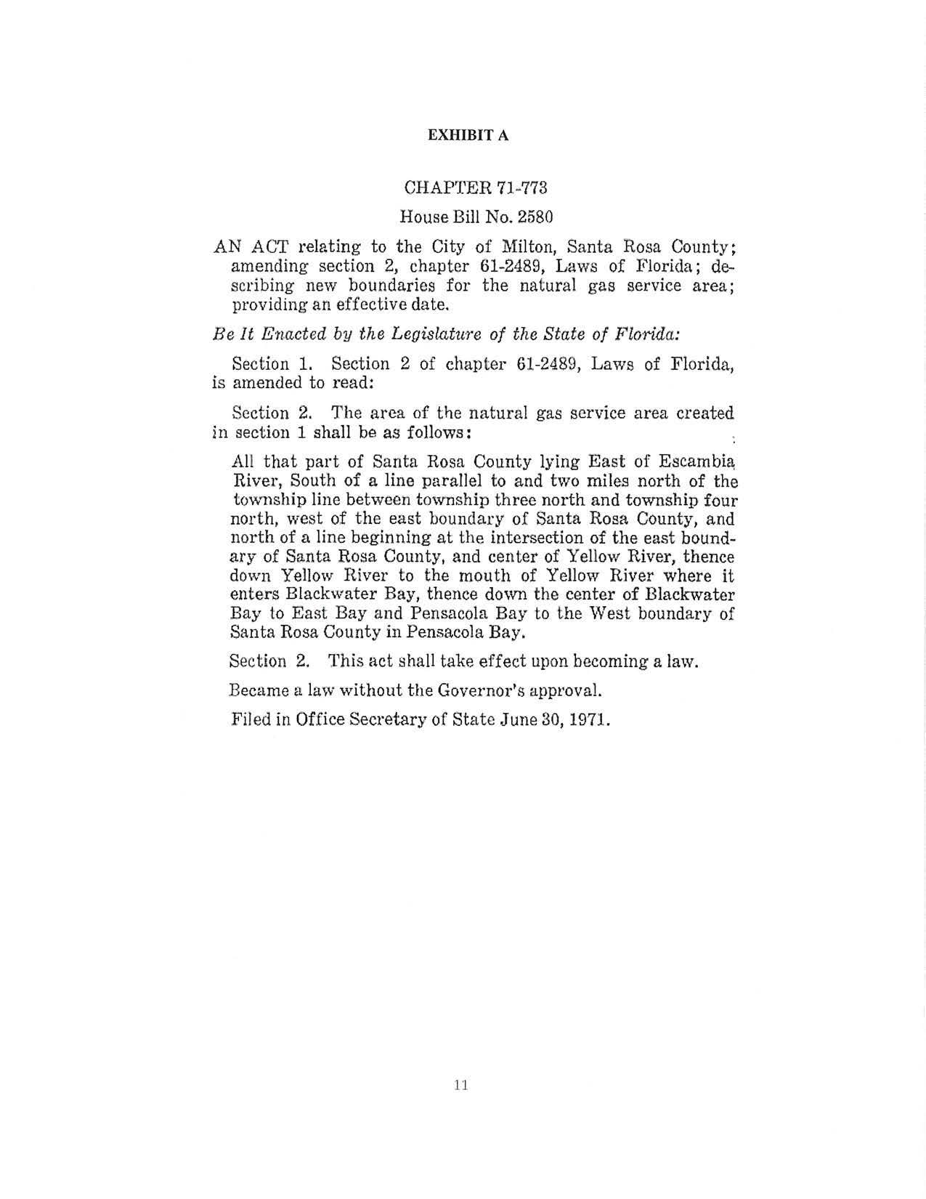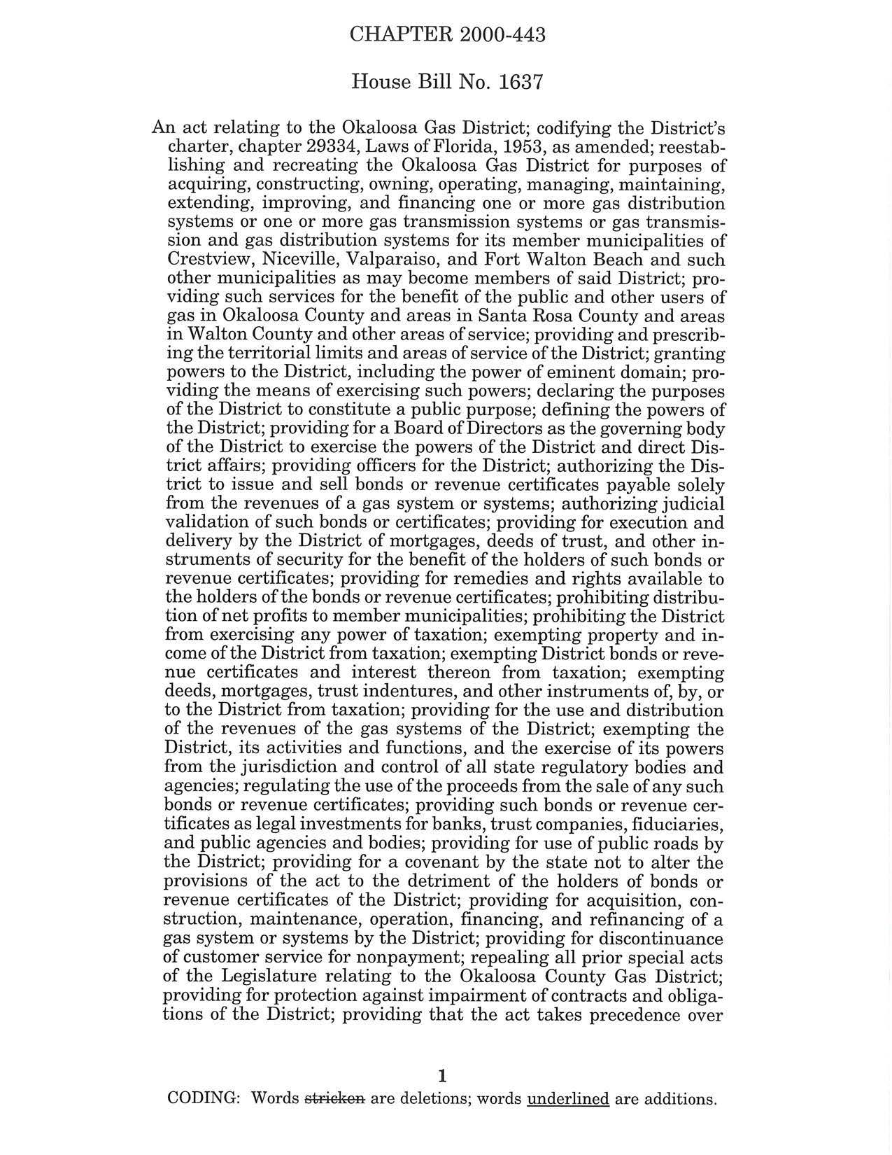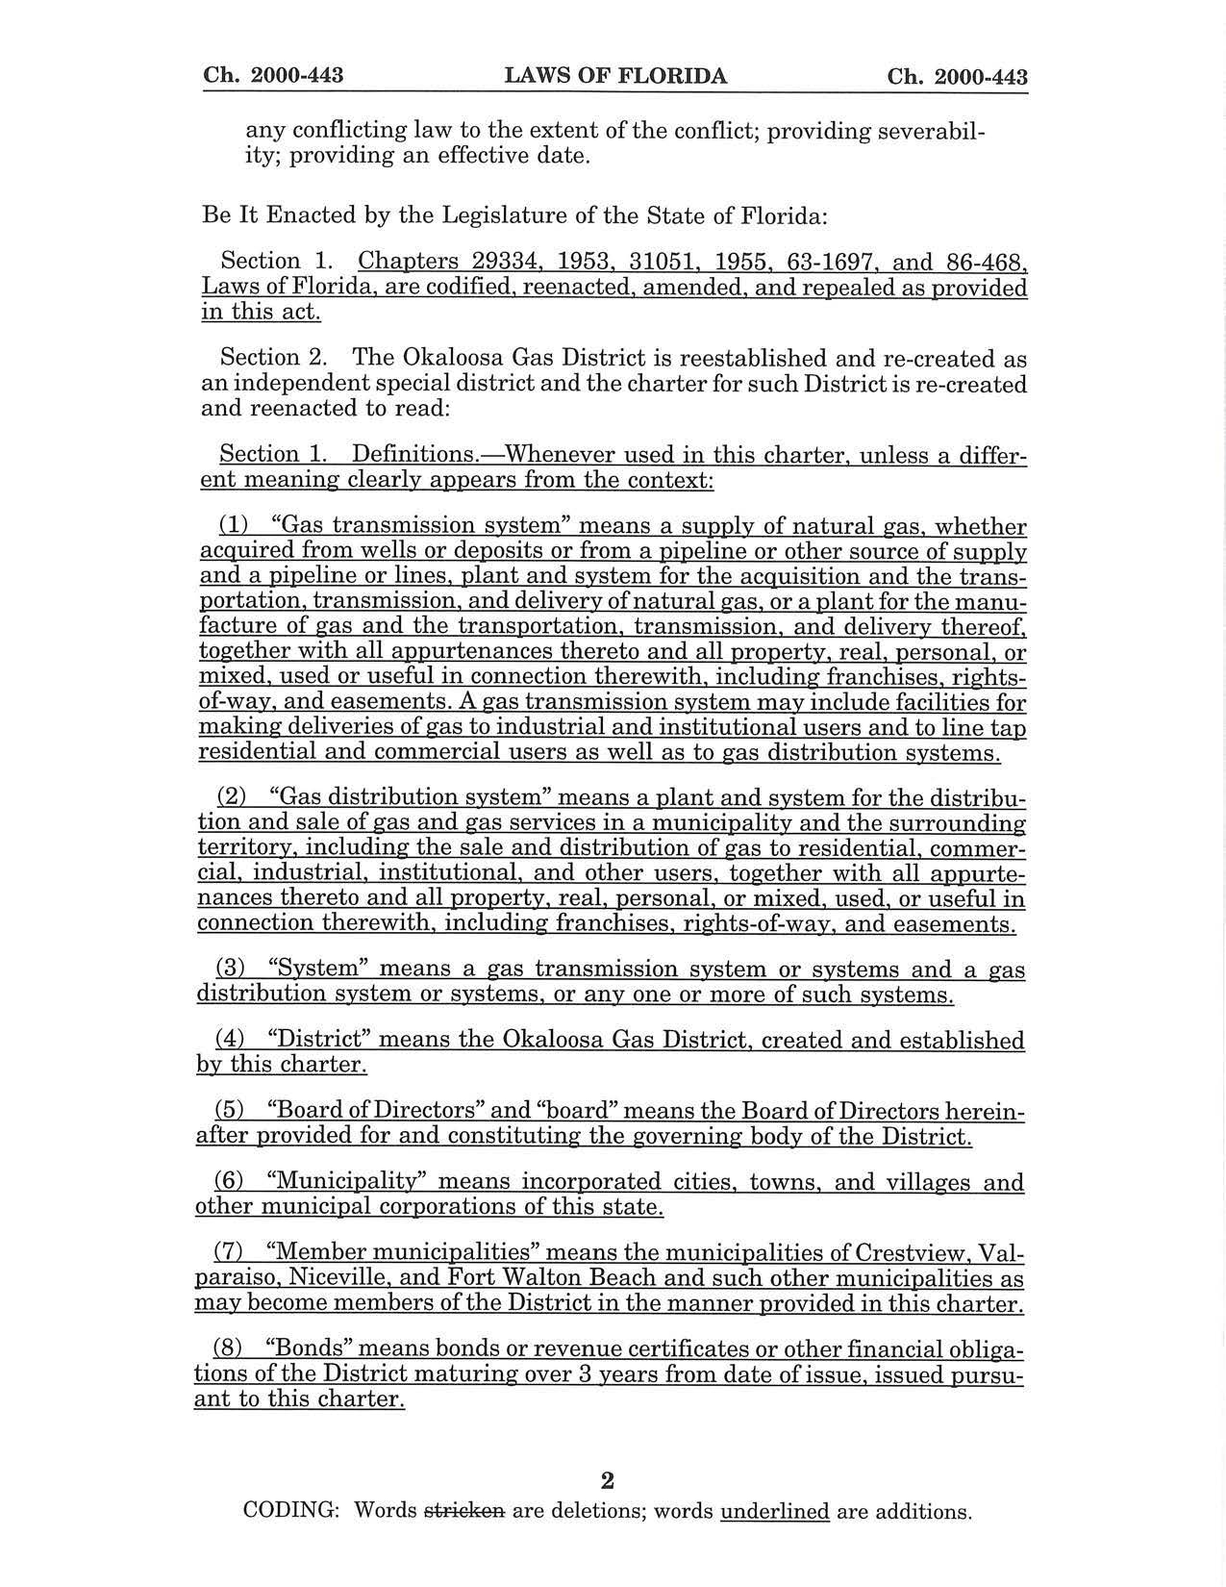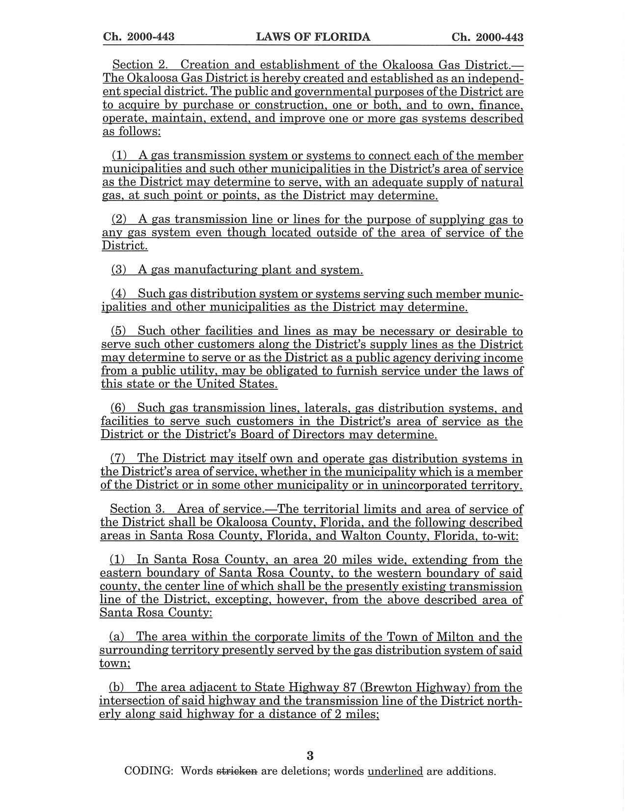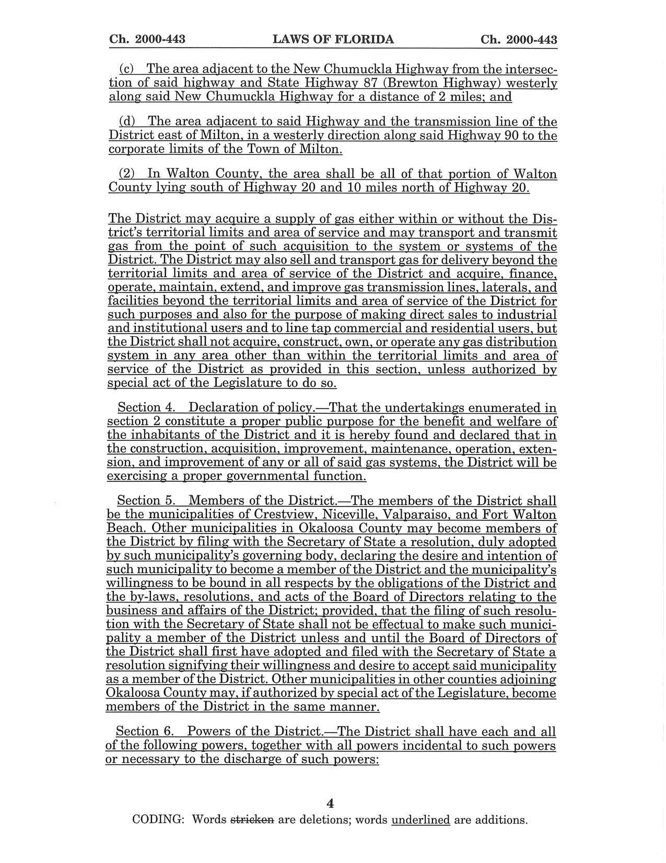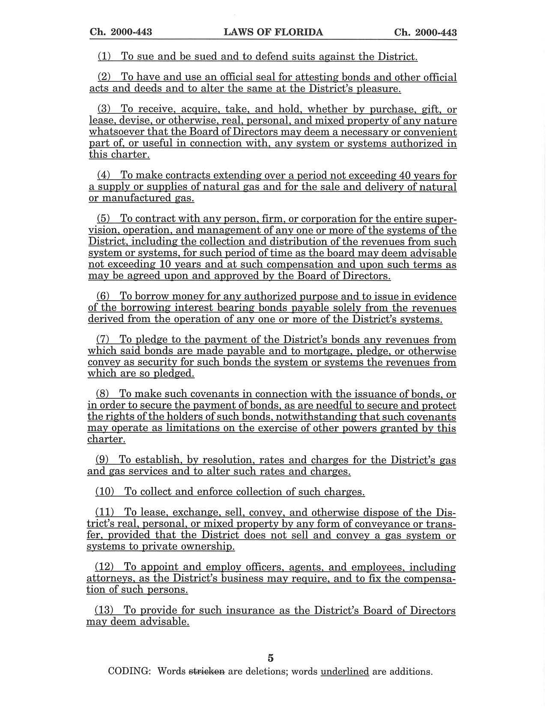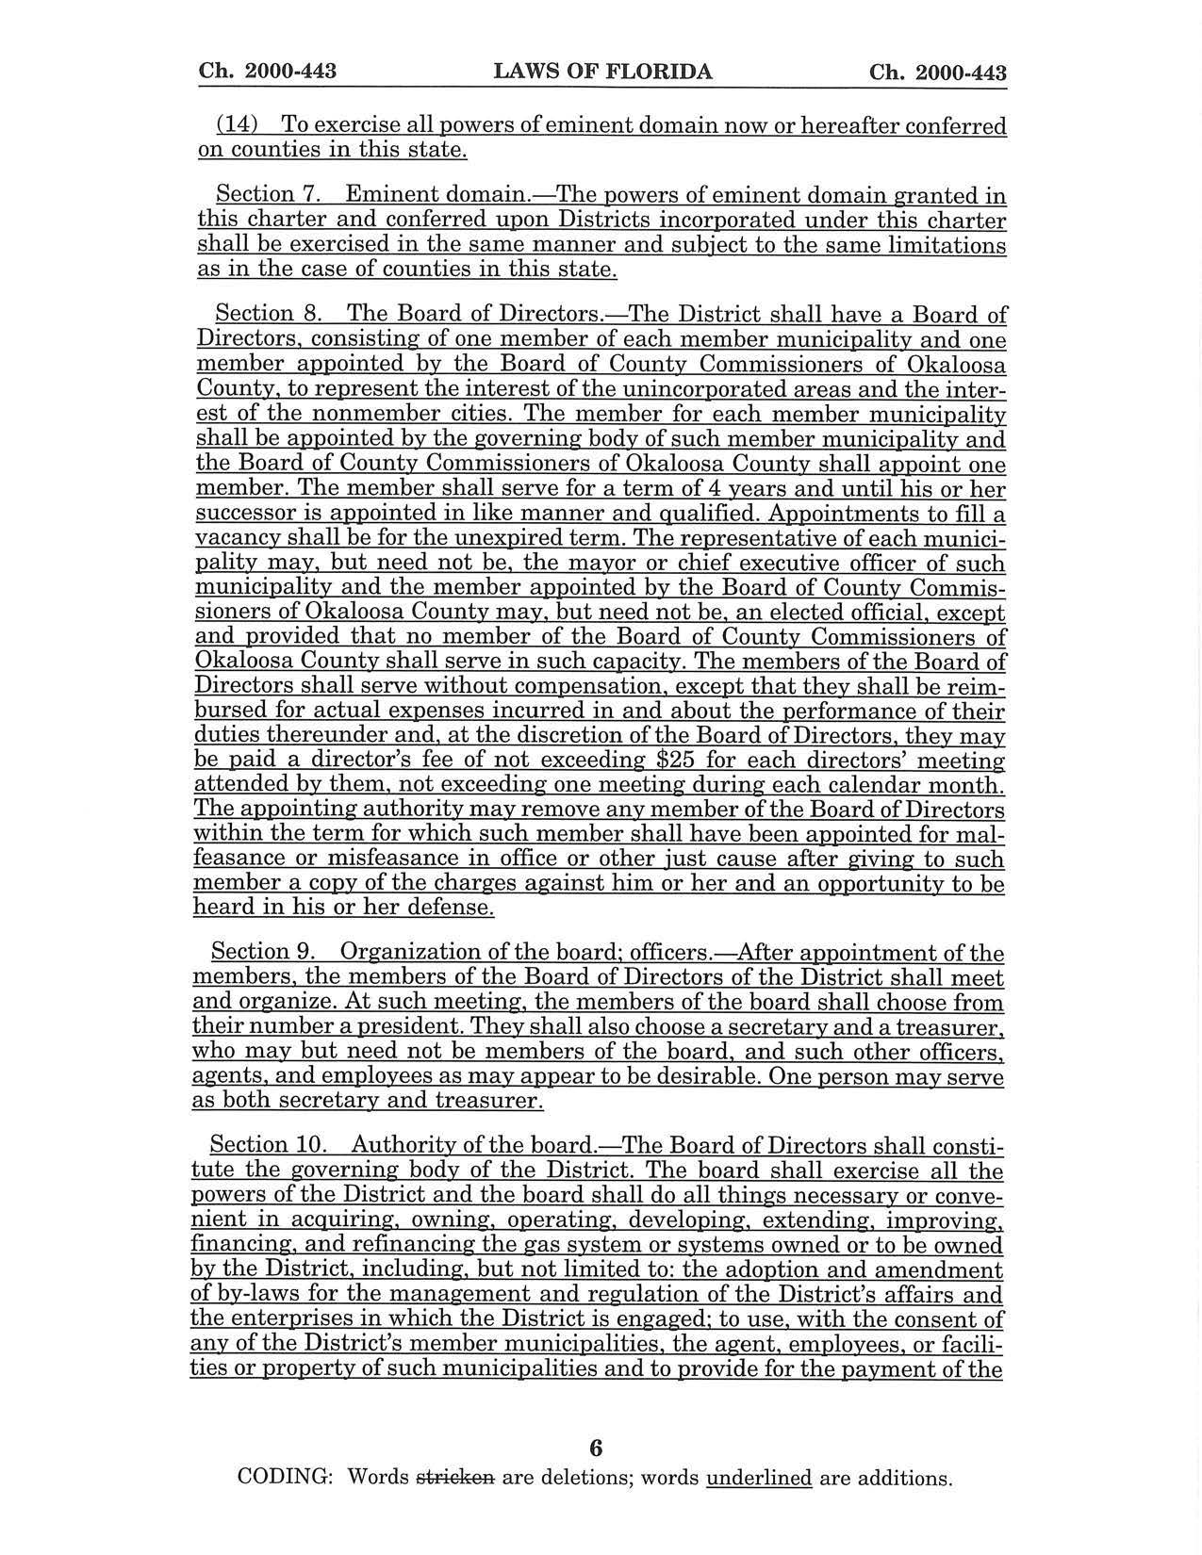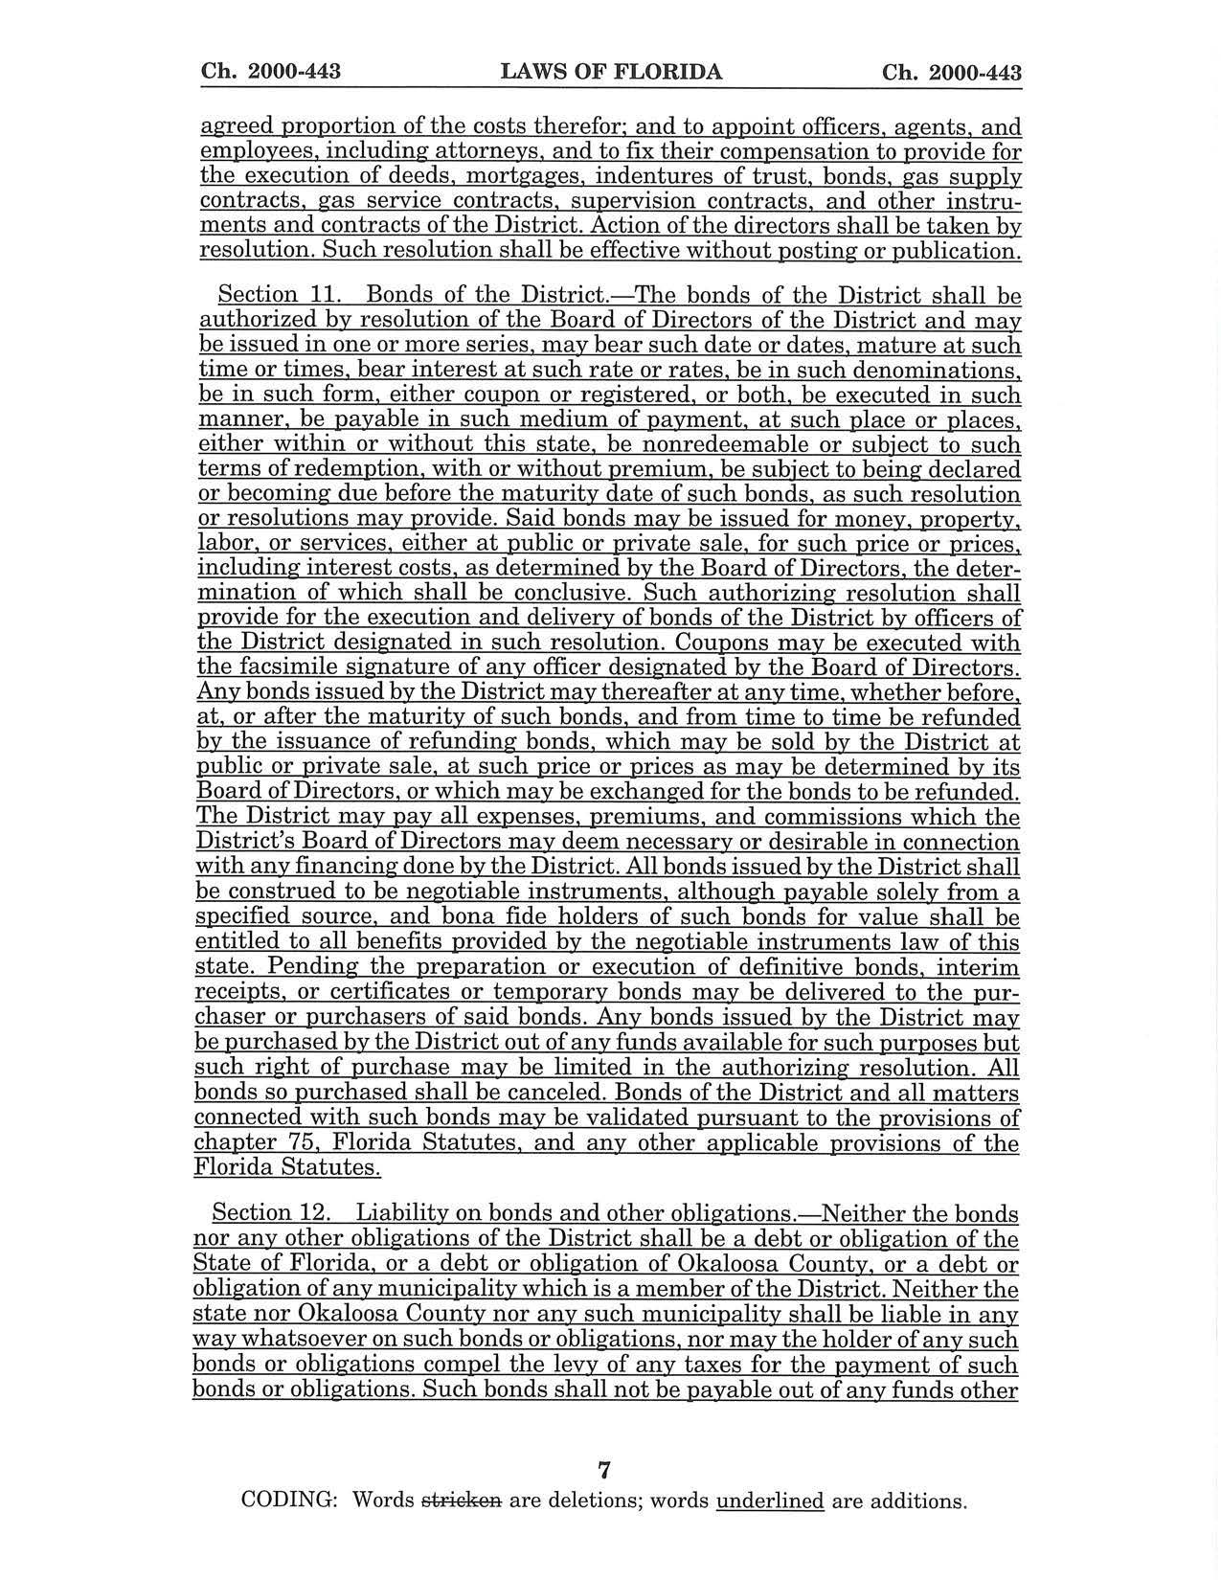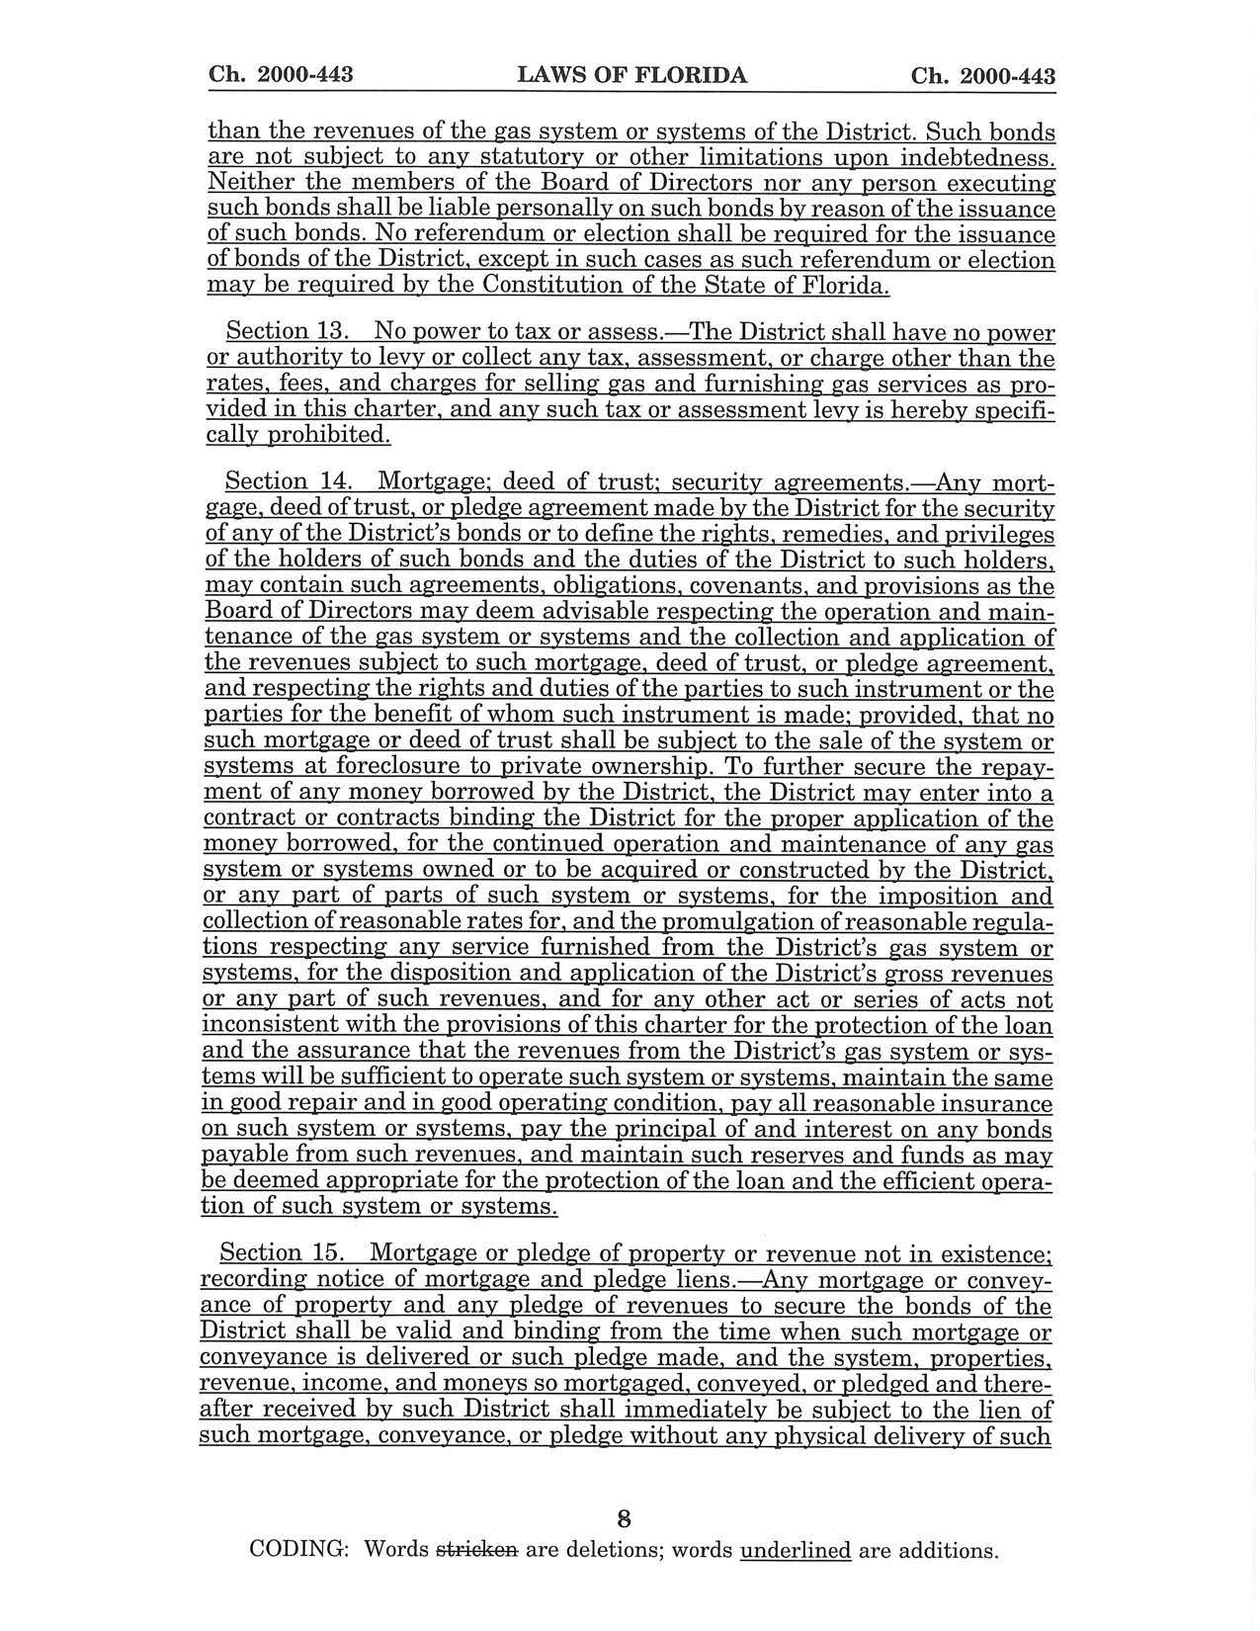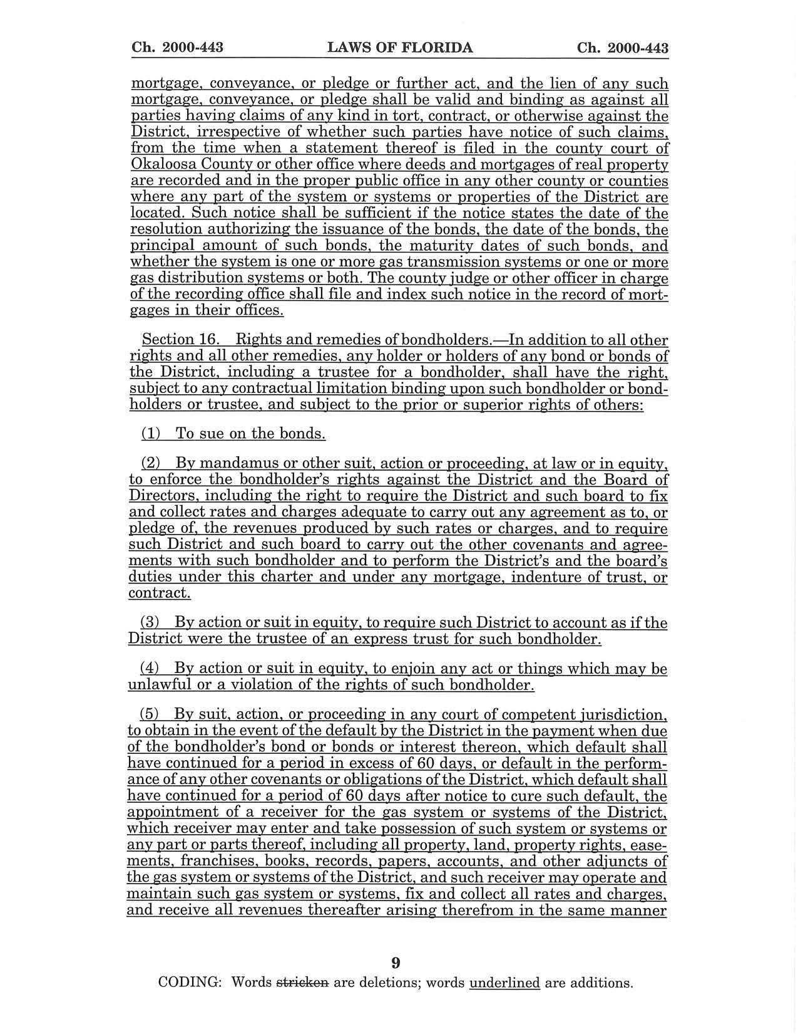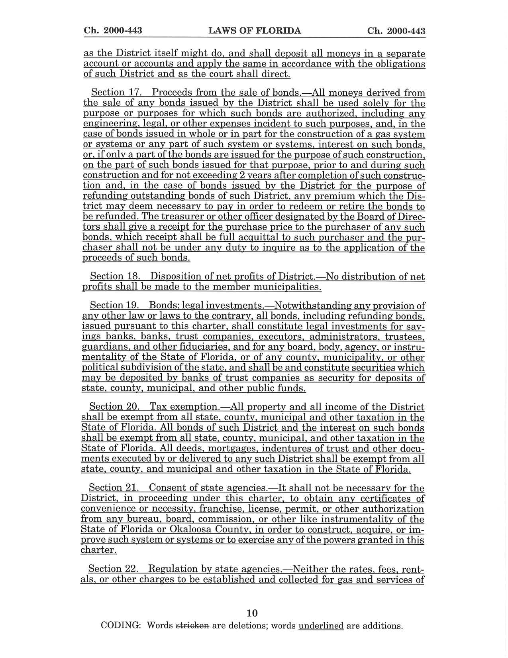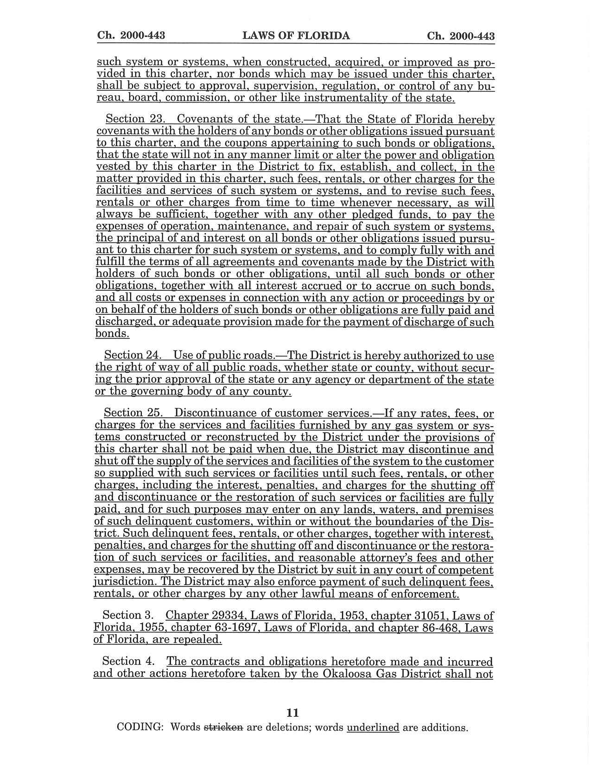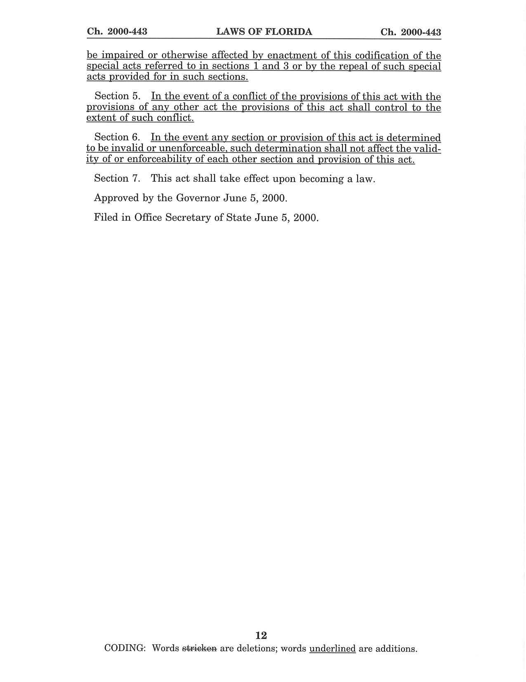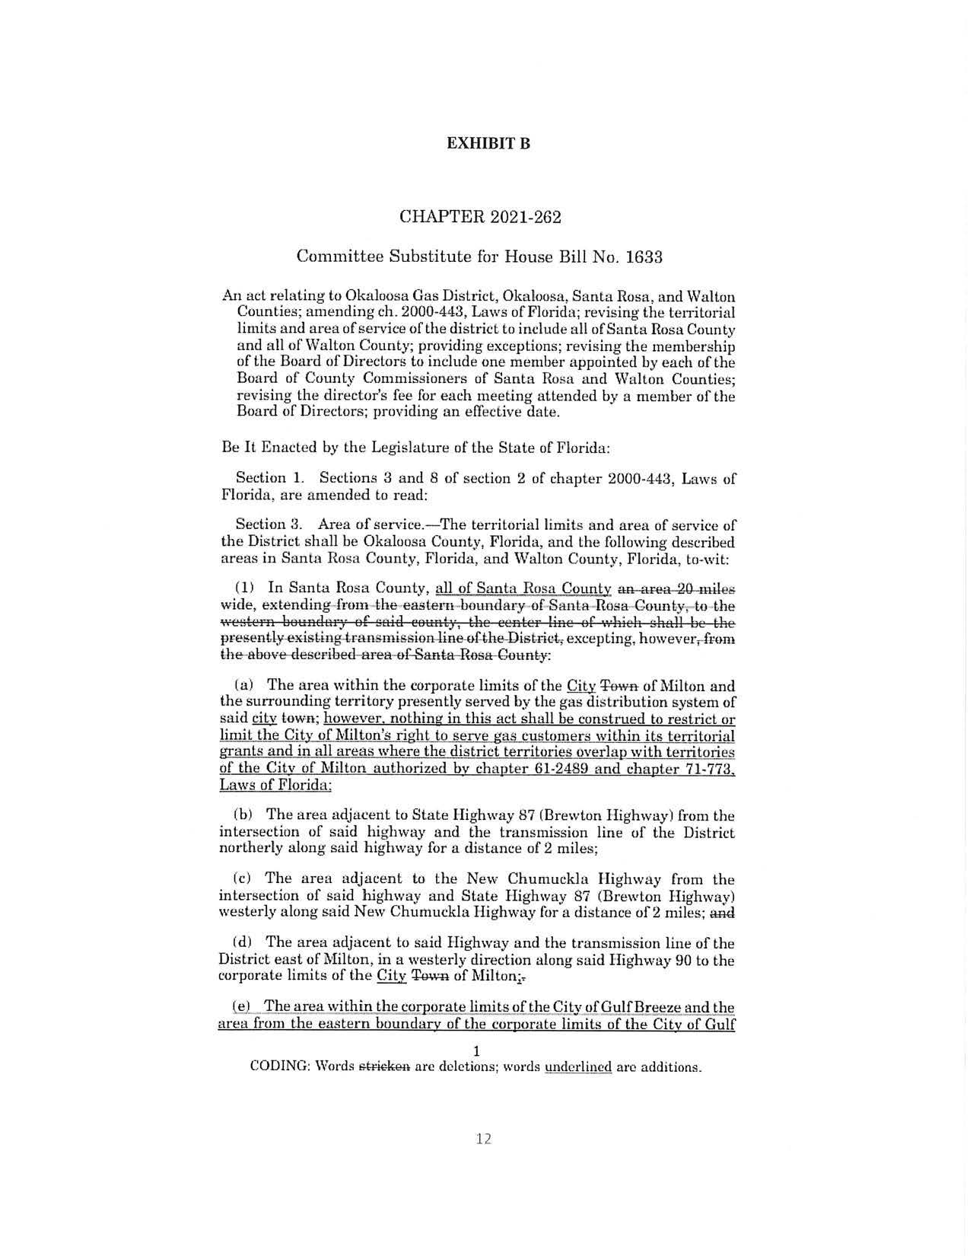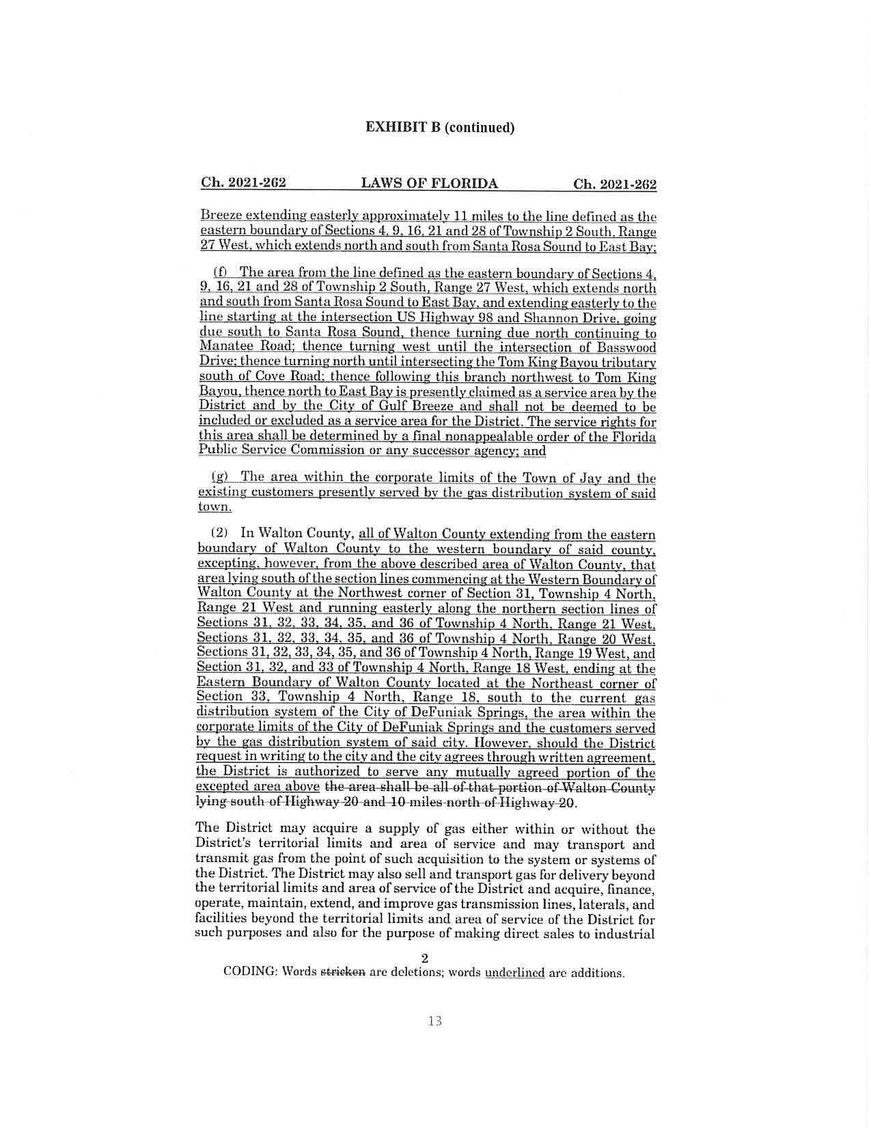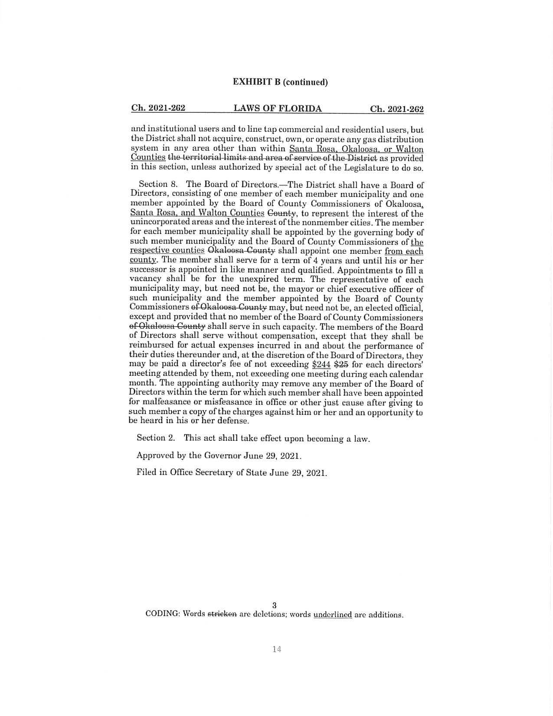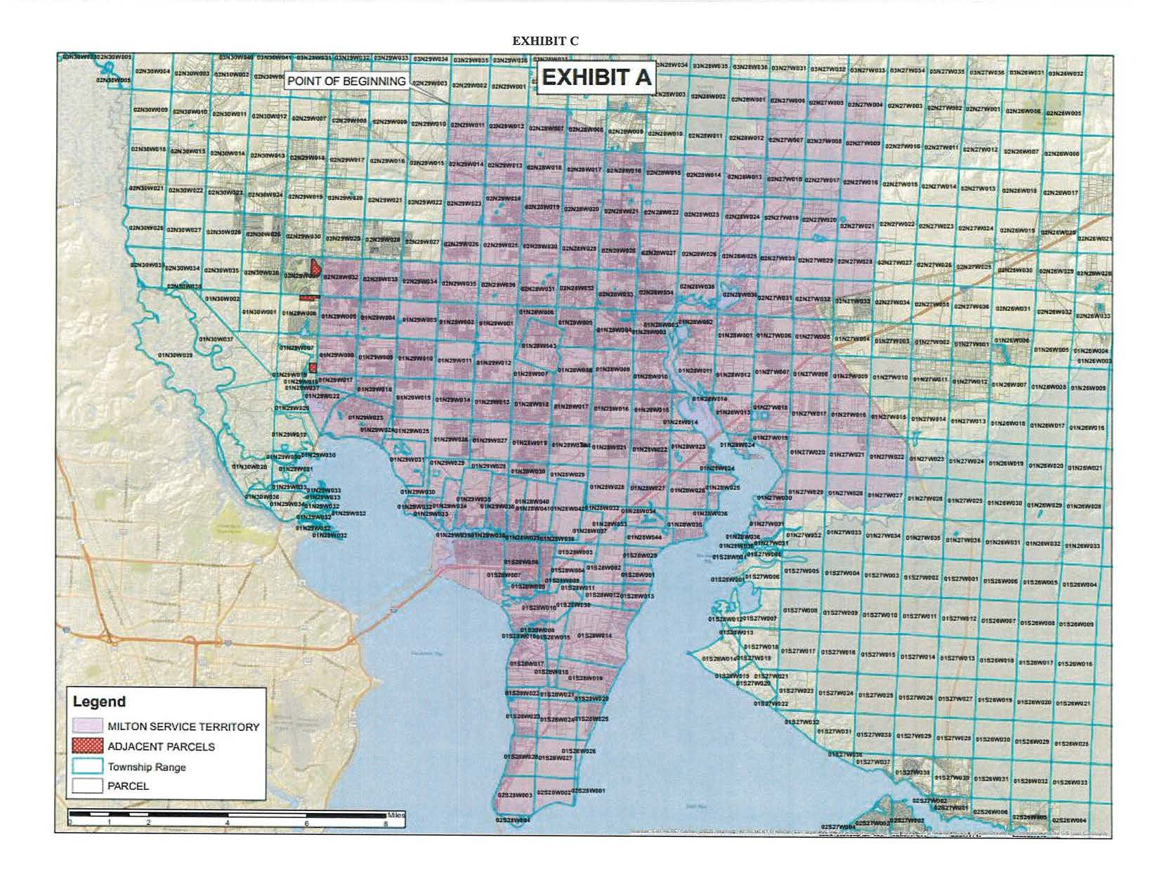

1. Response No. 5 in Staff’s First Data Request, Document No. 11469-2022.
2. *Utilities Commission of the City of New Smyrna Beach v. Florida Public Service Commission*, 469 So. 2d 731 (Fla. 1985).
3. Chapter 71-773 amended Chapter 61-2489, Laws of Florida.
4. Chapter 29334, Laws of Florida.
5. Response No. 2 in Staff’s First Data Request, Document No. 11469-2022.
6. Response No. 5 in Staff’s First Data Request, Document No. 11469-2022.
7. Chapter 2021-262 amended Chapter 2000-443, Laws of Florida.