|  |  |  |  |
| --- | --- | --- | --- |
| State of Florida  pscSEAL | | Public Service Commission  Capital Circle Office Center ● 2540 Shumard Oak Boulevard Tallahassee, Florida 32399-0850  -M-E-M-O-R-A-N-D-U-M- | |
| DATE: | January 27, 2023 | | |
| TO: | Office of Commission Clerk (Teitzman) | | |
| FROM: | Office of the General Counsel (Sunshine)  Division of Economics (Guffey)  Office of Industry Development and Market Analysis (Fogleman, Deas) | | |
| RE: | Docket No. 20230011-TP – Proposed amendment of Rule 25-4.0665, F.A.C., Lifeline Assistance. | | |
| AGENDA: | 02/08/23 – Regular Agenda – Rule Proposal – Interested Persons May Participate | | |
| COMMISSIONERS ASSIGNED: | | | All Commissioners |
| PREHEARING OFFICER: | | | Graham |
| RULE STATUS: | | | Proposal May Be Deferred |
| SPECIAL INSTRUCTIONS: | | | Pursuant to Section 120.74(5), F.S., the deadline to publish the proposed rule is April 1, 2023. |

Case Background

This rulemaking, to amend Rule 25-4.0665, Florida Administrative Code (F.A.C.), Lifeline Assistance, was initiated as a result of changes to Section 364.10, Florida Statutes (F.S.), made in the 2022 Legislative Session to conform to current federal regulations. The amendments are intended to comport with the recent changes to Section 364.10, F.S.

The amendment to Section 364.10, F.S., clarifies that an eligible telecommunications carrier (ETC) must notify a Lifeline subscriber of impending termination of Lifeline service if there is reason to believe the subscriber no longer qualifies for the service and requires a subscriber to provide proof of continued eligibility for Lifeline service upon request of the ETC, the Federal Communications Commission (FCC) or its designee. Additionally, the amendment to Section 364.10, F.S., removed obsolete provisions relating to income eligibility standards that were inconsistent with current FCC requirements; removed references to state agencies no longer involved in the development of procedures for promoting Lifeline, leaving only the Commission and the Department of Children and Families (DCF); clarified that the Commission and DCF may exchange information with ETCs, and the FCC or its designee, in order to enroll eligible customers in Lifeline service; and requires any state agency that determines a person is eligible for Lifeline service to coordinate with the FCC or its designee to verify eligibility.

Notice of the rule development appeared in the October 17, 2022, edition of the Florida Administrative Register, Vol. 48, No. 202. No workshop was requested and none was held. This recommendation addresses whether the Commission should amend Rule 25-4.0665, F.A.C. Rulemaking is necessary to implement Section 364.10, F.S., as identified in the Commission’s 2022 Regulatory Plan. Accordingly, pursuant to Section 120.74(5), F.S., the Commission must publish a notice of proposed rule amending Rule 25-4.0665, F.S., by April 1, 2023.

The Commission has jurisdiction pursuant to Sections 120.54, 350.127(2), 364.01, and 364.10, F.S.

Discussion of Issues

Issue :

 Should the Commission propose the amendment of Rule 25-4.0665, F.A.C.?

Recommendation:

 Yes, the Commission should propose the amendment of Rule 25-4.0665, F.A.C., as set forth in Attachment A. The Commission should also certify Rule 25-4.0665, F.S., as a minor violation rule. (Sunshine, Fogleman, Deas, Guffey)

Staff Analysis:

 Staff is recommending amendments to Rule 25-4.0665, F.A.C., to clarify and update the rule, and to implement changes necessitated by the amendment to Section 364.10, F.S., made in the 2022 Legislative Session.

Specifically, the recommended proposed amendments to the rule include: (1) removal of obsolete language relating to ETC approval of applications and use of specific application forms; (2) incorporating by reference, and changing the program enrollment process from Lifeline Simplified Enrollment Process to Lifeline Promotion Process, which facilitates the electronic transfer of eligible customer information from the DCF and the Commission to ETCs; (3) clarifying the responsibilities of ETCs and the Commission regarding the Lifeline Promotion Process; and (4) moving the existing Lifeline availability advertising criteria from Section (11) to Section (4) in the recommended proposed amended rule for cohesiveness.

***Minor Violation Rules Certification***

Pursuant to Section 120.695, F.S., for each rule filed for adoption, the agency head shall certify whether any part of the rule is designated as a rule the violation of which would be a minor violation.[1] Rule 25-4.0665, F.A.C., is currently listed on the Commission’s website as a rule for which a violation would be minor because violation of the rule would not result in economic or physical harm to a person or have an adverse affect on the public health, safety, or welfare or create a significant threat of such harm.

The amendments to Rule 25-4.0665, F.A.C., would not change its status as a minor violation rule. Thus, staff recommends that the Commission certify Rule 25-4.0665, F.A.C., as a minor violation rule.

***Statement of Estimated Regulatory Costs***

Pursuant to Section 120.54(3)(b), F.S., agencies are encouraged to prepare a statement of estimated regulatory costs (SERC) before the adoption, amendment, or repeal of any rule. A SERC was prepared for this rulemaking and is appended as Attachment B to this recommendation.

The SERC concludes that the amendment of Rule 25-4.0665, F.A.C., will not likely, directly or indirectly, increase regulatory costs in excess of $200,000 in the aggregate in Florida within one year after implementation. Further, the SERC’s economic analysis concludes that the amendment to the rule will not likely have an adverse impact on economic growth, private sector job creation or employment, private sector investment, business competitiveness, productivity, or innovation in excess of $1 million in the aggregate within five years of implementation. Thus, the rule does not require legislative ratification pursuant to Section 120.541(3), F.S.

In addition, the SERC states that the rule amendments will not have an adverse impact on small businesses and will have no impact on small cities or counties. The SERC concludes that there will be no transactional costs likely to be incurred by individuals and entities required to comply with the requirements of the rule. No regulatory alternatives were submitted pursuant to Section 120.541(1)(a), F.S. None of the impact/cost criteria established in Section 120.541(2)(a), F.S., will be exceeded as a result of the recommended amendment to Rule 25-4.0665, F.A.C.

***Conclusion***

Based on the foregoing analysis, staff recommends that the Commission propose the amendment of Rule 25-4.0665, F.A.C., as set forth in Attachment A. Staff also recommends that the Commission certify Rule 25-4.0665, F.A.C., as a minor violation rule.

Issue :

 Should this docket be closed?

Recommendation:

 Yes. If no requests for hearing, information regarding the SERC, proposals for a lower cost regulatory alternative, or Joint Administrative Procedures Committee (JAPC) comments are filed, the rule should be filed with the Department of State, and the docket should be closed. (Sunshine)

Staff Analysis:

 If no requests for hearing, information regarding the SERC, proposals for a lower cost regulatory alternatives, or JAPC comments are filed, the rule may be filed with the Department of State and the docket should be closed. (Sunshine)

**25-4.0665 Lifeline Assistance.**

(1) Eligible Telecommunications Companies must offer Lifeline Assistance as prescribed by the Federal Communications Commission in Title 47, Code of Federal Regulations, Part 54, Subpart E, Universal Service Support for Low-Income Consumers, Sections 54.400 through 54.423~~17~~, in effect as of September 8, 2022~~as amended October 1, 2017~~, which are hereby incorporated into this rule by reference, and which are available at [http://www.flrules.org/Gateway/reference.asp?No=Ref-_____~~10061~~](http://www.flrules.org/Gateway/reference.asp?No=Ref-10061).

(2) Eligible telecommunications carriers may assist customers with ~~When~~ enrolling ~~customers~~ in the Lifeline program through the provider portal with the National Lifeline Eligibility Verifier, as defined in Title 47, Code of Federal Regulations, Part 54, Subpart E, Universal Service Support for Low-Income Consumers, Section 54.400(o).~~, eligible telecommunications carriers shall accept FCC Form 5629 (09/18), OMB APPROVAL EDITION 3060-0819, entitled “Lifeline Program Application Form,” which is incorporated into this rule by reference and which is available at~~ [~~http://www.flrules.org/Gateway/reference.asp?No=Ref-10073~~](http://www.flrules.org/Gateway/reference.asp?No=Ref-10073) ~~or from the Universal Service Administrative Company’s website at https://www.usac.org/_res/documents/li/pdf/nv/LI_Application_UniversalForm.pdf. The Spanish version of this form, FCC Form 5629 (09/18), OMB APPROVAL EDITION 3060-0819, entitled “Programa de Lifeline: Formulario de Aplicación,” is also incorporated into this rule by reference and is available at~~ [~~http://www.flrules.org/Gateway/reference.asp?No=Ref-10075~~](http://www.flrules.org/Gateway/reference.asp?No=Ref-10075) ~~or from the Universal Service Administrative Company’s website at https://www.usac.org/_res/documents/li/pdf/nv/LI-SP_Application_UniversalForms.pdf. Eligible telecommunications carriers shall also accept Form PSC 1023 (08/18), entitled “Lifeline Florida On-line Application for Recipients of Medicaid or Supplemental Nutrition Assistance Program (SNAP),” which is incorporated into this rule by reference and which is available at~~ [~~http://www.flrules.org/Gateway/reference.asp?No=Ref-10052~~](http://www.flrules.org/Gateway/reference.asp?No=Ref-10052) ~~or from the Commission’s website at www.floridapsc.com, by selecting “Lifeline Assistance,” then selecting “Public Service Commission Secure On-Line Application Form.”~~

~~(3) When recertifying customers in the Lifeline program, eligible telecommunications carriers shall accept FCC Form 5630 (09/18), OMB APPROVAL EDITION 3060-0819, entitled “Lifeline Program Annual Recertification Form,” which is incorporated into this rule by reference and which is available at~~ [~~http://www.flrules.org/Gateway/reference.asp?No=Ref-10078~~](http://www.flrules.org/Gateway/reference.asp?No=Ref-10078) ~~or from the Universal Service Administrative Company’s website at https://www.usac.org/_res/documents/li/pdf/nv/LI_Recertification_UniversalForms.pdf. The Spanish version of this form, FCC Form 5630 (09/18), OMB APPROVAL EDITION 3060-0819, entitled “Programa de Lifeline: Formulario de Recertificación,” is also incorporated into this rule by reference and is available at~~ [~~http://www.flrules.org/Gateway/reference.asp?No=Ref-10080~~](http://www.flrules.org/Gateway/reference.asp?No=Ref-10080) ~~or from the Universal Service Administrative Company’s website at https://www.usac.org/_res/documents/li/pdf/nv/LI-SP_Recertification_UniversalForms.pdf.~~

~~(4) To obtain information necessary to confirm whether a customer is eligible for Lifeline assistance in instances where the customer shares an address with another Lifeline recipient, eligible telecommunications carriers shall accept FCC Form 5631 (09/18), OMB APPROVAL EDITION 3060-0819, entitled “Lifeline Program Household Worksheet,” which is incorporated into this rule by reference and which is available at~~ [~~http://www.flrules.org/Gateway/reference.asp?No=Ref-10081~~](http://www.flrules.org/Gateway/reference.asp?No=Ref-10081) ~~or from the Universal Service Administrative Company’s website at https://www.usac.org/_res/documents/li/pdf/nv/LI_Worksheet_UniversalForms.pdf. The Spanish version of this form, FCC Form 5631 (09/18), OMB APPROVAL EDITION 3060-0819, entitled “Programa de Lifeline: Planilla de Hogar,” is also incorporated into this rule by reference and is available at~~ [~~http://www.flrules.org/Gateway/reference.asp?No=Ref-10082~~](http://www.flrules.org/Gateway/reference.asp?No=Ref-10082) ~~or from the Universal Service Administrative Company’s website at https://www.usac.org/_res/documents/li/pdf/nv/LI-SP_Worksheet_UniversalForms.pdf.~~

~~(5) Eligible telecommunications carriers must allow customers the option to submit Lifeline application and recertification forms via U.S. Mail or facsimile, and may allow applications to be submitted electronically. Eligible telecommunications carriers must also allow customers the option to submit copies of supporting documents via U.S. Mail or facsimile.~~

(3)~~(6)~~ All eligible telecommunications carriers shall participate in the Lifeline Promotion ~~Simplified Enrollment~~ Process. For purposes of this rule, the Lifeline Promotion ~~Simplified Enrollment~~ Process is an electronic interface between the Department of Children and Families~~y Services~~, the Commission, and the eligible telecommunications carrier to provide eligible consumers information on how to apply for Lifeline assistance ~~that allows low-income individuals to enroll in Lifeline~~ following enrollment in a qualifying public assistance program.

(a) The eligible telecommunications carrier shall maintain with the Commission the name(s), email address(es) and telephone number(s) of at least one company representative who will manage the user accounts on the Commission’s Lifeline secure website.

(b)~~(a)~~ The Commission shall send an email to the eligible telecommunications carrier informing the eligible telecommunications carrier that a list of customers enrolled in a Lifeline qualifying public assistance program is ~~applications are~~ available for retrieval from the Commission’s Lifeline secure website.

~~(b) The eligible telecommunications carrier shall maintain at least one current email address with the Commission, which the Commission will use to inform the eligible telecommunications carrier of the Commission’s Lifeline secure website address and that new Lifeline applications are available for retrieval.~~

(c) Eligible telecommunications carriers shall contact customers on the list to whom they provide service and that do not already participate in Lifeline, to inform them of the Lifeline application process with the National Lifeline Eligibility Verifier. For customers on the list that are not contacted by the eligible telecommunications carrier, within 20 calendar days of receiving the Commission’s email notification, the eligible telecommunications carrier shall provide to the Commission the customer identification number, name, address, telephone number, and the Department of Children and Families application date. This information can be provided via the Commission’s dedicated Lifeline facsimile telephone line at (850) 717-0108, an electronic response via the Commission’s Lifeline secure website, or file the information with the Office of Commission Clerk.~~The eligible telecommunications carrier shall maintain with the Commission the names, email addresses and telephone numbers of at least one company representative who will manage the user accounts on the Commission’s Lifeline secure website.~~

~~(d) Within 20 calendar days of receiving the Commission’s email notification that the Lifeline application is available for retrieval, the eligible telecommunications carrier shall provide a facsimile response to the Commission via the Commission’s dedicated Lifeline facsimile telephone line at (850)717-0108, or an electronic response via the Commission’s Lifeline secure website, identifying the customer name, address, telephone number, and date of the application for:~~

~~1. Misdirected Lifeline applications; or~~

~~2. Applications for customers currently receiving Lifeline assistance.~~

~~In lieu of a facsimile or electronic submission, the eligible telecommunications carrier may file the information with the Office of Commission Clerk.~~

(d)~~(e)~~ Pursuant to S~~s~~ection 364.107(1), F.S., information filed by the eligible telecommunications carrier in accordance with paragraph (3~~6~~)(c~~d~~) of this rule is confidential and exempt from S~~s~~ection 119.07(1), F.S. However, the eligible telecommunications carrier may disclose such information consistent with the criteria in S~~s~~ection 364.107(3)(a), F.S. For purposes of this rule, the information filed by the eligible telecommunications carrier will be presumed necessary for disclosure to the Commission pursuant to the criteria in S~~s~~ection 364.107(3)(a)4., F.S.

(4) Eligible telecommunications carriers must advertise the availability of Lifeline assistance. Pursuant to Title 47, Code of Federal Regulations, Part 54, Subpart E, Section 54.405(b), all eligible telecommunications carriers are obligated to publicize the availability of Lifeline assistance in a manner reasonably designed to reach those likely to qualify for the assistance. Only posting the availability of Lifeline assistance on an eligible telecommunications carrier’s website is insufficient to meet this requirement. Advertising the availability of Lifeline assistance can be achieved by using any of the following media: flyers, local newspaper ads, local TV ads, mail, email, web advertisements, bill inserts and other text-based methods of advertisement or a combination of such media. Pursuant to Title 47 of the United States Code, Section 214(e)(1)(B), as amended December 1, 1997, which is hereby incorporated into this rule by reference, and which is available at <http://www.flrules.org/Gateway/reference.asp?No=Ref-10057>, charges must also be included in the Lifeline advertisement. The company may redirect consumers to a toll free customer service number and website to see applicable charges and fees in lieu of listing all charges in an advertisement.

~~(7) An eligible telecommunications carrier shall not impose additional verification requirements on subscribers beyond those which are required by this rule.~~

~~(8) Within 20 calendar days of rejecting a Lifeline application, an eligible telecommunications carrier must provide written notice to the customer providing the reason for rejecting the Lifeline application, and providing contact information for the customer to get information regarding the application denial. Rejected applications received by way of the Simplified Enrollment Process under subsection (6) must also be reported to the Commission via the Commission’s dedicated Lifeline facsimile telephone line at (850)717-0108 or electronically via the Commission’s Lifeline secure website, with the reason why the application was rejected. In lieu of a facsimile or electronic submission, the eligible telecommunications carrier may file the information with the Office of Commission Clerk.~~

(5)~~(9)~~ An eligible telecommunications carrier or its designee must provide written notice prior to the termination of Lifeline assistance pursuant to Title 47, Code of Federal Regulations, Part 54, Subpart E, Section 54.405(e) Carrier obligation to offer Lifeline, De-enrollment~~, as amended October 1, 2017~~. The notice of impending termination shall contain the telephone number at which the subscriber can obtain information about the subscriber’s Lifeline assistance from the eligible telecommunications carrier. The notice shall also inform the subscriber of the availability, pursuant to section 364.105, F.S., of discounted residential basic local telecommunications service.

(6)~~(10)~~ All eligible telecommunications carriers shall provide current Lifeline program company information to the Universal Service Administrative Company at www.lifelinesupport.org so that the information can be posted on the Universal Service Administrative Company’s consumer website.

~~(11) Eligible telecommunications carriers must advertise the availability of Lifeline assistance. Pursuant to Title 47, Code of Federal Regulations, Part 54, Subpart E, Section 54.405(b), all eligible telecommunications carriers are obligated to publicize the availability of Lifeline assistance in a manner reasonably designed to reach those likely to qualify for the assistance. Only posting the availability of Lifeline assistance on an eligible telecommunications carrier’s website is insufficient to meet this requirement. Advertising the availability of Lifeline assistance can be achieved by using any of the following media: flyers, local newspaper ads, local TV ads, mail, email, web advertisements, bill inserts and other text-based methods of advertisement or a combination of such media. Pursuant to Title 47 of the United States Code, Section 214(e)(1)(B), as amended December 1, 1997, which is hereby incorporated into this rule by reference, and which is available at~~ [~~http://www.flrules.org/Gateway/reference.asp?No=Ref-10057~~](http://www.flrules.org/Gateway/reference.asp?No=Ref-10057)~~, charges must also be included in the Lifeline advertisement. The company may redirect consumers to a 1-800 customer service number and website to see applicable charges and fees in lieu of listing all charges in an advertisement.~~

(7)~~(12)~~ Eligible telecommunications carriers must file all reports with the Commission in accordance with Title 47, Code of Federal Regulations, Part 54, Subpart E, Section 54.422(c), Annual reporting for eligible telecommunications carriers that receive low-income support~~, as amended October 1, 2017, which is hereby incorporated into this rule by reference, and which is available at~~ [~~http://www.flrules.org/Gateway/reference.asp?No=Ref-10058~~](http://www.flrules.org/Gateway/reference.asp?No=Ref-10058).

*Rulemaking Authority 120.80(13)(d), 350.127(2), 364.10(2)(i~~j~~) FS. Law Implemented 364.10, 364.105, 364.183(1) FS. History–New 1-2-07, Amended 12-6-07, 6-23-10, 11-21-18, _______.*

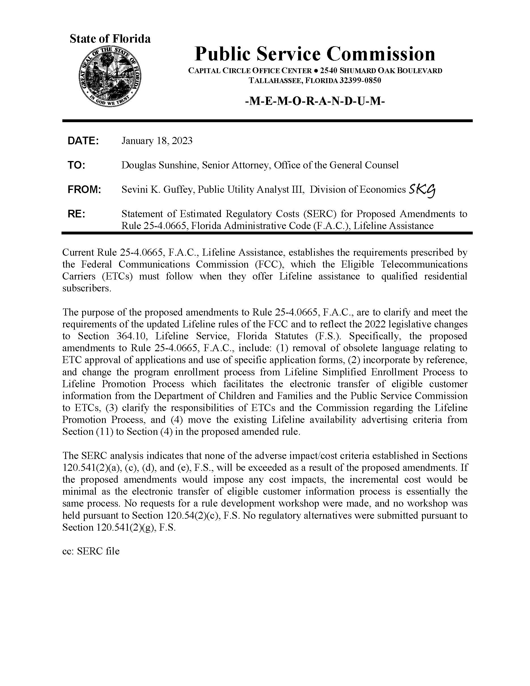

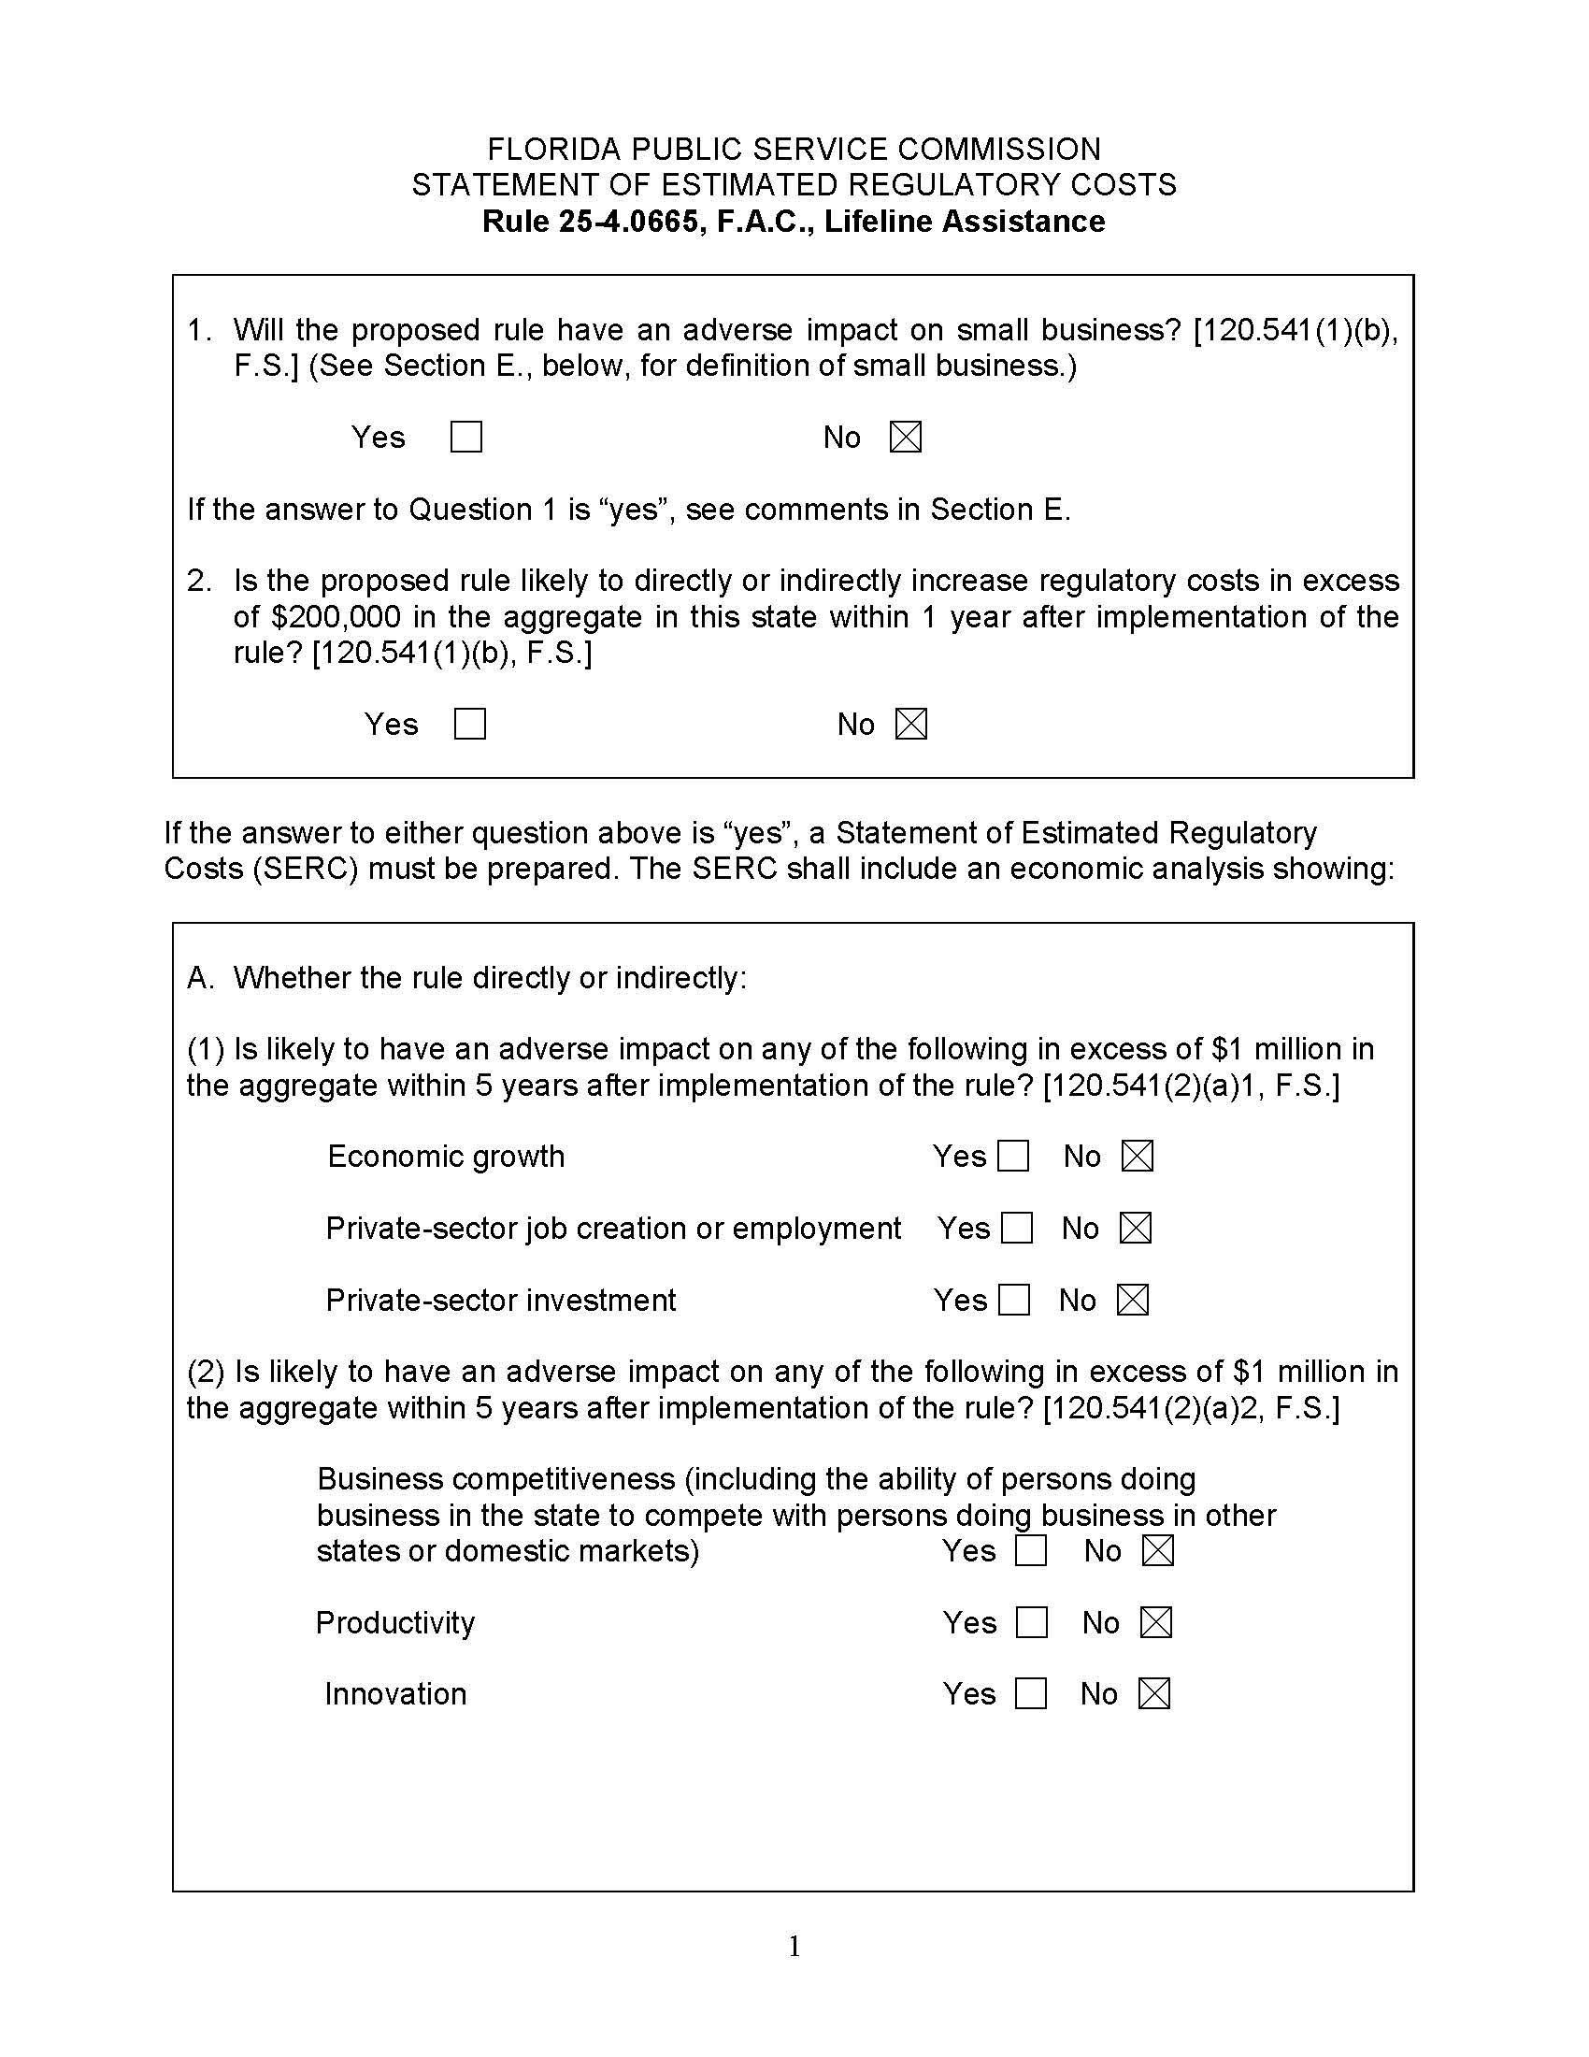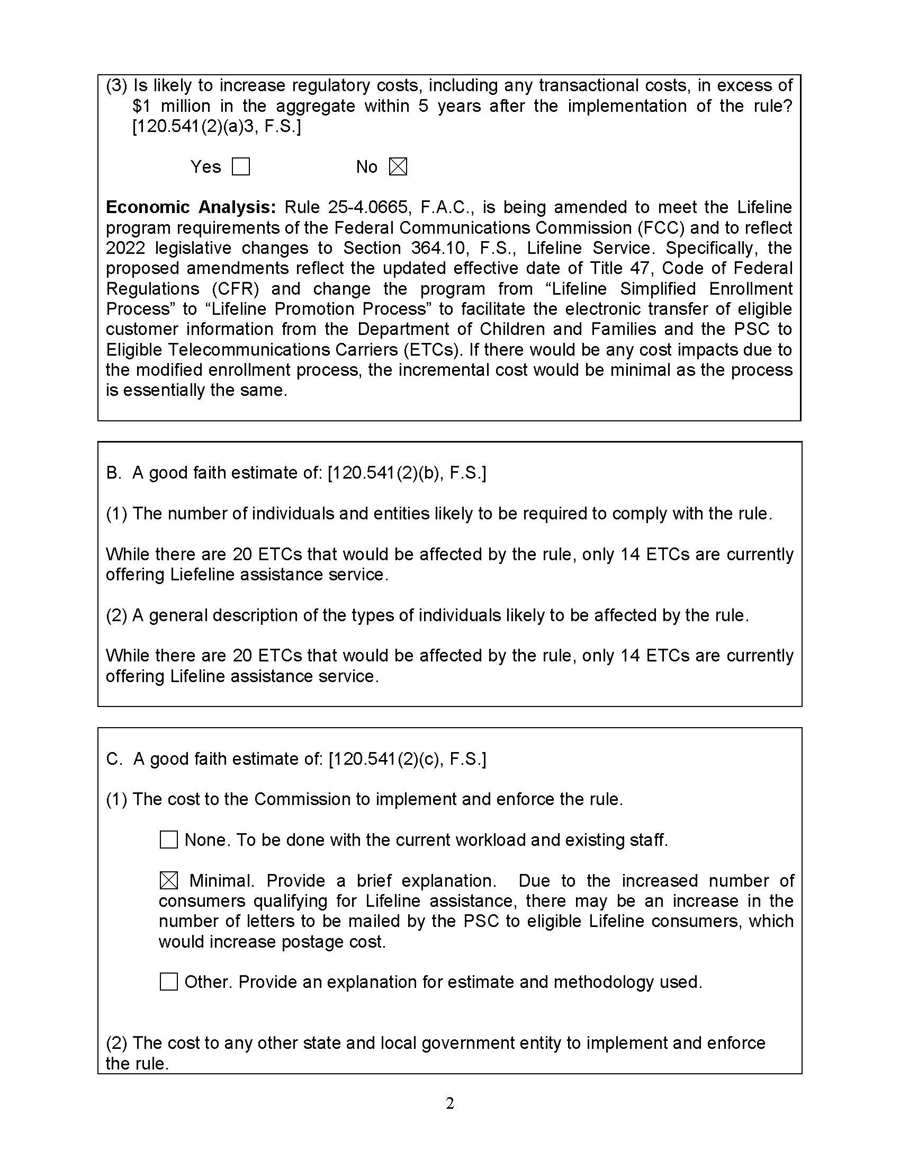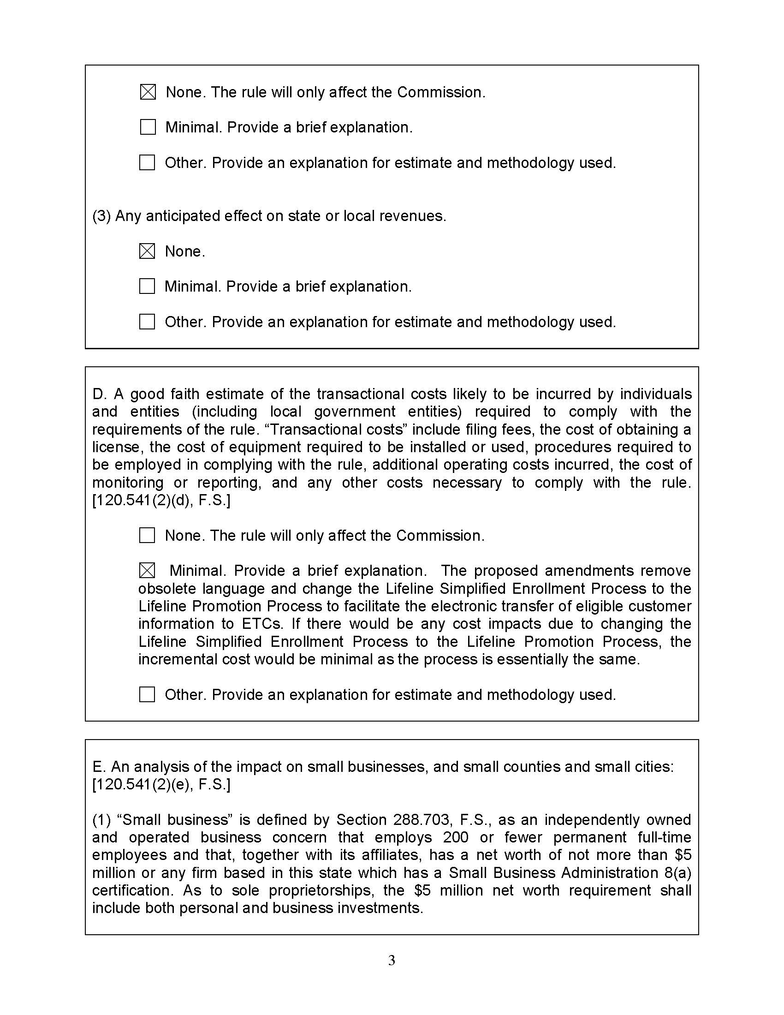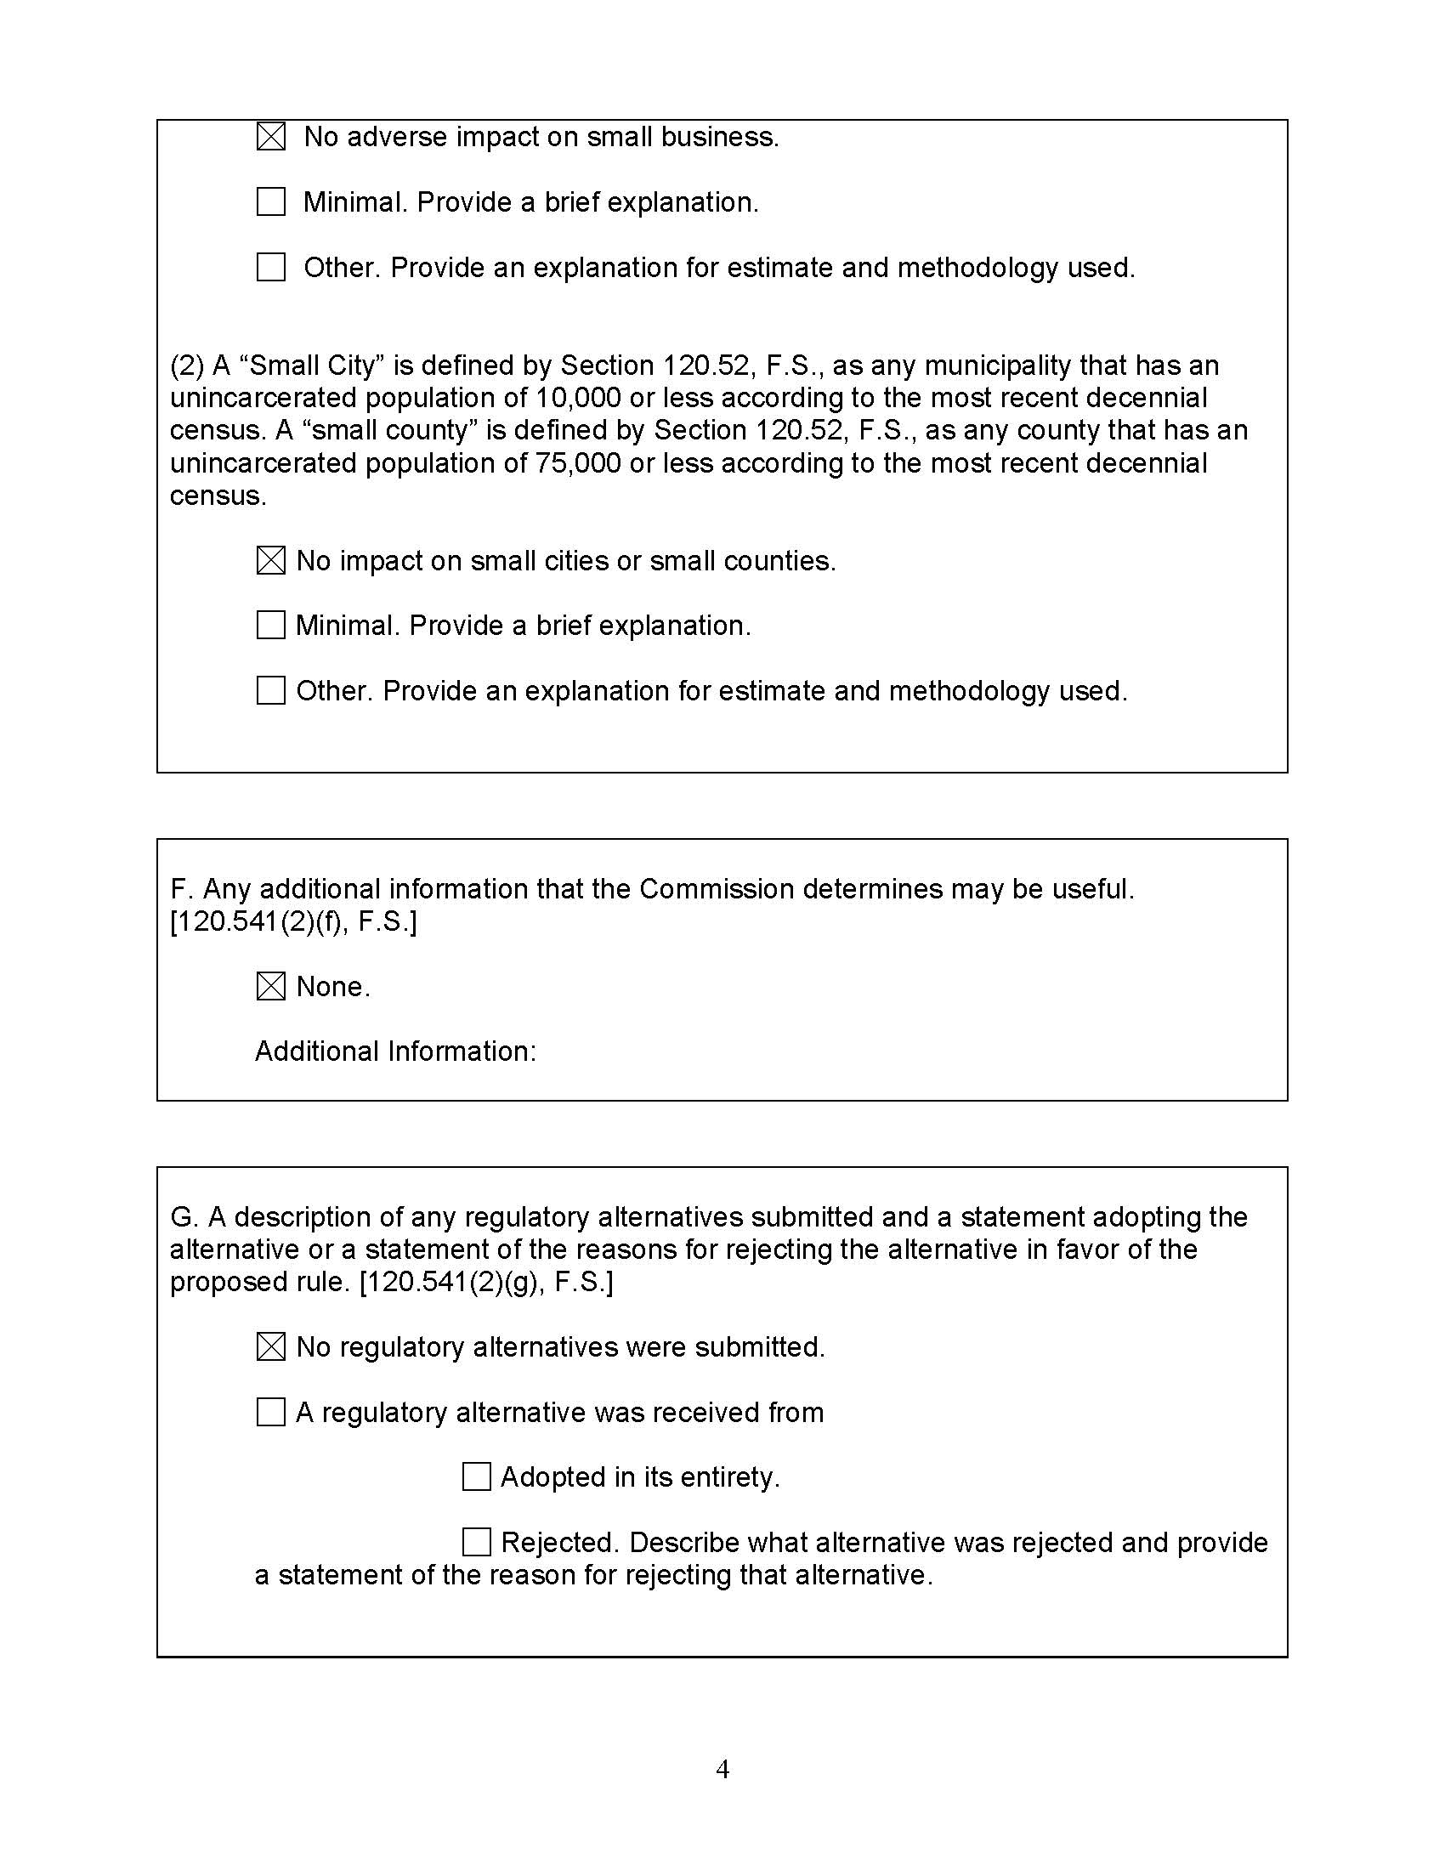

1. Section 120.695(2)(c)3., F.S.