|  |  |  |  |
| --- | --- | --- | --- |
| State of Florida  pscSEAL | | Public Service Commission  Capital Circle Office Center ● 2540 Shumard Oak Boulevard Tallahassee, Florida 32399-0850  -M-E-M-O-R-A-N-D-U-M- | |
| DATE: | February 23, 2023 | | |
| TO: | Office of Commission Clerk (Teitzman) | | |
| FROM: | Office of the General Counsel (Rubottom, Jones) SMC  Division of Economics (Guffey) JGH  Division of Engineering (Ellis, King, Thompson) TB | | |
| RE: | Docket No. 20200181-EU – Proposed amendment of Rule 25-17.0021, F.A.C., Goals for Electric Utilities. | | |
| AGENDA: | 03/07/23 – Regular Agenda – Rule Proposal – Interested Persons May Participate | | |
| COMMISSIONERS ASSIGNED: | | | All Commissioners |
| PREHEARING OFFICER: | | | La Rosa |
| RULE STATUS: | | | Proposal May Be Deferred |
| SPECIAL INSTRUCTIONS: | | | None |

Case Background

Rule 25-17.0021, Florida Administrative Code (F.A.C.), Goals for Electric Utilities, implements the Commission’s statutory mandate to adopt goals for electric utilities, approve utility plans, and collect periodic reports from utilities related to promoting efficiency and conservation of electric energy as provided in Sections 366.80-366.83 and 403.519, Florida Statutes (F.S.), known together as the Florida Energy Efficiency and Conservation Act (FEECA). The Commission is required by FEECA to establish goals at least once every five years for utilities subject to FEECA. The utilities are required to develop plans and programs to reach those goals and submit them for approval by the Commission.

The six electric utilities currently subject to FEECA are Florida Power & Light Company (FPL), Duke Energy Florida, LLC (Duke), Tampa Electric Company (TECO), Florida Public Utilities Company (FPUC), JEA, and Orlando Utilities Commission (OUC).

In the 2019 goal-setting proceeding, the Commission chose to continue the goals established by its 2014 goal-setting decision for the period 2020-2024 and directed staff to review the FEECA process for potential updates and revisions.[1] This rulemaking was initiated at the direction of the Commission following the 2020 DSM plan-approval proceeding.[2]

FEECA’s Requirements

The Legislature adopted FEECA in order to promote four key priorities: (1) reducing the growth rates of weather-sensitive peak demand and electricity usage, (2) increasing the efficiency of the production and consumption of electricity and natural gas, (3) encouraging demand-side renewable energy systems, and (4) conserving expensive resources, particularly petroleum fuel.[3] The Legislature emphasized that it is critical to utilize “efficient and cost-effective” conservation systems.[4]

The Legislature set forth in Section 366.82, F.S., appended as Attachment C, specific statutory guidelines for the Commission to implement FEECA’s objectives through the establishment of conservation goals for utilities and approval of utility plans to meet those goals.

The Commission’s goal-setting and plan-approval proceedings are conducted pursuant to Sections 120.569 and 120.57, F.S., affording all parties whose substantial interests are affected the opportunity to participate in discovery, to offer testimony and other evidence, and to conduct cross-examination of witnesses at the administrative hearings.

FEECA’s Goal-Setting Process for Electric Utilities

Section 366.82(2), F.S., directs the Commission to “adopt appropriate goals for increasing the efficiency of energy consumption and increasing the development of demand-side renewable energy systems.” It further provides that the Commission should specifically include goals designed to increase the conservation of expensive resources, such as petroleum fuels; to reduce and control the growth rates of electric consumption; to reduce the growth rates of weather-sensitive peak demand; and to encourage development of demand-side renewable energy resources.

The Commission is required by Section 366.82(3), F.S., in the process of developing conservation goals, to “evaluate the full technical potential of all available demand-side and supply-side conservation and efficiency measures.” The Commission is further directed by that section, in establishing the goals, to take into consideration:

1. The costs and benefits to customers participating in the measure.
2. The costs and benefits to the general body of ratepayers as a whole, including utility incentives and participant contributions.
3. The need for incentives to promote both customer-owned and utility-owned energy efficiency and demand-side renewable energy systems.
4. The costs imposed by state and federal regulations on the emission of greenhouse gases.

As mentioned above, the Commission is required to review the goals at least every five years, and the Commission may change the goals for reasonable cause.[5]

FEECA’s Electric Utility Plan Approval Process

Section 366.82(7), F.S., addresses the Commission’s process for approving utility plans and programs to meet the conservation goals. Utility programs may include any measure “within the jurisdiction of the [C]ommission which the [C]ommission finds likely to be effective.” In approving plans and programs for cost recovery, the Commission “shall have the flexibility to modify or deny plans or programs that would have an undue impact on the costs passed on to customers.” When a utility completes its plans and programs, the Commission is required to determine what further goals, plans, and programs are warranted and adopt them.[6]

Other Commission Rules Implementing FEECA

The Commission rules implementing FEECA are located in Chapter 25-17, F.A.C., including particular rules that apply to electric utilities promoting conservation through DSM efforts. FEECA’s emphasis on utilizing cost-effective energy conservation is codified in Rule 25-17.008, F.A.C., which prescribes cost-effectiveness data reporting formats for demand-side conservation programs. *See also* Rule 25-17.001, F.A.C. Rule 25-17.015, F.A.C, contains the filing requirements for cost recovery for approved conservation efforts through the Energy Conservation Cost Recovery (ECCR) proceedings.

Procedural Issues

A Notice of Rule Development for Rule 25-17.0021, F.A.C., appeared in the November 24, 2020, edition of the Florida Administrative Register, Vol. 46, No. 229. No other Commission rules implementing FEECA were noticed for rule development as part of this rulemaking.

Staff rule development workshops were held on January 14, 2021,[7] May 18, 2021,[8] and on November 30, 2022.[9] Participants at the workshops included: Duke, FPL, Gulf Power Company, TECO, FPUC, JEA, the Office of Public Counsel (OPC), City of Miami Beach, City of St. Petersburg, Orange County, Broward County, Advanced Energy United (AEU) (formerly known as Advanced Energy Economy), American Council for an Energy Efficient Economy (ACEEE), Catalyst Miami, Ceres, the CLEO Institute (CLEO), Connected in Crisis Coalition, E4TheFuture, Environmental Coalition of Southwest Florida (ECOSWF), Family Action Network Movement, Florida Conservation Voters, Florida Rising, IGT Solar, Johnson Consulting Group, League of United Latin American Citizens (LULAC), Miami Climate Alliance, NAACP Florida State Conference, Net Plus Solar Power Group, Real Building Consultants, Solar United Neighbors of Florida, Southeast Energy Efficiency Alliance (SEEA), Southeast Sustainability Directors Network (SSDN), Southern Alliance for Clean Energy (SACE), Southface Institute (Southface), Synapse Energy Economics, Tampa Bay Energy Efficiency Alliance, Vote Solar, and various private individuals.

Post-workshop comments were filed after each workshop. Prior to the third workshop, staff published a revised draft of the rule for discussion and consideration, and post-workshop comments were filed with comments on that draft by: Duke, FPL, TECO, ACEEE, AEU, Catalyst Miami, Alianza for Progress, Florida Conservation Voters, Healthy Gulf, Florida Clinicians for Climate Action, Broward Climate Alliance, Florida Immigration Coalition, and Opportunity for All Floridians, CLEO, a group of Florida faith leaders, Google Nest, LULAC, ECOSWF, Miami-Dade County, OPC, ReThink Energy Florida, SACE, Sierra Club, Southface, and Vote Solar. Additionally, over 2,000 correspondence documents with comments on this rule development have been placed in the docket from various individuals and utility customers.

This recommendation addresses whether the Commission should propose the amendment of Rule 25-17.0021, F.A.C., Goals for Electric Utilities. The Commission has jurisdiction pursuant to Sections 120.54, 366.05, and 366.82, F.S.

Discussion of Issues

Issue 1:

 Should the Commission propose the amendment of Rule 25-17.0021, F.A.C., Goals for Electric Utilities?

Recommendation:

 Yes. The Commission should propose the amendment of Rule 25-17.0021, F.A.C., as set forth in Attachment A. The Commission should also certify that Rule 25-17.0021, F.A.C., is a rule the violation of which would be a minor rule violation pursuant to Section 120.695, F.S. (Rubottom, Thompson, Guffey)

Staff Analysis:

 Rule 25-17.0021, F.A.C., implements FEECA’s requirement that the Commission adopt appropriate efficiency and conservation goals for electric utilities and approve utility plans and programs designed to meet those goals. The purpose of this rulemaking is to improve the administrative efficiency and overall transparency of the Commission’s goal-setting process.

The long-standing goal-setting process has featured annual goals proposed by utilities based upon the aggregated demand and energy savings of individual conservation measures. These measures can include the replacement of existing technology with more energy efficient equipment that results in electric demand and energy savings. Once goals are approved by the Commission, utilities propose conservation plans that bundle measures into programs to be offered to customers. For example, multiple lighting technology measures can be bundled into a lighting program. The existing rule, however, does not require a utility to include measures used in its aggregated proposed goals in the programs ultimately offered to customers. This results in a disconnect in the Commission’s annual review of utility performance because demand and energy savings achieved from customer participation in approved programs is compared to the measure-based goals established by the Commission.

Additionally, the goal-setting process under the existing rule provides the utilities with discretion to submit their proposed annual goals based upon only their preferred cost-effectiveness tests. This practice has resulted in limiting the breadth of information and data on the cost-effectiveness of conservation measures and programs that the Commission can consider as it develops and establishes goals.

Staff’s recommended rule amendments make two primary revisions to the goal-setting process designed to address the concerns outlined above: (1) goals would be based upon projected savings from potential programs offered to customers rather than upon aggregated savings from individual conservation measures; and (2) utilities would be required to provide projected savings or goals developed under two cost-effectiveness scenarios, rather than a single cost-effectiveness test, in order to provide a more robust record of evidence. Specifically, staff’s objective with the recommended amendments is to bring into the goal-setting phase a greater focus on potential conservation programs that could be offered to customers in order to reach a utility’s approved goals.

Staff believes that the recommended amendments to the rule, as set forth in Attachment A, would improve the transparency and efficiency of the goal-setting and plan-approval processes, as well as ensure that the Commission can gather and analyze information necessary and relevant to fulfilling FEECA’s statutory mandate to utilize cost-effective efficiency and conservation systems.

Summary and Analysis of Recommended Amendments

Staff’s recommended amendments to Rule 25-17.0021, F.A.C., will be discussed subsection-by-subsection through the rule as set forth in Attachment A. For each subsection, the discussion will first present a summary and explanation of the recommended amendments, then a summary of comments related to that subsection as received from stakeholders and staff’s recommendations on those comments.

As a threshold matter, this recommendation addresses the comments staff believes to be within the scope of Rule 25-17.0021, F.A.C.[10] In addition to the comments discussed below, Duke, FPL, and TECO (“Utilities”) provided comments in support of staff’s recommended rule amendments. In general, the Utilities agreed that the amendments would provide greater transparency, increase administrative efficiency in the goal-setting and plan-approval processes, and provide the Commission with additional information and flexibility to meet FEECA’s requirements to balance costs and benefits.

Additionally, some stakeholders submitted comments on other matters, such as supply-side and transmission efficiency measures; amending Rule 25-17.008, F.A.C., to adopt a “modified Total Resource Cost Test” that includes a “societal adder” to account for non-energy benefits; replacing the Commission’s Cost Effectiveness Manual with a National Standard Practice Manual; and the creation of a DSM Working Group comprised of utilities and other interested stakeholders. This recommendation does not address those issues because staff believes those comments are outside the scope of this rulemaking.

The majority of non-utility individuals and groups that participated in the rule development workshops and submitted comments on the draft rule, including individuals who submitted correspondence documents, were closely aligned in their basic positions and suggestions. Because their comments were largely similar in substance, those commenters will be referred to collectively as “Stakeholders” for purposes of discussing their comments.[11]

Subsection (1) Recommended Amendments

Subsection (1) of the recommended amended rule addresses the frequency, nature, and basis of the goals the Commission will set for electric utilities. Recommended amendments clarify language related to the evidence upon which the Commission will base the FEECA goals and how the Commission will gather the information necessary to develop and assess potential goals. In particular, paragraph (1)(a) codifies the statutory requirement that the Commission shall evaluate the technical potential of available measures, as required by Section 366.82(3), F.S., and the word “programs” was added in paragraph (1)(b) to clarify that the estimate of reasonably achievable savings should be focused on potential DSM programs. Other recommended amendments to subsection (1) include:

* Language related to the frequency of goal-setting procedures (“at least once every five years”) was moved to this subsection from subsection (2).
* Deleted the word “numerical” to allow the Commission the flexibility to set non-numerical goals if appropriate under FEECA.
* Deleted language related to the specific objectives of the goals because it restated language existing in Section 366.82(2), F.S.
* General updates to language for clarity.

Summary of Comments Received & Staff Response

Stakeholders suggest that the rule should include some consideration or mechanism to increase participation in DSM programs among low-income customers. Stakeholders assert that the DSM goals established by the Commission should include separate and discrete DSM goals for low-income customers. They point out that because low-income customers generally spend a higher percentage of household income on energy, they would experience a significant benefit from the lower electricity bills associated with DSM program participation. They further point out that the needs and market barriers unique to low-income customers negatively affect their ability to participate in DSM measures. Therefore, Stakeholders want the Commission to set discrete kilowatt (KW) and kilowatt-hour (KWH) savings goals for low-income customers that would make it easier for low-income customers to participate in utility-sponsored DSM programs. Suggestions for such goals also included requiring a minimum percentage of utilities’ DSM spending to be allocated for low-income programs.

Under the amended rule as recommended, the Commission will establish goals for Residential customers based on an analysis of the technical potential of available measures and cost-effective savings reasonably achievable through DSM programs, as required by Section 366.82(3), F.S. Staff notes, however, that the residential market segment is not differentiated by income levels and thus, low-income customers are already included in the technical potential and cost-effectiveness analysis for this market segment. Therefore, staff believes it unnecessary to require distinct goals for a customer class included within the Residential market segment.

Further, staff believes that codifying distinct low-income goals would unnecessarily restrict the discretion given to the Commission by statute. As Stakeholders observe, low-income customers have higher market barriers affecting participation in DSM measures. FEECA contemplates overall conservation goals, DSM plans and programs designed to meet those goals, and particular DSM measures included in those plans and programs. *See* Section 366.82(2)-(3), F.S. Thus, if the Commission sets discrete goals for low-income customers, then discrete plans, programs, and measures for low-income customers would be required to meet those goals under FEECA. However, if low-income customers are considered as part of the Residential market segment for goal-setting purposes, the Commission could consider potential low-income DSM measures as part of a portfolio within a larger Residential plan or program, allowing greater flexibility in how utilities can account for, and the Commission can consider, the particular needs of low-income customers. The Commission has a history of doing just that by directing utilities to use a “portfolio approach” that allows low-income DSM measures to be considered as part of a “bundle” with cost-effective programs.[12]

For these reasons, staff does not recommend the Commission include provisions related to separate low-income goals in the rule.

Subsection (2) Recommended Amendments

Subsection (2) of the recommended amended rule codifies and clarifies the technical potential study to be conducted by electric utilities and filed for the Commission to evaluate in developing goals as required by FEECA in Section 366.82(3), F.S.

Staff’s recommended amendments to this subsection clarify that the technical potential study should focus on DSM measures associated with particular major end-use categories in the Residential and Commercial/Industrial Market Segments. The assessment of major end-use categories was moved to this subsection from subsection (3) of the existing rule, and the lists of major end-use categories were amended for consistency and clarity. Of particular note, the “Renewable/Natural gas substitutes for electricity” category was deleted to avoid confusion regarding substitution between electricity and natural gas. Because both electric and gas energy resources are covered by FEECA with separate goals, staff believes that electric utilities should not be encouraged to meet their own FEECA goals by undermining FEECA’s priorities for natural gas conservation, and vice versa. In general, staff believes load-building DSM measures—such as those substituting one FEECA resource for another—should not be encouraged as measures to meet FEECA goals.

Additional recommended amendments to subsection (2) are:

* Added language clarifying that the Commission has flexibility to set the filing schedule for the technical potential study in an order establishing procedure.
* Required the utilities to assess “the full potential of all available demand-side conservation and efficiency measures” mirroring the statutory language in Section 366.82(3), F.S.
* Moved language related to frequency of goal-setting procedures (“at least once every five years”) from this subsection to subsection (1).
* Moved language related to the Commission’s discretion to review and modify goals to subsection (5) of the amended rule in order to keep the focus of subsection (2) on the technical potential study.

Summary of Comments Received & Staff Response

Stakeholders suggest that “efficient electricity substitutes for natural gas” should be added as an end-use category considered in the technical potential study, arguing that electricity is a more efficient energy source than natural gas and would thus provide a net gain in conservation of resources. Stakeholders also suggest adding an additional end-use category, such as “other,” as a catch-all category to allow the Commission to consider efficiency measures related to emerging technologies—such as electric vehicles—that do not fit under any of the end-use categories listed in the subsection.

As stated above, staff believes load-building DSM measures—such as those substituting natural gas consumption for electricity—should not be encouraged as viable measures to meet FEECA goals. Thus, staff recommends that the Commission not include in subsection (2) the addition of an end-use category encouraging such substitution.

Additionally, staff recommends that the Commission not include a catch-all “other” category because it would not provide sufficient guidelines for implementation or enforcement. As such, it could be construed as a broad claim of authority beyond what FEECA grants. Staff believes the categories contained in the recommended amended rule are sufficient to allow the Commission to consider the full technical potential of all available DSM measures, as required by FEECA in Section 366.82(3), F.S., without foreclosing the future consideration of available measures that may not fit neatly into the end-use categories enumerated in the rule.

Subsection (3) Recommended Amendments

Subsection (3) of the recommended amended rule focuses on cost-effectiveness data and prescribes information to be provided by utilities that will enable the Commission to consider the costs and benefits of potential DSM programs and the potential costs passed on to customers, as required by FEECA in Sections 366.81 and 366.82(3), (7), F.S.

In particular, each electric utility is required to file proposed DSM goals developed using the technical potential study in subsection (2). In addition to the proposed goals, each electric utility must file DSM goals developed under two cost-effectiveness scenarios: in one scenario, the goals must include potential DSM programs that pass the Participant Test and the Rate Impact Measure (RIM) Test; in the other scenario, the goals must include potential programs that pass the Participant Test and the Total Resource Cost (TRC) Test.[13] In each scenario, the DSM programs may include individual DSM measures that do not pass the cost-effectiveness tests but the program itself, comprised of various measures, must pass the combination of tests prescribed for that scenario.

Staff believes that the two cost-effectiveness scenarios discussed above will provide the Commission with a broad range of information related to the costs and benefits of available DSM measures—information that will equip the Commission to comply with FEECA’s requirements to consider the costs and benefits of those measures on participants, non-participants, and the general body of ratepayers as a whole, as required by FEECA in Section 366.82(3), F.S., without relying on the outcome of a single cost-effectiveness test.

The recommended amended language also provides that goal projections must provide estimated annual demand and energy savings from potential DSM programs and estimated annual program costs. This will allow the Commission to consider the benefit of overall savings from DSM programs in light of the overall cost of the programs.

The cost-effectiveness information provided through the two scenarios and related estimated annual program costs will give the Commission at the goal-setting stage information relevant to its statutory mandate to assess whether potential DSM plans and programs proposed to meet the goals may have an undue impact on rates as required by FEECA in Section 366.82(7), F.S. Additionally, the recommended amendments will allow the Commission to remain flexible to respond appropriately to the availability of evolving technologies and to the shifting market conditions as they exist at the time of each goal-setting proceeding.

Additional recommended amendments to subsection (3) clarify that the schedule for each utility to file proposed goals will be set by the Commission’s order establishing procedure, and they make general updates to the language for clarity and specificity.

Summary of Comments Received & Staff Response

Comments on subsection (3) addressed two principal areas: first, the rule’s prescribed cost-effectiveness analysis and particularly the RIM Test; and second, how the Commission should address free ridership concerns.

##### *Cost Effectiveness & RIM Test*

Stakeholders suggest that the Commission exempt DSM programs designed for low-income customers from its cost-effectiveness analysis.

Staff believes that exempting DSM programs for low-income customers from cost-effectiveness analysis violates FEECA’s directives to analyze cost effectiveness, particularly its requirement that the Commission must consider the costs and benefits of potential DSM measures as it establishes goals for utilities. See Section 366.82(3), F.S. Thus, staff did not treat such programs differently in its recommended amendments.

Stakeholders also argue that the Commission should amend the rule to eliminate the RIM Test from its analysis of cost-effectiveness. They assert that the RIM Test treats customer bill savings resulting from efficiency measures as lost utility revenue, and thus as a cost rather than a benefit. Stakeholders also argue that the actual impact on rates resulting from lost revenues is speculative and highly dependent on other market factors, and that because the test only indicates the direction of resulting pressure on rates (upward or downward), the RIM Test thus provides no meaningful information for the Commission to assess cost effectiveness. Stakeholders argue that although the RIM Test may limit cross-subsidization of utility-led DSM measures that put upward pressure on rates, this concern is mitigated by simultaneous downward pressure on rates resulting from DSM benefits such as reduced fuel use, efficient consumption, and avoided generation investments. Further, Stakeholders contend that the RIM Test favors DSM measures that do little to nothing to decrease energy consumption while disfavoring measures that result in more efficient consumption, an outcome that they argue undermines FEECA’s legislative purpose.

Stakeholders suggest that in place of the RIM Test, the rule should require that utilities analyze cost effectiveness using the Utility Cost Test (UCT), also known as the Program Administrator Test, which is essentially the RIM Test analysis without the lost revenue cost component. Stakeholders argue that this is an improvement on current Commission practice because the UCT compares a utility’s cost of saving energy by administering DSM measures to the utility’s cost of providing power through supply resources. Additionally, the UCT symmetrically compares the direct utility costs of operating DSM programs against the direct financial benefits of efficiency which are passed on to all customers. Stakeholders suggest that in order to include the UCT in the rule, the Commission could either amend the Cost Effectiveness Manual incorporated into Rule 25-17.008, F.A.C., or alternatively the Commission could provide a standard definition of the UCT test in Rule 25-17.0021, F.A.C.

Staff recommends that the Commission not eliminate or replace the RIM Test. Staff believes that the RIM Test provides valuable information not provided by the UCT or any of the Commission’s other cost-effectiveness tests, information staff believes to be relevant to the cost-effectiveness considerations required by FEECA. In particular, as described in more detail below, the RIM Test’s consideration of a utility’s lost revenue is relevant to FEECA’s mandate to consider the costs passed on to the general body of ratepayers.[14]

FEECA declares that it is essential to utilize cost-effective DSM and conservation systems. See Section 366.81, F.S. Additionally, FEECA requires that in establishing goals, the Commission must consider the “costs and benefits to the general body of ratepayers as a whole.” See Section 366.82(3)(b), F.S. Further, FEECA requires that in approving DSM plans and programs for cost recovery, the Commission must examine whether they will result in “an undue impact on the costs passed on to customers.” See Section 366.82(7), F.S.

For purposes of reporting cost-effectiveness data required by Rule 25-17.0021, F.A.C., the three cost-effectiveness tests used by the Commission are defined and described in Rule 25-17.008, F.A.C., which incorporated the Commission’s Cost Effectiveness Manual.[15] The RIM Test is one piece, but an important piece, of the cost-effectiveness puzzle that helps the Commission discern the overall cost-effectiveness picture of potential DSM programs along with the other tests utilized by the Commission.

* The Participants Test analyzes costs and benefits of a DSM measure from the perspective of customers participating in the measure, including the cost of installing DSM equipment and the benefit of reduction in electricity bills.
* The Total Resource Cost Test measures the net costs and benefits of a DSM program as a resource option compared to other traditional supply resources, including the costs and benefits both to participants and the utility administering the program. Lost revenues (bill reductions) are not considered in the TRC Test because they are treated as a transfer payment—a cost to the utility that exactly matches the benefit to participating customers.
* The Rate Impact Measure Test measures the direction of pressure on rates likely to result from a DSM program relative to the pressure without the DSM program. It compares the change in utility revenue to the change in utility costs to determine whether a DSM measure will place upward or downward pressure on rates for the general body of ratepayers, including customers not participating in the DSM program.

The Cost Effectiveness Manual states that in evaluating conservation programs, “the Commission will review the results of all three tests to determine cost effectiveness.” However, Rule 25-17.008(4), F.A.C., states that “[n]othing in this rule shall be construed as prohibiting any party from providing additional data proposing additional formats for reporting cost effectiveness data.”

Staff believes that it is important to the Commission’s cost-effectiveness analysis under FEECA to consider the estimated impact of lost utility revenue that will result from potential DSM measures. A utility’s rates are designed to recover both fixed costs and variable costs from a projected total sales volume. When energy sales (kilowatt-hours or KWH) and thus, total revenue, are reduced through efficiency and conservation, a utility’s variable costs decrease but, in general, fixed costs remain unchanged. Thus, all other things remaining equal, a utility would no longer recover all its fixed costs from the lower revenue total. In other words, a loss in energy sales could put upward pressure on rates for the general body of ratepayers because the utility’s fixed costs would be spread across fewer KWH. Therefore, an analysis of the estimated impact of a DSM measure on a utility’s revenue helps the Commission consider the potential impact on future rates for the general body of ratepayers, as required by FEECA in Section 366.82(3) and (7), F.S.

Although the RIM Test does treat a reduction in the bills of participating customers as “lost revenue,” and therefore as a cost both to the utility and to the general body of ratepayers, bill reductions are considered as a benefit under the Participants Test.[16] Staff believes that eliminating the RIM Test and its analysis of lost revenues would restrict the Commission’s statutory flexibility to consider a wide array of cost-effectiveness data upon which to determine, in light of variable market conditions, the overall cost effectiveness of a potential DSM measure.

Staff also believes that the spectrum of cost-effectiveness tests required by staff’s recommended amendments to the rule will provide the Commission with a broad range of information related to the costs and benefits of available DSM measures—data that will put the Commission in the best position to comply with FEECA’s requirements to consider the costs and benefits of those measures on participants, non-participants, and the general body of ratepayers as a whole, as required by FEECA in Section 366.82(3), F.S. In addition, the tests, the RIM Test in particular, will give the Commission at the goal-setting stage information relevant to its statutory mandate to assess whether potential DSM plans and programs may have an undue impact on rates, as required by FEECA in Section 366.82(7), F.S.

For these reasons, staff recommends that the Stakeholders’ suggestions to eliminate the RIM Test from the Commission’s cost-effectiveness analysis should not be accepted. Staff recommends that the Commission continue utilizing the RIM Test as provided in the proposed amended rule in order to establish a robust record of evidence related to cost effectiveness upon which the Commission can set conservation goals for electric utilities in accordance with the directives prescribed by FEECA and with the full range of flexibility granted to the Commission by statute.

##### *Free Rider Considerations*

Stakeholders ask that the Commission include in the rule an explicit bar on the Commission’s use of the two-year payback screen as a method for considering free riders. Stakeholders argue that the payback screen as historically applied by the Commission eliminates many of the most common and cost-effective measures available, including many that would benefit low-income customers. They assert that eliminating the two-year payback screen would roughly double the cost-effective savings potential of DSM goals. Stakeholders further assert that the application of a payback screen lacks evidentiary basis, and they suggest that the rule should require utilities to apply evidence-based methodologies that are consistent with industry standard practices to consider overlapping measures, rebound effects, free riders, and interactions with building codes and appliance efficiency standards. Stakeholders also suggest that free ridership should be addressed in the program design phase and through post-implementation evaluation, measurement, and verification (EM&V) to track and assess free rider concerns.

FEECA requires that in developing the goals, the Commission must take into consideration “the costs and benefits to the general body of ratepayers as a whole, including utility incentives and participant contributions.” *See* Section 366.82(3)(b), F.S. Additionally, FEECA requires the Commission to consider the “need for incentives to promote . . . energy efficiency and demand-side renewable energy systems.” *See* Section 366.82(3)(c), F.S. Furthermore, FEECA provides in Section 366.82(5), F.S., that the Commission shall consider information related to the pursuit of a “least-cost strategy, including *non-utility programs* targeted at reducing and controlling the per capita use of electricity in the state” as well as the impact of building codes and appliance efficiency standards on “the need for *utility-sponsored* conservation and energy efficiency measures and programs.” (emphasis added). In approving plans and programs for cost recovery, the Commission “shall have the flexibility to modify or deny plans or programs that would have an undue impact on rates.” *See* Section 366.82(7), F.S. It is from these provisions that the Commission derives its statutory mandate to consider “free riders” in analyzing the cost effectiveness of a potential DSM measure.

In the Commission’s DSM goal-setting and plan-approval processes, the term “free rider” describes a utility customer who accepts a utility incentive to participate in a DSM measure even though they would likely engage in that DSM activity without the incentive. DSM activity has the inherent benefit to participating customers of lowering electricity consumption and bills, a benefit that operates as a natural incentive to engage in the activity. Thus, it is reasoned that a rational customer would participate if the benefits outweigh the cost. However, a utility incurs costs to administer a DSM measure, including incentives given to customers to encourage participation in the program. These incentives are then recovered in electric rates collected from the general body of ratepayers, including those not participating in the DSM measure, through the ECCR clause.[17] Thus, the Commission has historically sought to limit incentives paid for DSM participation to customers who would likely engage in the conservation activity without the incentive.

The Commission has historically used a time-based “payback screen” to screen out potential free riders.[18] A payback period is the time it takes for a customer to recover through bill reductions the up-front costs of installing a DSM system or adopting a DSM activity. It is reasoned that if a DSM measure would “pay for itself” within a certain period of time, the customer already has enough economic incentive to adopt that system or activity, and an incentive paid to those customers are more likely to be ineffective or superfluous. Thus, those DSM measures are “screened out” in order to avoid collecting through general rates or the ECCR clause incentives paid to customers who were already sufficiently incentivized to participate. In other words, because the incentive paid to a free rider adds no marginal participation in the DSM measure and no marginal contribution to FEECA’s objectives, non-participants should not be required to pay for these incentives through increased rates.

It is important to note that there are many market factors that can change the costs and benefits to customers and affect the length of a payback period and whether a utility incentive is necessary. For instance, if there are rebates or tax incentives available for adopting a particular DSM measure, the up-front cost to the customer is reduced, and the payback period is also reduced because it will take less time for the DSM measure to pay for itself through reduced customer bills. Similarly, if fuel costs are high, the customer will realize greater bill reductions, and the DSM measure will take less time to pay for itself. Conversely, low fuel costs and an absence of rebates or tax incentives would result in a longer payback period, and where a DSM measure has a longer payback period, more customers are likely to require the encouragement of utility incentives in order to participate. Thus, staff believes it is important that the Commission maintain a flexible and responsive approach to considering free ridership under whatever market conditions exist at the time of future goal-setting proceedings.

Further, when a DSM measure is “screened out” by a time-based payback screen, that in no way indicates that the DSM measure will be entirely abandoned or that Florida’s electricity customers will be deprived of any conservation or efficiency benefits the DSM measure could have produced. In fact, the measures are screened out of a utility’s DSM plan precisely because customers are likely to participate in the DSM measure without utility incentives. To that end, the payback screen analysis provides insight as to what types of measures the Commission could include in utility educational programs, such as audits. By redirecting some utility DSM spending from incentives and program administration to educational efforts that inform customers about these quick pay-back efficiency options, the Commission can leverage the inherent benefits of DSM activity to incentivize customers to adopt the “screened out” measure, thereby advancing the goals of FEECA while reducing the overall cost to be passed on to the general body of ratepayers. Thus, FEECA’s priorities can still be advanced, and the general body of ratepayers can still experience the associated benefits despite a measure being “screened out” of a utility’s DSM portfolio.

Stakeholders ask the Commission to amend the rule to expressly eliminate the use of a time-based payback screen in favor of post-implementation EM&V practices performed by utilities, a costly method that does not prevent free rider participation on the front end and thus increases costs passed on to non-participants through the ECCR clause. Contrary to Stakeholders’ assertion that the application of a payback screen lacks evidentiary basis, the Commission has repeatedly considered testimony supporting the application of a payback screen as a method of considering free ridership and addressing the appropriate length of the payback period.[19] Importantly, the Commission has also over-ruled the results of the payback screen and, in order to capture more potential savings through available DSM programs, included in utilities’ residential goals DSM measures that were initially screened out by a two-year payback screen.[20]

Staff recommends that the Commission not amend the rule in a way that forecloses its ability to use a time-based payback screen and that the Commission not limit its statutory discretion and flexibility to account for and respond to variable market factors that impact the naturally-occurring incentives of DSM activity. While the application of a time-based payback screen has never been prescribed by Commission rule, and is not prescribed by the recommended rule language, the methodology continues to offer the Commission a valuable tool for considering free ridership and, when the Commission finds its application supported by evidence, for avoiding undue impact on the costs passed on to non-participating customers, as required by FEECA in Sections 366.82(3), (5), and (7), F.S.

Stakeholders also suggest that the Commission exempt from standard free ridership considerations DSM programs and measures designed for low-income customers in order to expand access to utility-sponsored DSM programs.

For the reasons stated above with respect to cost-effectiveness analysis, staff does not recommend that the Commission exempt low-income programs from free rider considerations. Further, staff believes that free ridership in a DSM measure directly affects the utility incentive costs passed on to the general body of ratepayers, and thus that exempting any measures from standard free ridership considerations would violate FEECA’s directives under Sections 366.82(3)(b)-(c), F.S.

Subsection (4) Recommended Amendments

In subsection (4), the recommended amended rule addresses the filing requirements for each electric utility to submit a plan to meet its Commission-approved DSM goals. The recommended amendments add specificity to what information must be included in DSM plan filings and update language for consistency. Additionally, paragraph (4)(j) was added to the rule, requiring utilities to file in their DSM plan an estimate of the annual amount to be recovered through ECCR proceedings. The recommended amendment will give the Commission an opportunity at the plan-approval phase to consider the potential costs to be passed on to customers and avoid potentially “undue impact” in accordance with FEECA Section 366.82(7), F.S.

Additional recommended amendments to subsection (4) update the language for consistency and delete redundant or unnecessary language.

Summary of Comments Received & Staff Response

Stakeholders ask the Commission to require utilities to consider in the DSM plan design process strategies for minimizing free ridership, in connection with the post-implementation EM&V measures discussed above in comments on subsection (3). Additionally, Stakeholders suggest that the rule should require utilities to consider “customer segments” in their DSM plan filings rather than “customer classes” in order to include low-income customers separately and distinctly from residential, commercial, and industrial classes.

For the reasons stated above, staff believes a consideration of free ridership is appropriate at the goal-setting stage in connection with the Commission’s analysis of the cost effectiveness of potential DSM measures as required by FEECA in Section 366.82(3), F.S. Further, an estimate of the cost effectiveness of each proposed program is required in paragraph (4)(i) of the recommended amendments to the rule, contemplating a continuing need to account for free riders as well as the other cost-effectiveness considerations required by subsection (3). Thus, staff does not recommend that the Commission include additional requirements to consider free rider concerns in subsection (4).

Additionally, staff believes it is unnecessary and counterproductive to consider low-income participants as a separate and distinct customer class for DSM plan-approval purposes. As stated above, FEECA contemplates flexibility in the design of particular measures that can be included within plans and programs that are designed to meet approved conservation goals. Thus, considering programs for low-income customers separately would limit the Commission’s statutory ability to approve residential DSM programs that include less cost-effective low-income DSM measures in a portfolio with more cost-effective measures.

Subsection (5) Recommended Amendments

Staff’s recommended amendments to subsection (5) are to retain the provision that the Commission has the discretion to review and modify an electric utility’s DSM goals, language that was originally contained in subsection (2). No comments were received on subsection (5).

Subsection (6) Recommended Amendments

Subsection (6) of the recommended amended rule relates to the annual DSM reporting required for each electric utility. This subsection was renumbered due to the addition of subsection (5). It contains no substantive amendments, making only minor updates to language for clarity and consistency. No comments were received on subsection (6).

Minor Violation Rules Certification

Pursuant to Section 120.695, F.S., for each rule filed for adoption, the agency head shall certify whether any part of the rule is designated as a rule the violation of which would be a minor violation. Rule 25-17.0021, F.A.C., is on the Commission’s minor violation rule list because violation of the rule would not result in economic or physical harm to a person; adverse effects on the public health, safety, or welfare; and would not create a significant threat of such harm. The proposed amendments to the rule would not alter the likelihood or risk of such harms in the event of a violation. Thus, if the Commission proposes the amendment, staff recommends that the Commission certify that Rule 25-17.0021, F.A.C., is a rule the violation of which would be a minor violation pursuant to Section 120.695, F.S.

Statement of Estimated Regulatory Costs

Pursuant to Section 120.54, F.S., agencies are encouraged to prepare a statement of estimated regulatory costs (SERC) before the adoption, amendment, or repeal of any rule. Agencies are required to prepare a SERC for any rule that will have an adverse impact on small business or that is likely to directly or indirectly increase regulatory costs in excess of $200,000 in the aggregate within one year after implementation. The SERC analysis includes whether the rule will, within five years of implementation, have an adverse impact in excess of $1 million in the aggregate on economic factors such as economic growth, private sector job creation or employment, private sector investments, or business competitiveness, productivity, or innovation. If expected adverse impacts or regulatory costs exceed any of the above criteria, a proposed rule may not take effect until it is ratified by the Legislature.

A SERC was prepared and is appended as Attachment B. The SERC concludes that the rule will not have an adverse impact on small business and that the rule is not likely to directly or indirectly increase regulatory costs in excess of $200,000 in the aggregate within one year after implementation. Further, the SERC concludes that the rule will not likely have an adverse impact on economic growth, private sector job creation or employment, private sector investment, or business competitiveness, productivity, or innovation in excess of $1 million in the aggregate within five years of implementation. None of the adverse impact or regulatory cost criteria set forth in Section 120.541(2)(a), F.S., will be exceeded as a result of the recommended amendments to the rule. Thus, the rule does not require legislative ratification pursuant to Section 120.541(3), F.S. In addition, the SERC states that the rule will have no impact on small cities or counties and will not increase the cost to the Commission to implement and enforce the rule. No regulatory alternatives have been submitted pursuant to Section 120.541(1)(a), F.S.

Conclusion

Based on the foregoing, staff recommends the Commission propose the amendment of Rule 25-17.0021, F.A.C., as set forth in Attachment A. In addition, staff recommends that the Commission certify that Rule 25-17.0021, F.A.C., is a rule the violation of which would be a minor rule violation pursuant to Section 120.695, F.S.

Issue 2:

 Should this docket be closed?

Recommendation:

 Yes, if no requests for hearing or JAPC comments are filed, and no proposal for a lower cost regulatory alternative is submitted, the rule should be filed for adoption with the Department of State, and the docket should be closed. (Rubottom)

Staff Analysis:

 If no requests for hearing or JAPC comments are filed, and no proposal for a lower cost regulatory alternative is submitted pursuant to Section 120.541(1)(a), F.S., the rule may be filed with the Department of State for adoption, and the docket should be closed.

**25-17.0021 Goals for Electric Utilities.**

(1) The Commission will ~~shall~~ initiate a proceeding at least once every five years to establish ~~numerical~~ goals for each affected electric utility, as defined by Section 366.82(1)(a), F.S.~~, to reduce the growth rates of weather-sensitive peak demand, to reduce and control the growth rates of electric consumption, and to increase the conservation of expensive resources, such as petroleum fuels.~~ The Commission will set annual ~~Overall~~ Residential kilowatt (KW) and kilowatt-hour (KWH) goals and annual ~~overall~~ Commercial/Industrial KW and KWH goals ~~shall be set by the Commission for each year~~ over a ten-year period. The goals will ~~shall~~ be based on:

(a) An assessment of the technical potential of available measures; and

(b) A~~a~~n estimate of the total cost-effective KW ~~kilowatt~~ and KWH ~~kilowatt-hour~~ savings reasonably achievable through demand-side management programs in each utility’s service area over a ten-year period.

(2) Pursuant to the schedule in an order establishing procedure in the proceeding to establish demand-side management goals, each utility must file a technical potential study. ~~The Commission shall set goals for each utility at least once every five years.~~ The technical potential study must be used to develop the proposed demand-side management goals, and it must assess the full technical potential of all available demand-side conservation and efficiency measures, including demand-side renewable energy systems, associated with each of the following market segments and major end-use categories.

Residential Market Segment:

(Existing Homes and New Construction should be separately evaluated) Major End-Use Category

(a) Building Envelope Efficiencies.

(b) Cooling and Heating Efficiencies.

(c) Water Heating Systems.

(d) Lighting Efficiencies.

(e) Appliance Efficiencies.

(f) Peak Load Shaving.

(g) Solar Energy and Renewable Energy Sources.

Commercial/Industrial Market Segment:

(Existing Facilities and New Construction should be separately evaluated) Major End-Use Category

(h) Building Envelope Efficiencies.

(i) Cooling and Heating Efficiencies.

(j) Lighting Efficiencies.

(k) Appliance Efficiencies.

(l) Power Equipment/Motor Efficiency.

(m) Peak Load Shaving.

(n) Water Heating Systems.

(o) Refrigeration/Freezing Equipment.

(p) Solar Energy and Renewable Energy Sources.

(q) High Thermal Efficient Self Service Cogeneration.

Each utility’s filing must describe how the technical potential study was used to develop the goals filed pursuant to subsection (3) below, including identification of measures that were analyzed but excluded from consideration. ~~The Commission on its own motion or petition by a substantially affected person or a utility may initiate a proceeding to review and, if appropriate, modify the goals. All modifications of the approved goals, plans and programs shall only be on a prospective basis.~~

(3) Pursuant to the schedule in an order establishing procedure in the proceeding to establish demand-side management goals, each utility must file its proposed demand-side management goals. ~~In a proceeding to establish or modify goals, each utility shall propose numerical goals for the ten year period and provide ten year projections, based upon the utility’s most recent planning process, of the total, cost-effective, winter and summer peak demand (KW) and annual energy (KWH) savings reasonably achievable in the residential and commercial/industrial classes through demand-side management.~~ Each utility must also file demand-side management goals developed under two scenarios: one scenario that includes potential demand-side management programs that pass the Participant and Rate Impact Measure Tests, and one scenario that includes potential demand-side management programs that pass the Participant and Total Resource Cost Tests, as these terms are used in Rule 25-17.008, F.A.C. Each utility’s goal projections ~~projection~~ must be based on the utility’s most recent planning process and must ~~shall~~ reflect the annual KW and KWH savings, over a ten-year period, from potential demand-side management programs with consideration of overlapping measures, rebound effects, free riders, interactions with building codes and appliance efficiency standards, and the utility’s latest monitoring and evaluation of conservation programs and measures. In addition, for each potential demand-side management program identified in the proposed goals and in each scenario described above, each utility must provide overall estimated annual program costs over a ten-year period. ~~Each utility’s projections shall be based upon an assessment of, at a minimum, the following market segments and major end-use categories.~~

~~Residential Market Segment:~~

~~(Existing Homes and New Construction should be separately evaluated) Major End-Use Category~~

~~(a)~~ ~~Building-Envelope Efficiencies.~~

~~(b)~~ ~~Cooling and Heating Efficiencies.~~

~~(c)~~ ~~Water Heating Systems.~~

~~(d)~~ ~~Appliance Efficiencies.~~

~~(e)~~ ~~Peakload Shaving.~~

~~(f)~~ ~~Solar Energy and Renewable Energy Sources.~~

~~(g)~~ ~~Renewable/Natural gas substitutes for electricity.~~

~~(h)~~ ~~Other.~~

~~Commercial/Industrial Market Segment:~~

~~(Existing Facilities and New Construction should be separately evaluated) Major End-Use Category~~

~~(i)~~ ~~Building Envelope Efficiencies.~~

~~(j)~~ ~~HVAC Systems.~~

~~(k)~~ ~~Lighting Efficiencies.~~

~~(l)~~ ~~Appliance Efficiencies.~~

~~(m)~~ ~~Power Equipment/Motor Efficiency.~~

~~(n)~~ ~~Peak Load Shaving.~~

~~(o)~~ ~~Water Heating.~~

~~(p)~~ ~~Refrigeration Equipment.~~

~~(q)~~ ~~Freezing Equipment.~~

~~(r)~~ ~~Solar Energy and Renewable Energy Sources.~~

~~(s)~~ ~~Renewable/Natural Gas substitutes for electricity.~~

~~(t)~~ ~~High Thermal Efficient Self Service Cogeneration.~~

~~(u)~~ ~~Other.~~

(4) Within 90 days of a final order establishing or modifying goals, each utility must file its demand-side management plan that includes the programs to meet the approved goals, along with program administrative standards that include a statement of the policies and procedures detailing the operation and administration of each program. ~~or such longer period as approved by the Commission, each utility shall submit for Commission approval a demand side management plan designed to meet the utility’s approved goals.~~ The following information must ~~shall~~ be filed ~~submitted~~ for each demand-side management program included in the utility’s demand-side management plan for a ten-year projected horizon period:

(a) The program name;

(b) The program start date;

~~(c)~~ ~~A statement of the policies and procedures detailing the operation and administration of the program;~~

(c) ~~(d)~~ The total number of customers, or other appropriate unit of measure, in each class of customer (i.e. residential, commercial, industrial, etc.) for each calendar year in the planning horizon;

(d) ~~(e)~~ The total number of eligible customers, or other appropriate unit of measure, in each class of customers (i.e., residential, commercial, industrial, etc.) for each calendar year in the planning horizon;

(e) ~~(f)~~ An estimate of the annual number of customers, or other appropriate unit of measure, in each class of customers projected to participate in the program for each calendar year of the planning horizon, including a description of how the estimate was derived;

(f) ~~(g)~~ The cumulative penetration levels of the program by calendar year calculated as the percentage of projected cumulative participating customers, or appropriate unit of measure, by year to the total customers eligible to participate in the program;

(g) ~~(h)~~ Estimates on an appropriate unit of measure basis of the per customer and program total annual KWH reduction, winter KW reduction, and summer KW reduction, both at the customer meter and the generation level, attributable to the program. A summary of all assumptions used in the estimates and a list of measures within the program must ~~will~~ be included;

(h) ~~(i)~~ A methodology for measuring actual KW ~~kilowatt~~ and KWH ~~kilowatt-hour~~ savings achieved from each program, including a description of research design, instrumentation, use of control groups, and other details sufficient to ensure that results are valid;

(i) ~~(j)~~ An estimate of the cost-effectiveness of the program using the cost-effectiveness tests required pursuant to Rule 25-17.008, F.A.C. ~~If the Commission finds that a utility’s conservation plan has not met or will not meet its goals, the Commission may require the utility to modify its proposed programs or adopt additional programs and submit its plans for approval.~~

(j) An estimate of the annual amount to be recovered through the energy conservation cost recovery clause for each calendar year in the planning horizon.

(5) The Commission may, on its own motion or on a petition by a substantially affected person or a utility, initiate a proceeding to review and, if appropriate, modify the goals. All modifications of the approved goals, plans, and programs will be on a prospective basis.

(6) ~~(5)~~ Each utility must ~~shall~~ submit an annual report no later than March 1 ~~of each year~~ summarizing its demand-side management plan and the total actual achieved results for its approved demand-side management plan in the preceding calendar year. The report must ~~shall~~ contain~~, at a minimum,~~ a comparison of the achieved KW and KWH reductions with the established Residential and Commercial/Industrial goals, and the following information for each approved program:

(a) The name of the utility;

(b) The name of the program and program start date;

(c) The calendar year the report covers;

(d) The t~~T~~otal number of customers, or other appropriate unit of measure, by customer class for each calendar year of the planning horizon;

(e) The t~~T~~otal number of customers, or other appropriate unit of measure, eligible to participate in the program for each calendar year of the planning horizon;

(f) The t~~T~~otal number of customers, or other appropriate unit of measure, projected to participate in the program for each calendar year of the planning horizon;

(g) The potential cumulative penetration level of the program to date calculated as the percentage of projected participating customers to date to the total eligible customers in the class;

(h) The actual number of program participants and the current cumulative number of program participants;

(i) The actual cumulative penetration level of the program calculated as the percentage of actual cumulative participating customers to the number of eligible customers in the class;

(j) A comparison of the actual cumulative penetration level of the program to the potential cumulative penetration level of the program;

(k) A justification for any variance ~~variances~~ greater ~~larger~~ than 15% from ~~for~~ the annual goals established by the Commission;

(l) Using on-going measurement and evaluation results the annual KWH reduction, the winter KW reduction, and the summer KW reduction, both at the meter and the generation level, per installation and program total, based on the utility’s approved measurement/evaluation plan;

(m) The per installation cost and the total program cost of the utility;

(n) The net benefits for measures installed during the reporting period, annualized over the life of the program, as calculated by the following formula:

annual benefits = Bnpv × d/[1 - (1+d)-n ]

where

|  |  |  |
| --- | --- | --- |
| Bnpv | = | cumulative present value of the net benefits over the life of the program for measures installed during the reporting period. |
| d | = | discount rate (utility’s after tax cost of capital). |
| n | = | life of the program. |

*Rulemaking Authority 350.127(2), 366.05(1)~~, 366.82(1)-(4)~~ FS. Law Implemented 366.82~~(1)-(4)~~ FS. History–New 4-30-93, Amended .*

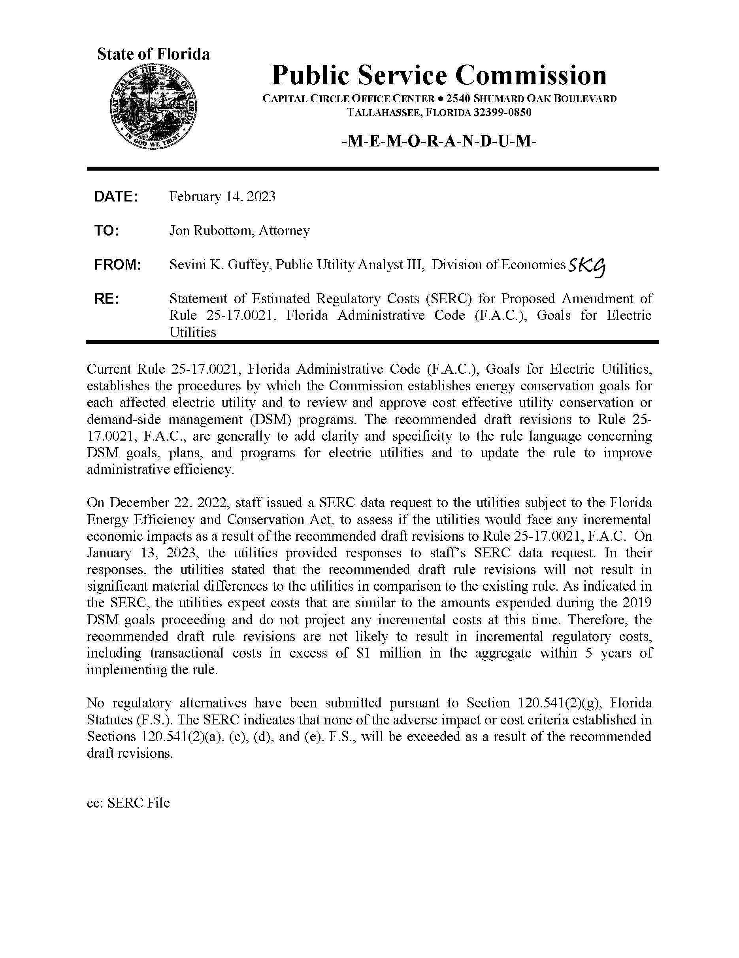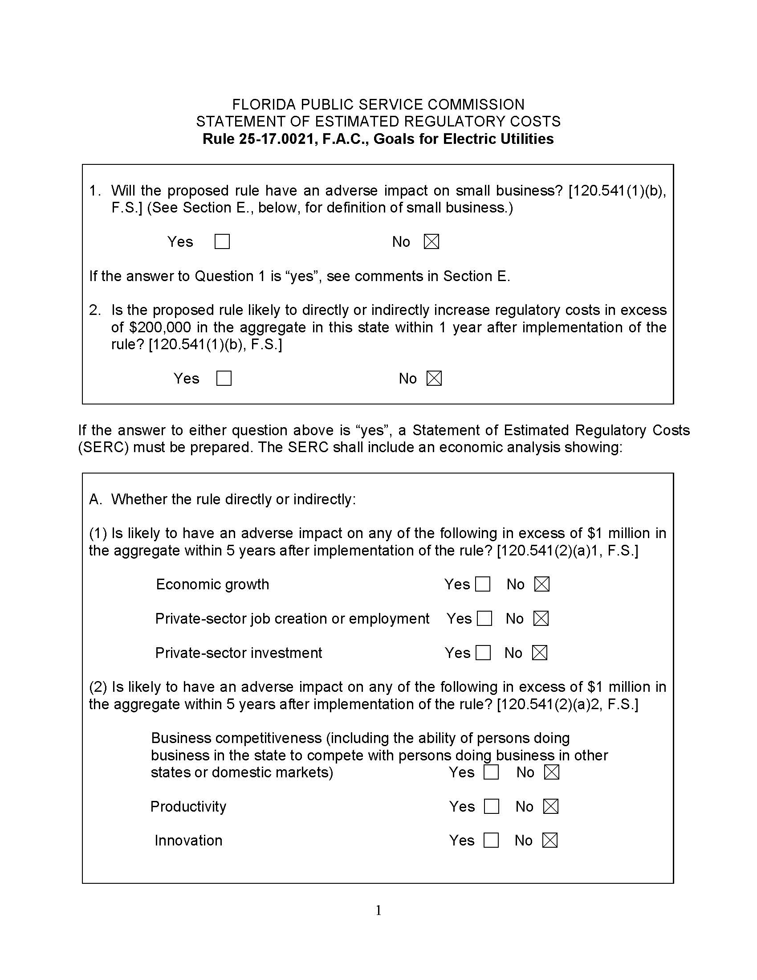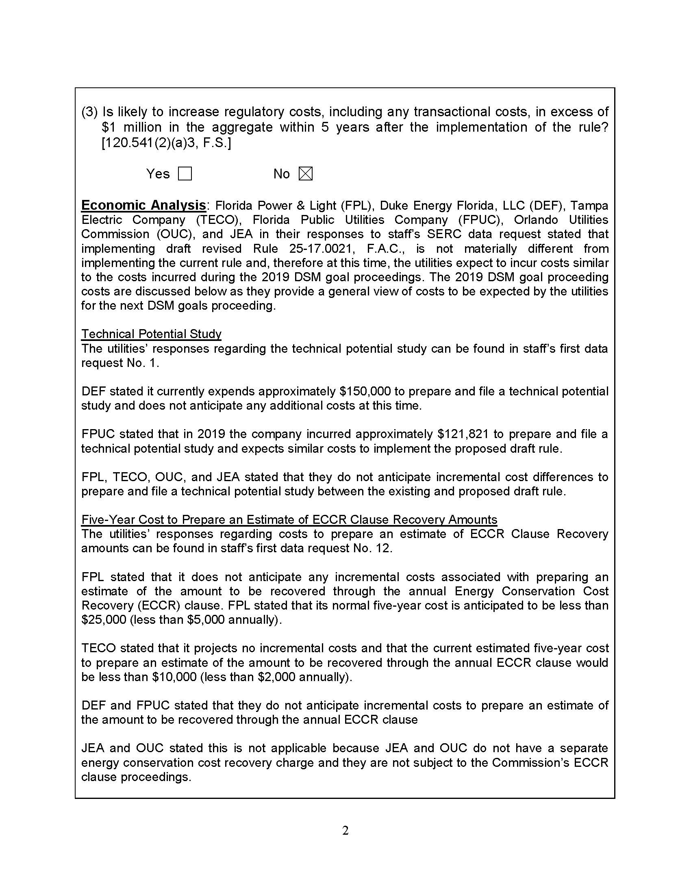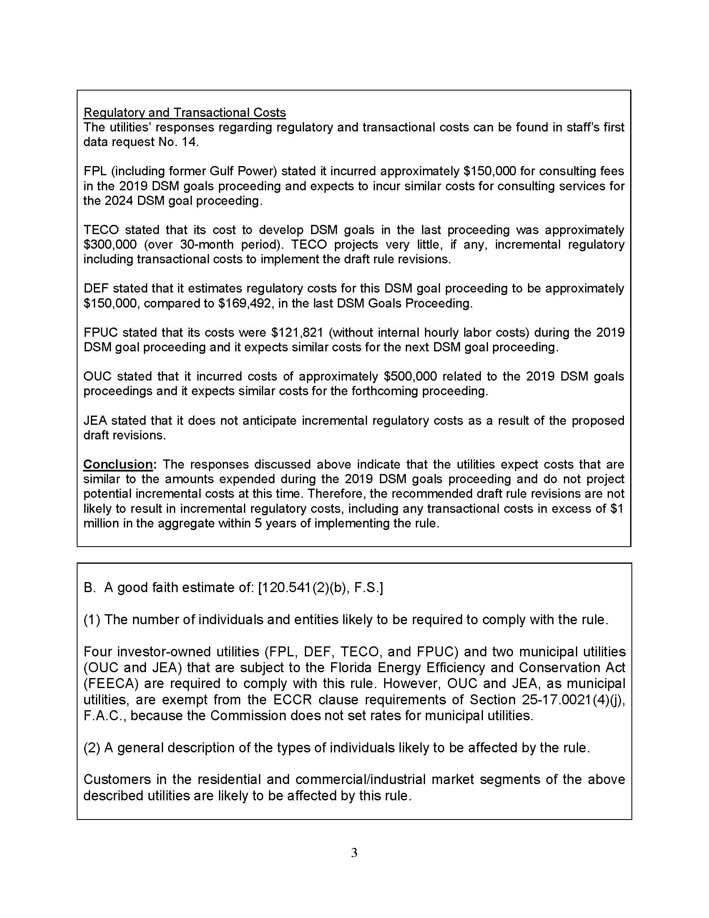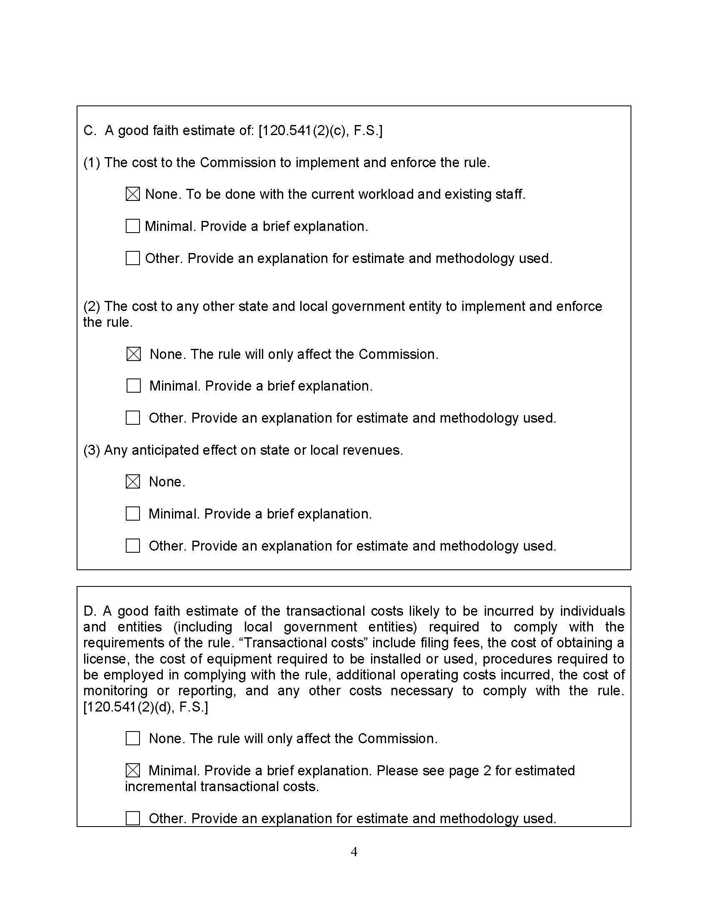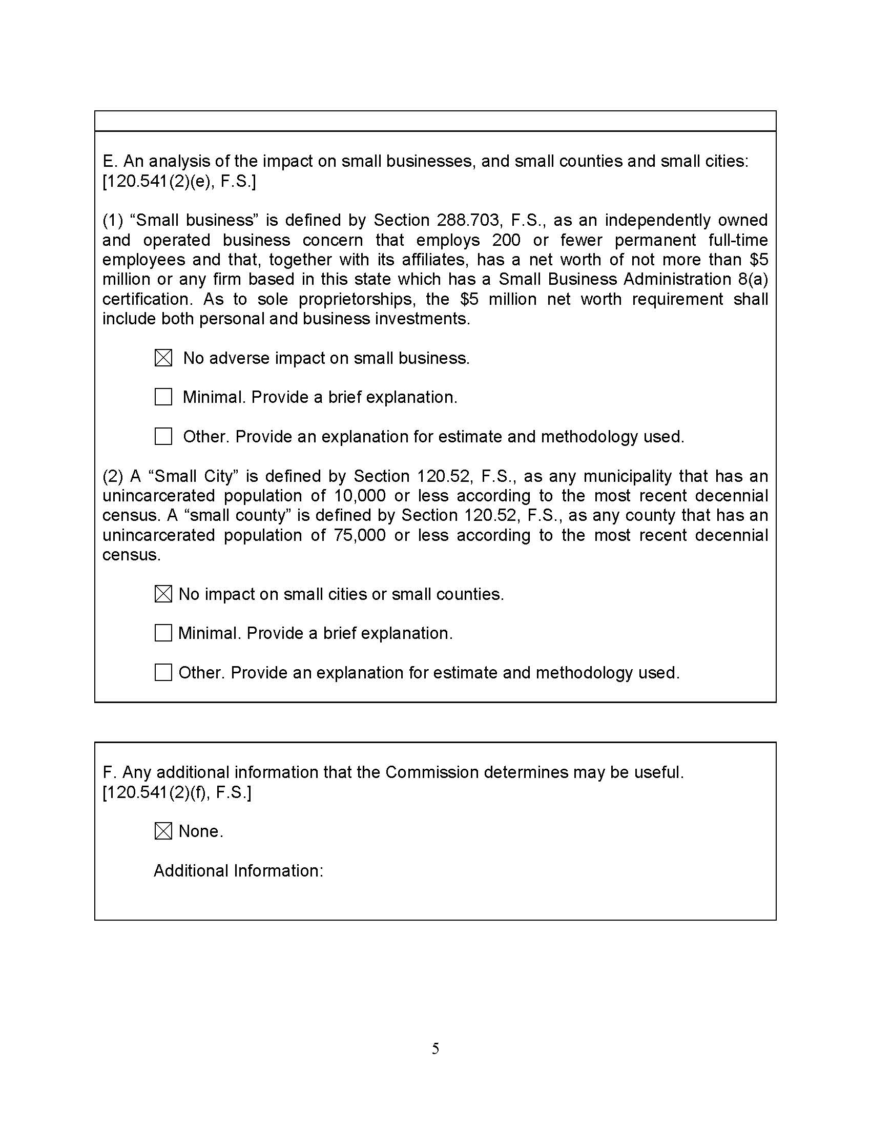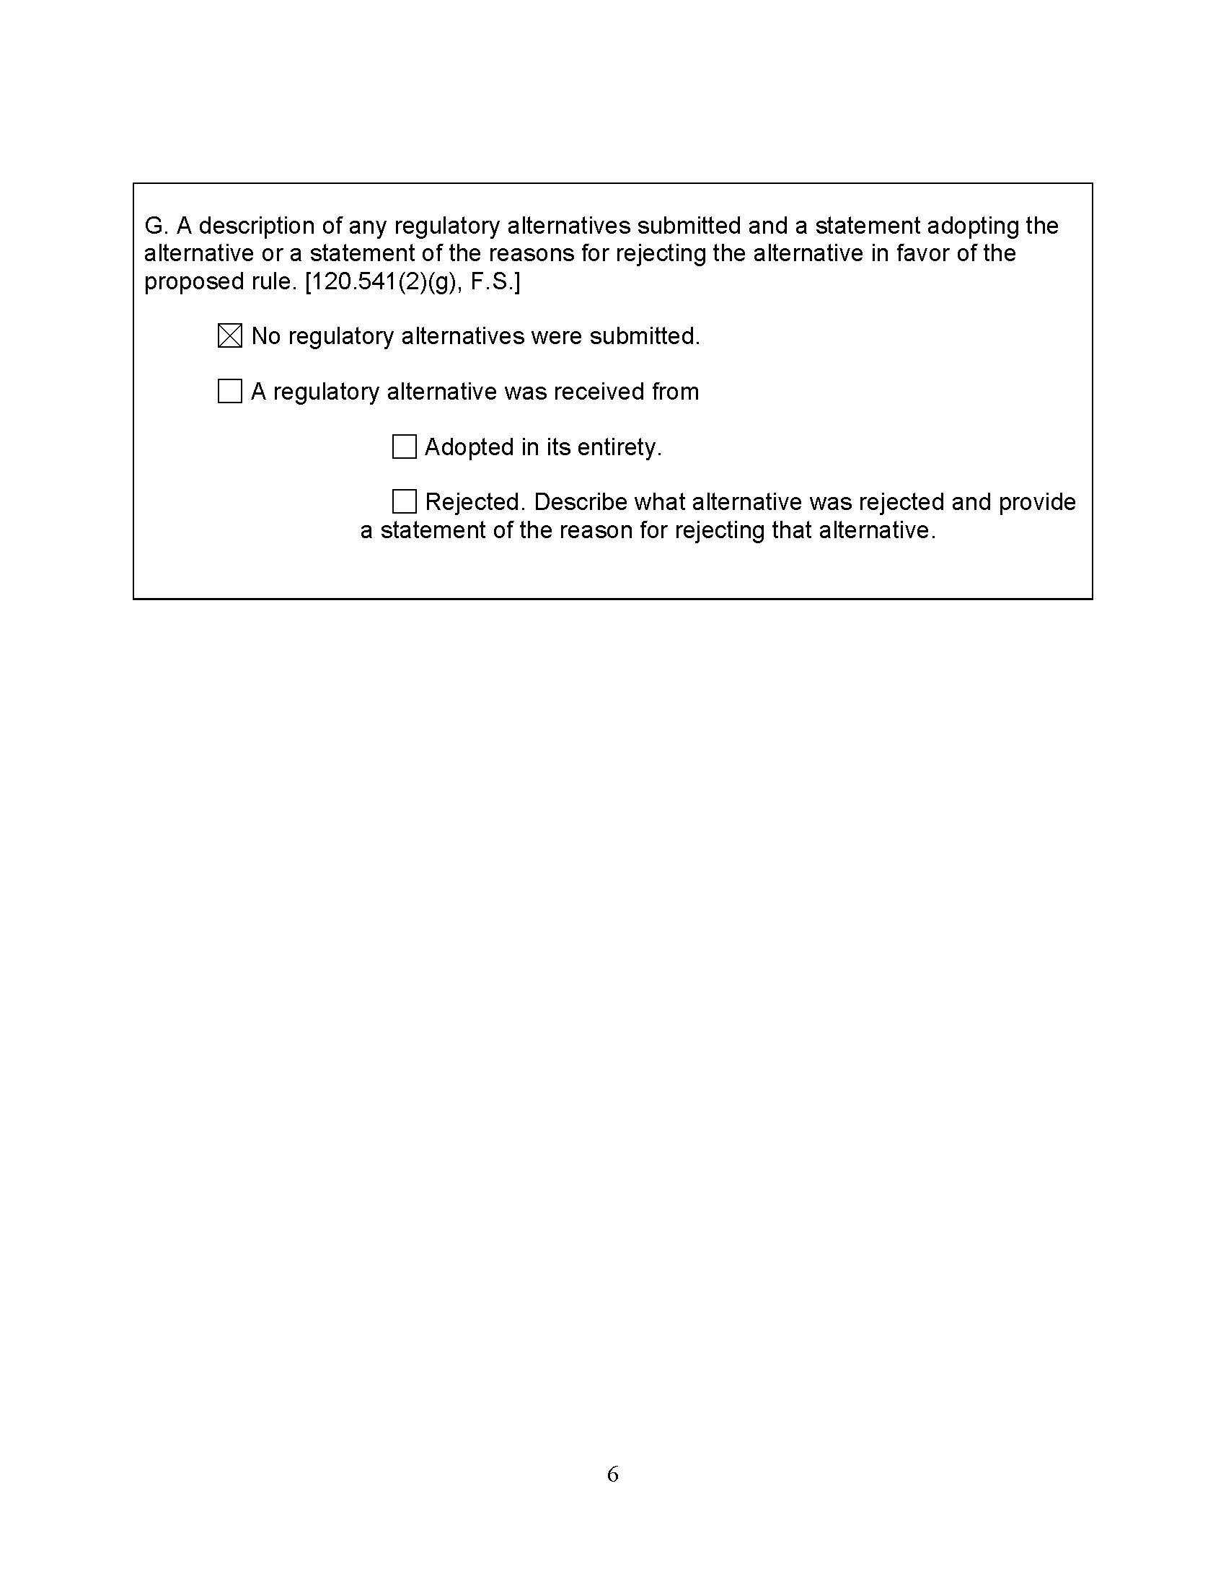

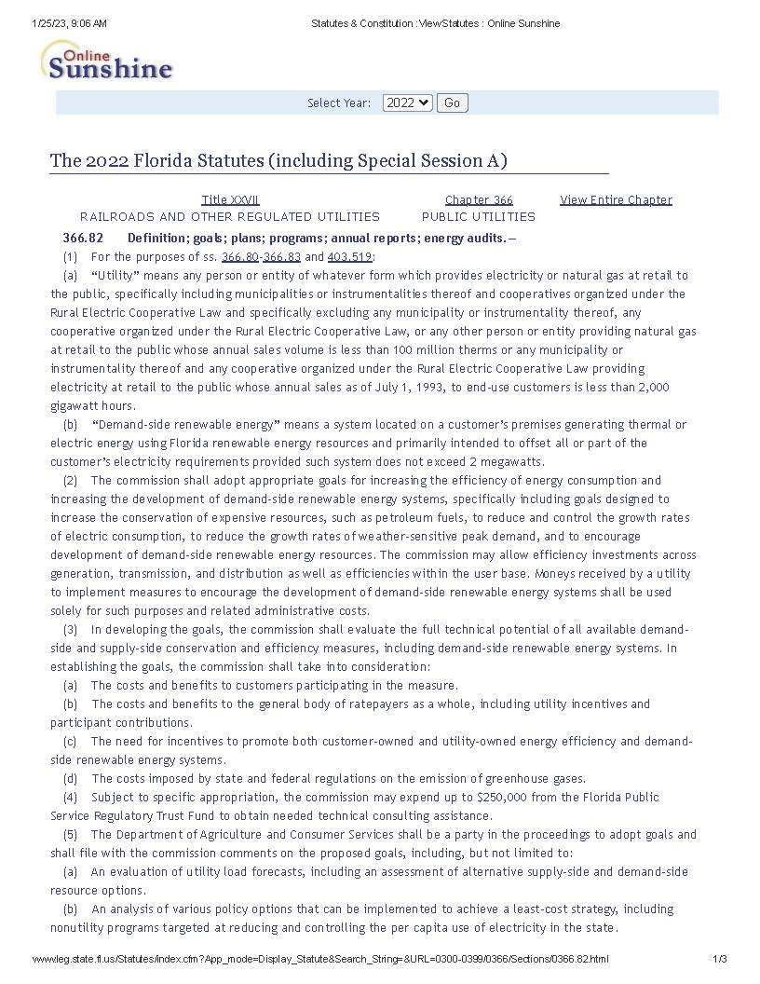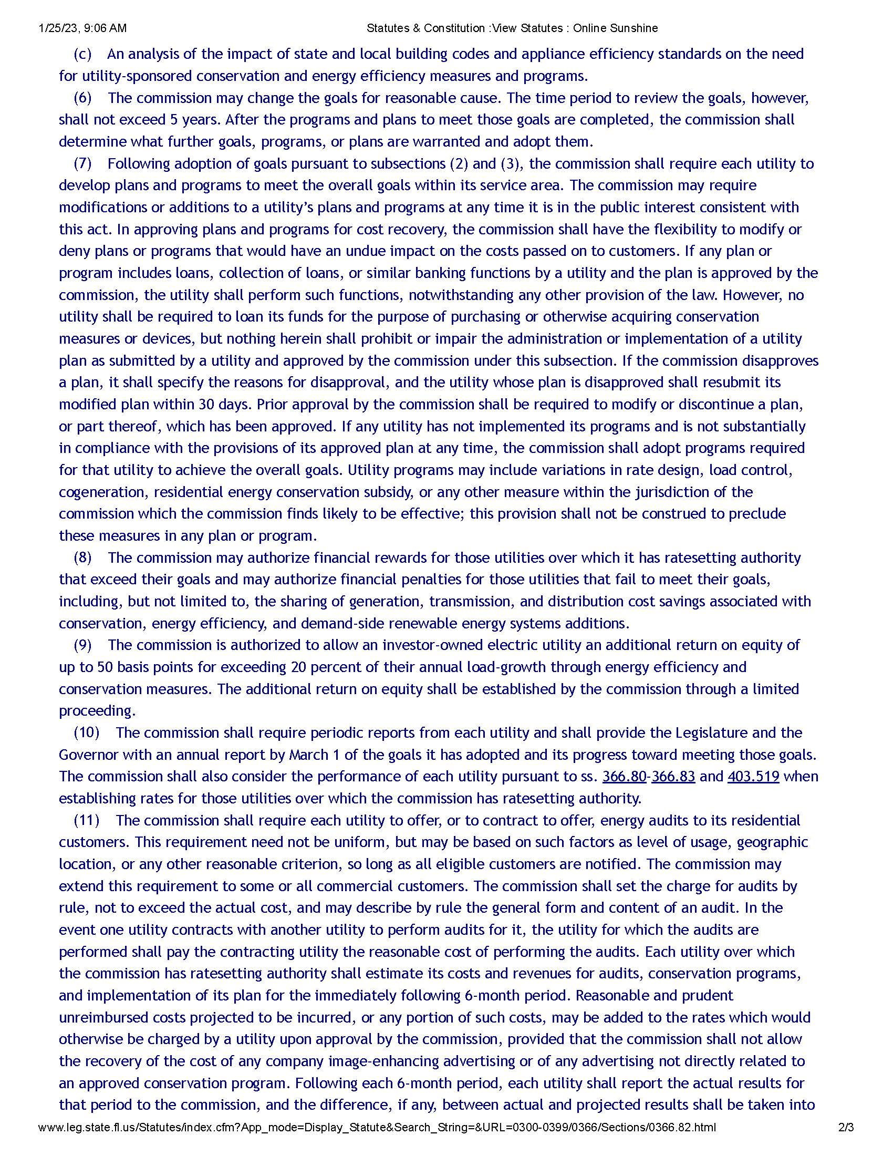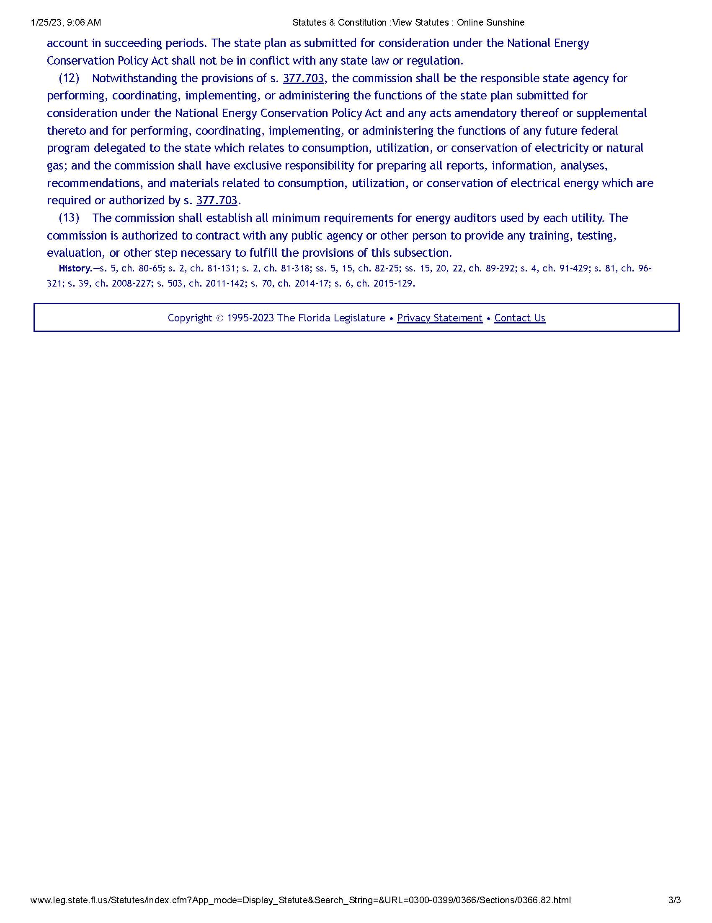

1. Order No. PSC-2019-0509-FOF-EG, *Final Order Approving Numeric Conservation Goals*,issued on November 26, 2019, in Docket Nos. 20190015-EG, 20190016-EG, 20190017-EG, 20190018-EG, 20190019-EG, 20190020-EG, 20190021-EG, *In re: Commission review of numeric conservation goals.*
2. *See* Docket Nos. 20200053-EG, 20200054-EG, 20200055-EG, 20200056-EG, 20200060-EG.
3. *See* Section 366.81, F.S.
4. *Id.*
5. Section 366.82(6), F.S.
6. Section 366.82(6), F.S.
7. Document No. 13530-2020.
8. Document No. 03755-2021.
9. Document No. 11025-2022.
10. As stated above, only Rule 25-17.0021, F.A.C., was included in the notice for rule development. Thus, comments pertaining to other rules or to matters outside the scope of this rule are not addressed in this recommendation.
11. Some stakeholders, including SACE, LULAC, ECOSWF, AEU, CLEO, Southface, and Vote Solar, contributed to the creation and filing of a consensus draft revision of the rule that summarized the proposals of a majority of commenters. Staff considered this consensus draft along with all other comments filed in the docket.
12. *See* Order No. PSC-14-0696-FOF-EU, *Final Order Approving Numeric Conservation Goals*, at p. 27,issued on December 16, 2014, in Docket Nos. 130199-EI, 130200-EI, 130201-EI, 130202-EI, 130203-EI, and 130204-EI, *In re: Commission review of numeric conservation goals.* (directing utilities to consider low-income customers using a “portfolio approach of information coupled with cost-effective incentives to address this market”).
13. For a detailed description of each cost-effectiveness test, see Rule 25-17.008, F.A.C., which incorporates the Commission’s Cost Effectiveness Manual for Demand Side Management Programs and Self Service Wheeling Proposals (Cost Effectiveness Manual).
14. Section 366.82(3)(b), (7), F.S.
15. Because only Rule 25-17.0021, F.A.C., was noticed for rule development, the potential amendment of other Commission rules is not the subject of this rulemaking and is not addressed in this recommendation.
16. It is significant to note that revenue gains resulting from a potential DSM measure are treated in the opposite way: in the Participants Test, it would be an increase in customer bills and therefore a cost, but in the RIM Test they would be a revenue increase and therefore a benefit to the utility. *See* Order No. 24745, *Notice of Adoption of Rule Amendment*,issued on July 7, 1991, in Docket No. 891324-EU, *In Re: Amendment of Rule 25-17.008, F.A.C., pertaining to Conservation and Self-Wheeling Cost Effectiveness Data Reporting Format*.
17. Rule 25-17.015, F.A.C. governs the Commission’s ECCR proceedings.
18. The use of a time-based payback screen has been recognized and approved by the Commission as far back as its 1994 goal-setting proceeding and used consistently since then. *See e.g.,* Order No. PSC-94-1313-FOF-EG, *Order Setting Conservation Goals*, issued on October 25, 1994, in Docket Nos. 930548-EG, 930549-EG, 930550-EG, and 930551-EG, *In Re: Adoption of Numeric Conservation Goals and Consideration of National Energy Policy Act Standards (Section 111).*; Order No. PSC-09-0855-FOF-EG, *Final Order Approving Numeric Conservation Goals*, issued on December 30, 2009, in Docket Nos. 080407-EG, 080408-EG, 080409-EG, 080410, EG, 080411-EG, and 080412-EG, *In re: Commission review of numeric conservation goals.*
19. *See, e.g.,* Order No. PSC-09-0855-FOF-EG, at pp. 8-9 (discussing the direct testimony of FPL witness Dean related to the rationale for a two-year payback screen).
20. *Id.* at 9-10. *See also* Order No. PSC-15-0323-PAA-EG, (stating that the use of a two-year payback screen at the goal-setting stage is “not so rigid as to prevent low-cost measures from being included in carefully crafted utility [DSM] programs”).