BEFORE THE FLORIDA PUBLIC SERVICE COMMISSION

|  |  |
| --- | --- |
| In re: Fuel and purchased power cost recovery clause with generating performance incentive factor. | DOCKET NO. 20230001-EI  ORDER NO. PSC-2023-0112-PCO-EI  ISSUED: March 24, 2023 |

The following Commissioners participated in the disposition of this matter:

ANDREW GILES FAY, Chairman

ART GRAHAM

GARY F. CLARK

MIKE LA ROSA

GABRIELLA PASSIDOMO

ORDER APPROVING DUKE ENERGY FLORIDA, LLC’S

MID-COURSE CORRECTION

BY THE COMMISSION:

BACKGROUND

On January 23, 2023, Duke Energy Florida, LLC (DEF or Company), filed for a mid-course correction of both its 2023 fuel and capacity cost recovery factors.[1] This petition was amended on February 27, 2023 (MCC Petition).[2] DEF’s currently-effective 2023 fuel and capacity factors were approved last year at the November 17-18, and December 6, 2022 final hearing.[3] Underlying the approval of DEF’s 2023 factors was our review of the Company’s projected 2023 fuel- and capacity-related costs. These costs are recovered through fuel and capacity cost recovery factors that are set/reset annually in this docket. However, during the 2022 annual fuel clause cycle, DEF proposed not to include the majority of its unrecovered 2022 fuel costs in the fuel factors approved at the December 6th final hearing. Instead, DEF indicated it would be petitioning for recovery of those costs through a separate filing. The primary rationale for this course of action was that the extreme volatility of natural gas prices in 2022 had made a reliable projection of final 2022 costs impractical. We subsequently ordered DEF’s filing to be submitted on or before January 23, 2023.[4]

Mid-Course Corrections

We use mid-course corrections between annual clause hearings whenever costs deviate from revenue by a significant margin. Under Rule 25-6.0424, Florida Administrative Code (F.A.C.), which is commonly referred to as the “mid-course correction rule,” a utility must notify us whenever it expects to experience an under- or over-recovery of certain service costs greater than 10 percent. The notification of a 10 percent cost-to-revenue variance shall include a petition for mid-course correction to the fuel cost recovery or capacity cost recovery factors, or shall include an explanation of why a mid-course correction is not practical.

DEF’s Petition for Mid-Course Correction

Through its MCC Petition, DEF is proposing a mid-course correction of its 2023 fuel and capacity charges. Specifically, we are being asked to approve increases to DEF’s fuel cost recovery factors to incorporate its currently-projected 2023 end-of-year fuel cost under-recovery in the amount of approximately $469 million. With respect to capacity costs, the Company is proposing to incorporate into rates the 2022 tax-savings effect of the Inflation Reduction Act (IRA) of 2022 in the amount of approximately $11.7 million.[5]

The Company is requesting that its revised fuel and capacity factors and associated tariff sheet No. 6.105 become effective beginning with the first billing cycle of April 2023. Also included in the Company’s proposed tariff are the (proposed) rate adjustments related to its recovery of storm restoration (to include reserve replenishment) costs related to Hurricanes: Elsa, Eta, Ian, Isaias, and Nicole, and Tropical Storm Fred, as petitioned for in Docket No. 20230020-EI.[6] However, while the rate adjustments are addressed on proposed tariff sheets No. 6.105 and No. 6.106 in Appendix A to this order, neither the Interim Storm Charge nor its associated rates are at issue in this proceeding.

We are vested with jurisdiction over the subject matter of this proceeding by the provisions of Chapter 366, Florida Statutes (F.S.), including Sections 366.04, 366.05, and 366.06, F.S.

DECISION

DEF participated in our most-recent fuel hearing which took place during November 17-18, 2022, and December 6, 2022. The fuel order stemming from that proceeding set the Company’s fuel and capacity cost recovery factors effective with the first billing cycle of January 2023.[7] However, as discussed below, the currently-authorized fuel cost recovery factors do not include certain deferred fuel costs that were primarily incurred in 2022. In support of the deferral, DEF argued that the 2022 natural gas market was so volatile that its total annual fuel (natural gas) cost could not be accurately predicted and that it was better to wait and use actual costs for setting rates with respect to the 2022 under-recovery. Some factors that influenced natural gas prices in 2022 include reduced storage levels, strong liquefied natural gas exports, global military conflict, and capital/expenditure discipline being practiced by drilling companies.

DEF Fuel and Purchased Power Mid-Course Correction

DEF filed for a mid-course correction of its fuel and capacity charges on January 23, 2023.[8] This filing was amended on February 27, 2023.[9] The Company’s amended petition and supporting documentation satisfy the filing requirements of Rule 25-6.0424(1)(b), F.A.C. In accordance with the noticing requirement of Rule 25-6.0424(2), F.A.C., DEF filed a letter on March 29, 2022, informing usthat it was projecting an under-recovery position of greater than 10 percent for the recovery period ending on December 31, 2022.[10] However, in analyzing settlement prices for natural gas, the Company determined that the continuing price volatility warranted deferring a decision to file for a mid-course correction.

The Company developed its proposed mid-course correction factors using twelve months of forecasted sales data (April 2023 through March 2024). However, the factors proposed in this proceeding are currently contemplated to be charged for 9 months in 2023. As is typical procedure, later this year newly developed 12-month-applicable factors will be proposed for authorization to begin with the first billing cycle of January 2024.

DEF Capacity Mid-Course Correction

DEF filed for a mid-course adjustment of its capacity charges along with its fuel mid-course correction. DEF’s capacity proposal is not being driven by a cost recovery position outside the absolute value of 10 percent as calculated using the methodology prescribed in Rule 25-6.0424(1)(a), F.A.C. The purpose of this proposed change is to expeditiously return to customers the benefit of the 2022 tax savings produced by the IRA. The estimated 2022 tax benefit is $11,668,131, and constitutes the amount by which DEF proposes to reduce 2023 capacity costs. DEF proposes to refund this amount over a 9-month period from April through December 2023. We find that this treatment of the 2022 IRA tax savings is appropriate and hereby approve it.

Actual Period-Ending 2022 Fuel Cost Recovery Position

DEF’s actual fuel cost recovery position at the end of 2022 is an under-recovery of ($1,354,975,755), of which $175,789,361 has been previously incorporated into 2023 rates.[11] This $175,789,361 amount consists of the second half, or $123,418,788, associated with the “Rate Mitigation Agreement” between DEF and the Office of Public Counsel, the Florida Industrial Power Users Group, the Florida Retail Federation, Nucor Steel Florida, Inc., the Southern Alliance for Clean Energy, and White Springs Agricultural Chemicals, Inc. d/b/a PCS Phosphate.[12] The first half of the Rate Mitigation Agreement amount was collected in 2022. The remainder, in the amount of $52,370,573, represents the carry forward from DEF’s 2022 mid-course correction proceeding.[13]

Increased pricing for natural gas was the primary driver of the 2022 under-recovery. More specifically, the Company estimated an annual natural gas cost of $5.20 per million British thermal unit (MMBtu) in its last mid-course correction filing and derivation of 2022 customer fuel rates.[14] This figure includes delivery costs. However, as indicated in the Company’s December 2022 A-Schedule, DEF’s average 2022 cost of natural gas was $8.50 per MMBtu, representing a difference of 63.5 percent.[15] Natural gas-fired generation comprised approximately 85.7 percent of DEF’s generation mix in 2022.[16]

Projected 2023 Fuel Cost Recovery Position

DEF’s 2023 fuel-related revenue requirement has decreased substantially since the filing of its last cost projection in September 2022.[17] More specifically, in DEF’s updated projection DEF’s estimated 2023 fuel-related costs are reduced by $710,224,788. Thus, taking into account the net carry forward from 2022, the proposed incremental amount for inclusion in rates is ($468,961,606).

The primary factor driving the change in projected 2023 fuel costs is lower assumed pricing for natural gas. More specifically, the underlying market-based natural gas price data used for the original 2023 fuel cost projection was sourced on June 13, 2022.[18] This data was used to produce an estimated average 2023 delivered natural gas cost of $8.07 per MMBtu.[19] However, as indicated in its MCC Petition, DEF now estimates its average cost of natural gas in 2023 will be $4.76 per MMBtu, representing a decrease of 41.0 percent.[20] The updated cost estimate was based on natural gas futures/prices sourced on February 14, 2023, or roughly eight months later than the previous estimate used to set current rates.[21]

Recovery Period and Interest Premium

As proposed, DEF’s recovery period for its 2022 under-recovery of fuel costs is over 12 months of sales (beginning April 2023 and ending March 2024).[22] DEF utilized the 30-day AA Financial Commercial Paper Rate to determine its 2022 interest amount.[23] The projected 2023 monthly interest rate was estimated for all months by using the January 2023 average of the 30-day AA Financial Commercial Paper Rate of 0.374 percent.[24]

Mid-Course Correction Percentage

Following the methodology prescribed in Rule 25-6.0424(1)(a), F.A.C., the mid-course percentage is equal to the estimated end-of-period total net true-up, including interest, divided by the current period’s total actual and estimated jurisdictional fuel revenue applicable to period, or ($468,961,606) / $2,281,046,501.[25] This calculation results in a mid-course correction level of (20.6) percent at December 31, 2023.

Fuel Factor

DEF’s currently-approved annual levelized fuel factor beginning with the first January 2023 billing cycle is 6.257 cents per kilowatt-hour (kWh).[26] The Company is requesting to increase its currently-approved 2023 annual levelized fuel factor beginning April 2023 to 7.445 cents per kWh, or by 19.0 percent.[27]

Bill Impacts

Table 1 below shows the bill impact on a typical residential customer using 1,000 kWh of electricity a month associated with the current and proposed service charges. This table also includes the storm-related cost recovery proposal that, if approved, would begin in April 2023.[28]

| Table 1 | | | | |
| --- | --- | --- | --- | --- |
| Monthly Residential Billing Detail for the First 1,000 kWh | | | | |
| **Invoice Component** | **Currently-Approved Charges Beginning March 2023**  **($)** | **Proposed Charges**  **Beginning**  **April**  **2023**  **($)** | **Difference**  **($)** | **Difference**  **(%)** |
| Base Charge[29] | $78.82 | $78.82 | $0.00 | 0.0% |
| Fuel Charge | 59.61 | 71.27 | 11.66 | 19.6% |
| Capacity Charge | 13.28 | 12.85 | (0.43) | (3.2%) |
| Conservation Charge | 3.20 | 3.20 | 0.00 | 0.0% |
| Environmental Charge | 0.22 | 0.22 | 0.00 | 0.0% |
| Storm Protection Plan Charge | 4.14 | 4.14 | 0.00 | 0.0% |
| Interim Storm Charge[30] | 0.00 | 13.14 | 13.14 | 100.0% |
| Asset Securitization Charge | 2.03 | 2.03 | 0.00 | 0.0% |
| Gross Receipts Tax | 4.25 | 4.89 | 0.64 | 15.1% |
| **Total** | $165.55 | $190.56 | $25.01 | 15.1% |

Source: MCC Petition, Schedule E-10, and FPSC Division of Economics.

DEF’s current total residential bill for the first 1,000 kWh of electricity usage in March of 2023 is $165.55. If DEF’s mid-course correction proposal is approved, the current total residential bill for the first 1,000 kWh of electricity usage, beginning April 2023, will be $190.56. This amount includes the proposed interim storm charge as filed in Docket No. 20230020-EI. This represents an increase of 15.1 percent. For non-residential customers, DEF reported that based on average levels of usage and specific rate schedules, bill increases for small- and medium-size commercial customers would be 15.0 percent and 15.5 percent, respectively. Bill increases for large-size commercial customers would be 16.6 percent, and 17.7 percent for industrial customers.[31]

21 Month Recovery

At our direction, the effect on monthly bills of lengthening the proposed recovery period from 12 to 21 months has also been calculated. The total base/unrecovered 2022 fuel cost is the same under the 21-month scenario as DEF’s proposed 12 month recovery scenario. However, lengthening the time period over which the 2022 fuel cost under-recovery is recovered by the Company lowers the monthly fuel charge but results in increased carrying costs.

Table 2 below shows the bill impact on a typical residential customer using 1,000 kWh of electricity a month associated with this optional recovery scenario.

| Table 2 | | | | |
| --- | --- | --- | --- | --- |
| 21 Month Recovery Residential Billing Detail for the First 1,000 kWh | | | | |
| **Invoice Component** | **Currently-Approved Charges Beginning March 2023**  **($)** | **21 Month Charges**  **Beginning**  **April**  **2023**  **($)** | **Difference**  **($)** | **Difference**  **(%)** |
| Base Charge[32] | $78.82 | $78.82 | $0.00 | 0.0% |
| Fuel Charge | 59.61 | 53.02 | (6.59) | (11.1%) |
| Capacity Charge | 13.28 | 12.85 | (0.43) | (3.2%) |
| Conservation Charge | 3.20 | 3.20 | 0.00 | 0.0% |
| Environmental Charge | 0.22 | 0.22 | 0.00 | 0.0% |
| Storm Protection Plan Charge | 4.14 | 4.14 | 0.00 | 0.0% |
| Interim Storm Charge[33] | 0.00 | 13.14 | 13.14 | 100.0% |
| Asset Securitization Charge | 2.03 | 2.03 | 0.00 | 0.0% |
| Gross Receipts Tax | 4.25 | 4.41 | 0.16 | 3.8% |
| **Total** | $165.55 | $171.83 | $6.28 | 3.8% |

Source: Document No. 01387-2023, Schedule E-10.

DEF’s proposed fuel charge increase results in a “first-tier residential” fuel charge, (i.e., residential charge for the first 1,000 kWh of energy sales) of 7.127 cents per kWh. This factor produces a corresponding monthly fuel charge of $71.27. With respect to the optional recovery scenario, the first-tier residential factor would be 5.302 cents per kWh.[34] This would result in a fuel charge of $53.02 for the first 1,000 kWh of energy usage. The estimated decrease in the monthly first-tier residential fuel charge (1,000 kWh) under this scenario is approximately ($6.59), or a (11.1) percent decrease from the currently-approved level, going from $59.61 to $53.02. The difference in total bill amount (first-tier residential - 1,000 kWh), which encompasses all proposed changes beginning in April 2023, is from $190.56 to $171.83, or a reduction of (9.8) percent if the fuel cost under-recovery is spread over 21 months, rather than the proposed 12 months. The proposed capacity cost recovery reduction would be unaffected by the optional 21 month recovery scenario.

For non-residential customers, based on average levels of usage and specific rate schedules, bill increases for small- and medium-size commercial customers would be 3.9 percent and 2.0 percent, respectively, bill increases for large-size commercial customers would be 2.3 percent, and (2.5) percent for industrial customers.[35] The tariff associated with the 21 month recovery scenario is found in Appendix A to this order.

DEF has requested that its 2022 fuel cost under-recovery and 2023 projected fuel costs be spread over 12 months effective beginning the first billing cycle of April 2023. This would impose an increase of $11.66 in the fuel cost recovery factor on the monthly bill of a residential customer using 1,000 kWh as shown in Table 1. Using a 21 month recovery period for 2022 fuel cost under-recovery and 2023 projected fuel costs would impose a decrease of $6.59 on the monthly bill of the same residential customer using 1,000 kWh as shown in Table 2.

It is true, as DEF argues, that the recovery over a 12 month time period will decrease the carrying costs paid by current customers on the net fuel cost under-recovery of $468,961,606. It is also true that if natural gas prices continue to decline in 2023, resulting in a greater 2023 factor over-recovery than currently projected, the 2024 fuel factor will be reduced by that amount. However, we cannot ignore the fact that ratepayers are facing the highest interest rates, food prices, and gas prices in a decade at this time. In this environment, we find that extending the recovery time period to 21 months and lowering the impact fuel costs have on customers’ bills is appropriate and results in fuel cost recovery rates that are fair, just, and reasonable.

For the reasons stated above, we find that DEF’s current fuel cost recovery factors shall be adjusted by $468,961,606 to incorporate its currently-projected 2023 end-of-year fuel cost under-recovery spread over a 21 month recovery period. Additionally, DEF’s currently-approved capacity cost recovery factors shall be amended to incorporate a refund of ($11,668,131) related to the tax savings associated with the IRA of 2022 recovered over a 9 month period. The revised fuel and capacity cost recovery factors associated with our decision to use a 21 month recovery period are found in Appendix A to this order.

Effective date

Over the last 20 years in the Fuel Clause docket, we have considered the effective date of rates and charges of revised fuel cost recovery factors on a case-by-case basis. We have approved fuel cost recovery factor rate decreases effective sooner than the next full billing cycle after the date of our vote with the range between the vote and the effective date being from 25 to 2 days. The rationale for that action being that it was in the customers’ best interests to implement the lower rate as soon as possible.[36]

With regard to fuel cost recovery factor rate increases, we have approved an effective date of the revised factors ranging from 14 to 29 days after the vote.[37] In those cases typically the utility had given its customers 30 days’ written notice before the date of the vote that a fuel cost recovery factor increase had been requested and provided the proposed effective date of the higher fuel factors.

In its MCC Petition, DEF proposes to collect the actual 2022 under-recovery of fuel costs over 12 months, beginning with the first billing cycle of April 2023. The capacity cost reduction (2022 tax reduction) will occur over 9 months, or from April through December, 2023. In the instant case, there are 25 days between our vote on March 7th and the beginning of DEF’s April 2023 billing cycle (April 1st).[38]

Concerning customer advisement of the instant request, DEF states that it will notify its customers of the proposed rate changes through bill inserts included with its March 2023 invoices. Additionally, on January 23, 2023, the same day DEF filed its original petition for mid-course correction, the Company posted a “press release” to its website, while also issuing the information to various media outlets describing the proposal.[39] An additional email will also be sent to large-account customers.

For these reasons, we find that the fuel and capacity cost recovery factors, as shown on sheet No. 6.105 in Appendix A, shall become effective with the first billing cycle of April 2023.

Therefore, it is

ORDERED by the Florida Public Service Commission that adjustments to Duke Energy Florida, LLC’s currently approved fuel cost recovery factors to incorporate the currently-projected 2023 end-of-year fuel cost under-recovery in the amount of $468,961,606 spread over a 21 month recovery period is hereby approved. It is further

ORDERED that adjustments to Duke Energy Florida, LLC’s currently-approved capacity cost recovery factors to incorporate a refund of ($11,668,131) related to the tax savings associated with the IRA of 2022 is hereby approved. It is further

ORDERED that Staff shall have administrative authority to review and approve tariff changes consistent with our decision in this matter. It is further

ORDERED that the fuel and capacity cost recovery factors and tariffs, as shown on Appendix A of this order, shall become effective with the first billing cycle of April 2023. It is further

ORDERED that the fuel and purchased power cost recovery clause docket is an on-going proceeding and shall remain open.

By ORDER of the Florida Public Service Commission this 24th day of March, 2023.

|  |  |
| --- | --- |
|  | /s/ Adam J. Teitzman |
|  | ADAM J. TEITZMAN  Commission Clerk |

Florida Public Service Commission

2540 Shumard Oak Boulevard

Tallahassee, Florida 32399

(850) 413‑6770

www.floridapsc.com

Copies furnished: A copy of this document is provided to the parties of record at the time of issuance and, if applicable, interested persons.

SBr

NOTICE OF FURTHER PROCEEDINGS OR JUDICIAL REVIEW

The Florida Public Service Commission is required by Section 120.569(1), Florida Statutes, to notify parties of any administrative hearing or judicial review of Commission orders that is available under Sections 120.57 or 120.68, Florida Statutes, as well as the procedures and time limits that apply. This notice should not be construed to mean all requests for an administrative hearing or judicial review will be granted or result in the relief sought.

Mediation may be available on a case-by-case basis. If mediation is conducted, it does not affect a substantially interested person's right to a hearing.

Any party adversely affected by this order, which is preliminary, procedural or intermediate in nature, may request: (1) reconsideration within 10 days pursuant to Rule 25-22.0376, Florida Administrative Code; or (2) judicial review by the Florida Supreme Court, in the case of an electric, gas or telephone utility, or the First District Court of Appeal, in the case of a water or wastewater utility. A motion for reconsideration shall be filed with the Office of Commission Clerk, in the form prescribed by Rule 25-22.0376, Florida Administrative Code. Judicial review of a preliminary, procedural or intermediate ruling or order is available if review of the final action will not provide an adequate remedy. Such review may be requested from the appropriate court, as described above, pursuant to Rule 9.100, Florida Rules of Appellate Procedure.

APPENDIX A

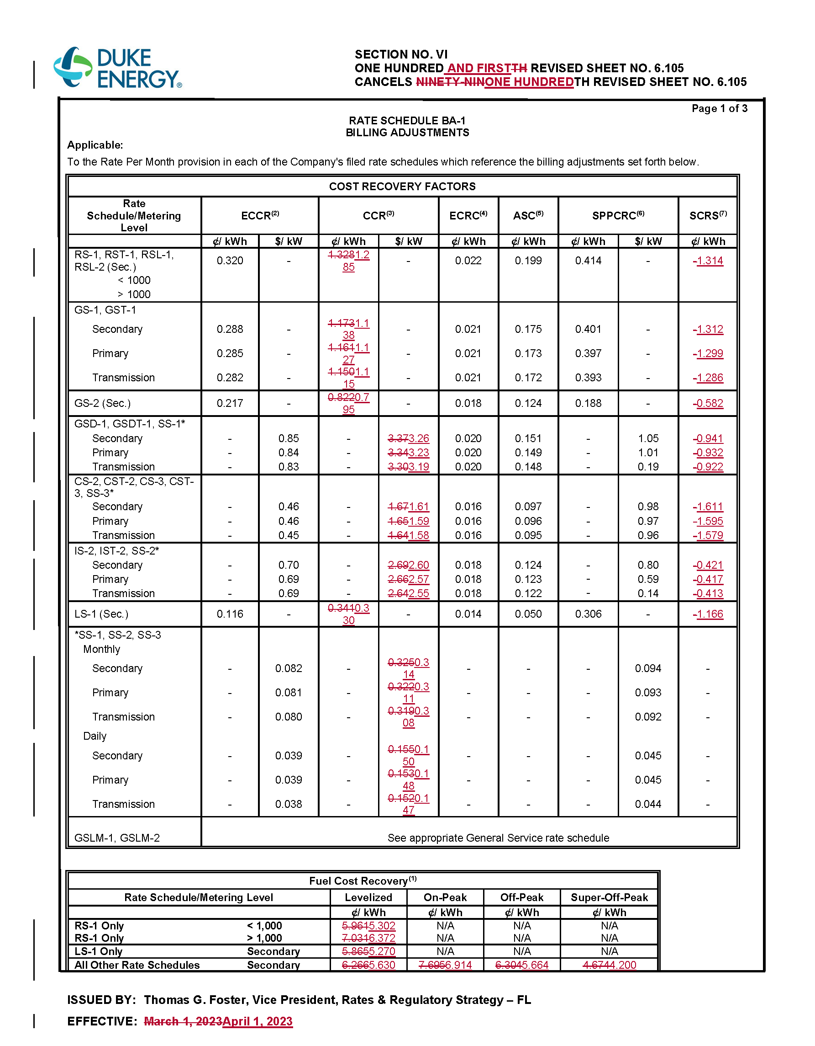

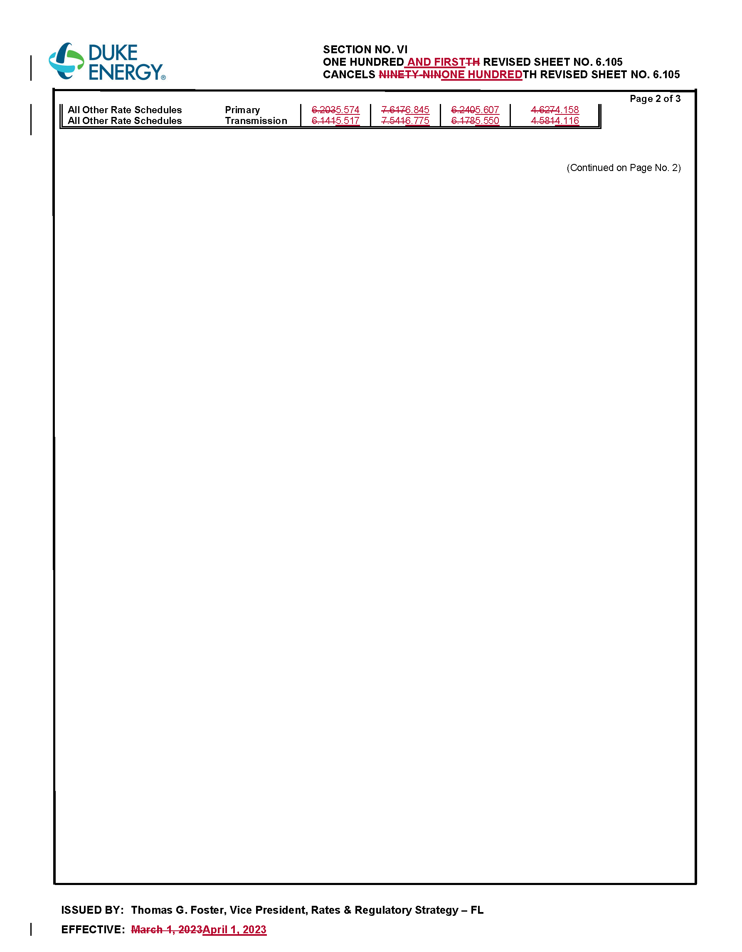

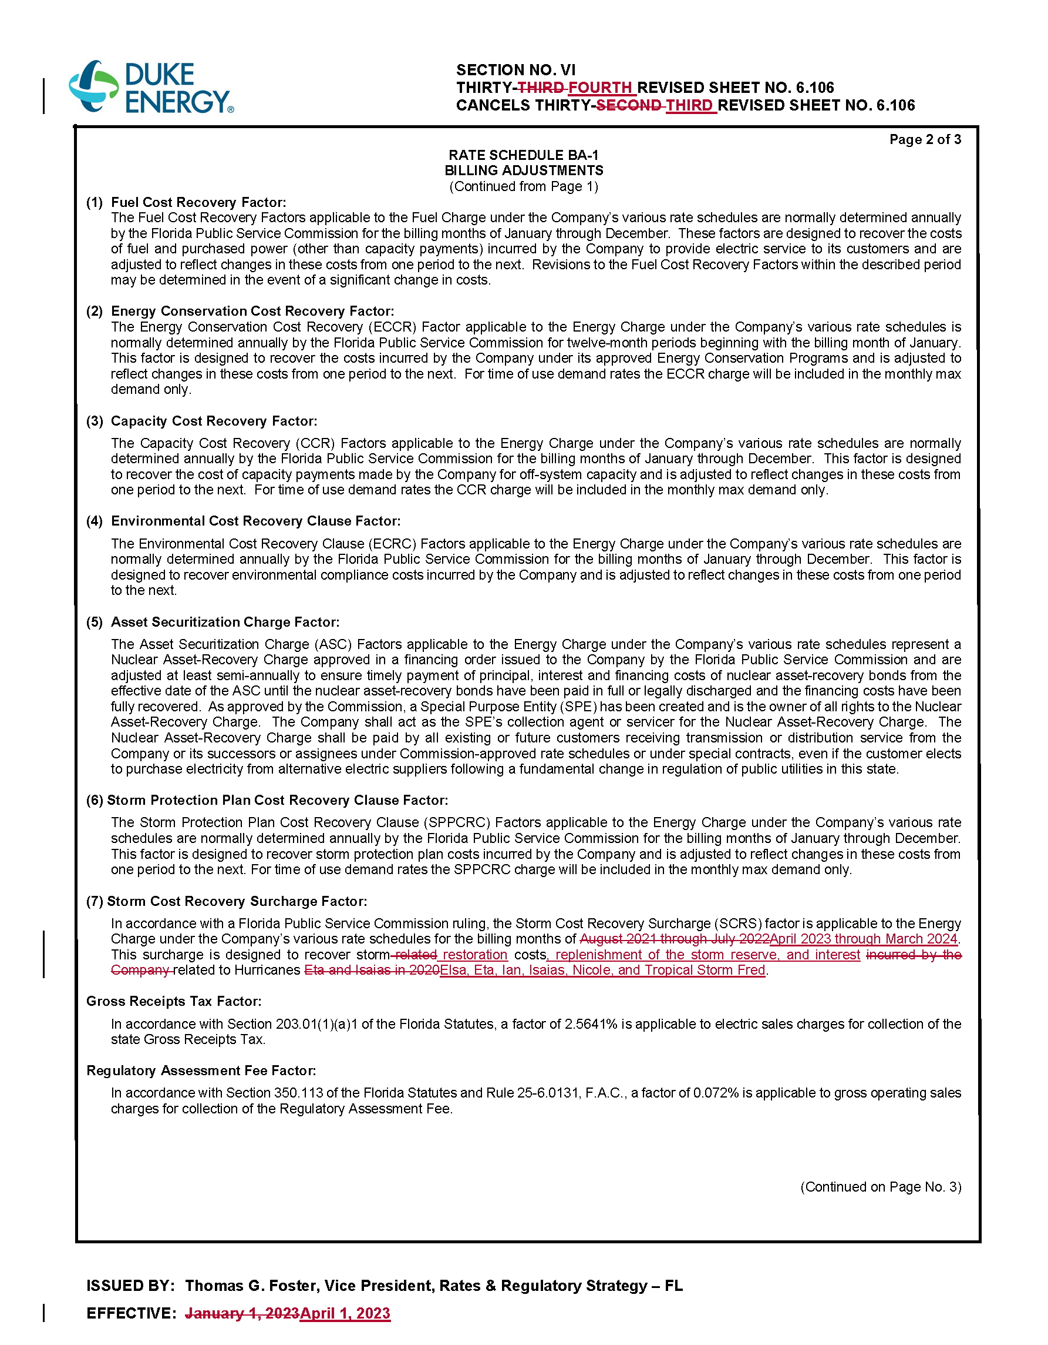

1. Document No. 00417-2023.
2. Document No. 01366-2023.
3. Order No. PSC-2023-0026-FOF-EI, issued January 6, 2023, in Docket No. 20230001-EI, *In re: Fuel and purchased power cost recovery clause with generating performance incentive factor*.
4. Order No. PSC-2023-0026-FOF-EI.
5. Retroactively effective to January 1, 2022, the IRA expanded federal income tax benefits for renewable energy by allowing owners of solar projects which begin construction before 2025 the option to elect to receive Production Tax Credits rather than Investment Tax Credits for eligible facilities. The tax savings noted through-out this order were produced by the Company electing to record Production Tax Credits rather than Investment Tax Credits for eligible facilities.
6. See Document No. 00418-2023 for further information regarding DEF’s Interim Storm Charge request.
7. Order No. PSC-2023-0026-FOF-EI.
8. Document No. 00417-2023.
9. Document No. 01366-2023.
10. Document No. 02134-2022.
11. Order No. PSC-2023-0026-FOF-EI.
12. See Document No. 10082-2021, filed in Docket No. 20210001-EI, *In re: Fuel and purchased power cost recovery clause with generating performance incentive factor*, Docket No. 20210097-EI, *In re: Petition for Limited Proceeding for Recovery of Incremental Storm Restoration Costs Related to Hurricane Eta and Isaias, by Duke Energy Florida, LLC*, and Docket No. 20210010-EI, *In re: Storm Protection Plan Cost Recovery Clause*. This motion was ultimately adjudicated in Docket No. 20210158-EI.
13. Order No. PSC-2022-0061-PCO-EI, issued February 17, 2022, in Docket No. 20220001-EI, *In re: Fuel and purchased power cost recovery clause with generating performance incentive factor*.
14. Document No. 13092-2021.
15. Document No. 00282-2023.
16. *Id*.
17. Document No. 05978-2022.
18. Document No. 01366-2023.
19. Document No. 05978-2022.
20. Document No. 01366-2023.
21. *Id*.
22. Document No. 01366-2023.
23. Document No. 00864-2023.
24. Document Nos. 00864-2023 and 01368-2023, and The Federal Reserve System (U.S. Federal Reserve) published Commercial Paper Rates which can be located via the following link: <https://www.federalreserve.gov/releases/cp/>
25. The estimated end-of-period total net true-up, or the mid-course correction amount being sought for recovery in this proceeding, consists of the 2022 under-recovery of ($1,354,975,755), the Rate Mitigation Plan amount for 2023 of $123,418,788, the 2022 mid-course correction carry forward amount of $52,370,573, and the change in projected 2023 fuel-related costs of $710,224,788, for a total of ($468,961,606).
26. Order No. PSC-2023-0026-FOF-EI.
27. Document No. 01366-2023.
28. Document No. 00418-2023.
29. DEF’s 2023 base rates for December 2022 – February 2023 is $89.39; for March 2023 – November 2023 is $78.82. The weighted average is equal to: (($89.39 * 3) + (78.82 * 9)) / 12 = $81.46.
30. Subject to our approval in Docket No. 20230020-EI.
31. Document No. 01394-2023.
32. DEF’s 2023 base rates for December 2022 – February 2023 is $89.39; for March 2023 – November 2023 is $78.82. The weighted average is equal to: (($89.39 * 3) + (78.82 * 9)) / 12 = $81.46.
33. Subject to our approval in Docket No. 20230020-EI.
34. Document No. 01387-2023.
35. Document No. 01394-2023.
36. Order No. PSC-08-0825-PCO-EI, issued December 22, 2008, in Docket No. 080001-EI, *In re: Fuel and purchased power cost recovery clause with generating performance incentive factor*; Order No. PSC-09-0254-PCO-EI, issued April 27, 2009, in Docket No. 090001-EI, *In re: Fuel and purchased power cost recovery clause with generating performance incentive factor;* Order No. PSC-11-0581-PCO-EI, issued on December 19, 2011, in Docket No. 110001-EI, *In re: Fuel and purchased power cost recovery clause with generating performance incentive factor*; Order No. PSC-12-0342-PCO-EI, issued July 2, 2012, in Docket No. 120001-EI, *In re: Fuel and purchased power cost recovery clause with generating performance incentive factor*; Order No. PSC-2012-0082-PCO-EI, issued February 24, 2012, in Docket No. 120001-EI, *In re: Fuel and purchased power cost recovery clause with generating performance incentive factor*; Order No. PSC-15-0161-PCO-EI, issued April 30, 2015, in Docket No. 150001-EI, *In re: Fuel and purchased power cost recovery clause with generating performance incentive factor*; Order No. PSC-2018-0313-PCO-EI, issued June 18, 2018, in Docket No. 20180001-EI, *In re: Fuel and purchased power cost recovery clause with generating performance incentive factor*; Order PSC-2020-0154-PCO-EI, issued May 14, 2020, in Docket No. 20200001-EI, *In re: Fuel and purchased power cost recovery clause with generating performance incentive factor.*
37. Order No. PSC-03-0381-PCO-EI, issued March 19, 2003, in Docket No. 030001-EI, *In re: Fuel and purchased power cost recovery clause with generating performance incentive factor*; Order No. PSC-03-0382-PCO-EI, issued March 19, 2003, in Docket No. 030001-EI, *In re: Fuel and purchased power cost recovery clause with generating performance incentive factor*; Order No. PSC-03-0400, issued March 24, 2003, in Docket No. 030001-EI, *In re: Fuel and purchased power cost recovery clause with generating performance incentive factor*; Order No. PSC-03-0849-PCO-EI, issued July 22, 2003, in Docket No. 030001-EI, *In re: Fuel and purchased power cost recovery clause with generating performance incentive factor*; Order No. PSC-09-0213-PCO-EI, issued April 9, 2009, in Docket No. 090001-EI, *In re: Fuel and purchased power cost recovery clause with generating performance incentive factor;* Order No. PSC-2019-0109-PCO-EI, issued March 22, 2019, in Docket No. 20190001-EI, *In re: Fuel and purchased power cost recovery clause with generating performance incentive factor.*
38. Document No. 00864-2023.
39. *Id*.