|  |  |  |  |
| --- | --- | --- | --- |
| State of Florida  pscSEAL | | Public Service Commission  Capital Circle Office Center ● 2540 Shumard Oak Boulevard Tallahassee, Florida 32399-0850  -M-E-M-O-R-A-N-D-U-M- | |
| DATE: | June 28, 2023 | | |
| TO: | Office of Commission Clerk (Teitzman) | | |
| FROM: | Office of Industry Development and Market Analysis (Williams, Fogleman)  Office of the General Counsel (Imig, Harper) | | |
| RE: | Docket No. 20230047-TP – Commission approval of Florida Telecommunications Relay, Inc.'s fiscal year 2023-2024 proposed budget. | | |
| AGENDA: | 07/11/23 – Regular Agenda – Interested Persons May Participate | | |
| COMMISSIONERS ASSIGNED: | | | All Commissioners |
| PREHEARING OFFICER: | | | Administrative |
| CRITICAL DATES: | | | None |
| SPECIAL INSTRUCTIONS: | | | Anticipate the need for sign language interpreters and assisted listening devices. Please place near the beginning of the agenda to reduce interpreter costs. |

Case Background

The Telecommunications Access System Act of 1991 (TASA) established a statewide telecommunications relay system. Section 427.704(1), Florida Statutes (F.S.), provides that the Florida Public Service Commission (Commission) shall establish, implement, promote, and oversee the administration of the statewide telecommunications access system to provide access to telecommunications relay services by persons who are deaf, hard of hearing, or speech impaired. TASA provides for the purchase and distribution of specialized telecommunications devices as defined in Section 427.703(11), F.S. As defined by Section 427.703(16), F.S., this system is to provide telecommunications service for deaf or hard of hearing persons that is functionally equivalent to the service provided to hearing persons.

The telecommunications access system provides deaf or hard of hearing persons access to basic telecommunications services by using a specialized Communications Assistant that relays information between the deaf or hard of hearing person and the other party to the call. The primary function of the telecommunications access system is accomplished by the deaf or hard of hearing person using a Telecommunications Device for the Deaf (TDD). The person using the TDD types a message to the Communications Assistant who in turn voices the message to the other party or types the message to a Captioned Telephone that displays real-time captions of the conversation.

Florida Telecommunications Relay, Inc. (FTRI), a non-profit corporation formed by the local exchange telephone companies, was selected by the Commission to serve as the telecommunications access system administrator. FTRI is primarily responsible for the purchase and distribution of specialized telecommunications equipment. As part of this process, FTRI contracts with other organizations to assist in the distribution of equipment and provide customer training on the proper use of the equipment and the relay service. FTRI also conducts marketing to raise awareness of available specialized equipment and related relay service. Finally, FTRI pays the relay services provider that is selected by the Commission through a request for proposals process. The current relay service provider is T-Mobile USA, Inc. (T-Mobile).

FTRI, as the TASA Administrator, is funded through the Telecommunications Relay Service (TRS) surcharge. This surcharge was capped by the Florida Legislature at a maximum of $0.25 per switched access line (landline) per month. The Florida Legislature limited collection of the surcharge to only 25 lines per account billed. Only local exchange telecommunications companies are required to collect and remit this surcharge to FTRI. The initial TRS surcharge was set at $0.05 per access line per month.[1] Since then, the Commission has changed the surcharge to meet FTRI’s budgetary needs. The monthly surcharge is currently $0.10 per access line.

As part of its oversight responsibilities of the telecommunications access system, the Commission reviews and approves a budget submitted by FTRI on an annual basis. On March 30, 2023, FTRI submitted for approval its proposed Fiscal Year 2023/2024 budget, which is included as Attachment A to this recommendation. FTRI also compared its proposed budget to the Commission-approved budget, as well as the estimated revenue and expenses, for Fiscal Year 2022/2023. FTRI’s estimated revenue and expenses were based on actual data from the first two quarters and estimated data for the third and fourth quarters of the current fiscal year.

Staff sent data requests to FTRI on a number of issues included in its Fiscal Year 2022/2023 estimate of expenses and its proposed Fiscal Year 2023/2024 budget. FTRI’s responses to staff’s data requests are included in the docket file. On May 15, 2023, FTRI filed third quarter financial information. With this updated information, staff formulated its own estimated expenses for Fiscal Year 2022/2023, which is reflected in Attachment B.

This recommendation addresses FTRI’s proposed budget and recommended TRS surcharge for Fiscal Year 2023/2024. The TRS surcharge is the only rate the Commission establishes for telecommunications companies. The Commission is vested with jurisdiction pursuant to Chapter 427, F.S.

Discussion of Issues

Issue :

 Should the Commission approve FTRI's proposed iPad/Samsung Tablet Pilot Project (Tablet Pilot)?

Recommendation:

 No. Staff recommends the Commission deny FTRI’s proposed Tablet Pilot based on the absence of statutory authority. (Williams, Fogleman, Imig, Harper)

Staff Analysis:

As part of FTRI’s proposed budget for Fiscal Year 2023/2024, FTRI included a Tablet Pilot (see Attachment C). FTRI notes that equipment distribution and client servicing has been declining because clients and potential clients are transitioning to newer advanced technologies. The purpose of the Tablet Pilot is to address this issue by offering more advanced technologies as part of its equipment distribution program.

FTRI’s stated purpose of the Tablet Pilot is to make available iPad and Samsung (Android) Tablets for underserved Floridians with hearing loss, including those who are Deaf, hard of hearing, Deafblind, and those with speech disabilities. The tablets will be pre-loaded with communication applications. FTRI also seeks to evaluate the effectiveness of using these tablets with Wi-Fi broadband connection for the purposes of the communication application. The tablets will not connect directly to cellular networks and the cost associated with Internet access is not supported by the pilot. FTRI also states that:

It is our goal for this iPad/Samsung Tablet Pilot Project to become permanent once [the] State Legislature makes changes to TASA to allow FTRI to continue offering telecommunications equipment with broadband connectivity, including iPad/Samsung Tablets.

Tablet Procurement

FTRI seeks approval to purchase up to 220 iPad and/or Samsung S6 Lite (Android) Tablets. FTRI intends to purchase these tablets with warranty and support agreements through Teltex, a disability equipment supplier. FTRI projected start-up funding of $221,600 during the first year of the pilot project. The initial cost (as of 8/30/22 per Teltex) for each device is as follows: iPad 64GB Wi-Fi with a 10.2” screen or Samsung S6 Lite 64GB Wi-Fi with 10.4” screen, at $980.00 for Deaf and Hard of Hearing or $1,280.00 for Speech Disabilities. The Tablet Pilot budget proposes 200 TDD tablets and 20 tablets with the additional speech disability software.

Qualification Process

FTRI initially proposed to set income-eligibility for Deaf customers at 200 percent of the federal poverty level, and for individuals who are hard of hearing or speech impaired at 400 percent of the federal poverty level. Those receiving benefits from Supplemental Security Income/Social Security Disability Insurance, Veterans Affairs, Social Security, Supplemental Nutrition Program for Women, Infants, and Children, or Welfare would be exempt from this financial eligibility requirement. However, in response to a staff data request, FTRI modified its proposal to set a uniform financial eligibility threshold of 200 percent of the 2023 Federal Poverty Guidelines (income of less than $29,160 for one person). Clients can also be eligible to participate in the Tablet Pilot if they meet Lifeline eligibility requirements.[2]

Other States

FTRI notes that some state programs are able to distribute more advanced types of equipment. In response to a staff data request, FTRI reports a survey it conducted via Telecommunications Equipment Distribution Program Association (TEDPA) members in November 2022 that showed at least 14 states have distribution programs providing various types of iPad and/or Android devices. FTRI also stated that Teltex has deployed over 20,000 Apple and Android devices to at least 25 state programs as of June 1, 2023.

According to FTRI, two states reported that they use a state relay surcharge on landlines to cover the cost of iPad and Android devices. Furthermore, of the 21 states that responded to FTRI’s survey, 14 have both landline and wireless surcharges, and 3 states responded that they rely on public funding instead of a surcharge to pay for the wireless services.

Legal Barriers

Because the TRS industry is evolving and basic TRS and Captioned Telephone Service (CapTel or CTS) users are transitioning to Internet Protocol (IP) Relay,[3] Video Relay Service (VRS),[4] IP CTS,[5] and Wireless Service,[6] FTRI’s Tablet Pilot may benefit FTRI’s clients’ current needs. The TASA statute provides that the specialized telecommunications devices and the relay service should utilize “state-of-the-art” technologies and encourages the incorporation of new beneficial technologies as they are developed.[7] However, the question is whether tablets fall within that category in the context of TASA, which also provides in relevant part:

‘Specialized telecommunications device’ means a TDD, a volume control handset, a ring signaling device, or any other customer premises **telecommunications equipment specifically designed or used to provide** **basic access to telecommunications services** for a hearing impaired, speech impaired, or dual sensory impaired person.[8]

Furthermore, TDD is defined as:

‘Telecommunications device for the deaf’ or ‘TDD’ means a mechanism **which is connected to a standard telephone line**, operated by means of a keyboard, and used to transmit or receive signals through telephone lines.[9]

The Tablet Pilot equipment is basically a computer tablet. Consumers can use such tablets for browsing the web, reading and sending email, viewing and taking photos, watching videos, listening to music, playing games, and reading e-books. Software can be purchased for other productivity functions, such as drafting documents, creating spreadsheets, developing presentations, and editing photographs. While additional applications may be available that provide assistance to the deaf and hard of hearing community, staff believes that a tablet is not a specialized telecommunications device specifically designed or used to provide basic access to telecommunications service for a hearing impaired, speech impaired, or dual sensory impaired person. Thus, such computer tablets are not supported by TASA. Furthermore, the statutory definition for TDD equipment is even more restrictive, requiring that equipment be connected by a standard telephone line, which is not an option for either tablet proposed in the pilot project.

FTRI acknowledges that it intends to make the Tablet Pilot permanent once legislation is passed to authorize the use of such equipment. If the TASA statute is not updated before the end of the first-year project, FTRI has indicated that it may request second-year funding from the Commission. Staff contends that such a change in legislation is necessary for either a permanent or a pilot program. Simply limiting the number of tablets and scope of participants as FTRI proposes does not address the statutory barriers.

Further, even if the statute explicitly allowed for the use of such equipment as proposed in the Tablet Pilot, there remains a potential fairness/subsidization issue as to paying for such devices. Although access line revenues to support the relay program continue to decline as consumers move away from landlines in favor of other technologies, the current TASA statute allows for a surcharge to be applied only to basic telecommunications access lines.[10] Thus, basic telecommunications service customers would be paying for computer tablets under FTRI’s proposed program, rather than just basic access to telecommunications services as TASA is currently designed.

Other Funding Sources

Although staff understands the potential benefits of the Tablet Pilot, staff recommends that the Tablet Pilot be denied based on the current statute. However, staff believes nothing prevents FTRI from pursuing external funding for this or similar projects. Section 427.705(5)(c), F.S., provides for FTRI to apply for, contract for, receive, and expend for the purposes of this part any appropriation, grant, gift, or donation from the Federal Government or any other public or private source. Staff encourages FTRI to pursue such options, particularly in the absence of statutory changes granting authority to distribute advanced equipment. Potential funding and/or partner organizations may include: Florida Office of Broadband, Florida Alliance for Assistive Technology (FAAST), Florida Department of Education - Division of Vocational Rehabilitation (DVR), federal grants, and grants from corporate foundations.

**Conclusion**

Staff recommends the Commission deny FTRI’s proposed Tablet Pilot based on the absence of statutory authority.

However, if the Commission chooses to approve the Tablet Pilot, staff recommends FTRI’s Tablet Pilot expense should not be subject to supplemental funding requests during Fiscal Year 2023/2024. In addition, the Commission should require FTRI to provide a status report with its quarterly financial filings providing information on the number of participants, dollars spent per client, vendor expense, and any additional pertinent information.

Issue 2:

 Should the Commission approve FTRI's proposed budget as presented in Attachment A for Fiscal Year 2023/2024?

Recommendation:

 No. Staff recommends the Commission modify FTRI’s proposed budget expenses of $3,734,638 to increase relay service expense by $159,924, decrease TDD equipment expense by $196,000, decrease Volume Control Phone (VCP) Speech Impaired equipment expense by $25,600, and approve a total budget expense of $3,672,962 for Fiscal Year 2023/2024, effective upon issuance of the consummating order. (Williams, Fogleman, Imig, Harper)

Staff Analysis:

**Traditional Telecommunications Relay Service**

The traditional TRS cost to FTRI as approved in the T-Mobile contract is currently $1.60 per session minute. T-Mobile’s projections indicate that traditional TRS minutes of use during Fiscal Year 2023/2024 will decrease by 23 percent from the current fiscal year. It has been observed that traditional relay users are transitioning to the following services:

* IP Relay
* VRS
* IP CTS
* Wireless Service

**CapTel Service**

The CapTel cost to FTRI as approved in the T-Mobile contract is currently $1.67 per session minute. CapTel service uses a specialized telephone that provides captioning of the incoming call for a deaf or hard of hearing person. T-Mobile’s projections show that CapTel minutes of use during Fiscal Year 2023/2024 will decline by 35 percent from the current fiscal year. CapTel users are also transitioning to other forms of advanced services as listed above.

**Florida Telecommunications Relay, Inc. Budget**

Attachment A reflects FTRI’s Fiscal Year 2023/2024 proposed budget, which was reviewed and adopted by FTRI’s Board of Directors prior to filing with the Commission. FTRI submitted its budget on March 30, 2023, projecting total expenses of $3,734,638. FTRI presented two options for the TRS surcharge. FTRI proposed the Commission establish a surcharge of $0.07 per line, which would result in total surcharge revenue of $2,413,410. As an option, FTRI proposed a $0.09 TRS surcharge that would generate total surcharge revenue of $3,102,955.

In addition, FTRI is expected to generate significantly more interest income than in previous years through investments in an Investment Trust Money Market account and 3-month T-bills. Interest income is projected to be $682,040 during Fiscal Year 2023/2024, resulting in total operating revenue of $3,095,450 at the $0.07 surcharge and $3,784,995 at the $0.09 surcharge. Staff will address both surcharge options in Issue 3 of the recommendation.

T-Mobile’s forecasted Fiscal Year 2023/2024 traditional TRS minutes of use are 651,963, while its forecasted CapTel minutes of use are 153,345. FTRI’s proposed TRS and CapTel service provider expense for Fiscal Year 2023/2024 is $1,139,303. For comparison, the Commission-approved budget for the current fiscal year reflected traditional TRS minutes of 851,208 and CapTel minutes of 237,981, with a total TRS and CapTel service provider expense of $1,759,361.

**Analysis**

Staff developed an estimate of FTRI’s final expenses for Fiscal Year 2022/2023, which is presented in Attachment B. Staff used actual data from the first three quarters and took an average of those three quarters to estimate the fourth. Staff’s estimates were then used as one element in evaluating FTRI’s proposed budget, along with analyzing past Commission-approved FTRI budgets to identify and evaluate ongoing cost reduction measures.

Below is staff’s review of selected items from FTRI’s proposed budget expense by category.

**Category I – Relay Services**

Category I captures Dual Party Relay (DPR) provider expenses for traditional TRS and CapTel service currently provided by T-Mobile. In Fiscal Year 2022/2023, basic TRS and CapTel minutes of use decreased from the prior fiscal year. Based on continued advancements in technology, along with the expansion of consumer choice, it appears that minutes of use for these services will continue to decline.

The relay service expenses are calculated using the minutes of use as projected by T-Mobile and relay service contract rates. The proposed budget presented $1,139,303 in relay service expense. However, staff determined that this total expense was calculated using the previous contract rates of $1.35 for TRS and $1.69 for CapTel. The correct contract rates are $1.60 for TRS and $1.67 for CapTel, which when applied to the forecasted minutes of use increases relay service expense by $159,924, resulting in total expense of $1,299,227.

**Category II – Equipment & Repairs**

Category II expenses reflect the purchase of equipment to be distributed to clients and the repairs that FTRI must make to keep the equipment in working order. FTRI has requested $623,058 for Fiscal Year 2023/2024. FTRI’s proposed budget represents a $246,353 increase in expense from the current Commission-approved budget. The proposed increase in equipment and repairs expense is largely associated with its proposed Tablet Pilot. The Tablet Pilot is comprised of a $196,000 increase in TDD equipment expense and a $25,600 increase in VCP Speech Impaired equipment expense. Implementation of the proposed Tablet Pilot would represent 90 percent of the increase in expense for Category II. As discussed in Issue 1, staff recommends not approving the additional equipment expense related to the Tablet Pilot based the absence of statutory authority.

Staff recommends approval of $401,458 for equipment and repairs expense.

**Category III – Equipment Distribution & Training**

Category III reflects the cost of distributing equipment throughout the state and the training of consumers in the use of that equipment. FTRI’s proposed budget requests $315,766 for distribution and training, which reflects a $95,046 increase from the current Commission-approved budget.

Expenses related to Regional Distribution Centers (RDCs) are the largest component of Category III expenses. FTRI’s proposed budget for RDCs is $249,291, which is $46,845 higher than the current Commission-approved budget. Staff supports FTRI’s efforts to expand the quantity of RDCs and provide adequate funding to increase RDC contributions to FTRI’s equipment distribution efforts.

Staff believes FTRI’s proposed budget for Category III expense is reasonable for budgeting purposes and provides FTRI flexibility while continuing to negotiate fees with the RDCs.

**Category IV – Outreach**

Outreach efforts are designed to promote FTRI’s equipment distribution services and to raise awareness about Florida relay service. FTRI’s proposed Fiscal Year 2023/2024 Outreach budget increases expense by $26,783.

FTRI employs various forms of communication in its outreach strategy. FTRI plans to continue advertising in newspapers using free-standing insert ads (flyers) in markets where effective. However, FTRI acknowledges that it has witnessed rapid changes in the newspaper industry. In response, FTRI will utilize other print tools such as direct mail post cards and coupon book advertisements. FTRI also plans to continue expanding its digital marketing campaign, including increased use of banner ads on websites, as well as targeted email and social media campaigns.

The Commission has encouraged FTRI to research and consider more technologically advanced and cost-effective forms of outreach. For example, the Commission encouraged FTRI to consider adding an online chat function to help with customer inquiries. FTRI implemented the chat function, termed “FTRI Chat”, in its proposed Fiscal Year 2022/2023 budget. Staff believes FTRI’s proposed budget for Category IV expense is reasonable.

**Category V – General & Administrative**

Category V reflects expenses associated with FTRI’s operations, such as office and furnishings, employee compensation, contracted services (auditors, attorney and computer consultants), computers, and other operating expenses. FTRI is proposing $1,094,079 for Fiscal Year 2023/2024, which represents a $24,770 increase in Category V expense from the current Commission-approved budget. Staff believes FTRI’s Category V expenses are reasonable.

**Conclusion**

Staff recommends the Commission modify FTRI’s proposed budget expenses of $3,734,638 to increase relay service expense by $159,924, decrease TDD equipment expense by $196,000, decrease VCP Speech Impaired equipment expense by $25,600, and approve a total budget expense of $3,672,962 for Fiscal Year 2023/2024, effective upon issuance of the consummating order.

Issue :

 What TRS surcharge should the Commission approve for Fiscal Year 2023/2024?

Recommendation:

 Staff recommends the Commission approve FTRI’s optional proposal to reduce the TRS surcharge to $0.09. Staff recommends the Commission order all local exchange companies to bill the $0.09 TRS surcharge for Fiscal Year 2023/2024, effective September 1, 2023. (Williams, Fogleman, Imig, Harper)

Staff Analysis:

 Based on current industry trends, FTRI estimates that access lines will decrease at the rate of approximately eight percent from the current fiscal year as more consumers transition from landline phones. Holding the TRS surcharge constant, a decrease in access lines results in a decrease in revenues to support FTRI’s activities. FTRI’s proposal to reduce the TRS surcharge from $0.10 to $0.07 per access line places further downward pressure on revenues. FTRI’s justification for reducing the surcharge by this amount is to reduce the reserve account. FTRI also filed an optional proposal to reduce the TRS surcharge to $0.09 per access line for the Commission’s consideration.

If approved, a surcharge of $0.09 is expected to generate $3,102,955 in surcharge revenue, resulting in total operating revenue of $3,784,995 when combined with interest income. This represents a $112,033 surplus for Fiscal Year 2023/2024.[11] Staff estimates that FTRI’s revenue less expenses at the current fiscal year-end will result in a surplus of $520,074, which will be added to the operating account for 2023/2024.

Staff notes that reducing the surcharge to $0.07 would generate surcharge revenue of $2,413,410, resulting in total operating revenue of $3,095,450 when combined with interest income. This would result in a budget shortfall of $577,513. By comparison, a $0.08 surcharge would result in a budget shortfall of $232,740. In previous years, the Commission has allowed FTRI to draw from the reserve account to cover shortfalls in the approved budget.

FTRI maintains a reserve account with a current balance of approximately $23 million. The reserve account represents funds that were originally set aside in anticipation that the Federal Communications Commission (FCC) might delegate intrastate costs associated with Video Relay Service (VRS) and Internet Protocol Caption Telephone Service (IP-CTS) to states. FTRI explained that based on its review and understanding, there is no indication that the FCC will delegate VRS and IP-CTS authority to states in the foreseeable future. Given the overall size of the surplus account, and the expected surplus from the current fiscal year, staff believes a reduction in the surcharge is reasonable.

Staff supports the $0.09 option because it balances the budget more precisely assuming the Commission approves staff’s recommended expense adjustments in Issue 2. Further, maintaining the reserve account at or near current levels provides financial flexibility and support if FTRI obtains authority in the future to distribute more advanced equipment.

**Conclusion**

Staff recommends the Commission approve FTRI’s optional proposal to reduce the TRS surcharge to $0.09. Staff recommends the Commission order all local exchange companies to bill the $0.09 TRS surcharge for Fiscal Year 2023/2024, effective September 1, 2023.

Issue 4:

 Should this docket be closed?

Recommendation:

 If no person whose substantial interests are affected by the proposed agency action files a protest within 21 days of the issuance of the order, this docket should be closed upon the issuance of a consummating order. (Imig, Harper)

Staff Analysis:

 At the conclusion of the protest period, if no protest is filed this docket should be closed upon the issuance of a consummating order.

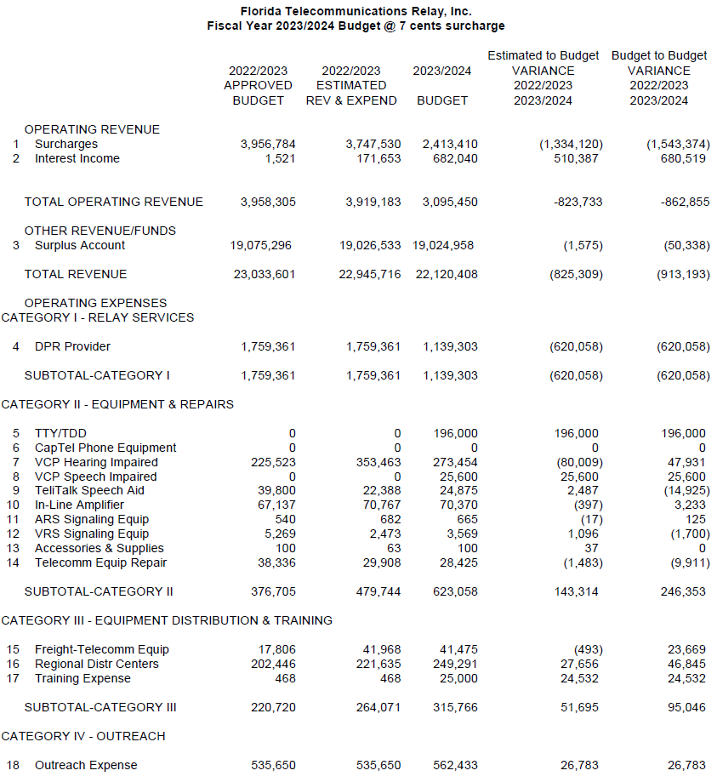

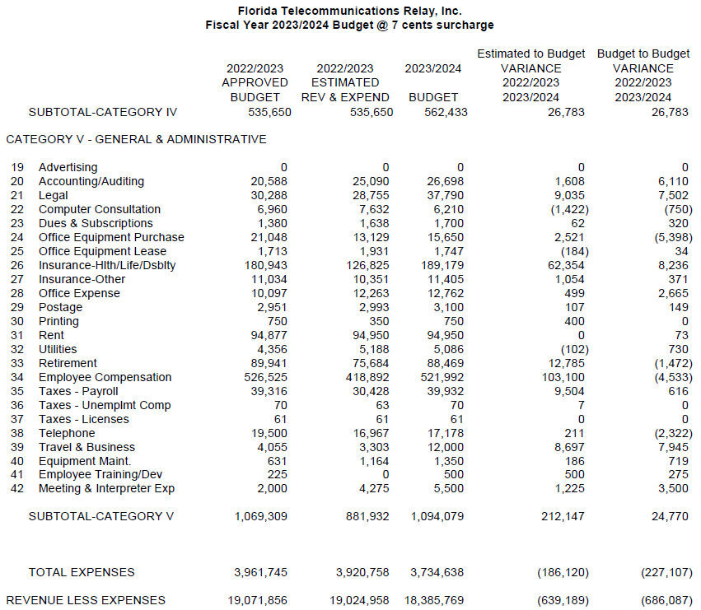

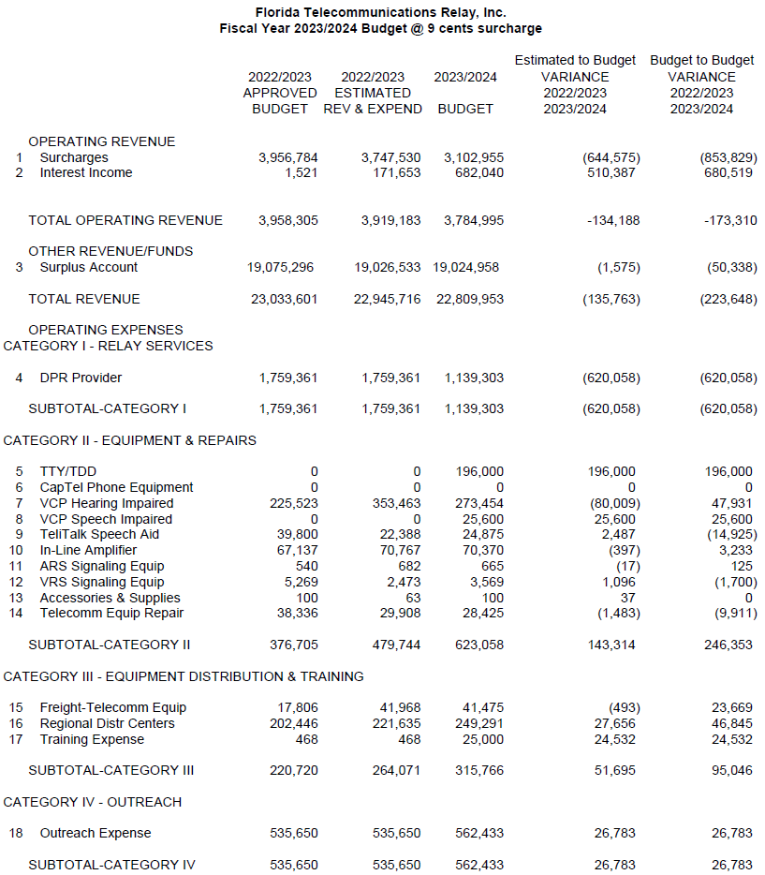

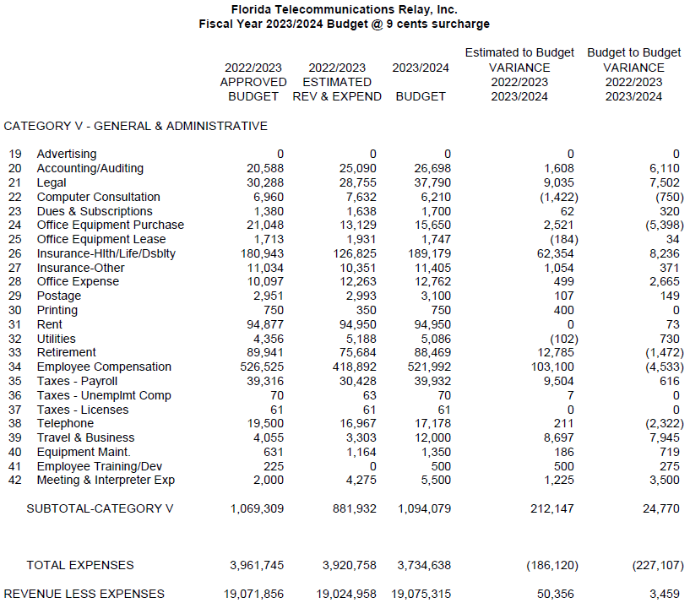

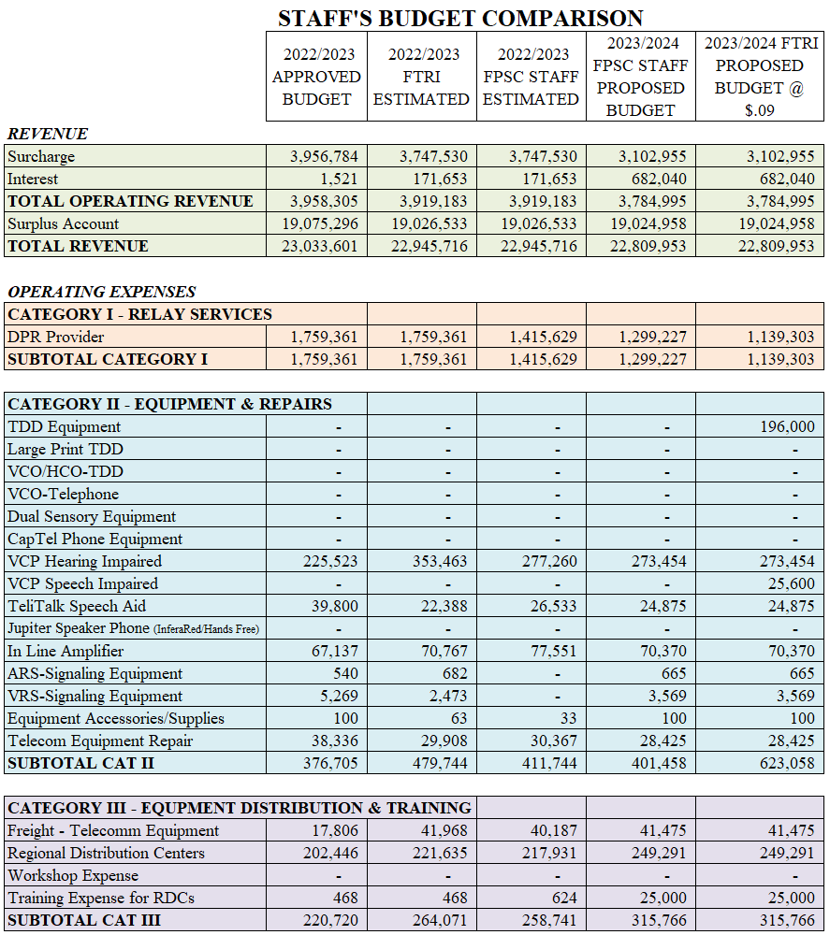

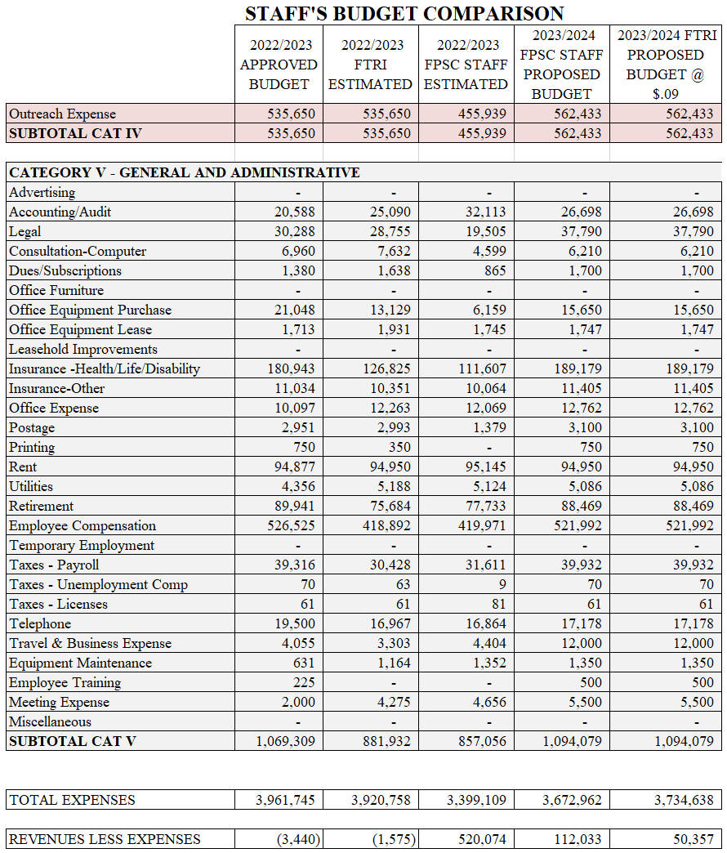

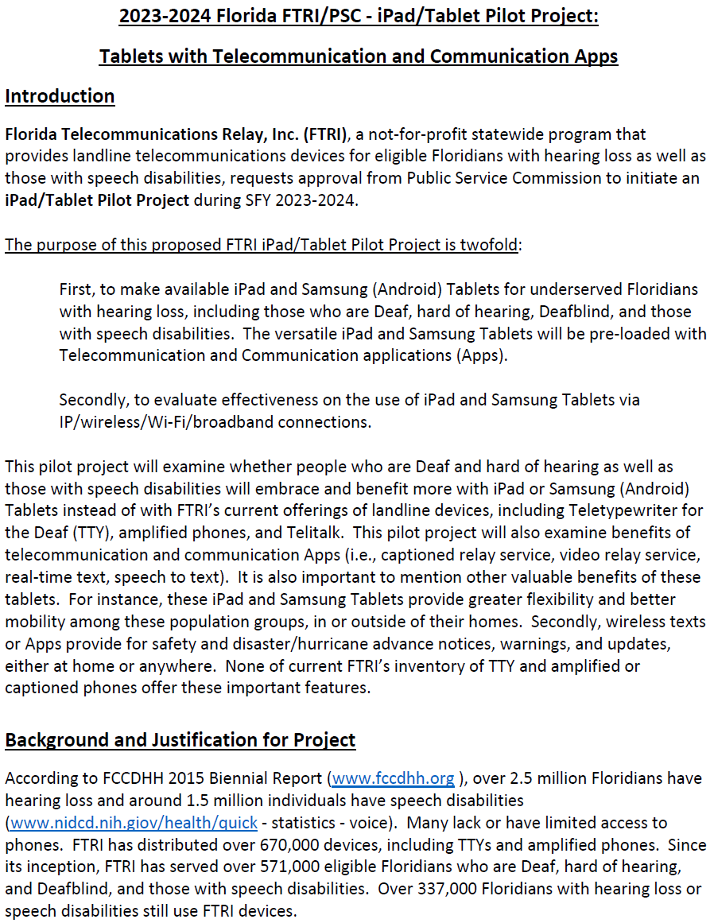

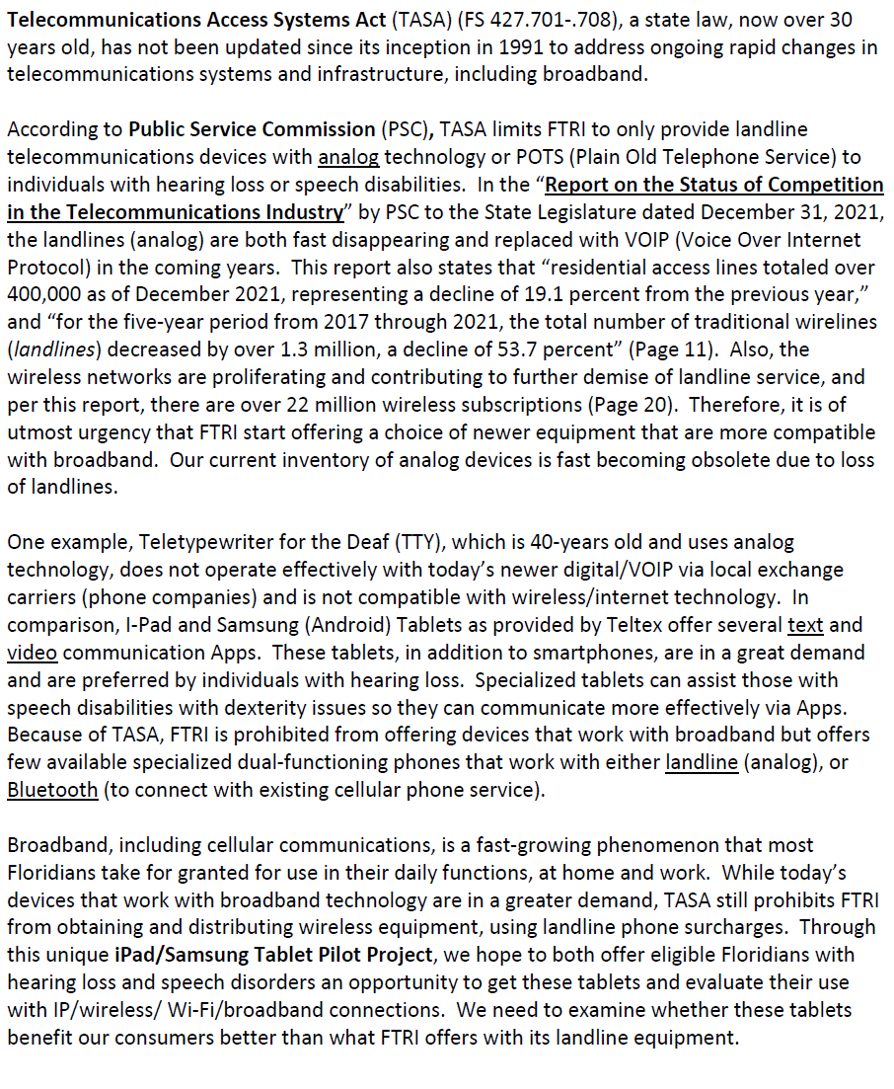

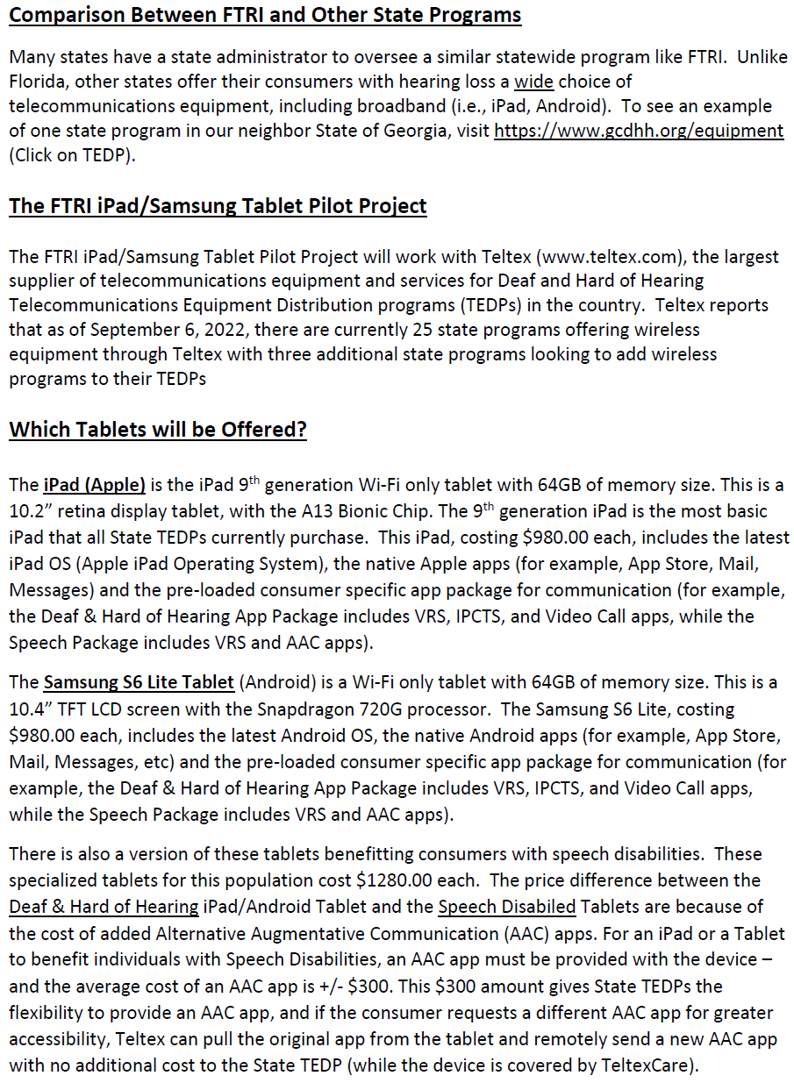

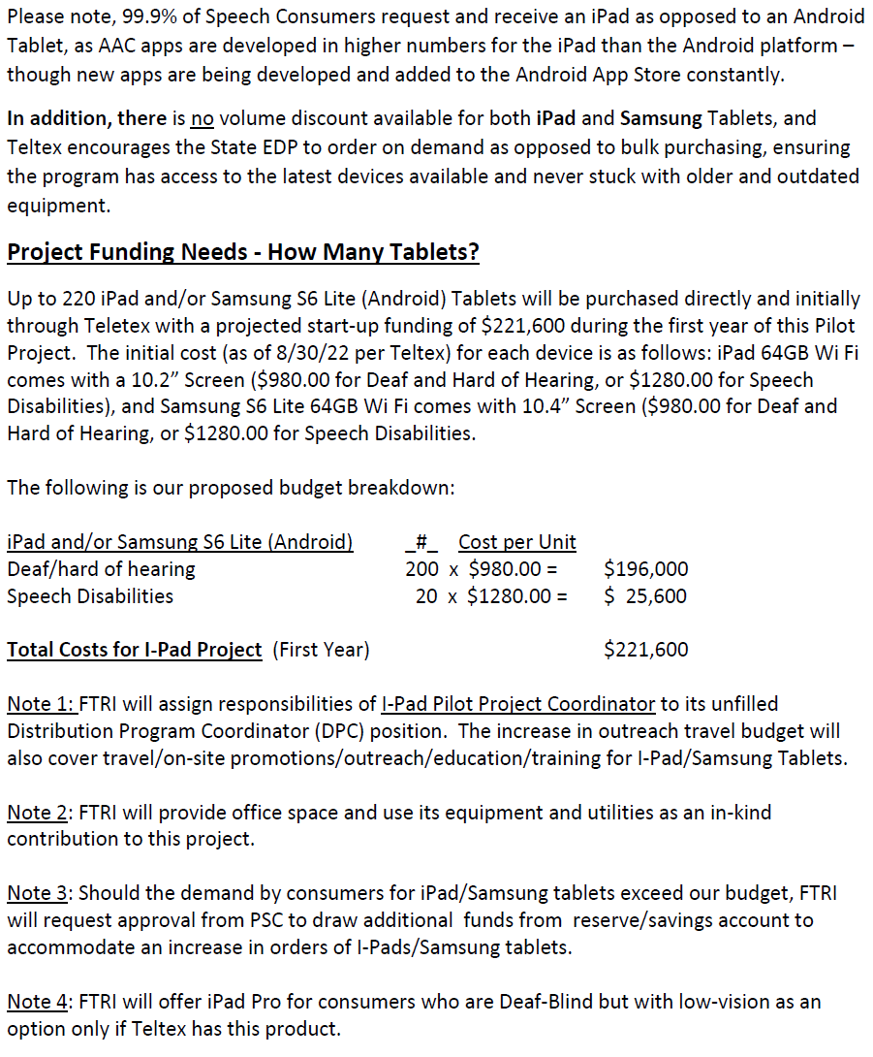

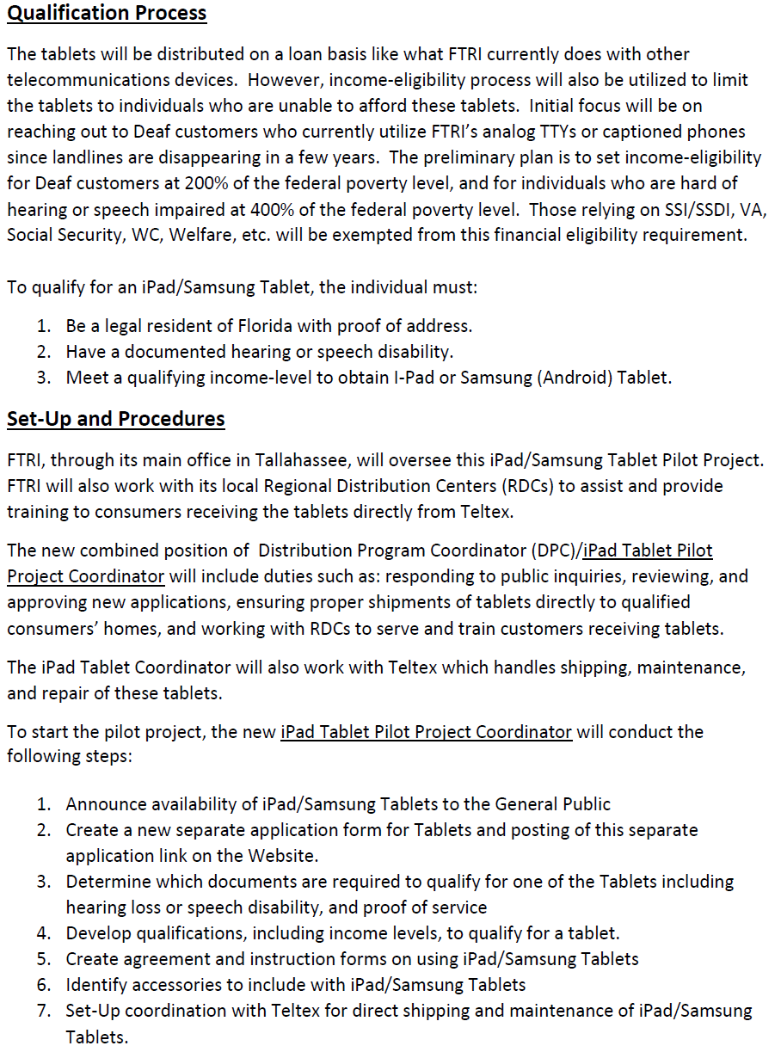

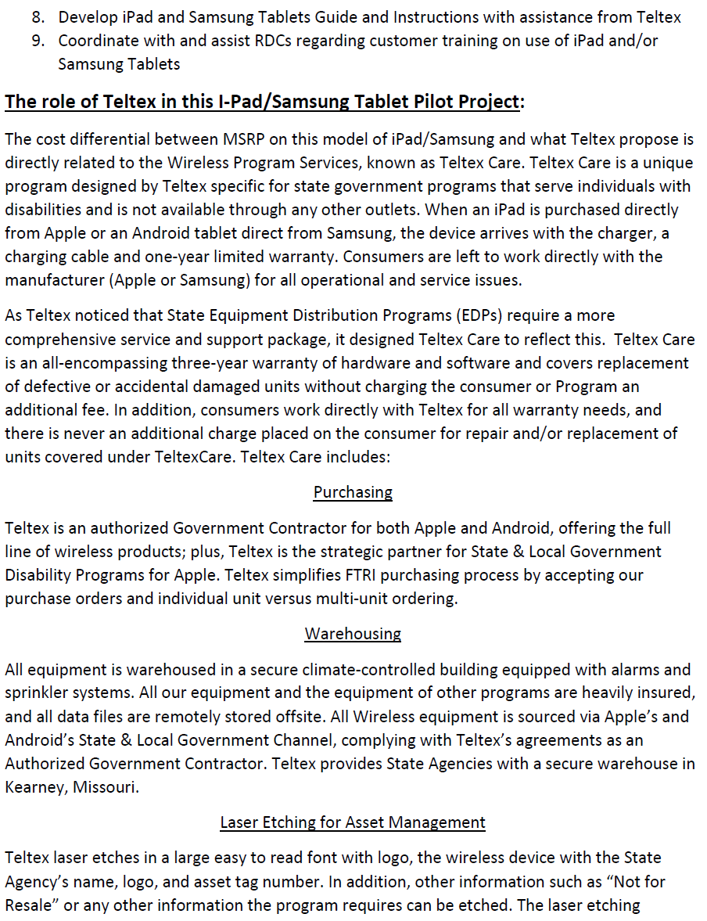

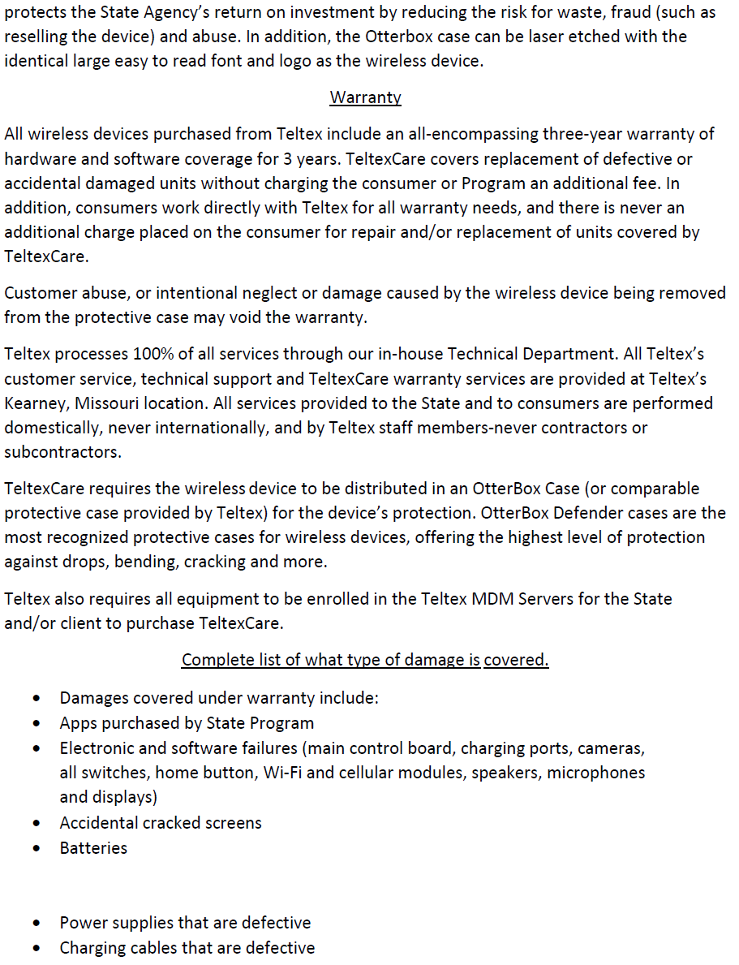

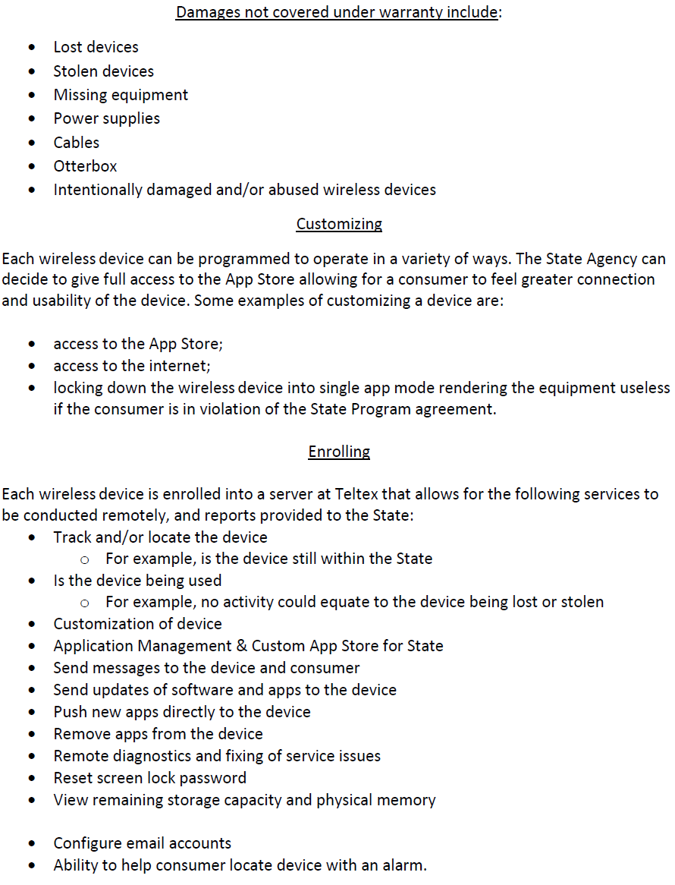

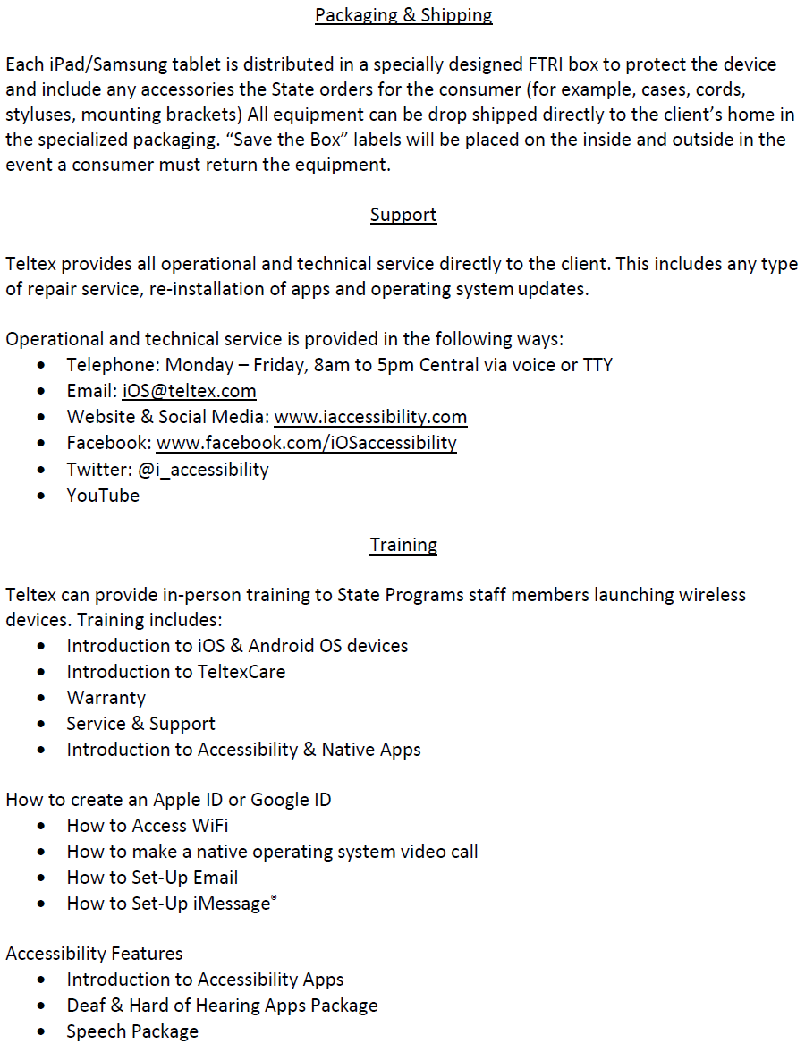

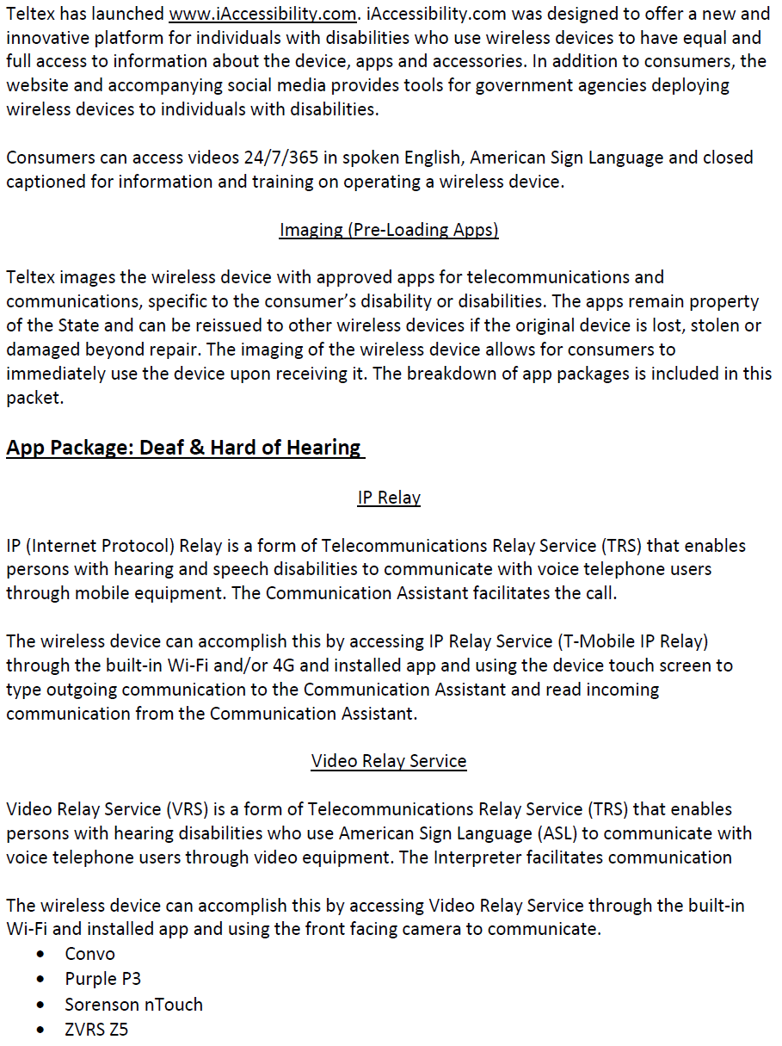

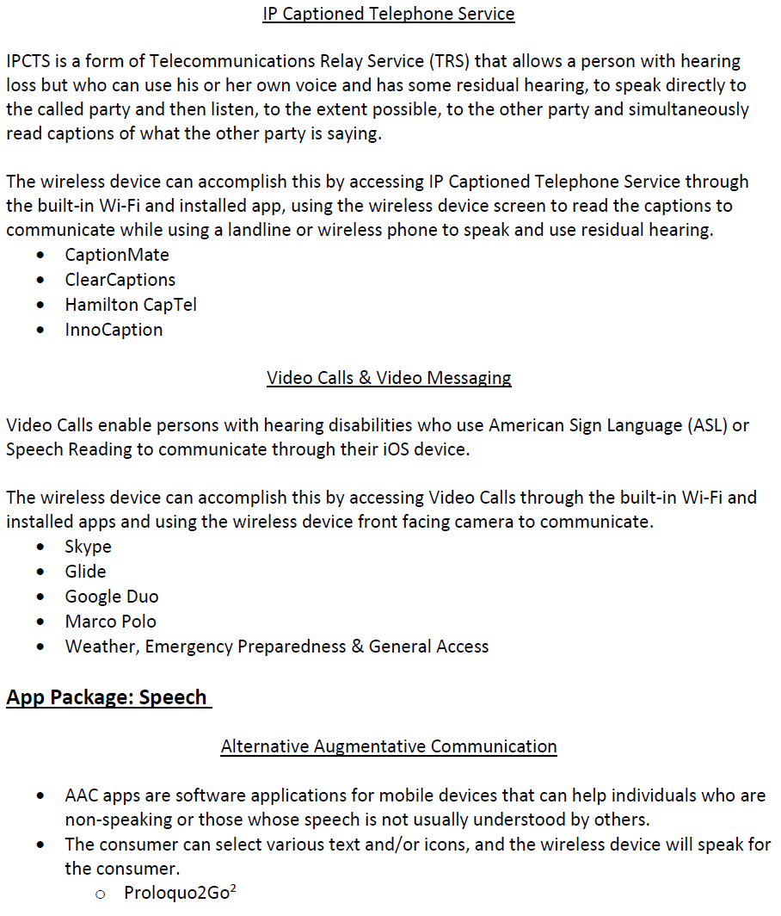

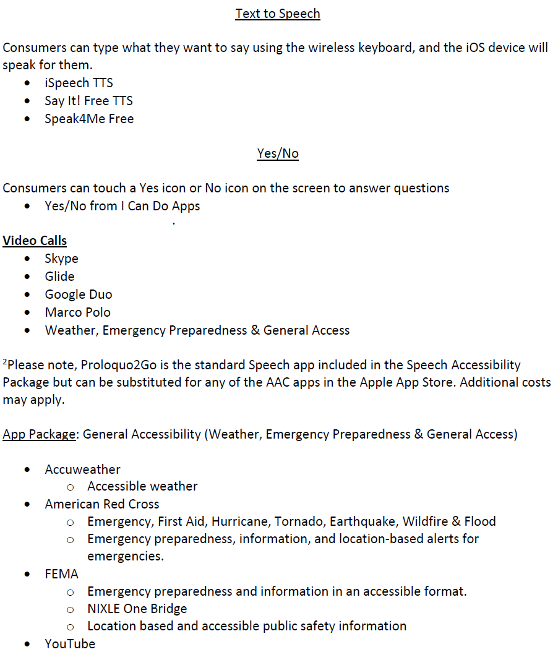

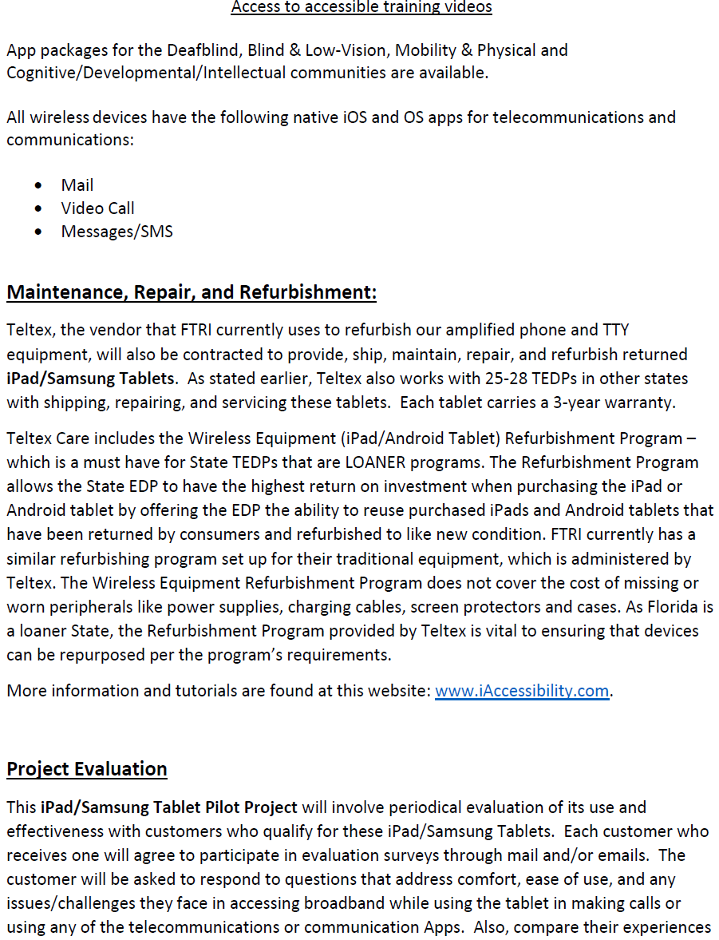

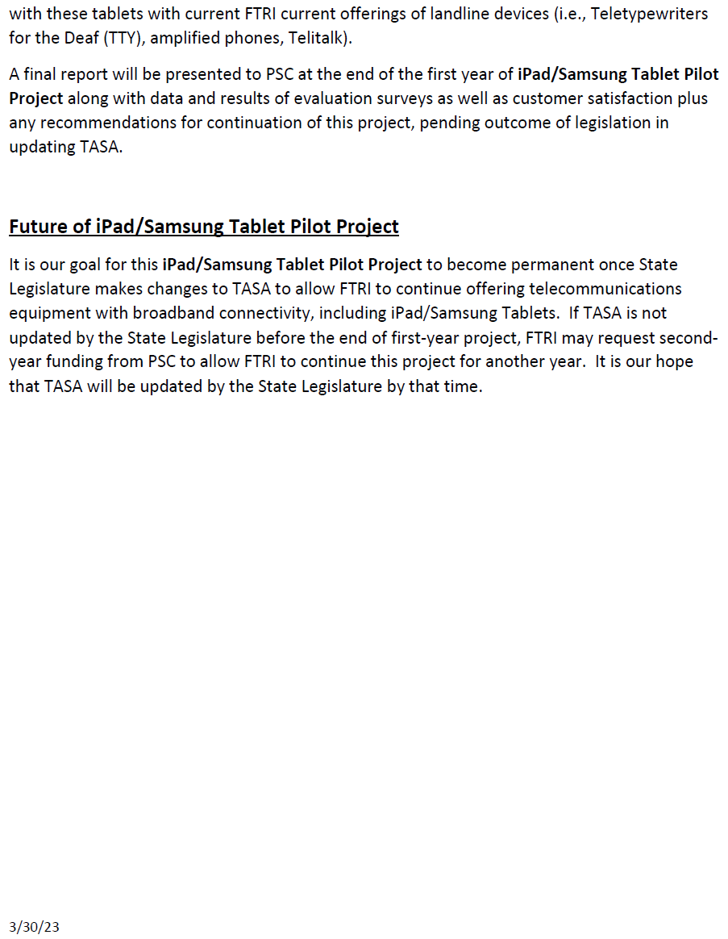

1. Order No. 24581, issued May 24, 1991, in Docket No. 910496-TP, *In re: Implementation of Florida Telecommunications Access System Act of 1991*.
2. Currently, eligibility programs include: SNAP, Medicaid, Federal Public Housing Assistance, Supplemental Security Income, Veterans or Survivors Pension Program.
3. IP Relay allows people who have difficulty hearing or speaking to communicate using a computer and the Internet, rather than a Text Telephone (TTY) and a telephone line.
4. VRS enables persons with hearing disabilities who use American Sign Language to communicate with voice telephone users through video equipment, rather than through typed text. Video equipment links the VRS user with a TRS operator so that the VRS user and the operator can see and communicate by signed conversation.
5. IP captioned telephone service allows users to simultaneously listen and read the text of what the other party in a telephone conversation has said, where the connection carrying the captions between the service and the user is via an IP addressed and routed link.
6. Wireless services offer applications such as text, instant messaging, and video chat.
7. Section 427.702(g), F.S. and Section 427.702(3)(c), F.S.
8. Section 427.703(14), F.S.
9. Section 427.703(11), F.S.
10. Section 427.704(4)(a)(1), F.S.
11. Budget surplus and shortfalls for each TRS surcharge are calculated using staff’s recommended budget expense amounts.