BEFORE THE FLORIDA PUBLIC SERVICE COMMISSION

|  |  |
| --- | --- |
| In re: Petition for approval of transportation service agreement with Florida Public Utilities Company by Peninsula Pipeline Company, Inc. | DOCKET NO. 20230063-GU  ORDER NO. PSC-2023-0212-PAA-GU  ISSUED: July 25, 2023 |

The following Commissioners participated in the disposition of this matter:

ANDREW GILES FAY, Chairman

ART GRAHAM

GARY F. CLARK

MIKE LA ROSA

GABRIELLA PASSIDOMO

NOTICE OF PROPOSED AGENCY ACTION

ORDER APPROVING FIRM TRANSPORTATION SERVICE AGREEMENT

BY THE COMMISSION:

NOTICE is hereby given by the Florida Public Service Commission that the action discussed herein is preliminary in nature and will become final unless a person whose interests are substantially affected files a petition for a formal proceeding, pursuant to Rule 25-22.029, Florida Administrative Code (F.A.C.).

Background

On April 24, 2023, Peninsula Pipeline Company, Inc. (Peninsula) filed a petition seeking approval of a Firm Transportation Service Agreement (Agreement) between Peninsula and Florida Public Utilities Company (FPUC), collectively the parties. The purpose of the Agreement is to allow FPUC to provide natural gas service to existing and future residential, commercial, and industrial customers in and near the City of Newberry (Newberry or the City) in Alachua County. Newberry currently does not provide natural gas service but customers have the option to use propane as a secondary fuel source provided by propane distributors.

Peninsula operates as an intrastate natural gas transmission company as defined by Section 368.103(4), Florida Statutes (F.S.).[1] FPUC is a local distribution company (LDC) subject to our regulatory jurisdiction pursuant to Chapter 366, F.S.

By Order No. PSC-07-1012-TRF-GP,[2] Peninsula received approval of an intrastate gas pipeline tariff that allows it to construct and operate intrastate pipeline facilities and to actively pursue agreements with natural gas customers. Peninsula provides gas transportation service only; it does not engage in the sale of natural gas. Pursuant to Order No. PSC-07-1012-TRF-GP, Peninsula is allowed to enter into certain gas transmission agreements without our prior approval.[3] However, Peninsula is requesting our approval of this proposed Agreement as it does not fit any of the criteria enumerated in the tariff for which our approval would not be required.[4] The parties are subsidiaries of Chesapeake Utility Corporation, a Delaware corporation authorized to conduct business in Florida, and agreements between affiliated companies must be approved by us pursuant to Section 368.105, F.S., and Order No. PSC-07-1012-TRF-GP.

Pursuant to the proposed Agreement and project map (Attachments A and B to this order), Peninsula will construct, own, and operate a new natural gas pipeline and update an existing gate station located in Trenton, which will be an interconnect with Florida Gas Transmission Company’s (FGT) interstate pipeline system. During the evaluation of the petition, FPUC and Commission staff had an informal meeting on April 18, 2023, and Commission staff issued two data requests to the parties for which responses were received on May 17, 2023 and on June 13, 2023. We have jurisdiction over this matter pursuant to Sections 366.05(1), 366.06, and 368.105, F.S.

Decision

**Proposed Transportation Service Agreement**

The City of Newberry currently does not provide natural gas service but customers who desire to use gas have the ability to purchase propane as their secondary fuel source. We do not regulate propane suppliers. FPUC believes that once the natural gas distribution system in the City is completed and service becomes available, some propane customers may opt for natural gas as it is a cheaper fuel.

FPUC explained that Newberry is experiencing increased development in residential, commercial, and light industrial sectors. FPUC further stated that the City has indicated a high interest in obtaining reliable and reasonable natural gas service and FPUC has obtained several letters of interest from home builders and other businesses. The proposed Agreement will also support the City’s economic development plan which emphasizes the development of commercial and light industrial sectors of its local economy. FPUC indicated it also anticipates interest from a large scale industrial customer who currently uses coal as a fuel source.

In response to the City’s interest in bringing natural gas service to the area, the parties have entered into the proposed Agreement to enable FPUC to expand its distribution system. FPUC stated that it has a franchise agreement in the City for natural gas service. The Company asserts that the proposed project and Agreement with Peninsula to extend natural gas service to Newberry and its vicinity is the most economical approach to meet the area’s customer demand.[5]

The proposed Agreement specifies an initial term of 20 years and thereafter shall be extended on a year-to-year basis, with no changes in the terms of the Agreement, unless either party gives no less than 90 days of written notification of termination. If either party desires to negotiate modifications to the rates or terms of this Agreement, they may do so no less than 120 days prior to expiration of the current active term.

**Proposed Newberry Project**

Attachment B to this order shows the proposed Newberry gas distribution expansion project. Peninsula stated that it would begin by updating an existing gate station interconnection with the West Leg of FGT located off of SR 26 in Trenton, in Gilchrist County. FPUC explained that the West Leg is unconstrained, meaning that FGT has transportation capacity available. As shown by the red line, starting at the existing gate station interconnection with FGT, Peninsula would construct approximately 93,300 feet (17.67 miles) of 4-inch steel pipeline traveling east along SR 26 and ending at a newly constructed metering and regulation (M&R) station located off US Highway 41, which Peninsula would also construct. The completion of these projects will enable FPUC-owned gas to be transported to Newberry. In response to Commission staff’s first data request, Peninsula stated that it anticipates to begin construction in the second quarter of 2024 while the completion would depend on contractor resources and coordination with the City.[6]

**Anticipated System Benefits**

The parties stated that the proposed Agreement has the added benefit of providing FPUC with an additional source of gas (via the Peninsula intrastate pipeline) and enhancing an existing interconnection with the FGT pipeline.

The parties assert that the proposed project will enable FPUC, having a franchise agreement with the City, to serve residential, commercial, and industrial customers in the City and its vicinity who currently do not have natural gas service. The parties further assert that construction of the pipeline will allow the current and future customers in the area to obtain less expensive natural gas (as opposed to propane) as their energy source. FPUC stated that the proposed project would allow them to transfer 200 residential propane customers to natural gas in the first year of operation. The petition also states that the proposed project will support the City’s economic development plan with emphasis on commercial and light industrial segments of its economy.

The parties assert that Central Alachua County is currently served by FGT’s East Leg, which is constrained. The proposed pipeline project interconnecting to FGT’s unconstrained West Leg will have the added benefit of incremental supply to natural gas facilities in Central Alachua County supplied by the East Leg.

In response to Commission staff’s first data request, the parties stated that FPUC did not obtain formal Request for Proposals responses from other entities.[7] FPUC explained that in previous discussions and requests with FGT for other projects, FGT has declined to bid on projects related to construction, owning, and operating laterals such as the proposed expansion project in this petition, which are not a focus of FGT’s expansion activities.

FPUC explained that the proposed Newberry project is larger than what FPUC would typically undertake on its own. Due to various tariff requirements, if FPUC undertook the project, the project costs would unduly burden the City and its customers seeking natural gas service. Therefore, FPUC contracted with Peninsula to undertake the proposed Newberry project as it falls within its pipeline operation portfolio. As such, Peninsula will construct, own, and operate the 17.67 mile interconnect with FGT, which would protect the general body of ratepayers from potential unforeseen construction price increases or other related challenges.[8] Upon the completion of Peninsula’s portion of the pipeline construction, FPUC will begin development of its gas distribution system in the City.

**Negotiated Monthly Reservation Payments to Peninsula**

The parties assert that the negotiated monthly reservation charge contained in the proposed agreement is consistent with market rates because the rates are substantially the same as rates set forth in similar agreements as required by Section 368.105(3)(b), F.S. The parties assert that Peninsula will recover the pipeline and district regulator construction costs through the monthly reservation charge to FPUC as shown in Exhibit A to the proposed Agreement. The monthly reservation charge is designed to recover costs such as, but not limited to, engineering, permitting, materials, and installation costs associated with pipeline and related facilities, ongoing maintenance including Pipeline and Hazardous Materials Safety Administration compliance, safety requirements, property taxes, gas control, and Peninsula’s return on investment.

FPUC stated that it will initially recover its payments to Peninsula through the Purchased Gas Adjustment (PGA) and swing service rider mechanisms.[9] The PGA allows FPUC to periodically adjust the price of natural gas supplied to its customers to reflect the actual cost of gas purchased and delivered on behalf of the customers. The swing service rider allows FPUC to recover intrastate capacity costs from their transportation customers and is a cents per therm charge that is included in the monthly customer gas bill of transportation customers. While FPUC will incur costs associated with this service expansion, new load added to the system will help spread the costs over a larger customer base. If the actual need for gas does not meet the projected demand, FPUC stated that it will endeavor to sell the excess capacity on Peninsula and those proceeds will be applied to offset PGA costs to the general body of ratepayers.[10]

FPUC currently is negotiating with a nearby large industrial customer to provide natural gas service. Payments from this industrial customer will be used to offset the amounts paid to Peninsula by the general body of ratepayers.

**Conclusion**

Based on the petition and the parties’ responses to Commission staff’s data requests, we find that the proposed Agreement is reasonable and meets the requirements of Section 368.105, F.S. Furthermore, the proposed Agreement benefits FPUC’s current and potential future customers by interconnecting to FGT’s less constrained West Leg, allowing FPUC to provide natural gas service in and around the City of Newberry in Alachua County. Therefore, we approve the proposed Firm Transportation Service Agreement dated April 5, 2023, between Peninsula and FPUC.

Based on the foregoing, it is

ORDERED by the Florida Public Service Commission that the Firm Transportation Service Agreement dated April 5, 2023, between Florida Public Utilities Company and Peninsula Pipeline Company, Inc., is approved. It is further

ORDERED that the provisions of this Order, issued as proposed agency action, shall become final and effective upon the issuance of a Consummating Order unless an appropriate petition, in the form provided by Rule 28-106.201, Florida Administrative Code, is received by the Commission Clerk, 2540 Shumard Oak Boulevard, Tallahassee, Florida 32399-0850, by the close of business on the date set forth in the “Notice of Further Proceedings” attached hereto. It is further

ORDERED that in the event this Order becomes final, this docket shall be closed.

By ORDER of the Florida Public Service Commission this 25th day of July, 2023.

|  |  |
| --- | --- |
|  | /s/ Adam J. Teitzman |
|  | ADAM J. TEITZMAN  Commission Clerk |

Florida Public Service Commission

2540 Shumard Oak Boulevard

Tallahassee, Florida 32399

(850) 413‑6770

www.floridapsc.com

Copies furnished: A copy of this document is provided to the parties of record at the time of issuance and, if applicable, interested persons.

DD

NOTICE OF FURTHER PROCEEDINGS OR JUDICIAL REVIEW

The Florida Public Service Commission is required by Section 120.569(1), Florida Statutes, to notify parties of any administrative hearing that is available under Section 120.57, Florida Statutes, as well as the procedures and time limits that apply. This notice should not be construed to mean all requests for an administrative hearing will be granted or result in the relief sought.

Mediation may be available on a case-by-case basis. If mediation is conducted, it does not affect a substantially interested person's right to a hearing.

The action proposed herein is preliminary in nature. Any person whose substantial interests are affected by the action proposed by this order may file a petition for a formal proceeding, in the form provided by Rule 28-106.201, Florida Administrative Code. This petition must be received by the Office of Commission Clerk, 2540 Shumard Oak Boulevard, Tallahassee, Florida 32399-0850, by the close of business on August 15, 2023.

In the absence of such a petition, this order shall become final and effective upon the issuance of a Consummating Order.

Any objection or protest filed in this/these docket(s) before the issuance date of this order is considered abandoned unless it satisfies the foregoing conditions and is renewed within the specified protest period.

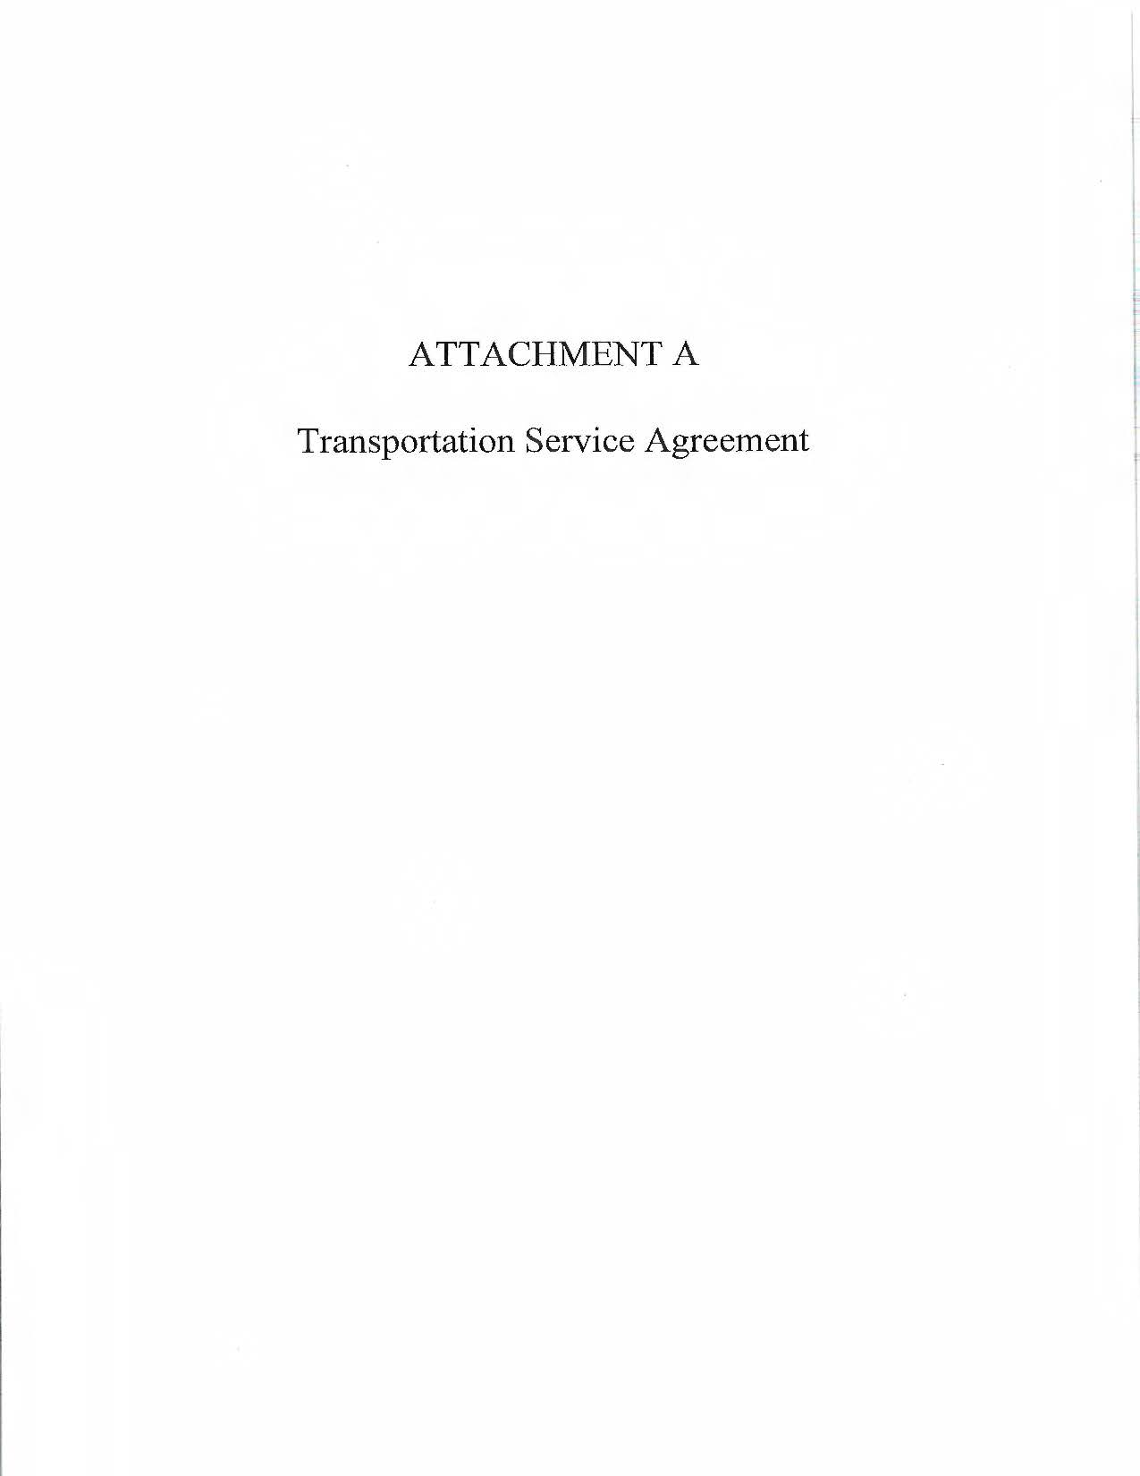

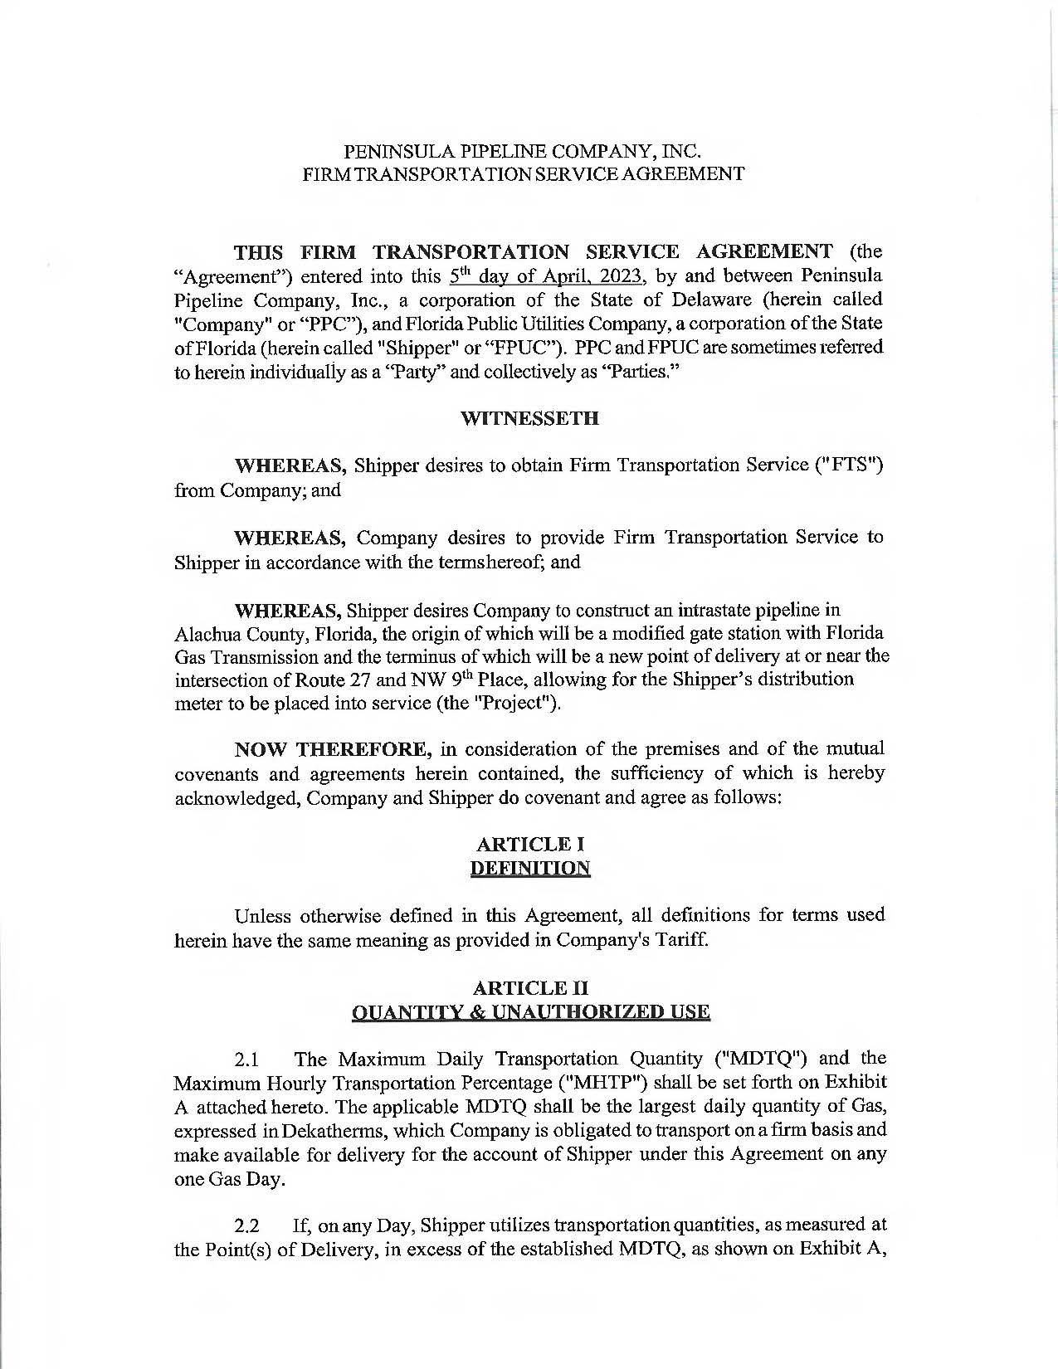

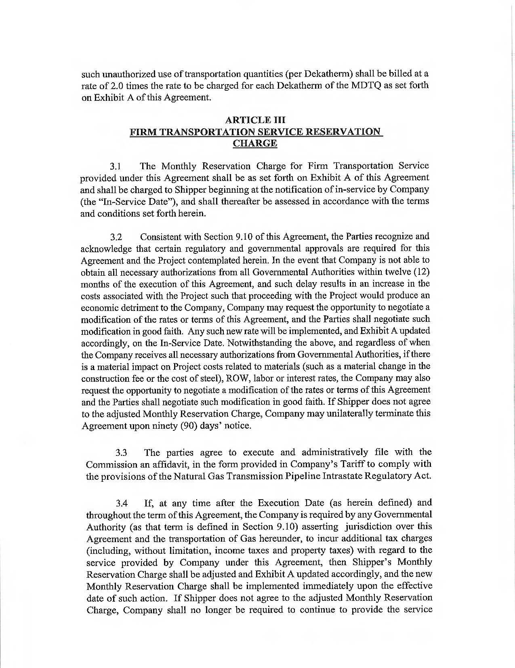

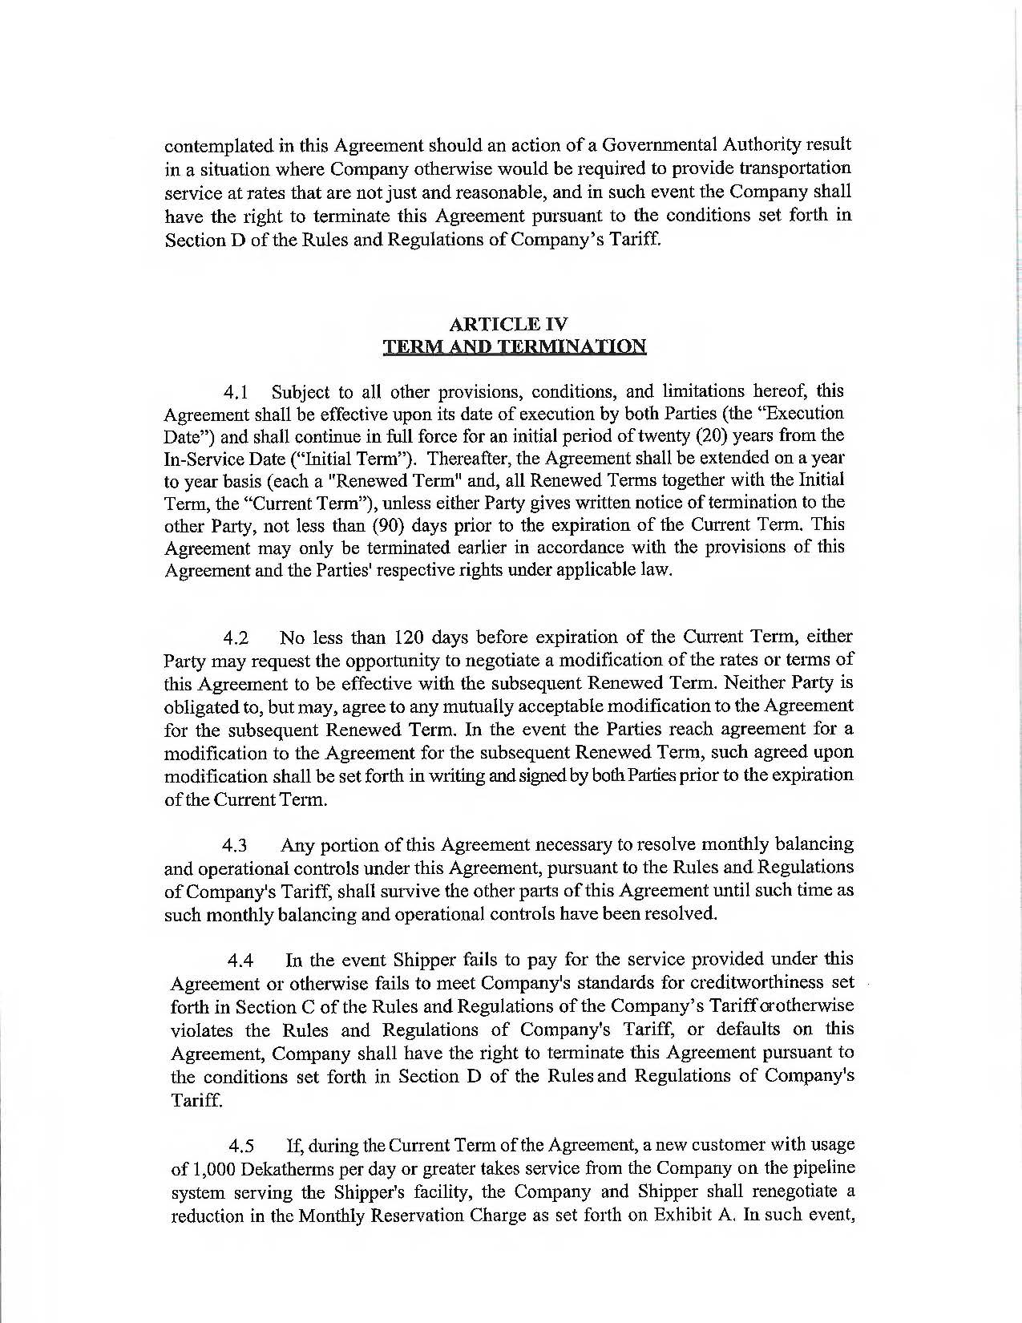

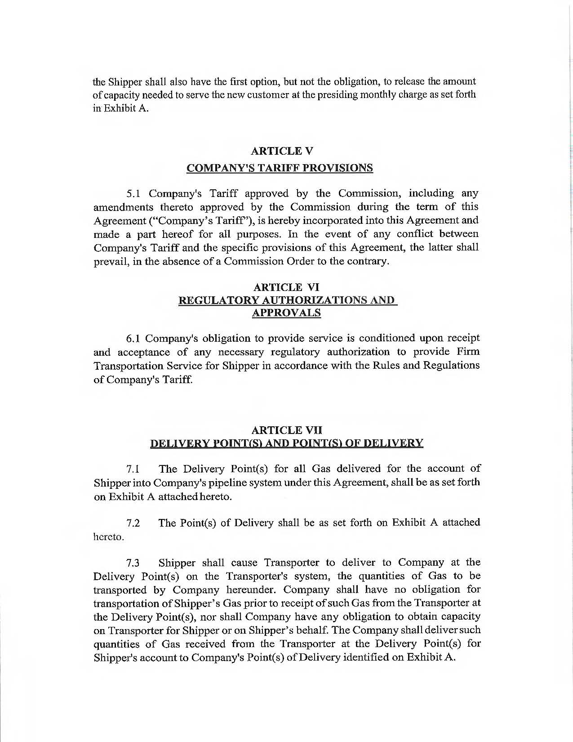

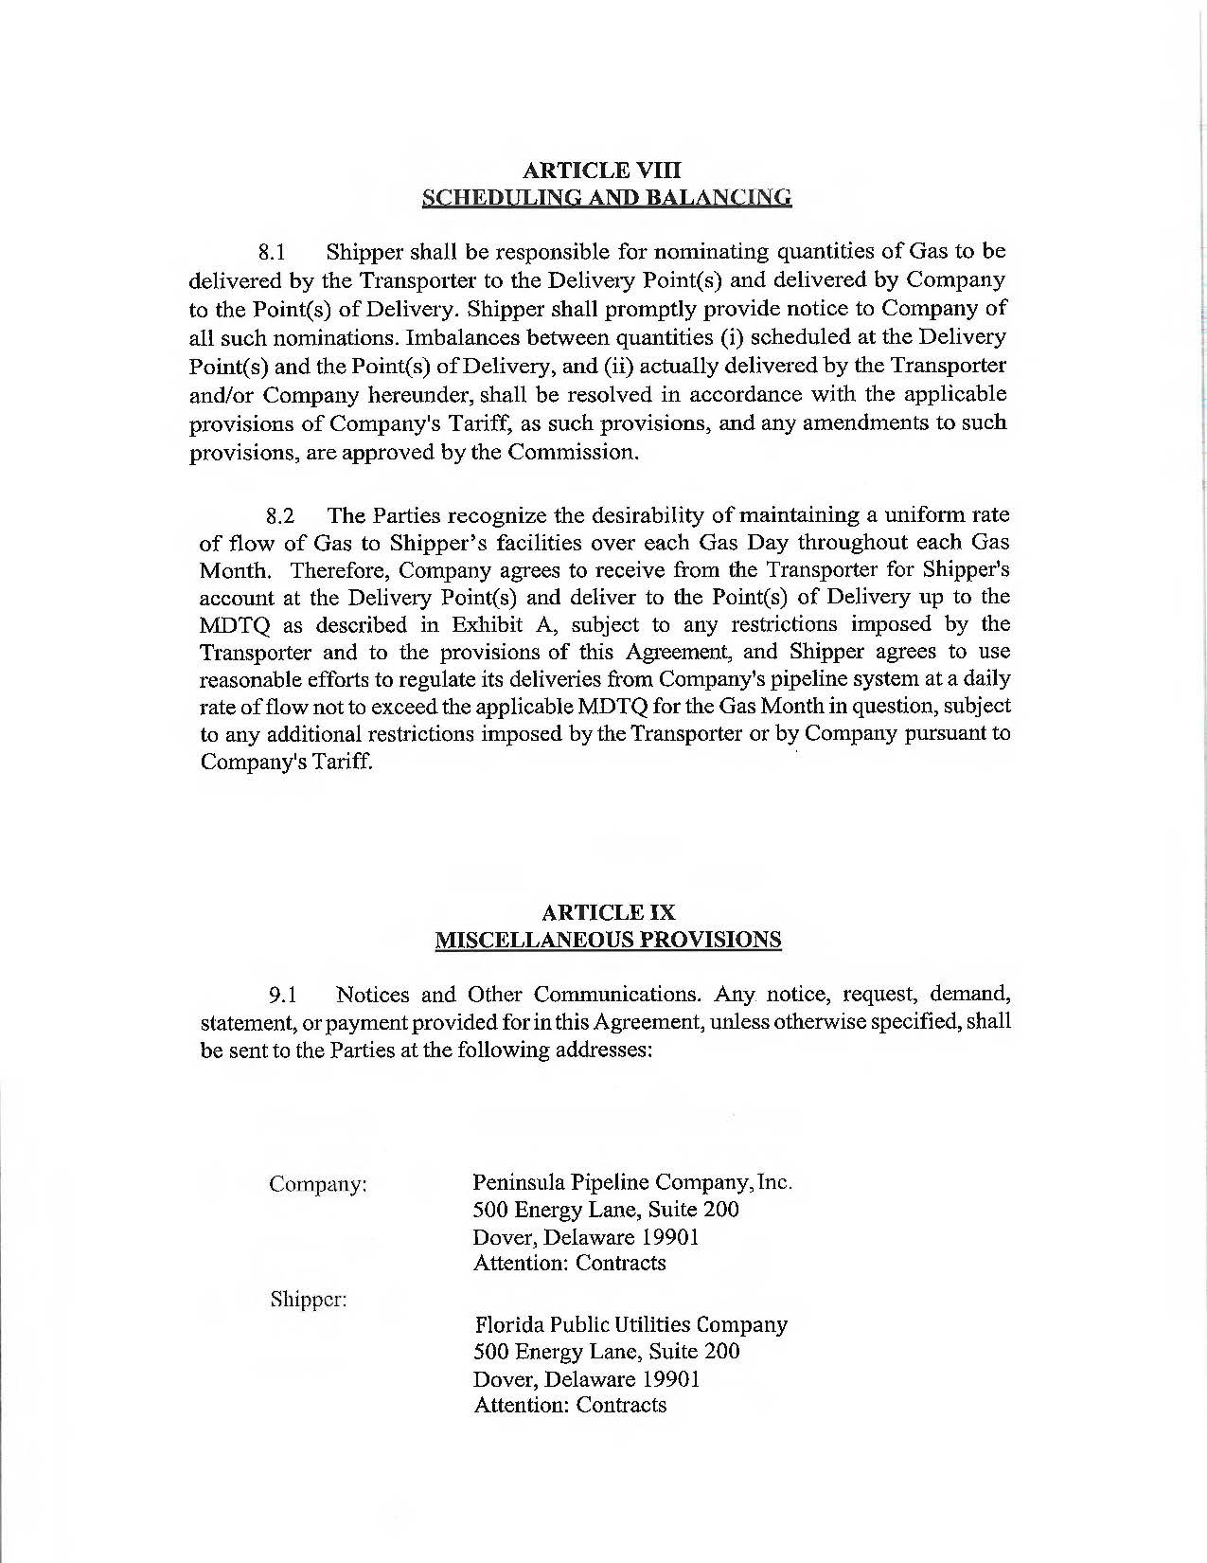

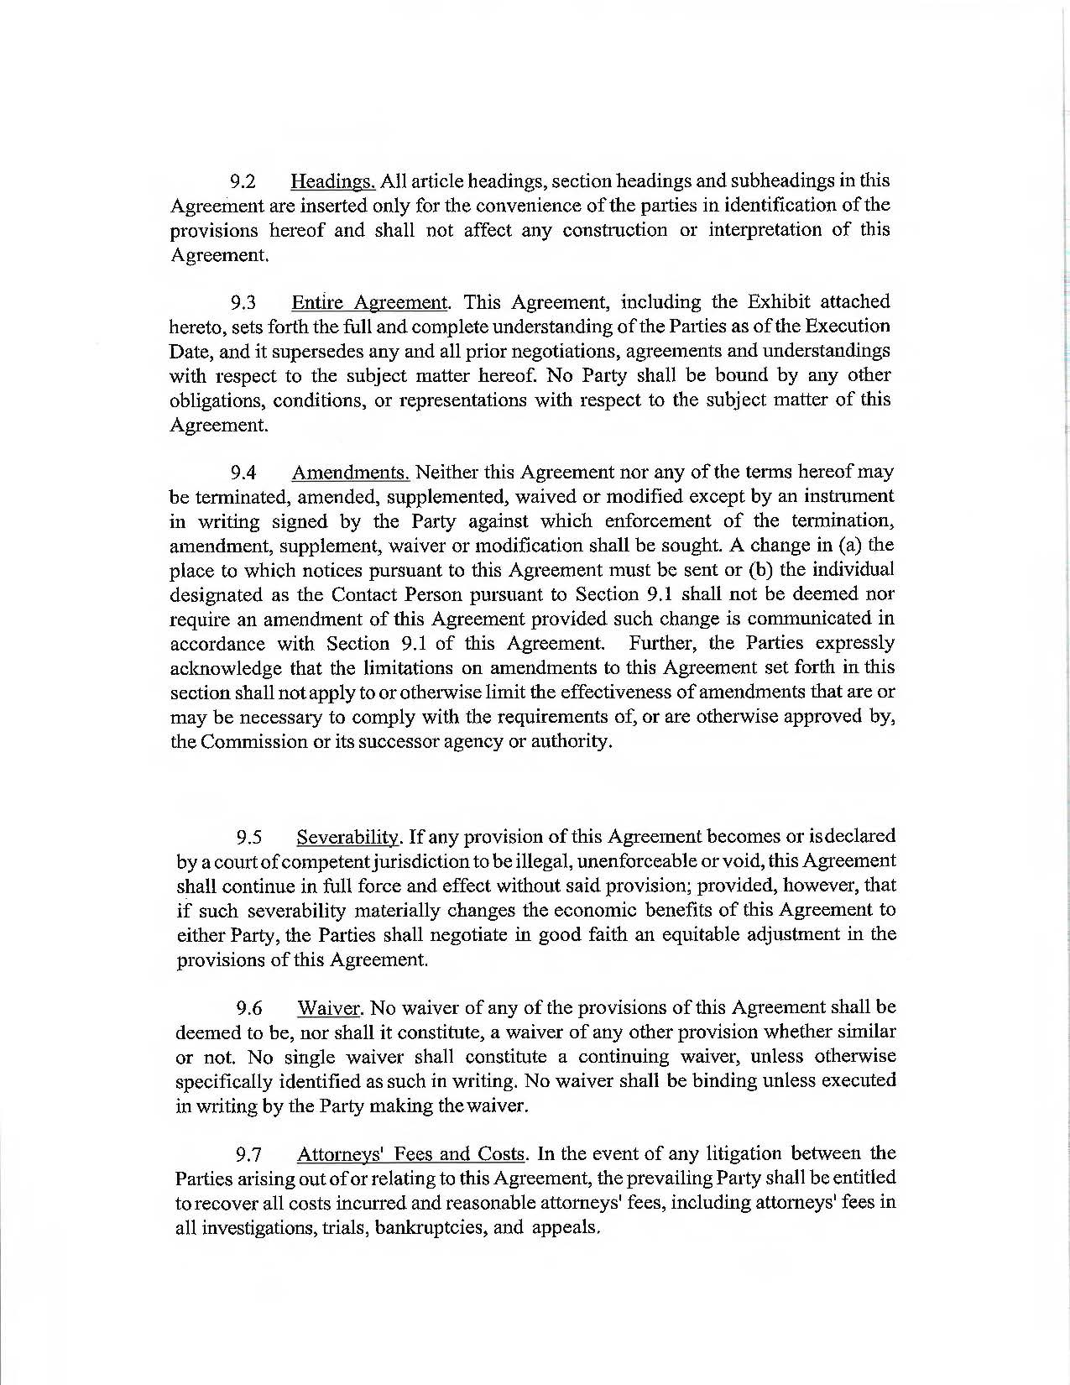

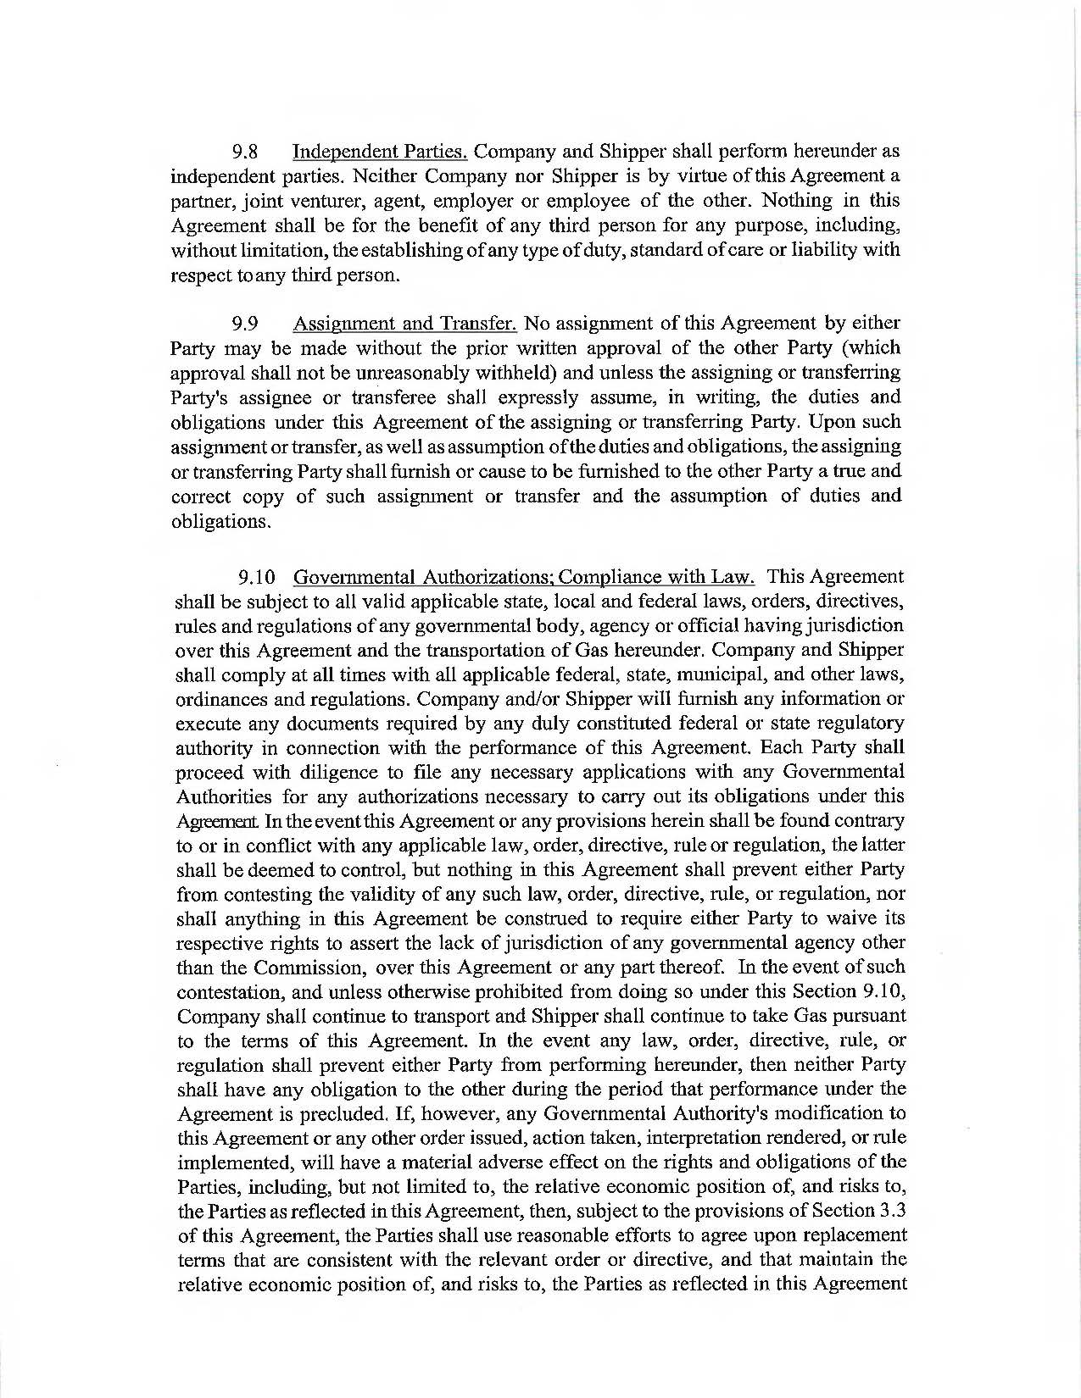

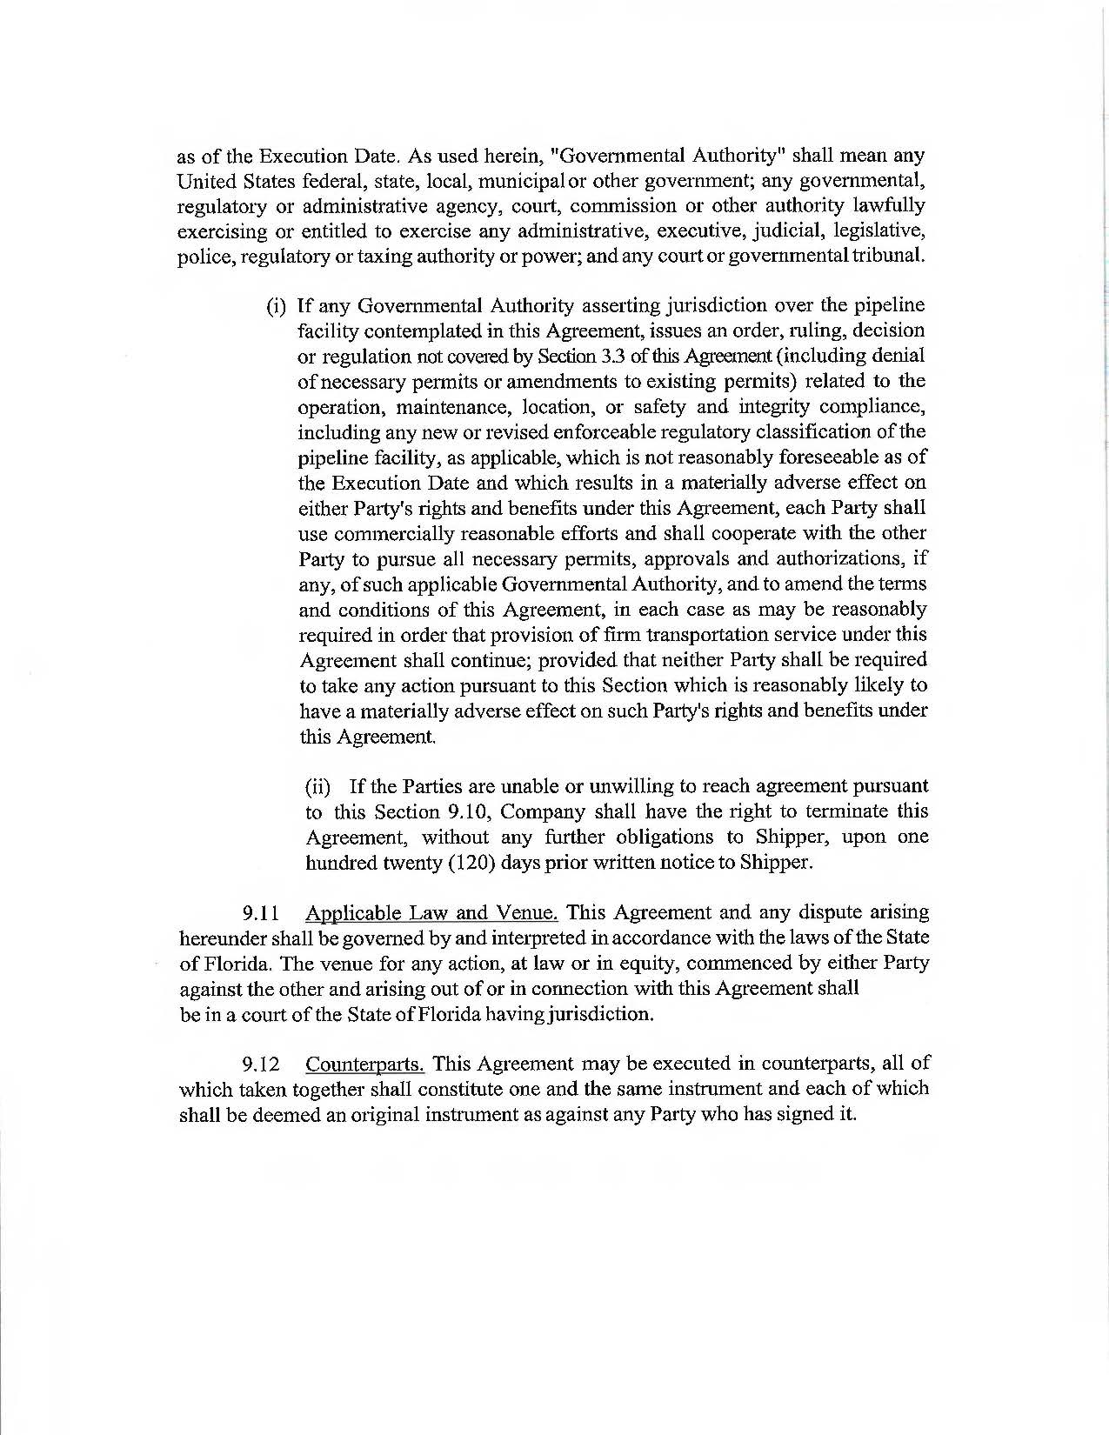

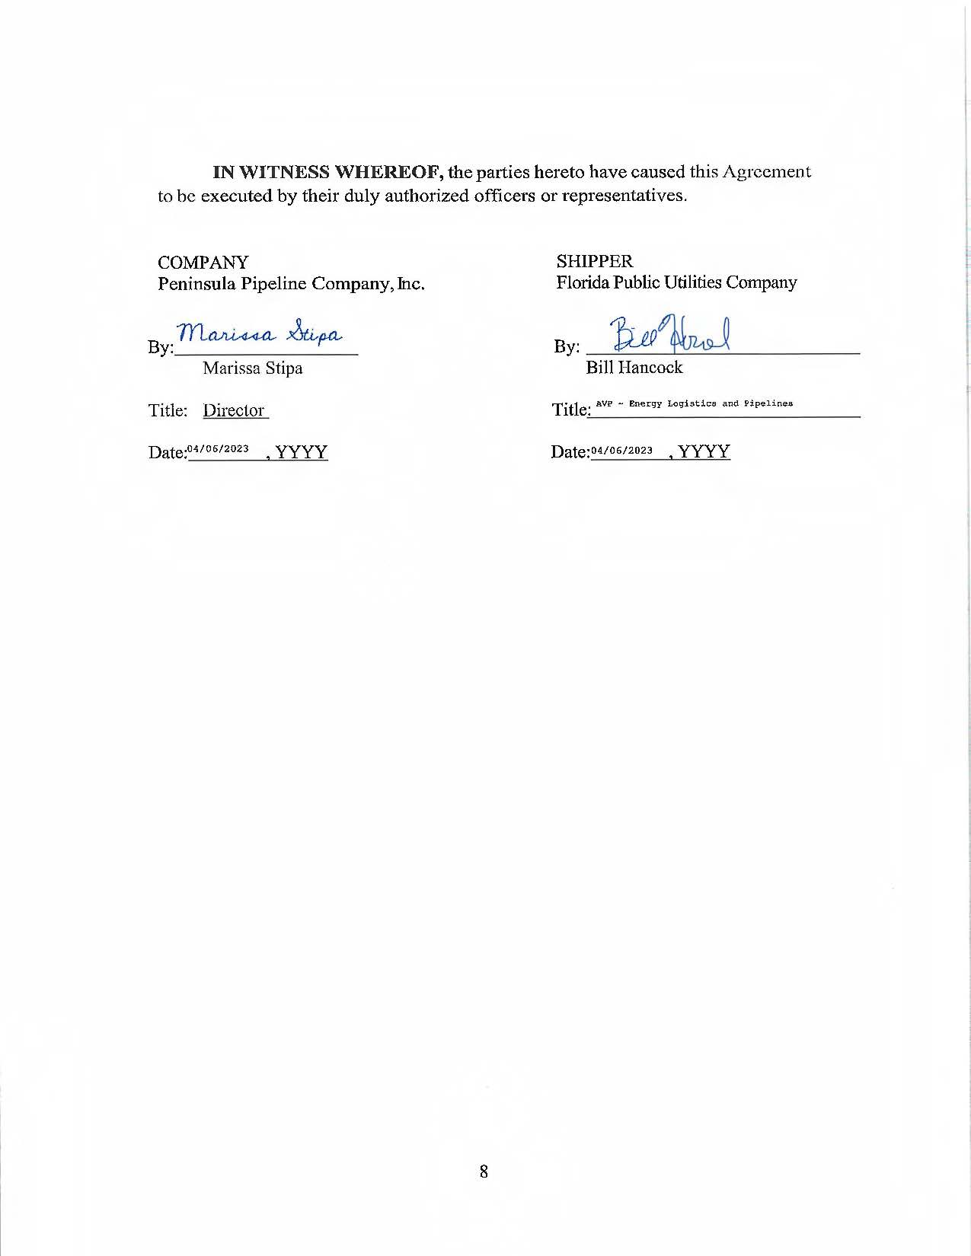

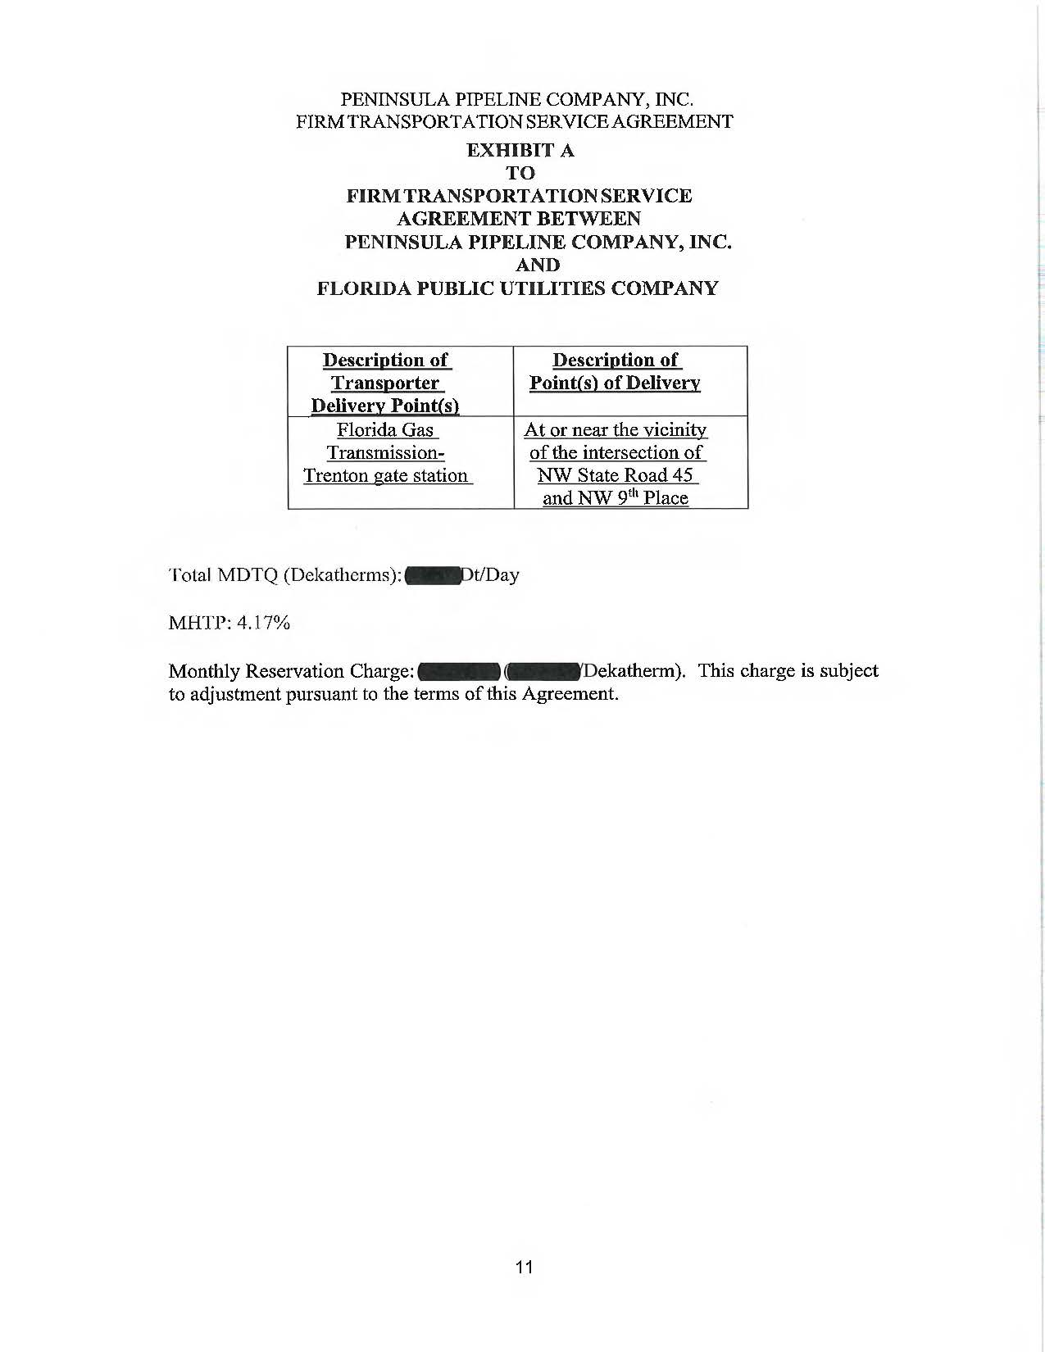



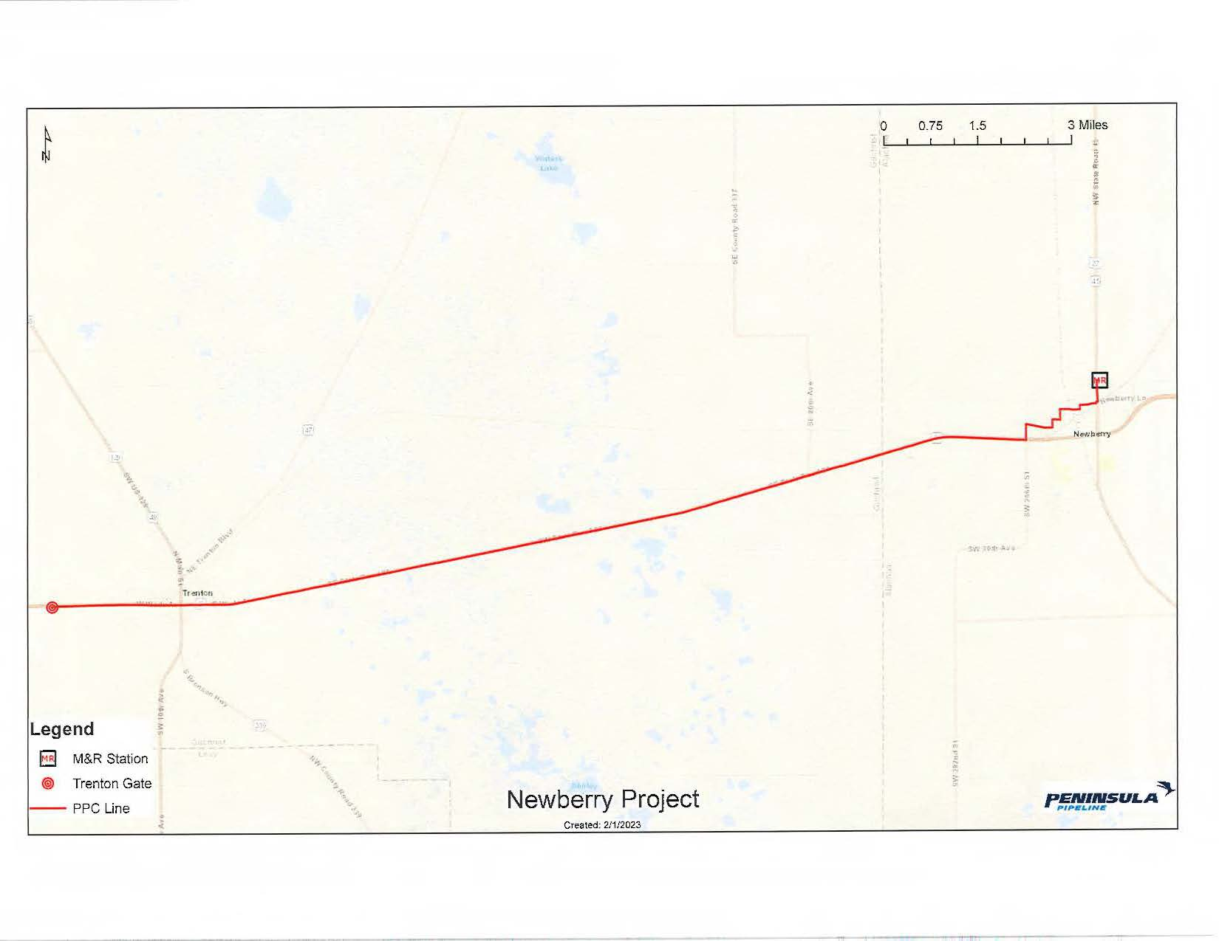

1. Order No. PSC-06-0023-DS-GP, issued January 9, 2006, in Docket No. 050584-GP, *In re: Petition for declaratory statement by Peninsula Pipeline Company, Inc. concerning recognition as a natural gas transmission company under Section 368.101, F.S., et seq.*
2. Order No. PSC-07-1012-TRF-GP, issued December 21, 2007, in Docket No. 070570-GP, *In re: Petition for approval of natural gas transmission pipeline tariff by Peninsula Pipeline Company, Inc.*
3. Peninsula Pipeline Company, Inc., Intrastate Pipeline Tariff, Original Vol. 1, Original Sheet No. 11, Section 3.
4. Peninsula Pipeline Company, Inc., Intrastate Pipeline Tariff, Original Vol. 1, Original Sheet No. 12, Section 4.
5. Response No. 3 in Staff’s Second Data Request, Document No. 03625-2023.
6. Response No. 2 in Staff’s First Data Request, Document No. 03271-2023.
7. Response No. 5 in Staff’s First Data Request, Document No. 03271-2023.
8. Response No. 2 in Staff’s Second Data Request, Document No. 03625-2023.
9. Response No. 6 in Staff’s First Data Request, Document No. 03271-2023.
10. Response No. 1 in Staff’s Second Data Request, Document No. 03625-2023.