|  |  |  |  |
| --- | --- | --- | --- |
| State of Florida  pscSEAL | | Public Service Commission  Capital Circle Office Center ● 2540 Shumard Oak Boulevard Tallahassee, Florida 32399-0850  -M-E-M-O-R-A-N-D-U-M- | |
| DATE: | September 21, 2023 | | |
| TO: | Office of Commission Clerk (Teitzman) | | |
| FROM: | Office of Industry Development and Market Analysis (Wooten, Nave)  Office of the General Counsel (Sparks, Marquez) | | |
| RE: | Docket No. 20230093-TX – Bankruptcy cancellation of CLEC Certificate No. 8867 issued to Discount CLEC Services Corporation. | | |
| AGENDA: | 10/03/23 – Regular Agenda – Proposed Agency Action – Interested Persons May Participate | | |
| COMMISSIONERS ASSIGNED: | | | All Commissioners |
| PREHEARING OFFICER: | | | Administrative |
| CRITICAL DATES: | | | None |
| SPECIAL INSTRUCTIONS: | | | None |

Case Background

This recommendation addresses a telecommunications company with an active certificate of authority that has completed Chapter 7 bankruptcy proceedings. In a Chapter 7 bankruptcy proceeding, the company stops all operations and goes completely out of business.[1]

Pursuant to Section 364.335(2), Florida Statutes (F.S.), applicants for certificates of authority must “. . . ensure continued compliance with applicable business formation, registration, and taxation provisions of law.” A liquidated company would be unable to comply with these requirements.

Discount CLEC Services Corporation currently holds CLEC Certificate No. 8867, issued by the Commission on July 24, 2015. The company filed for Chapter 11 bankruptcy on September 14, 2016. On March 21, 2017, the bankruptcy type was converted to Chapter 7 bankruptcy, and on July 27, 2018, the case was decreed to have been fully administered.

The Commission has jurisdiction over this matter pursuant to Chapter 364, including Sections 364.01 and 364.335, F.S.

Discussion of Issues

Issue :

Should the Commission, on its own motion, cancel Discount CLEC Services Corporation’s CLEC certificate and service schedules (if any) due to the company’s Chapter 7 bankruptcy liquidation?

Recommendation:

 Yes, the Commission, on its own motion, should cancel Discount CLEC Services Corporation’s CLEC certificate and service schedules (if any) due to the company’s Chapter 7 bankruptcy liquidation effective upon the issuance of a final order in this docket. (Wooten, Nave)

Staff Analysis:

 The Public Access to Court Electronic Records system shows that Discount CLEC Services Corporation completed a Chapter 7 bankruptcy liquidation on July 27, 2018.[2] According to the U.S. Securities and Exchange Commission, “(U)nder Chapter 7, the company stops all operations and goes completely out of business. A trustee is appointed to "liquidate" (sell) the company's assets and the money is used to pay off the debt, which may include debts to creditors and investors.”[3],[4] A company that has undergone Chapter 7 bankruptcy proceedings will no longer be able to serve its customers or meet its obligation to maintain continued compliance with applicable business formation, registration, and taxation provisions of law.

The Florida Department of State, Division of Corporations website shows that the company filed its last annual report on October 30, 2018, and the company’s status is listed as “inactive” as of September 27, 2019.[5] The Federal Communications Commission Form 499 Filer Database lists the company as no longer active as of March 31, 2018.[6],[7]

Discount CLEC Services Corporation did not have any outstanding Regulatory Assessment Fees (RAFs) when its bankruptcy was converted to a Chapter 7 proceeding. Upon notification that a company has entered into a Chapter 7 bankruptcy case, the Commission ceases to bill for RAFs, because RAFs owed are not secured debts and, as a practical matter, are uncollectible.

Staff recommends that the Commission, on its own motion, cancel Discount CLEC Services Corporation’s CLEC certificate and service schedules (if any) due to the company’s Chapter 7 bankruptcy liquidation effective upon the issuance of a final order in this docket.

Issue 2:

 Should this docket be closed?

Recommendation:

 Yes, if no person whose substantial interests are affected by the proposed agency action files a protest within 21 days of the issuance of the order, this docket should be closed upon the issuance of a consummating order. (Sparks, Marquez)

Staff Analysis:

 If no person whose substantial interests are affected by the proposed agency action files a protest within 21 days of the issuance of the order, this docket should be closed upon the issuance of a consummating order.

**Discount CLEC Services Corporation**

**United States Bankruptcy Court**

**Final Decree**

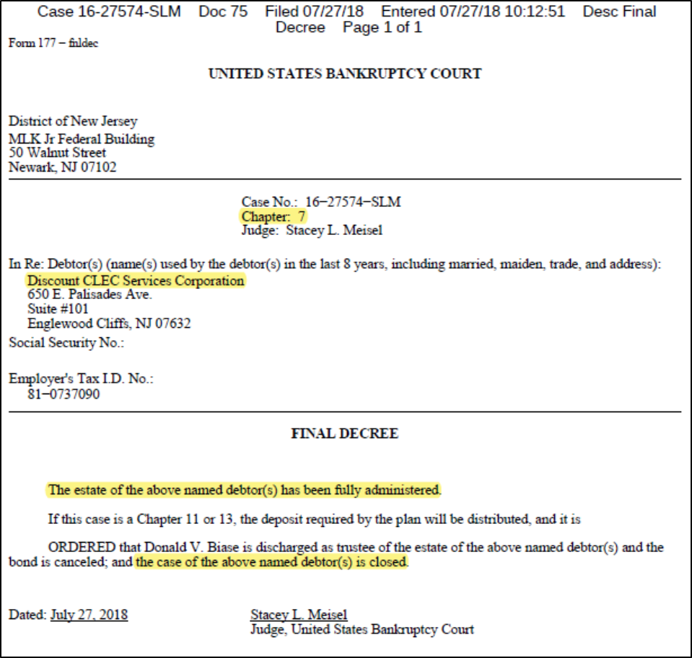

1. U.S. Securities and Exchange Commission,“*Bankruptcy: What Happens When Public Companies Go Bankrupt*,” modified January 19, 2016, <https://www.sec.gov/reportspubs/investor-publications/investorpubsbankrupthtm.html>, accessed August 11, 2023.
2. *See* Attachment A.
3. U.S. Securities and Exchange Commission,“*Bankruptcy: What Happens When Public Companies Go Bankrupt*,” modified January 19, 2016, <https://www.sec.gov/reportspubs/investor-publications/investorpubsbankrupthtm.html>, accessed August 11, 2023.
4. *See* 11 U.S.C. §721.
5. Florida Department of State Division of Corporations, Sunbiz Corporate Records Search, <https://dos.myflorida.com/sunbiz/>, accessed August 25, 2023.
6. FCC Form 499 is used to facilitate the quarterly and annual revenue reporting requirements for telecommunications companies. The FCC Form 499 Filer Database is a compilation of all telecommunications companies that are required to file either Form 499-Q or Form 499-A. It contains company information such as the company’s name, address, designated agent, and jurisdictions in which it provides service.
7. FCC, “FCC Form 499 Filer Database Detailed Information,” updated August 18, 2023, <https://apps.fcc.gov/cgb/form499/499detail.cfm?FilerNum=832119>, accessed August 25, 2023.