|  |  |  |  |
| --- | --- | --- | --- |
| State of Florida  pscSEAL | | Public Service Commission  Capital Circle Office Center ● 2540 Shumard Oak Boulevard Tallahassee, Florida 32399-0850  -M-E-M-O-R-A-N-D-U-M- | |
| DATE: | September 21, 2023 | | |
| TO: | Office of Commission Clerk (Teitzman) | | |
| FROM: | Division of Economics (Guffey, McClelland)  Office of the General Counsel (Stiller) | | |
| RE: | Docket No. 20230087-EU – Joint petition for renewal of territorial agreement and approval of a first amendment, in Monroe County, by Florida Keys Electric Cooperative Association, Inc. and Utility Board of the City of Key West. | | |
| AGENDA: | 10/03/23 – Regular Agenda – Proposed Agency Action – Interested Persons May Participate | | |
| COMMISSIONERS ASSIGNED: | | | All Commissioners |
| PREHEARING OFFICER: | | | Clark |
| CRITICAL DATES: | | | None |
| SPECIAL INSTRUCTIONS: | | | None |

Case Background

On August 2, 2023, Florida Keys Electric Cooperative Association, Inc. (FKEC) and the Utility Board of the City of Key West, d/b/a Keys Energy Services (KEYS), filed a joint petition for renewal of territorial agreement and approval of a first amendment (First Amendment). The Commission approved a territorial agreement between FKEC and KEYS, (collectively, the parties) in 1991 (1991 Territorial Agreement).[1] The 1991 Territorial Agreement expired in September 2021 at the end of its 30-year term and automatically renewed for an additional 30 years. Although the two utilities did not seek Commission approval of their renewed 1991 Territorial Agreement at the end of its first 30-year term, as required by the 1991 Territorial Agreement, the parties stated that they have abided by the conditions of the agreement with the exception of the provision of electric service to Pigeon Key.[2]

The proposed First Amendment addresses a modification to the existing service territory boundary to allow FKEC to provide electric service to Pigeon Key, which currently lies in KEYS’ service territory. Pigeon Key was designated as a National Historic Landmark in 1990. In 1992, the Pigeon Key Foundation, Inc., (Foundation) was created as a **non-profit** organization to preserve and protect Pigeon Key. The Foundation has been utilizing self-service generators during the past 29 years and has requested electric service and hence the need for the proposed First Amendment.

The 1991 Territorial Agreement and territorial map are Attachment A and the proposed First Amendment, including the map depicting the modified service boundary, is included in Attachment B to this recommendation.

During the review process, staff issued two data requests to the parties on August 10 and 29, 2023. Responses were received on August 23 and on September 7, 2023. Staff also had an informal telephonic meeting with the parties on September 7, 2023. This recommendation addresses the renewal of the 1991 Territorial Agreement, proposed First Amendment to the 1991 Territorial Agreement and associated revised boundary map. The Commission has jurisdiction over this matter pursuant to Sections 366.04 and 366.05, Florida Statutes (F.S.).

Discussion of Issues

Issue :

 Should the Commission approve the renewal of the 1991 Territorial Agreement and the proposed First Amendment to the 1991 Territorial Agreement and associated revised boundary map between Florida Keys Electric Cooperative Association, Inc. and the Utility Board of the City of Key West, d/b/a Keys Energy Services, in Monroe County?

Recommendation:

 Yes, the Commission should approve the renewal of the 1991 Territorial Agreement and the proposed First Amendment to the 1991 Territorial Agreement and associated revised boundary map between FKEC and KEYS in Monroe County. The renewal of the 1991 Territorial Agreement and proposed First Amendment would enable FKEC to provide electric service to the Foundation pursuant to the proposed revised service boundary and avoid duplication of service. (Guffey, McClelland)

Staff Analysis:

 FKEC is a rural electric cooperative and KEYS is a municipal electric utility. Pursuant to Section 366.04(2)(d), F.S., and Rule 25-6.0440(2), F.A.C., the Commission has the jurisdiction to approve territorial agreements between and among rural electric cooperatives, municipal electric utilities, and other electric utilities. Unless the Commission determines that the agreement will cause a detriment to the public interest, the agreement should be approved.[3]

1991 Territorial Agreement

FKEC and KEYS entered into an electric service territorial agreement in June 1991, which the Commission approved in September 1991.[4] The 1991 Territorial Agreement which had a 30-year term, clearly identified the geographic areas to be served by each utility which allowed the two utilities to prevent potential uneconomic duplication of facilities and hazardous situations within their specified service territories. There were no customer or facility transfers contemplated in the 1991 Agreement.

The 1991 Territorial Agreement’s 30-year term expired in September 2021 and automatically renewed for an additional 30 years since neither of the parties gave notice to not renew. Paragraph 11 of the 1991 petition recognized that any modifications, changes, or corrections must be approved by this Commission. Additionally, Section 5.1 of the 1991 Agreement states that:

each such renewal of this Agreement shall require prerequisite approval of the Commission with the same effect as the original Commission approval of this Agreement as required and approved for in Article 4 hereof.

The parties explained that due to staffing changes there was a delay in filing a petition with the Commission for renewal of the 1991 Territorial Agreement. However, the parties stated that with the exception of the provision of electric service to Pigeon Key, which is discussed below and the subject of the proposed First Amendment, the parties abided by the 1991 Territorial Agreements and have had no disputes.

Proposed First Amendment to the 1991 Agreement

Through the proposed First Amendment to the 1991 Territorial Agreement, the parties seek to modify the service territory boundary and allow FKEC to provide electric service to Pigeon Key at the request of the Foundation. Prior to the Foundation’s request for electric service, neither KEYS nor FKEC provided electric service to the island. Provision of electricity by KEYS to the Pigeon Key poses significant engineering and economic challenges due to the geographic and environmental conditions. Although KEYS owns electric transmission poles approximately 350 feet from the island, the poles do not carry distribution lines and KEYS does not have the ability to step down the electricity. The parties state that if KEYS were to extend the distribution lines to Pigeon Key, the most economical method to do so would cost approximately $6 million.

The costs incurred by FKEC to add facilities within its service boundary in order to connect to the Foundation’s point of service is $6,011.53.[5] Considering the above-stated challenges if KEYS were to provide electric service to the Foundation, allowing FKEC to provide electric service to the Foundation is the most economical and practical solution.

In response to staff discovery, the parties stated that FKEC has been providing service to the Foundation since May 2021.[6] The parties acknowledge that they should have requested Commission approval of the First Amendment to the 1991 Agreement prior to providing service to the Foundation; however, the parties explained that due to staffing changes there was a delay in filing a petition with the Commission.

Pursuant to Rule 25-6.0440(1)(d), F.A.C., affected customers must be notified of difference in service and rates. In June 2023, FKEC provided the Foundation a customer notice indicating the rates and tariffs that would be applicable to the Foundation. The Foundation receives electric service under FKEC’s General Service Demand tariff. In response to staff’s data request, the parties provided a copy of FKEC’s customer notification and applicable tariff information.[7] The parties informed staff that there have been no customer comments or objections regarding this proposed territorial amendment and no customer comments have been filed in the docket file.

Conclusion

After review of the petition, the 1991 Territorial Agreement, the First Amendment to the 1991 Territorial Agreement, evaluation of responses to staff’s data requests, and informal telephonic meeting with the parties, staff believes that the renewal of the 1991 Territorial Agreement and First Amendment would not be a detriment to the public interest and would enable FKEC to serve the Pigeon Key Foundation in an efficient manner. It appears that the 1991 Agreement and First Amendment and associated modified boundary map would eliminate any potential uneconomic duplication of facilities and not cause a decrease in the reliability of electric service. As such, staff believes that the Commission should approve the renewal of the 1991 Territorial Agreement between FKEC and KEYS along with the proposed First Amendment to the 1991 Territorial Agreement and associated revised service boundary map, effective on the date of the final Commission order. FKEC and KEYS should be put on notice that any further modifications to the Territorial Agreement should be promptly submitted to the Commission for its review and approval.

Issue :

 Should this docket be closed?

Recommendation:

 Yes. If no protest is filed by a person whose substantial interests are affected within 21 days of the issuance of the Order, this docket should be closed upon the issuance of a Consummating Order. (Stiller)

Staff Analysis:

 If no protest is filed by a person whose substantial interests are affected within 21 days of the issuance of the Order, this docket should be closed upon the issuance of a Consummating Order.

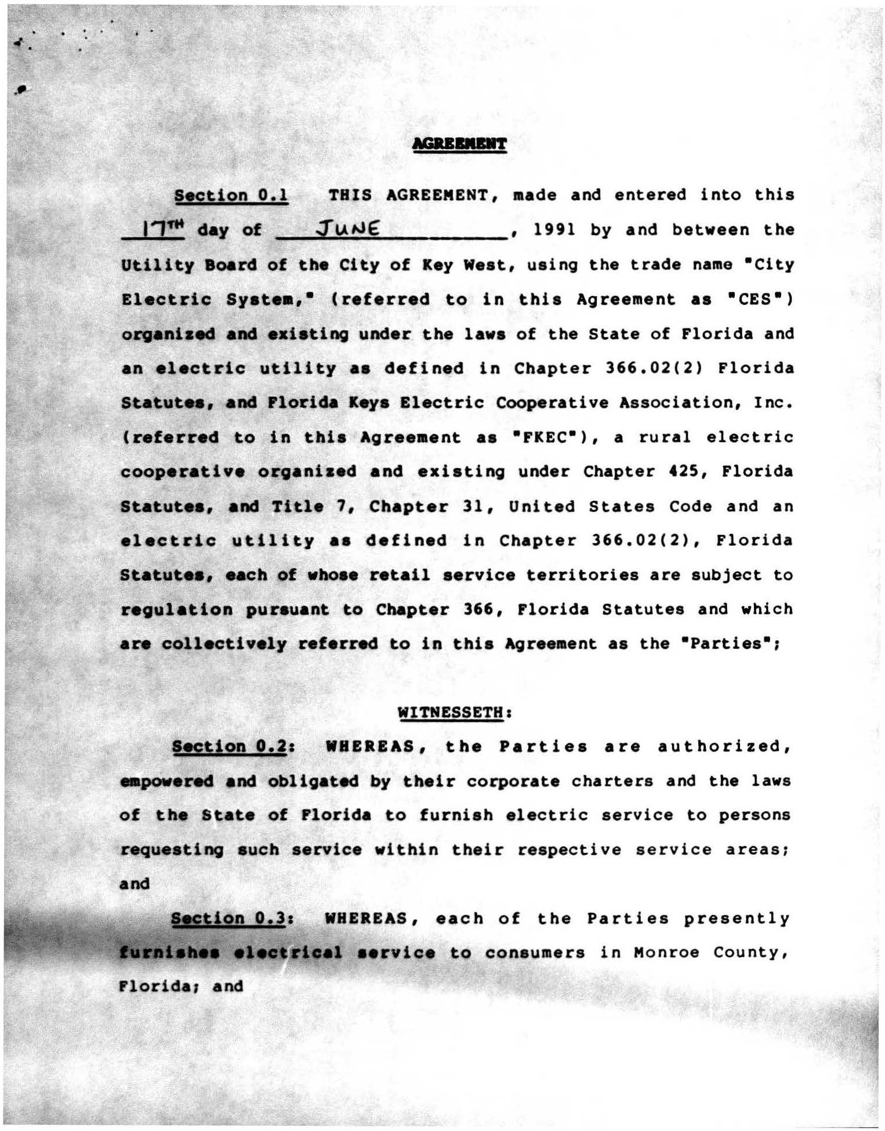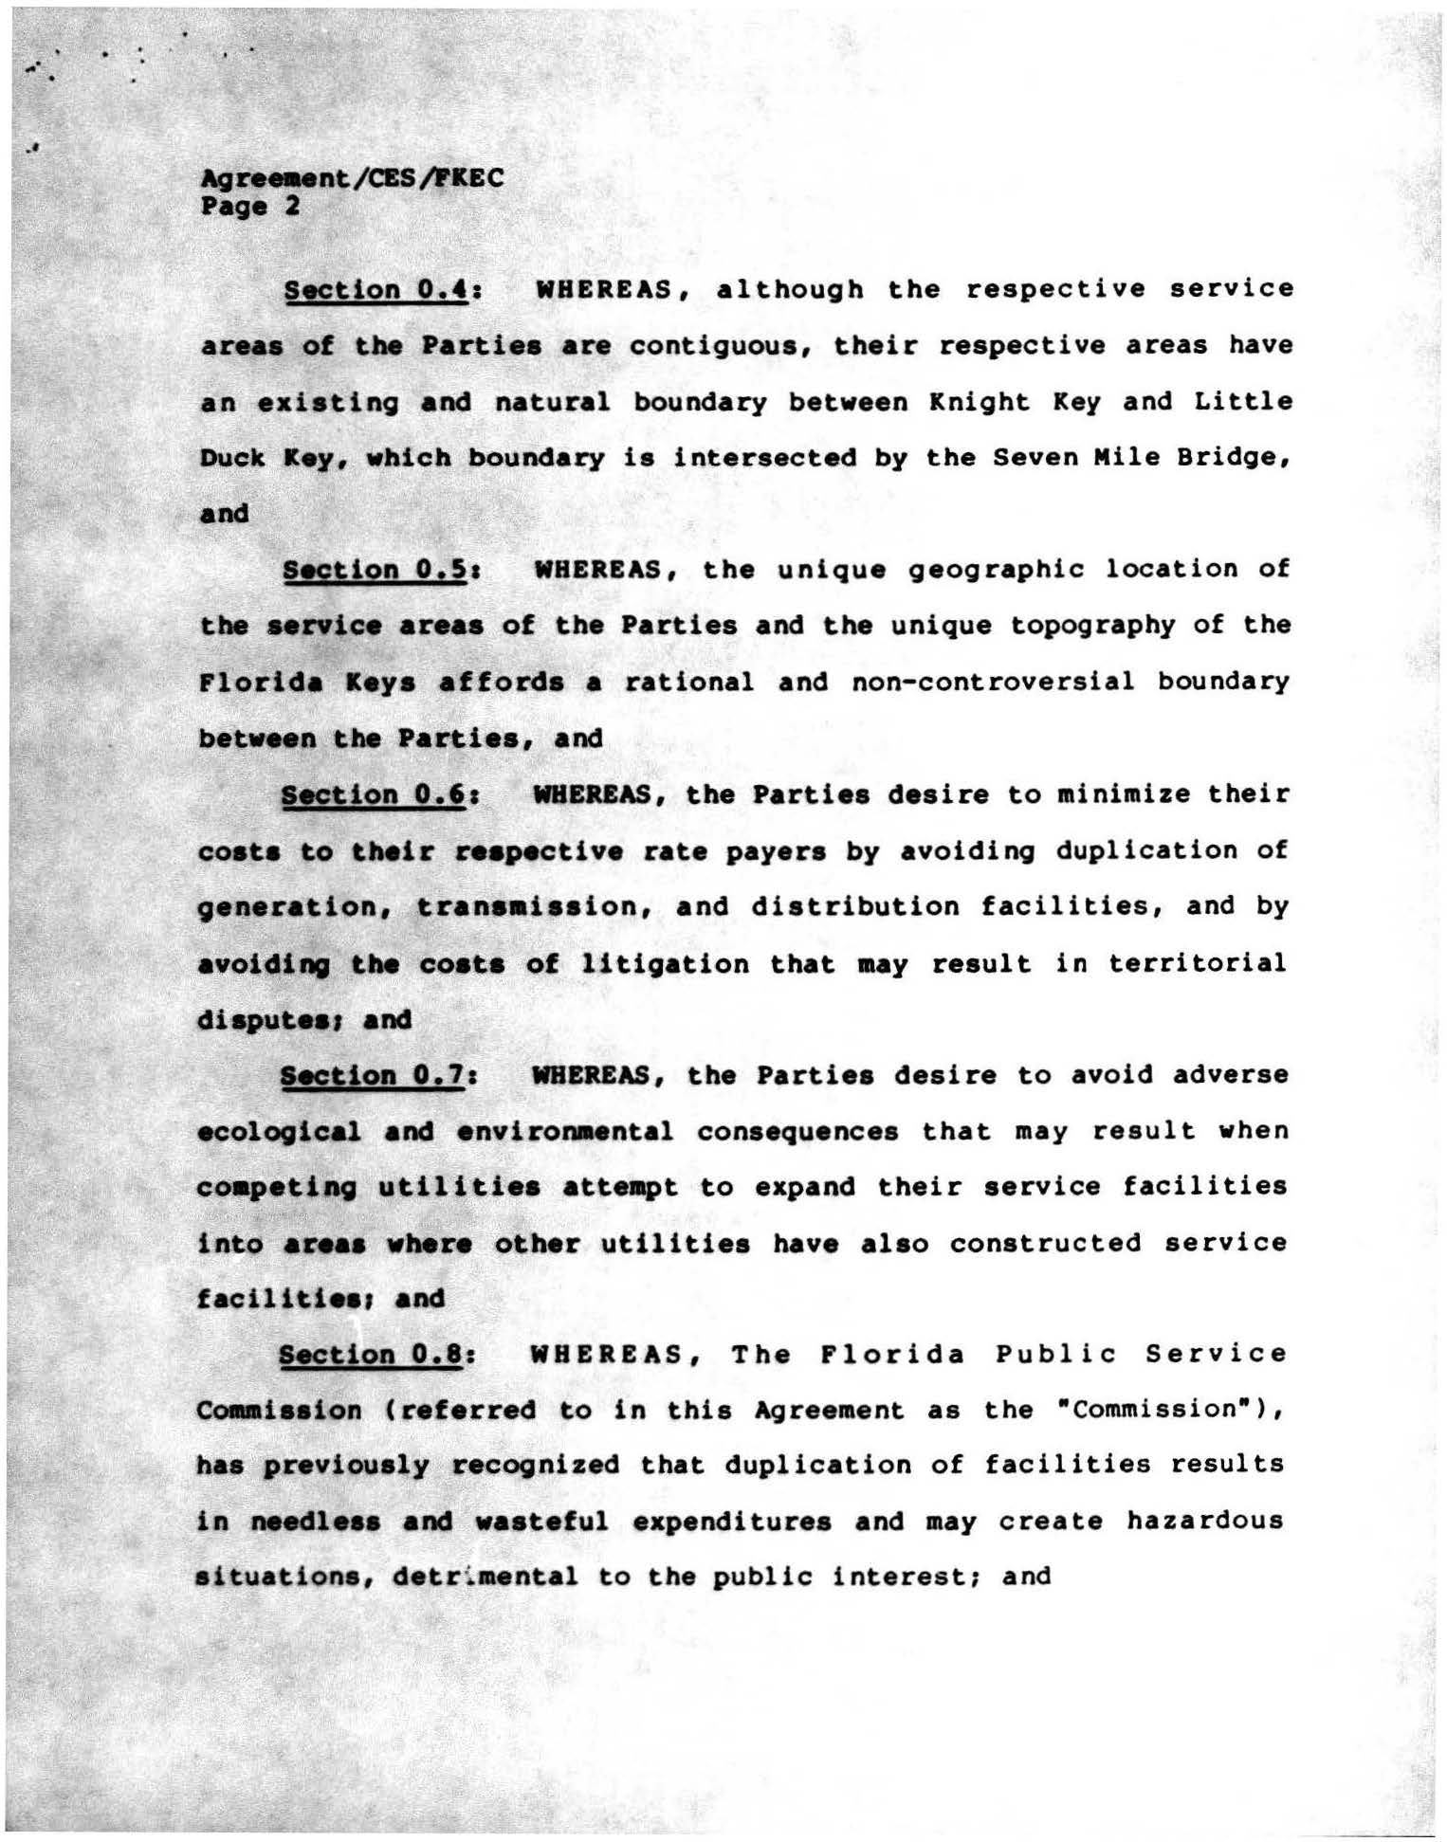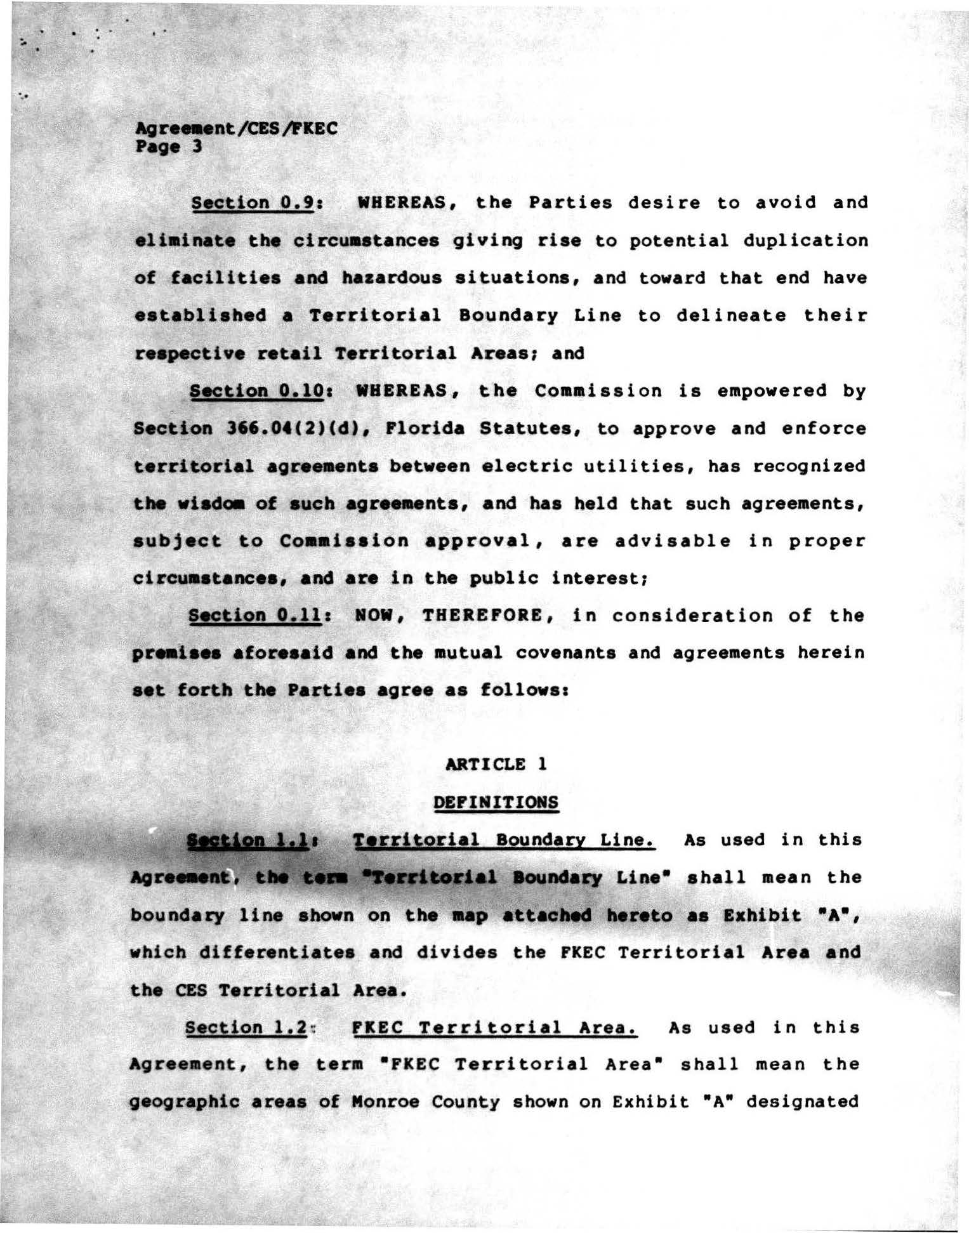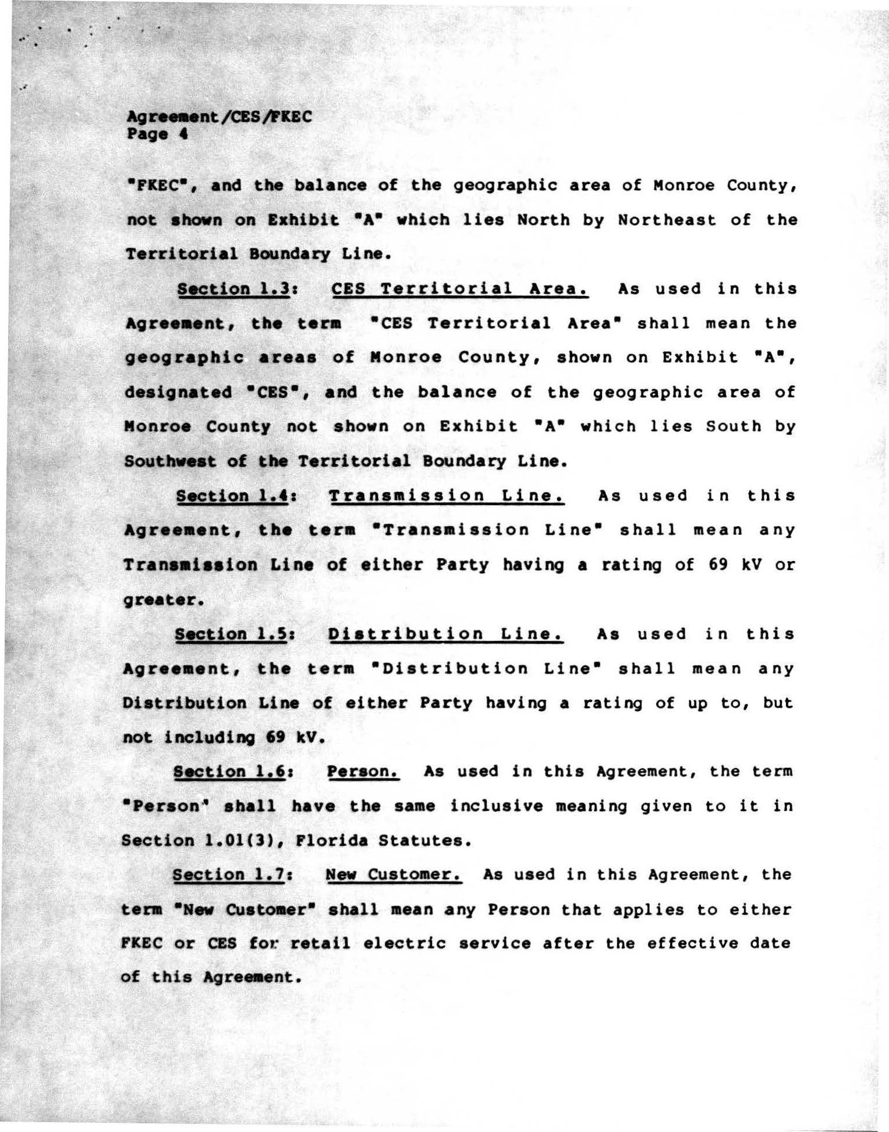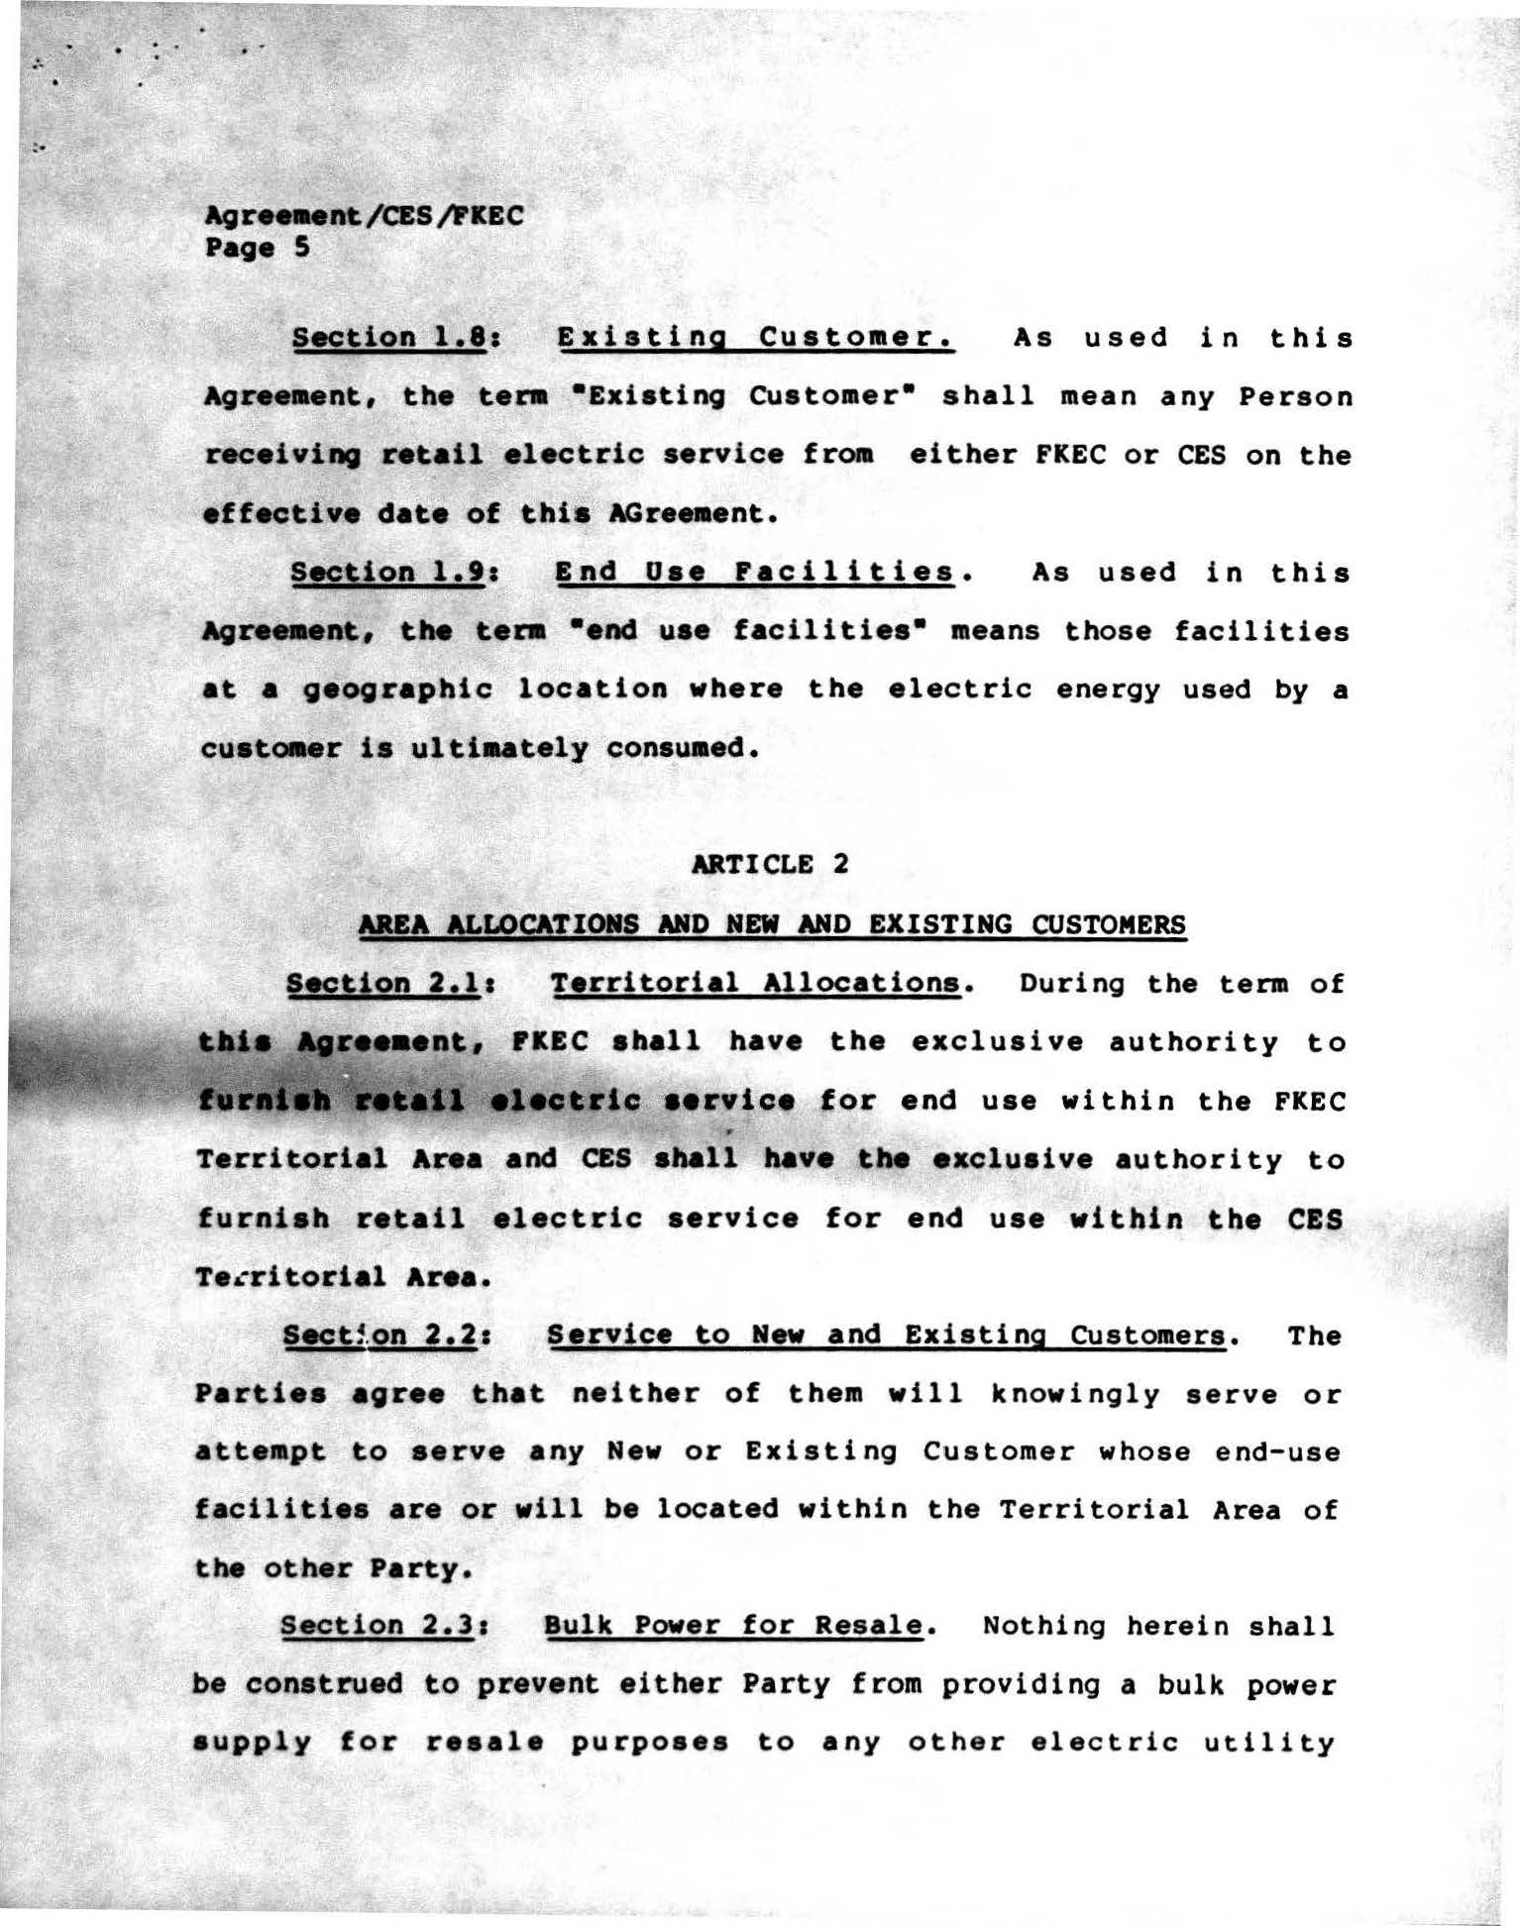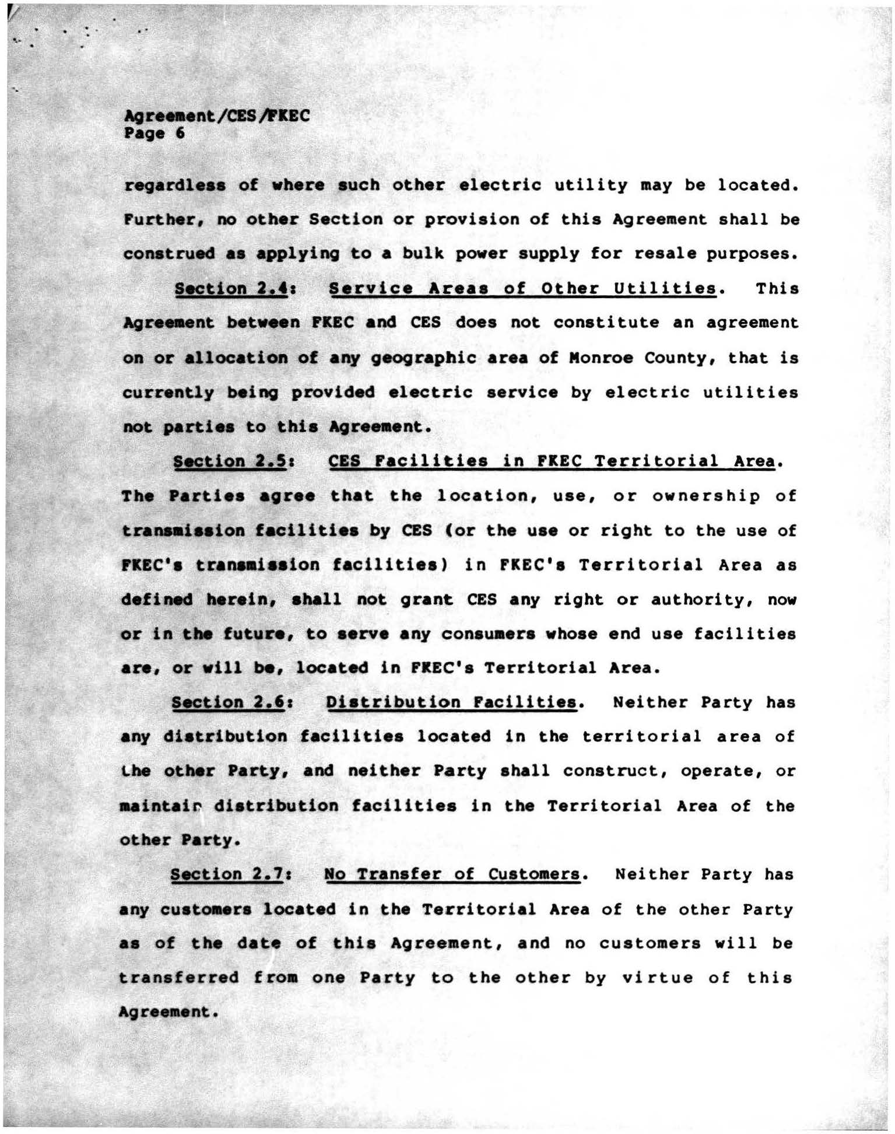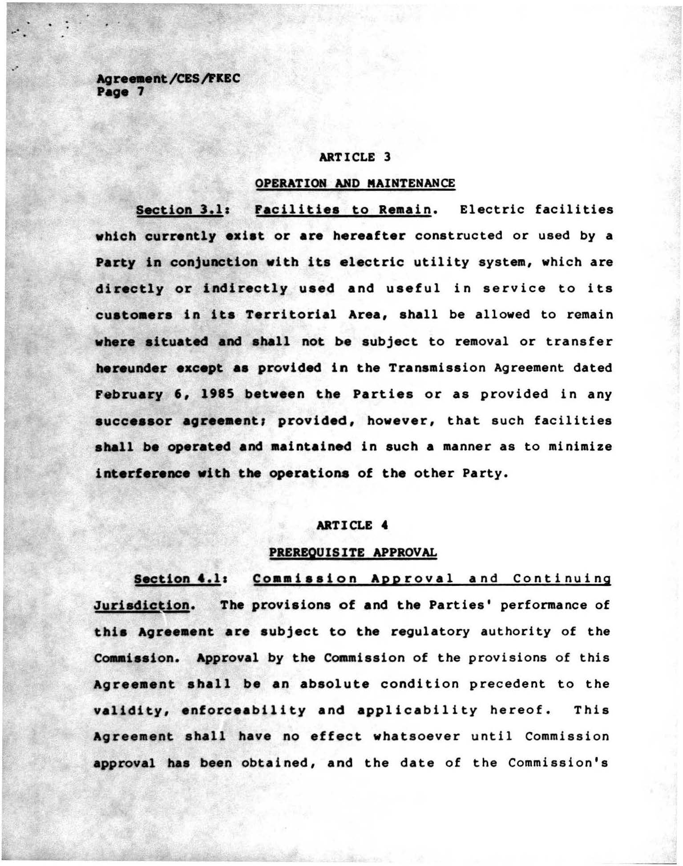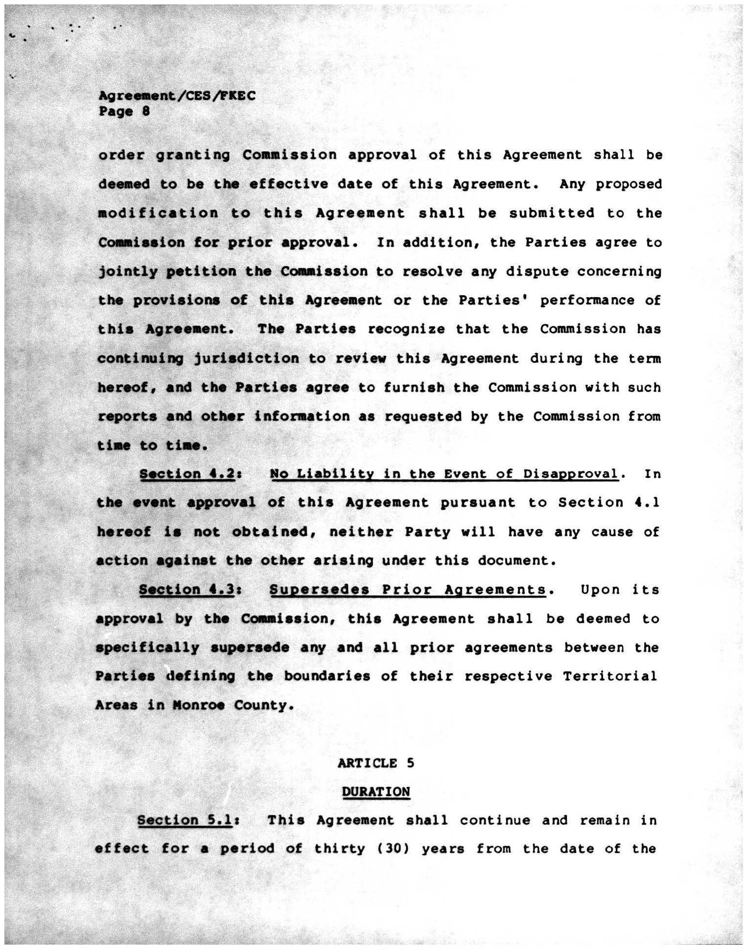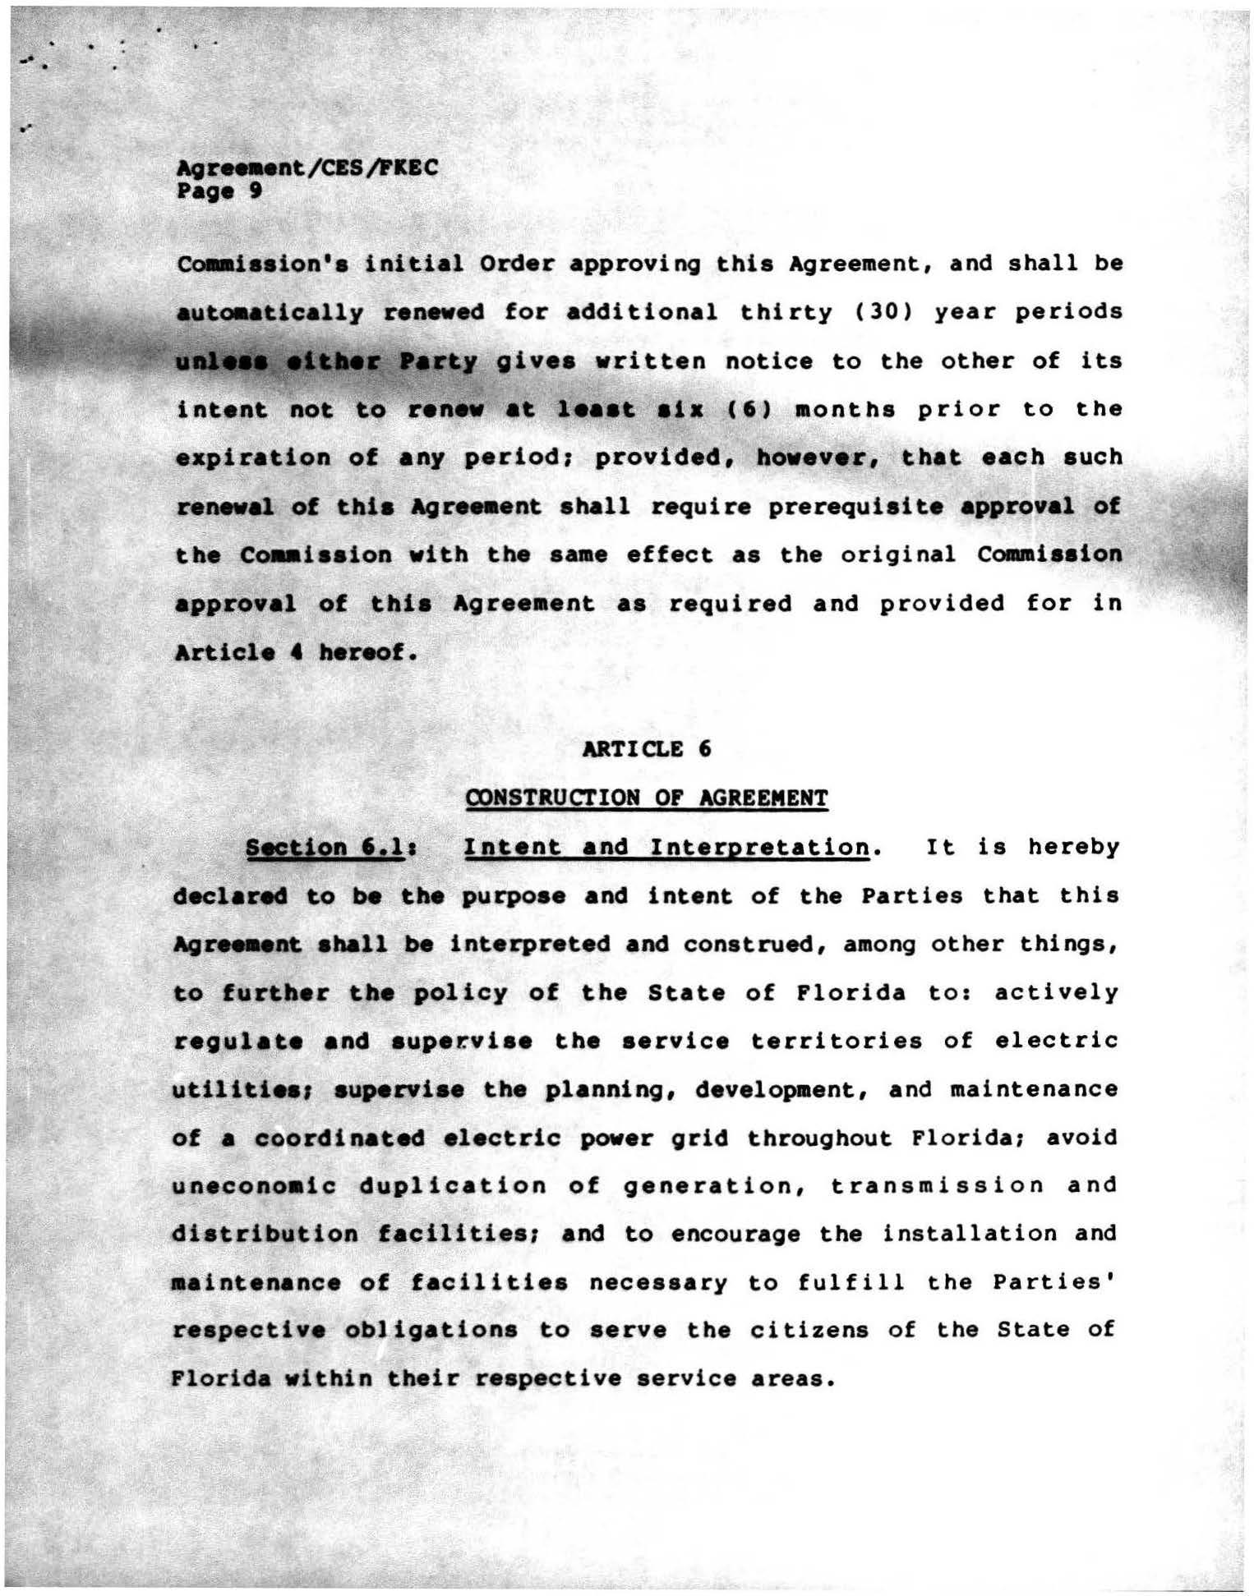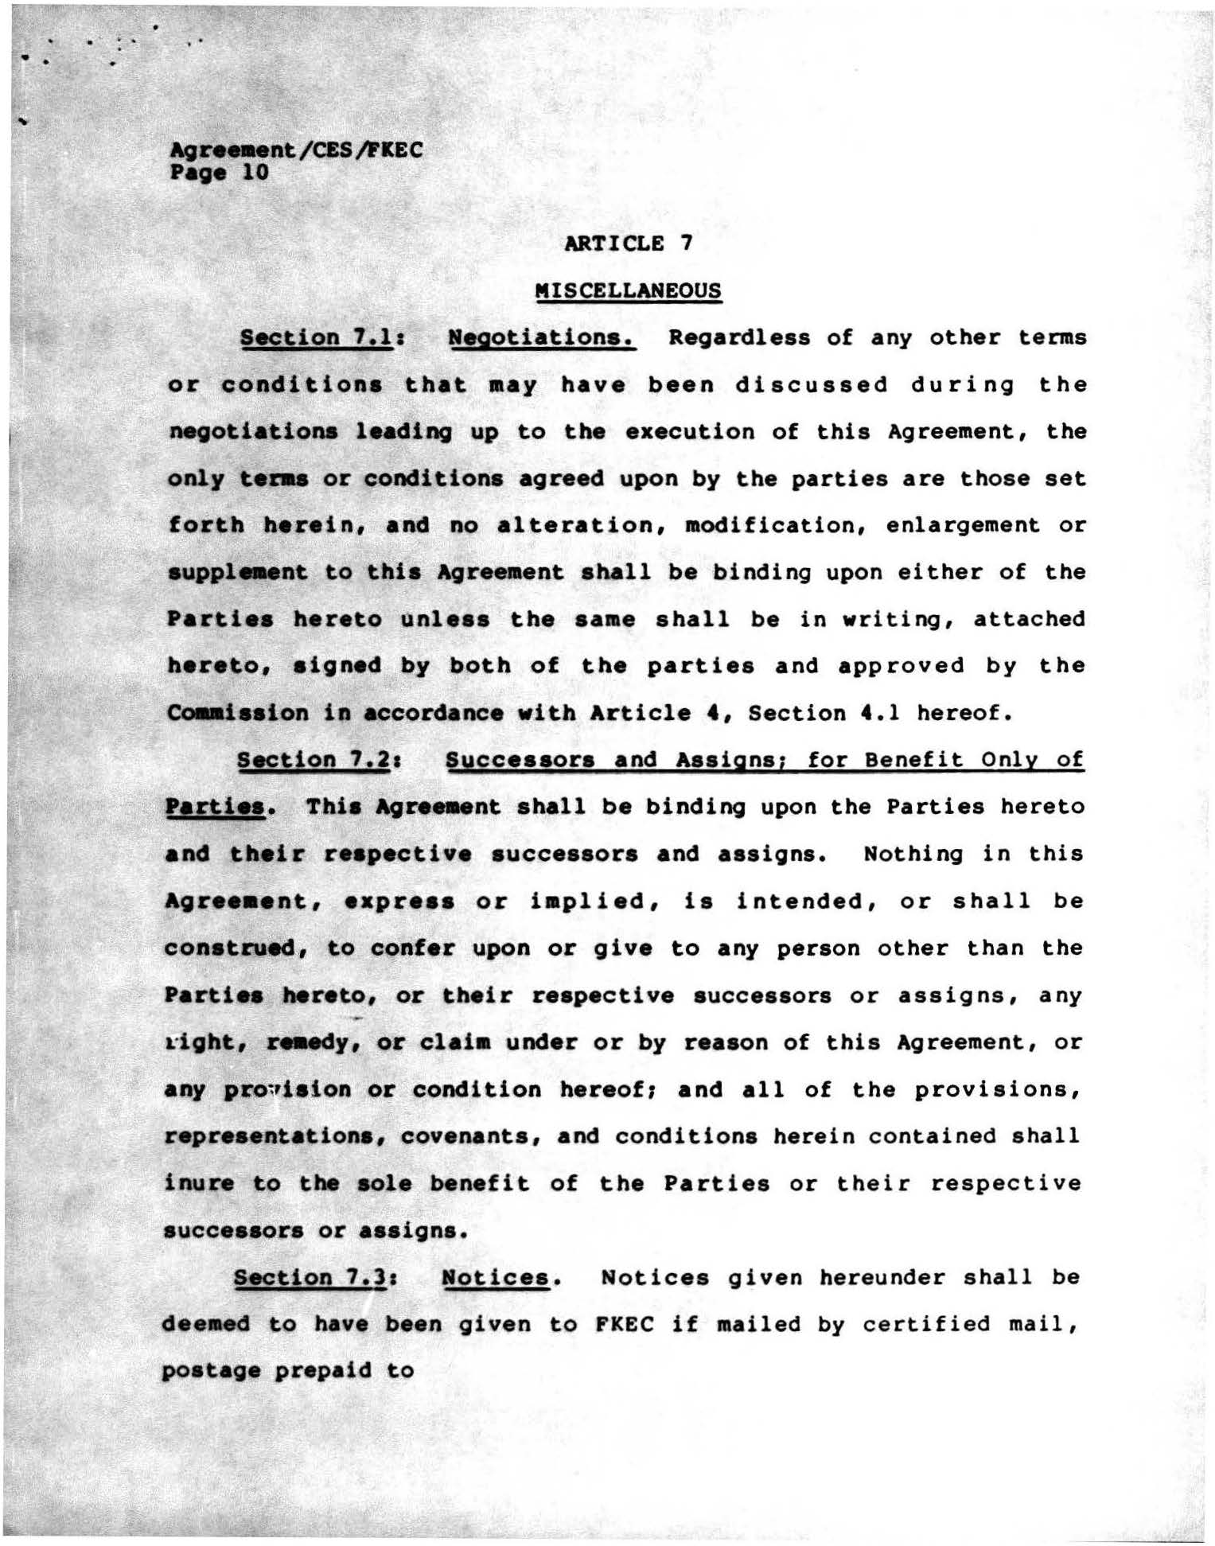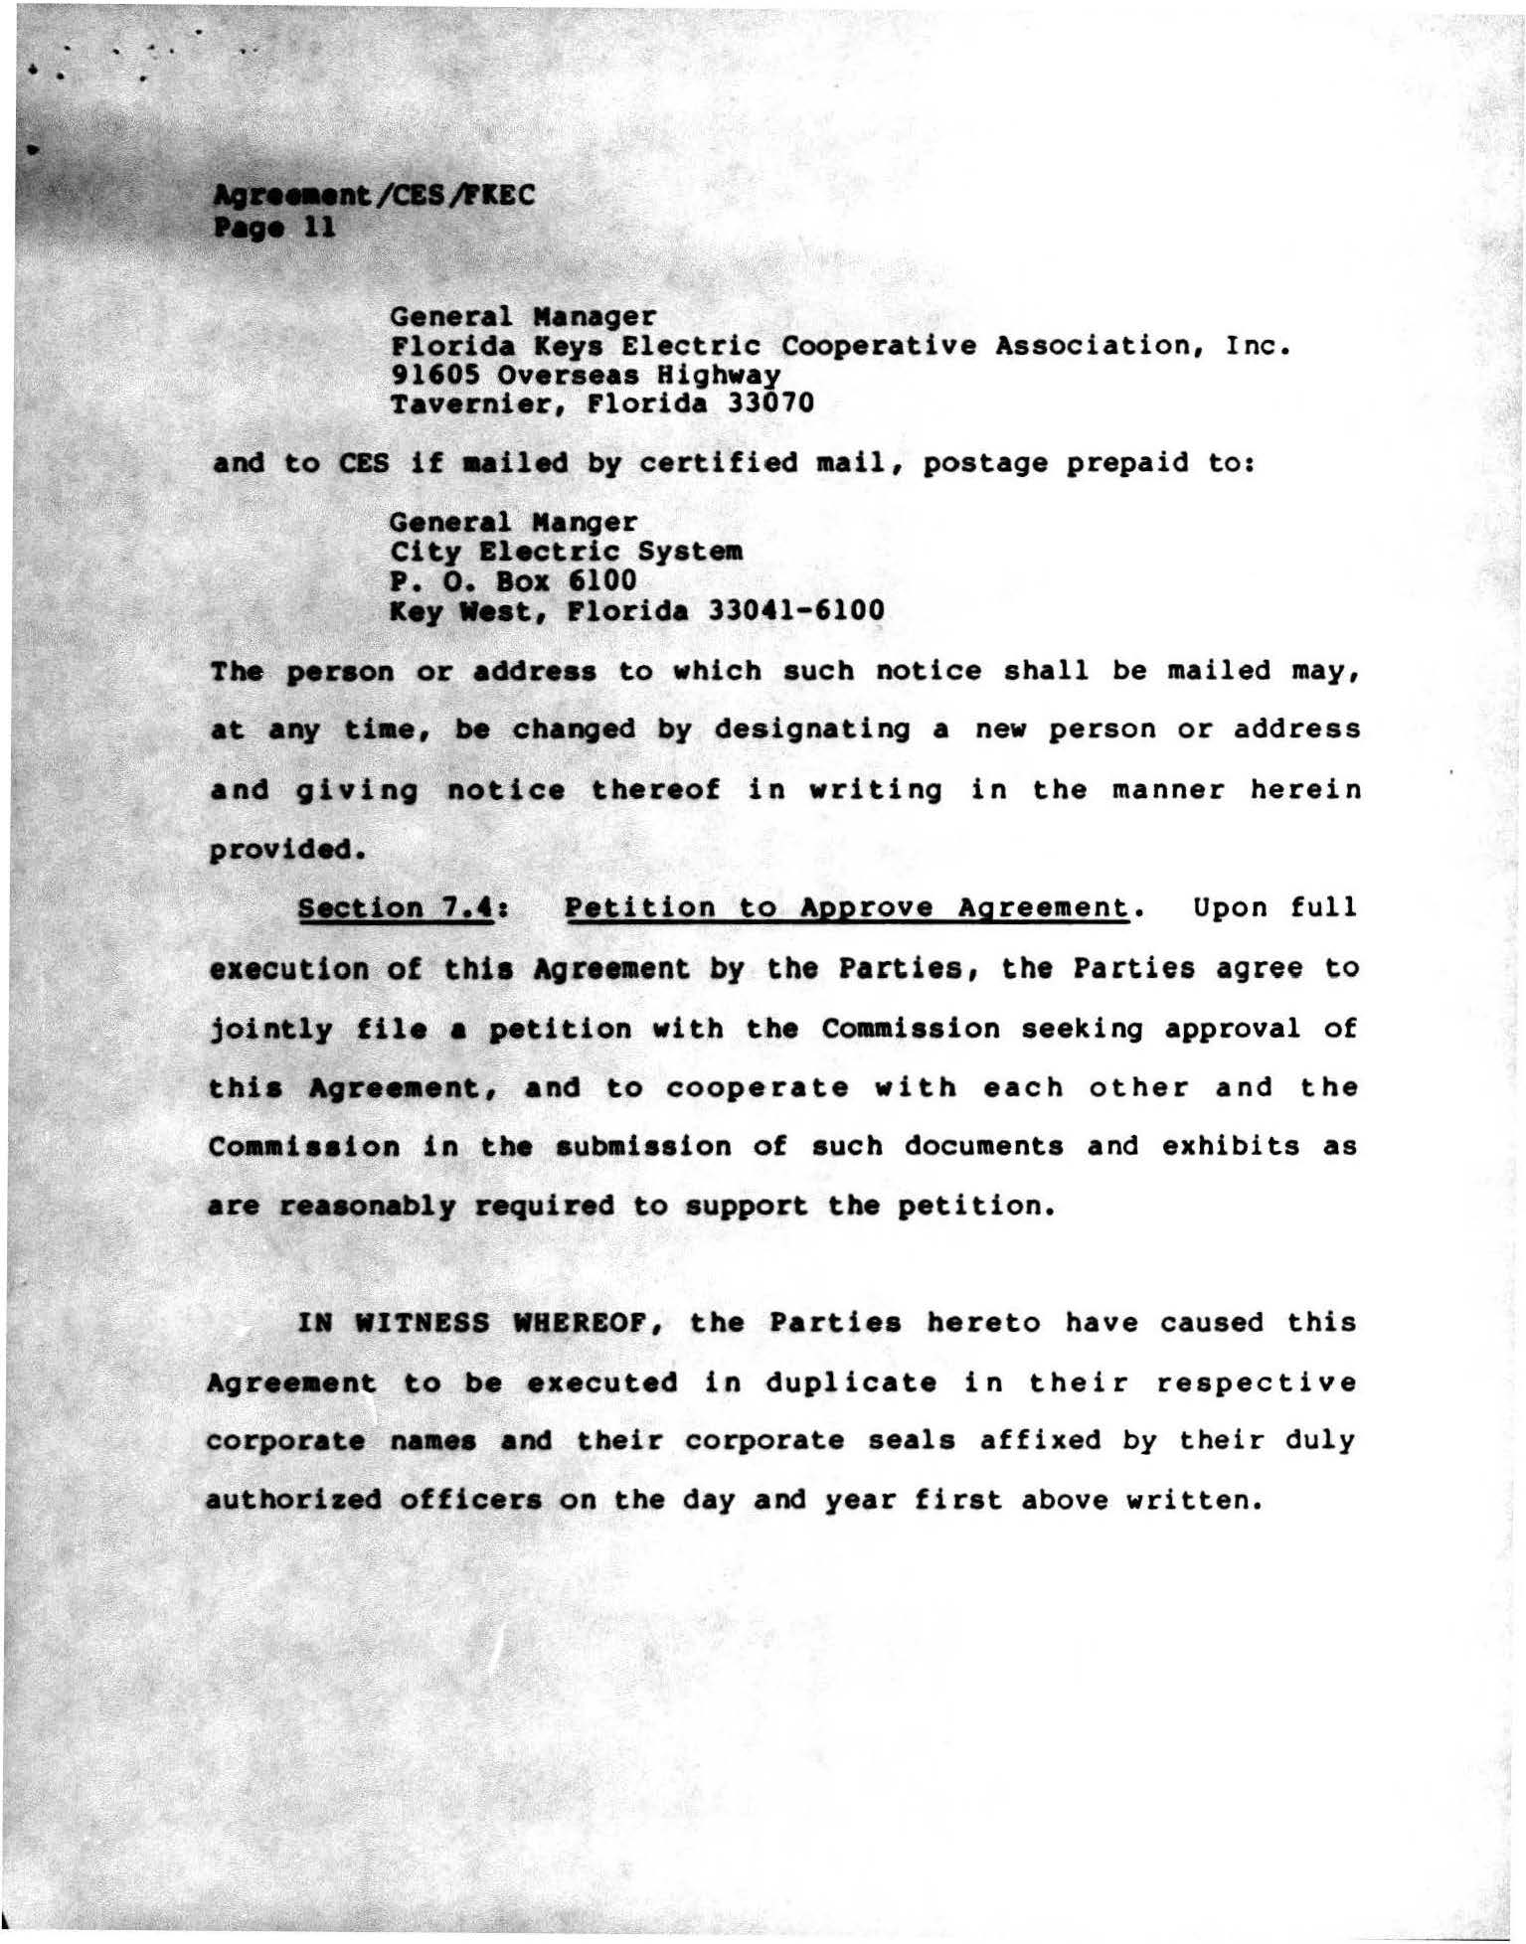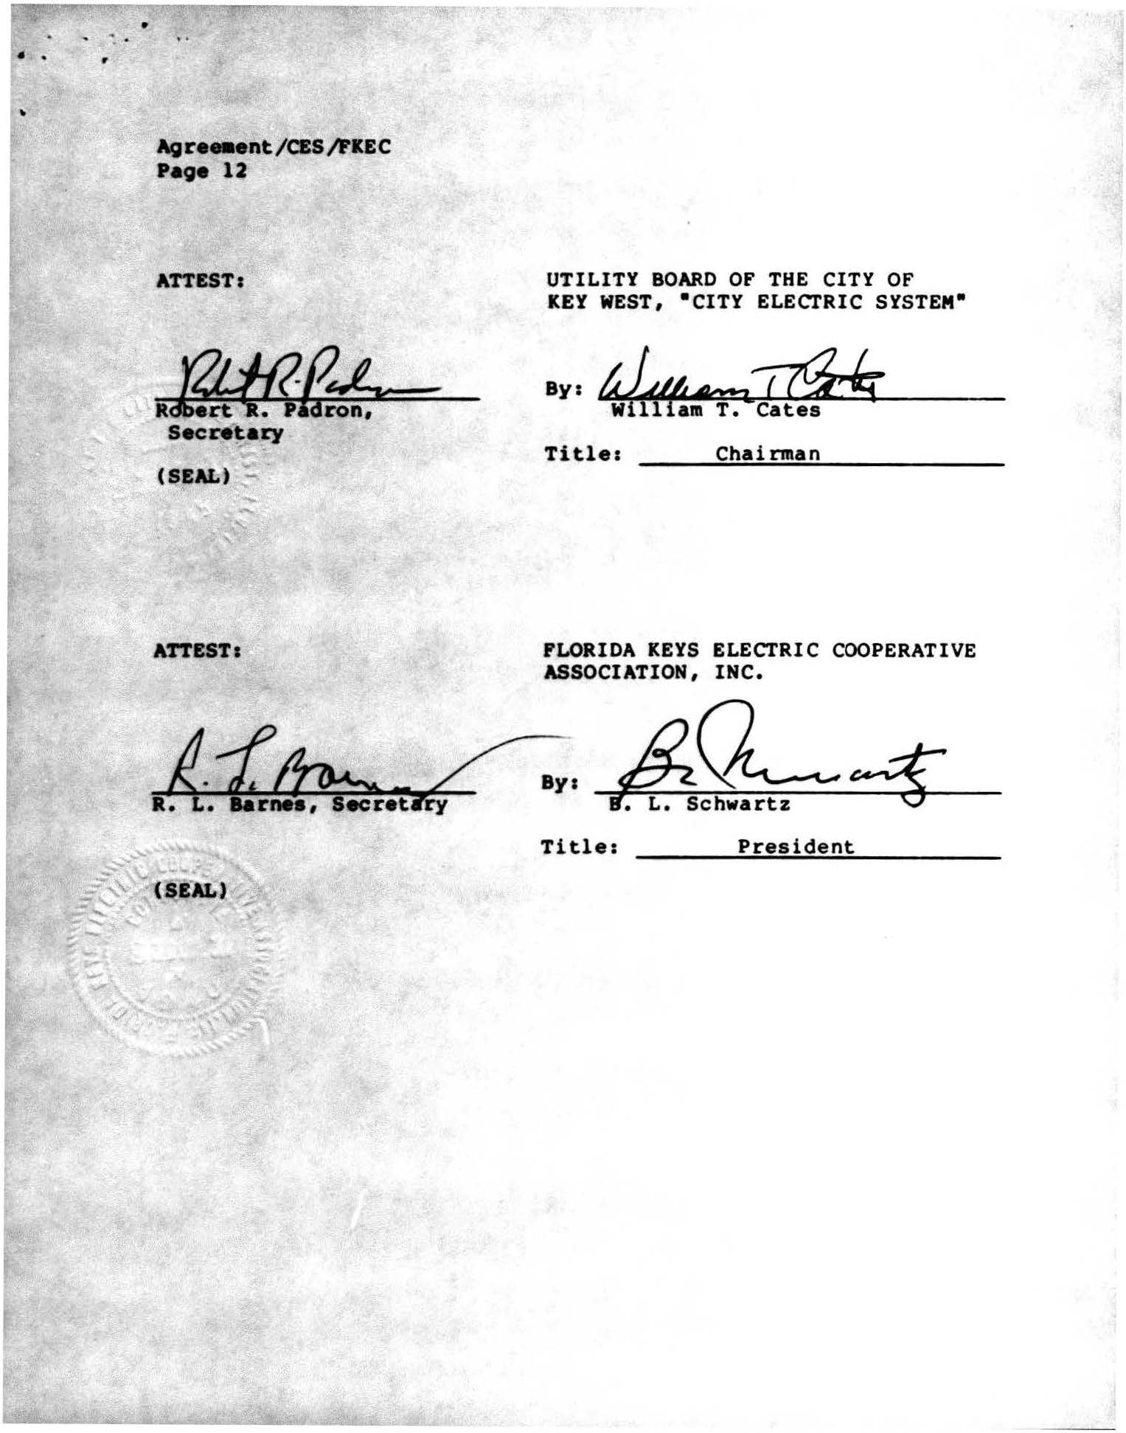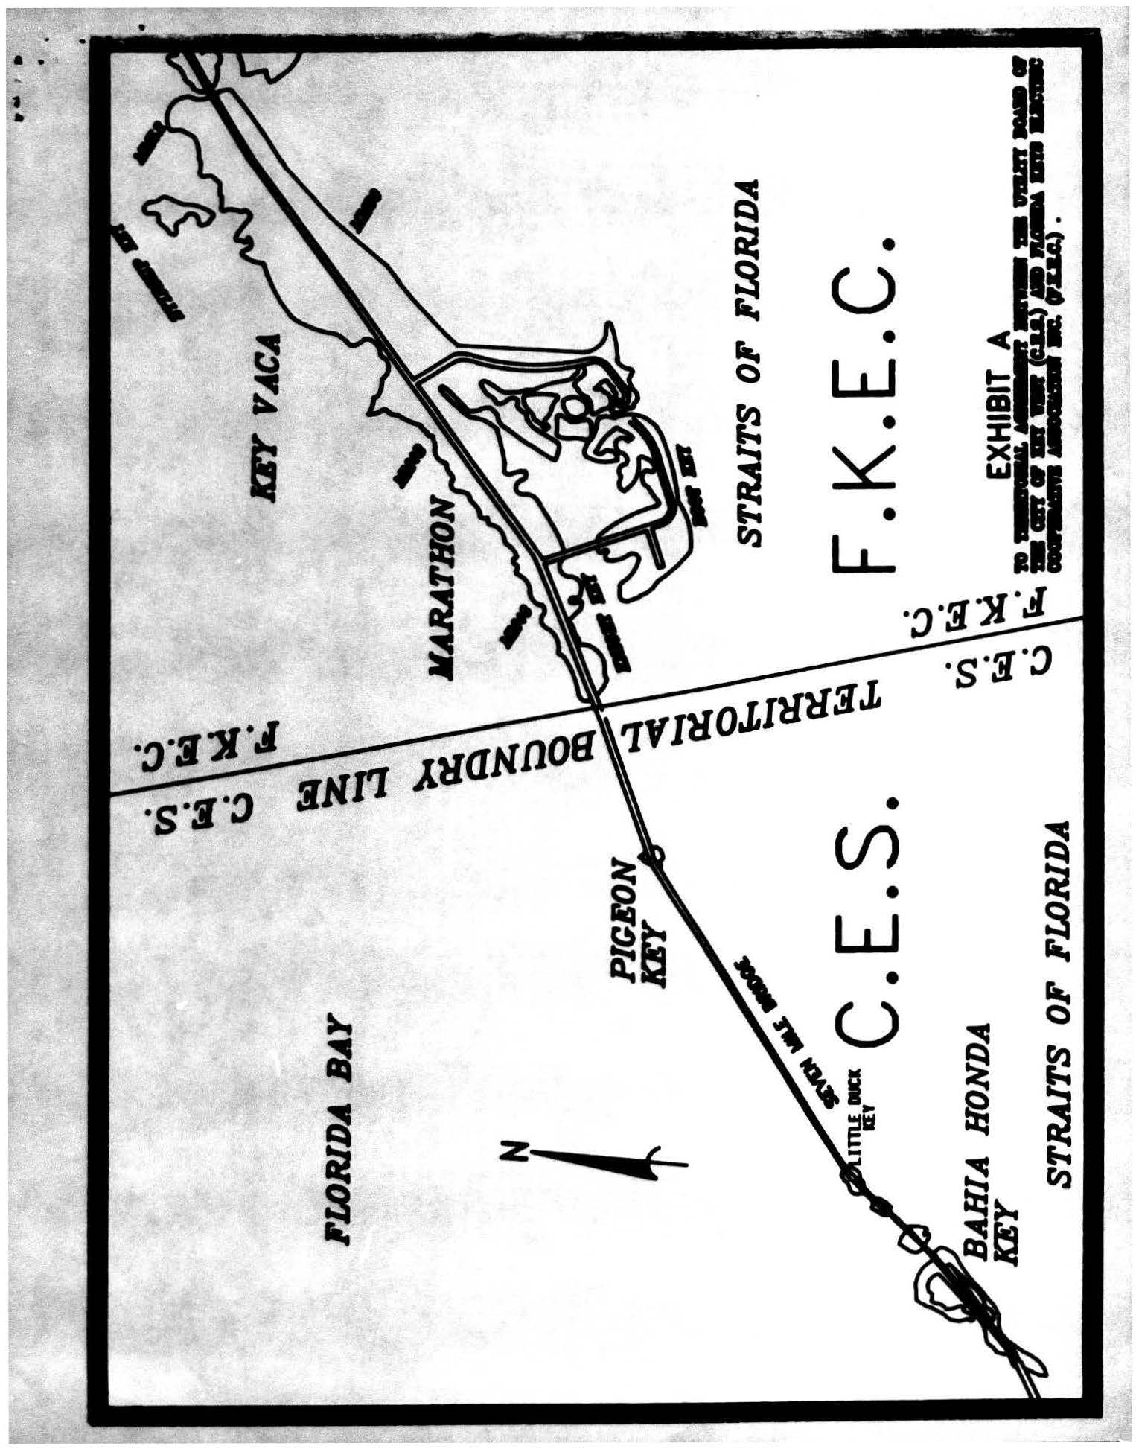

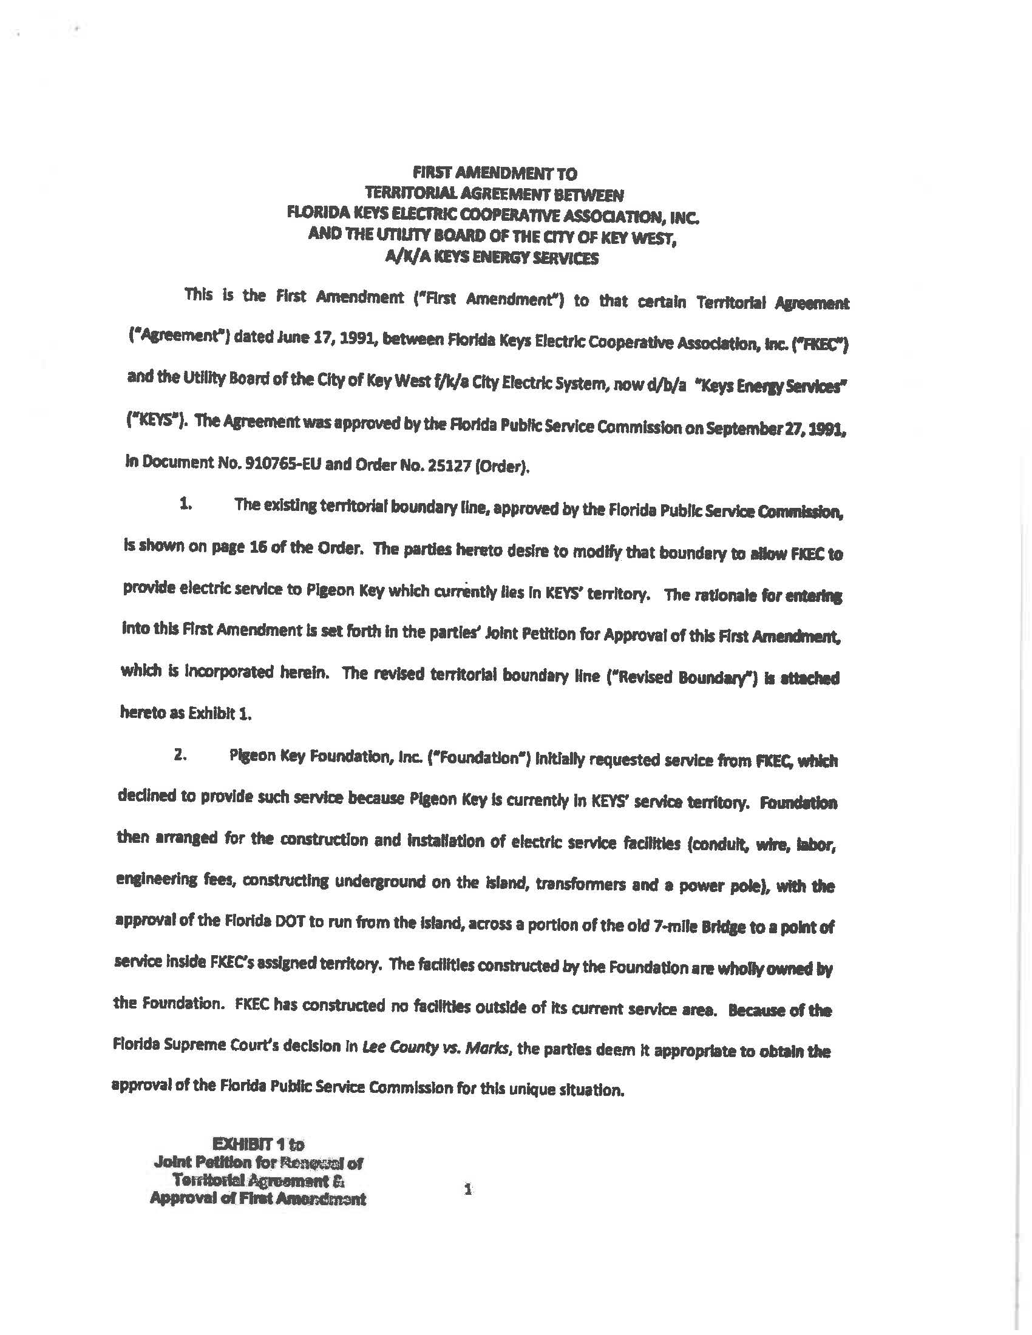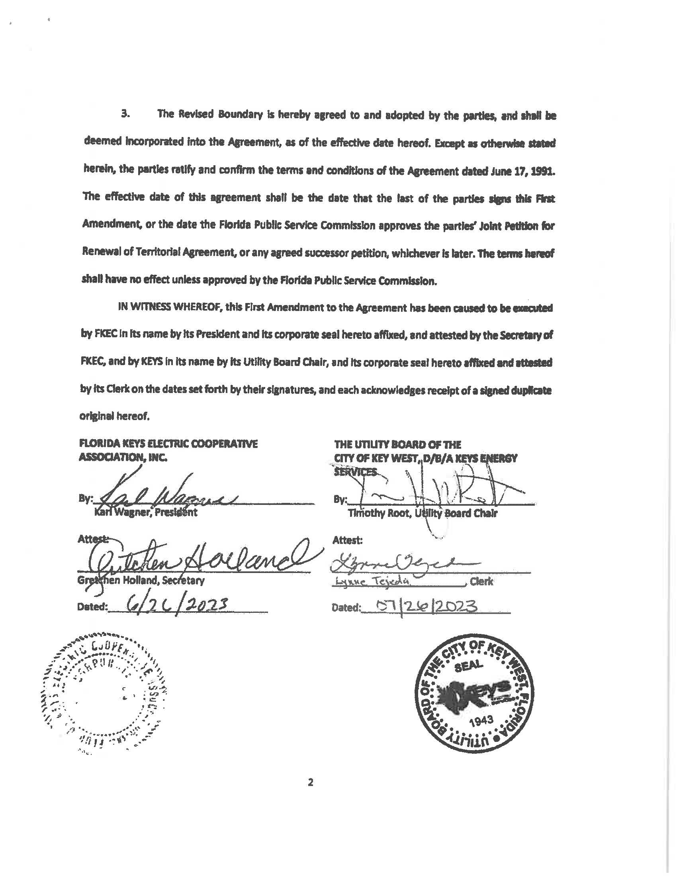

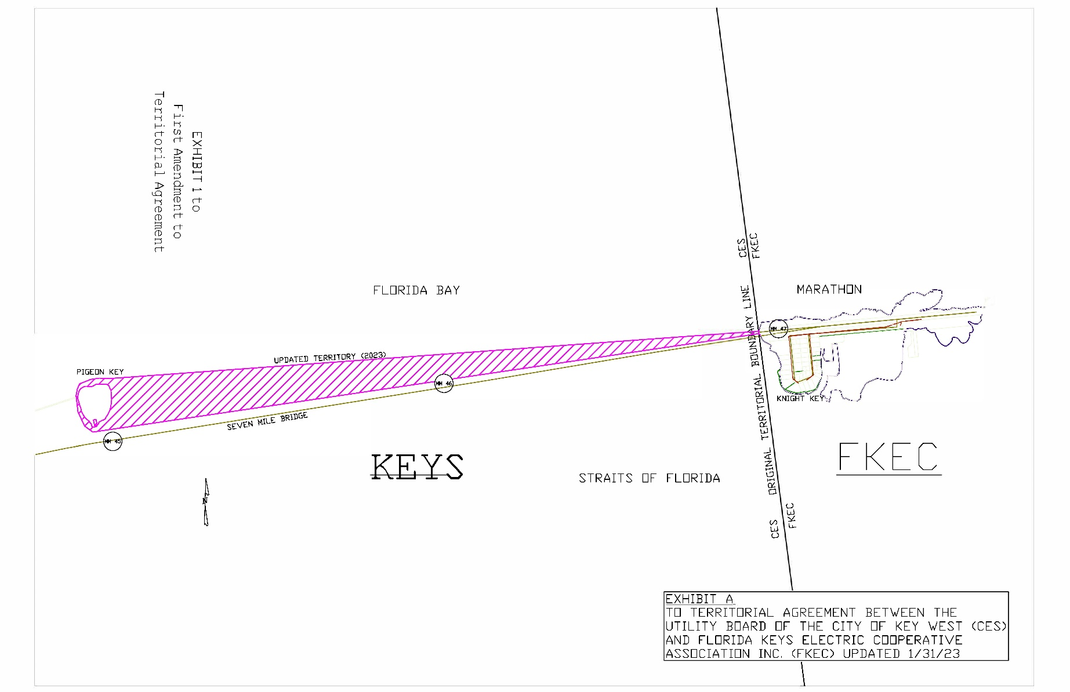

1. Order No. 25127, issued on September 27, 1991, in Docket No. 910765-EU, *In re: joint Petition of Florida Keys Electric Cooperative association, Inc., and the Utility board of the City of Key West for approval of a territorial agreement.*
2. Response No. 2 in Staff’s First Data Request, Document No. 04944-2023.
3. Utilities Commission of the City of New Smyrna Beach v. Florida Public Service Commission, 469 So. 2d 731 (Fla. 1985).
4. Order No. 25127, issued on September 27, 1991, in Docket No. 910765-EU, *In re: joint Petition of Florida Keys Electric Cooperative association, Inc., and the Utility board of the City of Key West for approval of a territorial agreement*.
5. Paragraph 11 of the petition and customer notification referenced in Response No. 10 in staff’s First Data Request.
6. Response No. 2 in Staff’s First Data Request, Document No. 04944-2023.
7. Response No. 11 and attachments in Staff’s First Data Request, Document No. 04944-2023.