|  |  |  |  |
| --- | --- | --- | --- |
| State of Florida  pscSEAL | | Public Service Commission  Capital Circle Office Center ● 2540 Shumard Oak Boulevard Tallahassee, Florida 32399-0850  -M-E-M-O-R-A-N-D-U-M- | |
| DATE: | September 21, 2023 | | |
| TO: | Office of Commission Clerk (Teitzman) | | |
| FROM: | Division of Economics (Ward, Hampson)  Office of the General Counsel (Brownless) | | |
| RE: | Docket No. 20230068-EI – Petition for approval of smart outdoor lighting services pilot program by Duke Energy Florida, LLC. | | |
| AGENDA: | 10/03/23 – Regular Agenda – Tariff Filing – Interested Persons May Participate | | |
| COMMISSIONERS ASSIGNED: | | | All Commissioners |
| PREHEARING OFFICER: | | | Administrative |
| CRITICAL DATES: | | | 01/15/24 (8-Month Effective Date) |
| SPECIAL INSTRUCTIONS: | | | None |

Case Background

On May 15, 2023, Duke Energy Florida, LLC (Duke or utility) filed a petition for approval of the smart outdoor lighting services pilot program (pilot program). Specifically, Duke is proposing to make modifications to Tariff Sheet Nos. 6.280 and 6.281 to allow certain customers who take service under the existing LS-1 lighting tariff to set their own personal lighting schedule and to dim the lights. Currently, all lights offered under the tariff operate from dusk to dawn.

In Order No. PSC-2023-0182-PCO-EI, the Commission suspended Duke’s proposed modifications to Tariff Sheet Nos. 6.280 and 6.281 to allow staff time to gather additional data.[1] On June 26, 2023, staff issued its first data request, to which Duke responded on July 17, 2023. Staff issued a second data request on July 28, 2023, to which Duke responded on August 11, 2023. Staff noticed a scrivener’s error in the tariff sheets filed with the petition, and Duke included updated legislative and clean versions of the tariff sheets in response to staff’s first data request. The proposed legislative tariffs are included in this recommendation as Attachment A. This recommendation addresses the proposed smart outdoor lighting services pilot program. The Commission has jurisdiction over this matter pursuant to Sections 366.03, 366.04, 366.05, and 366.06, Florida Statutes (F.S.).

Discussion of Issues

Issue :

 Should the Commission approve Duke's smart outdoor lighting services pilot program?

Recommendation:

 Yes, the Commission should approve Duke’s smart outdoor lighting services pilot program and the associated revised Tariff Sheet Nos. 6.280 and 6.281 effective on the date of the final Commission order approving the pilot. The pilot program would allow Duke to gather data on energy usage changes from participating customers so that it may develop a future program that is appropriately priced. Participating customers would be able to customize the operating and dimming schedule of their lights. (Ward)

Staff Analysis:

Rate Schedule LS-1

Rate schedule LS-1, Lighting Service, is available to any customer for the sole purpose of lighting roadways or other land use areas. Currently, the energy rates for the LS-1 tariff are set for all customers based on the same lighting schedule (dusk to dawn), with no option to dim the lights. Customers taking service under the LS-1 tariff pay a fixed monthly customer charge, a non-fuel energy charge based on per kWh usage, cost recovery factors, as well as per unit fixture and maintenance charges. Service is available to both metered and unmetered customers.

Proposed Pilot Program

Under the proposed pilot program, Duke would offer certain customers taking service under rate schedule LS-1 the option to set their own lighting schedules and dim the lights. The rates offered under the current tariff would remain the same. Customers would be able to schedule lighting service during the time period from 30 minutes prior to dusk until 30 minutes after dawn. The terms and conditions of the pilot program state that customers would be able to request brightness between 50 and 100 percent of the standard output of the fixture. Additionally, the terms and conditions state that participating customers would be able to request changes to their lighting schedules during the pilot program. The processing time for normal schedule changes would be five business days and the processing time for “emergent special events” would be three business days. Examples of these special events given by Duke in response to staff’s first data request include turning off desired lights for a fireworks show, community concerts, or outdoor movie events.

If approved, the pilot would run for a period of 18 months beginning on the date of the final Commission order approving the petition. In response to staff’s first data request, the utility stated that customers would be enrolled in the pilot program for a period of 12 consecutive months, with enrollment ending after the sixth month of the pilot program. In its petition, the utility stated that it would file an amendment to its LS-1 tariff to remove references to the pilot program no less than sixty days before its expiration.

Pilot Program Participation and Availability

In its petition, Duke stated that customers would be able to participate if they take service for at least five light-emitting diode (LED) lights with company installed smart nodes. In response to staff’s first data request, Duke stated that it has begun installing the smart nodes on all compatible LEDs through its typical installation and maintenance work. In response to staff’s second data request, Duke stated that there are no incremental costs associated with the installation of a smart node. Additionally, the utility asserted that, as of July 2023, 250 customers have LED light fixtures with smart nodes installed. The utility estimates that approximately 25 to 50 customers would participate in the pilot program. Duke proposes to limit participation in the pilot program to 10,000 lights, while also reserving the right to allow additional participation.

The pilot program would be available to both metered and unmetered customers. In response to staff’s first data request, Duke stated that pilot program participants on LS-1 with metered accounts would be charged based on their actual kWh usage, so their actual energy consumption would be charged based on their energy usage (which may be higher or lower). In response to staff’s second data request, the utility stated that it would measure the impact of the program on unmetered customers by utilizing vendor provided software that tracks street light usage based on being on/off or dimmed and compare that to data from a normal streetlight that turns the light on from dusk to dawn.

In its petition, Duke stated that the purpose of the pilot program is to gather data on energy usage changes from participating customers so that it can develop a future permanent program that is appropriately priced. Examples of customers who might participate in the pilot include a sporting arena that may only need lights on until the late evening or a parking lot that may need to light the lot for slightly longer than dusk to dawn.

Pilot Program Costs

In response to staff’s second data request, the utility stated that the marketing cost of the pilot program is estimated to be between $3,320 and $5,320. These costs include the one time cost for the development of a customer website and the one time cost for 500 color printouts of a pilot program factsheet. Duke stated that these costs are not included in rate base and would be included in future rate cases if applicable.

Conclusion

Having reviewed the petition and staff data request responses, staff recommends that the Commission approve Duke’s proposed smart outdoor lighting services pilot program and associated revised Tariff Sheet Nos. 6.280 and 6.281 effective the date of the final Commission order approving the pilot. The proposed pilot program would allow Duke to gather data on energy usage changes from participating customers so that it may develop a permanent future program that is appropriately priced. Participating customers would be able to customize the operating and dimming schedules of their lights.

Issue :

 Should this docket be closed?

Recommendation:

 If Issue 1 is approved and a protest is filed within 21 days of the issuance of the order, the tariff should not go into effect pending resolution of the protest. If no timely protest is filed, this docket should be closed upon the issuance of a consummating order. (Brownless)

Staff Analysis:

 If Issue 1 is approved and a protest is filed within 21 days of the issuance of the order, the tariff should not go into effect pending resolution of the protest. If no timely protest is filed, this docket should be closed upon the issuance of a consummating order.

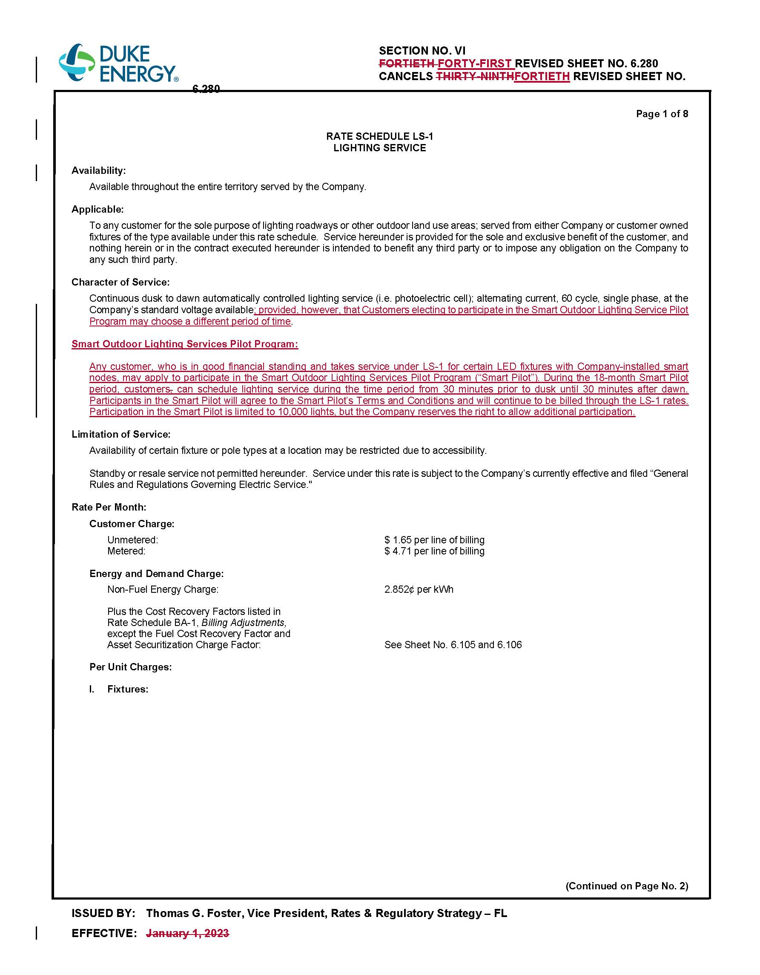

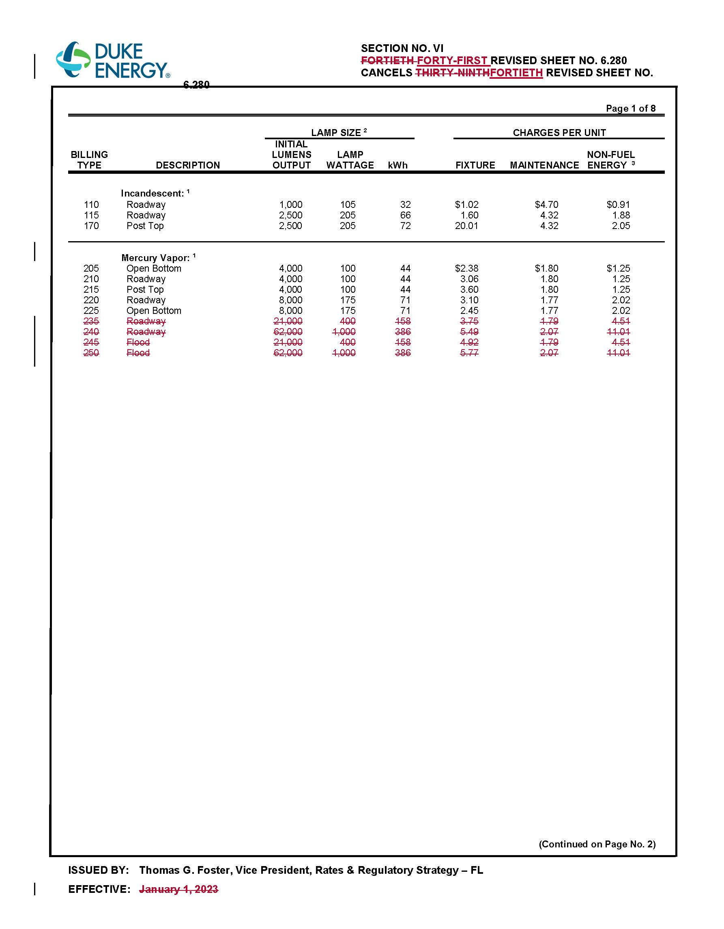

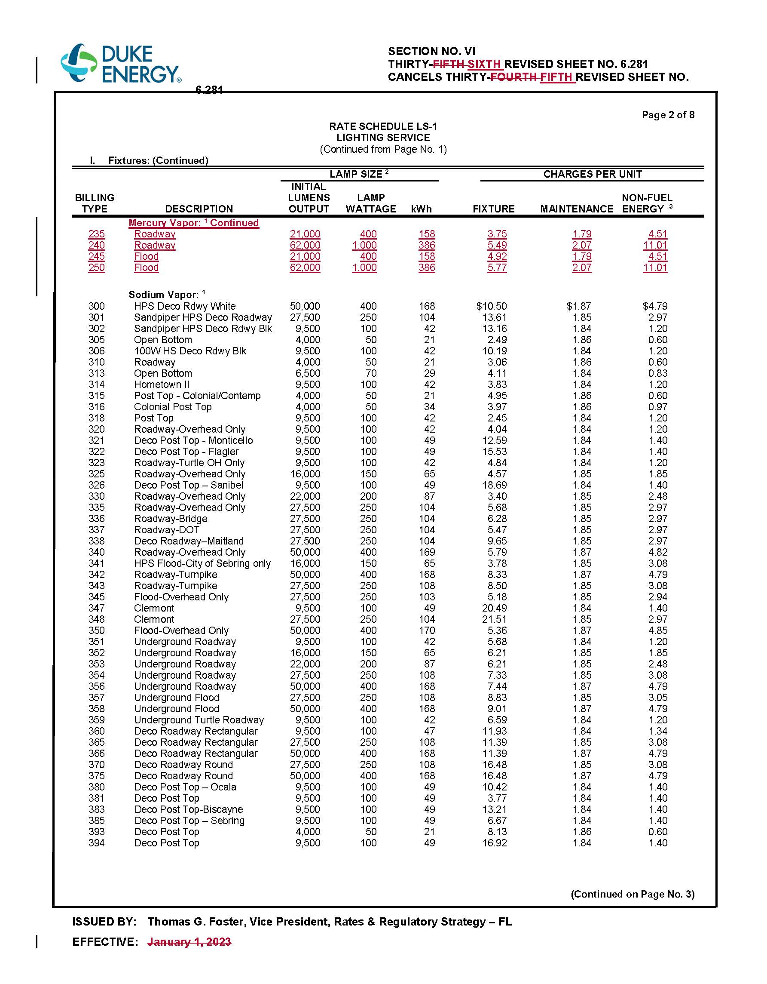

1. Order No. PSC-2023-0182-PCO-EI, issued June 26, 2023, in Docket No. 20230068-EI, *In re: Petition for approval of smart outdoor lighting services pilot program by Duke Energy Florida, LLC*.