BEFORE THE FLORIDA PUBLIC SERVICE COMMISSION

|  |  |
| --- | --- |
| In re: Joint petition for renewal of territorial agreement and approval of a first amendment, in Monroe County, by Florida Keys Electric Cooperative Association, Inc. and Utility Board of the City of Key West. | DOCKET NO. 20230087-EU  ORDER NO. PSC-2023-0319-PAA-EU  ISSUED: October 20, 2023 |

The following Commissioners participated in the disposition of this matter:

ANDREW GILES FAY, Chairman

ART GRAHAM

GARY F. CLARK

MIKE LA ROSA

GABRIELLA PASSIDOMO

NOTICE OF PROPOSED AGENCY ACTION

ORDER GRANTING petition for renewal of territorial

agreement and approval of A first amendment

BY THE COMMISSION:

NOTICE is hereby given by the Florida Public Service Commission that the action discussed herein is preliminary in nature and will become final unless a person whose interests are substantially affected files a petition for a formal proceeding, pursuant to Rule 25-22.029, Florida Administrative Code (F.A.C.).

Background

On August 2, 2023, Florida Keys Electric Cooperative Association, Inc. (FKEC) and the Utility Board of the City of Key West, d/b/a Keys Energy Services (KEYS), filed a joint petition for renewal of territorial agreement and approval of a first amendment (First Amendment). We approved a territorial agreement between FKEC and KEYS (collectively, the parties) in 1991 (1991 Territorial Agreement).[1] The 1991 Territorial Agreement expired in September 2021 at the end of its 30-year term and automatically renewed for an additional 30 years. Although the two utilities did not seek our approval of their renewed 1991 Territorial Agreement at the end of its first 30-year term, as required by the 1991 Territorial Agreement, the parties stated that they have abided by the conditions of the agreement with the exception of the provision of electric service to Pigeon Key.

The proposed First Amendment addresses a modification to the existing service territory boundary to allow FKEC to provide electric service to Pigeon Key, which currently lies in KEYS’ service territory. Pigeon Key was designated as a National Historic Landmark in 1990. In 1992, the Pigeon Key Foundation, Inc., (Foundation) was created as a **non-profit**organization to preserve and protect Pigeon Key. The Foundation has been utilizing self-service generators during the past 29 years and has requested electric service and hence the need for the proposed First Amendment.

The 1991 Territorial Agreement and territorial map are appended to this Order as Attachment A. The First Amendment, including the map depicting the modified service boundary, is appended as Attachment B to this Order.

During the review process, Commission staff issued data requests to the parties on August 10 and 29, 2023. Responses were received on August 23 and on September 7, 2023. Commission staff also had an informal telephonic meeting with the parties on September 7, 2023. This Order is for the renewal of the 1991 Territorial Agreement and the proposed First Amendment to the 1991 Territorial Agreement, including the associated revised boundary map. We have jurisdiction over this matter pursuant to Sections 366.04 and 366.05, Florida Statutes (F.S.).

Decision

FKEC is a rural electric cooperative and KEYS is a municipal electric utility. Pursuant to Section 366.04(2)(d), F.S., and Rule 25-6.0440(2), F.A.C., we have jurisdiction to approve territorial agreements between and among rural electric cooperatives, municipal electric utilities, and other electric utilities. Unless we determine that the agreement will cause a detriment to the public interest, the agreement should be approved.[2]

1991 Territorial Agreement

FKEC and KEYS entered into an electric service territorial agreement in June 1991, which we approved in September 1991.[3] The 1991 Territorial Agreement, which had a 30-year term, clearly identified the geographic areas to be served by each utility which allowed the two utilities to prevent potential uneconomic duplication of facilities and hazardous situations within their specified service territories. There were no customer or facility transfers contemplated in the 1991 Agreement.

The 1991 Territorial Agreement’s 30-year term expired in September 2021 and automatically renewed for an additional 30 years since neither of the parties gave notice to not renew. Paragraph 11 of the 1991 petition recognized that we must approve any modifications, changes, or corrections. Additionally, Section 5.1 of the 1991 Agreement states that:

each such renewal of this Agreement shall require prerequisite approval of the Commission with the same effect as the original Commission approval of this Agreement as required and approved for in Article 4 hereof.

The parties explained that the delay in filing a petition with us for renewal of the 1991 Territorial Agreement was due to staffing changes. However, the parties stated that with the exception of the provision of electric service to Pigeon Key, which we discuss below and the subject of the proposed First Amendment, the parties abided by the 1991 Territorial Agreements and have had no disputes.

Proposed First Amendment to the 1991 Agreement

Through the proposed First Amendment to the 1991 Territorial Agreement, the parties seek to modify the service territory boundary and allow FKEC to provide electric service to Pigeon Key at the request of the Foundation. Prior to the Foundation’s request for electric service, neither KEYS nor FKEC provided electric service to the island. Provision of electricity by KEYS to the Pigeon Key poses significant engineering and economic challenges due to geographic and environmental conditions. Although KEYS owns electric transmission poles approximately 350 feet from the island, the poles do not carry distribution lines and KEYS does not have the ability to step down the electricity. The parties state that if KEYS were to extend the distribution lines to Pigeon Key, the most economical method to do so would cost approximately $6 million.

The costs incurred by FKEC to add facilities within its service boundary in order to connect to the Foundation’s point of service is $6,011.53. Considering the above-stated challenges if KEYS were to provide electric service to the Foundation, we find that allowing FKEC to provide electric service to the Foundation is the most economical and practical solution.

In response to Commission staff discovery, the parties stated that FKEC has been providing service to the Foundation since May 2021. The parties acknowledge that they should have requested our approval of the First Amendment to the 1991 Agreement prior to providing service to the Foundation; however, the parties explained that there was a delay in filing a petition with us due to staffing changes.

Pursuant to Rule 25-6.0440(1)(d), F.A.C., affected customers must be notified of difference in service and rates. In June 2023, FKEC provided the Foundation a customer notice indicating the rates and tariffs that would be applicable to the Foundation. The Foundation receives electric service under FKEC’s General Service Demand tariff. In response to Commission staff’s data request, the parties provided a copy of FKEC’s customer notification and applicable tariff information.[4] The parties stated that there have been no customer comments or objections regarding this proposed territorial amendment and no customer comments have been filed in the docket file.

Conclusion

After review of the petition, the 1991 Territorial Agreement, the First Amendment to the 1991 Territorial Agreement, and evaluation of responses to our staff’s data requests, we find that the renewal of the 1991 Territorial Agreement and First Amendment would not be a detriment to the public interest and would enable FKEC to serve the Pigeon Key Foundation in an efficient manner. The 1991 Agreement and First Amendment and associated modified boundary map would eliminate any potential uneconomic duplication of facilities and not cause a decrease in the reliability of electric service. Accordingly, we approve the renewal of the 1991 Territorial Agreement between FKEC and KEYS and the proposed First Amendment to the 1991 Territorial Agreement and associated revised service boundary map, effective on the date of our final order. The parties shall promptly submit any further modifications to the Territorial Agreement to us for review and approval.

Based on the foregoing, it is

ORDERED by the Florida Public Service Commission that the joint petition for renewal of territorial agreement and approval of a first amendment, in Monroe County, by Florida Keys Electric Cooperative Association, Inc. and Utility Board of the City of Key West, is hereby approved. It is further

ORDERED that the territorial agreement between Florida Keys Electric Cooperative Association, Inc. and Utility Board of the City of Key West is hereby renewed for a thirty year term commencing September 2021. It is further

ORDERED that service boundary map (Attachment A to the territorial agreement) between Florida Keys Electric Cooperative Association, Inc. and Utility Board of the City of Key West is hereby modified as depicted on Attachment B to this Order. It is further

ORDERED that the provisions of this Order, issued as proposed agency action, shall become final and effective upon the issuance of a Consummating Order unless an appropriate petition, in the form provided by Rule 28-106.201, Florida Administrative Code, is received by the Commission Clerk, 2540 Shumard Oak Boulevard, Tallahassee, Florida 32399-0850, by the close of business on the date set forth in the “Notice of Further Proceedings” attached hereto. It is further

ORDERED that in the event this Order becomes final, this docket shall be closed.

By ORDER of the Florida Public Service Commission this 20th day of October, 2023.

|  |  |
| --- | --- |
|  | /s/ Adam J. Teitzman |
|  | ADAM J. TEITZMAN  Commission Clerk |

Florida Public Service Commission

2540 Shumard Oak Boulevard

Tallahassee, Florida 32399

(850) 413‑6770

www.floridapsc.com

Copies furnished: A copy of this document is provided to the parties of record at the time of issuance and, if applicable, interested persons.

SPS

NOTICE OF FURTHER PROCEEDINGS OR JUDICIAL REVIEW

The Florida Public Service Commission is required by Section 120.569(1), Florida Statutes, to notify parties of any administrative hearing that is available under Section 120.57, Florida Statutes, as well as the procedures and time limits that apply. This notice should not be construed to mean all requests for an administrative hearing will be granted or result in the relief sought.

Mediation may be available on a case-by-case basis. If mediation is conducted, it does not affect a substantially interested person's right to a hearing.

The action proposed herein is preliminary in nature. Any person whose substantial interests are affected by the action proposed by this order may file a petition for a formal proceeding, in the form provided by Rule 28-106.201, Florida Administrative Code. This petition must be received by the Office of Commission Clerk, 2540 Shumard Oak Boulevard, Tallahassee, Florida 32399-0850, by the close of business on November 13, 2023.

In the absence of such a petition, this order shall become final and effective upon the issuance of a Consummating Order.

Any objection or protest filed in this/these docket(s) before the issuance date of this order is considered abandoned unless it satisfies the foregoing conditions and is renewed within the specified protest period.

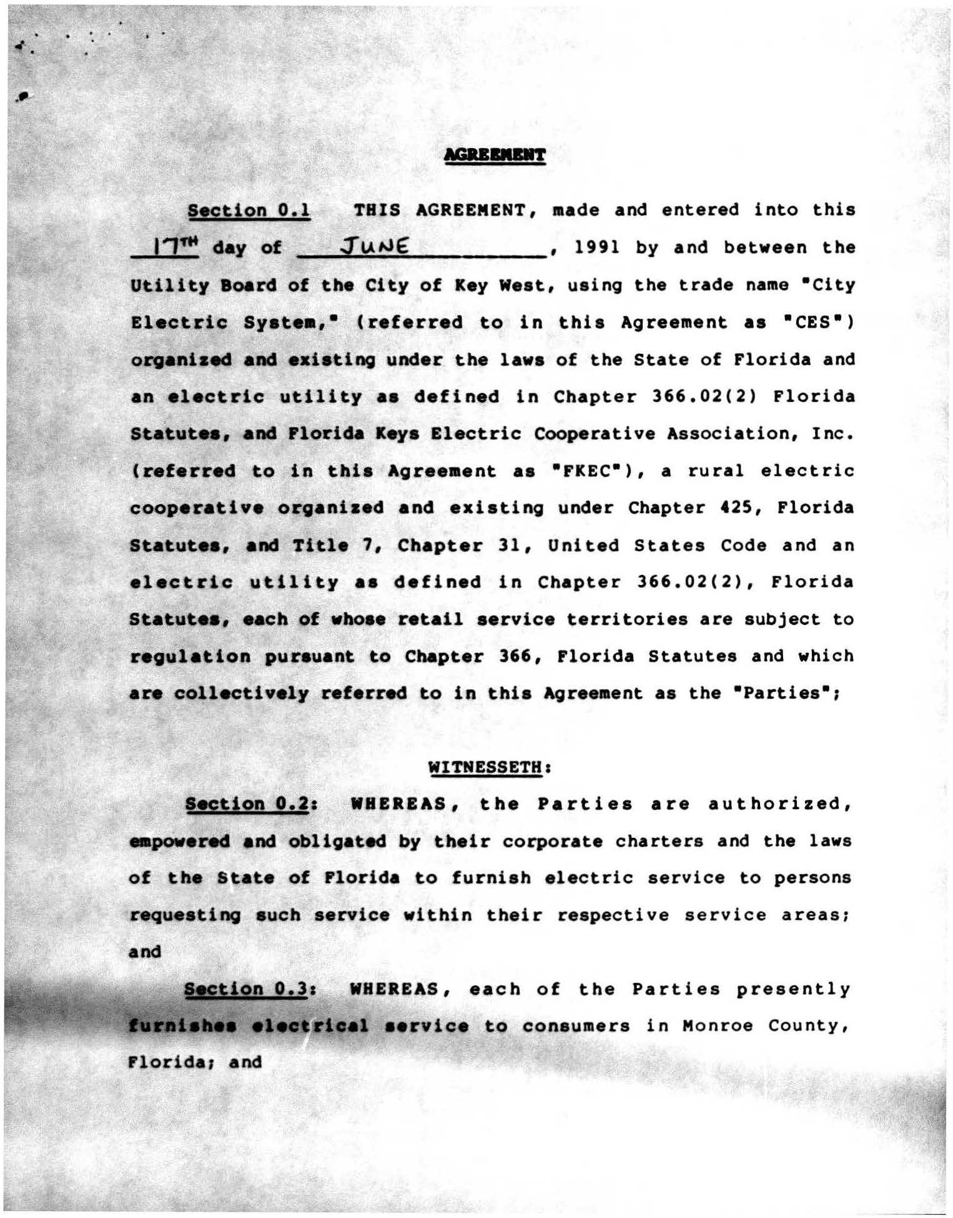

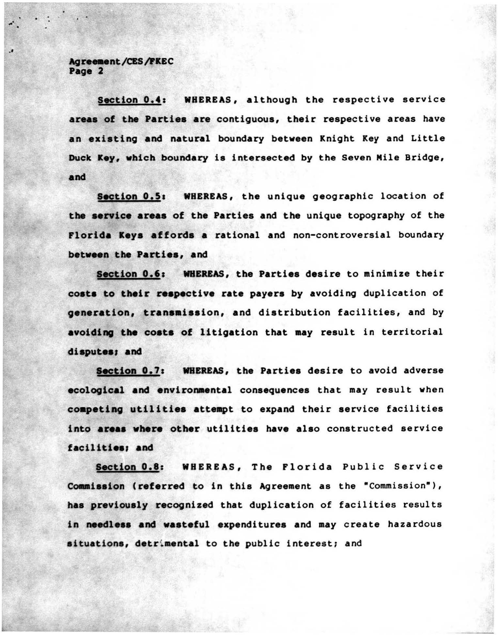

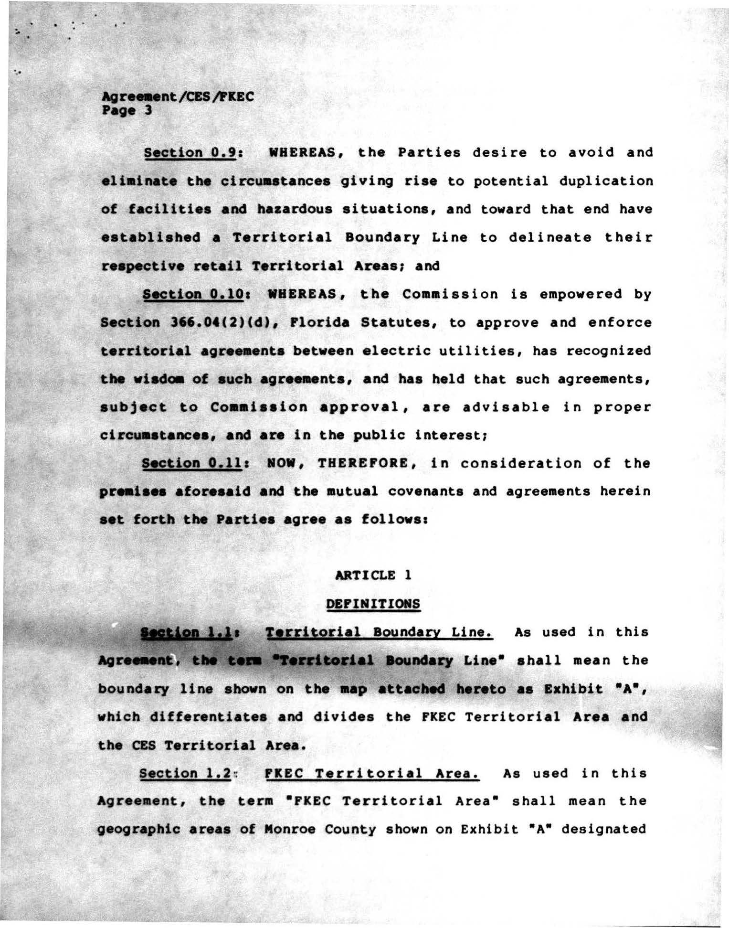

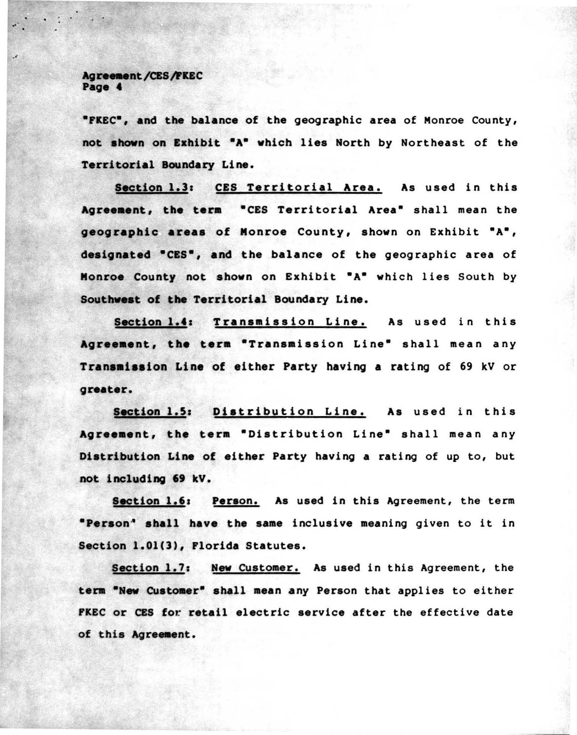

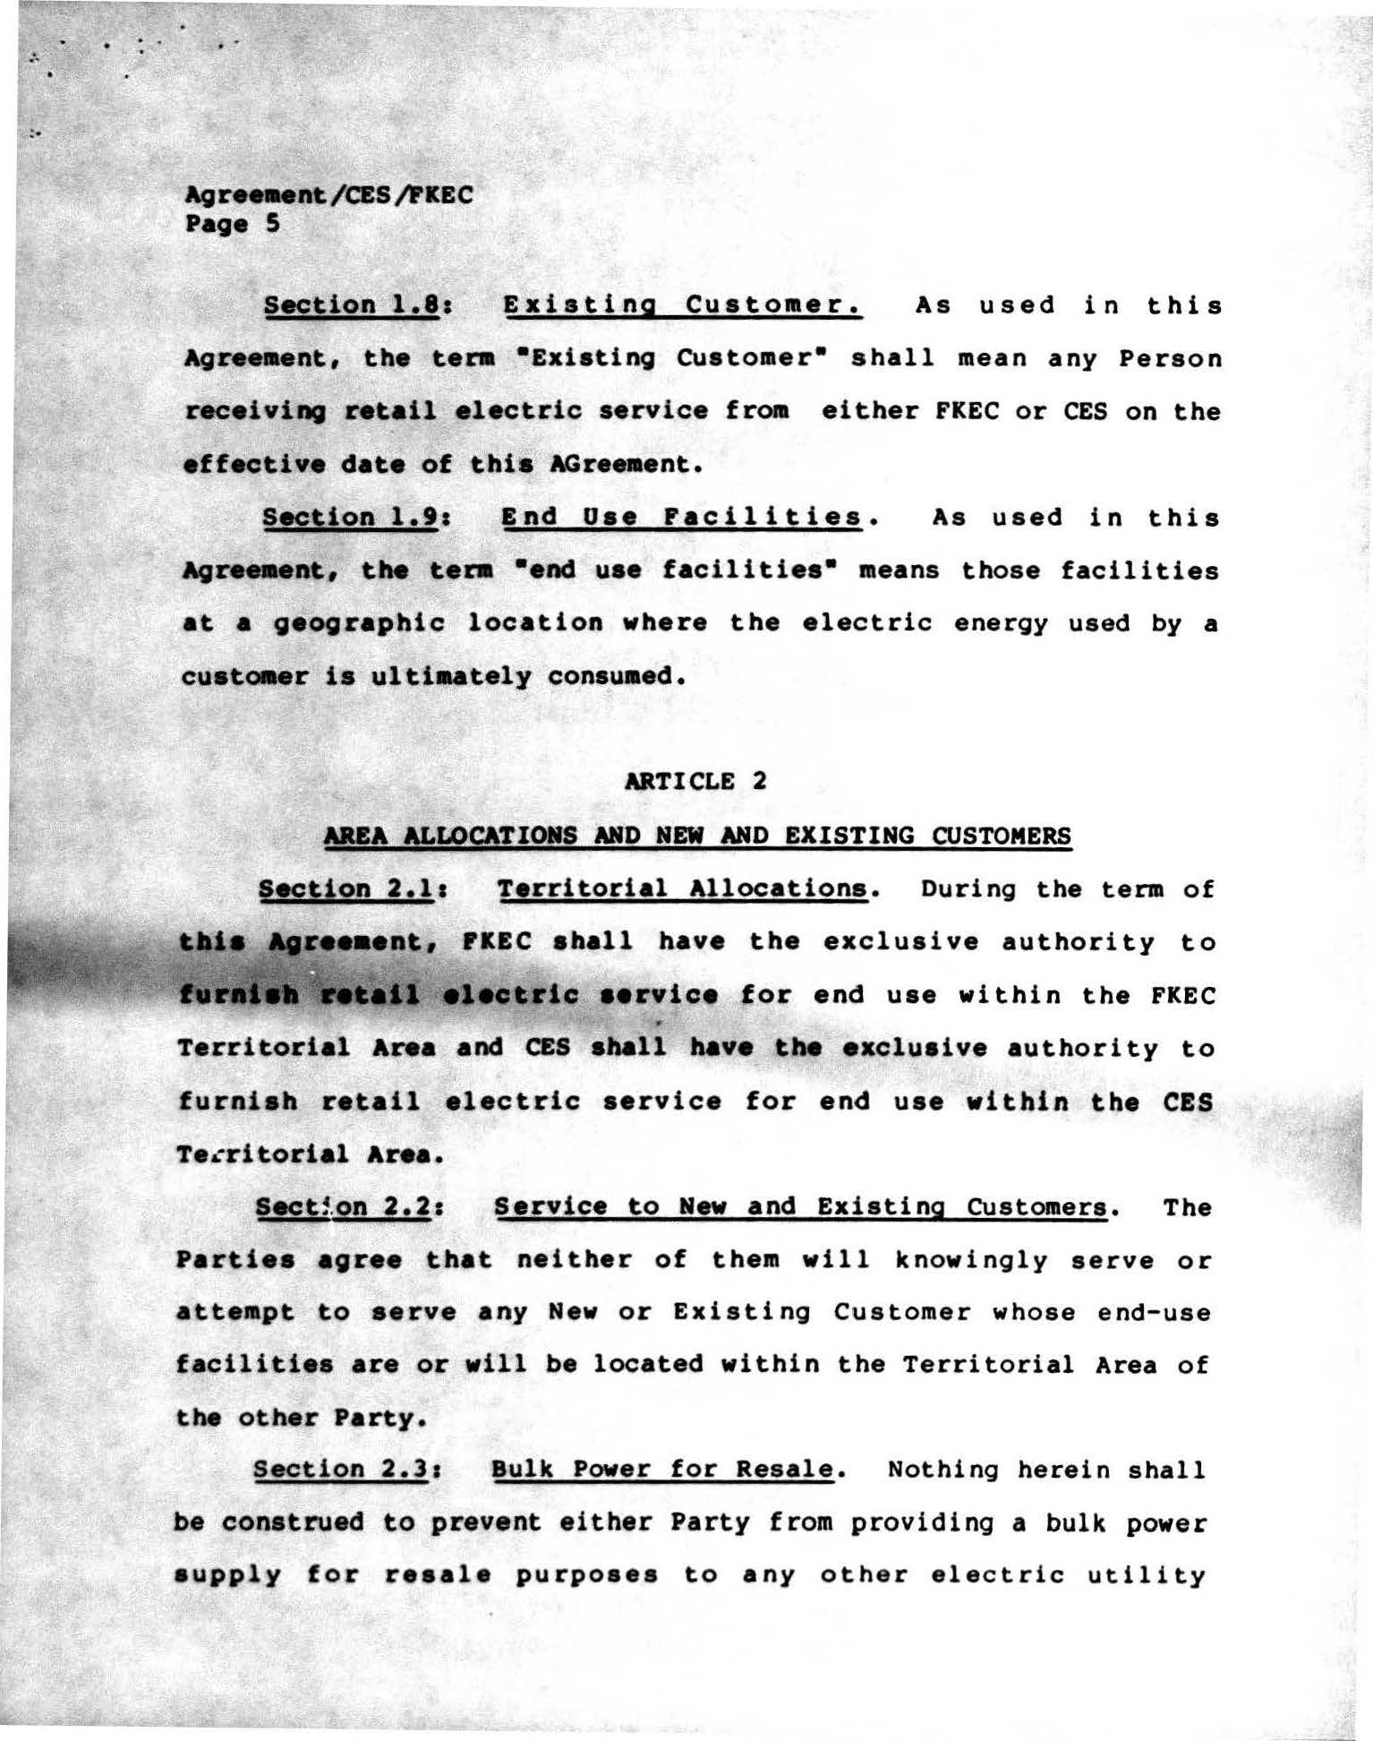

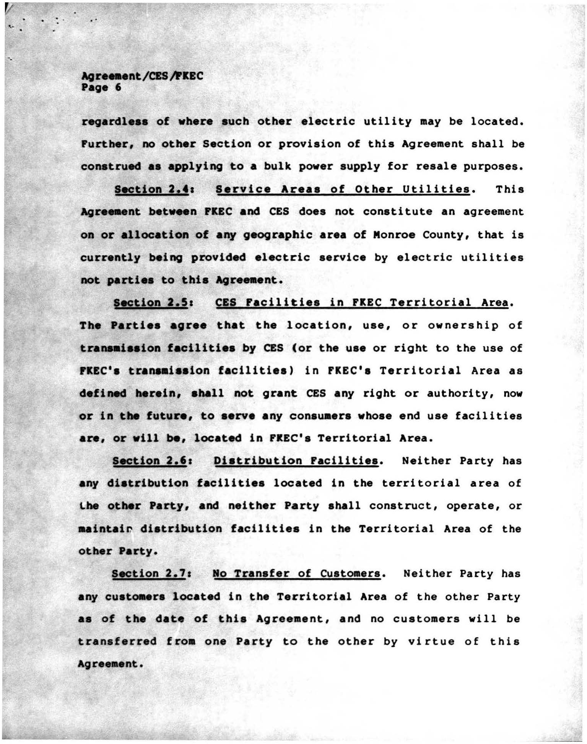

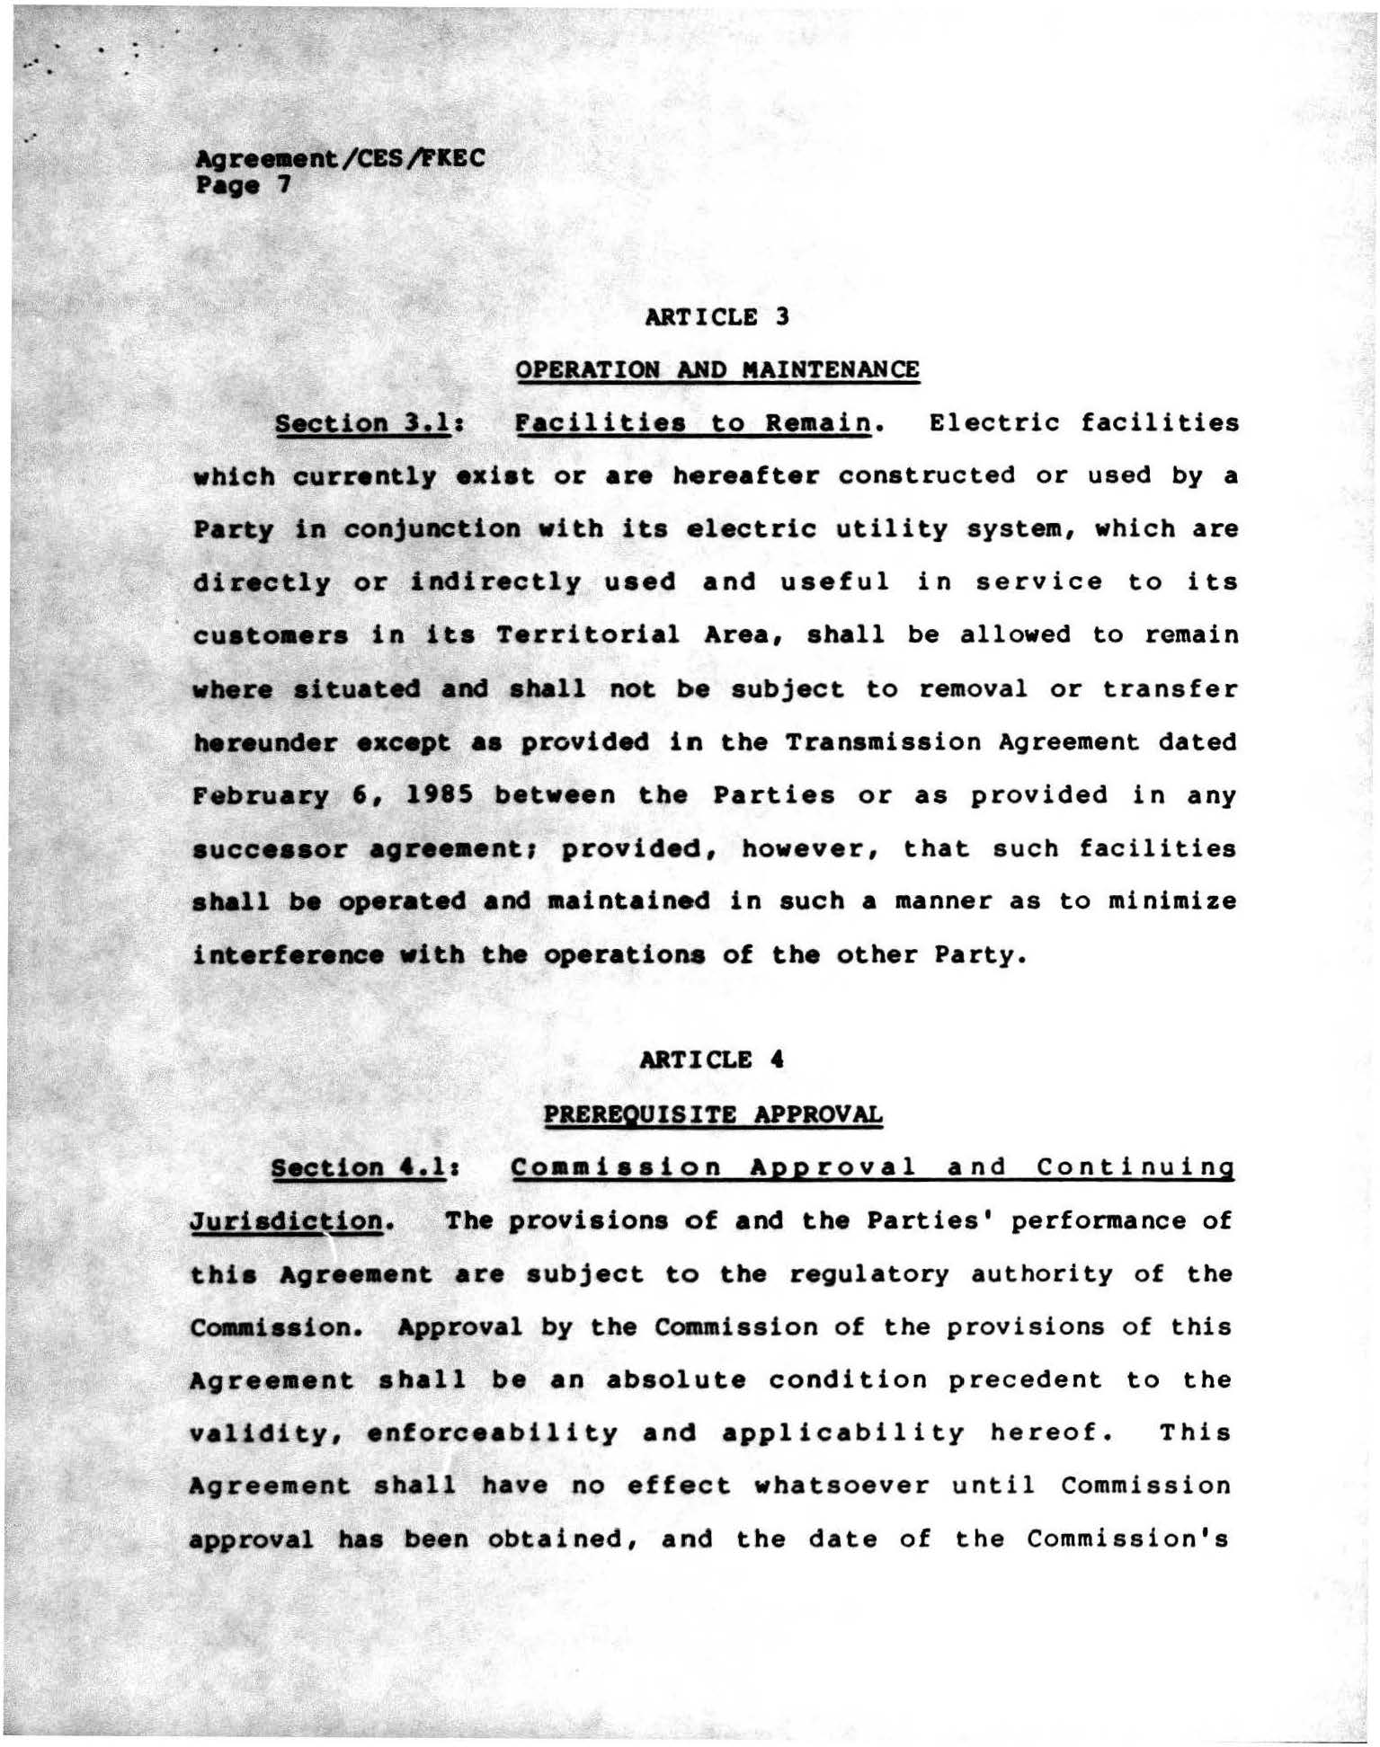

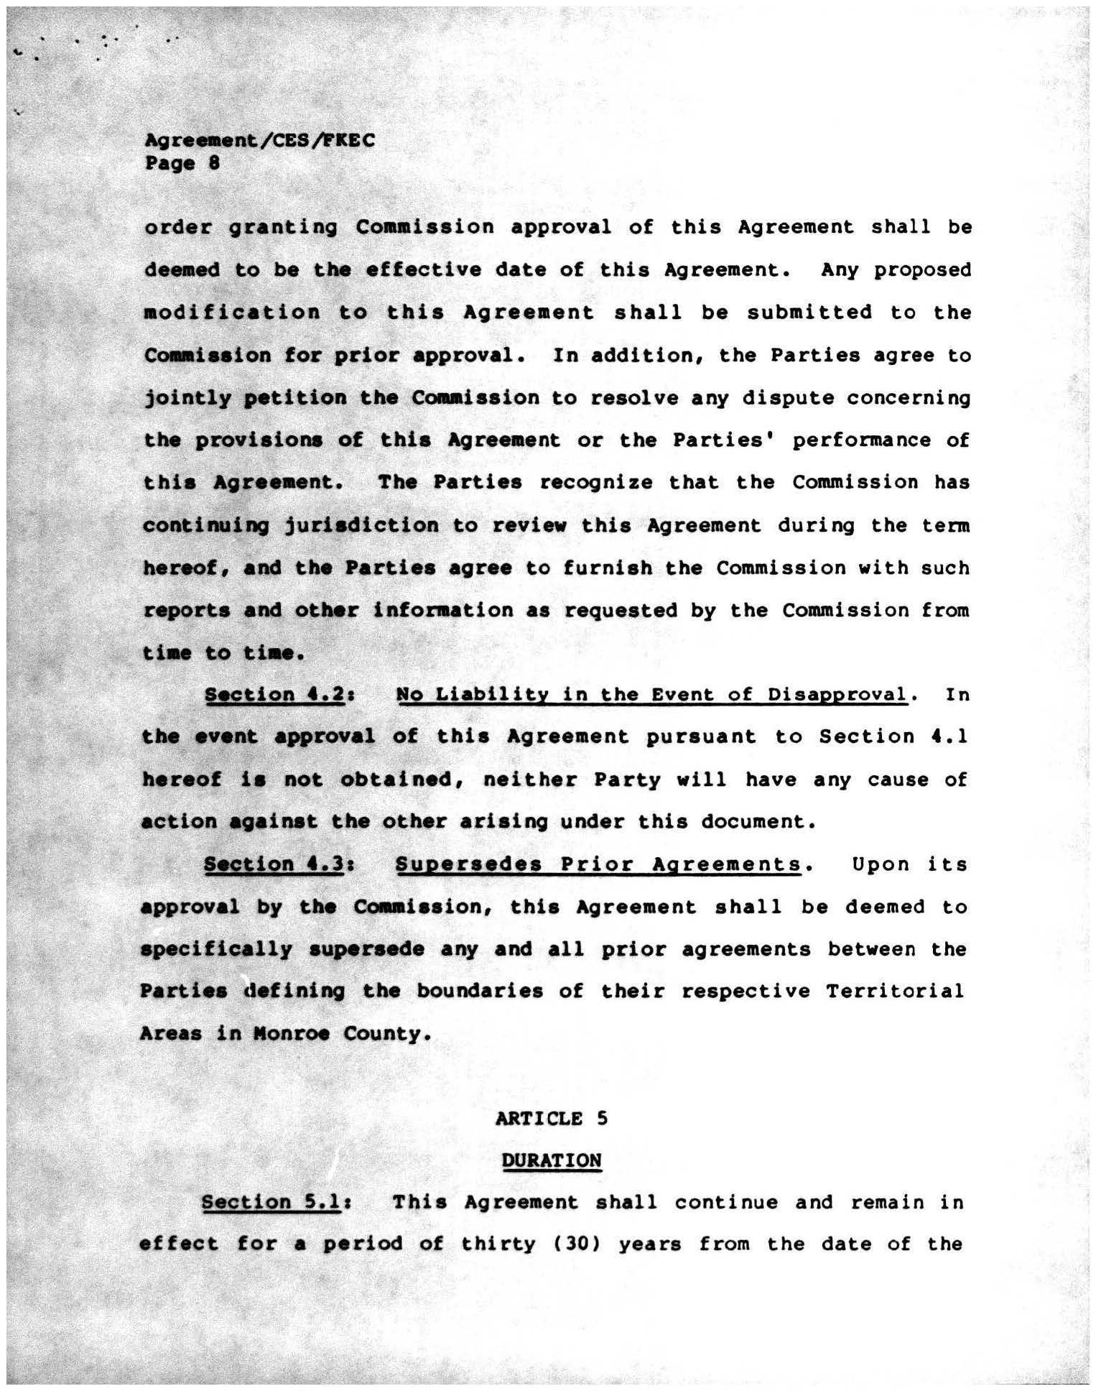

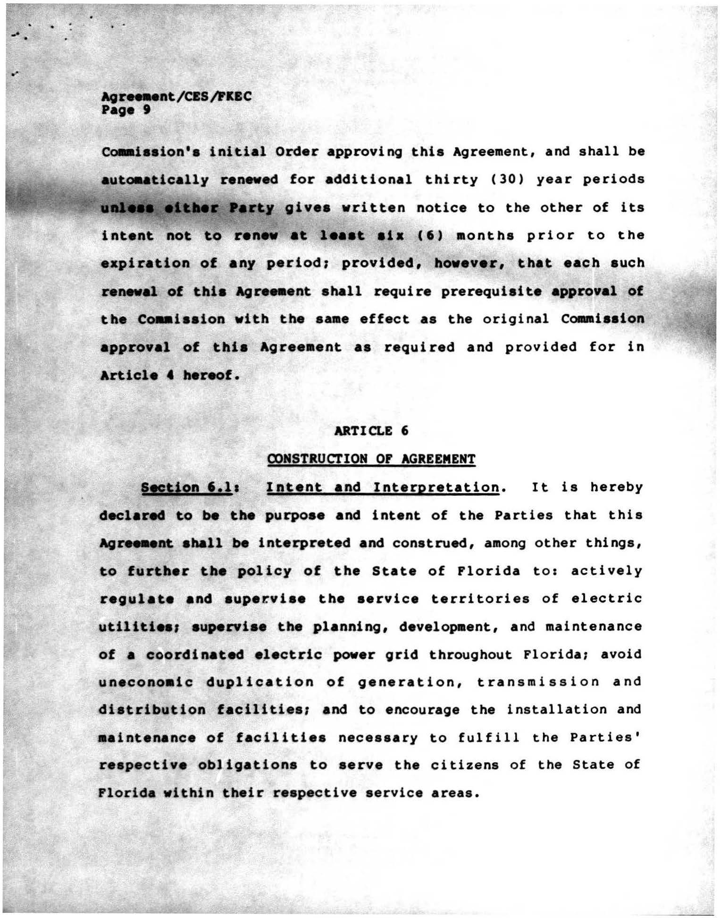

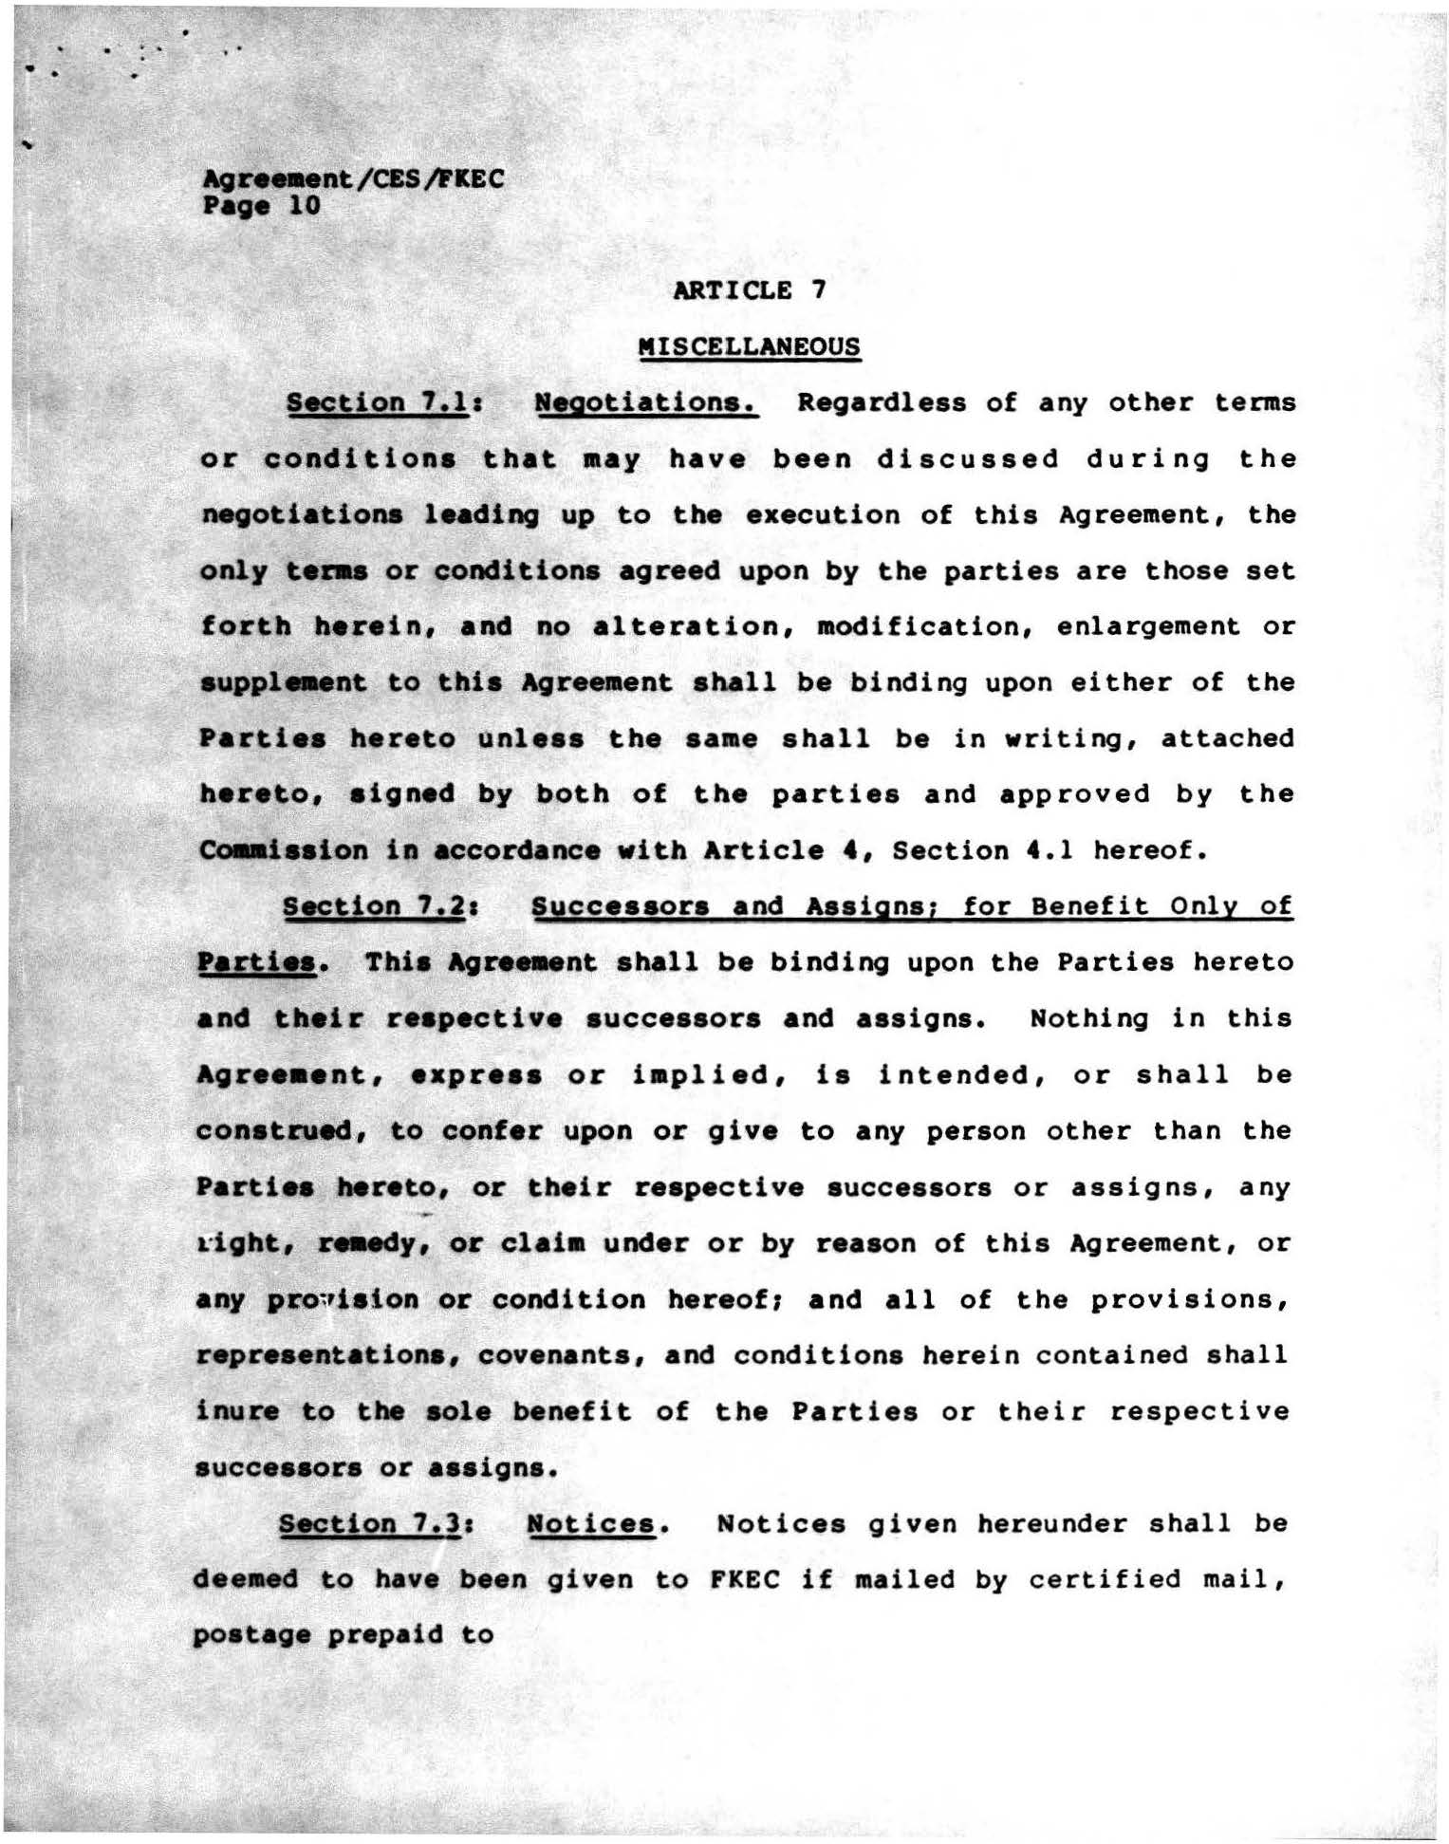

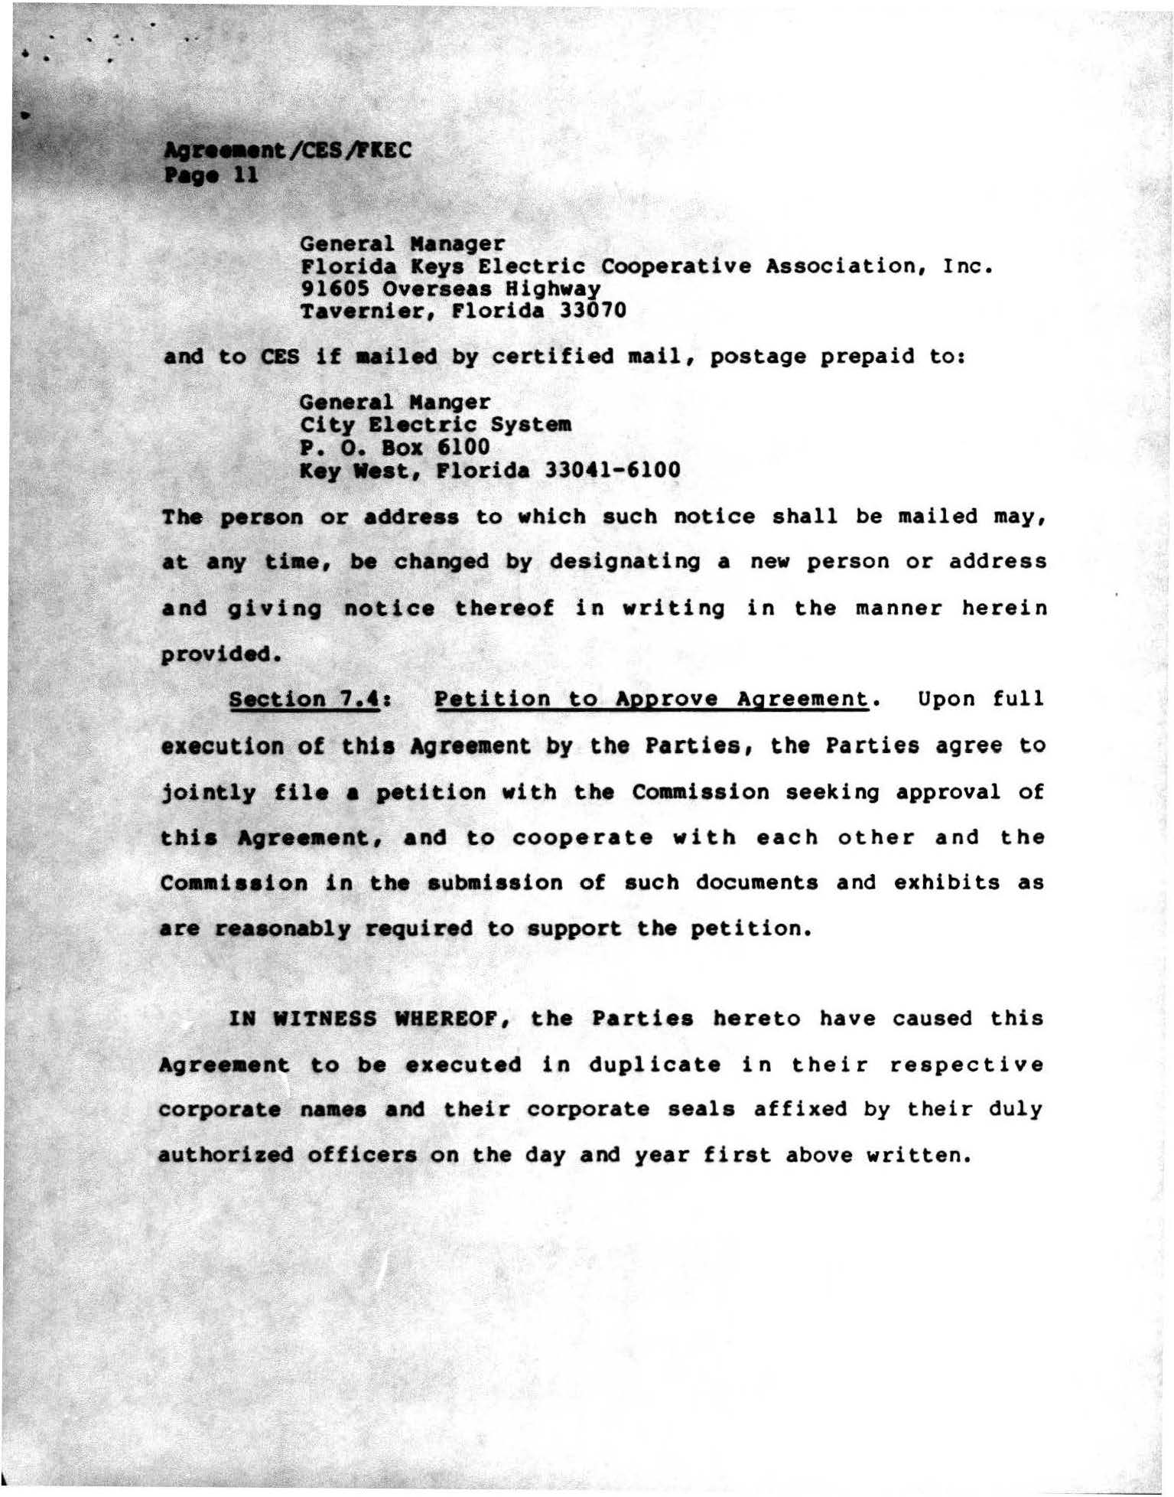

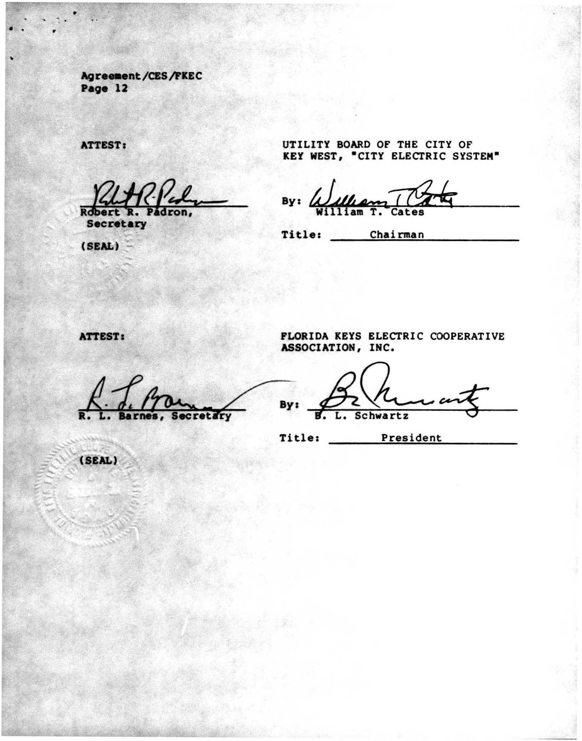

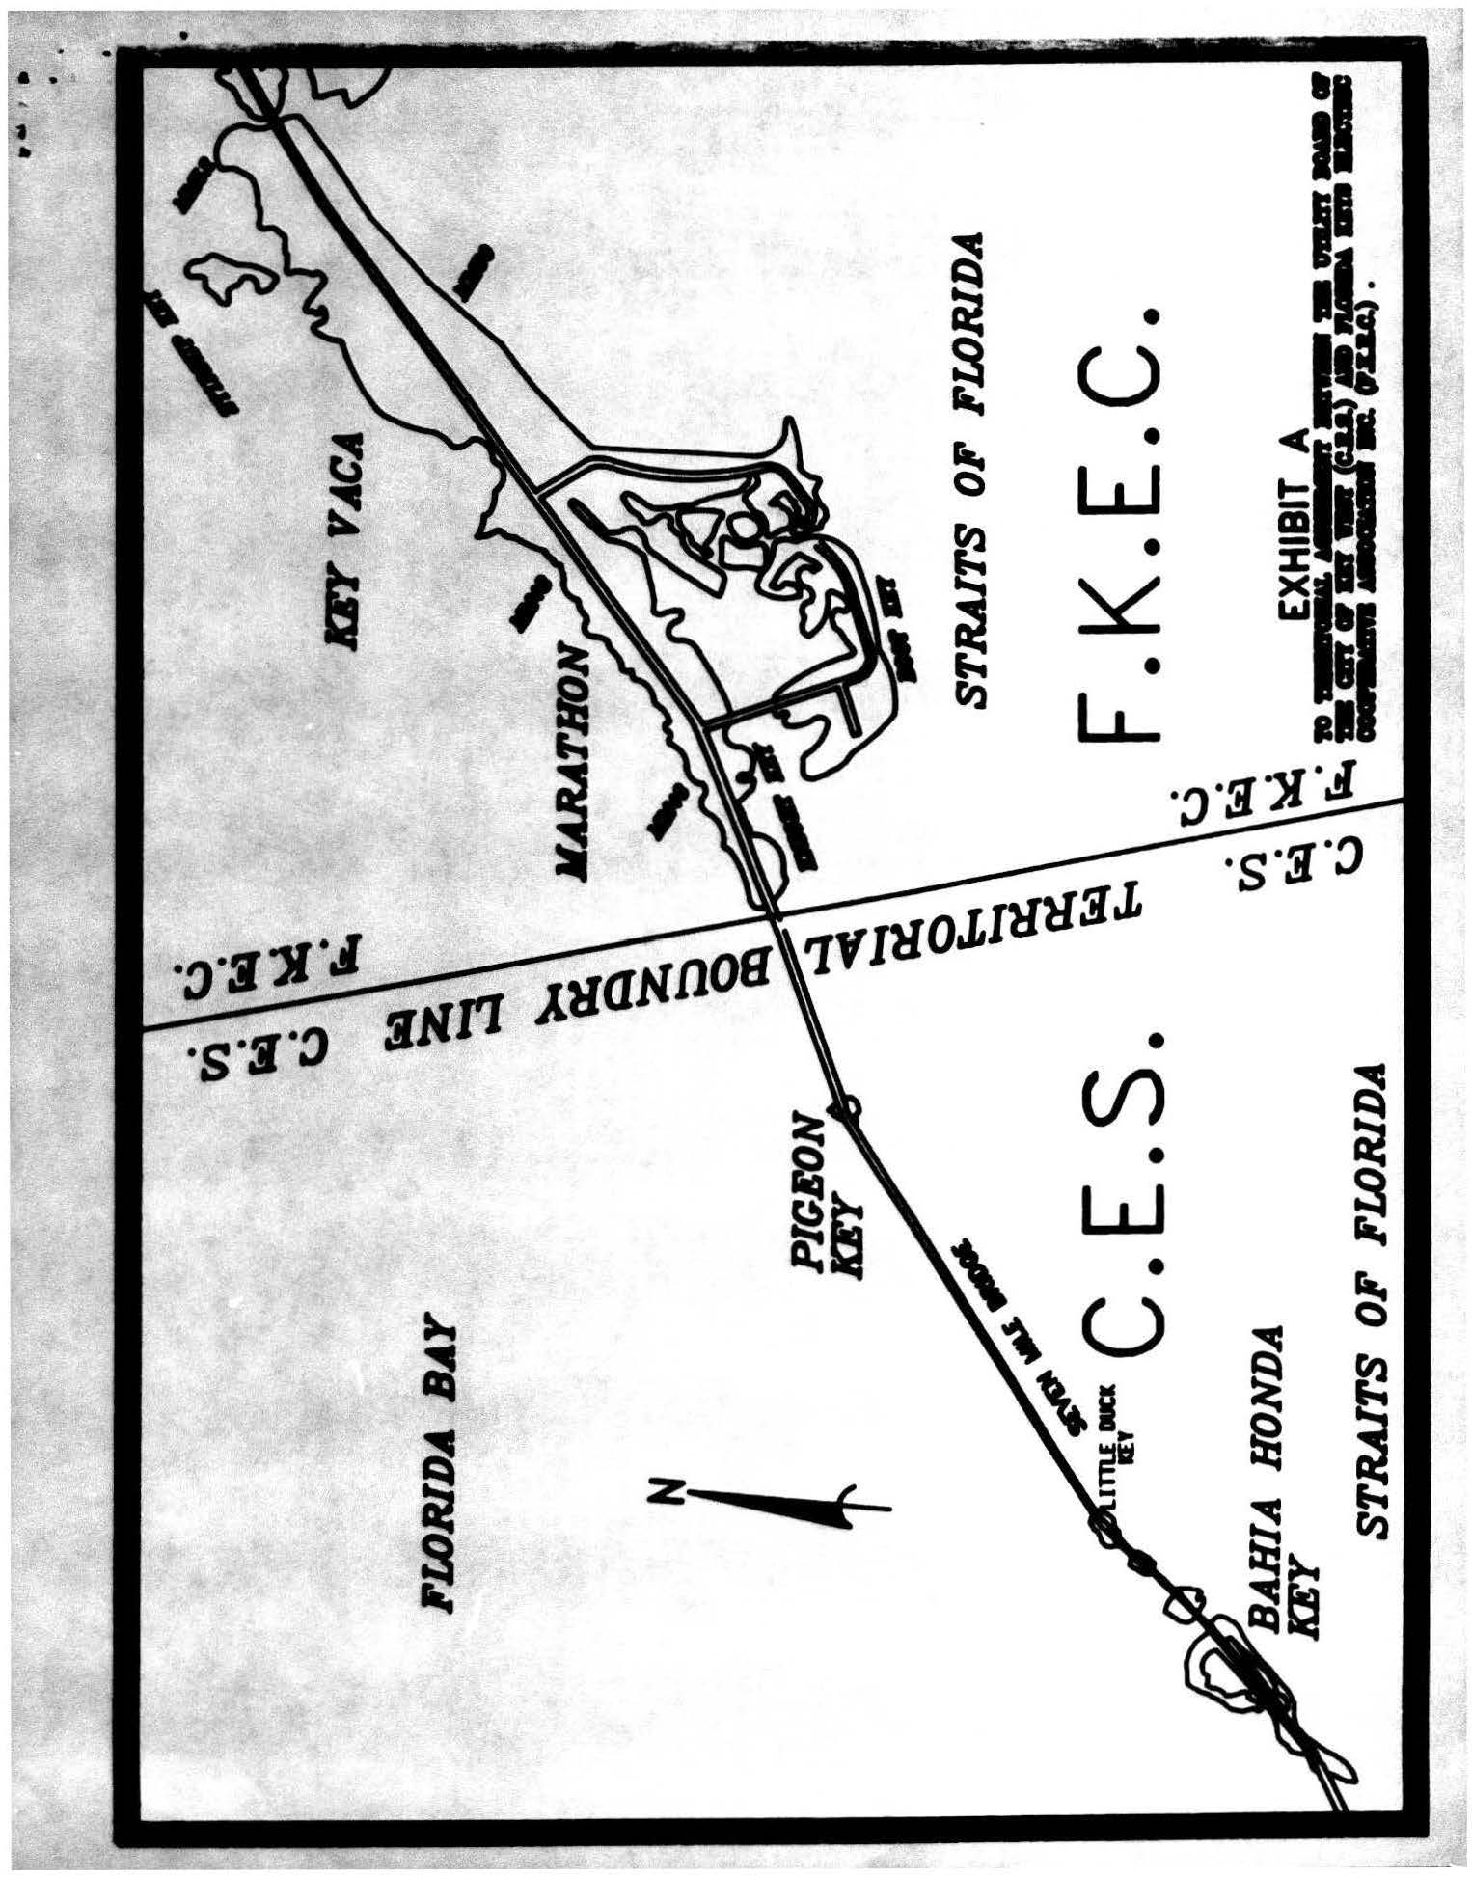

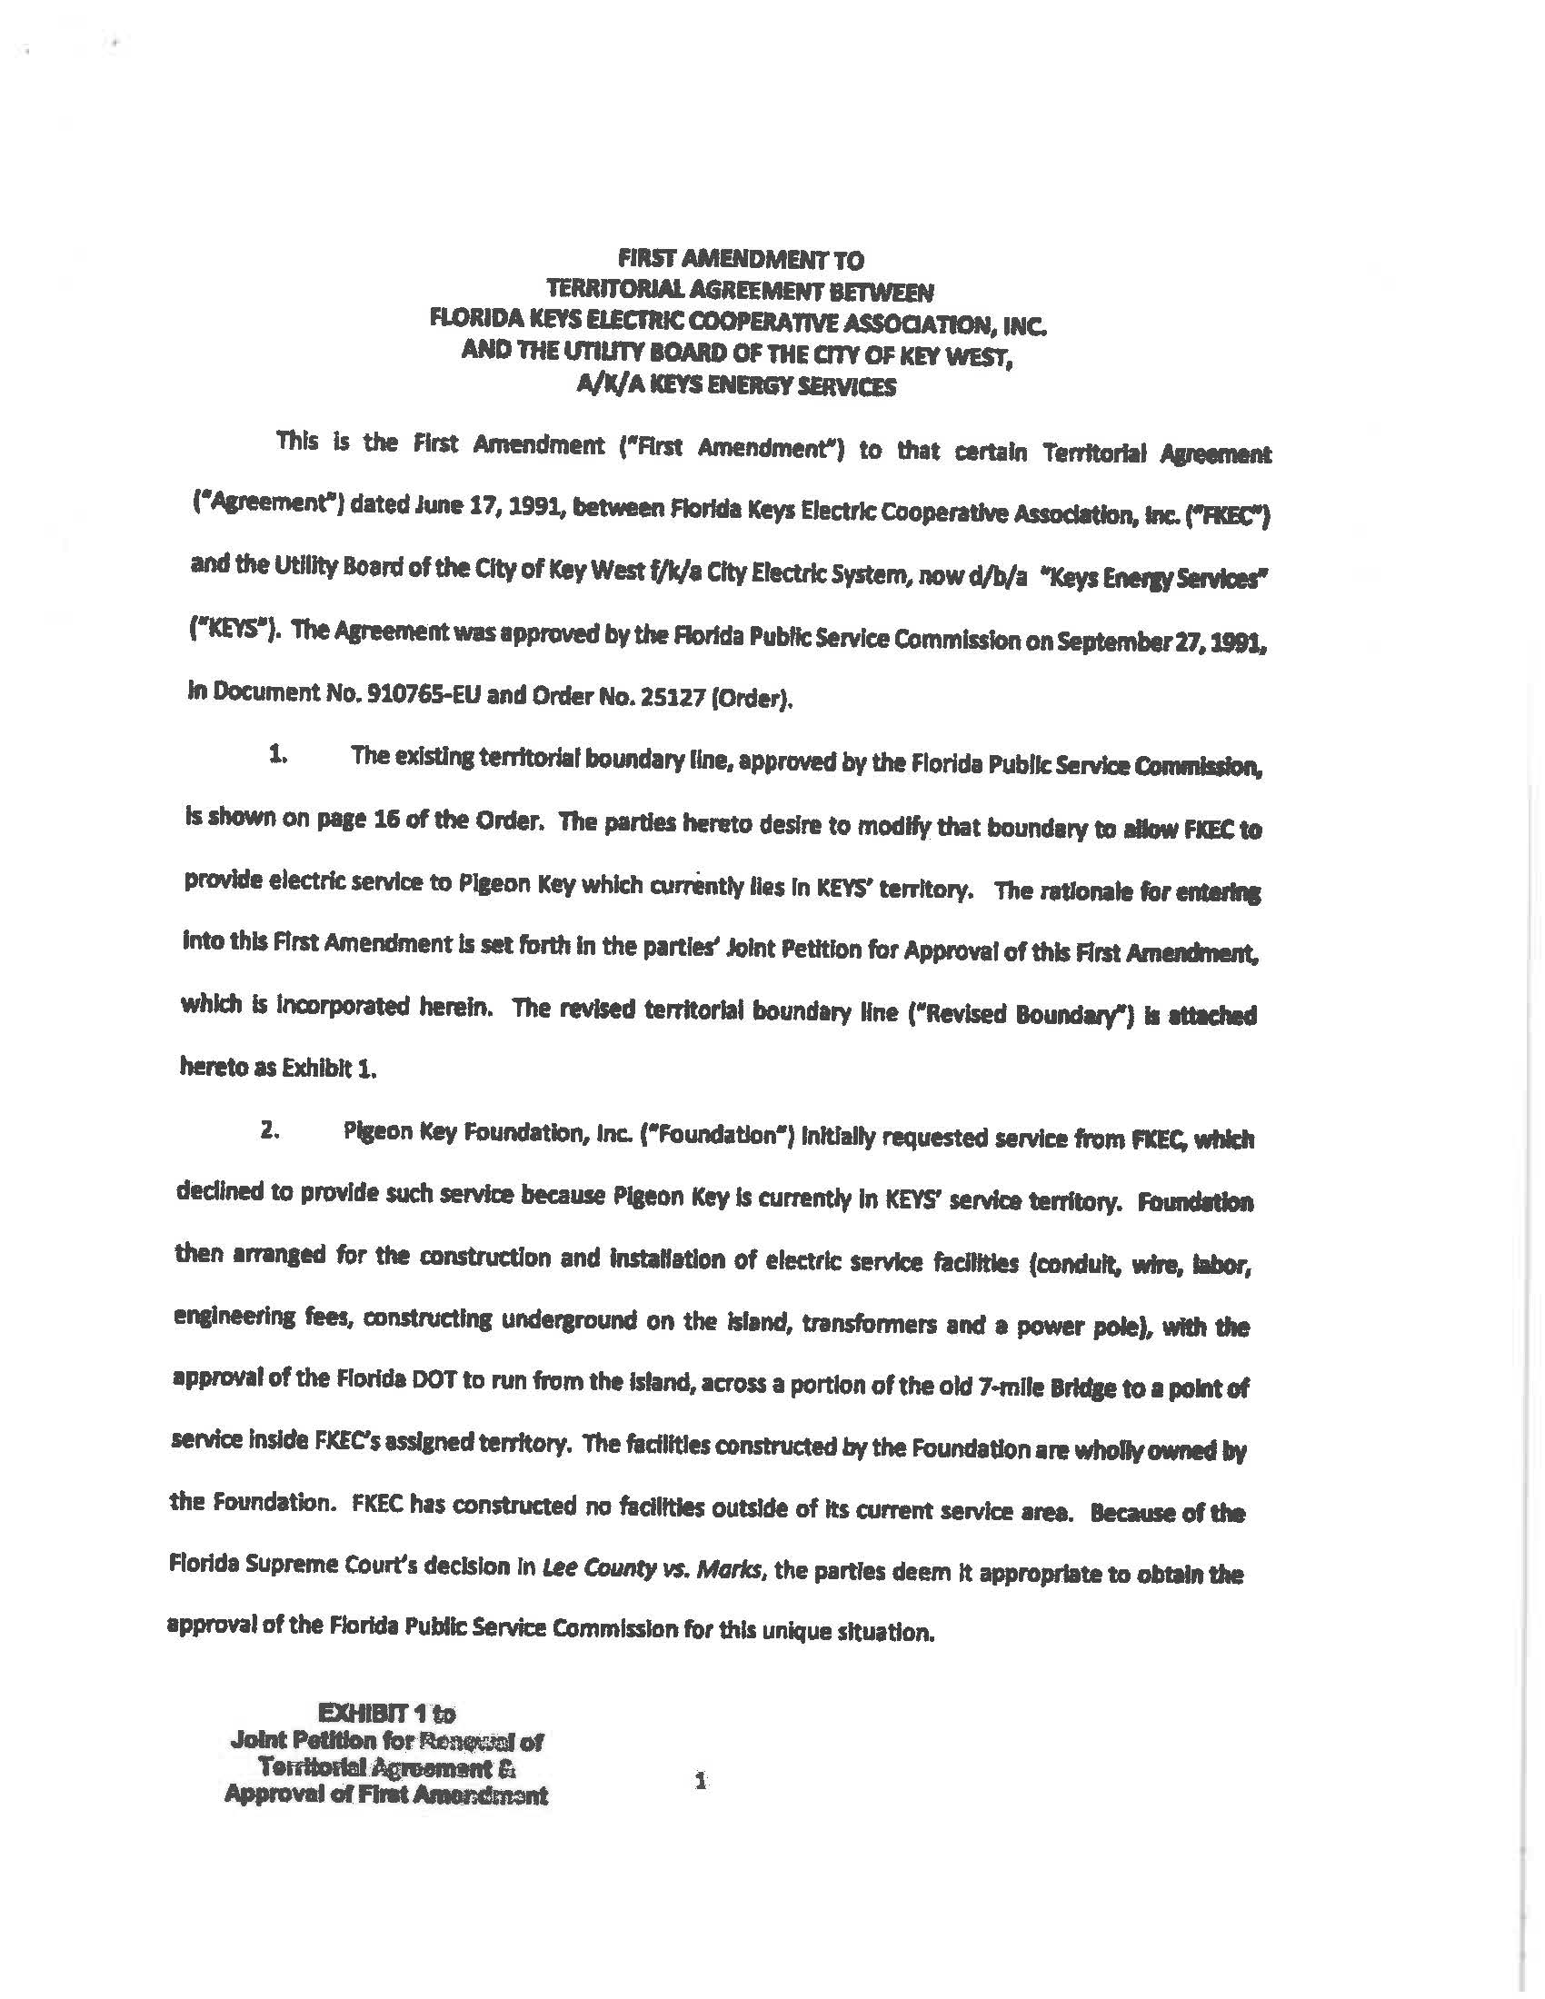

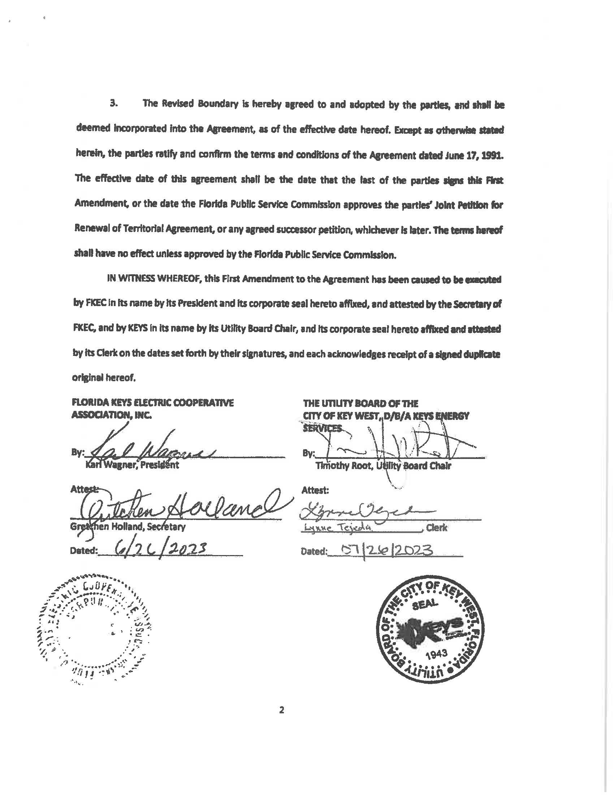

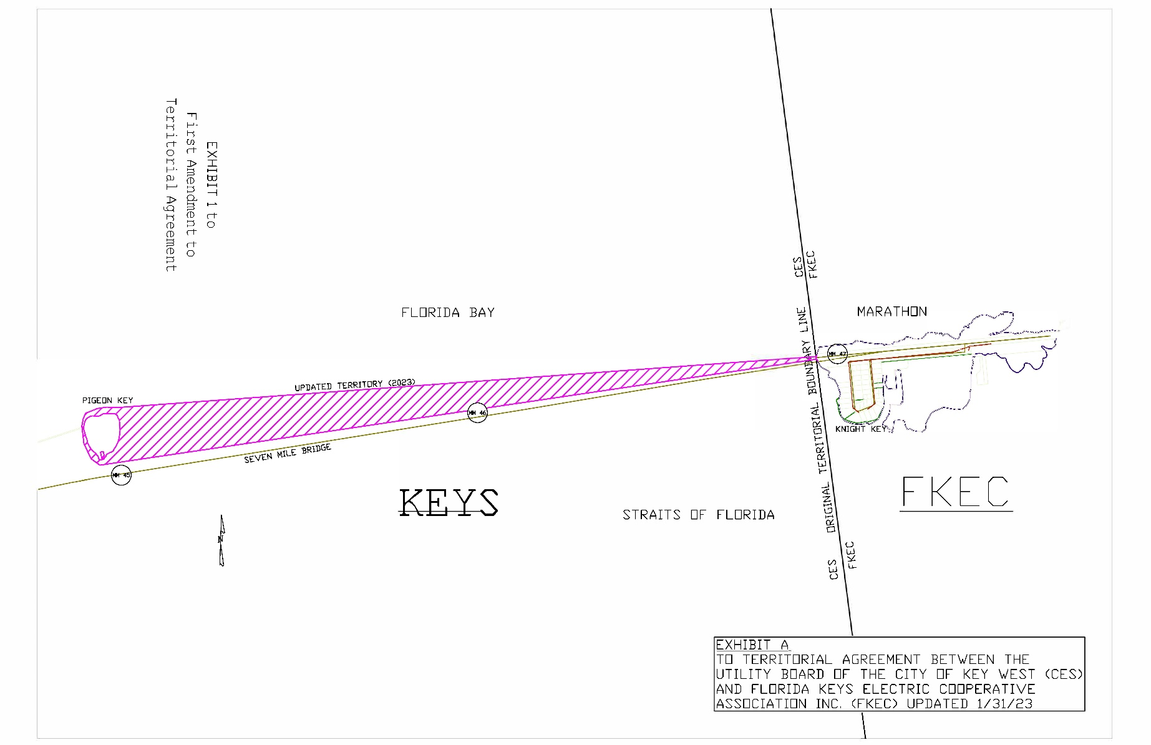

1. Order No. 25127, issued on September 27, 1991, in Docket No. 910765-EU, *In re: joint Petition of Florida Keys Electric Cooperative association, Inc., and the Utility board of the City of Key West for approval of a territorial agreement.*
2. *Utilities Commission of the City of New Smyrna Beach v. Florida Public Service Commission*, 469 So. 2d 731 (Fla. 1985).
3. Order No. 25127, issued on September 27, 1991, in Docket No. 910765-EU, *In re: joint Petition of Florida Keys Electric Cooperative association, Inc., and the Utility board of the City of Key West for approval of a territorial agreement*.
4. Response No. 11 and attachments in Staff’s First Data Request, Document No. 04944-2023.