|  |  |  |  |
| --- | --- | --- | --- |
| State of Florida  pscSEAL | | Public Service Commission  Capital Circle Office Center ● 2540 Shumard Oak Boulevard Tallahassee, Florida 32399-0850  -M-E-M-O-R-A-N-D-U-M- | |
| DATE: | October 27, 2023 | | |
| TO: | Office of Commission Clerk (Teitzman) | | |
| FROM: | Division of Economics (P. Kelley, Hampson)  Division of Accounting and Finance (Buys, Gatlin)  Office of the General Counsel (Thompson) | | |
| RE: | Docket No. 20230097-GU – Petition for approval of safety, access, and facility enhancement program true-up and 2024 cost recovery factors, by Florida City Gas. | | |
| AGENDA: | 11/09/23 – Regular Agenda – Tariff Filing – Interested Persons May Participate | | |
| COMMISSIONERS ASSIGNED: | | | All Commissioners |
| PREHEARING OFFICER: | | | Administrative |
| CRITICAL DATES: | | | 04/30/24 (8-Month Effective Date) |
| SPECIAL INSTRUCTIONS: | | | None |

Case Background

On August 31, 2023, Florida City Gas (FCG or utility) filed a petition for approval of its safety, access, and facility enhancement program (SAFE) true-up and 2024 cost recovery factors. The SAFE program was originally approved by the Commission in Order No. PSC-15-0390-TRF-GU (2015 Order) to recover the cost of relocating on an expedited basis certain existing gas mains and associated facilities from rear lot easements to the street front.[1] In the 2015 Order, the Commission found that the relocation of mains and services to the street front provides for more direct access to the facilities and will enhance the level of service provided to all customers through improved safety and reliability. The SAFE factor is a surcharge on customers' bills.

In the 2015 Order, the Commission required the utility to file an annual petition, beginning in 2016, for review and resetting of the SAFE factors to true-up any prior over-or under-recovery and to set the surcharge for the coming year. The SAFE program was originally approved as a 10-year program and was planned to finish in 2025.

During the utility’s 2022 rate case, the Commission approved a stipulation for the expansion of the SAFE program in Order No. PSC-2023-0177-FOF-GU (Rate Case Order).[2] The parties agreed and the Commission found that the continuation of the SAFE program beyond its original 2025 expiration date and the relocation of an additional approximately 150 miles of mains and 13,874 services was reasonable.[3]

In the Rate Case Order, the Commission further approved a stipulation for the replacement of approximately 160 miles and 8,059 associated services of “orange pipe,” through the SAFE program.[4] All parties to the rate case agreed that orange pipe is a specific plastic material that was used in the 1970s and 1980s that has been studied by the United States Department of Transportation Pipeline and Hazardous Materials Safety Administration and shown through industry research to exhibit premature failure in the form of cracking.

In addition, as part of its rate case, FCG moved the SAFE investment and related expenses as of December 31, 2022, from clause recovery to base rates, in compliance with the 2015 Order.[5] Specifically, the 2015 Order stated that “…if FCG files a base rate case prior to 2025, the then-current SAFE surcharge program would be folded into any newly approved rate base, and the surcharge would begin anew.”[6] The Commission approved FCG’s proposal to move the SAFE surcharge into base rates in the Rate Case Order.[7] The rate case decision was effective May 1, 2023.

The current 2023 SAFE factors were approved by Order No. PSC-2022-0403-TRF-GU (2022 Order).[8] The SAFE factors effective January 2023 were calculated based on the assumption that the Commission would approve the request to roll SAFE investments into rate base in the rate case docket and therefore decreased compared to the 2022 SAFE factors. Since the rate case decision became effective May 1, 2023 (as opposed to January 2023), FCG did not collect the full SAFE revenue requirement in 2023, resulting in a 2023 under-recovery. The 2022 Order provided that if the Commission has not made a decision in the 2022 rate case prior to the January 1, 2023 effective date, then any SAFE revenue requirement not collected in 2023 would be trued-up in the next SAFE filing. Accordingly, FCG has included the 2023 under-recovery with the proposed 2024 SAFE factors.

Finally, in the Rate Case Order, the Commission required FCG to propose a new investment/construction schedule and term for the SAFE program in its next applicable annual SAFE filing. Subsequently, FCG now proposes in this petition to extend the SAFE program for an additional 10-year period through 2035 for the replacement of orange pipe and relocation of rear lot mains and services to the street front. The utility proposes to begin the replacement of orange pipe in 2024 and continue through 2033. FCG also proposes to begin the relocation of mains and services in 2026 and continue through 2035.

In Order No. PSC-2023-0302-PCO-GU, the Commission suspended the proposed tariffs to allow staff sufficient time to analyze the utility’s filing, pursuant to Section 366.06(3), Florida Statue (F.S.). Commission staff issued their first data request to FCG on September 13, 2023, for which FCG provided a response on September 19, 2023. Staff issued a second data request on September 22, 2023 for responses were received September 28, 2023.

FCG’s annual progress in the SAFE program is shown in Attachment A to the recommendation. The proposed 2024 SAFE factors are shown in Attachment B to the recommendation on Tariff Sheet No. 79. The Commission has jurisdiction over the matter pursuant to Sections 366.04, 366.041, 366.05, and 366.06, F.S.

Discussion of Issues

Issue :

 Should the Commission approve FCG's proposed SAFE tariffs for the period January through December 2024?

Recommendation:

 Yes. The Commission should approve FCG’s proposed SAFE tariff for the period January through December 2024. After reviewing FCG’s filings and supporting documentation, the calculations of the 2024 SAFE factors appear consistent with the methodology approved in the 2015 Order and are reasonable and accurate. Furthermore, staff recommends that the Commission approve FCG’s proposed 10-year SAFE investment and construction schedule. The proposed tariffs, provided in Attachment B to this recommendation, should be effective for the first billing cycle in January 2024 through the last billing cycle of December 2024. (P. Kelley, Hampson)

Staff Analysis:

 Under the SAFE program originally approved in 2015, FCG was ordered to relocate or replace 254.3 miles of mains and 11,443 associated service lines from rear property easements to the street over a 10- year period, ending in 2025. The utility began its mains and services replacements at the end of 2015. The surcharges have been in effect since January 2016. During 2023, the utility has replaced 26 miles of mains and 1,399 services, as shown in Attachment B to the recommendation.[9]

**Proposed SAFE Timeline**

FCG proposes a 10-year investment and construction schedule for the continuation and expansion of the SAFE program projects, as approved in the Rate Case Order. FCG stated in response to staff’s data request that the 10-year schedule aligns similarly with the original approval for the 2015 SAFE program, which had a 10-year period.[10] FCG also explained that delaying projects would prevent customers and communities from safe access to natural gas in the form of declining pipe integrity. FCG further stated that accelerating the respective 10-year timeline would have a negative impact on customers’ billing and could potentially require FCG to engage additional outside resources.[11] Staff believes that the proposed 10-year investment and construction schedule for the SAFE program projects is reasonable, based on FCG’s provided arguments and the Commission’s previous approval of similar timelines for investments made through a surcharge.[12] Staff recommends that FCG should be required to file a final true-up of the actual SAFE program costs at the end of the 10-year period, once all program costs are known.

**Prioritization of SAFE Relocation and Replacement Projects**

The utility stated that prioritization of the SAFE relocation and replacement projects was determined by FCG’s risk assessment model, the Distribution, Integrity, and Management Program (DIMP). Based on FCG’s DIMP, the utility has prioritized future SAFE projects based on the location of the pipelines, material of the pipelines, leak incident rates, maintenance access complications, and customer encroachments.

**True-ups by Year**

As required by the 2015 Order, the utility’s calculations for the 2024 revenue requirement and SAFE factors include a final true-up for 2022, and an estimated/actual true-up for 2023, and projected costs for 2024.

***Final True-up for 2022***

FCG stated that the revenues collected for 2022 were $4,562,635, compared to a revenue requirement of $4,305,208 resulting in an over-recovery of $257,427. Adding the 2021 final under-recovery of $326,212 and the $257,427 over-recovery of 2022, including interest, results in a final 2022 under-recovery of $35,929.[13]

***Actual/Estimated 2023 True-up***

FCG provided actual revenues for January through June and forecasted revenues for July through

December 2023, totaling $674,737 as compared to a projected revenue requirement of $2,506,526, resulting in an under-recovery of $1,831,789. Adding the 2022 under-recovery of $35,929 to the 2023 under-recovery of $1,831,789, the resulting total 2023 true-up, including interest, is an under-recovery of $1,935,339.[14]

**Projected 2024 Costs**

The utility’s projected investment for 2024 is $29,851,712 for its projects located in Miami-Dade and Brevard County. The revenue requirement, which includes a return on investment, depreciation, and taxes is $2,682,570. The return on investment calculation includes federal income taxes, regulatory assessment fees, and bad debt. After adding the 2023 under-recovery of $1,935,339, the total 2024 revenue requirement is $4,647,910. Table 1-1 displays the projected 2024 revenue requirement calculation.

Table 1-1

2024 Revenue Requirements Calculation

|  |
| --- |
| 2024 Projected Investment $29,851,712 |
| Return on Investment $1,861,231  Depreciation Expense $441,201  Property Tax Expense $380,138  2024 Revenue Requirement $2,682,570  Plus 2023 Under-recovery $1,965,339  Total 2024 Revenue Requirement $4,647,910 |

Source: Page 6 of Attachment D of the petition and Attachment 2 in response to Staff’s First Data Request No. 1

**Proposed 2024 SAFE Factors**

The SAFE factors are fixed monthly charges. FCG’s cost allocation methodology was approved in the 2015 Order and was used in the instant filing. The approved methodology allocates the current cost of a 2-inch pipe to all customers on a per customer basis and allocates the incremental cost of replacing a 4-inch pipe to customers who use over 6,000 therms per year. For customers who require 4-inch pipes, the cost takes into account that the minimum pipe is insufficient to serve their demand, and therefore, allocates an incremental per foot cost in addition to the all-customer cost. The resulting allocation factors are applied to the 2024 total revenue requirement to develop the monthly SAFE factors.

The proposed fixed monthly SAFE factor is $3.17 for customers using less than 6,000 therms per year (current factor is $0.44). The proposed fixed monthly SAFE factor for customers using more than 6,000 therms per year is $5.44 (current factor is $0.98). Staff notes that the current 2023 SAFE factors decreased from 2022 since the Commission approved moving SAFE investments into rate base in the Rate Case Order, resulting in a lower SAFE factor.

**Conclusion**

The Commission should approve FCG’s proposed SAFE tariff for the period January through December 2024. After reviewing FCG’s filings and supporting documentation, the calculations of the 2024 SAFE factors appear consistent with the methodology approved in the 2015 Order and are reasonable and accurate. Furthermore, staff recommends that the Commission approve FCG’s proposed 10-year SAFE investment and construction schedule. The proposed tariffs, provided in Attachment B to this recommendation, should be effective for the first billing cycle in January 2024 through the last billing cycle of December 2024.

Issue :

 Should this docket be closed?

Recommendation:

 Yes. If Issue 1 is approved and a protest is filed within 21 days of the issuance of the order, the tariffs should remain in effect, with any revenues held subject to refund, pending resolution of the protest. If no timely protest is filed, this docket should be closed upon the issuance of a consummating order. (Thompson)

Staff Analysis:

 Yes. If Issue 1 is approved and a protest is filed within 21 days of the issuance of the order, the tariffs should remain in effect, with any revenues held subject to refund, pending resolution of the protest. If no timely protest is filed, this docket should be closed upon the issuance of a consummating order.

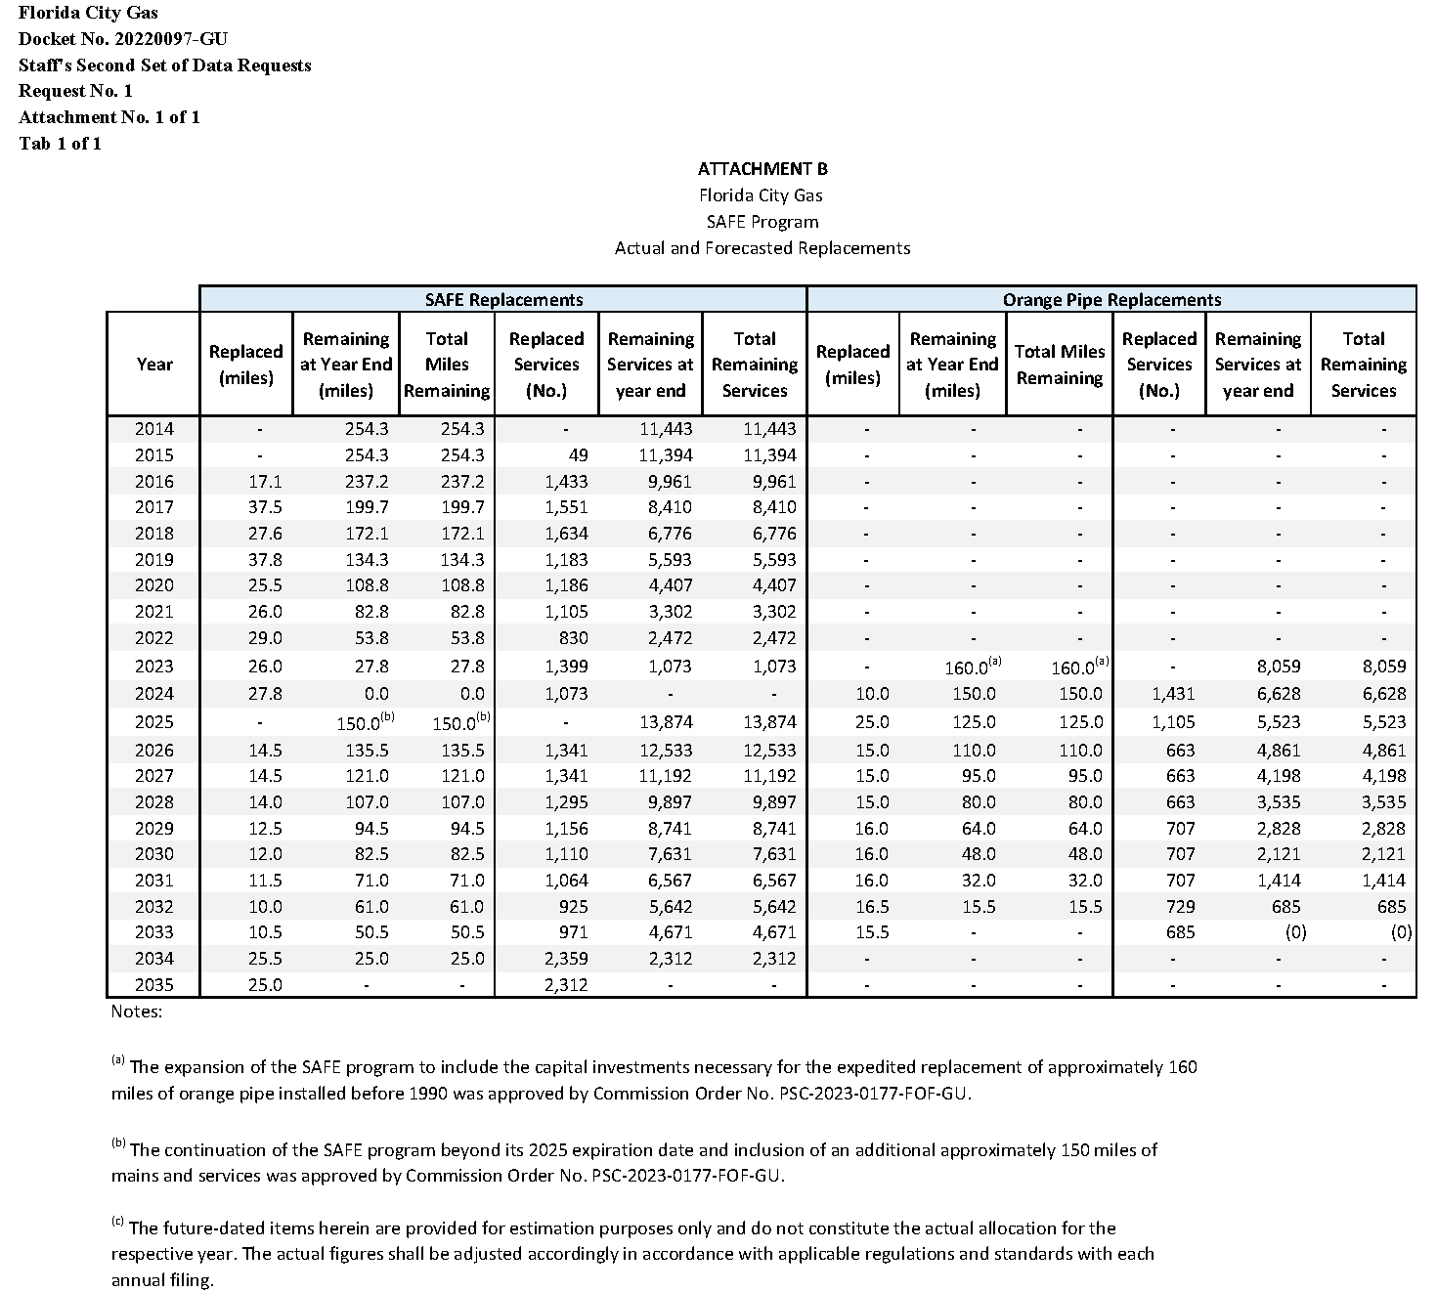

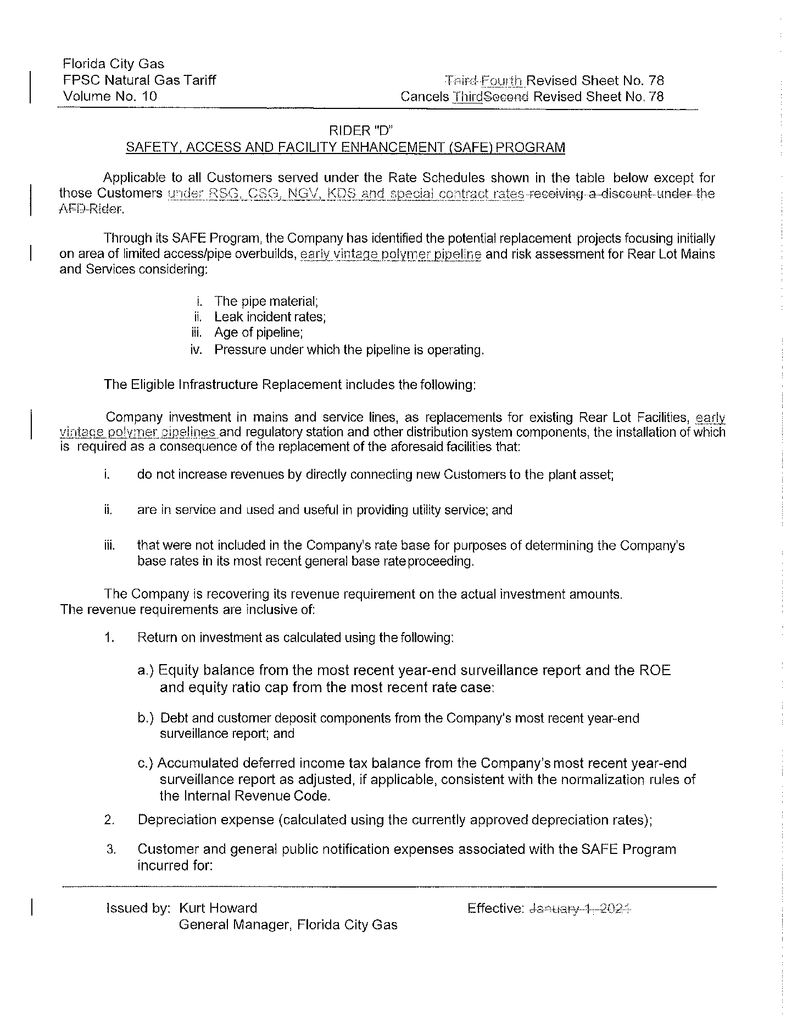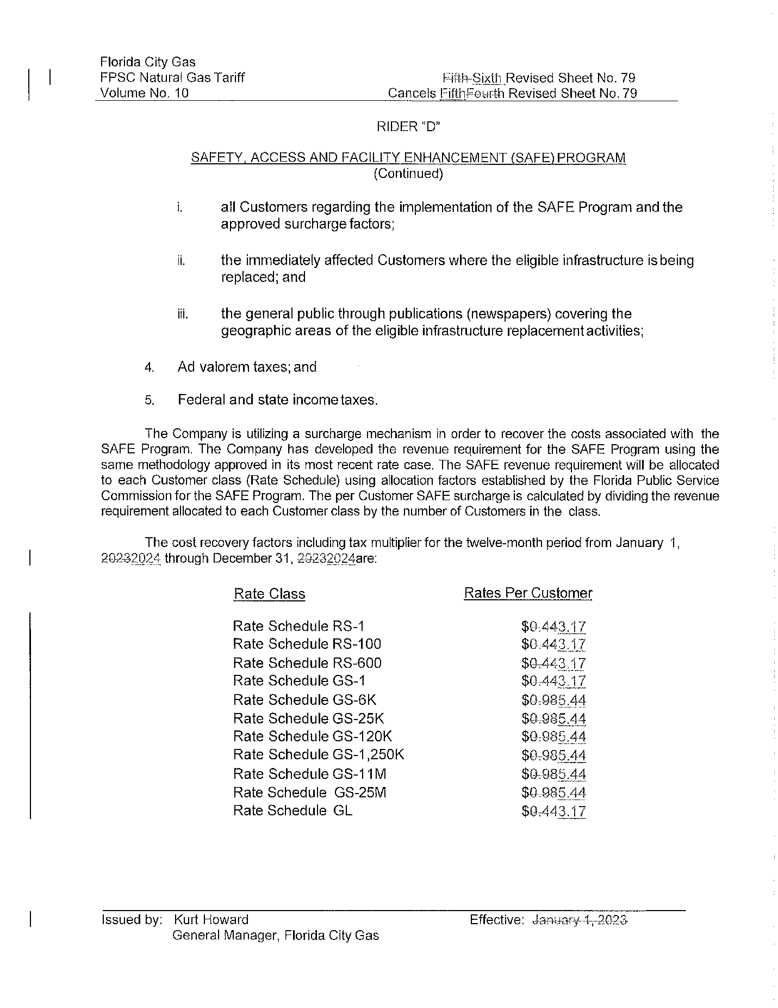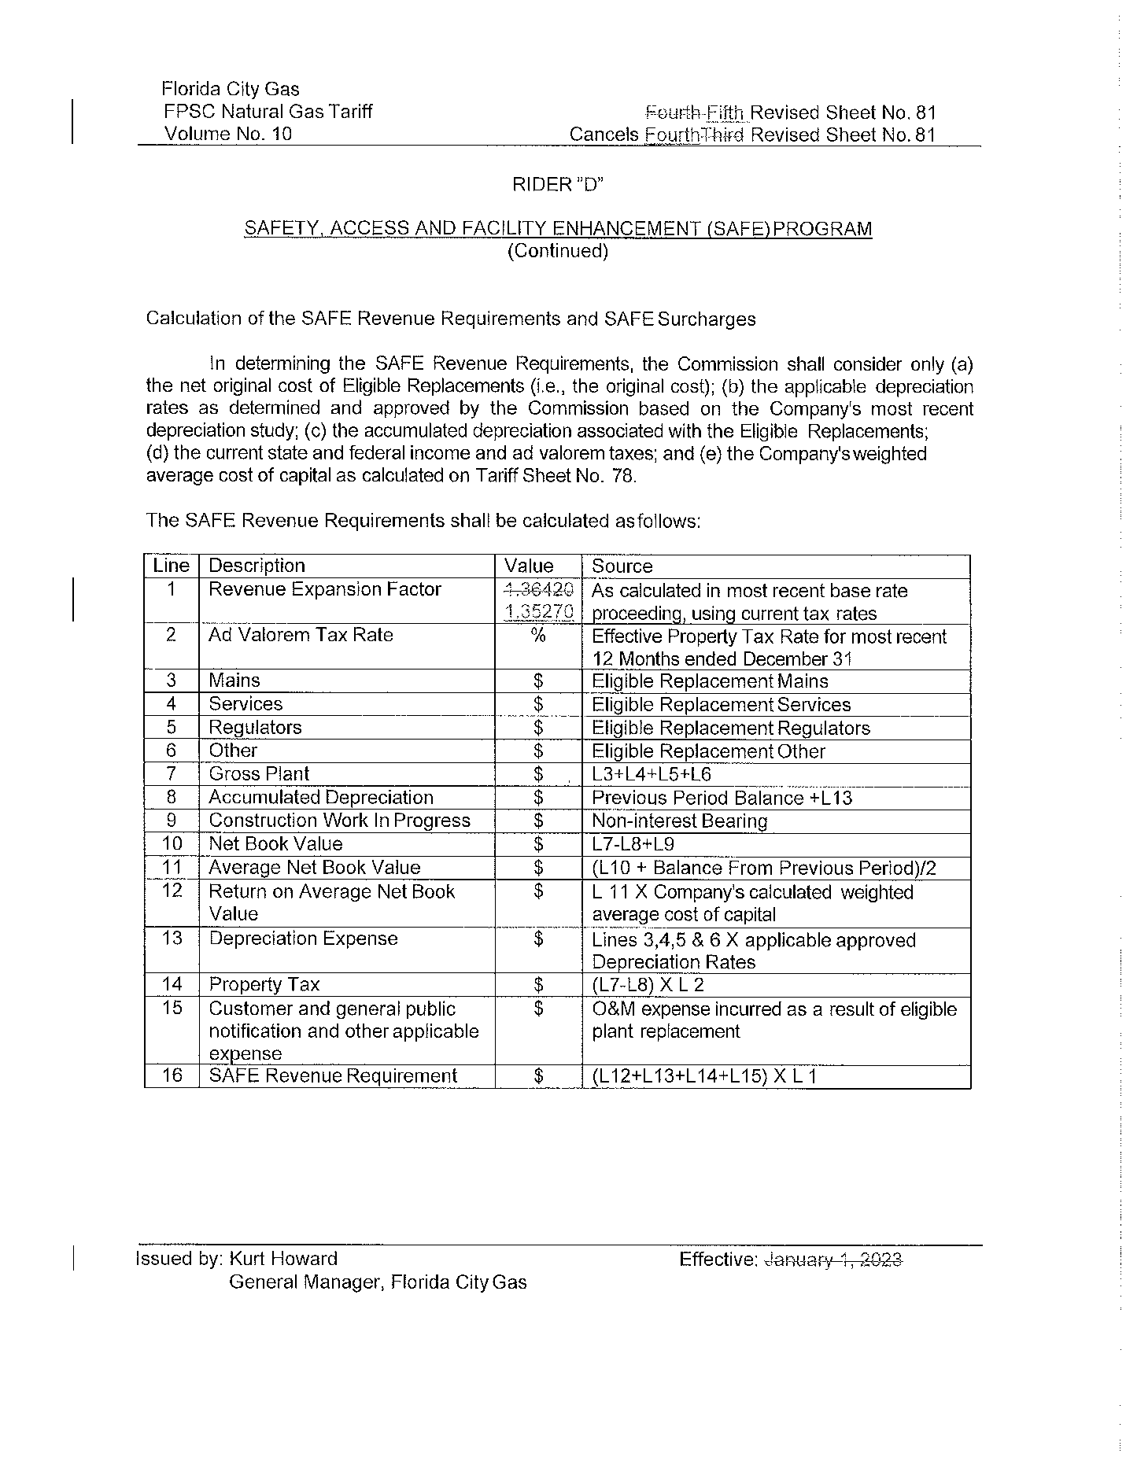

1. Order No. PSC-15-0390-TRF-GU, issued September 15, 2015, in Docket No. 20150116-GU, *In re: Petition for approval of safety, access, and facility enhancement program and associated cost recovery methodology, by Florida City Gas.*
2. Order No. PSC-2023-0177-FOF-GU, issued June 9, 2023, in Docket No. 20220069-GU, *In re: Petition for rate increase by Florida City Gas.*
3. See page 72, Section X, B. of Order No. PSC-2023-0177-FOF-GU.
4. See page 72, Section X, C. of Order No. PSC-2023-0177-FOF-GU.
5. Docket No. 20220069-EI, *In re: Petition for approval of rate increase and request for approval of depreciation rates*, filed May 31, 2022.
6. See page 4 of Order No. PSC-15-0390-TRF-GU.
7. See page 18 of Order No. PSC-2023-0177-FOF-GU.
8. Order No. PSC-2022-0403-TRF-GU, issued November 21, 2022, in Docket No. 20220153-GU, *In re: Petition for approval of safety, access, and facility enhancement program true-up and 2023 cost recovery factors, by Florida City Gas.*
9. DN 05438-2023, data response No. 1.
10. DN 05277-2023, data response No. 5.
11. DN 05438-2023, data response No. 4.
12. Order No. PSC-2023-0235-PAA-GU, issued August 15, 2023, in Docket No. 20230029-GU, *In re: Petition for approval of gas utility access and replacement directive, by Florida Public Utilities Company.* Order No. PSC-12-0490-TRF-GU, issued September 24, 2012, in Docket No. 120036-GU, *In re: Joint petition for approval of Gas Reliability Infrastructure Program (GRIP) by Florida Public Utilities Company and the Florida Division of Chesapeake Utilities Corporation.* Order No. PSC-12-0476-TRF-GU, issued September 18, 2012, in Docket No. 110320-GU, *In re: Petition for approval of Cast Iron/Bare Steel Pipe Replacement Rider (Rider CI/BSR), by Peoples Gas System.*
13. The calculation also includes a December 2021 true-up of $7,799 booked in January 2022. The petition shows $37,226 as the final 2022 true-up as a result of a cell error, the correct number is $35,929. The error does not impact the final rates.
14. The calculation also includes a December 2022 true-up of $26,525 booked in January 2023.