|  |  |  |  |
| --- | --- | --- | --- |
| State of Florida  pscSEAL | | Public Service Commission  Capital Circle Office Center ● 2540 Shumard Oak Boulevard Tallahassee, Florida 32399-0850  -M-E-M-O-R-A-N-D-U-M- | |
| DATE: | October 27, 2023 | | |
| TO: | Office of Commission Clerk (Teitzman) | | |
| FROM: | Division of Economics (Ward, Hampson, P. Kelley)  Office of the General Counsel (Brownless) | | |
| RE: | Docket No. 20230094-GU – Petition by Peoples Gas System, Inc. for approval of special contract with Tampa Port Authority. | | |
| AGENDA: | 11/09/23 – Regular Agenda – Proposed Agency Action – Interested Persons May Participate | | |
| COMMISSIONERS ASSIGNED: | | | All Commissioners |
| PREHEARING OFFICER: | | | Graham |
| CRITICAL DATES: | | | None |
| SPECIAL INSTRUCTIONS: | | | None |

Case Background

On August 25, 2023, Peoples Gas System, Inc. (Peoples or the utility) filed a petition for approval of a special contract with the Tampa Port Authority (the Port). The Port is the governing body and port authority of the Hillsborough County Port District, an independent special district of the State of Florida, created by Chapter 95-488, Laws of Florida (the Port’s Enabling Act).

The Port is seeking gas service from Peoples in order to run a standby gas-fired electric generator that would add resiliency during a loss of electric power. The proposed special contract modifies Peoples’ standard gas service agreement to correspond with the terms of the Port’s Enabling Act. Specifically, the term of the grant of easement and the indemnification language are being modified. Peoples and the Port have executed an easement agreement which is separate from the special contract. The easement agreement itself does not require Commission approval and was signed by representatives of the Port on June 13, 2023.

The purpose of the special contract is to allow Peoples to construct a service line and provide natural gas service to the Port. The natural gas would power a gas-fired electric generator that would provide resiliency to the Port during times of electrical power outages. Under the special contract the Port would take service for 500 therms per year at a capacity of 3,000 cubic feet per hour. In response to staff’s first data request, Peoples stated that the service line constructed in the easement will be 1¼” in diameter and approximately 258 linear feet. The utility also stated that it has constructed an approximate 450-feet long extension of the main pipeline within the right of way to provide service to the Port. The extension is not part of the special contract.

On October 6, 2023, staff issued a data request, to which responses were received on October 12, 2023. The proposed special contract is included in this recommendation as Attachment A. The Commission has jurisdiction over this matter pursuant to Sections 366.03, 366.04, 366.05, and 366.06, Florida Statutes (F.S.).

Discussion of Issues

Issue :

 Should the Commission approve the special contract between Peoples and Tampa Port Authority?

Recommendation:

 Yes, the Commission should approve the special contract between Peoples and Tampa Port Authority. The changes addressed in the special contract are necessary to correspond with the terms of Tampa Port Authority’s Enabling Act and allow it to receive gas service. Peoples should file a conformed copy of the signed special contract with the Commission before the special contract becomes effective. (Ward)

Staff Analysis:

 Pursuant to Rule 25-9.034, Florida Administrative Code, Commission approval is required if a utility enters into a contract where its filed regulations and standard approved rate schedules are not specifically covered under the contract. The proposed special contract makes changes to Peoples’ standard gas service agreement and requires Commission approval under this rule.

Peoples Gas Service Agreement

Peoples’ standard gas service agreement contained in Tariff Sheet Nos. 8.102 and 8.102-1 is completed by a customer in order to initiate natural gas service. The gas service agreement includes a wide range of customer information as well as terms and conditions. Included within the terms and conditions is a grant of “perpetual right of ingress and egress” to allow the utility to operate and maintain the gas pipe and gas meter installed on the customer’s property. Additionally, the utility’s standard indemnity provision specifies that the customer: “shall be responsible for marking and/or locating any underground facilities that may be on Customer’s property that do not belong to local utilities (Power, Telephone, Water, Cable TV companies, etc.) and agrees to indemnify and hold [c]ompany harmless for any damages arising out of Customer’s failure to do so.”

Port Enabling Act

The Port’s Enabling Act establishes the powers necessary for the Port to carry out the provisions of its Enabling Act and has “the specific responsibility of planning and of carrying out plans for the long-range development of the facilities of and traffic through the port in the port district.”[1] Additionally, the Enabling Act provides for certain conditions related to easements and rights of way. Specifically, the Enabling Act provides that:

“[e]asements for rights of way for railroads, pipelines, gas pipes, and electric transmission, telephone, and telegraph lines may be granted by the port authority for a period not to exceed 40 years with an option of 40 years without the approval, of the electors, but no such easement shall be exclusive, and every easement shall be subject to the right of the port authority or its successors and assigns to use and occupy the lands over or under the pipe or other line for any legitimate purpose.”

Proposed Special Contract

The proposed special contract modifies the term of the grant of easement and the indemnification language of the standard gas service agreement form to correspond with the terms of the Port’s Enabling Act. Specifically, the right of ingress and egress is limited to a period of 40 years with automatic one-year extensions at the expiration of the 40 year period. Additionally, the special contract modifies the standard gas service agreement to specify that the customer’s indemnification of the utility is “to the extent permitted by law.” The extent permitted by law is a $200,000 limit on damages. Section 768.28(5), F.S.

Staff has reviewed the proposed special contract and the provided easement agreement between Peoples and the Port and believes that the special contract would not negatively impact the general body of ratepayers. In response to staff’s data request, Peoples explained that no other customer would connect to the service line constructed for the Port, because the facilities within the easement are fully located on the property owned and maintained by the Port.[2] Furthermore, Peoples explained that it would not connect potential future customers to the Port’s service line, because this would be inconsistent with the utility’s best practices. Instead, any future customers would be required to connect to the existing main pipeline located in the right of way outside of the Port’s property.[3]

Conclusion

Staff believes that the special contract between Peoples and Tampa Port Authority is reasonable and that the changes made to Peoples standard form gas service agreement are necessary to correspond with the terms of the Port’s Enabling Act. Staff recommends approval of the special contract. Peoples should file a conformed copy of the signed special contract with the Commission before the special contract becomes effective.

Issue :

 Should this docket be closed?

Recommendation:

 Yes. If no protest is filed by a person whose substantial interests are affected within 21 days of the issuance of the Order, this docket should be closed upon the issuance of a Consummating Order. (Brownless)

Staff Analysis:

 If no protest is filed by a person whose substantial interests are affected within 21 days of the issuance of the Order, this docket should be closed upon the issuance of a Consummating Order.

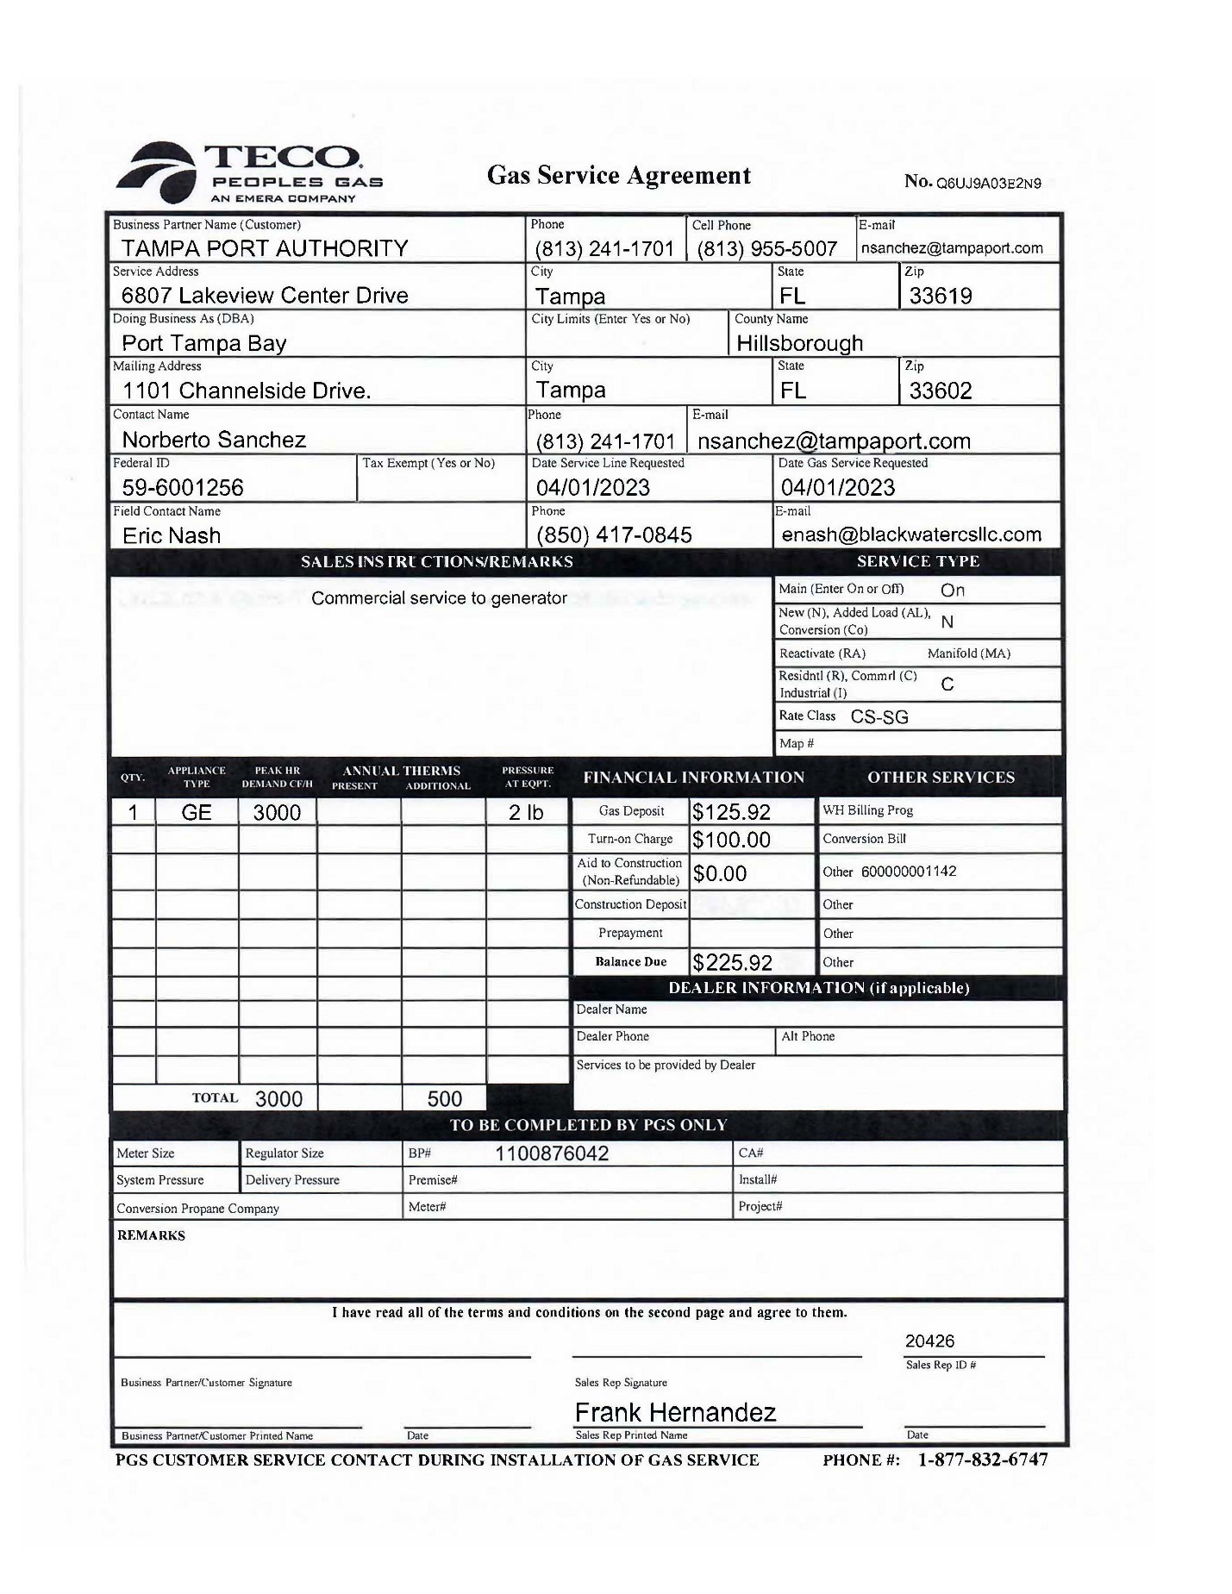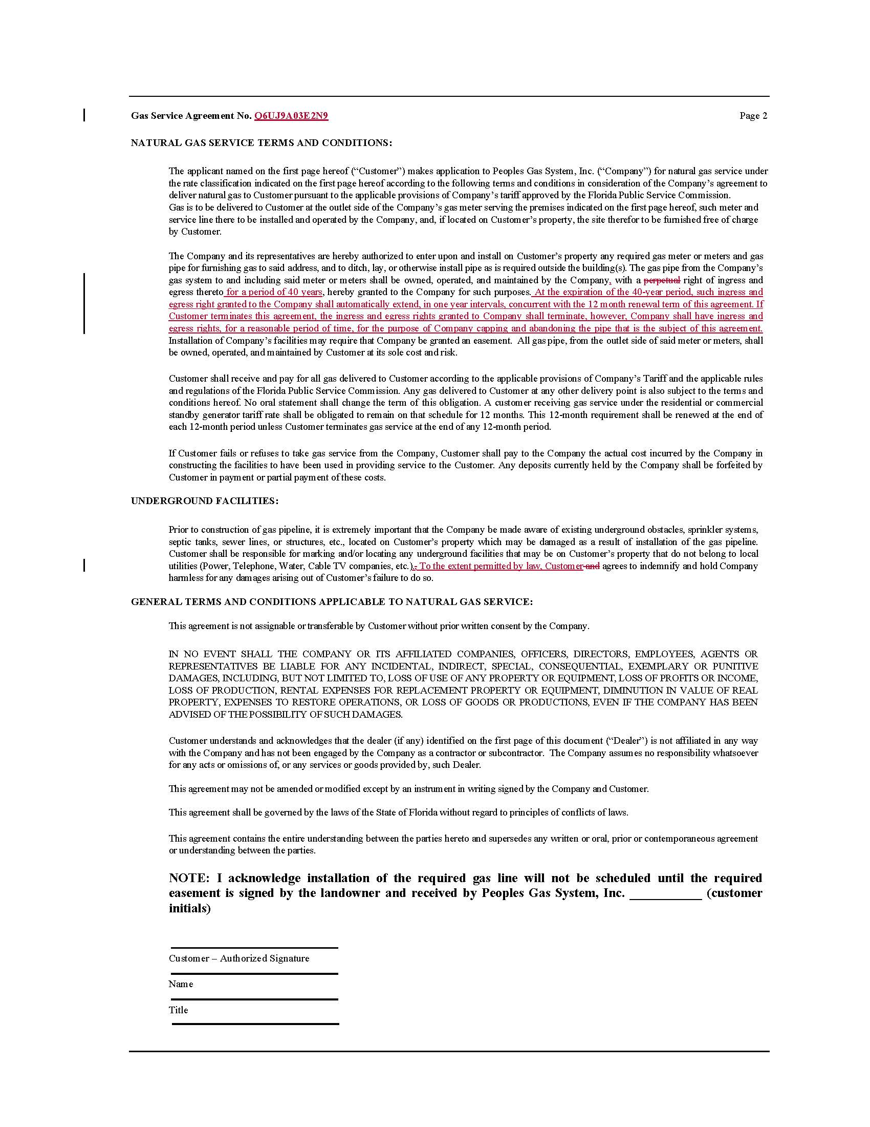

1. Chapter 95-488, Section 7, Laws of Florida.
2. DN 05652-2023, response No. 7.
3. DN 05652-2023, response No. 9.