|  |  |  |  |
| --- | --- | --- | --- |
| State of Florida  pscSEAL | | Public Service Commission  Capital Circle Office Center ● 2540 Shumard Oak Boulevard Tallahassee, Florida 32399-0850  -M-E-M-O-R-A-N-D-U-M- | |
| DATE: | October 27, 2023 | | |
| TO: | Office of Commission Clerk (Teitzman) | | |
| FROM: | Division of Economics (Ward, Hampson)  Division of Accounting and Finance (Hinson)  Office of the General Counsel (Sandy) | | |
| RE: | Docket No. 20230098-GU – Petition for approval of 2022 true-up, projected 2023 true-up, and 2024 revenue requirements and surcharges associated with cast iron/bare steel pipe replacement rider, by Peoples Gas System. | | |
| AGENDA: | 11/09/23 – Regular Agenda – Tariff Filing – Interested Persons May Participate | | |
| COMMISSIONERS ASSIGNED: | | | All Commissioners |
| PREHEARING OFFICER: | | | Administrative |
| CRITICAL DATES: | | | 05/01/24 (8-Month Effective Date) |
| SPECIAL INSTRUCTIONS: | | | None |

Case Background

On September 1, 2023, Peoples Gas System, Inc. (Peoples or utility) filed a petition for approval of its final 2022 true-up, projected 2023 true-up, and 2024 revenue requirement and surcharges associated with the cast iron/bare steel replacement rider (CI/BSR Rider or rider). The rider was originally approved in Order No. PSC-12-0476-TRF-GU (2012 Order) to recover the cost of accelerating the replacement of cast iron and bare steel pipes through a surcharge on customers' bills.[1] In the 2012 Order, the Commission found that, “replacement of these types of pipelines is in the public interest to improve the safety of Florida's natural gas infrastructure, and reduce the possibility of loss of life and destruction of property should an incident occur.” Peoples' current surcharges were approved in Order No. PSC-2022-0405-TRF-GU (2022 Order).[2]

In Order No. PSC-17-0066-AS-GU, the Commission approved a comprehensive settlement agreement between PGS and the Office of Public Counsel (OPC).[3] The settlement agreement, in part, added problematic plastic pipe (PPP) installed in the company's distribution system to eligible replacements under the rider beginning in 2017 and continuing through 2028. PPP was manufactured before 1983 and has significant safety concerns. In certain areas, the PPP is interspersed with, or connected to, the cast iron/bare steel pipe that is being replaced under the rider. As provided for in the settlement agreement, PPP replacements are included in the calculation of the 2024 rider surcharges.

On April 4, 2023, Peoples filed its petition for a rate increase in Docket No. 20230023-GU (rate case), which is pending a final decision by the Commission in December. As required in the original 2012 Order, Peoples has proposed to move CI/BSR investments into rate base that were made during January 1, 2021 through December 31, 2023. Accordingly, the CI/BSR tariff provided in the petition, and shown in Attachment B, has been calculated using the assumption that the Commission will approve Peoples’ request to move CI/BSR investments into rate base. If the Commission has not made a decision in the rate case prior to the January 1, 2024 effective date of the proposed CI/BSR factors, then any CI/BSR revenue requirement not collected in 2024 would be trued-up in the next CI/BSR filing.

In Order No. PSC-2023-0301-PCO-GU, issued October 10, 2023, the Commission suspended Peoples’ proposed modifications to Tariff Sheet No. 7.806 to allow staff time to gather additional data. On September 12, 2023, staff issued its first data request, to which Peoples responded on September 22, 2023. Staff issued a second data request on September 26, 2023, to which Peoples responded on October 5, 2023. Peoples filed a revised response to staff’s first data request on October 23, 2023.

Attachment A to this recommendation contains tables which display the replacement progress and forecasts for CI/BSR Rider (Table 2) and for PPP (Table 3). Additionally, Peoples provided Table 1 which consolidates actual and projected CI/BSR and PPP miles replaced investment and revenue requirements for each year of the replacement program. Attachment B contains the proposed tariff. The Commission has jurisdiction over this matter pursuant to Sections 366.03, 366.04, 366.05, and 366.06, Florida Statutes (F.S.).

Discussion of Issues

Issue 1:

 Should the Commission approve Peoples' proposed CI/BSR Rider surcharges for the period January through December 2024?

Recommendation:

 Yes, the Commission should approve Peoples’ proposed CI/BSR Rider surcharges to be effective for the first billing cycle of January through the last billing cycle of December 2024. Staff has reviewed Peoples’ filings and supporting documentation and believes that the calculations are consistent with the methodology approved in the 2012 Order and are reasonable and accurate. (Ward)

Staff Analysis:

 The CI/BSR Rider charges have been in effect since January 2013 and were projected to be in effect for 10 years with replacement projects completed by the end of 2022. In response to staff’s first data request, Peoples stated that it experienced delays in cast iron/bare steel replacement that prevented it from completing the cast iron/bare steel projects within the projected 10-year time period.[4] Peoples stated that it expects to have approximately 7.5 miles of cast iron/bare steel replacement remaining entering 2024.

In 2023, Peoples’ cast iron/bare steel and PPP replacement activity focused in the areas of Miami, Tampa, St. Petersburg, Orlando, Eustis, Jacksonville, Lakeland, Daytona, Avon Park, Jupiter, and Ocala. In 2024, Peoples states it will focus on replacement projects in Miami, Orlando, Jacksonville, Eustis, Lakeland, Daytona, St. Petersburg, Avon Park, and any further identified cast iron/bare steel in the system. A detailed description of the projects, including their address, has been provided in response to staff’s first data request.[5]

True-ups by Year

Peoples’ calculation for the 2024 revenue requirement and surcharges includes a final true-up for 2022, an actual/estimated true-up for 2023, and projected costs for 2024. Pursuant to the 2012 Order, the capital expenditures for 2023 and 2024 exclude the first $1 million of facility replacements each year because that amount is included in rate base. Peoples has included depreciation expense savings as discussed in the 2012 Order; however, the utility has not identified any operations and maintenance savings.

Final True-up for 2022

Exhibit A of the petition shows that the revenues collected for 2022 were $5,052,616 compared to a revenue requirement of $5,020,126, resulting in an over-recovery of $32,490. The final 2021 under-recovery of $563,794, 2022 over-recovery of $32,490, state tax rate change recovery adjustment of $253,079, and interest associated with any over- and under-recoveries, results in a final 2022 under-recovery of $787,888. In response to staff’s data request, Peoples explained that the state tax rate change adjustment of $253,079 was previously approved by the Commission.[6] Furthermore, the description provided in Exhibit A to the petition, page 2, line 9a was incorrect and should instead read, “2021 & 2022 State Corporate Income Tax Rate Changes Adjustment (PSC-2022-0134-PAA-GU).”[7]

Actual/Estimated 2023 True-up

In Exhibit B of the petition, Peoples provided actual revenues for January through July and forecast revenues for August through December of 2023, totaling $8,361,539, compared to an actual/estimated revenue requirement of $7,586,789, resulting in an over-recovery of $774,750. The final 2022 under-recovery of $787,888, 2023 over-recovery of $774,750, and interest associated with any over- and under-recoveries, results in a total 2023 under-recovery of $10,683.

Projected 2024 Costs

Exhibit C of the petition shows Peoples projects investment or capital expenditures of $18,802,302 for the replacement of cast iron/bare steel infrastructure and PPP in 2024, excluding the $1 million adjustment to rate base. The return on investment, depreciation expense (less savings), and property tax expense associated with that investment are $905,720. After adding the total 2023 under-recovery of $10,683, the total 2024 revenue requirement is $916,404. Table 1-1 displays the 2024 revenue requirement calculation. In response to staff’s first data request Peoples provided updated investment and revenue requirement projections for the CI/BSR and PPP which is contained in Table 1 of Attachment A. On a phone call with staff Peoples explained that the 2024 revenue requirement in the petition and the 2024 revenue requirement in Table 1 of Attachment A are different because they were forecast at different times.

Table 1-1

2024 Revenue Requirement

|  |  |
| --- | --- |
| 2024 Projected Expenditures | $18,802,302 |
| Return on Investment | $786,310 |
| Depreciation Expense (less savings) | $118,789 |
| Property Tax Expense | $622 |
| 2024 Revenue Requirement | $905,721 |
| Plus 2023 Under-recovery | $10,683 |
| Total 2024 Revenue Requirement | $916,404 |

Source: Page 1 of 2 in Exhibit C in petition (Docket No. 20230098-GU).

Proposed Surcharges

As established in the 2012 Order, the total 2024 revenue requirement is allocated to rate classes using the same methodology that was used for the allocation of mains and services in the cost of service study used in Peoples' most recent approved rate case. After calculating the percentage of total plant costs attributed to each rate class, the respective percentages were multiplied by the 2024 revenue requirement resulting in the revenue requirement by rate class. Dividing each rate class's revenue requirement by projected therm sales provides the rider surcharge for each rate class.

If the Commission approves this recommendation, the proposed 2024 rider surcharge for residential customers would be $0.00322 per therm (compared to the current surcharge of $0.03111). The 2024 monthly bill impact would be $0.06 for a residential customer who uses 20 therms. The proposed tariff sheet is provided in this recommendation as Attachment B.

Conclusion

Staff has reviewed Peoples’ filings and supporting documentation and believes that the calculations are consistent with the methodology approved in the 2012 Order and are reasonable and accurate. Therefore, Staff recommends that the Commission should approve Peoples’ proposed CI/BSR Rider surcharges to be effective for the first billing cycle of January through the last billing cycle of December 2024.

Issue 2:

 Should this docket be closed?

Recommendation:

 Yes. If Issue 1 is approved and a protest is filed within 21 days of the issuance of the order, the tariff should remain in effect, with any revenues held subject to refund, pending resolution of the protest. If no timely protest is filed, this docket should be closed upon the issuance of a consummating order. (Sandy)

Staff Analysis:

 Yes. If Issue 1 is approved and a protest is filed within 21 days of the issuance of the order, the tariff should remain in effect, with any revenues held subject to refund, pending resolution of the protest. If no timely protest is filed, this docket should be closed upon the issuance of a consummating order.

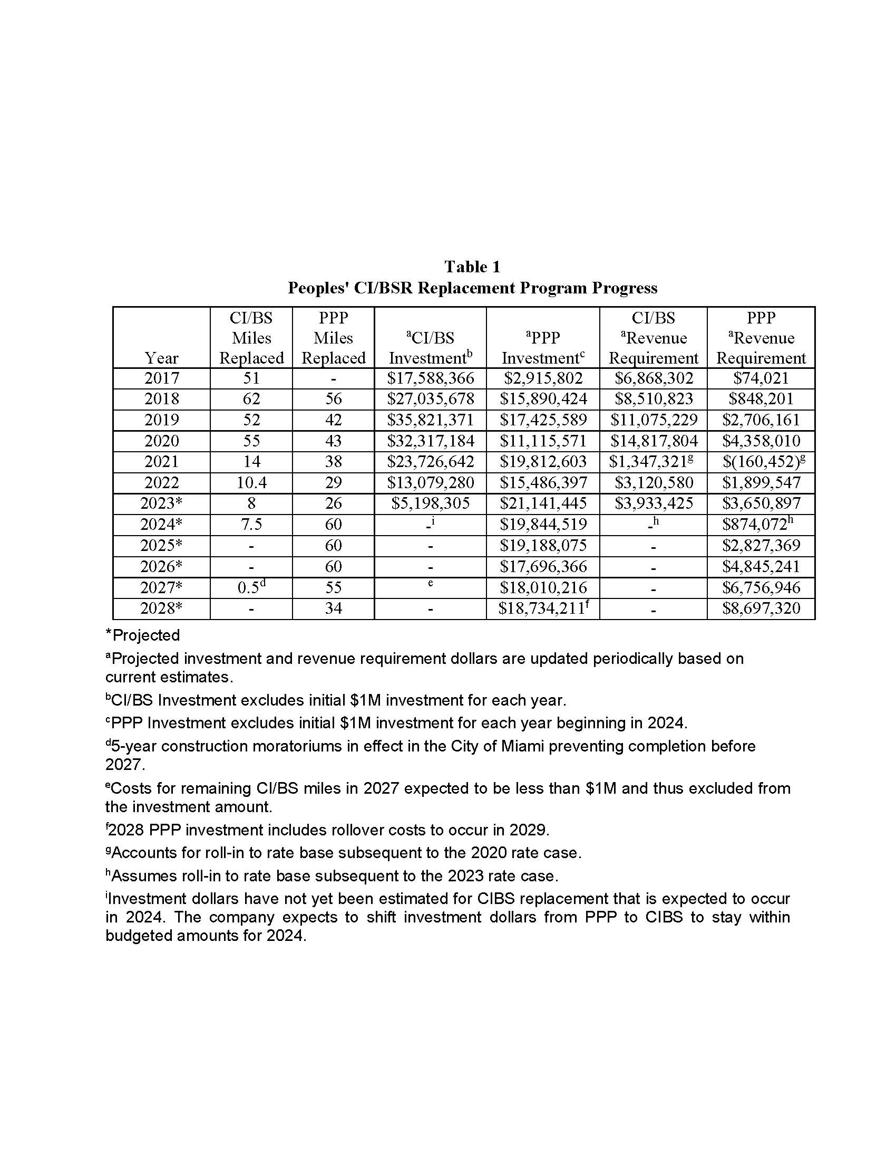

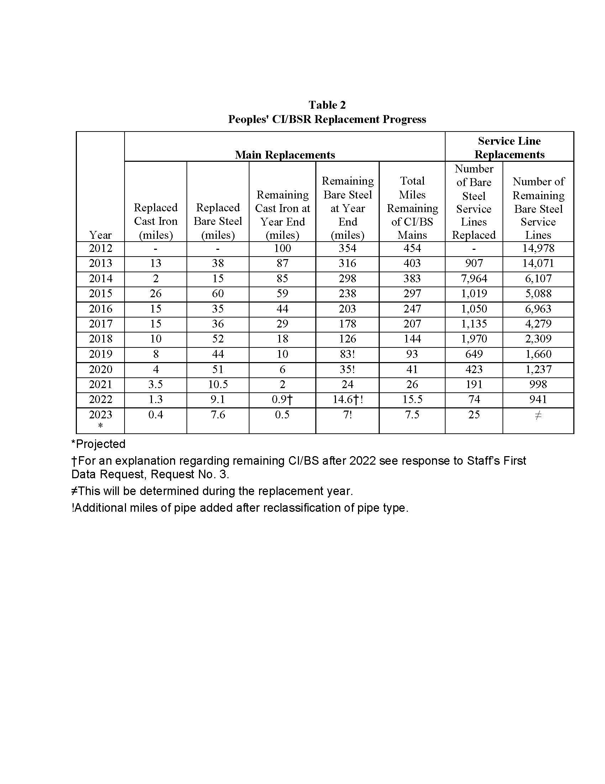

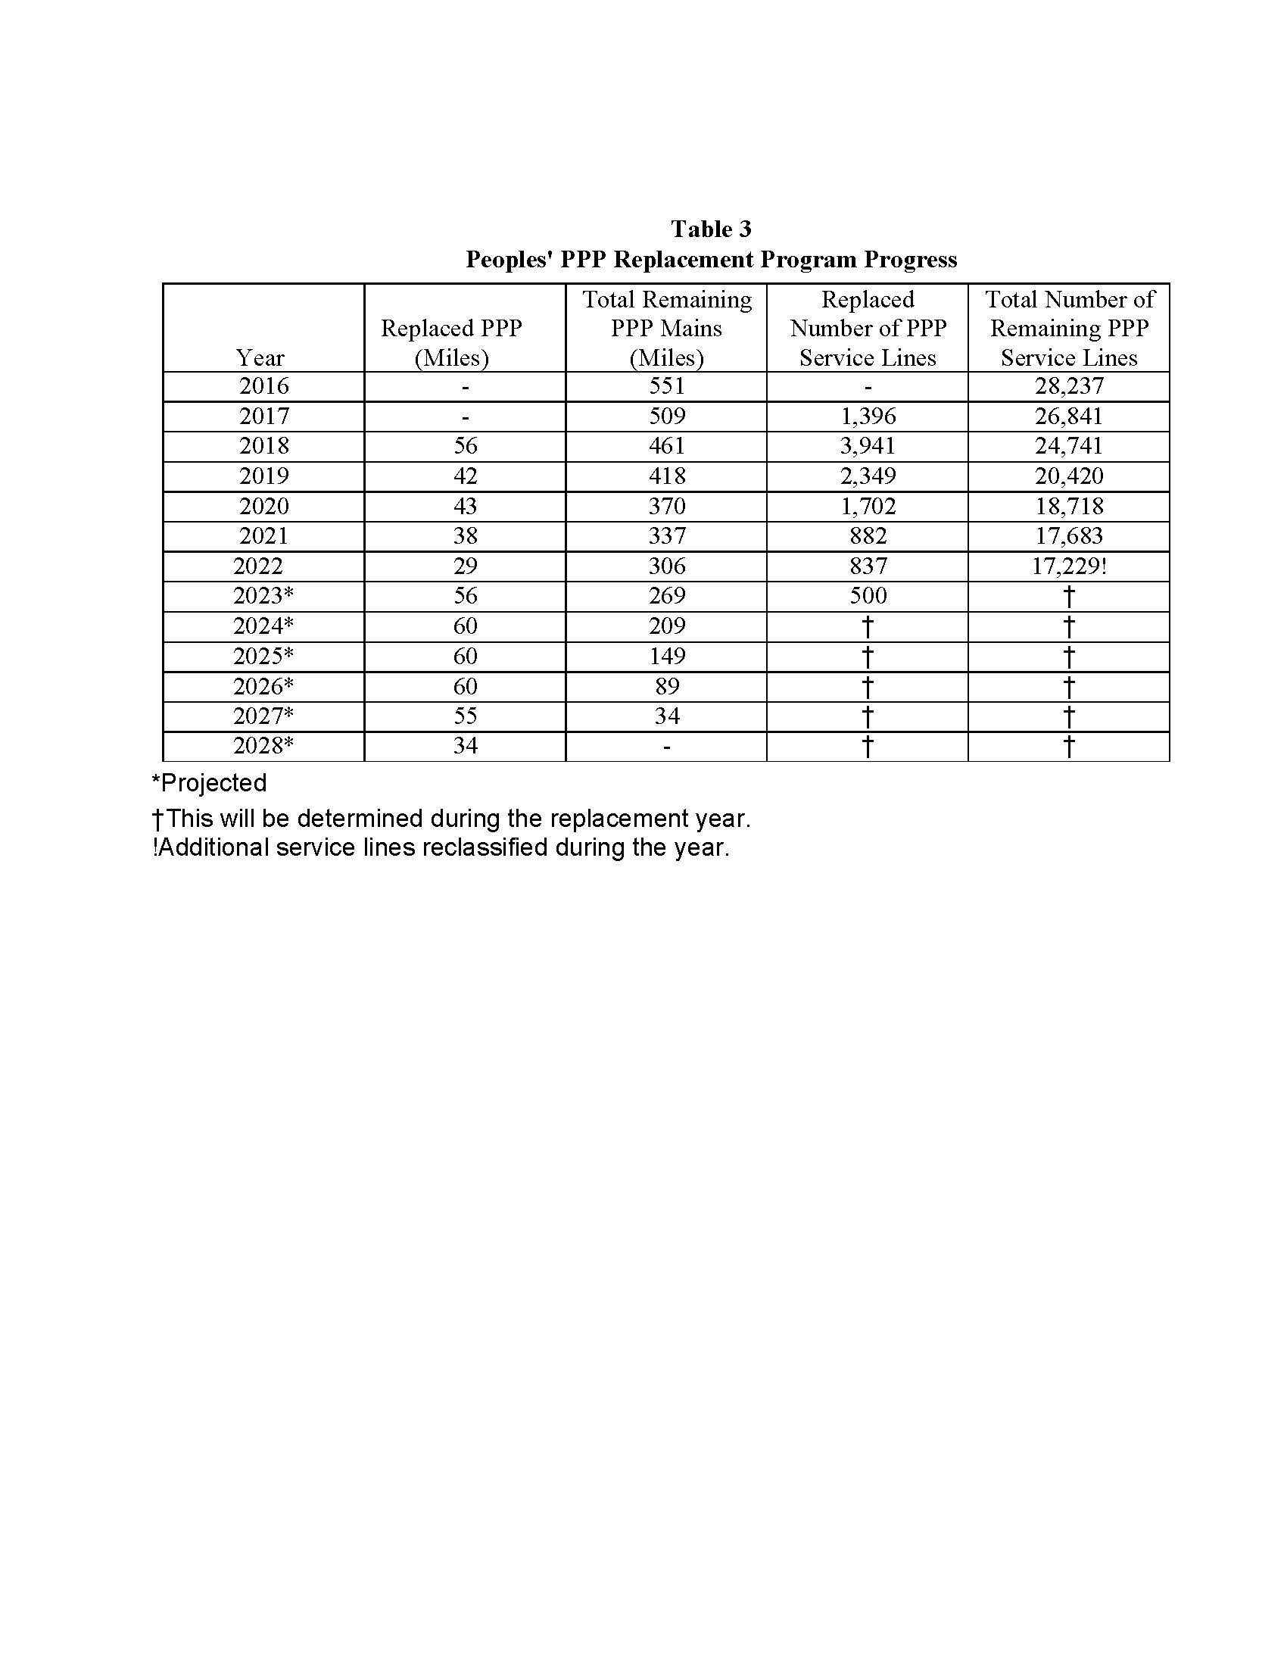

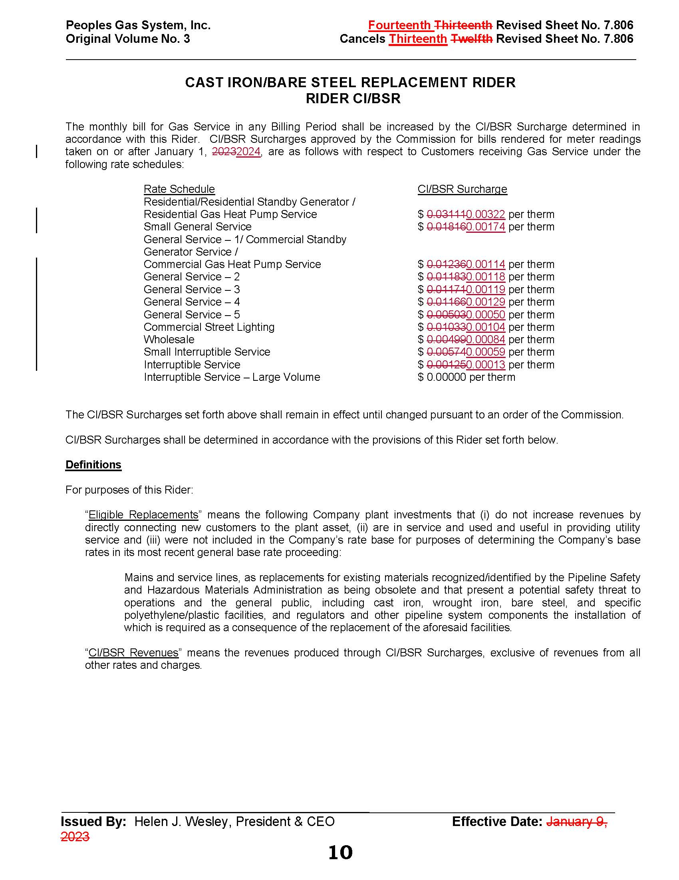

1. Order No. PSC-12-0476-TRF-GU, issued September 18, 2012, in Docket No. 20110320-GU, *In re: Petition for*

   *approval of Cast Iron/Bare Steel Pipe Replacement Rider (Rider CI/BSR), by Peoples Gas System.*
2. Order No. PSC-2022-0405-TRF-GU, issued November 21, 2021, in Docket No. 20220152-GU, *In re: Petition for approval of 2021 true-up, projected 2022 true-up, and 2023 revenue requirements and surcharges associated with cast iron/bare steel replacement rider, by Peoples Gas System.*
3. Order No. PSC-17-0066-AS-GU, issued February 28, 2017, in Docket No. 20160159-GU, *In re: Petition for approval of settlement agreement pertaining to Peoples Gas System’s 2016 depreciation study, environmental reserve account, problematic plastic pipe replacement, and authorized ROE.*
4. DN 05355-2023, response No. 3.
5. DN 05355-2023, response No. 3.
6. Order No. PSC-2022-0134-PAA-GU, issued April 11, 2022, in Docket No. 20220018-GU, *In re: Petition for limited proceeding to address the impact of changes to Florida state income tax rates by Peoples Gas System.*
7. DN 05484-2023, response No. 1.