BEFORE THE FLORIDA PUBLIC SERVICE COMMISSION

|  |  |
| --- | --- |
| In re: Petition by Peoples Gas System, Inc. for approval of special contract with Tampa Port Authority. | DOCKET NO. 20230094-GU  ORDER NO. PSC-2023-0352-PAA-GU  ISSUED: November 20, 2023 |

The following Commissioners participated in the disposition of this matter:

ANDREW GILES FAY, Chairman

ART GRAHAM

GARY F. CLARK

MIKE LA ROSA

GABRIELLA PASSIDOMO

NOTICE OF PROPOSED AGENCY ACTION

ORDER APPROVING SPECIAL CONTRACT

BY THE COMMISSION:

NOTICE is hereby given by the Florida Public Service Commission that the action discussed herein is preliminary in nature and will become final unless a person whose interests are substantially affected files a petition for a formal proceeding, pursuant to Rule 25-22.029, Florida Administrative Code (F.A.C.).

BACKGROUND

On August 25, 2023, Peoples Gas System, Inc. (Peoples or the utility) filed a petition for approval of a special contract with the Tampa Bay Port Authority (the Port). The Port is the governing body and port authority of the Hillsborough County Port District, an independent special district of the State of Florida, created by Chapter 95-488,, Laws of Florida (the Port’s Enabling Act).

The Port is seeking gas service from Peoples in order to run a standby gas-fired electric generator that would add resiliency during a loss of electric power. The proposed special contract modifies Peoples’standard gas service agreement to correspond with the terms of the Port’s Enabling Act. Specifically, the term of the grant of easement and the indemnification language are being modified. Peoples and the Port have executed an easement agreement which is separate from the special contract. The easement agreement itself does not require our approval and was signed by representatives of the Port on June 13, 2023.

The purpose of the special contract is to allow Peoples to construct a service line and provide natural gas service to the Port. The natural gas would power a gas-fired electric generator that would provide resiliency to the Port during times of electrical power outages. Under the special contract the Port would take service for 500 therms per year at a capacity of 3,000 cubic feet per hour. The service line constructed in the easement will be 1¼”inches in diameter and approximately 258 linear feet. An extension of the main pipeline within the right of way of approximately 450 feet has already been constructed to provide service to the Port. The extension is not part of the special contract. The proposed special contract is Attachment A to this order.

We have jurisdiction over this matter pursuant to Sections 366.03, 366.04, 366.05, and 366.06, Florida Statutes (F.S.).

DECISION

Pursuant to Rule 25-9.034, F.A.C., our approval is required if a utility enters into a contract where its filed regulations and standard approved rate schedules are not specifically covered under the contract. The proposed special contract makes changes to Peoples’ standard gas service agreement and requires our approval under this rule.

Peoples Gas Service Agreement

Peoples’ standard gas service agreement contained in Tariff Sheet Nos. 8.102 and 8.102-1 is completed by a customer in order to initiate natural gas service. The gas service agreement includes a wide range of customer information as well as terms and conditions. Included within the terms and conditions is a grant of “perpetual right of ingress and egress” to allow the utility to operate and maintain the gas pipe and gas meter installed on the customer’s property. Additionally, the utility’s standard indemnity provision specifies that the customer: “shall be responsible for marking and/or locating any underground facilities that may be on Customer’s property that do not belong to local utilities (Power, Telephone, Water, Cable TV companies, etc.) and agrees to indemnify and hold [c]ompany harmless for any damages arising out of Customer’s failure to do so.”

Port Enabling Act

The Port’s Enabling Act establishes the powers necessary for the Port to carry out the provisions of its Enabling Act and has “the specific responsibility of planning and of carrying out plans for the long-range development of the facilities of and traffic through the port in the port district.”[1] Additionally, the Enabling Act provides for certain conditions related to easements and rights of way. Specifically, the Enabling Act provides that:

“[e]asements for rights of way for railroads, pipelines, gas pipes, and electric transmission, telephone, and telegraph lines may be granted by the port authority for a period not to exceed 40 years with an option of 40 years without the approval, of the electors, but no such easement shall be exclusive, and every easement shall be subject to the right of the port authority or its successors and assigns to use and occupy the lands over or under the pipe or other line for any legitimate purpose.”

Proposed Special Contract

The proposed special contract modifies the term of the grant of easement and the indemnification language of the standard gas service agreement form to correspond with the terms of the Port’s Enabling Act. Specifically, the right of ingress and egress is limited to a period of 40 years with automatic one-year extensions at the expiration of the 40 year period. Additionally, the special contract modifies the standard gas service agreement to specify that the customer’s indemnification of the utility is “to the extent permitted by law.” The extent permitted by law is a $200,000 limit on damages. Section 768.28(5), F.S.

We have reviewed the proposed special contract and the provided easement agreement between Peoples and the Port and find that the special contract would not negatively impact the general body of ratepayers. Peoples explained that no other customer would be able to connect to the service line constructed for the Port, because the facilities within the easement are fully located on the property owned and maintained by the Port.[2] Furthermore, potential future customers could not connect to the Port’s service line because this would be inconsistent with the utility’s best practices. Instead, any future customers would be required to connect to the existing main pipeline located in the right of way outside of the Port’s property.[3]

We find that the special contract between Peoples and Tampa Port Authority is reasonable and that the changes made to Peoples standard form gas service agreement are necessary to correspond with the terms of the Port’s Enabling Act. For these reasons, we hereby approve the special contract. We further find that Peoples shall file a conformed copy of the fully executed special contract with us before the special contract becomes effective.

Based on the foregoing, it is

ORDERED by the Florida Public Service Commission that the special contract between Peoples Gas System, Inc. and the Tampa Port Authority contained in Attachment A is hereby approved. Peoples shall file a conformed copy of the signed special contract with this Commission before the special contract becomes effective. It is further

ORDERED that the provisions of this Order, issued as proposed agency action, shall become final and effective upon the issuance of a Consummating Order unless an appropriate petition, in the form provided by Rule 28-106.201, F.A.C., is received by the Commission Clerk, 2540 Shumard Oak Boulevard, Tallahassee, Florida 32399-0850, by the close of business on the date set forth in the “Notice of Further Proceedings” attached hereto. It is further

ORDERED that if no protest is filed by a person whose substantial interests are affected within 21 days of the issuance of this Order, this docket shall be closed upon the issuance of a Consummating Order.

By ORDER of the Florida Public Service Commission this 20th day of November, 2023.

|  |  |
| --- | --- |
|  | /s/ Adam J. Teitzman |
|  | ADAM J. TEITZMAN  Commission Clerk |

Florida Public Service Commission

2540 Shumard Oak Boulevard

Tallahassee, Florida 32399

(850) 413‑6770

www.floridapsc.com

Copies furnished: A copy of this document is provided to the parties of record at the time of issuance and, if applicable, interested persons.

SBr

NOTICE OF FURTHER PROCEEDINGS OR JUDICIAL REVIEW

The Florida Public Service Commission is required by Section 120.569(1), Florida Statutes, to notify parties of any administrative hearing that is available under Section 120.57, Florida Statutes, as well as the procedures and time limits that apply. This notice should not be construed to mean all requests for an administrative hearing will be granted or result in the relief sought.

Mediation may be available on a case-by-case basis. If mediation is conducted, it does not affect a substantially interested person's right to a hearing.

The action proposed herein is preliminary in nature. Any person whose substantial interests are affected by the action proposed by this order may file a petition for a formal proceeding, in the form provided by Rule 28-106.201, Florida Administrative Code. This petition must be received by the Office of Commission Clerk, 2540 Shumard Oak Boulevard, Tallahassee, Florida 32399-0850, by the close of business on December 11, 2023.

In the absence of such a petition, this order shall become final and effective upon the issuance of a Consummating Order.

Any objection or protest filed in this/these docket(s) before the issuance date of this order is considered abandoned unless it satisfies the foregoing conditions and is renewed within the specified protest period.

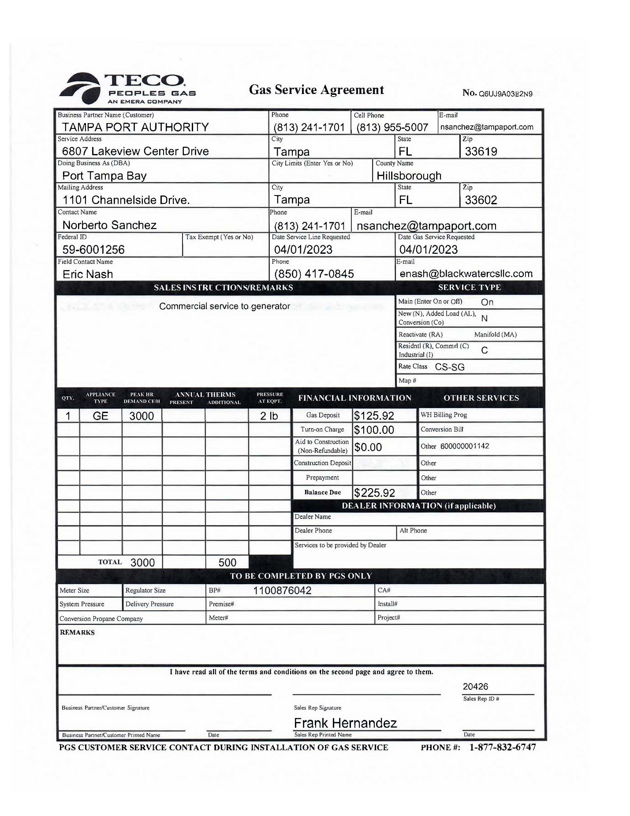

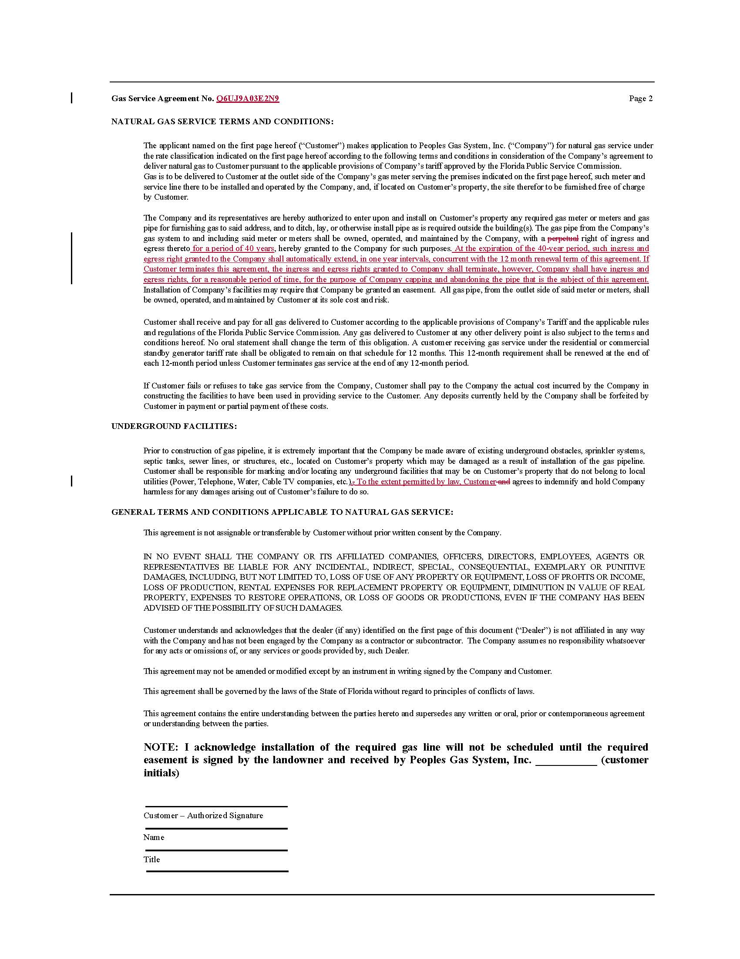

1. Chapter 95-488, Section 7, Laws of Florida.
2. DN 05652-2023, response No. 7.
3. DN 05652-2023, response No. 9.