BEFORE THE FLORIDA PUBLIC SERVICE COMMISSION

|  |  |
| --- | --- |
| In re: Request for approval of new class of service in Okaloosa County by North Florida Community Water Systems. | DOCKET NO. 20230112-WU  ORDER NO. PSC-2023-0386-TRF-WU  ISSUED: December 22, 2023 |

The following Commissioners participated in the disposition of this matter:

ANDREW GILES FAY, Chairman

ART GRAHAM

GARY F. CLARK

MIKE LA ROSA

GABRIELLA PASSIDOMO

ORDER APPROVING BASE FACILITY CHARGES FOR NEW METER SIZES

BY THE COMMISSION:

Background

North Florida Community Water Systems, Inc. (NFCWS or utility) provides water and wastewater service to several counties including a system in Okaloosa County. The utility’s Okaloosa County system provides water service to approximately 236 residential customers.[1] The utility has never had a rate case, but recently had a price index approved in 2023.[2]

On October 10, 2023, pursuant to Section 367.091(5), Florida Statutes (F.S.), NFCWS filed a request to include additional base facility charges (BFC) based on the American Water Works Association (AWWA) meter equivalents for larger meter sizes. The utility indicated in its application that it had a request to install a one-inch meter size in the Okaloosa water system. According to the utility’s current tariff, the utility only has a BFC for a 5/8 x 3/4 inch meter size for both residential and general service classes. This order addresses the utility’s request to include additional BFCs up to a six-inch meter size to the residential and general service tariffs as shown in Attachment A to the order. We have jurisdiction pursuant to Section 367.091, F.S.

Decision

In its application, the utility is requesting BFCs for meter sizes up to 6 inches for the residential and general service classes. As noted, the utility’s residential and general service tariff only has a BFC for a 5/8 x 3/4 inch meter size. The utility’s proposed BFCs for the additional meter sizes are calculated by using the utility’s existing residential BFC of $33.86 for the 5/8 x 3/4 inch size meter as a foundation, and then applying the AWWA’s meter equivalent factor. The AWWA meter equivalent factors are contained in Rule 25-30.055, Florida Administrative Code. NFCWS’s proposed BFCs for the residential and general service meters based on the AWWA meter equivalents are shown in Table 1:

**Table 1**

**Current and Proposed Residential and General Service BFC Charges**

|  |  |  |
| --- | --- | --- |
| **Meter Size** | **AWWA Meter Factor** | **BFC** |
| 5/8" x 3/4" | 1 | $33.86 |
| 3/4" | 1.5 | $50.79 |
| 1" | 2.5 | $84.65 |
| 1-1/2" | 5 | $169.30 |
| 2" | 8 | $270.88 |
| 3" | 16 | $541.76 |
| 4" | 25 | $846.50 |
| 6" | 50 | $1,693.00 |

The utility’s proposed tariff, which includes BFCs for additional meter sizes based on the AWWA meter equivalents for the residential and general service classes, is approved. The utility’s proposed Second Revised Sheet No. 12.4 and Second Revised Sheet No. 13.4 are approved as filed. The approved tariffs shall be effective as of December 5, 2023. Since no current customers are affected by the tariff revisions, no customer notices are required.

Based on the foregoing, it is

ORDERED by the Florida Public Service Commission that the North Florida Community Water System, Inc.’s proposed tariff is approved. The utility’s proposed Second Revised Sheet No. 12.4 and Second Revised Sheet No. 13.4 are approved as filed. It is further

ORDERED that the tariff sheets shall be effective as of December 5, 2023. It is further

ORDERED that is a protest is filed within 21 days of the issuance of this order, the tariff shall remain in effect with the revenues held subject to refund pending resolution of the protest, and the docket should remain open. If no timely protest is filed, the docket should be closed upon the issuance of a Consummating Order.

By ORDER of the Florida Public Service Commission this 22nd day of December, 2023.

|  |  |
| --- | --- |
|  | /s/ Adam J. Teitzman |
|  | ADAM J. TEITZMAN  Commission Clerk |

Florida Public Service Commission

2540 Shumard Oak Boulevard

Tallahassee, Florida 32399

(850) 413‑6770

www.floridapsc.com

Copies furnished: A copy of this document is provided to the parties of record at the time of issuance and, if applicable, interested persons.

MRT

NOTICE OF FURTHER PROCEEDINGS

The Florida Public Service Commission is required by Section 120.569(1), Florida Statutes, to notify parties of any administrative hearing or judicial review of Commission orders that is available under Sections 120.57 or 120.68, Florida Statutes, as well as the procedures and time limits that apply. This notice should not be construed to mean all requests for an administrative hearing or judicial review will be granted or result in the relief sought.

Mediation may be available on a case-by-case basis. If mediation is conducted, it does not affect a substantially interested person's right to a hearing.

The Commission's decision on this tariff is interim in nature and will become final, unless a person whose substantial interests are affected by the proposed action files a petition for a formal proceeding, in the form provided by Rule 28-106.201, Florida Administrative Code. This petition must be received by the Office of Commission Clerk, 2540 Shumard Oak Boulevard, Tallahassee, Florida 32399-0850, by the close of business on January 12, 2024.

In the absence of such a petition, this Order shall become final and effective upon the issuance of a Consummating Order.

Any objection or protest filed in this docket before the issuance date of this order is considered abandoned unless it satisfies the foregoing conditions and is renewed within the specified protest period.

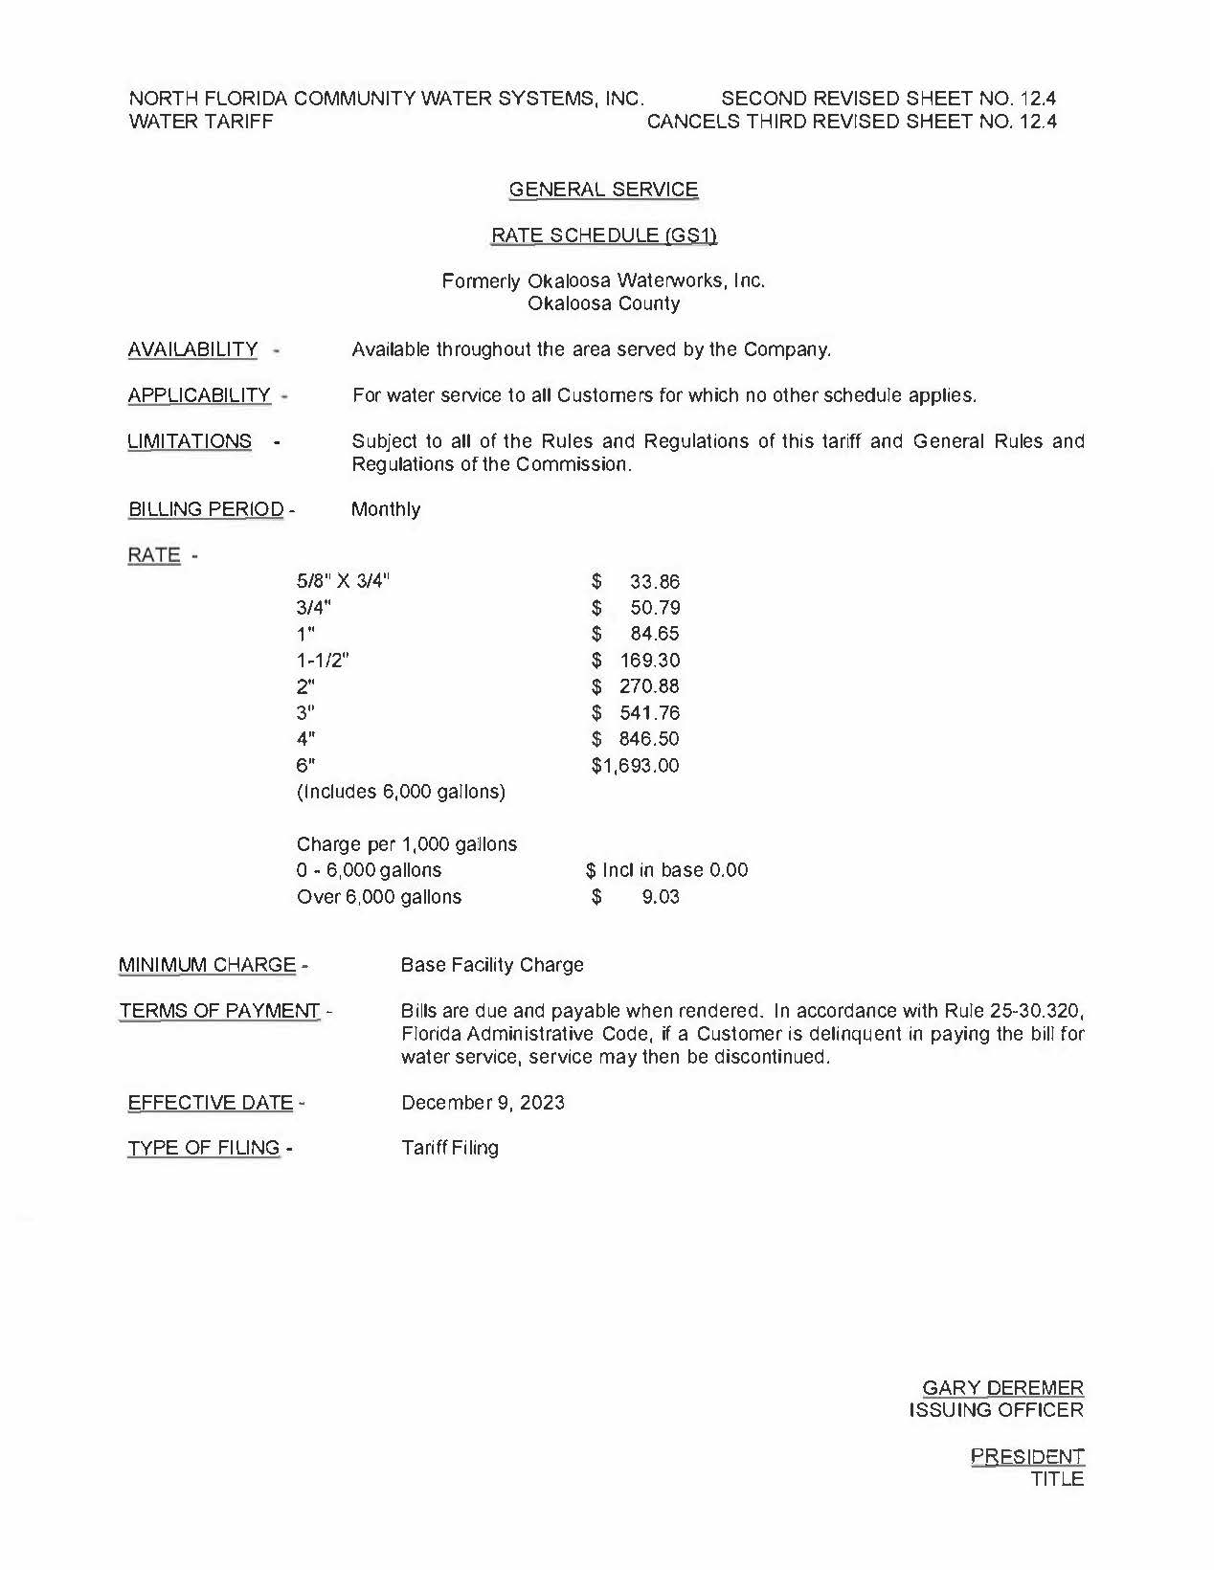

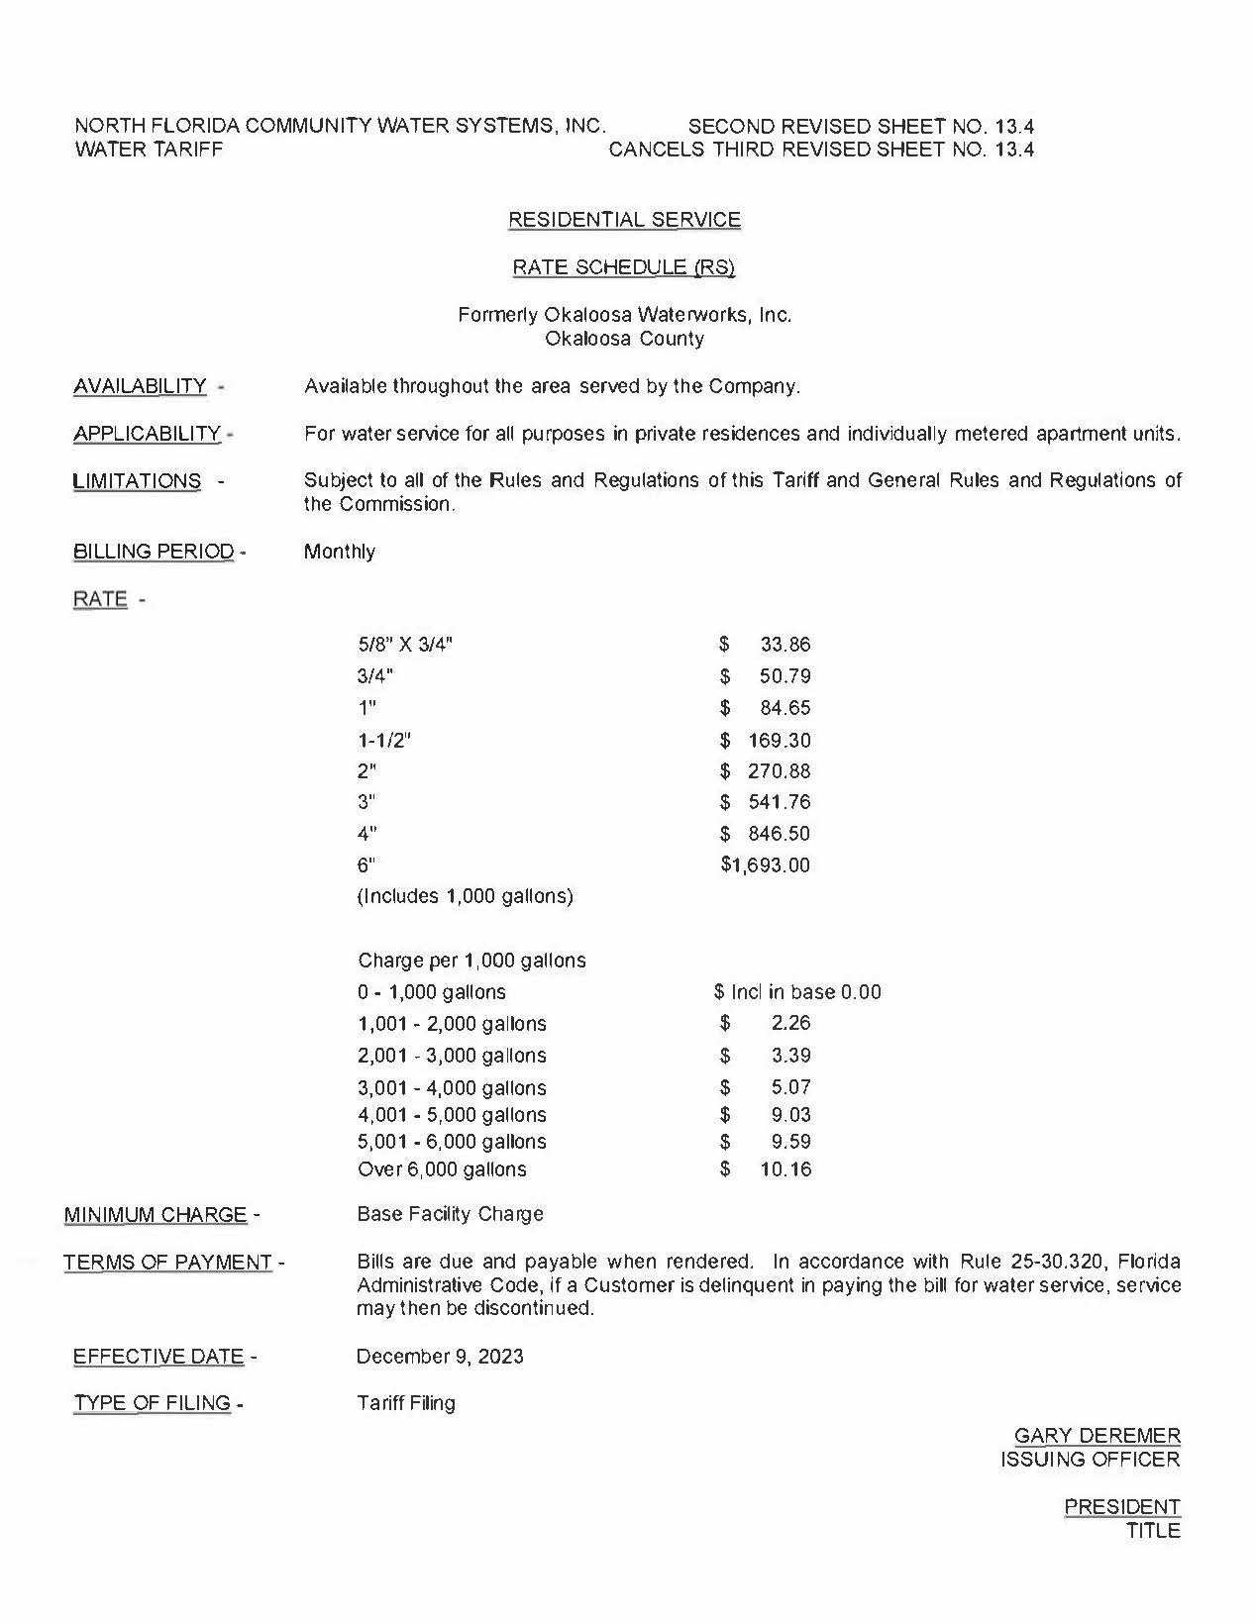

1. Number of customers as reported in 2022 Annual Report ending December 31, 2022.
2. North Florida Community Water Systems, Inc. Water Tariff Nos. 12.4 and 13.4.