State of Florida   |  | Public Service Commission  Capital Circle Office Center ● 2540 Shumard Oak Boulevard  Tallahassee, Florida 32399-0850  -M-E-M-O-R-A-N-D-U-M-
DATE: | February 22, 2024
TO: | Office of Commission Clerk (Teitzman)
FROM: | Division of Engineering (Ramirez-Abundez, Ellis, Wooten)  Office of the General Counsel (Imig)
RE: | Docket No. 20230129-EI – Petition for approval of revised purchased power agreement with Pasco County, by Tampa Electric Company.
AGENDA: | 03/05/24 – Regular Agenda – Proposed Agency Action – Interested Persons May Participate
COMMISSIONERS ASSIGNED: |  |  | All Commissioners
PREHEARING OFFICER: |  |  | La Rosa
CRITICAL DATES: |  |  | None
SPECIAL INSTRUCTIONS: |  |  | None

Case Background
On April 4, 2023, the Florida Public Service Commission (Commission) approved Tampa Electric Company’s (TECO or Company) Purchase Power Agreement (PPA or Contract) for the Pasco County (Pasco) Waste-To-Energy Facility (WTE Facility), with restrictions on TECO’s cost recovery for transmission costs and renewable energy credits (RECs). The PPA was based on Pasco owning and operating a WTE Facility, located in Spring Hill, Florida. Pasco’s WTE Facility is within Duke Energy Florida, LLC’s (DEF’s) service territory and would require access to DEF’s transmission capacity to deliver electricity to TECO. The transmission costs disallowed for cost recovery were related to a contract provision that could have shifted some of transmission costs from Pasco to TECO above a set threshold. The REC costs were not approved for cost recovery at that time, but TECO could still purchase them, provided it demonstrated the need for any purchases in a future proceeding. After the Commission’s decision, the PPA was canceled by both parties, pursuant to the terms of the PPA, because cost recovery of all terms was not granted.

On November 17, 2023, TECO filed a petition for approval of a negotiated PPA for the purchase of firm capacity and energy with Pasco. A copy of the PPA is attached (Attachment A). Pasco proposes to sell 18 megawatts (MW) of firm capacity and energy for ten years, from January 1, 2025, through December 31, 2034. Unlike the prior PPA, this PPA does not contain a transmission cost sharing threshold, and includes RECs as part of the initial energy purchase.

The Commission has jurisdiction over this matter pursuant to Sections 366.051, 366.81, and 366.91, Florida Statutes (F.S.).

Discussion of Issues

Issue 1:
Should the Commission approve cost recovery of the negotiated purchase power agreement between Tampa Electric Company and Pasco County?

Recommendation:
Yes. Based on staff’s review, the negotiated PPA improves TECO’s fuel diversity with the addition of renewable energy and is cost-effective based on current forecasts, saving a projected $7.3 million in Net Present Value (NPV), with savings beginning the first year of the PPA. The Contract has adequate security and performance guarantees to protect ratepayers in the event of a default or non-performance by Pasco. In addition, consistent with Order No. PSC-2023-0132-PAA-EI, the Company will not seek cost recovery for any transmission studies or upgrades. (Ramirez-Abundez)

Staff Analysis:
Pasco proposes to sell 18 MW of firm capacity and energy from its WTE Facility to TECO for ten years from January 1, 2025, through December 31, 2034. The WTE Facility uses municipal solid waste as its primary fuel, a source of renewable energy pursuant to Section 366.91(2)(b), F.S. The price structure in the Contract has no capacity payment, but an “all-in” confidential dollars per megawatt-hour (MWh) energy rate payment that escalates annually.
Rule 25-17.0832(3), Florida Administrative Code (F.A.C.), states that in reviewing negotiated firm capacity and energy contracts for the purposes of cost recovery, the Commission shall consider factors relating to the contract that would impact the utility’s customers, including: need for power by the purchasing utility and/or Florida utilities statewide, the cost-effectiveness of the contract, security provisions for early payment, and performance guarantees associated with the facility. These factors are evaluated below.

Need For Power
Based on TECO’s 2023 Ten-Year Site Plan (TYSP), the next planned capacity addition that could be avoided is an 18.7 MW natural gas-fired reciprocating engine with an in-service date of January 2030. Therefore, the PPA’s firm capacity of 18 MW would help avoid or defer the construction of future generation for the duration of the PPA until 2035. In addition to firm capacity, the PPA would improve the Company’s fuel diversity by increasing the contribution of renewable resources. TECO is forecast to rely upon natural gas for up to 82.8 percent of its energy during the Contract period, according to its 2023 TYSP. Therefore, staff believes the proposed PPA will enhance TECO’s system reliability and increase its fuel diversity.

Cost-Effectiveness
Rule 25-17.0832(3)(b), F.A.C., states in part that the Commission should consider whether the cumulative present worth of a payment to the Qualifying Facility (QF) is not greater than the cumulative present worth of purchasing utility’s avoided cost of capacity and energy. This cost-effectiveness evaluation was based on the differential between TECO’s internal system costs versus the proposed payments under the PPA in two scenarios, with and without the PPA. In response to the staff’s data request, TECO provided its cost-effectiveness analysis that estimated the net cumulative benefits of the PPA at $7.3 million on an NPV basis. System savings are primarily associated with reduced fuel and fuel transportation costs, in addition to some deferred generation costs. Using the base fuel and emission price forecasts, the PPA is anticipated to be cost-effective on a cumulative basis for every year of the period, starting with the first year. The Company also performed high and low fuel sensitivities, in which the PPA was also cost-effective on a cumulative NPV basis over the term of the Contract. In addition, TECO will receive any Renewable Energy Credits (RECs) generated by the WTE Facility from its associated energy at no cost. In response to a staff data request, TECO states if it sells any of the RECs it will pass on any revenue to ratepayers. These potential revenues are not included in the economic evaluation of the PPA.
The PPA includes fixed energy rate payment, and therefore the rates are not allowed to float with changes to TECO’s system fuel cost. This allocates the risk of fuel price fluctuation from the Pasco WTE Facility to TECO’s ratepayers. For example, if fuel costs do not escalate as quickly as projected in the cost-effectiveness analyses, it may result in a loss to customers. Conversely, if fuel costs escalate faster, customers would see an increased benefit. Regardless, TECO would remain obligated to pay the contracted rate and may seek to recover the costs from the ratepayers through the Fuel Clause, subject to Commission review. In Order No. PSC-11-0439-PAA-EQ, the Commission expressed concerns regarding fixed price contracts and noted that utilities are responsible for including terms and conditions that minimize risk to the company’s general body of ratepayers, and encouraged utilities to strive to avoid fixed price contracts.

Security Capacity Payment
Rule 25-18.032(3)(c), F.A.C., requires the Commission to consider security factors relating to the contract for early capacity payments. Security guarantees included in the contract are provisions to ensure repayment of firm capacity and energy payment in the event that the QF fails to deliver firm capacity and energy to adhere to the terms and conditions of the contract. The Contract begins in the year 2025, and the avoided unit is scheduled to be in-service in 2030. If the QF defaults during this time, the Contract includes a termination security table for determining compensation to TECO. Staff reviewed the security terms and conditions contained in the negotiated Contract and found them adequate to protect ratepayers.

Performance Guarantees
Rule 25-17.0832(3)(d), F.A.C., requires the Commission consider whether the utility’s ratepayers will be protected by the contract’s terms. Performance guarantees, as included in this contract, detail how the QF is to operate and require financial penalties or other remedies should it fail to do so within the contract’s terms and conditions. The protections include a lower energy rate if Pasco does not provide a monthly energy availability of at least 92 percent. Also, if the Pasco WTE Facility has availability of less than 70 percent for any 6 months in a calendar year during the Contract, this failure will be considered default, which means that TECO can recover the cost of obtaining replacement power from Pasco. Staff reviewed the performance guarantees contained in the negotiated Contract and found them adequate to protect ratepayers.
Other Considerations
The proposed PPA includes additional risks relating to transmission costs. In a typical purchase power contract, the QF is assumed to be responsible for transmission-related costs. For example, in TECO’s current Standard Offer Contract, the QF is solely responsible for all costs to provide transmission to the interconnection point with the Company. As the Pasco WTE Facility is located in DEF’s service territory, the Seller requires the use of a part of DEF’s transmission capacity to deliver energy to the delivery point with TECO. Normally, Pasco would request this service and pay DEF for the transmission service, due to being the QF pursuant to Rule 25-17.0889, F.A.C. However, in this case, Section 5 of the PPA makes TECO responsible for requesting and securing the required transmission service from DEF, and for paying transmission capacity fees based on DEF’s Open Access Transmission Tariff (OATT). TECO’s monthly payments to Pasco would then be reduced by the amount of the transmission capacity fees paid to DEF. This contractual mechanism appears to have a net zero effect on ratepayers.
In addition, Section 5 of the PPA also makes TECO responsible for potential transmission studies and possible upgrades, if needed, to secure DEF’s transmission capacity for Pasco’s WTE Facility. TECO has stated, consistent with Order No. PSC- 2023-0132-PAA-EI, that it will not seek cost recovery of any transmission costs related to transmission studies or potential upgrades.

Conclusion
Based on staff’s review, the negotiated PPA improves TECO’s fuel diversity with the addition of renewable energy and is cost-effective based on current forecasts, saving a projected $7.3 million in NPV, with savings beginning the first year of the PPA. The Contract has adequate security and performance guarantees to protect ratepayers in the event of a default or non-performance by Pasco. In addition, consistent with Order No. PSC-2023-0132-PAA-EI, the Company will not seek cost recovery for any transmission studies or upgrades.

Issue 2:
Should this docket be closed?

Recommendation:
Yes. This docket should be closed upon issuance of a Consummating Order unless a person whose substantial interest are affected by the Commission’s decision files a protest within 21 days of the issuance of the proposed agency action. (Imig)

Staff Analysis:
This docket should be closed upon issuance of a Consummating Order unless a person whose substantial interests are affected by the Commission’s decision files a protest within 21 days of the issuance of the proposed agency action.

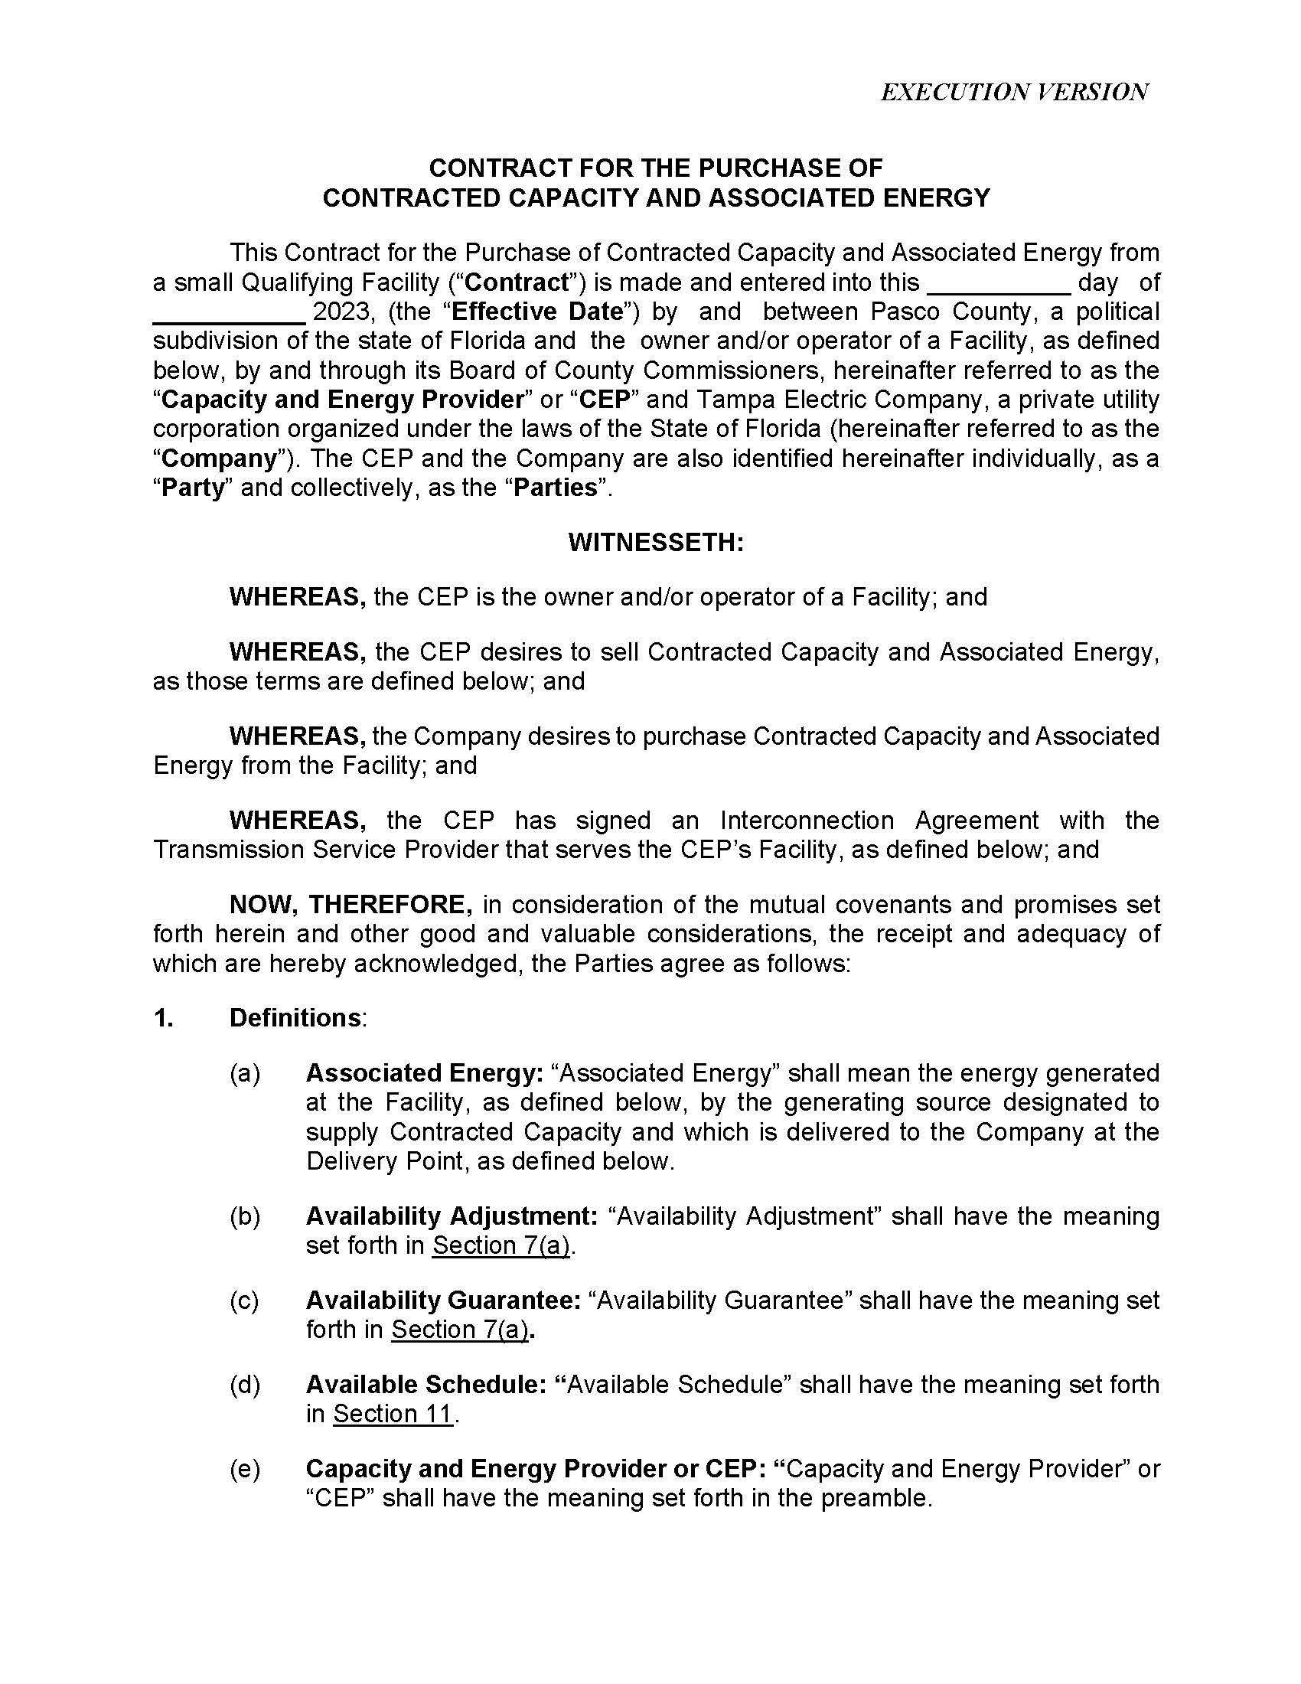

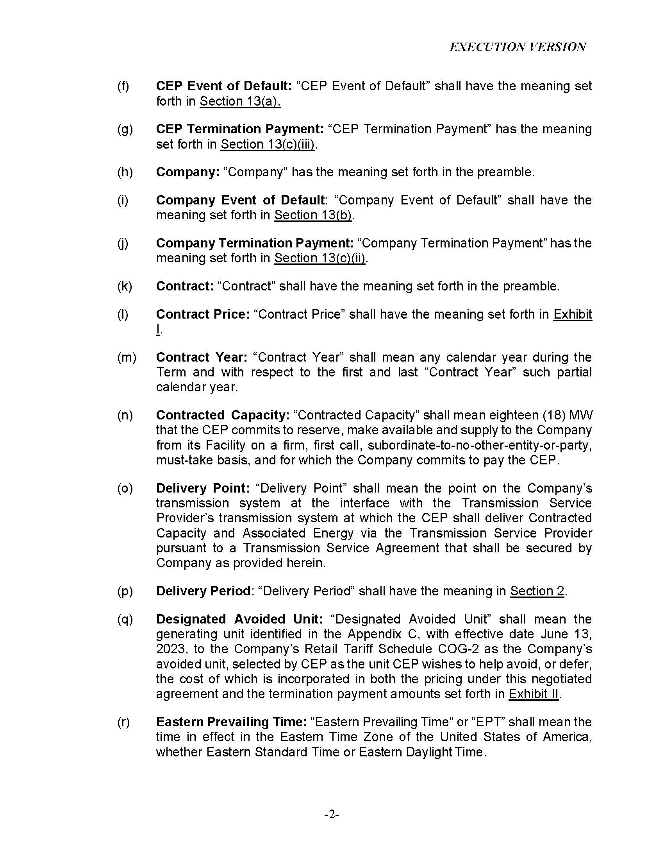

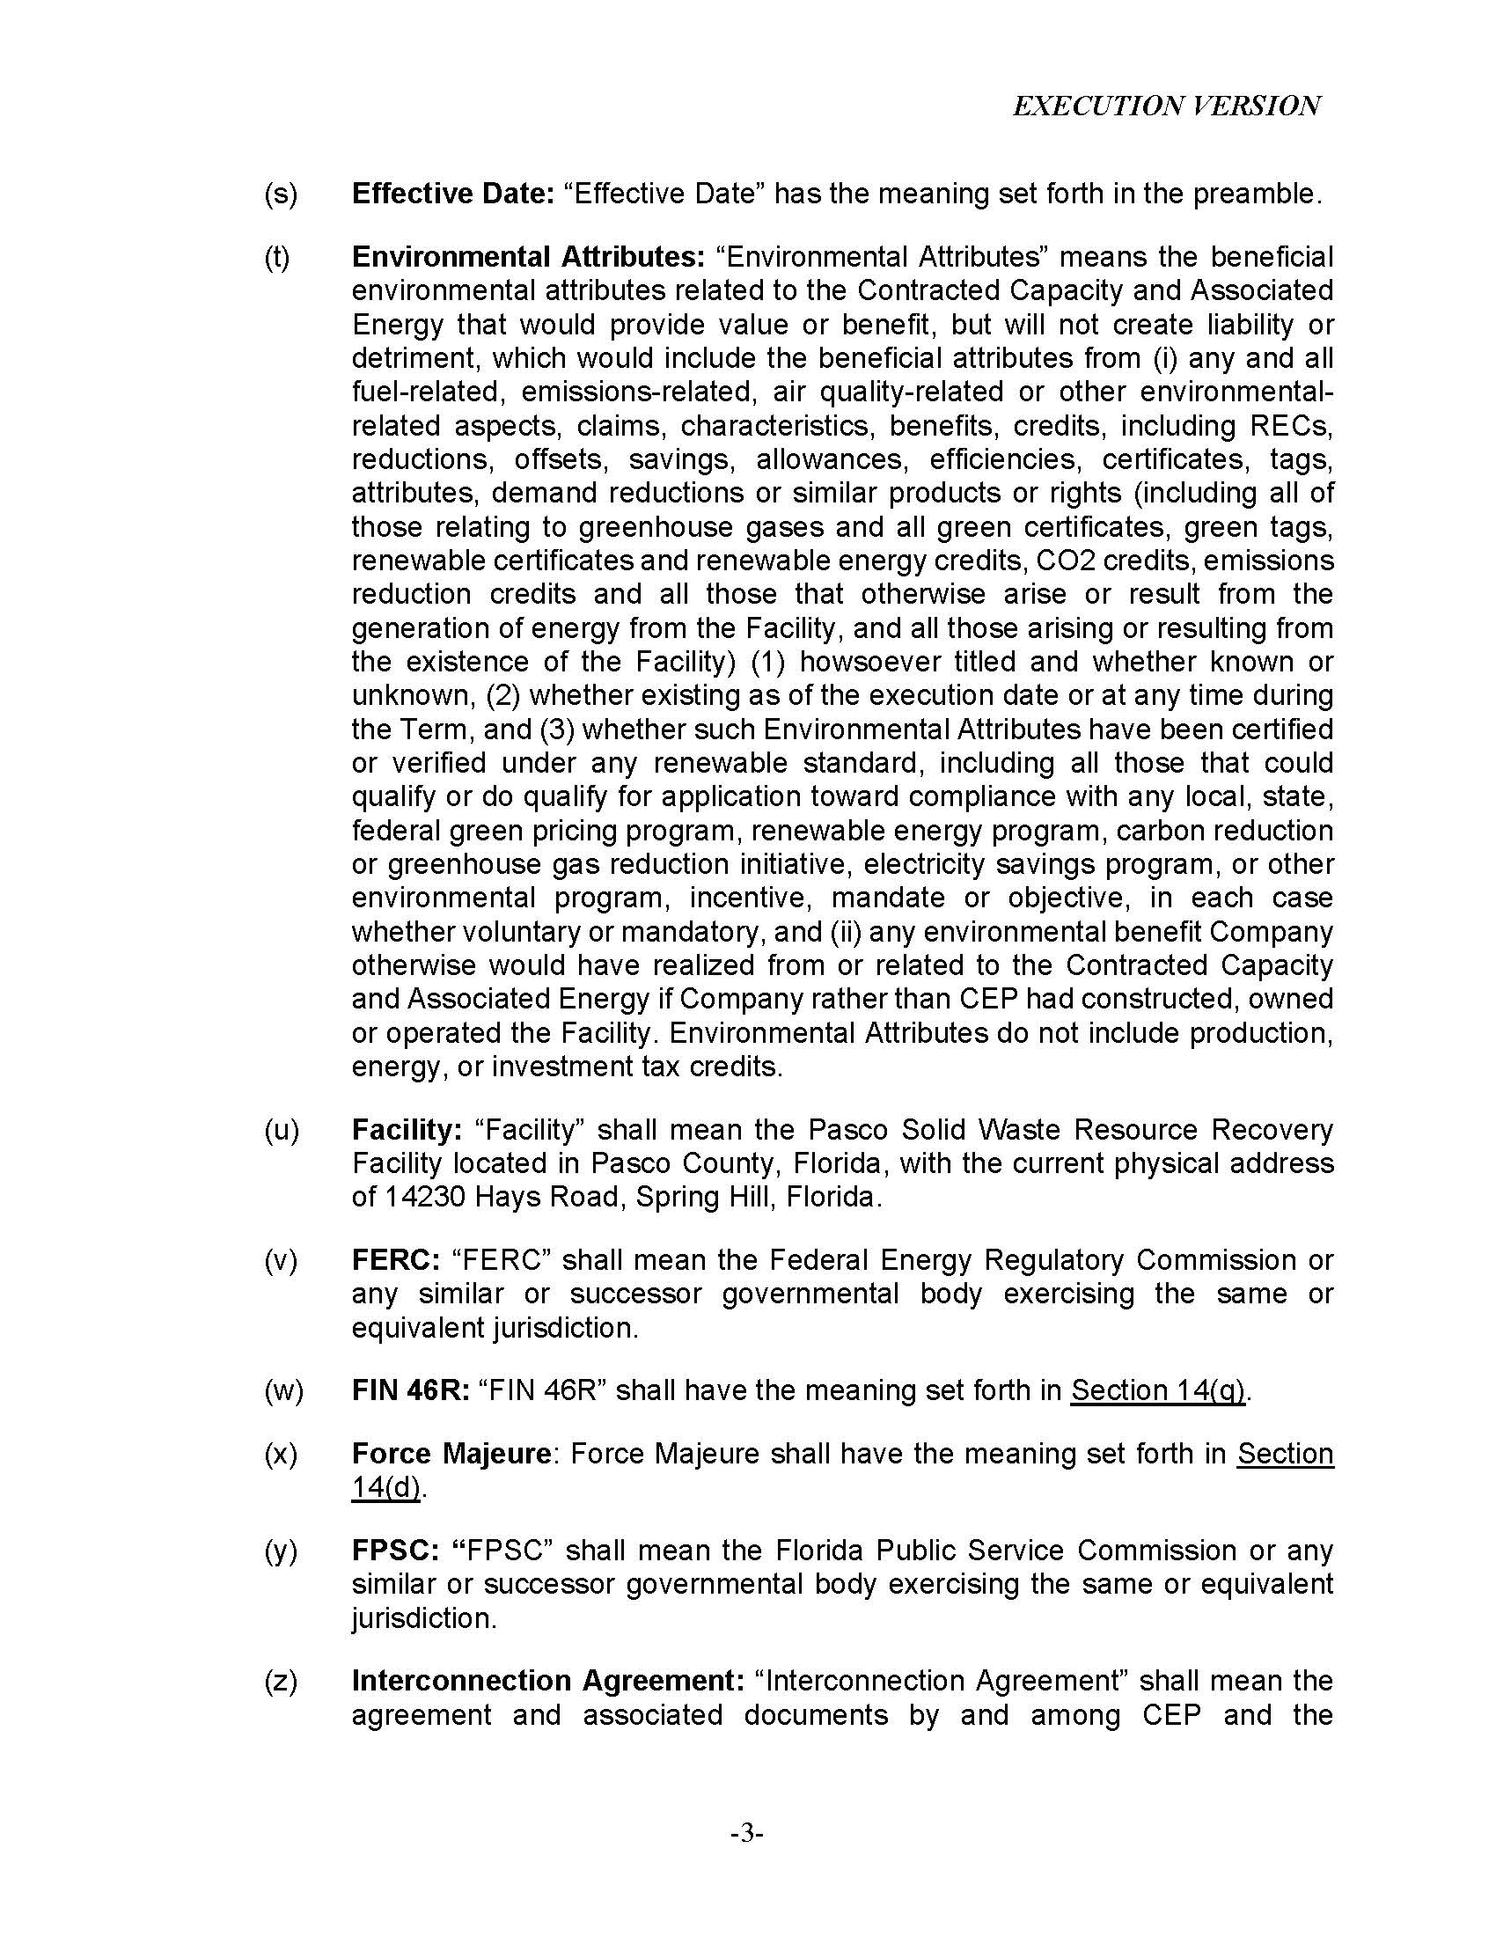

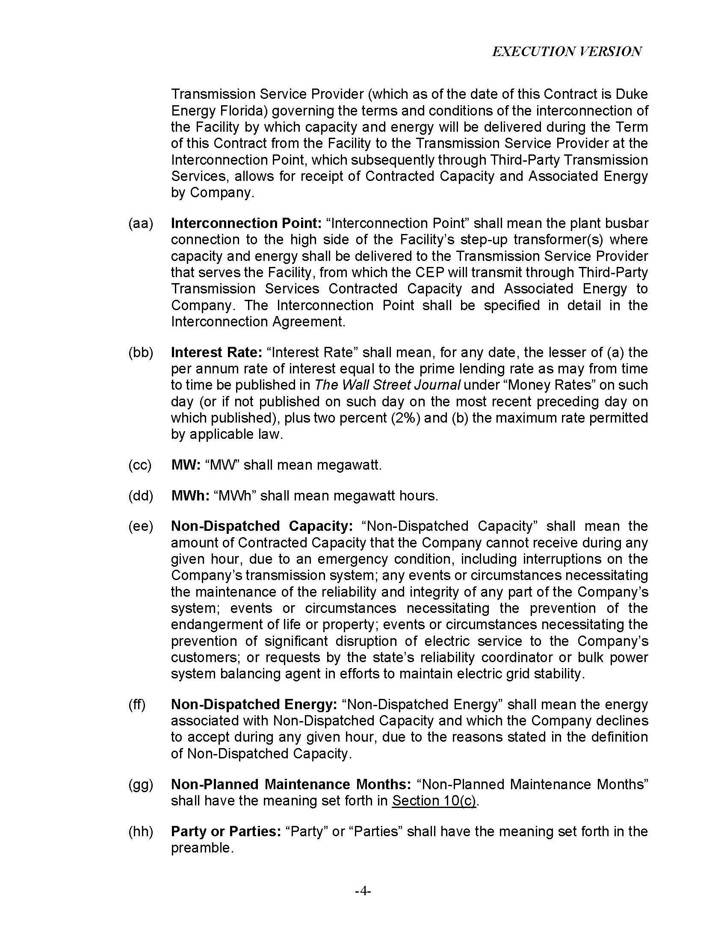

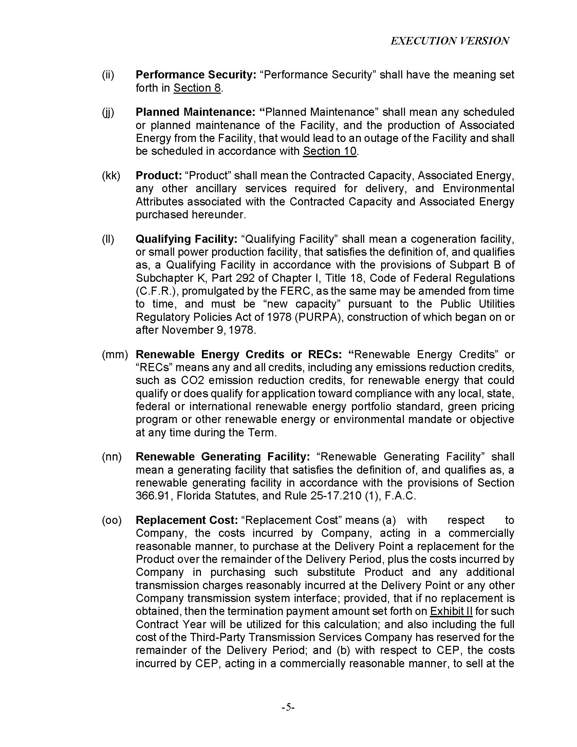

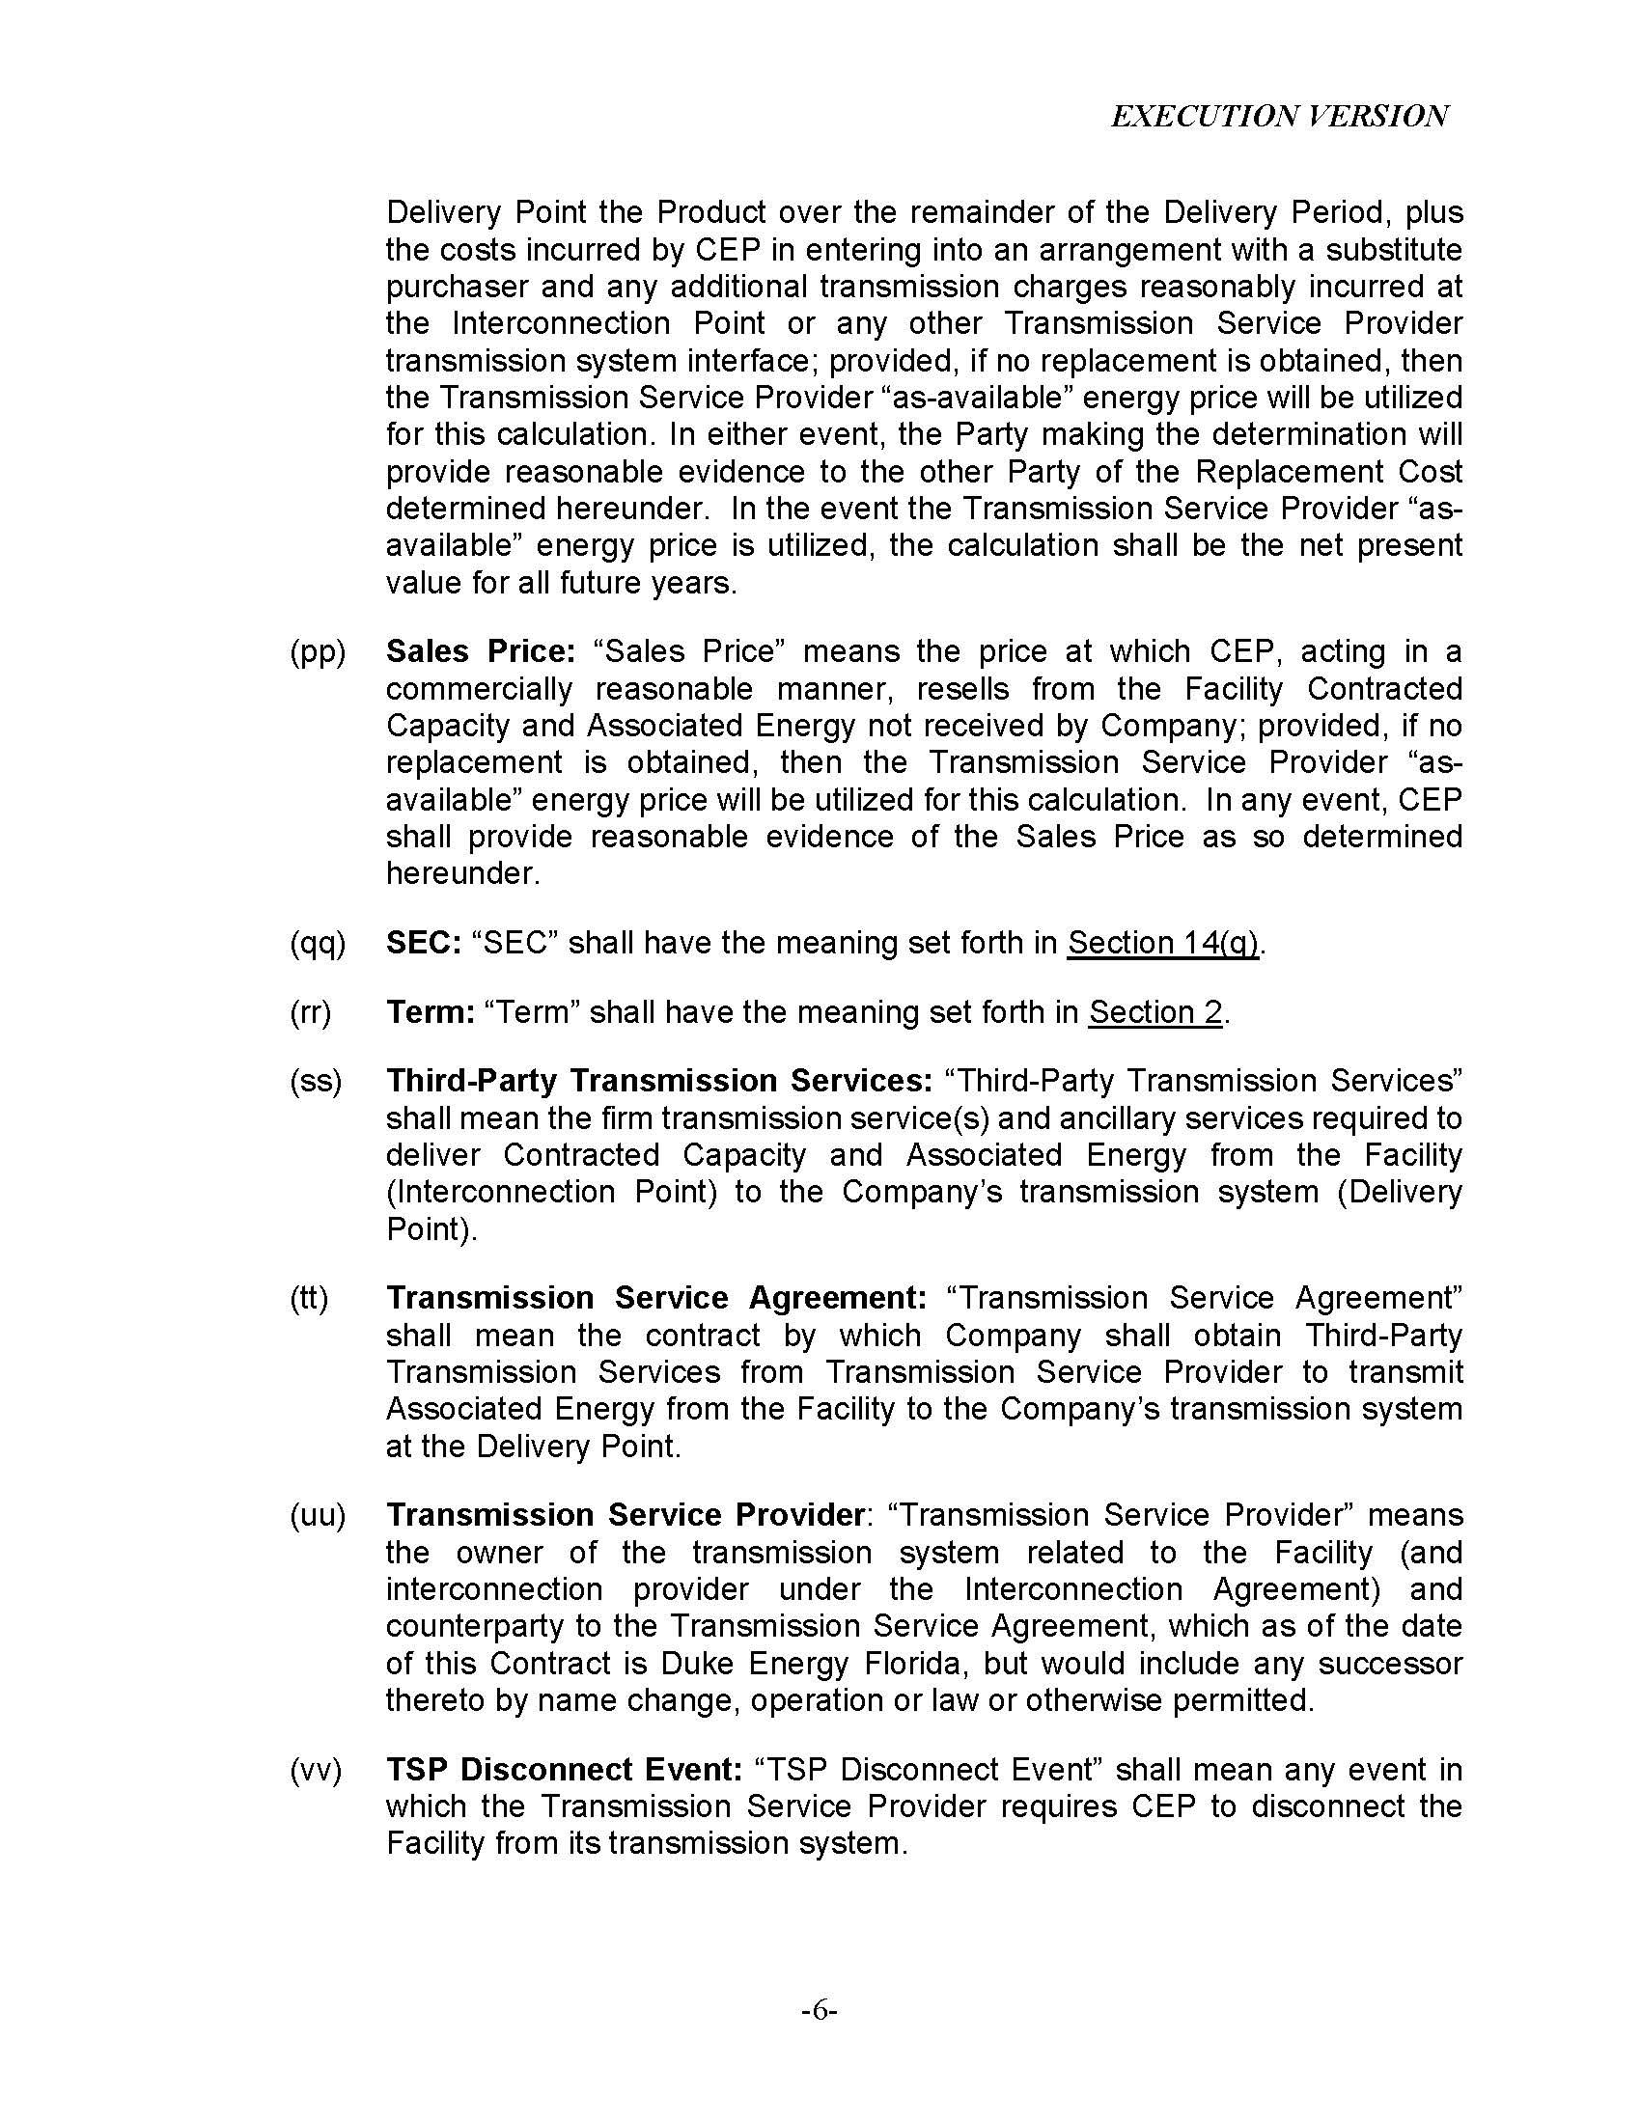

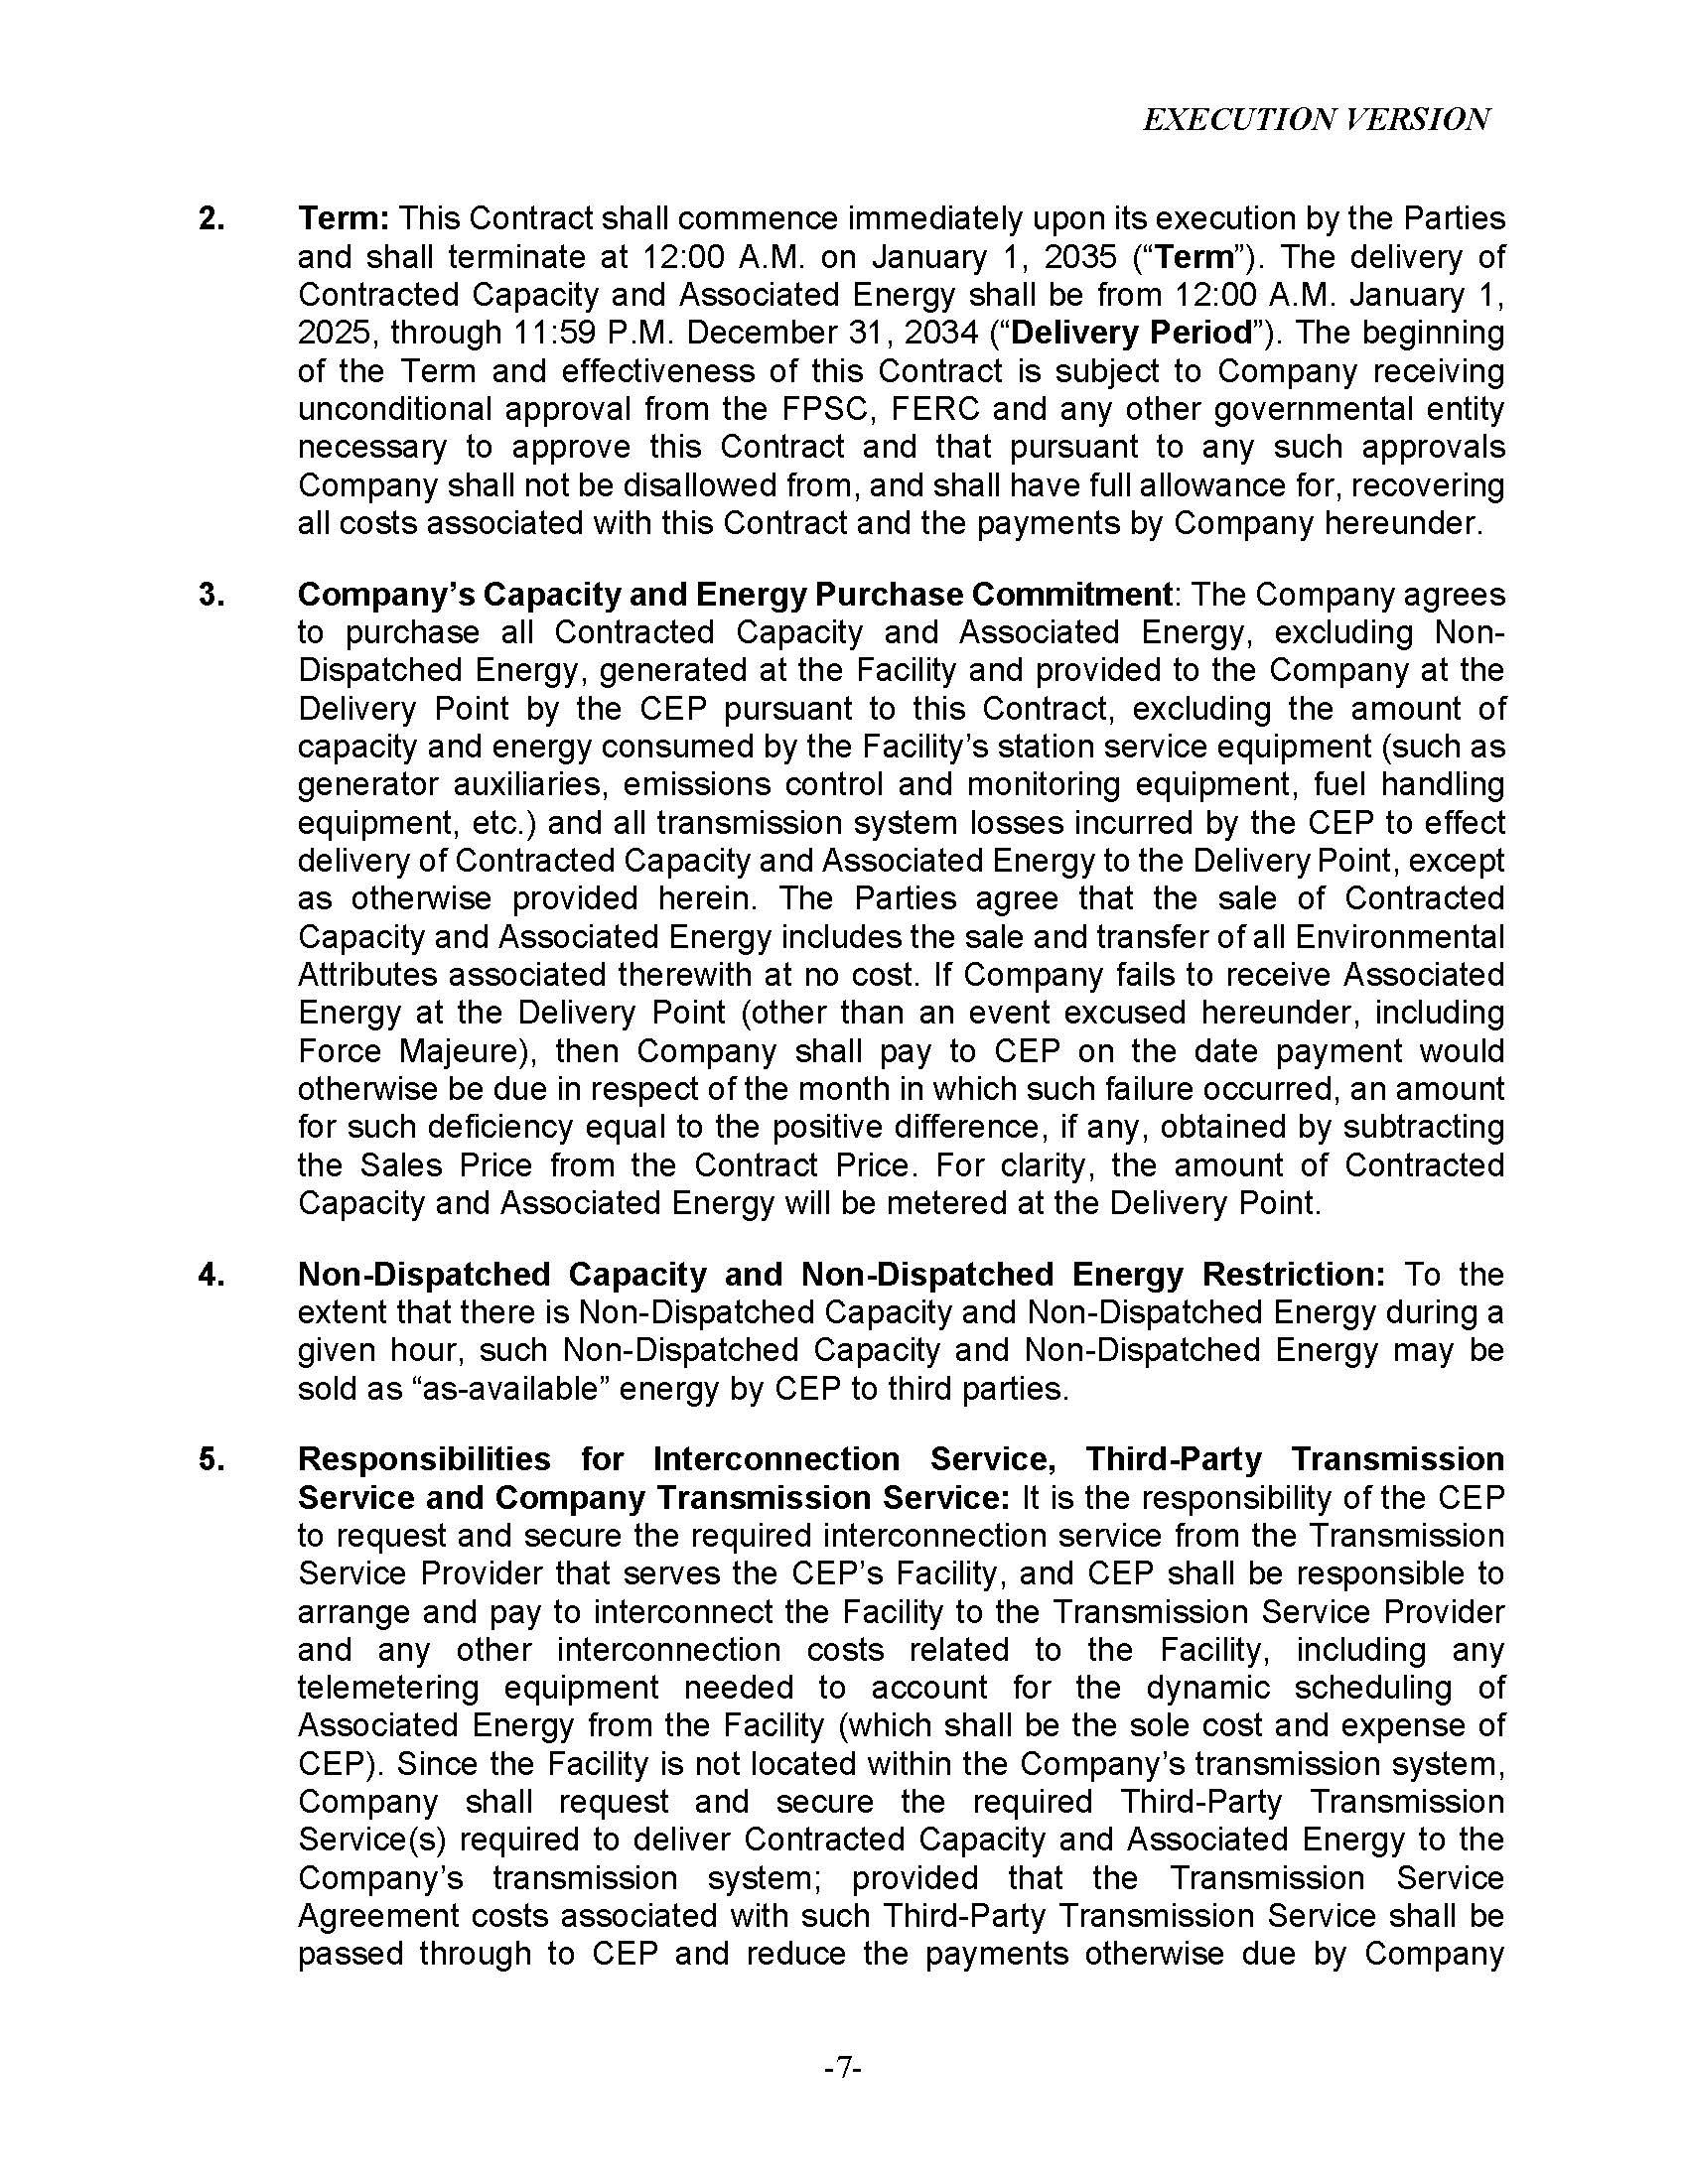

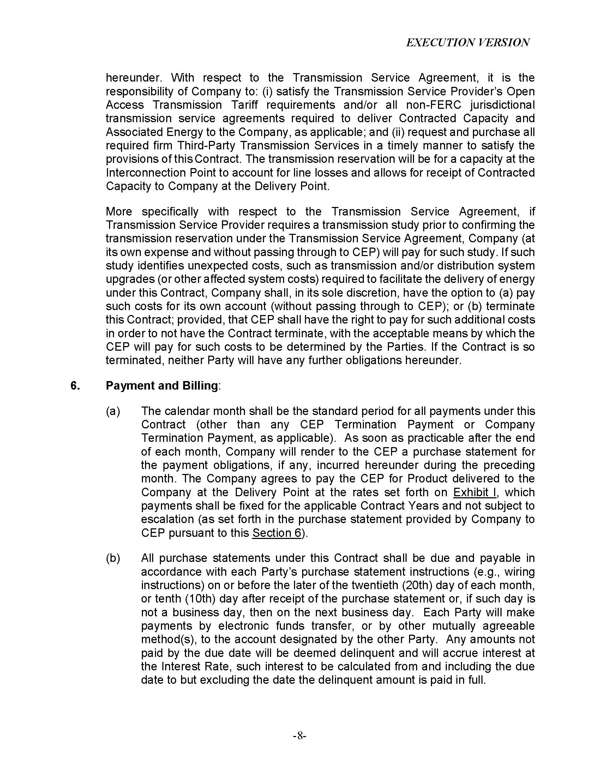

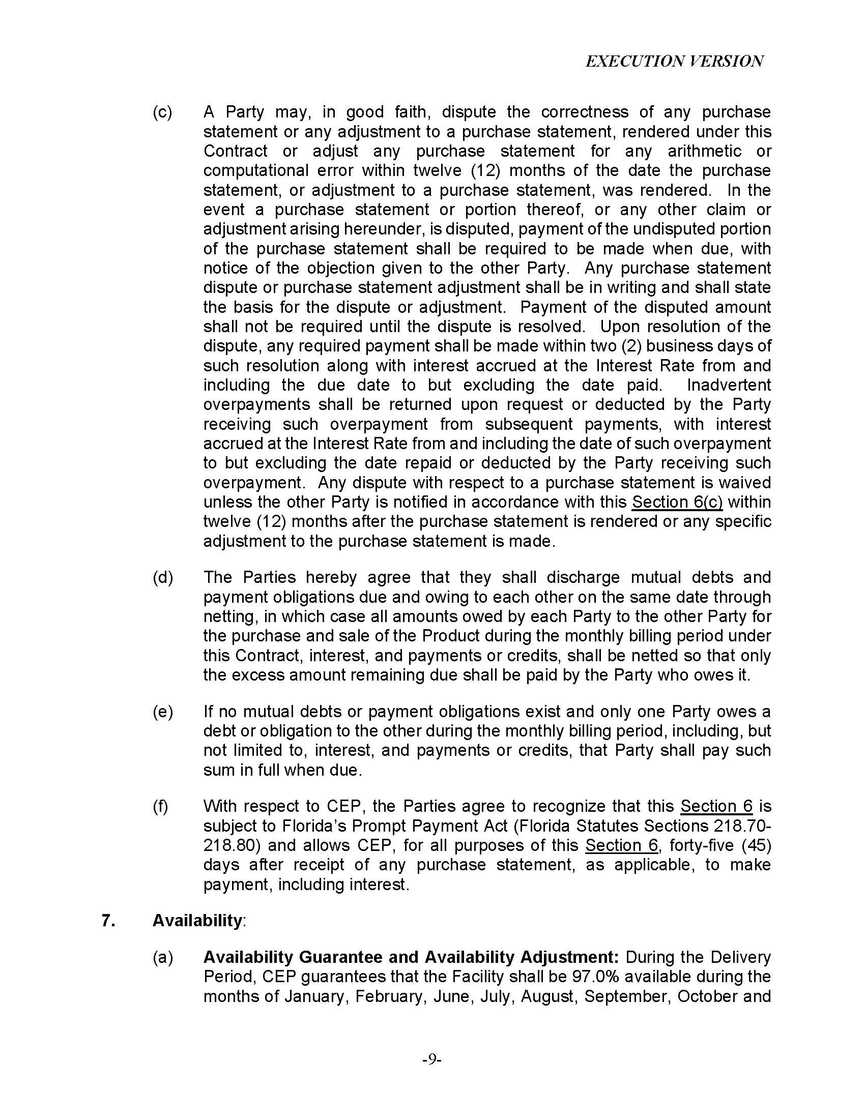

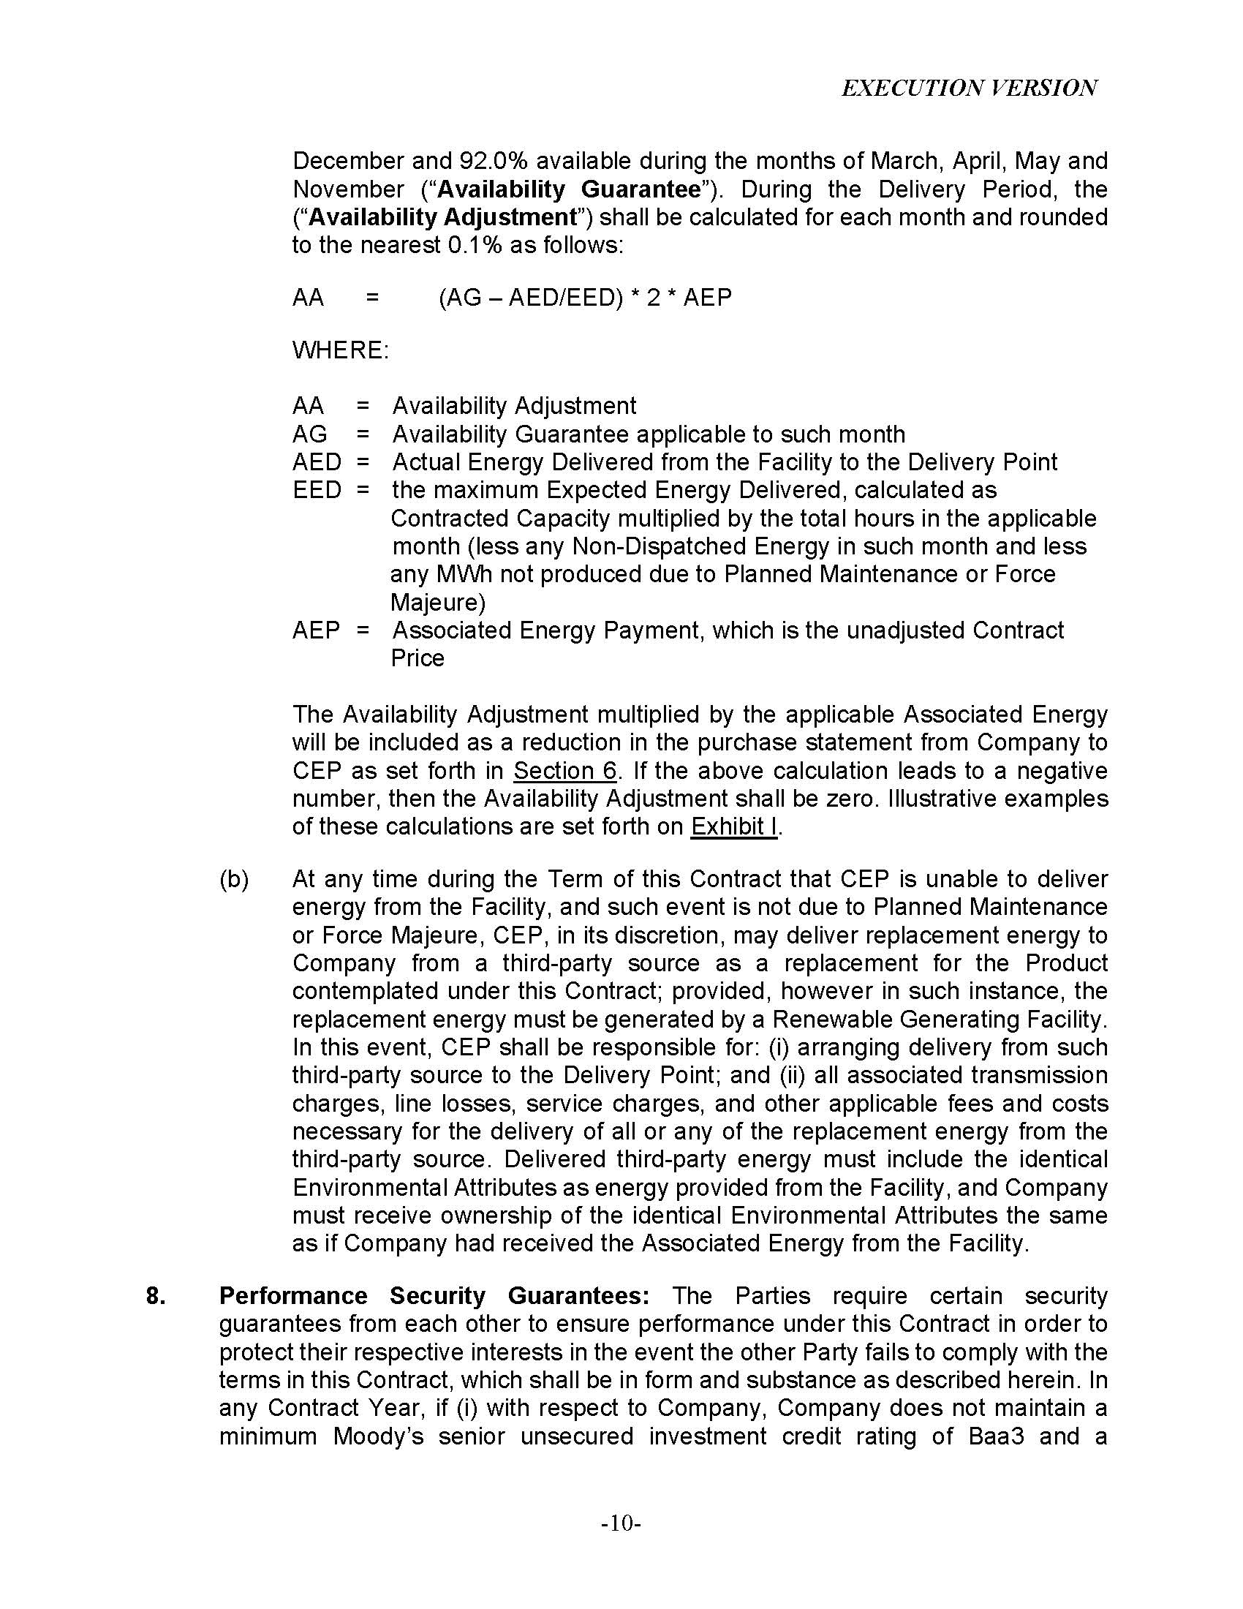

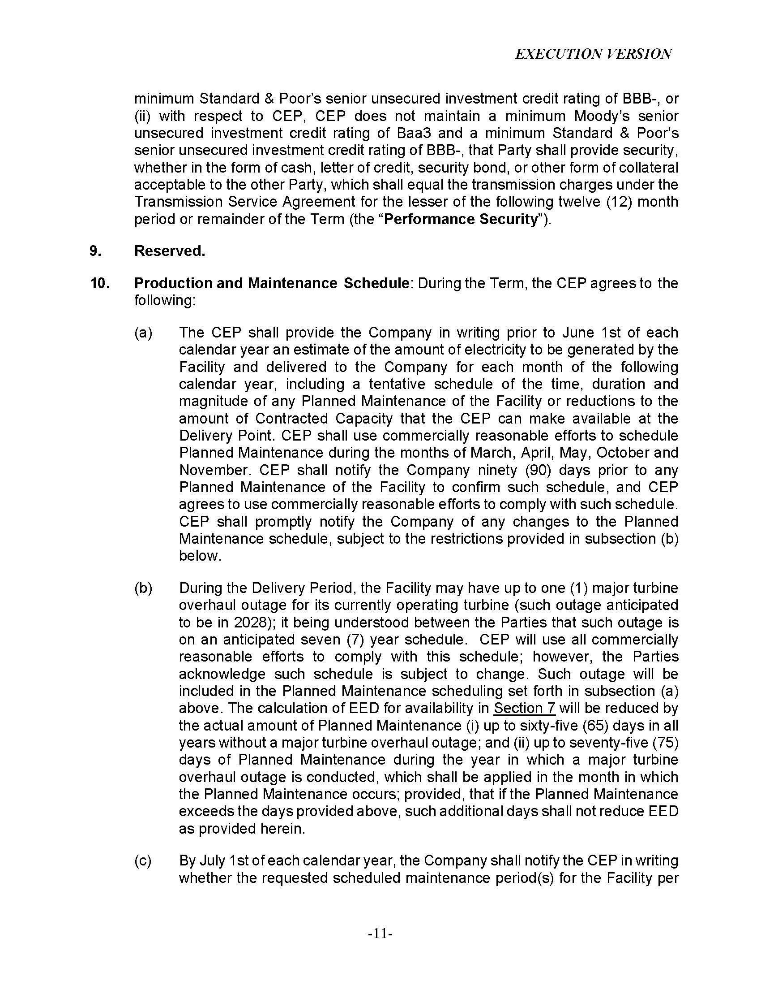

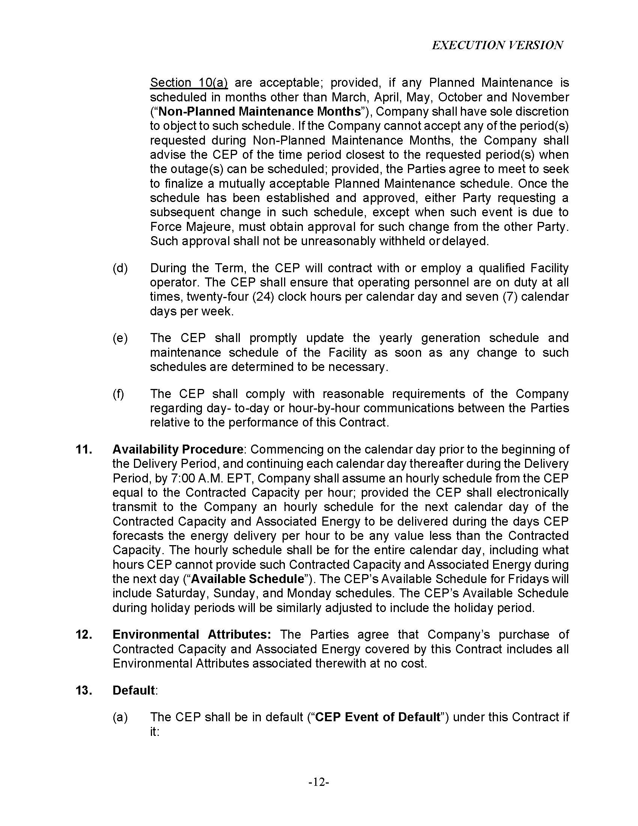

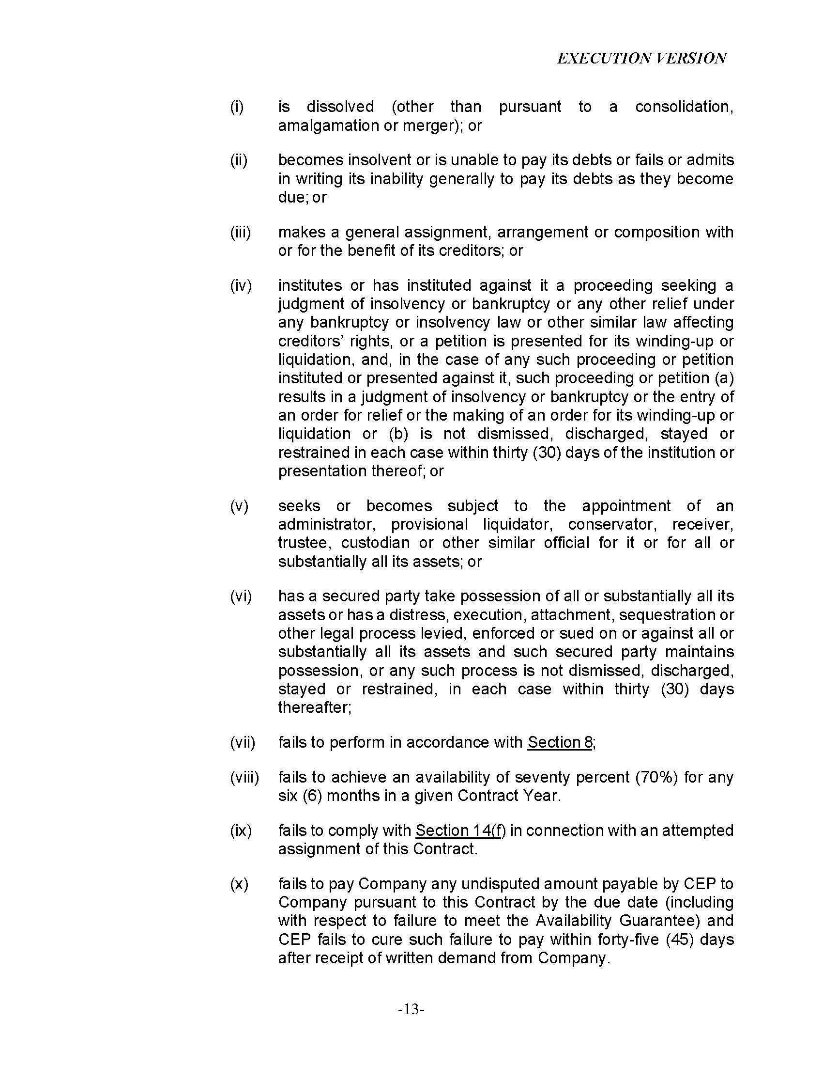

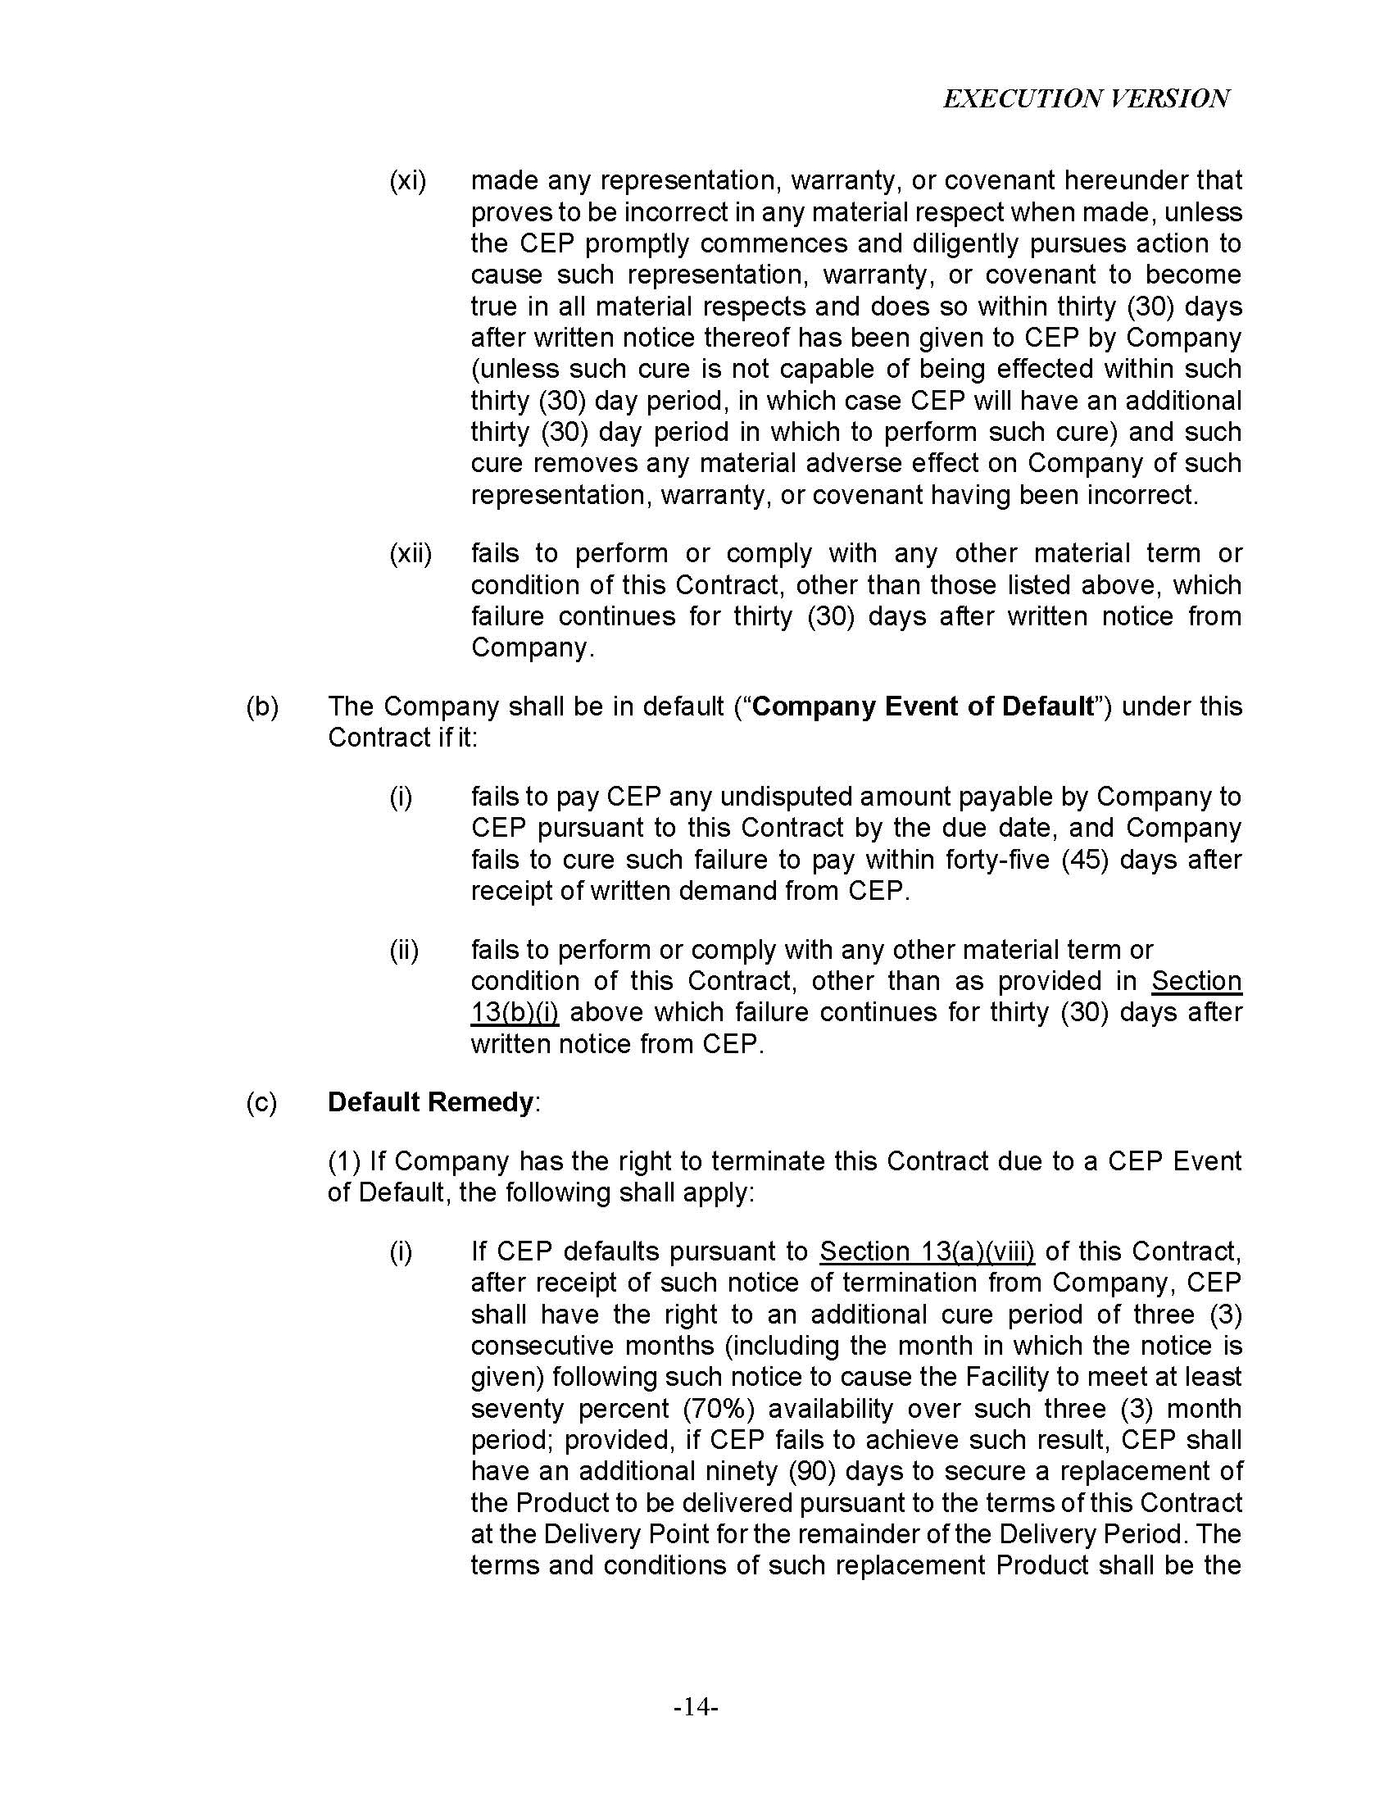

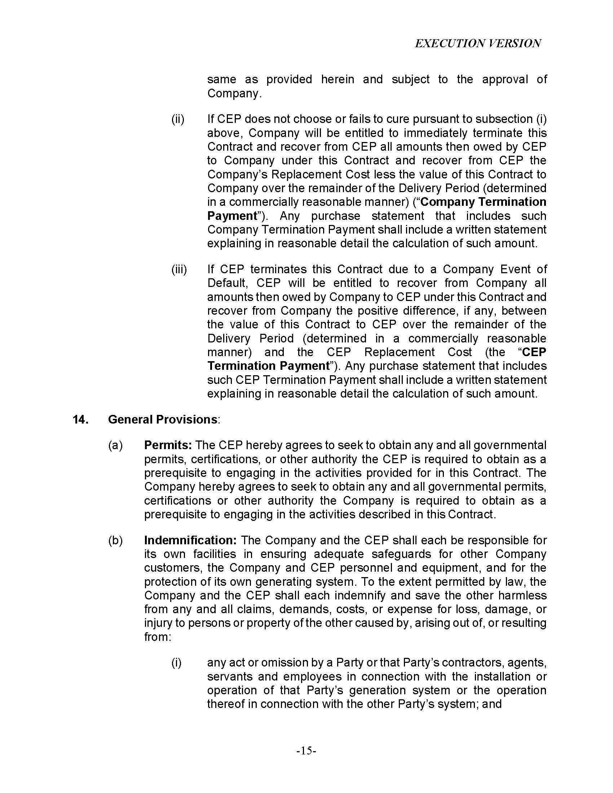

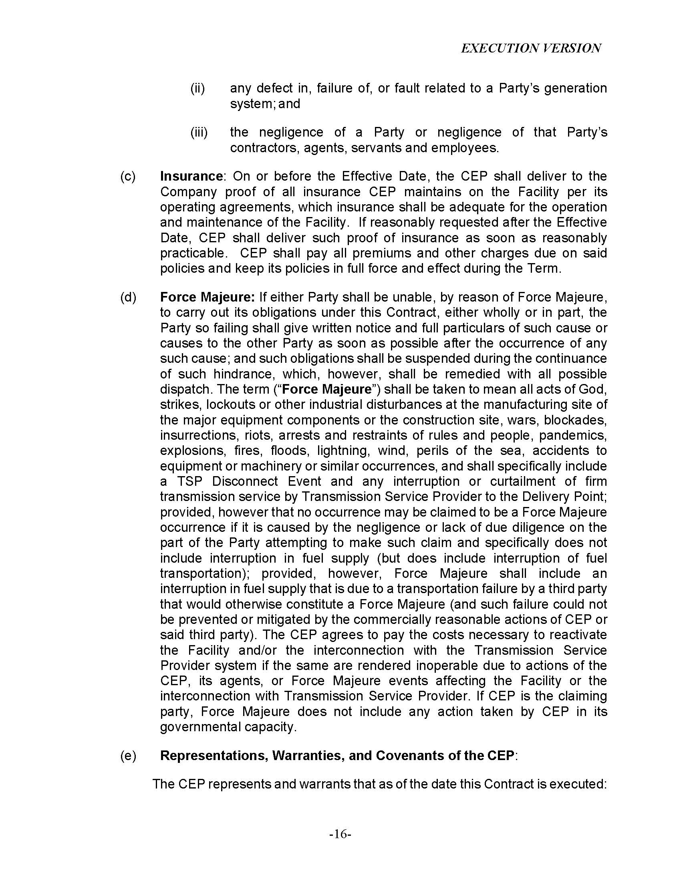

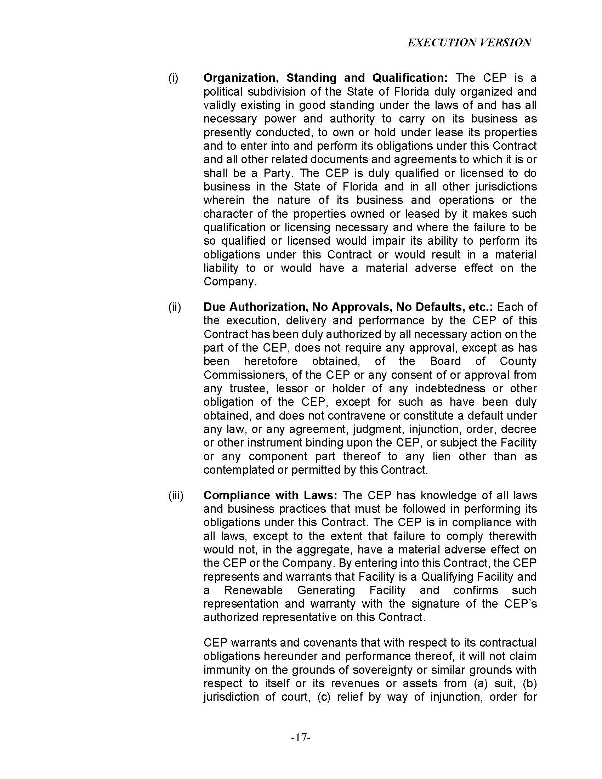

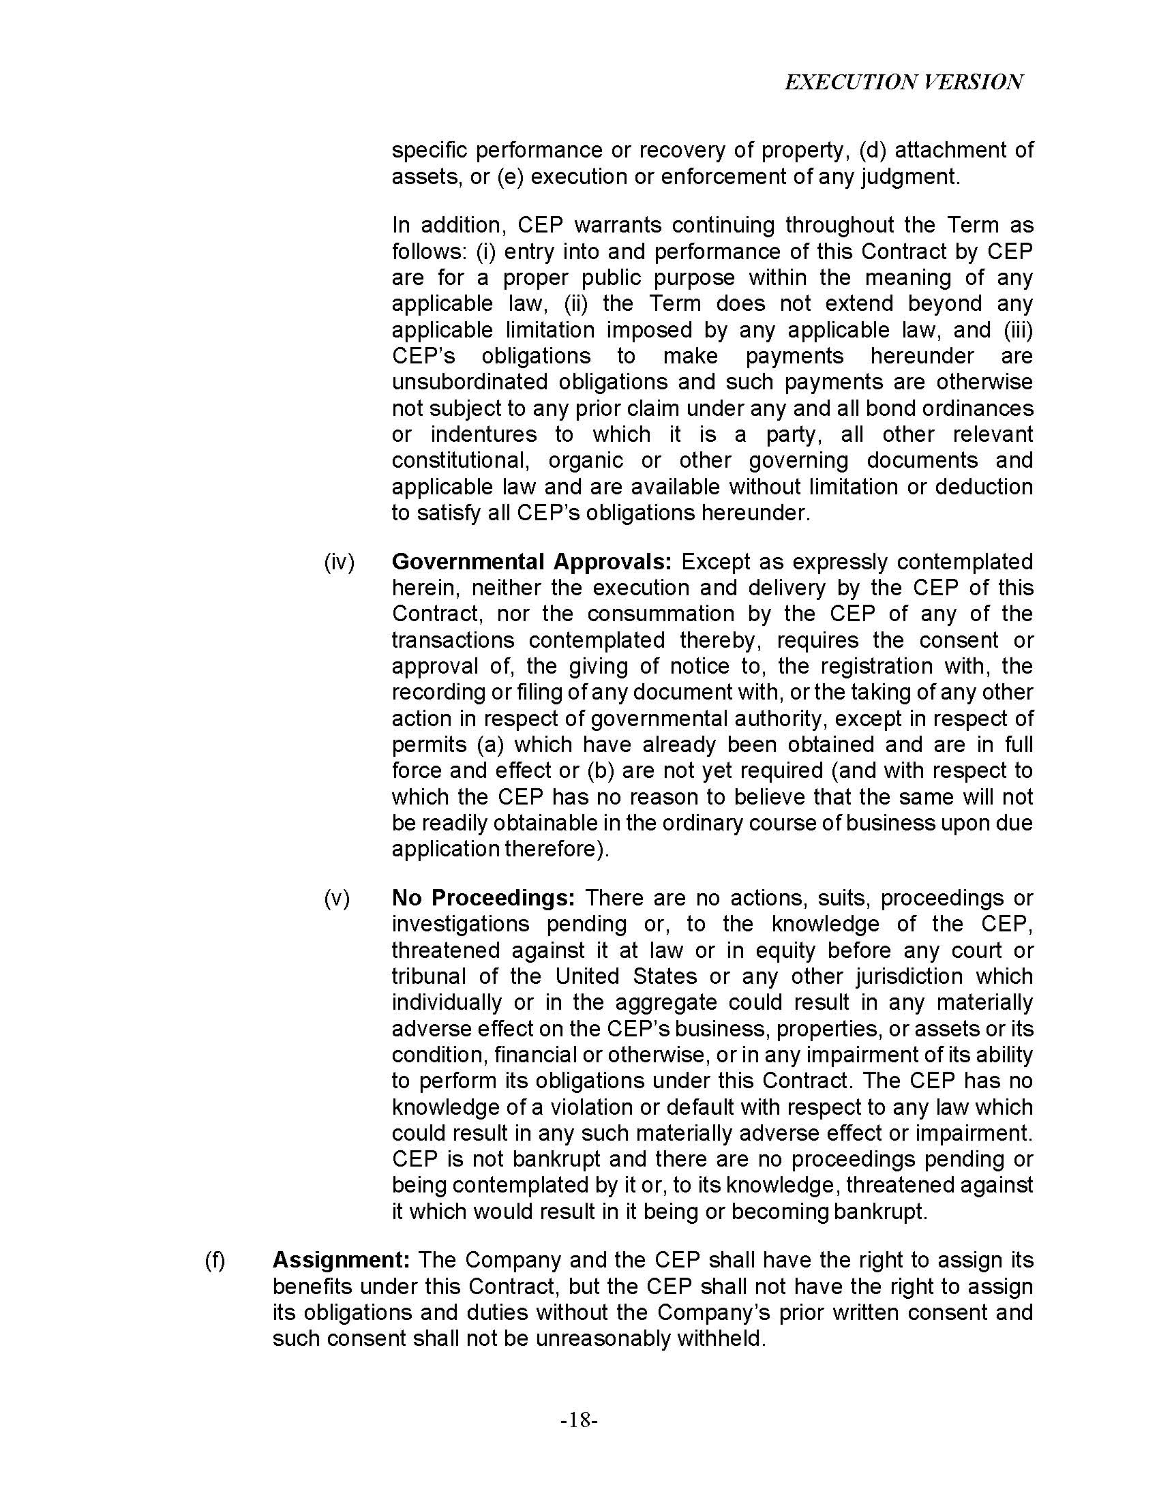

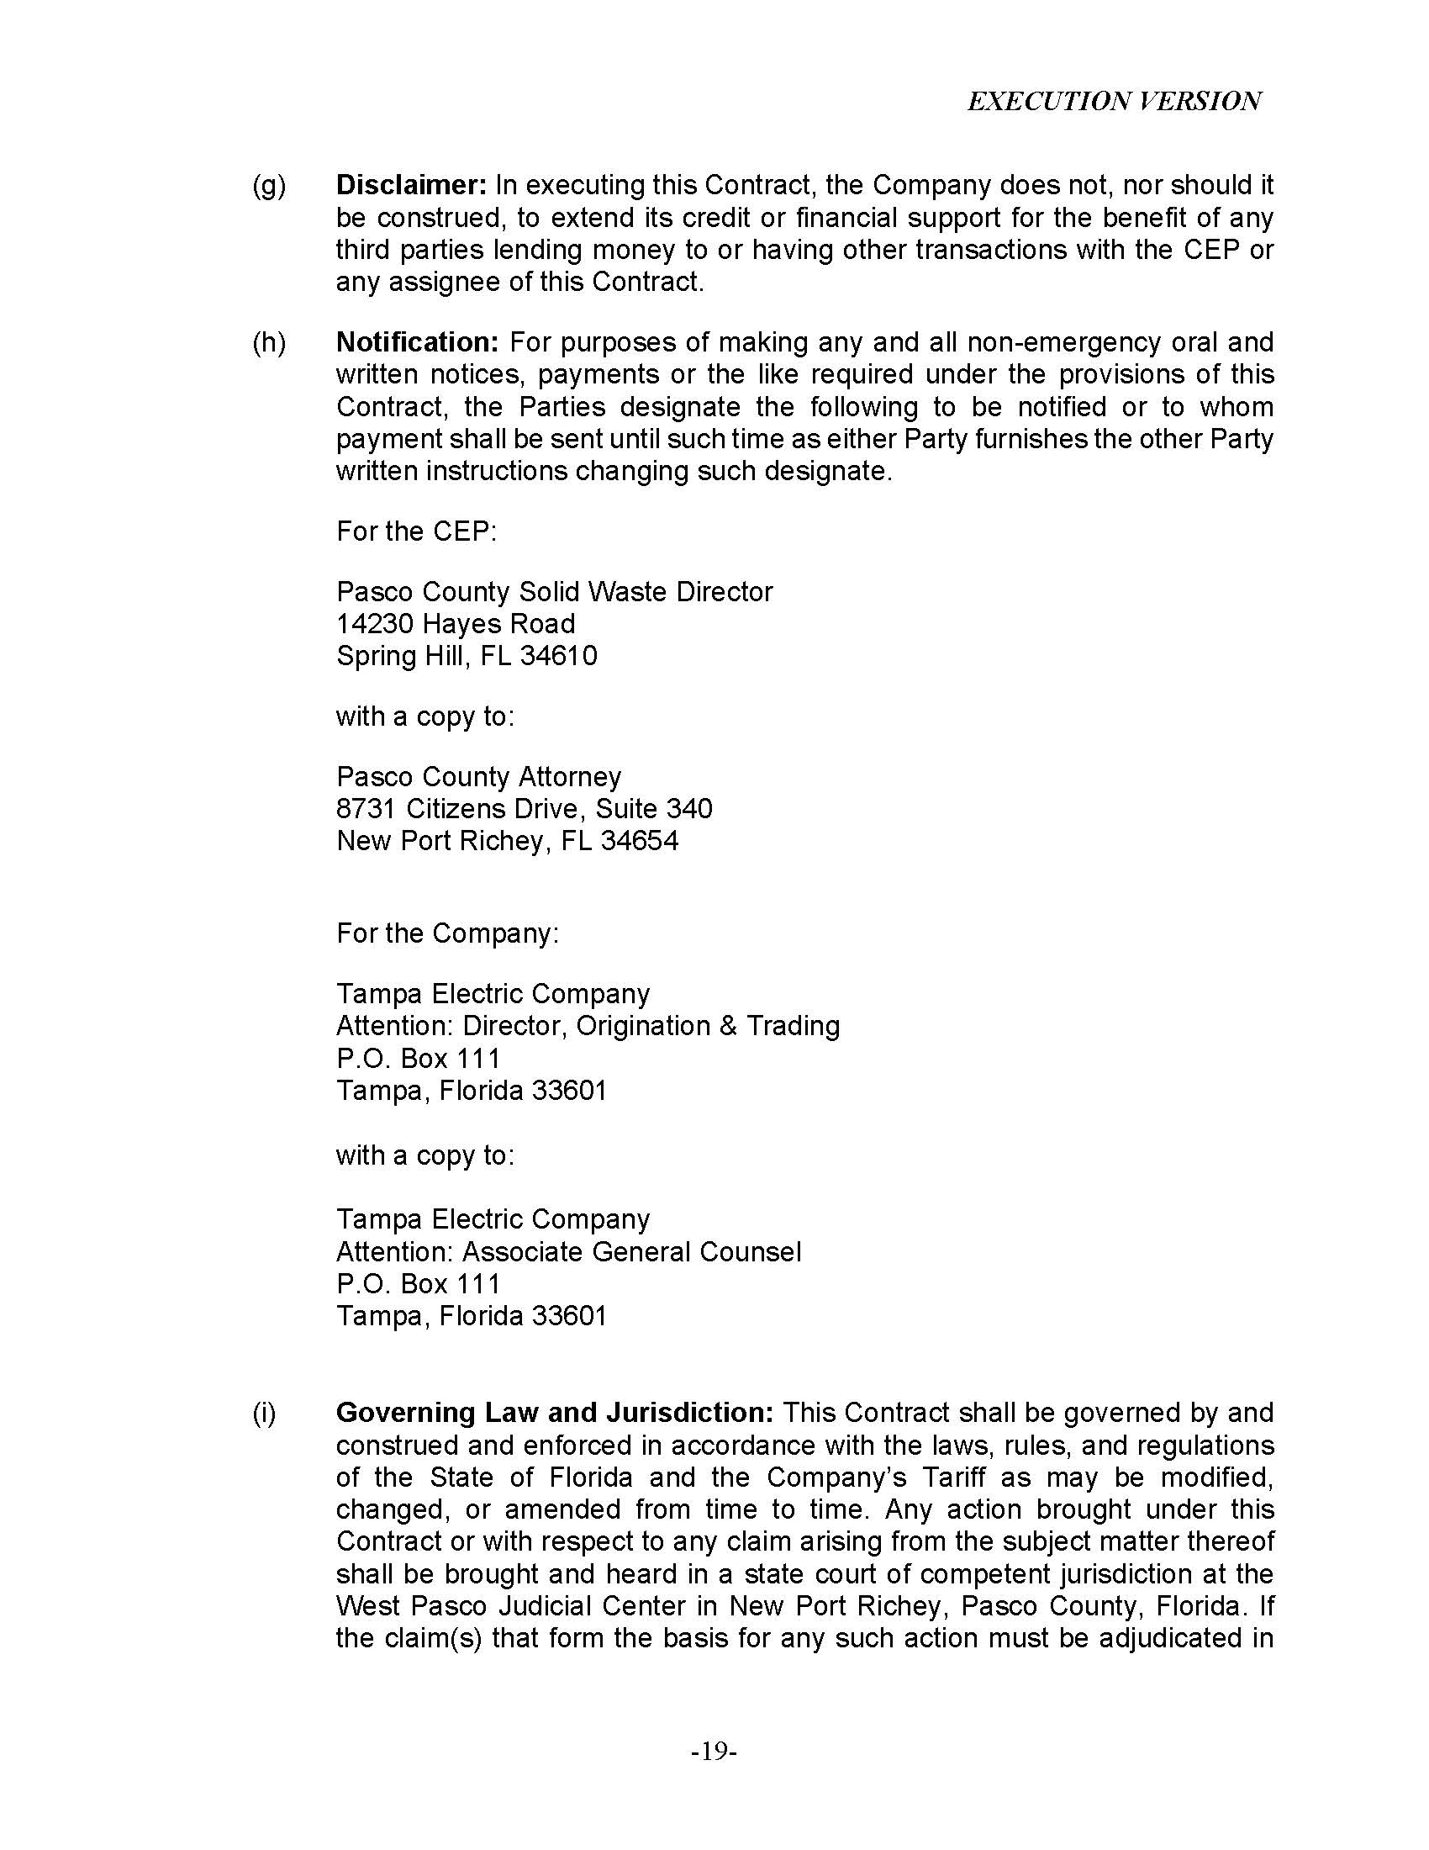

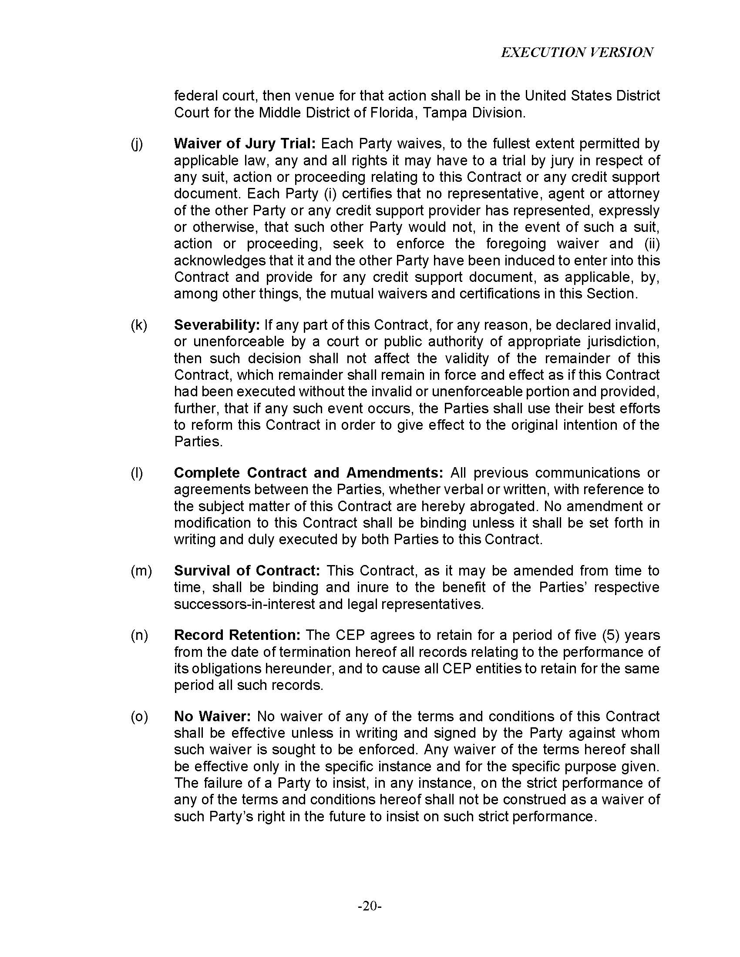

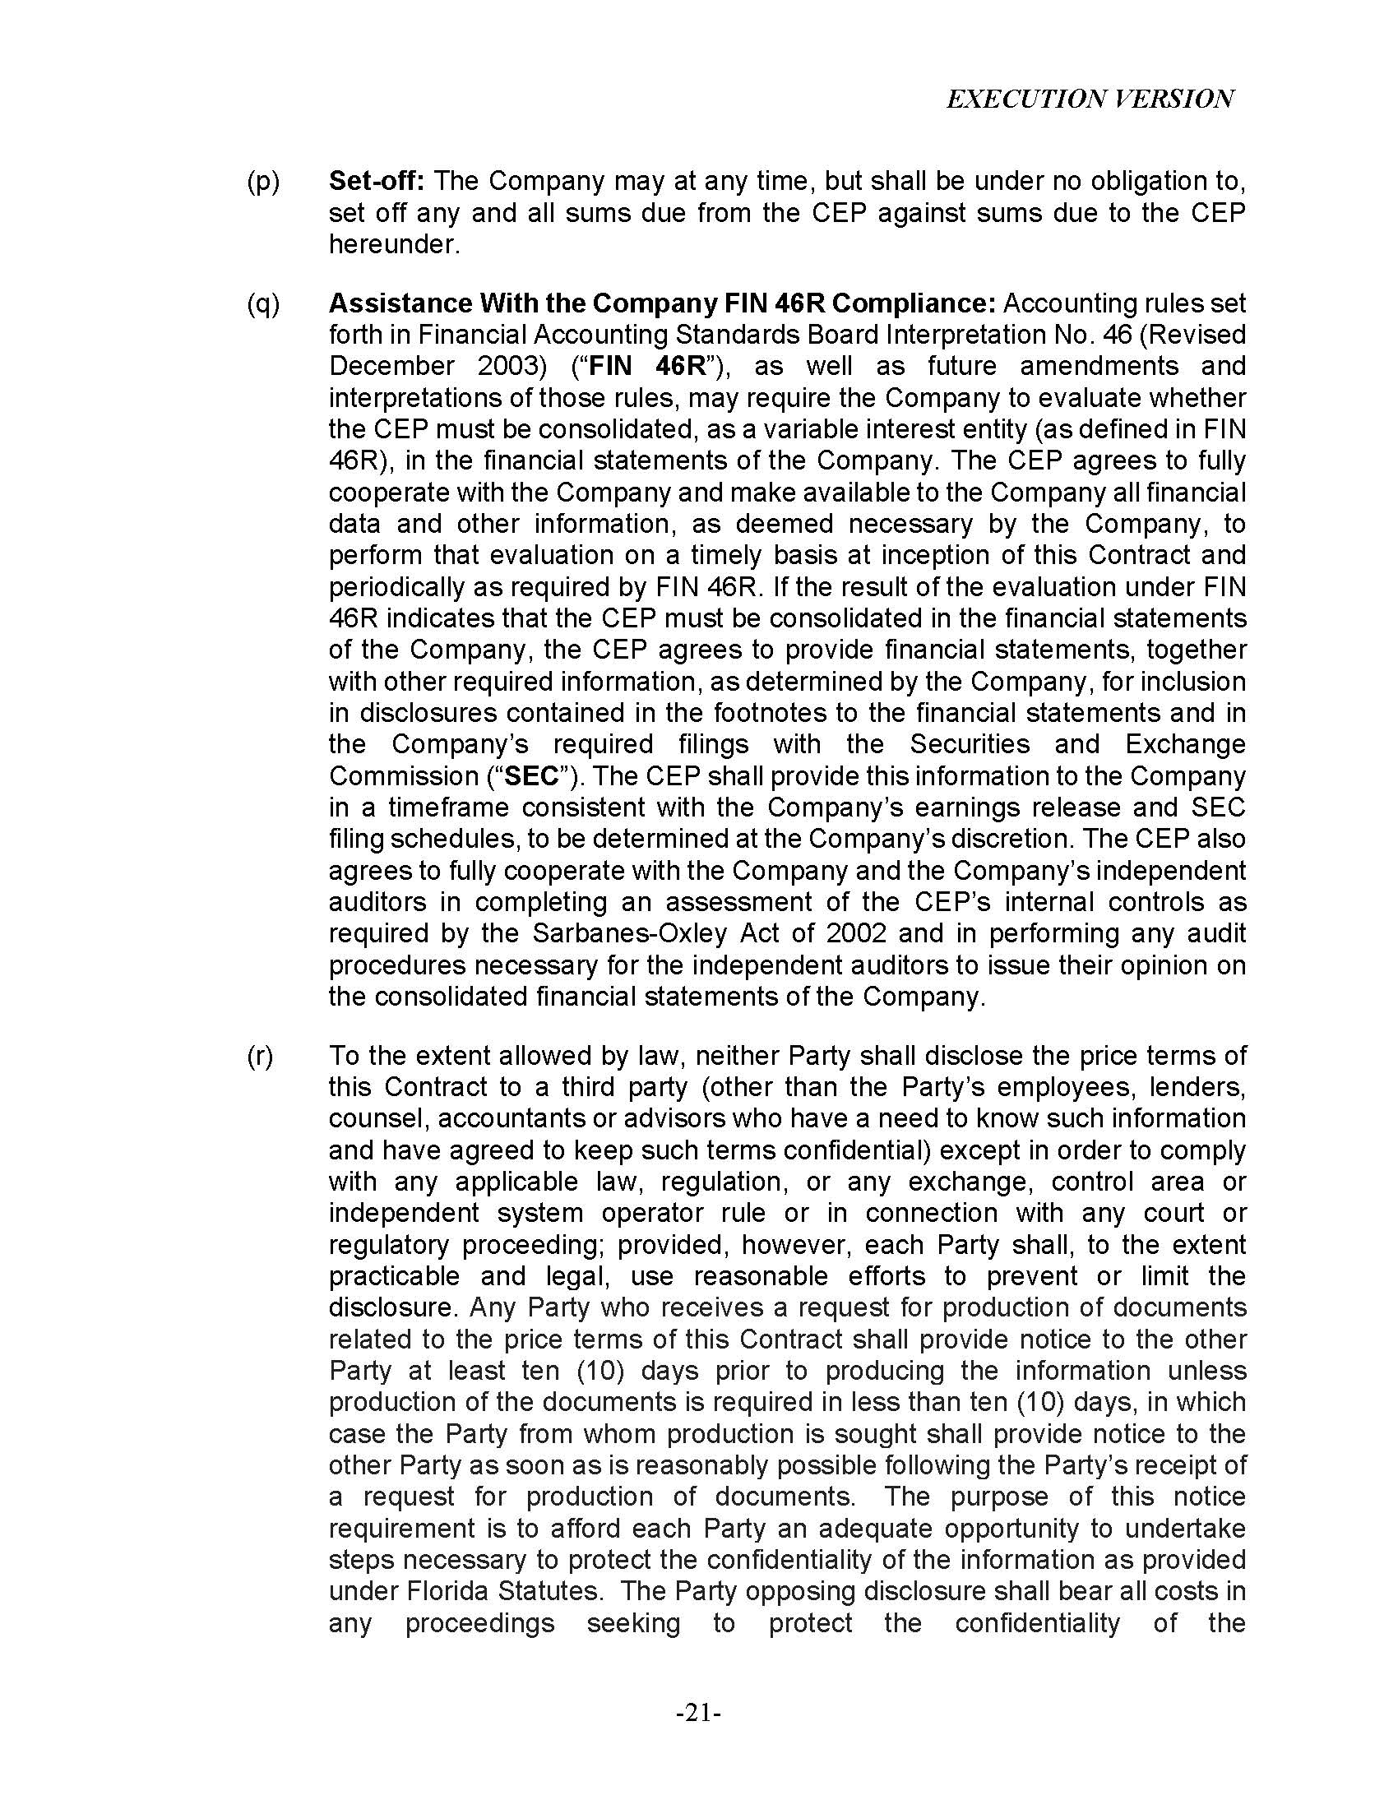

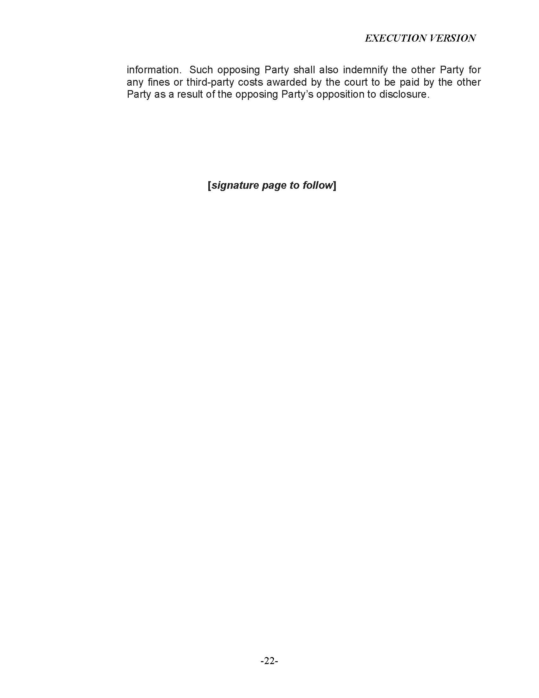

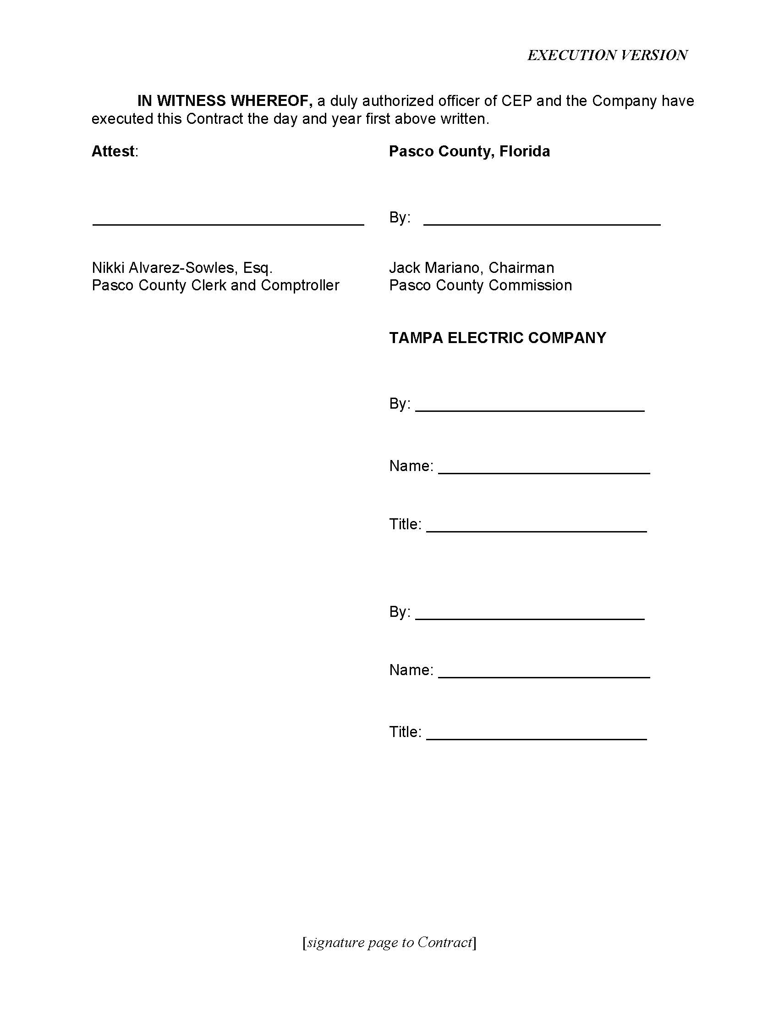

See Order No. PSC-2023-0132-PAA-EI, issued April 18, 2023, in Docket No. 20220186-EI, In re: Petition for approval of purchase power agreement between Tampa Electric Company and Pasco County.
Document No. 00219-2024, filed on January 18, 2024, in Docket No. 20230129-EI.
Document No. 00219-2024, filed on January 18, 2024, in Docket No. 20230129-EI.
See Order No. PSC-11-0439-PAA-EQ, issued October 11, 2011, in Docket No. 20110090-EQ, In re: Petition for Approving Negotiated Power Purchase Agreement between Progress Energy Florida, Inc. and U.S. Ecogen Polk, LLC.
See Order No. PSC-2023-0179-PAA-EQ, issued June 21, 2023, in Docket No. 20230041-EQ, In re: Petition for approval of revisions to standard offer contracts and rate schedule COG-2, by Tampa Electric Company.

