|  |  |  |  |
| --- | --- | --- | --- |
| State of Florida  pscSEAL | | Public Service Commission  Capital Circle Office Center ● 2540 Shumard Oak Boulevard Tallahassee, Florida 32399-0850  -M-E-M-O-R-A-N-D-U-M- | |
| DATE: | June 6, 2024 | | |
| TO: | Office of Commission Clerk (Teitzman) | | |
| FROM: | Office of Industry Development and Market Analysis (Williams, Fogleman)  Office of the General Counsel (Imig, Farooqi, Harper) | | |
| RE: | Docket No. 20240056-TP – Commission approval of Florida Telecommunications Relay, Inc.'s fiscal year 2024-2025 proposed budget. | | |
| AGENDA: | 06/18/24 – Regular Agenda – Interested Persons May Participate | | |
| COMMISSIONERS ASSIGNED: | | | All Commissioners |
| PREHEARING OFFICER: | | | Clark |
| CRITICAL DATES: | | | None |
| SPECIAL INSTRUCTIONS: | | | Anticipate the need for sign language interpreters and assisted listening devices. Please place near the beginning of the agenda to reduce interpreter costs. |

Case Background

The Telecommunications Access System Act of 1991 (TASA) established a statewide telecommunications relay system. Section 427.704(1), Florida Statutes (F.S.), provides that the Florida Public Service Commission (Commission) shall establish, implement, promote, and oversee the administration of the statewide telecommunications access system to provide access to telecommunications relay services by persons who are deaf, hard of hearing, or speech impaired. TASA provides for the purchase and distribution of specialized telecommunications devices as defined in Section 427.703(11), F.S. As defined by Section 427.703(16), F.S., this system is to provide telecommunications service for deaf or hard of hearing persons that is functionally equivalent to the service provided to hearing persons.

The telecommunications access system provides deaf or hard of hearing persons access to basic telecommunications services by using a specialized Communications Assistant that relays information between the deaf or hard of hearing person and the other party to the call. The primary function of the telecommunications access system is accomplished through the use of a Telecommunications Device for the Deaf (TDD). The person using the TDD types a message to the Communications Assistant who in turn voices the message to the other party or types the message to a Captioned Telephone that displays real-time captions of the conversation.

Florida Telecommunications Relay, Inc. (FTRI), a non-profit corporation formed by the local exchange telephone companies, was selected by the Commission to serve as the telecommunications access system administrator. FTRI is primarily responsible for the purchase and distribution of specialized telecommunications equipment. As part of this process, FTRI contracts with other organizations to assist in the distribution of equipment and provide customer training on the proper use of the equipment and the relay service. FTRI also conducts marketing to raise awareness of available specialized equipment and related relay service. Finally, FTRI pays the relay services provider that is selected by the Commission through a request for proposals process. The current relay service provider is T-Mobile USA, Inc. (T-Mobile).

FTRI, as the TASA Administrator, is funded through the Telecommunications Relay Service (TRS) surcharge. This surcharge was capped by the Florida Legislature at a maximum of $0.25 per switched access line (landline) per month, with a limit of 25 lines per account billed. Only local exchange telecommunications companies are required to collect and remit this surcharge to FTRI. The initial TRS surcharge was set at $0.05 per access line per month.[1] The Commission has changed the surcharge through the years to meet FTRI’s budgetary needs. The monthly surcharge is currently $0.09 per access line.

As part of its oversight responsibilities of the telecommunications access system, the Commission reviews and approves a budget submitted by FTRI on an annual basis. On May 6, 2024, FTRI submitted its Fiscal Year 2024/2025 budget for the Commission’s consideration, which is included as Attachment A.[2] FTRI also compared its proposed budget to the Commission-approved 2023/2024 budget, as well as the estimated revenue and expenses. FTRI’s estimated revenue and expenses were based on actual data from the first two quarters and estimated data for the third and fourth quarters of the current fiscal year. On May 13, 2024, FTRI filed third quarter financial information. With this updated information, staff formulated its own estimated expenses for Fiscal Year 2023/2024, which is reflected in Attachment B.

This recommendation addresses FTRI’s proposed budget and recommended TRS surcharge for Fiscal Year 2024/2025. The TRS surcharge is the only rate the Commission establishes for telecommunications companies. The Commission is vested with jurisdiction pursuant to Chapter 427, F.S.

Discussion of Issues

Issue 1:

 Should the Commission approve FTRI's proposed Fiscal Year 2024/2025 budget as presented in Attachment A?

Recommendation:

 Yes. Staff recommends the Commission approve FTRI’s proposed budget expenses of $3,286,708 for Fiscal Year 2024/2025, effective upon issuance of the consummating order. (Williams, Fogleman, Imig, Harper)

Staff Analysis:

**Traditional Telecommunications Relay Service**

The traditional TRS cost to FTRI as approved in the T-Mobile contract is currently $1.60 per session minute. T-Mobile’s projections indicate that traditional TRS minutes of use during Fiscal Year 2024/2025 will decrease by 25 percent from the current fiscal year. It has been observed that traditional relay users are transitioning to the following services:

* IP Relay
* VRS
* IP CTS
* Wireless Service

**CapTel Service**

The CapTel cost to FTRI as approved in the T-Mobile contract is currently $1.67 per session minute. CapTel service uses a specialized telephone that provides captioning of the incoming call for a deaf or hard of hearing person. T-Mobile’s projections show that CapTel minutes of use during Fiscal Year 2024/2025 will decline by 45 percent from the current fiscal year. CapTel users are also transitioning to other forms of advanced services as listed above.

**Florida Telecommunications Relay, Inc. Budget**

Attachment A reflects FTRI’s Fiscal Year 2024/2025 proposed budget, which was reviewed and adopted by FTRI’s Board of Directors prior to filing with the Commission. FTRI’s proposed budget projects total expenses of $3,286,708. FTRI also proposed the Commission reduce the current $.09 surcharge to $.08 per line, which would result in total surcharge revenue of $2,349,642. FTRI projects $1,099,754 in interest income during Fiscal Year 2024/2025 through investments in its Investment Trust Money Market account and 3-month T-bills. As a result, FTRI’s total operating revenue is estimated to be $3,449,396.

T-Mobile’s forecasted Fiscal Year 2024/2025 traditional TRS minutes of use are 487,992, while its forecasted CapTel minutes of use are 84,435. FTRI’s proposed TRS and CapTel service provider expense for Fiscal Year 2024/2025 is $921,793. For comparison, the Commission-approved budget for the current fiscal year reflected traditional TRS minutes of 651,963 and CapTel minutes of 153,345, with a total TRS and CapTel service provider expense of $1,299,227.

**Analysis**

Staff developed an estimate of FTRI’s final expenses for Fiscal Year 2023/2024, which is presented in Attachment B. Staff used actual data from the first three quarters and took an average of those three quarters to estimate the fourth. Staff’s estimates were then used as one element in evaluating FTRI’s proposed budget, along with analyzing past Commission-approved FTRI budgets to identify and evaluate ongoing cost reduction measures.

Below is staff’s review of selected items from FTRI’s proposed budget expense by category.

**Category I – Relay Services**

Category I captures Dual Party Relay (DPR) provider expenses for traditional TRS and CapTel service currently provided by T-Mobile. In Fiscal Year 2023/2024, basic TRS and CapTel minutes of use decreased from the prior fiscal year. Based on continued advancements in technology, along with the expansion of consumer choice, it appears that minutes of use for these services will continue to decline.

The relay service expenses are calculated using the minutes of use forecasted by T-Mobile and the relay service contract rates. The current T-Mobile contract rates are $1.60 for TRS and $1.67 for CapTel, which when applied to the forecasted minutes of use results in FTRI’s proposed $921,793 total relay service expense.

Staff recommends approval of $921,793 for DPR provider expenses.

**Category II – Equipment & Repairs**

Category II expenses reflect the purchase of equipment to be distributed to clients and the repairs that FTRI must make to keep the equipment in working order. FTRI has requested $465,154 for Fiscal Year 2024/2025. FTRI’s proposed budget represents a $63,696 increase in expense from the current Commission-approved budget.

The proposed increase in equipment and repairs expense is largely associated with increased demand for VCP Hearing Impaired phones and In-Line Amplifier equipment, in addition to replacement of legacy equipment with more advanced devices, such as the new XLC8GLT Deluxe captioning device. FTRI explained that it no longer purchases traditional CapTel devices associated with CapTel service. The XLC8GLT Deluxe device will replace the current XLC8 and will include a large captioning screen that only works with landlines and allows the customer to view larger captions on the screen via an installed application. FTRI further proposes that, going forward, the Caption Call Equipment line item be renamed Caption Devices to more accurately reflect the advanced technology.

Staff recommends approval of the proposed $465,154 for equipment and repairs expense.

**Category III – Equipment Distribution & Training**

Category III reflects the cost of distributing equipment throughout the state and the training of consumers in the use of that equipment. FTRI’s proposed budget requests $262,000 for distribution and training, which reflects a $53,766 decrease from the current Commission-approved budget.

Expenses related to Regional Distribution Centers (RDCs) are the largest component of Category III expenses. FTRI’s proposed budget for RDCs is $200,000, which is $49,291 lower than the current Commission-approved budget. FTRI proposes no increase in Fiscal Year 2024/2025 to the fees paid per service provided by RDCs. FTRI is hopeful that the increase in these fees made in Fiscal Year 2023/2024 will continue to incent RDCs to provide more services. FTRI stated that it has seen a small increase in services provided by RDCs in the current Fiscal Year.

Staff recommends approval of FTRI’s $262,000 proposed budget for Category III expenses.

**Category IV – Outreach**

Outreach efforts are designed to promote FTRI’s equipment distribution services and to raise awareness about Florida relay service. FTRI’s proposed Fiscal Year 2024/2025 Outreach budget increases expense by $16,873.

FTRI employs various forms of communication in its outreach strategy. FTRI plans to continue advertising in newspapers using free-standing insert ads (flyers) in markets where effective. However, FTRI acknowledges that it has witnessed rapid changes in the newspaper industry. In response, FTRI will continue to utilize other print tools such as direct mail post cards and coupon book advertisements. FTRI also plans to continue expanding its digital marketing campaign, including increased use of banner ads on websites, as well as targeted email and social media campaigns.

The Commission has encouraged FTRI to research and consider more technologically advanced and cost-effective forms of outreach. For example, the Commission encouraged FTRI to consider adding an online chat function to help with customer inquiries. FTRI implemented the chat function, termed “FTRI Chat,” in its Fiscal Year 2022/2023 budget.

Staff recommends approval of FTRI’s proposed budget for Category IV expenses.

**Category V – General & Administrative**

Category V reflects expenses associated with FTRI’s operations, such as office and furnishings, employee compensation, contracted services (auditors, attorney and computer consultants), computers, and other operating expenses. FTRI is proposing $1,058,455 for Fiscal Year 2024/2025, which represents a $35,624 decrease in Category V expense from the current Commission-approved budget.

Staff recommends approval of FTRI’s Category V expenses.

**Conclusion**

Staff recommends the Commission approve FTRI’s proposed budget expenses of $3,286,708 for Fiscal Year 2024/2025, effective upon issuance of the consummating order.

Issue :

 What TRS surcharge should the Commission approve for Fiscal Year 2024/2025?

Recommendation:

 Staff recommends the Commission approve FTRI’s proposal to reduce the TRS surcharge from $0.09 to $0.08. Staff recommends the Commission order all local exchange companies to bill the $0.08 TRS surcharge for Fiscal Year 2024/2025, effective September 1, 2024. (Williams, Fogleman, Imig, Harper)

Staff Analysis:

 Based on current industry trends, FTRI estimates that access lines will decrease at the rate of approximately nine percent from the current fiscal year as more consumers transition away from landline phones. Holding the TRS surcharge constant, a decrease in access lines results in a decrease in revenues to support FTRI’s activities. FTRI’s proposal to reduce the TRS surcharge from $0.09 to $0.08 per access line places further downward pressure on revenues. If approved, the lower surcharge of $0.08 is expected to generate $2,349,642 in surcharge revenue.

FTRI also maintains a reserve account with a current balance of approximately $20 million. The reserve account represents funds that were originally set aside in anticipation that the Federal Communications Commission (FCC) might delegate intrastate costs associated with Video Relay Service (VRS) and Internet Protocol Caption Telephone Service (IP-CTS) to states. Though conversations continue, there remains no clear indication that the FCC will delegate VRS and IP-CTS authority to states in the foreseeable future. FTRI currently invests the reserve account in three-month treasury bills and money market accounts to generate interest income. FTRI estimates interest income for Fiscal Year 2024/2025 will be $1,099,754, representing a $417,714 increase from Fiscal Year 2023/2024.

The sum of the surcharge revenue, $2,349,642, with the estimated interest income, $1,099,754, results in the total operating revenue of $3,449,396. Even with a decrease in the surcharge, FTRI’s proposed budget will result in an estimated surplus for Fiscal Year 2024/2025 of $162,688.[3]

Staff supports the reduction to $0.08 because it balances the budget more precisely compared to maintaining the current $0.09 surcharge.

**Conclusion**

Staff recommends the Commission approve FTRI’s proposal to reduce the TRS surcharge from $0.09 to $0.08. Staff recommends the Commission order all local exchange companies to bill the $0.08 TRS surcharge for Fiscal Year 2024/2025, effective September 1, 2024.

Issue :

 Should this docket be closed?

Recommendation:

 If no person whose substantial interests are affected by the proposed agency action files a protest within 21 days of the issuance of the order, this docket should be closed upon the issuance of a consummating order. (Imig, Harper)

Staff Analysis:

 At the conclusion of the protest period, if no protest is filed this docket should be closed upon the issuance of a consummating order.

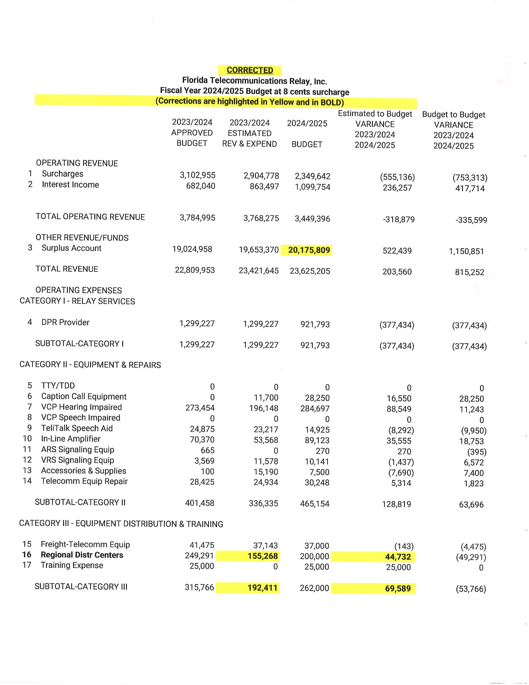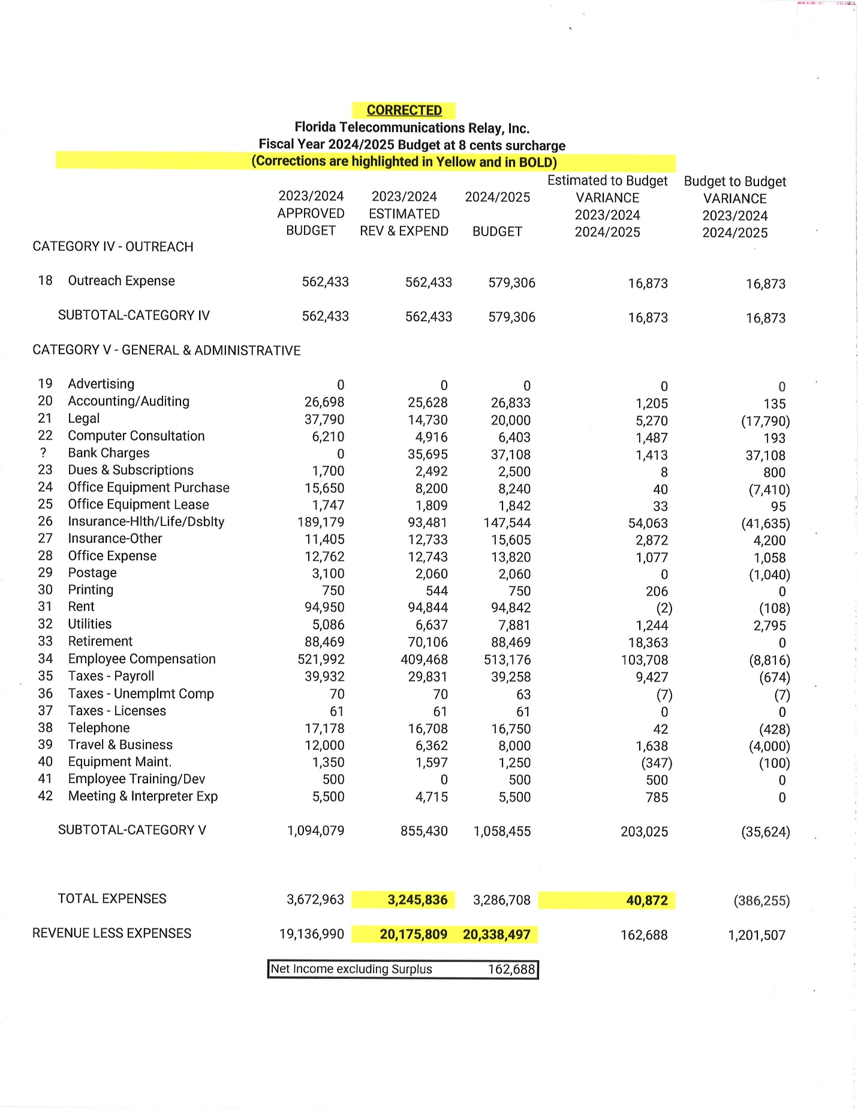

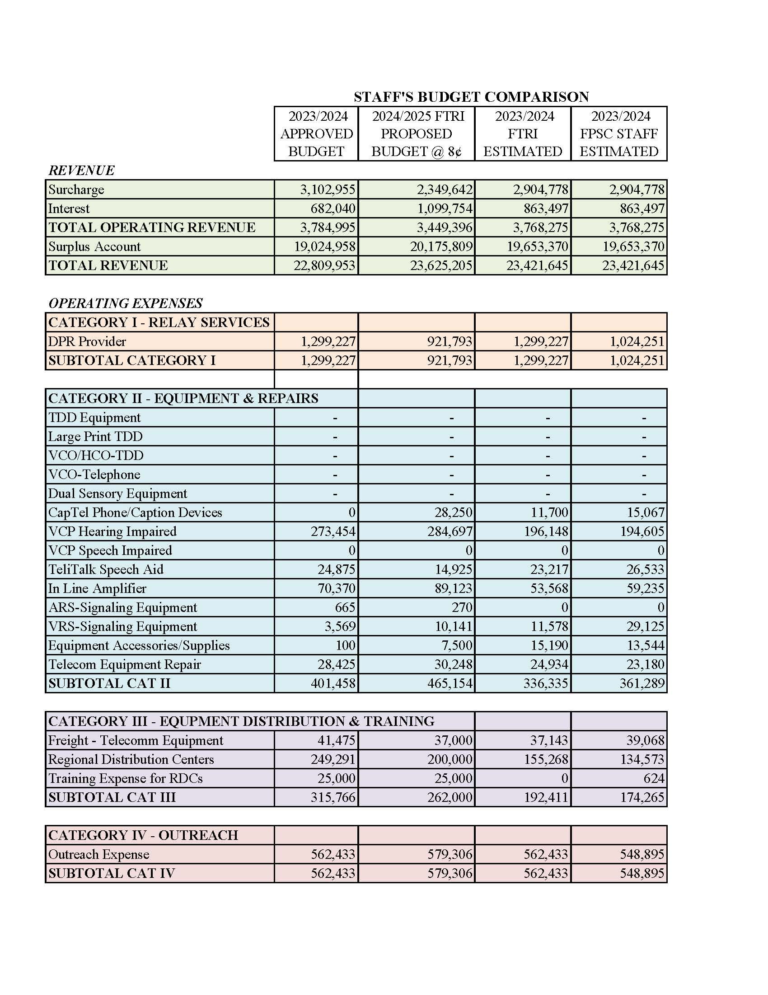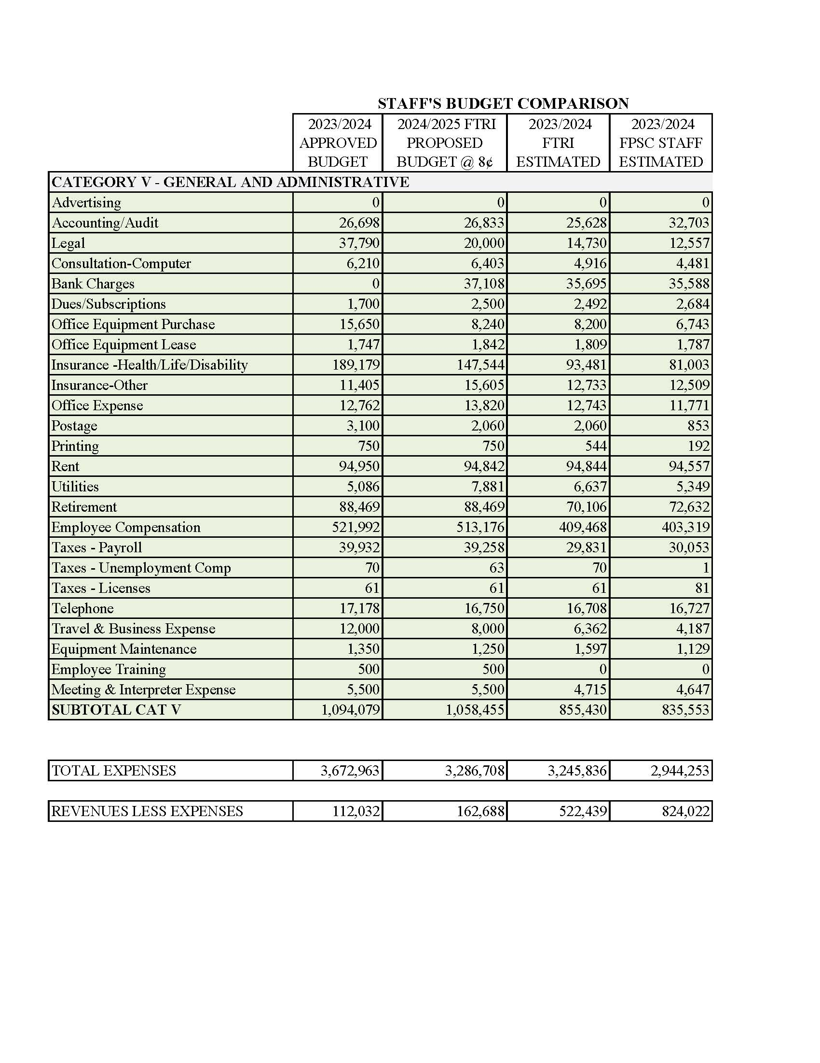

1. Order No. 24581, issued May 24, 1991, in Docket No. 910496-TP, *In re: Implementation of Florida Telecommunications Access System Act of 1991*.
2. On April 1, 2024, FTRI submitted a proposed Fiscal Year 2024/2025 budget. Staff found errors and inconsistencies in the budget. FTRI resubmitted its corrected budget on May 6, 2024. For purposes of this recommendation, the corrected budget filed on May 6, 2024.
3. Budget surplus and shortfalls for each TRS surcharge are calculated using staff’s recommended budget expense amounts.